Supplementary Information for: FLAME OUT! END-TRIASSIC MASS EXTINCTION POLYCYCLIC AROMATIC HYDROCARBONS REFLECT MORE THAN FIRE
Authors: C. P. Fox^{1#*}, J. H. Whiteside², P. E. Olsen³, K. Grice¹

Bristol Channel Basin, southwest UK
The St. Audrie’s Bay and Lilstock outcrops in the Bristol Channel Basin, SW UK, are within close geographic proximity to each another, being approximately 7 km part. The lithology between sections (Fig. S1) is so similar that comparisons between sections can be made without the aid of biostratigraphy and isotope geochemistry.
The Bristol Channel Basin, SW UK that includes the St. Audrie’s Bay (51.182833°, -3.286000°) and Lilstock (51.200757°, -3.176389°) sections, is well characterized in terms of paleontology, palynology (Mander et al., 2008; Warrington et al., 2008 and refs therein; Bonis et al., 2010), and geochemistry (Beith et al., 2021; Fox et al., 2022, 2020; Jaraula et al., 2013). Importantly, the St. Audrie’s Bay is a focal ETE section to which many records are compared. The St. Audrie’s Bay and Lilstock sedimentary successions were located at ~31°N paleolatitude in the late Triassic/early Jurassic (Kent and Tauxe, 2005) and represent locations closer to paleoislands compared to other Bristol Channel Basin section e.g., Lavernock Point (Whiteside and Marshall, 2008). The late Rhaetian to early Hettangian age strata (Triassic-Jurassic boundary transition) are represented by the Westbury, Lilstock, and Blue Lias formations, with the Lilstock Formation subdivided into the Cotham and Langport members. Some authors (Hodges, 2021) divide the same interval into the White Lias and Watchet formations and do not recognize the Lilstock Formation, but these units are rarely used along the southern outcrops of the Bristol Channel Basin and are not used here.
The Westbury Formation, a regionally extensive marine unit that contains the precursor CIE, consists of dark grey to black organic rich mudstones (“shales”) and subordinate silty calcareous mudstones that are interbedded with grey limestone concretions. The Westbury Formation contains small-sized invertebrate fossils with low diversity and a notable absence of fossil groups such as sponges, bryozoans, and ammonites, deposited during fluctuating, albeit low, salinities (Swift, 1999). The Formation generally represents a calm offshore but shallow sea with maximum flooding surface in the middle of the Formation, possibly at a maximum total organic carbon spike below the precursor CIE recorded in the middle/upper portion of the Formation (Hesselbo et al., 2004).
Overlaying the Westbury Formation, the Cotham Member contains green-grey calcareous mudstones, subordinate limestones, and sandstones. Lithological features during this interval include soft sediment deformation of sandstones that are cut by siltstone-filled desiccation cracks (above which a hiatus is recorded), wave ripples, and possible raindrop imprints, indicating a shallower water environment. The Cotham Member is separated into the upper and lower units above and below where the first (and deepest) desiccation cracks occur. It is at this interval the initial CIE begins. Water depth is inferred to shallow upward through the lower Cotham Member, although marine pelagophytes swiftly reduce at the Westbury Formation to Cotham Member boundary suggesting a regression event (Fox et al., 2020; Hesselbo et al., 2004). This interval, especially the upper part, is marked by a near absence of marine biota, representing a shallow brackish to freshwater lagoon-type environment, on the order of 10s of cm at some intervals (Mayall, 1983; Mander et al., 2008; Warrington et al., 2008 and refs therein). Lithological differences occur in the lower Cotham Member and Westbury Formation between St. Audrie’s Bay and Lilstock; there is clear separation between the Westbury Formation and the lower Cotham Member at St. Audrie’s Bay. Lithological changes are less obvious at the section we sampled at Lilstock because of laterally inconsistent, post-depositional mixing, where the light-colored basal lower Cotham Member and dark upper Westbury Formation strata are churned.
The Langport Member contains nodular/laminated peloidal and microspar pale grey limestones with marine fossils returning in close proximity to a minor transgression event and termination of the initial CIE (Fox et al., 2020; Mander et al., 2008; Wignall and Bond, 2008). In the SW UK, this Member has been described as representing the distal part of a carbonate ramp (Hesselbo et al., 2004), or a warm, shallow, carbonate-rich lagoon (Hounslow et al., 2004) punctuating more humid conditions with increased aridity (Wignall and Bond, 2008). Biomarkers of microbial mat containing organisms, laminar and thrombolytic stromatolites, and an absence of metazoans are evidenced within the Cotham and Langport members during the initial CIE supporting the formation of microbial mats that likely accounts for the negative δ¹³C_{org} anomaly (Fox et al., 2020 and refs therein). The initial CIE and apparent “dead zone” is purported to mark the extinction horizon (Mander et al., 2008). However, lack of marine biota at this interval is simply explained by low water depth and low salinity (described above).
The transition from the Langport Member to the Blue Lias Formation is marked by a flooding event, in which marine water quickly became stratified, anoxic, euxinic and acidic (Fox et al., 2022), and shift to organic-matter rich highly lithified black shales, termed the paper shales (Richardson, 1911). Better placement for the extinction horizon is within the very basal Blue Lias Formation coincident with a Lilliput assemblage of bivalves, last occurrences of conodonts and the reptile clade Phytosauria (Fox et al., 2020; Wignall and Atkinson, 2020), and the strongest evidence of CAMP-driven environmental perturbations; acidification, anoxia, and photic zone euxinia (PZE) (Atkinson and Wignall, 2019; Beith et al., 2021; Fox et al., 2022). This portion of the Blue Lias Formation, termed the pre-planorbis beds, is at least 10s of meters preventing influence of wave action on bottom waters.
Samples from the St. Audrie’s Bay section in this study span the upper two meters of the Westbury Formation, through Cotham and Langport members of the Lilstock Formation, to the very base of the Blue Lias Formation. Samples from the Lilstock section begin at the very top of the Westbury Formation, continue through the Cotham and Langport members of the Lilstock Formation and the lower 1.2 meters of the Blue Lias Formation. Lithological similarities between sections allow for correlation independent of geochemical proxies.

Polycyclic Aromatic Hydrocarbons (PAHs) and Compound-Specific Isotopes
Table S1 provides the m/z transitions used in selection ion monitoring mass spectrometry methods for all PAH compounds used in this study. Karp et al., (2020) suggest that combustion-derived PAHs should be grouped based on their physiological characteristics rather than ring number; comparison between PAH groupings based on physiological characteristics and ring number is given in Fig S2. Additionally, Fig. S2 shows all combustion-related PAHs that comprise the total concentration of combustion-derived PAHs presented in Fig. 2. Fig. S3 shows the extended profile of all n-alkanes and regular isoprenoids, (some data of which were first presented in Fox et al., (2022, 2020), terrestrial vs. marine input (Peters et al., 2004) and eukaryotic vs. bacterial input (Fox et al., 2020; Grice et al., 2005; Jaraula et al., 2013). Note that in Fig. S3, the depth profile of St. Audrie’s Bay is expanded so that the lithological transitions correlate to those at Lilstock based on Fig. S1, and two depths profiles are produced (original and scaled). For full details see Fox et al., (2020). Fig. S4 and S5 show full pyrogenic vs. petrogenic profiles, with ratios based on Yunker et al., (2002).

Wildfires in the ETE
Evidence of wildfires comes from increased charcoal abundances and the combustion-derived PAHs phenanthrene, fluoranthene, pyrene, benzo(a)anthracene, chrysene, triphenylene, benzo(e)pyrene, benzo(a)pyrene, benzo(bjk)fluoranthene, Indeno[1,2,3-cd]pyrene, benzo(ghi)perylene, and coronene (Fig. 1; Table 1 in the main text) with those having a HMW (i.e., five or more rings) best representing evidence of paleowildfires. Thus far, charcoal and combustion-derived PAH evidence of wildfire through ETE is found in samples from various sites in German, Danish, Polish, Greenland, Iranian and Chinese Basins, some of which extend into the lower Jurassic. Figure 2 in the main manuscript gives the localities and summary of these increases relative to correlative records and biostratigraphic markers. Here we present a more comprehensive review.
In Greenland (Astartekløft), increases in the HMW PAHs benzo(ghi)peryelene and coronene occur within the CIE (Williford et al., 2014) correlated to the initial and main CIE in the SW UK (Belcher et al., 2010; Hesselbo et al., 2002; Mander et al., 2013). These PAH increases coincide with maximum charcoal content, increased gymnosperm resin derivatives, maximum plant turnover, and abrupt plant diversity loss, and are interpreted to represent paleowildfire activity and terrestrial ecosystem stress (Williford et al., 2014 and refs therein).
In the Polish Basin, Poland increased charcoal abundances and elevated concentrations of combustion-derived PAHs in two upper Triassic and five lower Jurassic sections are attributed to wildfire activity (Marynowski and Simoneit, 2009). Two pulses of increased combustion-derived PAHs are recorded in the Triassic-Jurassic Kamień Pomorski IG-1 section in NW Poland. The first increase takes place in the initial CIE during elevated total organic carbon (TOC) and close to evidence of darkened palynomorphs. The second and larger increase takes place at the Triassic-Jurassic boundary and coincides with darkened palynomorphs and the onset of the main CIE (Marynowski and Simoneit, 2009; Pieńkowski et al., 2014, 2011). Each pulse is characterized by similar concentrations of LMW and HMW PAHs but those most abundant include the phenanthrene, fluoranthene, pyrene, and benzo(ghi)perylene (Marynowski and Simoneit, 2009).
The Central/Southern Chinese sections Guangyuan and Hechuan in the N and S Sichuan Basin, respectively, both show three pulsed increases in three to six ringed combustion-derived PAHs. Ascribed to a combustion origin based on PAH ratios (e.g., Fluoranthene/Fluoranthene + Pyrene), two pulses occur in the Rhaetian attributed to changes in the paleo-Intertropical Convergence Zone and another at the Triassic-Jurassic boundary attributed to CAMP-driving global warming. Additionally, increases in furan-structured O-containing PAHs occur coincident with combustion-derived PAHs and are attributed to weathering. Although not chemostratigraphically correlated, increases in combustion-derived PAHs at the Triassic-Jurassic boundary coincide with shifts to the δ¹³C_{org} record, albeit negative in Guangyuan and positive in Hechuan (Song et al., 2020). Additionally, the Qili section in the NE Sichuan Basin various charcoal fragments are found in the upper Rhaetian and Triassic-Jurassic boundary (Pole et al., 2018). In the more poleward Junggar Basin, NW China, minor initial CIE combustion-derived PAHs increases are driven by benzo(bjk?)fluoranthenes. However, in the main CIE and above the last occurrence of Cerebropollenites thiergartii much larger increases of combustion-derived PAHs are recorded and driven by phenanthrene, fluoranthene, and pyrene (Fang et al., 2021).
In the Hägnach Quarry, SW Germany, charcoal evidence in the late Triassic (upper Keuper/late Rhaetian) is taken as direct evidence of paleowildfire activity, although no mention of the frequency is given (Uhl and Montenari, 2011). In N Germany (Mariental-1) PAHs increase in the Trilete beds and the basal portion of the CIE chemostratigraphically correlated to the initial CIE in the SW UK (Fig. 2). Based on increases in the ratio of the high-molecular-weight (HMW) PAHs coronene to benzo[a]pyrene (C/BaP; values of 3.46) and high concentrations of coronene (Fig. 2) PAH increases were attributed directly to CAMP activity, possibly intrusions into coal beds, rather than CAMP-induced biomass burning. This hypothesis is based on 1) an absence of charcoal; 2) darkened palynomorphs in the Trilete beds that are attributed to CAMP-induced soil acidification and/or sulphuric acid depositions (van de Schootbrugge et al., 2009); and 3) data from burn experiments in which biomass burning resulted in both low concentrations of HMW compounds including coronene and low ratios of C/BaP (Freeman and Cattell, 1990). However, based on more recent findings, PAH increases at Mariental-1 could be attributed to biomass burning rather than a direct signal of the CAMP. For example, periods of intense biomass burning can preferentially form HMW pyrogenic PAHs, i.e. PAH compounds containing more aromatic rings including coronene (six rings) (Finkelstein et al., 2005) with studies during other mass extinction events using increased abundances of coronene to indicate intervals of most intense paleowildfire activity (Kaiho et al., 2020). Additionally, increases in the pyrogenic PAHs benzo(a)anthracene and benzo(ghi)perylene at Mariental-1 are equal to or much greater than those of coronene and benzo(a)pyrene (see Fig. S6); a profile consistent with combustion of terrestrial material (Freeman and Cattell, 1990; Karp et al., 2020). Finally, sedimentary charcoal preservation is biased towards high temperature burning events and combustion of woody material but Mariental-1 PAH increases coincide with fern proliferation.
Charcoal (fusain) found in South Wales (Bristol Channel Basin, SW UK), in stratigraphic intervals described as the latest Rhaetian (likely the Penarth Group) and lower Lias (see next section for further details), is ascribed to paleowildfire activity (Harris, 1958). However, due to limited information it is difficult to discern at precisely which intervals these charcoal intervals occur and how much their abundances increase or change. At the Kamarmacheh Kuh section, Tabas Basin in Central Iran combustion chars and charcoal (semifusinite) increase across the Triassic-Jurassic boundary (Alipour et al., 2021). Finally, the coal beds of Denmark and Southern Sweden show increasing charcoal abundances across the Triassic-Jurassic boundary beginning in the latest Rhaetian with increased charcoal throughout the lower Jurassic (Hettangian and Sinemurian). Notably the two latest Rhaetian charcoal-containing coal beds reportedly correspond to the middle Westbury Formation in the SW UK (i.e., below the initial CIE). However, these coal beds were deposited during a maximum flooding event, which in the SW UK occurs at the transition from the Lilstock Formation to the Blue Lias Formation.

Mass Balance Calculations
The following mass balance calculation gives the isotopic composition of a material, such as sedimentary organic matter, if the isotopic composition and abundance is known of the materials contents:
$$δ_{T}= δ_{1}M_{1}+ δ_{2}M_{2} + δ_{n}M_{n}$$
Here, T is the total isotopic composition of the system/material, δ_{n} is the isotopic composition and M_{n} is mass of each individual component. Using the relative abundances and isotopic compositions of pristane, phytane, and various n-alkanes representing lower trophic photosynthetic organisms and higher land plants we used the mass balance calculation to show how changes from these biomarkers, their isotopic composition, and their abundances produce a similar profile to the bulk organic carbon isotope record (δ¹³C_{org}) (Fig 4 in the main text). We used the following equation
$$δ_{T}= {δ^{13}C_{pr}M}_{C_{pr}}+{δ^{13}C_{ph}M}_{C_{ph}}+{δ^{13}{n\text{-}C}_{17}M}_{n\text{-}C_{17}}+{δ^{13}{n\text{-}C}_{18}M}_{n\text{-}C_{18}}+{δ^{13}{n\text{-}C}_{19}M}_{n\text{-}C_{19}}+{δ^{13}{n\text{-}C}_{27}M}_{n\text{-}C_{27} }+{δ^{13}{n\text{-}C}_{29}M}_{n\text{-}C_{29}}+{δ^{13}{n\text{-}C}_{31}M}_{n\text{-}C_{31}}$$

References
Alipour, M., Alizadeh, B., Jahangard, A., GandomiSani, A., 2021. Wildfire events at the Triassic–Jurassic boundary of the Tabas Basin, Central Iran. Int. J. Coal Sci. Technol. 8, 897–907. https://doi.org/10.1007/s40789-021-00436-2
Atkinson, J.W., Wignall, P.B., 2019. How quick was marine recovery after the end-Triassic mass extinction and what role did anoxia play? Palaeogeogr. Palaeoclimatol. Palaeoecol. 528, 99–119. https://doi.org/https://doi.org/10.1016/j.palaeo.2019.05.011
Beith, S.J., Fox, C.P., Marshall, J.E.A., Whiteside, J.H., 2021. Persistent photic zone euxinia in the northwest Tethys impinged end-Triassic extinction recovery. Palaeogeogr. Palaeoclimatol. Palaeoecol. (in Press.
Belcher, C.M., Mander, L., Rein, G., Jervis, F.X., Haworth, M., Hesselbo, S.P., Glasspool, I.J., McElwain, J.C., 2010. Increased fire activity at the Triassic/Jurassic boundary in Greenland due to climate-driven floral change. Nat. Geosci. 3, 426–429. https://doi.org/10.1038/ngeo871
Fang, Y., Fang, L., Deng, S., Lu, Y., Wang, B., Zhao, X., Wang, Y., Zhang, H., Zhang, X., Sha, J., 2021. Carbon isotope stratigraphy across the Triassic-Jurassic boundary in the high-latitude terrestrial Junggar Basin, NW China. Palaeogeogr. Palaeoclimatol. Palaeoecol. 577, 110559. https://doi.org/https://doi.org/10.1016/j.palaeo.2021.110559
Finkelstein, D.B., Pratt, L.M., Curtin, T.M., Brassell, S.C., 2005. Wildfires and seasonal aridity recorded in Late Cretaceous strata from south-eastern Arizona, USA. Sedimentology 52, 587–599. https://doi.org/https://doi.org/10.1111/j.1365-3091.2005.00712.x
Fox, C.P., Cui, X., Whiteside, J.H., Olsen, P.E., Summons, R.E., Grice, K., 2020. Molecular and isotopic evidence reveals the end-Triassic carbon isotope excursion is not from massive exogenous light carbon. Proc. Natl. Acad. Sci. 117, 30171 LP – 30178. https://doi.org/10.1073/pnas.1917661117
Fox, C.P., Whiteside, J.H., Olsen, P.E., Cui, X., Summons, R.E., Idiz, E., Grice, K., 2022. Two-pronged kill mechanism at the end-Triassic mass extinction. Geology. https://doi.org/10.1130/G49560.1
Freeman, D.J., Cattell, F.C.R., 1990. Woodburning as a source of atmospheric polycyclic aromatic hydrocarbons. Environ. Sci. Technol. 24, 1581–1585. https://doi.org/10.1021/es00080a019
Grice, K., Cao, C., Love, G.D., Böttcher, M.E., Twitchett, R.J., Grosjean, E., Summons, R.E., Turgeon, S.C., Dunning, W., Jin, Y., 2005. Photic Zone Euxinia During the Permian-Triassic Superanoxic Event. Science (80-. ). 307, 706 LP – 709. https://doi.org/10.1126/science.1104323
Harris, T.M., 1958. Forest Fire in the Mesozoic. J. Ecol. 46, 447–453. https://doi.org/10.2307/2257405
Hesselbo, S.P., Robinson, S.A., Surlyk, F., 2004. Sea-level change and facies development across potential Triassic–Jurassic boundary horizons, SW Britain. J. Geol. Soc. London. 161, 365–379. https://doi.org/10.1144/0016-764903-033
Hesselbo, S.P., Robinson, S.A., Surlyk, F., Piasecki, S., 2002. Terrestrial and marine extinction at the Triassic-Jurassic boundary synchronized with major carbon-cycle perturbation: A link to initiation of massive volcanism? Geology 30, 251–254.
Hodges, P., 2021. A new ammonite from the Penarth Group, South Wales and the base of the Jurassic System in SW Britain. Geol. Mag. 158, 1109–1114. https://doi.org/DOI: 10.1017/S0016756820001107
Hounslow, M.W., Posen, P.E., Warrington, G., 2004. Magnetostratigraphy and biostratigraphy of the Upper Triassic and lowermost Jurassic succession, St. Audrie’s Bay, UK. Palaeogeogr. Palaeoclimatol. Palaeoecol. 213, 331–358. https://doi.org/https://doi.org/10.1016/j.palaeo.2004.07.018
Jaraula, C.M.B., Grice, K., Twitchett, R.J., Böttcher, M.E., LeMetayer, P., Dastidar, A.G., Opazo, L.F., 2013. Elevated pCO₂ leading to Late Triassic extinction, persistent photic zone euxinia, and rising sea levels. Geology 41, 955–958. https://doi.org/10.1130/G34183.1
Kaiho, K., Aftabuzzaman, M., Jones, D.S., Tian, L., 2020. Pulsed volcanic combustion events coincident with the end-Permian terrestrial disturbance and the following global crisis. Geology 49, 289–293. https://doi.org/10.1130/G48022.1
Karp, A.T., Holman, A.I., Hopper, P., Grice, K., Freeman, K.H., 2020. Fire distinguishers: Refined interpretations of polycyclic aromatic hydrocarbons for paleo-applications. Geochim. Cosmochim. Acta 289, 93–113. https://doi.org/https://doi.org/10.1016/j.gca.2020.08.024
Kent, D. V, Tauxe, L., 2005. Corrected Late Triassic Latitudes for Continents Adjacent to the North Atlantic. Science (80-. ). 307, 240 LP – 244. https://doi.org/10.1126/science.1105826
Mander, L., Kürschner, W.M., McElwain, J.C., 2013. Palynostratigraphy and vegetation history of the Triassic{\textendash}Jurassic transition in East Greenland. J. Geol. Soc. London. 170, 37–46. https://doi.org/10.1144/jgs2012-018
Mander, L., Twitchett, R.J., Benton, M.J., 2008. Palaeoecology of the Late Triassic extinction event in the SW UK. J. Geol. Soc. London. 165, 319–332. https://doi.org/10.1144/0016-76492007-029
Marynowski, L., Simoneit, B.R.T., 2009. Widespread upper Triassic to lower Jurassic wildfire records from Poland: Evidence from charcoal and pyrolytic and pyrolytic polycyclic aromatic hydrocarbons. Palaios 24, 785–798.
Mayall, M.J., 1983. An earthquake origin for synsedimentary deformation in a late Triassic (Rhaetian) lagoonal sequence, southwest Britain. Geol. Mag. 120, 613–622. https://doi.org/DOI: 10.1017/S001675680002776X
Peters, K.E., Walters, C.C., Moldowan, J.M., 2004. The Biomarker Guide: Volume 2: Biomarkers and Isotopes in Petroleum Systems and Earth History, 2nd ed. Cambridge University Press, Cambridge. https://doi.org/DOI: 10.1017/CBO9781107326040
Pieńkowski, G., Niedźwiedzki, G., Brański, P., 2014. Climatic reversals related to the Central Atlantic magmatic province caused the end-Triassic biotic crisis—Evidence from continental strata in Poland, in: Keller, G., Kerr, A.C. (Eds.), Volcanism, Impacts, and Mass Extinctions: Causes and Effects. Geological Society of America, p. 0. https://doi.org/10.1130/2014.2505(13)
Pieńkowski, G., Niedźwiedzki, G., Waksmundzka, M., 2011. Sedimentological, palynological and geochemical studies of the terrestrial Triassic–Jurassic boundary in northwestern Poland. Geol. Mag. 149, 308–332. https://doi.org/10.1017/S0016756811000914
Pole, M., Wang, Y., Dong, C., Xie, X., Tian, N., Li, L., Zhou, N., Lu, N., Xie, A., Zhang, X., 2018. Fires and storms—a Triassic–Jurassic transition section in the Sichuan Basin, China. Palaeobiodiversity and Palaeoenvironments 98, 29–47. https://doi.org/10.1007/s12549-017-0315-y
Richardson, L., 1911. The Rhætic and Contiguous Deposits of West, MID, &amp;amp; Part of East Somerset. Q. J. Geol. Soc. 67, 1–74. https://doi.org/10.1144/GSL.JGS.1911.067.01-04.03
Song, Y., Algeo, T.J., Wu, W., Luo, G., Li, L., Wang, Y., Xie, S., 2020. Distribution of pyrolytic PAHs across the Triassic-Jurassic boundary in the Sichuan Basin, southwestern China: Evidence of wildfire outside the Central Atlantic Magmatic Province. Earth-Science Rev. 201, 102970. https://doi.org/https://doi.org/10.1016/j.earscirev.2019.102970
Swift, A., 1999. Stratigraphy (including biostratigraphy), in: Swift, A., Martill, D.M. (Eds.), Fossils of the Rhaetian Penarth Group. The Palaeontological Association, pp. 15–31.
Uhl, D., Montenari, M., 2011. Charcoal as evidence of palaeo-wildfires in the Late Triassic of SW Germany. Geol. J. 46, 34–41. https://doi.org/https://doi.org/10.1002/gj.1229
van de Schootbrugge, B., Bachan, A., Suan, G., Richoz, S., Payne, J.L., 2013. Microbes, mud and methane: cause and consequence of recurrent Early Jurassic anoxia following the end-Triassic mass extinction. Palaeontology 56, 685–709. https://doi.org/https://doi.org/10.1111/pala.12034
van de Schootbrugge, B., Quan, T.M., Lindström, S., Püttmann, W., Heunisch, C., Pross, J., Fiebig, J., Petschick, R., Röhling, H.-G., Richoz, S., Rosenthal, Y., Falkowski, P.G., 2009. Floral changes across the Triassic/Jurassic boundary linked to flood basalt volcanism. Nat. Geosci. 2, 589–594. https://doi.org/10.1038/ngeo577
Warrington, G., Cope, J.C.W., Ivimey-Cook, H.C., 2008. The St Audrie’s Bay-Doniford Bay section, Somerset, England: updated proposal for a candidate Global Stratotype Section and Point for the base of the Hettangian Stage, and of the Jurassic System. Int. Subcomm. Jurassic Stratigr. Newsl. 35, 2–66.
Whiteside, D.I., Marshall, J.E.A., 2008. The age, fauna and palaeoenvironment of the Late Triassic fissure deposits of Tytherington, South Gloucestershire, UK. Geol. Mag. 145, 105–147. https://doi.org/10.1017/S0016756807003925
Wignall, P.B., Atkinson, J.W., 2020. A two-phase end-Triassic mass extinction. Earth-Science Rev. 208, 103282. https://doi.org/10.1016/j.earscirev.2020.103282
Wignall, P.B., Bond, D.P.G., 2008. The end-Triassic and Early Jurassic mass extinction records in the British Isles. Proc. Geol. Assoc. 119, 73–84. https://doi.org/https://doi.org/10.1016/S0016-7878(08)80259-3
Williford, K.H., Grice, K., Holman, A., McElwain, J.C., 2014. An organic record of terrestrial ecosystem collapse and recovery at the Triassic–Jurassic boundary in East Greenland. Geochim. Cosmochim. Acta 127, 251–263. https://doi.org/https://doi.org/10.1016/j.gca.2013.11.033
Yunker, M.B., Macdonald, R.W., Vingarzan, R., Mitchell, R.H., Goyette, D., Sylvestre, S., 2002. PAHs in the Fraser River basin: a critical appraisal of PAH ratios as indicators of PAH source and composition. Org. Geochem. 33, 489–515. https://doi.org/https://doi.org/10.1016/S0146-6380(02)00002-5

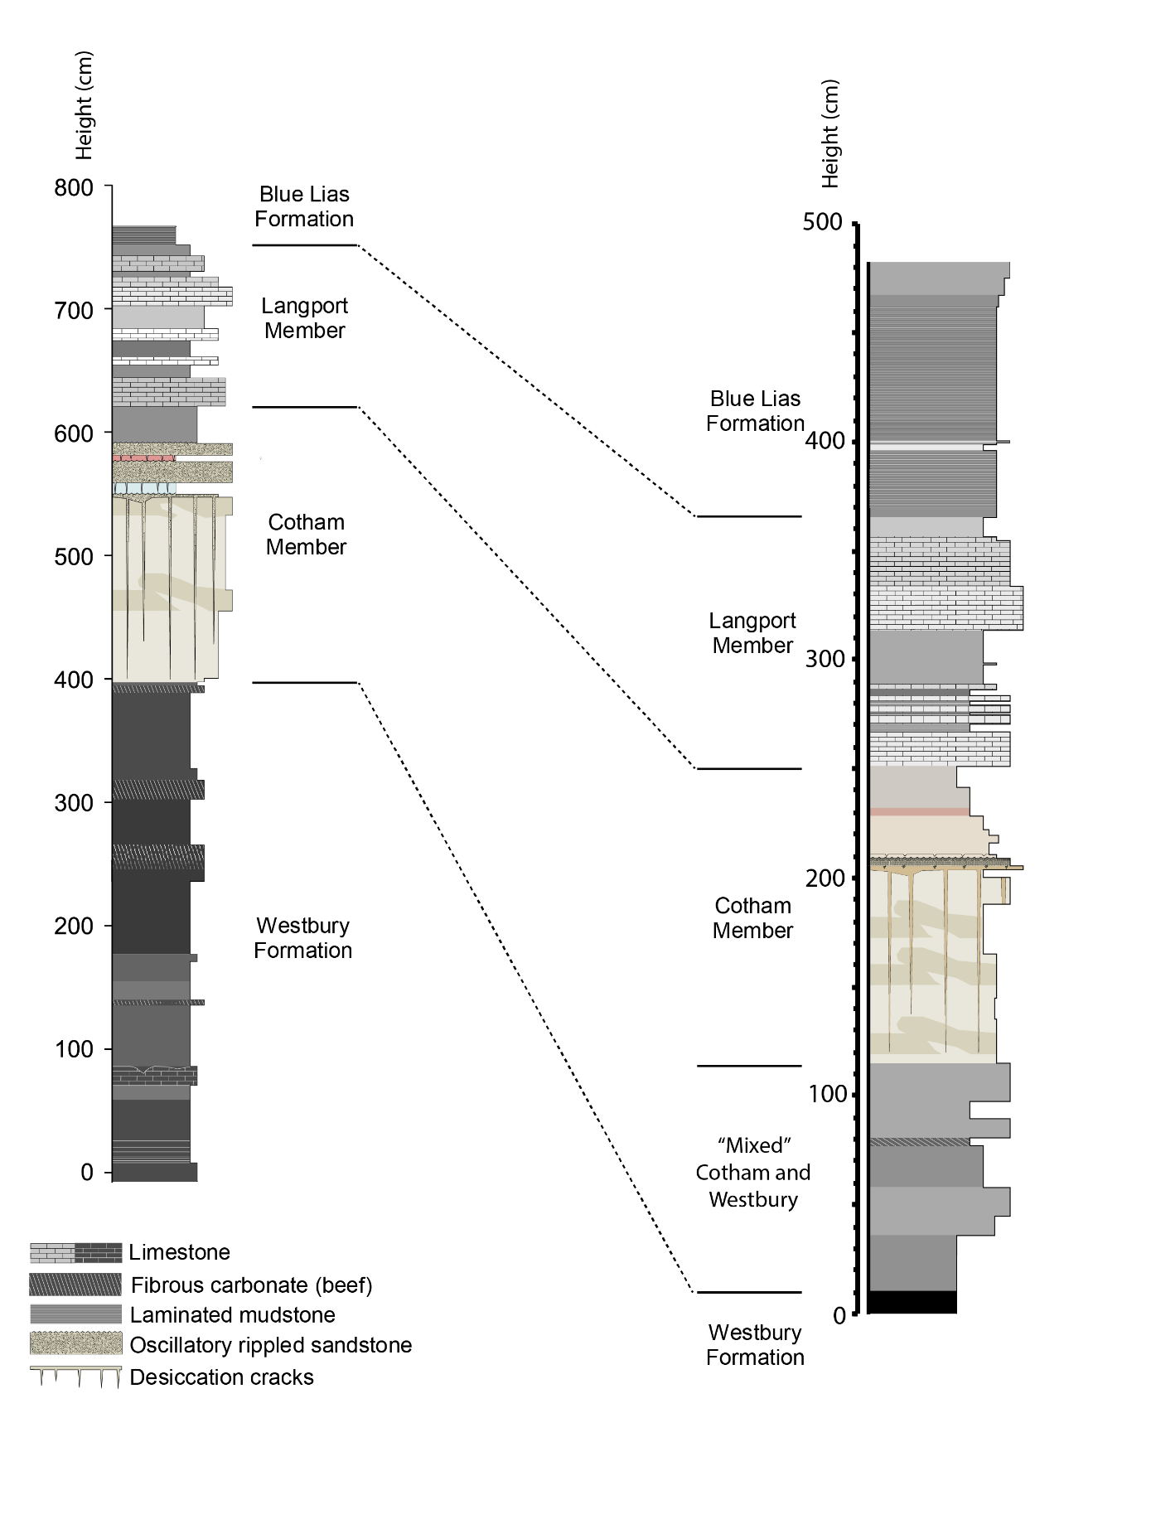
Figure S1: Lithological comparison between St. Audrie’s Bay (left) and Lilstock (right).
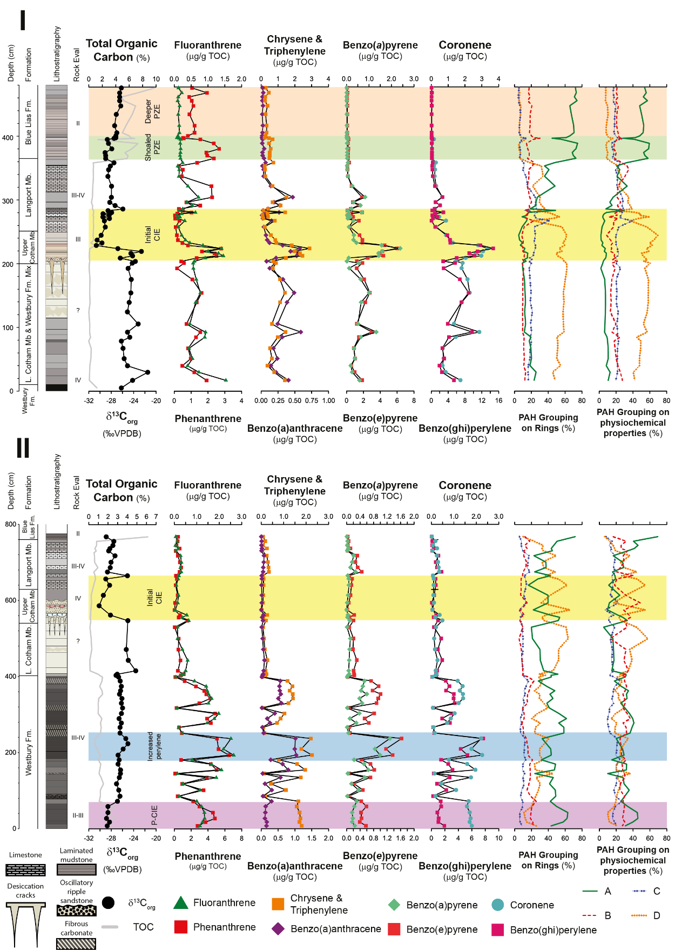

Figure S2: Individual PAH biomarkers related to combustion and PAH groupings based on ring number and physicochemical properties (i.e., octanal-water partition coefficients). Upper panel (I): Lilstock. Lower panel (II): St. Audrie’s Bay. Purple, blue and yellow bars represent the precursor CIE, increased in perylene index, and the initial CIE, respectively. Green- and peach-coloured bars in the Blue Lias Formation represent shoaled and deeper photic zone euxinia, respectively. Symbols for individual PAH compounds given at the bottom of the graph. Rock-Eval groupings first published in Fox et al., (2021). For PAHs grouped on ring no.: A – phenanthrene and fluoranthene (three rings); B – benzo(a)anthracene, Chrysene and Triphenylene (four rings); C – benzo(e)pyrene and benzo(a)pyrene (five rings); D – benzo(ghi)perylene and coronene (6 and 7 rings, respectively). For PAH groupings based on physiochemical properties: A – phenanthrene and anthracene; B – pyrene and fluoranthene; C – benzo(bjk)fluoranthene, benzo(a)anthracene, benzo(a)pyrene, chrysene and triphenylene; D – indeno[1,2,3-cd)pyrene, benzo(ghi)perylene, and benzo(e)pyrene. Note that PAH groupings based on physiochemical properties are from Fig. 9 in (Karp et al., 2020). Full profiles of coronene, benzo(a)pyrene and coronene/benzo(a)pyrene are also given in Figure S7.
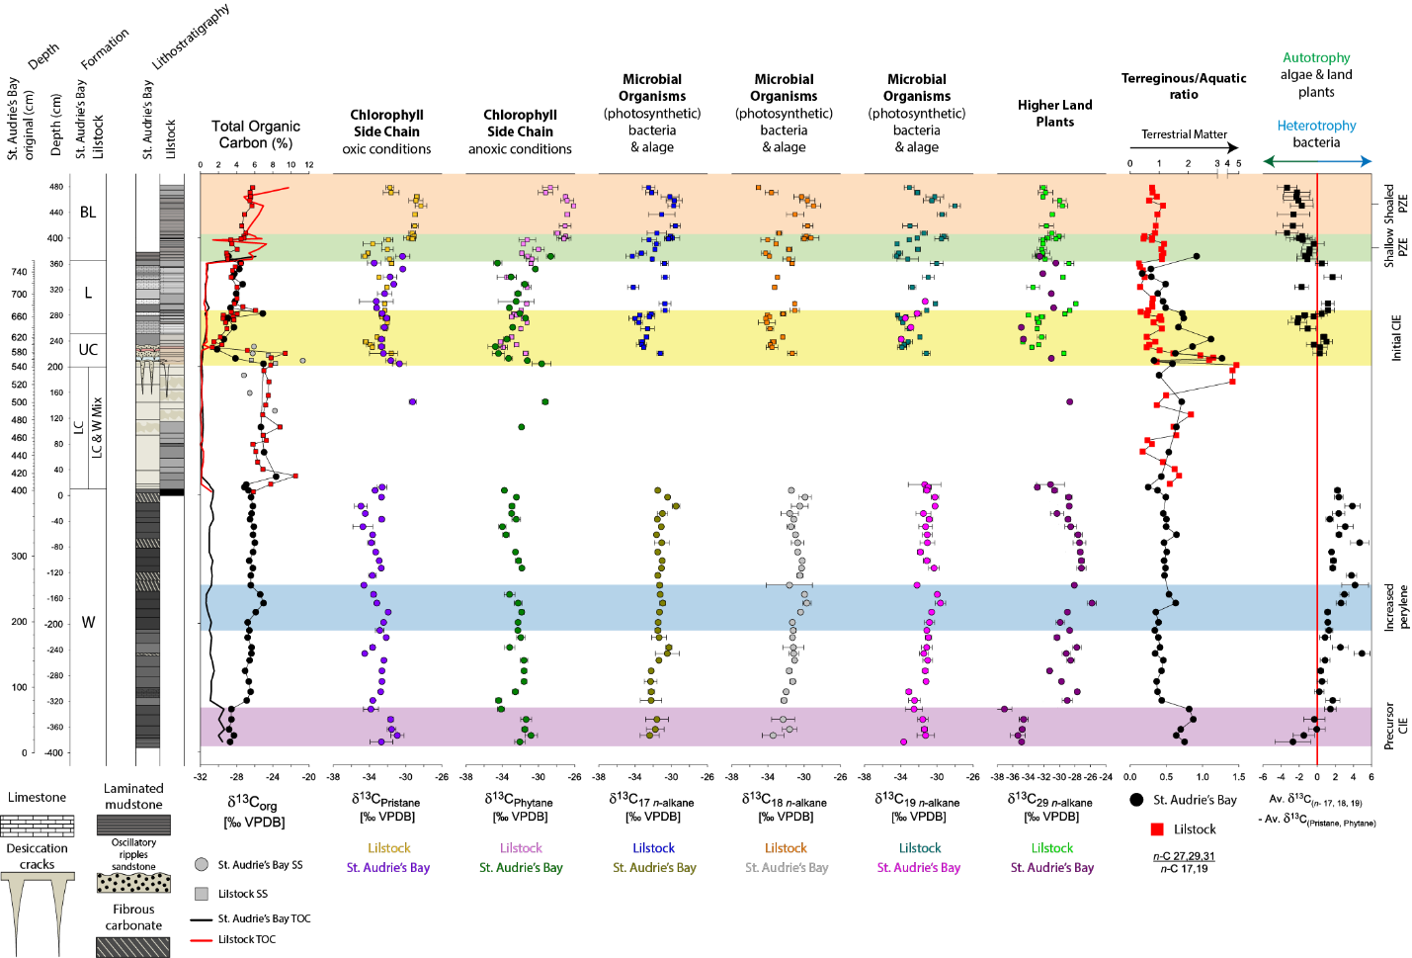

Figure S3: Full profile of compound-specific isotopes, ratios of terrestrial input (terrigenous/aquatic ratio), and autotrophy versus heterotrophy at St Audrie’s Bay (circles) and Lilstock (squares). Intervals of interest marked by colour bars with text to the right. Some details previously reported in Fox et al., (2022, 2020).

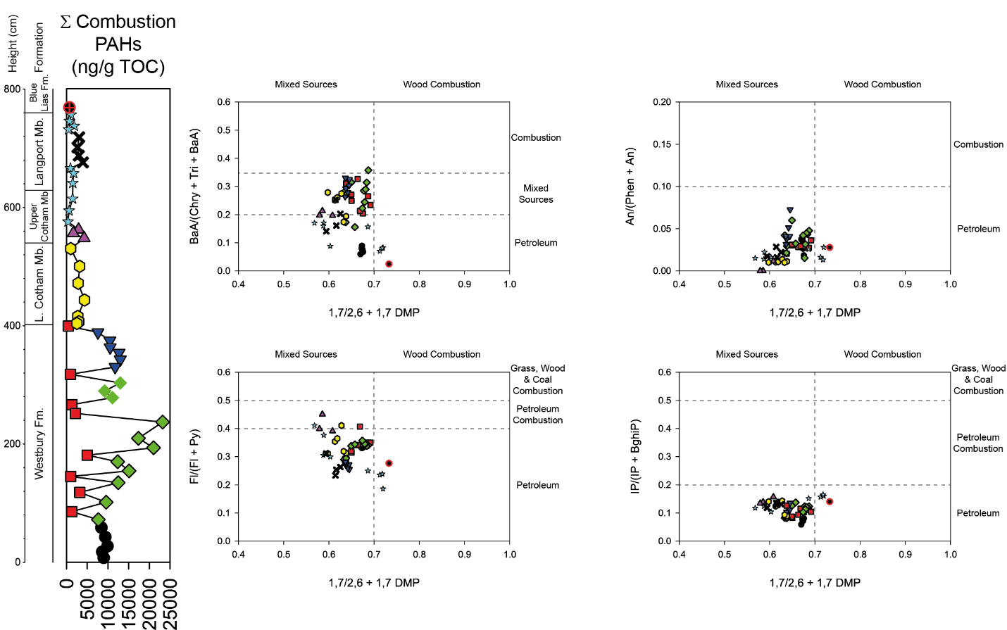
Fig S4: St. Audrie’s Bay PAH ratios plotted against modern parameters to disentangle organic matter source. Based on Yunker et al., (2002). Samples suggest “mixed” sources.

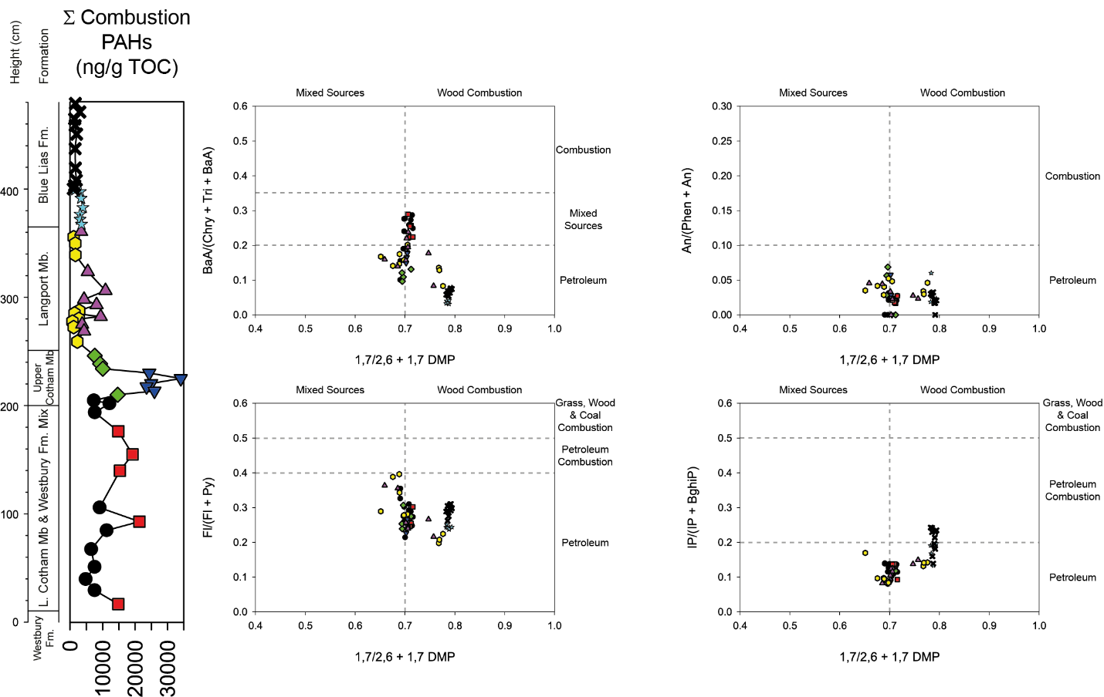
Fig S5: Lilstock PAH ratios plotted against modern parameters to disentangle organic matter source. Based off Yunker et al., (2002). Samples suggest “mixed” sources.
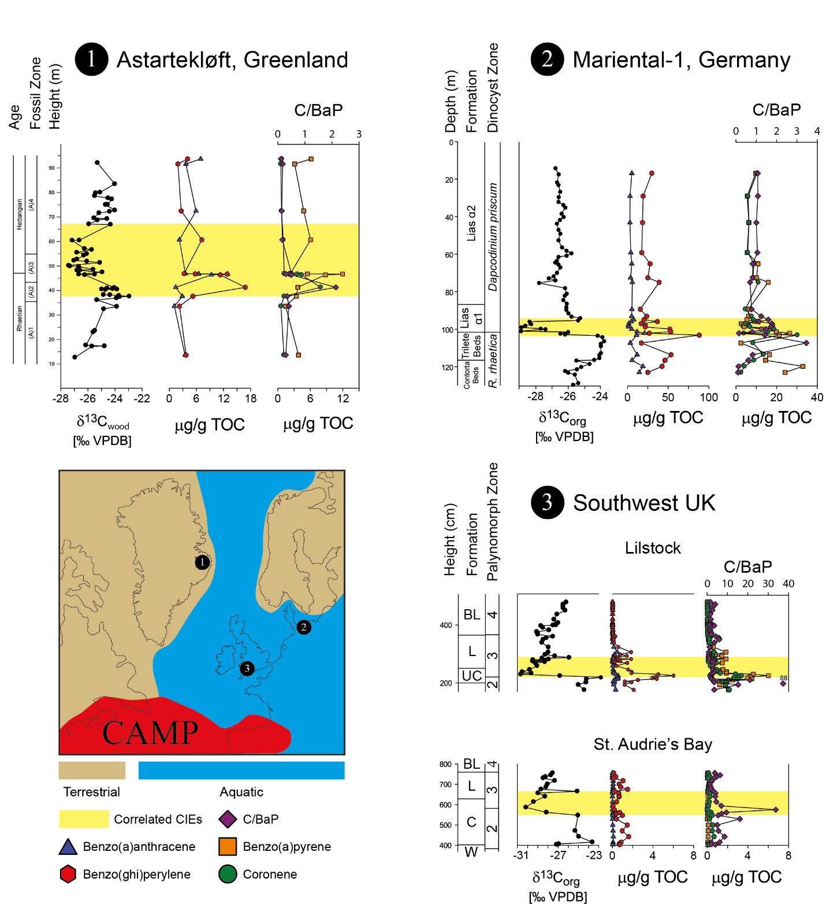
Figure S6: Comparisons of PAHs between E Greenland, NW Germany, and the SW UK. Note that these samples also show abundances of benzo(ghi)perylene and benzo(a)anthracene. For full details regarding biostratigraphy and ecological changes see Fig. 2 in the main text. PAHs from Williford et al., (2014), van de Schootbrugge et al., (2009), and this study. Reconstruction in the bottom left after Hesselbo et al., (2002) and van de Schootbrugge et al., (2013).
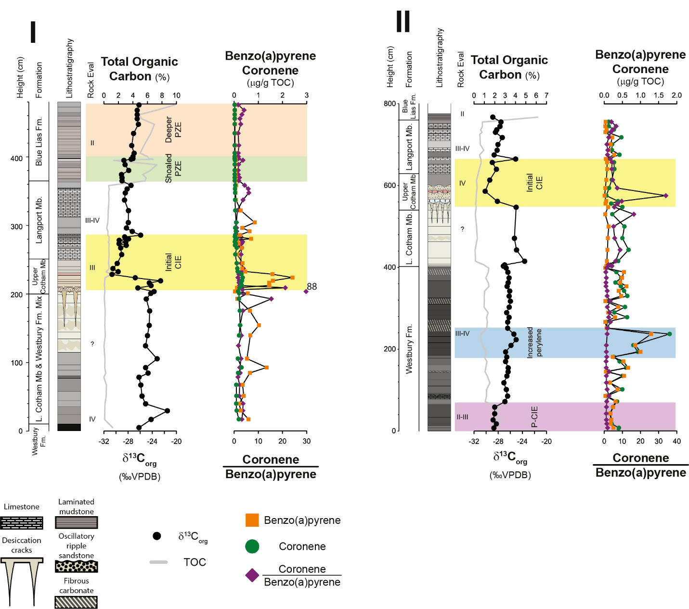
Figure S7: Full plots of benzo(a)pyrene, coronene, and ratios of coronene/benzo(a)pyrene at Lilstock (I; left) and St. Audrie’s Bay (II; right).

Table S1. PAH compounds used in this study and their m/z transition for quantification.

Compound | m/z
Dibenzothiophene | 184
Dibenzofuran | 168
Methyldibenzofurans | 182
Phenanthrene, anthracene, | 178
Methylphenanthrenes | 192
Ethylphenanthrenes | 206
Retene | 234, 219
Fluoranthene, pyrene | 202
Methylfluoranthene  Methylpyrene | 216
Benzo[a]anthracene, chrysene, triphenylene | 228
Benzo[b/j/k]fluoranthene, benzo[e]pyrene, benzo[a]pyrene | 252
Perylene | 252
Indeno[1,2,3-cd]pyrene, benzo[ghi]perylene | 276
Coronene | 300

