Volatility and Return Connectedness of Cryptocurrency, Gold, and Uncertainty: Evidence from the Cryptocurrency Uncertainty Indices

Ahmed H. Elsayed
Department of Economics & Finance, Durham University, Durham DH1 3LB, the UK
Department of Economics, Faculty of Commerce, Zagazig University, Egypt
Email: ahmed.elsayed@durham.ac.uk

Giray Gozgor
Istanbul Medeniyet University, Turkey
Email: giray.gozgor@medeniyet.edu.tr

Larisa Yarovaya
University of Southampton, the UK
Email: l.yarovaya@soton.ac.uk

January 29, 2022
Abstract
This paper examines the dynamic connectedness of return- and volatility spillovers among cryptocurrency index (CRIX), Gold, and uncertainty measures. Apart from traditional uncertainty measures, we also consider two novel uncertainty measures: Cryptocurrency Policy Uncertainty and Cryptocurrency Price Uncertainty indices. We observe that cryptocurrency policy uncertainty is the main transmitter of the return spillovers to other variables. In addition, Gold is a net receiver of both the return and the volatility spillovers. These results are valid under bearish, bullish, and normal market conditions. Our findings contribute to the literature considering the spillover effect between cryptocurrencies and other assets and their determinants.

JEL Classification: C22; D81; G15

Keywords: dynamic connectedness; cryptocurrency, policy uncertainty; price uncertainty; gold
1. Introduction
The role of cryptocurrencies in the global financial system has increased year by year. The recent data in December 2021 show that the market cap of cryptocurrencies has exceeded $2.25T. Bitcoin still has a leading role in the cryptocurrency market, with a market cap of around $0.92T in December 2021. However, the dominance of Bitcoin has been steadily decreasing with the rise of Altcoins (Chowdhury et al., 2021; Dastgir et al., 2019; Elsayed et al., 2021; Fang et al., 2020a, and 2020b; Ji et al., 2019; Liu et al., 2020; Shi et al., 2020; Yi et al., 2018), and specifically Ethereum-based tokens, such as non-fungible tokens (NFTs) and decentralised finance (DeFi) assets (Katsiampa et al., 2021; Yousaf and Yarovaya, 2021). Also, periods of significant volatility in the cryptocurrency markets during the key events in the cryptocurrency area, e.g., DeFi boom and attack on cryptocurrency exchanges, increased attention and uncertainty on cryptocurrency markets (Lucey et al., 2021). Besides, the global shocks, such as the COVID-19 pandemic, significantly changed the co-movements between cryptocurrencies and more traditional investment assets reflected in the prices of the digital assets. For instance, the World Health Organization (WHO) characterised the COVID-19 as a global pandemic on March 11, 2020, and the Bitcoin price was $7,911. Following the initial pandemic shock, it decreased to $4,970 on March 12, 2020. However, it has experienced a huge upward trend during the global COVID-19 pandemic in one year. Specifically, Bitcoin's price exceeded the $60K threshold on March 13, 2021. Therefore, researchers and traders try to understand the dynamics of cryptocurrencies' returns and the price volatility of cryptocurrencies and financial markets during the COVID-19 period (see, e.g., Albulescu, 2021; Goodell and Goutte, 2021; Jiang et al., 2021; Wu et al., 2021; Yarovaya et al., 2021), and the role of uncertainty in shaping these dynamics.
Given this backdrop, this paper aims to understand the impact of uncertainty on the dynamics of cryptocurrency returns and the price volatility of cryptocurrency markets. We examine the dynamic connectedness of return spillovers and volatility spillovers between uncertainty measures and the cryptocurrency benchmark index (CRIX) and the new cryptocurrency price uncertainty (UCRY_Price) and cryptocurrency policy uncertainty (UCRY_Policy) indices. The use of cryptocurrency-specific news-based uncertainty measures will help shed light on how uncertainty originates in cryptocurrency markets and change the dynamics of digital assets. Existing literature predominantly utilise the traditional measures of uncertainty, such as the Volatility (VIX) (see, e.g., Bouri et al., 2018) and the Economic Policy Uncertainty (EPU) indices (see, e.g., Demir et al., 2018), which might insufficiently capture the increased uncertainty around specific events in the cryptocurrency domain. Therefore, in this paper, we combine traditional and cryptocurrency-specific uncertainty indices to show how these measures correlate with each other. We also include the Gold returns to address portfolio diversification purposes (see, e.g., Corbet al., 2018 and 2019; Gozgor et al., 2019a). According to Hassan et al. (2021), only gold demonstrated a significant safe-haven property against cryptocurrency uncertainty among precious metals. Our sample period spans the data from November 24, 2014, to February 15, 2021, covering the COVID-19 breakout.
Previous literature reports the significant effects of uncertainty measures on cryptocurrency returns and price volatility. However, the majority of papers utilised the traditional measures of uncertainty only. For instance, Bouri et al. (2017) indicate that Bitcoin returns can be used for hedging against uncertainty measured by the VIX. Demir et al. (2018) show that the EPU index in the United States has predictive power on Bitcoin returns, which negatively relates to the Bitcoin returns. The impact becomes positive at the lower and the higher quantiles. In conclusion, Bitcoin can be used to hedge uncertainty. Aysan et al. (2019) show that geopolitical risks are negatively related to Bitcoin returns. Still, the effects of geopolitical risks on returns and the price volatility of Bitcoin are positive at extreme quantiles.
Gozgor et al. (2019b) obtained similar evidence on the significant hedging capacities of Bitcoin against the uncertainty shocks using another uncertainty measure: The United States trade policy uncertainty index. Fang et al. (2019) observe that the global EPU index promotes the hedging capacity of portfolios against Bitcoin price volatility. Wu et al. (2019) also find that Bitcoin reacts more responsive to the EPU shocks than Gold. Therefore, Bitcoin has a higher hedging capacity than Gold against the EPU shocks. However, Wang et al. (2019) show that the risk spillover impact from the EPU to Bitcoin price volatility is negligible.
On the other hand, Cheng and Yen (2020) demonstrate that the EPU index in China has predictive power on the monthly returns of Bitcoin. Similarly, Yen and Cheng (2021) state that the EPU index in China has predictive power on the monthly price volatility of Bitcoin, and the relationship is negative. Finally, Colon et al. (2021) observe that cryptocurrencies have a significant hedging capacity against geopolitical risk. However, they have weak hedging features against the EPU, especially during the bull market periods.
Unlike these papers, this paper uses two novel uncertainty measures: UCRY_Policy and UCRY_Price. These measures have been introduced by Lucey et al. (2021), following the spirit of Baker et al. (2016). Lucey et al. (2021) have implemented text-mining queries on the LexisNexis business platform. The authors have considered specific words related to "uncertainty" with their combinations of "cryptocurrencies," including "Bitcoin," "Ethereum," "Litecoin," "Ripple," and "Tether" with the words "central bank" or "government, or "regulators." Our research is among the first studies that analysed the impact of UCRY indices on cryptocurrency markets. Our results are robust under different econometric techniques.
The remaining parts of the paper are organised as follows. Section 2 explains the methodology, data sources and provides descriptive statistics. Section 3 discusses the empirical results, and Section 4 concludes.

2. Methodology
2.1 Methods
To investigate the impact of different uncertainty measures on the return and volatility of the cryptocurrency market, we utilise the Time-Varying Parameter Vector Autoregressive (TVP-VAR) approach of Antonakakis et al. (2020). The choice of the econometric method is motivated by the study's objectives and the research question under consideration. Forbes and Rigobon (2002) show that financial markets are highly correlated during turbulent periods, without changes in their real connectedness. As a result, estimates of conditional correlation models could be biased as they are sensitive to the market state. Contrary to the DCC-GARCH models, the spillover technique is based on the Forecast Error Variance Decomposition (FEVD) function from a generalised Vector Autoregressive Model (VAR) and hence, is independent of conditional correlation estimates (Elsayed and Helmi, 2021; Maghyereh et al., 2015). Finally, the TVP-VAR model significantly improves the spillover method developed by Diebold and Yilmaz (2012) in several ways, such as the sensitivity of the model to outliers, no need to set the size of the rolling window arbitrarily, and no loss of observations (Antonakakis et al., 2019; Korobilis and Yilmaz, 2018). The TVP-VAR model of order one can be written as:
$$Y_{t}=β_{t}Y_{t-1}+ϵ_{t} ϵ_{t}|Ω_{t}\sim N\left(0, S_{t}\right) (1)$$
$$vec\left(β_{t}\right)=vec\left(β_{t-1}\right)+υ_{t} υ_{t}|Ω_{t}\sim N\left(0, R_{t}\right) (2)$$
where $Y_{t}$ and $ϵ_{t}$ are $N×1$ vectors of endogenous variables and error disturbance terms with an $N×N$ time-varying variance-covariance matrix, $S_{t}$. Furthermore, $vec\left(β_{t}\right)$ and $υ_{t}$ denote $N^{2}p×1$ dimensional vectors with an $N^{2}p×N^{2}p$ variance-covariance matrix, $R_{t}$. Using the moving average representation based on the Wold theorem, the h-step-ahead Generalised Forecast Error Variance Decomposition (GFEVD) could be written as follows:
$${\check{θ}}_{ij}\left(H\right)=\frac{\sum_{t=1}^{H-1}{ξ_{ij}^{2}}}{\sum_{j=1}^{N}{\sum_{t=1}^{H-1}{ξ_{ij}^{2}}}} (3)$$
where ${\check{θ}}_{ij}$ represents the pairwise directional connectedness from variable $j$ to variable $i$ is its forecast error variance share. Accordingly, the Total Connectedness Index (TCI) is calculated as follows:
$$TCI=\frac{\sum_{i,j=1, i≠j}^{N}{{\check{θ}}_{ij}\left(H\right)}}{\sum_{i,j=1}^{N}{{\check{θ}}_{ij}\left(H\right)}}*100 (4)$$
$$C_{j→i}=\frac{\sum_{j=1, j≠i}^{N}{{\check{θ}}_{ij}\left(H\right)}}{\sum_{i,j=1}^{N}{{\check{θ}}_{ij}\left(H\right)}}*100 (5)$$
$$C_{i→j}=\frac{\sum_{j=1, j≠i}^{N}{{\check{θ}}_{ji}\left(H\right)}}{\sum_{i,j=1}^{N}{{\check{θ}}_{ji}\left(H\right)}}*100 (6)$$
In addition to the TCI, the aggregated directional spillovers to/from other variables have been calculated. In particular, Eq. (5) indicates the impact of a shock in variable $j$ on all other variables $i$, whereas Eq. (6) estimates the aggregated influence that all other variables $i$ have on variable $j$. Accordingly, the net total directional spillovers are calculated by subtracting Eq. (6) from Eq. (5).
$$C_{j}=C_{j→∙}-C_{j←∙} (7)$$
The net total directional spillovers indices calculation is very valuable. The sign determines whether a variable is a net transmitter (positive) or a net receiver (negative) of shocks from all other variables. Finally, the Net Pairwise Directional Spillover (NPDS) could be calculated as the difference between spillover transmitted from market $i$ to market $j$ and those transmitted from $j$ to $i$:
${NPDS}_{ij}=\frac{{\check{θ}}_{ji}\left(H\right)-{\check{θ}}_{ij}\left(H\right)}{N}*100 (8)$
2.2 Data and Descriptive Statistics
We utilise weekly data of the new UCRY_Policy and UCRY_Price indices introduced by Lucey et al. (2021) and available from the authors' website. These indices capture price and policy uncertainty beyond Bitcoin price volatility, and they have been constructed using 726.9 million news articles from the Lexis Nexis Business database, as specified in Eqs. 9 and 10 below:
$UCRY_{Policyt}=\left(\frac{N_{1t}-μ_{1}}{σ_{1}}\right)+100$ (9)
$Y_{Pricet}=\left(\frac{N_{2t}-μ_{2}}{σ_{2}}\right)+100$ (10)
Where $UCRY_{Policyt}$ and $UCRY_{Pricet}$ are the values of the Cryptocurrency Policy and Price Uncertainty indices in the weeks t, $N_{1t}$ and $N_{2t}$ are weekly observed value of news articles on LexisNexis business concerning cryptocurrency policy uncertainty and prices, respectively. While $μ_{1}$ and $μ_{2}$ are mean values of the news articles collected for each index, and $σ_{1}$ and $σ_{2}$ are the standard deviations of such.
The CRIX data were collected from the CRIX-Network website (Trimborn and Härdle, 2018). The CRIX tracks the performance and volatility in the whole cryptocurrency market. These indices are designed to deal with disproportionate capitalisation issues in crypto markets and the dominance of Bitcoin (Hassan et al., 2021). The EPU data are obtained from Baker et al. (2016), available at https://www.policyuncertainty.com/). Finally, Gold and the VIX have been sourced from the Thomson Reuters DataStream platform. The sample period spans from November 24, 2014, to February 15, 2021, and is determined by the data availability.
Figure 1 shows the level series, where the COVID-19 era, which starts on March 11, 2020, is tagged in red. All variables (the CRIX, UCRY_Policy, UCRY_Price, EPU, Gold, and VIX) have been calculated as the first logarithmic difference between two consecutive observations to ensure stationarity.
[Insert Figure 1 here]
Table 1 also summarises descriptive statistics for CRIX, UCRY_Policy, UCRY_Price, EPU, Gold, and VIX. It also reports the results of the Jarque–Bera (JB) test for normality and the Augmented Dickey-Fuller (ADF) and Phillips-Perron (PP) unit root tests. In addition, Q(20) and Q2(20) are the Ljung–Box statistics for serial correlation in raw series and squared residuals. The ARCH (20) testing Engle's ARCH effects up to 20 lags. Finally, the bottom side of Table 1 shows the correlation among the variables.
[Insert Table 1 here]

3. Empirical Results
We start with the return- and volatility spillovers over the full sample for the return spillover across indices and total contribution to/from other indices. Figure 2 Panel A provides the returns spillovers, and Figure 2 Panel B indicates the volatility spillovers. Figure 3 also shows the total return and volatility spillovers indices from December 1, 2014, to February 15, 2021. These results show the time-varying behaviour of the total return and volatility connectedness across the variables. These results are based on the GFEVD obtained from a TVP-VAR model of order one and 10-step ahead forecasts over the full sample.
[Insert Figures 2 and 3 here]
Figure 4 shows the dynamic net directional return (volatility) spillover indices, and Figure 5 duplicates the dynamic connectedness of pairwise return (volatility) spillovers. In Figures 4 and 5, the positive (negative) values indicate that the variable under consideration is a net transmitter (receiver) of shocks to (from) all other variables.
[Insert Figures 4 and 5 here]
Finally, Figures 6 and 7 show the total return and volatility spillovers connectedness in the Quantile VAR (τ = 0.05 and τ = 0.95). These results indicate that the dynamic return and volatility spillovers indices are time-varying and responsive to financial and economic stress periods. In particular, total return spillovers jumps to high levels with the start of the COVID-19 pandemic. However, total volatility spillovers reacted to the COVID-19 during the second wave of the virus.
[Insert Figures 6 and 7 here]
Furthermore, Table 2 reports the static analyses for the return- and the volatility connectedness. It is observed that the UCRY_Policy and the VIX are the system's main net transmitters of the return- and the volatility spillovers. In contrast, the EPU and Gold are the main net receivers. The CRIX is a net transmitter of return spillovers but a net receiver of volatility spillovers over the full sample period. On the other hand, the UCRY_Price is a net receiver of return spillovers but a net transmitter of volatility spillover.
[Insert Table 2 here]
Table 3 shows the details of the return connectedness at different quantiles. Similar patterns on returns spillovers are observed at the lower and the upper quantiles (i.e., the bearish and the bullish market conditions), where the UCRY_Policy, the UCRY_Price, and the EPU are net transmitters. Notably, the UCRY_Policy is the main transmitter of return spillovers to other variables. Gold is a net receiver under bearish, bullish, and normal market conditions. In contrast, the CRIX and Gold are net receivers of the return spillover. The VIX is a net receiver during the bearish market but a net transmitter of risk during the bullish market.
[Insert Table 3 here]
Table 4 shows the details of the volatility connectedness at quantiles. The CRIX, the UCRY_Policy, and the UCRY_Price are net transmitters during the bearish market, whereas the EPU, Gold, and the VIX are net receivers of volatility spillovers. On the contrary, a reverse pattern is observed under bullish market conditions except for Gold, a net receiver of risk spillovers under different market conditions. Thus, we conclude that Gold is a net receiver of volatility spillover under bearish, bullish, and normal market conditions.
[Insert Table 4 here]

4. Conclusion
This paper examines the dynamic connectedness of return spillovers and volatility spillovers between uncertainty measures (the VIX, the EPU, the UCRY_Policy, and the UCRY_Price), Gold, and the CRIX index. The paper uses the weekly data from November 24, 2014, to February 15, 2021. The empirical findings show that the UCRY_Policy is the main transmitter of return spillovers to other variables. This evidence shows the significant role of cryptocurrency policy uncertainty in cryptocurrency markets, affecting the other uncertainty measures. This is a novel finding as our paper is the first to highlight the influential power of the cryptocurrency policy uncertainty index. In addition, we find that Gold is a net receiver of both the return and the volatility spillover under bearish, bullish, and normal market conditions. Therefore, Gold is highly sensitive to uncertainty shocks, and it is significantly affected by cryptocurrency markets. Thus, while existing evidence suggests that Gold can be used for hedging purposes against uncertainty shocks (e.g., Hassan et al., 2021; Gozgor, 2019a; and Wu et al., 2019), our analysis uncovered that gold is susceptible to return and volatility spillovers from cryptocurrency uncertainty measures. Therefore, investors and traders should seek alternative assets rather than gold to hedge the uncertainty shocks from cryptocurrencies.
It is important to note that our evidence is limited to Gold in commodity markets. Future studies can include agricultural and energy commodities to analyse their returns and volatility relationships with cryptocurrency markets under uncertainty shocks. Stock markets are also the leading candidates to investigate returns and volatility spillovers. We should enhance our knowledge of the effects of cryptocurrency policy and price uncertainty measures on financial markets.

References
Albulescu, C.T. (2021). COVID-19 and the United States financial markets' volatility. Finance Research Letters, 38, 101699.
Alexander, C., & Dakos, M. (2020). A critical investigation of cryptocurrency data and analysis. Quantitative Finance, 20(2), 173-188.
Antonakakis N., Chatziantoniou I., & Gabauer D. (2020). Refined measures of dynamic connectedness based on time-varying parameter vector autoregressions. Journal of Risk Financial Management, 13(4), 84.
Antonakakis, N., Gabauer, D., & Gupta, R. (2019). International monetary policy spillovers: Evidence from a time-varying parameter vector autoregression. International Review of Financial Analysis, 65, 101382.
Aysan, A.F., Demir, E., Gozgor, G., & Lau, C.K.M. (2019). Effects of the geopolitical risks on Bitcoin returns and volatility. Research in International Business and Finance, 47, 511-518.
Baker, S.R., Bloom, N., & Davis, S.J. (2016). Measuring economic policy uncertainty. The Quarterly Journal of Economics, 131(4), 1593-1636.
Bouri, E., Gupta, R., Tiwari, A.K., & Roubaud, D. (2017). Does Bitcoin hedge global uncertainty? Evidence from wavelet-based quantile-in-quantile regressions. Finance Research Letters, 23, 87-95.
Chowdhury, M., Damianov, D.S. & Elsayed, A.H. (2021). Bubbles and crashes in cryptocurrencies: Interdependence, contagion, or asset rotation?. Finance Research Letters, 102494.
Cheng, H.P., & Yen, K.C. (2020). The relationship between the economic policy uncertainty and the cryptocurrency market. Finance Research Letters, 35, 101308.
Colon, F., Kim, C., Kim, H., & Kim, W. (2021). The effect of political and economic uncertainty on the cryptocurrency market. Finance Research Letters, 39, 101621.
Corbet, S., Lucey, B., Urquhart, A., & Yarovaya, L. (2019). Cryptocurrencies as a financial asset: A systematic analysis. International Review of Financial Analysis, 62, 182-199.
Corbet, S., Meegan, A., Larkin, C., Lucey, B., & Yarovaya, L. (2018). Exploring the dynamic relationships between cryptocurrencies and other financial assets. Economics Letters, 165, 28-34.
Dastgir, S., Demir, E., Downing, G., Gozgor, G., & Lau, C. K. M. (2019). The causal relationship between Bitcoin attention and Bitcoin returns: Evidence from the Copula-based Granger causality test. Finance Research Letters, 28, 160-164.
Demir, E., Gozgor, G., Lau, C.K.M., & Vigne, S.A. (2018). Does economic policy uncertainty predict the Bitcoin returns? An empirical investigation. Finance Research Letters, 26, 145-149.
Diebold F.X., & Yılmaz K. (2012). Better to give than to receive: predictive directional measurement of volatility spillovers. International Journal of Forecasting, 28(1), 57-66.
Elsayed, A.H., Gozgor, G., & Lau, C.K.M. (2021). Causality and dynamic spillovers among cryptocurrencies and currency markets. International Journal of Finance & Economics, forthcoming, doi: 10.1002/ijfe.2257
Elsayed, A.H. & Helmi, M.H. (2021). Volatility transmission and spillover dynamics across financial markets: The role of geopolitical risk. Annals of Operations Research, 305, 1-22.
Fang, L., Bouri, E., Gupta, R., & Roubaud, D. (2019). Does global economic uncertainty matter for the volatility and hedging effectiveness of Bitcoin? International Review of Financial Analysis, 61, 29-36.
Fang, J., Gozgor, G., Lau, C. K. M., & Lu, Z. (2020). The impact of Baidu Index sentiment on the volatility of China's stock markets. Finance Research Letters, 32, 101099.
Fang, T., Su, Z., & Yin, L. (2020). Economic fundamentals or investor perceptions? The role of uncertainty in predicting long-term cryptocurrency volatility. International Review of Financial Analysis, 71, 101566.
Goodell, J.W., & Goutte, S. (2021). Co-movement of COVID-19 and Bitcoin: Evidence from wavelet coherence analysis. Finance Research Letters, 38, 101625.
Gozgor, G., Lau, C.K.M., Sheng, X., & Yarovaya, L. (2019a). The role of uncertainty measures on the returns of gold. Economics Letters, 185, 108680.
Gozgor, G., Tiwari, A.K., Demir, E., & Akron, S. (2019b). The relationship between Bitcoin returns and trade policy uncertainty. Finance Research Letters, 29, 75-82.
Hassan, M.K., Hasan, M.B., & Rashid, M.M. (2021). Using precious metals to hedge cryptocurrency policy and price uncertainty. Economics Letters, 206, 109977.
Ji, Q., Bouri, E., Lau, C.K.M., & Roubaud, D. (2019). Dynamic connectedness and integration in cryptocurrency markets. International Review of Financial Analysis, 63, 257-272.
Jiang, Y., Wu, L., Tian, G., & Nie, H. (2021). Do cryptocurrencies hedge against EPU and the equity market volatility during COVID-19? – New evidence from quantile coherency analysis. Journal of International Financial Markets, Institutions and Money, 72, 101324.
Katsiampa, P., Yarovaya, L., & Zięba, D. (2021). High-Frequency connectedness between Bitcoin and other top-traded crypto assets during the COVID-19 crisis. Available at SSRN, No. 3871405.
Korobilis, D., & Yilmaz, K. (2018). Measuring dynamic connectedness with large Bayesian VAR models. Available at SSRN, No.3099725.
Liu, W., Semeyutin, A., Lau, C.K.M., & Gozgor, G. (2020). Forecasting value-at-risk of cryptocurrencies with RiskMetrics type models. Research in International Business and Finance, 54, 101259.
Lucey, B., Vigne, S., Yarovaya, L., & Wang, Y. (2021). The cryptocurrency uncertainty index. Finance Research Letters, forthcoming, 102147, doi: 10.1016/j.frl.2021.102147
Shi, Y., Tiwari, A.K., Gozgor, G., & Lu, Z. (2020). Correlations among cryptocurrencies: Evidence from multivariate factor stochastic volatility model. Research in International Business and Finance, 53, 101231.
Trimborn, S., & Härdle, W.K. (2018). CRIX an Index for cryptocurrencies. Journal of Empirical Finance, 49, 107-122.
Wang, G.J., Xie, C., Wen, D., & Zhao, L. (2019). When Bitcoin meets economic policy uncertainty (EPU): Measuring risk spillover effect from EPU to Bitcoin. Finance Research Letters, 31, 489-497.
Wu, S., Tong, M., Yang, Z., & Derbali, A. (2019). Does gold or Bitcoin hedge economic policy uncertainty? Finance Research Letters, 31, 171-178.
Wu, W., Tiwari, A. K., Gozgor, G., & Leping, H. (2021). Does economic policy uncertainty affect cryptocurrency markets? Evidence from Twitter-Based uncertainty measures. Research in International Business and Finance, 58, 101478.
Yarovaya, L., Mirza, N., Abaidi, J., & Hasnaoui, A. (2021). Human capital efficiency and equity funds' performance during the COVID-19 pandemic. International Review of Economics and Finance, 71, 584-591.
Yen, K.C., & Cheng, H.P. (2021). Economic policy uncertainty and cryptocurrency volatility. Finance Research Letters, 38, 101428.
Yi, S., Xu, Z., & Wang, G.J. (2018). Volatility connectedness in the cryptocurrency market: Is Bitcoin a dominant cryptocurrency? International Review of Financial Analysis, 60, 98-114.
Yousaf, I., & Yarovaya, L. (2021). Static and dynamic connectedness between NFTs, Defi and other assets: portfolio implication. Available at SSRN, No. 3946611.

Figure 1
Level Series

Notes: Figure provides the daily data of the cryptocurrency benchmark index (CRIX), UCRY_Policy (UC_PO), UCRY_Price (UC_PR), US economic policy uncertainty (EPU), Gold, and the VIX from November 24, 2014, to February 15, 2021. The red area highlights the COVID-19 pandemic, which starts on March 11, 2020 (the date the World Health Organization (WHO) declared the outbreak of the COVID-19 pandemic).

Figure 2
Return and Volatility Spillovers over the Full Sample

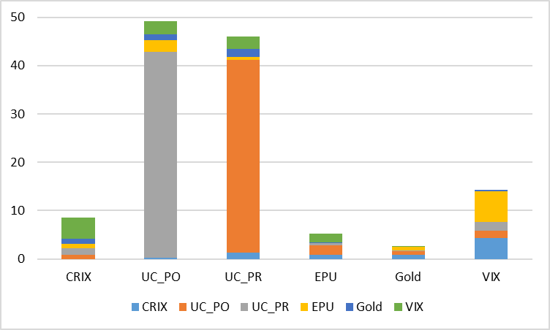 | 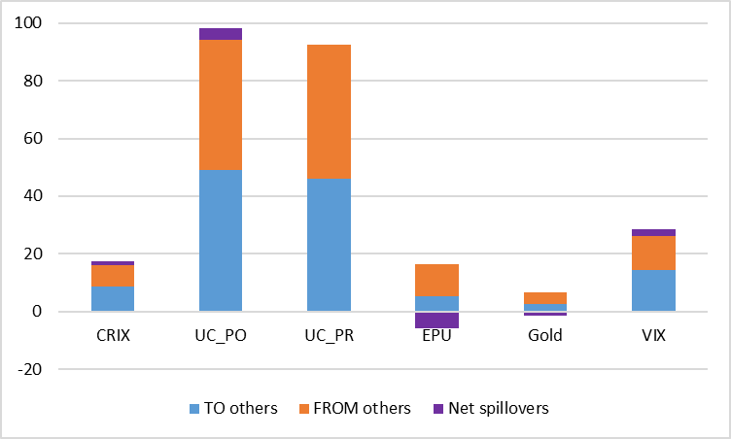
Return spillover across indices | Total contribution to/from other indices
Panel A: Return Spillovers
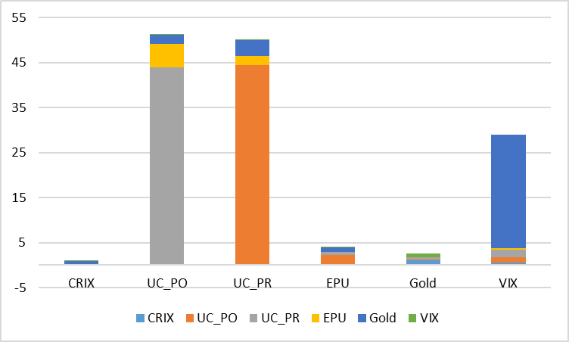 | 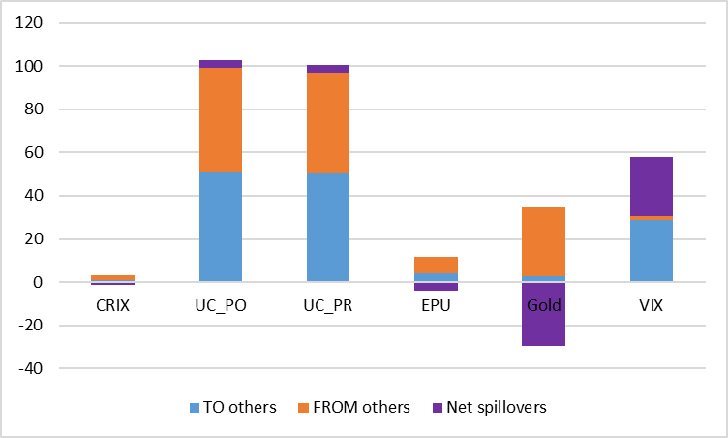
Volatility spillover across indices | Total contribution to/from other indices
Panel B: Volatility Spillovers

Figure 3
Total Return and Volatility Spillovers Indices
Notes: This graph portrays the time-varying behaviour of the total return and volatility connectedness across CRIX, UCRY_Policy, UCRY_Price, EPU, Gold, and VIX.

Figure 4
Dynamic Net Directional Return (Volatility) Spillover Indices

Panel A: Dynamic net directional return spillover indices

Panel B: Dynamic net directional volatility spillover indices

Notes: This graph portrays the time-varying behaviour of the net spillover of each variable. Positive (negative) values indicate that the variable under consideration is a net transmitter (receiver) of shocks to (from) all other variables.

Figure 5
Dynamic Connectedness of Pairwise Return (Volatility) Spillovers

Panel A: Dynamic pairwise return spillover indices

Panel B: Dynamic pairwise volatility spillover indices

Notes: This graph represents the time-varying behaviour of the pairwise return (volatility) spillover between the CRIX and each of the other variables under consideration. Positive (negative) values indicate that the CRIX is transmitting (receiving) shocks to (from) the other variable.

Figure 6
Total Return Spillovers Connectedness in the Quantile VAR
(Extreme Upper Quantile τ = 0.95 and Extreme Lower Quantile τ = 0.05)

Figure 7
Total Volatility Spillovers Connectedness in the Quantile VAR (Extreme Upper Quantile τ = 0.95 and Extreme Lower Quantile τ = 0.05)

Table 1
Descriptive Statistics and Correlation Matrix
 | CRIX | UCRY_Policy | UCRY_Price | EPU | Gold | VIX
Mean | 1.657 | 0.018 | 0.019 | 0.271 | 0.126 | 0.171
Std. Dev. | 8.826 | 0.608 | 0.573 | 28.573 | 1.633 | 14.012
Max. | 26.390 | 2.958 | 4.811 | 114.542 | 6.331 | 76.996
Min. | -27.299 | -1.611 | -1.835 | -84.680 | -9.608 | -37.363
Skewness | -0.142 | 0.804 | 2.656 | 0.407 | -0.369 | 1.384
Kurtosis | 1.100 | 2.895 | 20.132 | 1.493 | 4.403 | 5.295
JB | 17.486*** | 148.446*** | 5870.204*** | 39.196*** | 269.928*** | 483.447***
ADF | -11.792*** | -19.632*** | -9.597*** | -17.779*** | -15.853*** | -14.694***
PP | -11.791*** | -30.622*** | -31.290*** | -29.857*** | -15.821*** | -17.735***
Q(20) | 67.730*** | 67.150*** | 79.652*** | 37.984*** | 10.419* | 16.010*
Q²(20) | 25.378*** | 11.606 | 23.467*** | 7.969 | 36.128** | 1.204
ARCH(20) | 73.144*** | 26.569*** | 54.996*** | 57.769*** | 10.5 | 6.158
Correlation Matrix
CRIX | 1
UCRY_Policy | 0.08 | 1
UCRY_Price | 0.138 | 0.869 | 1
EPU | -0.114 | 0.124 | 0.046 | 1
Gold | 0.08 | -0.012 | 0.07 | 0.028 | 1
VIX | -0.224 | 0.17 | 0.153 | 0.15 | 0.03 | 1
Notes: This table reports descriptive statistics for the daily data series. All variables have been calculated as the first logarithmic difference between two consecutive observations to ensure stationarity. ***, **, * indicate significance at the 1%, 5%, and 10% levels.

Table 2
Return and Volatility Connectedness (Static Analyses)
Panel A: Return Spillovers
 | CRIX | UCRY_Policy | UCRY_Price | EPU | Gold | VIX | FROM
CRIX | 92.445 | 0.204 | 1.239 | 0.918 | 0.807 | 4.387 | 7.555
UCRY_Policy | 0.881 | 55.101 | 39.881 | 1.85 | 0.801 | 1.486 | 44.899
UCRY_Price | 1.296 | 42.637 | 53.581 | 0.467 | 0.202 | 1.817 | 46.419
EPU | 1.002 | 2.465 | 0.709 | 88.83 | 0.72 | 6.274 | 11.17
Gold | 0.993 | 1.138 | 1.616 | 0.119 | 95.846 | 0.288 | 4.154
VIX | 4.466 | 2.738 | 2.613 | 1.919 | 0.115 | 88.149 | 11.851
TO others | 8.638 | 49.183 | 46.058 | 5.274 | 2.644 | 14.251
Net spillovers | 1.08 | 4.28 | -0.36 | -5.89 | -1.51 | 2.4 | TCI = 21.0%
Panel B: Volatility Spillovers
 | CRIX | UCRY_Policy | UCRY_Price | EPU | Gold | VIX | FROM
CRIX | 97.85 | 0.27 | 0.19 | 0.15 | 0.97 | 0.57 | 2.15
UCRY_Policy | 0.05 | 52.31 | 44.22 | 2.05 | 0.22 | 1.15 | 47.69
UCRY_Price | 0.03 | 43.74 | 53.28 | 0.76 | 0.46 | 1.73 | 46.72
EPU | 0.15 | 5.23 | 2.15 | 92.16 | 0.08 | 0.23 | 7.84
Gold | 0.57 | 1.97 | 3.4 | 0.99 | 67.81 | 25.26 | 32.19
VIX | 0.14 | 0.2 | 0.24 | 0.1 | 0.81 | 98.52 | 1.48
TO others | 0.94 | 51.4 | 50.2 | 4.05 | 2.54 | 28.94 | TCI = 23.0%
Net spillovers | -1.21 | 3.71 | 3.49 | -3.79 | -29.66 | 27.45
Notes: This table presents empirical results of return and volatility spillovers among CRIX, UCRY_Policy, UCRY_Price, EPU, Gold, and the VIX. The lag length is selected following the Bayesian information criterion (BIC). 'TO others' signifies directional spillovers correspond to the off-diagonal column sums, i.e., spillovers from variable i to all variables j. 'FROM' represents the off-diagonal row sums of directional spillovers, i.e., spillovers from all variables j to the variable i. Net spillovers are simply the "TO others" minus "FROM others." Finally, the total spillover index, TCI, demonstrates that the proportion of the forecast error variance comes from spillovers.

Table 3
Return Connectedness in Quantiles
Panel A: Return Spillovers (Extreme Lower Quantile τ = 0.05)
 | CRIX | UCRY_Policy | UCRY_Price | EPU | Gold | VIX | FROM
CRIX | 30.41 | 15.01 | 13.62 | 14.57 | 15.63 | 10.76 | 69.59
UCRY_Policy | 13.11 | 25.81 | 22.91 | 14.29 | 10.44 | 13.43 | 74.19
UCRY_Price | 12.30 | 24.66 | 27.26 | 12.56 | 10.75 | 12.48 | 72.74
EPU | 13.59 | 16.04 | 13.11 | 27.96 | 14.76 | 14.54 | 72.04
Gold | 15.35 | 12.61 | 12.28 | 15.22 | 31.22 | 13.32 | 68.78
VIX | 11.42 | 15.32 | 13.73 | 16.21 | 14.08 | 29.24 | 70.76
TO others | 65.75 | 83.63 | 75.65 | 72.86 | 65.67 | 64.54 | TCI = 71.4%
Net spillovers | -3.84 | 9.44 | 2.91 | 0.82 | -3.11 | -6.23
Panel B: Return Spillovers (Extreme Upper Quantile τ = 0.95)
 | CRIX | UCRY_Policy | UCRY_Price | EPU | Gold | VIX | FROM
CRIX | 24.63 | 15.13 | 14.22 | 14.77 | 15.03 | 16.21 | 75.37
UCRY_Policy | 13.16 | 24.47 | 23.08 | 15.01 | 10.68 | 13.60 | 75.53
UCRY_Price | 13.42 | 23.62 | 26.53 | 12.75 | 10.72 | 12.96 | 73.47
EPU | 13.48 | 16.34 | 13.80 | 27.35 | 12.78 | 16.24 | 72.65
Gold | 15.50 | 13.61 | 12.86 | 15.10 | 26.42 | 16.51 | 73.58
VIX | 12.15 | 14.38 | 12.64 | 16.62 | 13.96 | 30.26 | 69.74
TO others | 67.70 | 83.08 | 76.61 | 74.25 | 63.17 | 75.53 | TCI = 73.4%
Net spillovers | -7.67 | 7.56 | 3.13 | 1.6 | -10.41 | 5.78
Notes: This table presents empirical results of return spillovers among CRIX, UCRY_Policy, UCRY_Price, EPU, Gold, and the VIX. These results are based on the GFEVD obtained from a Quantile-VAR model of order one and 10-step ahead forecast. The lag length is selected following the Bayesian information criterion (BIC).

Table 4
Volatility Connectedness in Quantiles
Panel A: Volatility Spillovers (Extreme Lower Quantile τ = 0.05)
 | CRIX | UCRY_Policy | UCRY_Price | EPU | Gold | VIX | FROM
CRIX | 67.32 | 2.67 | 3.26 | 9.58 | 9.5 | 7.67 | 32.68
UCRY_Policy | 2.64 | 48.7 | 41.25 | 5.47 | 0.28 | 1.66 | 51.3
UCRY_Price | 2.91 | 41.61 | 49.09 | 3.63 | 0.45 | 2.32 | 50.91
EPU | 11.95 | 7.76 | 5.07 | 68.74 | 2.59 | 3.88 | 31.26
Gold | 10.38 | 0.45 | 0.69 | 2.95 | 77.86 | 7.67 | 22.14
VIX | 11.64 | 2.5 | 3.5 | 4.35 | 7.25 | 70.75 | 29.25
TO others | 39.53 | 54.99 | 53.77 | 25.98 | 20.07 | 23.21 | TCI = 36.3%
Net spillovers | 6.85 | 3.69 | 2.86 | -5.28 | -2.07 | -6.04
Panel B: Volatility Spillovers (Extreme Upper Quantile τ = 0.95)
 | CRIX | UCRY_Policy | UCRY_Price | EPU | Gold | VIX | FROM
CRIX | 29.81 | 11.05 | 12.62 | 18.59 | 12.10 | 15.82 | 70.19
UCRY_Policy | 10.67 | 22.54 | 22.39 | 12.28 | 12.34 | 19.79 | 77.46
UCRY_Price | 11.94 | 16.98 | 20.03 | 13.23 | 14.95 | 22.87 | 79.97
EPU | 17.45 | 13.89 | 13.46 | 31.30 | 11.02 | 12.88 | 68.70
Gold | 14.16 | 7.27 | 10.09 | 12.16 | 18.29 | 38.04 | 81.71
VIX | 12.92 | 10.22 | 13.04 | 12.54 | 17.38 | 33.90 | 66.10
TO others | 67.14 | 59.41 | 71.60 | 68.80 | 67.79 | 109.39 | TCI = 74.0%
Net spillovers | -3.04 | -18.05 | -8.37 | 0.10 | -13.92 | 43.28
Notes: This table presents the empirical results of volatility spillovers among CRIX, UCRY_Policy, UCRY_Price, EPU, Gold, and the VIX. These results are based on the GFEVD obtained from a Quantile-VAR model of order one and 10-step ahead forecast. The lag length is selected following the Bayesian information criterion (BIC).

Corresponding author: ahmed.elsayed@durham.ac.uk
See Coinmarketcap.com for the most recent statistics and Bitcoin price dynamics. However, many concerns have been raised regarding the quality of data extracted from free open sources such as Cryptocompare, Coinmarketcap, and Coingecko. This data should be taken carefully due to the use of non-traded prices on individual coins, errors in time stamps, and non-synchronous, among other issues. For a detailed discussion on this matter, please refer to the paper by Alexander and Dakos (2020).
Please see the URL for UCRY data here: https://sites.google.com/view/cryptocurrency-indices/home?authuser=0
Please see the URL for CRIX data here: https://thecrix.de/.

