Original manuscript, published in Journal of Archaeological Science.
Full reference: Andrade, P., J.Goff, R.Pearce, A.Cundy, D.Sear, and V.Castro (2022). Evidence for a mid-Holocene drowning from the Atacama Desert coast of Chile? Journal of Archaeological Science, 140, 105565. DOI: 10.1016/j.jas.2022.105565

Evidence for a Mid-Holocene Drowning from the Atacama Desert Coast of Chile

Pedro Andrade¹, James Goff^{2,3*}, Richard Pearce², Andrew Cundy², David Sear⁴, Victoria Castro⁵

¹ School of Anthropology, Universidad de Concepción, Victor Lamas 1290, Concepción, Chile. E-mail: pandradem@udec.cl
² School of Ocean and Earth Science, National Oceanography Centre (Southampton), University of Southampton, Southampton, UK. E-mail: r.pearce@noc.soton.ac.uk; A.Cundy@soton.ac.uk
³ Earth and Sustainability Science Research Centre (ESSRC), School of Biological, Earth and Environmental Sciences, UNSW Sydney, Kensington, NSW 2052, Australia. E-mail: j.goff@unsw.edu.au
⁴ School of Geography & Environmental Science, University of Southampton, Highfield, Southampton, UK. E-mail: D.Sear@soton.ac.uk
⁵ Departamento de Antropología, Facultad de Ciencias Sociales, Universidad de Chile-Universidad Alberto Hurtado, Santiago, Chile. E-mail: macastrr@uahurtado.cl
* Corresponding author:
Earth and Sustainability Science Research Centre (ESSRC), School of Biological, Earth and Environmental Sciences, UNSW Sydney, Kensington, NSW 2052, Australia. Email address: j.goff@unsw.edu.au (J. Goff).
ABSTRACT

Coastal archaeological communities were exposed to numerous risks associated with living in their liminal environment. Many of the problems faced by these populations have been recorded and interpreted through their skeletal remains, but death by drowning in saltwater is not easy to recognise and as such is invariably either ignored, inferred, or discounted as a possible cause of death. Here we develop and test an enhanced microscopic marine fingerprinting methodology to determine the death by drowning of a ~5,000 year old coastal hunter-gatherer from the hyperarid coast of northern Chile. Through the application of this forensic method, we were able to detect the presence of a range of exogenous microscopic material that allows us to postulate his death because of drowning in the nearshore environment. This methodology has the potential to greatly enrich our understanding of past human-environment interactions not only in northern Chile but also around the world’s coastlines. How pervasive was drowning in prehistory particularly along an active, tectonic margin exposed to palaeotsunamis and extreme ENSO-related palaeostorms?

Keywords:
Holocene; Chile; Residual Bone Marrow; Exogenous Microscopic Material; Saltwater Drowning

- Introduction

Drowning is a major cause of deaths globally and currently represents around 7% of global injury-related deaths per annum, an estimated 372 000 people, the majority of whom die in saltwater (Peden et al., 2018). There is a wealth of data from modern examples including drowning deaths associated with rip currents (e.g. Brewster et al., 2019; Castelle et al., 2016), tsunamis (Cain et al., 2019), cyclones/hurricanes (Keim, 2006), boats (e.g. commercial fishing, shore angling, use of a tender: Pointer et al., 2018; refugees: Patterson, 2019), diving (e.g. Figueroa et al.,, 2019), and homicide (Leth, 2019).
We posit that deaths due to saltwater drowning were similarly a major cause of morbidity among human populations in prehistory, in large part due to the extensive use of coastal locations for settlement, and the use of transport by sea as an early and major source of travel. Indeed, in some parts of the world evidence for drownings at sea can be traced back many hundreds to thousands of years through written records or mythology. For example, In Greek mythology, Palaimon (Melicertes) was drowned at sea (and then rescued by a dolphin) with a later cult worshipping him at the Sanctuary of Palaimon in Isthmia (Faraone, 2018). Medieval British literature records that around 300 people drowned (including the only legitimate son and heir of King Henry I of England) when the White Ship sank in the English Channel on 25 November 1120 AD (Van Kempen, 2016). In Chile, Santiago was founded in 1541 and one of the first historically recorded events is that of a shipwreck and deaths by drowning (Vidal Gormaz, 1901).
In the absence of any form of written record, determining whether a person drowned in salt- or fresh-water, is a matter for forensic archaeology. Most commonly, forensic archaeology involves the application of archaeological techniques to the search for and recovery of evidential material from crime scenes (Delabarde et al., 2013; Vinayak et al., 2010). In many cases, bodies are recovered weeks, months or even years after death and are in a decomposed or skeletonised form. At this point, it is difficult to determine the exact cause of death and investigators invariably resort to having the femoral bone (or one or more of the large bones – radius, ulna, humerus, tibia, fibula) forensically analysed using the ‘diatom test’ (Vinayak et al., 2010). This diatom test is a recognised forensic technique that has been almost exclusively used in modern legal cases (Carlie et al., 2014).
The diatom test works on the basis that, if present, these siliceous unicellular algae are inhaled into the lungs by the victim during drowning. Being siliceous means that diatoms can survive the physical abrasion and chemical attack associated with this process, and because they are found in a wide range of natural waters in different species assemblages, allows their subsequent identification and attribution to a particular environment (e.g. freshwater or saltwater). The lungs (pulmonary alveoli) rupture during drowning and saltwater enters the bloodstream and can be transported throughout the entire body by the capillary network and into the “closed system” of the bone marrow (Carlie et al., 2014). In the case of skeletonised remains, the only option is to study the bone marrow of the large bones. Other bones such as the pelvis and vertebrae are too porous to allow for an interpretation of drowning based on the presence of diatoms in the bone marrow, because of the possibility of exchange between the bone marrow and the surroundings (Carlie et al., 2014; Delabarde et al., 2013).
In addition to its use in modern legal cases, the diatom test could in theory be used on prehistoric skeletal material from larger bones. Carlie et al. (2014) successfully used the diatom test on residual bone marrow (a greyish-brown material in the marrow space) from the right humerus of a Late Neolithic child’s skeleton recovered from a well in Sweden. While there may be some potential for contamination in such multi-millennial skeletal remains, Carlie et al. (2014) pointed out that this was extremely unlikely to occur in the large bones between the bone marrow and the surroundings. This is because there is only a small opening at one end with a twisted channel for the capillaries to pass through the compact and trabecular bone. Equally, while contamination from the exterior bone surface into a degraded part of the outer cortical bone is the most frequent diagenetic change, such modification appears to be restricted to, at most, the outer ca. 0.5 mm of bone (Rasmussen et al., 2019).
The remains of four diatoms were found by Carlie et al. (2014) in the residual bone marrow - Epithemia adnata, Pinnularia sp. (two examples), and a fragment of Pinnularia sp. Although this represents a low diatom density in the residual bone marrow, this to be expected (Levkov et al., 2017), and as such requires considerable effort to ensure that a total count of the entire sample is carried out, but on the other hand it proved that the child drowned in freshwater.
It is worth noting that while marine diatoms are rarely present in the “closed system” of the bone marrow other than by drowning in saltwater, the main criticism of the validity of the diatom test concerns possible contamination. This criticism has been raised because of potential ante- (AM) and post-mortem (PM) penetration of diatoms into the large bones and their possible presence in bodies of those who did not drown (Bortolotti et al., 2011; Lunetta et al., 2013). In principle, AM false positive findings can occur because of gastro-enteric (GE) absorption caused by ingesting a diatom-laden food such as shellfish or through diatom-rich drinks. However, the case for GE absorption is contradictory at best and there appears to be no definite proof that it actually occurs (Yen et al., 2007; Lunetta et al., 2013). A stronger case could be made for PM penetration primarily during the sample preparation sequence from the cleansing water used, to laboratory equipment and clothing. In essence, careless sampling procedures can lead to contamination but this is not surprising (Lunetta et al., 2013).
In a recent publication, Cain et al. (2019) discussed the possibility that several prehistoric coastal mass burials reported in the archaeological literature could be related to drownings associated with past palaeotsunami (or palaeostorm) inundation. They suggested that this was an important fourth category of mass burial alongside deaths from warfare (with funeral rites), hasty burials (without funeral rites) for the victims of an epidemic or famine, and those of prisoners of war or convicts (Little and Papadopoulos 1998). However, the diatom test has never been reported for possible prehistoric victims of saltwater drowning (Cain et al., 2019), despite (a) the likely importance of drowning as a cause of death in prehistoric societies exploiting marine faunal resources, and (b) the recognition that an ability to establish drowning as the cause of death adds an important new tool to forensic archaeological research (Carlie et al., 2014).
Here we address this gap by reporting on a forensic archaeological study of residual bone marrow from mid-Holocene skeletal remains discovered in a prehistoric mass burial along the Atacama Desert coast of Chile (Fig. 1). We assess the utility of a wider microscopic marine fingerprinting methodology, based on the diatom test but coupled with more traditional forensic archaeological techniques, in identifying cause of death in excavated human remains tentatively ascribed to drowning (Andrade et al., 2016), and discuss its implications for interpretation of the coastal archaeological record.

- Regional Overview

The Atacama Desert coast is one of the harshest environments in the world. With the exception of small springs along the coast, there are no permanent large water bodies between the mouth of the Loa River in the north and the town of Chañaral to the south, a distance of over 500 km (Fig. 1). The hostility of this landscape is exacerbated by repeated earthquakes, tsunamis, and floods, the latter often produced by the heavy El Nino-Southern Oscillation (ENSO) driven rains that have affected the region for at least 4000 years (Vargas et al., 2006).
In contrast, the adjacent marine environment is a highly productive ecosystem maintained by the presence of the Humboldt Current and coastal upwelling of nutrient-rich waters. Despite the notably inhospitable and unstable terrestrial environment, the productivity of the marine ecosystem has remained relatively stable over multi-year periods providing most of the resources necessary to sustain an almost uninterrupted human presence and settlement along the coast for around 12 000 years (Salazar et al., 2018).
Archaeological surveys along the region’s coastline have established a general regional chronology of human occupation dominated by a variety of hunter-gatherer communities making use of both littoral and offshore marine resources (Andrade et al., 2014; Castelleti, 2007; Castro, 2014; Llagostera, 2005; Salazar et al., 2015). The earliest, Archaic I (12 000 to 10 000 cal. BP), is characterised by the presence of the Huentelauquen Complex, a population of highly mobile hunter-gatherers that inhabited the coast from Antofagasta (Fig. 1) to the south. Their subsistence lifestyle was based on the consumption of benthic fish and intertidal mollusks, complemented by terrestrial and marine mammals. Around 10 000 BP the coastal area of Antofagasta was abandoned for almost 1500 years with the re-occupation of this area marking the beginning of the Archaic II (8500 to 7500 cal. BP) period (Salazar et al., 2015). Settlement patterns indicate the presence once more of a highly mobile hunter-gatherer population establishing their short-term camps in sites not used by earlier peoples. The subsistence lifestyle during this period was based mainly on the consumption of fish, predominantly mackerel (Trachurus murphyi). This primary food source was complemented with mollusks, terrestrial mammals and sea birds.
The coastal population started to increase from about 7500 cal BP marking the start of the Archaic III (7500 to 5500 cal. BP) period. While subsistence practices were similar to those of Archaic II, settlement sizes grew and large shell middens developed (Salazar et al., 2020). Artefactual assemblages show an increasing sophistication of tools based around the exploitation of marine faunal resources. Round and straight shell fishhooks, harpoons, bone fishhook weights, knives and scrapers predominated with the production of shell beads marking an increasing complexity in trade goods (Mengozzi 2016; Soto et al., 2018).
The Archaic IV (5500 to 4500 cal BP) period is marked by notable changes in architecture with groups of round stone structures constructed on top of old shell middens, most probably representing increasing social complexity (Ballester et al., 2017; Núñez et al., 1974; Zlatar, 1983). Until recently, traditional archaeological interpretations inferred that these buildings were mainly for domestic use but were also used as funerary structures, an association known as the Caleta Huelen pattern. More recently, however, this interpretation has been questioned with their funerary use becoming the dominant purpose (Power, 2017). The cultural continuity shown over the previous two periods (Archaic III and IV) is contrasted by an abrupt disruption during Archaic V (4500 to 3500 cal BP). Stable communities are replaced by short-time occupations with scarce stratigraphic deposits. A greater diversity of marine fauna is recognised with an increase in the consumption of shellfish. All of these changes are most likely related to extreme tectonic and climatic events that affected the region around 4,000 cal BP (Leon et al., 2019; Vargas et al., 2006).
This long-term exploitation of marine resources within such a hostile environment for human occupation defines a pattern of coastal activities that continues to the present day. Life along this coastline was and is dangerous, and this is recognised in prehistory with adaptive strategies in place to lower the risk of drowning or injuries when gathering marine resources (Carter, 2016). The archaeological record therefore offers a unique opportunity to study human-environment interactions at their extreme.

3. Study Site

Copaca 1 is a coastal archaeological site about 30 km south of Tocopilla (Fig. 1). It is located on a marine terrace some 11 masl and 160 m inland, protected from the dominant southerly winds by a rocky outcrop. First reported in the mid 1960´s (Berdichewski, 1965), it was later subjected to systematic surveys undertaken between 2011 and 2013 (Castro et al., 2016). Nine occupation layers dating to between approx. 7900 and 5000 cal BP were identified within a large (5000 m²) shell midden (Olguin et al., 2015). These dates indicate that the site had been occupied by hunter-gatherers between the Archaic II and Archaic IV periods. It is characterised by a semi-permanent occupation with artefactual remains including fishhooks, harpoons (shafts, hooks and lithic projectile heads), a poteras (a hook used to catch octopuses), and net/fishhook weights consistent with the exploitation of marine resources (Rubio and Castro 2019). An almost intact round stone structure containing four well-preserved human skeletons was discovered beneath the midden. All four are secondary burials comprising three adults (two males and one female) and one sub adult. They were buried between layers 5 and 6 that are dated to between 5590-5462 cal yr BP (UGAM-8345, charcoal) and 5773-5657 cal yr BP (UGAM-8346, charcoal) respectively (Table 1).

4. Forensic Archaeology

4.1. Osteo-archaeology

The focus of this study, Individual 1, was an adult male buried on his back, showing articulation from the pelvic girdle to the feet with the left leg separated from the body (Fig. 2) and both the scapular girdle and cervical vertebrae disarticulated. The head was separated from the body with two Echinus sp. shells replacing the missing cervical vertebrae. The comingled human bones of an infant were recovered from between the legs of this skeleton. All the skeletons were dated and analysed for stable isotopes, showing both similar ages and a subsistence diet based on the consumption of high-marine protein, complemented with C4 plants (a marine ¹⁴C calibration curve was used: Table 1) (Andrade et al., 2016).
The age and sex determination on Individual 1 based on cranial, dental and pelvic features indicate a male between 35 and 45 years old (Andrade et al., 2016). This individual was around 160 ± 1.7 cm tall with several pathologies including degenerative joint and dental diseases, metabolic stress, traumas and activity markers in the skeletal record (Andrade et al., 2016). Osteo-arthritis could be observed in several joints of the appendicular and axial skeleton affecting mainly the upper limb and thoracic and lumbar vertebrae. In the upper limbs, there was severe osteoarthritis in both elbows leaving traits of eburnation, most notably on the left hand side.
The presence of cribra orbitalia in both eye sockets is interpreted as evidence of metabolic stress caused by iron deficiency related to the ingestion of fish or marine mammal meat containing the parasite Dyphillobothrium pacifficum (Andrade et al., 2016; Araújo et al., 2015; Jimenez et al., 2012). A sign of a repaired blunt trauma was recorded in the posterior area of the parietal bone, and activity markers related to squatting facets in both tibiae, external auditory exostoses in both ear channels, and severe retroversion in both humeri were noted. Dental pathologies include the presence of tartar, periodontal disease, and three abscesses. Dental wear is severe and has destroyed most of the enamel exposing the dentine and, in some cases, the pulp chamber. No dental cavities were found.
Based upon the osteo-archaeological evidence, Andrade et al. (2016) proposed that this individual possessed the characteristics of a coastal hunter-gatherer engaged in numerous food gathering activities including fishing. Activity markers in the bones related to rowing (retroversion in both humeri), harpooning (degenerative joint diseases in both elbows), shellfish harvesting (squatting facets in both tibiae), exposure to cold water (external auditory exostosis) and the loading and carrying of extra-corporeal weight. Dental wear related to the use of the mouth for the processing of material such as leather, and also the consumption of a hard, non-processed, diet rich in inedible material such as sand, commonly found in shellfish (refer to Andrade et al 2016 and Castro et al., 2016 for further details concerning the Copaca site - marine resource exploitation, artifacts and osteoarchaeological information). It was speculated that the unusual nature of disarticulation could be an indication of drowning at sea and subsequent recovery of the body from the shoreline (Andrade et al., 2016). Our hypothesis based on this evidence, is that marine diatoms and/or other indicators will be present in the residual bone marrow of Individual 1.

4.2. Microscopic marine fingerprinting
4.2.1. Method
For the diatom test used on modern drowning victims, Thomas et al. (1961) and Timperman (1962) dissolved sternum bone marrow in a Kjeldahl flask containing 50 ml of nitric acid. Pollanen et al. (1997) however, made a slight modification to this method by removing bone marrow (50 gm) from the femur and putting it into a boiling flask. Approximately, 50 ml of concentrated nitric acid was then added and the marrow-acid suspension was simmered on a hot plate for approximately 48 hours in a fume hood. They analysed 771 Canadian cases of freshwater drownings and noted a Summer-Winter diatom cycle with the winter months having the highest frequency of samples devoid of diatoms. This reflected variations in seasonal diatom productivity with high concentrations of diatoms occurring during Spring and Autumn (Cameron, 2004). As such, they found that diatom frustules were only present in about one-third of all drownings (Pollanen, 1997; Pollanen et al., 1997).
The diatom cycle for offshore Chilean waters is somewhat different. In general, the diatom biomass is controlled by the Humboldt Current System (HCS) that can be divided in two latitudinal areas near 26°S (around Chañaral, Fig. 1). To the north, in our study area, it is a permanent annual feature with no notable seasonal variability and, as such, the annual diatom biomass is moderately consistent (Thiel et al., 2007). However, during La Niña phases of ENSO the HCS moves further offshore leading to a reduction of biological production in the coastal zone and a reduction in diatom biomass (Mogollón and Calil, 2017). While diatoms are always present, they are at a much reduced level during La Niña phases. Therefore, like the findings of Pollanen et al. (1997), the absence of evidence is not evidence of absence.
The techniques adopted for the diatom tests on modern drowning victims are chemically aggressive procedures aimed at removing bone marrow from the sample, but in doing so this compromises the ability to identify other (non-diatomaceous) small particles or organisms suspended in the seawater. Irrespective of the precise technique used in modern forensic testing and being cognisant of the possibility of samples devoid of diatoms, we adopted a less aggressive process on the residual bone marrow in an attempt to preserve a wider range of exogenous microscopic material.
It should be noted that marine diatom valve sizes vary, with an average of 16.1-59.2 µm and a maximum of 100-160 µm and so, in theory, any similar-sized particles suspended in the water may also be transported by the capillary network and deposited in the bone marrow during drowning (Cameron, 2004; Levkov et al., 2017). However, for modern humans maximum capillary diameters (tibiae) vary with age, from a normal size of around 82-117 µm for young adults up to as great as 385 µm in old age (Rajapakse et al., 2015). While in a younger person the capillary size may limit the species diversity of marine diatoms and other exogenous microscopic material, this is less of an issue for older people. A maximum capillary diameter of around 385 µm provides an upper size limit and the presence of any exogenous microscopic material larger than this seems likely to indicate potential PM contamination.
The diatom test uses bone marrow from large bones, but this would equally apply to testing for any exogenous microscopic material. While the femur is preferred, the femora for Individual 1 were broken and, as such, there was a possibility of contamination. Therefore, the intact right tibia and left humerus were selected (Figs. 3a, 3b). All sampling equipment was rinsed with double distilled water and, once the outer surface of each bone had been sampled they were rinsed again. A small 10 mm diameter incision was cut into the shaft of each bone with 0.5-1.0 g of residual bone marrow scraped from inside using a metallic dental pick. The sample was then sealed in a small, sterilised plastic storage tube.
The residual bone marrow was decanted and treated in sterilised test tubes with 10% HCl for 24 hours. Initial testing with several drops of 10% HCl was undertaken to ensure reaction rates continued at a controlled rate. After 24 hours, or cessation of the reaction if this was longer, the samples were diluted with MQ water and centrifuged 8X. Thereafter 10% hydrogen peroxide solution was carefully added to each sample. The test tubes were heated in a 60$°$C water bath for 5 days or until evidence of reaction ceased, and topped up with 10% H₂O₂, as deemed necessary. Washing was undertaken with MQ water as previously. The extract was stored in MQ water.
Samples were prepared for Scanning Electron Microscopy (SEM) using standard SEM stub preparation methods prior to Au-coating. SEM imaging and Energy Dispersive X-Ray Spectroscopy (EDS) analysis was undertaken at the University of Southampton SEM Facility using a Carl Zeiss Leo 1450VP SEM and an Oxford Instruments silicon drift detector using the AZec 3.3 SP1 software. Images were scanned to identify any exogenous microscopic materials and where appropriate their geochemistry was analysed.

4.2.2. Results
Individual 1 dates to around 5563-5025 cal yr BP (Table 1) which fits well with the ages of the enclosing sediments. There was an absence of marine microfossil material on external bone surfaces. However, SEM images revealed a range of exogenous microscopic material contained within the residual bone marrow.
A total scan of residual bone marrow samples from the right tibia and left humerus found them to be devoid of diatom frustules, marine or otherwise. However, a variety of microscopic material was identified including, parasite eggs (e.g. Figs. 3c, 3d), pyritised microalgae with overgrowths (e.g. Figs. 3e, 3f), shallow marine Acritarchs (e.g. Fig. 3g), a micro-meteorite (Fig. 3h), mineral grains (e.g. Fig. 3i, ~100 µm ‘a’ axis), and broken sponge spicules (Flügel, 2010; e.g. Fig. 3j).
Adopting a technique targeting the identification of any exogenous microscopic material within the residual bone marrow, as opposed to limiting the search solely to diatoms that have a recognised low density, meant that a total count was unnecessary. The mere presence of a range of marine exogenous material is potentially diagnostic of drowning. Indeed, while no diatom frustules were identified in this case, there was an abundance of shallow marine Acritarchs and mineral grains visible in over 20% of all images.
Acritarchs are single-celled microfossils that generally range from a few micrometres (μm) to around a millimetre (mm) in size (Agić, 2016; Xiao et al., 2014). The name Acritarch comes from the Greek words achritos and arché, meaning ‘uncertain’ and ‘origin’. They are a polyphyletic group that most likely includes organisms that are similar but not closely related to each other, such as phytoplankton (algae) and animal egg cases (Agić, 2016). An Acritarch is composed of an organic-walled vesicle that is usually rounded or elongate in shape and is resistant to being dissolved in acid. Those within the residual bone marrow were predominantly non-spinose (having no ornamentation - spines) sphaeromorphs, with most having one or more opening (encystments) (Agić, 2016; Pyle et al., 2006). Some had smooth surfaced vesicles and others a variety of surface sculpture (Figs. 3e, 3f, 3g). While many Acritarchs can be ornamented with spiny protrusions, none was found in the samples analysed.
An EDS analysis of 118 mineral grains extracted from the residual bone marrow indicated a predominance of Quartz, Albite, and Amphibole grains (based on observed elemental compositions) consistent with the local geology (Kidder et al., 2020). The grains were predominantly sub-angular, generally indicative of water borne sediments (Bui et al., 1989; Kok et al., 2012), and ranged in size from 5-423 µm long axis to 2.6-340 µm short axis (Fig. 4).
In the atmospheric sciences, dust (<70um) is defined as well rounded material that can be readily suspended by wind with material <20um suspended for long distances. In contrast, sand (63-2000um) is rarely suspended and is predominantly transported by saltation (Kok et al., 2012). Finer sediments transported by water tend to be sub-angular to angular since the higher viscosity of water prevents high rates of attrition as seen in wind transport (Kok et al., 2012). PM intrusion of finer inorganic sediments into the bone marrow by wind or water is unlikely unless the skeleton was left exposed, and sub-angular grains with a diameter range that reflects censoring by the size of the capillary, would tend to evidence a water borne source. These findings coupled with the articulation of the body suggests that the individual was placed in the burial soon after death.

5. Discussion

As noted by Carlie et al. (2014) in the only known use of the diatom test on prehistoric residual bone marrow in a freshwater drowning, diatom densities seem likely to be extremely low, creating the possibility of missing the evidence in a scan of thousands of images. To date, our residual bone marrow studies of potential prehistoric drowning victims along Chile’s coast have revealed only a single diatom. This was from a ~400 year-old individual who most likely died in a tsunami (J. Goff, unpublished data). Therefore, our adaptation of the diatom test to search for as broad a selection of exogenous microscopic material as possible is arguably a more valuable tool to determine prehistoric drowning victims. This is particularly valid where only small masses of residual bone marrow are preserved or available for analysis - forensic application of the diatom test typically uses 100g of bone marrow material or more (Lunetta et al., 2013).

Recognising that contamination is unlikely, the occurrence of any exogenous microscopic material in what is effectively a closed system most likely indicates that drowning took place. Numerous mineral grains and Acritarchs together with other finds such as a micro-meteorite and broken sponge spicules, all point to ingestion of a wide variety of material. The presence of abundant Acritarchs is both useful and frustrating. It is useful because geological research indicates that these are largely a group of unidentified marine plankton. On the other hand, it is frustrating because natural classifications of Acritarchs are rarely attempted or accepted (Agić, 2016).
One possible concern is the presence of parasite eggs. However, bone diagenesis of skeletal material occurs in all environments and is typically accompanied by micro-cracks in bones buried in arid environments (Maurer et al., 2014; Piepenbrink and Schutkowski, 1987). Microbial degradation quite likely by a single organism produces sub-micron spongiform porosity (Turner-Walker, 2019). This could lead to the introduction of microscopic parasitic material but is unlikely to be responsible for the range of exogenous microscopic material contained within the residual bone marrow.
The abundant mineral grains in the residual bone marrow were comprised of material consistent with the local geology (Kidder et al., 2020). As noted above, one of the most significant concerns with a study of the residual bone marrow of ancient skeletal material is that of possible PM contamination. If it is assumed that the marrow in the large bones represents a closed system then the mineral grain size range should reflect the spatial carrying capacity of the capillary network. Assuming that there is a wide grain size range within the enclosing sediments of the skeletal remains, a lack of contamination would be reflected in a narrower range of sizes consistent with the maximum capillary diameter. A study of modern human capillary diameters indicated that these can range from around 82-117 µm for young adults up to as great as 385 µm in old age (Rajapakse et al., 2015). However, it is not quite as simple as this with pericytes (small cells on the outside of capillaries) capable of dilating capillary diameter in response to both short-term and long-term metabolic stress (Hamilton et al., 2010). As noted, Individual 1 suffered considerable metabolic stress (Andrade et al., 2016; Araújo et al., 2015; Jimenez et al., 2012). Furthermore, data on variations in capillary diameter are based upon modern humans ranging from a young (27-yr old) to old (82-yr old) individual (Rajapakse et al., 2015). In the context of the prehistoric Atacama region the average life expectancy was around 33.2 years (Costa et al., 2000), indicating that Individual 1 was an old man within his group. In this instance, therefore it is reasonable to propose that capillary diameters for Individual 1 most likely varied in size towards the upper end of the rage (385 µm). The presence of numerous mineral grains in excess of this maximum would most likely suggest that PM contamination had occurred, but this is not the case here (Fig. 4).
The hypothesis that individual 1 is possibly a victim of drowning seems highly likely given the combination of osteo-archaeological evidence and the presence of marine exogenous microscopic material in the residual bone marrow of large bones (left humerus, right tibia). The question then arises as to what was the likely cause of drowning. At Copaca 1 there are no associated contemporaneous geological deposits that have been identified as either palaeotsunami or palaeostorm deposits. It is worth noting that, at present, the oldest known palaeotsunami in the immediate vicinity of the site is around 4000 years BP, some 1000 years younger (Fig. 1: Cobija, Cachinales, Los Bronces, Hornos de Cal; León et al., 2019). However, there is evidence for two possible contemporaneous palaeotsunamis some 1,000+ km to the south at Quintero (5000 and 5600 cal yr BP; Goff et al., 2020).While a tsunami from this earthquake source area seems to be an unlikely contender simply based upon the distance from Copaca, it is actually a strong candidate based upon recent historical events. Wave heights from the 2015 Illapel tsunami (with an earthquake source a mere 130 km north of Quintero) were in the order of 60 cm as far north as Arica (Williamson et al., 2017). Such waves from moderately distant-sourced events create significant hazards resulting from strong currents and remain even today an underappreciated risk for maritime communities (Borrero et al., 2015).
While there is moderately strong case to infer a possible palaeotsunami-related drowning, such a proposition must be considered alongside the more prosaic interpretation of a fishing accident.
The presence of predominantly sub-angular mineral grains within the residual bone marrow suggests that drowning probably occurred in a turbulent nearshore environment where it was more likely that fine (more angular) sediment would be entrained. This inference appears to be supported by the presence of abundant shallow marine Acritarchs in the residual bone marrow. However, it should be noted that deeper, open water drowning cannot be completely discounted. Either scenario is entirely plausible for drowning by palaeotsunami or fishing accident.
While radiocarbon dating of the other skeletal remains in the mass grave indicate that they all died around the same time (Castro et al., 2016), and their burial together suggests this to be the case, we did not find any evidence to indicate that they drowned. Neither Individual 2, a 25-30 year-old male with similar osteo-archaeological and lifestyle characteristics to Individual 1, nor Individual 3, a 20-25 year-old female, had any exogenous microscopic material in their residual bone marrow (bones of the sub-adult were in a poor state of preservation and therefore not examined). These observations are important for two reasons. First, this is a strong indication that there was an absence of contamination caused by either taphonomic processes associated with bone diagenesis or AM/PM penetration of exogenous microscopic material into the large bones. Second, it would seem that Individual 1 was the only drowning victim to be placed in this mass burial. This may work against a possible palaeotsunami drowning interpretation, although the examination of other contemporaneous skeletal remains in the region, and fine-tuning the age range for Individual 1 will help to better clarify this issue.

6. Conclusions

We modified and tested an independent forensic archaeological method on skeletal remains that had osteo-archaeological characteristics indicative of a coastal hunter-gatherer lifestyle for which a drowning death had been proposed. Here we show the value to be gained by using a modified version of a modern forensic technique used on drowning victims for the determination of a prehistoric drowning death. Our analysis suggests that the victim most likely drowned in a marine accident, although there is also a moderately strong case to be made for a palaeotsunami-related drowning. The analysis reveals that for archaeological investigations this technique can be broadened out to include the identification of any exogenous microscopic material contained within residual bone marrow, recovered from an essentially contaminant-free closed systems. Its use in coastal archaeological settings opens up significant opportunities for a richer interpretation/re-interpretation of single and multiple burial sites over thousands of years.
Following the discovery of the drowning death of a mid-Holocene coastal hunter-gatherer in northern Chile, one immediate question is how pervasive such events were in prehistory particularly along an active tectonic margin exposed to palaeotsunamis and extreme ENSO-related palaeostorms? Individual 1 was part of a mass grave containing four individuals and mirrors findings of similar sites along the region’s coastline. Geoarchaeological research linking contemporaneous drowning-related single/mass burials with palaeotsunamis and palaeo-ENSO events has the potential to enrich our understanding of past human-environment interactions not only in northern Chile but also around the world’s coastlines.

Declarations of interest:
Declarations of interest: none.

Acknowledgements
This research did not receive any specific grant from funding agencies in the public, commercial, or not-for-profit sectors. We are grateful to Drs. Jennifer Pike (Cardiff University) and Anna Pieńkowski (Norwegian Polar Institute), Professors Sreepat Jain (Adama Science and Technology University, Ethiopia) and Reed Wicander (Central Michigan University, USA), for their assistance with the identification of several enigmatic exogenous microscopic organisms. Genevieve Cain (University of Oxford) is thanked for her original conceptual thinking that both underpinned and drove this work. GC is grateful to Robin Cain for his support at the early stages of this research.

References

Agić, H., 2016. Fossil Focus: Acritarchs. Palaeo. Online 6, 11, 1–13.

Andrade, P., Castro, V., Aldunate, C., 2016. Reconstrucción del modo de vida de individuos del arcaico de la costa arreica del norte de Chile: una aproximación bioarqueológica desde el sitio Copaca 1. Chungará (Arica) 48, 73–90.

Andrade, P., Salazar, D., Urrea, J., Castro, V., 2014. Modos de vida de los cazadores-recolectores de la costa arreica del norte grande de Chile: Una aproximación bioarqueológica a las poblaciones prehistóricas de Taltal. Chungara Rev. Ant. Chilena 46, 467–491.

Araújo, A., Reinhard, K., Ferreira, L.F., 2015. Palaeoparasitology - Human Parasites in Ancient Material. Adv. Parasit. 90, 349–387.

Ballester, B., Calás, E., Pellegrino, C., Vidal, E., Aguilera, P., 2017. La vida en comunidad de los cazadores pescadores marinos del desierto de Atacama (4000-200º cal a.C.). In Gallardo, F., Ballester, B., Fuenzalida, N. (Eds). Monumentos Funerarios de la Costa del Desierto de Atacama. Los cazadores-recolectores marinos y sus intercambios (500 a.C.-700 d.C.). Santiago: Sociedad Chilena de Arqueología-Centro de Estudios Interculturales e Indígenas.

Berdichewsky, B., 1965. Exploración arqueológica en la costa de la provincia de Antofagasta. Centro de Estudios Antropológicos, Departmento de Ciencias Sociales, Universidad de Chile.

Borrero, J., Lynett, P., Kalligeris, N., 2015. Tsunami currents in ports. Phil. Trans. Roy. Soc. A: Math. Phys. Eng. Sci. 373, 20140372.

Bortolotti, F., Del Balzo, G., Calza, R., Valerio, F., Tagliaro, F., 2011. Testing the specificity of the diatom test: search for false-positives. Med. Sci. Law 51, 7–10.

Brewster, B.C., Gould, R.E., Brander, R.W., 2019. Estimations of rip current rescues and drowning in the United States. Nat. Haz. Earth Sys. Sci. 19, 389–397.

Bui, E.N., Mazzullo, J.M., Wilding, L.P., 1989. Using quartz grain size and shape analysis to distinguish between aeolian and fluvial deposits in the Dallol Bosso of Niger (West Africa). Earth Surf. Process. Landforms 14, 157–166.

Cain, G., Goff, J., McFadgen, B.G., 2019. Prehistoric mass burials: Did death come in waves? J. Arch. Method .Theory 26, 714–754.

Cameron, N.G., 2004. The use of diatom analysis in forensic geoscience. Geol. Soc. London, Spec. Pub. 232, 277–280.

Carlie, A., Arcini, C., Druid, H., Risberg, J., 2014. Archaeology, forensics and the death of a child in Late Neolithic Sweden. Antiquity 88, 1148–1163.

Carter, C.P., 2016. The Economy of Prehistoric Northern Chile: Case Study Caleta Vitor. Unpublished PhD thesis, Australian National University, Canberra, 479 pp.

Castelle, B., Scott, T., Brander, R.W. and McCarroll, R.J., 2016. Rip current types, circulation and hazard. Earth-Sci. Rev. 163, 1–21.

Castelleti, J. 2007. Patrón de asentamiento y uso de recursos a través de la secuencia ocupacional prehispana en la costa de Taltal. Actividad de titulación presentada para optar al Título de Magister en Antropología con mención en Arqueología. Instituto de investigaciones arqueológicas y museo, Magister en Antropología, Universidad Católica del Norte. Antofagasta, Chile.

Castro V., 2014. Prehispanic cultures in the Atacama Desert: a Pacific coast overview. In Sanz, N., Arriaza, B., Standen, V. (Eds.) The Chinchorro culture. A comparative perspective. The archaeology of the earliest human mummification. UNESCO Publishing, Paris. 11–34.

Castro, V., Aldunate, C., Varela, V., Olguín, L., Andrade, P., García-Albarido, F., Rubio, F., Castro, P., Maldonado, A., Ruz, J., 2016. Ocupaciones arcaicas y probables evidencias de navegación temprana en la costa arreica de Antofagasta, Chile. Chungara Rev. Ant. Chilena 48, 503–530.

Costa, M.A., Varela, H.H., Cocilovo, J.A., Quevedo, S., Valdano, S.G., 2000. Perfil paleodemográfico de Morro de Arica, una población de pescadores arcaicos del norte de Chile. Boletín Museo Nac. Hist. Natural, 49, 215–235

Delabarde, T., Keyser, C., Tracqui, A., Charabidze, D., Ludes, B., 2013. The potential of forensic analysis on human bones found in riverine environment. For. Sci. Int. 228, e1–5.

Faraone, C.A., 2018. Roman-Period Mystery Cults as the Focal Points of Cursing Rituals? Acta Antiqua Acad. Sci. Hungaricae 58, 465–479.

Figueroa, C., Mathenge, G., Linhart, C., James, P.A., 2019. Deaths at sea in the Pacific islands: challenges and opportunities for civil registration and vital statistics systems. Asia-Pacific Sus. Dev. J. 26, 107–124.

Flügel, E., 2010. Microfacies of carbonate rocks: analysis, interpretation and application. 2nd Edition. Springer Science & Business Media, Berlin. 984 pp.

Goff, J., Witter, R., Terry, J., Spiske, M., 2020. Palaeotsunamis in the Sino-Pacific region. Earth-Sci. Rev. 210, 103352.

Hamilton, N.B., Attwell, D., Hall, C.N., 2010. Pericyte-mediated regulation of capillary diameter: a component of neurovascular coupling in health and disease. Front. Neuro. 2, 1–5.

Jimenez, J.A., Rodriguez, S., Gamboa, R., Rodriguez, L., Garcia, H.H., Cysticercosis Working Group in Peru, 2012. Diphyllobothrium pacificum infection is seldom associated with megaloblastic anemia. Am. J Trop. Med. Hygiene 87, 897–901.

Keim, M.E., 2006. Cyclones, tsunamis and human health. Oceanography 19, 40–49.

Kidder, J.A., Leybourne, M.I., Layton-Matthews, D., Bowell, R., Rissmann, C.W.F., 2020. A review of hydrogeochemical mineral exploration in the Atacama Desert, Chile. Ore Geol. Rev. 124, 103562.

Kok, J.F., Parteli, E.J.R., Michaels. T.I., Bou Karam, D., 2012. The physics of wind-blown sand and dust. Rep. Prog. Phys. 75, 106–901.

León, T, Vargas, G., Salazar, D., Goff, J., Guendón, J.L., Andrade, P., Alvarez, G., 2019. Recording large Holocene paleotsunamis along the hyperarid coastal Atacama Desert in the major Northern Chile Seismic Gap. Qua. Sci. Rev. 220, 335–358.

Leth, P.M., 2019. Homicide by drowning. For. Sci. Med. Path. 15, 233–238.

Levkov, Z., Williams, D.M., Nikolovska, D., 2017. The use of diatoms in forensic science: advantages and limitations of the diatom test in cases of drowning. In Williams, M., Hill, T., Boomer, I., Wilkinson, I.P. (Eds.) The Archaeological and Forensic Applications of Microfossils: A Deeper Understanding of Human History. Micropalaeontological Society, Geol. Soc. Spec. Pubs., 261–277.

Little, L.M., Papadopoulos, J.K., 1998. A social outcast in early Iron Age Athens. Hesperia: J. Am. School. Class. Studies Athens 67, 375–404.

Llagostera, A., 2005. Culturas costeras precolombinas en el norte chileno: secuencia y subsistencia de las poblaciones arcaicas. In Figueroa, E. (Ed.) Biodiversidad marina: valoración, usos y perspectivas. ¿ Hacia donde va Chile? Editorial Universitaria, Santiago. Pp.107–148.

Lunetta, P., Miettinen, A., Spilling, K., Sajantila, A., 2013. False-positive diatom test: a real challenge? A post-mortem study using standardized protocols. Legal Med. 15, 229–234.

Maurer, A.F., Person, A., Tütken, T., Amblard-Pison, S., Ségalen, L., 2014. Bone diagenesis in arid environments: an intra-skeletal approach. Palaeo. Palaeo. Palaeo. 416, 17–29.

Mengozzi, F., 2016. Hacia una aproximación de las tradiciones tecnológicas de cuentas de las “poblaciones marítimas con arquitectura” en la costa arreica del Norte Grande de Chile. Tesis para optar al título de Arqueóloga, Universidad de Chile, Chile.

Mogollón, R., Calil, P.H., 2017. On the effects of ENSO on ocean biogeochemistry in the Northern Humboldt Current System (NHCS): A modeling study. J. Mar. Sys. 172, 137–159.

Núñez, L., Zlatar, V., Núñez, P., 1974. Caleta Huelén 42: Una aldea temprana en el norte de Chile: Nota Preliminar. Imprenta Universitaria: Universidad de Panamá.

Olguín, L., Castro, V., Castro, P., Peña-Villalobos, I., Ruz, J., Santander, B., 2015. Exploitation of faunal resources by marine hunter–gatherer groups during the Middle Holocene at the Copaca 1 site, Atacama Desert coast. Quat. Int. 373, 4–16.

Patterson, R.E., 2019. Black Bodies Drowning in the Mediterranean Sea: Why Does the World Not Care? UCLA J. Int. Foreign Aff. 23, 183.

Peden, A.E., Demant, D., Hagger, M.S., Hamilton, K., 2018. Personal, social, and environmental factors associated with lifejacket wear in adults and children: a systematic literature review. PloS one 13, e0196421

Piepenbrink, H., Schutkowski, H., 1987. Decomposition of skeletal remains in desert dry soil: A roentgenological study. Human Evol. 2, 481–491.

Pointer, K., Milligan, G.S., Garratt, K.L., Clark, S.P., Tipton, M.J., 2018. A 10-year descriptive analysis of UK Maritime and Coastguard data on lifejacket use and drowning prevention. Safety Sci. 109, 195–200.

Pollanen, M.S., 1997. The Diagnostic Value of the Diatom Test for Drowning, II Validity: Analysis of Diatoms in Bone Marrow and Drowning Medium. J. For. Sci. 42, 286–90.

Pollanen, M.S., Cheung, C., Chiasson, D.A., 1997. The diagnostic value of the diatom test for drowning, I. Utility: A retrospective analysis of 771 cases of drowning in Ontario, Canada. J. For. Sci. 42, 281–285.

Power, X., 2017. Propuesta teórico-metodologica para el studio intrasitio de yacimientos del Arcaico Tardío, norte de Chile. Master Dissertation. Universidad Católica del Norte.

Pyle, L.J., Narbonne, G.M., Nowlan, G.S., Xiao, S., James, N.P., 2006. Early Cambrian metazoan eggs, embryos, and phosphatic microfossils from northwestern Canada. J. Paleont. 80, 811–825.

Rajapakse, C.S., Bashoor-Zadeh, M., Li, C., Sun, W., Wright, A.C., Wehrli, F.W., 2015. Volumetric cortical bone porosity assessment with MR imaging: validation and clinical feasibility. Radiology 276, 526–535.

Rasmussen, K., Milner, G., Skytte, L., Lynnerup, N., Thomsen, J., Boldsen, J., 2019. Mapping diagenesis in archaeological human bones. Heritage Sci 7, 41.

Rubio, F., Castro, M., 2019. Paisajes culturales del litoral desértico de Atacama, Chile. Diálogo entre la Etnografía y la Arqueología para el estudio del sitio arqueológico Copaca. Rev. Española Ant. Am. 49, 29–48.

Salazar, D., Arenas, C., Andrade, P., Olguín, L., Torres, J., Flores, C., Vargas, G., Rebolledo, S., Borie, C., Sandoval, C., Silva, C., 2018. From the use of space to territorialisation during the Early Holocene in Taltal, coastal Atacama Desert, Chile. Quat. Int. 473, 225–241.

Salazar, D., Figueroa, V., Andrade, P., Salinas, H., Olguín, L., Power, X., Rebolledo, S., Parra, S., Orellana, H., Urrea, J., 2015. Cronología y organización económica de las poblaciones arcaicas de la costa de Taltal. Est. Atacameños 50, 7–46.

Salazar, D., Power, X., Andrade, P., Flores, C., Rebolledo, S., Torres, J., Vargas, G., Monroy, I., Borie, C., Olguín, L., Guendón, J., 2020. Trayectoria histórica y complejidad entre los cazadores-recolectores-pescadores del Holoceno medio en la costa norte de Chile. In, Sanhueza, L., Troncoso, A., Campbell, R. (Eds.) Iguales pero diferentes: Trayectorias Históricas Prehispánicas en el Cono Sur. Santiago, Chile. Social-Ediciones, 49–94.

Soto, C., Power, X., Ballester, B., 2018. Circulación de objetos perforados de concha: Aportes para la interpretación de su rol en las relaciones sociales del desierto de atacama entre los 6000-3500 ap. Bol. Museo Chileno Arte Precolombino 23, 51–69.

Thiel, M., Macaya, E.C., Acuña, E., Arntz, W.E., Bastias, H., Brokordt, K., Camus, P.A., Castilla, J.C., Castro, L.R., Cortés, M., Dumont, C.P., Escribano, R., Fernandez, M., Gajardo, J.A., Gaymer, C.F., Gomez, I., González, A.E., González, H.E., Haye, P.A., Illanes, J.-E., Iriarte, J.L., Lancellotti, D.A., Luna-Jorquera, G., Luxoro, C., Manriquez, P.H., Marín, V., Muñoz, P., Navarrete, S.A., Perez, E., Poulin, E., Sellanes, J., Sepúlveda, H.H., Stotz, W., Tala, F., Thomas, A., Vargas, C.A., Vasquez, J.A., Vega, J.M., 2007. The Humboldt Current System of Northern and Central Chile: oceanographic processes, ecological interactions and socioeconomic feedback. Ocean. Mar. Biology: Ann. Rev. 45, 195–344.

Thomas, F. Hecke, V.W., Timperman, J., 1961. The detection of diatoms in the bone marrow as evidence of death by drowning. J. For. Med. 8, 142–44.

Timperman, J., 1962. The detection of diatoms in the marrow of sternum as evidence of Death by Drowning. J. For. Med. 9, 134–36.

Turner-Walker, G., 2019. Light at the end of the tunnels? The origins of microbial bioerosion in mineralised collagen. Palaeo. Palaeo. Palaeo. 529, 24–38.

van Kempen, A.F., 2016. ‘A mission he bore–to Duke William he came’: Harold Godwineson's Commentum and his covert ambitions. Hist. Res. 89, 591–612.

Vargas, G., Rutllant, J., Ortlieb, L., 2006. ENSO tropical-extratropical climate tele-connections and mechanisms for Holocene debris ﬂows along the hyperarid coast of western South America (17º-24ºS). Earth Planet. Sci. Lett. 249, 467–483.

Vidal Gormaz, F., 1901. Algunos naufrajios ocurridos en las costas chilenas. Desde su descubrimiento hasta nuestros dias. Imprenta Elzeveriana, Santiago, Chile.

Vinayak, V., Goyal, M.K., Mishra, V., Rai, A., 2010. Diatoms as a great forensic tool in investigation of deaths due to drowning: a case study. J. For. Med. Tox. 27, 51–54.

Williamson, A., Newman, A., Cummins, P., 2017. Reconstruction of coseismic slip from the 2015 Illapel earthquake using combined geodetic and tsunami waveform data. J. Geophys. Res.: Solid Earth 122, 2119–2130.

Winkler, E.A., 2017. Stephen of Blois. In Echard, S., Rouse, R. (Eds.) Encyclopedia of Medieval British Literature, Wiley-Blackwell, Chichester, 1–1.

Xiao, S., Zhou, C., Liu, P., Wang, D., Yuan, X., 2014. Phosphatized acanthomorphic acritarchs and related microfossils from the Ediacaran Doushantuo Formation at Weng’an (South China) and their implications for biostratigraphic correlation. J. Paleont. 88, 1–67.

Zlatar, V., 1983. Replanteamiento sobre el problema Caleta Huelén 42. Chungara, Rev. Ant. Chilena, 10, 21–28.
Figure and Table Captions

Fig. 1. Copaca, Chile: a) The Chilean coastline showing the study site location and contextual information including the tectonic setting, the Humboldt Current (light blue upward arrows - seasonal upwelling, dark blue – permanent upwelling), and palaeotsunamis mentioned in the text (Cobija, Cachinales, Los Bronces, Hornos de Cal and Quintero), and the study site location; b) Aerial photograph of the study site showing environmental and archaeological context - contours at 0.5 m intervals (2.5 m intervals defined by red lines; dark blue text – adjacent archaeological sites, dark and light blue lines delimit specific site features – refer to Castro et al.,, 2016 for details).

Fig. 2. Copaca study site: a) Round stone structure containing four well-preserved human skeletons; b) Individual 1 (note the two Echinus sp. shells replacing the missing cervical vertebrae).

Fig. 3. Sampled bones and examples of microscopic exogenous material retrieved from Individual 1: a) Left Humerus, b) Right Tibia, c and d) Parasite egg, e and f) non-spinose, pyritised sphaeromorphic microalgae with overgrowths, g) a degraded prasinophyte unicellular green algae, such as a leiosphaerid or tasmanid – a shallow marine Acritarch with a convoluted labyrinthic surface and numerous holes (possibly canals into interior), h) micro-meteorite (a hematite composition), i) mineral grain, j) sponge spicule fragment.

Fig. 4. Mineral grain sizes (n=118) from sampled bone marrow. Potential capillary diameter size range: Green dashed line indicates maximum for that for a young person, pink dashed line the maximum for an old person. Two SEM images of mineral grains are shown.

Table 1
Calibrated radiocarbon data on human bone and charcoal from the Copaca site (grey shaded area indicates dates for layers that enclose the burial).

Fig. 1.
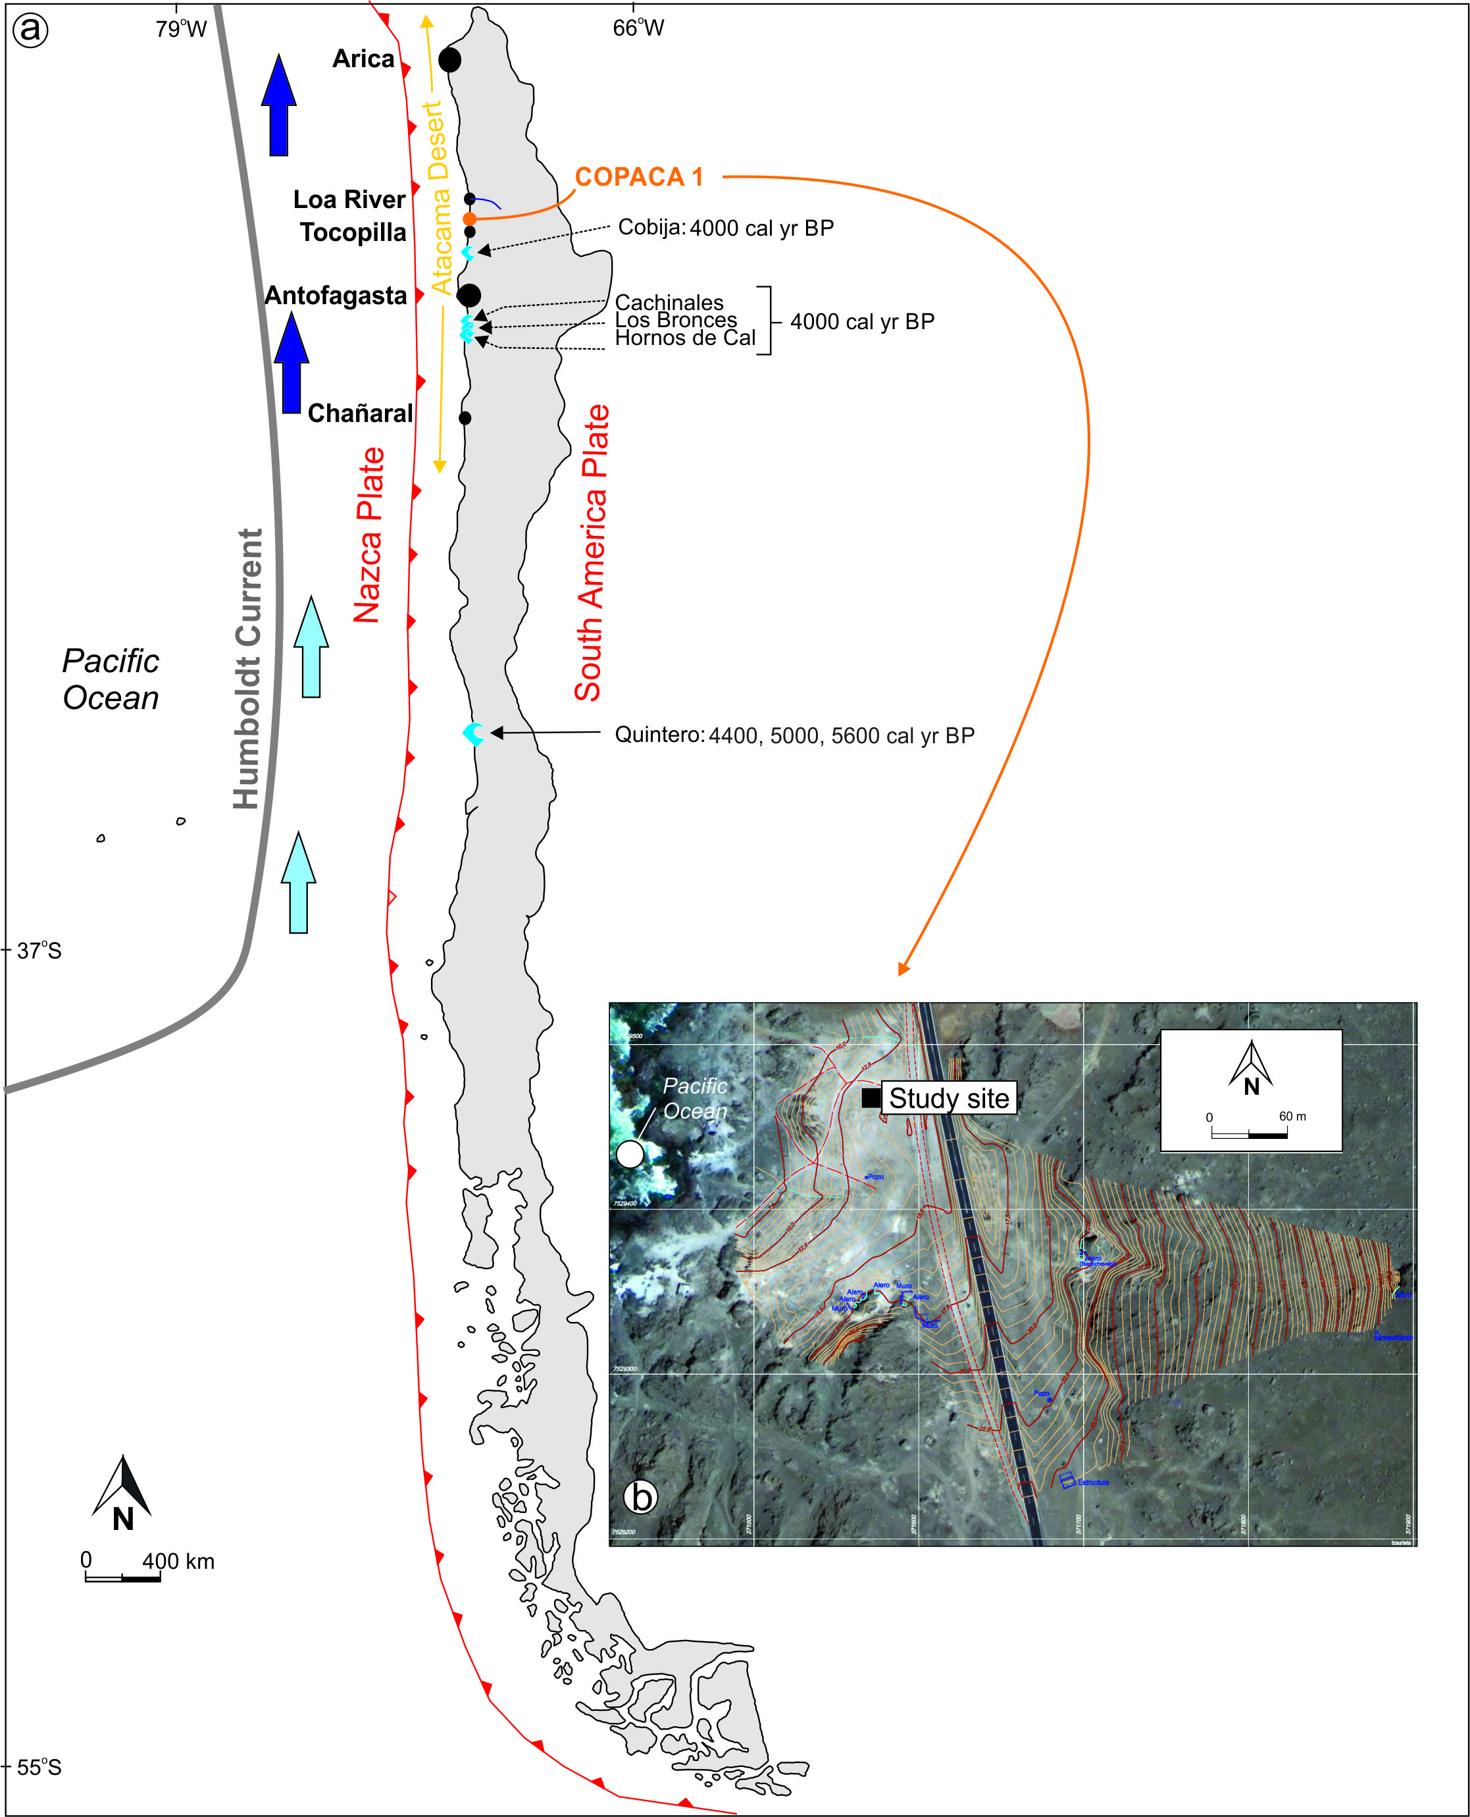

Fig. 2.
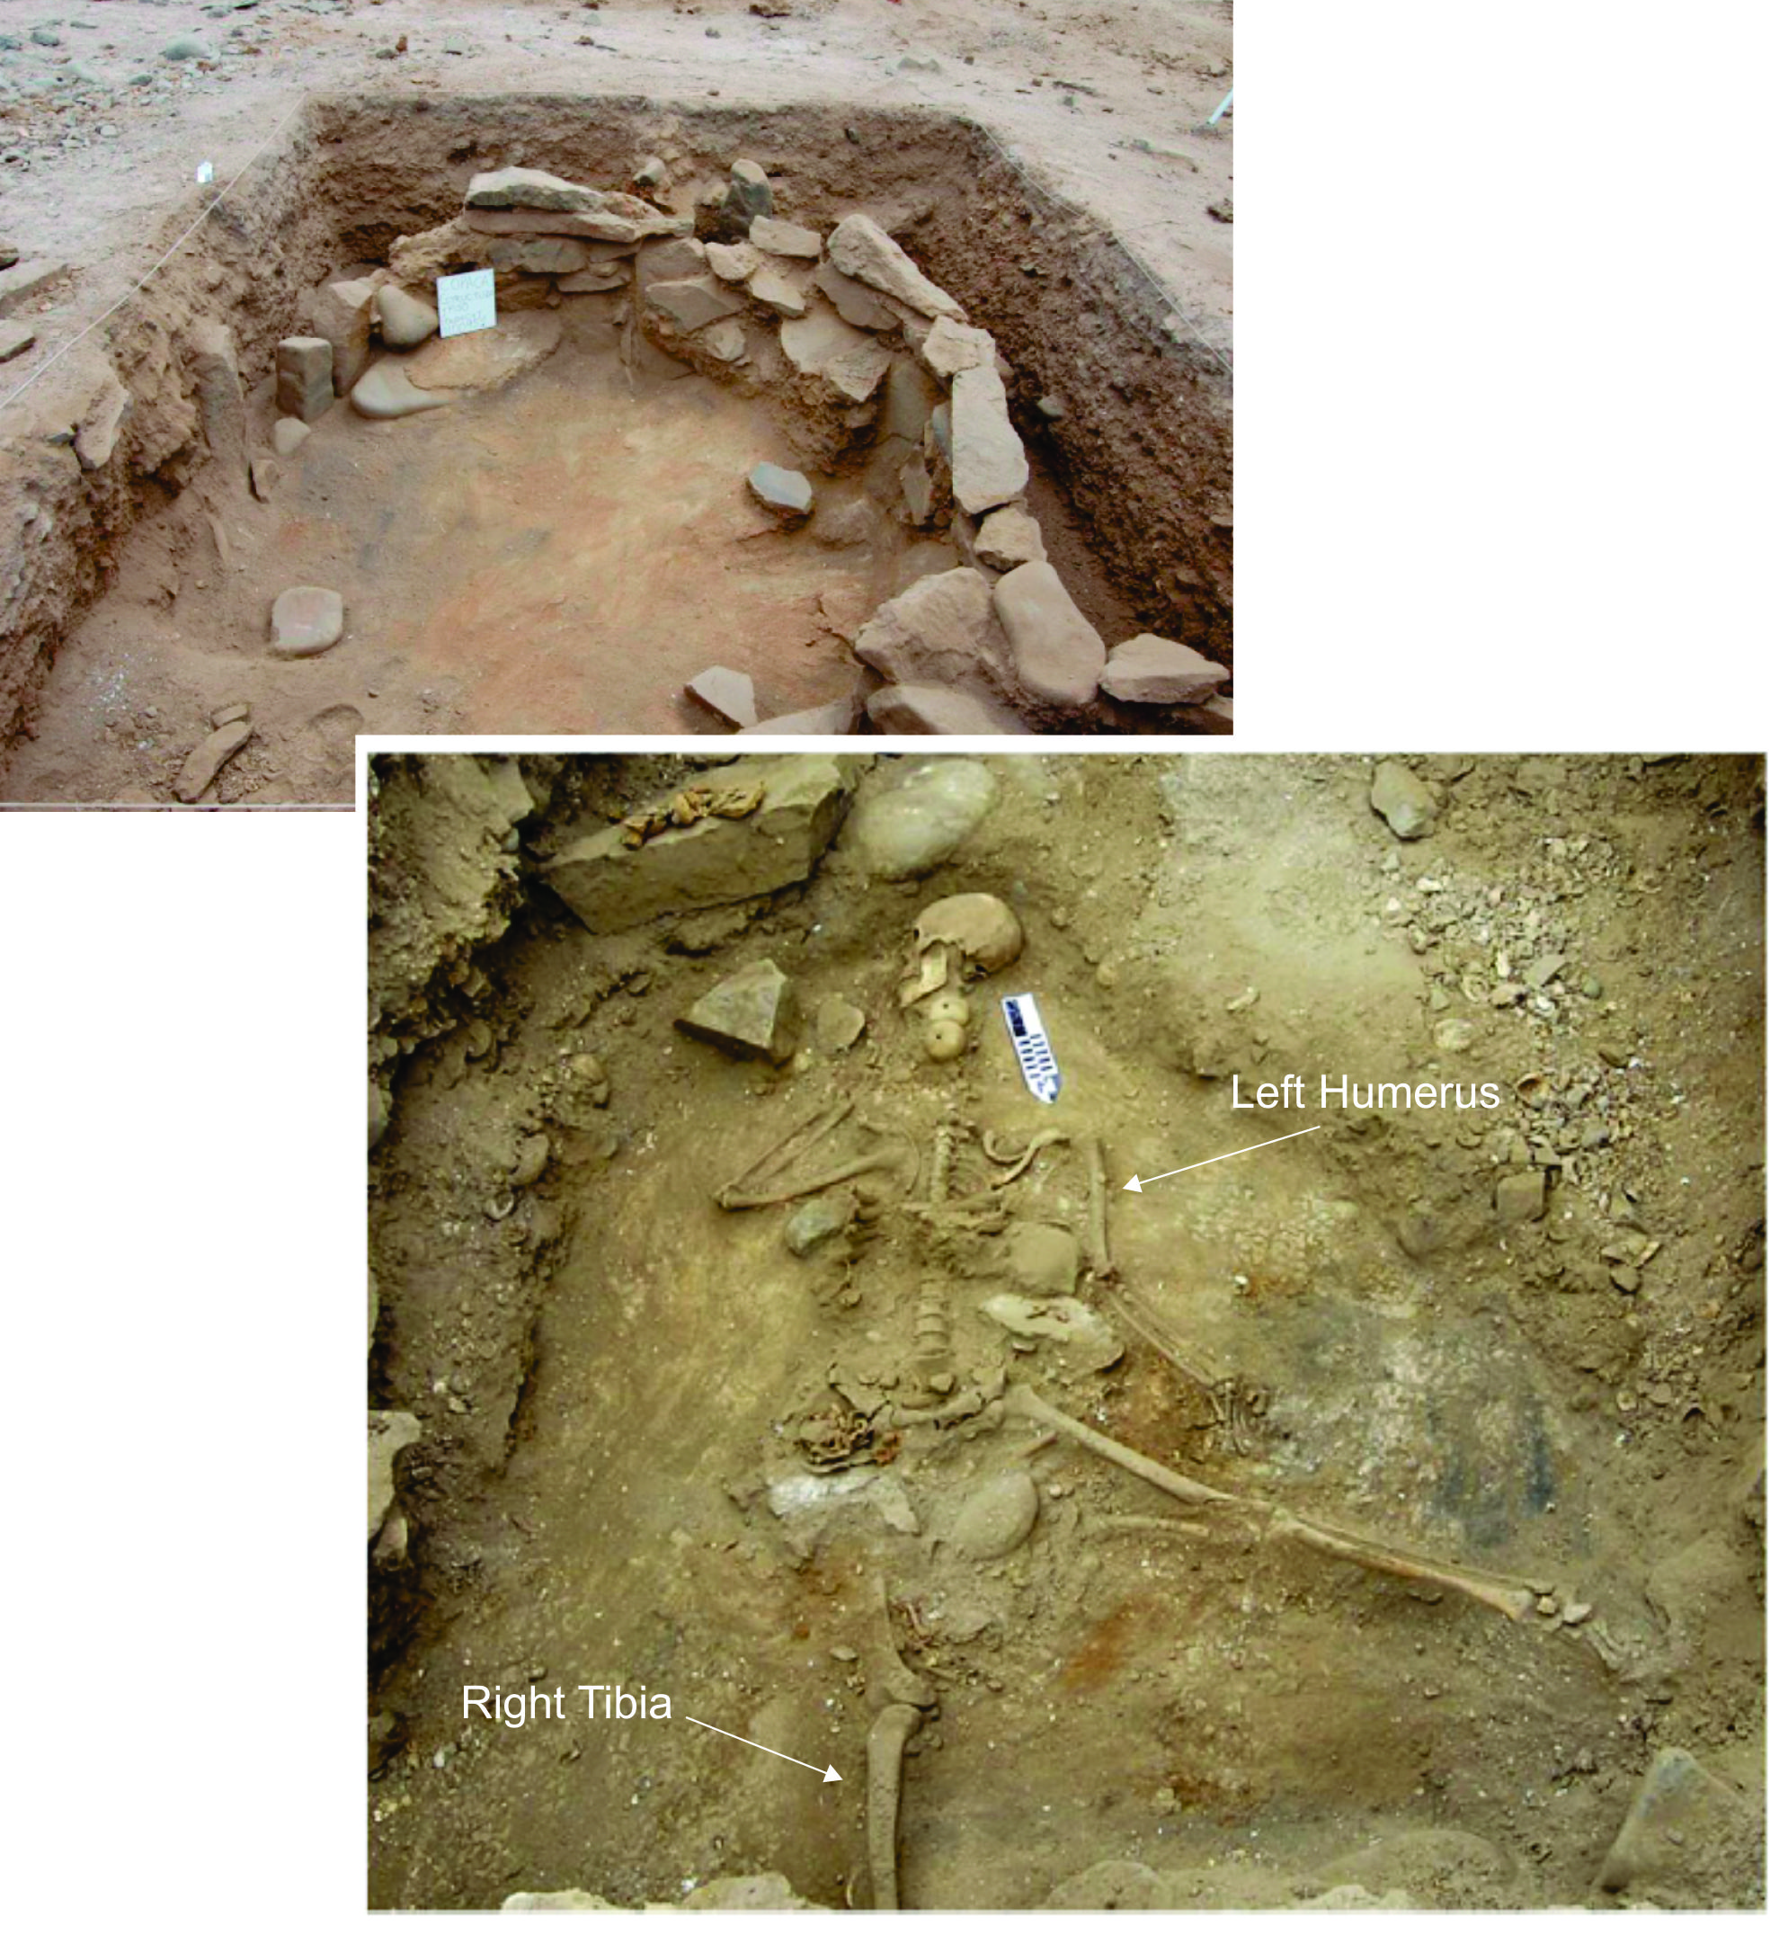

Fig. 3.
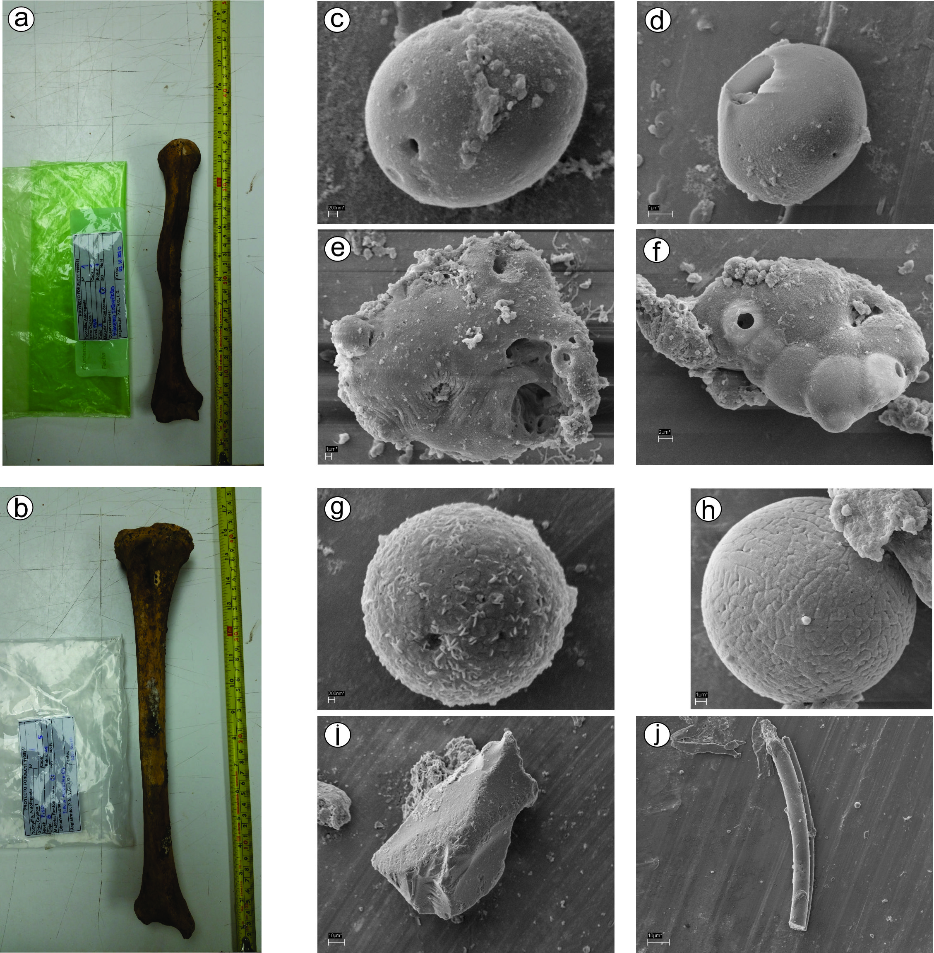

Fig. 4.
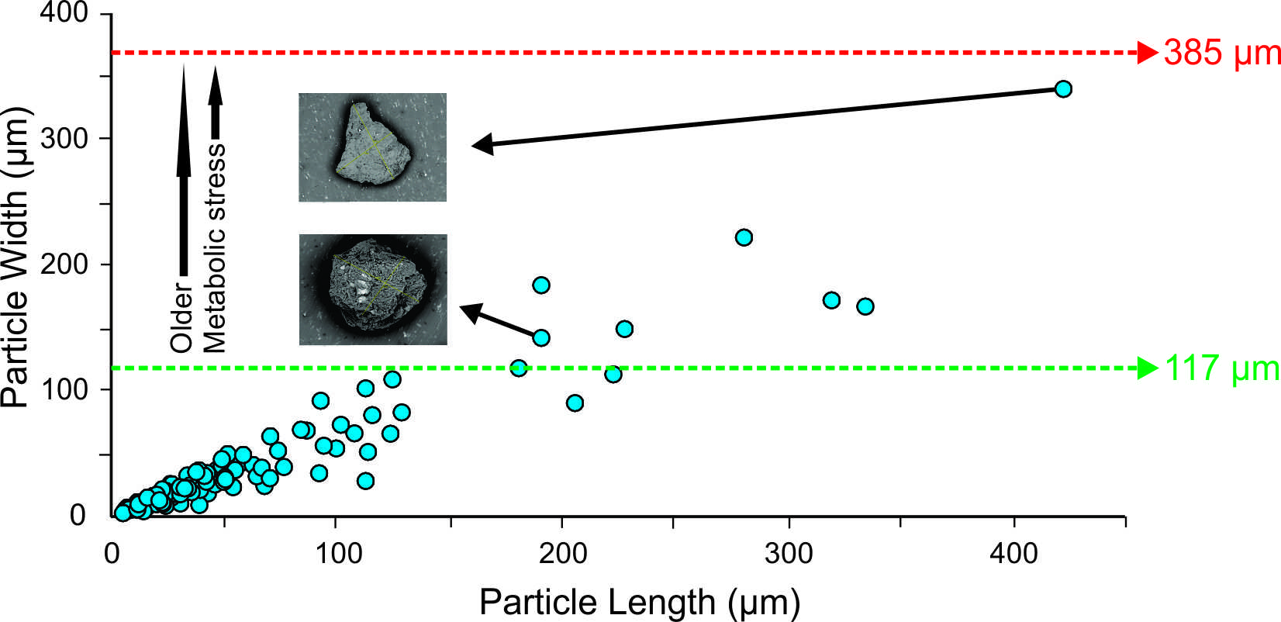

Table 1.

Lab Code | Layer | CAR¹ | Cal. 14C Age (cal yr BP) | Sample | 13^{δ}C
UGAMS 8342 | 2 | 4540±25 | 5301-5040 | Charcoal | -20.2
UGAMS 8345 | 5 | 4810±25 | 5590-5462 | Charcoal | -12.65
UGAMS 8346 | 6 | 5060±25 | 5773-5657 | Charcoal | -24.38
UGAMS 9145 | 9 | 7010±25 | 7868-7695 | Charcoal | -11.7
UGAMS 15623 | 5-6 | 5200±25 | 5563-5025 | Human Bone (I.1) | -12
UGAMS 15624 | 6 | 5220±25 | 5569-5045 | Human Bone (I.2) | -11.5
UGAMS 15625 | 6 | 5140±25 | 5477-4917 | Human Bone (I.3) | -11.9
UGAMS 15626 | 5-6 | 5150±25 | 5505-4940 | Human Bone (I.4) | -12.2

¹CAR – Conventional Radiocarbon Age

