A combined volume of fluid and immersed boundary method for free surface simulations induced by solitary waves

Qiu Jin, Dominic Hudson, Pandeli Temarel

Maritime Engineering Science Group, Faculty of Engineering and Physical Sciences, University of Southampton, Southampton, UK

*Corresponding author name: Qiu Jin
Affiliation: Faculty of Engineering and Physical Sciences, University of Southampton, Southampton, UK
Detailed permanent address: University of Southampton, Southampton Boldrewood Innovation Campus, Burgess Road, Southampton, SO16 7QF
Telephone number: +44 07842820658
Email address: qiu.jin@soton.ac.uk
Email address: dominic@soton.ac.uk (Dominic Hudson)
Email address: p.temarel@soton.ac.uk (Pandeli Temarel)

Abstract
A combined volume of fluid and immersed boundary method is developed to simulate free surface flow induced by solitary waves. The simulations of problems involving free boundaries with large deformations are known to be challenging due to the discontinuity of density and momentum flux across the interface. In order to reduce the spurious velocities and prevent unphysical tearing of the interface, an extra velocity field is designed to extend the velocity of the water into the air and to enforce a new boundary condition near the free surface. The free surface is captured using a new Volume of Fluid (VOF) method and a boundary layer is built on the air side by an immersed boundary method. A density-weight smoothing approach is used to reconstruct the velocities inside the boundary layer. The accuracy of the new solver is verified by two benchmark problems, the propagation of a solitary wave in constant depths and run-up of a solitary wave on a slope. The performances of the new solver are compared with the original VOF solver, analytical solutions and one-phase flow solver results, and better results are obtained. The simulation of a plunging wave breaking on a slope further demonstrates the capability of the new solver to capture strong air-water interactions. It is shown to improve the robustness and stability of two-phase flow simulations and higher accuracy can be obtained on a relatively coarse grid compared to the original volume of fluid method.

Keywords: two-phase flow; solitary wave; volume of fluid method; immersed boundary method; Density-weight smoothing method
Nomenclature
CFD | Computational fluid dynamics | VOF | Volume of fluid
LS | Level set | GFM | Ghost fluid method
FSI | Fluid-structure interactions | IB | Immersed boundary
FVM | Finite volume technique | CSS | Continuous surface stress
EV | Extrapolated liquid velocity | DW | Density-weight smoothing
u | Velocity vector | $$u_{i}$$ | Velocity components of u
$$u^{*}$$ | Momentum-equation-deduced velocity | $$\tilde{u}$$ | Extrapolated velocity with DW approach
t | Time | $$u_{n}$$ | Velocity at time step n
$$u_{new}$$ | Smoothed velocity from IB | $$u_{n+1}$$ | Velocity at time step n+1
p | Pressure | $$ρ$$ | Density
$$μ$$ | Dynamic viscosity | g | Gravitational acceleration
$$V_{p}$$ | Volume of the cell | a | Vector variable
$$S$$ | Face area vector | $$ϕ$$ | Scalar variable
$$F$$ | Mass fluxes | $$α$$ | Volume fraction
$$n$$ | Normal vector | $$κ$$ | Curvature
$$f_{i}$$ | Body source | $$S_{f}$$ | Area of the f^{th} face
$$f_{σ}$$ | Surface tension | $$σ$$ | Surface tension coefficient

1. Introduction
Free surface flow simulation is a classical multiphase flow problem encountered in the field of ocean engineering. When ocean waves travel from deep sea into shallow waters, the wave propagation is naturally influenced by the decreasing water depths resulting in wave deformation, run-up and even wave breaking on the sloping beaches. The wave induced intensive flow can exert significant hydrodynamic loading on the offshore, induce sediment transport, and even deteriorate coastal structures such as pile foundations. Therefore, it is crucial to be able to accurately describe and predict the very unstable process of wave propagation on a sloping beach.
In the earlier studies, free surface flow simulations rely largely on theoretical analysis [1] [2], numerical models[3] [4] [5]. However, the analytical approaches are only applied to the simple geometries and limited to idealized cases. Numerical models are useful for practical problems with high efficiency but fail to describe accurately the physical phenomena due to the neglection of the viscosity effect [6]. For breaking waves problems with discontinuous interface and strong turbulence and vorticity, none of these approaches can be useful. To consider the complex flow details in the process of wave propagation, run-up and breaking, computational fluid dynamics (CFD) techniques based on Navier-Stokes equations are used in a growing number of applications during the past two decades.
Based on the different treatments of the air phase, the Navier-Stokes solvers can be classified as single-phase flow solvers and two-phase flow solvers. The single-phase flow solvers are efficient since only the water phase is solved with an atmospheric pressure boundary condition at the free surface [7][8]. These solvers are appliable in a wide range of applications such as computational ship hydrodynamics where the water phase accounts for most resistance [9]. However, most of these solvers are not capable for wave breaking problems with air-water interaction and air entrainment [10].
An alternative choice is two-phase solvers. Both air and water phase are solved in a single set of governing equations coupled with an implicit free surface capturing scheme such as Level Set (LS) method and Volume of Fluid (VOF) method. Many two-phase solvers have been successfully applied to model the complex free surface flow problems, such as REEF3D[11][12], OpenFOAM[13][14], Truchas[15][16]. They are powerful tools and widely used in modelling breaking waves and associated forces.
Despite the popularity of the two-phase flow solvers, there are issues when dealing with two-phase interface conditions. Spurious velocities and the distorted interface are widely observed in the computed results, but the origin of these spurious velocity has not been identified [17]. The interface boundary layer is not well resolved in all implicit interface capturing methods with large jumps in the material properties between the two phases. The discontinuities give rise to additional difficulties for the momentum transport equations and ultimately results in spurious velocities and spurious shear near the interface [18]. The jump condition can be treated with a Ghost Fluid Method (GFM) [19][20][21]. Two additional distinct velocity fields are defined across the whole domain for the two phases separately and reconnected though a pressure jump condition, but at the expense of significant numerical cost and stability problems. A less complicated approach to reduce the spurious velocities is to apply a smoother to the velocity in the air phase side of the interface and enforce a free surface boundary similar to an Immersed Boundary(IB), the fluid-structure boundary, condition in Fluid-Structure Interactions (FSI) problems [22].
The immersed boundary (IB) method[23] has been widely applied to ensures a no-slip boundary condition for simulating multiphase flow problems because of its inherent advantages, such as the simplicity for grid generation within the framework of the Navier-Stokes solvers[24]. The IB methods are used to deal with fluid-solid problems but have been applied for multiphase problems with diverse physical phenomena[25]. An IB-LB (immersed boundary-lattice Boltzmann) method has been proposed in [26] to simulate single-and multi-component fluid flows in the presence of fixed or moving solid boundaries.
An IBVOF method proposed in the previous study [27] is used to deal with the spurious velocity near the interface caused by the high-density ratio. A new boundary condition near the interface is built and an extrapolated liquid velocity (EV) approach extends the velocity of the denser phase beneath the interface to the lighter phase above the interface. This approach improves the accuracy of the two-phase flow solver. However, the application is limited on uniform Cartesian coordinate system since x- and y- coordinates are used. In order to extend the application of the proposed IBVOF method, another density-weight smoothing (DW) approach is developed in present work.
In this paper, a combined volume of fluid and immersed boundary (IBOVF) method is proposed to deal with free surface simulation induced by a solitary wave. A boundary layer is designed to smooth the velocity field and prevent the tearing of the interface due to the tangential velocity between the two phases across the interface. The IBVOF method is incorporated into a typical two-phase flow solver OpenFoam 5.0. The performance of the new solver is first evaluated by a droplet test case. This allows the direct comparison of the new solver and the original VOF solver in interface convection. Two more benchmark tests, propagation and runup of a solitary wave [17], are conducted to check the numerical stability and robustness of the new method for non-linear wave simulations. The results of all the test cases are compared with the original VOF solver, analytical solutions or one-phase flow solvers. Finally, plunging wave breaking on a slope is simulated to demonstrate the capability of the new solver to capture strong air-water interactions. The overall wave breaking process, wave surface profile and velocity field are investigated, and the results are in good agreement with published experimental data.
2. Numerical method
2.1. Navier-Stokes equations
The governing equations for the impressible viscous flow are the Navier-Stokes equations[28]:
$∇∙u=0,$ (1)
$\frac{∂ρu}{∂t}+∇∙\left(ρuu\right)=-∇p+∇∙\left(μ∇u\right)+gρ,$ (2)
where u is the velocity vector with components of the velocity (u, v, w) in the x-, y-, z-direction, respectively, and t, p, $ρ$, $μ$ and g are the time, the pressure, the density, the dynamic viscosity coefficient and gravitational acceleration, respectively.
The increase of density ratio causes additional difficulties to the two-phase flow simulations. Numerical errors coming from the imbalance between pressure gradient and density gradient [21] cause spurious velocity when solving the momentum equation. Consider a hydrostatic case and neglect the viscous term in Eq. (2), the momentum equation can be written as:
$\frac{∂u}{∂t}=-\frac{1}{ρ}∇p+g$. (3)
This equation becomes ill-conditioned because of the density which changes abruptly from air to water with the volume fraction on the right-hand side of the equation [18]. The inaccuracies caused by the modified Laplacian operator, as well as the imbalance between the pressure and density gradients, cause spurious velocities near the interface. The spurious velocity is greater in the air phase since the spurious pressure is the same in both phases across the interface. Furthermore, the resulting spurious velocity acts as a source of disturbance in velocity fields, accumulates over time, creates vorticity particularly in the air phase and eventually affects the velocity field in the water phase. Another cause of the spurious velocity coming from the spatial discretization. The Navier-Stokes equations are discretized using the finite volume technique (FVM), and dependent variables are defined at cell centers using a collocated variable arrangement. The generalized form of Gauss’s theorem [29] is used throughout the spatial discretization procedure:
$\left(∇∙a\right)V_{p}=\sum_{f}{S∙a_{f}}$, (4)
where $V_{p}$ is the volume of the cell, a is a vector variable, the subscript f implies the value of the variable in the middle of the face, and $S$ is the outward-pointing face area vector. The discretization of a convection term of any scalar property $ϕ$ is obtained by:
$\int_{V_{p}}{∇∙(ρuϕ)}dV=\sum_{f}{S∙{(ρuϕ)}_{f}}=\sum_{f}{S∙{(ρu)}_{f}}ϕ_{f}$. (5)
The face values that used to define the spatial discretization is calculated from the averaged values stored in the central volumes [30]. The discretization becomes more challenging when it comes to two-phase flow simulations with a high-density ratio. These face mass fluxes ($F=S∙{(ρu)}_{f}$) obtained from the interpolated values of $ρ$ and $u$ are not straightforward. The gradients of both density and velocity are inconsistent across the interface due to the different physical properties of air and water. The numerical inaccuracy is another source of spurious velocities observed across the free surface.
It is important to note that these two causes of spurious velocity do not include surface tension effects using Continuous Surface Stress (CSS) model [31]. The surface tension effects are not considered in all cases except the case of plunging breaking solitary waves on a slope in this paper.

2.2. Two-phase flow modeling
Two-phase flows are considered as two incompressible, isothermal and immiscible fluids [28]. A Multidimensional Universal Limiter for Explicit Solution (MULES) method is used to resolve the flow of both air and water phases and the evolution of the free surface. It is an algebraic VOF (AVOF) method, and no interface reconstruction process is applied during the calculation. The free surface is tracked as:
$\frac{∂α}{∂t}+∇∙\left(uα\right)=0,$ (6)
where $α$ is the volume fraction, which is defined as the relative proportion of water in each cell. If $α=1$, the cell is full of water and if $α=0$, the cell is full of air, and in any other case the cell contains the interface between the two phases. The unit normal vector, $n$, and the local curvature, $κ$, are defined as
$n=\frac{∇α}{\left|∇α\right|}$, (7)
and
$κ=∇∙n=∇∙\frac{∇α}{\left|∇α\right|}$. (8)
In a VOF method, the two immiscible fluids are considered as one effective fluid throughout the domain. The physical properties, density and viscosity, are defined by the volume fraction $α$:
$ρ=ρ_{1}α+ρ_{2}(1-α)$, (9)
$μ=μ_{1}α+μ_{2}(1-α)$. (10)
where $ρ_{1}$, $ρ_{2}$, $μ_{1}$ and $μ_{2}$ are the density and viscosity of water and air. The discontinuity of the volume fraction is one of the most important difficulties in numerical simulations of two-phase flows employing VOF models [32]. This discontinuity not only causes problems with interfacial form and geometrical characteristics like curvatures, but it also causes abrupt changes in fluid properties like momentum flux and density gradient. Small mistakes in the volume fraction computation and accompanying gradients or divergency terms can cause large errors near the free surface, especially for cases with high-density ratios such as air and water flow. In order to overcome the numerical instabilities encountered near the free surface, special treatment is required to resolve the boundary layer and to eliminate the errors caused by the discontinuous volume fraction.
2.3. Combined VOF with immersed boundary method (IBVOF)
In the developed DW-IBVOF method, the first key step is to represent the interface and identify the phase state of the grid cells with the VOF volume fraction ($α$) as shown in Fig. 1. The next step is to compute the momentum-equation-deduced velocity and reconstruct the velocity with the DW approach. The velocity field is then updated with direct forcing approach to satisfy the desired boundary conditions on the interface. Finally, the pressure is updated with the new velocity field through the velocity and pressure coupling algorithm.
2.3.1. Identify the position of the interface
The density weighting smoothing approach is used to extrapolate the velocity of water slightly beneath the free surface to air slightly above the free surface. It is therefore necessary to have a clear identification for the interface between the two phases. In present study, an iso-surface with $α=0.5$is used to represent the free surface and to distinguish the air and water phase (see Fig. 1).
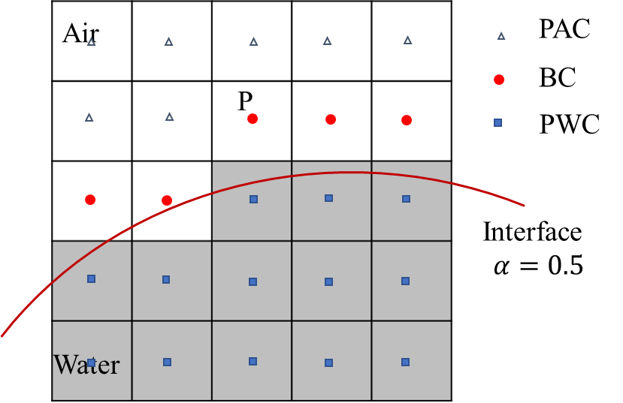
Fig. 1. Phase state re-identification near the free surface.
(PWC: Water cells, BC: Boundary cells, PAC: Air cells)
The boundary layer is built only in the air phase side to guarantee the accurate calculation of the water phase. The air phase is more sensitive to the numerical instability and larger spurious velocities tend to be generated. Thus, the water cells, boundary layer cells and air cells are identified as:
(1) PWC: if $α\left(P\right)≥0.5$;
(2) BC: if $α\left(P\right)<0.5$ and at least one of its neighbor cells $α\left(N_{i}\right)>0.5$;
(3) PAC: if $α\left(P\right)<0.5$ and all its neighbor cells $α\left(N_{i}\right)<0.5$ ;
where cell N shares a cell surface with cell P and is defined as cell P’s neighbor cell (see Fig. 2). And i is the number of the neighbor cells of cell P.
2.3.2. Density-weight smoothing method
After the boundary cell are identified, the next step is to reconstruct an extra velocity field $\tilde{u}$ for this thin boundary layer. The idea of density-weight smoothing comes from Fu’s research [33]. The complete formulation for this smoother is as follows:
$\tilde{u_{i}}=\frac{〈ρu_{i}〉}{〈ρ〉} for α<0.5$ (11)
where $\tilde{u_{i}}$ is the smoothed velocity field, $u_{i}$ is the unfiltered velocity field, $ρ$ is the density, $α$ is the volume fraction. Brackets denote smoothing.
In present work, a smoother proposed by Lafaurie et al. [34], namely a Laplacian filter that transforms the function into a smoother one:
${〈F(x)〉}_{P}=\frac{\sum_{f=1}^{n}{{\left(F(x)\right)}_{f}S_{f}}}{\sum_{f=1}^{n}{S_{f}}},$ (12)
where the subscript P denotes the cell index, f denotes the face index and $S_{f}$ is the area of the f^{th} face. The interpolated value ${\left(F(x)\right)}_{f}$ at the face center is calculated using linear interpolation.
Namely:
${〈ρ〉}_{P}=\frac{\sum_{f=1}^{n}{{\left(ρ\right)}_{f}S_{f}}}{\sum_{f=1}^{n}{S_{f}}}$, (13)
${〈ρu_{i}〉}_{P}=\frac{\sum_{f=1}^{n}{{\left(ρu_{i}\right)}_{f}S_{f}}}{\sum_{f=1}^{n}{S_{f}}}$. (14)
The formulation of the smoothed velocity keeps the same:
${\left(\tilde{u_{i}}\right)}_{p}=\frac{{〈ρu_{i}〉}_{p}}{{〈ρ〉}_{p}} for α<0.5.$ (15)

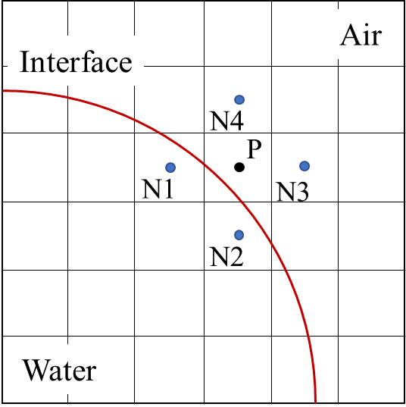
Fig. 2. Air cell (P) and neighbor cells (N) used in density smoother.
Compared to the EV approach, the DW approach has advantages in two aspects. Numerically, the DW is relatively easy to apply to two-phase flow solvers. No coordinate information is required in the smoothing process, which means irregular or unstructured mesh is allowed. It is also easier for the DW approach to extend to 3D dimension as well. The DW approach is more reasonable in term of physical property. Both of the two phases are considered when smoothing the velocity across the interface, while the denser phase has larger effect on the boundary layer. To distinguish the two solvers, the IBVOF solver combined with the EV approach is called EV-IBVOF solver and the one with the DW approach is called DW-IBVOF solver.
2.3.3. Direct forcing approach
The last step is to design a non-slip boundary condition in the boundary cells. To simulate the influence of the modified velocity on the air phase, a discrete forcing function, $f_{i}$, is introduced to the momentum equation (Eq. 2.).
$\frac{∂ρu}{∂t}+∇∙\left(ρuu\right)+∇p-∇∙\left(μ∇u\right)-gρ=f_{i}$ (16)
$f_{i}$ is a body source used in fluid-structure interaction problems to build the non-slip boundary in the immersed boundary methods and it now functions as a velocity corrector for the boundary layer cells. When $f_{i}=0$, Eq.18. is a normal momentum equation and a momentum-equation-deduced velocity $u^{*}$ field is obtained. The $f_{i}$ is used to apply the effect of water to the air and enforce a non-slip condition. For a time-stepping scheme, Eq.18 can be re-written with $u^{*}$.
$\frac{u^{*}-u_{n}}{∆t}={RHS}_{i}\left(u_{n}\right)+f_{i}$, (17)
where $u_{n}$ is velocity from the previous time step t=n, and $f_{i}=0$ at this step, ${RHS}_{i}\left(u_{n}\right)$ is the sum of all the terms in the right hand of the momentum equation.
The density-weight smoothing method in section 2.3.2 is used to extrapolate the velocity field for the boundary layer cells. The velocity corrector ${f_{i}}^{*}$ is calculated from Eq. 19 by substituting the momentum-equation-deduced velocity $u^{*}$ with the extrapolated velocity $\tilde{u}$:
$\frac{\tilde{u}-u_{n}}{∆t}={RHS}_{i}\left(u_{n}\right)+{f_{i}}^{*}$, (18)
${f_{i}}^{*}=\frac{\tilde{u}-u_{n}}{∆t}-\frac{u^{*}-u_{n}}{∆t}=\frac{\tilde{u}-u^{*}}{∆t}$, (19)
The velocity corrector ${f_{i}}^{*}$ is then applied back to the discretized momentum equations
$\frac{u_{new}-u_{n}}{∆t}={RHS}_{i}\left(u_{n}\right)+{f_{i}}^{*}$. (20)
The resulting velocity $u_{new}$ will meet the required non-slip immersed boundary conditions on the interface.
The final step is to update the pressure and velocity by the velocity and pressure coupling algorithm. The new velocity field $u_{new}$ is used to solve the pressure Poisson equation and the final velocity $u_{n+1}$ and pressure $p_{n+1}$ for the next time step t=n+1 are obtained.
A flow chart of the DW-IBVOF solver is shown in Fig. 3. The basic computational process is given for each time step. The back parts are the process of the original two-phase flow solver interFoam while the red parts present the designed boundary and how the velocities are changed step by step. The pressure field is updated alongside with the velocity field through the pressure and velocity coupling process.
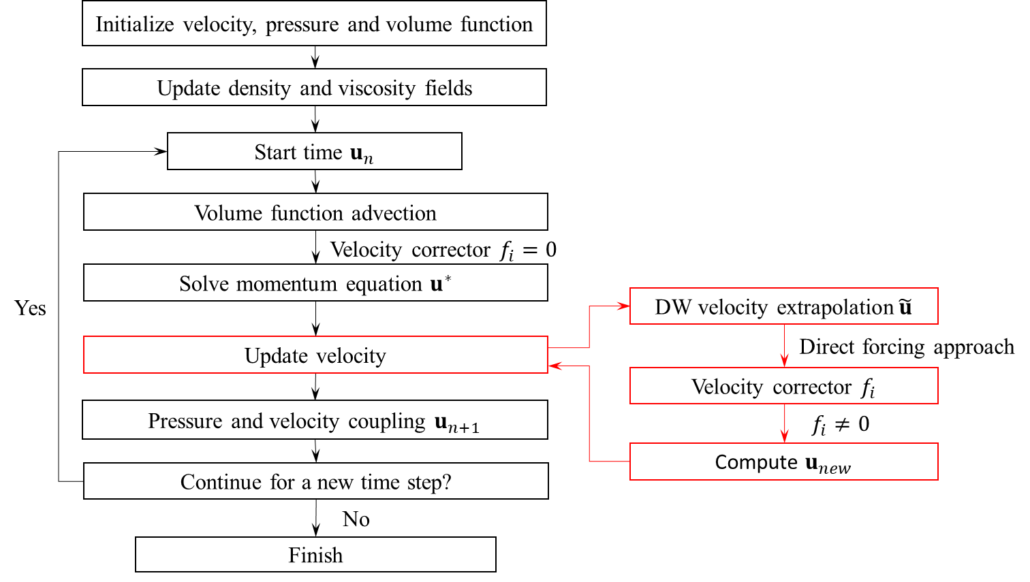
Fig. 3. Flow chart of the DW-IBVOF solver.

2.4. Surface tension
The surface tension plays an important role in breaking waves problems since it is found to have a significant effect to the breaking criteria in the vicinity of the crest and the shape of the wave crest[35][36]. In the present study, the surface tension term is evaluated using a continuum surface force (CSF) model[37]:
$f_{σ}=σκ∆α,$ (21)
where $σ$ is surface tension coefficient, $σ$= 0.072 kg/s² in an air-water system, $κ$ is the curvature of the free surface and is defined as:
$κ=-∇∙\frac{∇α}{\left|∇α\right|}.$ (22)

3. Code verification
A simple two-dimensional test case, transport of a very-high density fluid droplet in a stagnant air, is applied to check numerical stability and robustness of the developed two-phase flow solver. The test case has been numerically studied in several papers [18] [27] [38] [39]. A droplet of diameter D = 1 m is initially placed in a rectangle computational domain with L= 2D and H= D (see Fig. 4.). Boundary conditions are set as periodic. The droplet is moving with a constant horizontal velocity $U_{l}=(1,0)$ m/s from left to right whilst the gas is initially at rest. The density ratio is set to be 10e6. Viscous effects, surface tension and gravity are neglected in this case. Theoretically, the droplet is expected to remain perfectly circular as it passes through the air since the impact of the surrounding air is minimal. The ability of the solvers in handling the density jump is therefore tested.
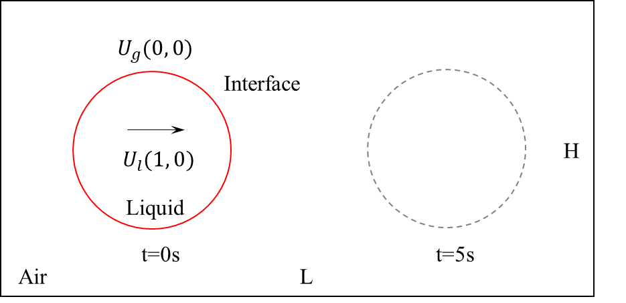
Fig. 4. High density droplet case setup. Red line is the initial interface, and the gray dashed line is the theorical position of the interface at t= 5 s.
Simulations are carried out using fixed uniform Cartesian grids. Three different mesh sized are considered, ranging from $∆x=∆y=5/64$, $∆x=∆y=5/128$ to $∆x=∆y=5/256$. Time step is set adjustable with the maximum Courant number, Co= 0.1 in all these cases. The results of the two proposed solvers, EV-IBVOF solver and DW-IBVOF solver, are compared with analytical solutions and the original two-phase flow interFoam solver in OpenFOAM 5.0.
The velocity field in early stage and the final shape of the interface obtained with the three solvers are compared with each other. At the early-stage t= 0.1 s, the high-density droplet stays spherical with its center moving to x= 2.6m. The liquid velocity should stay constant, whereas the air velocity field should be similar to that generated by air flow around a stationary cylinder. The velocity field obtained from a one-phase flow solver in OpenFOAM, pimpleFoam, is presented in Fig. 5(a). In the setup of the pimpleFoam solver, the cylinder is placed in an initially uniform air flow with $U_{a}=U_{l}=-1$ m/s. Slip wall boundary condition is employed on the surface of the cylinder. The rest of numerical setup and mesh are set up the same as the two-phase flow with $∆x=∆y=5/128$. The relative velocity to the initial droplet velocity, $U_{r}=U_{l}-U_{one}$ is shown in Fig.5(a), where $U_{one}$ is the air flow velocity obtained from the pimpleFoam solver. The figures are split into two portions for easy viewing. The colored velocity magnitudes are shown on the tip sides and the velocity directions with arrows are shown on the bottom sides.
The shape of the droplet and the velocity field at t= 0.1s with the three two-phase flow solvers are shown in Fig. 5(b) (c) and (d). The position of interface is shown with an iso-surface $α$=0.5 in a white line. As shown in the interFoam solver results, the velocity inside the droplet remains its initial value, but there are some deviations from the pimpleFoam solver in the air region near the interface. The differences between the results of the two-phase flow solver and the analytical results are interpreted as spurious velocities. The maximum value of velocity $U_{r}$ in the pimpleFoam solver simulations is 1.04 m/s while the maximum value in the interFoam solution reaches 1.27 m/s.
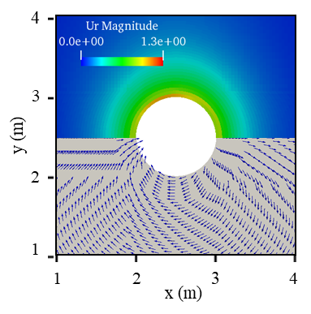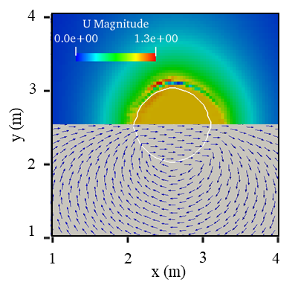
(a) One-phase flow solver (b) InterFoam solver
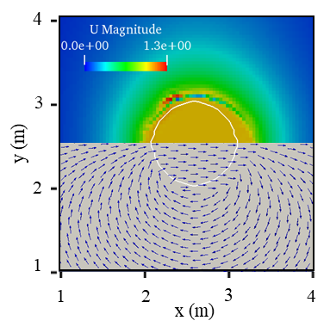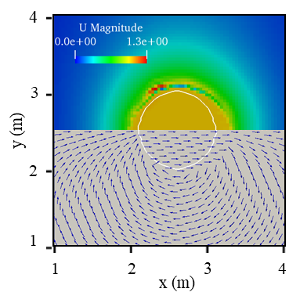
(c) EV-IBVOF solver (d) DW-IBVOF solver
Fig. 5. Velocity field with $∆x=∆y=5/128$ at t = 0.1 s. The top half shows the colored velocity magnitude and the bottom half shows the velocity direction with arrows.
The spurious velocity is caused by an imbalance between pressure and density gradients. Because the momentum equations create the same stress across the interface, the influence of the numerical inaccuracy on the air phase is considerably higher than on the water phase and larger velocity gradients in the air tend to be formed. A non-viscous vortex is formed on the top left side of the droplet since the air velocity adjusts to the movement of the droplet to maintain continuity and momentum, and the large velocity gradients enlarges this vortex due to the discontinuous velocity in the air phase at the interface.
While the value is relatively small in comparison to the air side, the spurious velocity is present on the liquid side as well, particularly in the top left area of the droplet. This velocity is then employed for volume fraction function convection, distorting the interface in the process. The velocity fields in the air obtained from the two IBVOF solvers are closer to the pimpleFoam solver than the interFoam solver. The maximum and minimum velocity magnitude variations near the interface are smaller, implying that the velocity gradient in the air is more reasonable with the IBVOF solvers. As shown in Fig. 5 (c) and (d), the velocity profile using the DW-IBVOF solver is very closed to the EV-IBVOF solver at the early stage. This is reasonable since the only difference between the two solvers is the different operation when driving the lighter phase above the interface by the velocity of the denser phase. In the EV approach, this aim is achieved through pure mathematical operations while the DW approach uses density weighting. When it comes to the problems with density ratios equals to 10e6, the resulting value of the lighter phase with DW approach almost equals to the denser phase next to it.
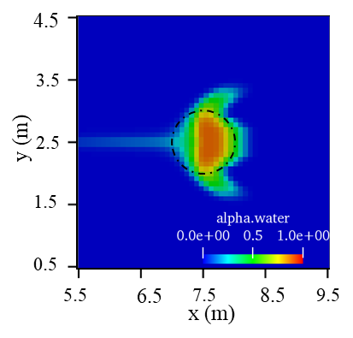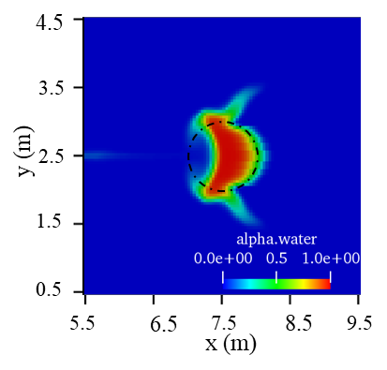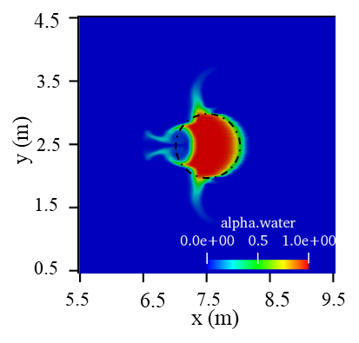
(a) $∆x=∆y=5/64$ (b) $∆x=∆y=5/128$ (c) $∆x=∆y=5/256$
Fig. -6. Volume fraction $α$ distribution of high-density droplet with the interFoam solver at t = 5s.
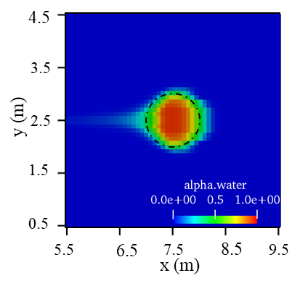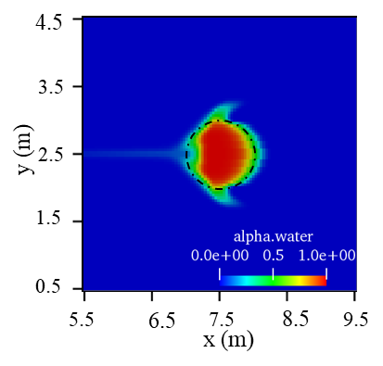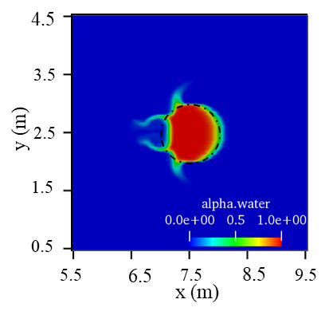
(a) $∆x=∆y=5/64$ (b) $∆x=∆y=5/128$ (c) $∆x=∆y=5/256$
Fig.7. Volume fraction $α$ distribution of high-density droplet with the EV-IBVOF solver
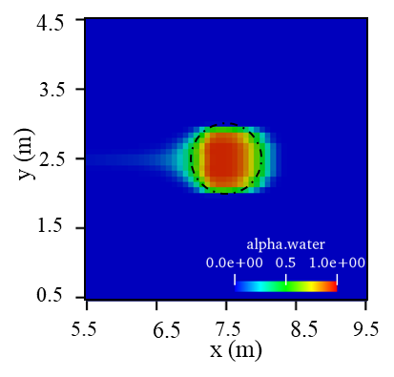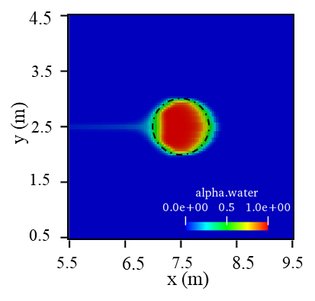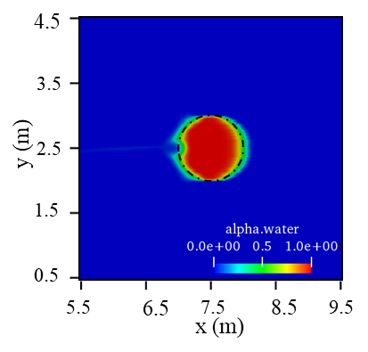
(a) $∆x=∆y=5/64$ (b) $∆x=∆y=5/128$ (c) $∆x=∆y=5/256$
Fig. 8. Volume fraction $α$ distribution of high-density droplet with the DW-IBVOF solver at t = 5s.
The volume fraction fields, which are the final forms and positions of the droplet at t = 5 s, are shown in Fig. 6for the three meshes with the interFoam solver. The theoretical position of the droplet is added in the figures with dashed black lines. The majority of the droplets are contained within the exact circle, however all three meshes show significant deformations. The unphysical fracturing of the drop is caused by an incorrect transfer of momentum from the liquid to the air. The droplet's liquid tends to spread to the top and bottom gas cells. The coarsest mesh only has a maximum volume fraction of 0.886, when it should be 1. The droplet form approaches the precise answer in a monotonic manner. Artificially high velocities, on the other hand, are always present at the contact, and large-scale interface deformations are still apparent.
Fig. 7 and Fig. 8 show the final shape of the interface with the two IBVOF solvers. In terms of both droplet position and shape, the IBVOF solver outperforms the interFoam solver and the unphysical shattering of the drop is considerably reduced even in the coarsest mesh. Though the velocity field obtained with the two IBVOF solvers appear to be very similar at the early stage, the discrepancies between the two solvers grows with time. Compared to the results with the interFoam solver, the EV-IBVOF solver indeed suppress sightly the unphysical tearing of the interface. However, the discrepancies between numerical results and exact solution still exist. The wiggly surface obtained with the EV-IBVOF solver are similar to that with the interFoam solver especially with the finer mesh (see Fig. 7). The extrapolated velocity from the denser phase to the lighter phase via pure mathematic operation may be not good enough.
As shown in Fig.8, the final shapes of the droplet obtained with the DW-IBVOF solver are smoothed and closer to the perfect circle on all the mesh sizes. Major part of the deformation generated in the results of the interFoam and EV-IBVOF solvers are eliminated, though a small notch is observed on the left side of the droplet on the finest mesh. The DW-IBVOF solver shows its advantages in dealing with problems with a band of layers that the value of α transmit from 0 to 1.
4. Results and discussion
In this section, the new two-phase flow solver verified above is first tested against two benchmark problems defined by Pawel A [17]. In the first case, a solitary wave propagated in a numerical wave flume with a horizontal flat bottom. In the second one, a solitary wave runs up on a plane beach with a slope of $θ=10°$. In both benchmark cases, the fluids are set as inviscid and without surface tension. This allows the direct comparison of the two-phase flow solvers against the well-controlled potential theory without the influence of viscosity or other spurious effects. Then, a case of plunging breaking solitary waves on a slope is preformed to further verified the new solver in the application of free surface flow problems in the real world. Both viscosity and surface tension are considered in this case and the results are compared with experimental data.
The numerical setup for the three cases is similar as shown in Fig. 9 and Table 1. The defining waves parameters are the water depth, D, wave height, h, and slope of beach, $θ$. For the first case in Section 4.1, the flume bottom is horizontal so the slope $θ=0°$. The origin of the coordinate system is defined at the bottom left of the corner at the inlet boundary, positive x-axis pointing downstream and y-axis pointing upward.

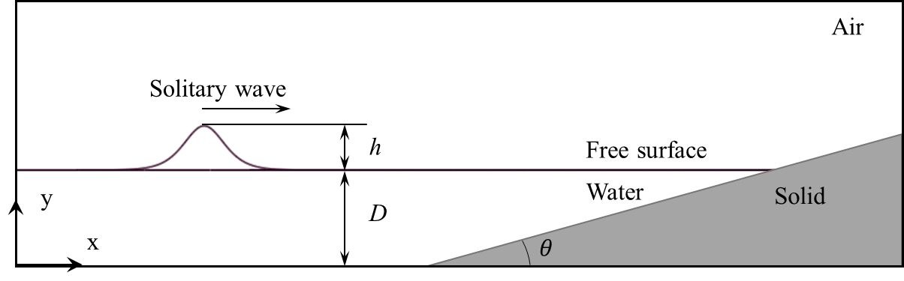
Fig. 9. Numerical setup for the solitary wave cases.

Table 1. Parameters for the solitary wave simulations
Cases | D | h/D | $$θ$$
4.1. | 1m | 0.3 | 0$°$
4.2. | 1m | 0.3 | 10$°$
4.3. | 0.205m | 0.33 | 5.2$°$

4.1. Propagation of a solitary wave in constant depths
The benchmark test is carried out in a two-dimensional numerical wave tank with L= 72.6 m and H=2.7 m. The still water level over the horizonal bottom is D= 1m. A solitary wave is initially placed with its crest at x= 15 m and propagates alongside the wave tanks for 9 s. In this test, both phases are set as inviscid, so a uniform mesh is used in the whole domain and slip boundary conditions are applied on the walls of the wave flume. Theoretically, the solitary wave is expected to remain the initial wave height and free surface shape when propagating in the flume under these conditions. The results of a one-phase flow solver in OpenFOAM, pimpleFoam, is used as a reference solution in this case. Only the air phase is resolved. The numerical setup for the pimpleFoam is similar to section 3, where the fixed circle is replaced by a wave-profiled bump and the initial velocity of air is set the same value as the celerity of the solitary wave in the opposite direction, c= -3.56 m/s. In the verified cases in section 3 and in the reference [17], the grid convergence of the two-phase flow solvers has been checked. The finest mesh size with $∆x=∆y=$ 0.017 m is used to compare the new solver with the reference solution and other two-phase flow solvers. The time step is controlled by the Courant number condition, Co= 0.5 in this case.
Fig. 10 shows the wave elevation for the Solitary wave propagation at x=30m with the interFoam solver and the new DW-IBVOF solver. The analytical results according to the solitary wave theory [40] are given in dots. It is obvious that the shape of wave deforms from around t= 5.6s in the interFoam solutions while superior shape preservation is obtained with the DW-IBVOF solver during the whole simulation. To further investigate the wave deformation, Fig. 11 shows the final wave profiles after 10 s of propagation with the two solvers and the analytical results. Good agreements are obtained with both solvers. The wave height remains the same with the theory and almost no visible phase shift is observed. However, in terms of surface presentation, better performance is obtained with the DW-IBVOF solver on the left side of the wave crest where interFoam solver gives a wiggly surface. Some wiggles are still observed in the results of the DW-IBVOF solver which can be caused by other reasons, such as the convection of the volume fraction. There could be some spurious velocities near the interface, but they are strongly suppressed by the DW-IBVOF solver.

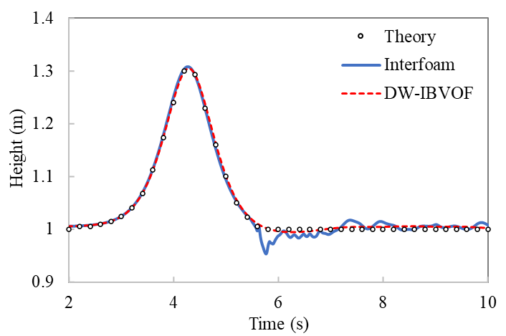
Fig. 10. Wave elevation for Solitary wave propagation at x= 30 m.
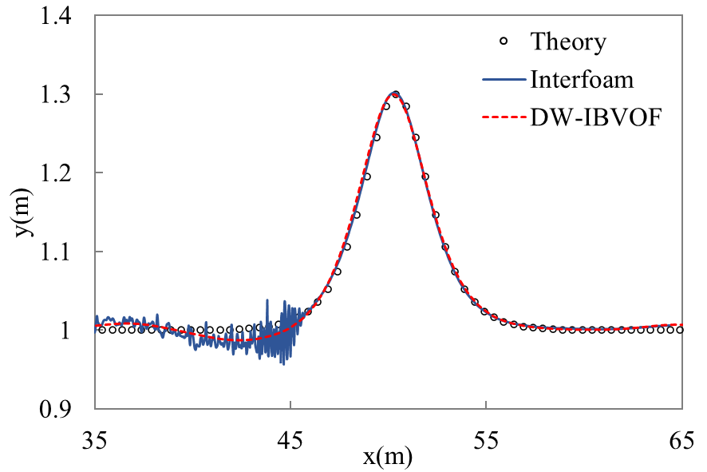
Fig. 11. Wave profiles after 10s of propagation.
The velocity fields in this region x= [42m, 48m] with the two solvers are shown in Fig. 12. The position of the free surface is shown with the iso-surface $α$=0.5 in a white line. A large spurious velocity is observed in the air region with the interFoam solver. The maximum value of relative velocity $U_{r}=c-U$ in this region getting from in the one-phase flow solver simulations is 0.34 m/s while the maximum value in the interFoam solution reaches 7.504 m/s on the left side of the solitary wave at around x= 46m. The spurious velocity comes from the imbalance between pressure gradient and density gradient in the momentum equation and accumulates with time. The effect of the numerical error on the air phase is much greater than on the water phase since the same stress is generated from the momentum equations.

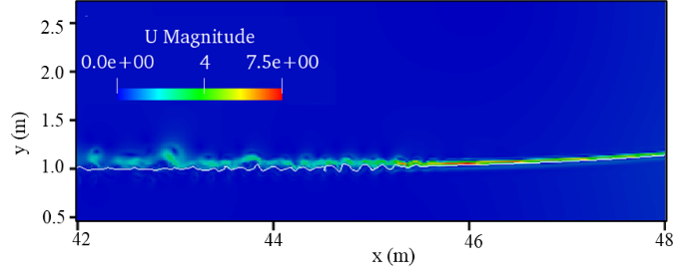
(a) interFoam
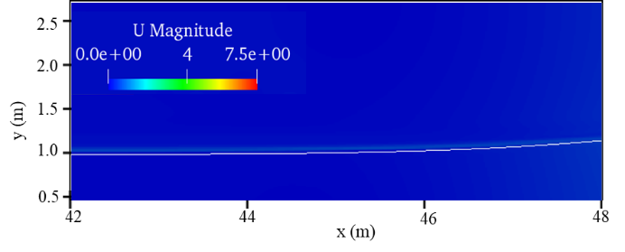
(b) DW-IBVOF solver
Fig. 12. Velocity field during wave propagation at t= 10 s. The white line represents the free surface with the iso-surface $α=$ 0.5.
Compared to the interFoam, the DW-IBVOF solver shows its ability in suppressing the spurious velocities. The maximum value of velocity in DW-IBVOF solver is 0.667 m/s in the air phase at the similar position of the maximum velocity at around x= 46m. Though double to the one-phase flow solver value, it is in the same order of magnitude. The discontinuity in the velocity between the air and water across the free surface is smoothed by the built free surface boundary layer. The interface instabilities and unphysical tearing of the interface are suppressed. A smoother free surface is obtained.
To better understand the behavior of the free surface, the horizontal velocity profiles along a vertical cross-section going up through the wave crest at t= 10s are investigated. In Fig. 13, the reference result consists of two parts. For the air phase with y> 1.3 m, the reference velocity is the relative velocity $U_{r}$ getting from the one-phase flow solver, and for the water phase with y< 1.3 m, the reference equals to the solitary wave theory. The two parts are connected with a straight line.
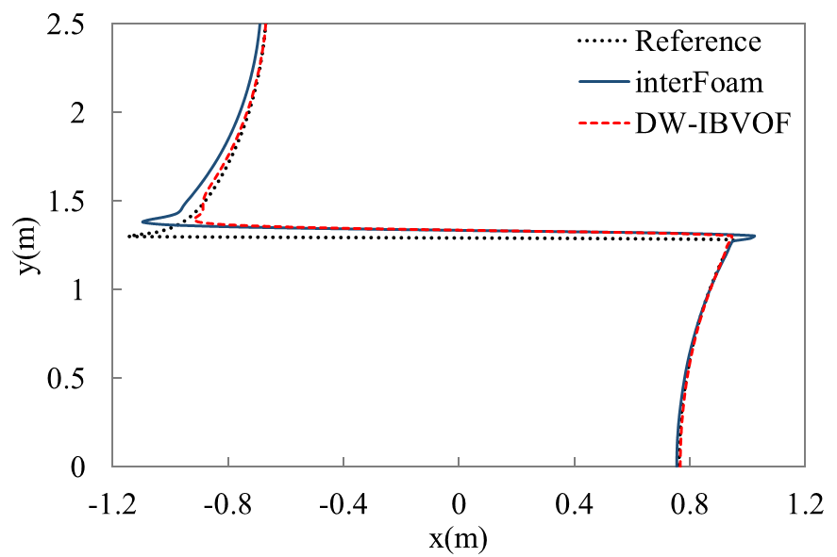
Fig. 13. The horizontal velocity profiles of the two phases along a vertical cross-section going the wave crest at t= 10 s.
It is evident that the velocity profiles of both the two two-phase flow solvers agree well with the reference solutions especially for the main bulk of the water phase. In both two-phase solvers, a narrow band is generated to transfer the velocity across the interface from water phase to air phase. This jump of the velocity mainly exists in air phase since the air phase is much lighter than the water phase. The large velocity gradient acts as the source of the no-viscous vortex on the left side of the wave crest and eventually effects the behavior of water with time as shown in Fig. 12. Smaller velocity gradient is observed in the results with the DW-IBVOF solver. The boundary layer designed by the density-weight smoothing method and immersed boundary method smooths the jump of the velocity field and reduces the velocity gradient in the lighter fluid near the interface.
Beside of the large velocity gradient in the air phase, an increase of velocity in water phase close to the interface is generated in the results of interFoam solver. The overshooting in the particle velocities in the top of the crest is a common feature in other two-phase flow solvers like Thetis as shown in Fig. 14. Truchas shows a very close result as the reference solution but presents artificially high velocities at the front of the solitary wave [17]. In simulations with Gerris, a reduced gravity approach, with which gravity is applied in a bond around the interface. The approach helps to reduce the imbalance of dynamic pressure gradient and density gradient.
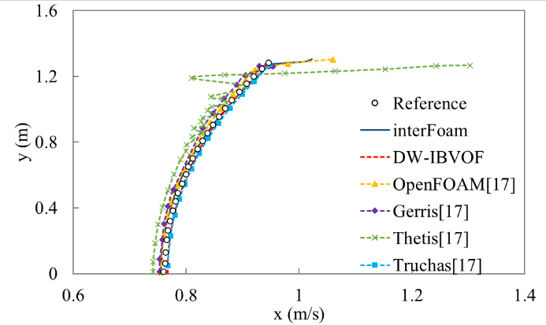
Fig. 14. The horizontal velocity profiles of the water phase along a vertical cross-section going the wave crest compared with the benchmark results at t= 10 s. The data of OpenFoam, Gerris, Thetis and Truchas are obtained from benchmark cases [17].

Among all these two-phase solvers, the velocity profiles obtained with DW-IBVOF solver follow the reference solution quite well, both in sense of the water phase and air phase. The particle kinematics in the wave crest is an important feature in wave propagation simulations [41]. The spurious velocity can have an important effect on the advection of the free surface in a long-time simulation and the proposed DW-IBVOF solver provides much better accuracy in the two-phase flow calculations.
4.2. Run-up of a solitary wave on a slope
The second benchmark case used in present work is the runup of a solitary wave on a plane slope. The numerical test is carries out in a two-dimensional numerical wave tank with L=45 m and H=2.7 m. The slope starts at x= 30m with an angel of $θ=10°$. The solitary wave (parameters given in Table 1) is initially placed with its crest at x= 15 m and propagates towards to the slope for 10s. Both phases are set as inviscid and the surface tension is neglected to compare the results of the two-phase flow solvers with a fully non-linear boundary integral solver based on potential theory [35]. Slip boundary conditions are applied on the walls of the wave flume. According to the solitary wave and slope parameters, no breaking should occur in this benchmark test. Similar to case 4.1, the highest resolution in reference [17] is used in present work. The maximum Co number equals 0.5 in each case.
Fig. 15 shows the snapshots of volume fraction $α$ distribution with the two solvers during wave runup process at t= 5.4 s and Fig. 16 shows the comparison of wave profile. A wiggly surface is clearly observed close to the wave crest in the results of interFoam. Similar to the wiggly surface in case 4.1, the considerably distorted interface is caused by the spurious velocity generated near the interface. Fig. 17 presents the velocity field at t= 5.4s with the two solvers. Artificially high velocities are present in the air phase with a maximum value of 11.6 m/s. A strong increase of velocity is also observed in the water phase closed to the interface. These spurious velocities directly lead to the unphysical shear of the interface since the they are used in the convection of the volume fraction.
With a higher velocity than the main body of the wave, the water that closed to the interface moves in a spurious way and tends to spread to the air region from the tip of the swash tongue as shown in Fig. 15. A mini plunging breaking wave is generated at around x= 35.5m on the slope with several separated droplets, which should not happen in this case. This problem is commonly present in solutions of Gerris and Thetis [17] and simply refining the mesh cannot remove the droplets during the simulation. It is therefore important to reduce the spurious velocity near the interface.
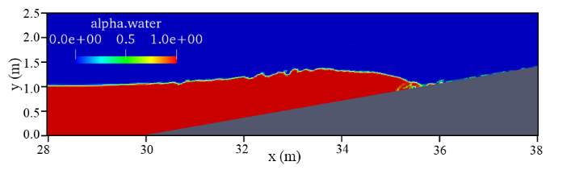
(a) InterFoam solver
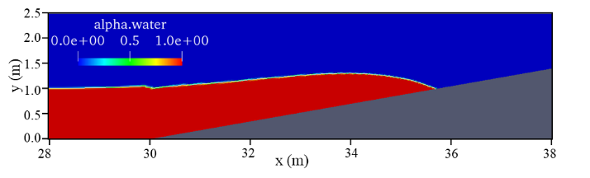
(b) DW-IBVOF solverFig. 15. Volume fraction $α$ distribution during wave runup at t= 5.4 s.
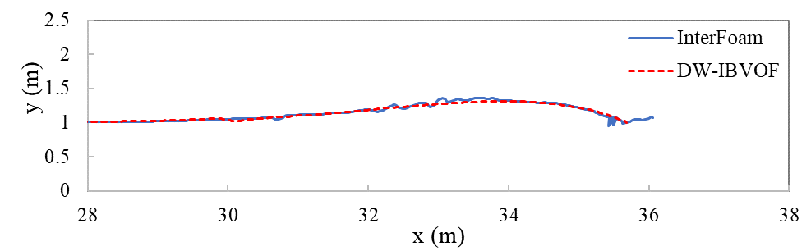
Fig. 16. Comparison of wave profile with the two two-phase flow solvers at t= 5.4s

Compare to the interFoam solver, the DW-IBVOF solver is superior in prediction in both interface shape and velocity field as shown in Fig. 15(b) and Fig. 17(b). The velocity of the water phase beneath the interface is extended into the air phase above the interface due to the high-density ratio between water and air. The maximum value of the velocity with DW-IBVOF in the same region is only 7.7 m/s. A better predicted velocity field improves the accuracy of volume fraction convection and a smooth free surface is obtained without any separated droplets from the tip of the wave.

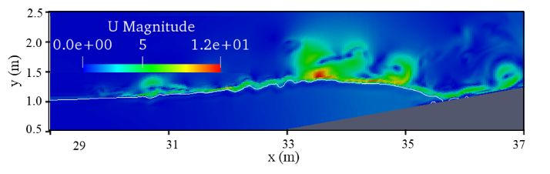
(a) InterFoam solver
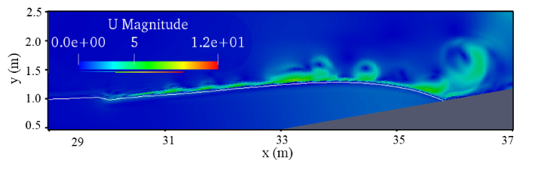
(b) DW-IBVOF solver
Fig. 17. Velocity field during wave runup at t=5.4 s.
In the benchmark test [17], the evolution of the maximum elevation of the free surface with four two-phase flow solvers are collected and compared with potential solutions (shown in Fig. 18). The separated drops are removed from the results and only the largest connected water region is taken into account. The results of the original interFoam (with and without the spurious droplets) and the DW-IBVOF solvers are added into the figure. It is surprising to see the large distance between the separated droplets and the main body of the wave which is almost equal to the height of the maximum runup elevation of the wave. The elevation of the main body with interFoam shares same trend with other solvers. Among all the solvers, Gerris and DW-IBVOF solvers give the closest results with the reference. No separated droplets are found in these two solvers, which could be the reason. Gerris seems to be the best solver from Fig. 18, but some bubbles are reported that sticked to the slope during the wave runup and rundown process, which may eventually damage the flow simulations. The overall good performance of the DW-IBVOF proves that the present methods improve the accuracy of two-phase flow simulations.
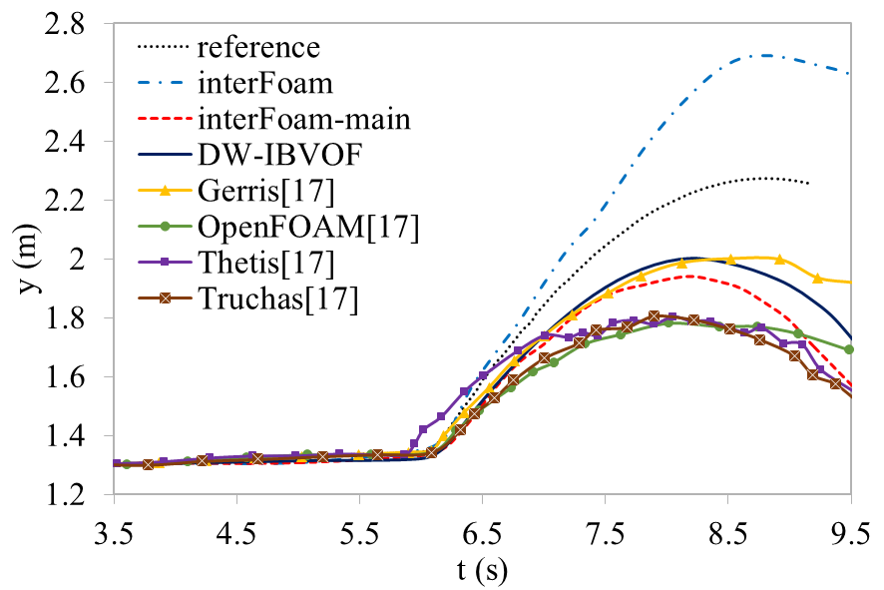
Fig. 18. Evolution of the maximum elevation of free surface compared with the benchmark results during wave runup.

It is interest to see that even for the main water body, the interFoam in present work is better than the OpenFoam used in the reference paper [17]. A main issue may the different treatment of the solid boundaries. An immersed solid boundary condition is applied on the beach in the benchmark test which the authors are unsuccessful in using it. A slip boundary condition is used instead. Another reason could be the mesh configuration. Even though the mesh used in present work is designed as the same as the benchmark test, the size and shape of the mesh could be slightly different, especially in the junction region of horizonal bottom and the slope, because of the irregular shape of the wave flume. A discussion of mesh configuration is given in [17], but is beyond the scope of the present work.
4.3. Plunging breaking solitary waves on a slope
To demonstrate the capability of the proposed solver in the application of free surface simulations in the real ocean engineering, numerical simulations for an experimental case are carried out in this section. Different to case 4.1 and 4.2, both viscosity and surface tension are taken into account and the numerical results are compared with the experimental data [15].
The numerical simulations are carried out in a three-dimensional (3D) numerical wave tank with length L=8 m, height H=0.6 m and width W= 0.3m. The numerical setup is similar to case 4.2 and shown in Fig. 9. The slope with an angle of $θ=5.1°$ starts at x= 4m. The still wave depth is D= 0.205m. A solitary wave with amplitude h/D= 0.33 is initially placed at x= 1.815 m and propagates towards to the slope. The simulations end up after the runup process is completed and a plunging breaker is generated. All the physical parameters, densities, viscosities and surface tension, are set the same as the experiments. No-slip boundary condition is imposed on all the walls of the numerical wave tank.
A structured mesh is used to discretize the computation domain. The grids are uniform in the spanwise and streamwise direction, $∆x=∆z=3 mm$, but nonuniform in the vertical direction, i.e., $∆y_{max}=3 mm$ and $∆y_{min}=0.2 mm$. The meshes near the bottom of the wave tank and the surface of the slope are smaller to capture better the near-wall turbulent flow. The maximum Co number is set to be 0.5, the same as the numerical setup in c. A standard $k-ε$ turbulence model along with the Reynolds averages Navier-Stokes equations (RANS) is used to describe the turbulent flow in the two phases. A non-slip wall boundary is applied on the bottom of the wave tank and the standard wall function [42] is employed for the near wall treatment.
4.3.1. Free surface profiles
When the solitary wave travels close to the slope, the characteristics of the wave such as wave height and velocities, change due to the water depth. The wave crest becomes steep and generates a plunging breaker towards to the slope. Fig. 19 shows the comparison of volume fraction with interFoam and DW-IBVOF solvers at different times and Fig. 20-22 present the computed free surface profiles compared with the experimental data in the pre-breaking zone; no breaking has occurred yet. The numerical solutions with two-phase flow solver Truchas in [15] are also given in the comparison as a reference. Overall, the numerical results from the three two-phase flow solvers, Truchas, the proposed DW-IBVOF and the original interFoam, fit well with the experimental data for the locations and wave profiles.
At t= 2.525 s, the wave starts shoaling and transforming. In terms of surface shape prediction, the interFoam solver gives the steepest wave crest on the wave front among the three solvers. The discrepancies between numerical results of interFoam solver and experimental data grow with time. At t= 2.64 s, the experimental wave front is almost vertical while in the results of interFoam, the plunging breaker have generated and tend to overturn.
The Truchas solver, on the contrary, shows a much gentler wave profile. At t= 2.525 s, the results of Truchas are in good agreement with the laboratory wave front. The differences occur during the wave runup process. According to Mo et al’s work [15], the wave overturn predicted by Truchas is later than the experimental data and is around 85 mm further away from the inlet boundary, which is proved by Fig. 9 where the Truchas still shows a relatively gradual wave profile with non-breaking characteristics. This may be caused by the resolution is not fine enough to capture the variation of velocity. The finest mesh near the bottom of the computational domain that Mo used is 4 mm is larger than the coarsest mesh in the present work.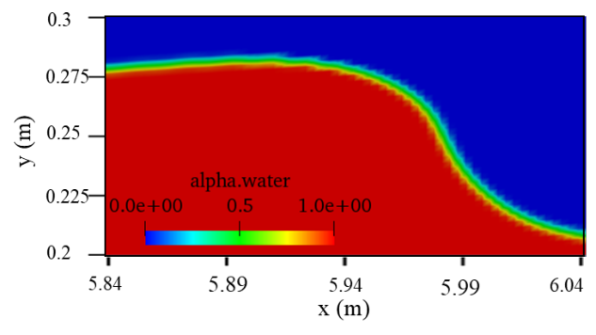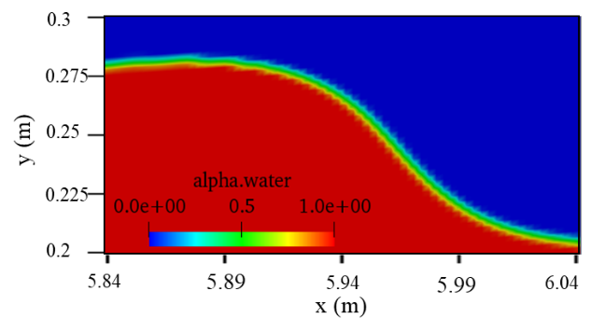
(a) InterFoam at t= 2.525 s (b) DW-IBVOF at t= 2.525 s.
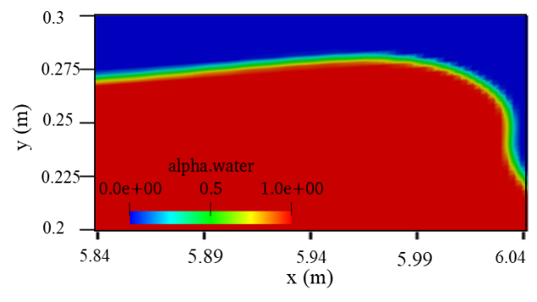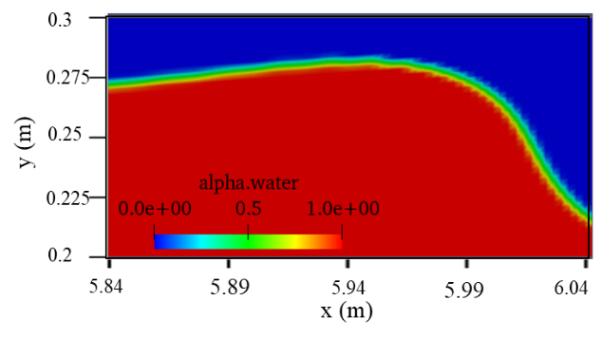
(c) InterFoam at t= 2.57 s (d) DW-IBVOF at t= 2.57 s.
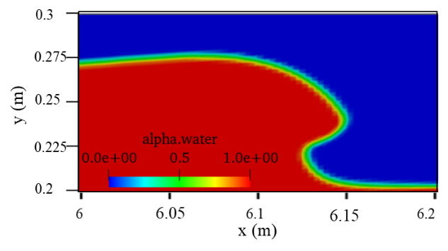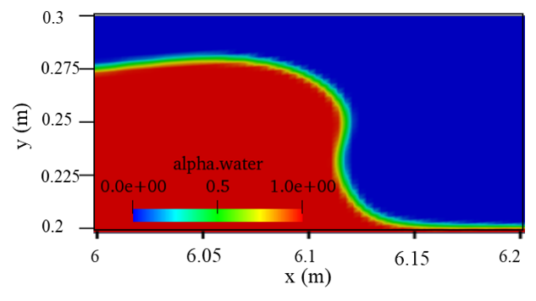
(e) InterFoam at t= 2.64 s (f) DW-IBVOF at t= 2.64 s.
Fig. 19. Comparison of volume fraction with interFoam and DW-IBVOF solvers at different times
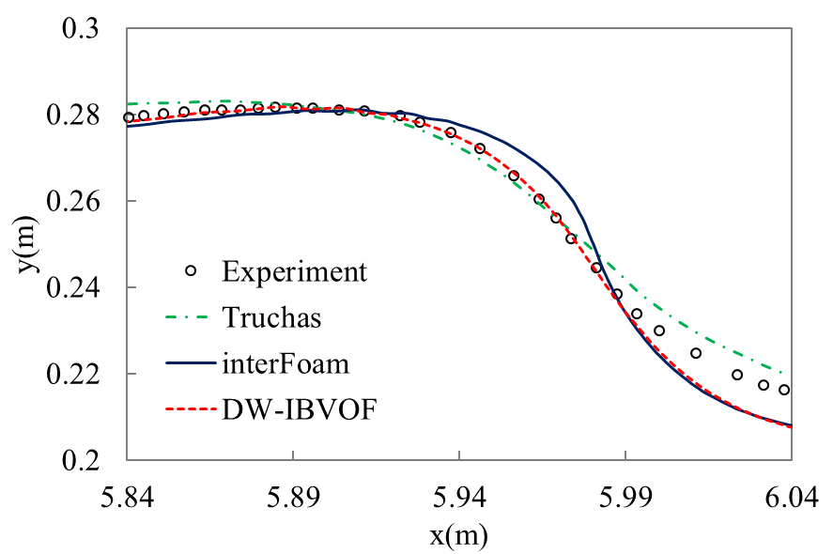
Fig. 20. Comparison of experimental data and numerical solutions for free surface elevation at t= 2.525 s.
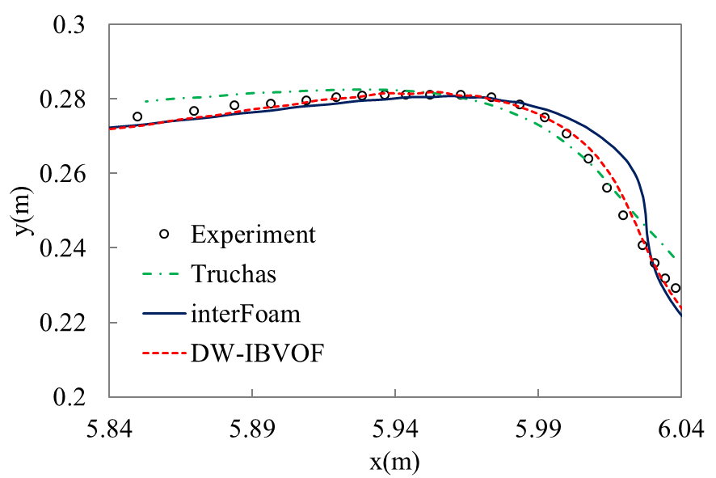
Fig. 21. Comparison of experimental data and numerical solutions for free surface elevation at t= 2.57 s.
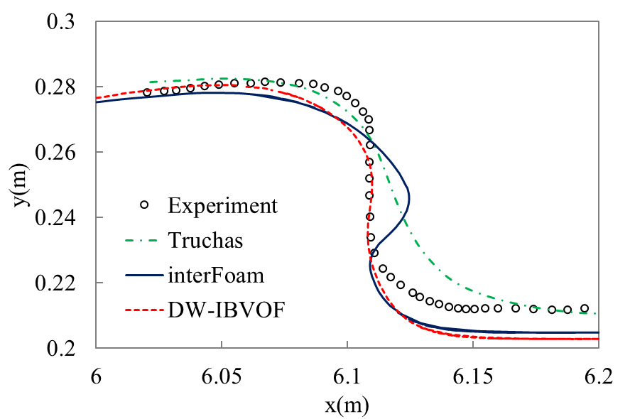
Fig. 22. Comparison of experimental data and numerical solutions for free surface elevation at t= 2.64 s.
Among the three solvers, the proposed DW-IBVOF solver shows the best agreement with the experimental observations. The discrepancies on the wave crest between numerical results of interFoam solver and experimental data are corrected by the modified velocity field. Similar to case 4.1 and case 4.2, artificial high velocities are observed in the air phase and a strong increase of velocity occurs in the water phase closed to the interface. To better understand the reasons behind the wave front shape, the velocity profiles of water phase is investigated in the next section.
It's worth noting that the positions of the free surface closest to the slope determined from experiment and Truchas in reference [15] are somewhat higher than the level of still water. However, in the research of other authors [6][43][44] and in the current study, the water along the slope remains undisturbed and the water height remains constant the same as the still water until the wave arrives.

4.3.2. Horizontal velocity profiles
In this section, the horizontal velocity profiles of the water phase are investigated to understand the deformation of the wave front. Fig. 23 shows the computed velocity field with interFoam and DW-IBVOF solvers at different times the same as the volume fraction in section 4.3.1. The solid white line presents the position of the free surface. According to the wave profiles, the vertical profiles of horizontal velocity at different sections at different times are shown in Fig. 24-26. It is obvious that the values of velocity obtained from the Trucha are 10% -15% lower than the experimental data and the other two solvers, even though the shape of velocity profiles compare well. These differences directly result in the late overturning of wave crest in the simulations with the Truchas.
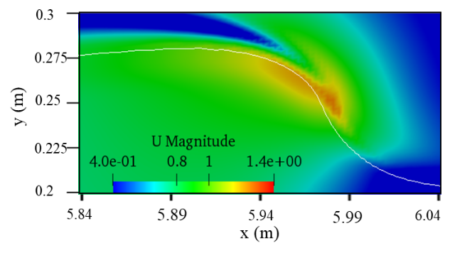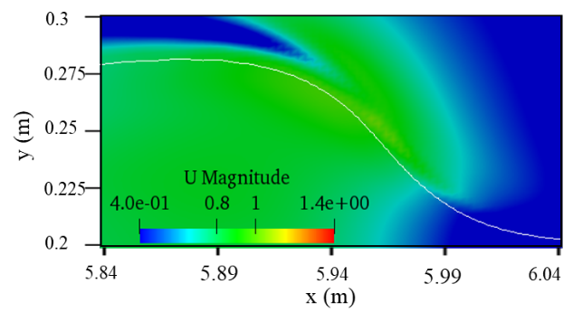
(a) InterFoam at t= 2.525 s (b) DW-IBVOF at t= 2.525 s.
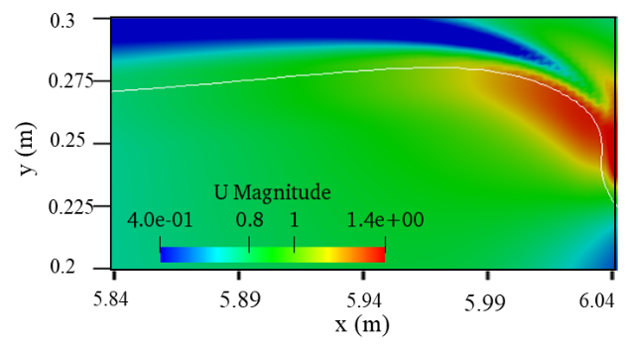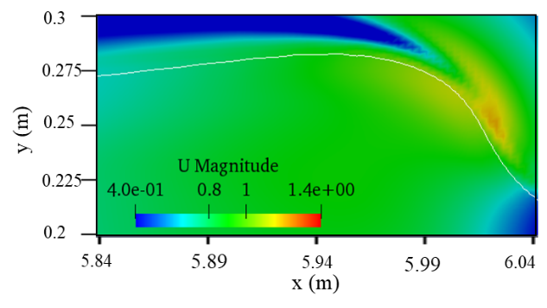
(c) InterFoam at t= 2.57 s (d) DW-IBVOF at t= 2.57 s.
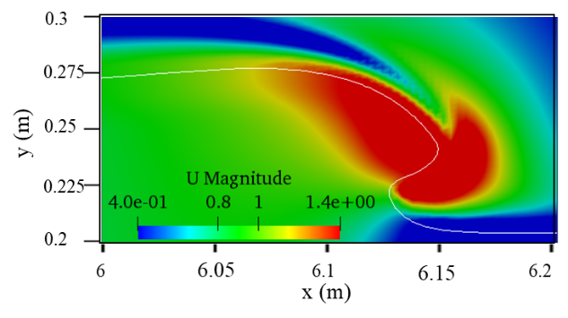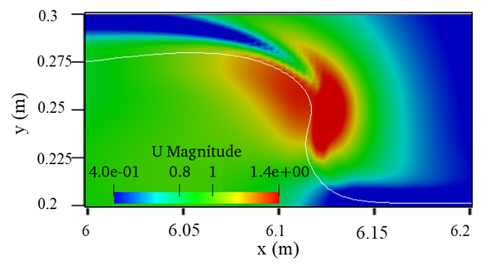
(e) InterFoam at t= 2.64 s (f) DW-IBVOF at t= 2.64 s.
Fig. 23. Comparison of velocity field with interFoam and DW-IBVOF solvers at different times
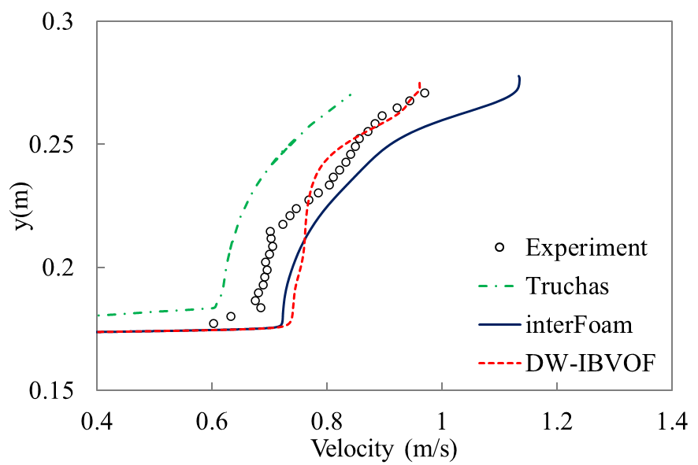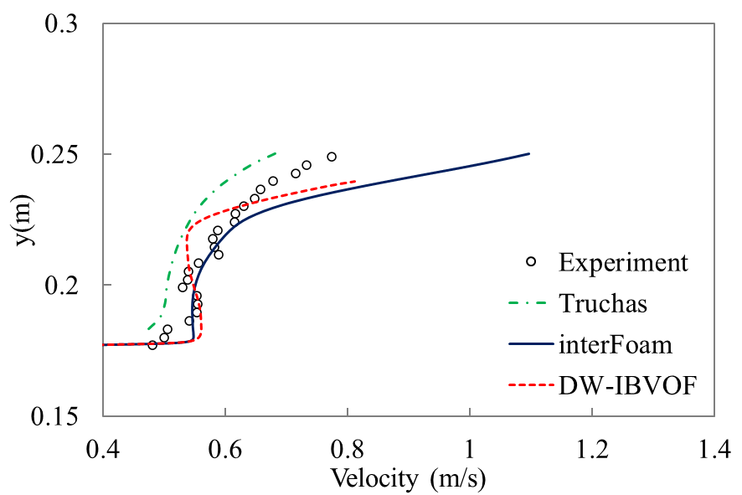
(a) Section x= 5.94 m (b) Section x= 5.98m
Fig. 24. Vertical profiles of horizontal velocity at t= 2.525 s.
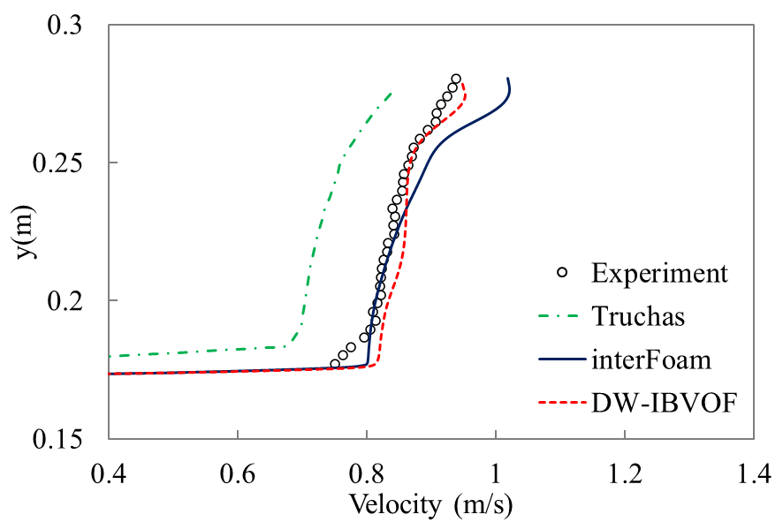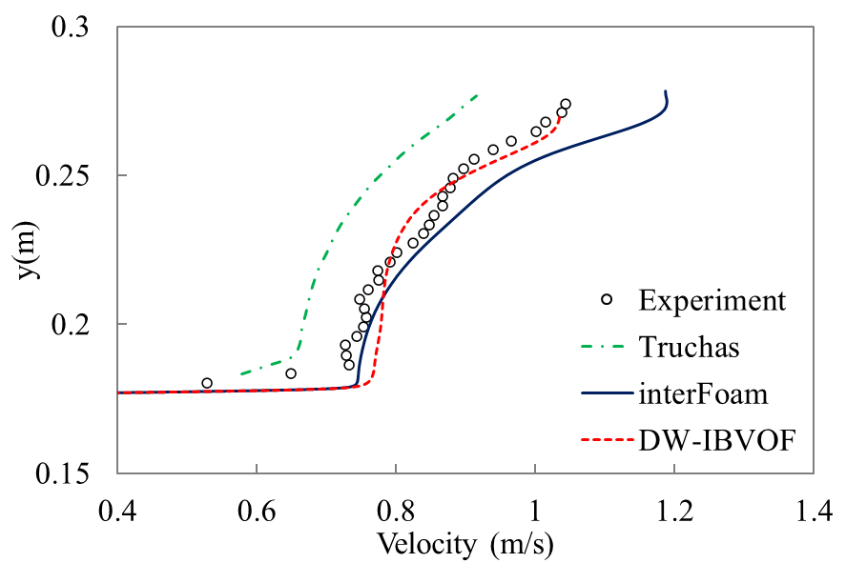
(a) Section x= 5.94 m (b) Section x= 5.98m
Fig. 25. Vertical profiles of horizontal velocity at t= 2.57s
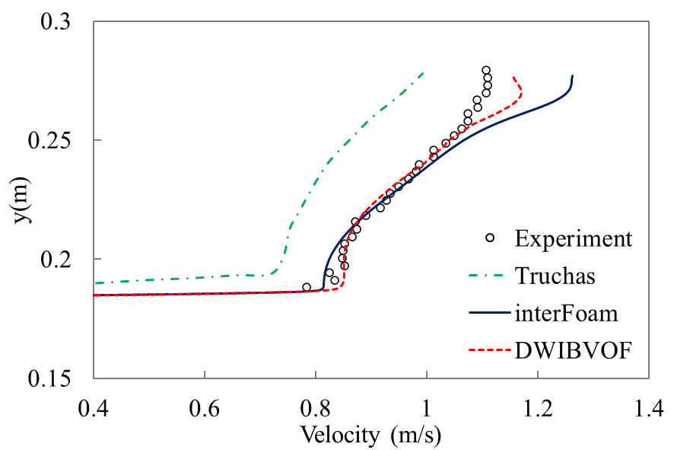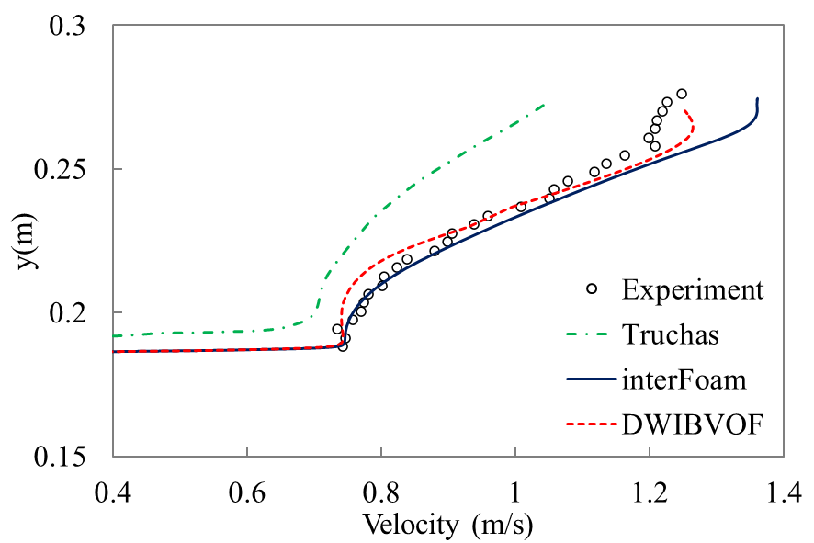
(a) Section x= 6.094 m (b) Section x= 6.098m
Fig. 26. Vertical profiles of horizontal velocity at t= 2.64s
In general, the velocity profiles with the interFoam and the DW-IBVOF solvers in present work compare satisfactorily with the experimental observation, both in the magnitude and the shape. Similar to case 4.1 and 4.2, strong air flows are induced with a series of vortices in both air and water. As shown in the figures, the high velocity always presents in the results obtained with the interFoam closed to the free surface and gradually decreases alongside the vertical direction. The discrepancies between the numerical simulations and experimental date are larger at sections x= 5.98m and x= 6.098 m which are closed to the wave front, which is the source of the observed overturned plunging breaker.

5. Conclusions
In this paper, a combined volume of fluid and immersed boundary method has been developed for the viscous free surface simulations induced by solitary waves. This work is based on a typical two-phase flow solver and to deal with spurious velocities caused by the momentum interpolation errors across the interface. A density-weight smoothing (DW) method is developed to extend the water slightly below the interface to the air velocity slightly above the interface in a physical manner, so that a thin boundary layer is built on the air phase side. Such treatment improves the accuracy and stability of high-density ratio two-phase flow simulations.
To accurately predict the behaviors of free surface with strong air-water inactions, it is critical to develop a high-fidelity and robust solver that can handle the moving boundaries. The comparison between the DW-IBVOF results with the original interFoam further validate the proposed numerical method. The spurious velocities are eliminated especially on the tips of the wave front and the regions near the free surface, and the gradient of velocity are corrected.
Several cases have been used to validate the new two-phase flow solver. In the first case, a simple two-dimensional test case, transport of a very-high density fluid droplet in a stagnant air, has been simulated on three different meshes. The source of the spurious velocity has been identified and investigated. Though monotonic grid convergence of the original solver interFoam has been observed, the spurious velocity cannot be eliminated by mesh refinement. Then, two two-dimensional no-viscous benchmark tests, the propagation and the run-up of a solitary wave, have been carried out. The free surface profiles and velocity fields have been compared with theorical results or one-phase flow solver results, and better agreement has been obtained with the proposed DW-IBVOF solver.
Finally, the simulations of the new solver have been extended to three-dimensional cases. Viscosities of both phases and surface tension are added and RANS turbulent model is used. The case of plunging breaking solitary waves on a slope further verified the solver in the applications in the real world. The spurious velocity in the water phase near the interface finally results in the fake deformation of the interface. The proposed density-weight smoothing (DW) method and the designed boundary layer on the interface suppress the spurious velocities and improve the accuracy and stability of air-water flow simulations.
The following process of wave breaking and its action with the slope are worth investigating in the design of offshore structure, however, is beyond the scope of the present work. Further applications of this solver in large scale wave-body interaction problems should be investigated in the future work.

Acknowledgements
This research was supported by the University of Southampton, the China Scholarship Council No 201706950085 and the Major International (Regional) Joint Research Program of China (Grant NO. 51720105011).
References
[1] U. Kânoǧlu, C.E. Synolakis, Long wave runup on piecewise linear topographies, J. Fluid Mech. (1998). https://doi.org/10.1017/S0022112098002468.
[2] S.T. Grilli, I.A. Svendsen, Computation of nonlinear wave kinematics during propagation and runup on a slope, PROC. NATO Adv. Res. Work. WATER WAVE KINEMATICS, Ser. E Appl. Sci. MOLDE, NORWAY, MAY 22-25, 1989 }E. (1990). https://doi.org/10.1007/978-94-009-0531-3_24.
[3] P.L.F. Liu, Y.S. Cho, M.J. Briggs, U. Kanoglu, C.E. Synolakis, Runup of solitary waves on a circular Island, J. Fluid Mech. (1995). https://doi.org/10.1017/S0022112095004095.
[4] V. Vladimirovitch Titov, C. Emmanuel Synolakis, Modeling of breaking and nonbreaking long-wave evolution and runup using vtcs-2, J. Waterw. Port, Coast. Ocean Eng. (1995). https://doi.org/10.1061/(ASCE)0733-950X(1995)121:6(308).
[5] J.A. Zelt, The run-up of nonbreaking and breaking solitary waves, Coast. Eng. (1991). https://doi.org/10.1016/0378-3839(91)90003-Y.
[6] P. Lin, K.A. Chang, P.L.F. Liu, Runup and rundown of solitary waves on sloping beaches, J. Waterw. Port, Coast. Ocean Eng. (1999). https://doi.org/10.1061/(ASCE)0733-950X(1999)125:5(247).
[7] Q. Zhao, S. Armfield, K. Tanimoto, Numerical simulation of breaking waves by a multi-scale turbulence model, Coast. Eng. (2004). https://doi.org/10.1016/j.coastaleng.2003.12.002.
[8] E.D. Christensen, R. Deigaard, Large eddy simulation of breaking waves, Coast. Eng. (2001). https://doi.org/10.1016/S0378-3839(00)00049-1.
[9] F. Stern, J. Yang, Z. Wang, H. Sadat-Hosseini, M. Mousaviraad, Computational ship hydrodynamics: Nowadays and way forward, in: Int. Shipbuild. Prog., 2013. https://doi.org/10.3233/ISP-130090.
[10] M. Alagan Chella, H. Bihs, D. Myrhaug, M. Muskulus, Hydrodynamic characteristics and geometric properties of plunging and spilling breakers over impermeable slopes, Ocean Model. 103 (2016) 53–72. https://doi.org/10.1016/j.ocemod.2015.11.011.
[11] M. Alagan Chella, H. Bihs, D. Myrhaug, M. Muskulus, Breaking characteristics and geometric properties of spilling breakers over slopes, Coast. Eng. (2015). https://doi.org/10.1016/j.coastaleng.2014.09.003.
[12] A. Aggarwal, H. Bihs, D. Myrhaug, M.A. Chella, Characteristics of breaking irregular wave forces on a monopile, Appl. Ocean Res. (2019). https://doi.org/10.1016/j.apor.2019.06.003.
[13] N.G. Jacobsen, D.R. Fuhrman, J. Fredsøe, A wave generation toolbox for the open-source CFD library: OpenFoam®, Int. J. Numer. Methods Fluids. (2012). https://doi.org/10.1002/fld.2726.
[14] J. Jose, S.J. Choi, K.E.T. Giljarhus, O.T. Gudmestad, A comparison of numerical simulations of breaking wave forces on a monopile structure using two different numerical models based on finite difference and finite volume methods, Ocean Eng. (2017). https://doi.org/10.1016/j.oceaneng.2017.03.045.
[15] W. Mo, A. Jensen, P.L.F. Liu, Plunging solitary wave and its interaction with a slender cylinder on a sloping beach, Ocean Eng. (2013). https://doi.org/10.1016/j.oceaneng.2013.09.011.
[16] H.L. Wu, S.C. Hsiao, T.C. Lin, Evolution of a two-layer fluid for solitary waves propagating over a submarine trench, Ocean Eng. (2015). https://doi.org/10.1016/j.oceaneng.2015.10.004.
[17] P.A. Wroniszewski, J.C.G. Verschaeve, G.K. Pedersen, Benchmarking of Navier-Stokes codes for free surface simulations by means of a solitary wave, Coast. Eng. (2014). https://doi.org/10.1016/j.coastaleng.2014.04.012.
[18] O. Desjardins, V. Moureau, Methods for multiphase flows with high density ratio, Cent. Turbul. Res. Proc. Summer Progr. (2010).
[19] S. Tanguy, T. Ménard, A. Berlemont, A Level Set Method for vaporizing two-phase flows, J. Comput. Phys. (2007). https://doi.org/10.1016/j.jcp.2006.07.003.
[20] F. Gibou, L. Chen, D. Nguyen, S. Banerjee, A level set based sharp interface method for the multiphase incompressible Navier-Stokes equations with phase change, J. Comput. Phys. (2007). https://doi.org/10.1016/j.jcp.2006.07.035.
[21] V. Vukčević, H. Jasak, I. Gatin, Implementation of the Ghost Fluid Method for free surface flows in polyhedral Finite Volume framework, Comput. Fluids. (2017). https://doi.org/10.1016/j.compfluid.2017.05.003.
[22] J. Yang, F. Stern, Sharp interface immersed-boundary/level-set method for wave-body interactions, J. Comput. Phys. (2009). https://doi.org/10.1016/j.jcp.2009.05.047.
[23] R. Mittal, G. Iaccarino, Immersed boundary methods, Annu. Rev. Fluid Mech. (2005). https://doi.org/10.1146/annurev.fluid.37.061903.175743.
[24] J. Xin, F. Shi, Q. Jin, C. Lin, A radial basis function based ghost cell method with improved mass conservation for complex moving boundary flows, Comput. Fluids. (2018). https://doi.org/10.1016/j.compfluid.2018.09.004.
[25] J.Y. Shao, C. Shu, Y.T. Chew, Development of an immersed boundary-phase field-lattice boltzmann method for neumann boundary condition to study contact line dynamics, J. Comput. Phys. (2013). https://doi.org/10.1016/j.jcp.2012.08.040.
[26] Z. Li, J. Favier, U. D’Ortona, S. Poncet, An immersed boundary-lattice Boltzmann method for single- and multi-component fluid flows, J. Comput. Phys. 304 (2016) 424–440. https://doi.org/10.1016/j.jcp.2015.10.026.
[27] Q. Jin, D. Hudson, W.G. Price, A Combined Volume of Fluid and Immersed Boundary Method for Modelling of Two-Phase Flows with High Density Ratio, J. Fluids Eng. (2021) 1–39. https://doi.org/10.1115/1.4052242.
[28] OpenFOAM, Open∇FOAM - The Open Source CFD Toolbox - User Guide, OpenFOAM Found. (2014). https://doi.org/10.1023/A.
[29] W.F. Pfeffer, The Divergence Theorem, Trans. Am. Math. Soc. (1986). https://doi.org/10.2307/2000057.
[30] C.M. Klaij, M. Hoekstra, G. Vaz, Design, analysis and verification of a volume-of-fluid model with interface-capturing scheme, Comput. Fluids. (2018). https://doi.org/10.1016/j.compfluid.2018.05.016.
[31] D.A. Hoang, V. van Steijn, L.M. Portela, M.T. Kreutzer, C.R. Kleijn, Benchmark numerical simulations of segmented two-phase flows in microchannels using the Volume of Fluid method, Comput. Fluids. (2013). https://doi.org/10.1016/j.compfluid.2013.06.024.
[32] A. Albadawi, D.B. Donoghue, A.J. Robinson, D.B. Murray, Y.M.C. Delauré, Influence of surface tension implementation in Volume of Fluid and coupled Volume of Fluid with Level Set methods for bubble growth and detachment, Int. J. Multiph. Flow. (2013). https://doi.org/10.1016/j.ijmultiphaseflow.2013.01.005.
[33] T.C. Fu, T.T. O’Shea, C.Q. Judge, D. Dommermuth, K. Brucker, D.C. Wyatt, A detailed assessment of numerical flow analysis (NFA) to predict the hydrodynamics of a deep-V planing hull, in: Int. Shipbuild. Prog., 2013: pp. 143–169. https://doi.org/10.3233/ISP-130087.
[34] B. Lafaurie, C. Nardone, R. Scardovelli, S. Zaleski, G. Zanetti, Modelling merging and fragmentation in multiphase flows with SURFER, J. Comput. Phys. (1994). https://doi.org/10.1006/jcph.1994.1123.
[35] G.K. Pedersen, E. Lindstrøm, A.F. Bertelsen, A. Jensen, D. Laskovski, G. Sælevik, Runup and boundary layers on sloping beaches, Phys. Fluids. (2013). https://doi.org/10.1063/1.4773327.
[36] G. Chen, C. Kharif, S. Zaleski, J. Li, Two-dimensional Navier-Stokes simulation of breaking waves, Phys. Fluids. (1999). https://doi.org/10.1063/1.869907.
[37] J.U. Brackbill, D.B. Kothe, C. Zemach, A continuum method for modeling surface tension, J. Comput. Phys. (1992). https://doi.org/10.1016/0021-9991(92)90240-Y.
[38] M. Bussmann, D.B. Kothe, J.M. Sicilian, Modeling high density ratio incompressible interfacial flows, in: Am. Soc. Mech. Eng. Fluids Eng. Div. FED, 2002. https://doi.org/10.1115/FEDSM2002-31125.
[39] V. Le Chenadec, H. Pitsch, A monotonicity preserving conservative sharp interface flow solver for high density ratio two-phase flows, J. Comput. Phys. (2013). https://doi.org/10.1016/j.jcp.2013.04.027.
[40] J. Fenton, A ninth-order solution for the solitary wave, J. Fluid Mech. (1972). https://doi.org/10.1017/S002211207200014X.
[41] J. Roenby, H. Bredmose, H. Jasak, A computational method for sharp interface advection, R. Soc. Open Sci. (2016). https://doi.org/10.1098/rsos.160405.
[42] H.K. Versteeg, W. Malalasekera, G. Orsi, J.H. Ferziger, A.W. Date, J.D. Anderson, An Introduction to Computational Fluid Dynamics - The Finite Volume Method, 1995.
[43] B.M. Sumer, M.B. Sen, I. Karagali, B. Ceren, J. Fredsøe, M. Sottile, L. Zilioli, D.R. Fuhrman, Flow and sediment transport induced by a plunging solitary wave, J. Geophys. Res. Ocean. (2011). https://doi.org/10.1029/2010JC006435.
[44] C. Lin, P.H. Yeh, M.J. Kao, M.H. Yu, S.C. Hsieh, S.C. Chang, T.R. Wu, C.P. Tsai, Velocity fields in near-bottom and boundary layer flows in prebreaking zone of a solitary wave propagating over a 1:10 slope, J. Waterw. Port, Coast. Ocean Eng. (2015). https://doi.org/10.1061/(ASCE)WW.1943-5460.0000269.

