A systematic review of emerging contaminants in the Greater Bay Area (GBA), China: current baselines, knowledge gaps, and research and management priorities.

Author names and affiliations
Cundy, A.B.^{a,b}*, Rowlands, F.M.ª, Lu, G.^{b,c}, Wang, W.-X.^{b, c, d}

ª GAU-Radioanalytical, School of Ocean and Earth Science, University of Southampton, National Oceanography Centre (Southampton), Southampton, SO14 3ZH, U.K.
^{b} Southern Marine Science and Engineering Guangdong Laboratory (Guangzhou), Guangzhou, 511458, China
^{c} Research Center for the Oceans and Human Health, City University of Hong Kong Shenzhen Research Institute, Shenzhen 51807, China
^{d} School of Energy and Environment, State Key Laboratory of Marine Pollution, City University of Hong Kong, Kowloon, Hong Kong, China
*Corresponding author: A.Cundy@soton.ac.uk

Abstract.
Development of the Greater Bay area, China (GBA) has imposed significant pressures on ecosystems within the wider Pearl River Delta (PRD) system, including through inputs of contaminants from the GBA’s rapidly expanding urban, industrial and agricultural activities. Here, we assess publication trends, sampling focus, and concentrations observed for a range of emerging contaminants (pharmaceutical and personal care products, pesticides, other endocrine disrupting chemicals, platinum group elements, and microplastics) in the GBA, via a systematic review of papers (n = 407) indexed in Science Direct, SpringerLink and Wiley Online databases. While emerging contaminants form the focus of increasing numbers of publications since 2006, they are understudied compared to more traditionally-measured contaminants (here, DDT and polycyclic aromatic hydrocarbons, PAHs). BisphenolA was the most widely studied of the emerging contaminants (n = 41 studies) in the GBA, followed by macrolides (n = 32 studies). While multiple point measurements with high precision and low detection limits have been reported for various emerging contaminants, these have not been integrated for management purposes. A relatively high percentage of studies present data from single deployments (48% of studies, despite strong seasonality in the PRD system), data coverage is variable spatially, and reported contaminant concentrations vary significantly (over one to four orders of magnitude). We assess the currently published knowledge under the Source-Pathway-Receptor contaminant linkage model and use this to identify (a) current research emphasis in relation to assessment of contaminant risk, and (b) key knowledge gaps around sources, pathways and receptors in the GBA system.

Highlights:
- A systematic review was performed on emerging contaminant data from the GBA, China
- Emerging contaminants are understudied compared to “traditional” contaminants
- Key knowledge gaps remain around sources, pathways and receptors
- Available data do however provide a baseline dataset to inform future studies

Keywords: Pearl River Estuary; Pearl River Delta; emerging contaminants; risk management; environmental baseline.
- Introduction:
As a fulcrum of China’s “Belt and Road” strategy, the Guangdong-Hong Kong-Macao Greater Bay area (the Greater Bay Area or GBA) of China is a national initiative highlighted in the Chinese government’s 13th Five Year Plan. This initiative aims to build a globally competitive business, financial, industry, science and innovation metropolitan area in Southern China (historically called the Pearl River Delta Metropolitan region), consisting of nine large cities in the Pearl River Delta (PRD) of Guangdong Province, and two special administrative regions (SARs) of the People’s Republic of China– Hong Kong and Macao (Figure 1). The GBA will add to the limited list of other mega-regions globally including the Tokyo-Osaka mega region in Japan, and the Northeast Corridor and the San Francisco Bay Area of the United States (www.cnbayarea.org.cn). The GBA is situated in the Pearl River Delta system, with eight major river inputs on its western side and significant seasonal influences from oceanic waters in the south. Human activities have strongly affected the morphology and biogeochemistry of the PRD system. By the end of 2020, the area was home to 86 million people (Constitutional and Mainland Affairs Bureau, 2021). Occupying less than one percent of China’s land space, the GBA contributes about 11 percent of China’s economic output (about 11.6 trillion RMB or 1.67 trillion US dollars, Constitutional and Mainland Affairs Bureau, 2021). The GBA has become one of the most economically developed and urbanized regions of China, hosting the country’s largest exporters and technology firms, and forming China’s e-commerce industrial base (PwC, 2017; Yang et al., 2021).

As the policies of the Greater Bay Area are further implemented, the region is expected to play an even more important role in supporting China’s international trade activities, and enhancing the regional connections between China and other nations. The heart of the GBA initiative is the development of four core cities: Hong Kong (international financial, shipping, trading, and aviation hub), Shenzhen (national innovation and technology hub, R&D centre), Guangzhou (a leading state-level city and provincial political, economic, cultural, and transportation hub) and Macau (connector for Lusophone countries, tourism, and leisure hub) (PwC, 2017; Constitutional and Mainland Affairs Bureau, 2021). Economically, the GBA is also supported by high value-added manufacturing, pharmaceutical industries, energy, and other industries from other cities, including Zhuhai, Foshan, Huizhou, Dongguan, Zhongshan, Jiangmen and Zhaoqing, which have an important role in supporting the development of the core productivity cluster.

As the “world’s factory”, South China’s Guangdong Province is home to nearly 3 million industrial companies, and the manufacturing output of the GBA is significant on a world scale (Wu et al., 2021a). Historically, from the 1990s, the Pearl River Estuary and Delta has been a major manufacturing centre for electronic products, toys, textiles and clothing, and plastic products. Currently, the top 8 manufacturing segments (in terms of scale) within the GBA are computing, communications and other electronic equipment, electrical machinery and equipment, automobiles, metal ware, chemical materials and products, nonmetallic minerals, rubber and plastics, and textiles and apparel (PwC, 2017). This manufacturing activity, and the rapid urban development of the area, has led to release of a range of potentially toxic elements and compounds into the local and regional environment, including the toxic metals zinc, lead, and cadmium, organic contaminants including polycyclic aromatic hydrocarbons (PAHs), polychlorinated biphenyls (PCBs), and brominated organic compounds, and various organic micropollutants (e.g. pharmaceuticals and endocrine disruptors, Wang & Rainbow, 2020). In addition, the GBA is one of the most important regions in China for agriculture and aquaculture, with widespread use of nutrients, pesticides and antimicrobial compounds. These anthropogenic activities and related contaminant discharges have caused a significant deterioration of water quality over the past 40 years. Previous studies have reported high concentrations of trace metals (Cd, Cr, Cu, Ni, Pb, As, Hg, and Zn) and pesticides (e.g. DDT at 976 ng/L in Daya Bay water, and at 1500 ng/g in crabs, and OCPs at 3.95 ng/g in sediments), PAHs (1370 ng/g in sediments, Pintado-Herrera et al., 2017 and 522 ng/L in PRD waters), antibiotics (VAs, OFL, ETM, and CIP), endocrine-disrupting chemicals (EDCs) (e.g. alkylphenol octylphenol (OP) at 3366 ng/L, nonylphenol (NP) at 581 ng/L, and phthalate esters (PAEs) at 47.3 μg/g in riverine sediments), alternative halogenated flame retardants (e.g. Tetrabromosphenol A (TBBPA) at 2830 pg/L in river water and 3268 pg/L in suspended particles, He et al., 2016), and pharmaceuticals and personal care products (PPCPs, at 267 ng/g in shellfish and fish), in soils, river waters, sediments, and organisms in the GBA (Wang & Hao, 2020; Wang & Rainbow, 2020; Liu et al., 2019).

Figure 1 The Greater Bay Area of China, and its constituent eleven cities.

Therefore, in common with many coastal urbanised areas, there is increasing concern in the Pearl River Estuary and the wider Pearl River Delta both around the impacts of those contaminants that have traditionally been measured in environmental monitoring programmes (e.g. trace metals, and persistent organic contaminants such as DDT, persistent chlorinated organics, polycyclic aromatic hydrocarbons etc.) and of a suite of newer or emerging organic and inorganic contaminants (substances which are not yet, or which have only recently been, regulated but which may be of environmental or human health concern), consisting of a range of pharmaceutical and personal care product residues (inter alia illicit drug metabolites), perfluoroalkyl compounds, plasticisers, newly formulated pesticides, platinum group elements (PGE), and microplastics. These emerging contaminants (ECs) are derived from various sources within the PRD and GBA, notably waste water treatment works, e-wastes recycling, and pharmaceutical facilities, but also from non-point sources such as run-off from streets and agricultural land (Richardson and Ternes, 2018). Despite their presence at typically ug/L or sub-ug/L concentrations, residues of several ECs have been observed to cause biological disruption/dysfunction, and generational effects, in exposed organisms via a number of mechanisms including endocrine dysfunction (Chen et al., 2018a; Thomas et al., 2018; Gibson et al., 2021). Given the global concern around these contaminants (e.g. Kolpin et al., 2002; Petrie et al., 2015; Costa et al., 2019; Gaston et al., 2019) and their relative environmental ubiquity in water, sediment and biota (e.g. Celis-Hernandez et al., 2021), there is an urgent need to: (a) better understand their sources, and the pathways through which they enter fluvial, coastal and marine ecosystems; and (b) assess their ecosystem and human health risks, and develop practical methods that can be applied to limit these risks. This applies particularly in heavily developed (and still rapidly urbanising) systems such as the Pearl River Delta and GBA, where elevated concentrations of various emerging contaminants (such as antibiotics, EDCs, flame retardants and pharmaceuticals and personal care products) have been identified (see above), where multiple chemical stressors and exposure pathways are present, and where contaminant inputs (and accumulation in various environmental receptors) may continue to increase without significant risk mitigation interventions (e.g. Gibson et al., 2021).

Here, we review the international academic literature published between 1980 and 2019 (inclusive, n = 407 studies) on contaminants in the Pearl River Delta (PRD) system, focusing both on those contaminants more traditionally monitored in environmental systems (here, DDT and polycyclic aromatic hydrocarbons, PAHs) and on a range of emerging contaminants (representing pharmaceutical and personal care products (specifically macrolides, diclofenac and triclosan), other pesticides (specifically chlorpyrifos and pyrethroid pesticides), other endocrine disrupting chemicals (specifically estradiol and bisphenol A), perfluorinated substances, platinum group elements, and microplastics). We assess publication trends by contaminant and over time, the focus of the available data (in terms of sampling timescales, sampled media, and the sub-environments of the PRD sampled), and the concentrations observed. Based on this, we assess the currently published knowledge under the Source-Pathway-Receptor contaminant linkage “model”, and use this to identify gaps in the current understanding of emerging contaminant risk, and the information and data required to fill these gaps and allow more effective, integrated, risk assessment and management of these contaminants in the PRD system.
- Methods:
Data collection: an initial literature search was carried out using the databases of Science Direct, SpringerLink and Wiley Online from January 1980 – December 2019. We recognise that, by excluding Chinese language literature and grey literature (e.g. unpublished government reports, some PhD theses) which may not be indexed in these databases, we have not encompassed all data published on the Greater Bay area within our review. The databases used however include publications from over 4000 journals, giving an extensive database of accessible, international publications, including by core research groups and organisations working in the PRD system. We argue therefore that this provides a sufficient selection of publications to assess publication trends, and publication focus, although we recognise that this focus on internationally-indexed publications may slightly skew earlier trends in numbers of publications (given an earlier focus by Chinese researchers on publishing in Chinese language journals (Xie and Freeman, 2019)). Two key terms were used in each search (Table 1), key term 1 represented the location and key term 2 represented the specific contaminant or contaminant group.

Table 1: Search terms used for literature search (rationale behind choice of specific contaminant is given in main text, under Keywords Selection).
Key term 1 | Key term 2 | Key term 2 Contaminant Group (for emerging contaminants)
Macau | Platinum group elements | Emerging trace metal contaminants
Hong Kong | Microplastics | Plastics
Shenzhen | DDT** | -
Guangdong | Chlorpyrifos | Pesticide
Greater Bay area* | Pyrethroids | Pesticide
Pearl River Estuary | Macrolides | Antibiotics, Pharmaceutical and Personal Care Products (PPCPs)
Pearl River Delta | Diclofenac | Anti-inflammatory, Pharmaceutical and Personal Care Products (PPCPs)
 | Triclosan | Pharmaceutical and Personal Care Products (PPCPs)
 | Estradiol | Steroidal hormone
 | Perfluorinated (to cover PFAS and derivatives) | Perfluorinated substances
 | Bisphenol A | Plastic monomer and plasticizer
 | PAH** | -
 | Radiometric / 210Pb | N/A
*Note: Greater Bay area was removed as a search term after the first two searches, due to the large number of irrelevant articles returned. This was an artefact of the searches giving results just for the “Bay” part of the search term, such as San Francisco Bay.
** Included to allow comparison of publication trends on emerging contaminants with those for more traditionally measured or monitored contaminants.
Keywords selection: contaminants were selected to represent key groups (or sources) of emerging contaminants, taking into account local usage and regulatory regimes, with two examples of contaminants more traditionally monitored in environmental systems (here, DDT and polycyclic aromatic hydrocarbons, PAHs, representing long-established and well-recognised pesticide and coal/oil/wood-burning derived contaminants) also included, for comparison. Specifically, for the emerging contaminants, the following contaminants or contaminant groups were chosen (Table 1): Emerging trace metal contaminants (from e-wastes recycling, automobile emissions, and other sources) - Platinum group elements; Pesticides - Chlorpyrifos (organophosphate pesticide used on crops, animals, and buildings), and Pyrethroids (commercial and household insecticides); Pharmaceutical and Personal Care Products (PPCPs) - macrolides (class of antibiotics), diclofenac (anti-inflammatory drug), and triclosan (antibacterial and antifungal agent); Steroidal hormones - estradiol; Plastics and plasticisers - bisphenol A, and microplastics; and Perfluorinated substances (a wide class of halogenated so-called “forever chemicals”, made up of carbon chains to which fluorine atoms are bound, which are of increasing international concern and research focus, e.g. Chohan et al., 2020). An additional term, “radiometric/210Pb” was included to incorporate literature using dated sediment core analysis of spatial and temporal contaminant trends.
Data cleaning and analysis: the resultant list of published literature was then filtered to include only research articles. The abstracts or materials and methods sections of the remaining research articles were examined to determine whether they met the criteria for the study. In the above example, only papers involving both Hong Kong and microplastics were used, as per the search term. Papers only concerning Hong Kong, and those only concerning microplastics, were discarded. Further discrimination was applied to remove those papers concerning laboratory studies using ex situ biota (e.g. in laboratory dosing studies), as the focus of the study was the “Delta” environment itself. Journal articles which involved only microcosm / bench studies were also discounted, even if they used materials from the study area. The exception to this was studies which stated a specific (relatively reproducible) sample site location with a pollutant concentration for that site. For biota, the samples had to be taken from the study area specifically for the purpose of the study – studies using samples bought from markets were discounted as the exact provenance of the biota sample was not defined. Papers from the watershed of the Pearl River Estuary only were selected, despite the search term Guangdong covering a large area. Areas outside the watershed, estuary, or the sea immediately below the mouth of the estuary were discounted (e.g. Daya Bay). In total, 407 articles were retained for further analysis (listed in full, alongside their classifications (see below), in Appendix A).
The references were incorporated into a Microsoft Excel database for subsequent analysis, with full bibliographic information (including year of publication, and contaminant(s) of focus). References were classified using each of the following classification criteria: Sampling timescale; Section of system; Focus of study; and Risk Category (as described in Appendix B), and plotted graphically for analysis of trends and differences.

- Results:
3.1 Publication trends by contaminant, and over time.
Classifying the studies by contaminant of focus (Figure 2) showed a dominance of papers on more traditionally-monitored contaminants, represented here by DDT and PAHs (54% of papers). BisphenolA was the most widely studied of the emerging contaminants (n = 41 studies) in the GBA, followed by macrolides (n = 32 studies), then estradiol, triclosan and microplastics (n = 20 – 30 studies). All other contaminants were mentioned in less than 20 studies. Assessing publication trends over time (Figure 3), the first papers analysing emerging contaminants in the GBA appear from 2006, with an increasing number of publications post-2015 (although this recent increase is less clearly seen in the data for chlorpyrifos and pyrethroid insecticides). DDT shows a significantly longer publication history, with publication numbers peaking in the period 2005 – 2011 (Figure 3c) (while DDT was banned for use as a pesticide in China in 1983, its use continued as an insecticide in Dicofol (trade name Kelthane), a nonsystemic acaricide extensively used for controlling mites that damage cotton, fruit trees, and vegetables (Qiu et al., 2005), the production of which terminated in 2014). PAHs (Figure 3d) show a similar long publication history, although recent (post-2011) publications on this contaminant group are more common than those for DDT (studied in 23% of total 2016-2019 papers, compared to 10% for DDT).

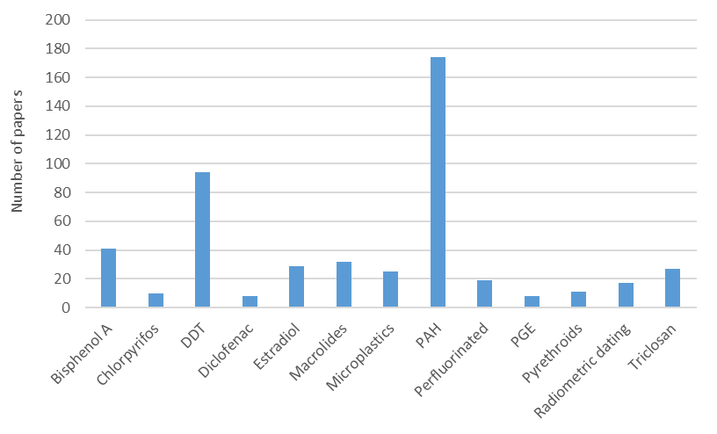
Figure 2: Numbers of studies examining different emerging contaminants (by representative compound group or indicator contaminant) in the PRD, over the period January 1980 – December 2019. Data are also shown for the more established and traditionally measured contaminants DDT and polycyclic aromatic hydrocarbons (PAH), for comparison. PGE = Platinum Group Elements.

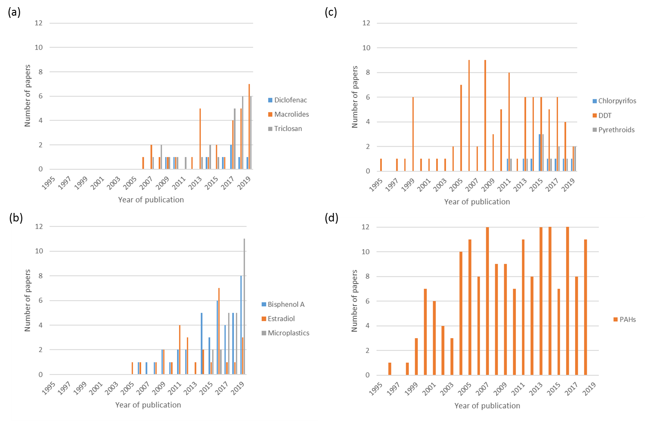
Figure 3: Publication trends with time for (a) selected pharmaceutical and personal care products (PPCPs – diclofenac, macrolides, triclosan), (b) plasticiser/additive bisphenol A, estradiol (and related compounds), and microplastics, (c) chlorpyrifos, DDT, and pyrethroid pesticides, and (d) PAHs, in published studies on the GBA.

3.2 Sampling timescales and sampling focus.
The data presented in the literature for the study contaminants in the wider PRD system cover a range of sampling or deployment timescales (Figure 4). A relatively high percentage of studies present data from a one-off, or single, deployment (48% of studies). Given the strongly seasonal climate in the PRD system (which is heavily influenced by the Asian monsoon), there is also a focus on seasonal sampling (in 22% of studies). Longer-term datasets, and presentation of data from sediment core studies (which, when combined with radiometric or other dating, provide a decadal plus chronology of particle reactive contaminant inputs to the PRD system), are less frequently presented (<8% of studies). Reported sampling timescales are similar for both the traditionally-monitored and emerging contaminants studied, although there is a greater emphasis on seasonal sampling than one-off sampling for bisphenol A, Triclosan and Diclofenac (Appendix C, Figure C.1).

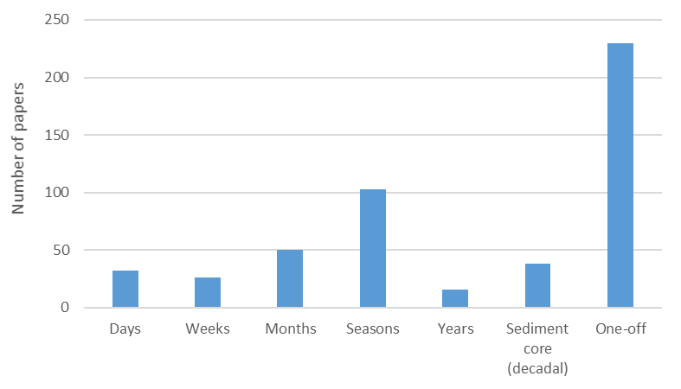
Figure 4: Reported sampling timescales in PRD literature, or periods over which samples were collected for study. Studies using dated sediment cores are referred to as “Sediment core (Decadal)” while “One-off” refers to studies where a single sample collection phase or deployment was undertaken. Y-axis shows number of studies.

The published studies also focus on different components of the PRD system (Figure 5), with riverine sections of the delta system sampled and published on most frequently, followed by Soil and Freshwater Wetland, then Sub-tidal and Marine (see Appendix B for sub-system definitions). Relatively few studies (< 7%) can be classed as system-wide (i.e. where the study has included two or more of the listed environmental compartments). When assessing the studies based on the target (sampled) medium or environmental receptor (i.e. the receiving environment), most studies focus on sediment (soils, riverine or inter-tidal / marine sediments, but also sewage sludges) or water (and to a lesser extent atmospheric sampling), or a combination of these. The percentage of studies examining human health, or concentrations in biota (non-seafood, includes vegetation, diatoms, invertebrates and marine mammals, and seafood, those organisms typically consumed by the local population) were relatively low, each at < 8% of studies.
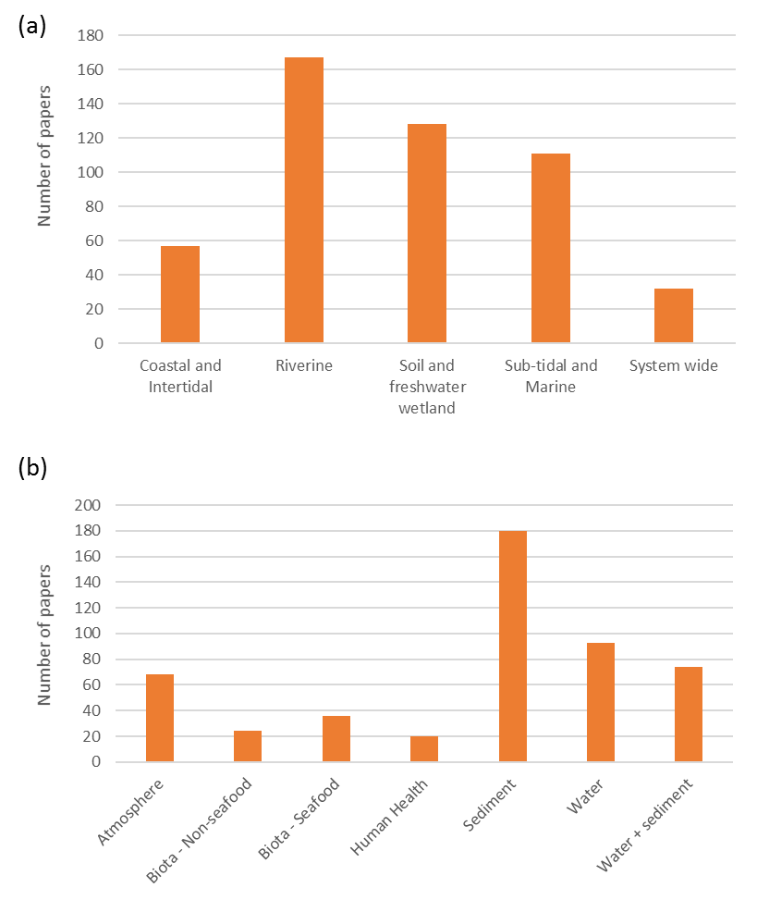

Figure 5: Sampling focus within reviewed PRD literature. Y-axes show number of papers, X-axis shows sampling focus by (sub)environment (a), and by sampling medium or environmental receptor (b).

3.3 Emerging contaminant concentrations in the PRD system: current baselines.
The studies analysed present often single deployment (or single location) datasets, targeting different sampling media and sub-components of the PRD system, with data collected using different sampling methods (and reported using different units). For example, water sampling methods reported in 26 studies of macrolides and other antibiotics in the PRD apply pre-filtration with filter mesh sizes ranging from 0.22um to 1um or greater, therefore removing varying size fractions of suspended colloidal material prior to analysis (for 3 studies, no pre-filtering is reported). Given these factors, it is difficult to systematically compare concentrations observed within and across the PRD system (and indeed with other environments globally). Table 2 however summarises the concentrations observed in different media for those emerging contaminants showing a larger available dataset (n > 20 published studies). Bisphenol A was the most widely studied of the emerging contaminants (n = 41 studies), followed by macrolides (n = 32 studies), then estradiol (and related compounds), triclosan and microplastics (all > 20 studies). Concentrations reported vary significantly, over one to four orders of magnitude, and coverage is highly variable spatially, for example over 50% of studies presenting microplastics data are focused on the Hong Kong region. Water and sediment data are reported far more frequently than other media, e.g. air or biological media. A number of studies examine wet season versus dry season contaminant concentrations (bold italicised in Table 2), most commonly for bisphenol A, although given the large variability in the reported data no consistent trends for enrichment in dry season over wet season concentrations (or vice versa) in either water or sediment can be identified. In terms of contaminant levels observed, measured concentrations of BPA and macrolides are consistent with those reported previously in other Asian river and coastal systems (which similarly show high variability between lowest and highest observed concentrations, Corrales et al., 2015, Schafhauser et al. 2018, Quoc Anh et al., 2021). For estradiol and related compounds, reported estrone (E1) concentrations typically exceed those of 17 β-estradiol (E2), although concentrations observed are again highly variable within and between different media, and maximum concentrations for both E1 and E2 are within ranges reported elsewhere in Asia (and in Europe, e.g. Nazari and Suja 2016). Triclosan concentrations have been previously noted to be relatively high in Pearl River system waters (Bedoux et al., 2012), with maximum water concentrations in excess of 1000ng/l (Table 2). Despite a relatively short expected environmental half-life (Bedoux et al., 2012), triclosan has been reported at high ng/g concentrations in sediments particularly during the dry season, and at pg/g to ng/g levels in fish and other organisms (Table 2). Reported microplastic concentrations vary over four orders of magnitude in water samples, and three orders of magnitude in sediments, although this is consistent with the highly variable concentrations reported at other locations and reflects a combination of spatial contaminant heterogeneity and differences in sampling methods (with consequent differing recoveries and microplastics size selectivity, highlighted by Fok and Cheung, 2015 and others). Fok and Cheung (2015) note high abundances of microplastics on Hong Kong beaches (5595 items/m²) compared to international averages, with a dominance of expanded polystyrene debris argued to be derived from container and insulation debris in the Pearl River.

Table 2: Range of baseline concentrations (where reported) observed for selected pharmaceutical and personal care products (PPCPs – macrolides, triclosan), microplastics and the plasticiser/additive bisphenol A, and estradiol and related compounds, in published studies on the PRD (2006 – 2019, inclusive).

Contaminant | Average concentrations in water (various units) | Average concentrations in sediment (various units) | Other media | References
Bisphenol A | 12.41-62.78 ng/l; 13.7-91.2 ng/l; 43.5-639.1 ng/l; 75.6-7480 ng/l; 11 – 777 ng/l; 5.84-469 ng/l; 6-881 ng/l; 60-720 pg/l; 429 ng/l; 4-377 ng/l; 2.2-1030 ng/l; 13.7-91.2 ng/L in river water, 2.3-97.6 ng/L in suspended sediment from the Guangzhou-Dongguan reaches of the PRD;  nd-604.2 ng/l in Shenzhen rivers’ waters. Wet/dry season data: 6200/2570, 107/95.3, 2.3-892/2.69-1340, 34.8-608.8/41.7-250.2, 19/7.1, 64.5/69.5 (all ng/l). | 970 ng/g; 2.31-13.16 ng/g; 1.7-430 ng/g; 128 ng/g; 0.11-359 ng/g; 12.8-298.4 ng/g; 3 – 156 ng/g; 0.6-4 ng/g; 218 ng/g; 80-400 ng/g; 8 ng/g; 868 ng/g. Wet/dry season data: 42.9/37.7, 2.54-269/6.47-433; 232/196 (all ng/g). | Mussel (green-lipped and common blue): 105.3 ng/g dw; Clam: 0.49-1.34 ng/g dw; Mullet: 0.19-1.27 ng/g dw; Chub: 38-81 ng/g (dorsal muscle); Algae: 16-94 ng/g dw; Carp: 70-1020 ng/g; Fish: <LOQ – 6.01 ng/g; Shellfish: <LOQ – 396 ng/g; Fish: 47.6/179 ng/g ww (wet/dry season) | Chen et al., 2016; Chiu et al., 2018; Diao et al., 2017; Gong et al., 2009, 2011, 2012, 2016, 2019; Huang et al., 2018; Li et al., 2019; Liu et al., 2010; Lv et al., 2019; Peng et al., 2006, 2008, 2017a, 2017b, 2018; Xiong et al., 2016; Xu et al., 2014a, 2014b, 2015, 2016; Yamazaki et al., 2015; Yang et al., 2014; Yuan et al., 2015; Zhao et al., 2009, 2019.  Gong et al., 2015 (in Chinese);  Liang & Zong, 2013 (in Chinese)
Macrolides | Total macrolides: 22.8 - 216 ng/l; 29.9/30.2 ng/l (wet / dry season); Erythromycin: 890.5 ng/l, 12 ng/l, 455 – 2980 ng/l, 1 – 315 ng/l, 5.2 ng/l, 6 – 53.6 ng/l, <LOQ – 1578 ng/l, 10.1 ng/l. Roxithromycin: 31.5 ng/l, 13 ng/l, 92 – 428 ng/l, 1 – 105 ng/l, 21.1 ng/l, 0.7 – 4.1 ng/l. | Total macrolides: 197 ng/g, 16.5/13.8 ng/g (wet/dry season); Erythromycin: 10.4 ug/kg, <LOQ – 385 / <LOQ - 55.9 ug/kg (wet / dry season); Roxithromycin: 2.1 ng/g, 2.96 ug/kg, 69.6 ug/kg, <LOQ -122 / <LOQ - 40.9 ug/kg. | Carp: Erythromycin: Up to 2390 μg/kg ww (liver). | Chen et al., 2013; Deng et al., 2018; Gulkowska et al., 2008; Huang et al., 2018; Li et al., 2013, 2018a; Minh et al., 2009; Selvam et al., 2017; Su et al., 2014; Tang et al., 2019; Xu et al., 2007; Xu et al., 2013; Yang et al., 2010; Zhang et al., 2018; Zhao et al., 2015a.
Estradiol and related compounds | Estrone: <LOQ – 1.2 ng/l, 1.5 – 8.2 ng/l, 8.4 – 62.8 ng/l, <LOQ – 2.4 ng/l, <LOQ – 1.5, <LOQ – 76 ng/l, 1 ng/l / <LOQ (wet/dry season); 17 β-estradiol: 1 – 1.7 ng/l, <LOQ – 7.5 ng/l, nd-1.2 ng/l in river water, nd-0.32 ng/L in suspended particles in river water from the Guangzhou-Dongguan reaches of the PRD, 8.15 / 35.7 ng/l (wet/dry season); 17 α-ethynilestradiol: 10 – 269 ng/l, 2.9 ng/l, <LOQ – 3.43 ng/l, nd-11.6 ng/l in Shenzhen rivers’ waters; E2 activity equivalents: <LOQ – 40.7 ng/l, 0.07 – 8.06 ng/l; | Estrone: 1.3-10.9 ng/g, <LOQ – 14.4 ng/g, <LOQ – 4.7 ng/g, 9.5 / 1.5 ng/g (wet/dry season); 17 β-estradiol: 0.9 – 2.6 ng/g; 17 α-ethynilestradiol: 7 – 144 n/g, 4.4 ng/g. | Carp: E2 activity equivalents: 1.2-10.97 ng/g. | Chen et al., 2016; Fang et al., 2012; Gong et al., 2009, 2011, 2012, 2016, 2019; Liu et al., 2010, Lv et al., 2019; Peng et al., 2008; Xu et al., 2014b, 2016; Yang et al, 2014; Yuan et al., 2015; Zhao et al., 2009. Gong et al., 2015 (in Chinese); Liang & Zong, 2013 (in Chinese)
Triclosan | 4.1 – 117 ng/l; 25.3 ng/l; <LOQ – 29.2 ng/l; 612 ng/l; 305 – 1023 ng/l; 16 - 99 ng/l; <LOQ – 478 ng/l; 0.6 - 347 ng/l; 5.06-253/1.81-282 ng/l (wet season/dry season range). | <LOQ – 64.9 ng/g; 36.9 ng/g; 0.44 – 216 ng/g; 127 ng/g; 41.7 ng/g; 32.6 ng/g; 1.84 ng/g; 53.8 ng/g; 353 ng/g; <LOQ – 1329 ng/g; 0.87-199 / 0.84-689 ng/g (wet season / dry season range). | Bream: 262 ng/g lipid; Carp: 10 ng/g lipid; Shellfish: 261 pg/g ww; Miscellaneous fish: 25.8 – 40.8 ng/g, <LOQ – 79.5 ng/g ww. | Chau et al., 2008; Chen et al., 2014, 2018b; Fan et al., 2019a; Huang et al., 2018; Lu et al., 2019; Peng et al., 2008, 2017a, 2017b, 2018; Pintado-Herrera et al., 2017; Wu et al., 2007; Yao et al., 2018; Yu et al., 2011; Zhang et al., 2015; Zhao et al., 2009, 2010.
Microplastics | 3.6 items/m³;  7.4 items/m³;  0.57 items / l; 379 to 7924 items/m³; 51 to 27,909 items per 100 m³; 19,860 items/m³ (urban) and 8902 items/m³ (estuary). | 685 items/kg; 258 items/kg; 889-5595 items/m²; 6838 items / m²; 80 to 9597 items / kg; 0.58 and 2116 items/kg; 49 to 279 items/kg; 178-544 items/kg; 347 items/m² | Demersal fish: 54% of fish stomachs contained microplastic (hard fragments and fibres); Oyster: 1.5 to 7.2 items per gram tissue wet weight; Oyster: 0.62 items/g (ww); Tilapia: 27.4 items/individual, Carp: 0.2 items/individual. | Chan et al., 2019; Cheung et al., 2016, 2018, 2019; Fan et al., 2019b; Fok and Cheung, 2015; Fok et al., 2017; Li et al., 2018b; Lin et al., 2018; Lo et al., 2018; Teng et al., 2019; Tsang et al., 2017; Wang et al, 2017; Yan et al., 2019; Zhao et al, 2015b; Zheng et al., 2019
Notes: Contaminants are listed in order of total number of studies published.

- Discussion:
  - Overview of current data coverage for emerging contaminants in the PRD.
There is an increasing literature (from 2006) on a range of emerging contaminants in the Pearl River Delta system, although numbers of publications are significantly lower than those reporting more traditionally monitored contaminants (here, DDT and PAHs). A relatively high percentage of published studies present data from one-off or single deployments (48% of studies) which, given the strongly seasonal climate in the PRD system (which is heavily influenced by the Asian monsoon), is unlikely to effectively capture likely seasonal variations in inputs and in observed concentrations (although as noted above there is greater emphasis on seasonal sampling than one-off sampling in bisphenol A, Triclosan and Diclofenac literature). In addition, relatively few studies have examined concentrations and their variation across different sub-environments of the PRD (freshwater, terrestrial, estuarine, marine, atmospheric). For example, of 32 papers reporting macrolide concentrations in the PRD (Table 2, Appendix A), 10 report concentrations in samples taken spatially along a sampling transect, but sampling in 8 of these 10 studies is confined to riverine (freshwater and freshwater tidal) sections of the Pearl River only. A more integrated study was published by Xu et al. (2013), who presented data for antibiotics (including the macrolides erythromycin and roxithromycin) in water at eight major run-off outlets and sixteen estuarine and marine sampling stations in the PRE, during both wet and dry seasons, to investigate annual antibiotic mass flux and assess consequent ecological and ecosystem risk. This study, and similar integrated studies (e.g. Peng et al., 2017b, for BPA and a range of personal care products), do allow system-wide assessments to be made of specific emerging contaminant concentrations and sources (and risk) at particular times and time intervals (e.g. Figure 6, where antibiotic inputs from the Shenzhen Bay area can be clearly discerned in both wet and dry season samples). As noted in section 3.3 however different studies apply different sampling, preparation and reporting methods, meaning that it is difficult to systematically compare published concentrations observed within and across the PRD system between different studies (and at different times), and with other environments globally. Similar concerns have been raised elsewhere for example on the presentation and comparison of microplastics concentrations in different studies (e.g. Waldschläger et al. 2020). Effectively, much of the available data for the PRD present multiple point measurements, often with great precision and low detection limits, but these are not integrated for management purposes (Figure 4, 5, Table 2).

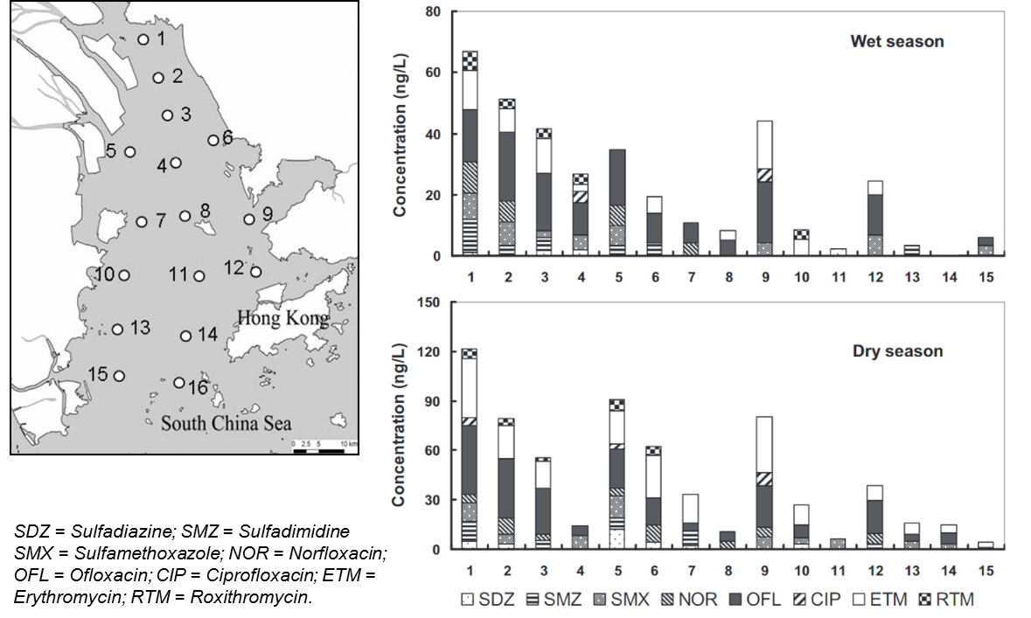
Figure 6: Antibiotics (including the macrolides erythromycin and roxithromycin) detected in water samples at sixteen estuarine and marine sampling stations in the PRE, 2009/2010 (data and figure adapted from Xu et al., 2013). Site 16 is not shown in the graphical figure because no antibiotics were detected at this site.
  - Using the Source-Pathway-Receptor model to identify current knowledge gaps in environmental risk from emerging contaminants.
A widely used method for assessing and managing contaminant risk, particularly in the international contaminated land sector as part of risk-based land management, is the Source-Pathway-Receptor (SPR) or contaminant linkage model (Figure 7). For a risk to be present, a source (of hazardous substance or property), a receptor (that could be affected adversely by the contamination) and a pathway (linking the source to the receptor) must be present. A risk management intervention can take place at any point in the SPR linkage provided that it breaks the linkage, which might be by removing the source, intercepting the pathway, or modifying the receptor behaviour or location. Application of the SPR (and linked) model(s) has been previously discussed for the identification of the current gaps in knowledge around transport processes and ecotoxicological risk from microplastics (Waldschläger et al. 2020), and for developing integrated sediment and contaminant management strategies for post-industrial coasts (Bardos et al., 2020). As noted by Waldschläger et al. (2020) a major advantage of the SPR model is its simplicity, its flexibility and the ability to identify relationships in complex systems. Assessing the current published knowledge for the PRD under the Source-Pathway-Receptor contaminant linkage “model” can provide a useful framework to assess the utility of these data for examining system risk (and potential risk mitigation strategies) due to emerging contaminants. For the PRD, our contaminant publication database can be classified based on the components of the Source-Pathway-Receptor framework (Figure 7). Here, publications are categorised as referring to: Source (where the source of the contaminant in question is one of the main discussion points, for example PAHs released by vehicle emissions into the atmosphere); Pathway (where the study focuses on how the contaminant is transferred through the system, such as atmospheric deposition onto soils); and Receptor (where the pollutant is aggregated over time). This last term has been ascribed to studies where the concentration of the pollutant is determined as a finite end point, such as in a sediment sample or fish tissue, unless there is further discussion such as re-suspension of solids or eating of fish. Studies are classed as “Integrated” when the study considered two or more aspects of the contaminant linkage or SPR framework. Although this classification is somewhat subjective, assessment of the published data (Figure 7a) split by sampling media/focus shows a predominance of receptor-focused studies (largely based on sediments as receptors, n = 96, followed by studies on biota used for human consumption (biota – seafood), n = 31). Fewer studies focus on sources (most commonly soil/sedimentary (n = 27) and atmospheric (n = 24) sources) and pathways (most commonly covering water (n = 39) and atmospheric (n = 34) transport pathways), and there are fewer still which consider more than one component of the relevant contaminant linkage (“Integrated”, Figure 7). In these more integrative studies, soil/sediment and water/sediment-based contaminant linkages are most commonly examined (n = 15 and 14, respectively). There is a relative lack of integrated data (covering each of source, pathway AND receptor) (a) through which overall risk from individual contaminants and contaminant linkages can be examined, particularly to ecological and human health receptors, and (b) which can be used for targeted risk management interventions (e.g. to identify which critical pathways need to be managed, which receptors are most at risk, etc). Assessing the data in a similar way by individual contaminant (or contaminant group) shows a similar focus on receptors (with the exception of PAHs (where source, pathway, receptor, and integrated, studies are relatively common), and from the emerging contaminants assessed, macrolides (where source and receptor studies are equally common) and estradiol (where there is a dominance of pathway studies)), and relative lack of integrated studies (Figure 7b). In combination with the data presented in Figures 4 and 5, and Table 2, Figure 7 highlights both the current research emphasis in the published data in relation to the assessment of contaminant risk, and key knowledge gaps around sources, pathways and receptors in the GBA system. These knowledge gaps include:
Source: Given the relative paucity of studies on contaminant sources (particularly for chlorpyrifos, diclofenac, estradiol, perfluorinated compounds, PGE and pyrethroids, Figure 7b), what are the relative extent of point-source vs non-point inputs, and how do these vary seasonally and with extreme climatic conditions? Source identification is a major challenge in the PRD system given the very complicated hydrodynamic nature of the wider Pearl River estuary. For some contaminants (e.g. PGE), differentiating the contributions of natural sources versus anthropogenic inputs remains difficult (although the use of isotope “fingerprinting” of other metals may provide useful insights, e.g. Cundy and Croudace 2017, Ma et al., 2020, Wu et al., 2021b).
Pathway: Given the current sampling focus on different components of the PRD system (Figure 5), which are the main areas of contaminant accumulation across the PRD system for different emerging contaminant groups? While currently published data examine both water and sediment concentrations for a range of emerging contaminants (e.g. Table 2), to what extent do contaminants locally partition between water and suspended and deposited particulate matter (including different parts of the water column, e.g. is accumulation in the surface microlayer observed, Anderson et al., 2018) and how is this partitioning influenced by expected contaminant distribution coefficients or Log K_{ow}, and local environmental conditions (e.g. Liang et al., 2013)? What is the extent of contaminant sequestration and breakdown in sediments, and what is the role of biotic and UV-light driven contaminant degradation in surface waters (e.g. Wang et al., 2020)?
Receptor: While previous studies have examined emerging contaminant concentrations in a range of fish and shellfish species (Table 2), organism-based receptor studies vary according to contaminant type. For example, macrolide concentrations have been reported relatively widely in sediments, but not in biological receptors such as fish (Zhao et al., 2015a apart), despite their potential to bioaccumulate and generate genetic and histologic alterations in fish tissue, even at environmental exposure levels (Yang et al., 2020). Similarly, target species vary between publications (e.g. Table 2). The impacts on lower trophic level organisms are currently unclear, as are pathways for bioaccumulation. A number of published papers have examined concentrations of multiple contaminant groups in individual organisms (e.g. Leung et al., 2005, Guo et al., 2008), but are there possible synergistic impacts from the presence of (and exposure to) a wide “suite” of emerging contaminants? Given the strong seasonality and complex nature of the PRD, can the impacts of trace contaminants on organism and ecosystem function be differentiated from natural variability?
And more generally, what are the current fluxes of emerging contaminants through the PRD, and are these increasing over time?
These are important research questions and topics to address if we are to understand fully the environmental cycling of, and physical, chemical and biological accumulation or attenuation processes for, emerging contaminants in the PRD, and use this understanding to develop cost-effective contaminant mitigation strategies. These mitigation strategies include those which use and enhance the natural system attenuation capacity to reduce fluxes through the system (targeting contaminant pathways), and which can complement source reduction measures such as regulation, policy changes, use of alternative chemicals, improved effluent and wastewater treatment, etc. These enhanced attenuation strategies can include installation or engineering of riparian buffers, sustainable urban drainage systems, constructed wetlands, phytomanagement, and other nature-based solutions, which can operate in tandem with policy/regulatory and “hard” engineered solutions (such as effluent treatment facilities) to enhance contaminant trapping, sorption and breakdown in the PRD system and its various agricultural, industrial and urban environments. In turn, these nature-based strategies can (a) provide wider environmental, economic and societal benefits (e.g. flood control, air quality benefits, carbon sequestration and other ecosystem service benefits, Song et al., 2019, Bardos et al., 2020), (b) support ecological restoration (e.g. Cundy et al., 2021, Duan et al., 2021), and (c) link with regional and national plans (e.g. the ‘Sponge cities’ plan, ICLEI, 2017, Qi et al., 2020) to increase resilience to future climate change. Successful application of these enhanced attenuation or nature-based strategies requires rigorous understanding of contaminant accumulation and (bio)degradation processes in sedimentary and biological systems, and systematic measurements over time of contaminant inputs, outputs and fluxes (e.g. Environment Agency, 2000).

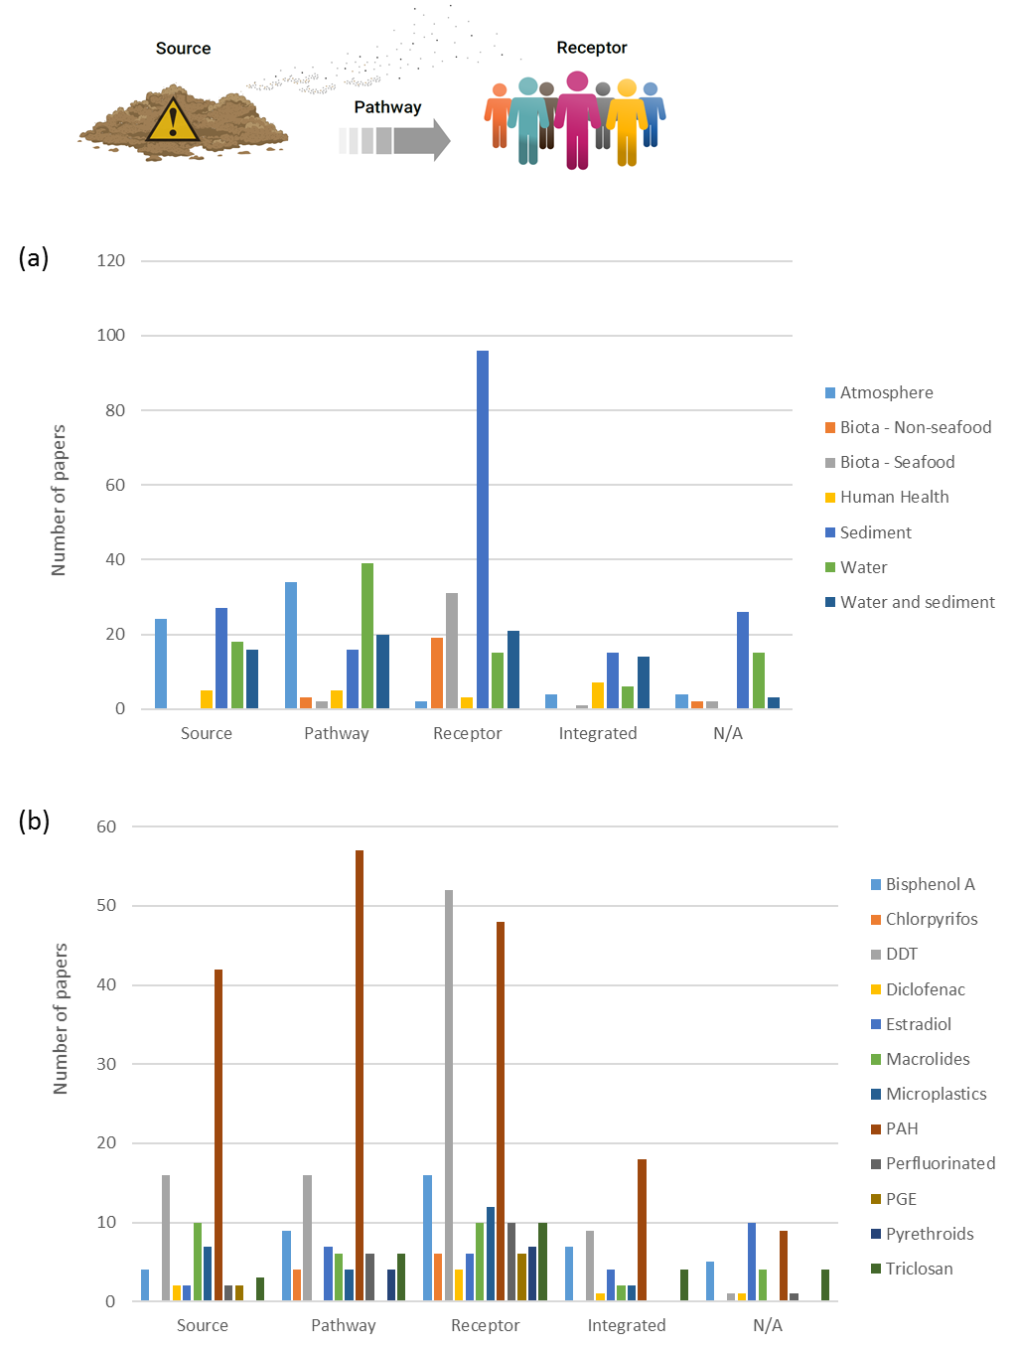
Figure 7: (a) Focus of published literature from the PRD (split by sampling medium / focus) on different components of the source, pathway, receptor linkage for management of risk. Y-axis scale shows number of publications. (b) As (a), but split by contaminant or contaminant group. Upper, inset, figure schematically illustrates the S-P-R or contaminant linkages concept – see text for further discussion.
4.3 Environmental baselines, and integrated sampling approaches.
Despite the knowledge gaps outlined in sections 4.1 and 4.2, the available data do provide a baseline dataset to target and frame (a) further studies and monitoring programmes, by identifying possible contaminant “hot-spots” (either spatially or in different environmental media, noting high variability in reported concentrations, Table 2) and (b) contaminant management. For the latter, a key limiting point to note is the dominance of one-off sampling approaches in the literature (Figure 4), and the targeting of different components of the PRD system (Figure 5). As a consequence it is difficult to systematically compare published concentration data, collected over a number of years and in different areas / media, spatially across the PRD and temporally to fully assess the effectiveness of ongoing source and other management activities (e.g. via regulation, policy, changes in use and industrial and agricultural practice etc). A number of PRD studies have however examined emerging contaminant concentrations in various fish, shellfish and other organisms (particularly tilapia Tilapia aurea, carp Cyprinus carpio, oyster Ostrea gigas, and the green-lipped mussel Perna viridis, Table 2), in both wild and (where relevant) farmed organisms. There is potential to use these as sentinel or indicator organisms, and develop time-series of (a) environmental contaminant loadings based on tissue concentrations (for wild organisms), or (b) potential contaminant build up in aquaculture systems (for farmed species), particularly for more soluble or bioavailable contaminants. These would provide valuable data on ecosystem transfer or food chain risk, including to humans through organism consumption. Given the strong salinity and other gradients across the PRD use of different organisms, however, would be required in different parts of the PRD system. There is also utility in assessing dated sedimentary records, either from river and estuarine bed sediments (e.g. Bottcher et al., 2010), or from less disturbed intertidal and fringing mangrove sediments (e.g. Li et al., 2016) to provide decadal-centennial datasets of historical contaminant loading and fluxes (for more particle-reactive and persistent contaminants), in order to set a baseline against which to judge future contaminant trends and the impact of contaminant management strategies. Such studies can also be used to assess the potential trapping, sequestration and breakdown of emerging contaminants within sediment sinks (e.g. Celis-Hernandez et al., 2021) and, cf. the discussion in section 4.2 above, the possibility of using sediment systems as contaminant storage or breakdown areas (e.g. Li et al., 2016; Bardos et al., 2020) to reduce contaminant fluxes through the PRD to the South China Sea.

- Conclusions:
- Based on a systematic review of academic literature published between 1980 and 2019 (inclusive), while emerging contaminants form the focus of increasing numbers of publications since 2006, they are relatively understudied in the Pearl River Delta system compared to more traditionally-measured contaminants (in this study, represented by DDT and PAHs). BisphenolA was the most widely studied of the emerging contaminants (n = 41 studies) in the GBA, followed by macrolides (n = 32 studies).
- While multiple point measurements with high precision and low detection limits have been reported for various emerging contaminants in the PRD these have not been integrated for management purposes. Some studies do present a more integrated assessment of emerging contaminant concentrations and their variation across different sub-environments of the PRD (i.e. freshwater, terrestrial, estuarine, marine, atmospheric), but these effectively provide temporal “snap-shots”. Different studies apply different sampling, preparation and reporting methods, and sample different locations or environmental media, meaning that it is difficult to systematically compare emerging contaminant concentrations observed within and across the PRD between different studies (and at different times), and with other environments globally.
- Assessing the currently published knowledge for the Pearl River Delta under the Source-Pathway-Receptor contaminant linkage “model” provides a framework to evaluate the usefulness of the available data in examining system risk from emerging contaminants (and potential risk mitigation strategies). Key knowledge gaps remain around Sources (including the extent of point-source vs non-point inputs, and how these vary seasonally and with extreme climatic conditions), Pathways (including areas of contaminant accumulation in the PRD system for different emerging contaminant groups, contaminant partitioning between water and sediments, and the extent of contaminant sequestration and breakdown in sediments) and Receptors (including impacts on lower trophic level organisms, and possible synergistic impacts from the presence of (and exposure to) a wide “suite” of emerging contaminants).
- Despite these knowledge gaps, the available data do provide a baseline dataset to target and frame further studies and monitoring programmes, particularly using sentinel or indicator organisms. There is also utility in assessing sedimentary records to provide decadal-centennial datasets of historical contaminant loading and fluxes (for more particle-reactive and persistent contaminants), in order to set a baseline against which to judge future contaminant trends and the impact of contaminant management strategies.

Funding:
This work was supported by a collaborative research grant award from the Southern Marine Science and Engineering Guangdong Laboratory (Guangzhou) (GML2019ZD0409) and (SMSEGL20SC01-V). The authors are grateful to two anonymous reviewers for constructive comments that helped improve and clarify this manuscript.

References:
Anderson, Z.T., Cundy, A.B., Croudace, I.W., Warwick, P.E., Celis-Hernandez, O., and Stead, J.L. (2018). A rapid method for assessing the accumulation of microplastics in the sea surface microlayer (SML) of estuarine systems. Scientific Reports, 8:9428 | DOI:10.1038/s41598-018-27612-w.
Bardos, R. P., Spencer, K. L., Ward, R. D., Maco, B. H., and Cundy, A. B. (2020). Integrated and Sustainable Management of Post-industrial Coasts. Frontiers in Environmental Science, 8:86, https://doi.org/10.3389/fenvs.2020.00086
Bedoux, G., Roig, B., Thomas, O., Dupont, V., and Le Bot, B. (2012). Occurrence and toxicity of antimicrobial triclosan and by-products in the environment. Environmental Science and Pollution Research, 19, 1044–1065.
Böttcher, M. E., Voss, M., Schulz-Bull, D., Schneider, R., Leipe, T., and Knöller, K. (2010). Environmental changes in the Pearl River Estuary (China) as reflected by light stable isotopes and organic contaminants. Journal of Marine Systems, 82, suppl., Supplement 1: S43-S53, doi:10.1016/j.jmarsys.2010.02.004
Celis-Hernandez, O., Cundy, A. B., Croudace, I. W., Ward, R. D., Busquets, R. and Wilkinson, J. L. (2021). Assessing the role of the “estuarine filter” for emerging contaminants: pharmaceuticals, perfluoroalkyl compounds and plasticisers in sediment cores from two contrasting systems in the southern U.K. Water Research, 189, 116610. https://doi.org/10.1016/j.watres.2020.116610
Chan, H. S. H., Dingle, C., and Not, C. (2019). Evidence for non-selective ingestion of microplastic in demersal fish. Marine Pollution Bulletin, 149, 110523. https://doi.org/10.1016/j.marpolbul.2019.110523
Chau, W. C., Wu, J. lin, and Cai, Z. (2008). Investigation of levels and fate of triclosan in environmental waters from the analysis of gas chromatography coupled with ion trap mass spectrometry. Chemosphere, 73(1 SUPPL.), 13–17. https://doi.org/10.1016/j.chemosphere.2007.01.087
Chen, Y., Leung, K. S. Y., Wong, J. W. C., and Selvam, A. (2013). Preliminary occurrence studies of antibiotic residues in Hong Kong and Pearl River Delta. Environmental Monitoring and Assessment, 185(1), 745–754. https://doi.org/10.1007/s10661-012-2589-x
Chen, Z. F., Ying, G. G., Liu, Y. S., Zhang, Q. Q., Zhao, J. L., Liu, S. S., Chen, J., Peng, F. J., Lai, H. J., and Pan, C. G. (2014). Triclosan as a surrogate for household biocides: An investigation into biocides in aquatic environments of a highly urbanized region. Water Research, 58, 269–279. https://doi.org/10.1016/j.watres.2014.03.072
Chen, X. W., Zhao, J. L., Liu, Y. S., Hu, L. X., Liu, S. S., and Ying, G. G. (2016). Evaluation of estrogenic activity in the Pearl River by using effect-directed analysis. Environmental Science and Pollution Research, 23(21), 21692–21702. https://doi.org/10.1007/s11356-016-7377-7
Chen, L., Hu, Ch., Tsui, M. M. P., Wang, T., Peterson, D. R., Shi, Q., Lam, P. K. S., Au, T., Lam, J. C. W., and Zhou, B. (2018a). Multigenerational Disruption of the Thyroid Endocrine System in Marine Medaka after a Life-Cycle Exposure to Perfluorobutanesulfonate. Environmental Science and Technology, 52, 4432−4439.
Chen, Z. F., Wen, H. B., Dai, X., Yan, S. C., Zhang, H., Chen, Y. Y., Du, Z., Liu, G., and Cai, Z. (2018b). Contamination and risk profiles of triclosan and triclocarban in sediments from a less urbanized region in China. Journal of Hazardous Materials, 357, 376–383. https://doi.org/10.1016/j.jhazmat.2018.06.020
Cheung, P. K., Cheung, L. T. O., and Fok, L. (2016). Seasonal variation in the abundance of marine plastic debris in the estuary of a subtropical macro-scale drainage basin in South China. Science of the Total Environment, 562, 658–665. https://doi.org/10.1016/j.scitotenv.2016.04.048
Cheung, P. K., Fok, L., Hung, P. L., and Cheung, L. T. O. (2018). Spatio-temporal comparison of neustonic microplastic density in Hong Kong waters under the influence of the Pearl River Estuary. Science of the Total Environment, 628–629, 731–739. https://doi.org/10.1016/j.scitotenv.2018.01.338
Cheung, P. K., Hung, P. L., and Fok, L. (2019). River Microplastic Contamination and Dynamics upon a Rainfall Event in Hong Kong, China. Environmental Processes, 6(1), 253–264. https://doi.org/10.1007/s40710-018-0345-0
Chiu, J. M. Y., Po, B. H. K., Degger, N., Tse, A., Liu, W., Zheng, G., Zhao, D. M., Xu, D., Richardson, B., and Wu, R. S. S. (2018). Contamination and risk implications of endocrine disrupting chemicals along the coastline of China: A systematic study using mussels and semipermeable membrane devices. Science of the Total Environment, 624, 1298–1307. https://doi.org/10.1016/j.scitotenv.2017.12.214
Chohan, A., Petaway, H., Rivera-Diaz, V., Day, A., Colaianni, O., and Keramati, M. (2020). Per and polyfluoroalkyl substances scientific literature review: water exposure, impact on human health, and implications for regulatory reform. Reviews on Environmental Health, 36, 235-259. https://doi.org/10.1515/reveh-2020-0049
Constitutional and Mainland Affairs Bureau (2021). Overview of Greater Bay Area. https://www.bayarea.gov.hk/en/about/overview.html (accessed August 2021).
Corrales, J. Kristofco, L. A., Baylor Steele, W., Yates, B. S., Breed, C. S., Spencer Williams, E., and Brooks, B. W. (2015). Global Assessment of Bisphenol A in the Environment: Review and Analysis of Its Occurrence and Bioaccumulation. Dose Response, 13(3). doi: 10.1177/1559325815598308.
Costa, F., Lago, A., Rocha, V., Barros, O., Costa, L., Vipotnik, Z., Silva, B., and Tavares, T. (2019). A Review on Biological Processes for Pharmaceuticals Wastes Abatement—A Growing Threat to Modern Society. Environmental Science and Technology, 53, 7185-7202.
Cundy, A. B., and Croudace, I. W. (2017). The fate of contaminants and stable Pb isotopes in a changing estuarine environment: 20 years on. Environmental Science & Technology, 51(17), 9488-9497. https://doi.org/10.1021/acs.est.7b00973
Cundy, A.B., LaFreniere, L., Bardos, R.P., Yan, E., Sedivy, R., and Roe, C. (2021). Integrated phytomanagement of a carbon tetrachloride-contaminated site in Murdock, Nebraska (USA). Journal of Cleaner Production, 290, 125190. https://doi.org/10.1016/j.jclepro.2020.125190.
Deng, W. J., Li, N., and Ying, G. G. (2018). Antibiotic distribution, risk assessment, and microbial diversity in river water and sediment in Hong Kong. Environmental Geochemistry and Health, 40(5), 2191–2203. https://doi.org/10.1007/s10653-018-0092-1
Diao, P., Chen, Q., Wang, R., Sun, D., Cai, Z., Wu, H., and Duan, S. (2017). Phenolic endocrine-disrupting compounds in the Pearl River Estuary: Occurrence, bioaccumulation and risk assessment. Science of the Total Environment, 584–585, 1100–1107. https://doi.org/10.1016/j.scitotenv.2017.01.169
Duan, Y., Tang, J., Li, Z., Yang, B., Yan, Y., and Yang, Y. (2021). Vegetated Buffer Zone Restoration Planning in Small Urban Watersheds. Water, 13, 3000. https://doi.org/10.3390/w13213000.
Environment Agency (2000). Guidance on the Assessment and Monitoring of Natural Attenuation of Contaminants in Groundwater. R&D Publication 95, ISBN: 1 85705 263 2, pp 131.
Fan, J. J., Wang, S., Tang, J. P., Zhao, J. L., Wang, L., Wang, J. X., Liu, S. L., Li, F., Long, S. X., and Yang, Y. (2019a). Bioaccumulation of endocrine disrupting compounds in fish with different feeding habits along the largest subtropical river, China. Environmental Pollution, 247, 999–1008. https://doi.org/10.1016/j.envpol.2019.01.113
Fan, Y., Zheng, K., Zhu, Z., Chen, G., and Peng, X. (2019b). Distribution, sedimentary record, and persistence of microplastics in the Pearl River catchment, China. Environmental Pollution, 251, 862–870. https://doi.org/10.1016/j.envpol.2019.05.056
Fang, Y. X., Ying, G. G., Zhao, J. L., Chen, F., Liu, S., Zhang, L. J., and Yang, B. (2012). Assessment of hormonal activities and genotoxicity of industrial effluents using in vitro bioassays combined with chemical analysis. Environmental Toxicology and Chemistry, 31(6), 1273–1282. https://doi.org/10.1002/etc.1811
Fok, L., and Cheung, P. K. (2015). Hong Kong at the Pearl River Estuary: A hotspot of microplastic pollution. Marine Pollution Bulletin, 99(1–2), 112–118. https://doi.org/10.1016/j.marpolbul.2015.07.050
Fok, L., Cheung, P. K., Tang, G., and Li, W. C. (2017). Size distribution of stranded small plastic debris on the coast of Guangdong, South China. Environmental Pollution, 220, 407–412. https://doi.org/10.1016/j.envpol.2016.09.079
Gaston, L., Lapworth, D. J., Stuart, M., and Arnscheidt, J. (2019). Prioritization Approaches for Substances of Emerging Concern in Groundwater: A Critical Review. Environmental Science and Technology, 53, 6107−6122.
Gibson, G., Cundy, A., Kafwamfwa, N., and Stewart, A. (2021). ‘‘Old’’ and ‘‘new’’ contaminants and their management: learning from the past, looking to the future. Environmental Geochemistry and Health. https://doi.org/10.1007/s10653-021-01042-6.
Gong, J., Ran, Y., Chen, D., Yang, Y., and Ma, X. (2009). Occurrence and environmental risk of endocrine-disrupting chemicals in surface waters of the Pearl River, South China. Environmental Monitoring and Assessment, 156(1–4), 199–210. https://doi.org/10.1007/s10661-008-0474-4
Gong, J., Ran, Y., Chen, D. Y., and Yang, Y. (2011). Occurrence of endocrine-disrupting chemicals in riverine sediments from the Pearl River Delta, China. Marine Pollution Bulletin, 63(5–12), 556–563. https://doi.org/10.1016/j.marpolbul.2011.01.026
Gong, J., Ran, Y., Chen, D., Yang, Y., and Zeng, E. Y. (2012). Association of endocrine-disrupting chemicals with total organic carbon in riverine water and suspended particulate matter from the Pearl River, China. Environmental Toxicology and Chemistry, 31(11), 2456–2464. https://doi.org/10.1002/etc.1961
Gong, J., Huang, W., Yang, J., et al. (2015). Occurrence of colloid-bound endocrine-disrupting chemicals in the Pearl River, China. China Environmental Science, 35(2), 617-623 (in Chinese).
Gong, J., Huang, Y., Huang, W., Ran, Y., and Chen, D. (2016). Multiphase partitioning and risk assessment of endocrine-disrupting chemicals in the Pearl River, China. Environmental Toxicology and Chemistry, 35(10), 2474–2482. https://doi.org/10.1002/etc.3419
Gong, J., Ran, Y., Zhang, D., Chen, D., Li, H., and Huang, Y. (2019). Vertical profiles and distributions of aqueous endocrine-disrupting chemicals in different matrices from the Pearl River Delta and the influence of environmental factors. Environmental Pollution, 246, 328–335. https://doi.org/10.1016/j.envpol.2018.12.015
Gulkowska, A., Leung, H. W., So, M. K., Taniyasu, S., Yamashita, N., Yeung, L. W. Y., Richardson, B. J., Lei, A. P., Giesy, J. P., and Lam, P. K. S. (2008). Removal of antibiotics from wastewater by sewage treatment facilities in Hong Kong and Shenzhen, China. Water Research, 42(1–2), 395–403. https://doi.org/10.1016/j.watres.2007.07.031
Guo, L., Qiu, Y., Zhang, G., Zheng, G. J., Lam, P. K. S., and Li, X. (2008). Levels and bioaccumulation of organochlorine pesticides (OCPs) and polybrominated diphenyl ethers (PBDEs) in fishes from the Pearl River estuary and Daya Bay, South China. Environmental Pollution, 152(3), 604–611. https://doi.org/10.1016/j.envpol.2007.06.067
He, M., Li, Q., Zhao, J., et al. (2016). Concentrations and partitioning of halogenated flame retardants in industrial water of Dongjiang River. Environmental Science, 37(7), 2539-2546 (in Chinese).
Huang, C., Wu, L. H., Liu, G. Q., Shi, L., and Guo, Y. (2018). Occurrence and Ecological Risk Assessment of Eight Endocrine-Disrupting Chemicals in Urban River Water and Sediments of South China. Archives of Environmental Contamination and Toxicology, 75(2), 224–235. https://doi.org/10.1007/s00244-018-0527-9
Huang, H., Wu, J., Ye, J., Ye, T., Deng, J., Liang, Y., & Liu, W. (2018). Occurrence, removal, and environmental risks of pharmaceuticals in wastewater treatment plants in south China. Frontiers of Environmental Science and Engineering, 12(6). https://doi.org/10.1007/s11783-018-1053-8
ICLEI. (2017). China’s Sponge City concept: Restoring the urban water cycle through nature-based solutions. Local Governments for Sustainability, https://unfccc.int/files/parties_observers/submissions_from_observers/application/pdf/777.pdf (accessed 17th August 2021).
Kolpin, D. W., Furlong, E. T., Meyer, M. T., Thurman, E. M., Zaugg, S. D., Barber, L. B., and Buxton, H. T. (2002). Pharmaceuticals, hormones, and other organic wastewater contaminants in US streams, 1999-2000: a national reconnaissance. Environmental Science and Technology, 36 (6), 1202-1211.
Leung, C. C. M., Jefferson, T. A., Hung, S. K., Zheng, G. J., Yeung, L. W. Y., Richardson, B. J., and Lam, P. K. S. (2005). Petroleum hydrocarbons, polycyclic aromatic hydrocarbons, organochlorine pesticides and polychlorinated biphenyls in tissues of Indo-Pacific humpback dolphins from south China waters. Marine Pollution Bulletin, 50(12), 1713–1719. https://doi.org/10.1016/j.marpolbul.2005.08.024
Li, W., Shi, Y., Gao, L., Liu, J., and Cai, Y. (2013). Occurrence, distribution and potential affecting factors of antibiotics in sewage sludge of wastewater treatment plants in China. Science of the Total Environment, 445–446, 306–313. https://doi.org/10.1016/j.scitotenv.2012.12.050
Li, R., Xu, H., Chai, M., and Qiu, G-Y. (2016). Distribution and accumulation of mercury and copper in mangrove sediments in Shenzhen, the world’s most rapid urbanized city. Environmental Monitoring and Assessment, 188, 87. https://doi.org/10.1007/s10661-016-5103-z
Li, S., Shi, W., Li, H., Xu, N., Zhang, R., Chen, X., Sun, W., Wen, D., He, S., Pan, J., He, Z., and Fan, Y. (2018a). Antibiotics in water and sediments of rivers and coastal area of Zhuhai City, Pearl River estuary, south China. Science of the Total Environment, 636, 1009–1019. https://doi.org/10.1016/j.scitotenv.2018.04.358
Li, H. X., Ma, L. S., Lin, L., Ni, Z. X., Xu, X. R., Shi, H. H., Yan, Y., Zheng, G. M., and Rittschof, D. (2018b). Microplastics in oysters Saccostrea cucullata along the Pearl River Estuary, China. Environmental Pollution, 236, 619–625. https://doi.org/10.1016/j.envpol.2018.01.083
Li, Z., Zhang, W., and Shan, B. (2019). The effects of urbanization and rainfall on the distribution of, and risks from, phenolic environmental estrogens in river sediment. Environmental Pollution, 250, 1010–1018. https://doi.org/10.1016/j.envpol.2019.04.108
Liang, D., and Zong D.-L. (2013). Pollution investigation of estrogen in major rivers of Shenzhen. Environmental Monitoring Management and Technology, 25(2), 29-32 (in Chinese).
Liang, X., Chen, B., Nie, X., Shi, Z., Huang, X., and Li, X. (2013). The distribution and partitioning of common antibiotics in water and sediment of the Pearl River Estuary, South China. Chemosphere, 92(11), 1410–1416. https://doi.org/10.1016/j.chemosphere.2013.03.044
Lin, L., Zuo, L. Z., Peng, J. P., Cai, L. Q., Fok, L., Yan, Y., Li, H. X., and Xu, X. R. (2018). Occurrence and distribution of microplastics in an urban river: A case study in the Pearl River along Guangzhou City, China. Science of the Total Environment, 644, 375–381. https://doi.org/10.1016/j.scitotenv.2018.06.327
Liu, Y., Guan, Y., Tam, N. F. Y., Mizuno, T., Tsuno, H., and Zhu, W. (2010). Influence of rainfall and basic water quality parameters on the distribution of endocrine-disrupting chemicals in coastal area. Water, Air, and Soil Pollution, 209(1–4), 333–343. https://doi.org/10.1007/s11270-009-0202-x
Liu, C., Lin, S., Jiao, X., et al. (2019). Problems and treatment countermeasures of water environment in Guangdong-Hong Kong-Macao Greater Bay Area. Acta Scientiarum Naturalium Universitatis Pekinensis, 55(6), 1085-1096 (in Chinese).
Lo, H. S., Xu, X., Wong, C. Y., and Cheung, S. G. (2018). Comparisons of microplastic pollution between mudflats and sandy beaches in Hong Kong. Environmental Pollution, 236, 208–217. https://doi.org/10.1016/j.envpol.2018.01.031
Lu, S., Wang, N., Ma, S., Hu, X., Kang, L., and Yu, Y. (2019). Parabens and triclosan in shellfish from Shenzhen coastal waters: Bioindication of pollution and human health risks. Environmental Pollution, 246, 257–263. https://doi.org/10.1016/j.envpol.2018.12.002
Lv, Y. Z., Yao, L., Wang, L., Liu, W. R., Zhao, J. L., He, L. Y., and Ying, G. G. (2019). Bioaccumulation, metabolism, and risk assessment of phenolic endocrine disrupting chemicals in specific tissues of wild fish. Chemosphere, 226, 607–615. https://doi.org/10.1016/j.chemosphere.2019.03.187
Ma, L., Wang, W., Xie, M.-W., Wang, W.-X., and Evans, R.D. (2020). Using Zn Isotopic Signatures for Source Identification in a Contaminated Estuary of Southern China. Environmental Science and Technology, 54, 8, 5140–5149. https://doi.org/10.1021/acs.est.9b05955
Minh, T. B., Leung, H. W., Loi, I. H., Chan, W. H., So, M. K., Mao, J. Q., Choi, D., Lam, J. C. W., Zheng, G., Martin, M., Lee, J. H. W., Lam, P. K. S., and Richardson, B. J. (2009). Antibiotics in the Hong Kong metropolitan area: Ubiquitous distribution and fate in Victoria Harbour. Marine Pollution Bulletin, 58(7), 1052–1062. https://doi.org/10.1016/j.marpolbul.2009.02.004
Nazari, E. and Suja, F. (2016). Effects of 17β-estradiol (E2) on aqueous organisms and its treatment problem: a review. Reviews in Environmental Health, 31(4), 465–491.
Peng, X., Wang, Z., Yang, C., Chen, F., and Mai, B. (2006). Simultaneous determination of endocrine-disrupting phenols and steroid estrogens in sediment by gas chromatography-mass spectrometry. Journal of Chromatography A, 1116(1–2), 51–56. https://doi.org/10.1016/j.chroma.2006.03.017
Peng, X., Yu, Y., Tang, C., Tan, J., Huang, Q., and Wang, Z. (2008). Occurrence of steroid estrogens, endocrine-disrupting phenols, and acid pharmaceutical residues in urban riverine water of the Pearl River Delta, South China. Science of the Total Environment, 397(1–3), 158–166. https://doi.org/10.1016/j.scitotenv.2008.02.059
Peng, F. J., Pan, C. G., Zhang, M., Zhang, N. S., Windfeld, R., Salvito, D., Selck, H., Van den Brink, P. J., and Ying, G. G. (2017a). Occurrence and ecological risk assessment of emerging organic chemicals in urban rivers: Guangzhou as a case study in China. Science of the Total Environment, 589, 46–55. https://doi.org/10.1016/j.scitotenv.2017.02.200
Peng, X., Xiong, S., Ou, W., Wang, Z., Tan, J., Jin, J., Tang, C., Liu, J., and Fan, Y. (2017b). Persistence, temporal and spatial profiles of ultraviolet absorbents and phenolic personal care products in riverine and estuarine sediment of the Pearl River catchment, China. Journal of Hazardous Materials, 323, 139–146. https://doi.org/10.1016/j.jhazmat.2016.05.020
Peng, X., Zheng, K., Liu, J., Fan, Y., Tang, C., and Xiong, S. (2018). Body size–dependent bioaccumulation, tissue distribution, and trophic and maternal transfer of phenolic endocrine-disrupting contaminants in a freshwater ecosystem. Environmental Toxicology and Chemistry, 37(7), 1811–1823. https://doi.org/10.1002/etc.4150
Petrie, B., Barden, R., and Kasprzyk-Hordern, B. (2015). A review on emerging contaminants in wastewaters and the environment: current knowledge, understudied areas and recommendations for future monitoring. Water Research, 72, 3-27.
Pintado-Herrera, M. G., Wang, C., Lu, J., Chang, Y. P., Chen, W., Li, X., and Lara-Martín, P. A. (2017). Distribution, mass inventories, and ecological risk assessment of legacy and emerging contaminants in sediments from the Pearl River Estuary in China. Journal of Hazardous Materials, 323, 128–138. https://doi.org/10.1016/j.jhazmat.2016.02.046
PwC (2017). New opportunities for the Guangdong-Hong Kong-Macau Greater Bay Area. PricewaterhouseCoopers, report SG-20170711-1-C2, available at: https://www.pwchk.com/en/research-and-insights/editors-pick/new-opportunities-for-the-guangdong-hong-kong-macau-greater-bay-area.pdf (accessed May 2021).
Qi, Y., Chan, F.K.S., Thorne, C., O’Donnell, E., Quagliolo, C., Comino, E., Pezzoli, A., Li, L., Griffiths, J., Sang, Y., and Feng, M. (2020). Addressing challenges of urban water management in Chinese Sponge Cities via nature-based solutions. Water, 12, 2788, https://doi.org/10.3390/w12102788.
Qiu, X., Zhu, T., Yao, B., Hu, J., and Hu, S. (2005). Contribution of Dicofol to the Current DDT Pollution in China. Environmental Science and Technology, 39 (12), 4385-4390. DOI: 10.1021/es050342a
Quoc Anh, H., et al. (2021), Antibiotics in surface water of East and Southeast Asian countries: A focused review on contamination status, pollution sources, potential risks, and future perspectives. Science of the Total Environment, 764, 142865.
Richardson, S. and Ternes, T. A. (2018). Water analysis: emerging contaminants and current Issues. Analytical Chemistry, 90, 398−428.
Schafhauser, B. H., Kristofco, L. A., de Oliveira, C. M. R., and Brooks, B. W. (2018). Global review and analysis of erythromycin in the environment: Occurrence, bioaccumulation and antibiotic resistance hazards. Environmental Pollution, 238, 440-451. https://doi.org/10.1016/j.envpol.2018.03.052
Selvam, A., Kwok, K., Chen, Y., Cheung, A., Leung, K. S. Y., and Wong, J. W. C. (2017). Influence of livestock activities on residue antibiotic levels of rivers in Hong Kong. Environmental Science and Pollution Research International, 24(10), 9058–9066. https://doi.org/10.1007/s11356-016-6338-5
Song, Y., Kirkwood, N., Maksimović, C., Zheng, X., O’Connor, D., Jin, Y., and Hou, D. (2019) Nature based solutions for contaminated land remediation and brownfield redevelopment in cities: A review. Science of the Total Environment, 663, 568-579. https://doi.org/10.1016/j.scitotenv.2019.01.347.
Su, H. C., Pan, C. G., Ying, G. G., Zhao, J. L., Zhou, L. J., Liu, Y. S., Tao, R., Zhang, R. Q., and He, L. Y. (2014). Contamination profiles of antibiotic resistance genes in the sediments at a catchment scale. Science of the Total Environment, 490, 708–714. https://doi.org/10.1016/j.scitotenv.2014.05.060
Tang, J., Wang, S., Fan, J., Long, S., Wang, L., Tang, C., Tam, N. F., and Yang, Y. (2019). Predicting distribution coefficients for antibiotics in a river water–sediment using quantitative models based on their spatiotemporal variations. Science of the Total Environment, 655, 1301–1310. https://doi.org/10.1016/j.scitotenv.2018.11.163
Teng, J., Wang, Q., Ran, W., Wu, D., Liu, Y., Sun, S., Liu, H., Cao, R., and Zhao, J. (2019). Microplastic in cultured oysters from different coastal areas of China. Science of the Total Environment, 653, 1282–1292. https://doi.org/10.1016/j.scitotenv.2018.11.057
Thomas, J. K., Birceanu, O., Sadoul, B., and Vijayan, M. M. (2018). Bisphenol A in Eggs Impairs the Long-Term Stress Performance of Rainbow Trout in Two Generations. Environmental Science and Technology, 52, 7951-7961.
Tsang, Y. Y., Mak, C. W., Liebich, C., Lam, S. W., Sze, E. T. P., and Chan, K. M. (2017). Microplastic pollution in the marine waters and sediments of Hong Kong. Marine Pollution Bulletin, 115(1–2), 20–28. https://doi.org/10.1016/j.marpolbul.2016.11.003
Waldschläger K., Lechthaler, S., Stauch, G., and Schüttrumpf, H. (2020). The way of microplastic through the environment – Application of the source-pathway-receptor model. Science of the Total Environment, 713:136584.
Wang, J., Peng, J., Tan, Z., Gao, Y., Zhan, Z., Chen, Q., and Cai, L. (2017). Microplastics in the surface sediments from the Beijiang River littoral zone: Composition, abundance, surface textures and interaction with heavy metals. Chemosphere, 171, 248–258. https://doi.org/10.1016/j.chemosphere.2016.12.074
Wang, Y., Fan, L., Crosbie, N., and Roddick, F.A. (2020). Photodegradation of emerging contaminants in a sunlit wastewater lagoon, seasonal measurements, environmental impacts and modelling. Environmental Science: Water Research and Technology, 6, 3380-3390. https://doi.org/10.1039/D0EW00527D
Wang, W.-X., and Rainbow, P. (2020). Environmental Pollution of the Pearl River Estuary, China: Status and impact of contaminants in a rapidly developing region. Springer-Verlag Berlin Heidelberg, 125pp, doi: 10.1007/978-3-662-61834-9.
Wang, F. and Hao, R. J. (2020). Environmental Pollution in Pearl River Delta, China: Status and Potential Effects. Journal of Environmental Informatics Letters, 3, 110-123, doi:10.3808/jeil.202000033.
Wu, J. L., Lam, N. P., Martens, D., Kettrup, A., and Cai, Z. (2007). Triclosan determination in water related to wastewater treatment. Talanta, 72(5), 1650–1654.
Wu, T., Ma, X., and Lu, H. (2021a). Xinhua headlines: China’s manufacturing heartland accelerates digital transformation. http://www.xinhuanet.com/english/2021-04/05/c_139859765.htm (accessed August 2021).
Wu, W., Qu, S., Nel, W., and Ji, J. (2021b). Tracing and quantifying the sources of heavy metals in the upper and middle reaches of the Pearl River Basin: New insights from Sr-Nd-Pb multi-isotopic systems. Chemosphere, 132630. https://doi.org/10.1016/j.chemosphere.2021.132630
Xie, Q., and Freeman, R.B. (2019). Bigger Than You Thought: China’s Contribution to Scientific Publications and Its Impact on the Global Economy. China and World Economy, 27, 1-27.
Xiong, J., Li, G., An, T., Zhang, C., and Wei, C. (2016). Emission patterns and risk assessment of polybrominated diphenyl ethers and bromophenols in water and sediments from the Beijiang River, South China. Environmental Pollution, 219, 596–603. https://doi.org/10.1016/j.envpol.2016.06.021
Xu, W. hai, Zhang, G., Zou, S. chun, Li, X. dong, and Liu, Y. chun. (2007). Determination of selected antibiotics in the Victoria Harbour and the Pearl River, South China using high-performance liquid chromatography-electrospray ionization tandem mass spectrometry. Environmental Pollution, 145(3), 672–679. https://doi.org/10.1016/j.envpol.2006.05.038
Xu, W., Yan, W., Li, X., Zou, Y., Chen, X., Huang, W., Miao, L., Zhang, R., Zhang, G., and Zou, S. (2013). Antibiotics in riverine runoff of the Pearl River Delta and Pearl River Estuary, China: Concentrations, mass loading and ecological risks. Environmental Pollution, 182, 402–407. https://doi.org/10.1016/j.envpol.2013.08.004
Xu, E. G. B., Liu, S., Ying, G. G., Zheng, G. J. S., Lee, J. H. W., and Leung, K. M. Y. (2014a). The occurrence and ecological risks of endocrine disrupting chemicals in sewage effluents from three different sewage treatment plants, and in natural seawater from a marine reserve of Hong Kong. Marine Pollution Bulletin, 85(2), 352–362. https://doi.org/10.1016/j.marpolbul.2014.02.029
Xu, W., Yan, W., Huang, W., Miao, L., and Zhong, L. (2014b). Endocrine-disrupting chemicals in the Pearl River Delta and coastal environment: sources, transfer, and implications. Environmental Geochemistry and Health, 36(6), 1095–1104. https://doi.org/10.1007/s10653-014-9618-3
Xu, E. G. B., Morton, B., Lee, J. H. W., and Leung, K. M. Y. (2015). Environmental fate and ecological risks of nonylphenols and bisphenol A in the Cape D’Aguilar Marine Reserve, Hong Kong. Marine Pollution Bulletin, 91(1), 128–138. https://doi.org/10.1016/j.marpolbul.2014.12.017
Xu, E. G., Ho, P. W. L., Tse, Z., Ho, S. L., and Leung, K. M. Y. (2016). Revealing ecological risks of priority endocrine disrupting chemicals in four marine protected areas in Hong Kong through an integrative approach. Environmental Pollution, 215, 103–112. https://doi.org/10.1016/j.envpol.2016.04.090
Yamazaki, E., Yamashita, N., Taniyasu, S., Lam, J., Lam, P. K. S., Moon, H. B., Jeong, Y., Kannan, P., Achyuthan, H., Munuswamy, N., and Kannan, K. (2015). Bisphenol A and other bisphenol analogues including BPS and BPF in surface water samples from Japan, China, Korea and India. Ecotoxicology and Environmental Safety, 122, 565–572. https://doi.org/10.1016/j.ecoenv.2015.09.029
Yan, M., Nie, H., Xu, K., He, Y., Hu, Y., Huang, Y., and Wang, J. (2019). Microplastic abundance, distribution and composition in the Pearl River along Guangzhou city and Pearl River estuary, China. Chemosphere, 217, 879–886. https://doi.org/10.1016/j.chemosphere.2018.11.093
Yang, J. F., Ying, G. G., Zhao, J. L., Tao, R., Su, H. C., and Chen, F. (2010). Simultaneous determination of four classes of antibiotics in sediments of the Pearl Rivers using RRLC-MS/MS. Science of the Total Environment, 408(16), 3424–3432. https://doi.org/10.1016/j.scitotenv.2010.03.049
Yang, J., Li, H., Ran, Y., and Chan, K. (2014). Distribution and bioconcentration of endocrine disrupting chemicals in surface water and fish bile of the Pearl River Delta, South China. Chemosphere, 107, 439–446. https://doi.org/10.1016/j.chemosphere.2014.01.048
Yang, C., Song, G., and Lim, W. (2020) A review of the toxicity in fish exposed to antibiotics. Comparative Biochemistry and Physiology Part C: Toxicology & Pharmacology, 237, 108840, https://doi.org/10.1016/j.cbpc.2020.108840.
Yang, C., Xia, R., Li, Q., Liu, H., Shi, T., Wu, G. (2021). Comparing hillside urbanizations of Beijing-Tianjin-Hebei, Yangtze River Delta and Guangdong-Hong Kong-Macau greater Bay area urban agglomerations in China. International Journal of Applied Earth Observations and Geoinformation, 102:102460. https://doi.org/10.1016/j.jag.2021.102460
Yao, L., Zhao, J. L., Liu, Y. S., Zhang, Q. Q., Jiang, Y. X., Liu, S., Liu, W. R., Yang, Y. Y., and Ying, G. G. (2018). Personal care products in wild fish in two main Chinese rivers: Bioaccumulation potential and human health risks. Science of the Total Environment, 621, 1093–1102. https://doi.org/10.1016/j.scitotenv.2017.10.117
Yu, Y., Huang, Q., Cui, J., Zhang, K., Tang, C., and Peng, X. (2011). Determination of pharmaceuticals, steroid hormones, and endocrine-disrupting personal care products in sewage sludge by ultra-high-performance liquid chromatography-tandem mass spectrometry. Analytical and Bioanalytical Chemistry, 399(2), 891–902. https://doi.org/10.1007/s00216-010-4295-2
Yuan, K., Kang, H., Yue, Z., Yang, L., Lin, L., Wang, X., and Luan, T. (2015). Determination of 13 endocrine disrupting chemicals in sediments by gas chromatography-mass spectrometry using subcritical water extraction coupled with dispersed liquid-liquid microextraction and derivatization. Analytica Chimica Acta, 866, 41–47. https://doi.org/10.1016/j.aca.2015.02.011
Zhang, N. S., Liu, Y. sheng, Van den Brink, P. J., Price, O. R., and Ying, G. G. (2015). Ecological risks of home and personal care products in the riverine environment of a rural region in South China without domestic wastewater treatment facilities. Ecotoxicology and Environmental Safety, 122, 417–425. https://doi.org/10.1016/j.ecoenv.2015.09.004
Zhang, M., Liu, Y. S., Zhao, J. L., Liu, W. R., He, L. Y., Zhang, J. N., Chen, J., He, L. K., Zhang, Q. Q., and Ying, G. G. (2018). Occurrence, fate and mass loadings of antibiotics in two swine wastewater treatment systems. Science of the Total Environment, 639, 1421–1431. https://doi.org/10.1016/j.scitotenv.2018.05.230
Zheng, K., Fan, Y., Zhu, Z., Chen, G., Tang, C., and Peng, X. (2019). Occurrence and Species-Specific Distribution of Plastic Debris in Wild Freshwater Fish from the Pearl River Catchment, China. Environmental Toxicology and Chemistry, 38(7), 1504–1513. https://doi.org/10.1002/etc.4437
Zhao, J. L., Ying, G. G., Wang, L., Yang, J. F., Yang, X. B., Yang, L. H., and Li, X. (2009). Determination of phenolic endocrine disrupting chemicals and acidic pharmaceuticals in surface water of the Pearl Rivers in South China by gas chromatography-negative chemical ionization-mass spectrometry. Science of the Total Environment, 407(2), 962–974. https://doi.org/10.1016/j.scitotenv.2008.09.048
Zhao, J. L., Ying, G. G., Liu, Y. S., Chen, F., Yang, J. F., and Wang, L. (2010). Occurrence and risks of triclosan and triclocarban in the Pearl River system, South China: From source to the receiving environment. Journal of Hazardous Materials, 179(1–3), 215–222. https://doi.org/10.1016/j.jhazmat.2010.02.082
Zhao, J. L., Liu, Y. S., Liu, W. R., Jiang, Y. X., Su, H. C., Zhang, Q. Q., Chen, X. W., Yang, Y. Y., Chen, J., Liu, S. S., Pan, C. G., Huang, G. Y., and Ying, G. G. (2015a). Tissue-specific bioaccumulation of human and veterinary antibiotics in bile, plasma, liver and muscle tissues of wild fish from a highly urbanized region. Environmental Pollution (Barking, Essex : 1987), 198, 15–24. https://doi.org/10.1016/j.envpol.2014.12.026
Zhao, S., Zhu, L., and Li, D. (2015b). Characterization of small plastic debris on tourism beaches around the South China Sea. Regional Studies in Marine Science, 1, 55–62. https://doi.org/10.1016/j.rsma.2015.04.001
Zhao, X., Qiu, W., Zheng, Y., Xiong, J., Gao, C., and Hu, S. (2019). Occurrence, distribution, bioaccumulation, and ecological risk of bisphenol analogues, parabens and their metabolites in the Pearl River Estuary, South China. Ecotoxicology and Environmental Safety, 180(May), 43–52. https://doi.org/10.1016/j.ecoenv.2019.04.083
APPENDIX A.
Listing of articles retained for further analysis, and their classifications (see Excel spreadsheet).

APPENDIX B.
Literature review classifications.
Classification criteria were as follows:
- Sampling timescale
- Section of system
- Focus of study
- Risk Category
Sampling timescale:
Days, where samples were collected over a few days such as in air monitoring.
Weeks, samples collected regularly for a few weeks.
Months, samples collected regularly for a few months or over a year.
Seasons, samples collected e.g. during the wet and dry seasons. This could be over just the two seasons or seasonally over a few years.
Years, samples collected regularly (if not frequently) over 2 or more years.
Sediment core (decadal), giving an integrated record of pollutant deposition over time, usually decadal timescales.
One off, where samples were collected once only.
Section of system:
Coastal and intertidal includes beaches, intertidal mudflats and mangroves. Also, marine sewage outfalls and air monitoring points close to the sea.
Subtidal and marine, the Pearl River Estuary itself and the northern part of the South China Sea. Papers from the watershed of the Pearl River estuary only were used. Areas outside the estuary or the sea immediately below the mouth were discounted (e.g. Daya Bay)
Soil and freshwater wetland, includes agricultural soils and some mariculture sites but also indicates the inland built environment.
Riverine covers the non-tidal river environment and reservoirs.
System wide indicates that the study has included 2 or more of the above sections.
Focus of study:
This is the environmental compartment of the Pearl River Delta system that has been focussed on during the reported research activities.
Atmosphere, which is mainly active air sampling, but also includes wet and dry deposition from the atmosphere.
Biota – non-seafood, includes vegetation, diatoms, invertebrates and marine mammals.
Biota – seafood, where the sampling location is known. As previously stated, market-bought fish samples were discounted as their provenance was unknown. Up to 5 dominant species were listed (Latin and common names).
Human health indicates that the paper was predominantly focussed on risk to human health from the environment, such as from eating contaminated fish. This does not include purely human-focussed research, for example DDT in maternal milk in Hong Kong.
Sediment could be soils, riverine or inter-tidal / marine sediments, but also sewage sludges.
Water includes aqueous outflows from sewage treatment plants. It also includes suspended particulate matter which may subsequently be removed from the aqueous phase.
Water and sediment, where both phases have been sampled from the same place at the same time.
Risk category:
This heading described the general focus of the study in question, based on the contaminant linkages concept, and options were:
Source, where the source of the pollutant in question is one of the main discussion points, for example PAHs released by vehicle emissions into the atmosphere.
Pathway, where the study focuses on how pollutant is moved through the system, such as atmospheric deposition onto soils.
Receptor, where the pollutant is aggregated over time. This term has generally been ascribed to studies where the concentration of the pollutant is determined as a finite end point, such as in a sediment sample or in fish flesh, unless there is further discussion such as re-suspension of solids or eating of fish.
Integrated, where the study considered two or more aspects listed above.
N/A, where none of the above applies. This could be a method development paper if it states a measured result from a clearly defined location within the study area. Any papers which simply state (e.g.) Pearl River estuary water as the sample were not used as the sampling location is not defined.

APPENDIX C

Figure C.1: Breakdown of sampling timescales by contaminant. Y-axis shows number of publications.

Abbreviations: GBA: Greater Bay Area; PRD: Pearl River Delta.

