New insights in establishing the structure-property relations of novel plasmonic nanostructures for clean energy applications
Priyanka Verma,^{a,b} Yasutaka Kuwahara,^{a,c,d,e} Kohsuke Mori,^{a,c,d} Robert Raja^{b} and Hiromi Yamashita*^{,a,c,d}
ªDivision of Materials and Manufacturing Science, Graduate School of Engineering, Osaka University, 2-1 Yamadaoka, Suita, Osaka 565-0871, Japan
^{b}School of Chemistry, University of Southampton, University Road, Highfield, Southampton, SO17 1BJ, United Kingdom
^{c} Innovative Catalysis Science Division, Institute for Open and Transdisciplinary Research Initiatives (ICS-OTRI), Osaka University, Suita, Osaka 565-0871, Japan.
^{d} Elements Strategy Initiative for Catalysts & Batteries ESICB, Kyoto University, Katsura, Kyoto 615-8520, Japan
^{e}JST, PRESTO, 4-1-8 Honcho, Kawaguchi, Saitama 332-0012, Japan
*Correspondence: yamashita@mat.eng.osaka-u.ac.jp (H.Y.)
Abstract
Plasmonic nanostructures have provided unique opportunities for harvesting solar energy to facilitate various chemical reactions. In the past decade, localized surface plasmon resonance (LSPR) has been extensively explored in catalysis to increase the activity and selectivity of chemical transformation reactions under mild reaction conditions, however, they are still subjected to many challenges in terms of lower efficiency, stability and reaction mechanisms under light irradiation conditions. There have been numerous research efforts in exploring the catalytic trends, mechanisms, challenges and applications in plasmonic catalysis. Several cutting-edge characterization techniques (UV-vis, surface voltage spectroscopy, SERS, photoluminescence, photocurrent measurements and theoretical simulations) have been employed to characterize and establish the structure-property relationship of noble metal-based plasmonic hybrid nanostructures. In this review, we have attempted to correlate the operando techniques to understand the structural details and their plasmonic catalytic activities in emerging applications, hydrogen generation and CO₂ reduction reactions.

- Introduction
The continuous increase in the amounts of carbon dioxide (CO₂) in the atmosphere because of the burning of fossil fuels is the main cause of the degrading atmospheric conditions and the global rise in temperature leading to global warming. The rise in the sea levels and worsening conditions of the environment need solutions in order to mitigate the effects arising due to the rise in the levels of CO₂. The limited resources on the earth and the continuous production of chemicals at high temperatures and pressures have contributed to advancing the effects arising from environmental pollution and climate change.^{1–4} As of 2017, the global CO₂ emission was 32.8 billion tons in which the major producer countries were China, USA, India, Russia and Japan.⁵ Several schemes and policies are being introduced by the government to expand the use of renewable energy most efficiently and affordably.^{6–8} According to Japan’s 2020 Energy report by the Ministry of Economy, Trade and Industry (METI) Agency for Natural Resources and Energy, the nation’s dependency on renewable energy (for example, geothermal, wind and solar power) has increased from 4.4 % in 2010 to 8.2 % 2018.⁵ However, there is still a major proportion of 85.5 % dependency on fossil fuels along with 6.3 % accounting for hydroelectric and nuclear sources of energy. There is a need for a transition to make the desired shift in the consumption of energy from fossil fuels towards renewable sources.^{9–14}
The quest for developing alternative sources of energy that are efficient, stable and sustainable for the environment has increased to diminish the detrimental damage caused by the pollution and chemical industries.^{15–20} One of the factors to mitigate the impacts on the environment is to explore solar energy as a renewable energy source on earth to drive efficient chemical reactions with the use of an appropriate photocatalyst material.^{21–27} Photocatalysis has already made substantial progress towards sustainable chemistry in various important research applications including water splitting,^{28–35} removal and degradation of organic pollutants,^{36–41} solar cells,^{42–45} water purification^{46–50} and several organic transformation reactions.^{51–55} In the last decade, plasmonic nanomaterials have evolved as emerging materials to catalyze reactions under solar light irradiation because of their unique interaction with light owing to the localized surface plasmon resonance (LSPR) effect.^{56,57} The LSPR effect arises due to the establishment of resonant condition between the frequency of incident light irradiation with the frequency of oscillating electrons against the restoring force as shown in Figure 1 (a). The plasmons can undergo decay via radiative or non-radiative pathway (Figure 1 (b)) in which the radiative decay involves the re-emission of photons and non-radiative decay leads to the generation of electrons and holes. This effect has been applied in photocatalytic reactions to tune the rate and selectivity of product formation because of the generation of high-energy charge carriers.⁵⁸ The combination of the plasmonic metal with an active metal also has been a popular approach to enhance the catalytic and plasmonic properties as schematically shown in Figure 1 (c). The plausible mechanistic pathways for the enhanced catalytic performance are summarized in Figure 1 (d-f). Figure 1 (d) shows the indirect charge transfer mechanism, where the photogenerated charge carriers undergo Fermi-Dirac distribution and gets transferred to the LUMO of the substrate molecules. The intramolecular excitation of substrate molecules takes place when the energy gap between the lowest unoccupied molecular orbital (LUMO) and highest occupied molecular orbital (HOMO) matches with the energy of radiative photons from the plasmonic metal (Figure 1 (e)). In contrast, the direct charge transfer phenomenon involves the injection of electrons from the plasmonic metal to the LUMO of the adsorbate molecules, also known as chemical interface damping (CID), as shown in Figure 1 (f). However, it is difficult to achieve direct charge transfer mechanism with noble metals as the strong interaction between the metal and adsorbate is essential. Plasmonics has gathered a lot of interest from several different research fields and has opened up a new avenue by creating a bridge between catalysis,^{59–63} quantum chemistry^{64–67} and plasmonics⁶⁸ to study the charge carrier generation by metal NPs irradiation. Especially in the last five years, there has been substantial interest in the number of chemical reactions that can exploit the plasmonic energy gathered on the surface of noble metal and semiconductor-based catalysts under mild reaction conditions.^{69–75} The plasmonic nanocatalysts often undergo fast recombination and hence display lower efficiency in the generation of photoinduced charge carriers.⁵⁶ The combination of plasmonic catalysts with semiconductors can form a Schottky barrier which prevents the recombination of charge carriers.^{76–79} Apart from the lower light absorption efficiency of such reactions, there is a lack of understanding in the detailed mechanistic pathway to enhance the rate of reaction by the transfer of high-energy plasmons to the substrate molecules.^{80–83} This has been one of the major problems to realize the use of plasmonic photocatalysts in industrial applications.⁸⁴ The decoding of the complex reaction phenomenon of LSPR has been implemented by introducing several spectroscopic analyses such as surface-enhanced Raman scattering (SERS),^{85–87} surface voltage spectroscopy,^{88–90} dark-field spectroscopy,^{91–93} transient photocurrent analysis,⁹³ theoretical calculations to simulate the electric field enhancements and photoluminescence measurements.^{94–96} The operando techniques can assist in revealing the structural details to further complement with their catalytic applications under solar light irradiation conditions.^{97–99}

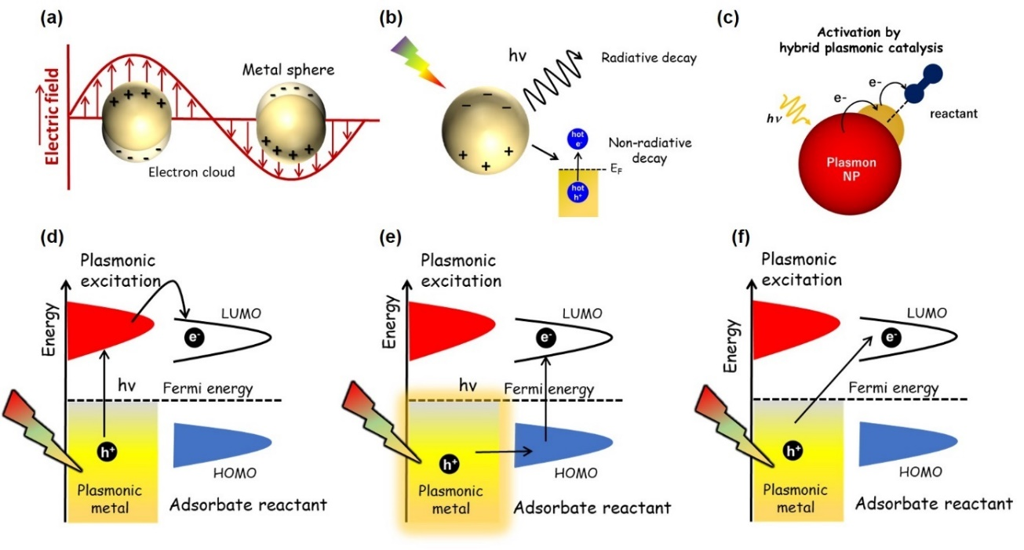
Figure 1. Schematic illustration of plasmonic excitation and decay mechanisms (a) localized surface plasmon in spherical metal NP, (b) decay emission of excited plasmons via radiative and non-radiative emissions, (c) Activation by plasmonic metal heterojunction with the active metal, (d) plasmon-induced indirect charge transfer mechanism, (e) direct intramolecular excitation mechanism, and (f) direct charge transfer mechanism.
Scheme 1 (a) and (b) summarizes the timeline of milestones identifying the several breakthroughs and pioneering attempts in the emerging field of noble metal-based plasmonic catalysis^{75,100–115} and spectroscopic techniques^{116–129} used for characterizing plasmonic NPs, respectively. Numerous research articles have already been published introducing the concept of LSPR, tuning the selectivity of the reaction, single-active plasmonic nanostructures, surface catalyzed reactions and strategies to enhance the yield of organic transformation reactions.^{56,57,75,130–149} The review articles on an in-depth discussion of spectroscopic advances in plasmonics including SERS,^{150,151} dark-field spectroscopy,¹⁵² molecular sensing and detection^{153–155} and transient photocurrent measurements can also be referred to build up the knowledge of basic concepts in this field.^{156,157} To the best of our knowledge, there is no published article yet interfacing the gap between the two research fields viz., plasmonic catalysis and operando techniques. Herein, we begin by a brief introduction of the fundamentals of plasmonics in catalysis and the structural characterization tools reported in the literature followed by in-situ spectroscopic techniques to establish a roadmap in optimizing the field of plasmonic catalysis. Some relevant examples dealing with noble metal-based plasmonic catalysis and our perspective are included in the conclusion section. The possible research directions have also been proposed at the end enabling us to accomplish the goal of representing plasmonic catalysis as one of the strong fields amongst photocatalysis especially in major reactions viz., hydrogen generation¹⁵⁸ and CO₂ reduction.¹⁵⁹
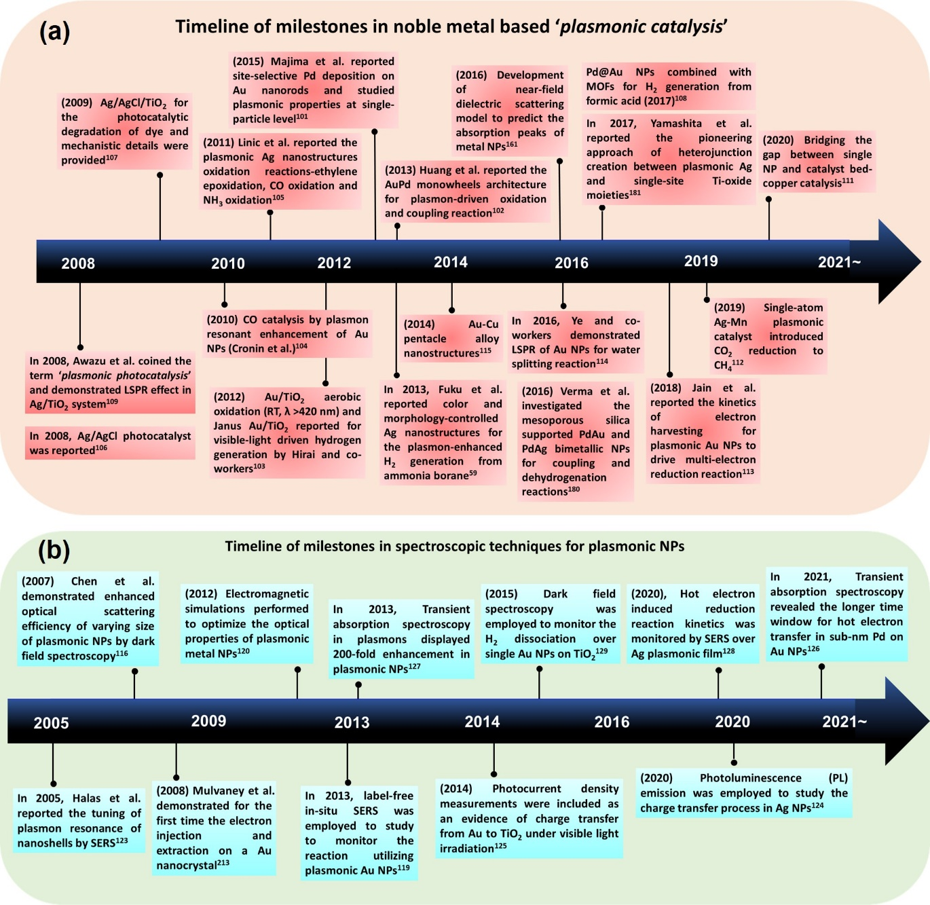
Scheme 1. Schematic illustration showing the timeline of milestones in the field of (a) noble metal-based- plasmonic catalysis and (b) spectroscopic techniques for plasmonic NPs.

2. Fundamentals of plasmonics in catalysis
Nanoparticles are small-sized particles within the size range of 1-100 nm that are capable of exhibiting unique physical and chemical properties when compared with large-sized bulk materials. The metal NPs display fascinating characteristics that are different from bulk metal species and hold huge potential in the fields of nanotechnology, biomedicine and engineering. The fundamental application of plasmon in metal NPs dates back to 4th century as observed in the Lycurgus cup created by Romans. This was special in many aspects because of the presence of Ag and Au NPs in the glass matrix and can show different colors when viewed in reflected and transmitted light. The tunability of different colors was also due to their different size and morphology which can scatter light differently and exhibit unique colors. In 1857, Faraday reported the first report on the optical absorption of colloidal Au NPs and in 1908, the optical simulation of metal NPs was performed by Mie based on Maxwell’s theory of electromagnetism, which was later postulated as the theory of surface plasmon resonance. The term ‘surface plasmon’ was at first used in 1960 and its demonstration in catalysis was done in 1996 utilizing Au/TiO₂ system under visible light irradiation.
The popular expression of plasmonic frequency, shown in equation (1), also found its basis from Maxwell’s equations where ω_{p}, N, e, ε₀ and m_{eff} represent plasmonic frequency, number density of charge carriers, electronic charge, effective mass and permittivity of free space, respectively.
$ω_{p}=\sqrt{\frac{{Ne}^{2}}{ε_{0}m_{eff}}}$ (1)
The plasma frequency, ω_{p}, can be defined as the frequency of collective oscillation of free electrons presuming that all the electrons are moving in phase. When the frequency of incident light ω_{L} is less than the plasmonic frequency ω_{p} the charge carriers screen out the incident light and lead to reflection. On the other hand, if ω_{L} exceeds the ω_{p}, complete transmission of light takes place since it is too fast for charge carriers to respond to it. A resonance condition is acquired only when ω_{L} becomes equal to ω_{p}. The charge permittivity ε₀ generally ignores the dissipation caused by the motion of charge carriers within the material. The modified or the actual permittivity can be calculated as per the Drude model by equation (2), where γ is the relaxation frequency between different scattering events.
$ε_{m}=1- \frac{ω_{p}^{2}}{ω^{2}+iγω}$ (2)
In simple terms, the phenomenon of surface plasmon resonance is defined as the collective oscillation of conduction electrons present in metal NPs when a beam of suitable frequency impinges on its surface. The frequency of oscillation at which this resonance takes place is called surface plasmon energy and it can vary based on the type of metal, their size, morphology and dielectric properties of the surrounding medium. Due to the confined effect of geometrical boundaries in metal NPs, the SPR is called localized surface plasmon resonance (LSPR). The plasmonic metal can interact with the incoming photons to create significant absorption and scattering cross-sections. The interaction and oscillations of electrons create a strong electromagnetic field around the metal NP and have been applied in various technologies including surface-enhanced Raman scattering (SERS), nanophotonics, optical sensing and photothermal therapies. The LSPR wavelength can be tuned by varying size, morphology and surrounding environment around the plasmonic metal. The plasmonic resonant excitation of metal nanostructures can decay radiatively or non-radiatively due to the scattering of photons. The radiative emission of energetic charge carriers can be transferred to the adjacent metal or undergoes localized heating. The generation of electromagnetic field enhancement can also undergo interaction with the surrounding metal or semiconductor species via near-field enhancement effects of dipole-dipole coupling. Figure 2 schematically summarizes the series of events taking place in the plasmonic NP after establishing the resonant condition with the incoming light irradiation and the terms and definitions relating to the introduction of plasmon in catalysis have been enlisted in Table 1. Upon light illumination, the plasmonic NP can undergo decay via radiative and non-radiative emissions. The radiative decay involves the re-emission of photons via scattering and non-radiative emission involves the formation of hot electrons and holes within the time scales of femtoseconds (fs). The electron-hole pair formed by the non-radiative emission is also known as Landau damping (LD) and the hot electrons can be further transferred to the excited states of the adjacent reactant/substrate molecules. The energy dissipation within the metal nanostructures can lead to an increase in the localized temperature of the catalytic system, known as plasmonic heating. The LSPR excitation in the metal nanostructure can also create an enhanced electric field near the metal NP and be transferred to the other species in the neighborhood via near-field interaction effects.
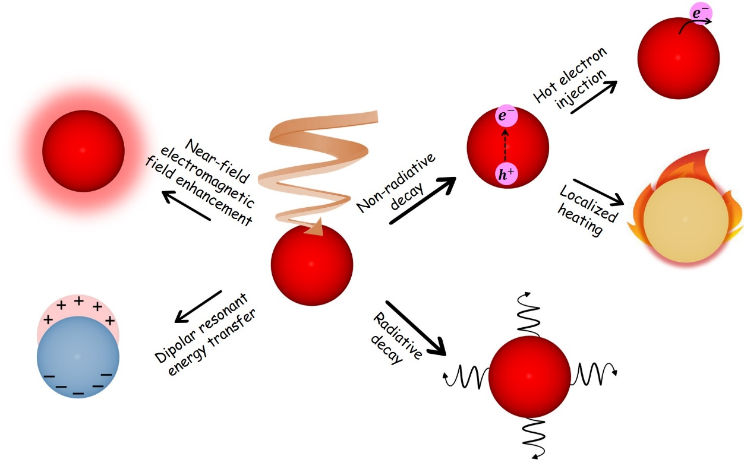
Figure 2. Plasmonic excitation of metal NP leading to series of processes due to LSPR effect.

It is well understood that the rate of relaxation is inversely proportional to the lifetime of charge carriers and includes the contribution of many factors including radiative decay, decay in bulk, surface scattering and hot-spot formation. Scheme 2 summarizes the time scales of the relaxation mechanism for plasmon and excited charge carriers.¹⁶⁰ The decay of hot electrons lies around 100 femtoseconds (fs) due to electron-electron scattering and electron-phonon scattering is usually in the range of picoseconds (ps). The dissipation of heat takes place at timescales longer than 10 ps. These relaxation times are essential in order to study the dynamics of plasmonic excitation and interpret their mechanistic pathways, especially in catalytic enhancement processes. The plasmonic excitation process is different when compared with conventional semiconductor catalysis in terms of their electronic states, relaxation times, optical tunability and visible-light responsiveness. A brief comparison of the advantages and disadvantages of plasmonic and semiconductor photocatalysis has been enlisted in Table 2.
In addition to the noble metal plasmonic NPs, the non-plasmonic metal NPs have also been researched in the last 5 years. The combination of the traditional SPR model and near-field scattering promoted metal particles optical absorption model assists in the wide-spectrum optical absorption of non-plasmonic metal particles. For example, Sun’s group reported the tuning of the absorption peak of Pt NPs by altering their dielectric environment using the scattering light absorption model. The Pt NPs were deposited on (3-Aminopropyl)triethoxysilane (APTES) modified SiO₂ and the scattered light in the near field is absorbed by the Pt NPs to display well-defined absorption peaks in the visible spectrum. The creation of photon-harvesting channel by non-plasmonic metal was employed in selective oxidation of benzyl alcohol to benzaldehyde and hydrogen generation reactions.^{161–165}

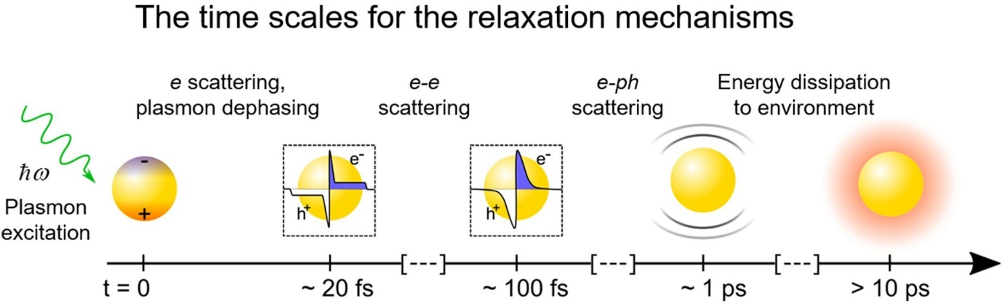
Scheme 2. Sequence of events and approximate timescales in the excitation and decay of plasmonic charge carriers following the absorption of photons by a metal nanoparticle. Reproduced with permission.¹⁶⁰ Copyright 2019, Elsevier.

Table 1. Terms, definitions and explanations commonly used in plasmonic catalysis.
Terms in plasmonic catalysis | Definition/Explanation
Plasmon | Quantum of charge oscillations
SPR | Surface plasmon resonance is the collective oscillation of conduction electrons in metal NPs when a beam of suitable frequency impinges on its surface
LSPR | Due to the confined effect of geometrical boundaries in metal NPs, the SPR is called localized surface plasmon resonance (LSPR)
Surface plasmon energy | The frequency of oscillation at which this resonance takes place is called surface plasmon energy
Radiative decay | After light absorption, the decay takes place by the re-emission of  photons
Landau damping/non-radiative decay | A quantum mechanical phenomenon in which the transfer of plasmon takes place into an e⁻-h⁺ pair within a time scale of femtoseconds (fs).
Hot electrons and holes | The high-energy photogenerated charge carriers (1-3 eV) formed by the illumination of visible light irradiation onto plasmonic metal NPs
Plasmonic catalysis | An emerging branch of photocatalysis based on the optoelectronic properties of noble metal NPs in the nanoscale regime
Near-field enhancement effects | The amplification of the electric field around a plasmonic metal NP when irradiated at a resonant frequency of light. The enhanced electric field is transferred to the other species in its neighborhood through near-field interaction effects
Hot spots | Hot spots are the active sites formed in the complex morphological nanostructures other than the sphere due to the light confinement, especially on the edges and tips. These can also be created when two NPs are present in the close vicinity to each other.
Intraband transition | The lower energy transitions altering the energy distribution within the conduction band of the plasmonic metal.
Interband transition | The higher energy transitions in which the excited electrons reach the energy equivalent to the Fermi level.
Hot electron injection | The hot electrons movement from the plasmonic metal to the excited states of the reactant/substrate or adjacent molecule.
Plasmonic heating | The localized heating increases the temperature of the catalytic  system due to the energy dissipation with the metal nanostructures.
PIRET | Plasmon-induced resonance energy transfer is the transfer of plasmonic oscillation energy from the plasmonic metal to the semiconductor via electromagnetic field or dipole-dipole interactions.
DIET | Desorption induced by electronic transition is defined as the transfer of electrons from the metal surface to the LUMO of substrate molecules, forming transient negatively charged species. These species form product molecules by undergoing transformation via electronic and vibrational changes in the metal and reactant states.

Table 2. Advantages (column highlighted in green) and disadvantages of plasmonic catalysis over conventional semiconductor-based catalysis.
Characteristics | Plasmonic photocatalysis | Conventional semiconductor photocatalysis
Electronic states | 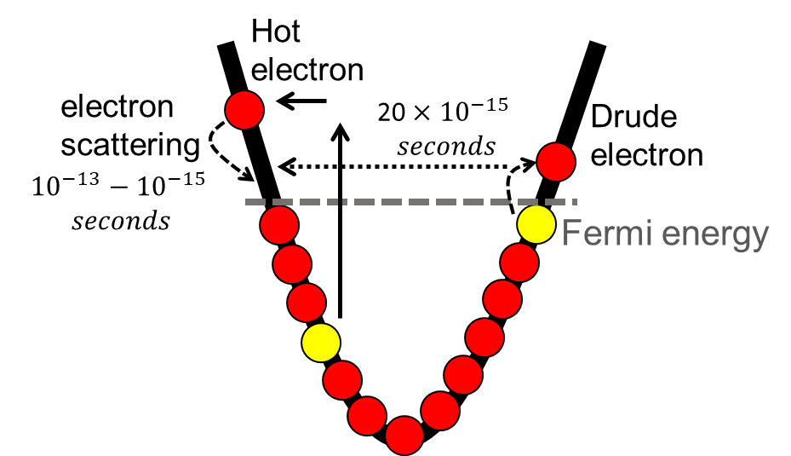 | 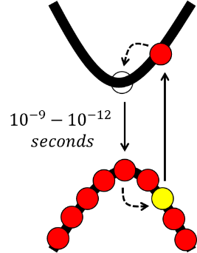
Lifetime of charge carriers | Shorter time scales of high energy charge carriers within femtoseconds | The lifetime of charge carriers is usually longer within the range of ns-ps
Visible-light responsiveness | Visible-NIR light responsiveness | Poor visible light responsiveness. Usually tailored to display visible light absorption by combining with co-catalysts
Cost-effective | Non-economical noble metals (expensive) and yet to establish practical applications (field is still in its infancy) | Economical (cheap) and have been applied in many practical applications to date
Mechanistic details | In-depth understanding of the mechanism is still unclear | The pathways and mechanistic details are well established
Reaction pathways | Unconventional reaction pathways targeting improved product selectivity | Depends on the individual catalytic system
Near-field enhancements | The generation of the electric field around metal NP as high as 10³-10⁵ (evidenced by FDTD and SERS analysis) can lead to significant enhancements in the catalytic reaction | No significant effect
Localized heating | Plasmonic localized heating can lead to an increase in the temperature due to the energy dissipation | No significant effect
Optical tunability | Light absorption can be tailored and extended to higher wavelengths by changing the morphology, size and dielectric of the surrounding medium | No significant effect and can vary from case to case

3. Characterization techniques for plasmonic NPs
3.1. Structural characterization
The rational design and construction of multifunctional nanocatalysts by careful engineering of the size, morphology, composition, defects and photo-absorption are essential in realizing the solar-to-chemical energy conversion with higher quantum efficiency values.¹⁶⁶ In the structural characterization of novel plasmonic nanostructures, there is substantial room for improvement in tuning the structural design and tailoring the activity and selectivity of catalysts.^{167–171} To achieve this goal in the rapidly advancing field, it is essential to understand the structure-property relations between the plasmonic nanostructure and their catalytic response using commonly employed and higher resolution spectroscopical techniques.^{113,172–174} In this section, we have gathered the three most significant structural characterization techniques viz. UV-vis absorption, X-ray-based spectroscopic analysis including X-ray absorption (XAS) and X-ray photoelectron spectroscopy (XPS) on selected examples of noble metal plasmonic NPs. Table 3 summarizes the reported examples along with their characteristics and implications in the context of their structural characterization.
Table 3. Structure-property relationships from the characterization of the plasmonic catalyst.
Spectroscopic technique | Plasmonic photocatalyst | Evidence and Explanation | Ref.
UV-vis | Ag-Cu/UCPT | ²F_{7/2} $→$²F_{5/2} transition from Yb³⁺ further extended towards Vis-NIR upon introducing Ag-Cu NPs | ¹⁷⁵
UV-vis | Ag/NaNbO₃ | An absorption edge in the Vis region at 508 nm with Ag NPs | ¹⁷⁶
UV-vis | Ag/SBA-15 (Y), Pd/Ag/SBA-15 (Y) | An intense absorption at 410 nm due to spherical morphology | ^{177,178}
UV-vis | Ag/SBA-15 (R), Pd/Ag/SBA-15 (R), Ag/SBA-15 (B) and Pd/Ag/SBA-15 (B) | Two absorption peaks in the Vis and NIR due to transverse and longitudinal mode of nanorods | ^{177,178}
UV-vis | Ru/Ag/SBA-15 (B) | Two absorption peaks centered at 370 and 990 nm and decreased intensity of the first peak due to surface coverage of Ag with Ru NPs | ¹⁷⁹
UV-vis | Au/SBA-15 and Pd/Au/SBA-15 | An intense absorption peak at 520 nm for Au/SBA-15 and no significant change with Pd deposition | ¹⁸⁰
UV-vis | Ag/Ti-SBA-15 | A single absorption peak at 410 nm and displayed more intensity than Ag/SBA-15 | ¹⁸¹
UV-vis | curcumin functionalized Ag NPs (c-AgNPs) | A single absorption peak at 420 nm | ¹⁸²
UV-vis | 3D nanoporous gold (NPG) | The presence of two absorption peaks at 490 nm and 533 nm | ¹⁸³
UV-vis | AgPt modified Au nanostars | An absorption peak centered at ∼ 500 nm and red-shifted in the NIR region at 1017 nm | ¹⁸⁴
UV-vis | Au/TiO₂ (0.5 wt %) | A single absorption peak at 533 nm | ¹⁸⁵
UV-vis | Au/TiO₂ (nanorod, nanotube and microporous) | The absorption wavelength in the range of 540-556 nm; order of absorption intensities- Au/TiO₂ nanorod > nanotube > microporous | ¹⁸⁶
X-ray photoelectron spectroscopy (XPS) | Ag/CeO₂/SBA-15 | Shift towards higher B.E. values of 375.7 and 369.7 eV corresponding to 3d_{3/2} and 3d_{5/2}, respectively. The peak shift was attributed to the possible charge transfer from CeO₂ to Ag NPs, attributing the heterojunction interaction between the atoms sitting adjacent to each other | ¹⁸⁷
X-ray photoelectron spectroscopy (XPS) | Au/TiO₂ | The 4f core splits into a doublet (4f_{5/2} and 4f_{7/2}) separated by 3.7 eV | ¹⁸⁵
X-ray photoelectron spectroscopy (XPS) | Pd/Au/SBA-15 and  Pd/Ag/SBA-15 | Net charge transfer from Ag to Pd and from Pd to Au, affirmed by the obtained shift in the B.E of Ag 3d and Au 4f towards higher and lower values | ^{178,180}
X-ray photoelectron spectroscopy (XPS) | Ag/Ti-SBA-15 | Electron enriched Ag NPs due to shifting in the B.E. towards lower values when compared with Ag/SBA-15 | ¹⁸¹
X-ray photoelectron spectroscopy (XPS) | Au/TiO₂ | A negative shift by 0.4 eV in the Au 4f_{7/2} peak illustrating the charge transfer from oxygen vacancies to Au | ¹⁸⁵
X-ray absorption spectroscopy (XAS) | Ag/SBA-15 | Ag K-edge - A main peak at 2.7 Å in FT-EXAFS due to Ag-Ag metallic bond in the sample catalysts | ¹⁷⁷
X-ray absorption spectroscopy (XAS) | Pd/Ag/SBA-15 | In the Pd K-edge FT-EXAFS spectra, the Pd-Pd distance was shorter than the Pd foil, indicating the formation of heterojunction between Ag-Pd atoms | ¹⁷⁸
X-ray absorption spectroscopy (XAS) | Pt/Ag/SBA-15 | A decrease in the intensity of the white line in the XANES spectra was observed when compared with monometallic Ag/SBA-15, suggesting the bimetallic interaction between Pt and Ag | ¹⁸⁸
X-ray absorption spectroscopy (XAS) | Pd/Au/SBA-15 | The Au L_{III}-edge spectra for Au/SBA-15 and Pd/Au/SBA-15 displayed an intense peak at 2.5 Å, similar to that of Au foil | ¹⁸⁰
X-ray absorption spectroscopy (XAS) | Ag/Ti-SBA-15 | A single peak at 4968 eV in the XANES spectra showing tetrahedral coordination environment in Ag/Ti-SBA-15 | ¹⁸¹
X-ray absorption spectroscopy (XAS) | UiO-66(Zr₈₅Ti₁₅) | A sharp pre-edge peak at 4970 eV confirming the tetrahedral coordination of Ti-oxide in the nodes of MOFs. The FT-EXAFS depicted a strong signal at 1.8 Å evidencing the presence of isolated Ti-oxide species without any aggregated TiO₂ species | ¹⁰⁸

3.1.1. UV-vis spectroscopy
To begin with, a relatively less explored field of lanthanides doped materials was used to coat plasmonic materials onto them for photocatalytic applications. One recent example in which Ag-Cu decorated on UCPT (NaY₄:Yb,Tm@NaYF₄:Yb@porousTiO₂) can display significant absorption in the visible-NIR region.¹⁷⁵ The transition corresponding to ²F_{7/2} $→$²F_{5/2} was labeled as coming from lanthanide Yb³⁺ in the UCP. The coating with TiO₂ led to the decrease in the absorption at 450 nm, displaying a band gap of 3.2 eV. The decoration with Ag-Cu NPs could maintain a wide absorption spectrum in the UV-vis-NIR region. The search for the development of new materials has resulted in utilizing NaNbO₃ as an alternative to using conventional semiconducting supports because of its non-toxicity and excellent stability.¹⁷⁶ With a band gap of 3.35 eV, it can only display absorption in the UV region therefore, it is coupled with plasmonic Ag NPs in order to extend its absorption and lower the energy band gap of the material. Consequently, the absorption edge shifted from 371 nm to 508 nm due to the surface plasmonic effect of Ag NPs and enhances the separation of photogenerated charge carriers.
The optical property of several size and morphology-controlled Ag NPs was reported by Mori et al. in which the mesoporous SBA-15 silica was used as the support material.¹⁷⁷ The various colors of Ag NPs arising from the LSPR effect were light green/yellow, yellow/bright orange, red and blue based on the size and aspect ratio of metal nanostructures.⁵⁹ The optical absorption of these nanostructures also reflected the difference in the absorption due to the variation in their geometry. The SBA-15 support did not display any optical absorption which is beneficial to study the effects arising barely from plasmonic NPs. An intense absorption peak at 410 nm was obtained for the spherical NPs with colors varying from yellow to greenish orange. The red and blue nanorods displayed two peaks in the visible and near infrared (NIR) region of the spectrum corresponding to the transverse and longitudinal mode of nanorods (Figure 3 (a)). The different modes of polarization can lead to the formation of number of LSPR absorption peaks. The highest aspect ratio of blue nanorods was confirmed due to its absorption at λ > 900 nm and accounts for the promising light harvesting ability for the design of plasmonic catalysts.
Verma et al. carried out the deposition of an active metal Pd onto size and morphology-controlled plasmonic Ag nanostructures by an LSPR-assisted photo-deposition method using visible light irradiation.¹⁷⁸ An aqueous suspension of yellow, red and blue Ag nanostructures was irradiated with light to activate the plasmonic nanostructures followed by the addition of Pd precursor solution (Pd(OAc)₂) with continuous irradiation for 2 h without adding a reducing agent. The obtained bimetallic nanomaterials were labeled as Pd/Ag/SBA-15 (Y), Pd/Ag/SBA-15 (R) and Pd/Ag/SBA-15 (B). The trend and number of peaks in the optical absorption were similar, however, a decrease in the absorption intensity was observed due to the interference in the light absorption by Pd NPs as shown in Figure 3 (b). This observation indicated the preservation of the morphology of plasmonic nanostructures after the introduction of the second metal in the system. A similar study with the deposition of Pt NPs on spherical Ag NPs also displayed an overall decrease in the absorption intensity due to the surface coverage with the active metal.¹⁸⁸
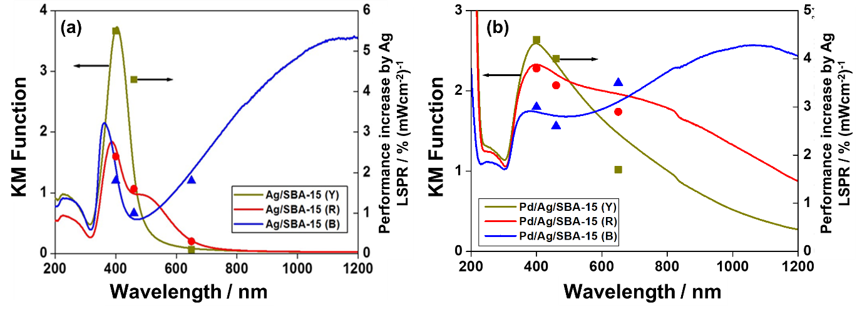
Figure 3. Absorption spectrum of size and color controlled (a) Ag/SBA-15 and (b) Pd/Ag/SBA-15. Reproduced with permission.¹⁷⁸ Copyright 2015, The Royal Society of Chemistry.

The absorption of Ag nanorods in the near-infrared region prompted us to explore the different combinations of Ag with other active metals such as Ni, Co, Pd and Ru.¹⁷⁹ The 0.5 wt % of active metal ‘M’ was deposited onto 1.0 wt % Ag nanorods by LSPR-assisted deposition followed by NaBH₄ reduction. The optical signature absorption of Ag nanorods was observed at (370, 980 nm) and for the active metal combination of Ru/Ag, Pd/Ag, Co/Ag, Ni/Ag at (370, 990), (360, 1020), (373, 842) and (373, 994) nm, respectively. The transverse mode of absorption for bimetallic nanostructures decreased slightly suggesting the surface coverage of nanorods with active metal species. The longitudinal mode of absorption follows the trend; Pd/Ag > Ag > Ru/Ag > Co/Ag > Ni/Ag. The obtained order of absorption was found to be in agreement with the catalytic enhancements under visible light irradiation, as discussed in the catalysis section 4.2. The replacement of spherical Ag NPs by Au shifted the plasmonic absorption towards higher wavelengths of λ = 520 nm and Pd deposition did not affect the intensity and absorption maxima of Au NPs.¹⁸⁰ The increase in the overall width of absorption intensity was attributed to the enhanced surface electron density of the metal NPs. The single-site Ti species displays an absorption peak below 280 nm because of the ligand-to-metal charge-transfer (LMCT) transition from oxygen (O²⁻) to titanium (Ti⁴⁺) species. The optical absorption of Ag NPs became more intense when combined with small amounts of single-site Ti species in the catalytic system.¹⁸¹ For example, the plasmonic peak of Ag/Ti-SBA-15 at 410 nm displayed intense absorption when compared with Ag/SBA-15 (λ = 405 nm) without any doped Ti-oxide species. The use of a large proportion of titanium precursors led to the formation of aggregated TiO₂ particles instead of single-site Ti species, labeled as Ag/TiO₂/SBA-15. The absorption maxima also shifted to higher wavelengths at 420 nm due to the formation of large-sized Ag NPs, further confirmed by TEM micrographs. The curcumin functionalized Ag NPs (c-AgNPs) were prepared by using an alkaline solution of curcumin with an average diameter of ~17 nm.¹⁸² An Ag13-curcumin complex was studied by density functional theory (DFT) calculation. Time-dependent-DFT studies were also carried out to simulate the UV-vis spectrum with an absorption maximum at 420 nm and to propose the charge transfer from Ag to curcumin.
The Au nanostructure can also display excellent LSPR absorption along with superior catalytic performance under solar light irradiation conditions. In a recent example, free-standing nanoporous gold (NPG) nanostructure was fabricated by dealloying the Ag₆₅Au₅₅ in 69 wt % HNO₃ solution at room temperature conditions.¹⁸³ The nanopore size of the 3D NPG structure can be varied from 18.3 to 57.3 nm by changing the period of dealloying. This can be confirmed via the appearance of two peaks in the UV-vis spectroscopic measurements at 490 nm and 533 nm. The second peak displays a shift towards higher wavenumbers from 533 nm to 575 nm when the pore size was increased from 18.3 to 57.3 nm. The Au nanostars (NSs) coated with AgPt NPs are prepared by using Au NRs as the seeds for the seed-mediated method of preparation.¹⁸⁴ The site-selective deposition of AgPt NPs was carried out by changing the ratio of Pt precursor (H₂PtCl₆) and KI solution in the synthesis procedure to form AgPt-covered, tipped and edged Au NSs. The Au NSs contained the core size of 43 $±$ 5 nm and branches of 35 $±$ 10 nm. The UV-vis spectra of Au nanostars (NSs) exhibited an LSPR peak around 1006 nm which was red-shifted in comparison to bare Au NRs (Figure 4). The AgPt coating on Au NSs slightly red-shifted the LSPR peak at 1017 nm because of its modification with AgPt NPs. As the concentration of AgPt NPs was increased, the absorption displayed a decrease in the overall intensity, further confirming the change in the morphology of the nanostructures. The unique morphology of Au nanostructures can absorb significantly extending the absorption towards the Vis-NIR regime of the spectrum and provide more active and defect sites in order to facilitate the rate of reaction. The comparative higher surface area values assist in the nucleation and growth of the multibranched nanostructures and also strengthen the stability of the material.

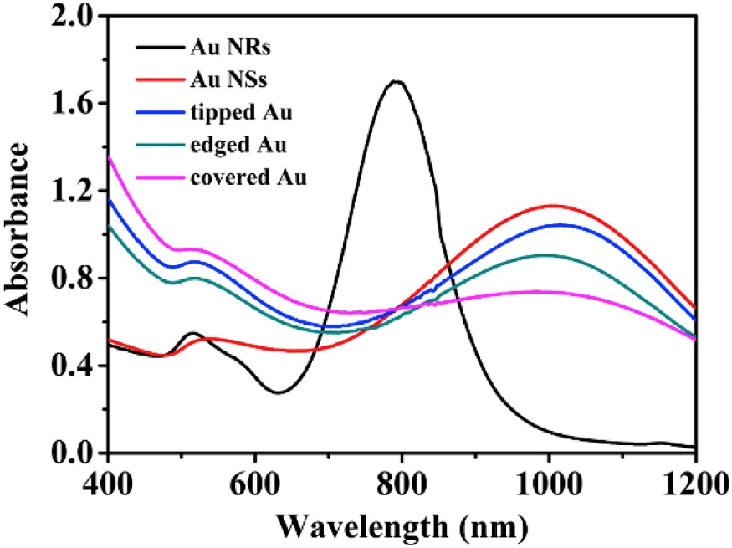
Figure 4. Absorption spectra of Au NRs, Au NSs and AgPt modified NSs. Reproduced with permission.¹⁸⁴ Copyright 2019, Elsevier.

To extend the light absorption of UV-active TiO₂ photocatalyst, Jo et al. reported the synthesis of Au/TiO₂ by photo-assisted deposition method in which the loading amount of Au NPs was varied from 0.5 wt % to 3.0 wt %.¹⁸⁵ An intense LSPR absorption peak for Au0.5/TiO₂ centered at 533 nm was observed and the increase in the Au wt% loading increases the LSPR absorption intensity without significantly shifting the absorption maxima peak position. The TEM images revealed the change in the NPs size from 8.5-11.7 nm. This observation indicated that the size of Au NPs did not vary much with the change in the loading amounts of Au NPs, as further demonstrated by the UV-vis and TEM micrographs. Verma et al. investigated the deposition of Au NPs on morphology-controlled TiO₂ photocatalyst using the impregnation followed by H₂ reduction process at 300 °C for 2 h.¹⁸⁶ The LSPR absorption of three different catalysts was found to be within the range of 540-556 nm with the order of absorption intensities following the trend Au/TiO₂ nanorod > nanotube > microporous catalysts. Under visible light irradiation, the catalytic enhancement was found to be in agreement with their optical absorption intensities, further confirming the role of Au NPs in the LSPR enhancement of catalytic performance.

3.1.2. X-ray Photoelectron Spectroscopy
X-ray photoelectron spectroscopy (XPS) is a strong and useful tool to characterize the surface composition and chemical states of prepared plasmonic nanostructures.^{189,190} It can provide useful information about the (1) metal oxidation state and (2) local environment around the metal nanocatalyst.^{191–193} For example, the electronic state of Ag NPs in XPS can be studied by the presence of two peaks at the binding energy values of 374.2 eV and 368.2 eV separated by the splitting doublet of 6.0 eV. The influence of CeO₂ coating on the mesoporous SBA-15 silica combined with Ag NPs was studied and compared with Ag/SBA-15 and Ag foil as the standard sample.¹⁸⁷ The Ag 3d peak in Ag/CeO₂/SBA-15 was obtained towards higher binding energy (B.E.) values of 375.7 and 369.7 eV corresponding to 3d_{3/2} and 3d_{5/2}, respectively, when compared with Ag/SBA-15. These values were obtained after adjusting the C1s calibration at 284.8 eV. The peak shift was attributed to the possible charge migration from CeO₂ to Ag NPs due to their different electronegative values. This observation provided evidence of the hetero-interaction between the atoms sitting next to each other. The XPS spectra of Ce 3d displayed multiplets of six peaks with Ce 3d_{3/2} and Ce 3d_{5/2} peaks exhibiting spin-orbit coupling of 18.6 eV at B.E. of 887.3 eV and 905.9 eV, respectively. The plasmonic Ag NPs were also deposited on oxide supports such as TiO₂, CeO₂, ZrO₂ and Al₂O₃ to study the influence of support materials on photocatalytic performance under visible light irradiation.¹⁹⁴ The B.E. shift was assigned to the difference in the electronegative values between Ag and the metal present in the oxide. The least electronegative Ce (1.12) displayed the lowest B.E. value of Ag and can keep Ag in the most reduced state. The case study of Au NPs in XPS is also well reported. When Au NPs were immobilized on shape-controlled TiO₂, the core 4f splits into doublet peaks, 4f_{5/2} and 4f_{7/2}, indicating the zero oxidation state of Au nanostructures.¹⁸⁶ The peak intensity was also varied upon changing the morphology of TiO₂ from nanotube to nanorod and microporous structures. The most intense peak was shown by Au/TiO₂ nanorod at 86.7 and 83.0 eV followed by Au/TiO₂ nanotube and microporous catalyst at B.E. of (86.6, 82.9) and (86.8, 83.1), respectively. The low intensity and shift in the B.E. values implied the poor distribution and presence of Au in most oxidized state in microporous support.
XPS has also been used to study the heterojunction interaction in the bimetallic PdAu and PdAg NPs supported on mesoporous SBA-15 silica as shown in Figure 5.¹⁸⁰ At first, the metallic nature was confirmed by the presence of doublet peaks in Au, Ag and Pd XPS spectra (4f_{5/2}, 4f_{7/2} - Au and 3d_{3/2}, 3d_{5/2} - Ag and Pd). Based on the difference in the electronegativity values of the three elements, Ag (1.93), Au (2.54) and Pd (2.20), the net charge transfer occurs from Ag to Pd and from Pd to Au. This was affirmed by the obtained B.E. shift of Ag 3d towards higher values and for Au 4f towards lower values. Similarly, the local environment around Ag NPs in Ag/Ti-SBA-15 was investigated to study the effect of introducing single site Ti-oxide species and aggregated TiO₂ moieties in the framework of mesoporous SBA-15 silica.¹⁸¹ The formation of electron-enriched Ag NPs to facilitate enhancing the rate of reaction was confirmed by the shift in the B.E. towards lower values when compared with the XPS spectrum of Ag/SBA-15. The chemical state of Au/TiO₂ was studied by measuring the Ti 2p, Au 4f and O 1s XPS spectra. ¹⁸⁵ The presence of two peaks in O 1s spectra was assigned to the O²⁻ (lattice) and Ti-OH (surface) species. A negative shift by 0.4 eV in the Au 4f_{7/2} peak was obtained at 83.6 eV illustrating the charge migration from oxygen vacancies to Au present in Au/TiO₂. Furthermore, the peak intensities and the ratio of Au in a zero-valent state were directly proportional to the amount of Au loading in the catalyst.

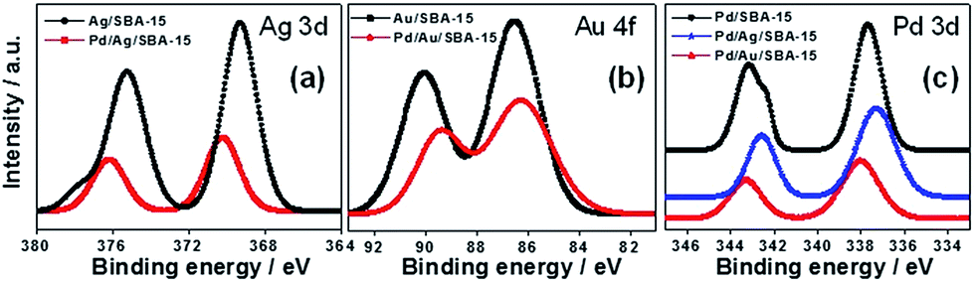

Figure 5. XPS spectra of (a) Ag 3d, (b) Au 4f and (c) Pd 3d for Ag/SBA-15, Au/SBA-15, Pd/Ag/SBA-15, Pd/Au/SBA-15 and Pd/SBA-15 catalysts. Reproduced with permission.¹⁸⁰ Copyright 2016, The Royal Society of Chemistry.

3.1.3. X-ray absorption spectroscopy (XAS)
The X-ray absorption spectrum is measured by the bombardment of X-rays of definite energy on a sample, leading to the excitation or ejection of core electrons.^{195–197} This process can be quantified by measuring the fluorescence exhibited by the excited atom and comparing it with the intensity of incident irradiation. The obtained peaks and shoulders in the absorption spectrum near the edge position are called as X-ray absorption near-edge structure (XANES) spectrum and the oscillations obtained above the edge are known as the extended X-ray absorption fine structure (EXAFS) spectrum.^{198,199} It is used as a powerful tool to determine the chemical state and local environment of the elements even those which are low in abundance or concentration.^{200,201} In the structural characterization of plasmonic nanocatalysts, XAS has been employed numerous times to display the contiguous M-M bonding in the metal atoms. For example, when the XAFS measurements were performed on morphology-controlled Ag/SBA-15 nanocatalysts, the Ag K-edge XANES spectra appeared similar to the Ag foil.¹⁷⁷ The Fourier transform EXAFS spectra displayed the main peak at 2.7 Å due to the presence of an Ag-Ag metallic bond in the sample catalysts. The Pd K-edge EXAFS spectra of bimetallic Pd/Ag/SBA-15 catalyst also confirmed the metallic state of Pd NPs.¹⁷⁸ However, the distance of Pd-Pd was shorter than the Pd foil, indicating the formation of heterojunction between Ag-Pd atoms. In the combination of Pt/Ag/SBA-15 bimetallic catalyst, the XANES spectra displayed a decrease in the intensity of the white line when compared with monometallic Ag/SBA-15.¹⁸⁸ This observation was suggestive of the bimetallic interaction of Pt and Ag NPs. An intense peak at 2.7 Å was present in all samples and a peak corresponding to Ag-O-Ag bonding at 1.9 Å was absent, indicating the presence of Ag in a zero-oxidation state. The plasmonic and structural properties of PdAg bimetallic NPs were extended towards PdAu NPs and their local structures were also investigated by XAS.¹⁸⁰ The Au L_{III}-edge spectra for precursor (HAuCl₄), standard (Au foil), Au/SBA-15 and Pd/Au/SBA-15 are shown in Figure 6 (A) in which the monometallic and bimetallic catalysts displayed an intense peak at 2.5 Å, affirming the similar nature as that of Au foil. The peak corresponding to Au-Cl bond at 1.9 Å in HAuCl₄ was found to be absent in other catalysts. The Ag K-edge and Pd K-edge displayed results similar to as described above (Figure 6 (B, C)) for morphology controlled Pd/Ag/SBA-15 catalysts.
The XANES spectra can also provide useful information in distinguishing the coordination environment of oxide species. For example, the tetrahedral or octahedral coordination of Ti-oxide species in the prepared catalyst, Ag/Ti-SBA-15, was investigated to find the effect of Ti doping on the overall structure and catalytic performance.¹⁸¹ The Ti K-edge XANES spectra of Ag/Ti-SBA-15 was measured and compared with Ti-SBA-15, TiO₂ and titanium tetrabutoxide (TBOT). The Ti source precursor, TBOT, exhibited a single peak at 4968 eV showing tetrahedral coordination, similar to Ti-SBA-15 and Ag/Ti-SBA-15. However, TiO₂ displayed multiple peaks from 4964 to 4974 eV, confirming the octahedral coordination of Ti in oxide form. The single peak in tetrahedral coordination of Ti represents the electron transition from 1s to t_{2g} and the formation of single-site Ti-oxide species. Further confirmation of the difference in the geometry of prepared catalysts was performed by UV-vis spectroscopic measurements, as discussed in the respective section. Similarly, the doping of single-site Ti species within the nodes of MOFs was also reported and studied by XANES and EXAFS analysis and compared with the standard spectrum of TiO₂.¹⁰⁸ The titanium was doped in the zirconium-based MOF (UiO-66(Ti_{x}Zr_{100-x})), functionalized with amine groups and loaded with plasmonic Au@Pd NPs. A sharp pre-edge peak at 4970 eV was obtained for UiO-66(Zr₈₅Ti₁₅), confirming the tetrahedral coordination of Ti-oxide present in the nodes of MOFs. The Fourier transform EXAFS data for TiO₂ revealed the presence of the Ti-O-Ti bond due to the presence of a broad peak between 2.0-3.0 Å. This broad peak was absent in the case of UiO-66(Zr₈₅Ti₁₅) and rather a strong signal at 1.8 Å confirmed the presence of isolated Ti-oxide species without any component of aggregated TiO₂ species.

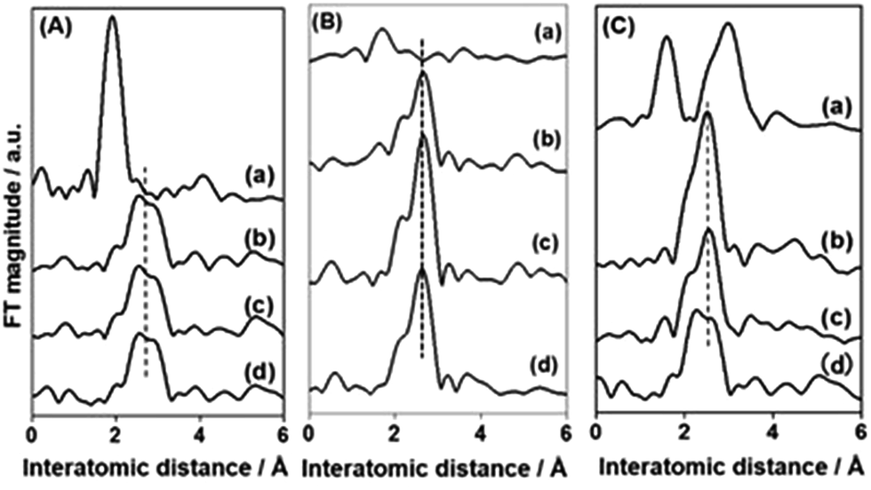
Figure 6. FT-EXAFS spectra of (A) Au L_{III}-edge of (a) HAuCl₄, (b) Au foil, (c) Au/SBA-15 and (d) Pd/Au/SBA-15. (B) Ag K-edge of (a) AgO, (b) Ag foil, (c) Ag/SBA-15 and (d) Pd/Ag/SBA-15. (C) Pd K-edge of (a) PdO, (b) Pd foil, (c) Pd/Ag/SBA-15 and (d) Pd/Au/SBA-15. Reproduced with permission.¹⁸⁰ Copyright 2016, The Royal Society of Chemistry.

3.2. Spectroscopic/operando techniques for characterizing plasmonic NPs
The decay of LSPR can take place via interband, intraband, or by the generation of photoinduced charge carriers i.e. hot electrons and holes.^{202,203} The role of hot electrons in carrying out the catalytic transformation at the nanoscale and investigating the mechanism of the reaction has been studied and reported by modern analytical and spectroscopic techniques.^{204–206} The process of charge transfer in the plasmon-mediated catalysis was evidenced at single-particle resolution using operando techniques.^{97,111,207,208} In this section, we have briefly described the case studies of noble metal-based plasmonic nanostructures to understand the structural details and evidence the chemistry behind the reaction rate enhancement under light illumination conditions. Table 4 enlists the characterization tools and their evidence and explanation in plasmonic catalysis to investigate the migration of charge carriers.

Table 4. Spectroscopic technique and the inference from the plasmonic catalyst.
Spectroscopic technique | Plasmonic photocatalyst | Evidence and Explanation | Ref.
Transient absorption (TA) spectroscopy | Ag-TiO₂-Au | Electron injection from Ag to the conduction band of TiO₂ evidenced by a broad peak from 620 to 740 nm. | ²⁰⁹
Transient absorption (TA) spectroscopy | Pd skin/Au-MOF | One negative peak at 520 along with two positive peaks assigned to plasmonic absorption and revealed a longer time window for hot electron transfer | ¹²⁶
Transient absorption (TA) spectroscopy | Ag₄₄(SR)₃₀/TiO₂ | Upon excitation, highly intense five absorption bands can act as small band gap semiconductors | ²¹⁰
Transient absorption (TA) spectroscopy | Ag/W₁₈O₄₉ | Blue shifted band evidencing the possible interaction by charge transfer | ²¹¹
Photocurrent density | Ag/TiO_{2-x} | A 15 times higher current density in comparison to TiO₂ | ²¹²
Photocurrent density | Ag/AgVO₃@CdS/BiVO₄ | The higher current density than individual components and exhibited resistance towards photo corrosion | ¹²⁴
Dark-field spectroscopy | Au nanocrystal | An electron transfer rate of 4600 electrons was displayed | ²¹³
Dark-field spectroscopy | Single Au/TiO₂ | Evidence of gas-solid interface reaction by gas adsorption and charge migration | ¹²⁹
Electromagnetic field enhancement (FDTD simulations) | (Au/AgAu)@CdS | Multi-interfacial plasmon coupling displayed strong field enhancement effects | ²¹⁴
Electromagnetic field enhancement (FDTD simulations) | Ag/P25/RGO prism | The presence of sharp tips enhanced electric fields and produced strong LSPR effects | ²¹⁵
Electromagnetic field enhancement (FDTD simulations) | Ag@Pd nanocube | The strong electric field near Ag but decreased with a coating of Pd due to faster plasmon decay | ²¹⁶
Electromagnetic field enhancement (FDTD simulations) | Pd₉₀Au₁₀/Al₂O₃ | An enhancement factor of 23.8 under a monochromatic light illumination of 530 nm. | ²¹⁷
Electromagnetic field enhancement (FDTD simulations) | Au@Pd@UiO-66-NH₂ | Pd shell thickness of 0.5 nm onto Au acting as the antenna was optimized | ¹²⁶
Surface-enhanced Raman scattering (SERS) spectroscopy | AuNBP@AgPt | In-situ reduction of 4-NTP to 4-ATP monitored by SERS under 785 nm excitation | ²¹⁸
Surface-enhanced Raman scattering (SERS) spectroscopy | Ag/TiO₂/Ag | Quantitative detection of methylene blue and reduction of 4-NTP was demonstrated | ²¹⁹
Surface-enhanced Raman scattering (SERS) spectroscopy | Au@Ag NRs | Dimerization of 4-NTP to DMAB within 120 s under 532 nm excitation | ²²⁰
Surface-enhanced Raman scattering (SERS) spectroscopy | Ag plasmonic film | Hot electron-induced reduction of 4-NTP in the presence of HCl | ¹²⁸
Surface-enhanced Raman scattering (SERS) spectroscopy | Pt-Au-Ag cubic mesh | In-situ kinetics of reaction by comparing the band intensity of 4-NTP (1350 cm⁻¹) and 4-ATP (1600 cm⁻¹) | ²²¹
Photoluminescence (PL) spectroscopy | Ag/AgVO₃@CdS/BiVO₄ | Under 450 nm excitation, the charge transfer was evidenced by lower PL intensity than individual components | ¹²⁴

3.2.1. Transient absorption spectroscopy
Transient photoelectrochemical (PCE) measurements were employed to study the charge transport and recombination mechanistic pathway of the photocatalysts. Van et al. synthesized the multimetallic Ag-TiO₂-Au catalyst and explored the flow of hot electrons in which Ag, TiO₂ and Au acting as the light-harvesting component, electron relay and catalytic active site, respectively. A combination of ultrafast visible and infrared spectroscopy techniques was employed in which the time for exciting hot electrons to flow from Ag to active site Au displayed 700 fs through the electron relay process.²⁰⁹ Figure 7 displays the transient absorption spectra of Ag-TiO₂-Au in which the rising edge region at 470 nm represents the electron-electron scattering events. A broad signal from 620 to 740 nm affirms the presence of electrons in the conduction band of TiO₂ indicating the electron injection process from LSPR excitation of Ag. The hot electrons are then transferred to Au within 500 fs until the saturation of the 5d band structure of Au. The plasmonic catalyst was tested in the reduction of 4-nitrophenol in the presence of NaBH₄ and a 16-fold enhancement in the catalytic activity was observed under light illumination at 445 nm in comparison to dark conditions. This work can be cited as a recent example to display the flow of charge carriers using ultrafast spectroscopic studies.
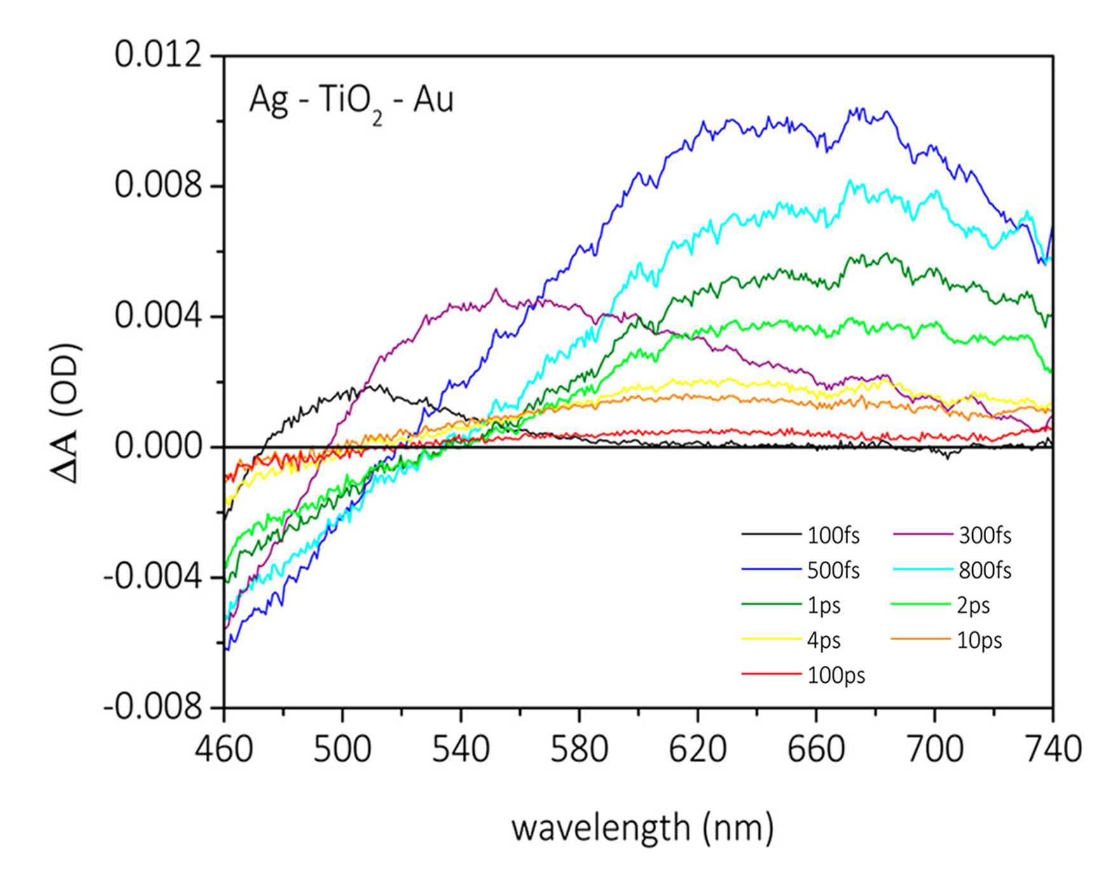
Figure 7. Transient absorption spectra of Ag-TiO₂-Au catalyst. Reproduced with permission²⁰⁹. Copyright 2020, American Chemical Society.
The combination of Ag/TiO₂ was also studied by Lu and co-workers to design the heterojunction between plasmonic Ag and Ti³⁺ doped macro-meso-porous TiO₂ represented as Ag/TiO_{2-x} catalyst.²¹² The TiO_{2-x} framework was prepared by microwave(MW)-assisted deposition method using vitamin C as the reducing agent and Ag NPs were prepared by the photodeposition method under visible light irradiation. It was observed that Ag/TiO_{2-x} catalyst displayed enhanced photocatalytic activities than the individual components and Ag/TiO₂ catalyst. The presence of oxygen vacancies in the TiO_{2-x} framework and Ag/TiO_{2-x} catalyst in the form of Ti³⁺ was detected by electron paramagnetic resonance (EPR) signal at g=2.005 which was absent in the case of TiO₂. These oxygen vacancies can act as the site for trapping charge carriers accounting for the enhanced photocatalytic activity. The photocurrent densities of Ag/TiO_{2-x} heterostructure were measured and observed to be 15 times higher than the pure TiO₂ support, suggesting the higher number of charge carriers within the material. Further, it was found to be stable for up to four reaction cycles indicating the stability of the photocatalytic materials. The formation of the Schottky barrier at the junction due to the interaction between plasmonic Ag and Ti³⁺ species explains the enhanced photocurrent density values. The photocurrent density with time on the heterostructure 1Ag/AgVO₃@CdS/BiVO₄ can be measured by switching on and off the solar light irradiation.¹²⁴ The heterostructure response towards photocurrent density was much higher than the individual components affirming the synergistic interaction when present in combined form as a heterostructure. They could also retain the same photoresponse for several cycles enabling resistance towards photocorrosion. These results further assisted in explaining the superior photocatalytic activity of 1Ag/AgVO₃@CdS/BiVO₄ than BiVO₄ and CdS.
The chemical processes facilitated by high-energy charge carriers are often studied by ultrafast laser-probe experiments. They can measure the electron transfer dynamics within the time scales of femtoseconds. The deposition of Ag nanoclusters (NCs) Ag₄₄(SR)₃₀ (SR = thiolate) on TiO₂ semiconductor and the charge transfer at the interface was investigated by using ultrafast transient absorption (TA) spectroscopy.²¹⁰ The spectroscopic enhancements and catalytic yield results were compared with Ag NPs deposited on TiO₂ and with bare TiO₂ semiconductor. The Ag nanocluster displayed five different absorption bands in the spectrum with strong intensity at λ = 412, 483, 535, 641 and 833 nm. It was revealed by spectroscopic evidence that by carrying out excitation at different wavelengths of light, NCs can act as small band gap semiconductors. Hence, other than the plasmonic characteristics of Ag nanostructures, the nanoclusters can act as semiconductor under UV-vis light irradiation. Only visible light excitation led to the generation of photoexcited charge carriers, similar to the plasmonic behavior of NPs. The UV-vis light irradiation can make Ag NCs a small-band-gap semiconductor to decrease the recombination rate of charge carriers. Additionally, the rate of hydrogen generation of 7.4 mmol h⁻¹g_{catalyst}⁻¹ was ten folds when compared with pristine TiO₂ NPs. Ultrafast TA measurements were also carried out on sub-nm Pd skin/Au NPs encapsulated within MOF to understand the charge carrier dynamics in plasmonic Au NPs.¹²⁶ One negative signal peak at 520 nm surrounded by two positive peaks was assigned to the broad plasmon peak in the absorption spectrum. The excess energy of the photogenerated charge carriers is dissipated by the electron-phonon coupling followed by the heat transfer from the lattice to the surrounding environment through phonon-phonon scattering effects.
The development of novel Ag nanorice on W₁₈O₄₉ nanowire structure and their ultrafast electron transfer process from W₁₈O₄₉ to Ag was elucidated by TA spectroscopy.²¹¹ Under an excitation wavelength of 400 nm, a strong TA band was obtained for W₁₈O₄₉ from 450 nm to 510 nm whereas Ag displayed a narrow band at 435 nm. The Ag/W₁₈O₄₉ heterostructure displayed a blue-shifted band indicating the possible interaction and charge transfer between the two components (Figure 8 (A)). The TA kinetic curves were also measured using the probe excitation of 480 nm in which a time constant, τ = 2.6 ps (obtained from Figure 8 (B, C)) for the heterostructure indicated the formation of charge transfer channel at the interface, assisting in the electron transfer from W₁₈O₄₉ to Ag making latter as electron-rich species. The generation of hot electrons from the heterostructure was demonstrated by measuring the incident to photon conversion efficiency (IPCE) under an excitation wavelength from 900 to 1500 nm. The equation is shown in (3) where λ is the wavelength of the incident light, J_{light} is the incident power density, and I is the photocurrent density.
$IPCE = \frac{1240I}{λJ_{light}}× 100\%$ (3)

The IPCE measurements correlate the optical absorption bands present in the plasmonic nanocatalyst under the excitation of IR light. It was observed that the IPCE values of the heterostructure were two times higher than the individual Ag and W₁₈O₄₉ components. This can be explained due to the kinetic processes involving the improved generation and suppressive relaxation of hot electrons.²¹¹ The generation of hot electrons was also evidenced by the formation of Pt⁰ NPs upon SPR excitation of plasmonic heterostructure as shown in Figure 8 (E). The kinetic process of the electron transfer mechanism is shown in Figure 8 (D). Upon IR light irradiation, the plasmonic excitation generates an electric field around the NP and form hot electrons. These photoinduced hot electrons can assist in the adsorption of the substrate molecule to yield the final product.

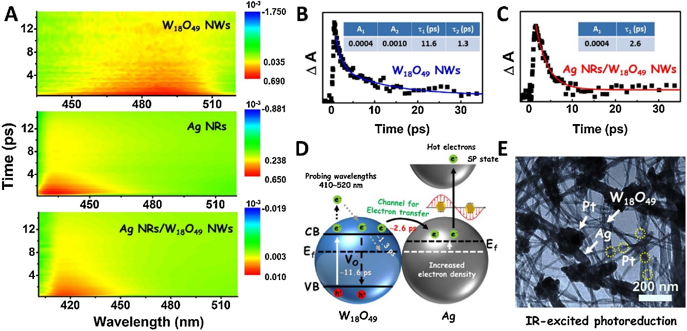

Figure 8. A) Ultrafast transient absorption spectra; (B, C) TA kinetics curves of W₁₈O₄₉ NWs and Ag/W₁₈O₄₉ heterostructures with a probing wavelength at 480 nm; (D) Illustration of electron transfer pathway in the Ag/W₁₈O₄₉ and (E) TEM image of the Pt nanoparticle-loaded Ag/W₁₈O₄₉ heterostructures formed via an IR-excited photoreduction reaction. Reproduced with permission.²¹¹ Copyright 2019, Elsevier.

3.2.2. Dark-Field Spectroscopy
Dark-field spectroscopy has become an important plasmonic spectroscopic technique to characterize NPs on a single particle level.²²² This technique assists in evaluating the optical properties of NPs and understanding the effect of change in the morphology and refractive index of the reaction medium. It can provide the real-time analysis of catalytic reactions which can assist in understanding the reaction kinetics. At the current stage, the reaction kinetics of nanocatalyst has been measured by single-molecule fluorescence, SERS, X-ray absorption and dark-field spectroscopy. In comparison to the limitation of hotspots in SERS, quenching of dyes in fluorescence measurements and damage of the sample by X-ray, dark-field spectroscopy is a simple and convenient technique. The noble metal Ag/Au nanostructures act as a catalyst in several reactions where the substrate molecule gets adsorbed on the surface of the catalyst and carry out the electron transfer process from donor to acceptor.
The representative SEM images of varying morphology of Ag nanoprisms are shown in Figure 9 (a) in which single-particle dark-field spectroscopy was used to display that fluorescence from molecules is dependent on the scattering properties of the particles.¹¹⁶ Figure 9 (b) represents the dark-field micrograph of varying size and morphology of Ag NPs demonstrating different colors in the dark-field spectra due to enhanced scattering of light by different shaped nanostructures. Mulvaney et al. reported the monitoring of electron injection and extraction on a gold nanocrystal during oxidation of ascorbic acid via dark-field plasmon spectroscopy.²¹³ An electron transfer rate of 4600 electrons and 65 molecules of O₂ per second was measured to display the redox reaction on gold nanocrystal for the very first time. This technique can prove to be pivotal in establishing the plasmon-enhanced reaction mechanism of catalytic reactions. Cheng et al. also studied the real-time monitoring of the plasmon-induced oxidation reaction over Au nanorods immobilized on a glass substrate or freely moving in solution.²²³ This imaging technique was used to study the reaction rate in which the immobilized Au nanorods displayed a slow reaction rate than bulk solution indicating the influence of the self-catalysis mechanism. The Dark-field spectroscopy analysis is not only limited to solid-liquid reactions but can also be used to explore reactions at the gas-solid interface. For example, Collins et al. monitored the hydrogen dissociation over single Au NPs supported on semiconducting metal oxide supports (anatase TiO₂, ZnO).¹²⁹ The direct evidence of gas adsorption and charge migration and the role of semiconducting metal oxide support can be investigated in real-time.

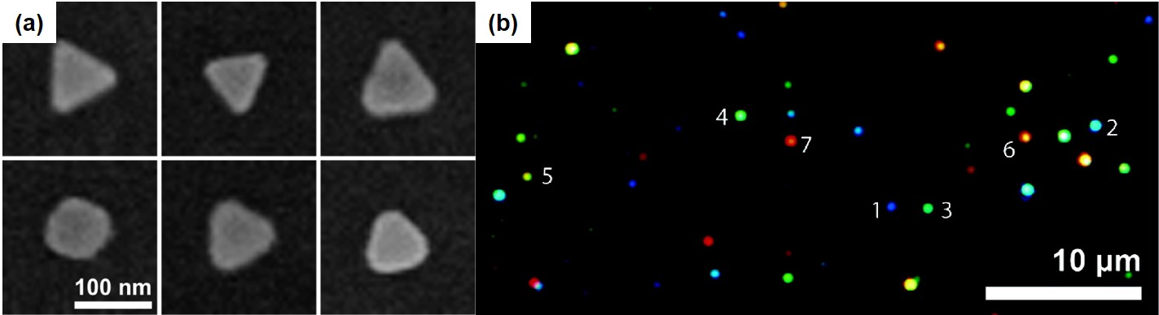
Figure 9. (a) SEM images of size and morphology varied Ag nanoprisms (b) Dark-field micrograph displaying different colors due to different optical scattering efficiency of nanoparticles. Reproduced with permission.¹¹⁶ Copyright 2007, American Chemical Society.

3.2.3. Electric field enhancements
Recently, significant research interest has been focused on understanding the enhancements in the reaction rate in plasmonic catalysis. One of the critical effects is the electric field enhancement effect in plasmon chemistry which occurs at small lengths with fast time scales. It is essential to dive into the details of this aspect of the mechanistic pathway to understand its contribution and to determine the most active plasmon regions in the photocatalyst. An excellent example was reported by Chen et al. in which they studied the synthesis of multi-interfacial plasmon coupled (Au/AgAu)@CdS core-shell nanohybrids for the hydrogen generation from water.²¹⁴ The Au/AgAu core was prepared with multiple adjustable nanogaps varying from one, two, three and four by galvanic replacement process. The UV-vis spectra was found to display maximum absorption for four-gap nanostructure and the TEM micrograph of four-gap Au/AgAu and (Au/AgAu)@CdS showed the irregular morphologies with sharp corners. These can serve as sites for hot spots for electric field enhancement effects, especially at the peripherals. It was observed that the gap also displayed strong electric field enhancements due to the multi-interfacial plasmonic coupling between core and shell components. The photocatalytic hydrogen generation was carried out using Na₂SO₃-Na₂S as sacrificial agents under visible light irradiation (λ > 420 nm). A hydrogen production rate of 4.71 mmolg⁻¹h⁻¹ was obtained for a four-gap hybrid which was 15.9, 7.2 and 2.5 times higher than the one, two and three-gap (Au/AgAu)@CdS nanohybrid. This observation was in accordance with the optical absorption and near-field enhancement effects. The underlying mechanism was proposed in which the plasmonic energy harvested by Au/AgAu hybrid is transferred to the CdS which can produce hydrogen upon reacting with water and sacrificial agents. The near-field enhancement effects and interfacial plasmon coupling are the main factors contributing to the higher catalytic performance under visible light irradiation for the four-gap (Au/AuAg)@CdS nanohybrid catalyst.
A ternary plasmonic catalyst was designed by combining Ag NPs and reduced graphene oxide (RGO) to enhance the efficiency of TiO₂ (P25) photocatalyst (Figure 10 (a)).²¹⁵ The three different morphologies of plasmonic nanostructures were prepared (sphere, decahedron and prism) and their electric field intensity distributions were calculated using FDTD simulations as displayed in Figure 10 (b-d). Under an excitation wavelength of 611 nm, the enhanced electric fields can be observed especially in decahedron and prism-based nanostructures with the presence of sharp tips facilitating stronger LSPR effects. The photocatalytic removal of methylene blue (MB) dye using Ag/P25/RGO with 0.4 wt % Ag nanoprisms and 5 wt % RGO displayed 10 times more activity than the pure P25 photocatalyst.

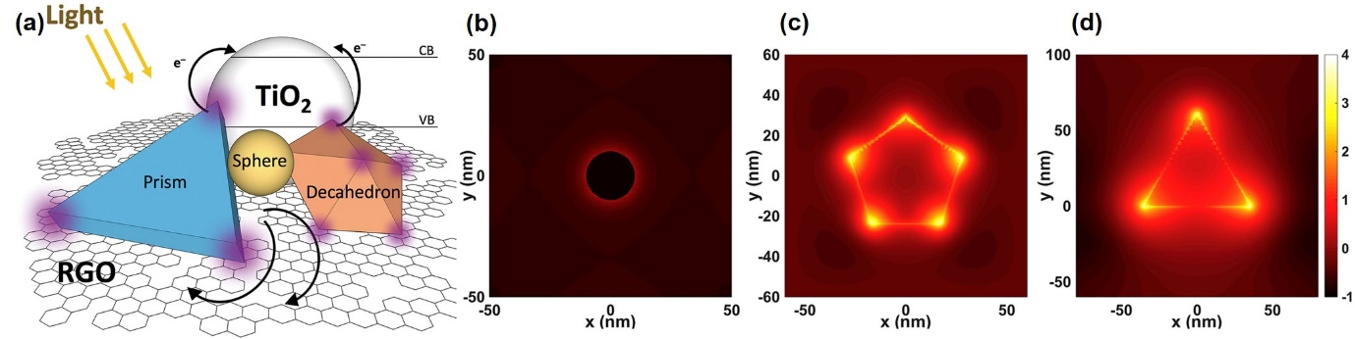
Figure 10. (a) Illustration of the mechanisms of enhanced photocatalytic efficiency of Ag and RGO co-loaded TiO₂ nanocomposite, (b) Simulated electric field intensity distributions for sphere, (b) decahedron and (d) prism-shaped Ag nanostructures irradiated by an unpolarized light source with wavelengths of 611 nm. The intensity bar shows logarithmic-scale intensity. Reproduced with permission.²¹⁵ Copyright 2020, Elsevier.

The calculation of surface electric field intensity by finite element method (FEM) for Ag@Pd core-shell catalyst where nanocube Ag absorbs visible light and Pd acts as the catalytically active component was reported.²¹⁶ As shown in Figure 11 (a), the strong electric field intensity is generated around Ag due to the plasmon coupling effect however, it was reduced significantly with the coating of Pd (Figure 11 (b)). The local heating power density for Ag@Pd was higher than Ag@Ag due to the faster channel of plasmon decay accumulating on the Pd shell forming a belt on the outer surface.

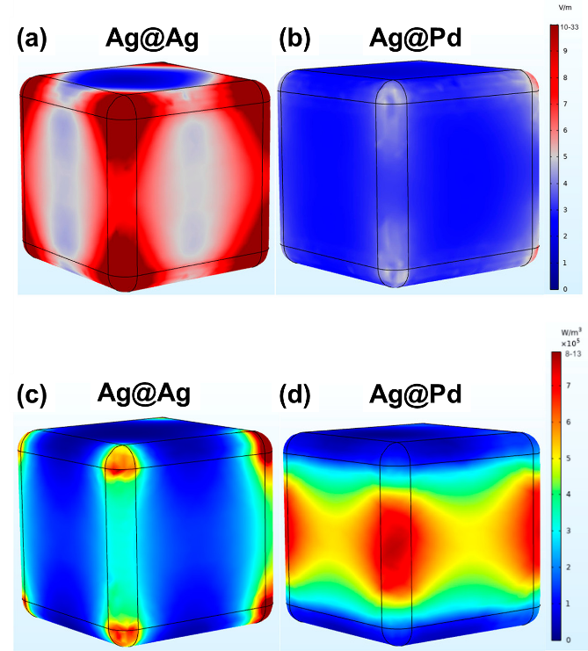
Figure 11. Electrical field distributions of Ag (a) and Ag@Pd (b) nanocubes along with the localized heating power densities of Ag (c) and Ag@Pd (d) nanocubes. Reproduced with permission.²¹⁶ Copyright 2020, American Chemical Society.

Ye et al. calculated the electromagnetic field utilizing FDTD simulations over Pd_{x}Au_{y}/Al₂O₃ catalysts and obtained enhancements over all the catalysts under monochromatic light irradiation of 530 nm as shown in Figure 12 (a-f). The minimum EM field enhancement of 23.2 was obtained over Pd/Al₂O₃ because of its no inherent optical absorption and reached as high as 64.0 for pure Au/Al₂O₃ catalyst. The trend in the light absorption was found to be similar to that of the EM field and catalytic enhancements of PdAu metal NPs, suggesting the significance of plasmonic characteristics of the prepared catalysts.

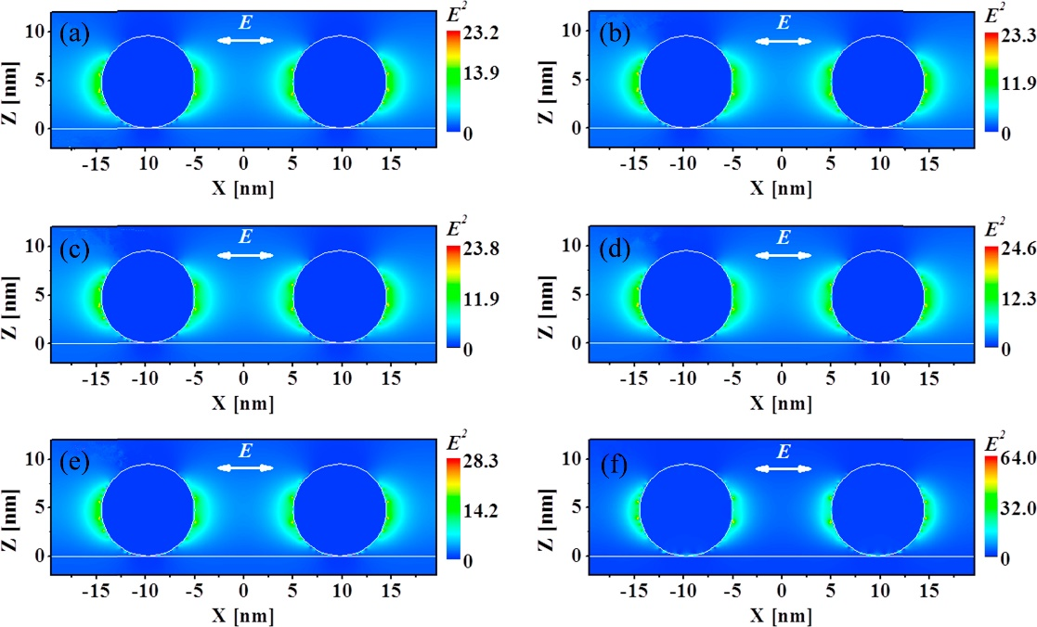
Figure 12. Cross sectional views and EM enhancement around several ratios of PdAu NPs over Al₂O₃ catalyst using FDTD simulations (a) Pd/Al₂O₃, (b) Pd₉₈Au₂/Al₂O₃ (c) Pd₉₀Au₁₀/Al₂O₃ (d) Pd₈₀Au₂₀/Al₂O₃ (e) Pd₅₀Au₅₀/Al₂O₃ (f) Au/Al₂O₃. Reproduced with permission.²¹⁷ Copyright 2016, Elsevier.

Theoretical simulations over Au@Pd@UiO-66-NH₂ were also carried out to understand the mechanistic pathway in the CO₂ hydrogenation reaction.¹²⁶ The Pd thickness shell was varied in order to investigate its effects in enhancing the plasmonic catalysis. The electric field enhancements around Au@UiO-66-NH₂, Au@Pd@UiO-66-NH₂-0.5 and Au@Pd@UiO-66-NH₂-2 were calculated as shown in Figure 13. The enhancement shown by the catalyst with Pd shell thickness of 0.5 nm was due to the Au core acting as an antenna to absorb the visible light and enhances it around the Pd shell. However, the thickness of the shell decreases the ability to absorb light and creation of field enhancements effects. The observed near-field effects were also in agreement with the catalytic activity enhancements under visible light irradiation.

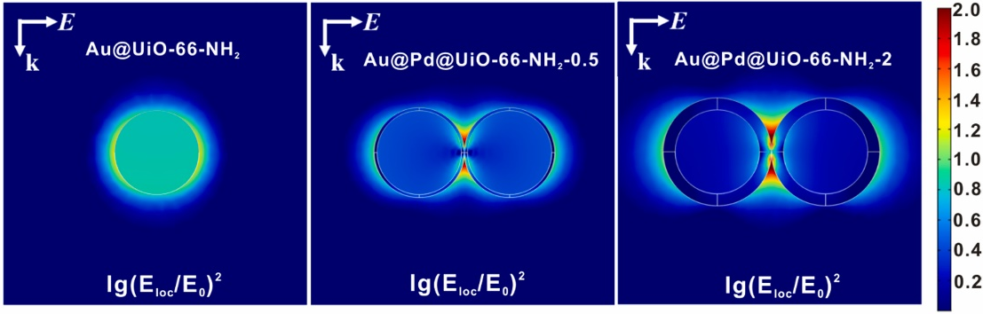
Figure 13. Simulated electric field enhancements around (a) Au@UiO-66-NH₂, (b) Au@Pd@UiO-66-NH₂-0.5 and (c) Au@Pd@UiO-66-NH₂-2. Reproduced with permission.¹²⁶ Copyright 2021, Elsevier.

3.2.4. Surface-Enhanced Raman Scattering (SERS) spectroscopy
SERS is a powerful analytical technique for characterization applicable in various fields such as biomedical, chemical, quantitative analysis, in situ reaction monitoring and life science applications. It can provide useful information about molecular vibrations for understanding the plasmon-substrate interactions because of its sensitivity on a single-atom level. It allows for the study of enhancement in the Raman signal from the nearby atoms using a suitable probe molecule and offers several advantages by furnishing useful information such as the molecular structure, orientation and vibration and environment. The possible detected enhancement in SERS can reach as high as 10¹² due to the electromagnetic enhancements around the hot spots. Xu et al. has recently utilized SERS for reduction reaction monitoring of 4-nitrothiophenol (4-NTP) to 4-aminothiophenol (4-ATP) catalyzed by Au nanobipyramids (NBP)-embedded AgPt hollow nanostructures.²¹⁸ The in situ monitoring of the reduction reaction by NaBH₄ was demonstrated by using 4-NTP as a probe for Au NBP@AgPt nanocage and nanoframe under an excitation wavelength of 785 nm. The 4-NTP modified nanocage SERS spectra was measured after the addition of NaBH₄ at t=0 min until t = 55 min. It was observed that the vibrational band intensity of NO₂ in 4-NTP (ν_{NO2} = 1330 cm⁻¹) continues to decrease and for the 4-ATP tends to increase at ν_{CC =} 1595 cm⁻¹ with time.
The synthesis of Ag/TiO₂/Ag nanocomposite by employing Ag nanospheres as the core to coat a layer of TiO₂ as a shell and further deposit Ag NPs onto TiO₂ shell to form Ag satellite shell-type structure also employed SERS technique.²¹⁹ The SERS sensitivity of Ag/TiO₂/Ag nanocatalyst for 4-NTP reduction to 4-ATP using in situ monitoring of the chemical reduction reaction using NaBH₄ reductant under 785 nm excitation was studied. Further, the quantitative detection of methylene blue with concentrations as low as 10⁻¹⁰ M was demonstrated. Similarly, Lu et al. studied the monitoring of 4-NTP reaction on Au@Ag NRs using time-dependent SERS spectroscopy under 532 nm excitation.²²⁰ However, the authors observed the dimerization of 4-NTP to 4,4-dimercaptoazobisbenzene (DMAB) within 120 s of reaction time due to the generation of plasmon-induced hot electrons. The surface reduction of 4-NTP on Ag plasmonic film (PF) using the SERS technique using HCl as the hydrogen source instead of a usual reducing agent was investigated by Qiu’s group.¹²⁸ Interestingly, authors have proved the hot electron-assisted reduction of 4-NTP to DMAB by correlating the Cl⁻ concentration and reaction pathway. In strongly acidic conditions (concentration > 0.1 M), the DMAB peak was not detected. However, for H⁺ concentration below 0.01 M, intense SERS bands of DMAB were observed. The observed results suggest that the reaction mechanism depends on the concentration of H⁺ and Cl⁻ ions which align with the explanation of hot electrons participation in the reaction. Ryu et al. explored the characterization of bimetallic and trimetallic nanomesh structures via SERS spectroscopy using Ag-Au, Pd-Au-Ag and Pt-Au-Ag for the 4-NTP reduction to 4-ATP.²²¹ The reaction kinetics was studied by monitoring the SERS bands intensity of 4-NTP at 1350 cm⁻¹ and 4-ATP at 1600 cm⁻¹. The Pt-Au-Ag cubic mesh (CMs) structure displayed the most active catalytic activity as shown in Figure 14 (a-c).

Figure 14. SERS spectra for the reduction of 4-NTP to 4-ATP catalyzed by (a) Ag−Au CMs, (b) Pd−Au−Ag CMs and (c) Pt−Au−Ag CMs. Reproduced with permission.²²¹ Copyright 2020, American Chemical Society.

A hierarchical Ag nanocone arrays represented as “hedgehog-like” arrays (HLAs) are fabricated on 3D polystyrene (PS) for generating high density localized hot spots.²²⁴ The SERS performance was evaluated by using p-aminothiophenol (PATP) as the probe molecule under a laser excitation of 633 nm and compared with planar nanocone arrays (NCAs) and 3D nanosphere arrays (NSAs). The Raman signal of HLAs is 6-7 times more intense than NCAs and NSAs. Furthermore, the FDTD calculated electromagnetic field around HLAs was more pronounced because of the presence of sharp nano-tips, 3D structures and coupling effect between the nanocones. The strong electromagnetic field and hot-electron excitation prompted authors to investigate the methylene blue (MB) dye degradation. The active oxygen species, formed by the interaction between O₂ and hot electrons, can combine with MB to generate CO₂ and H₂O. The strategy of combining SERS with plasmonic catalysis is gaining popularity and has a great potential for discoveries in the field of plasmonic nanochemistry. Lee and coworkers reported the synthesis of Au NP trimers through galvanic replacement reaction between Ag nanoprisms and Au precursor solution.²²⁵ After that, Au was used as a core to develop an active metal shell (M= Pd, Pt) onto them to form Au@M NPs trimer. The Au trimer sized 58 $±$ 6 nm, was stabilized because of the van der Waals interactions mediated by the presence of PVP polymer. The prepared catalyst was also found to be stable under different reaction conditions such as a change in the reaction solvent, pH and prolonged ultrasonic treatment. The photoreduction of 4-nitrobenzenethiol (4-NBT) was used as the test reaction to assess the performance of these novel nanostructures by SERS measurements. Under the laser excitation of 633 nm and 2 mW cm⁻², the three main peaks of 4-NBT (1084, 1334 and 1569 cm⁻¹) were observed at t = 0 seconds. The formation of products was affirmed by the appearance of three new peaks corresponding to DMAB at 1145, 1393 and 1439 cm⁻¹. This photo-induced reduction gives evidence of hot electron generation by Au trimer NPs under laser excitation conditions. The SERS provides a quantitative analysis of reaction products but lacks the spatial resolution to study the factor influencing the catalytic efficiency in plasmonic nanostructures. Tip-enhanced Raman spectroscopy (TERS) can overcome such limitation in which the plasmonic metal is formed at the apex of the scanning probe by etching or depositing them on commercially available silicon probes. Li et al. investigated the relation between catalytic activity and local electric fields on Au@Pd and Au@Pt nanoplates using tip-enhanced Raman scattering (TERS).²²⁶ A comparison of the magnitude of electric field generation for mono- and bi-metallic nanostructures was established and correlated with the catalytic efficiencies.

3.2.5. Photoluminescence (PL) spectroscopy
To gain a better understanding of charge transfer and recombination mechanisms during light irradiation conditions, photoluminescence (PL) emission spectroscopy is employed. Kang’s group and co-workers synthesized Ag/AgVO₃@CdS/BiVO₄ photocatalyst for hydrogen generation (105,541 μmol/g) using lactic acid as the hole scavenger agent under solar light irradiation.¹²⁴ Under an excitation wavelength of 450 nm, the obtained PL spectra are shown in Figure 15 with intensity maxima at 519.9, 538.9 and 539 nm for BiVO₄, CdS and CdS/BiVO₄, respectively. The Ag/AgVO₃@CdS/BiVO₄ heterostructure displays much lower PL intensity suggesting an efficient charge separation of electrons and holes due to the presence of Ag/AgVO₃ nanoclusters. The lower PL intensity of the heterostructure was ascribed to the possible charge migration from BiVO₄ and Ag/AgVO₃ to CdS.

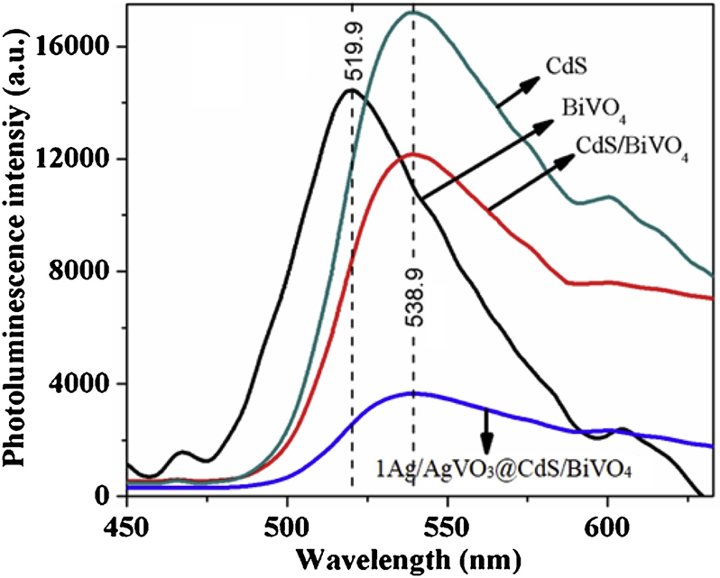
Figure 15. Photoluminescence spectra of CdS, BiVO₄, CdS/BiVO₄ and 1Ag/Ag/AgVO₃@CdS/BiVO₄. Reproduced with permission.¹²⁴ Copyright 2020, Elsevier.

4. Noble metal nanostructures-based plasmonic catalysis
The UV-light absorption of n-type semiconductors limits the efficient utilization of broad spectrum of solar energy. Hence, the combination of the plasmonic metal with semiconductors is a popular approach to increase the visible-light-responsiveness of the photocatalytic materials. In this respect, Ag and Au-based metal NPs have been most widely researched to achieve strong visible light absorption along with an improved charge transfer efficiency under illumination conditions. The use of plasmonic NPs in visible-light-driven catalysis is highly promising because of their high cross-section extinction coefficient values amongst all other metal NPs.²²⁷ It has been widely researched that incorporating plasmonic NPs can lead to higher reaction rates and improved selectivity under mild reaction conditions. In this section, we will discuss Ag- and Au-based noble metal-based catalysts for the two of the most challenging and popular reactions viz. CO₂ reduction and hydrogen generation via plasmon-mediated catalysis. The catalytic systems included in this section are based on Ag and Au NPs supported on a variety of support materials, for example, Al₂O₃, metal-organic frameworks (MOFs), TiO₂, TiO_{2-x}, mesoporous silica (SBA-15) and carbon materials. Table 5 summarizes the specific examples of plasmonic catalysts along with the details of the reaction conditions and photocatalytic performance under solar light irradiation.

Table 5. Plasmon-mediated catalysis over Ag- and Au-based catalysts.
Plasmonic photocatalyst | Photocatalytic reaction | Light source | Reaction conditions | Photocatalytic performance | Ref.
Ag/TNTAs-E | CO₂ reduction to CH₄ | 300 W Xe lamp with 400 nm cut off filter | CO₂ and H₂O vapor produced by NaHCO₃ with HCl, gas products analyzed with GC equipped with flame ionization detector and methanizer | CH₄ production rate ~ 50 mmolh⁻¹m⁻² | ²²⁸
Ag NPs/ACFs | CO₂ reduction to methanol | 300 W Xe lamp with 420 nm cut off filter | Catalyst (15 mg), water (20 mL), CO₂ (0.6 MPa), temperature (80 °C) and no sacrificial agent | CH₃OH evolution rate 13.9 μmolg⁻¹h⁻¹ | ²²⁹
CN/Au | CO₂ reduction to CO and CH₄ | Xe lamp | Catalyst (30 mg), ethanol (5 mL), deionized water (0.5 mL) | CO (28.3 μmolg⁻¹h⁻¹) and  CH₄ (1.3 μmolg⁻¹h⁻¹) | ²³⁰
Pd₉₀Au₁₀/Al₂O₃ | CO₂ reduction | Xe lamp | Catalyst (15 mg) packed in alumina cell, gas flow rate (20 mL min⁻¹) | CO₂ conversion rate (1210.6 μmolg⁻¹min⁻¹) | ²¹⁷
Au/TNTs | CO₂ reduction to CH₄ | 300 W Xe lamp | CO₂ flow rate (50 ccmin⁻¹), Pressure (100 kPa), time (2 h) | 14.67 % CH₄ yield | ²³¹
Au@Pd@UiO-66-NH₂-0.5 | CO₂ reduction to CO | 300 W Xe lamp | Catalyst (5 mg), CO₂/H₂ (1MPa) and temperature (150 °C) | 3737 μmol/g_{metal}/h | ¹²⁶
HUY@S-TOH/AuPd | CO₂ reduction to CH₄ | 300 W Xe lamp, λ > 400 nm | 500 mL cylindrical glass reactor with CO₂ gas (99.9 % purity) | 47 μmol/g_{cat}·h | ²³²
Au_{x}@ZIF-67 | CO₂ reduction to methane and methanol | 150 W Xe lamp | Catalyst (50 mg), 10.0 wt % triethanolamine (TEOA), NaHCO₃ (67 mg), | 2.5 mmolg⁻¹h⁻¹ (methanol) and 0.5 mmolg⁻¹h⁻¹ (ethanol) | ²³³
AgNi/SiO₂ | CO₂ conversion to methane | Laser illumination at 405 nm | Catalyst (50 mg), CO₂/H₂/N₂ = 1:4:1 at 723 K | 22.8 % conversion, 42.4 % CH₄ selectivity | ²²⁷
Ag-HMO | CO₂ reduction to methane | 300 W Xe lamp, λ > 420 nm | Catalyst (100 mg), water (15 mL), CO₂ (0.5 MPa), 60 °C | 0.61 molmol⁻¹ | ¹¹²
Ag@TiO₂ | CO₂ reduction to methane | 300 W Xe lamp, λ > 350 nm | 11.58 mL Pyrex reactor purged with CO₂ and water vapor (0.5 %) | 14.8 μmolg⁻¹ | ²³⁴
Cu-Cu₂O | CO₂ reduction to CO and CH₄ | 350 W Xe lamp | Catalyst (50 mg), HCl (4M) and NaHCO₃ (85 mg) | CO= 3.25 μmolg⁻¹h⁻¹ and CH₄ yield ~ 0.5μmolg⁻¹h⁻¹ | ²³⁵
PVP-capped Au NP | CO₂ reduction to methane and ethane | 300 W Xe lamp, 300 W cm⁻²  λ> 400 nm | Colloidal Au NPs (10%), isopropanol (3 mL), CO₂ (10 mLmin⁻¹, 20 min), 10 h | TON_{CH4} = 6.8 NP⁻¹  TON_{C2H6} = 5.6 NP⁻¹ | ²³⁶
Ag/AgVO₃@CdS/BiVO₄ | Hydrogen generation from water | 300 W Xe lamp | lactic acid (10 vol%), water | Rate = 105,541 μmol/g | ¹²⁴
(Au/AgAu)@CdS | Hydrogen generation from water | 300 W Xe lamp, λ > 420 nm | Catalyst (50 mg), Na₂SO₃ (0.25 M), Na₂S (0.35 M) | Rate = 4.71 mmolg⁻¹h⁻¹ | ²¹⁴
Au/TiO₂ | Hydrogen generation from AB | 500 W Xe, λ > 420 nm | Catalyst (20 mg), water (5 mL), 0.5 mL AB (0.04 M) | 0.36 μmolmin⁻¹ | ¹⁸⁵
Ag/SBA-15 (B) | Hydrogen generation from AB | 500 W Xe, λ > 420 nm | Catalyst (20 mg), water (5 mL), 0.5 mL AB (0.04 M) | 0.67 μmolmin⁻¹ | ¹⁷⁷
Pd/Ag/SBA-15 (B) | Hydrogen generation from AB | 500 W Xe, λ > 420 nm | Catalyst (20 mg), water (5 mL), 0.5 mL AB (0.04 M) | 2.28 μmolmin⁻¹ | ¹⁷⁸
Ru/Ag/SBA-15 (B) | Hydrogen generation from AB | 500 W Xe, λ > 420 nm | Catalyst (20 mg), water (5 mL), 0.5 mL AB (0.04 M) | 3.60 μmolmin⁻¹ | ¹⁷⁹
Ag/Ti-SBA-15 | Hydrogen generation from AB | 500 W Xe, λ > 420 nm | Catalyst (20 mg), water (5 mL), 0.5 mL AB (0.04 M) | 3.3 μmolmin⁻¹ | ¹⁸¹
Au-Pt@CdS | Hydrogen generation by the oxidation of benzyl alcohol | 300 W Xe, λ > 420 nm | Catalyst (2 mL suspension) and 0.5 M alcohol | 153 μmolh⁻¹ | ¹⁶⁵
Au/CdSe NCs | Hydrogen generation from water | 300 W Xe, λ > 420 nm | Catalyst (1 mg), Na₂SO₃ (0.05 M) and Na₂S (0.07 M) | 73 mmol $g_{CdSe}^{-1}$ h⁻¹ | ²³⁷
Au/m-Ta₂O₅ | Hydrogen generation from methanol | 300 W Xe, λ > 400 nm | Catalyst (50 mg) and methanol aqueous (20 mL) | 29 μmolh⁻¹g⁻¹ | ²³⁸

4.1. Plasmon-mediated CO₂ reduction
Researchers have started investigating the conversion of CO₂ to value-added chemicals such as methane, formic acid and methanol via catalytic, photocatalytic and electrocatalytic pathways.^{159,239} The photocatalytic reduction of CO₂ can be seen as a promising technique to carry out artificial photosynthesis fulfilling the requirement of multielectron and multiproton reactions. However, in the current scenario, there are still many challenges that are limiting the performance of CO₂ reduction because of low energy efficiency and product selectivity. Recently Amal et al. reported the bimetallic interaction between Ag-Ni NPs to affect the size and distribution of NPs on support materials and also the extent of optical absorption.²²⁷ The application of plasmonic AgNi NPs on insulator silica support was applied in the CO₂ methanation reaction in which Ni was selected because of its high activity, low cost and easy availability. The combination with Ag allows the unique exploitation of visible light sensitivity of plasmonic NPs. The bimetallic NPs were prepared by co-impregnation (CI) and sequential impregnation (SI) methods using AgNO₃ and Ni(NO₃)₂•6H₂O as the metal precursor solutions. The activity and selectivity of series of AgNi/SiO₂ based catalysts were tested under thermal and laser illumination conditions. The presence of hot electrons in Ag under irradiation conditions was identified as the main factor in enhancing the CO₂ methanation reaction. These hot electrons are then transferred to metallic Ni NPs where the samples with stronger Ag-Ni interaction displayed the highest enhancement under illumination conditions.
A new frontier gaining popularity in heterogeneous catalysis is single-atom catalysis. Single-atom catalysts (SACs) have well-defined active sites and the rational design of new catalysts combined with plasmonic NPs is an interesting approach to fine-tune the activity and selectivity of chemical reactions. Ding et al. reported the design of single-atom silver-manganese (Ag-HMO) catalysts for CO₂ reduction to methane under light irradiation conditions with a reaction rate of 0.61 mol mol⁻¹ catalysts.¹¹² The hollandite manganese dioxide (HMO) was prepared by the hydrothermal synthesis method and a single atom of Ag could enter into the tunnels of HMO due to the migration properties of Ag atoms. It has been speculated that Ag atoms promote the generation and transfer of hot electrons to increase the photocatalytic activity. The hot electrons generated by single Ag atoms and surface Ag NPs upon visible light irradiation are transferred to the HMO semiconductor and reduces the recombination rate of electrons and holes and hence promote photocatalytic activity. Furthermore, the high CO₂ adsorption capacity of HMO enables the faster reduction of adsorbed CO₂ on the surface of the catalyst.
The heterojunction of semiconductors with plasmonic NPs has attracted significant research interest as plasmonic NPs can assist in enhancing the efficiency of light absorption via the LSPR effect. The synthesis of Ag@TiO₂ core-shell nanostructure for the photoconversion of CO₂ to CH₄ was recently reported.²³⁴ The nanocatalyst was prepared by coating TiO₂ on Ag core NPs with a mean diameter of 50 nm (Figure 16 (a)). The NPs were dispersed on the glass plate and annealed at 500 °C in order to remove all the carbon and organic residues from the photocatalyst, named Ag@TiO₂ h₅₀₀. The rate of CH₄ generation over core-shell photocatalyst after 3h photoirradiation was 14.8 μmol g⁻¹ which was four times higher than the bare TiO₂ h₅₀₀ (3.9 μmol g⁻¹) as shown in Figure 16 (b). Under monochromatic light irradiation (365 nm, 5.0 mWcm⁻²), the apparent quantum yield for CH₄ generation from CO₂ was 5.7$×$ 10⁻³ %. The proposed mechanism was based on the light scattering effects for plasmonic NPs with a size exceeding 50 nm in diameter. Upon light irradiation (λ > 350 nm), the plasmonic Ag core scatters light to the TiO₂ NPs and increases the photon flux in the TiO₂ shell, leading to the increase in the photocatalytic performance as shown in Figure 16 (c).
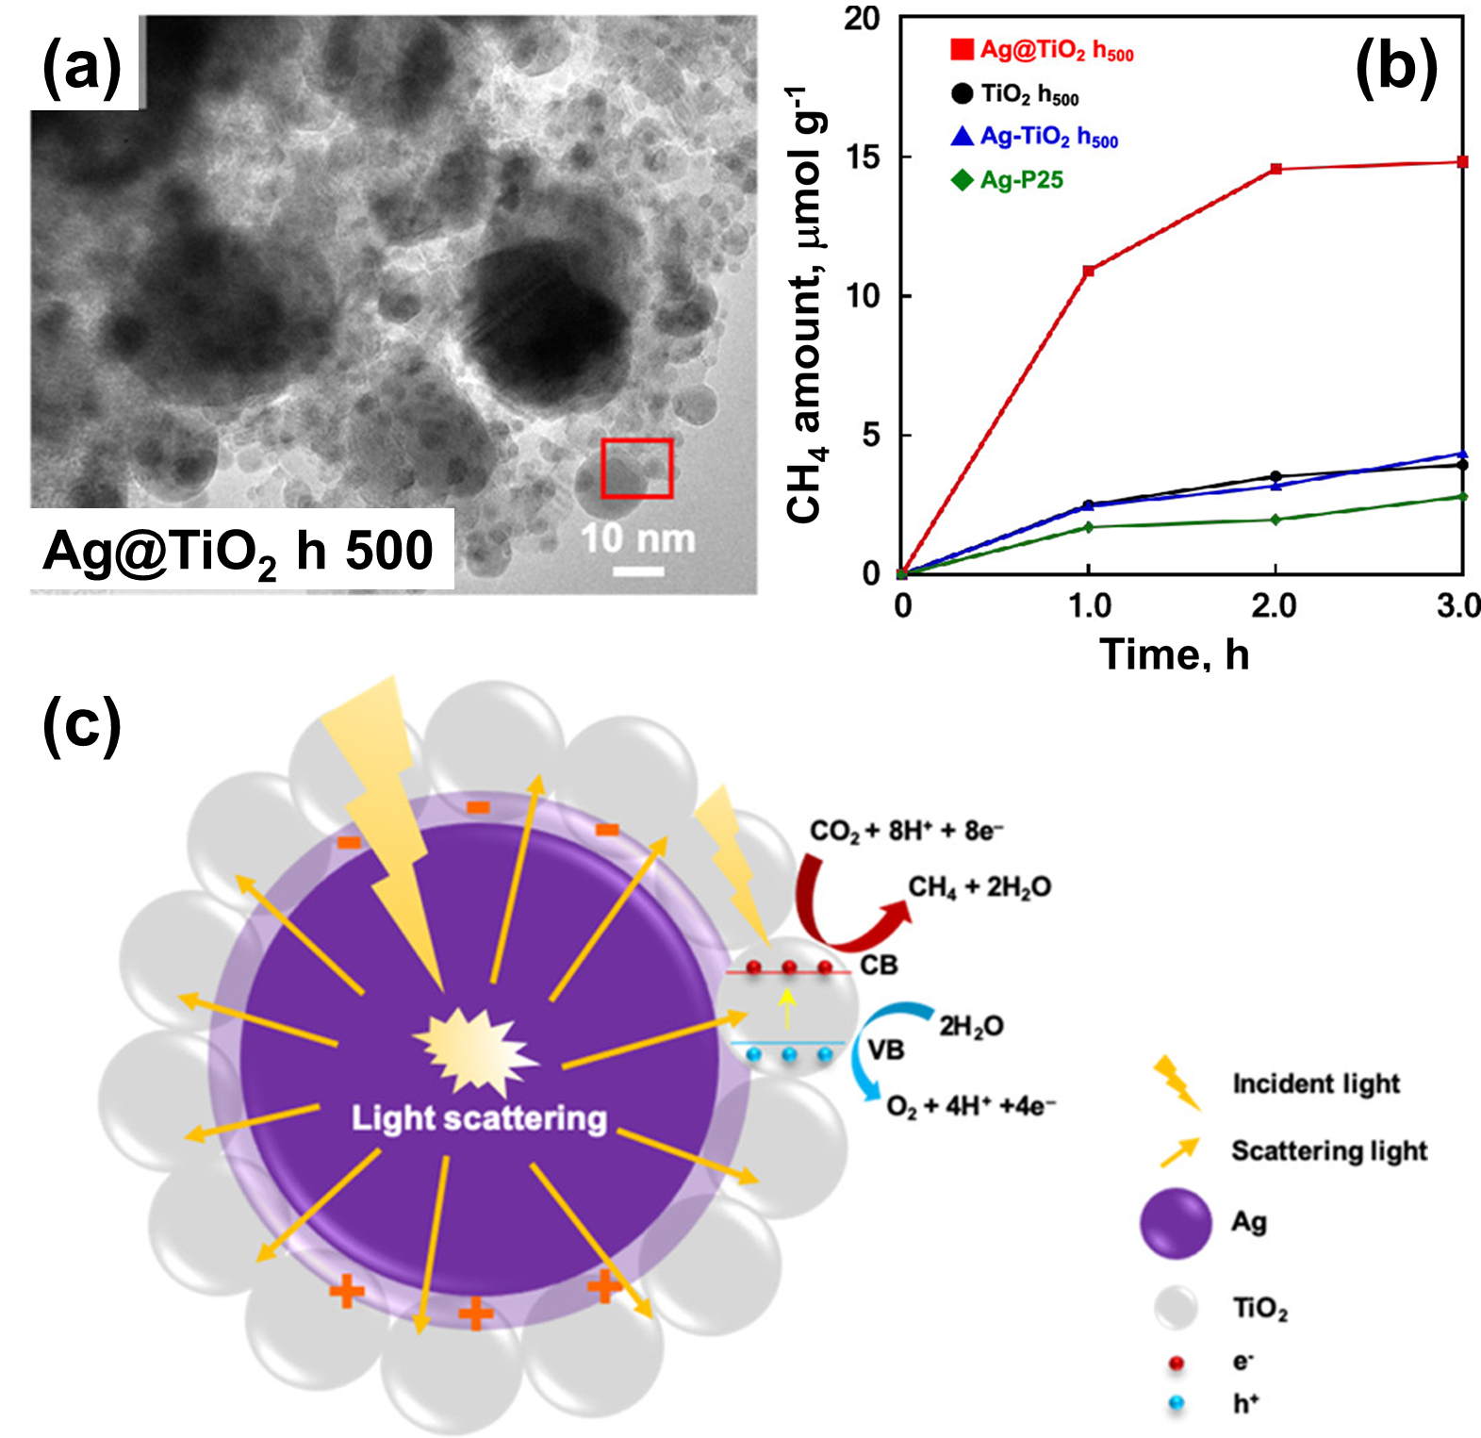
Figure 16. (a) TEM image of Ag@TiO₂ h₅₀₀ (b) Time course of CH₄ evolution over prepared catalysts and (c) plausible mechanism for the conversion of CO₂ to CH₄ over Ag@TiO₂ core-shell nanostructure. Reproduced with permission.²³⁴ Copyright 2019, American Chemical Society.
The union of Ag with TiO₂ is a popular choice for many researchers to combine the UV-active TiO₂ and LSPR sensitive Ag NPs. Cheng et al. reported the surface plasmon resonance of Ag deposited on TiO₂ nanotube arrays (TNTAs) for the photocatalytic CO₂ reduction to methane and methanol.²²⁸ Ag NPs were loaded by the electrochemical deposition method into the inner space of TNTAs (Ag/TNTAs-E) and studied by Raman and light absorption spectroscopic analysis. Ag NPs were also deposited by a conventional method of deposition (Ag/TNTAs-C) for comparative characterization and photocatalytic studies. The intensity of optical absorption of Ag/TNTAs-E was found to be higher than Ag/TNTAs-C because the scattered light is absorbed more effectively by the NPs present within the inner spaces of the TNTAs (Figure 17 (a)). Furthermore, the Raman signals were also observed to be more intense for Ag/TNTAs-E catalyst suggesting the Ag NPs in the inner spaces of TNTAs are enhancing the SERS and SPR effects of Ag NPs. The migration pathway of charge carriers on Ag-loaded TNTAs was studied by synchronous-illumination X-ray photoelectron (SIXPS) spectroscopy analysis. Under light irradiation of 520 nm, a shift in the Ti 2p_{3/2} peak by 0.1 eV was observed towards lower binding energy values, indicating the transfer of charge from Ag to TiO₂. This observation concludes that Ag NPs can cross the Schottky barrier and can transfer the ‘hot electrons’ to the TNTAs, leading to the formation of electron-rich TiO₂ species. The photocatalytic CO₂ reduction to CH₄ was studied using prepared catalysts. TNTAs and P25 did not display any catalytic activity whereas Ag/TNTAs-C and Ag/TNTAs-E showed active catalytic performance in which Ag/TNTAs exhibited most active activity because of the presence of Ag NPs in the inner space of TNTAs leading to enhanced SPR effects. The isotope studies utilizing ¹²C and ¹³C-labeled CO₂ confirmed that CO₂ is the origin of the formation of hydrocarbon products. Furthermore, the in-situ DRIFTS analysis was carried out to study the formation of intermediates during the reaction in dark and under 520 nm LED light irradiation conditions (Figure 17 (b)). A few low intense peaks from carbonate and water were observed in dark conditions whereas gradually increasing peaks of HCOO⁻, HCHO and CH₃O intermediates were observed under light irradiation conditions.
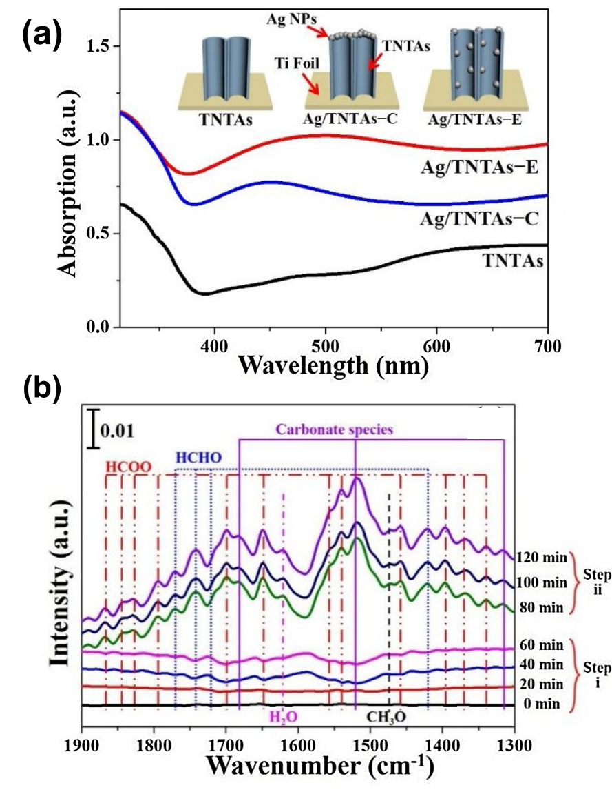
Figure 17. (a) UV-vis absorption spectra (b) The in-situ diffuse reflectance infrared Fourier transform spectra (DRIFTS) using Ag/TNTAs-E in dark (step i) and under LED light illumination conditions (step ii). Reproduced with permission.²²⁸ Copyright 2018, Elsevier.
McCloskey’s group studied the plasmonic CO₂ reduction using polycrystalline Ag thin film catalyst and reported that the formation of products is dependent on the applied potential.²⁴⁰ For example, under a small applied potential value, the selective formation of carbon monoxide was observed and under larger cathode potential, the formic acid and methanol were produced. This study summarizes the careful tuning of product formation over plasmonic photocatalyst upon varying the applied potential. The three different mechanisms for the enhanced catalytic activity and selectivity were proposed namely, direct charge transfer, indirect charge transfer and transient negative ion (TNI) mechanism. The direct charge transfer mechanism involves the direct charge transfer to the intermediate complex formed by the metal and adsorbate, and the indirect charge transfer mechanism involves the transfer of hot electrons from SPR excited plasmonic Ag to the unoccupied molecular orbitals of the adsorbate. In the TNI mechanism, the hot electrons are temporarily transferred to the unoccupied molecular orbitals of the adsorbate and return to the metal, leaving the adsorbate in a vibrationally active state leading to enhanced catalytic activity. Further mechanistic details can be inferred by employing spectroscopic and computational studies. The photocatalytic CO₂ reduction on Ag plasmonic catalyst was also reported and obtained results were complemented with in-situ surface-enhanced Raman spectroscopy for single NP.²⁴¹ This multielectron and multiproton reaction assisted by plasmonic enhancement revealed the presence of intermediate species, for example, HOCO* to gain deeper insights into the reaction. The carbon fibers prepared by the acid etching and ultrasonic treatment were used as the support to deposit Ag NPs labeled as Ag NPs/ACFs for the photocatalytic conversion of CO₂ to methanol.²²⁹ The purpose of acid etching was to introduce additional functional groups and create more synergistic interaction between the metal NPs and carbon fibers. This interaction has led to 2.5 times more active photocatalytic performance than Ag NPs deposited on carbon fibers (5.5 μmol g⁻¹h⁻¹) without acid treatment. The absorbance of Ag/ACFs was also much stronger due to the plasmonic resonance of Ag NPs and the texture effect of carbon fibers from etching. The authors investigated the superior photocatalytic performance by the operando technique, for example, transient photocurrent response analysis to study the charge separation efficiency of electrons and hole pairs. Under visible light irradiation with several light on-off conditions. Amongst all, Ag NPs/ACFs displayed the most intense photocurrent response due to the efficient charge separation and transfer of plasmon-excited electrons from Ag NPs to ACF.
Moving forward, there are numerous reports which exploit the LSPR characteristics of Au NPs. From now on, such examples involving Au in monometallic form or combination with active metals will be discussed. The electrochemical deposition of Au NPs on titanium nanotubes (TNTs) to form Au/TNTs was studied for the gas phase photocatalytic CO₂ conversion reaction into CH₄.²³¹ A gas-solid phase photoreactor was used with CO₂ and water vapor as the reactant under visible light irradiation. The total amount of CH₄ formed by TNTs and Au/TNTs in 2 h was observed to be 8.26 % and 14.67 %, respectively. The higher photoactivity of Au/TNTs was attributed to its significantly higher absorption owing to the LSPR effect that enables the capture of photon energy more efficiently and then transfers it to the conduction band of TiO₂. The reduced recombination rate of electron/hole pairs was studied by photoluminescence spectroscopy. In addition, the uniform distribution of Au NPs inside the nanotube wall of TiO₂ assists in the efficient light absorption further enhancing the photocatalytic activity. The mechanistic details explain the formation of multiple SPR junctions which enhances the separation efficiency of photogenerated charge carriers. Xiang and coworkers reported the immobilization of Au NPs on amine-functionalized graphitic carbon nitride (g-C₃N₄) (labeled as CN/Au) by N₂ plasma treatment method with an average diameter of 4.05 nm.²³⁰ The catalytic activity was explored in the absence of cocatalyst and sacrificial agent for the photocatalytic reduction of CO₂ under visible light irradiation. The purpose of amine functionalization was to enhance the CO₂ adsorption capacity due to the introduction of basic functionalities. The time-of-flight secondary ion mass spectrometry (TOF-SIMS) analysis and solid-state ¹³C NMR spectra were used to confirm the presence and position of amino groups within the support material. The presence of Au plasmonic NPs assisted in the generation of hot electrons and increasing the local temperature and the Schottky junction at the interface between Au and g-C₃N₄ assisted in the transfer of electrons from g-C₃N₄ to Au NPs and thereby suppressing the recombination of charge carriers. The obtained product evolution rate for CO and CH₄ was observed to be 28.3 and 1.3 μmolh⁻¹g⁻¹. The design of Pd_{x}Au_{y} bimetallic alloy structure by carefully tuning the amount of Pd and Au supported on Al₂O₃ support was explored in order to improve the optical and catalytic properties.²¹⁷ The optical absorption of Au plasmonic NPs and the enhanced electromagnetic field promoted CO₂ activation and further reduction under visible light irradiation. The optimum value of x and y was found to be Pd₉₀Au₁₀/Al₂O₃ with a CO₂ photoreduction activity of 1210.6 μmolg⁻¹min⁻¹. The increase in the amount of x (Au content) made the Au_{x}Pd_{y} catalyst more electron-deficient and led to enhanced stability in the catalyst. To understand the effect of plasmonic enhancement, several catalytic experiments with different filters of wavelengths ranging from 400-750 nm were studied. The filters having a wavelength in the region of optical absorption (400-520 nm) of PdAu catalyst displayed significant enhancement whereas the filters with wavelength away from the absorption region displayed catalytic activity comparable to the thermal catalytic reaction. The authors also calculated the electromagnetic field distribution by FDTD simulations which has been discussed in detail in the respective section 3.2.3.
Burgi and coworkers investigated the synthesis of core-shell Pd-Au NPs within urchin-like yolk@shell TiO_{2-x}H_{x} (HUY@S-TOH/AuPd) for the photocatalytic CO₂ conversion to CH₄.²³² The advantage of using yolk-shell urchin type of nanostructure were to provide improved photocatalytic sites for absorption, reflection and scattering around the needles and space in the yolk-shell structure. The size and shape of needles could be tuned by varying the type of alcohol used during the synthesis procedure. In addition to the oxygen vacancies introduced in TiO₂ to improve the visible light absorption, the introduction of PdAu metal NPs was justified as the electron sinks and active sites for the photocatalytic CO₂ reduction reaction. A reaction rate of 47 μmol g⁻¹ h⁻¹ was obtained under visible light irradiation conditions. A plausible mechanism was proposed based on the generation of photogenerated charge carriers at the interface of TiO₂ and TiO_{2-x}H_{x} and then to the AuPd NPs to carry out the reduction of CO₂ (Scheme 3). Meanwhile, the generated holes can carry out the oxidation of water into H⁺ and oxygen. Furthermore, the hot electrons generated by the LSPR excitation can also further assist in increasing the electron density on the Pd shell for the reduction reaction. The key factors to enhance the photoreduction of CO₂ were summarized as the presence of defects, surface area, porosity and cocatalyst to achieve efficient gas adsorption, light absorption and charge carrier migration with a lower recombination rate.
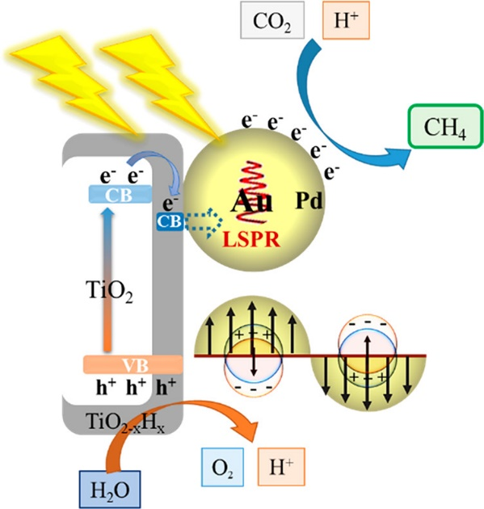
Scheme 3. Illustration of the proposed mechanism for CO₂ reduction using HUY@S-TOH/AuPd nanocatalyst under light irradiation conditions. Reproduced with permission.²³² Copyright 2020, American Chemical Society.
The tunable structures of metal-organic frameworks allow them to be used as a suitable support for immobilizing plasmonic metal NPs. Kuang and coworkers reported the CO₂ hydrogenation reaction to CO using PdAu NPs deposited on UiO-66-NH₂ under light irradiation conditions with a superior reaction rate of 3737 μmol/g_{metal}/h at 150 °C. The synthesis of sub-nm (0.5 nm) Pd skin/Au NPs was carried out in three steps. At first, Au NPs covered with polyvinylpyrrolidone (PVP) were prepared by using HAuCl₄ as the Au precursor and sodium citrate as the reducing agent with an average diameter of 13.8 nm. The core-shell structure synthesis of Au@Pd NPs was done by seed-mediated synthesis method in which the Pd shell thickness can be tailored from 0.5-2.0 nm by varying the amounts of H₂PdCl₄ precursor solution followed by covering the NPs in the MOF (UiO-66-NH₂) framework to protect NPs from sintering. In addition, the amine groups present in the MOF framework can provide great adsorption capacity towards the activation and conversion of CO₂ molecules. The photocatalytic activity varied linearly with the intensity of light irradiation suggesting the operation of a hot electron-driven mechanism. The thickness of the Pd shell had a very significant role in enhancing the rate of reaction for example, when a 2.0 nm Pd shell was used in catalysis, a reaction rate of 1911 μmol/g_{metal}/h was obtained which was almost half of the results obtained with 0.5 nm thickness Pd shell. The combination of average-sized 30-40 nm of plasmonic Au NPs with zeolitic imidazolate framework (ZIF-67) was also reported for the photoreduction of CO₂.²³³ The Au NPs prepared by the PVP-capped synthesis displayed an intense plasmonic absorption peak at 520 nm and were deposited on the ZIF-67 framework as schematically illustrated in Figure 18 (a). The different loadings of Au NPs were tested in order to find an optimum amount of Au loading on the MOF framework. Bare ZIF-67 did not show any catalytic activity in the CO₂ reduction, however, the combination with Au NPs exhibited activity towards CO₂ reduction. As shown in Figure 18 (b, c), the photocatalytic activity was found to decrease with a further increase in the Au NPs wt % because of the aggregation of Au NPs on the surface of ZIF-67. The photocatalytic rate of CO₂ reduction into methanol and ethanol was obtained to be 2.5 and 0.5 mmol g⁻¹ h⁻¹, respectively with a quantum yield of 6.4 % at 420 nm. The electrochemical impedance spectroscopy and photocurrent response for Au_{x}/ZIF-67 material was measured to understand the details of the charge transfer mechanism.
Yang et al. reviewed NIR responsive photocatalysts based on semiconductor-based photocatalysts (WO_{3-x}, MoO_{3-x}, TiO_{2-x}) for applications such as H₂ generation, CO₂ reduction and pollutant degradation reactions.²⁴² Yu’s group studied the synthesis of Cu-Cu₂O octahedrons by the in-situ deposition of Cu NPs on Cu₂O octahedrons and tested in the photoreduction of CO₂ to CO and CH₄. The optical absorption of Cu₂O was observed in the region of ~620 nm. The Cu NPs deposition extended the optical absorption in the NIR region of the spectrum and improved the selectivity of CH₄ formation. A photocatalytic CO and CH₄ yield of 3.25 μmolg⁻¹h⁻¹ and ~0.5μmolg⁻¹h⁻¹ was obtained due to the possible electron transfer from plasmonic metal to the acceptor state in the Cu₂O semiconductor.²³⁵

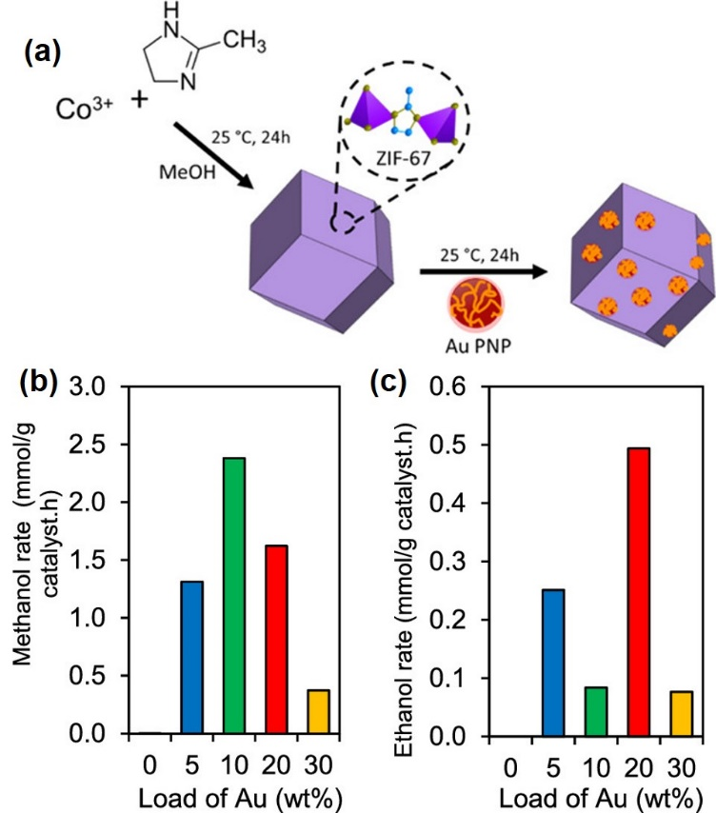
Figure 18. (a) Illustration of the synthesis of Au_{x}@ZIF-67, (b) Photocatalytic activity for the methanol and (c) ethanol formation over varying loadings of Au under visible light irradiation. Reproduced with permission.²³³ Copyright 2020, American Chemical Society.

The control of reaction selectivity by plasmonic excitation has also been recently explored by the transfer of hot electrons from plasmonic metal to the specific molecular orbitals of the substrate molecules to form a selective product. Despite many attempts to study the reaction rate and enhancements, it is still quite challenging to control the selectivity of reaction products. The choice of nanomaterials composition, light characteristics, alloy formation, the effect of support materials are the main factors affecting the selectivity of product formation in a reaction. Specifically, the wavelength and intensity of light are significant to decide the configuration of excited plasmons to form selective products. For example, Yu et al. recently reported the change in the selectivity of product formation in the CO₂ hydrogenation reaction to form ethane (C₂H₆) and methane (CH₄) over plasmonic Au NPs (Figure 19).²³⁶ It was observed that the TON for the synthesis of both the products decreased with an increase in the wavelength of the light irradiation from 460 nm to 530 nm. At monochromatic wavelength ≥ 490 nm, there was no C₂H₆ formation because of its high energy requirement than the formation of CH₄. At a fixed irradiation wavelength of 488 nm, an increase in the intensity of light irradiation can form C₂H₆ at an intensity greater than 390 mWcm⁻². This result suggests that a careful modulation of light intensity can lead to selective product formation utilizing plasmonic catalysts.
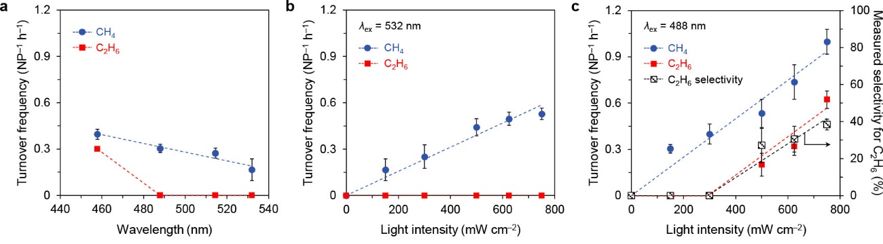
Figure 19. Turnover frequencies for CH₄ and C₂H₆ formation (a) as a function of the laser excitation wavelength at 150 mW cm⁻², (b) as a function of light intensity at λ_{ex} = 532 nm of Au and (c) light intensity for interband excitation at λ_{ex} = 488 nm of Au NP. Reproduced with permission.²³⁶ Copyright 2018, American Chemical Society.

The doping of alloys is one of the strategies to tune the selectivity of the product formation under visible light irradiation. To achieve higher product selectivity, inhibiting the side reactions plays an important role in enhancing the conversion efficiency. In an interesting report by Zhao et el., the incorporation of Cu and H atoms in the lattice of Pd supported on C₃N₄, can play a key role in inhibiting the CO and H₂ formation during CO₂ reduction reaction.¹⁶² The preferential formation of CH₄ was obtained due to the hydrogen doping in the interstitial site of Pd forming metal hydride species and preventing the hydrogen evolution and causing the consecutive reduction of CO to CH₄. Table 6 summarizes the changes in the selectivity of CO₂ reduction as a function of various descriptors including doping, morphology, facet dependency and light modulation.
Table 6. Changes in the selectivity of CO₂ reduction as a function of various descriptors affecting the catalytic activity.
Descriptor | Plasmon-assisted selective reduction of CO₂ | Ref.
Doping/Alloy formation | Incorporating Cu and H atoms in Pd/C₃N₄ inhibit the formation of side products and preferentially form the CH₄ | ¹⁶²
Light modulation | Monochromatic light irradiation could selectively form the CH₄ and not C₂H₆. However, at λ = 488 nm irradiation, increase in the intensity of light irradiation led to the formation of C₂H₆ | ²³⁶
Light modulation | The CH₄ formation was significantly enhanced (~10 times increase) on changing the wavelength irradiation from 532 to 254 nm in the Au/TiO₂ catalytic system | ²⁴³
Facet dependency | Selective deposition of Ag on {210} and {001} facets of TiO₂ formed selective products; {001} facet for CH₄ while {210} led to CO formation | ²⁴⁴
Lattice engineering | The isolated Cu atoms in the Pd lattice could selectively form CH₄ and not CO when molar ratio of Pd:Cu > 7:1 | ²⁴⁵
Surface functionalization | Surface etching of Cu atoms in AuCu/TiO₂ can generate Cu vacancies and facilitate the selective formation of CH₄ | ²⁴⁶
Morphology | Cu@Co core-shell structure could attain 98% CO selectivity when compared with monometallic and CuCo bimetallic catalyst | ²⁴⁷

4.2. Plasmon-mediated hydrogen generation
In our previous article, a library of catalysts was created based on noble metal NPs and semiconductor doped plasmonic catalysts and extensively discussed for hydrogen generation reaction and their plausible mechanistic pathways.⁵⁶ In this section, we will briefly introduce our results on the design and catalysis of Ag and Au plasmonic NPs immobilized on the mesoporous silica support material. A series of morphology-controlled monometallic Ag/SBA-15 plasmonic NPs and bimetallic M/Ag/SBA-15 in conjunction with active metal species were synthesized. A discussion of their structural characterization by UV-vis, XAS and XPS can be referred in the structural characterization of plasmonic NPs sections 3.1.1, 3.1.2 and 3.1.3. At first, monometallic size and color-controlled Ag/SBA-15 NPs were synthesized by MW heating method using 1-hexanol as the solvent to carry out the reduction of Ag⁺ ions to Ag NPs immobilized in the channels of the silica.¹⁷⁷ The morphology of Ag nanostructures could be tuned by changing the heating times of MW irradiation between 3-5 min leading to the formation of yellow, red and blue nanostructures corresponding to morphologies of a sphere, a rod of short aspect ratio and a rod of longer aspect ratio, respectively. The average diameter of the yellow sphere (Ag/SBA-15 (Y)) was observed to be 4 nm and the aspect ratio for red (Ag/SBA-15 (R)) and blue (Ag/SBA-15 (B)) nanorods was observed to be 2.8 and 6.1, respectively (Figure 20 (a-c)).²⁴⁸ The three different catalysts displayed active performance in the hydrogen generation from ammonia borane (AB) (Figure 20 (d)). The hydrogen can be released from AB in 3:1 molar ratio as shown in equation (4).^{68,249,250}
NH₃BH₃ + 2H₂O $→$ N$H_{4}^{+}$ + B$O_{2}^{-}$ + 3H₂ (4)
The order of catalytic performance was observed to be Ag/SBA-15 (Y) > Ag/SBA-15 (R) > Ag/SBA-15 (B) with a highest reaction rate of 0.94 mol% min⁻¹ in dark conditions. Under visible light irradiation (λ> 420 nm), the highest reaction rate of 1.60 mol% min⁻¹ was achieved with yellow spherical NPs. However, the enhancement trend in the catalytic performance was observed to be Ag/SBA-15 (B) > Ag/SBA-15 (R) > Ag/SBA-15 (Y), with an enhancement rate of 20 mol% shown by blue nanorods. The monometallic Ag NPs were studied in conjunction with active Pd metal species. The process of deposition was carried out by the LSPR-assisted method which involves an aqueous suspension of Ag NPs to be irradiated with light in order to activate Ag NPs and then adding Pd precursor solution to form PdAg/SBA-15 (Y), PdAg/SBA-15 (R) and PdAg/SBA-15 (B).¹⁷⁸ For bimetallic nanostructures, a similar trend in the catalytic performance and rate enhancement was observed in which PdAg/SBA-15 (Y) displayed the reaction rate of 4.64 mol% min⁻¹ and Pd/Ag/SBA-15 (B) with an enhancement of 40.8 mol% under visible light irradiation conditions. The Ag/SBA-15 (B) nanorod catalyst was chosen to explore its catalytic activity in combination with other active metals, for example, Pd, Ni, Co and Ru because of its maximum enhancement effect under visible light irradiation conditions.¹⁷⁹ Amongst all, Ru/Ag/SBA-15 (B) was found to be the most active catalyst with a reaction rate of 3.6 μmol min⁻¹, however, Pd/Ag/SBA-15 (B) displayed highest enhancement factor (R_{L}/R_{D}) with a value of 1.84. The trend in the enhancement factor (values in parentheses) was found to be Pd/Ag/SBA-15 (1.84) > Ag/SBA-15 (1.53) > Ru/Ag/SBA-15 (1.34) > Co/Ag/SBA-15 (1.22) > Ni/Ag/SBA-15 (1.01). This order was in agreement with the optical absorption intensity of the longitudinal mode of the NRs as discussed in UV-Vis spectroscopy section 3.1.1.
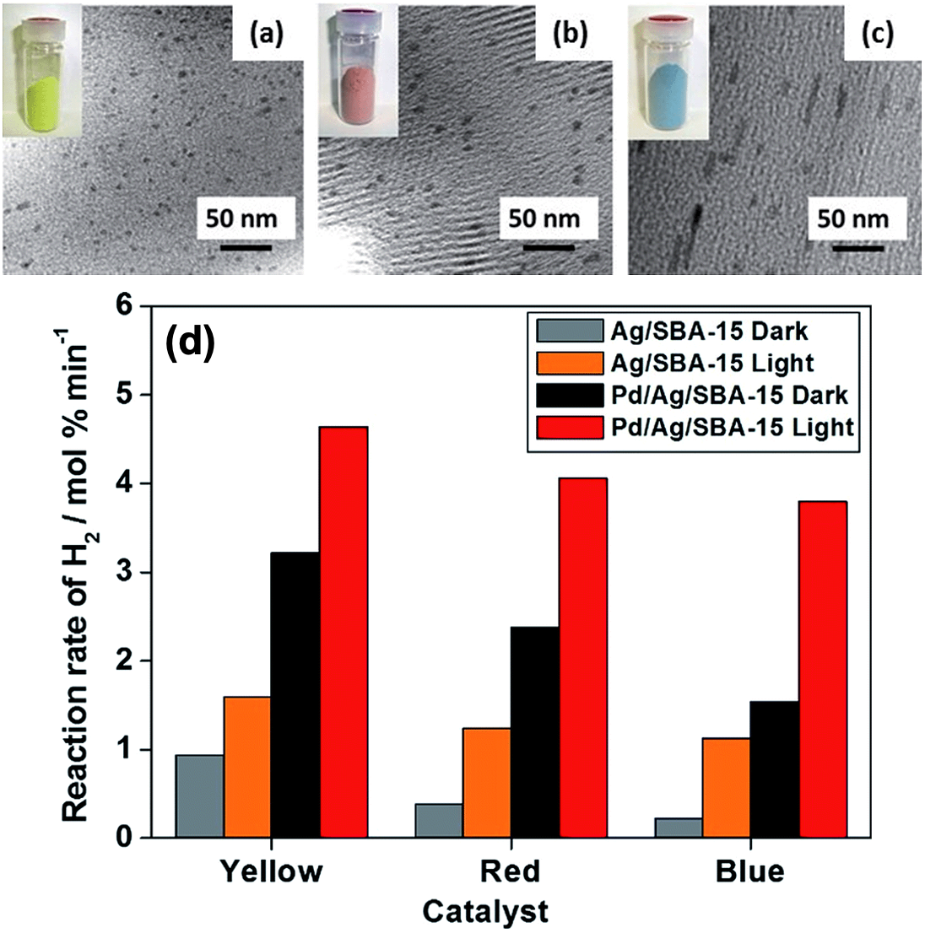
Figure 20. (a-c) TEM micrographs of different color and sized Ag/SBA-15 catalysts and (d) Reaction rate comparison in the hydrogen generation by Ag/SBA-15 and Pd/Ag/SBA-15 in dark and under light irradiation conditions (λ > 420 nm). Reproduced with permission.¹⁷⁸ Copyright 2015, The Royal Society of Chemistry.
For comparison of the plasmonic properties and catalytic performances, Pd/Au/SBA-15 nanostructures were prepared and compared with Pd/Ag/SBA-15 for AB decomposition and Suzuki-Miyaura coupling reaction.¹⁸⁰ The Pd/Ag/SBA-15 nanocatalyst displayed superior catalytic performance in the AB decomposition reaction, whereas Pd/Au/SBA-15 catalyst exhibited superior photocatalytic performance in the Suzuki-Miyaura coupling reaction. A plausible charge transfer pathway accounting for the enhanced catalytic performance under visible light irradiation was proposed. The hot electrons generated by the visible light excitation of plasmonic NPs are transferred to the active metal site and then to the lowest unoccupied molecular orbital (LUMO) of the substrate molecules. This process can lead to the formation of transient negative species which ultimately causes the bond weakening of the substrate molecules. The bond weakening or elongation has been studied and confirmed by several researchers by DFT calculations. After activation, the hot electrons are transferred back to the highest occupied molecular orbital and then to the plasmonic metal NPs. When Ag NPs were deposited onto Ti-SBA-15 mesoporous silica, an enhancement in the catalytic activity was observed when compared with Ag/SBA-15 nanocatalyst.¹⁸¹ The single-site Ti-SBA-15 catalyst was prepared by a similar procedure as SBA-15 in addition to the small amounts of Ti-precursor solution. The Ag/Ti-SBA-15 displayed AB dehydrogenation reaction rate of 3.3 μmol min⁻¹ which was twice of Ag/SBA-15 and six times higher than Ag/TiO₂/SBA-15. The key factors to achieve superior catalytic performance include the synergistic interaction and creation of heterojunction between UV and Vis-light active components. Moreover, the optimum doping of titanium in the mesoporous silica and effective charge transfer relay between the components play a major role in advancing the catalytic performance under solar light irradiation conditions. The Ag plasmonic NPs were also utilized to carry out the chemoselective p-nitrostyrene reduction to p-aminostyrene using AB as the source of hydrogen generation.^{187,194,251} For example, when the size and color-controlled Ag NPs were used in this reaction, an improvement in the chemoselectivity was obtained under visible and monochromatic light irradiation conditions.
The photoredox catalysis of plasmonic nanostructures was studied for the oxidation of benzyl alcohol to benzaldehyde and the amount of hydrogen generated during the process was monitored.¹⁶⁵ The engineering of catalyst was done by combining Au nanorods, Pt NPs and CdS as the plasmonic metal, non-plasmonic metal and semiconductor component, respectively. The CdS deposited Pt-tipped Au nanorods displayed superior photocatalytic activity (153.0 μmolh⁻¹) because of the enhanced light absorption ability and electric field distribution around the metal NPs. The immobilization of plasmonic Au NPs on diverse supports (such as Ta₂O₅ and CdSe) has led to interesting catalytic enhancements in the hydrogen generation reaction. For example, a photodeposition technique was employed to deposit Au NPs onto mesoporous Ta₂O₅ (Au/m-Ta₂O₅) for the efficient hydrogen generation from methanol under visible light irradiation (λ > 400 nm). The large specific surface area and mesoporosity of m-Ta₂O₅ in combination with the SPR effect of Au NPs were responsible for the enhanced photocatalytic activities (29 μmolh⁻¹g⁻¹).²³⁸ An emulsion-based self-assembly approach was utilized to prepare Au/CdSe nanoclusters in which Au NPs and CdSe quantum dots (QDs) were in the size range of 7.2 nm and 3.3 nm, respectively. The photocatalytic hydrogen generation from water displayed a reaction rate of 73 mmol $g_{CdSe}^{-1}$ h⁻¹, which was almost 10 times higher than bare CdSe QDs under visible light irradiation.²³⁷ The transfer of plasmon energy from Au NPs enhances the charge carrier generation and suppresses the recombination of photogenerated charge carriers.
5. Future directions
The field of plasmonic catalysis is proceeding at a rapid rate because of its recent increase in research interest worldwide. Although significant advancements in recent years, the detailed understanding of the mechanistic pathway is limited and therefore needs further investigation. For example, the photogeneration of hot electrons and holes, their decay mechanism, the pathway and transfer of charge carriers and positioning of their energy levels in comparison to conventional semiconductor photocatalysts. The charge transfer of hot electrons can play a significant role in deciding the activity and selectivity of the reaction. The hot electron injection into the specific bonds of the adsorbate species can affect the activity and selectivity of a chemical reaction. It is possible to adjust the energy of photogenerated species based on the optical absorption of metal nanostructures including the LSPR wavelength and intensity of absorption. Hence, further advancements in controlling the geometry and composition will benefit in realizing the tunability of the charge transfer process. The resonant energy transfer and the creation of electromagnetic field around metal NPs should be explored.
The development and implementation of new spectroscopic and microscopic techniques which can assist in investigating the in-depth understanding of the plasmonic enhancement phenomenon is required. Till date, the techniques employed to study the charge transfer mechanism in plasmonic NPs involve transient absorption measurements, photocurrent measurements, photoluminescence analysis, surface-enhanced Raman scattering and dark-field spectroscopy. The development of theoretical models to predict and understand the molecular behavior of plasmonic NPs will assist in the design of new materials. The cooperative effort between experiments and theory is required to unravel the details of mechanistic aspects in plasmonic catalysis. As summarized above, X-ray absorption near field edge structure (XANES) and extended X-ray absorption fine structure spectroscopy (EXAFS) can serve as a powerful tool to understand the local structure and coordination environment of plasmonic metal species.²⁴⁹ SERS can provide useful information on the formation of hot spots and the transfer of hot electrons via using a suitable probe molecule.¹⁴⁶ The transient absorption spectroscopies are also useful to study the lifetime of photogenerated charge carriers and can introduce a new direction in studying plasmonic enhancement processes. Not only operando techniques but also the design and discovery of new photocatalytic materials is significant to exploit the unique characteristics of plasmonic materials.²⁵² The development of new plasmonic materials is an attractive field and can assist in realizing some catalytic reactions that cannot be carried out by conventional thermal pathways.¹⁴¹ While coinage metal LSPR property has mainly been discussed in this article, some doped semiconductor plasmonic property has also been investigated in the last few years. Despite the immense efforts from researchers in plasmon-enhanced catalysis, a lot still can be done to achieve more success in this field. For example, to be able to differentiate the contribution of LSPR by using special methods such as isotopic experiments and DFT calculations. The discovery of new chemical processes which are especially challenging in thermal or electrochemical catalysis such as N₂ reduction and low carbon alkane conversion to value-added products. Next, the in-depth understanding of the surface-active sites and rate-determining steps during the catalytic reaction is essential in order to design the control the morphology of plasmonic nanostructures in photocatalysis. The application of single-site-resolved and time-resolved techniques should be further employed as state-of-the-art characterization techniques. Regarding the theoretical simulation studies, a careful inclusion of the dielectric constant of the surrounding medium, type, morphology and spatial distribution of metal should be considered for accurate and more realistic results.
In plasmonic catalysis, the reaction conversion efficiency and selectivity towards a specific product formation are usually very low. The plasmonic enhancement in catalysis is dependent on various factors such as the size and morphology of the photocatalysts, reaction conditions, intensity, power and wavelength of irradiation conditions, hence the reproducibility and consistency in obtaining the results is necessary.¹⁴⁵ In addition, varying one parameter at a time and keeping others constant is important to carefully study the factors affecting the yield of a chemical reaction. A discussion on the activation mechanism should also be distinguished amongst various factors including generation of hot electrons, near-field effects, elastic scattering and heating effects.¹³⁶ Furthermore, the development of theoretical models and approaches to study the plasmonic photoexcited states in order to decrease their activation energy barrier is essential to advance the rate of reaction and tune the selectivity of the reaction.¹⁴¹ Another idea for future research directions is to target single-particle plasmonic excitation in order to localize photothermal reactions in combination with plasmonic NPs.¹⁴⁵ To carry out a visible-light-driven catalytic reaction, it is essential to extend the absorption wavelength in the visible-NIR region of the spectrum. This can be achieved by increasing the size of plasmonic NPs or by combining them with suitable support material or active co-catalysts. However, increasing the size of NPs to a large extent can decrease the intensity of plasmonic absorption so, the size and morphology should be tailored and studied carefully.
There is a possibility that the formation of intermediate species under plasmonic excitation in multielectron reactions can vary under thermal conditions. The significance of using light and the generation of intermediates and surface adsorbates should be explored to correlate the differences in the catalytic activities in the presence and absence of light irradiation conditions. The methods and tools to study the mechanistic interactions would be beneficial in modeling the engineering of the plasmonic catalysts. The operando methods will further assist in enhancing the knowledge on the charge distribution and their interaction with the substrate molecules and semiconductor species. The fundamental information will definitely facilitate in expanding the optimization and efficiency of plasmon-assisted catalytic reactions for various applications. It might be possible to directly observe the plasmon-enhancement phenomenon by the development of microscopic techniques. The synergistic implementation of the photonic characteristics and plasmonic properties can lead to improved quantum efficiencies. The preparation of plasmonic photocatalysts with a higher transport rate of photogenerated charge carriers and lower recombination rate will create a desired transition to develop photocatalysts for practical applications. The application of plasmonic nanocatalysts is a rapidly growing research field and continuous efforts will bring significant contribution towards energy and environmental remediation.
In this section, we have proposed a few possible directions for future research, however, there can be many different perspectives because the field is still in its infancy and awaiting many innovations and inventions in the coming years. Moving forward, we hope that such strategies and techniques will continue to be explored and implemented for large-scale applications. There are still problems related to scaling up the method of preparation of plasmonic NPs and use them for industrial applications. We envision that combining the operando techniques with advances in plasmonic catalysis and working on the challenges identified in this section, will bring several breakthroughs and open up a new era in the field of plasmonic catalysis for industrial applications.
6. Conclusions
Noble metal nanostructures provide promising prospects to exploit the plasmonic excitation of visible light irradiation to design photocatalytic materials for solar energy utilization.⁵⁶ The basic understanding of the light-matter interactions and the ability to mimic the photosynthetic process by plasmonic excitation makes this research more captivating for researchers to unfold its potential for various applications. The recent examples and studies presented in this article prove that plasmon-mediated catalysis and related spectroscopic techniques will hold strong potential and place in the design and development of photocatalyst materials.¹⁴⁰ The series of complicated processes occurring within the plasmonic enhancement phenomenon, for example, scattering, electron collision and localized heating, project it as a fascinating topic for researchers to continue exploring and investigating this research field.¹⁴³ The non-radiative decay of plasmonic excitation can form high energy charge carriers i.e., hot electrons and hot holes, which can drive the chemical reactions by thermal and non-thermal reaction pathways.¹³¹
In this article, we have summarized the characterization techniques and noble metal-based nanostructures for plasmonic catalysis that are available at the current stage in plasmon chemistry. The article has been written with the purpose to establish the structure-property relationships of plasmonic nanostructures along with presenting a detailed discussion on the spectroscopic advances in the field of plasmonic catalysis. The structural characterization techniques including UV-Vis, XAS and XPS were introduced by citing examples of Ag and Au-based hybrid NPs supported on TiO₂, SBA-15, single-site Ti-oxide and CeO₂ modified SBA-15, MOFs, CeO₂ and NaNbO₃. The spectroscopic studies were reviewed by transient absorption spectroscopy, dark-field measurements, SERS, PL and electromagnetic enhancement simulation studies. The plasmonic catalysis in the hydrogen generation and CO₂ reduction reaction was discussed with the case studies of multifunctional and multimetallic Ag and Au-based metal NPs immobilized on TiO₂, silica, C₃N₄, Al₂O₃, MOF and MnO₂ where the significant reaction yields were obtained by Au@Pd@UiO-66-NH₂-0.5 (3737 μmolg⁻¹h⁻¹) in CO₂ reduction and Ag/AgVO₃@CdS/BiVO₄ (105,541 μmolg⁻¹) for the hydrogen generation from water. The formation of a selective product, especially in CO₂ reduction, in plasmonic catalysis depends largely on the modulation of light property, use of alloys and the composition of support materials. By altering the size, shape and dielectrics of the environment, the LSPR properties can be modulated which affects the activity and selectivity of the reaction. Furthermore, the synergistic cooperation between the supports and introduced functionalities can play a key role in enhancing product selectivity. By overviewing this holistic approach of summarizing the characteristics and catalysis of plasmonic nanomaterials, we are in a better position to further design and control the tunability of nanoarchitectures in order to maximize their catalytic performance and enhancements under solar light irradiation for hydrogen generation and CO₂ reduction reactions. We hope that understanding of the underpinning details of the design of new materials and their exact mechanistic pathway will assist in creating a clearer picture and moving a step closer towards efficient solar energy utilization.
Acknowledgments
The present work was partially supported by Grants-in-Aid for Scientific Research (No. 19K15311, 26220911, 18K14056, and 19H00838) from the Japan Society for the Promotion of Science (JSPS) and MEXT. YK, KM and HY acknowledge the MEXT program “Element Strategy Initiative” (No. JPMXP0112101003). Priyanka Verma gratefully acknowledges the Japan Society for the Promotion of Science (JSPS) for the International Postdoctoral Fellowship (P21042) at Osaka University, Japan.

Author contributions: Priyanka Verma: Writing- Original draft, Revision, Review & Editing. Kohsuke Mori: Supervision, Revision & Suggestions. Yasutaka Kuwahara: Supervision, Revision & Suggestions. Robert Raja: Supervision, Revision & Suggestions. Hiromi Yamashita: Supervision, Funding acquisition, Revision & Suggestions.
Conflict of interest: The authors declare that they have no known competing financial interests or personal relationships that could have appeared to influence the work reported in this paper.

References
1. Nerem, R. S., Beckley, B.D., Fasullo, J.T., Hamlington, B.D., Masters, D., Mitchum, G.T. Climate-change–driven accelerated sea-level rise detected in the altimeter era. Proc. Natl. Acad. Sci. U. S. A. 115, 2022–2025 (2018).
2. Ağbulut, Ü., Sarıdemir, S. A general view to converting fossil fuels to cleaner energy source by adding nanoparticles. Int. J. Ambient Energy 42, 1569–1574 (2021).
3. Oppenheimer, M. Climate change and environmental pollution: Physical and biological interactions. Clim. Change 15, 255–270 (1989).
4. Johnsson, F., Kjärstad, J., Rootzén, J. The threat to climate change mitigation posed by the abundance of fossil fuels. Clim. Policy 19, 258–274 (2019).
5. METI. Japan’s Energy 2019 - Ministry of Economy, Trade and Industry Agency for Natural Resources and Energy. Japan’s Energy 2020 - Minist. Econ. Trade Ind. Agency Nat. Resour. Energy (2020).
6. Brockway, P. E., Owen, A., Brand-Correa, L. I., Hardt, L. Estimation of global final-stage energy-return-on-investment for fossil fuels with comparison to renewable energy sources. Nat. Energy 4, 612–621 (2019)
7. Hager, C., Hamagami, N. Local Renewable Energy Initiatives in Germany and Japan in a Changing National Policy Environment. Rev. Policy Res. 37, 386–411 (2020).
8. Zhu, D., Mortazavi, S. M., Maleki, A., Aslani, A., Yousefi, H. Analysis of the robustness of energy supply in Japan: Role of renewable energy. Energy Reports 6, 378–391 (2020).
9. Marques, A. C., Fuinhas, J. A. Drivers promoting renewable energy: A dynamic panel approach. Renew. Sustain. Energy Rev. 15, 1601–1608 (2011).
10. Ringsmuth, A. K., Landsberg, M. J., Hankamer, B. Can photosynthesis enable a global transition from fossil fuels to solar fuels, to mitigate climate change and fuel-supply limitations? Renew. Sustain. Energy Rev. 62, 134–163 (2016).
11. Khan, N., Kalair, E., Abas, N., Kalair, A. R., Kalair, A. Energy transition from molecules to atoms and photons. Eng. Sci. Technol. 22, 185–214 (2019).
12. Gielen, D., Francisco, B., saygin, D., Bazilian, M.D., Wagner, N., Gorini, R. The role of renewable energy in the global energy transformation. Energy Strateg. Rev. 24, 38–50 (2019).
13. Marques, A. C., Fuinhas, J. A. Is renewable energy effective in promoting growth? Energy Policy 46, 434–442 (2012).
14. Azar, C., Lindgren, K., Larson, E., Möllersten, K. Carbon capture and storage from fossil fuels and biomass - Costs and potential role in stabilizing the atmosphere. Clim. Change 74, 47–79 (2006).
15. Barnes, D. F., Floor, W. M. Rural energy in developing countries: A challenge for economic development. Annu. Rev. Energy Environ. 21, 497–530 (1996).
16. Kaygusuz, K. Energy for sustainable development: A case of developing countries. Renew. Sustain. Energy Rev. 16, 1116–1126 (2012).
17. Ewing, M., Msangi, S. Biofuels production in developing countries: assessing tradeoffs in welfare and food security. Environ. Sci. Policy 12, 520–528 (2009).
18. Demirbas, A. H., Demirbas, I. Importance of rural bioenergy for developing countries. Energy Convers. Manag. 48, 2386–2398 (2007).
19. Okoro, O. I., Madueme, T. C. Solar energy investments in a developing economy. Renew. Energy 29, 1599–1610 (2004).
20. Dresselhaus, M. S., Thomas, I. L. Alternative energy technologies. dresselhaus2001. Nature 414, 332–337 (2001).
21. Luo, J., Zhang, S., Sun, M., Yang, L., Luo, S., Crittenden, J.C. A Critical Review on Energy Conversion and Environmental Remediation of Photocatalysts with Remodeling Crystal Lattice, Surface, and Interface. ACS Nano 13, 9811–9840 (2019).
22. Molaei, M. J. The optical properties and solar energy conversion applications of carbon quantum dots: A review. Sol. Energy 196, 549–566 (2020).
23. Zamaraev, K. I., Parmon, V. N. Potential Methods and Perspectives of Solar Energy Conversion via Photocatalytic Processes. Catal. Rev. 22, 261–324 (1980).
24. Malato, S., Blanco, J., Vidal, A., Richter, C. Photocatalysis with solar energy at a pilot-plant scale: An overview. Appl. Catal. B Environ. 37, 1–15 (2002).
25. Joshi, U. A., Palasyuk, A., Arney, D., Maggard, P. A. Semiconducting oxides to facilitate the conversion of solar energy to chemical fuels. J. Phys. Chem. Lett. 1, 2719–2726 (2010).
26. Rangan, K., Arachchige, S. M., Brown, J. R., Brewer, K. J. Solar energy conversion using photochemical molecular devices: Photocatalytic hydrogen production from water using mixed-metal supramolecular complexes. Energy Environ. Sci. 2, 410–419 (2009).
27. Zou, Z., Ye, J., Sayama, K., Arakawa, H. Direct splitting of water under visible light irradiation with an oxide semiconductor photocatalyst. Nature 414, 625–627 (2010).
28. Fu, C. F., Wu, X., Yang, J. Material Design for Photocatalytic Water Splitting from a Theoretical Perspective. Adv. Mater. 30, 1–11 (2018).
29. Fajrina, N., Tahir, M. A critical review in strategies to improve photocatalytic water splitting towards hydrogen production. Int. J. Hydrogen Energy 44, 540–577 (2019).
30. Maeda, K. Photocatalytic water splitting using semiconductor particles: History and recent developments. J. Photochem. Photobiol. C Photochem. Rev. 12, 237–268 (2011).
31. Ran, J., Zhang, J., Yu, J., Jaroniec, M., Qiao, S. Z. Earth-abundant cocatalysts for semiconductor-based photocatalytic water splitting. Chem. Soc. Rev. 43, 7787–7812 (2014).
32. Ni, M., Leung, M. K. H., Leung, D. Y. C., Sumathy, K. A review and recent developments in photocatalytic water-splitting using TiO2 for hydrogen production. Renew. Sustain. Energy Rev. 11, 401–425 (2007).
33. Takanabe, K. Photocatalytic Water Splitting: Quantitative Approaches toward Photocatalyst by Design. ACS Catal. 7, 8006–8022 (2017).
34. Maeda, K., Domen, K. Photocatalytic water splitting: Recent progress and future challenges. J. Phys. Chem. Lett. 1, 2655–2661 (2010).
35. Jafari, T., Moharreri, E., Amin, A.S., Miao, R., Song, W., Suib, S.L. Photocatalytic water splitting - The untamed dream: A review of recent advances. Molecules 21, 900, (2016).
36. Shi, L., Ding, W., Yang, S., He, Z., Liu, S. Rationally designed MoS2/protonated g-C3N4 nanosheet composites as photocatalysts with an excellent synergistic effect toward photocatalytic degradation of organic pollutants. J. Hazard. Mater. 347, 431–441 (2018).
37. Zhang, X., Wang, J., Dong, X. X., Lv, Y. K. Functionalized metal-organic frameworks for photocatalytic degradation of organic pollutants in environment. Chemosphere 242, 125144 (2020).
38. Chen, D., Cheng, Y., Zhou, N., Chen, P., Wang, Y., Li, K., Huo, S., Cheng, P., Peng, P., Zhang, R. et al. Photocatalytic degradation of organic pollutants using TiO2-based photocatalysts: A review. J. Clean. Prod. 268, 121725 (2020).
39. Zhao, J., Chen, C., Ma, W. Photocatalytic Degradation of Organic Pollutants Under Visible Light Irradiation. Top. Catal. 35, 269–278 (2005).
40. Gusain, R., Gupta, K., Joshi, P., Khatri, O. P. Adsorptive removal and photocatalytic degradation of organic pollutants using metal oxides and their composites: A comprehensive review. Adv. Colloid Interface Sci. 272, 102009 (2019).
41. Radhika, S., Thomas, J. Solar light driven photocatalytic degradation of organic pollutants using ZnO nanorods coupled with photosensitive molecules. J. Environ. Chem. Eng. 5, 4239–4250 (2017).
42. Tvrdy, K., Kamat, P. V. Quantum Dot Solar Cells. Compr. Nanosci. Technol. 1–5, 257–275 (2011).
43. Chen, D., Zhang, H., Liu, Y., Li, J. Graphene and its derivatives for the development of solar cells, photoelectrochemical, and photocatalytic applications. Energy Environ. Sci. 6, 1362–1387 (2013).
44. Green, M. A., Pillai, S. Harnessing plasmonics for solar cells. Nat. Photonics 6, 130–132 (2012).
45. Zhao, D., Yang, C. F. Recent advances in the TiO2/CdS nanocomposite used for photocatalytic hydrogen production and quantum-dot-sensitized solar cells. Renew. Sustain. Energy Rev. 54, 1048–1059 (2016).
46. Xiong, Z., Ma, J., Ng, W. J., Waite, T. D., Zhao, X. S. Silver-modified mesoporous TiO2 photocatalyst for water purification. Water Res. 45, 2095–2103 (2011).
47. Zhang, L., Kanki, T., Sano, N., Toyoda, A. Development of TiO2 photocatalyst reaction for water purification. Sep. Purif. Technol. 31, 105–110 (2003).
48. Mills, A., Davies, R. H., Worsley, D. Water purification by semiconductor photocatalysis. Chem. Soc. Rev. 22, 417–425 (1993).
49. Odling, G., Robertson, N. Bridging the gap between laboratory and application in photocatalytic water purification. Catal. Sci. Technol. 9, 533–545 (2019).
50. Gomez, L., Sebastian, V., Arruebo, M., Santamaria, J., Cronin, S. B. Plasmon-enhanced photocatalytic water purification. Phys. Chem. Chem. Phys. 16, 15111–15116 (2014).
51. Liang, C., Lu, Z-A., Chen, M-X., Zhang, Y., Zhang, B., Gao, G-L., Li, S. Recent Advances in Plasmon-Promoted Organic Transformations Using Silver-Based Catalysts. ACS Appl. Mater. Interfaces 12, 54266–54284 (2020).
52. Subudhi, S., Mansingh, S., Tripathy, S.P., Mohanty, A., Mohapatra, P., Rath, D., Parida, K. The fabrication of Au/Pd plasmonic alloys on UiO-66-NH2: An efficient visible light-induced photocatalyst towards the Suzuki Miyaura coupling reaction under ambient conditions. Catal. Sci. Technol. 9, 6585–6597 (2019).
53. Yu, C., Xie, X., Zhang, N. Selectivity control of organic chemical synthesis over plasmonic metal-based photocatalysts. Catal. Sci. Technol. 11, 425–443 (2021).
54. Kumar, A., Kumar, K., Krishnan, V. Sunlight driven methanol oxidation by anisotropic plasmonic Au nanostructures supported on amorphous titania: Influence of morphology on photocatalytic activity. Mater. Lett. 245, 45–48 (2019).
55. Zhang, C., Kong, T., Fu, Z., Zhang, Z., Zheng, H. Hot electron and thermal effects in plasmonic catalysis of nanocrystal transformation. Nanoscale 12, 8768–8774 (2020).
56. Verma, P., Mori, K., Kuwahara, Y., Raja, R., Yamashita, H. Plasmonic nanocatalysts for visible-NIR light induced hydrogen generation from storage materials. Mater. Adv. 2, 880–906 (2021).
57. Verma, P., Kuwahara, Y., Mori, K., Yamashita, H. Design of silver-based controlled nanostructures for plasmonic catalysis under visible light irradiation. Bull. Chem. Soc. Jpn. 92, 19–29 (2019).
58. Verma, P., Kuwahara, Y., Mori, K., Raja, R., Yamashita, H. Functionalized mesoporous SBA-15 silica: recent trends and catalytic applications. Nanoscale 12, 11333–11363 (2020).
59. Fuku, K., Hayashi, R., Takakura, S., Kamegawa, T., Mori, K., Yamashita, H. The Synthesis of Size- and Color-Controlled Silver Nanoparticles by Using Microwave Heating and their Enhanced Catalytic Activity by Localized Surface Plasmon Resonance. Angew. Chem. 125, 7594–7598 (2013).
The first report on morphology-controlled Ag/SBA-15 plasmonic nanocatalysts for the hydrogen generation from ammonia borane.
60. Anderson, S. R., O’Mullane, A. P., Della Gaspera, E., Ramanathan, R., Bansal, V. LSPR-Induced Catalytic Enhancement Using Bimetallic Copper Fabrics Prepared by Galvanic Replacement Reactions. Adv. Mater. Interfaces 6, 1–10 (2019).
61. Kale, M. J., Avanesian, T., Christopher, P. Direct photocatalysis by plasmonic nanostructures. ACS Catal. 4, 116–128 (2014).
62. Zhang, X., Chen, Y. L., Liu, R. S., Tsai, D. P. Plasmonic photocatalysis. Reports Prog. Phys. 76, (2013).
63. Guo, L., Jackman, J.A., Yang, H-H., Chen, P., Cho, N-J., Kim, D-H. Strategies for enhancing the sensitivity of plasmonic nanosensors. Nano Today 10, 213–239 (2015).
64. Li, M., Cushing, S.K., Wang, Q., Shi, X., Hornak, L.A., Hong, Z., Wu, N. Size-Dependent Energy Transfer between CdSe/ZnS Quantum Dots and Gold Nanoparticles. J. Phys Chem. Lett 2, 2125–2129 (2011).
65. Woo, J., Kim, J., Kim, H., Kim, Y., Lim, J. quantum chemistry package ACE-Molecule : An open-source real-space quantum chemistry package. J. Chem. Phys. 152, 124110 (2020).
66. Iida, K., Noda, M., Ishimura, K., Nobusada, K. First-Principles Computational Visualization of Localized Surface Plasmon Resonance in Gold Nanoclusters. J. Phys. Chem. A 118, 11317–11322 (2014).
67. Niezgoda, J. S., Yap, E., Keene, J. D., Mcbride, J. R., Rosenthal, S. J. Plasmonic CuxInyS2 Quantum Dots Make Better Photovoltaics Than Their Nonplasmonic Counterparts. Nano Lett. 14, 3262–3269 (2014).
68. Fernández-Catalá, J., Navlani-Garcia, M., Verma, P., Berenguer-Murcia, A., Mori, K., Kuwahara, Y., Yamashita, H., Cazorla-Amoros, D. Photocatalytically-driven H2 production over Cu/TiO2 catalysts decorated with multi-walled carbon nanotubes. Catal. Today 364, 182–189 (2021).
69. Straney, P. J., Diemler, N.A., Smith, A.M., Eddinger, Z.E., Gilliam, M.S., Millstone, J.E. Ligand-Mediated Deposition of Noble Metals at Nanoparticle Plasmonic Hotspots. Langmuir 34, 1084–1091 (2018).
70. Gutiérrez, Y., Brown, A. S., Moreno, F., Losurdo, M. Plasmonics beyond noble metals: Exploiting phase and compositional changes for manipulating plasmonic performance. J. Appl. Phys. 128, 080901 (2020).
71. Wan, D., Yan, B., Chen, J., Wu, S., Hong, J., Song, D., Zhao, X., Chi, X., Zheng, S., Huang, Z., Li, C. et al. New Family of Plasmonic Photocatalysts without Noble Metals. Chem. Mater. 31, 2320–2327 (2019).
72. Wang, F., Li, C., Chen, H., Jiang, R., Sun, L-D., Li, Q., Wang, J., Yu, J.C, Yan, C-H. Plasmonic harvesting of light energy for suzuki coupling reactions. J. Am. Chem. Soc. 135, 5588–5601 (2013).
73. Li, S., Miao, P., Zhang, Y., Wu, J., Zhang, B., Du, Y., Han, X., Sun, J., Xu, P. Recent Advances in Plasmonic Nanostructures for Enhanced Photocatalysis and Electrocatalysis. Adv. Mater. 33, 2000086 (2021).
74. Collins, G., Lonergan, A., McNulty, D., Glynn, C., Buckley, D., Hu, C., O'Dwyer, C. Semiconducting Metal Oxide Photonic Crystal Plasmonic Photocatalysts. Adv. Mater. Interfaces 7, 1901805 (2020).
75. Linic, S., Christopher, P., Ingram, D. B. Plasmonic-metal nanostructures for efficient conversion of solar to chemical energy. Nat. Mater. 10, 911–921 (2011).
76. Jiang, W., Bai, S., Wang, L., Wang, X., Yang, Li, Li, Y., Liu, D., Wang, X., Li, Z., Jiang, J. et al. Integration of Multiple Plasmonic and Co-Catalyst Nanostructures on TiO2 Nanosheets for Visible-Near-Infrared Photocatalytic Hydrogen Evolution. Small 12, 1640–1648 (2016).

77. Nithya, P. M., Devi, L. G. Effect of surface Ag metallization on the photocatalytic properties of BaTiO 3 : Surface plasmon effect and variation in the Schottky barrier height. Surfaces and Interfaces 15, 205–215 (2019).
78. An, H., Li, M., Liu, R., Gao, Z., Yin, Z. Design of AgxAu1−x alloy/ZnIn2S4 system with tunable spectral response and Schottky barrier height for visible-light-driven hydrogen evolution. Chem. Eng. J. 382, 122953 (2020).
79. Lang, Q., Chen, Y., Huang, T., Yang, L., Zhong, S., Wu, L., Chen, J., Bai, S. Graphene “bridge” in transferring hot electrons from plasmonic Ag nanocubes to TiO2 nanosheets for enhanced visible light photocatalytic hydrogen evolution. Appl. Catal. B Environ. 220, 182–190 (2018).
80. Christopher, P., Xin, H., Marimuthu, A., Linic, S. Singular characteristics and unique chemical bond activation mechanisms of photocatalytic reactions on plasmonic nanostructures. Nat. Mater. 11, 1044–1050 (2012).
81. Huang, H. J., Wu, J.C-S., Chiang, H-P., Chau, Y-F. C., Lin, Y-S., Wang, Y-H., Chen, P-J. Review of experimental setups for plasmonic photocatalytic reactions. Catalysts 10, 1–25 (2020).
82. Zhao, M., Chen, P. Exploring Plasmonic Photocatalysis via Single-Molecule Reaction Imaging. Nano Lett. 20, 2939–2940 (2020).
83. Jain, P. K. Taking the Heat off of Plasmonic Chemistry. J. Phys. Chem. C 123, 24347–24351 (2019).
84. Warkentin, C. L., Yu, Z., Sarkar, A., Frontiera, R. R. Decoding Chemical and Physical Processes Driving Plasmonic Photocatalysis Using Surface-Enhanced Raman Spectroscopies. Acc. Chem. Res. 54, 2457–2466 (2021).
85. Scaffidi, J. P., Gregas, M. K., Seewaldt, V., Vo-Dinh, T. SERS-based plasmonic nanobiosensing in single living cells. Anal. Bioanal. Chem. 393, 1135–1141 (2009).
86. Vo-Dinh, T., Wang, H. N., Scaffidi, J. Plasmonic nanoprobes for SERS biosensing and bioimaging. J. Biophotonics 3, 89–102 (2010).
87. Sharma, B., Frontiera, R. R., Henry, A. I., Ringe, E., Van Duyne, R. P. SERS: Materials, applications, and the future. Mater. Today 15, 16–25 (2012).
88. Lumdee, C., Toroghi, S., Kik, P. G. Post-fabrication voltage controlled resonance tuning of nanoscale plasmonic antennas. ACS Nano 6, 6301–6307 (2012).
89. Wang, S., Forzani, E. S., Tao, N. Detection of heavy metal ions in water by high-resolution surface plasmon resonance spectroscopy combined with anodic stripping voltammetry. Anal. Chem. 79, 4427–4432 (2007).
90. Tang, Y., Zeng, X., Liang, J. Surface plasmon resonance: An introduction to a surface spectroscopy technique. J. Chem. Educ. 87, 742–746 (2010).
91. Hu, H., Ma, C., Liu, Z. Plasmonic dark field microscopy. Appl. Phys. Lett. 96, (2010).
92. Li, G. C., Zhang, Y. L., Lei, D. Y. Hybrid plasmonic gap modes in metal film-coupled dimers and their physical origins revealed by polarization resolved dark field spectroscopy. Nanoscale 8, 7119–7126 (2016).
93. Lei, D. Y., Dominguez, A.I.F., Sonnefraud, Y., Appavoo, K., Haglund, R.F., Pendry, J.B., Maier, S.A. Revealing plasmonic Gap modes in particle-on-film systems using dark-field spectroscopy. ACS Nano 6, 1380–1386 (2012).
94. Schnepf, M. J., Mayer, M., Kuttner, C., Tebbe, M., Wolf, D., Dulle, M., Altantzis, T., Formanek, P., Forster, S., Bals, S. et al. Nanorattles with tailored electric field enhancement. Nanoscale 9, 9376–9385 (2017).
95. Grubisic, A., Ringe, E., Cobley, C.M., Xia, Y., Marks, L.D., Duyne, R.P.V., Nesbitt, D.J. Plasmonic near-electric field enhancement effects in ultrafast photoelectron emission: Correlated spatial and laser polarization microscopy studies of individual Ag nanocubes. Nano Lett. 12, 4823–4829 (2012).
96. Li, Y., Wen, T., Zhao, R., Liu, X., Ji, T., Wang, H., Shi, X., Shi, J., Wei, J., Zhao, Y. et al. Localized electric field of plasmonic nanoplatform enhanced photodynamic tumor therapy. ACS Nano 8, 11529–11542 (2014).
97. Alekseeva, S., Nedrygailov, I. I., Langhammer, C. Single Particle Plasmonics for Materials Science and Single Particle Catalysis. ACS Photonics 6, 1319–1330 (2019).
98. Wu, S., Hogan, N., Sheldon, M. Hot Electron Emission in Plasmonic Thermionic Converters. ACS Energy Lett. 4, 2508–2513 (2019).
99. Cortés, E. Efficiency and Bond Selectivity in Plasmon-Induced Photochemistry. Adv. Opt. Mater. 5, 1–13 (2017).
100. Seh, Z. W., Liu, S., Low, M., Zhang, S-Y., Liu, Z., Mlayah, A., Han, M-Y. Janus Au-TiO2 photocatalysts with strong localization of plasmonic near-fields for efficient visible-light hydrogen generation. Adv. Mater. 24, 2310–2314 (2012).
101. Zheng, Z., Tachikawa, T., Majima, T. Plasmon-enhanced formic acid dehydrogenation using anisotropic Pd-Au nanorods studied at the single-particle level. J. Am. Chem. Soc. 137, 948–957 (2015).
An interesting report on the site-selective Pd deposition on Au nanorods and investigation of plasmonic properties at single-particle level.
102. Huang, X., Li, Y., Chen, Y., Zhou, H., Duan, X., Huang, Y. Plasmonic and catalytic AuPd nanowheels for the efficient conversion of light into chemical energy. Angew. Chem. Int. Ed. 52, 6063–6067 (2013).
103. Tsukamoto, D., Shiraishi, Y., Sugano, Y., Ichikawa, S., Tanaka, S., Hirai, T. Gold nanoparticles located at the interface of anatase/rutile TiO2 particles as active plasmonic photocatalysts for aerobic oxidation. J. Am. Chem. Soc. 134, 6309–6315 (2012).
104. Hung, W. H., Aykol, M., Valley, D., Hou, W., Cronin, S. B. Plasmon resonant enhancement of carbon monoxide catalysis. Nano Lett. 10, 1314–1318 (2010).
105. Christopher, P., Xin, H., Linic, S. Visible-light-enhanced catalytic oxidation reactions on plasmonic silver nanostructures. Nat. Chem. 3, 467–472 (2011).
106. Wang, P., Huang, B., Qin, X., Zhang, X., Dai, Y., Wei, J., Whangbo, M-H. Ag@AgCl: A highly efficient and stable photocatalyst active under visible light. Angew. Chem. Int. Ed. 47, 7931–7933 (2008).
107. Yu, J., Dai, G., Huang, B. Fabrication and characterization of visible-light-driven plasmonic photocatalyst Ag/AgCl/TiO2 nanotube arrays. J. Phys. Chem. C 113, 16394–16401 (2009).
108. Wen, M., Mori, K., Kuwahara, Y., Yamashita, H. Plasmonic Au@Pd nanoparticles supported on a basic metal-organic framework: Synergic boosting of H2 production from formic acid. ACS Energy Lett. 2, 1–7 (2017).
The core-shell Pd@Au NPs were introduced within MOF frameworks for hydrogen generation from formic acid under solar light irradiation.
109. Awazu, K., Fujimaki, M., Rockstuhl, C., Tominaga, J., Murakami, H., Ohki, Y., Yoshida, N., Watanabe, T. A plasmonic photocatalyst consisting of silver nanoparticles embedded in titanium dioxide. J. Am. Chem. Soc. 130, 1676–1680 (2008).
The term 'plasmonic photocatalysis' was first coined and studied for the LSPR effect in Ag/TiO₂ catalytic system
110. Huang, X., Tang, S., Mu, X., Dai, Y., Chen, G., Zhou, Z., Ruan, F., Yang, Z., Zheng, N. Freestanding palladium nanosheets with plasmonic and catalytic properties. Nat. Nanotechnol. 6, 28–32 (2011).
111. Albinsson, D., Boje, A., Nilsson, S., Tiburski, C., Hellman, A., Strom, H., Langhammer, C. Copper catalysis at operando conditions—bridging the gap between single nanoparticle probing and catalyst-bed-averaging. Nat. Commun. 11, 1–13 (2020).
112. Ding, J., Liu, X., Shi, M., Li, T., Xia, M., Du, X., Shang, R., Gu, H., Zhong, Q. Single-atom silver–manganese catalysts for photocatalytic CO2 reduction with H 2 O to CH 4. Sol. Energy Mater. Sol. Cells 195, 34–42 (2019).
The concept of single-atom with plasmonic Ag NPs was investigated for CO₂ utilization.
113. Kim, Y., Smith, J. G., Jain, P. K. Harvesting multiple electron-hole pairs generated through plasmonic excitation of Au nanoparticles. Nat. Chem. 10, 763–769 (2018).
114. Liu, G., Li, P., Zhao, G., Wang, X., Kong, J., Liu, H., Zhang, H., Chang, K., Meng, X., Kako, T. et al. Promoting Active Species Generation by Plasmon-Induced Hot-Electron Excitation for Efficient Electrocatalytic Oxygen Evolution. J. Am. Chem. Soc. 138, 9128–9136 (2016).
115. He, R., Wang, Y-C., Wang, X., Wang, Z., Liu, G., Zhou, W., Wen, L., Li, q., Wang, X., Chen, X., Zheng, J. Hou, J.G. Facile synthesis of pentacle gold-copper alloy nanocrystals and their plasmonic and catalytic properties. Nat. Commun. 5, (2014).
116. Chen, Y., Munechika, K., Ginger, D. S. Dependence of fluorescence intensity on the spectral overlap between fluorophores and plasmon resonant single silver nanoparticles. Nano Lett. 7, 690–696 (2007).
First report on studying the enhanced optical scattering of Ag NPs by Dark-field spectroscopy.
117. Boerigter, C., Campana, R., Morabito, M., Linic, S. Evidence and implications of direct charge excitation as the dominant mechanism in plasmon-mediated photocatalysis. Nat. Commun. 7, (2016).
118. Zhang, R., Zhang, Y., Dong, Z.C., Jiang, S., Zhang, C., Chen, L.G., Zhang, L., Liao, Y., Aizpurua, J., Luo, Y. Chemical mapping of a single molecule by plasmon-enhanced Raman scattering. Nature 498, 82–86 (2013).
119. Xie, W., Walkenfort, B., Schlücker, S. Label-free SERS monitoring of chemical reactions catalyzed by small gold nanoparticles using 3D plasmonic superstructures. J. Am. Chem. Soc. 135, 1657–1660 (2013).
120. Scholl, J. A., Koh, A. L., Dionne, J. A. Quantum plasmon resonances of individual metallic nanoparticles. Nature 483, 421–427 (2012).
121. Tian, Y., Wang, H., Geng, Y., Cong, L., Liu, Y., Xu, W., Xu, S. Boosting a sub-10 nm nanogap array by plasmon-triggered waveguide resonance. Photonics Res. 8, 1850 (2020).
122. Zhou, L., Swearer, D.F., Zhang, C., Robatjazi, H., Zhao, H., Henderson, L., Dong, L., Christopher, P., Carter, E.A., Nordlander, P., Halas, N.J. Quantifying hot carrier and thermal contributions in plasmonic photocatalysis. Science 364, 69–72 (2019).
123. Halas, N. Playing with plasmons: Tuning the optical resonant properties of metallic nanoshells. MRS Bull. 30, 362–367 (2005).
One of the initial reports on the plasmon tunability was explored by utilizing SERS spectroscopy.
124. Mandari, K. K., Do, J. Y., Pandey, S., Vattikuti, S. V. P., Kang, M. Preparation of highly crystalline quaternary heterostructure catalyst for hydrogen evolution under solar light: Improved photoexcited charge separation. Mater. Res. Bull. 122, 110695 (2020).
125. Haro, M., Abargues, R., Herraiz-Cardona, I., Martínez-Pastor, J., Giménez, S. Plasmonic versus catalytic effect of gold nanoparticles on mesoporous TiO2electrodes for water splitting. Electrochim. Acta 144, 64–70 (2014).
126. Zhang, X., Fan, Y., You, E., Li, Z., Dong, Y., Chen, L., Yang, Y., Xie, Z., Kuang, Q., Zheng, L. MOF encapsulated sub-nm Pd skin/Au nanoparticles as antenna-reactor plasmonic catalyst for light driven CO2 hydrogenation. Nano Energy 84, 105950 (2021).
The synthesis of sub-nm Pd on Au NPs was reported and studied for hot electron transfer by operando techniques.
127. Zhou, W., Dridi, M., Suh, J. Y., Kim, C.H., Co, D.T., Wasielewski, M.R., Schatz, G.C., Odom, T.W. Lasing action in strongly coupled plasmonic nanocavity arrays. Nat. Nanotechnol. 8, 506–511 (2013).
128. Qiu, L., Pang, G.A., Zheng, G., Bauer, D., Wieland, K., Haisch, C. Kinetic and Mechanistic Investigation of the Photocatalyzed Surface Reduction of 4-Nitrothiophenol Observed on a Silver Plasmonic Film via Surface-Enhanced Raman Scattering. ACS Appl. Mater. Interfaces 12, 21133–21142 (2020).
129. Collins, S. S. E., Cittadini, M., Pecharromán, C., Martucci, A., Mulvaney, P. Hydrogen Spillover between Single Gold Nanorods and Metal Oxide Supports: A Surface Plasmon Spectroscopy Study. ACS Nano 9, 7846–7856 (2015).
130. Kho, E. T., Tan, T. H., Lovell, E., Wong, R.J., Scott, J., Amal, R. A review on photo-thermal catalytic conversion of carbon dioxide. Green Energy Environ. 2, 204–217 (2017).
131. Zhang, X., Ke, X., Yao, J. Recent development of plasmon-mediated photocatalysts and their potential in selectivity regulation. J. Mater. Chem. A 6, 1941–1966 (2018).
132. Dhiman, M. Plasmonic nanocatalysis for solar energy harvesting and sustainable chemistry. J. Mater. Chem. A 8, 10074–10095 (2020).
133. Ye, W., Long, R., Huang, H. & Xiong, Y. Plasmonic nanostructures in solar energy conversion. J. Mater. Chem. C 5, 1008–1021 (2017).
134. Smith, J. G., Faucheaux, J. A. & Jain, P. K. Plasmon resonances for solar energy harvesting: A mechanistic outlook. Nano Today 10, 67–80 (2015).
135. Naldoni, A., Riboni, F., Guler, U., Boltasseva, A., Shalaev, V.M., Kildishev, A.V. Solar-Powered Plasmon-Enhanced Heterogeneous Catalysis. Nanophotonics 5, 112–133 (2016).
136. Zheng, X., Zhang, L. Photonic nanostructures for solar energy conversion. Energy Environ. Sci. 9, 2511–2532 (2016).
137. Gellé, A., Moores, A. Plasmonic nanoparticles: Photocatalysts with a bright future. Curr. Opin. Green Sustain. Chem. 15, 60–66 (2019).
138. Tatsuma, T., Nishi, H. & Ishida, T. Plasmon-induced charge separation: Chemistry and wide applications. Chem. Sci. 8, 3325–3337 (2017).
139. Lang, X., Chen, X., Zhao, J. Heterogeneous visible light photocatalysis for selective organic transformations. Chem. Soc. Rev. 43, 473–486 (2014).
140. Gellé, A., Jin, T., Garza, L. d.l., Price, G.D., Besteiro, L.V., Moores, A. Applications of Plasmon-Enhanced Nanocatalysis to Organic Transformations. Chem. Rev. 120, 986–1041 (2020).
141. Meng, X., Liu, L., Ouyang, S., Xu, H., Wang, D., Zhao, N., Ye, J. Nanometals for Solar-to-Chemical Energy Conversion: From Semiconductor-Based Photocatalysis to Plasmon-Mediated Photocatalysis and Photo-Thermocatalysis. Adv. Mater. 28, 6781–6803 (2016).
142. Kubacka, A., Caudillo-Flores, U., Barba-Nieto, I., Fernández-García, M. Towards full-spectrum photocatalysis: Successful approaches and materials. Appl. Catal. A Gen. 610, (2021).
143. Aslam, U., Rao, V. G., Chavez, S., Linic, S. Catalytic conversion of solar to chemical energy on plasmonic metal nanostructures. Nat. Catal. 1, 656–665 (2018).
144. Sun, M., Xu, H. A novel application of plasmonics: Plasmon-driven surface-catalyzed reactions. Small 8, 2777–2786 (2012).
145. Cortés, E., Besteiro, L.V., Alabastri, A., Baldi, A., Tagliabue, G., Demetriadou, A., Narang, P. Challenges in Plasmonic Catalysis. ACS Nano 14, 16202–16219 (2020).
146. Zhang, P., Wang, T., Gong, J. Mechanistic Understanding of the Plasmonic Enhancement for Solar Water Splitting. Adv. Mater. 27, 5328–5342 (2015).
147. Yu, S., Wilson, A. J., Kumari, G., Zhang, X., Jain, P. K. Opportunities and Challenges of Solar-Energy-Driven Carbon Dioxide to Fuel Conversion with Plasmonic Catalysts. ACS Energy Lett. 2, 2058–2070 (2017).
148. Cheng, H., Fuku, K., Kuwahara, Y., Mori, K., Yamashita, H. Harnessing single-active plasmonic nanostructures for enhanced photocatalysis under visible light. J. Mater. Chem. A 3, 5244–5258 (2015).
149. Wang, W., Saji, S.E., Karuturi, S., Hong, Z., Meng, G., Cheng, Y., Yin, Z. NIR-plasmon-enhanced Systems for Energy Conversion and Environmental Remediation. Chem. Res. Chinese Univ. 36, 1000–1005 (2020).
150. Li, Z., Kurouski, D. Nanoscale structural characterization of plasmon-driven reactions. Nanophotonics 10, 1657–1673 (2021).
151. Su, H.-S., Feng, H.S., Wu, X., Sun, J.J., Ren, B. Recent advances in plasmon-enhanced Raman spectroscopy for catalytic reactions on bifunctional metallic nanostructures. Nanoscale 13, 13962–13975 (2021).
152. Mehta, N., Sahu, S. P., Shaik, S., Devireddy, R., Gartia, M. R. Dark-field hyperspectral imaging for label free detection of nano-bio-materials. Wiley Interdiscip. Rev. Nanomedicine Nanobiotechnology 13, 1–28 (2021).
153. Zhao, X., Wen, J., Zhu, A., Cheng, M., Zhu, Q., Zhang, X., Wang, Y., Zhang, Y. Manipulation and applications of hotspots in nanostructured surfaces and thin films. Nanomaterials 10, 1–13 (2020).
154. Wani, I. A. Review—Recent Advances in Biogenic Silver Nanoparticles & NanoComposite Based Plasmonic-Colorimetric and Electrochemical Sensors. ECS J. Solid State Sci. Technol. 10, 047003 (2021).
155. Ahn, H., Kim, S., Kim, Y., Kim, S., Choi, J-R., Kim, K. Plasmonic sensing, imaging, and stimulation techniques for neuron studies. Biosens. Bioelectron. 182, 113150 (2021).
156. Ouyang, Z., Zhou, N., MnNamee, M.G., Yan, L., Williams, O.F., You, W., Moran, A.M. Multidimensional time-of-flight spectroscopy. J. Chem. Phys. 154, 220901 (2021).
157. Zhao, L. Application of stepped light-induced transient measurements of photocurrent and photovoltage in charge-transfer mechanism characterization. J. Chinese Chem. Soc. 65, 1281–1285 (2018).
158. Yan, J., Verma, P., Kuwahara, Y., Mori, K., Yamashita, H. Recent progress on black phosphorus-based materials for photocatalytic water splitting. Small Methods 2, 1–9 (2018).
159. Verma, P., Stewart, D. J., Raja, R. Recent advances in photocatalytic CO2 utilisation over multifunctional metal–organic frameworks. Catalysts 10, 1176 (2020).
160. Besteiro, L. V., Yu, P., Wang, Z., Holleitner, A.W., Hartland, G.V., Wiederrecht, G.P., Govorov, A.O. The fast and the furious : Ultrafast hot electrons in plasmonic metastructures . Size and structure matter. Nano Today 27, 120–145 (2019).
161. Zhang, N., Han, C., Xu, Y-J., Foley, J.J., Zhang, D., Codrington, J., Gray, S.K., Sun, Y. Near-field dielectric scattering promotes optical absorption by platinum nanoparticles. Nat. Photonics 10, 473–482 (2016).
162. Zhao, L., Ye, F., Wang, D., Cai, X., Meng, C., Xie, H., Zhang, J., Bai, S. Lattice Engineering on Metal Cocatalysts for Enhanced Photocatalytic Reduction of CO2 into CH4. ChemSusChem 11, 3524–3533 (2018).
163. Zhang, N., Qi, M-Y., Yuan, L., Fu, X., Tang, Z-R., Gong, J., Xu, Y-J. Broadband Light Harvesting and Unidirectional Electron Flow for Efficient Electron Accumulation for Hydrogen Generation. Angew. Chem. Int. Ed. 58, 10003–10007 (2019).
164. Zhang, N., Han, C., Fu, X., Xu, Y. J. Function-Oriented Engineering of Metal-Based Nanohybrids for Photoredox Catalysis: Exerting Plasmonic Effect and Beyond. Chem 4, 1832–1861 (2018).
165. Han, C., Tang, Z. R., Liu, J., Jin, S., Xu, Y. J. Efficient photoredox conversion of alcohol to aldehyde and H2 by heterointerface engineering of bimetal-semiconductor hybrids. Chem. Sci. 10, 3514–3522 (2019).
166. Verma, P., Kondo, Y., Kuwahara, Y., Kamegawa, T., Mori, K., Raja, R., Yamashita, H. Design and application of photocatalysts using porous materials. Catal. Rev. - Sci. Eng. 63, 165–233 (2021).
167. Zhang, Q., Lee, I., Joo, J. I. B., Zaera, F. Core À Shell Nanostructured Catalysts. Acc. Chem. Res. 46, 1816–1824 (2013).
168. Trinh, T. T., Sato, R., Sakamoto, M., Fujiyoshi, Y., Haruta, M., Kurata, H., Teranishi, T. Visible to near-infrared plasmon-enhanced catalytic activity of Pd hexagonal nanoplates for the Suzuki coupling reaction. Nanoscale 7, 12435–12444 (2015).
169. Cardinal, M. F., Ende, E.V., Hackler, R.A., McAnally, M.O., Stair, P.C., Schatz, G.C., Duyne, R.P.V. Expanding applications of SERS through versatile nanomaterials engineering. Chem. Soc. Rev. 46, 3886–3903 (2017).
170. Langhammer, C., Larsson, E. M. Nanoplasmonic in situ spectroscopy for catalysis applications. ACS Catal. 2, 2036–2045 (2012).
171. Xie, W., Schlücker, S. Rationally designed multifunctional plasmonic nanostructures for surface-enhanced Raman spectroscopy: A review. Reports Prog. Phys. 77, 116502 (2014).
172. Zhan, C., Chen, X-J., Yi, J., Li, J-F., Wu, D-Y., Tian, Z-Q. From plasmon-enhanced molecular spectroscopy to plasmon-mediated chemical reactions. Nat. Rev. Chem. 2, 216–230 (2018).
173. Takeyasu, N., Kagawa, R., Sakata, K., Kaneta, T. Laser Power Threshold of Chemical Transformation on Highly Uniform Plasmonic and Catalytic Nanosurface. J. Phys. Chem. C 120, 12163–12169 (2016).
174. Hartman, T., Wondergem, C. S., Kumar, N., Van Den Berg, A., Weckhuysen, B. M. Surface- and Tip-Enhanced Raman Spectroscopy in Catalysis. J. Phys. Chem. Lett. 7, 1570–1584 (2016).
175. Reddy, K. L., Kumar, S., Kumar, A., Krishnan, V. Wide spectrum photocatalytic activity in lanthanide-doped upconversion nanophosphors coated with porous TiO2 and Ag-Cu bimetallic nanoparticles. J. Hazard. Mater. 367, 694–705 (2019).
176. Kumar, D., Sharma, S., Khare, N. Piezo-phototronic and plasmonic effect coupled Ag-NaNbO3 nanocomposite for enhanced photocatalytic and photoelectrochemical water splitting activity. Renew. Energy 163, 1569–1579 (2021).
177. Mori, K., Verma, P., Hayashi, R., Fuku, K., Yamashita, H. Color-Controlled Ag Nanoparticles and Nanorods within Confined Mesopores: Microwave-Assisted Rapid Synthesis and Application in Plasmonic Catalysis under Visible-Light Irradiation. Chem. Eur. J. 21, 11885–11893 (2015).
178. Verma, P., Kuwahara, Y., Mori, K., Yamashita, H. Synthesis and characterization of a Pd/Ag bimetallic nanocatalyst on SBA-15 mesoporous silica as a plasmonic catalyst. J. Mater. Chem. A 3, 18889–18897 (2015).
179. Verma, P., Kuwahara, Y., Mori, K., Yamashita, H. Synthesis of mesoporous silica-supported Ag nanorod-based bimetallic catalysts and investigation of their plasmonic activity under visible light irradiation. Catal. Sci. Technol. 7, 2551–2558 (2017).
180. Verma, P., Kuwahara, Y., Mori, K., Yamashita, H. Pd/Ag and Pd/Au bimetallic nanocatalysts on mesoporous silica for plasmon-mediated enhanced catalytic activity under visible light irradiation. J. Mater. Chem. A 4, 10142–10150 (2016).
181. Verma, P., Kuwahara, Y., Mori, K., Yamashita, H. Enhancement of Ag-based plasmonic photocatalysis in hydrogen production from ammonia borane by the assistance of single-site Ti-oxide moieties within a silica framework. Chem.Eur. J. 23, 3616–3622 (2017).
A pioneering approach of creating a heterojucntion between plasmonic Ag NPs and single-site Ti-oxide moieties.
182. Verma, A., Shukla, M., Kumar, S., Pal, S. & Sinha, I. Mechanism of visible light enhanced catalysis over curcumin functionalized Ag nanocatalysts. Spectrochim. Acta - Part A Mol. Biomol. Spectrosc. 240, 118534 (2020)..
183. Wang, Z., Du, J., Zhang, Y., Han, J., Huang, S., Hirata, A., Chen, M. Free-standing nanoporous gold for direct plasmon enhanced electro-oxidation of alcohol molecules. Nano Energy 56, 286–293 (2019).
184. Wei, Y., Zhang, X., Liu, Z., Chen, H. S., Yang, P. Site-selective modification of AgPt on multibranched Au nanostars for plasmon-enhanced hydrogen evolution and methanol oxidation reaction in visible to near-infrared region. J. Power Sources 425, 17–26 (2019).
185. Jo, S., Verma, P., Kuwahara, Y., Mori, K., Choi, W., Yamashita, H. Enhanced hydrogen production from ammonia borane using controlled plasmonic performance of Au nanoparticles deposited on TiO2. J. Mater. Chem. A 5, 21883–21892 (2017).
186. Verma, P., Mori, K., Kuwahara, Y., Cho, S. J., Yamashita, H. Synthesis of plasmonic gold nanoparticles supported on morphology-controlled TiO2 for aerobic alcohol oxidation. Catal. Today 352, 255–261 (2020).
187. Verma, P., Kuwahara, Y., Mori, K., Yamashita, H. Plasmonic catalysis of Ag nanoparticles deposited on CeO2 modified mesoporous silica for the nitrostyrene reduction under light irradiation conditions. Catal. Today 324, 83–89 (2019).
188. Verma, P., Yuan, K., Kuwahara, Y., Mori, K., Yamashita, H. Enhancement of plasmonic activity by Pt/Ag bimetallic nanocatalyst supported on mesoporous silica in the hydrogen production from hydrogen storage material. Appl. Catal. B Environ. 223, 10–15 (2018).
189. Smirnov, M. Y., Kalinkin, A. V., Bukhtiyarov, A. V., Prosvirin, I. P., Bukhtiyarov, V. I. Using X-ray photoelectron spectroscopy to evaluate size of metal nanoparticles in the model Au/C samples. J. Phys. Chem. C 120, 10419–10426 (2016).
190. Wojcieszak, R., Genet, M. J., Eloy, P., Ruiz, P., Gaigneaux, E. M. Determination of the size of supported Pd nanoparticles by X-ray photoelectron spectroscopy. Comparison with X-ray diffraction, Transmission electron microscopy, and H2 chemisorption methods. J. Phys. Chem. C 114, 16677–16684 (2010).
191. Fadley, C. S. X-ray photoelectron spectroscopy: Progress and perspectives. J. Electron Spectros. Relat. Phenomena 178–179, 2–32 (2010).
192. Greczynski, G., Hultman, L. X-ray photoelectron spectroscopy: Towards reliable binding energy referencing. Prog. Mater. Sci. 107, 100591 (2020).
193. Stöcker, M. X-Ray photoelectron spectroscopy on zeolites and related materials. Microporous Mater. 6, 235–257 (1996).
194. Verma, P., Kuwahara, Y., Mori, K., Yamashita, H. Visible-light-driven reduction of nitrostyrene utilizing plasmonic silver nanoparticle catalysts immobilized on oxide supports. Catal. Today 355, 620–626 (2020).
195. Yano, J., Yachandra, V. K. X-ray absorption spectroscopy. Photosynth. Res. 102, 241–254 (2009).
196. Lin, S. C., Chang, C-C., Chiu, S-Y., Pai, H-T., Liao, T-Y., Hsu, C-S., Chiang, W-H., Tsai, M-K., Chen, H.M. Operando time-resolved X-ray absorption spectroscopy reveals the chemical nature enabling highly selective CO2 reduction. Nat. Commun. 11, 1–12 (2020).
197. De Groot, F. High-resolution X-ray emission and X-ray absorption spectroscopy. Chem. Rev. 101, 1779–1808 (2001).
198. Bianconi, A. Surface X-Ray Absorption Spectroscopy: Surface Exafs and Surface Xanes. Appl. Surf. Sci. 6, 392–418 (1980).
199. Norman, D. X-ray absorption spectroscopy (Exafs and xanes) at surfaces. J. Phys. C Solid State Phys. 19, 3273–3311 (1986).
200. Iglesias‐Juez, A., Chiarello, G. L., Patience, G. S. & Guerrero‐Pérez, M. O. Experimental methods in chemical engineering: X ‐ray absorption spectroscopy— XAS , XANES , EXAFS. Can. J. Chem. Eng. 1–20 (2021) doi:10.1002/cjce.24291.
201. Quartieri, S. X-Ray Absorption Spectroscopy (XAS, EXAFS, XANES). Encycl. Archaeol. Sci. 1–6 (2018) doi:10.1002/9781119188230.saseas0613.
202. Xia, C., Gao, P.F., He, W., Wang, Y., Li, C-H., Zou, H.Y., Li, Y.F., Huang, C.Z. Long-distance transfer of plasmonic hot electrons across the Au-Pt porous interface for the hydrogen evolution reaction. J. Mater. Chem. C 9, 3108–3114 (2021).
203. Zhang, Z., Jiang, X., Liu, B., Guo, L., Lu, N., Wang, L., Huang, J., Liu, K., Dong, B. IR-Driven Ultrafast Transfer of Plasmonic Hot Electrons in Nonmetallic Branched Heterostructures for Enhanced H2 Generation. Adv. Mater. 30, 1–10 (2018).
204. Hartland, G. V., Besteiro, L. V., Johns, P., Govorov, A. O. What’s so Hot about Electrons in Metal Nanoparticles? ACS Energy Lett. 2, 1641–1653 (2017).
205. Manuel, A. P., Shankar, K. Hot electrons in TiO2–noble metal nano-heterojunctions: Fundamental science and applications in photocatalysis. Nanomaterials 11, (2021).
206. Zhang, Y., He, S., Guo, W., Hu, Y., Huang, J., Mulcahy, J.R., Wei, W.D. Surface-Plasmon-Driven Hot Electron Photochemistry. Chem. Rev. 118, 2927–2954 (2018).
207. Hamans, R. F., Kamarudheen, R., Baldi, A. Single particle approaches to plasmon-driven catalysis. Nanomaterials 10, 1–20 (2020).
208. Simoncelli, S., Pensa, E.L., Brick, T., Gargiulo, J., Lauri, A., Cambiasso, J., Li, Y., Maier, S.A., Cortes, E. Monitoring plasmonic hot-carrier chemical reactions at the single particle level. Faraday Discuss. 214, 73–87 (2019).
209. Van Turnhout, L., Hattori, Y., Meng, J., Zheng, K., Sá, J. Direct Observation of a Plasmon-Induced Hot Electron Flow in a Multimetallic Nanostructure. Nano Lett. 20, 8220–8228 (2020).
210. Wang, Y., Liu, X.H., Wang, Q., Quick, M., Kovalenko, S.A., Chen, Q-Y., Koch, N., Pinna, N. Insights into Charge Transfer at an Atomically Precise Nanocluster/Semiconductor Interface. Angew. Chem. Int. Ed. 59, 7748–7754 (2020).
211. Liu, Y., Zhang, Z., Fang, Y., Liu, B., Huang, J., Miao, F., Bao, Y., Dong, B. IR-Driven strong plasmonic-coupling on Ag nanorices/W18O49 nanowires heterostructures for photo/thermal synergistic enhancement of H2 evolution from ammonia borane. Appl. Catal. B Environ. 252, 164–173 (2019).
212. Lu, L., Wang, G., Xiong, Z., Hu, Z., Liao, Y., Wang, J., Li, J. Enhanced photocatalytic activity under visible light by the synergistic effects of plasmonics and Ti3+-doping at the Ag/TiO2-x heterojunction. Ceram. Int. 46, 10667–10677 (2020).
213. Novo, C., Funston, A. M., Mulvaney, P. Direct observation of chemical reactions on single gold nanocrystals using surface plasmon spectroscopy. Nat. Nanotechnol. 3, 598–602 (2008).
214. Ma, L., Chen, Y-L., yang, D-J., Li, H-X., Ding, S-J., Xiong, L., Qin, P-L., Chen, X-B. Multi-interfacial plasmon coupling in multigap (Au/AgAu)@CdS core-shell hybrids for efficient photocatalytic hydrogen generation. Nanoscale 12, 4383–4392 (2020).
215. Chen, Y. S., Chao, B. K., Nagao, T., Hsueh, C. H. Effects of Ag particle geometry on photocatalytic performance of Ag/TiO2/reduced graphene oxide ternary systems. Mater. Chem. Phys. 240, 122216 (2020).
216. Xu, P., Lu, W., Zhang, J. & Zhang, L. Efficient Hydrolysis of Ammonia Borane for Hydrogen Evolution Catalyzed by Plasmonic Ag@Pd Core-Shell Nanocubes. ACS Sustain. Chem. Eng. 8, 12366–12377 (2020).
217. Liu, H., Li, M., Dao, T.D., Liu, Y., Zhou, W., Liu, L., Meng, X., Nagao, T., Ye, J. Design of PdAu alloy plasmonic nanoparticles for improved catalytic performance in CO2 reduction with visible light irradiation. Nano Energy 26, 398–404 (2016).
218. Xu, J., Yun, Q., Wang, C., Li, M., Cheng, S., Ruan, Q., Zhu, X., Kan, C. Gold nanobipyramid-embedded silver-platinum hollow nanostructures for monitoring stepwise reduction and oxidation reactions. Nanoscale 12, 23663–23672 (2020).
219. Yang, J., Zhou, L., Wang, X-Y., Song, G., You, L-J., Li, J-M. Core-satellite Ag/TiO2/Ag composite nanospheres for multiple SERS applications in solution by a portable Raman spectrometer. Colloids Surfaces A Physicochem. Eng. Asp. 584, 124013 (2020).
220. Lu, Z., Dong, J., Han, Q., Gao, W., Wang, Y., Liu, J., Wang, Z., Sun, Z., Wang, B., Qi, J. Au@Ag nanorod horizontal arrays: Self-assembly preparation and in situ monitoring SERS of plasmonic catalytic reaction. J. Alloys Compd. 834, 155139 (2020).
221. Ryu, H. J., Shin, H., Oh, S., Joo, J.H., Choi, Y., Lee, J-S. Wrapping AgCl Nanostructures with Trimetallic Nanomeshes for Plasmon-Enhanced Catalysis and in Situ SERS Monitoring of Chemical Reactions. ACS Appl. Mater. Interfaces 12, 2842–2853 (2020).
222. Wang, H., Zhang, T., Zhou, X. Dark-field spectroscopy: Development, applications and perspectives in single nanoparticle catalysis. J. Phys. Condens. Matter 31, 473001 (2019).
223. Cheng, J., Liu, Y., Cheng, X., He, Y., Yeung, E. S. Real time observation of chemical reactions of individual metal nanoparticles with high-throughput single molecule spectral microscopy. Anal. Chem. 82, 8744–8749 (2010).
224. Guan, Y., Wang, Z., Gu, P., Wang, Y., Zhang, W., Zhang, G. An: In situ SERS study of plasmonic nanochemistry based on bifunctional ‘hedgehog-like’ arrays. Nanoscale 11, 9422–9428 (2019).
225. Lee, S., Hwang, H., Lee, W., Schebarchov, D., Wy, Y., Grand, J., Auguie, B., Wi, D.H., Cortes, E., Han, S.W. Core-Shell Bimetallic Nanoparticle Trimers for Efficient Light-to-Chemical Energy Conversion. ACS Energy Lett. 5, 3881–3890 (2020).
226. Li, Z., Rigor, J., Large, N., El-Khoury, P. Z., Kurouski, D. Underlying Mechanisms of Hot Carrier-Driven Reactivity on Bimetallic Nanostructures. J. Phys. Chem. C 125, 2492–2501 (2021).
227. García-García, I., Lovell, E.C., Wong, R.J., Barrio, V.L., Scott, B., Cambra, J.F., Amal, R. Silver-Based Plasmonic Catalysts for Carbon Dioxide Reduction. ACS Sustain. Chem. Eng. 8, 1879–1887 (2020).
228. Low, J., Qiu, S., Xu, D., Jiang, C., Cheng, B. Direct evidence and enhancement of surface plasmon resonance effect on Ag-loaded TiO2 nanotube arrays for photocatalytic CO 2 reduction. Appl. Surf. Sci. 434, 423–432 (2018).
229. Wang, R., Ding, J., Zhong, Q., Hu, J., Guo, H., Liu, Q. Plasmonic Ag Nanoparticles Decorated Acid-Aching Carbon Fibers for Enhanced Photocatalytic Reduction of CO2 into CH3OH Under Visible-Light Irradiation. Catal. Letters 151, 3079–3088 (2021).
230. Li, F., Zhou, H., Fan, J., Xiang, Q. Amine-functionalized graphitic carbon nitride decorated with small-sized Au nanoparticles for photocatalytic CO2 reduction. J. Colloid Interface Sci. 570, 11–19 (2020).
231. Khatun, F., Abd Aziz, A., Sim, L. C., Monir, M. U. Plasmonic enhanced Au decorated TiO2 nanotube arrays as a visible light active catalyst towards photocatalytic CO2 conversion to CH4. J. Environ. Chem. Eng. 7, 103233 (2019).
232. Ziarati, A., Badiei, A., Luque, R., Dadras, M., Burgi, T. Visible Light CO2 Reduction to CH4 Using Hierarchical Yolk@shell TiO2- xHx Modified with Plasmonic Au-Pd Nanoparticles. ACS Sustain. Chem. Eng. 8, 3689–3696 (2020).
233. Becerra, J., Nguyen, D. T., Gopalakrishnan, V. N., Do, T. O. Plasmonic Au Nanoparticles Incorporated in the Zeolitic Imidazolate Framework (ZIF-67) for the Efficient Sunlight-Driven Photoreduction of CO2. ACS Appl. Energy Mater. 3, 7659–7665 (2020).
234. Hong, D., Lyu, L. M., Koga, K., Shimoyama, Y., Kon, Y. Plasmonic Ag@TiO2 Core-Shell Nanoparticles for Enhanced CO2 Photoconversion to CH4. ACS Sustain. Chem. Eng. 7, 18955–18964 (2019).
235. Sayed, M., Zhang, L., Yu, J. Plasmon-induced interfacial charge-transfer transition prompts enhanced CO2 photoreduction over Cu/Cu2O octahedrons. Chem. Eng. J. 397, 125390 (2020).
236. Yu, S., Wilson, A. J., Heo, J., Jain, P. K. Plasmonic Control of Multi-Electron Transfer and C-C Coupling in Visible-Light-Driven CO2 Reduction on Au Nanoparticles. Nano Lett. 18, 2189–2194 (2018).
237. Shi, R. Cao, Y., Bao, Y., Zhao, Y., Waterhouse, G.I.N., Fang, Z., Wu, L-Z., Tung, C-H., Yin, Y., Zhang, T. Self-Assembled Au/CdSe Nanocrystal Clusters for Plasmon-Mediated Photocatalytic Hydrogen Evolution. Adv. Mater. 29, 1–7 (2017).
238. Zhou, C., Shang, L., Yu, H., Bian, T., Wu, L-Z., Tung, C-H., Zhang, T. Mesoporous plasmonic Au-loaded Ta2O5 nanocomposites for efficient visible light photocatalysis. Catal. Today 225, 158–163 (2014).
239. Verma, P., Le Brocq, J. J. M., Raja, R. Rational design and application of covalent organic frameworks for solar fuel production. Molecules 26, 4181 (2021).
240. Creel, E. B., Corson, E.R., Eichhorn, J., Kostecki, R., Urban, J.J., McCloskey, B.D. Directing Selectivity of Electrochemical Carbon Dioxide Reduction Using Plasmonics. ACS Energy Lett. 4, 1098–1105 (2019).
241. Kumari, G., Zhang, X., Devasia, D., Heo, J.. Jain, P. K. Watching visible light-driven CO2 reduction on a plasmonic nanoparticle catalyst. ACS Nano 12, 8330–8340 (2018).
242. Yang, Y., Tan, H., Cheng, B., Fan. J., Yu, J., Ho, W. Near-Infrared-Responsive Photocatalysts. Small Methods 5, 1–46 (2021).
243. Hou, W., Hung, W.H., Pavaskar, P., Goeppert, A., Aykol, M., Cronin, S.B. Photocatalytic conversion of CO2 to hydrocarbon fuels via plasmon-enhanced absorption and metallic interband transitions. ACS Catal. 1, 929–936 (2011).
244. Li, K., Peng, T., Ying, Z., Song, S. & Zhang, J. Ag-loading on brookite TiO2 quasi nanocubes with exposed {210} and {001} facets: Activity and selectivity of CO2 photoreduction to CO/CH4. Appl. Catal. B Environ. 180, 130–138 (2016).
245. Long, R., Li, Y., Liu, Y., Chen, S., Zheng, X., Gao, C., He, C., Chen, C., Qi, Z., Song, L., Jiang, J., Zhu, J., Xiong, Y. Isolation of Cu Atoms in Pd Lattice: Forming Highly Selective Sites for Photocatalytic Conversion of CO2 to CH4. J. Am. Chem. Soc. 139, 4486–4492 (2017).
246. Liu, Q., Chen, Q., Li, T., Ren, Q., Zhong, S., Zhao, Y., Bai, S. Vacancy engineering of AuCu cocatalysts for improving the photocatalytic conversion of CO2 to CH4. J. Mater. Chem. A 7, 27007–27015 (2019).
247. Lai, H., Xiao, W., Wang, Y., Song, T., Long, B., Yin, S., Ali, A., Deng, G-J. Plasmon-induced carrier separation boosts high-selective photocatalytic CO2 reduction on dagger-axe-like Cu@Co core–shell bimetal. Chem. Eng. J. 417, 129295 (2021).
248. Verma, P., Kuwahara, Y., Mori, K., Yamashita, H. Mesoporous silica–supported Ag-based plasmonic photocatalysts in Current Developments in Photocatalysis and Photocatalytic Materials, Ed. Wang, X., Anpo, M., Fu, X. Elsevier Chapter 22 353–368 (2020).
249. Yamashita, H., Mori, K., Kuwahara, Y., Kamegawa, T., Wen, M., Verma, P., Che, M. Single-site and nano-confined photocatalysts designed in porous materials for environmental uses and solar fuels. Chem. Soc. Rev. 47 8072–8096 (2018).
250. Navlani-García, M., Verma, P., Kuwahara, Y., Kamegawa, T., Mori, K., Yamashita, H. Visible-light-enhanced catalytic activity of Ru nanoparticles over carbon modified g-C3N4. J. Photochem. Photobiol. A Chem. 358, 327–333 (2018).
251. Verma, P., Navlani-García, M., Kuwahara, Y., Mori, K., Yamashita, H. Mesoporous silica supported Pd/Ag bimetallic nanoparticles as a plasmonic catalyst for chemoselective hydrogenation of p-nitrostyrene under visible light irradiation. J. Chem. Sci. 129, 1661–1669 (2017).
252. Verma, P., Raja, R., Yamashita, H. PdAu Core-Shell Nanostructures as Visible-Light Responsive Plasmonic Photocatalysts in Core-Shell and Yolk-Shell Nanocatalysts. Eds. Yamashita, H., Li, H. Springer Singapore, 261-274 (2021).

Author biographies

Priyanka Verma is currently working as a JSPS International Postdoctoral Fellow at Osaka University, Japan. She received her B.Sc. Hons. (2012) and M.Sc. (2014) in Chemistry from St. Stephen’s College, University of Delhi and Indian Institute of Technology, Hyderabad, respectively. She earned her Ph.D. (2017) in Engineering and later served as an assistant professor (2017-2019) at Osaka University. Dr. Verma’s notable awards include the Institute Gold Medal at IIT-Hyderabad (2014), Japan International Cooperation Agency (JICA) Fellowship for Ph.D. (2014-2017), Early-Career Scientists Research Grant from JSPS (2019), Royal Society-Newton International Fellowship (2019-2021) and JSPS Postdoctoral Fellowship (2021-2023). Her research interest focuses on the development of unique photo-active plasmonic nanomaterials for energy and environmental applications (h-index 15).


Yasutaka Kuwahara received his PhD degree in engineering from Osaka University in 2011. He joined Prof. C. W. Jones’ group at Georgia Institute of Technology, USA, as a postdoctoral fellow in 2011. After the fellowship, he was a researcher at National Institute of Advanced Industrial Science and Technology (AIST), Japan, in 2012–2014. He was appointed as an assistant professor in 2014–2019 and has been appointed as a lecturer since 2019 in Osaka University. He advanced to the current faculty position in 2014, and became an associate professor in 2021. His current research interests include the design of nanostructured catalysts with multi-functionalities using porous materials, and their applications to green chemical reactions and the conversion of energy and resources.

Kohsuke Mori received his PhD degree from the Graduate School of Engineering Science at Osaka University in 2003. In 2004, he joined Prof. T. Don, Tilley's group at University of California, Berkeley, as a postdoctoral fellow. He moved to the current faculty in 2005 and then became an associate professor in 2009. His current research interests focus on metal and alloy nanoparticle catalysts to establish clean and environmentally-friendly carbon neutral hydrogen energy process, hybrid photocatalysts based on visible-light-responsible metal complexes, and automobile catalysts.


Robert Raja is Professor of Materials Chemistry and Catalysis at the University of Southampton. The focal theme of research within his Group entails the discovery, design, and fabrication of novel catalytic materials, for application as single-site heterogeneous catalysts, in chemical, pharmaceutical and environmental sectors. His career includes appointments at the University of Cambridge (1999–2006), Bayer Chemicals, Germany (2001–2003) and 1851 Exhibition at the Royal Institution of Great Britain (1997–1999). Notable accolades include the 2020 Emerging Technologies Award in Energy and Environment and the Barrer Award from the Royal Society of Chemistry.

Hiromi Yamashita has been a professor at Osaka University since 2004. He received a PhD degree from Kyoto University in 1987. He was an assistant professor at Tohoku University and an associate professor at Osaka Prefecture University. He was also a visiting research fellow at the California Institute of Technology and an invited professor of University Pierre and Marie Curie. He has been the president of Asia and Pacific Association of Catalysis Societies (2019-), the president of Catalysis Society of Japan (2019-2020), the member of Academia Europea (2019-), and the editor of Applied Catalysis B (2006-). His research interests include the design of single-site photocatalysts and nanostructured catalysts.

