Low tropical diversity during the adaptive radiation of early land plants

Charles H. Wellman^{1*}, Christopher M. Berry², Neil S. Davies³, Franz-Josef Lindemann⁴, John E. A. Marshall⁵ and Amy Wyatt²

¹School of Biosciences, University of Sheffield, Western Bank, Sheffield S10 2TN, UK. ²School of Earth & Ocean Sciences, Cardiff University, Main Building, Park Place, Cardiff CF10 3AT, UK. ³Department of Earth Sciences, University of Cambridge, Downing Street, Cambridge CB2 3EQ, UK. ⁴Natural History Museum, University of Oslo, Sars’ gate 1, 0562 Oslo, Norway. ⁵School of Ocean and Earth Science, University of Southampton, National Oceanography Centre, Waterfront Campus, European Way, Southampton SO14 3ZH, UK.
E-mail: c.wellman@sheffield.ac.uk

The latitudinal biodiversity gradient, with tropical regions acting as ‘evolutionary cradles’, is a cornerstone of current biogeographical and ecological theory¹. In the modern world floral biodiversity and biomass is overwhelmingly concentrated in the tropics, and it is often assumed that the tropics were evolutionary cradles throughout land plant evolutionary history. For example, the origination and diversification of angiosperms is believed to have taken place in the Cretaceous tropics² and modern gymnosperms in the Permian tropics³. Here we show that during the first major diversification of land plants, in the late Silurian-Early Devonian, land plant biodiversity was much lower at the equator compared to medium-high southern latitudes. Throughout this crucial interval of plant evolution tropical vegetation remained depauperate and of very low taxonomic biodiversity, although with similar morphological disparity to the more diverse higher latitude floras. Possible explanations for this low tropical floral biodiversity include palaeocontinental configuration or adverse palaeotropical environmental conditions. We discount the possibility that it was simply a fortuitous feature of the biogeographical spread of the earliest vascular land plants.

The land plants (embryophytes) are a monophyletic group, which are believed to have evolved as an adaptive response to the invasion of the land (non-marine environments), probably from an aquatic multicellular green algae ancestor⁴⁻⁵. Molecular clock analyses suggest that they evolved sometime in the Cambrian-Ordovician⁶, but the first convincing fossil evidence, in the form of dispersed spores, does not appear until the Mid Ordovician (470-458 Ma)⁷. These first land plants appear to have been palaeogeographically widespread generalists, which were widely distributed by subaerially dispersed spores, and rapidly colonised the planet’s continents. However, a rather intriguing 40 million year period of stasis (‘slow fuse’) followed, during which the cryptospore-producing stem-group eophyte plants⁸ appear to have remained diminutive with very little morphological and anatomical innovation⁷⁻¹⁰. It was not until the late Silurian-Early Devonian (433-393 Ma) that land plants underwent their first major adaptive radiation. This is attested to by both the dispersed spore and plant megafossil records of the interval^{4,7}, which document how trilete spore-producing vascular plants first appeared alongside the eophytes and then radiated into the rhyniophytes, zosterophylls, lycopsids and trimerophytes⁴, concurrent with dramatic increases in morphological innovation and maximum plant size.
Historically, research on the early land plant fossil record (plant megafossils and their dispersed spores) has been concentrated at mid-high southerly palaeolatitudes. This is in part an artefact of palaeogeography because the two main supercontinents (Gondwana and Laurussia¹¹) were positioned largely in the southern hemisphere in the late Silurian-Early Devonian, and northern hemisphere land masses consisted only of a series of islands (the microcontinents of Siberia, Kazakhstan, North China and South China) (Fig. 1a).This configuration has resulted in a historic palaeogeographical bias in palaeobotanical research towards mid-latitude regions of Laurussia (i.e., modern day North America and Europe). At the same time, palaeobotanical analysis of deposits that straddle the late Silurian-Early Devonian palaeoequator has been hugely neglected, because it passed through Laurussia and Gondwana only in modern day Arctic Canada-Greenland (where sampling has been limited by inaccessibility) and Australia (where fossil preservation is poor due to Cenozoic deep desert-tropical weathering). As a consequence, until now there has been a persistent knowledge gap in our understanding of how the late Silurian-Early Devonian adaptive radiation of land plants manifested in palaeoequatorial regions.
Here we report on Lower Devonian (Lochkovian) early land plant megafossils and dispersed spores from the present day Arctic island of Spitsbergen in Svalbard, accessing a previously unutilized window onto the palaeo-tropics of Laurussia (Fig. 1). The collections come from the extensive 3400-3750 m thick Red Bay Group (typical ‘Lower Old Red Sandstone’ terrestrial-fluviatile-lacustrine deposits (Fig. 1c))¹²⁻¹³, which is well age-constrained by fish fossils (including biostratigraphically useful thelodonts)¹⁴⁻¹⁶. Palaeocontinental reconstructions locate the deposition of the Red Bay Group to northern Laurussia; at, or very close to, the palaeoequator in late Silurian-Early Devonian times (Fig. 1a)¹². From these deposits we have recovered numerous assemblages of abundant and well-preserved dispersed spores and a number of rich plant megafossil horizons (Fig. 2; Table 1).
The dispersed spore assemblages are remarkable in their simplicity in terms of taxonomic biodiversity and the prevalence of simple laevigate forms (Table 1; Fig. 2). They are dominated by simple smooth-walled retusoid (Retusotriletes spp.) and crassitate (Ambitisporites spp.) trilete spores comprising between 88.0- 93.5% of the assemblages. Rudimentary ornamented spores have grana, coni and verrucae that are seldom larger than 1 µm in height (Acinosporites spp., Aneurospora spp., Apiculiretusispora spp.). There are rare forms (comprising less than 0.5% of the assemblages and generally not featuring in counts) with proximal radial ribbing (Emphanisporites spp.), reticulate sculpture (Dictyotriletes sp.) or more complex zonate structure (Breconisporites sp. and Camptozonotriletes sp.). Notable is the near absence of cryptospores. Rare tetrads possibly represent cryptospore permanent tetrads but are more likely tetrads of trilete spores that have failed to dissociate. In terms of diversity only 18 species in 10 genera are present.
We have tabulated dispersed spore distribution in coeval Lochkovian deposits from the southern mid-high latitudes: Scotland (Supplementary Table 1), the Anglo-Welsh Basin (Supplementary Table 2) and the Ardenne-Rhenish region (Supplementary Table 3) from Laurussia; Iberia (Supplementary Table 4) and North Africa (Supplementary Table 5) from Peri-Gondwana and Gondwana. This database demonstrates that certain distinctive trilete spore morphotypes characteristic of coeval Lochkovian spore assemblages are absent from the Spitsbergen assemblages, such as those with patinate structure (Archaeozonotriletes, Chelinospora, Cymbosporites), those with biform ornament (Dibolisporites, Biornatispora), and various highly distinctive taxa such as Brochotriletes, Iberoespora, Perotrilites and Scylaspora. In terms of diversity, the Spitsbergen assemblages contain only 18 species in 10 genera of trilete spores. In coeval Lochkovian mid-latitude dispersed spore assemblages from the same palaeocontinent (Laurussia) both cryptospores and trilete spores are highly diverse. The absence of cryptospores is intriguing and would appear to reflect a complete absence of stem group eophyte plants⁸, despite the cryptospores being abundant and diverse in coeval spore assemblages from higher latitudes. In contrast, in terms of trilete spores 67(17) species(genera) have been reported from Scotland¹⁷, 99(25) from the Anglo-Welsh basin¹⁸ and 119(29) from the Ardennes-Rhenish region¹⁹. In coeval high latitude assemblages from Peri-Gondwana and Gondwana 66(21) species(genera) of trilete spore have been reported from Iberia²⁰⁻²¹ and 93(24) from North Africa²²⁻²³.
All of the trilete spores in our diversity database (see above) have also been scored using a system recently utilised for quantifying trilete spore disparity⁷(Supplementary Tables 6-10). The average Disparity Index score for the Spitsbergen assemblage is 11.7 (Supplementary Table 11) compared to that from the Anglo-Welsh basin (12.0), Scotland (11.9), the Ardennes-Rhenish region (12.8), Iberia (12.0) and North Africa (11.7) (see Table 2). It is interesting that, despite the absence of some notable genera, the Spitsbergen trilete spore assemblages appear to be of a similar level of morphological complexity to the other trilete spore assemblages. A common feature of adaptive radiations is an early burst of morphological novelty and our disparity data may be picking up this pattern among spores during the adaptive radiation of vascular plants.
South China is considered to have represented an isolated island that lay on or very close to the equator during the late Silurian-Early Devonian (Fig. 1a)¹¹ and is one of the very few other locations from where Lower Devonian (Lochkovian) equatorial dispersed spore and plant megafossil assemblages have been described. Traditionally the floras (mega and micro) of this isolated island have been considered to be highly endemic²⁴⁻²⁷. However, inspection of the Lochkovian dispersed spore floras from South China shows that they consist of abundant low diversity assemblages of simple spores, with a very high proportion of laevigate spores (Supplementary Table 12). The Chinese spore assemblages share all of the genera reported from Spitsbergen, with many species in common, except they appear to lack the zonate forms Camptozonotriletes and Breconisporites. The similarity of composition and morphotypes between the South China and Spitsbergen assemblages demonstrates that an abundance of simple forms is a common motif in all known, albeit rare, samples from the Silurian-Devonian palaeotropics²⁸⁻²⁹.
Plant megafossil assemblages were recovered from three rich plant beds from the Red Bay Group, two horizons previously reported in the small ravine near Frænkelryggen³⁰ and a new locality on Buchananhalvøya (Fig. 2). Plant/fungal taxa previously reported from the Red Bay Group by Høeg are the nematophytes Pachytheca cf. fasciculata Kidston & Lang and Prototaxites sp., the rhyniophytes Taeniocrada (?) spitsbergensis Høeg and Hostinella sp., and the zosterophyll Zosterophyllum sp.³⁰. Despite extensive searching our collections (Fig. 2) did not add to this depauperate flora. Plant megafossil assemblages from coeval mid-high latitude assemblages of Laurussia and Gondwana are notably more diverse^{4,7}. For example, the Lochkovian of the Anglo-Welsh Basin has yielded 32 species placed within 25 genera³¹. It is clear that notable plant groups are absent including the Rhyniophytoids with terminal sporangia (e.g. Cooksonia, Salopella, Tortilicaulis, Uskiella), more complexly- branched zosterophylls (e.g. definite Gosslingia) and early trimerophytes.

It is evident from the above discussion that the tropical Early Devonian Spitsbergen flora is significantly less taxonomically diverse and morphologically disparate than coeval higher latitude floras. Comparison with other potential tropical floras is limited. The enigmatic Baragwanathia flora of Australia is poorly age constrained and it is unclear if any of the plant assemblages are of Lochkovian age³². Dispersed spore assemblages of Lochkovian (and indeed Early Devonian) age are unknown from Australia. The South China microcontinent was located in tropical latitudes (see above) but was an isolated island that appears to have harboured a highly endemic flora³³. Lochkovian plant megafossils described to date consist entirely of zosterophylls and in this respect resemble the Spitsbergen flora³⁴⁻³⁷. The similarity between Lochkovian dispersed spore assemblages from South China and Spitsbergen is noted above and this includes a dominance of the simple retusoid spore Retusotriletes spp. that is known to be produced by many zosterophylls.
There are a number of possible explanations for the low taxonomic biodiversity of Early Devonian (Lochkovian) tropical floras. One possibility is that it is a consequence of palaeocontinental configuration. During the critical late Silurian-Early Devonian interval there was only limited land mass in tropical regions: the northern extremities of the supercontinents Laurussia and Gondwana, in addition to isolated island microcontinents such as South China. Potentially the lack of space and biotic interaction hindered the potential of the tropics to act as an ‘evolutionary cradle’ resulting in low biodiversity. Conversely, the much larger land areas in the southern mid-high latitudes may have provided the required space and interconnectivity to facilitate land plant diversification leading to higher biodiversity.
A second possibility is that the Lower Devonian (Lochkovian) witnessed extreme environments at the tropics that were detrimental to plants thriving and thus retarded evolutionary innovation and biodiversity. Obvious candidates for environmental stress are adverse climatic and atmospheric conditions. For example, high temperatures coupled with low atmospheric oxygen levels has been posited as an explanation for low tropical biodiversity during the Permian-Triassic³⁸. However, this time also witnessed low fish diversity due to the same stresses, whereas the fish biotas of tropical Spitsbergen are both abundant and diverse¹⁴⁻¹⁶, and are comparable in their abundance and diversity to those of the southern mid-high latitudes. Interestingly, the Lochkovian fish biotas of tropical South China are also abundant and diverse³⁹. It should also be pointing out that sedimentological evidence for climate extremes in the Spitsbergen sequences is lacking ¹²⁻¹³ with the stratigraphic sequence comprising typical continental ‘Lower Old Red Sandstone’ sediments similar to those from mid-high southerly palaeolatitudes of Laurussia.
A third possibility is that the pattern of biodiversity/disparity simply reflects an inherent (perhaps fortuitous) pattern of early land plant evolution. For example, land plants, particularly vascular plants, may have originated much further south in Laurussia or Gondwana⁷ and biodiversity may simply have taken longer to migrate to the equatorial northern extremities of these continents. However, this explanation seems less plausible given that vascular plants appeared in the Late Silurian (Pridoli), at the very latest, giving them an adequate period of time, at least several million years, to migrate across the continents by Lochkovian times.

Methods
Fieldwork expedition
Samples were collected during fieldwork in northern Spitsbergen undertaken in August 2018 by CMB, ND, F-JL, JEAM and CHW. The boat MS Farm was used for transport and accommodation. A number of sections in the Lower Devonian (Lochkovian) Red Bay Group sequence, which crops out in the vicinity of Red Bay, were explored (Fig. 1)¹¹⁻¹². These were sedimentologically/stratigraphically investigated and collected for palynological and palaeobotanical samples. Details of the palynological samples and palaeobotanical samples (plant beds) are provided in Online Content (Supplementary Table 13).
Palynology
For each sample 20g of fresh rock was cleaned and demineralised using standard palynological HCl-HF-HCl acid maceration techniques. Sieving was undertaken using a 20 μm mesh. The residue was then subjected to heavy mineral separation, using zinc chloride, to remove any remaining mineral matter. The residues were strew mounted onto glass coverslips and attached to glass slides using Epoxy resin. Rich assemblages of palynomorphs were recovered containing only land plant spores and phytodebris. The palynomorphs were well preserved and of moderate thermal maturity (T.A.I. 3.5-5.0 based on a standard colour scheme⁴⁰). Oxidation for between 10 and 60 minutes in fresh Schultz solution lightened the palynomorphs to a translucent yellow-orange suitable for light microscope analysis. All materials are curated in the Centre for Palynology of the University of Sheffield.
Palaeobotany
Extensive collections of land plant megafossil were collected from the ‘plant beds’ and shipped to Cardiff University. Here they were analysed by CMB and AW and photographed. All specimens are curated in the Department of Earth and Ocean Sciences of Cardiff University and the Natural History Museum Oslo.
Data availability
All data is available from the corresponding author.

Acknowledgements The 2018 expedition to northern Spitsbergen was funded by National Geographic Society grant CP-131R-17. We thank the Governor of Svalbard for permission to undertake the fieldwork (RiS-ID 10970).

Author contribution CMB, ND, F-JL, JEAM and CHW participated in the expedition to northern Spitsbergen and were involved in geological-stratigraphical-sedimentological interpretation and collecting samples for palynological/palaeobotanical analysis. CHW undertook the palynological research and created the spore diversity and disparity database. CMB and AW undertook the palaeobotanical research. All authors contributed to the design of the project, the interpretation of the data and the writing of the manuscript.

Competing interests The authors declare no competing interests.

Table legends

Table 1 Dispersed spore taxa and their distribution from the Lower Devonian (Lochkovian) Red Bay Group of Red Bay, Spitsbergen.

Table 2 A comparison of the diversity (disparity) of the dispersed trilete spore assemblages from the Red Bay Group, Spitsbergen compared to Lochkovian assemblages from elsewhere.

Figure legends
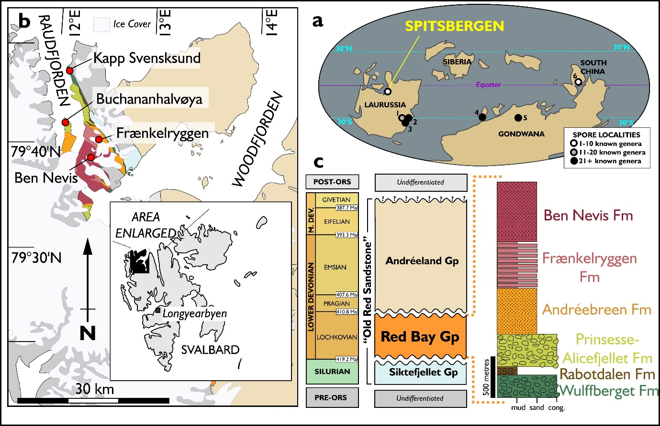
Fig. 1 Geology of the Lochkovian Red Bay Group of Spitsbergen. a, Lower Devonian (Lochkovian) palaeocontinental reconstruction after Torsvik & Cocks (2017)¹⁰. Note the position of Spitsbergen at the equator. 1 = Scotland; 2 = Ardenne-Rhenish region; 3 = Anglo-Welsh Basin; 4 = Northern Spain; 5 = North Africa (Libya); 6 = South China. b, Location map and geological map of the Spitsbergen Red Bay Group. c, Stratigraphy of the Late Silurian-Lower Devonian of Spitsbergen and stratigraphical nomenclature for the Red Bay Group. Spitsbergen Silurian-Devonian stratigraphical nomenclature follows Davies et al. (2021)¹². Red Bay Group stratigraphical column after Friend et al. (1997)¹¹. ORS = Old Red Sandstone.
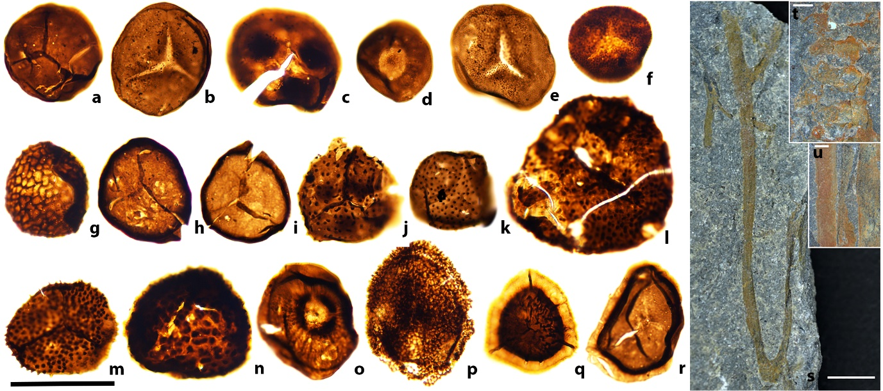
Fig. 2 Dispersed spores (a-r) and plant megafossils (s-u) from the Red Bay Group of Spitsbergen. Scale bar = 40 μm (a-r), 5 mm (s), 1 mm (t), 1 mm (u). a-r, dispersed spores. (a) Retusotriletes spp. 18SPITS07/1 (G29). (b) Retusotriletes triangulatus 18SPITS07/1(C25/1). (c) Retusotriletes maculatus 18SPITS05/1(L40/4). (d) Retusotriletes sp. A 18SPITS08/1(T36/4). (e) Apiculiretusispora sp. A 18SPITS08/1(W44). (f) Apiculiretusispora spp. 18SPITS22/1(F32). (g) Dictyotriletes sp. A 18SPITS05/1(M39/1). (h) Ambitisporites avitus 18SPITS07/1(P49/1). (i) Ambitisporites spp. 18SPITS08/1(Q36/3). (j) Aneurospora sp. B 18SPITS07/1(p46/4). (k) Aneurospora sp. A 18SPITS18/1(J44/3). (l) Aneurospora sp. C 18SPITS29/1(B29). (m) Aneurospora sp. D 18SPITS23/1(K28/2). (n) Aneurospora sp. E 18SPITS30/1(D36). (o) Emphanisporites sp. A18SPITS24/1(Y47/1). (p) Acinosporites sp. A 18SPITS21/1(L26/4). (q) Camptozonotriletes sp. A 18SPITS23/1(G53/4). (r) Breconisporites sp. A 18SPITS08/1(J30/4). s-u, plant megafossils. (s) Anisotomous branching in Zosterophyllum. The basal portion of the axis exhibits H- branching typical of that found in Zosterophyllum. The apical portion of the specimen dichotomises anisotomously, into a further dichotomising axis. PMO 235.642/a. (t) Fertile axis of Zosterophyllum with 4 pairs of sporangia. Associated axis can be seen on the most basal pair of sporangia. PMO 235.642/b. (u) Erect, overlapping Zosterophyllum axis. PMO 235.643.

References
1. Gaston, K. J. Global patterns of biodiversity. Nature 405, 220-227 (2000).
2. Friis, E. M., Crane, P. R., Pedersen, K. R. Early flowers and angiosperm evolution. Cambridge University Press (2011).
3. Blomenkemper, P. et al. A hidden cradle of plant evolution in Permian tropical lowlands. Science 362, 1414-1416 (2018).
4. Kenrick, P., Crane, P. R. The origin and early diversification of land plants: a cladistic study. Smithsonian Institution Scholarly Press (1997).
5. Puttick, M. N. et al. The interrelationships of land plants and the nature of the nature of the ancestral embryophyte. Curr. Biol. 28, 733-745 (2018).
6. Morris, J. L. et al. The timescale of early land plant evolution. PNAS 115, 2274-2283 (2018).
7. Wellman, C. H., Steemans, P. & Vecoli, M. Palaeophytogeography of Ordovician-Silurian land plants. In: Harper, D. & Servais, T. (eds) Palaeozoic palaeogeography. Mem. Geol. Soc. Lond. 38, 461-476 (2013).
8. Edwards, D., Morris, J. L., Axe, L., Duckett, J. G., Pressel, S. & Kenrick, P. Piecing together the eophytes – a new group of ancient plants containing cryptospores. New Phytologist 00, 000-000 (2021)
9. Gray, J. The microfossil record of early land plants; advances in understanding of early terrestrialization, 1970-1984. Phil. Trans. R. Soc. Lond. B 309, 167-195 (1985).
10. Wellman, C. H. Cryptospores from the type area for the Caradoc Series (Ordovician) in southern Britain. Palaeontol. 55, 103-136 (1996).
11. Torsvik, T. H. & Cocks, L. R. M. Earth history and palaeogeography (Cambridge University Press, 2017).
12. Harland, W. B. 1997. The Geology of Svalbard. Geological Society Memoir 17 published by The Geological Society London. 521 pp.
13. Davies, N. S., Berry, C. M., Marshall, J. E. A., Wellman, C. H. & Lindemann, F.-J. The Devonian landscape factory: plant-sediment interactions in the Old Red Sandstone of Svalbard and the rise of vegetation as a biogeomorphic agent. J. Geol. Soc. Lond. 178, OI: https://doi.org/10.1144/jgs2020-225 (2021).
14. Blieck, A., Goujet, D. & Janvier, P. The vertebrate stratigraphy of the Lower Devonian (Red Bay Group and Wood Bay Formation) of Spitsbergen. Modern Geol. 11, 197-217 (1987).
15. Blom, H. & Goujet, D. Thelodont scales from the Lower Devonian Red Bay Group, Spitsbergen. Palaeontol. 45, 795-820 (2002).
16. Pernègre, V. N. & Blieck, A. A revised heterostrachan-cased ichthyostratigraphy of the Wood Bay Formation (Lower Devonian, Spitsbergen), and correlation with Russian Arctic archipelagos. Geodiversitas 38, 5-20 (2016).
17. Wellman, C. H. & Richardson, J. B. Sporomorph assemblages from the ‘Lower Old Red Sandstone’ of Lorne Scotland. Sp. Pap. Palaeontol. 55, 41-101.
18. Richardson J.B. Taxonomy and classification of some new Early Devonian cryptospores from England. Sp. Pap. Palaeontol. 55, 7–40 (1996).
19. Steemans, P. Etude palynostratgraphique du Devonian Inferieur dansl’Ouest de l’Europe. Mémoires pour servir à l’Explication des cartes Géologiques et Minières de la Belgique 27, 1-453 (1989).
20. Rodriguez, R. M. Palinologia de las formaciones del Silurico Superior-Devonico Inferior de la Cordillera Cantabrica, Noroeste de España. Publicatión conjunta de la Institución Fray Bernardino de Sahagún, de la Excelentísima Diputación provincial de León y del Servicio de Publicaciones de la Universidad de León. 231 pp. (1983)
21. Richardson, J. B., Rodriguez, R. M. & Sutherland, S. J. E. Palynological zonation of Mid-Palaeozoic sequences from the Cantabrian Mountains, NW Spain: implications for inter-regional and interfacies correlation of the Ludfor/Pridoli and Silurian/Devonian boundaries, and plant dispersal patterns. Bull. Nat. Hist. Mus. Lond. (Geol.) 57, 115-162 (2001).
22. Rubinstein, C. & Steemans, P. Miospore assemblages from the Silurian-Devonian boundary, in borehole A1-61, Ghadames Basin, Libya. Rev. Palaeobot. Palynol. 118, 397-412 (2002).
23. Spina, A. & Vecoli, M. Palynostratigraphy and vegetational change in the Siluro-Devonian of the Ghadamis basin, North Africa. Palaeogeog. Palaeoclimatol. Palaeoecol. 282, 1-18 (2009).
24. Hao, S. G. & Gensel, P. G. 2001. The Posongchong floral assemblages of southeastern Yunnan, China – diversity and disparity in early Devonian plant assemblages. 103-119. In: Gensel, P. G. & Edwards, D. (eds) Plants invade the land. Columbia University Press, New York 304pp. (2001).
25. Wellman, C. H., Zhu, H., Marshall, J. E. A., Wang, Y., Berry, C. M. & Xu, H. Spore assemblages from the Lower Devonian Xujiachong Formation from Qujing, Yunnan, China. Palaeontol. 55, 583-611 (2012).
26. Hao, S. & Xue, J. The Early Devonian Posongchong flora of Yunnan. Science Press, Beijing. 366pp. (2013).
27. Edwards, D. & Li 2018, C-S. Further insights into the Lower Devonian terrestrial vegetation of Sichuan Province, China. Rev. Palaeobot. Palynol. 253, 37-48 (2018).
28. Gao, L. Early Devonian spore and acritarchs from the Guijiatum Formation of Qujing, China. Bull. Inst. Geol. Chin. Acad. Sci. 9, 125-136 (1984).
29. Tian, J. et al. Late Silurian to early Devonian palynomorphs from Qujing, Yunnan, southwest China. Acta Geol. Sinica. 85, 559-568 (2011).
30. Høeg, O. A. The Downtonian and Dittonian flora of Spitsbergen. Skrifter om Svalbard og Ishavet 83, 1-229 (1942).
31. Morris, J. L., Edwards, D. & Richardson, J. B. The advantages and frustrations of a plant Lagerstätte as illustrated by a new taxon from the Lower Devonian of the Welsh Borderland, UK. 49-67. In: Krings, M., Harper, C. J., Cuneo, N. R. & Rothwell, G. W. (eds) Transformative paleobotany. Academic Press, New York 732pp. (2018).
32. McSweeney, F. R., Shimeta, J. & Buckeridge, J. St. J. S. Two new genera of early Tracheophyta (Zosterophyllaceae) from the upper Silurian-Lower Devonian of Victoria, Australia. Alcheringa 10.1080/03115518.2020.1744725 (2020).
33. Xue, J. H. et al. Silurian-Devonian terrestrial revolution in South China: taxonomy, diversity, and character evolution of vascular plants in a paleogeographically isolated low-latitude region. Earth. Sci. Rev. 180, 92-125 (2018).
34. Hao, S. G. et al. Zosterophyllum Penhallow around the Silurian-Devonian boundary of northeastern Yunnan, China. Int. J. Plant Sci. 168, 477-489 (2007).
35. Hao, S. G. et al. Earliest rooting system and root: shoot ratio from a new Zosterophyllum plant, New Phyt. 185, 217-225 (2009).
36. Xue, J.-Z. Two zosterophyll plants from the Lower Devonian (Lochkovian) Xitun Formation of northeastern Yunnan, China. Acta Geol. Sin. 83, 504-512 (2009).
37. Xue, J.-Z. Lochkovian plants from the Xitun Formation of Yunnan, China and their palaeophytogeographical significance. Geol. Mag. 149, 333-344 (2012).
38. Sun, Y., Joachimski, M. M., Wignal, P. B. et al. Lethally high temperatures during the early Triassic greenhouse. Science 6105, 366-370 (2012).
39. Meng, X. Y. & Gai, Z. K. Falcornus, a new genus of Tridensaspidae (Galeaspida, stem-Gnathostomata) from the Lower Devonian in Qujing, Yunnan, China. Historical Biology 10.1080.
40. Traverse, A. 2007. Paleopalynology (2nd ed.) Springer 813pp.

Additional information
Supplementary information The online version contains supplementary material available at https://
Correspondence and requests for materials should be addressed to CHW.

