MOON RJ et al: Maternal and fetal genetic variation in vitamin D metabolism and umbilical cord blood 25-hydroxyvitamin D

Supplemental Tables and Figures

Supplementary Table 1: Characteristics of mothers and offspring included in the SWS analysis and those not included (without a measure of umbilical cord blood 25(OH)D)
 |  | SWS Not included (n=1140) | SWS Included (n=847) | p
Age (years), mean (SD) |  | 27.6 (3.8) | 28.4 (3.8) | <0.001
Late pregnancy smoking, n (%) |  | 180 (17.1) | 85 (10.8) | <0.001
Educational attainment ≥ A level (high school), n (%) |  | 631 (55.5) | 512 (60.7) | 0.02
Pre-pregnancy BMI (kg/m²), mean (SD) |  | 25.2 (4.7) | 25.5 (4.9) | 0.17
Pregnancy weight gain (kg), mean (SD) |  | 10.6 (4.2) | 10.6 (4.2) | 0.88
Late pregnancy triceps skinfold thickness (mm), mean (SD) |  | 21.6 (6.7) | 21.7 (7.0) | 0.76
Parity 1+, n(%) |  | 594 (52.2) | 426 (50.4) | 0.43
White ethnicity, n(%) |  | 1092 (95.8) | 817 (96.5) | 0.45
Early pregnancy 25(OH)D, nmol/l |  | 64.2 (26.0) | 61.1 (25.5) | 0.02
Late pregnancy 25(OH)D, nmol/l |  | 61.8 (30.6) | 68.6 (31.3) | <0.001
Vitamin D supplement use in late pregnancy, n(%) |  | 486 (46.1) | 417 (52.7) | 0.005
Offspring
Female, n (%) |  | 555 (48.7) | 399 (47.1) | 0.49
Gestation at birth (weeks), median (IQR) |  | 40.1 (39.1,41.0) | 40.1 (39.1,41.1) | 0.77
Birthweight (g), mean (SD) |  | 3456 (516) | 3503 (513) | 0.04
Umbilical cord blood 25(OH)D, nmol/l |  | - | 31.9 (18.3)

Supplementary Table 2: Genotype frequencies in mothers and offspring included in the SWS cohort
 |  | Mothers  N (%) | Offspring  N (%)
rs12785878 (DHCR7), n(%)
 | G:G | 45 (7.1) | 62 (7.8)
 | T:G | 209 (33.1) | 258 (32.5)
 | T:T | 378 (59.8) | 474 (59.7)
rs10741657 (CYP2R1), n (%)
 | A:A | 91 (14.4) | 121 (15.2)
 | G:A | 319 (50.4) | 395 (49.7)
 | G:G | 223 (35.2) | 279 (35.1)
rs6013897 (CYP24A1), n (%)
 | A:A | 18 (2.9) | 40 (5.0)
 | T:A | 213 (33.7) | 238 (30.0)
 | T:T | 401 (63.5) | 516 (65.0)
rs2282679 (GC), n (%)
 | C:C | 54 (8.5) | 61 (7.8)
 | C:A | 263 (41.6) | 342 (43.0)
 | A:A | 316 (49.9) | 392 (49.3)

Supplementary Table 3: Characteristics of mothers and offspring included in the MAVIDOS analysis and those not included
 |  | MAVIDOS Not included | MAVIDOS Included | p
n |  | 615 | 350
Age (years), mean (SD) |  | 30.6 (5.1) | 30.9 (5.2) | 0.48
Late pregnancy smoking, n (%) |  | 41 (7.6) | 17 (5.7) | 0.31
Educational attainment ≥ A level (high school), n (%) |  | 459 (77.4) | 258 (77.7) | 0.91
Pre-pregnancy BMI (kg/m²), mean (SD) |  | 26.3 (5.0) | 26.3 (5.0) | 0.81
Pregnancy weight gain (kg), mean (SD) |  | 9.5 (3.6) | 9.6 (3.7) | 0.75
Late pregnancy triceps skinfold thickness (mm), mean (SD) |  | 21.8 (6.7) | 22.1 (7.5) | 0.57
Parity 1+, n(%) |  | 327 (55.1) | 197 (59.3) | 0.21
Early pregnancy 25(OH)D (nmol/l) |  | 46.2 (17.6) | 46.4 (16.3) | 0.84
White ethnicity, n(%) |  | 563 (94.8) | 317 (94.9) | 0.93
Compliance with study medication (%), median (IQR) |  | 95.5  (88.2,98.9) | 95.6  (88.6,98.9) | 0.95
Offspring
Female, n (%) |  | 276 (44.9) | 172 (49.1) | 0.20
Gestation at birth (weeks), median (IQR) |  | 40.3 (39.3,41.0) | 40.1 (39.1,40.9) | 0.69
Birthweight (g), mean (SD) |  | 3463 (563) | 3565 (459) | 0.004

Supplementary Table 4: Characteristics of participants in the MAVDIOS study
 |  | Placebo | Cholecalciferol 1000 iu/day
n |  | 185 | 165
Age (years), mean (SD) |  | 30.8 (5.4) | 30.9 (5.0)
Late pregnancy smoking, n (%) |  | 8 (5.0) | 9 (6.5)
Educational attainment ≥ A level (high school), n (%) |  | 132 (75.9) | 126 (79.8)
Pre-pregnancy BMI (kg/m²), mean (SD) |  | 26.5 (5.1) | 26.2 (4.8)
Pregnancy weight gain (kg), mean (SD) |  | 9.9 (3.7) | 9.2 (3.7)
Late pregnancy triceps skinfold thickness (mm), mean (SD) |  | 22.7 (7.6) | 21.5 (7.3)
Parity 1+, n(%) |  | 96 (54.6) | 101 (64.7)
White ethnicity, n(%) |  | 165 (93.8) | 152 (96.2)
Compliance with study medication (%), median (IQR) |  | 93.7 (88.2,98.9) | 96.3 (90.2,98.9)
Early pregnancy 25(OH)D (nmol/l) |  | 46.5 (16.3) | 46.2 (16.4)
Late pregnancy 25(OH)D (nmol/l) |  | 44.0 (24.2) | 70.7 (22.9)
Maternal genotype
rs12785878 (DHCR7), n(%)
 | G:G | 16 (9.3) | 8 (5.1)
 | T:G | 59 (34.1) | 61 (39.1)
 | T:T | 98 (56.7) | 87 (55.8)
rs10741657 (CYP2R1), n (%)
 | A:A | 21 (12.4) | 22 (14.0)
 | G:A | 85 (50.0) | 72 (45.9)
 | G:G | 64 (37.7) | 63 (40.1)
rs6013897 (CYP24A1), n (%)
 | A:A | 9 (5.3) | 8 (5.2)
 | T:A | 58 (33.9) | 40 (25.8)
 | T:T | 104 (60.8) | 107 (69.0)
rs2282679 (GC), n (%)
 | C:C | 18 (10.5) | 15 (9.6)
 | C:A | 78 (45.6) | 70 (44.9)
 | A:A | 75 (43.9) | 71 (45.5)
Offspring
Female, n (%) |  | 94 (50.8) | 78 (47.3)
Gestation at birth (weeks), median (IQR) |  | 40.3 (39.3,41.0) | 40.1 (39.1,40.9)
Birthweight (g), mean (SD) |  | 3546 (484) | 3586 (429)
Umbilical cord blood 25(OH)D (nmol/l) |  | 28.6 (12.1) | 42.3 (13.1)
Offspring genotype
rs12785878 (DHCR7), n(%)
 | G:G | 9 (5.6) | 9 (6.3)
 | T:G | 58 (35.8) | 56 (39.2)
 | T:T | 95 (58.6) | 78 (54.6)
rs10741657 (CYP2R1), n (%)
 | A:A | 27 (17.2) | 17 (11.8)
 | G:A | 79 (50.3) | 63 (43.8)
 | G:G | 51 (32.5) | 64 (44.4)
rs6013897 (CYP24A1), n (%)
 | A:A | 4 (2.5) | 2 (1.4)
 | T:A | 53 (33.5) | 39 (27.1)
 | T:T | 101 (63.9) | 103 (71.5)
rs2282679 (GC), n (%)
 | C:C | 17 (10.5) | 12 (8.5)
 | C:A | 69 (42.6) | 64 (45.1)
 | A:A | 76 (46.9) | 66 (46.5)

Supplementary Figure 1: Meta-analysis of associations of (A) maternal and (B) offspring genotype at rs10741657 and rs6013897 with umbilical cord blood 25(OH)D
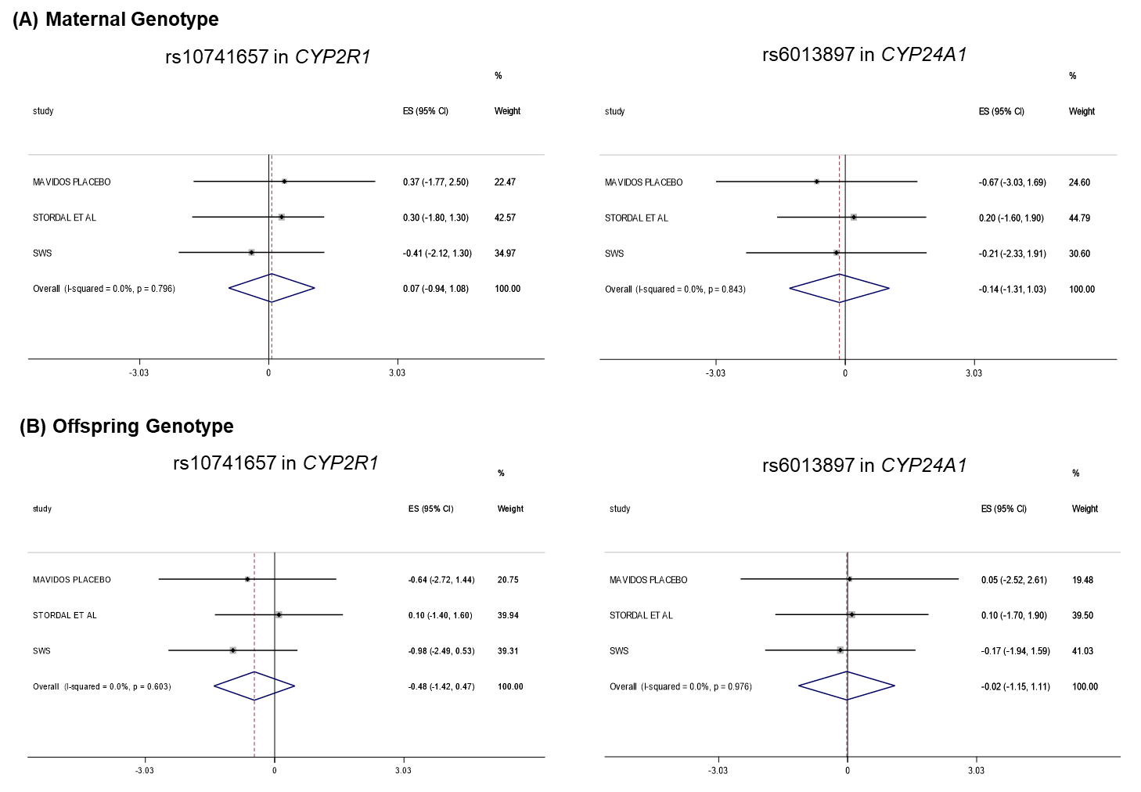

Supplementary Figure 2: Meta-analysis of associations of (A) maternal adjusted for offspring genotype and (B) offspring adjusted for maternal genotype at rs10741657 and rs6013897 with umbilical cord blood 25(OH)D