New integrated molecular approaches for understanding lake settlements in NW Europe
Antony G. Brown^{1,2}, Thierry Fonville², Maarten van Hardenbroek³, Graeme Cavers⁴, Anne Crone⁴, Finbar McCormick⁵, Emily Murray⁵, Helen Mackay⁶, Nicki J. Whitehouse⁷, Andrew C.G. Henderson³, Phil Barratt^{7,10}, Kim Davies⁹, Katie Head⁸, Peter Langdon², Inger G. Alsos¹ & Duncan Pirrie¹¹
¹ Tromsø Museum, UiT Arctic University of Norway
² Palaeoenvironmental Laboratory, School of Geography and Environmental Sciences, University of Southampton, Tony.Brown@soton.ac.uk
³ School of Geography, Politics and Sociology, Newcastle University, UK
⁴ AOC Archaeology Group, Edinburgh, Scotland, UK
⁵ Archaeology, Queen’s University Belfast, NI, UK
⁶ Department of Geography, Durham University, UK
⁷ Archaeology, School of Humanities, University of Glasgow, UK
⁸ School of Geography, Earth and Environmental Sciences, University of Plymouth, UK
⁹ Archaeology, IMSET, Bournemouth University, UK
¹⁰ Dept. of Classics and Archaeology, University of Nottingham, Nottingham, UK
¹¹ School of Applied Sciences, University of South Wales, Pontypridd, UK
* Author for correspondence Tony.Brown@soton.ac.uk

Abstract
Lake settlements, particularly crannogs, pose several contradictions – visible yet inaccessible, widespread yet geographically restricted, persistent yet vulnerable. To further our understanding, we have developed the integrated use of palaeolimnological (scanning XRF, pollen, spores, diatoms, chironomids, Cladocera, microcharcoal, biogenic silica, SEM-EDS, stable-isotopes) and biomolecular analyses (faecal stanols, bile acids, sedaDNA) of proximal and through-crannog cores in SW Scotland and Ireland. Both can be an effective methods for revealing occupation-chronologies and identifying on-crannog activities/practices. Strong results from sedaDNA and lipid biomarkers analysis demonstrate likely on-site animal slaughter, food storage and possibly feasting, suggesting multi-period elite site-associations, storage and protection, of valuable resources.

Keywords: British Isles, Ireland, lake settlements, molecular archaeology, sedaDNA, lipid biomarkers, crannogs
5988 words
Background: multiple perspectives on crannogs and lake settlements
The application of molecular analyses alongside traditional environmental techniques has huge potential for the examination of archaeological sites with either on-site or off-site proximal sedimentary records. Here we present biomolecular approaches to the archaeology of crannogs and demonstrate how these techniques can be used to establish site chronologies, on-site and off-site human activity, and site erosion all of which are also relevant to other lake settlement sites. Crannogs are dwelling sites located at the edges of lakes or on natural or artificial islands in the middle of a lake, or estuarine setting. They date from the Neolithic to later Historic period and although crannogs sensu stricto are distributed through Ireland, Scotland and occasionally further afield, the methodology outlined here is applicable to any sites in, or by, waterbodies such as lakes, estuaries and wetlands.
We provide short summaries of these new methods (in the text and Supplementary Material) using crannog and lake settlements as case studies. Lake settlements and crannogs, present several archaeological contradictions; common – but only in certain geographical areas, highly visible in the landscape – but surrounded by water with restricted access and difficult to excavate; and lastly ‘protected’ but almost un-protectable, being subject to erosion and degradation. These contradictions, along with the fame of the Alpine lake village discoveries fueled antiquarian interest in the 19th century (e.g. Munro 1882; Wood-Martin 1886) and led to the first modern excavations of crannogs such as at Loch Kinellan, Scotland 1914-1916 (Morrison 1985). Early, and many subsequent excavations, were within drained lake basins, although several have turned out to be lake settlements or villages rather than true crannogs – in the sense of an artificial island within a lake, wetland or estuary (Darvill 2008). This also highlights the fact that they rarely fit well into neat nomological, or indeed chronological, categories (Fredengren 2002), with natural islands frequently having been used for crannog and wetland village construction as well as lake edges and promontories e.g. Glastonbury Lake Village, England (Coles & Minnitt 1995), Lough Catherine, Ireland (Hencken & Davies 1951) and Cults Loch, Scotland (Cavers and Crone 2017). A further enigmatic element of crannogs is that it is always assumed, largely based on their relatively small size, that they were probably never unitary settlements, but were part of a dispersed habitation, activity, or pattern with corresponding dryland sites. These contradictions and questions inspired the research reported here in SW Scotland and Northern Ireland.
Estimates of the number of crannogs in Scotland and Ireland vary for several reasons, including definitional uncertainties, and the distribution and coverage of crannog surveys. These include SW Scotland (Morrison 1985; Henderson et al. 2021), the Republic of Ireland (Farrell et al. 1989), SW Scotland (Cavers and Henderson 2002; Henderson et al. 2002), NE Scotland (Stratigos and Noble 2018) and the Northern Isles (Stratigos 2021). The overall pattern is a relatively even coverage of both countries with some, probably real, gaps; such as SW Ireland, SE Scotland, and hotspots such as northern Midland Ireland (Figure 1). Crannogs have been reported outside this area including at Solvig in Denmark (Hertz 1974) and in the Baltic States (Pranckėnaitė 2014), but the most obvious outlier to the crannog distribution pattern is Llangorse Lake, South Wales - an early Medieval Royal site constructed between AD 889 and 893 (Lane & Redknapp 2019). This site was probably constructed by Irish craftsmen for a king of Brycheiniog who claimed to have been descended from a part-Irish dynasty. The historical narrative for this crannog is especially pertinent in drawing attention to the elite/royal connections that many crannogs appear to have had. Also relevant is the unusually rich material culture including bone, wood, pottery, lead, iron, flint, cereal grain but also richly embroidered textiles, which although richer than any other recently excavated crannog to date, but in line with Royal crannogs such as Lagore (Hencken 1950). Many crannog excavations, such as Buiston and Cults Loch in SW Scotland and Newtownland in Ireland, have often produced less spectacular but indicative material culture (Crone et al., 2018; Crone 2000; Cavers et al. 2017). Given the importance of these sites, together with the difficulty of excavating crannogs, especially those still surrounded by or under-water, alternatives ways of assessing and evaluating their archaeology is needed which we focvus on here.

The site-halo effect
All archaeological sites have some effects outside the activity area, however, this is more detectable in those environments that preserve both organic and inorganic material such as marshes, floodplains, rivers and lakes. Over the last twenty years, palaeolimnologists have demonstrated that in many small lakes, there is neither strong water mixing or fine sediment redistribution and as a result sedimentation and adsorption can be highly localized – being effectively diffusive plumes from point sources creating a site biogeochemical halo (SBH). This is inconvenient for palaeolimnologists, but good for archaeologists, as it means that whatever gets washed off an adjacent island, promontory, platform or through a pile-type structure can remain close to the site and be buried within nearby sediments. An excellent example of this are the artifacts and biological evidence found under pile-dwellings in Zurich (Heiss et al. 2017). The width of this site-halo will depend upon both the quantity emitted, its properties, and particularly whether it is fixed by sediment or marginal vegetation. Most biomolecules are relatively large, and both lipids and sedaDNA readily adheres and may even be absorbed by mineral aggregates and organic compounds in the lake sediment (Capo et al. 2021). The halo, which can be entirely biochemical with no increase in sediment thickness, extends out to a variable distance but generally less than 50 m (Fig. 1c). This is also dependent upon the lake bathymetry around the site location as submerged bench-edges or cliffs complicate this pattern. The SBH also contains material deliberately ejected into the water - from swords to bones.

Coring vs excavation
The data in this paper comes from lake sediment cores using large-diameter (10 cm) gravity or piston-type corers from rafts outside the perimeter of the site, exploiting the halo-effect outlined above. The marginal core is taken on the outer side of the crannog or island so it is as far away as possible from the lake shoreline. Additionally, and in order to compare this approach to a direct-site record, we have also undertaken a test excavation on one crannog and cored through two. Coring is only possible on sites that are predominantly made of timber, other organic matter, clay and soil, rather than gravel or large stone blocks, and using narrow gouges that can cut through saturated timbers. In our cases the core penetrated the entire structure into the underlying sediments. The results of these approaches are compared with marginal cores highlighting both advantages and disadvantages. Damage to the sites is minimal: using a 6 cm diameter corer, which is the largest that is practical, and on a typical crannog 30 m diameter and 3 m in thickness, under 0.0005% of the crannog would be destroyed, which is far less than is lost naturally in a single year from most sites by erosion (see discussion of erosion) and certainly less damaging than excavation.

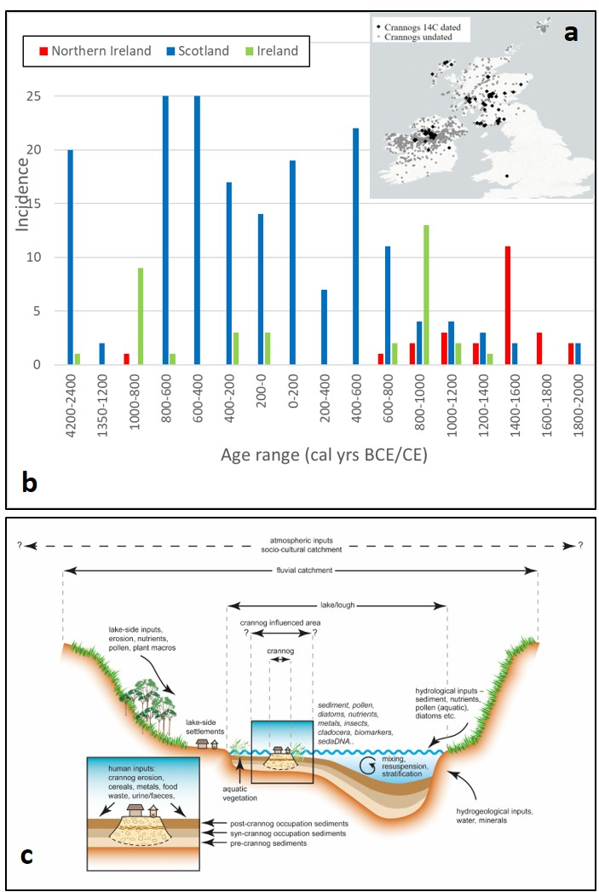
Figure 1. a Map of crannogs recorded in the dataset, b age distribution for Scotland and Irish crannogs radiocarbon dates using median ages estimated by Calib 8.2 (Reimer et al. 2020), c generalized stratigraphic model of a lake crannog and associated sediment inputs. Adapted and updated from Brown et al. (2021).
Refining chronologies
The gold-standard for the chronology of a crannog or lake settlement would be 100% excavation and dendrochronology of all phases. However, this is rarely achievable, and most dates from crannogs come from a single, or a few, timbers retrieved during diving, low-water conditions or lake drainage. Whilst immensely valuable, especially in single loch studies (Henderson et al. 2021) these can only ever provide a date of construction, use or re-use and cannot normally provide a Terminus Ante Quem (TAQ) or Terminus Post Quem (TPQ). If timbers can be shown to come from the base of a crannog or the final phase then the chronology is firmer, but this is rarely possible without excavation. However, if dendrochronology and underwater archaeology are used then the question of site contemporaneity and longevity can be addressed (Crone 2012). An alternative approach is coring either through the crannog itself, or the adjacent lake sediments. Marginal coring is relatively easy and allows dating of the stratigraphic/biogeochemical signature and SBH of the site from the lake sediment cores some meters away from the crannog.
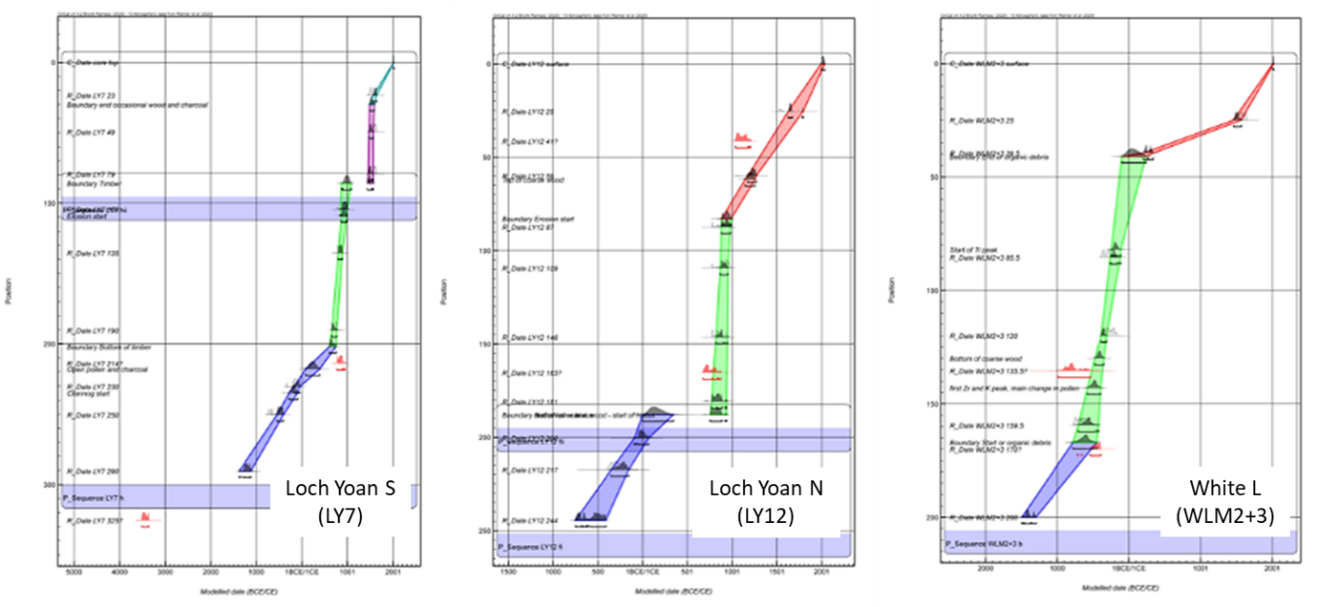
Figure 2. Modelled age-depth from Lough Yoan North and South Crannog and White Loch of Myrton. Where boundaries are present in the model, the sections between each are highlighted by different colours. Boundaries are inserted where there is a stratigraphic change or where there is reason to believe there could be a hiatus. Defaults are selected by OxCal. Note the date reversals in L Yoan S and White L and the high accumulation rate during crannog phases but variation in the overall curve. Further details of the age model development may be found in SI.
This has been undertaken for 15 crannogs (Supplementary material Table S1), and whilst it works well there are some issues where the stratigraphic link with the site is not clear. In these cases a reduction in loss on ignition (LOI, signifying increased clastic inputs), and an increase in the mineral component can be used to identify the crannog unit. Titanium (Ti) is typically used as it is stable and easily measured using scanning XRF. For 14C AMS dating there also needs to be abundant identifiable organic material, but this is quite common (including wood chips from construction). The resulting age-depth models based on ¹⁴C dates typically display non-linear accumulation rates in comparison to cores away from the crannog (Figure 1b, 2). Results from several crannog sites identify a hiatus (pause in accumulation of sediments or erosion) at the point of construction (Figure 2; Lough Yoan North). Whilst this does not affect periodization and indeed increases time resolution during crannog use due to the high sediment accumulation rate, it does complicate correlation of crannog construction with any potential stimuli – either societal or environmental. There is also frequently a spread in the ¹⁴C AMS dates including reversals (common in temperate lakes), which means that age-depth model development has to be undertaken with care. The causes of this are shown schematically in Figure 3 and relate to the conditions of construction, reconstruction, and critically, the modes of erosion either during crannog use, and/or post abandonment.
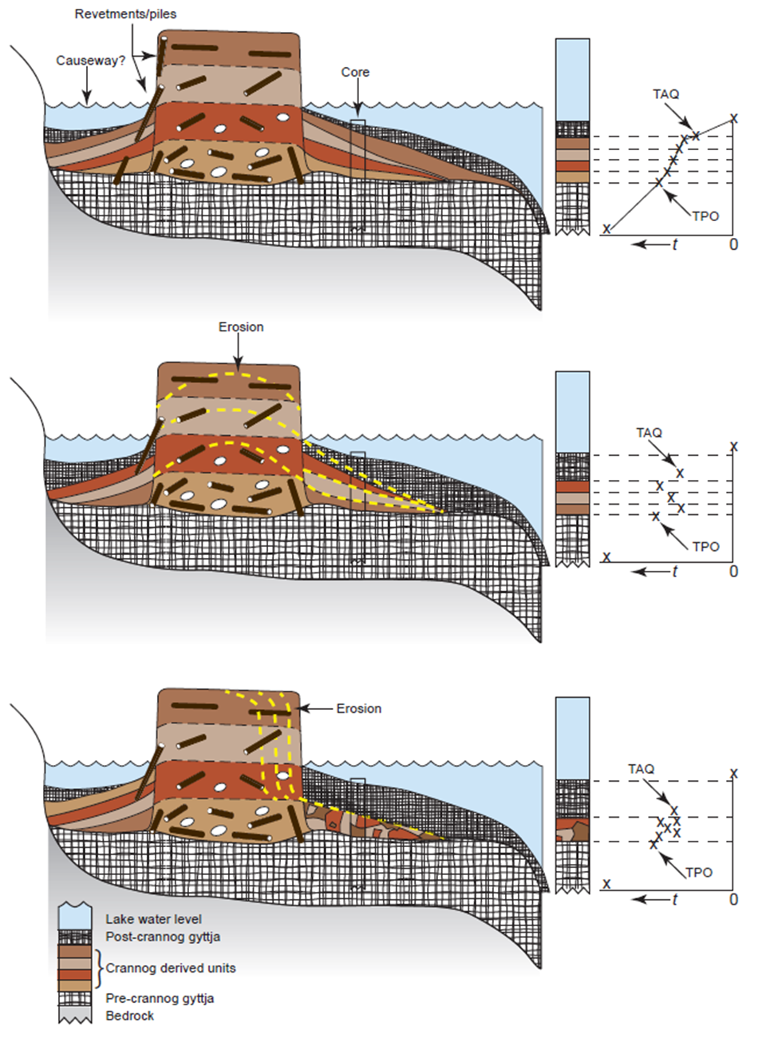
Figure 3. Generalised model of a typical crannog, its erosion and the likely implications for marginal age-depth curves (on right).
The complimentary approach of coring through the crannog was undertaken at two crannogs, one in SW Scotland (White Loch of Myrton) and one in Co Fermanagh, Ireland (Lough Yoan, South). This is not normally undertaken for both logistic and statutory reasons, and it is often impossible due to stones, but on sites constructed from sediment, soils and timbers it is a practical approach. The results were highly informative (Figure 4) revealing floors with faecal input and an estimate of abandonment date. This also allows tighter linkage of lake sediment cores with both the chronology, construction, and activity data in the absence of crannog excavation.
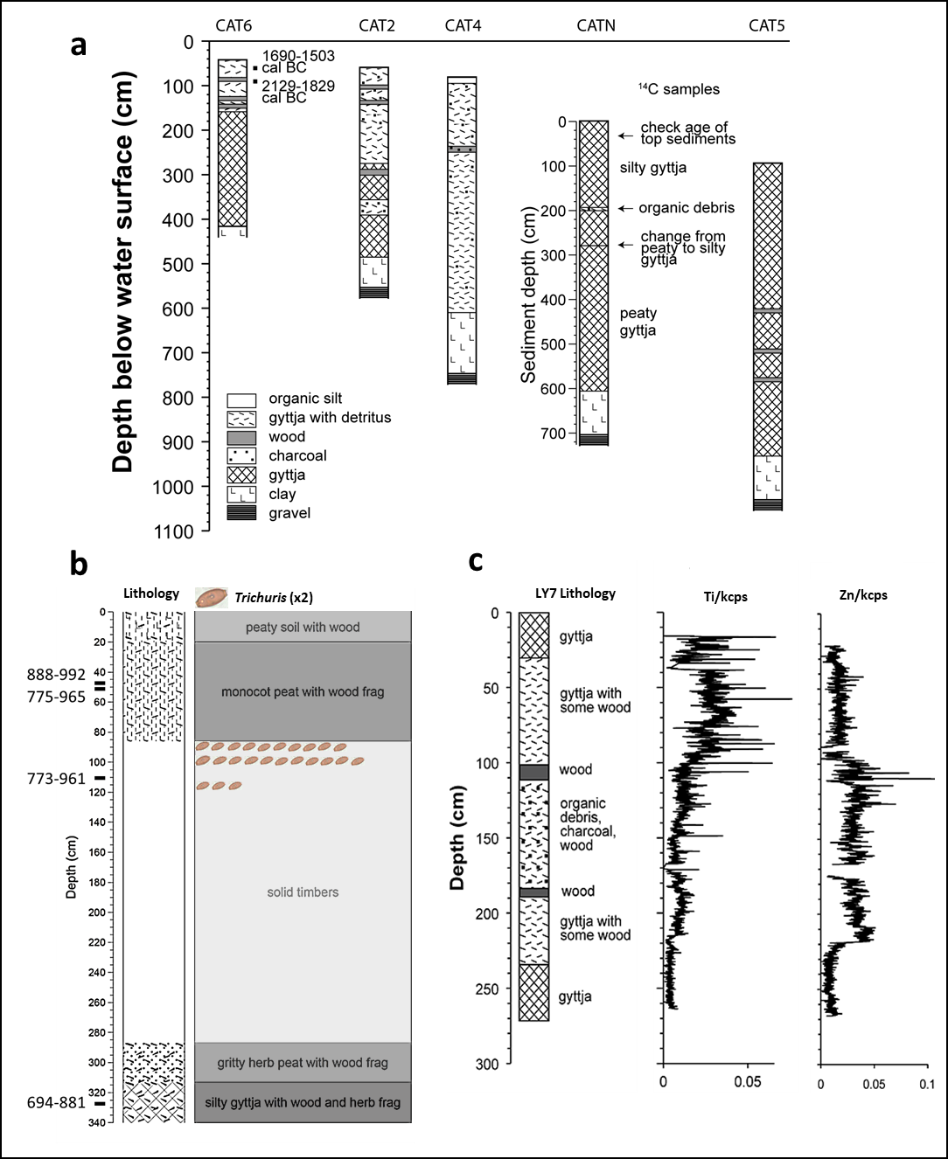
Figure 4. Examples of crannog related stratigraphies, a Lake sediment stratigraphy from a transect of cores extending out from Island McHugh, Lough Catherine, Co. Tyrone, Northern Ireland, b the through crannog core at Lough Yoan, South, Co. Fermanagh, Northern Ireland (dates in cal. Years AD) with record of Trichuris eggs on the crannog floor prior to abandonment, and c proximal crannog core from the crannog at Lough Yoan, South.

From on-site activities to societal interpretations using direct evidence and multiple proxies
Palaeoecological work, largely in Ireland, has previously shown crannog activities were reflected in a number of organic proxies including charcoal, pollen and spores, midges (chironomids), beetles, water flees (Cladocera), parasite eggs and diatoms (Brown et al., 2005; O’Brien, 2005; Selby et al., 2005). However, the existence of a mineralogical and molecular SBH as described above provides the ideal conditions to use an orthoganol multi-proxy design where the proxies are statistically independent so can potentially validate an inference through falsification (Bell & Blais 2021). The techniques used for geochemistry are x-ray flourescence (XRF), x-ray diffraction (XRD), automated SEM-EDS analysis (QEMSCAN), with sedaDNA metabarcoding for plants and mammals, and lipid biomarker analyses of bile acids and faecal stanols (Table 1 and Supplementary Material).

Data/Proxy | Method | Interpretation | Sites used
Pollen, NPP, spores, | Standard processing, microscopy | Local (catchment) vegetation change  Surrounding vegetation and landscape change  Crannog abandonment; cultivation/storage phases  Anomalous concentrations (roofing materials, bedding, animal dung) | Yoan (x3), Catherine (x2), White Loch, Barhapple, Derryhoughlaht, Aughlish
Diatoms | Standard processing, microscopy | Lake conditions (nutrient status, salinity..)  Human and animal eutrophication (TP index) | All except Barry, Auglish, Roughan
Chironomids, Cladocera | Sieving, optical microscopy | Lake conditions (e.g. eutrophication)  Aquatic vegetation change  Temperature | Yoan, Catherine, White Loch
Magnetic properties | Magnetic susceptibility meter (e.g. Bartington) | Core correlation  Changing inputs of clastic sediment  Crannog construction | all
Geochemistry | XRF (Itrax) | Changes in lake inputs: Ti, Si, Ca, etc.  Crannog construction (e.g. Ti)  Lake conditions (e.g. redox via Fe:Mn) | all
Sediment mineralogy | Automated SEM-EDS (QEMSCAN, see SM) | Changes in lake inputs: quartz, feldspar, clay minerals..  Crannog activities (e.g. apatite, metal ores, refined metals)  Lake conditions (e.g in-situ minerals – vivianite etc.. ) | Yoan N
Organic matter | loss on ignition (LOI) | Within lake organic production  Organic inputs to lake | all
C:N | CN analyser | Organic matter characterization | Catherine, Yoan, White Loch, Black Loch
δ ¹³C | Mass spectrometry | Within lake vs catchment organic matter sources  Lake productivity  Climate | Catherine, White Loch, Black Loch, Yoan
δ ¹⁵N | Mass spectrometry | Nitrogen sources and cycling and/or eutrophication and productivity | Catherine, Yoan, White Loch, Black Loch
sedaDNA | Metabacoding (see SM) | Local (catchment) vegetation change  Local (catchment) mammals and some invertebrates  On-crannog activities (e.g. slaughter, food storage) | Yoan N, Catherine, White Loch, Black Loch, Finlaggan, Clonmin
Biogenic silica (BSi) | Chemical leaching (see SM) | Within lake productivity (nutrient/disturbance/climate)  Climate | Yoan N, Catherine, Finlaggan, White Loch, Black Loch
Bile acids | Lipid analysis (see SM) | Keeping of animals  Human occupation  Slaughter | Yoan N, White Loch (x2), Black Loch
Fecal stanols | Lipid analysis (see SM) | Keeping of animals, slaughter  Human occupation | Yoan N, Catherine, Finlaggan, White Loch, Black Loch
Table 1. Summary of data and proxies used in lake studies with particular reference to the Celtic Connections and Crannogs Project.
Traditional environmental proxies all point to eutrophication of lakes around crannogs. This is clear from diatoms (Figure 5), as well as chironomids, Cladocera and lipid biomarkers. Using a diatom transfer function (a quantitative correlation method that uses modern training data to infer past environmental conditions) we can estimate the increase in lake phosphorus (Total Phosphorus, TP) around the site. The cause of this TP enrichment (and probably N enrichment) is addition of organic matter from animals, refuse, human waste etc. Some further inferences can be made from other traditional proxies such as pollen; several pollen diagrams not only show local deforestation associated with crannog construction, but also the unusual concentrations of herb types including Plantago lanceolata (ribwort plantain) and Pteridium (bracken), which were also found in the two through-crannog cores. The most plausible interpretation is that ribwort plantain is derived from intensive grazing of meadows near the sites (Jones & Haggar 1997). The bracken, which has also been found as complete fronds within crannog sediments was most likely brought onto sites for either/or animal and human bedding and/or roofing material, as known from ethnography (Campbell & Pelling, undated). At Lough Yoan whole bracken sporangia were present with many at the point of spore-release, indicating the bracken had been collected in summer (Figure 6).

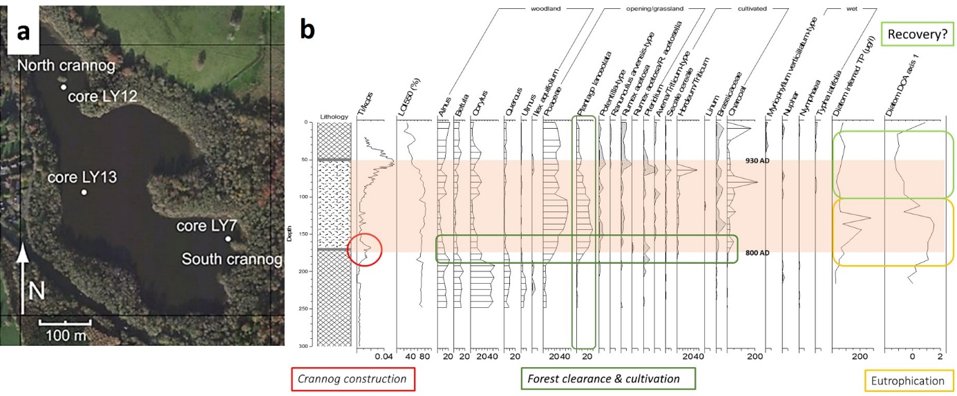Figure 5. Lough Yoan, Co. Fermanagh crannogs, a location of cores and b. selected traditional palaeoecological proxy data from Lough Yoan North marginal core; Ti, selected pollen, charcoal and diatom-inferred TP(Total Phosphorus) and PCA results (Principal Components Analysis). The crannog occupation period is shaded.

Mineralogical analyses can also highlightarchaeological processes. At Lough Yoan North core automated mineralogy (QEMSAN) revealed a dominance of small, angular and porous shards of apatite at the crannog level – significantly different from the level below the crannog phase (Figure 6 c, d). This is interpreted as fragments of bone from butchery waste and supports the interpretation from the sedaDNA and bile acids (Brown et al. 2021).

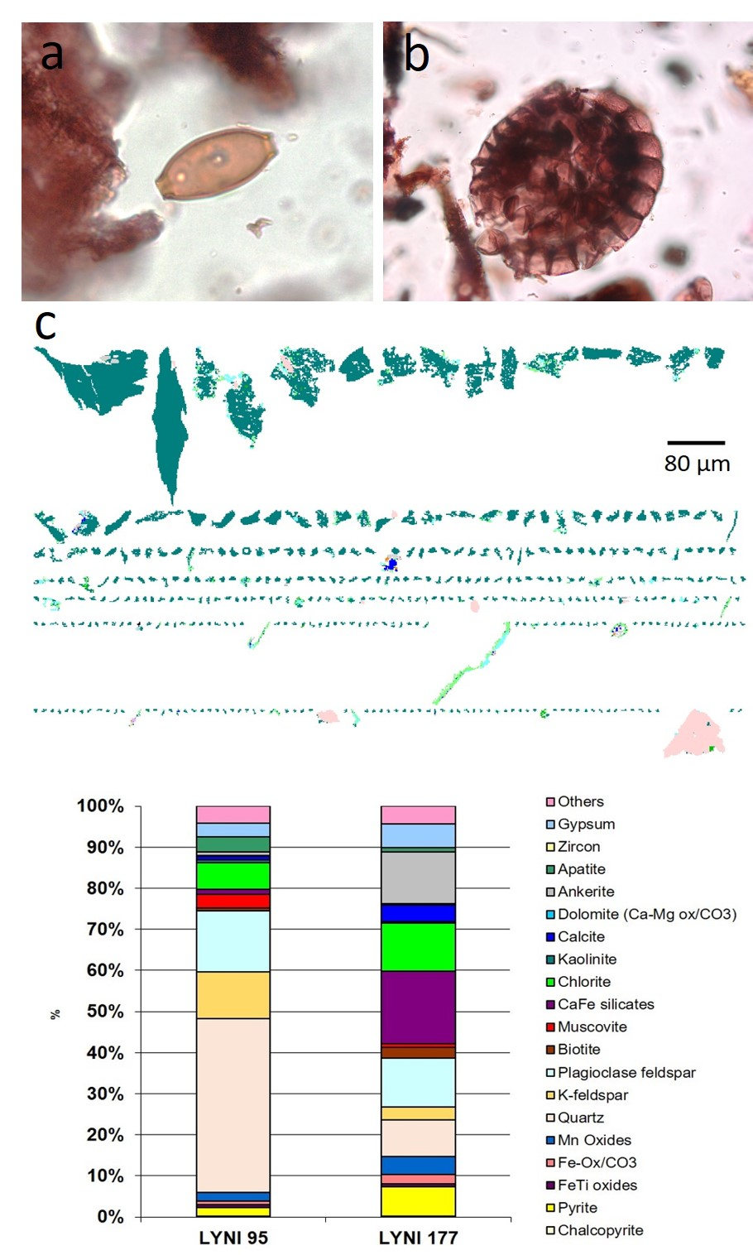
Figure 6. Microfossil and mineralogical proxies; a A complete sporangia of Pteridium (bracken) just about to open from Lough Yoan South core, b Trichuris (whipworm) from Lough Yoan S core (85 cm) c automated clast mineralogy from Lough Yoan North 95 cm (crannog level) showing the micro-shards of apatite (bone), and quantitative mineralogy from the same level compared with a level prior to the construction of the crannog.
Biomolecular proxies from sediments
The use of sedaDNA to reconstruct both vascular plants and animals has increased exponentially over the last few years particularly from lake sediments (Capo et al. 2021; Rijal et al. 2021). Details of the methodology are published elsewhere (Brown et al. 2021; Capo et al. 2021; method summary in Supplementary Materials) but the results on the three crannogs used so far have been remarkable (Figure 7). The plant sedaDNA data supports pollen data in the association of the crannog with cereal cultivation in tandem with local deforestation. Both Plantago lanceolata and Pteridium sedaDNA is also enhanced at the crannog levels. However, the results from the mammal primer are even more valuable – showing that the crannog units are associated with the appearance, or an increase in, sedaDNA of domesticated animals – principally cattle, sheep, pigs and possibly goats, as well as red deer. The simplest explanation of the combined evidence of eutrophication, pollen, and coprophilous spores is that these animals were being kept on the crannog and a combination of their dung, and/or slaughter products, entered the lakes from the crannogs. The strongest evidence comes from Lough Yoan where the peak of animal sedaDNA from the core has high levels of micro-fragments of apatite (3.65 %) as opposed to pre-crannog levels, which have far less (0.89%) (Brown et al. 2021). The association of crannogs with domestic animals and deer is attested through many animal bones from crannogs which have been interpreted in some contexts as feasting deposits (McCormick and Murray 2017). The advantage of plant sedaDNA over pollen and spores, is twofold; firstly, higher taxonomic resolution as sedaDNA is normally identifiable to species or genus level, and secondly, the certainty that the species was growing locally. Pollen and spores retain the advantages of being able to characterize the extra-local and regional vegetation and potential quantification of land cover (through modelling) which at present is impossible from sedaDNA. The sedaDNA animal data (mammal primers often catch many other organisms) are highly compatible with both coprophilous spore data and faecal lipid biomarkers (stanols and bile acids), which also exhibit high values during the periods of crannog use.

Figure 7. Selected sedaDNA and lipid biomarkers results from White Loch of Myrton, Lough Yoan (N) showing from top to bottom; stratigraphy, Ti, mammal sedaDNA (bars – repeats, diamonds – reads), fecal stanols and bile acids, lithocholic acid (LCA), deoxycholic acid (DCA) and chenodeoxycholic acid (CDCA), pollen and Total P (blue) with BSi (green).
Support for the presence of both mammals, and humans comes from the faecal stanols and the bile acids (Figure 7) which both rise during crannog use and have an overall relationship to the sedaDNA.. These molecular indicators also align well with the changes in pollen and also the record of TP and BSi highlighting changes to lake nutrients and productivity, resulting from the activities on the crannog.
The exploitation of the SBH by increasingly sophisticated methodologies can reveal on-site activities, but how this relates to the archaeological interpretation of crannogs depends on the societal and regional context. For example, if metalworking was found on a crannog, but also on a nearby contemporary dryland site it would have different functional implications to its being found on the crannog alone. This means that ideally, crannogs should not be studied in isolation but in combination with the dry-land sites that they are linked to. Crannogs are also linked to their environs by the resources they have garnered – the woodland use and management required for construction, repair, fuel, pastoral activity, arable horticulture, and rock and mineral exploitation both for construction and processing activities from grinding cereals to metalworking. Whilst not able to reveal as much cultural data as excavation, coring and the techniques described here can provide a remarkably detailed narrative of a site (Table 2).

Archaeology | Excav. | coring | Comments
Non-organic artifacts | ✔ | ✖ | One of the justifications for a small excavation and very rarely found in large diameter cores
Organic artefacts (e.g. textiles) | ✔ | ✖ | Only known from excavation
Chronology: dendro. | ✔ | ✖ | One of the main advantages of as full excavation as possible
Chronology: 14C | ✔ | ✔ | Depending upon the excavation a core can provide a better, or a less, comprehensive dating sequence
Construction/ abandonment | ✔ | ✔ | The clastic or Ti method can provide a comprehensive estimate of both construction and abandonment
Use of animals | (✔) | ✔ | Bones may be recovered if substrate is not acid, but, sedaDNA and faecal lipid biomarkers can be recovered from cores in both acidic and alkaline conditions; insects and NPPs can also inform on animal presence
Use of plants | ✔ | (✔) | Excavation may retrieve plant macrofossils but cores can retrieve small macrofossils, insect remains associated with plants, pollen and sedaDNA
Metalworking | ✔ | ✔ | Slag and geochemical indications can be present in cores
Cleaning | ✔ | ✔ | Directly through contexts indirectly through faunas
Stabling | ✔ | ✔ | Has been detected at L. Catherine from aDNA; may also be identified from insect remains in cores
Lake eutrophication | ✖ | ✔ | Both traditional palaeoecological methods (diatoms, cladocera, chironomids), BSi and stable isotopes
Human health | ✔ | ✔ | From parasites and parasite eggs in cores (e.g. Trichuris in a core from Lough Yoan); also fleas, lice and Coleoptera remains
Table 2. Summary table of advantages and disadvantages of marginal cores as compared to excavation.
Crannogs – monuments at risk?
This research has also, and inadvertently highlighted the condition of crannogs. As pointed out by Barber and Crone (1993) crannogs are vulnerable due to five processes; 1) subsidence due to compression of the sediment below them (unless founded on bedrock), 2) compaction of the sediment pile, 3) decay of the timber components, 4) erosion due to wave action and 5) siltation and associated root damage. Although restricted in number the 15 sites studied here all exhibited signs of erosion, 7 were moderately to highly eroded and 2 had been eroded to below the normal lake level (see Supplementary Material). Indeed it is the threats posed by this erosion and disturbance that warrants the application of the methods of both marginal and through-crannog coring coupled with biomolecular analyses.

Context and discussion
The scientific techniques outlined here can provide sophisticated windows into the lifeways of societies from the Neolithic to the post-Medieval periods – even if through the cultural filter of wetland site activities. The task for future work is to integrate these with the lower environmental potential, but greater representativity, of their associated settlements and sites on dryland and wider cultural contexts. Considering crannogs more specifically the frequent identification of ‘high-status’ activities and goods on some crannogs supports their role as places of protective custody of valuable resources, but also a degree of exclusion combined with the display of power and wealth (O’Sullivan, 2004). Low-status crannogs have been recorded such as Sroove, Ireland (Boyle 4004) but this may be due to later re-use as the resources required for construction implies considerable investment. Indeed biomolecular (and geochemical) methods may also be able to identify earlier activities which left no trace in the on-site material culture particularly as this could include infrequent events such as feasting and/or ceremonial activities. Shelley (2009) has shown that for the Medieval period in Scotland crannogs can be regarded as watery lodges or palaces and go out of fashion as display becomes increasingly mediated through estates, mansions and gardens. The royal association of many crannogs suggests that this is also a factor earlier in both Scotland and Ireland. This is also not unrelated to the ecclesiastical use of some crannogs, especially in the early Medieval period following the model of ascetic monasticism whereby a central monastery was surrounded by satellite hermitages in remote locations and particularly islands - although this was far more variable in Ireland (Bitel 2020). An additional element here is the early Christian tradition of islands as places of holiness, retreat and redemption, which can also have practical advantages, through a degree of protection and self-sufficiency. The religious association is visible through artifacts, such as crosses and the later documented use of crannogs by the church (Shelley 2009: Stratigos & Noble 2014). However, what this means, or implies, in different periods, and in different places, is obviously highly variable. One implication could be the seemingly paradoxical view that there is a fundamental limit about what we can know about crannogs by studying the crannogs in isolation. One key source of data is the distribution of crannogs in different periods, but this relies entirely on increasing the number of dated crannogs, dating crannog construction and re-use and comparing it to nearby dry-land sites (e.g. settlements, raths or ring-forts).
Conclusions
Crannogs and other wetland sites although generally problematic to excavate and frequently under threat, have unrivalled potential to reveal both lifeways and other aspects of our past not identifiable from most terrestrial sites. We describe here a coring approach exploiting the site biogeochemical halo (SBH) of sedaDNA and lipids that surrounds these sites. We were also able to correlate the marginal lake-cores with the site using through-site coring, an additional approach that maybe more practical than has been previously thought. Biomolecular techniques have the potential in these sites to reveal time-series of activities which would normally require excavation along with a high-level of environmental post-excavation analysis. These activities, such as animal keeping and slaughter, food storage, craft activities and aspects of human health may provide unique evidence of site use including feasting and ceremonial activities as well as providing a secure chronology of construction, use and abandonment. Although a relatively restricted site-type was used here (crannogs) the approach is equally applicable to sites in or by lakes, and also surrounded by wetlands, which are common in nearly all geographical regions and from prehistory to the post-medieval period.

Supplementary material
To view the online supplementary material (OMS) for this article, please visit:
Acknowledgements
All the research described here was funded by the UK Arts and Humanities Research Council (AH/M005259/1) and coring through Loch Yoan southern crannog was done under Northern Environment and Heritage Service License No. AE/16/18. We must also thank Geoff Hill and Iona Neilson for field assistance and Ludo Gielly for laboratory work in Grenoble and also the landowners who supported this work.

References
Barber, J. W. & B. A. Crone. 1993. Crannogs; a diminishing resource? A survey of the crannogs of southwest Scotland and excavations at Buiston. Antiquity 67: 520-533.
Bell, M. & J.M. Blais. 2021. Paleolimnology in support of archaeology: a review of past investigations and proposed framework for future study. J. Paleolimnology 65: 1-32.
Bitel, L.M. 2020. The monastic identity in Early Medieval Ireland. In I. Alison & L. M. Bitel (ed.) The Cambridge History of Medieval Monasticism. Cambridge University Press, Cambridge 297-316. https://www.cambridge.org/core/books/cambridge-history-of-medieval-monasticism-in-the-latin-west/monastic-identity-in-early-medieval-ireland/8F22E95CBED85E187F8A8CC8F809E44F/core-reader
Boyle, J.W. 2004. Lest the lowliest be forgotten: locating the impoverished in early medieval Ireland. International Journal of Historical Archaeology 8: 85-99.
Brown, A. G., et al. 2005. Vegetation, landscape and human activity in Midland Ireland: mire and lake records from the Lough Kinale-Derragh Lough area, Central Ireland. Vegetation History and Archaeobotany 14: 81-98.
Brown, A.G. et al. 2021. Ancient DNA, Lipid Biomarkers and Palaeoecological Evidence Reveals Construction and Life on early Medieval Lake Settlements. Scientific Reports
Caldwell, D. H. 2010. Finlaggan report 1: introduction and background. National Museums Scotland, 51p.
Campbell, G. & R. Pelling. Undated. The Palaeoethnobotany of Pteridium aquilinum (L.) Kuhn (Bracken): Myriad past and present uses from documentary evidence and the archaeobotanical record. Historic England Policy & Evidence, Fort Cumberland, Available at https://historicengland.org.uk/content/docs/advice/bracken-the-palaeoethnobotany-of-pteridium-aquilinum/
Capo, E. et al. 2021. Optimizing the experimental procedure to analyze ancient DNA preserved within lake sedimentary archives. Guidelines for future research using lake sedimentary DNA to track historical changes in terrestrial and aquatic ecosystems. Quaternary MDPI
Cavers, M.G. & A. Crone. 2017. Lake Dwelling in its Landscape: Iron Age Settlement at Cults Loch, Castle Kennedy, Dumfries & Galloway. Oxbow Books, Oxford
Cavers, M.G. & J. C. Henderson. 2002. South West Crannog Survey, Dumfries and Galloway (Colvend and Southwick; Dunscore; Inch; Lochrutton; Mochrum, New Abbey; Old Luce; Sanquhar; Urr parishes), survey. Discovery Excav. Scot. 3: 1-26
Carver, N. & C. Donnelly. 2011. Investigations at Castle Caulfield Lisnamonaghan Co. Tyrone. Data Structure Report 74, Centre for Archaeological Fieldwork, Queen’s University Belfast.
Coles, J. & S. Minnitt. 1995. ‘Industrious and Fairly Civilized’ the Glastonbury Lake Village. Somerset County Museums Service, Taunton.
Crone, A. 2000. The History of a Scottish Lowland Crannog: Excavations at Buiston, Ayrshire 1989-90, Scot Trust Arch Res.
Crone, A. 2012. Forging a chronological framework for Scottish crannogs; the radiocarbon and dendrochronological evidence. In M.S. Midgley, J. Sanders (eds) Lake Dwellings after Robert Munro. Proceedings from the Munro International Seminar: The Lake Dwellings of Europe, University of Edinburgh.
Crone, A., et al. 2018. Nasty, brutish and short? the life cycle of an Iron Age roundhouse at Black Loch of Myrton, SW Scotland. Journal of Wetland Archaeology 18: 138-162.
Darvill, T. 2008. The Concise Oxford Dictionary of Archaeology (2 ed.), Oxford University Press, Oxford.
Garrow, D. & F. Sturt. 2019. Neolithic crannogs: rethinking settlement, monumentality and deposition in the Outer Hebrides and beyond. Antiquity 93, 664-684.
Farrell, R.T., E.P. Kelly, M. Gowan. 1989. The crannogs archaeological survey (CAP), Republic of Ireland I: A pre-preliminary report. International Journal of Nautical Archaeology 18, 123-136.
Fonville, T., Brown, A.G. and Clarke, C. 2017. The environment in and around Cults Loch. In G. Cavers and A. Crone (Eds). A Lake Dwelling in Its Landscape, Oxbow Books, Oxford, p219-232.
Fredengren, C. 2003. Crannogs: a study of peoples interaction with lakes, with particular reference to Lough Gara in the north-west of Ireland. Wordwell.
Gray, J. 2015. Lough Aughlish, Co. Tyrone - Time Line. Killeeshil & Clonaneese Historical Society.
Heiss, A.G., et al. 2017. State of the (t)art. Analytical approaches in the investigation of components and production traits of archaeological bread-like objects applied to two finds from the Neolithic lakeshore settlement Parkhaus Opéra (Zürich, Switzerland). PLoS ONE 12(8): e0182401.
Hencken, H. 1950. Lagore Crannog: An Irish Royal Residence of the 7th to 10th centuries AD. Proceedings of the Royal Irish Academy 11: Section C. Hodges and Figgis & Co., 247p.
Hencken, H. & O. Davies. 1951. Excavations at Island MacHugh. American Journal of Archaeology, 55(4): 1-399.
Henderson, J., C., Holley, M.W., & Stratigos, M.J. 2021. Iron Age construction and early medieval reuse of crannogs in Loch Awe, Argyll: new radiocarbon dates and analysis. Proc. Soc. Antiq. Scot. 150: 435–449.
Hertz, J. 1974. The excavation of Solvig a Danish crannog in southern Denmark. Further excavation at Solvig. Chateau Gaillard 6: 84-105.
Jones, D., R.J. & Haggar. 1997. Impact of Nitrogen and Organic Manures on Yield, Botanical Composition and Herbage Quality of Two Contrasting Grassland Field Margins. Biological Agriculture & Horticulture 14(2): 107-123.

Lane, A., M. & M. Redknap. 2019. Llangorse Crannog: Excavation of an Early Medieval Royal Site in the Kingdom of Brycheiniog. Oxbow Books, Oxford.

Mackay, H., et al. 2021. Advancing understandings of Iron Age daily life: faecal biomarkers demonstrate temporal and spatial heterogeneity of roundhouse use in Scottish Wetland Village. Journal of Archaeological Sciences 121: 105202.

McCormick, F., T.R. Kerr, M. McClatchie, A. O'Sullivan. 2017. Early Medieval Agriculture, Livestock and Cereal Production in Ireland, AD 400-1100. (British Archaeological Reports International Series; no. BAR S2647, 2014)

McCormick, F. & E. Murray. 2017. The zooarchaeology of Medieval Ireland. In U. Albarella, M. Rizzetto, H. Russ, K. Vickers, S. Viner-Daniels (eds.). The Oxford handbook of Zooarchaeology. 195-213, Oxford University Press, Oxford.

Morrison, I. 1985. Landscape with Lake Dwellings. The Crannogs of Scotland. Edinburgh University Press, Edinburgh, 117p.

Munro, R. 1882.Ancient Scottish Lake Dwellings or Crannogs. Edinburgh.

Murray, E. 2016. Crannog on Lough Auglish near Castlecaulfield, Co. Tyrone. Unpub. Report Queens University Belfast.

O’Brien, C.E. et al. 2005. Sediment-based Multi-proxy Approach to the Archaeology of Crannógs: A Case Study from Central Ireland. The Holocene 15: 707-719.

O’Sullivan, A. 2004. The Social and Idealogical Role of Crannogs in Early Medieval Ireland. Unpublished PhD Thesis, UCD, Ireland.

Pranckėnaitė, E. 2014. Living in wetlands in the southeastern Baltic region during the Late Bronze to early Iron Age: the archaeological context of the Luokesa lake settlements. Vegetation History and

Archaeobotany 23(4): 341–54.

Reimer P, et al. 2020. The IntCal20 Northern Hemisphere radiocarbon age calibration curve (0-55 cal kBP). Radiocarbon 62: 725–757.

Rijal D. et al. 2021. Holocene plant diversity revealed by ancient DNA from 10 lakes in northern Fennoscandia. Science Advances 7: eabf9557.
Selby, K.A., C.E. O’Brien, A.G. Brown & I. Stuijts. 2005. A Multi-proxy Study of Holocene Lake Development, Lake Settlement and Vegetation History in Central Ireland. Journal of Quaternary Science 20: 147-168.
Shelley, M. 2009. Freshwater Scottish loch settlements of the Late Medieval and Early Modern periods; with particular reference to northern Stirlingshire, central and northern Perthshire, northern Angus, Loch Awe and Loch Lomond. PhD thesis, University of Edinburgh.
Stratigos, M. J. 2021. Island dwellings at 60º north: new evidence for crannogs in Iron Age Shetland. Oxford Journal of Archaeology 40(3): 286-308.
Stratigos, M. J. & G. Nobel. 2014. Crannogs, castles and lordly residences: new research and dating of crannogs in north-east Scotland. Proc. Soc. Antiq. Scot. 144: 205–222.
Stratigos, M. & G. Noble. 2018. A new chronology for crannogs in north-east Scotland. Proceedings of the Society of Antiquaries of Scotland 147: 147-173.
Thurston, T. & G. Plunkett. 2012. A dynamic human socioecology of Prehistoric and Protohistoric Ulster. Climates, Landscapes and Civilizations, Geophysical Monographs Series 198: American Geophysical Union, 117-191.
Wakeman, W. F. 1871. Remarks on the crannog at Ballydoolough, County of Fermanagh. The Journal of the Royal Historical and Archaeological Association of Ireland 1: 360-371.
Wood-Martin, W. 1886. The Lake Dwellings of Ireland: commonly called crannogs. Hodges, Figgis and Co., Dublin.

