Dinophysis spp. abundance and toxicity events in South Cornwall, U.K.: Interannual variability and environmental drivers at three coastal sites

Dr Anouska Panton (corresponding author)
School of Ocean and Earth Science, University of Southampton, National Oceanography Centre, European Way, Southampton, UK SO14 3ZH
Anouska.Panton@noc.soton.ac.uk

Professor Duncan A. Purdie
School of Ocean and Earth Science, University of Southampton, National Oceanography Centre, European Way, Southampton, UK SO14 3ZH
Abstract
Dinophysis is a genus of dinoflagellates with the potential to cause Diarrheic Shellfish Poisoning (DSP) in humans. The lipophilic toxins produced by some species of Dinophysis spp. can accumulate within shellfish flesh even at low cell abundances, and this may result in the closure of a shellfish farm if toxins exceed the recommended upper limit. Over the period 2014 to 2020 inclusive there were several toxic events along the South West coast of U.K. related to Dinophysis spp. The Food Standards Agency (FSA) monitoring programme measure Dinophysis cell abundances and toxin concentration within shellfish flesh around the coasts of England and Wales, but there are few schemes routinely measuring the environmental parameters that may be important drivers for these Harmful Algal Blooms (HABs). This study uses retrospective data from the FSA monitoring at three sites on the south Cornwall coast as well as environmental data from some novel platforms such as coastal WaveRider buoys to investigate potential drivers and explore whether either blooms or toxic events at these sites can be predicted from environmental data. Wind direction was found to be important in determining whether a bloom develops at these sites, and low air temperature in June was associated with low toxicity in the shellfish flesh. Using real time data from local platforms may help shellfish farmers predict future toxic events and minimise financial loss.
Keywords: Dinophysis, toxicity, WaveRider buoy, English Channel, shellfish
- Introduction
The phytoplankton genus Dinophysis consists of over one hundred species of phototrophic and heterotrophic armoured dinoflagellates with a global distribution. Several species of Dinophysis spp. produce lipophilic toxins, principally okadaic acid and its derivatives and pectenotoxins, and 7 of these species have been associated with Diarrheic Shellfish Poisoning (DSP) events across the globe (Reguera et al. 2012). Dinophysis spp. is therefore considered to be an ecologically significant genus on a global scale capable of causing Harmful Algal Blooms (HABs). A key feature of toxic Dinophysis species is their ability to cause toxicity in shellfish and DSP outbreaks in coastal waters at low cell densities of only 100 to 200 cells per litre (Klöpper et al. 2003, Lindahl et al. 2007, Reguera et al. 2012, Nielsen et al. 2016), so monitoring schemes need to be very vigilant to the presence of Dinophysis in shellfish-producing areas.
When considering the environmental drivers of Dinophysis spp. blooms, water column stability appears to be important with increased numbers of Dinophysis cells observed in stratified regions (e.g. Delmas et al. 1992, Díaz et al. 2021). This stratification could be due to either thermal gradients or the type of salinity-driven gradients seen in the plumes of large rivers such as the Rhine or the Loire (e.g. Peperzak et al. 1996, Velo-Suárez et al. 2010, Batifoulier et al. 2013). Blooms of Dinophysis spp. in shellfish-producing regions of the European coast are often not due to intrinsic growth of cells but rather caused by the transport and physical accumulation of cells from offshore areas (Godhe et al. 2002, Escalera et al. 2010). This transport can be driven by winds or coastal jets and tidal flow (Farrell et al. 2012). The role of physical processes such as these mean that cells can be transported over 100 km into bays or rias, and this can make the prediction of DSP events very difficult for monitoring agencies (Farrell et al. 2012, Moita et al. 2016). A DSP outbreak in 2013 linked to mussels harvested in the Shetland Islands was attributed to a shift in the predominant wind direction which resulted in the advection of Dinophysis towards shellfish production areas (Whyte et al. 2014), and Soudant et al. (1997) used Bayesian modelling to demonstrate that variability in D. acuminata abundance in Antifer, France was driven by site location within the coastline, wind regime and tidal flow.
The South West coast of Britain is an important region of shellfish production for the local economy (Hambrey & Evans 2016). Mussels (Mytilus edulis) are the dominant species produced with a total harvest in England in 2012 amounting to nearly 6 000 tonnes with an imputed value of £5.97 million (Ellis et al. 2015). In 2012 there were 16 shellfish enterprises operating in the South West inshore sector which constitutes 25% of the total number of shellfish enterprises in England that year (Ellis et al. 2015). This is also a region impacted by Dinophysis spp. blooms and associated toxic events in summer months (Dhanji-Rapkova et al. 2018). The development of tools to predict Dinophysis spp. blooms on both the English and French sides of the English Channel has been one of the targets for the Interreg-funded project S-3 EuroHAB (project website: www.s3eurohab.eu). There are currently no algorithms that can successfully identify Dinophysis spp. using satellite ocean colour methods, as blooms are often subsurface with low cell abundances (Ruiz-Villareal et al. 2016), so the role of environmental factors that are relatively easy to monitor in coastal areas has become the key focus. We present here the results of a retrospective study using environmental data from WaveRider buoys and coastal meteorological stations as well as the Food Standards Agency (FSA) biotoxin monitoring scheme to investigate the key drivers for the development of Dinophysis spp. blooms and potentially toxic events at impacted sites along the south Cornwall coast.

2. Methods
2.1 Site description
The three sites included in the study (St. Austell Bay, Fowey Pont Pill, and Lantivet Bay) are located on the South West coast of England (Fig.1 - map). All sites are regularly monitored for harmful phytoplankton species and related toxins by the Food Standards Agency (FSA) as areas of bivalve mollusc production for human consumption. A WaveRider buoy is located approximately 2.75 km offshore in a water depth of 10 m just east of Lantivet Bay at Looe Bay (latitude 50°20.33’ N, longitude 004°24.65’ W), and meteorological stations are located at Looe and at Bodmin (Fig. 1).
2.2 Data acquisition
Historical biotoxin and phytoplankton surveillance data (2014 to 2017 inclusive) for the three sites were downloaded from the Cefas data hub (https://www.cefas.co.uk/data-and-publications/habs/) and data from 2018 to 2020 inclusive were downloaded on a monthly basis from the same location. Dinophysis cells are identified to genus level only by this surveillance scheme. Some additional Dinophysis spp. abundance data for St. Austell Bay in 2018 were provided by Dr C. Widdecombe at Plymouth Marine Laboratory.
WaveRider data from the Looe Bay buoy and meteorological station for 2014 to 2020 inclusive were downloaded from the Channel Coastal Observatory website (https://coastalmonitoring.org/realtimedata/?chart=98&tab=waves). Data from the buoy includes parameters such as significant wave height (Hs, m), mean wave period (s), peak wave direction (°), and spread (also in °) and is recorded every 30 minutes. Sea surface temperature data is also available from the WaveRider buoy. River flow data from the River Fowey at Restormel were downloaded from the National River Flow Archive (https://nrfa.ceh.ac.uk/data/station/meanflow/48011) and hourly rainfall data from Bodmin (Fig.1) was obtained from the Met Office data archive (https://archive.ceda.ac.uk/).
2.3 Data interpretation and statistical analysis
Dinophysis spp. abundance data for each site was converted to a monthly mean abundance with any abundance values initially reported as zero cells/L converted to the limit of detection (40 cells/L). The toxicity data reported by the FSA is the total concentration of okadaic acid (OA), dinophysistoxins (DTXs) and pectenotoxins (PTXs) measured and is reported in µg okadaic acid equivalent per kg of shellfish flesh (µg OA eq.kg⁻¹). The maximum allowable concentration is the limit above which shellfish farms are closed, and this is currently 160 µg OA eq. kg⁻¹. The toxicity data was also converted to a monthly mean. Meteorological and wave data were converted first to a daily mean or daily total (rainfall only) and then a monthly mean was calculated from these daily values. A Principal Components Analysis (PCA) was performed on the monthly mean environmental data using PRIMER 7 software (Clarke & Gorley 2015).
It should be noted that, from 2018, once a shellfish site had been closed by the FSA for exceeding toxicity levels, further Dinophysis spp. abundance counts were not performed until the site reopened. This results in some gaps in abundance data during the period of site closure.

3. Results
Dinophysis spp. cells were detected at all three sites in all years from 2014 to 2020 (2015 to 2020 for Lantivet Bay; Fig. 2). Generally, cell counts were highest during the summer months of June, July, and August, regularly reaching over 1000 cells L⁻¹ with maximum abundances of 7000 cells L⁻¹ observed in July 2014 and July 2018 at St. Austell. In 2018 and 2020 Dinophysis cells appeared relatively early during the month of April but in 2017, when abundances were low throughout all 3 sites (maximum 320 cells L⁻¹), the peak abundance at Fowey of 120 cells L⁻¹ was observed in December. All sites had a toxicity event and subsequent fishery closure at some point during the 7-year study period. In 2014, St Austell Bay and Fowey sites both had closures (Lantivet Bay was not monitored in 2014) and in 2015, 2016, and 2018, all three sites had closures related to Dinophysis spp. In 2019 Fowey did not have a closure whilst St Austell Bay and Lantivet Bay both had a closure for a short 2-to 4-week period (Fig 2). In 2017 and 2020 there were no closures at any of the three sites.
3.1 Patterns in Dinophysis spp. abundance and toxicity events
There were four general patterns observed in the annual abundance and toxicity data at the three sites, ranging from no Dinophysis bloom detected to a prolonged bloom with a prolonged toxic event (Table 1). For the purpose of this study, a Dinophysis spp. bloom is defined as a minimum of two abundance counts above the alert limit of 100 cells/L within a two-week period. The same pattern was often observed at all three sites within the same year, but in some years there were differences in the patterns between sites (Table 2). The longest closures for toxicity events occurred in 2018 when fisheries were closed for between 98 days (Fowey) and 128 days (St Austell).
3.2 Environmental conditions
A PCA of monthly mean environmental data from all seven years (Fig. 3) demonstrates that much of the variability (61.4%) within the data can be explained by changes in parameters that indicate the amount of energy or mixing within the water column. Parameters derived from the WaveRider buoy such as significant wave height (Hs) and wave period all cluster together towards the left of PC1 as does wind speed, whilst wave spread is positioned towards the right of the same axis. The second axis (19.7%) is defined by wind direction and wave direction. Air temperature and sea surface temperature cluster together and contribute a further 8.1% to the overall variability within the data.
As the months of May, June, and July appear to be the months during which Dinophysis spp. abundance increases most at these sites, a second set of PCAs using monthly mean environmental data from each of these months in each year was performed (Fig. 4a-c). Again, data such as significant wave height and wind speed tend to cluster together as do wave direction and wind direction, but air temperature and sea surface temperature are more separated in May and June. In the monthly plots the percentage variation explained by PC1 ranges from 42.3 % to 46.0 % with PC2 ranging from 22.5 to 32.7 %. When the Dinophysis spp. abundance data from St Austell is overlaid upon the PCA, the influence of interannual variability in environmental variables such as wind speed and temperature can be clearly seen. Similar PCA plots with toxicity data from the St. Austell site overlaid upon the PCA are available in the Supplementary Information. Table 3 provides a summary of monthly means and the range of daily mean values for environmental data in May, June, and July of each year.
3.3 Interannual variability
Significant wave height data (daily mean) from the month of June in each year is shown in Fig. 5. It can be seen that the median value and the range of heights are lowest in 2014 and 2018 in particular, and there is a wider range of wave heights in 2017. The maximum significant wave height did not exceed 2 m in June of 2014 (1.7 m), 2016 (1.6 m), 2018 (1.6 m), and 2019 (1.9 m), whilst the maximum wave height observed in June 2017 was 3.4 m.
Sea surface temperature in June also showed considerable interannual variability (Fig. 6a). Median temperatures were highest in 2014 (15.0 °C) and 2018 (15.1 °C) but the greatest range in data was again seen in 2017 with the peak temperature reaching 22.6 °C. The temperatures in June of 2015, 2016 and 2019 were cooler with medians of 13.3 °C, 13.7 °C, and 13.7 °C respectively. Air temperature showed more variability than SST (Fig. 6b) with temperatures in 2019 and 2020 lower than in the other years of the study. 2014 and 2018 were relatively warm years, whilst there was a lot of variability in 2017 and more stable air temperatures in 2016 with a lower range.
Wind direction in June of 2016 and 2017 was typically from the south west at between 206° and 278° (Fig. 7). In other years there was a wider range of wind directions with more wind coming from the south east as well as from the south and south west.
The median wind speed in June of every year was less than 5 ms⁻¹ (Fig.8), but again a greater range of values was observed in June 2017 where the maximum wind speed recorded was 19.2 ms⁻¹. The smallest range in values was once again seen in June 2014 and June 2018 as well as in June 2016. Mean daily wind direction and wind speed for the months of May, June, and July of each year are plotted together in Fig. 9. Prolonged periods of low wind speed (< 5 ms⁻¹) were observed in 2014, 2015, 2016 and 2018 in particular whereas in 2017 there was a continuous period of 8 days where wind speeds exceeded 5 ms⁻¹ (Fig. 9).
River flow in the River Fowey was typically low throughout June with a median value of 1.8 m³s⁻¹ (data not shown). Highest mean flows of 2.3 m³s⁻¹ were observed in June 2020. Rainfall was also low with a median of 3.2 mm d⁻¹ (data not shown); values were highest in June 2020 with a monthly mean rainfall of 6.9 mm d⁻¹.
3.4 Relationship between wind speed and significant wave height
A linear regression analysis of all daily mean significant wave height (Hs) data against daily mean wind speed revealed a strong positive correlation (R² 0.69, data not shown). Less than 5% of days with a mean daily Hs of 1m or greater were associated with a daily mean wind speed of < 3 ms⁻¹, and only 17% of days with a mean daily Hs between 0.5 m and 1 m were associated with similar low wind speed. 95% of days with a mean daily Hs of more than 1.5 m had a mean daily wind speed of 5 ms⁻¹ or greater.
4. Discussion
Dinophysis spp. is an ecologically important genus of phytoplankton with the ability to cause Harmful Algal Blooms at low cell abundances (Lindahl et al. 2007). The coastal sites included in this retrospective study have had a significant impact from Dinophysis spp. related toxicity with regular closures affecting the local shellfish farms (Dhanji-Rapkova et al. 2018). In 2018 the longest closure of 128 days occurred at St Austell Bay. The financial impact of such closures can be devastating upon the local communities and especially upon the local shellfish farmers who have few options to cope with these closures. One recent estimate for the loss in sales for such farmers in Cornwall and South Devon ranges between £26,350 and £100,000 per week (Marcone & Hattam, in prep).
There was no clear annual pattern to the Dinophysis spp. abundance and toxicity events that occurred in the years of this study. The observed patterns ranged from no bloom at all to prolonged blooms with prolonged periods of toxicity at multiple sites. With little regular directed environmental monitoring occurring at many of the shellfish sites that may be impacted along the south Cornwall coast it is difficult to identify the key environmental drivers that support the development and/or maintenance of a Dinophysis spp. bloom in the area. Finding novel ways to monitor the potential local environmental drivers, such as those parameters monitored by coastal WaveRider buoys and associated meteorological stations, may provide a valuable resource for the future. There is currently no early warning system in place in this region to inform the shellfish industry about potential Dinophysis toxicity issues, but other regions of the United Kingdom have implemented successful online HAB prediction systems based on knowledge of local environmental conditions (e.g. Davidson et al. 2021).
Of the sites included within this study, St Austell Bay appears to be the most impacted of the three with longer closure durations and blooms appearing to start earlier in the year. Dinophysis spp. blooms typically commence offshore in stratified conditions during early summer (Delmas et al. 1992) before being transported inshore by hydrodynamic or meteorological processes (e.g. Farrell et al. 2012, Whyte et al. 2014, Moita et al. 2016), and hence the blooms observed along this coastline are most likely advected from offshore stratified waters of the English Channel into the coastal shellfish growing areas. Dinophysis spp.is known to occur in thermally-stratified waters offshore of these sites (Widdicombe et al. 2010) and has been observed at abundances up to 3264 cells L⁻¹ in thin layers within the thermocline in the same region (Barnett et al. 2019, in press). The timing of the appearance of Dinophysis at these coastal sites is therefore dependent upon both the timing of the offshore bloom and the prevailing wind conditions that may or may not advect the cells inshore. Both St Austell Bay and Lantivet Bay are wide-mouthed bays open to the English Channel to the south and southeast whilst the site at Fowey is within an enclosed estuary and at the mouth of a river. The transport of Dinophysis spp. cells into the estuary at Fowey may rely on more specific local transport processes but, once present within the estuary, the development and persistence of a bloom may be prolonged at this site if the residence time of water within the estuary is high under summer low river flow conditions.
June appears to be an important month in the growth dynamics of Dinophysis spp. at these three sites along the Cornish coast. One of the key questions to be answered by this retrospective study is whether environmental conditions in the month of June can be used to determine whether a bloom will develop at these sites. To help answer this question the four general patterns described in Table 2 can be employed to examine the combination of environmental conditions under which each of these patterns occur. The first pattern was the absence of a Dinophysis spp. bloom during the calendar year, and this was only observed at all 3 sites in 2017. PCA analysis suggests that the wind and wave direction in June (Fig. 4b) was one of the key environmental differences between 2017 and the other years. A change in the prevalent wind direction with subsequent transport of Dinophysis cells from offshore into shellfish-producing coastal areas has been linked with an outbreak of Diarrhetic Shellfish Poisoning in the UK in 2013 (Whyte et al. 2014), demonstrating the importance of monitoring wind patterns in areas known to be at risk of Dinophysis-related HABs. The mean daily wind direction in June 2017 (Fig. 7) was narrow in range compared to most other years with winds coming from a more south-westerly direction (Fig. 9). If bloom development at these sites is dependent upon cells being transported onshore from an established bloom further out in the stratified English Channel, then a south-easterly or even a southerly wind is most likely to result in the transport of cells to the sites and/or the entrapment of cells at the sites based on the geography of the coastline (Fig. 1). A predominantly south-westerly wind may result in the transport of the offshore cells into bays with a different geographical aspect or might transport any cells present at the sites away from the shellfish farms. However, the wind direction in June 2016 showed a similar range to that in June 2017 when a Dinophysis bloom and a toxic event did occur. Other environmental differences between these two years were wind speed and significant wave height, with both being greater in 2017. Increases in either of these parameters would have resulted in greater mixing within the coastal water column which may explain the lack of Dinophysis spp. cells in June 2017. Barnett et al. (2019) found that the subsurface thin layers associated with Dinophysis spp. were only present in offshore waters of the western English Channel at wind speeds of less than 8 m s⁻¹, suggesting that both strong stratification and low wind speeds are required for thin layers to persist in this area. Sherwin and Jonas (1994) observed that stratification in St Austell Bay itself is impacted by wind speed with speeds of greater than 3 -5 ms⁻¹ causing mixing of the water column.
The second general pattern observed was a Dinophysis spp. bloom but no development of toxicity within the shellfish flesh tested. This occurred at all sites in 2020 and in Fowey only in 2019. One of the defining features of June 2020 was a mean daily air temperature significantly lower than in all other years apart from 2019 (Fig. 6b), and wind speeds and significant wave heights were also amongst the highest (Fig. 8) in both 2020 and 2019. At the St Austell site the shellfish are grown on ropes suspended from a headline approximately 2 m below the water surface, and these ropes are 9 m long (Cefas 2010). A sanitary report for this site recommended monitoring points at 2 m depth with bagged mussels hung at these points for ease of sampling (Cefas 2010). At the Fowey site the mussels are grown in bags on trestles above the riverbed in drying areas exposed at low water (Cefas 2010a). At these shallow depths changes in air temperature may have an impact on the metabolism of the shellfish. Potential mechanisms for a temperature effect would either be through the lack of development of toxicity within the Dinophysis cell, or the lack of uptake or accumulation of toxic Dinophysis cells by the shellfish. The composition of the phytoplankton community and ratio of toxic to non-toxic cells would impact both the initial contamination of the shellfish as well as the decontamination rate (Rouillon & Navarro 2003). Mussels may transform pectenotoxins more rapidly than the other lipophilic toxins produced by Dinophysis spp. (Blanco 2018), so the toxin profile of the cells may also explain the lack of toxicity in this year. A third potential explanation could be that the species of Dinophysis causing the bloom in these years was a non-toxic species, but unfortunately the cells are only identified to genus level by the FSA so this theory can not be tested directly. The most common Dinophysis spp. in this area are Dinophysis acuminata and Dinophysis acuta (C. Widdicombe unpublished data, Barnett et al. 2019). Both are known to be toxin-producing and are the most common species linked to DSP events globally (Reguera et al. 2014), so it is unlikely that the species composition was the reason for the lack of toxicity in these years. The filtration rate of the mussel Mytilus edulis has been observed to decrease with decreasing temperature in a linear relationship (Kittner & Riisgård 2005), so filtration rates and subsequent accumulation rates may have been decreased in these cooler periods. The Dinophysis cells are believed to have been advected from larger offshore blooms into the area so local temperature conditions may not be directly relatable to toxin production in these cells, as net toxin production is highest in the early exponential growth phase (Basti et al. 2018) and there is little evidence for sustained in situ growth at these sites in 2020 with cell abundances fluctuating at all sites (Fig. 2).
Pattern 3 was a short Dinophysis spp. bloom associated with a short toxic event. This was observed in 2019 at the St Austell Bay and Lantivet Bay sites and was also observed in Fowey in 2015. It has already been reported that air temperatures were significantly lower in 2019 and, when comparing the daily mean air temperatures in 2015 to the remaining years, they are lower in range. There are two years when toxicity at the Fowey site was lower than at the other two sites and this may reflect the very shallow nature of the shellfish bed in Fowey that can be exposed at low water. In addition to lower ingestion rates, the duration that the mussels at Fowey are submerged and able to filter feed is potentially shorter than at the other two sites. The air temperature may still impact the blooms at St Austell Bay and Lantivet Bay but result in shorter periods of toxicity rather than no toxicity at all as observed at Fowey. Another factor to consider is the reason why the blooms were only short-lived on these occasions. Disruption of a developing Dinophysis spp. bloom could occur from increased mixing in the water column or from transport of the cells away from the site. Increased wind speed would be expected in both situations, and the PCA analysis for June 2019 and June 2015 both suggest that wind speed is important in these months. Peak abundances of Dinophysis in 2019 occurred in late May and were closely associated with a rise in toxicity in the shellfish flesh. Other studies have also documented rapid uptake and accumulation of DST toxins in mussels at the start of Dinophysis blooms (e.g. Lindegarth et al. 2009, Nielsen et al. 2016, Dhanji-Rapkova et al. 2018). The bloom in 2019 did not persist however so both cell abundances and shellfish toxicity decreased over the next few weeks allowing the beds to be re-opened for harvesting after only a short closure.
Finally Pattern 4 describes a prolonged Dinophysis bloom with a prolonged toxic event. This occurred in 2014, 2016, and 2018, as well as in 2015 at St Austell Bay and Lantivet Bay. The longest closures occurred in 2018 and the environmental conditions in June of this year were high air and sea temperatures, low significant wave height, low wind speed and a wide range of wind direction from south-easterly through southerly to south-westerly (Fig. 9). These conditions would support transport of cells into the study area as well as potential entrapment of the cells along the coastline. Low wind speeds and wave heights as well as elevated sea surface temperatures would result in a relatively stable water column which would promote Dinophysis spp. cell growth inshore and bloom propagation. The years 2014 and 2016 also had relatively low wind speeds and higher air temperatures, although the sea temperature was lower in 2016. There are other differences between these years, such as a smaller range of wind direction in a more south to south-westerly range in 2016, and some higher daily mean significant wave heights in 2014. In situ growth would result in the presence of more cells in the exponential growth phase when net toxin production is high (Basti et al. 2018) and the net production rate of toxins per unit volume would be higher at higher temperatures during the exponential growth phase (Kamiyama et al. 2010). These toxins would be ingested by the mussels and accumulate rapidly in the flesh as is observed in Fig. 2. Depuration of toxins from the mussels can be a slow process as some toxins in the DSP-related lipophilic toxin group take a longer time to be eliminated from the mussels (Lindegarth et al. 2009, Dhanji-Rapkova et al. 2018). As a result, shellfish toxicity and hence closure period can be prolonged for several weeks after the Dinophysis abundance has decreased.
The low river flows observed during this study together with low rainfall volumes rule out the role of freshwater stratification or decreased salinity events as drivers of Dinophysis spp. blooms during the summer period in this coastal region. Air temperature appears to be a potential indicator for toxicity events at these sites however when blooms are present, due to the shallow nature of the shellfish being sampled. Low air temperatures correlate with years where blooms did not become toxic or were only toxic for a brief period, and high air temperatures were present in years with prolonged blooms and toxicity. High air temperature is associated with stratification of the surface layer, but temperature is also an important driver for biological rate processes, and the development of toxicity during a Dinophysis spp. bloom is dependent upon several biological processes. The toxins involved are secondary metabolites (Reguera et al. 2012) and as such the production of these may be increased at increased temperatures. Further biological processes involved in the development of toxic events are the ingestion and depuration rates of the mussels or other shellfish feeding upon the Dinophysis cells (Klopper et al. 2003).
This study has taken a retrospective approach to examine the drivers of Dinophysis spp. blooms and toxic events at three coastal sites in south Cornwall that are known to be impacted on a regular basis. The use of data provided by the Looe Bay WaveRider buoy and associated meteorological station in Looe has shown to be a very useful resource to monitor the environmental conditions along this stretch of coastline. If some fuzzy logic type rules (e.g. Blauw et al. 2010) can be developed to describe conditions associated with Dinophysis spp. blooms in this region, then the WaveRider buoy data, which is available on the website in near real-time, could potentially be used in a predictive capacity for toxic events. In addition, the potential link between air temperature and toxicity could be a simple and cheap guide for fisherman to monitor.
5. Conclusions
Toxic Dinophysis spp. blooms on the South Cornwall coast can result in prolonged closures of shellfish areas and significant financial loss. Often regular environmental monitoring is not available at coastal sites, so it is difficult to predict the behaviour or toxicity of these blooms. Wind direction appears to be of importance for the development of blooms along this stretch of coastline with more southwesterly winds preventing the accumulation of blooms near the shellfish areas. Air temperature also appears to be important in the development of shellfish toxicity at these shallow sites.
Acknowledgements
The authors would like to thank Dr Claire Widdicombe at Plymouth Marine Laboratory for the provision of further Dinophysis abundance data from St Austell Bay and Dr Charlie Thompson for help with the WaveRider buoy data, and acknowledge both the Food Standards Agency and Cefas for provision of data. This work was funded by the European Regional Development Fund and is part of the Interreg S-3 EuroHAB Project.
References
Barnett, M.L., Kemp, A.E.S., Hickman, A.E., Purdie, D.A., 2019. Shelf sea subsurface chlorophyll maximum thin layers have a distinct phytoplankton community structure. Cont. Shelf Res. 174, 140-157.
Barnett, M.L., Kemp, A.E., Nimmo-Smith, A., Purdie, D.A. Total water column analysis shows the importance of a single species in subsurface chlorophyll maximum thin layers in stratified waters. Front. Mar. Sci, in press.
Basti, L., Suzuki, T., Uchida, H., Kamiyama, T., Nagai, S., 2018. Thermal acclimation affects growth and lipophilic toxin production in a strain of cosmopolitan harmful alga Dinophysis acuminata. Harmful Algae 73, 119-128.
Batifoulier, F., Lazure, P., Velo-Suárez, L., Maurer, D., Bonneton, P., Charria, G., Dupuy, C., Gentien, P., 2013. Distribution of Dinophysis species in the Bay of Biscay and possible transport pathways to Arcachon Bay. J. Marine Syst. 109-110, S273-S283.
Blanco, J., 2018. Accumulation of Dinophysis toxins in bivalve molluscs. Toxins 10, 453-479
Blauw, A.N., Anderson, P., Estrada, M., Johansen, M., Laanemets, J., Peperzak, L., Purdie, D., Raine, R., Vahtera, E., 2010. The use of fuzzy logic for data analysis and modelling of European harmful algal blooms: results of the HABES project. Afr. J. Mar. Sci. 28(2), 365-369.
Cefas, 2010. Sanitary survey of St Austell Bay. Cefas report on behalf of the Food Standards Agency, to demonstrate compliance with the requirements for classification of bivalve mollusc production areas in England and Wales under EC Regulation No. 854/2004.
Cefas, 2010a. Sanitary survey of the Fowey Estuary, Cornwall. Cefas report on behalf of the Food Standards Agency, to demonstrate compliance with the requirements for classification of bivalve mollusc production areas in England and Wales under EC Regulation No. 854/2004.
Clarke, K.R., Gorley, R.N., 2015. PRIMER v7: User Manual/Tutorial. PRIMER-E: Plymouth
Davidson, K., Whyte, C., Aleynik, D., Dale, A., Gontarek, S., Kurekin, A.A., McNeill, S., Miller, P.I., Porter, M., Saxon, R., Swan, S., 2021. HABreports: Online early warning of harmful algal and biotoxin risk for the Scottish shellfish and finfish aquaculture industries. Front. Mar. Sci. 8, 631732.
Delmas, D., Herbland, A., Maestrini, S.Y., 1992. Environmental conditions which lead to increase in cell density of the toxic dinoflagellates Dinophysis spp. in nutrient-rich and nutrient-poor waters of the French Atlantic coast. Mar. Ecol. Prog. Ser. 89, 53-61.
Dhanji-Rapkova, M., O’Neill, A., Maskrey, B.H., Coates, L., Alves, M.T., Kelly, R.J., Hatfield, R.G., Rowland-Pilgrim, S.J., Lewis, A.M., Algoet, M., Turner, A.D., 2018. Variability and profiles of lipophilic toxins in bivalves from Great Britain during five and a half years of monitoring: Okadaic acid, dinophysis toxins and pectenotoxins. Harmful Algae 77, 66-80.
Díaz, P.A., Peréz-Santos, I., Álvarez, G., Garreaud, R., Pinilla, E., Díaz, M., Sandoval, A., Araya, M., Álvarez, F., Rengel, J., Montero, P., Pizarro, G., López, L., Iriarte, L., Igor, G., Reguera, B., 2021. Multiscale physical background to an exceptional harmful algal bloom of Dinophysis acuta in a fjord system. Sci. Total Environ. 773, 145621.
Ellis, T., Gardiner, R., Gubbins, M., Reese, A., 2015. Aquaculture Statistics for the UK, with a Focus on England and Wales 2012. Centre for Environment, Fisheries and Aquaculture Science, Weymouth.
Escalera, L., Reguera, B., Moita, T., Pazos, Y., Cerejo, M., Cabanas, J.M., Ruiz-Villareal, M., 2010. Bloom dynamics of Dinophysis acuta in an upwelling system: In situ growth versus transport. Harmful Algae 9, 312-322.
Farrell, H., Gentien, P., Fernand, L., Lunven, M., Reguera, B., González-Gil, S., Raine, R., 2012. Scales characterising a high density thin layer of Dinophysis acuta Ehrenberg and its transport within a coastal jet. Harmful Algae 15, 36-46.
Godhe, A., Svensson, S., Rehnstam-Holm, A.-S., 2002. Oceanographic settings explain fluctuations in Dinophysis spp. and concentrations of diarrhetic shellfish toxin in the plankton community within a mussel farm area on the Swedish west coast. Mar. Ecol. Prog. Ser. 240, 71-83.
Hambrey, J., Evans, S., 2016. Aquaculture in England, Wales and Northern Ireland: An analysis of the Economic Contribution and Value of the Major Sub-Sectors and the Most Important Farmed Species. Seafish Report No. 694, ISBN No., 978-1-911073-00-0. 162p.
Kamiyama, T., Nagai, S., Suzuki, T., Miyamura, K., 2010. Effect of temperature on production of okadaic acid, dinophysistoxin-1, and pectenotoxin-2 by Dinophysis acuminata in culture experiments. Aquat. Microb. Ecol. 60, 193-202.
Kittner, C., Riisgård, H.U., 2005. Effect of temperature on filtration rate in the mussel Mytilus edulis: no evidence for temperature compensation. Mar. Ecol. Prog. Ser. 305, 147-152.
Klöpper, S., Scharek, R., Gerdts, G., 2003. Diarrhetic shellfish toxicity in relation to the abundance of Dinophysis spp. in the German Bight near Helgoland. Mar. Ecol. Prog. Ser. 259, 93-102.
Lindahl, O., Lundve, B., Johansen, M., 2007. Toxicity of Dinophysis spp. in relation to population density and environmental conditions on the Swedish west coast. Harmful Algae 6, 218-231.
Lindegarth, S., Torgersen, T., Lundve, B., Sandvik, M., 2009. Differential retention of okadaic acid (OA) group toxins and pectenotoxins (PTX) in the Blue Mussel, Mytilus edulis (L.), and European Flat Oyster, Ostrea edulis (L.). J. Shellfish Res. 28(2), 313-323.
Marcone, O., Hattam, C. Report on socio-economic impacts of HABs. In preparation.
Moita, M.T., Pazos, Y., Rocha, C., Nolasco, R., Oliveira, P.B., 2016. Toward predicting Dinophysis blooms off NW Iberia: A decade of events. Harmful Algae 53, 17-32.
Nielsen, L.T., Hansen, P.J., Krock, B., Vismann, B., 2016. Accumulation, transformation and breakdown of DSP toxins from the toxic dinoflagellate Dinophysis acuta in blue mussels, Mytilus edulis. Toxicon 117, 84-93.
Peperzak, L., Snoeijer, G.J., Dijkema, R., Gieskes, W.W.C., Joordens, J., Peeters, J.C.H., Schol, C., Vrieling, E.G., Zevenboom, W., 1996. Development of a Dinophysis acuminata bloom in the River Rhine plume (North Sea). In: Yasumoto, T., Oshima, Y., Fukoyo, Y. (Eds.), Harmful and Toxic Algal Blooms. Intergovernmental Oceanographic Commission of UNESCO, pp. 273-276.
Rouillon, G., Navarro, E., 2003. Differential utilization of species of phytoplankton by the mussel Mytilus edulis. Acta Oecologica 24 (S1), S299-S305.
Ruiz-Villareal, M., García-García, L.M., Cobas, M., Díaz, P.A., Reguera, B., 2016. Modelling the hydrodynamic conditions associated with Dinophysis blooms in Galicia (NW Spain). Harmful Algae 53, 40-52.
Sherwin, T.J, Jonas, P.J.C., 1994. The impact of ambient stratification on marine outfall studies in British waters. Mar. Poll. Bull. 28(9), 527-533.
Soudant, D., Beliaeff, B., Thomas, G., 1997. Dynamic linear Bayesian models in phytoplankton ecology. Ecol. Model. 99, 161-169.
Reguera, B., Riobó, P., Rodríguez, F., Díaz, P.A., Pizarro, G., Paz, B., Franco, J.M., Blanco, J., 2014. Dinophysis toxins: Causative organisms, distribution and fate in shellfish. Mar. Drugs 12, 394-461.
Reguera, B., Velo-Suárez, L., Raine, R., Park, M.G., 2012. Harmful Dinophysis species: A review. Harmful Algae 14, 87-106.
Velo-Suárez, L., Reguera, B., González-Gil, S., Lunven, M., Lazure, P., Nézan, E., Gentien, P., 2010. Application of a 3D Lagrangian model to explain the decline of a Dinophysis acuminata bloom in the Bay of Biscay. J. Marine Syst. 83, 242-252.
Whyte, C., Swan, S., Davidson, K., 2014. Changing wind patterns linked to unusually high Dinophysis blooms around the Shetland Islands, Scotland. Harmful Algae 39, 365-373.
Widdicombe, C.E., Eloire, D., Harbour, D., Harris, R.P., Somerfield, P.J., 2010. Long-term phytoplankton community dynamics in the Western English Channel. J. Plankton Res. 32(5), 643-655.
Fig. 1. Map of the study area. Red star depicts the location of the Looe Bay WaveRider buoy; green circles depict the FSA sampling sites at St. Austell (left), Fowey Pont Pill (centre), and Lantivet Bay (right); orange diamonds depict the meteorological stations at Bodmin (top) and Looe Coastguard Station (bottom); blue diamond depicts river flow gauge site at Restormel on the River Fowey.
Fig. 2. Abundance/toxicity/closure plots for St Austell (left column), Fowey (middle column), and Lantivet Bay (right column). Dinophysis spp. abundance (cells/L; bars) and total okadaic acid concentration (µg OA eq kg⁻¹; red circles), alert limit of 100 cells/L (dotted line) and maximum allowable concentration of 160 µg OA eq kg⁻¹ (red horizontal line). Blue horizontal line indicates a closure period. Ticks on top axis denote sampling dates for cell abundance.
Fig. 3. Principal Components Analysis (PCA) of mean monthly environmental data for all years.
Fig. 4. Principal Components Analysis (PCA) of monthly mean environmental data in (a) May, (b) June, and (c) July of each year. Bubbles depict mean Dinophysis spp. abundance (cells L⁻¹) at St Austell in that month. Please note scales in bubble plot differ.
Fig. 5. Daily mean significant wave height (m) in June of each year from the Looe Bay WaveRider buoy.
Fig. 6. (a)Daily mean sea surface temperature (SST, °C) in June of each year from the Looe Bay WaveRider buoy, and (b) daily mean air temperature (°C) in June of each year from the meteorological station at Looe.
Fig. 7. Daily mean wind direction (°) in June of each year from the meteorological station at Looe.
Fig. 8. Daily mean wind speed (m s⁻¹) in June of each year from the meteorological station in Looe.
Fig. 9. Combined daily mean wind direction (°) and wind speed (m s⁻¹) plots for May, June, and July of each year. Data is from Looe meteorological station. Direction arrow is pointing in the direction to which wind is blowing towards and length of arrow depicts wind speed. Arrows are colour coded into 3 speed categories -green < 3m s⁻¹, orange 3 – 5 m s⁻¹, and red > 5 m s⁻¹.
Table 1. Criteria defining the patterns observed in abundance and toxicity.
Pattern | Dinophysis spp. | Toxicity
1 | No bloom | No toxic event
2 | Bloom | No toxic event
3 | Short bloom | Short toxic event
4 | Prolonged bloom | Prolonged toxic event

Table 2. Patterns observed at the three sites during the study period.
Year | St Austell | Fowey | Lantivet Bay
2014 | 4 | 4 | No data
2015 | 4 | 3 | 4
2016 | 4 | 4 | 4
2017 | 1 | 1 | 1
2018 | 4 | 4 | 4
2019 | 3 | 2 | 3
2020 | 2 | 2 | 2

Table 3. Summary table with monthly mean value (bold) and range of daily mean values (brackets) in May, June, and July of each year. SST (sea surface temperature), air temperature (both in °C), wind speed (m s⁻¹), significant wave height (Hs, m), rainfall (mm), and river flow from the River Fowey (m³ s⁻¹).
 | 2014 |  |  | 2015 |  |  | 2016 |  |  | 2017 |  |  | 2018 |  |  | 2019 |  |  | 2020
 | May | June | July | May | June | July | May | June | July | May | June | July | May | June | July | May | June | July | May | June | July
SST  (°C) | 12.3 | 15.2 | 16.9 | 11.6 | 13.5 | 15.4 | 11.8 | 13.8 | 14.9 | 13.0 | 14.8 | 16.1 | 12.0 | 15.3 | 17.7 | 12.3 | 13.9 | 16.9 | 12.5 | 14.5 | 14.7
 | (10.9- 13.4) | (12.8- 17.9) | (15.7- 18.5) | (10.7- 12.6) | (11.4- 16.2) | (14.2- 16.3) | (10.2- 13.9) | (12.7- 15.2) | (13.3- 16.8) | (11.8- 14.4) | (12.4- 19.1) | (14.3- 17.2) | (10.0- 14.4) | (13.9- 17.6) | (16.5- 18.4) | (11.3- 13.6) | (12.9- 15.7) | (15.0- 18.6) | (10.9- 14.8) | (13.3- 17.3) | (13.5- 16.6)
Air temp  (°C) | 15.1 | 18.2 | 20.4 | 14.2 | 16.7 | 18.4 | 15.2 | 17.5 | 18.9 | 15.2 | 18.0 | 19.3 | 15.7 | 19.0 | 21.1 | 14.4 | 14.4 | 17.3 | 13.1 | 14.9 | 15.8
 | (12.8- 17.2) | (14.0- 21.5) | (17.2- 24.2) | (12.0- 16.7) | (14.0- 21.1) | (16.0- 20.3) | (12.3- 19.3) | (14.2- 19.8) | (16.6- 24.5) | (12.4- 19.9) | (15.6- 25.4) | (17.0- 22.4) | (11.8- 20.8) | (16.4- 22.9) | (18.6- 25.4) | (8.0 - 17.7) | (11.2- 19.9) | (15.3- 18.8) | (8.6 - 17.2) | (11.2- 20.6) | (14.1- 18.5)
Wind speed  (ms⁻¹) | 4.1 | 3.9 | 3.3 | 5.1 | 4.2 | 4.6 | 3.9 | 3.4 | 3.6 | 4.5 | 4.3 | 4.2 | 3.6 | 3.4 | 4.1 | 4.1 | 4.6 | 3.5 | 4.6 | 4.5 | 4.3
 | (1.9- 9.1) | (2.0- 8.7) | (2.0- 8.0) | (2.1- 12.6) | (2.1- 11.7) | (2.4- 8.2) | (2.1- 7.7) | (1.9- 6.1) | (2.0- 7.5) | (1.4- 11.4) | (1.6- 11.4) | (2.2- 8.5) | (1.0- 9.6) | (1.7- 6.0) | (1.9- 9.8) | (1.8- 8.8) | (1.8- 9.2) | (2.0- 7.4) | (1.6- 10.8) | (1.8- 10.6) | (2.3- 8.7)
Wave height  (m) | 0.60 | 0.54 | 0.44 | 0.85 | 0.56 | 0.75 | 0.55 | 0.52 | 0.50 | 0.72 | 0.65 | 0.60 | 0.47 | 0.44 | 0.44 | 0.52 | 0.63 | 0.49 | 0.64 | 0.57 | 0.53
 | (0.22 - 1.6) | (0.16 - 1.4) | (0.20 - 1.1) | (0.17 - 2.1) | (0.22 - 1.9) | (0.23 - 1.6) | (0.25 - 1.4) | (0.26- 0.97) | (0.22 - 1.2) | (0.32 - 1.6) | (0.24 - 1.9) | (0.18 - 1.9) | (0.20 - 1.5) | (0.16 - 1.0) | (0.18 - 2.0) | (0.21 - 1.8) | (0.21 - 1.2) | (0.12 - 1.4) | (0.22 - 1.5) | (0.16 - 1.5) | (0.15 - 1.4)
Rainfall  (mm) | 3.5 | 3.2 | 2.2 | 3.2 | 2.3 | 3.6 | 1.5 | 3.3 | 1.6 | 2.3 | 4.3 | 3.9 | 1.6 | 0.32 | 1.7 | 1.2 | 3.2 | 1.7 | 0.57 | 6.9 | 2.4
 | (0.0- 18.2) | (0.0- 21.8) | (0.0- 16.4) | (0.0- 20.8) | (0.0- 22.8) | (0.0- 30.6) | (0.0- 7.6) | (0.0- 17.6) | (0.0- 7.2) | (0.0- 14.0) | (0.0- 28.4) | (0.0- 30.4) | (0.0- 9.4) | (0.0- 2.8) | (0.0- 16.8) | (0.0-20.0) | (0.0- 23.6) | (0.0- 23.2) | (0.0- 7.8) | (0.0- 38.2) | (0.0- 11.8)
River flow  (m³s⁻¹) | 3.2 | 1.8 | 1.4 | 1.9 | 1.8 | 1.6 | 1.6 | 1.7 | 1.3 | 1.7 | 2.1 | 2.2 | 2.3 | 1.3 | 1.2 | 1.4 | 1.4 | 1.1 | 1.3 | 2.3 | 1.5
 | (1.9- 5.6) | (1.3- 2.6) | (1.2- 1.8) | (1.6- 3.3) | (1.3- 6.4) | (1.2- 5.2) | (1.3- 2.8) | (1.2- 6.4) | (1.1- 1.6) | (1.3- 3.0) | (1.3- 6.0) | (1.4- 8.1) | (1.5- 6.7) | (1.1- 1.5) | (0.97 - 1.7) | (1.2- 2.2) | (1.1- 2.2) | (0.86 - 1.4) | (1.0- 1.9) | (1.1- 6.5) | (1.2- 2.9)

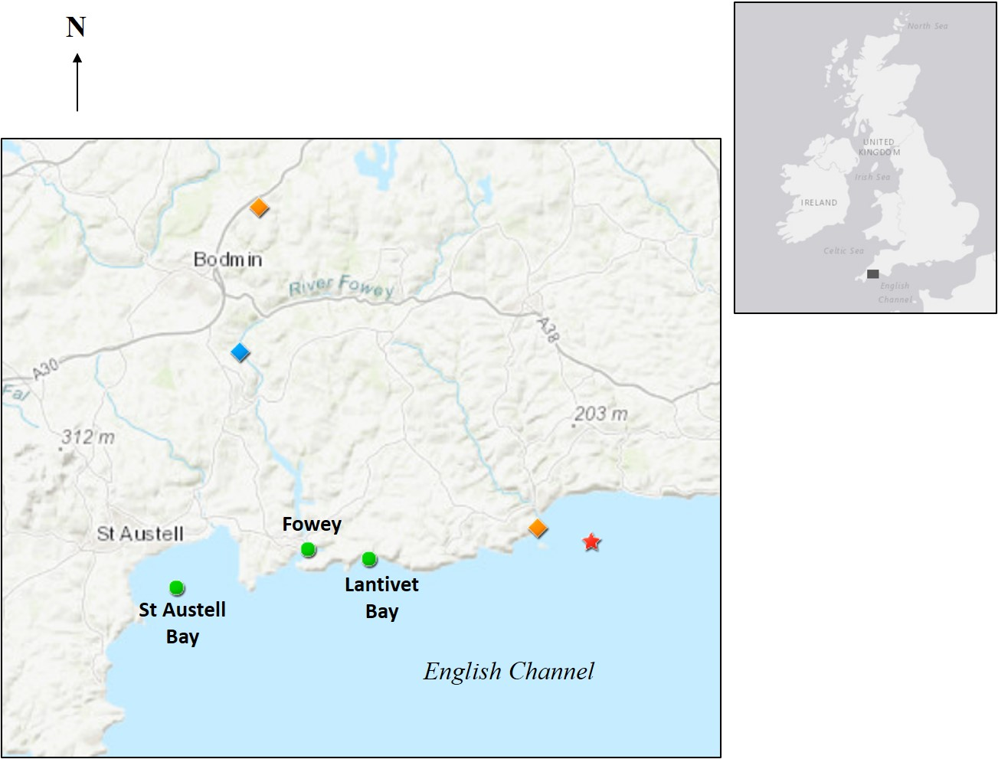
Fig. 1.

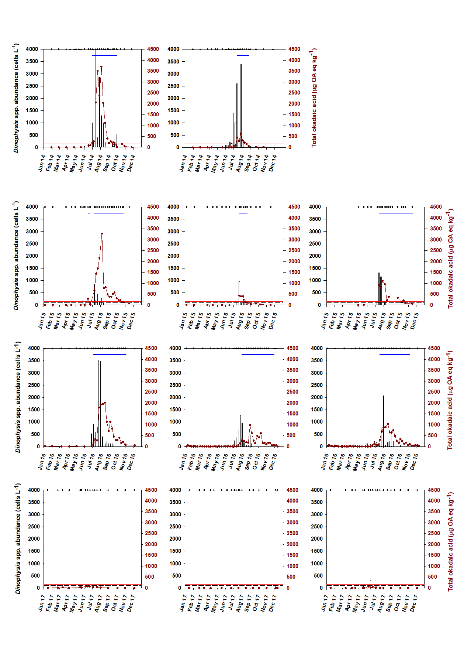
Fig. 2

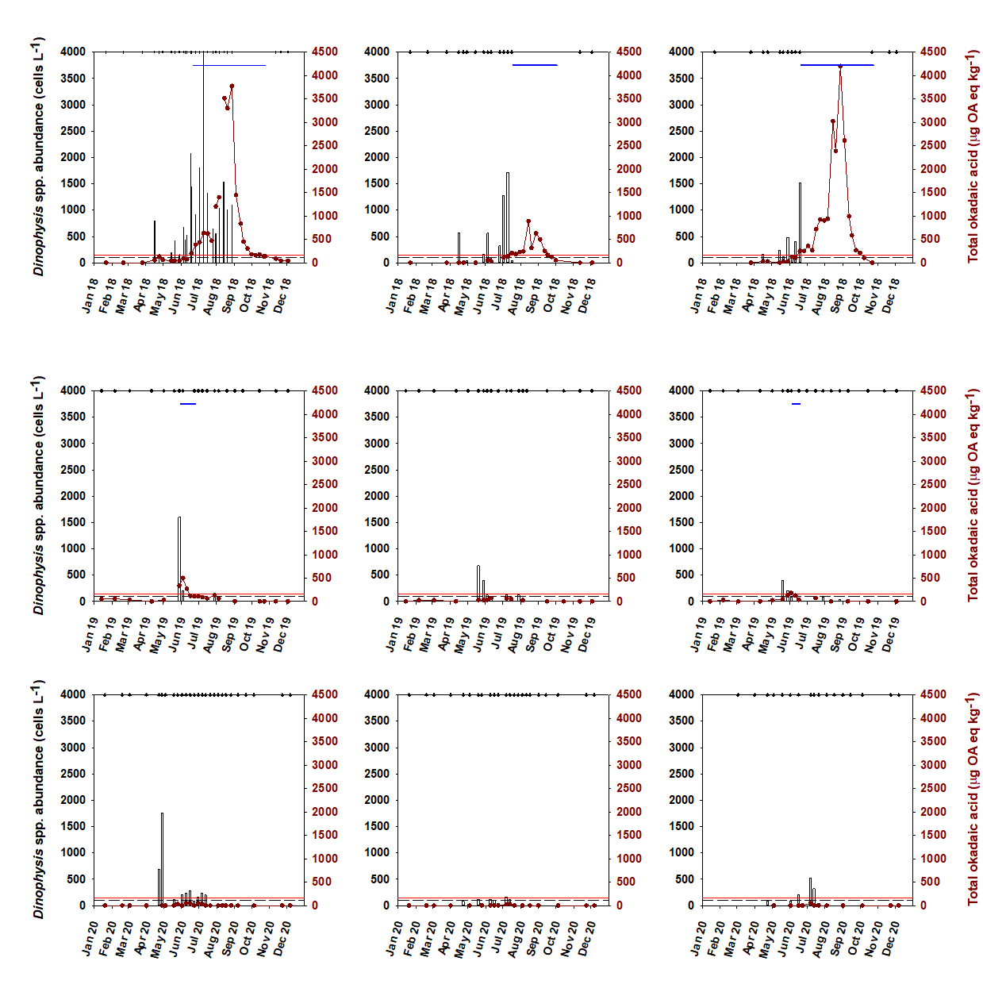
Fig. 2 (cont.)

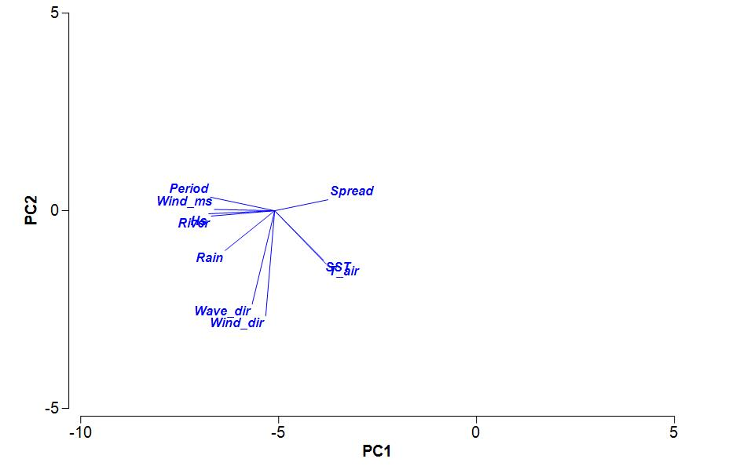

Fig. 3.

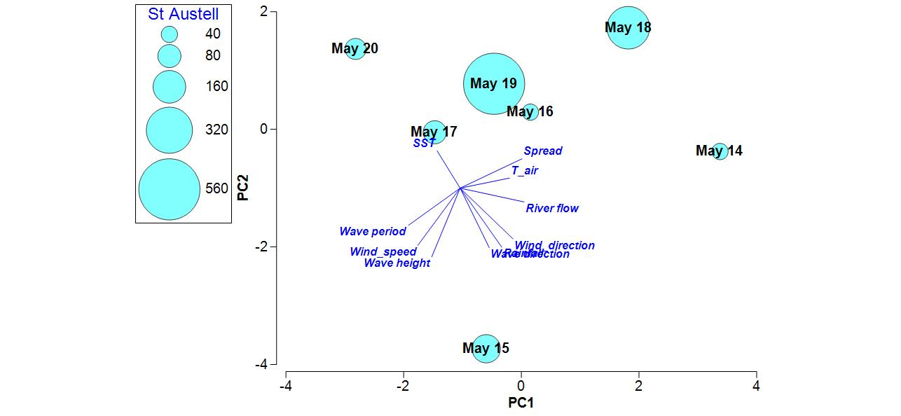
b
a
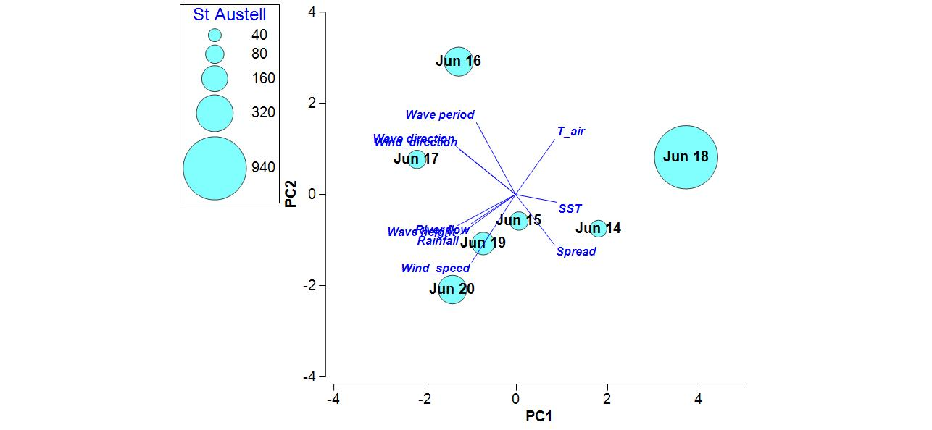
c
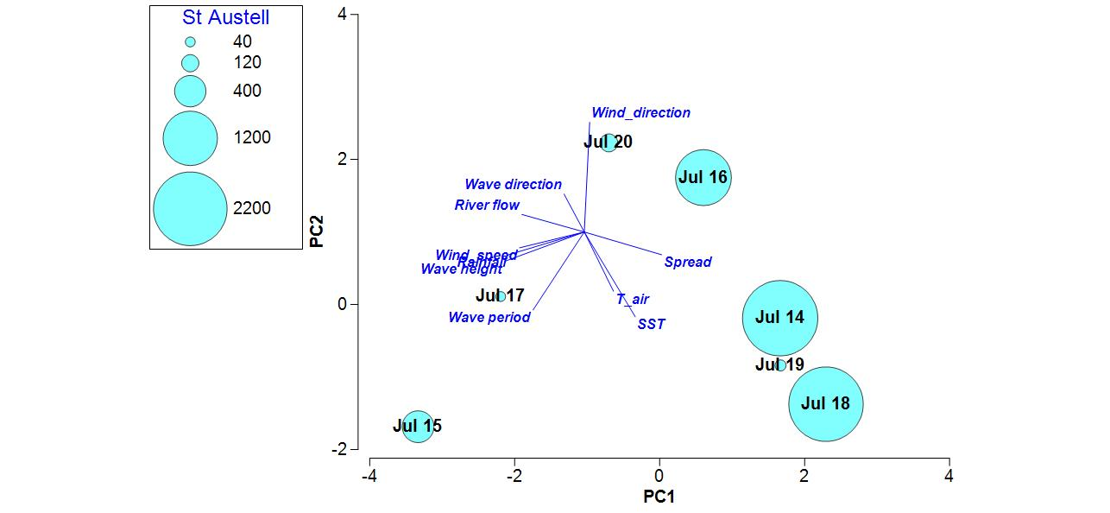
Fig. 4.

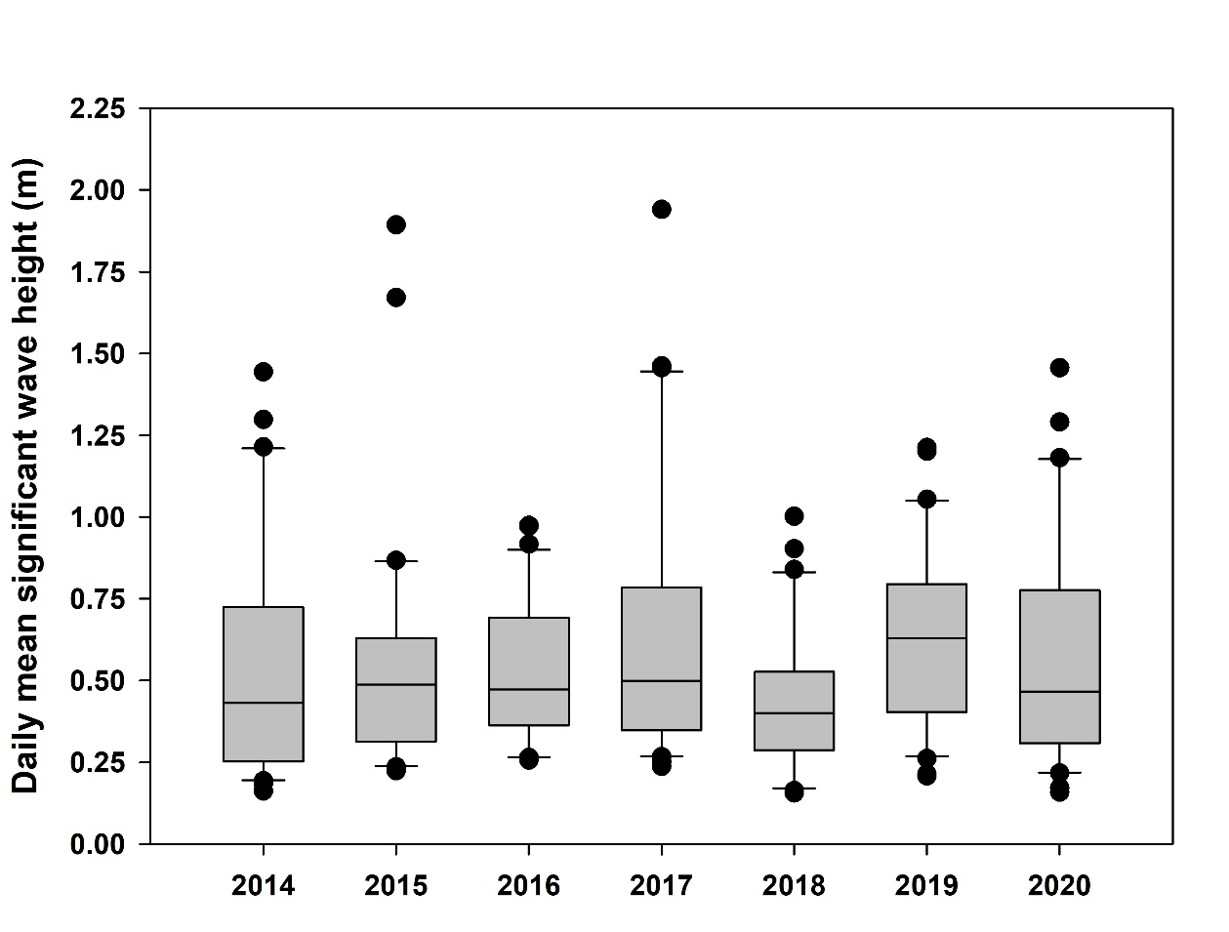

Fig. 5.

Fig. 6.
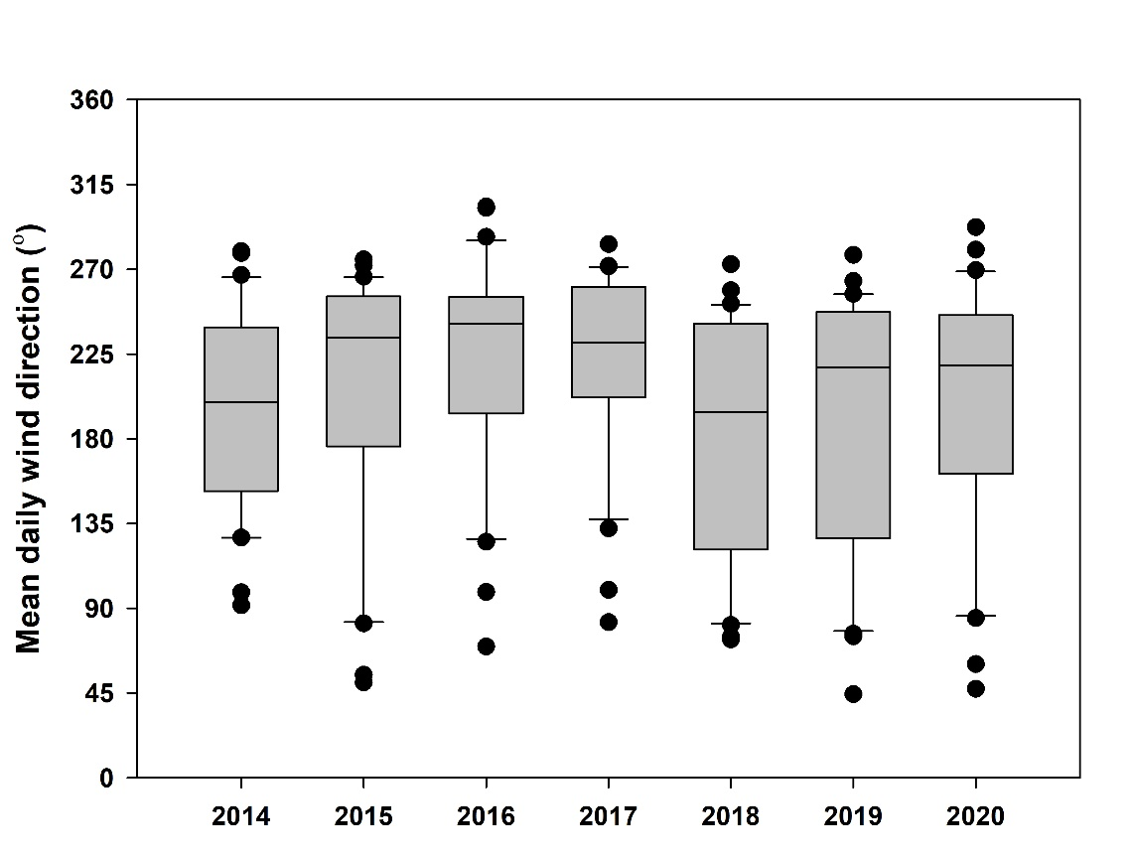

Fig. 7.

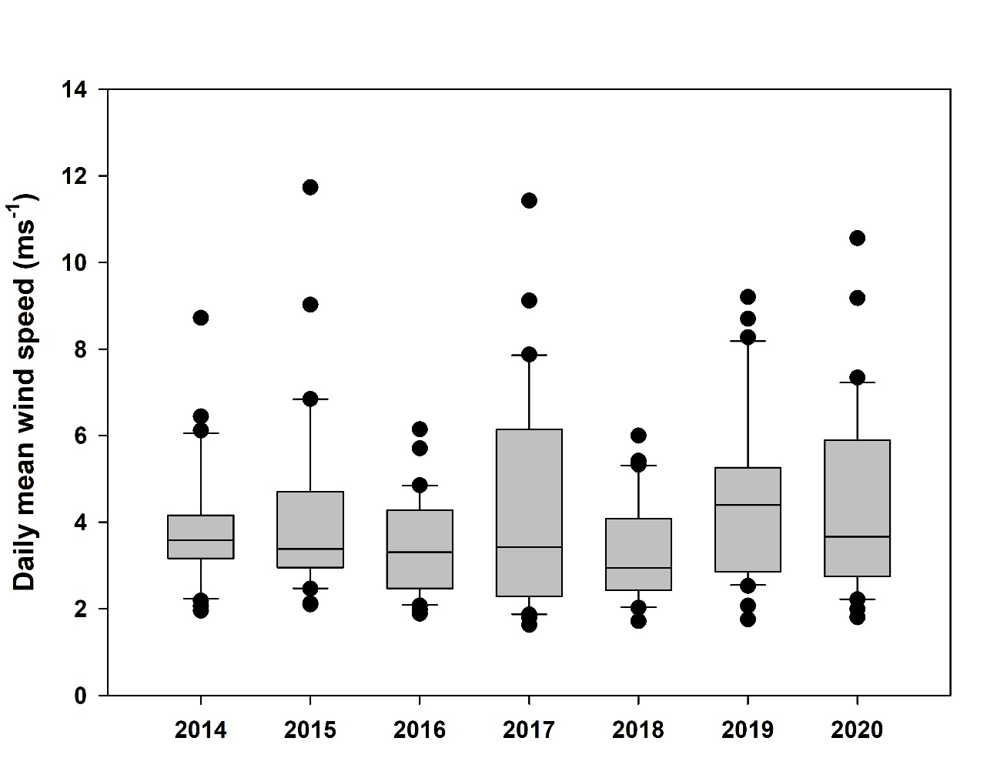

Fig. 8.

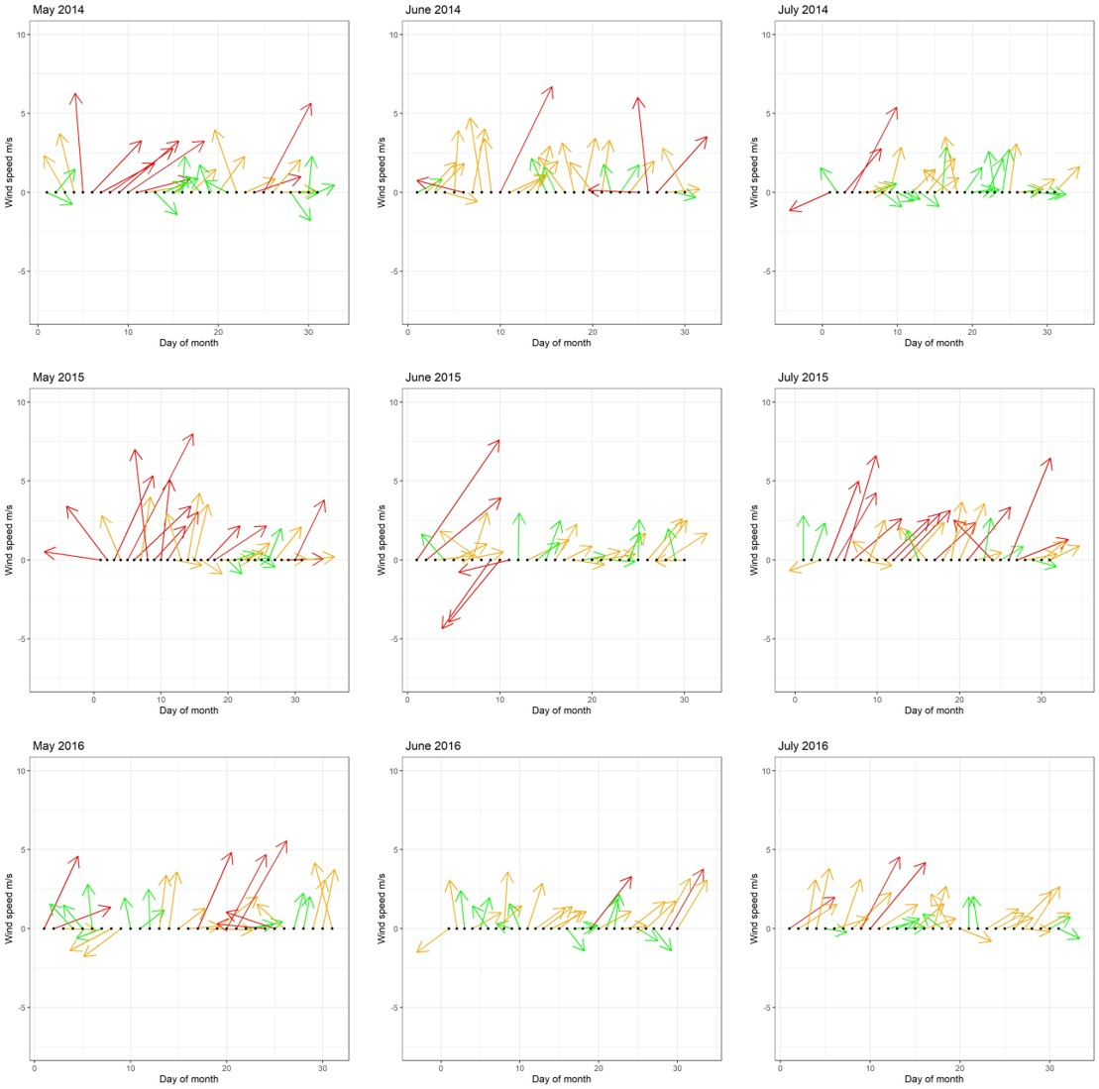
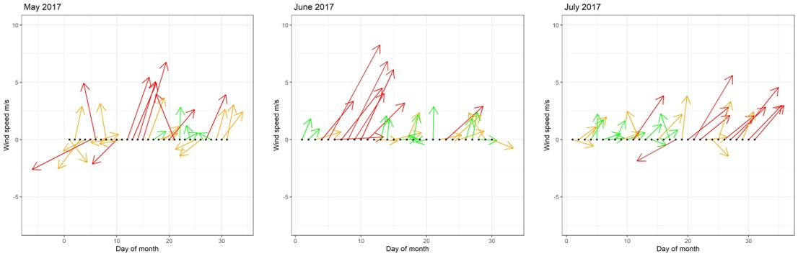
Fig. 9.
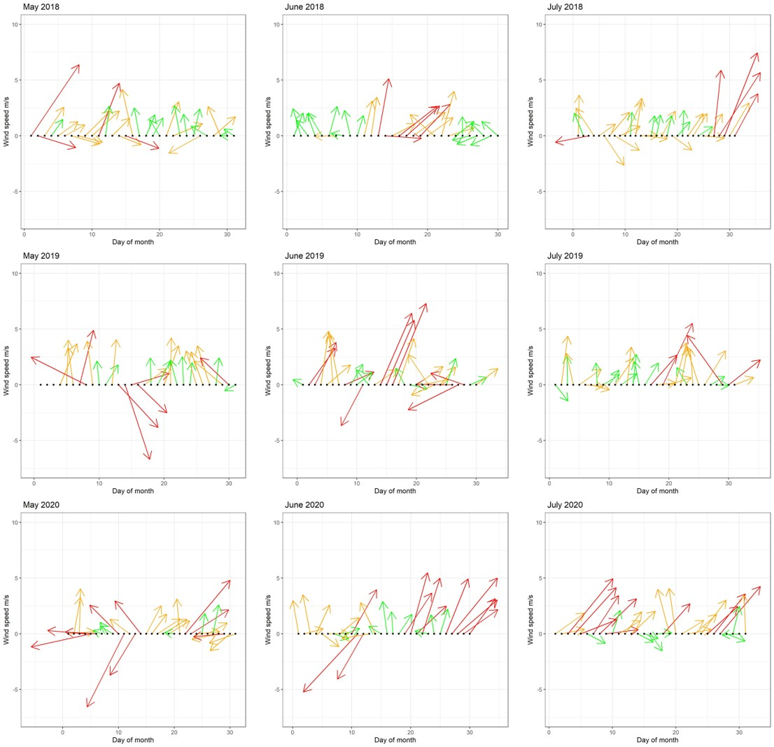

Fig. 9 (cont.)

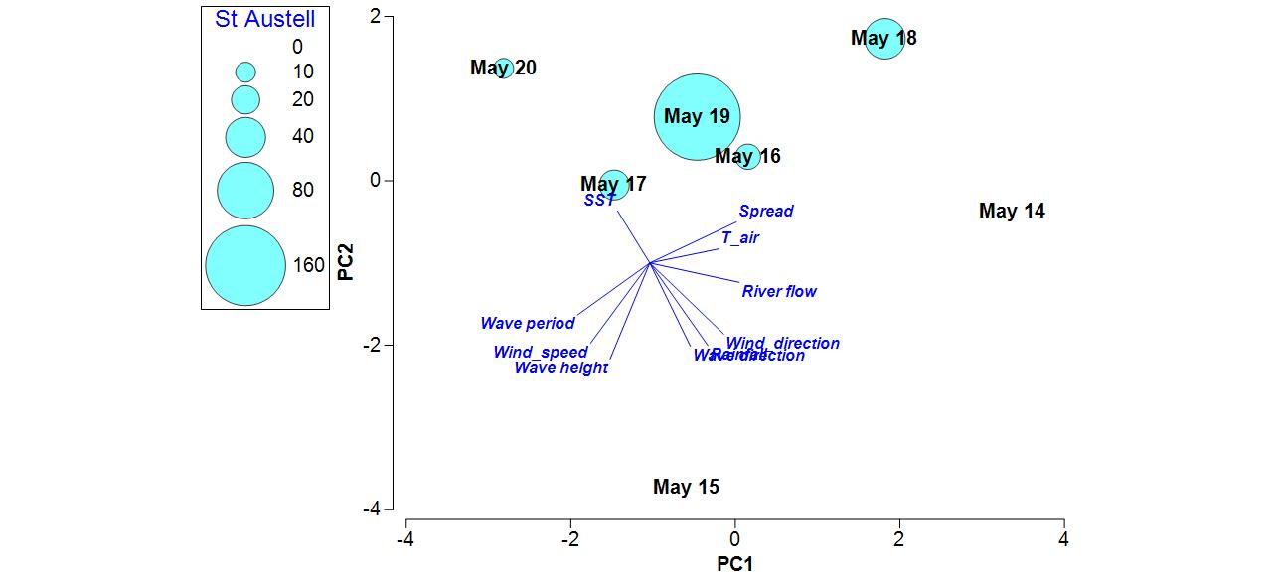
b
a
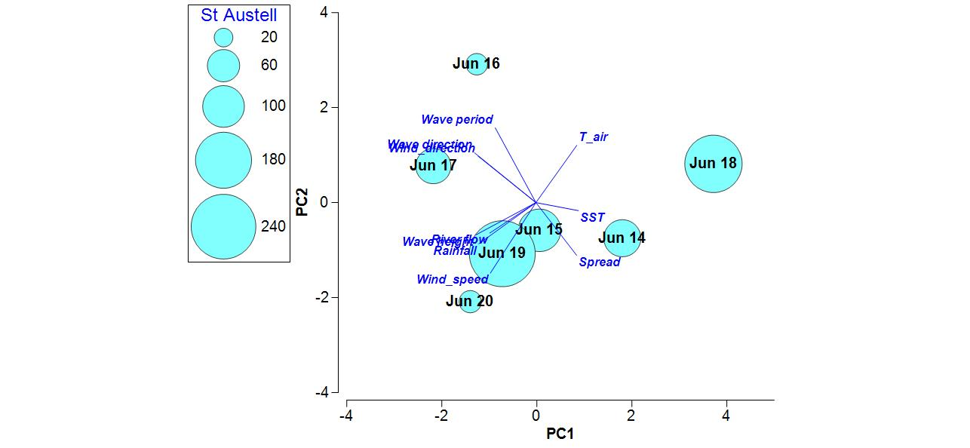
c
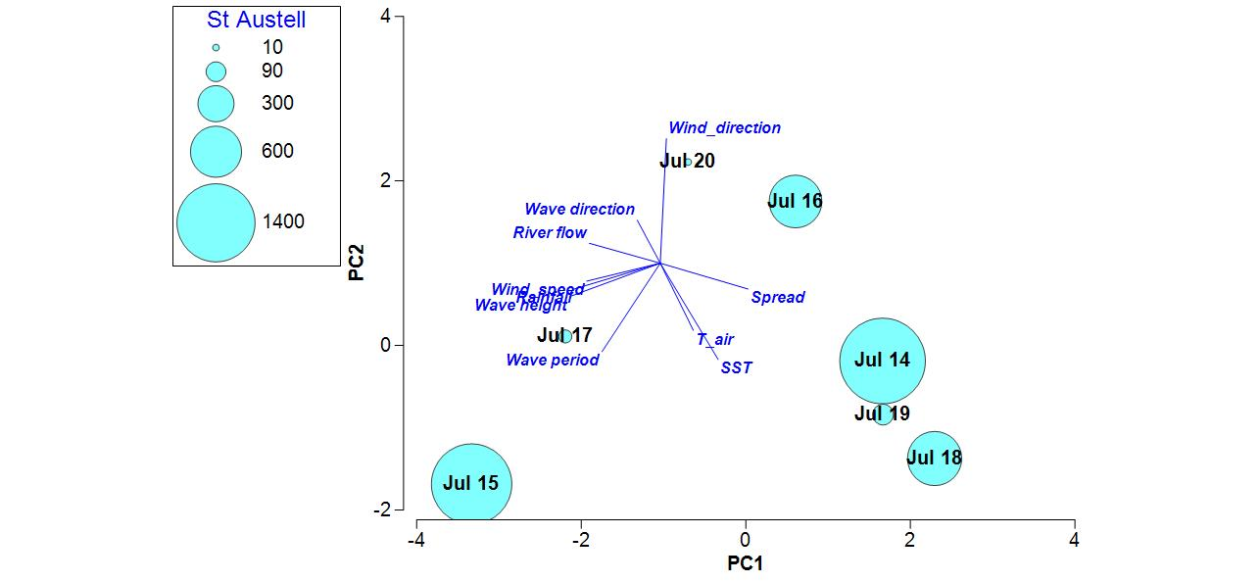
Supplementary figure 1. Principal Components Analysis (PCA) of monthly mean environmental data in (a) May, (b) June, and (c) July of each year. Bubbles depict mean concentration of total okadaic acid (µg OA eq kg⁻¹) in mussel flesh at St Austell in that month. Please note scales in bubble plot differ.

