Social Media Survey-

Please don’t open the booklet until your teacher tells you to

This page is blank

Social Media Survey-

Thank you for helping with this survey. Read the instructions carefully. You may not need to answer every answer so watch the arrows to see which ones you can miss out.

The survey is going to ask you about social media. There are no trick questions.

If you hand in this sheet, it will be used in the research.

Question 1: What is your school year? Tick one box only.
Year 7
Year 8
Year 9
Other Please state Year:
Question 2-
This next question wants to find which computer programs you know and whether you think they are social media.
Each program is show by an icon and its name. Next to the icon there are two columns.
- If you have heard of the program – put a tick in the first column

- And, if you think it is a social media program – put a tick in the second column too
- If you have not heard of the program – do nothing, leave both boxes empty

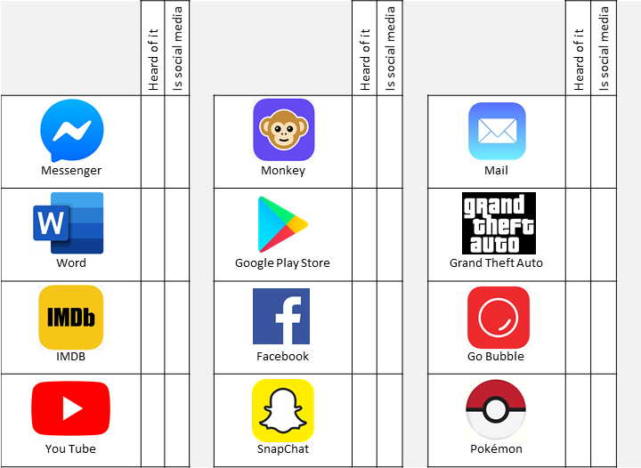

Question 2: Second Part:
Which of the following programs have you heard of and think are social media sites? Put a tick if you know the name and a second tick if it is social media.

Question 2: First part-
Which of the following programs have you heard of and think are social media sites?
Put a tick if you know the name and a second tick if it is social media.

Question 2: Second Part:
Which of the following programs have you heard of and think are social media sites? Put a tick if you know the name and a second tick if it is social media.

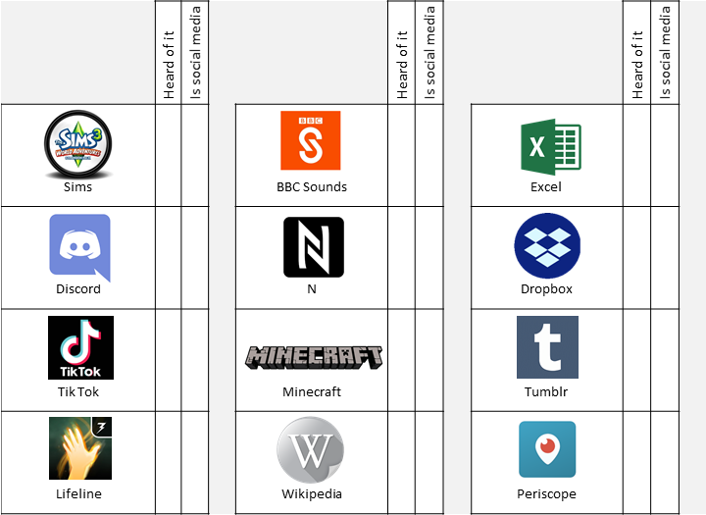

Question 2: Second part-
Which of the following programs have you heard of and think are social media sites? Put a tick if you recognise the name and a second tick if it is social media.
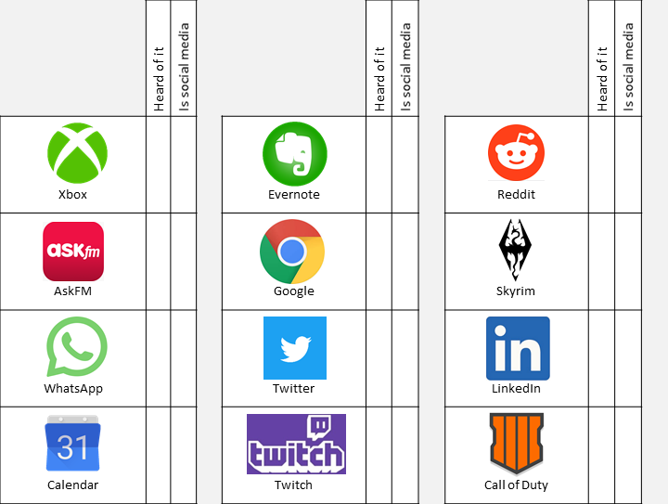

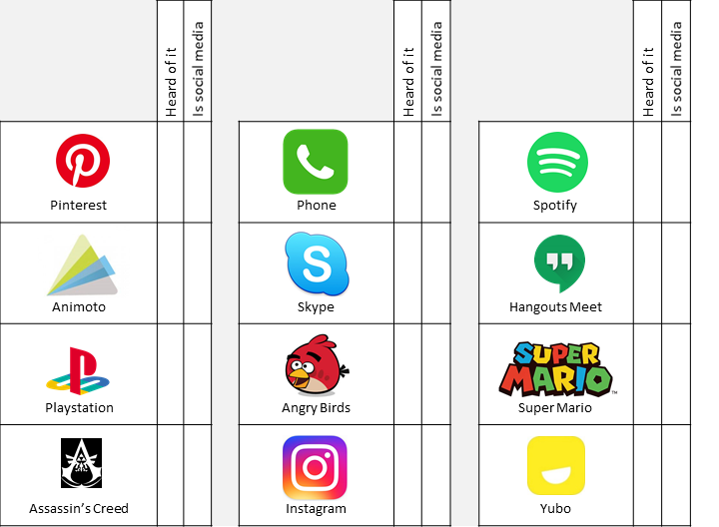
Question 3:- Think now about what you would like to be able to do on social media
How important is it that you can do  the following on social media?  Tick ONE box in each row | Not important | Quite important | Very  Important | Essential
Create a ‘Personal profile’ about yourself
Post your status updates
Post photos or pictures
Post videos

How important is it that you can do  the following on social media?  Tick ONE box in each row | Not important | Quite important | Very  Important | Essential
Send messages to other people
Make group for people to join
Show that you ‘Like’ other people’s posts
See the names of other people’s social media friends
How important is it that you can do  the following on social media?  Tick ONE box in each row | Not important | Quite important | Very  Important | Essential
Find out about the day's news on social media
Play computer games on social media
Share other people's posts with your friends
Write posts collaboratively with friends

How important is it that you can do  the following on social media?  Tick ONE box in each row | Not important | Quite important | Very  Important | Essential
Contact your friends
Keep in touch with members of your family
Make contact or follow celebrities (from sport, music, film, etc.)
Make contact with new people
Social media good or bad?
Question 4: The next questions wants to find out what you think is good and bad about social media.
What do you think is the best thing about social media?

What do you think is the worst thing about social media?

The next question asks if you have your own social media account
You have a social media account if:
- You have your own username and password to get onto social media, or
- You share a social media account with someone else, E.g. an adult or brother/sister

Question 5:- Do you have any social media accounts? (Tick one box)
NO STOP, you have finished the survey. Thank you for your time and effort.
YES

Just three more questions
Question 6: What social media programs do you regularly use? If you use more than three, name the ones that you use most often.
Don't worry about spelling the names correctly.
1.
2.

3.
Question 7: How do you get onto social media? Tick ONE box in each row.

 | Never | Sometimes | Often
- A mobile phone
- A desktop or laptop computer
- A touch-screen tablet (Such as an iPad)
- A games console (Such as Xbox or Nintendo)

Question 8:- Where do you go onto social media? Tick ONE box in each row.
 | Never | Sometimes | Often
- In your bedroom
- In a living room
- At school
- Travelling to or from school
- At a friend’s home
- When shopping
- On transport (bus, car, coach, taxi or train)
- Outdoors (in the street, park, woods, at the beach, etc.)

STOP: You have reached the end of the survey. Thank you for your time and effort.
REMEMBER:
- If you want your answers to be included in the research, you MUST hand this sheet into your teacher.
- If you don’t want the answers included, then DO NOT hand the sheet into your teacher.

