3D printed hollow microneedles for transdermal insulin delivery
Iakovos Xenikakis¹; Konstantinos Tsongas²; Orestis L. Katsamenis³; Dimitrios Tzetzis²; Dimitrios G. Fatouros ¹
¹School of Health, Faculty of Pharmacy, Division of Pharmaceutical Technology, Aristotle University of Thessaloniki, Thessaloniki 54124, Greece, iakpolxen@pharm.auth.gr (I.X), dfatouro@pharm.auth.gr (D.G.F)
² Digital Manufacturing and Materials Characterization Laboratory, School of Science and Technology, International Hellenic University, School of Science and Technology, 14km Thessaloniki - N. Moudania, Thermi GR57001, Greece, k.tsongas@ihu.edu.gr (K.T.), d.tzetzis@ihu.edu.gr (D.T.)
³μ-VIS X-ray Imaging Centre, Faculty of Engineering and Physical Sciences, University of Southampton, Southampton, United Kingdom, ok1r12@soton.ac.uk (O.L.K.)

INTRODUCTION
Microneedles (MN) are miniature devices of a maximum length of 1000 μm, capable of perforating painlessly stratum corneum and releasing their active content in the skin layers beneath. The significance of MNs lies on the fact that they have the potential to substitute the fear inducing injections, while avoiding first pass effect or other possibly unwished metabolic changes of the oral administration¹. In the current study 3D printed microneedles were fabricated by means of liquid crystal display (LCD) vat polymerization 3D printing technology for the transdermal delivery of human insulin in vitro.

MATERIALS AND METHODS

Fabrication of 3D printed hollow microneedles
HMN arrays (6 × 6) were designed with two different geometries namely curved pyramid and syringe-like, using a SolidWorks CAD software (Dassault Systèmes, SolidWorks Corporation, Waltham, MA, USA). Height was set around 1000 μm, while interspacing was 2000 μm (center to center distance). The whole patch was a 15 × 15 mm square surface. 3D-printing was conducted with Phrozen Shuffle 2018 3Dprinter, which polymerizes utilizing a LED light source. Resin NextDent Ortho Rigid, a biocompatible resin (Class IIa) was used as printing material. Final printing parameters were adjusted with ChiTuBox 64 slicing software.
Permeation studies
Permeation studies were conducted using vertical Franz diffusion cells and human insulin. HMN devices (HMNs of different geometries assembled with reservoirs) were manually pressed against skin samples for at least 30s exerting periodically soothe vibrating moves. Subsequently, skin tissues along with HMN devices were transferred on Franz receptors and donors were fastened. Franz receptors contained Phosphate Buffer Saline (PBS), pH 7.4.
Next, using a Watson-Marlow 205CA pump, insulin solution (1 mL, 20 IU/mL in citrate-phosphate buffer) was pumped at a flow rate of 0.5 mL/min through HMN devices. At 60 min, sample aliquots of 1mL were collected from the receptors and then analyzed by liquid chromatography-mass spectrometry (LC-MS).

Microneedles characterization
The structural features and the dimensions of HMN arrays were determined by of SEM studies. HMNs were inserted in a charge reduction sample holder and visualized with a Desktop Phenom ProX scanning electron microscope (ThermoFischer, USA)

Skin visualization studies
Skin samples were heated for 2 min at 60 °C and epidermis layers were removed using blunt forceps. Epidermis was fixed with 10% formaldehyde solution for 10 min. Subsequently, epidermis samples were placed in alcoholic solutions of increasing concentrations namely 50, 70, 96 and 100%, for 30 min in each case. Upon their dehydration skin samples attached on metal stubs using carbon tape and further visualized by means of SEM.

RESULTS

Fabrication and characterization of hollow microneedles
Representative 3D printed hollow microneedles are illustrated at Figure 1.
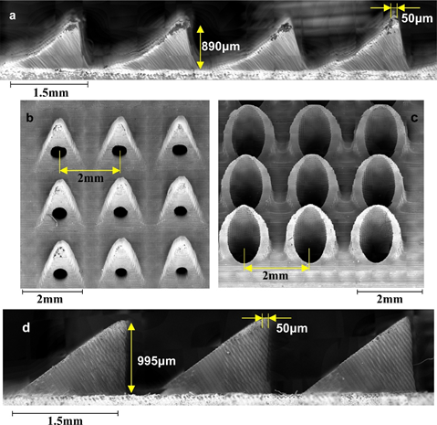
Figure 1: SEM micrographs: (a), (b) 3D printed curved pyramid and (c), (d) 3D printed syringe -like HMN arrays
Volumetric characterization (Figure 2) of the printed product was conducted by means of μCT. The results of the analysis demonstrated that the 3D printing method allows for high consistency and reproducibility with respect to needles’ length.
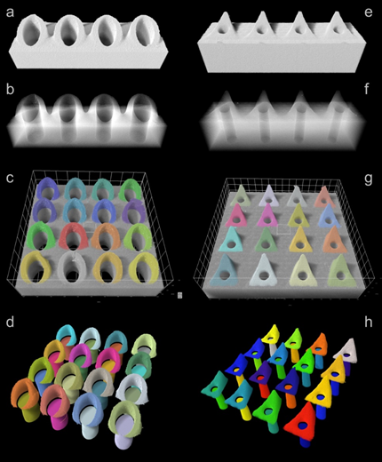
Figure 2. X-ray μCT of curved pyramid, syringe-like HMNs and their microchannels. Volumetric (a), (e) and semitransparent (b), (f) virtual section of a single needle row showing the needle structure and the lumen with respect to the needle. Sub-panels (c), (d) and (g), (h) show the segmented individual needles (c), (g) and the needle / lumen models (d), (h).

Skin visualization studies
SEM imaging of epidermis revealed the perforation sites caused by the HMNs. The pores created on skin surface after microneedle application is illustrated at Figure 3 alongside with the 3D roughness reconstruction of perforation site for curved pyramid HMNs and syringe-like HMNs.
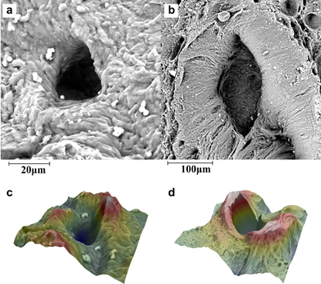
Figure 3. SEM imaging of microneedle created perforation sites for (a) curved pyramid HMNs (b) syringe-like HMNs and 3D roughness reconstruction of perforation sites for (c) curved pyramid HMNs (d) syringe-like HMNs.
Permeation studies
The cumulative amount of insulin permeated across human skin in vitro after 60 min is shown in Figure 4C. The cumulative amount of insulin permeated upon application of curved pyramide microneedles and syringe-like microneedles was 4.3 ± 1.1 % and 6.0 ± 2.3 %, respectively. The interactions between the coated surface of the microneedles and insulin at the timescale of 2 min (application time) are shown in Figure 4A. The initial insulin concentration decreased ca. 2% which can be considered negligible. The effect of the temperature had no effect to the stability of insulin as shown in Figure 4B.
Figure 4. A. Binding studies of insulin to surfactant coated microneedles, B. stability studies of insulin at 37ºC and C. cumulative amount of insulin permeating human skin after HMN treatment.

Conclusion
In the current study the structural features of two different 3D printed 6x6 HMN geometries were assessed. Non-destructive 3D (volumetric) imaging by means of μCT demonstrated that the 3D printing method used in this study allows for high consistency and reproducibility with respect to needles’ geometric characteristics. Diffusion studies demonstrated that syringe-like HMNs were more effective upon insulin administration compared with curved pyramid ones. Although syringe-like geometry penetrates skin at higher insertion force, it is probably more suitable for macromolecular drug delivery which might be attributed to the geometrical characteristics of the microneedles.

REFERENCES
- Prausnitz, M.R. Microneedles for transdermal drug delivery. Adv. Drug Deliv. Rev. 56, 581–587 (2004)
- Xenikakis, I, Tsongas K, Emmanouil K. Tzimtzimis, E.K., Katsamenis O.L., Demiri E, Constantinos K. Zacharis, C.K., Georgiou, D., Kalogianni, E.P., Tzetzis, D., Fatouros, D.G. Transdermal delivery of insulin across human skin in vitro with 3D printed hollow microneedles. J Drug Deliv. Sci.Techn. (2021)

