A review of energy storage mechanisms in aqueous aluminium technology
N Melzack, R G A Wills
¹Energy Technology Research Group, Mechanical Engineering, University of Southampton, Southampton, United Kingdom
* Correspondence:
N Melzack
n.melzack@soton.ac.uk
Keywords: aluminium-ion, energy storage, aluminium-ion batteries, Aluminium-air, aqueous aluminium
Abstract
This systematic review covers the developments in aqueous aluminium energy storage technology from 2012, including primary and secondary battery applications as well as supercapacitors. Aluminium is an abundant material, with a high theoretical volumetric energy density - 8.04 Ah cm⁻³. Combined with aqueous electrolytes, which have twice the ionic storage potential than non-aqueous versions – this technology has potential to serve many energy storage needs. The charge transfer mechanisms are discussed in detail with respect to aqueous aluminium-ion secondary batteries – where most research has focused in recent years. TiO₂ nanopowders have shown to be promising negative electrodes, with the potential for pseudocapacitive energy storage in aluminuim-ion cells. This review summarises the advances in Al-ion systems using aqueous electrolytes, focusing on electrochemical performance.
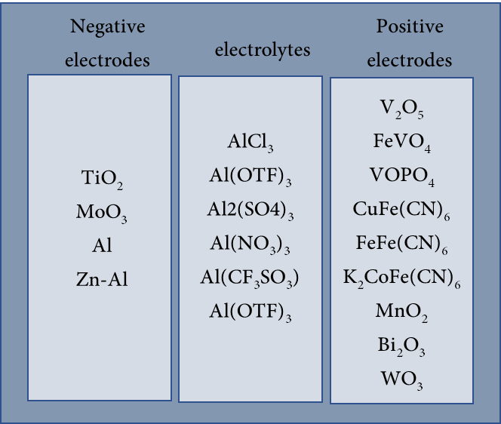

Introduction
Sustainable economies depend on the increasing reliability and use of energy storage (Tang, et al., 2013, IPCC, 2014, UK Energy Statistics, Q1 2019, 2019, Climate Change Act 2008, 2008, Larcher and Tarascon, 2015). Many energy storage devices are available, however Li-ion battery technology has accelerated the development of portable devices, electronic vehicles, and grid storage in the last two decades (Narins, 2017). Currently, this technology is hard to recycle, and relies on sparse and often politicised resources (Prior, et al., 2013, Maxwell, 2015, Huang, et al., 2018, Ciez and Whitacre, 2019). To further our sustainabledevelopment, it is important to co-develop our batteries to be easier to recycle, and have a lower environmental footprint. In this review, aluminium-based batteries operating with an aqueous electrolyte are evaluated as one such battery technology.
Secondary Aluminium-ion (Al-ion) batteries have not reached wide-scale commercial viability yet and are often grouped together with other multivalent metal ion systems in the literature (such as Mg and Ca) (Larcher and Tarascon, 2015, Chao, et al., 2020). However, aluminium is the most abundant metal in the earth’s crust (8.1 % wt), and third most abundant element (Abundance of Elements in The Earth’s Crust and in The Sea, 2016-2017). There are already established mining, production, and recycling industries for aluminium (Butterwick and Smith, 1986, U.S. Geological Survey, 2020), hinting at an easy and sustainable development roadmap ahead for utilising Al-ion technology within a circular economy.
The electronic configuration of aluminium is 1s² 2s² 2p⁶ 3s² 3p¹. The first three ionisation energies for aluminium are 578, 1817 and 2745 kJ mol⁻¹, while subsequent ionisation energies are an order of magnitude greater. The Al³⁺ ion has the same stable electronic configuration as atomic Neon and is the most common valence state for aluminium. This trivalent Al³⁺ ion is therefore capable of three electron transfers per ion, unlike Lithium’s monovalent Li⁺ - i.e. one Al-ion is equivalent to three Li-ions in terms of charge transfer. While this review is not a direct comparison with Li-ion technology, is useful to understand where Al-ion sits with regards to the present industry leader.
The ionic radius of Al is slightly smaller than Li, leading to a high charge density, meaning more charge transfer can occur with no increase in physical restriction to electrodes. Additionally, Al has a high density (2.7 g cm³ @25°C) which leads to a volumetric energy density of almost four times Lithium, 8.04 Ah cm⁻³ and 2.06 Ah cm⁻³ respectively (Das, et al., 2017, Elia, et al., 2021, Faegh, et al., 2021). Metallic Al also has high theoretical capacity and density (2981 mAh g⁻¹ and 4140 Wh kg⁻¹ respectively) This combined with the high abundance, safety, and well-established recyclability makes the Al-ion a great all-rounder as a charge carrier.
Two challenges arise with the higher charge densityfor intercalation-type processes; (1) the high charge density means it is difficult for Al³⁺ to lose its coordinating ligands in the solvated state and (2) while intercalating, the Al³⁺ ions can distort the lattice structure of electrodes. The former negates the advantage of the small ionic radius of Al³⁺, while the latter can reduce the lifetime significantly as the lattice distortions accumulate with each cycle.
This review will cover three the types of electrochemical energy storage devices which utilise aluminium ions in aqueous electrolytes: Rechargeable batteries, non-rechargeable batteries, and capacitors. The capacitor section will include devices named supercapacitors, ultracapacitors, capatteries and cabatteries. The key component in defining in a capacitor, for the purpose of this review, is that the primary form of energy storage is through charge separation.Capatteries are defined as a capacitor which shows faradaic redox reactions in addition to the charge separation; cabatteries primarily are batteries in which the double layer capacitance has a significant role in the charge storage. In recent years, the number of original research being published on aqueous aluminium energy storage has increased significantly. Figure 1 shows that from the single paper published in 2012 (Liu, et al., 2012), there were 77 total publications by the end of 2020.
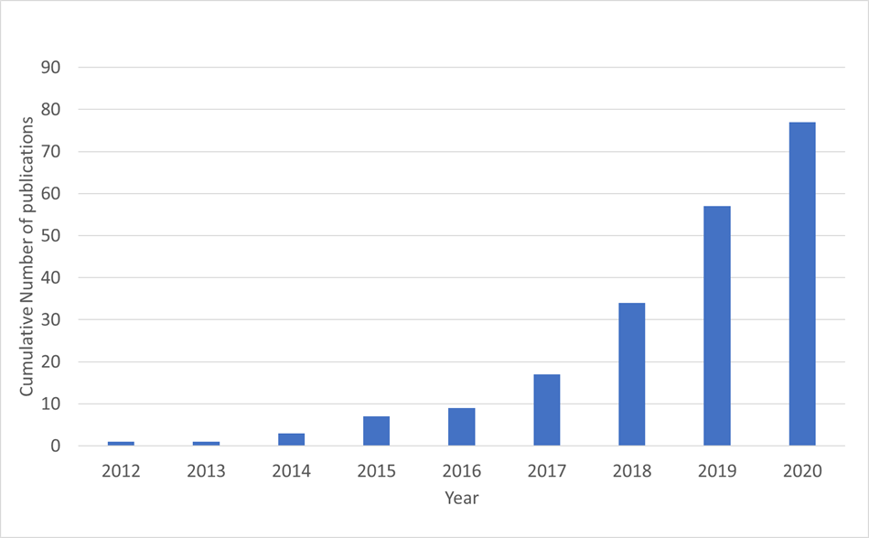
Figure 1 Cumulative number of original research papers published in English from 2012 to 2020 (assessed through google scholar search)
Batteries are electrochemical storage devices which rely primarily on the faradaic redox reaction as a means of charge storage and transfer. Secondary batteries, which facilitate reversible redox reactions, can be charged/discharged multiple times throughout their lifetime – these are rechargeable batteries. Primary batteries are non-reversable and thus can only be discharged a single time in their lifetime – i.e. non-rechargeable.

Aqueous electrolytes
An aqueous electrolyte uses water as the solvent for a variety of ionic salts. These electrolytes are often safer than ionic liquids, or non-aqueous electrolytes, due to their low flammability and ease of handling(Chao, et al., 2020). Ionic electrolytes such as those in Lithium-ion batteries, can emit volatile, flammable, toxic solvents when punctured, as well as be hazardous to work with for second-life or recycling applications (Christensen, et al., 2021, Larsson, et al., 2018). The solvent in aqueous electrolytes, water, is low-cost, widely available and does not require complex manufacturing or storage (compared to other electrolytes) (Gür, 2018). This already shows advantages in the economic and social (safety) aspects of battery development. However, while cheaper in absolute terms, when thinking in terms of cost per kW or kWh, it is not yet comparable to non-aqueous commercial batteries. Commercial non-aqueous Li-ion batteries production are expected to cost $362/kWh, $1446/kW in 2025 (Mongrid, et al., 2019), compared to an aqueous commercial Pb-acid battery, which is expected to cost $464/kWh, $1845/kW(Mongrid, et al., 2019).
There areperformance reasons for not using aqueous electrolytes. The main reason being the narrow electrochemical stability window (ESW) of water – about 1.23 V. Beyond this point, electrolysis of water takes place and the H₂O decomposes into its constituent parts (Zhang, et al., 2020). This would limit the energy density of cells constructed in this manner. However, there has already been research establishing that a diluted aqueous electrolyte can have an ESW of up to 2 V, and even higher with different salt concentrations, which shows promise for further developments (Suo, et al., 2015). A comparison of ESWs for other electrolytes is shown in Table 1. Lithium-salts in an ionic liquid are used in Li-ion commercial batteries today, they have a high ESW and can therefore deliver higher voltages with fewer cells in series. Polymer and gel-type electrolytes are still in their development stage and offer the advantage of a high ESW, with lower flammability, but are currently not used commercially. From this table, the aqueous WISE (water in salt electrolyte) in which the salt is saturated, have the potential for higher ESWs, but are still in the development phase.
Regardless of this low ESW, there is still high demand for aqueous electrolyte development. The potential ionic storage of such electrolytes is two orders of magnitude higher than that of organic non-aqueous electrolytes – this could enable far higher power capability (Zhang, et al., 2020). There has been an increase in aqueous electrolytes studied for Zn-ion (Wu, et al., 2021, Javed, et al., 2020), Na-ion (Jin, et al., 2021, Tapia-Ruiz, et al., 2021), and Li-ion batteries (von Wald Cresce and Xu, 2021).
Other limiting factors, not bespoke to aqueous electrolytes, also apply. Corrosion of electrodes is likely in protic electrolytes, while dendrite formation on electrodes are more likely in alkaline electrolytes(Zhang, et al., 2020, Chao, et al., 2020). These both limit lifetime and discharge voltage obtained over time.
Furthermore, in terms of sustainability, the energy density obtained is not the most key factor. Long lasting, reliable, safe, cost-effective, and scalable designs are far more critical. Therefore, the narrow ESW, while being widened as new research is published, is by no means a reason to disregard aqueous electrolytes(Posada, et al., 2017).
It is near impossible to fully evaluate the aqueous electrolyte in isolation. It forms part of a complex system. With regards to aluminium, few materials have been identified as suitable electrodes – that can both operate within the ESW and accommodate the large charge density. Having said that, the number of suitable electrodes is being added to currently, and this review will discuss some key developments in electrode material as well as the charge and degradation mechanisms found.

Table 1 Typical ESW for certain electrolytes
Electrolyte | type | ESW | reference
Lithium salts | Ionic liquid | 4-6 V | (Gores, et al., 2011)
PAN-gels | Polymer/aqueous | >4.5 V | (Gray and Armand, 2011, Wang, et al., 2019)
Crosslinked | Polymer | 3.9 V | (Gray and Armand, 2011)
Ionic Salt | aqueous | 1.23 V | (Dell, 1996)
WISE | aqueous | 3-4 V | (Suo, et al., 2017, Yang, et al., 2017)

Mechanism identification in secondary batteries
The following section discusses aqueous Al-ion secondary batteries, specifically the negative and positive electrode materials that have been studied, their reported performance, and the charge storage mechanisms involved. The most common electrode materials and electrolytes studied are presented in Figure 2, with detailed tables summarising key findings in Table 2 for negative electrode materials, and Table 3 for the positive electrode materials.
Figure 2 Key materials being studied in aqueous Al-ion batteries

Negative electrode
The negative electrode always has a more negative potential than the positive electrode when in a full cell. Sometimes this is referred to as the anode, but for secondary cells, since both reduction and oxidation takes place at the electrode depending on whether the cell is discharging or charging, it can be confusing to refer to it as the anode. Hence, negative electrode will be used throughout this section. Table 2 summarises the materials that have, to date, been studied as a negative electrode for an aqueous aluminium-ion cell. It is important to understand the difference between electrodes tested as ‘half cells’ and full cells in terms of the capacities and fade values ascertained. For a half cell, only the electrode testing will have an influence on the capacity and fade characteristics reported. However, with a full cell, both the positive and negative electrodes will have an influence and the reported capacities are for the whole cell, not just the electrode highlighted in the table. For example, Holland et al studied TiO₂ in a full cell with a Copper Hexacyanoferrate (CuHCF) positive electrode and found cycle life of 1750 cycles and a Coulombic efficiency of ~90% (Holland, et al., 2018a), however in a half cell with the same conditions, 5000 cycles were possible with ~99% Coulombic efficiency (Holland, et al., 2018b). The majority of papers to date have focussed on TiO₂ as a negative active material with MoO3 the next most cited material. Metallic aluminium, aluminium-alloys and T-Al (aluminium which has been pre-treated with chloroaluminate melts) have also been proposed. The materials are discussed by type in the following subsections.

Titanium dioxide

Titanium dioxide (TiO₂) is the most researched and well established electrode within the aqueous aluminium space thus far. Given this, the elucidation of charge transfer mechanisms is expected to be well known, but it isn’t. Much research focuses on the development of an operational electrode or full battery, reporting performance with little speculation on the exact mechanisms. Therefore, although this is a well-researched area, there are still many unknowns with regards to the exact charge storage mechanisms. There have been suggestions of capacitive surface storage, of intercalation, and redox reactions using the redox couple Ti³⁺/Ti⁴⁺ (and nonreversible reactions to Ti²⁺).
TiO₂ has been explored as an electrode in other cell designs, however, it was not reported as an option for Al-ion aqueous cells until 2012 at the earliest by Liu et al(Liu, et al., 2012). Liu used TiO₂ nanotubes to construct the electrode, which the author had previously used for Li-ion aqueous cells (Liu, et al., 2011), and a 1 M AlCl₃ electrolyte. This half-cell was shown to have a specific capacity of 75 mA h g⁻¹@ 4 mA cm⁻², 90% Columbic efficiency and voltage range of 1.1–0.4 V with a discharge plateau between 1.1 and ~ 0.8 V(Elia, et al., 2021, Liu, et al., 2012, Holland, et al., 2018 c). The method of electrochemical exchange is concluded to be intercalation of Al³⁺ into the TiO₂, with the resulting reaction including Ti-ions (Ti³⁺/Ti⁴⁺), or a non-reversible reaction to Ti²⁺. The author discusses the need for further investigation into the specifics. This is an important aspect for further development, if a non-reversible reaction to Ti²⁺ is occurring, it will reduce active material available for reactions over time, and increase the capacity fade, if the reactions are reversible, then other capacity fade mechanisms may be taking place, such as lattice structure breakdown. Figure 3 illustrates these two mechanisms.

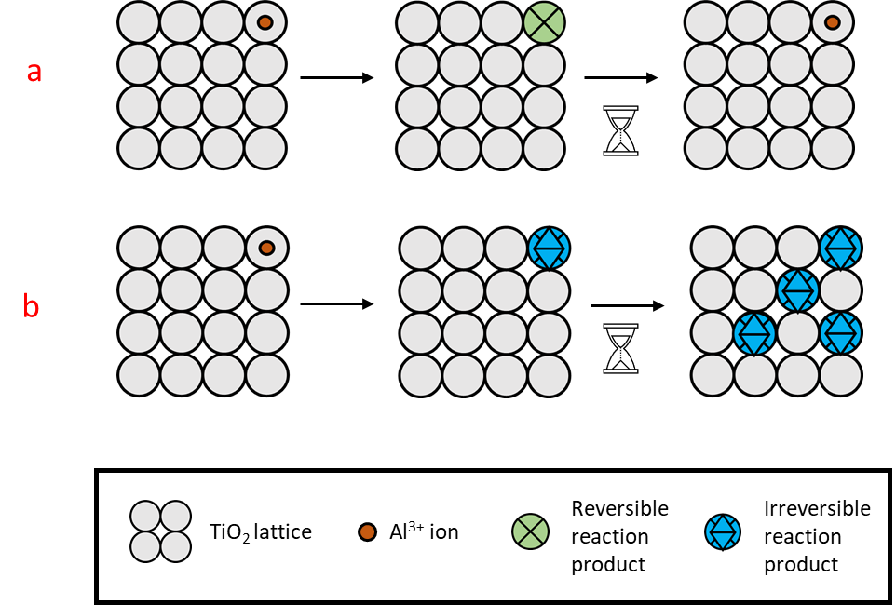
Figure 3 Illustration of reversible (a) and irreversible (b) reactions on the electrode material
Following this, in 2014, further development of the TiO₂ nanotube array was performed, looking at a variety of aqueous Al-ion electrolytes and concentrations(Liu, et al., 2014). This study further investigated the role of Ti-ions in the Al³⁺ insertion into the electrode, X-ray photoelectron spectroscopy (XPS) confirmed Al on the surface of the electrode after intercalation, but did not find evidence of Cl. More supporting evidence of the Ti³⁺/Ti⁴⁺ role was found, with the author concluding that Ti⁴⁺ must reduce to Ti³⁺ where the Al³⁺ is present on the surface, to maintain charge balance. There was also speculation of the additional role of Cl⁻ on the process – this was confirmed by using NaCl as an electrolyte for cyclic voltammetry alongside Al₂(SO₄)₃, which confirmed an assistive role of Cl in the electrochemical reaction (Liu, et al., 2014). Again, more research into the exact reaction mechanisms were clearly needed.
Work on Mg-ion aqueous cells, which produce a divalent ion – Mg²⁺ has also concluded that the redox couple Ti³⁺/Ti⁴⁺ is involved in the charge storage mechanism (Koketsu, et al., 2017). The role of oxygen vacancies within the TiO₂ electrode increase the insertion of the ions, which in turn increase the overall charge storage and capacity.
Holland et al (Holland, et al., 2018 b, Holland, et al., 2019) further investigated the role of Ti in the charge storage - using anatase TiO₂ nano-powder for the basis of the electrode, in a 1M AlCl₃ electrolyte. Increasing the pH of the electrolyte with HCl increased the redox peaks seen on a CV (Holland, et al., 2018 c, Holland, 2018 a). Initial work suggested the Ti³⁺/Ti⁴⁺ reduction only takes place at more negative potentials (~-1.3 V v SCE), and that there is some capacitive charge storage at the interface between electrode and electrolyte. To further test the capacitive storage hypothesis, this experiment was repeated, using a vacuum impregnation method to construct the TiO₂ nano-powder electrode (Holland, et al., 2019). By increasing the contact between the electrode and electrolyte (i.e. by using the vacuum impregnation method) Holland found a stable ~100% Coulombic efficiency up to a specific current of 40 A g⁻¹ . This, compared with the initial work of ~100% Coulombic efficiency up to only 7.2 A g⁻¹ (Holland, et al., 2018 b), shows the direct impact of increasing contact between the TiO₂ and Al₃Cl. This is convincing evidence for the pseudocapacitive nature at the interface.
The capacitive nature of the charge storage mechanism is further supported by the self-discharge seen in Al-ion aqueous cells with a TiO₂ electrode (Smith, et al., 2020). High self-discharge is a trait often seen in capacitors, with batteries and cells often retaining their charge for far longer (Afif, et al., 2019). Here we can find another clue to the pseudocapacitive nature of the charge storage. Given the evidence so far, the primary storage mechanism for Al in TiO₂ is most likely a surface reaction, involving the redox pair of Ti³⁺/Ti⁴⁺, on the surface of the electrode.
Up until this point, the crystal structure of the TiO₂ investigated has been anatase. However, another crystal lattice, rutile, was investigated in 2018 (Tang, et al., 2018) as a potential anode material. This computational analysis suggested that the rutile lattice has a far higher diffusion coefficient, D, than that of anatase, ~10⁻⁹ and 10⁻²⁰ cm² s⁻¹ respectively. In 2019, a rutile nano-powder was studied as an electrode, with 1M Al₃Cl electrolyte (Zhao, et al., 2019). A solid phase diffusion of the Al-ions into the TiO₂ was seen. Interestingly, for the rutile electrode, impedance seen increased with time (cycles), whereas it tends to decrease after the initial Electochemical Impedence Spectroscopy (EIS) for anatase nano-powders (Tang, et al., 2018). There is a need then for different studies to explore the precise mechanism with TiO₂, considering the crystal structure.

Aluminium and alloys
Using Al as the negative electrode is utilised in many ionic-liquid and non-aqueous based Al-ion systems. Within aqueous electrolytes a passivating oxide coating forms on the surface of such an electrode, making the aluminium electrochemically inert. In order to overcome this passivating layer, potentials higher than the ESW would be required, which would degrade the electrolyte itself. The key mechanism when looking at an Al electrode is the plating and stripping of the metal on the surface of such electrode as it charges and discharges. This is a surface reaction, and theoretically would have minimal degradation over time if the passivating layer could be controlled for.
Recently, Al anodes which have been treated with chloroaluminate melts have shown reduced amounts of the passivation layer, and demonstrated full cells using the treated Al (T-Al) anodes (Zhao, et al., 2018, He, et al., 2019, Wu, et al., 2019).Combined with MnO_{x} cathodes, three key studies in recent years have shown the plating and stripping of aluminium as the mechanism for charge transfer. However, the capacity fade of these cells is high – about 42% after only 65 cycles (He, et al., 2019, Wu, et al., 2019). This indicates that degradation within the electrolyte is still occurring, with the passivating layer still forming over time.
Using a Zn-Al alloy to reduce the passivation layer has been shown (Yan, et al., 2020). The Zn seemed to prevent a build-up of a passivating layer, while the Al-ions prevented Zn dendrites to form. It appeared both the plating and stripping of Al was seen on the surface, as well as an electrostatic/capacitive mechanism.
A recent study looking at Al foil with a KNCHF positive electrode, ascribed the capacity fade (~43% after 500 cycles) to the dissolution of nickel into the electrolyte (Gao, et al., 2020). This then reacted with the Al electrode, creating an unstable electrode-electrolyte-interface, which could be seen clearly in XRD, and through studying the increase in Ni quantity within the electrode over time. This shows that correct electrode pairing is vitally important in creating a viable Al-ion cell.

Molybdenum oxides
Molybdenum oxides have also been investigated as a negative electrode. In 2019, Lahan and Shyamal (Lahan and Das, 2019) investigated the role of electrolyte on the performance of MoO₃. They concluded that 1 M AlCl₃ was the superior electrolyte and found an impressive initial discharge capacity of 680 mA h g⁻¹ @ 2.5 A g⁻¹. However, by the 20th cycle this had dropped considerably to 168 mA h g⁻¹. This then remained stable up to 350 cycles, with no sign of decaying further. This phenomenon was explained by initial ‘trapping’ of the intercalating Al³⁺ in the MoO₃ structure over the first cycles – an irreversible process occurring alongside the reversible one. Interestingly, in 1 M Al(NO₃)_{3,} the authors found an initial discharge of 21296 mA h g⁻¹ @ 2.5 A g⁻¹, which then decayed to 15 mA h g⁻¹ by the 15th cycle. Again, the high initial discharge capacity indicates irreversible side reactions, such as corrosion which damaged the electrode – leading to the lower stabilised capacity of 15 mA h g⁻¹.
Later work in 2019 and 2020 by Wang et al (Wang, et al., 2019, Wang, et al., 2020)however found that 1 M Al(NO₃)₃ was a suitable electrolyte using MoO₃ nanobelts as the electrode material. The two studies show similar CV profiles for this set up, and also concur with the profiles reported in (Lahan and Das, 2019). Galvanostatic curves were collected for (Wang, et al., 2019, Wang, et al., 2020) , with (Wang, et al., 2020) showing a more ‘expected’ profile and initial discharge of ~308 – 232mA h g⁻¹ @ 1-8 A g⁻¹, two orders of magnitude fewer than (Lahan and Das, 2019) suggesting that the side reactions were reduced with the nanobelt structure. The profiles shown by (Wang, et al., 2019) are for MoO3 with a polypyrole (Ppy) coating, and show lower capacities still.
There is no cycling data provided for this half-cell set up to compare. However in (Wang, et al., 2020) MoO₃ was then used to create solid state flexible cells with a gelatin-PAM electrolyte with 1 M Al(NO₃)₃, which performed 2800 cycles with only 13.8% capacity fade seen – the low capacity fade is another indicator that there were fewer side reactions. The storage mechanisms were discussed in terms of the nanobelt structure and crystallographic plane of the MoO₃ (010) which was favourable for ion intercalation. XRD also showed that the d-spacing increased with Al³⁺ insertion but went back to pristine spacing on extraction – implying no permenant structural changes within the electrode, which may explain the long cycle life (Wang, et al., 2020). Further work which introduced Tantalum to the MoO_{x}, creating a nanotube array electrode – also suggests long cycle life (3000 cycles with 17% capacity fade) (Jin, et al., 2021).

Positive electrode
The positive electrode, for secondary cells, is the material that has the higher potential when in a full cell. Table 3 summarises the materials that have, to date, been studied as a positive electrode for an aqueous aluminium-ion cell. As with the previous section, half and full cell data are listed.

Vanadium containing electrodes
Vanadium oxides have been explored as cathodes, or positive electrodes in a variety of metal-ion cells (Song, et al., 2018), more recently aqueous Zn-ion cells have shown promise with a V₂O₅ electrode (Javed, et al., 2020).
Vanadium pentoxide xerogel (xero-V₂O₅) was first studied in aqueous Al-ion cells in 2016 (González, et al., 2016), using an electrolyte of 1 M AlCl3, it was shown that a discharge capacity of 120 mA h g⁻¹ @ 60 mA g⁻¹ could be achieved. With increasing current densities however, the performance suffered – 20 mA h g⁻¹ @ 200 mA g⁻¹. This suggests that the reaction at the electrode is diffusion controlled. The authors suggest that both protons and Al-ions are intercalating into the electrode simultaneously during discharge. It is already known that within the interlayers of xero-V₂O₅, pronated water and charged ions (such as Al³⁺) can be easily exchanged, when in an aqueous media (Znaidi, et al., 1989). Therefore, the ion exchange process may be happening alongside the intercalation. During charging, this ion-exchange may trap the Al-ions within the electrode structure and reduce the overall available capacity. This may be a reason for the high fade seen (~38%) after only 12 cycles.(González, et al., 2016).Further the intercalation of protons from the water can lead to the reduction of vanadium oxide, limiting the discharge capacity.
Further work in 2019 (Kumar, et al., 2019) looked at FeVO₄ as a cathode material, again with an electrolyte of 1 M AlCl₃. However, in this study ammonium hydroxide was added to the electrolyte to increase the pH to 3.5. The increased pH showed a high specific capacity of 350 mA h g⁻¹ @ 60 mA g⁻¹ . Initial conclusions from this study were that the aluminium was reacting reversibly with the cathode, however the exact mechanisms were complex. The study concluded that there were reactions between the cathode and Al³⁺, but also with the electrolyte itself. The rapid fading of this cell of 85% after 20 cycles is indicative of the parasitic reaction of the cathode with the electrolyte: loss of vanadium as V⁵⁺ to the electrolyte. These reactions also show a phase change of the cathode material, from a triclinic lattice to a more symmetrical system – there is some speculation about the reversibility of this change. Overall, though, the need for an EEI (electrode-electrolyte Interface) layer is discussed to reduce the parasitic reaction and maintain the high specific capacities found.
More recently, bronze-type vanadium dioxide holey nanobelts (B-VO₂) have been studied as a positive electrode. The nanobelts act like layers and the holey nature increases the surface area of the electrode, allowing easier, shorter diffusion paths for the Al-ions. When investigated in a 5 M Al(TOf)₃ electrolyte, a high capacity of 234 mA h g⁻¹ @ 150 mA g⁻¹ was seen, and at higher current densities (1 A g⁻¹) achieved 1000 cycles with 22.8% fade. Initially, the discharge capacity rose between cycles. This initial rise could be due to the electrolyte taking time to soak into all the pores of the electrode, or irreversible reactions taking place. The key reaction mechanism discussed was the parallel intercalation of both Al³⁺ and H⁺ into the B-VO₂. This is due to the hydrated Al-ions within the aqueous electrolyte. This is a similar mechanism as suggested for the xero-V₂O₅ (González, et al., 2016). Additionally, the reduction of V⁴⁺ to V³⁺ is seen alongside the intercalation. Similarly to (Kumar, et al., 2019), some vanadium (as V⁵⁺) is also seen to dissolve into the electrolyte in the initial cycles.
Further evidence of Vanadium dissolution into the electrolyte was found by (Zhao, et al., 2020), with a V₂O₅ nanorod cathode. The same fast decaying capacity over cycles was observed and attributed again to the vanadium dissolving into the 2 M Al(OTF)₃ electrolyte. The capacity faded from186 to 20 mA h g⁻¹ @ 40 mA g⁻¹ after fifty cycles. A barrier layer of Nafion was then placed on the surface of the electrode, to minimise the movement vanadium into the electrolyte. While the charge/discharge profiles were comparable to the un-protected electrode, the capacity fade was much improved. After 50 cycles the discharge capacity was still ~120 mA h g⁻¹ @ 40 mA g⁻¹.
In terms of the charge storage, analysis of SEM and EDX data showed that the aluminium may not have been intercalating into the electrode during discharge but forming a soluble product on the surface of the V₂O₅. Due to the lower pH of this electrolyte (~2) it was reasonably assumed that H⁺ were more likely intercalating into the V₂O₅ with fewer Al³⁺. This compares well with (Kumar, et al., 2019), which saw an increase in cell capacity at higher electrolyte pH, and other vanadium studies which see the proton intercalation occur alongside Al³⁺ (González, et al., 2016, Cai, et al., 2020).
In 2020, a flexible hydrogel electrolyte was used with a VOPO₄ electrode to create a flexible battery (Wang, et al., 2020). The long cycle life of this battery (2800 cycles @ 1 A g-1) and low capacity fade (~13.8%) shows promise for aqueous gel electrolytes combined with vanadium containing electrodes. The study did not mention any vanadium dissolution into the electrolyte, due to the long cycle life it seems reasonable that this was not present. However, a more recent study of VOPO₄ in Al(CF₃SO₃)₃ showed 40% fade after only 40 cycles (Pang, et al., 2021). and The key charge transfer mechanism was identified as intercalation of Al³⁺ combined with the redox pairs V⁵⁺/V⁴⁺ and V⁴⁺/V³⁺ . Interestingly on intercalation, the d-spacing (distance between layers in a crystal lattice) between VOPO₄ layers decreased when accommodating the Al³⁺. Usually the interlayers have been shown to increase as the Al³⁺ distorts the lattice to ‘fit’ in (Figure 4a) However, in this case, the electrostatic charge of the Al³⁺ must be attracting the negative oxygen atoms in the lattice( Figure 4b).. This process was confirmed as reversible, with the d spacing returning to pristine condition on de-intercalation.
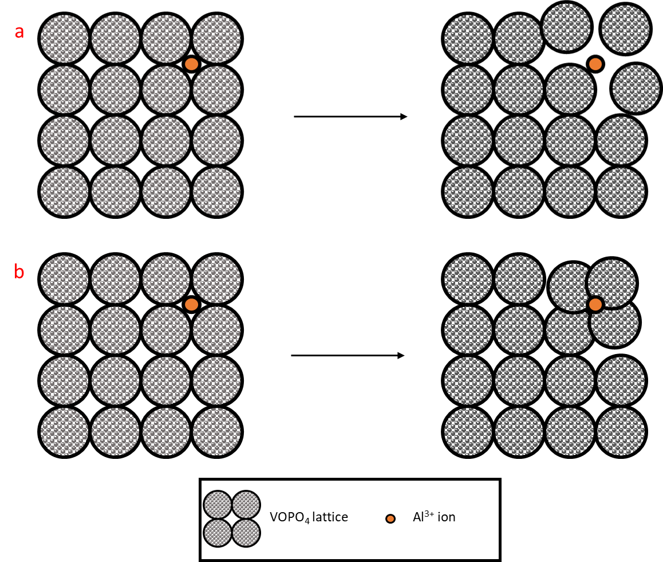
Figure 4 Illustration lattice accomodation to Al ions, a) lattice being expanded, and b) – lattice being attracted towards ions and contracting

Prussian blue analogues
Prussian Blue Analogues (PBAs) have the structure A_{x}MFe(CN)₆, where A is an alkali metal or alkaline earth metal, and M is a transition metal. PBAs have open lattice frameworks, characterised by large ionic channels and interstitial sites. These properties make them good candidates for electrode materials as they can accommodate guest ions within the framework easily. PBAs have been investigated as electrodes for other multi-valent ions (Chen, et al., 2017, Gheytani, et al., 2017, Kong, et al., 2014, Wessells, et al., 2011).
Copper hexacyanoferrate (KCuFe(CN)₆ but more commonly abbreviated to CuHCF) was investigated in an electrolyte of 1 M AlCl₃ + 1 M KCl (Holland, et al., 2018 c, Holland, et al., 2018 d). The presence of Fe in the electrolyte after cycling suggested an irreversible displacement of the Fe from the electrode within the cell. No further spectra or chemical analyses were performed on the electrode sample; therefore it is difficult to understand the exact reaction. Both the Al³⁺ and K⁺ ions may have contributed to this displacement during cycling. CuHCF has been used in K-ion cells, citing the intercalation of K⁺ alongside the reduction of Fe³⁺ to Fe²⁺ (Xia, et al., 2020, Jiang, et al., 2019). In 2019, Wang et al (Wang, et al., 2019) investigated a flexible Al-ion cell with a CuHCF positive electrode and MoO₃ negative electrode (this work precedes (Wang, et al., 2020) ). Prior to building the cell, Al³⁺ was pre-inserted into the CuHCF electrode. During discharge, a reduction of Fe³⁺ to Fe²⁺ was observed, maintaining the charge balance of the electrode as the Al-ions were extracted. Unlike in (Holland, et al., 2018 d), there was no mention of loss of Fe to the electrolyte. Wang et al used only an aluminium salt electrolyte, unlike Holland et al which used both Al and K salts. The exact mechanism which led to Fe displacement requires further investigation.
Potassium cobalt hexacyanoferrate (K₂CoFe(CN)₆) nanocubes have also been studied as a positive electrode in 1 M Al(NO₃)₃ (Ru, et al., 2020). Here the charge mechanism was identified as Al³⁺ intercalation into vacant potassium sites within the cubic lattice of the electrode. The corresponding reactions at the electrode to maintain balance are Fe³⁺ /Fe²⁺, which is typical of all PBAs so far. Additionally, a second peak in the CV corresponding to the pair Co^{2+/}Co³⁺ was identified. A two-step reaction is therefore possible with a ‘dehydration step’ involved prior to insertion into the lattice. The cycling performance is investigated, with 1600 cycles performed, with 25% capacity fade. Through SEM, it was shown that the nanocubic framework had partially collapsed after 1600 cycles – suggesting that structural changes due to cycling are the cause of capacity decay. The decay may be caused by the large charge density of the Al³⁺ distorting the structure, or though the physical size of the ion replacing the K vacancies due to Al’s larger ionic radius. Of further interest – this electrode was examined with other electrolyte salts (AlCl₃ and Al₂(SO₄)₂) and the performance was superior with Al(NO₃)₃. This makes the clear argument that it is not just the choice of electrode, but appropriate electrolyte which can impact on the performance and overall electrochemical mechanisms involved.
Water-in-Salt Electrolytes (WISE) describe an electrolyte whereby the salt outnumbers the water (solvent) in both volume and weight (Suo, et al., 2015). When this occurs, the water molecules do not fully solvate ions, and thus there are interionic pairs. This greatly increases the ionic conductivity and increases the ESW for the electrolyte (Suo, et al., 2017). Using this approach, a WISE was created with 5 M Al(OTF)₃ to investigate FeFe(CN)₆ (chemical equation K_{0.2}Fe[Fe(CN)₆]_{0.79}·2.1H₂O) as an electrode material (Zhou, et al., 2019). The ESW was increased from 1.23 V to 2.65 V, which facilitated a high specific capacity of 116 mA h g⁻¹ @ 150 mA g⁻¹, the highest seen for PBA electrodes currently. The reaction mechanisms within this system are discussed extensively. On initial charges the capacity of the cell slowly increases – due to the removal of residual K-ions over the first few cycles (providing more vacancies for Al³⁺ on subsequent cycles). Additionally, within the first few cycles, irreversible structural changes of the electrode lattice are seen from XRD, which may decrease but also stabilise the overall capacity by ‘trapping’ some Al-ions.
The redox pair Fe³⁺/ Fe²⁺ was observed, as is expected for PBAs, alongside Al³⁺ intercalation. There is also speculation about the role of K⁺, as well as protons within the charge/discharge process. However further studies are needed to understand these interactions. Further, the authors claim ‘good cycling stability’ (Zhou, et al., 2019) however, far superior PBA cycling stability have been observed in CuHCF discussed above (Holland, et al., 2018 c, Holland, et al., 2018 d, Liu, et al., 2015).
Although not described as a WISE, a high concentration (5 M Al(CF₃SO₃)₅) was the electrolyte used with a potassium nickel hexacyanoferrate (KNHCF) electrode to make a cell with an Al foil negative electrode (Gao, et al., 2020). Again, the redox pair Fe³⁺/ Fe²⁺ was observed, alongside Ni³⁺/Ni²⁺, during reversable Al³⁺ intercalation – similar to that shown by Ru et al with the Co^{2+/}Co³pair in the two-step reaction. A similar process may be occurring here. The KNHCF structure remained unchanged after 500 cycles, which suggests a stable positive electrode material for aqueous aluminium cells. Unfortunately, the capacity fade seems primarily due to the Al foil – as alumium corrodes readily in an aqueous environment. It would be useful to see KNCHF studied with different counter electrodes or with TiO₂ as the negative electrode, to fully see the limits of this material.

Manganese oxides
In the last few years Manganese Oxides have been researched as electrodes, both when combined as an Mn-Al ion battery(Zhao, et al., 2018, He, et al., 2019), and with only Al-ions as the charge carrier.
A multi-step process has been identified by a few studies, whereby Mn²⁺ initially dissolves into the electrolyte on the first discharge, forming an amorphous on the surface at the first charge. This layer is likely composed of Al, Mn, and O, and is likely soluble in water. It is this layer that then ‘plates and strips’ in subsequent cycles. By adding Mn salt initially into the electrolyte, this enhances the overall performance. These cells can therefore be described as Mn-Al ion cells.
When looking at the nanostructures, nanorods and nanowires have been investigated by Joseph et al (Joseph, et al., 2019, Joseph, et al., 2020). A potassium-rich manganese oxide was investigated, which formed nano-wires, in 1 M Al(NO₃)₃. During charge, there was a switch between the K and Al, whereby K-ions would dissolve into the electrolyte and be replaced by Al³⁺ in the vacancies. Over time the K-ions did not re-insert and the concentration of K in the electrolyte increased as cycling continued (Joseph, et al., 2019). When researching the Magnesium doped MnO₂ nano-rods, a similar mechanism was reported whereby the Mg²⁺ ions create large tunnels in the structure which allow for easy Al³⁺ intercalation (Joseph, et al., 2020). There is some speculation on whether this is a similar ‘exchange’ as was seen in (Joseph, et al., 2019). Additionally, to the intercalation, there is some capacitive charge storage observed at the surface of the electrode.
A mixture of surface mechanisms like the forming of a new layer, or capacitive storage is observed along with intercalation of Al³⁺ in the bulk of the electrode. If both surface and bulk processes can be taken advantage of, and optimised, this may be an exciting material for high performance Al-ion aqueous battery research.

Other materials
The use of graphite is more common in non-aqueous Al-ion batteries, however two studies have recently used them as the positive electrode within an aqueous cell (Mohanapriya and Jha, 2019, Nandi, et al., 2019). Multi-layer graphite (as discussed in (Nandi, et al., 2019)) showed an intercalation/de-intercalation of Al³⁺ between layers, however the expansion of the lattice during insertion led to cracking of the structure and hence a short cycle life. However when looking at graphene with the addition of carbon nanoparticles – a capacitive storage mechanism is suggested, which may lead to longer cycle life (apparently 0% fade over 3500 cycles (Mohanapriya and Jha, 2019)), but potentially a higher self-discharge.
Bismuth oxide (Bi₂O₃) was investigated in 2020 by Nandi and Shayamal ((Nandi and Das, 2020)). Initial discharge capacities in a full cell with Al-ion negative electrode showed very high values (1130 mA h g⁻¹ @ 1.5 A g⁻¹ ), and ~99% columbic efficiency. However, this dropped significantly to 103mA h g⁻¹ within 20 cycles, and remained stable for the following 50, showing no additional signs of capacity fade. This behaviour suggests that more complex reactions are being set up in the initial cycles, with potential parasitic reactions which require further investigation. Suggestions of both an alloying reaction between Bi and Al, as well as an interfacial storage between Bi and Al₂O₃ at the electrode/electrolyte interface.
Although WO₃ electrodes show poor Coulombic efficiency (~80% (Lahan and Das, 2019)) over cycling in both 1 M AlCl₃ and 0.5 M Al₂(SO₄)₃, the capacity increases over cycling time, to around double the initial capacity seen. With no significant structural changes seen in the electrode after 100 cycles, and the main mechanism assumed to be intercalation/deintercalation of Al³⁺, this could be an interesting material to study – if the Coulombic efficiency can be improved.
In the last year organic materials have been studied as electrodes, with quinones (Li, et al., 2021, He, et al., 2021) studied as a positive (and negative (Yan, et al., 2021)) electrodes, as well as phenazines (Chen, et al., 2021). These electrodes see conversions between hydroxyl and carbonyl groups, alongside the insertion/extraction of Al³⁺.

A note on half cells
Overall, the negative electrode half cells reported in the literature can be summarised as TiO₂ based, or MoO₃ based. Figure 2 plots the reported the cycle life of these half cells against the specific capacity reported. While the current density is not shown in this plot, we can see a cluster of low specific capacity reported for TiO₂ based half cells. There are only two MoO₃ based half cells reported with sufficient data to plot, however it appears a trend in higher specific capacity may be achievable with this electrode basis.
All but one of the reported half cells have a cycle life above 350. TiO₂ anatase nanopowder, with 1 M AlCl₃ +1 M KCl electrolyte shows excellent cycle life of 5000 cycles (Holland, et al., 2018 b). Other TiO₂ based electrodes only use an aluminium salt in the electrolyte, and do not have an additional potassium salt – there may therefore be potential in exploring electrolyte additives to improve the cycle life.
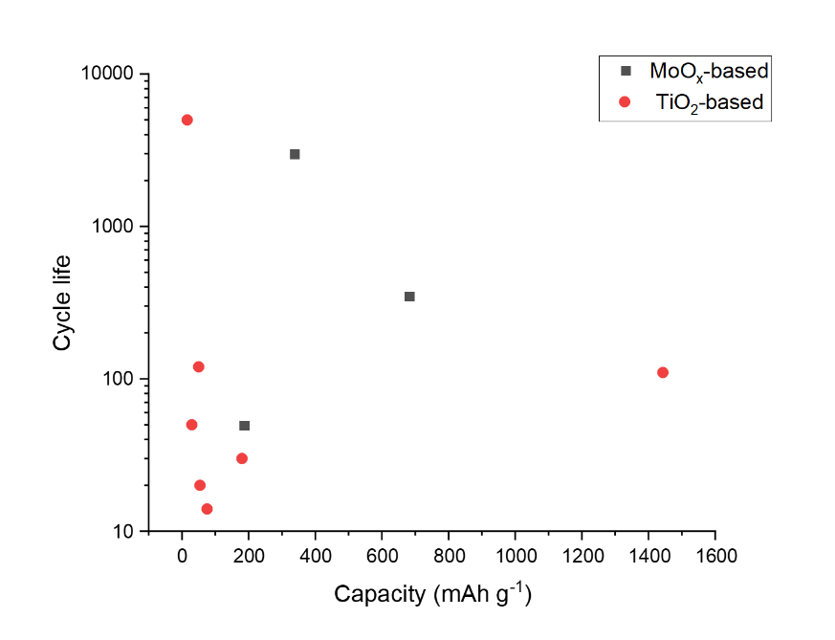
Figure 5 Cycle life plotted against specific capacity reported for TiO2 and MoO3 half cells (Liu, et al., 2012, Kazazi, et al., 2017)
There are many half-cells reported in the literature for the positive electrode. Figure 5 plots the cycle life against the specific capacity for half cells that have both these values reported in the literature. From the limited dataset provided. There is a suggestion that higher specific capacities (above 200 mA hg⁻¹ ) are achievable using vanadium based electrodes. Although the highest capacity example only reported a cycle life of 20 cycles. One data point for the graphite-based electrode of course does not provide a pattern, however the capacity reported (157 mA hg⁻¹) along with a promising cycle life of 3500 cycles would suggest further investigation into this electrode design (Mohanapriya and Jha, 2019). Interestingly, the highest cycle life reported is with the lowest specific capacity – although all the PBAs appear to have lower specific capacity, an anomalous 28000 cycles is reported for a CuHCF based electrode (Holland, et al., 2018 d). As with the high cycle life TiO2 from the negative electrode example, this electrode was tested in an electrolyte with both aluminium and potassium salts – suggesting that the potassium may help with cycle life extension – but perhaps not increase capacity.

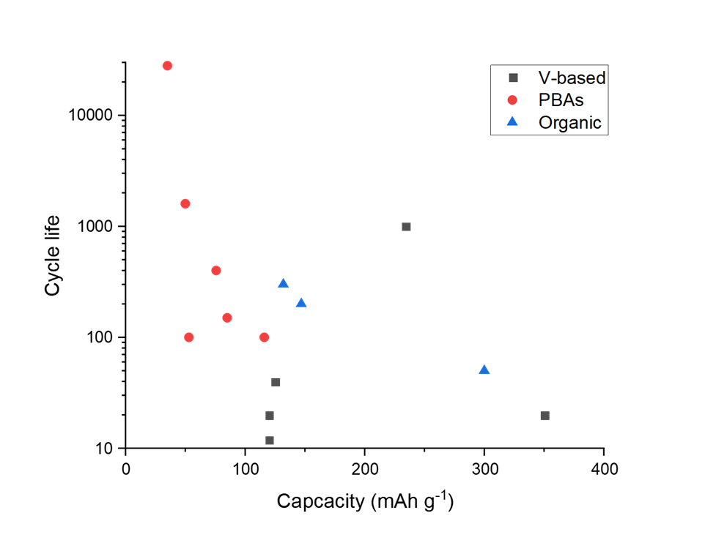
Figure 6 Cycle life plotted against specific capacity for half cells - positive electrodes (González, et al., 2016, Holland, et al., 2018, Parvizi and Kazazi, 2018, Nacimiento, et al., 2018, Zhou, et al., 2019, Joseph, et al., 2019, Lahan and Das, 2019, Lahan and Das, 2019, Kumar, et al., 2019, Mohanapriya and Jha, 2019, Ru, et al., 2020, Cai, et al., 2020)
Figure 6 plots the potential ranges for a selection of half cells. The majority of negative electrodes (TiO2 based) that report potential ranges are between -1.2 and -0.8 V vs Ag/AgCl. For the positive electrodes, there is more variation in potential range. Already pairs of electrodes for full cells can be suggested – TiO₂ and CuHCF make an obvious pairing, and have been studied extensively by Holland (Holland, et al., 2018 c, Holland, 2018 a). Figure 7 shows that this cell, with AlCl₃ + KCl electrolyte has a low capacity but long cycle life compared to other combinations (apart from MoO₃//VOPO₄). A potential combination that has not been discussed in literature so far may be TiO₂ and MnO₂ electrodes, as these have a large potential range between them. So far MnO₂ has only been studied with Al electrodes, which could be argued as being half cells with an Al counter electrode, as opposed to full cell studies, combining MnO₂ with TiO₂ in a full cell therefore would be useful.

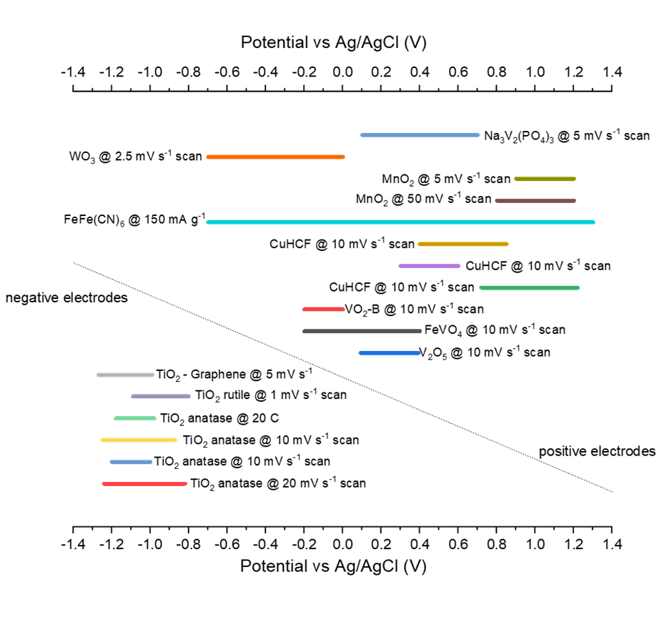
Figure 7 Potential ranges reported for various half cells converted to Ag/AgCl from (Liu, et al., 2012, Liu, et al., 2014, Holland, et al., 2018 b, Holland, et al., 2019, Holland, 2018 a, Zhao, et al., 2019, Kumar, et al., 2019, Zhao, et al., 2020, Cai, et al., 2020, Holland, et al., 2018 d, Zhou, et al., 2019, Liu, et al., 2015, Joseph, et al., 2019, Joseph, et al., 2020, Lahan and Das, 2019, Lahan, et al., 2017, Nacimiento, et al., 2018)

Full cells
As has been stressed throughout this review – understanding how electrodes behave as a full cell is important for the potential commercialisation of aqueous Al-ion technology. Figure 8 plots the cycle life against the specific capacity reported for full cells in the literature. The electrolyte used is overlaid, with cells grouped in rectangles which share a common electrolyte component. It could be suggested that full cells with an Al electrode, whether alloyed with Zn or pre-treated, have low cycle life regardless of the electrolyte. This can be seen with AlCl₃, Al(CF₃SO₃), and Al(OTF)₃ all showing low cycle life when paired with an Al electrode in a full cell. This is most likely due to the passivating layer which forms on the Al in the cell, which in half cells may not have been such a limiting factor. Further, Al foil is often not used as an electrode in a full cell, but rather as the counter electrode in a half cell set-up. Although the authors discuss their work as full cells, and a such they have been reported as full cells in this review, an Al electrode in a secondary aqueous cell is not likely to be practical or developed commercially. A case could be made that the Al(OTF)₃ also leads to lower cycle life cells, but since all examples reported have an Al based electrode, more research into this electrolyte may be useful. The AlCl₃ electrolyte appears to give good cycle life for TiO₂ containing electrodes – with the addition of KCl increasing cycle life further, although not to the same extent as with the half cells. Hydrogel electrolytes appear to increase cycle life substantially – with the PVA-Al(NO)₃ electrolyte combined with the Aluminium and PBA electrodes providing just over 500 cycles (Wang, et al., 2019)– the highest reported for an Al containing electrode within a full cell. Clearly, the Gelatin- polyacrylamide hydrogel has the highest cycle life reported for a full cell, 2800, with 13.8% capacity fade(Wang, et al., 2020) . Half cell vanadium containing electrodes reported between 12-1000 cycles (González, et al., 2016, Kumar, et al., 2019, Cai, et al., 2020), while half-cell MoO₃ (Lahan and Das, 2019, Joseph, et al., 2019) electrodes had cycle lives of 350-400. This hydrogel result requires more research, as this increase in cycle life combined with the flexibility of the cell described would certainly show commercial potential. Overall though, this figure demonstrates that there is no middle-ground currently with respect to capacity and cycle life – either high capacity or high cycle life is demonstrated, but both are unlikely, given the location of examples close to the axes. This then asks the development question – do we look to high capacity and attempt to increase cycle life, or look to high cycle life and attempt to increase capacity? Do the cells with high cycle life demonstrate a pseudocapacitive storage mechanism, which may enable a longer life and less damage to the electrodes – these research questions need further study and understanding.
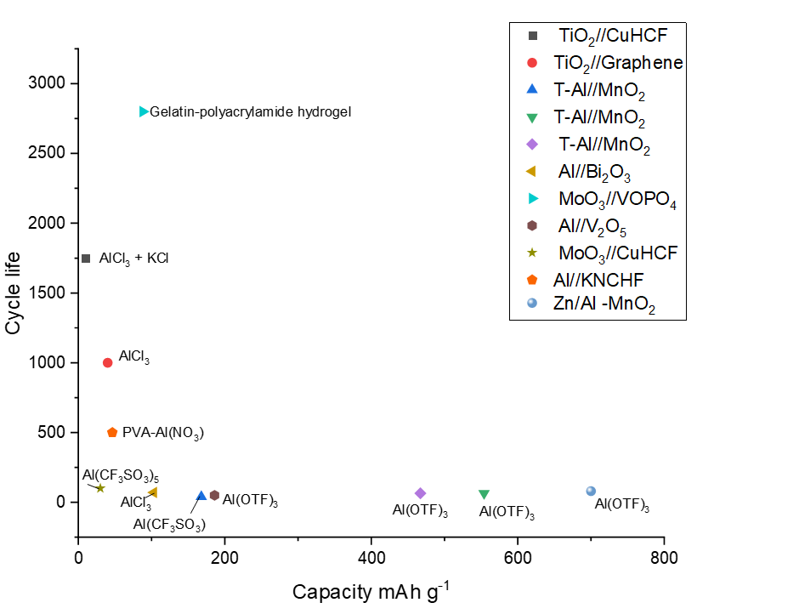
Figure 8 Cycle life plotted against specific capacity for full cells, with electrolyte information overlaid (Wang, et al., 2019, Holland, et al., 2018 c, Holland, 2018 a, Zhao, et al., 2018, He, et al., 2019, Wu, et al., 2019, Yan, et al., 2020, Gao, et al., 2020, Wang, et al., 2020, Zhao, et al., 2020, Nandi, et al., 2019, Nandi and Das, 2020)

Al-air and primary batteries
Aqueous aluminium-air batteries are generally non-rechargeable, primary batteries. Unlike in supercapacitors or most secondary batteries, it is not the ions within the electrolyte that are the charge carriers of the reaction. The main charge transfer mechanism is the reduction of oxygen from the air at the cathode combined with the oxidation of the aluminium-containing anode. The reaction is often reported as below

Anode: $Al+4OH^{-}↔Al{\left(OH\right)}_{4}^{-}+3e^{-}$
Cathode: $O_{2}+2 H_{2}O+4e^{-}↔4OH^{-}$
Overall Reaction: $3O_{2}+2Al ↔Al_{2}O_{3}$

Corrosion of the anode, or a build-up of a passivation layer, often limits the capacity and lifetime of an Al-air battery. Developments in minimising corrosion as well as increasing utilisation at the anode will thus be discussed in this section. Additionally, the Oxygen Reduction Reaction (ORR) at the cathode is a prime source of research, with electrocatalyst chemistries studied to speed up this reaction.
Table 4 summarises some of the aqueous Al-air studies from recent years, however, unlike with secondary batteries (where there are common data provided within the majority of research), the data provided within these studies varies, and therefore there are a few holes within the table. These holes certainly point to future potential studies, to acquire more data, and more comparable data in order to fully understand the performance of these cells. However, this is a complaint often found when reviewing papers – as different researchers wish to optimise different performance parameters

Anodes
As previously mentioned, all anodes for Al-air batteries contain aluminium. This ranges from high purity Al ((Di Palma, et al., 2017, Gaele, et al., 2021, Teabnamang, et al., 2020, Xue, et al., 2017, Hopkins, et al., 2018)) to complex lab-created alloys ((Wang, et al., 2017, Pino, et al., 2016, Zhang, et al., 2019, Wu, et al., 2019)) as well as the use of commercial off the shelf (COTS) alloys ((Katsoufis, et al., 2020, Ryu, et al., 2018, Mutlu, et al., 2017)).
High purity Al anodes are often used when investigating the impacts of a cathode, catalyst, or electrolyte additive, and therefore will not be discussed further in the section. The high purity Al is seen as the ‘baseline’ on which to improve through different processes. By manipulating the anode, it has been shown that the potential can be changed (Wang, et al., 2017) which increases the ESW, corrosion and side reactions can be limited and anode utilisation can be increased (Pino, et al., 2016).
The addition of antimony (Sb) to create an Al-alloy has been studied on various occasions, with the conclusions that the Al-Sb precipitates can inhibit corrosion of the anode, as well as slowing down the growth of a passivation layer on the anode surface (Zhang, et al., 2019, Liu, et al., 2019, Zhang, et al., 2020, Liu, et al., 2020). These anodes also showed a high OCV of >1.80 V, indicating that HER may be reduced due to the increased ESW of the electrodes.
Coating the anode has also been researched, as a way of inhibiting any passivation layers that may grow and allow increased utilisation of the anode. Carbon black was investigated as a coating on two Al alloys – Al1085 – a high purity alloy, and Al7475 – which also contains Zn, Mg, Si and Cr. As expected, the coating on the anodes increased the anode utilisation and cell capacity compared to the non-coated counterparts, with the coated Al745 achieving double the specific capacity of the uncoated Al7475 (540 and 1210 @ 10 mA cm⁻² respectively)(Pino, et al., 2016).

Cathodes and catalysts
Platinum and Manganese Oxide catalysts are commercially available and well established in Al-air cells. They are often used in studies which are investigating the electrolyte or anode specifically, and so will not be discussed in this section.
There have been few studies into new catalyst materials in the last five or so years, however in 2018, Wang et al investigated the use of an Fe-N-C catalyst (Wang, et al., 2018) and found it to be comparable in performance to Pt/C, and an open circuit voltage OCV of 1.74 V, which is relatively high for these batteries. The key advantage discussed here is the cost effectiveness and ease of production of Fe-N-C compared to Pt. A follow-up study in 2019, substituted some Cu for Fe (Li, et al., 2019), and found that the ORR was further boosted with this substitution.
Catalysts are primarily attached to a cathode substrate, such as a mesh or foam (normally nickel), with the use of binders. In 2020, a study looked at binder-free cathodes, using Co₃O₄ nanosheets (Liu, et al., 2020).

Additives and electrolytes
Liquid aqueous electrolytes typically used in Al-air cells are KOH, NaOH and NaCl, with limited discussion on the reasoning behind this choice in a particular battery.
Adding different additives to electrolytes to inhibit anode corrosion is of particular interest. K₂SnO₃ and APG were studied in 4 M KOH with an Al alloy anode and Mn_{x}O_{y}/Ag cathode catalyst (Wu, et al., 2020). The addition of the corrosion inhibitors allowed a uniform protective layer to form from the Sn within the Al alloy, compared to the uneven and rough layer formed without these additives. This layer protected the anode from corrosion and increased the capacity seen. The final reported capacity was 2180 mAh g⁻¹ @ 100 mA cm⁻² . It is. However not always fully reported which additives are used in electrolytes, for example ‘corrosion inhibitors’ were added to 6 M KOH in (Wang, et al., 2018), but their name and effect were not commented on.
More recently, hydrogels have been explored as electrolytes, in particular in a dual-electrolyte system. Using a hydrogel as a catholyte, and a non-aqueous anolyte (Teabnamang, et al., 2020) reduces corrosion at the anode, increasing its utilisation. A 40 hour discharge was reported for this cell, at a current density off 10 mA cm⁻² . The capacity reported was also comparable to other Al-air cells (2328 mAh g⁻¹). A 2021 study (Gaele, et al., 2021) using a similar approach to the electrolytes, had very low (50 μAh g⁻¹ @ 100 μA cm⁻²) capacity reported. Of course these two studies are not fully comparable, as they used different cathodes, catalysts, and different catholytes and anolytes in their designs, which shows that there is potential in dual electrolyte technology – however there are now more variables to assess, and presumably more trial and error to come.

Al-ions in aqueous supercapacitors
Energy storage in capacitors is achieved due to charge separation, and in more typical supercapacitors, this is due to the electrochemical double layer capacitance (EDLC). Additionally, in what would be called a pseudocapacitor (or capattery or cabattery), a mix of EDLC and surface adsorption, or redox reactions can be seen (Afif, et al., 2019) . The primary charge storage of these devices however is charge separation.
Supercapacitors traditionally have longer cycle life than batteries, as the electrochemistry does not occur within the electrode and therefore the structural changes seen in batteries are unlikely in supercapacitors. This can be seen with 10,000 cycles performed and around 10% fade in capacitance (Tian, et al., 2019, Krishnamoorthy and Jha, 2019).
In recent years only a few aqueous Al-ion supercapacitors have been investigated, however, for batteries, the TiO₂ (Holland, et al., 2018 b) and the graphite (Mohanapriya and Jha, 2019), capacitive storage has been identified as one of the storage mechanisms. With both these materials being researched as supercapacitor electrodes too (Krishnamoorthy and Jha, 2019, Zhong, et al., 2015). Research by Krishnamoorthy and Jha (Krishnamoorthy and Jha, 2019), suggests using their electrode as a cathode for an Al-ion battery, before demonstrating its use in a supercapacitor with an ionic liquid. Therefore, it is useful to bear in mind the potential for Al-ion use as a hybrid capacitor – which could reduce the cost and complexity for these applications (Smith, et al., 2020).

Conclusion
Aluminium has the capability to be a major player in energy storage solutions. Its high volumetric energy density, 8.04 Ah cm⁻³ , abundance, pre-existing production industry and recyclability make it a sustainable option. Pairing this technology with aqueous electrolytes in batteries and supercapacitors, have the potential produce inherently safe and cheap energy storage. The versatility of these systems has been discussed in the review.
Primary aluminium-air batteries are the most developed technology, with work towards increasing anode utilisation and reducing side reactions on-going. The capability for rechargeable aqueous Al-air batteries is only just being investigated, and so there is the opportunity to develop this further.
Secondary Al-ion batteries have had an increase of attention in the last five years or so, with the exact charge storage mechanisms remaining complex and unknown for many electrodes. This is clearly a space with the potential for growth, with better elucidation of reaction mechanisms and refinement of electrode choice. Al-ions have a variety of charge transfer mechanisms; for the TiO₂ negative electrodes, a surface pseudocapacitive reaction is most likely, while lattice expansion due to Al³⁺ insertion in vanadium containing positive electrodes shows that bulk reactions are also possible. There are many unknowns still, regarding the charge transfer within many electrode materials – with an engineering focus primarily on ‘does it work’ prior to the investigation into how. This is illustrated for CuHCF electrodes with as yet unexplained displaced Fe in the electrolyte. There are few studies into supercapacitors with Al-ion technology. However, many of the secondary batteries have pseudo-capacitive behaviour. It is expected that as the exact charge storage for some electrodes (such as TiO₂) is determined, the role of Al-ion technology may shift towards supercapacitor storage.

Tables
Electrolyte | type | ESW | reference
Lithium salts | Ionic liquid | 4-6 V | (Gores, et al., 2011)
PAN-gels | Polymer/aqueous | >4.5 V | (Gray and Armand, 2011, Wang, et al., 2019)
Crosslinked | Polymer | 3.9 V | (Gray and Armand, 2011)
Ionic Salt | aqueous | 1.23 V | (Dell, 1996)
WISE | aqueous | 3-4 V | (Suo, et al., 2017, Yang, et al., 2017)
Table 1 Typical ESW for certain electrolytes

Electrode material | Half or full cell | Electrolyte | Specific capacity | Columbic efficiency | Cycles performed | Capacity fade | Mechanism assumption | Reference
TiO₂ nanotubes | Half cell | 1 M AlCl₃ | 75 mA h g⁻¹  @ 4 mA cm⁻² | ~90% ª | 14 | Not discussed | Intercalation into TiO₂.  Speculation of Ti⁴⁺/Ti³⁺ redox couple | (Liu, et al., 2012)
TiO₂ nanotube array | Half cell | Various combinations of  NaCl + Al2(SO4)₃ | 75 mA h g⁻¹@  4 mA cm⁻² | Not discussed | Not discussed | Not discussed | Ti⁴⁺/Ti³⁺ redox couple, speculation of C^{l-} assistance in Al³⁺ insertion | (Liu, et al., 2014)
TiO₂ nanosphere | Half cell | 1 M AlCl₃ | 180 mA h g⁻¹ @ 50 mA g⁻¹ | ~90% ª | 30 | 6% | Not discussed | (Kazazi, et al., 2017)
TiO₂ anatase nanopowder | Half cell | 1 M AlCl₃ +  1 M KCl | 15.6 mA h g⁻¹  @ 2.85 mA g⁻¹ | 99% | 5000 | ~15%ª | Speculation on pseudocapacitive behaviour of Al and TiO₂ | (Holland, et al., 2018 b)
TiO₂ anatase nanopowder | Half cell | 1 M AlCl₃ +  1 M KCl | 15 mA h g⁻¹  @ 40 A g⁻¹ | ~100% ª | Not discussed | Not discussed | Pseudocapacitive behaviour of Al and TiO₂ | (Holland, et al., 2019)
TiO₂ anatase nanopowder | Full cell with CuHCF positive electrode | 1 M AlCl₃ +  1 M KCl | 10 mA h g⁻¹ @20 C | ~90% | 1750 | 7% | Al³⁺ surface adsorption or intercalation | (Holland, et al., 2018 c, Holland, 2018 a)
TiO₂ Rutile nanopowder | Half cell | 1 M AlCl₃ | 29.4 mA h g⁻¹  @0.5 A g⁻¹ | 89.8% | 50 | ~23% ª | Al³⁺ insertion in preference to the hydrogen evolution. Different long term behaviour to anatase noted | (Zhao, et al., 2019)
TiO₂ graphene | Half cell | Various  AlCl₃ (0.01−1M)  Al₂(SO₄)₃ (0.5 M)  Al(NO₃)₃ (1 M) | 50 mA h g⁻¹  @6.25 A g⁻¹  for  0.25 M AlCl₃ electrolyte | Not discussed | 120 with 0.25 M AlCl₃ electrolyte | ~50% ª | Graphene minimised resistance for charge carriers in the TiO₂, and enhanced insertion into electrode. Possibility of crystal phase transition of TiO₂ to aluminium titanate. | (Lahan, et al., 2017)
graphene- TiO₂ nanocomposite | Half cell | 0.5 M AlCl₃ | 54 mA h g⁻¹  @6.25 A g⁻¹ | Not discussed | 20 | Capacity increased during cycles | reversible crystal phase transition of TiO₂ to aluminium titanate | (Lahan and Das, 2018)
TiO₂ anatase nanopowder | Full cell with graphene positive electrode | 1 M AlCl₃ | 40 mA h g⁻¹  @ 1 mA cm⁻² | Not discussed | 1000 | ~38% ª | Not discussed | (Nandi, et al., 2019)
T-Al (Al pre-treated with chloroaluminate melts) | Full cell with MnO₂ positive electrode | 2 M Al(CF₃SO₃)  2 M  Al(CF₃SO₃)₃ + 0.1 M Mn(CF₃SO₃)₂ | 168 mA h g⁻¹ g @100 mA g⁻¹  100 mA h g⁻¹  @ 500 mA g⁻¹ | ~100%ª | 40  100 | ~50%ª  Not discussed | Plating and stripping of Al on surface  Al ions stripped from the anode may react with electrolyte and form a complicated product rich in Al and electrolyte components. | (Zhao, et al., 2018)
T-Al | Full cell with Birnessite MnO₂ positive electrode | 2 M (Al(OTF)₃)  2 M (Al(OTF)₃) + 0.5 M MnSO₄ | 350 mA h g⁻¹  @100 mA g⁻¹  554 mA h g⁻¹  @ 100 mA g⁻¹ | Not discussed | 30  65 | 88%  42% | Plating and stripping of Al on the surface | (He, et al., 2019)
T-Al | Full cell  with MnO₂ positive electrode | 5 M (Al(OTF)₃) | 467 mA h g⁻¹@ 0.01 mA cm⁻¹ | ~80%ª | 65 | ~42% ª | Plating and stripping of Al on the surface | (Wu, et al., 2019)
Al foil | Full cell with Bi₂O₃ positive electrode | 1 M AlCl₃ | 103 mAhg⁻¹ @ 0.5 Ag⁻¹ | 99% | 70 |  | Not discussed for Al | (Nandi and Das, 2020)
MoO₃ | Half cell | 1 M Al(NO₃)₃ | 308 mA h g⁻¹  @ 1 A g⁻¹  232 mA h g⁻¹  @ 8 mA g⁻¹ | Not discussed | Not discussed | Not discussed | Reversible intercalation of Al³⁺ between MoO₃ nanobelts | (Wang, et al., 2020)
MoO₃ | Full cell with VOPO₄ positive electrode | Gelatin-polyacryylamide hydrogel | 88 mA h g⁻¹  @ 6 A g⁻¹ | ~100%ª | 2800  @ 1 A g⁻¹ | 13.8% | As above | (Wang, et al., 2020)
MoO₃ | Half cell | 1 M AlCl₃ | 680 mA h g⁻¹  @ 2.5 A g⁻¹ | ~99%ª | 350 | ~75%ª | Reversible diffusion-controlled intercalation, with high Al³⁺ trapping in the first cycle | (Lahan and Das, 2019)
MoO₃ nanowire | Half cell | 1 M AlCl₃ | 300 mA h g⁻¹  @ 3 A g⁻¹ | ~89% | 400 | ~10% | Hexagonal crystal structure of electrode allows easy intercalation. Redox pair Mo⁶⁺/Mo⁵⁺ and Mo⁵⁺/Mo⁴⁺ | (Joseph, et al., 2019)
Al | Full cell with V₂O₅ positive elctrode | 2 M Al(OTF)₃ | 186 mA h g⁻¹  @ 40 mA g⁻¹ | Not discussed | 50 | 89%  (35% with Nafion barrier on V₂O₅ electrode) | Not discussed for Al | (Zhao, et al., 2020)
Ppy coated MoO₃ | Full cell with CuHCF positive electrode | PVA- Al(NO₃)₃ hydrogel | ~30 mA h g⁻¹ @ 200 mA g⁻¹ | Not discussed | 100 | 16.8% | Not discussed | (Wang, et al., 2019)
Al foil | Full cell with KNCHF positive electrode | 5 M Al(CF₃SO₃)₅ | 46.5 mA h g⁻¹ @ 20 mA g⁻¹ | ~100%ª | 500 | ~43%ª | Plating and stripping, with Ni acting as a catalyst to create an unstable interface | (Gao, et al., 2020)
Zn-Al alloy | Full cell with MnO₂ positive electrode | 2 M Al(OTF)₃ | ~700ª mA h g⁻¹  @ 100 mA g⁻¹ | ~100%ª | 80 | ~35%ª | Plating and stripping of Al, Zn substrate providing protection from passivation layer growth and Al providing shielding from Zn dendrite growth. | (Yan, et al., 2020)
Ti-deficient TiO₂ Rutile | Half cell | 1 M AlCl₃ | 143.1 mA h g⁻¹  @ 0.5 A g⁻¹  78 mA h g⁻¹  @ 3 A g⁻¹ | 70%ª | 110 | 18% | Al³⁺ ions can reversibly insert into Ti vacancies in the lattice | (Wu, et al., 2021)
Organic Anthraquinone | Full cell with CuHCF positive electrode | 1 M Al₂(SO₄)₃ | 53.2 mAh g⁻¹ @ 500 mA g⁻¹ | 99% | 100 | 10.9% | Enolization (an organic process) and ion-pairing charge storage mechanism of the electrode is a diffusion-controlled process, and the spaces between molecules in the crystal lattice is beneficial for protons and Al³⁺ diffusion | (Yan, et al., 2021)
MoTaO_{x} nanotubes | Half cell | 0.5 M Al₂(SO₄)₃ | 337 mAh g⁻¹ @ 350 mA g⁻¹ | 99%ª | 3000 | 17% | Nanotubes create a porous structure so Al³⁺ can intercalate/de-intercalate without damaging the structure | (Jin, et al., 2021)
ª values estimated from graph data
Table 2 Negative electrode material choices and mechanism assumptions

Electrode material | Half or full cell | Electrolyte | Initial specific capacity | Columbic efficiency | Cycles performed | Capacity fade | Mechanism assumption | Reference
Vanadium pentoxide xerogel (xero- V₂O₅) | Half cell | 1 M AlCl₃ | 120 mA h g⁻¹ @ 60 mA g⁻¹ | Not discussed | 12 | ~38%ª | Al ions and water molecules co-intercalate into V₂O₅. Proton exchange in the V₂O₅ interlayers may also be occurring. This is a diffusion-controlled process. | (González, et al., 2016)
FeVO₄ nanorods | Half cell | 1 M AlCl 3 +ammonium hydroxide | ~350 mA h g⁻¹ @ 60 mA g⁻¹ | Not discussed | 20 | ~85%ª | Complex reversible Al³⁺ insertion/reaction mechanism and poor insertion kinetics. Converting lattice of electrode | (Kumar, et al., 2019)
Bronze-type vanadium oxide (VO₂ – B) holey nanobelts | Half cell | 5 M Al(TOf)₃ | 234 mA h g⁻¹ @ 150 mA g⁻¹ | ~100%ª | 1000  @ 1 A g⁻¹ | 22.8% | H⁺ and Al³⁺ co-intercalation | (Cai, et al., 2020)
Vanadium Phosphate (VOPO₄) | Half cell | 1 M Al(NO₃)₃ | 115 mA h g⁻¹ @ 1A g⁻¹  64mA h g⁻¹  @ 6 A g⁻¹ | Not discussed | Not discussed | Not discussed | Intercalation of Al³⁺ accompanied by V⁵⁺/V⁴⁺ and V⁴⁺/V³⁺ reduction | (Wang, et al., 2020)
Vanadium Phosphate (VOPO₄) | Full cell with MoO₃ negative electrode | Gelatin-polyacryylamide hydrogel | 88 mA h g⁻¹  @ 6 A g⁻¹ | ~100%ª | 2800 @  1 A g⁻¹ | 13.8% | as above | (Wang, et al., 2020)
V₂O₅ nanorods | Full cell with Al negative electrode | 2 M Al(TOf)₃ | 186 mA h g⁻¹ @ 40 mA g⁻¹ | ~74%ª  (~100%ª with Nafion barrier) | 50 | 89%  (35% with Nafion barrier) | Al reacting at the surface while protons intercalate into the electrode | (Zhao, et al., 2020)
CuHCF | Half cell | 1 M AlCl₃ +  1 M KCl | 35 mA h g⁻¹ @ 1 A g⁻¹ | ~100% | 28000 | ~25% with various current densities | Not fully discussed, but suggestions of Fe dissolution into electrolyte. | (Holland, et al., 2018 d)
CuHCF | Full Cell with TiO2 negative electrode | 1 M AlCl₃ +  1 M KCl | 10 mA h g⁻¹ @ 333 mA g⁻¹ | ~90% | 1750 | 7% | Discussion of K⁺ intercalation alongside Al³⁺ | (Holland, et al., 2018 c)
CuHCF nanoparticles | Half cell | 0.5 M Al₂(SO₄)₃ | 75.75 mA h g⁻¹ @ 50 mA g⁻¹ | Not discussed | 400 @  400 mA g⁻¹ | 25.6% | Reduction of Fe³⁺ to Fe²⁺ was observed during discharge both in K and non K containing nanoparticles | (Parvizi and Kazazi, 2018)
CuHCF | Half cell  Full cell with MoO₃ negative electrode | 1 M Al(NO₃)₃  PVA- Al(NO₃)₃ hydrogel | 50 mA h g⁻¹ @ 500 mA g⁻¹  ~30 mA h g⁻¹ @ 200 mA g⁻¹ | Not discussed  Not discussed | Not discussed  100 | Not discussed  16.8% | Reduction of Fe³⁺ to Fe²⁺ was observed during discharge | (Wang, et al., 2019)
FeFe(CN)₆ | Half cell | 5 M Al(OTF)₃ (WISE) | 116 mA h g⁻¹ @ 150 mA g⁻¹ | 99% | 100 | 39% | Primarily Al³⁺ intercalation, suggests there may also be some K⁺ and proton insertion | (Zhou, et al., 2019)
K₂CoFe(CN)₆ | Half cell | 1 M Al(NO₃)₃ | 50 mA h g⁻¹ @ 0.1 A g⁻¹ | ~95% | 1600 | 24% | Al³⁺ intercalation, and redox couples of Co³⁺/Co²⁺ and Fe³⁺/Fe²⁺ | (Ru, et al., 2020)
KNHCF | Full cell with Al foil | 5 M Al(CF₃SO₃)₅ | 46.5 mA h g⁻¹ @ 20 mA g⁻¹ | ~100% | 500 | ~43%ª | Al³⁺ intercalation, and redox couples of Ni³⁺/Ni²⁺ and Fe³⁺/Fe²⁺ | (Gao, et al., 2020)
MnO₂ | Full cell with T-Al negative electrode | 2 M Al(CF₃SO₃)  2 M  Al(CF₃SO₃)₃ + 0.1 M Mn(CF₃SO₃)₂ | 168 mA h g⁻¹ g @100 mA g⁻¹  100 mA h g⁻¹  @ 500 mA g⁻¹ | ~100%ª | 40  100 | ~50%ª  Not discussed | Two phase reaction with soluble Al phase forming on surface of electrode, along with an amorphous MnO₂ layer | (Zhao, et al., 2018)
Birnessite MnO₂ | Full cell with T-Al negative electrode | 2M Al(OTF)₃ + 0.5 M MnSO₄ | 554 mA h g⁻¹  @ 100 mA g⁻¹ | ~100%ª | 65 | 42% | Three step process, Mn²⁺ dissolves into electrolyte on first discharge, on first charge forms layer with Al on electrode surface and this is then reversibly deposited/stripped over subsequent charges. | (He, et al., 2019)
Cryptomelane MnO₂ nanowires | Half cell | 1 M Al(NO₃)₃ | 109 mA h g⁻¹  @ 20 mA g⁻¹ | Not discussed | 60 | 38% | Al³⁺ intercalation, replacing the K-ions within the lattice, and Mn⁴⁺/Mn³⁺, Mn³⁺/Mn²⁺ redox pairs within the cathode. No structural changes of the nanowires. | (Joseph, et al., 2019)
Magnesium doped MnO₂ nanorods | Half cell | 1 M Al(NO₃)₃ | Not discussed | Not discussed | Not discussed | Not discussed | Diffusion controlled Al insertion, Mn⁴⁺/Mn³⁺, Mn³⁺/Mn²⁺ redox pairs, as well as surface pseudocapacitive storage | (Joseph, et al., 2020)
Mn₃O₄ | Full cell with Al negative electrode | 5 M Al(OTF)₃ (WISE) | 467 mA h g⁻¹@ 0.01 mA cm⁻¹ | ~80%ª | 65 | ~42% | Dissolution of Mn²⁺ into electrolyte and formation of amorphous layer alongside Al³⁺ intercalation | (Wu, et al., 2019)
MnO₂ | Full cell with Zn-Al negative electrode | 2 M Al(OTF)₃ | ~700ª mA h g⁻¹  @ 100 mA g⁻¹ | ~100%ª | 80 | ~35%ª | Al³⁺ intercalation and redox reactions of Mn⁴⁺/Mn³⁺, Mn³⁺/Mn²⁺ | (Yan, et al., 2020)
Graphite from 4B pencil sketch | Full cell withTiO₂ negative electrode | 1 M AlCl₃ | 40 mA h g⁻¹  @ 1 mA cm⁻² | Not discussed | 1000 | ~38%ª | Al³⁺ insertion/extraction, expansion of graphite interlayers during this process resulting in cracking of the electrode. | (Nandi, et al., 2019)
Graphite with carbon nano particle deposition | Half cell | 1 M AlCl₃ | 157 mA h g⁻¹  @ 1A g⁻¹ | Not discussed | 3500 @  50 A g⁻¹ | ~0% | Capacitive surface storage | (Mohanapriya and Jha, 2019)
Bi₂O₃ | Full cell with Al negative electrode | 1 M AlCl₃ | 1130 mA h g⁻¹  @ 1.5 A g⁻¹ | ~99%ª | 70 | ~98%ª | Alloying between Al-Bi, and interfacial charge separation – pseudo capacitive storage. | (Nandi and Das, 2020)
WO₃ | Half cell | 1 M AlCl₃  0.5 M Al₂(SO₄)₃ | ~100 mA h g⁻¹  @ 1.5 A g⁻¹  ~90 mA h g⁻¹  @ 1.5 A g⁻¹ | <80%  ~80% | 100  100 | Increased capacity to 210 mA h g⁻¹  Increased capacity to 185 mA h g⁻¹ | Intercalation of Al³⁺ | (Lahan and Das, 2019)
Na₃V₂(PO₄)₃ | Half cell | 0.1 M AlCl₃ | 120 mA h g⁻¹  @ 60 mA g⁻¹ | Not discussed | 20 | ~50%ª | Combination of surface capacitive storage and intercalation of Al³⁺ | (Nacimiento, et al., 2018)
macrocyclic calix[4]quinone (C4Q) | Half cell | 1 M Al(OTF)₃ | 300 mAh g⁻¹ @ 800 mA g⁻¹ | 98% | 50 | 19% @ room temperature  18% @ -20°C | Al(OTF)²⁺ cation acts as the active ion to reversibly combine  with quinone cathode | (Li, et al., 2021)
Organic compound containing Phenazine (PZ) | Half cell | 5 M Al(OTF)₃ | 132 mAh g⁻¹ @ 50 mA g⁻¹  41 mAh g⁻¹ @ 200 mA g⁻¹ | 90%ª | 300 | 23.5% | PZ  undergoes a reversible redox reaction of -C=N- with Al-  (OTF)2+ co-intercalation transfer process | (Chen, et al., 2021)
FeFe(CN)₆ | Full cell with pre-treated Al negative electrode | 1 M Al(OTF)₃ | 85 mAh g⁻¹ @ 100 mA g⁻¹ | 97.1% | 150 | 29% | It is speculated that the ion insertion mechanism of this cathode in the aqueous solution is accomplished in two steps | (Bai, et al., 2021)
VOPO₄ | Half cell | Al(CF₃SO₃)₃ | 125.4 mAh g⁻¹ @ 20 mA g⁻¹ | ~90%ª | 40 | 40% | Reversible intercalation of Al³⁺ into electrode, but potential damage to structure resulting in capacity fade | (Pang, et al., 2021)
CuHCF | Full cell with Anthraquinone negative electrode | 1 M Al₂(SO₄)₃ | 53.2 mAh g⁻¹ @ 500 mA g⁻¹ | 99% | 100 | 10.9% | K⁺ removal on first charge and subsequent Al³⁺ insertion/extraction on subsequent charges | (Yan, et al., 2021)
Organic tetrachloro-1,4-benzoquinone | Half cell | 1 M Al(OTf)₂ | 147 mAh g⁻¹ @ 200 mA g⁻¹ | 100%ª | 200 | 29.3% | Combination of chemical conversion of electrode from carbonyl to hydroxyl groups and the Al³⁺ insertion/de-insertion process | (Jin, et al., 2021, He, et al., 2021)
ª values estimated from graph data
Table 3 Positive electrode material choices and mechanism assumptions

Anode material | Cathode membrane material | Electrolyte | Specific capacity | Energy density | OCV | Comments | Ref
Nano-yttrium-stabilised-zirconium-aluminium alloy (nano-YSZ 5% wt) | Stainless steel mesh | 1 M KOH | 882 mAh g⁻¹ @ 2 mA cm⁻²  14.25 hrs discharge time | Not given | 1.44 V | Corrosion resistance, potential protective layer due to Z⁴⁺ on anode, increasing capacity and OCV | (Palanisamy, et al., 2020)
Al-Mn-Sb | MnO₂/C catalyst layer | 4 M KOH | 2797 mAh g⁻¹ @ 120 mA cm⁻² | 1854 m  Wh g⁻¹ @ 120 mA cm⁻² | 1.89 V | Increased corrosion resistance inhibits HER side reactions. | (Liu, et al., 2020)
Al 7075-T7351 alloy | Not discussed | 4 M NaOH | 2777 mAh g⁻¹ @ 50 mA cm⁻² | Not given | 1.47 V | Increased corrosion resistance due to Cu presence in alloy. | (Mutlu, et al., 2017)
Al 99.9% purity | Nickel foam, pourous PTFE and a Ag doped LAM catalytic layer | 4 M KOH | Not given | Not given | Not given |  | (Xue, et al., 2017)
Al 99.9% purity | Carbon particles, nano-manganese catalyst, nickel mesh | 4 M NaOH + 0.05 M Na₂SnO₃ | 2.697 Ah g⁻¹ @ 150 mA cm⁻² | 900 Wh kg⁻¹ | 1.22 V | Flow battery with oil displacing electrolyte when battery not in use. This reduced open circuit corrosion | (Hopkins, et al., 2018)
Al 6061 alloy | Nickel foam and silver manganate nanoplate catalyst | 6M KOH | 2843 Ah g⁻¹ @ 100 mA cm⁻²  7.3 hrs discharge time | ~2552 Wh kg⁻¹ @ 100 mA cm⁻² | ~1.42 V | Flow battery, with catalyst promoting ORR at cathode | (Ryu, et al., 2018)
Aluminium plate | Carbon paper | NaAlO₂ | 51.61 mAh cm⁻² (no current density given)  87 hrs discharge time | Not given | ~1.27 V | Demonstrating use of NaAlO₂ electrolyte | (Takeda and Taguchi, 2018)
Al nanoparticles on Al film | Pt/C on carbon paper | 2 M KOH gel | 50.18 mAh g⁻¹ @ 0.5 mA cm⁻² | Not given | Not given | Demonstrating 3D printed anode | (Yu, et al., 2018)
Al-Sb | MnO₂/C | 4 M KOH | 2317 Ah kg⁻¹ @ 20 mA cm⁻² | 3871 Wh kg⁻¹ @ 20 mA cm⁻² | 1.881 V | Al-Sb precipitates help inhibit self-corrosion of the anode, and slows the rate of a passive film growth on the surface | (Liu, et al., 2019)
Cu electrodeposited on Al | Not given | 1 M NaOH | Not given | Not given | 1.365 V (discharge) |  | (Mutlu and Yazıcı, 2019)
Al 0.5-Mg 0.1-Sn 0.05 In (wt%) | MnO₂ catalyst | 4 M NaOH | 2773 Ah kg⁻¹ @ 80 mA cm⁻² | 3217 Wh kg⁻¹ @ 80 mA cm⁻² | 1.196 V (discharge) | Indium reduces HER and increases anode efficiency | (Wu, et al., 2019)
Al-0.02Sb (wt%), heat treated for 3 hours at 550°C | MnO₂/C catalyst | 4 M KOH | 2758 Ah kg⁻¹ @ 20 mA cm⁻² | 3776 Wh kg⁻¹ @ 20 mA cm⁻² | 1.89 V | Long heat treatment increases Al-Sb precipitate grain growth and coarsening which worsens performance. 3 hrs was optimum performance. | (Zhang, et al., 2019)
Al-6061 alloy | Carbon black coated carbon cloth, with MnO₂ catalyst | 2 M KOH | Not given | 5.5 mWh cm⁻² @ 5 mA cm⁻² | ~1.4 V | Reduction reactions at a higher potential and lowered charge transfer resistance due to electrocatalyst. | (Katsoufis, et al., 2020)
Al-foil | Co₃O₄ nanosheets on N-doped carbon nanotubes and 3D graphene | 2 M KOH | 482 mAh g⁻¹ @ 1 mA cm⁻² | Not given | 1.52 V | Demonstrating binder free cathode with reliable performance | (Liu, et al., 2020)
Al sheet 99.9% wt purity | Nickel foam, MnO₂/C catalyst | Dual electrolyte  Aqueous catholyte : polymer gel with 3 M KOH  Non-aqueous anolyte: methanol solution with 3 M KOH | 2328 mAh g⁻¹ @ 10 mA cm⁻²  ~40 hours dicharge | Not given | 1.44 V | Reduced corrosion of anode using non-aqueous anolyte significantly enhances the capacity and anode utilisation | (Teabnamang, et al., 2020)
Al alloy | Mn_{x}O_{y}/Ag | 4 M KOH + 0.05 M K₂SnO₃ + 2 Mm apg | 2180 mAh g⁻¹ @  100 mA cm⁻² | Not given | 1.783 V | Addition of 0.05 M K₂SnO₃ + 2 Mm APG inhibits corrosion of anode through protective uniform Sn layer, increases capacity. | (Wu, et al., 2020)
Al-Sb | MnO₂/C catalyst | 4 M KOH | 2859 Ah kg⁻¹ @ 40 mA cm⁻² | 3547 Wh kg⁻¹ @ 40 mA cm⁻² | ~1.85 V | Rolling process to create anode and refine grains of Al-Sb | (Zhang, et al., 2020)
Pure Al (99.998%wt) | Pt/C | Dual electrolyte  Aqueous catholyte : saline hydrogel (XaKCl)  Non-aqueous anolyte: acidic PVA membrane with 5 MHCl | 50 μAh g⁻¹ @  100 μA cm⁻² | Not given | ~ 1.66 V |  | (Gaele, et al., 2021)
Al1085-Carbon Black  Al7475-Carbon Black | Ni mesh with MnO₂/C catalyst | 2 M NaCl | 740 mAh g⁻¹ @  6 mA cm⁻²  ~27 hrs discharge  1210 mAh g⁻¹ @  10 mA cm⁻²  ~34 hrs discharge | Not given | Not given | Carbon black coating increases lifetime and capacity of cell by increasing anode utilisation | (Pino, et al., 2016)
Al foil 99.998%wt purity | Ni foam with Pt catalyst | Hydrogel 8 M KOH with κ-carrageenan | 53 mAh cm⁻² @10 mA cm⁻²  ~5 hrs discharge | 33 mWh cm⁻² @10 mA cm⁻² |  | Granularity of the hydrogel plays a key role in capacity and lifetime of the cell | (Di Palma, et al., 2017)
Al–1.5Bi–1.5Pb–0.035Ga | MnO₂ | 2 M NaCl  4 M KOH | 2048 mAh g⁻¹ @  25 mA cm⁻²  2559 mAh g⁻¹ @  100 mA cm⁻² | 2244 mWh g⁻¹  @  25 mA cm⁻²  3058 mW g⁻¹  @  100 mA cm⁻² | 1.43 V  1.60 V | Anode alloy has a more negative potential than other anodes tested. In NaCl due to adsorption of Cl⁻. In KOH limits self corrosion | (Wang, et al., 2017)
Aluminium plate | Ni foam with Fe-N-C catalyst | 6 M KOH + corrosion inhibitors | 300 mA cm⁻² @  100 mA cm⁻² | Not given | 1.74 V | Use of Fe-N-C catalyst comparable to Pt/C | (Wang, et al., 2018)
Al plate | Cu-Fe-N-C Catalyst | 6 M NaOH | Not given | Not given | Not given | ORR speed increased with Cu-Fe-N-C catalyst compared to Fe-N-C | (Li, et al., 2019)
Table 4 Summary of recent aqueous Al-air studies

Electrode materials | Electrolyte | Capacitance | Specific energy | Specific Power | Specific capacity | Coulombic efficiency | Cycles performed | fade | Charge storage | Reference
CuFe-PBA and activated carbon (AC) – asymmetrical | 1 M Al(NO₃)₃ | Not given | 13 Wh kg⁻¹ | Not given | 37 mAh g⁻¹@ 1C | ~99% | 1000 | Specific capacity fade: ~10% | Uncertainty as to whether it is pseudocapacitive or purely EDLC | (Li, et al., 2015)
MnO₂ and Al doped TiO₂ nanotube arrays | 1 M AlCl₃ | 554 F g⁻¹ @ 10 mV s⁻¹ | 105.9 Wh kg⁻¹ | 1.02 kW kg⁻¹ | Not given | Not given | Not given | Not given | Introduction of Al³⁺ into the TiO2 lattice increase charge carrier density. MnO₂ maintains high energy density at high power densities | (Zhong, et al., 2015)
V₂O₅ Mesoporous Carbon – symmetrical | 1 M Al₂(SO₄)₃ | 290 F g⁻¹ @ 0.5 A g⁻¹ | 18 Wh kg⁻¹ | 147 W kg⁻¹ | Not given | ~100% | 10,000 | Specific capacitance fade:  12% | EDLC provided by the carbon, and additional surface redox reactions from Al³⁺ adsorption and V⁵⁺/V⁴⁺ redox couple | (Tian, et al., 2019)
Oxygen rich porous graphene | 1 M AlCl₃ | ~230 F g⁻¹ @  5 A g⁻¹ |  |  | 63.8 mAh g⁻¹ @ 5 A g⁻¹ | Not given | 10,000 | Specific capacitance fade:  7.4% | EDLC and potential adsorption/desorption | (Krishnamoorthy and Jha, 2019)
PEDOT:PSS on carbon cloth substrate and activated carbon  Not symmetrical | Unknown concentration Al₂(SO₄)₃ | 265 F g⁻¹ @  0.2 A g⁻¹ | { | 265 W kg⁻¹ | 51 mAh g⁻¹ @100 mA g⁻¹ | Not given | Not given | Not given | Reduction of charge transfer resistance compared to other cation salts | (Ai, 2020)
W₁₈O₄₉ nanowires (NWs)-reduced graphene oxide (rGO) and rGO  Not symmetrical | 1 M AlCl₃ | 365.5 F g⁻¹ @  1 A g⁻¹ | 28.5 | 751 | Not given | 95.1% | 12,000 | 3.3% | Intercalation of Al³⁺ | (Thalji, et al., 2021)
Table 5 Summary of recent Al-ion supercapacitors

Conflict of Interest
The authors declare that the research was conducted in the absence of any commercial or financial relationships that could be construed as a potential conflict of interest.

Author Contributions
NM – research and writing
RGAW – editing, support, writing

Funding
This work was funded by UKRI under an STFC Studentship and the EPSRC Faraday Training Grant EP/S514901/1.

References

W. Tang, Y. Zhu, Y. Hou, L. Liu, Y. Wu, K. P. Loh, H. Zhang and K. Zhu. Aqueous rechargeable lithium batteries as an energy storage system of superfast charging. Energy & Environmental Science. (2013), 6. 2093-2104. 10.1039/C3EE24249H

O. Contribution of Working Group III to the Fifth Assessment Report of the Intergovernmental Panel on Climate Change [Edenhofer, R. Pichs-Madruga, Y. Sokona, E. Farahani, S. Kadner, K., A. A. Seyboth, I. Baum, S. Brunner, P. Eickemeier, B. Kriemann, J. Savolainen, S. Schlömer, C. von Stechow, T. Zwickel and J.C. and M. (eds.)]. (2014). Climate Change 2014: Mitigation of Climate Change

(2019). UK Energy Statistics, Q1 2019

Climate Change Act 2008. (2008).

D. Larcher and J. M. Tarascon. Towards greener and more sustainable batteries for electrical energy storage. Nature Chemistry. (2015), 7. 19-29. 10.1038/nchem.2085

T. P. Narins. The battery business: Lithium availability and the growth of the global electric car industry. The Extractive Industries and Society. (2017), 4. 321-328. https://doi.org/10.1016/j.exis.2017.01.013

T. Prior, P. A. Wäger, A. Stamp, R. Widmer and D. Giurco. Sustainable governance of scarce metals: The case of lithium. Science of The Total Environment. (2013), 461-462. 785-791. https://doi.org/10.1016/j.scitotenv.2013.05.042

P. Maxwell. Transparent and opaque pricing: The interesting case of lithium. Resources Policy. (2015), 45. 92-97. https://doi.org/10.1016/j.resourpol.2015.03.007

B. Huang, Z. Pan, X. Su and L. An. Recycling of lithium-ion batteries: Recent advances and perspectives. Journal of Power Sources. (2018), 399. 274-286. https://doi.org/10.1016/j.jpowsour.2018.07.116

R. E. Ciez and J. F. Whitacre. Examining different recycling processes for lithium-ion batteries. Nature Sustainability. (2019), 2. 148-156. 10.1038/s41893-019-0222-5

D. Chao, W. Zhou, F. Xie, C. Ye, H. Li, M. Jaroniec and S.-Z. Qiao. Roadmap for advanced aqueous batteries: From design of materials to applications. Science Advances. (2020), 6. 4098. 10.1126/sciadv.aba4098

Abundance of Elements in The Earth’s Crust and in The Sea. (2016-2017). 14-17.

L. Butterwick and G. D. W. Smith. Aluminium recovery from consumer waste—I. Technology review. Conservation & Recycling. (1986), 9. 281-292. https://doi.org/10.1016/0361-3658(86)90018-4

U.S. Geological Survey, Mineral Commodity Summaries. (2020). 200.

S. K. Das, S. Mahapatra and H. Lahan. Aluminium-ion batteries: developments and challenges. Journal of Materials Chemistry A. (2017), 5. 6347-6367. 10.1039/C7TA00228A

G. A. Elia, K. V. Kravchyk, M. V. Kovalenko, J. Chacón, A. Holland and R. G. A. Wills. An overview and prospective on Al and Al-ion battery technologies. Journal of Power Sources. (2021), 481. 228870. https://doi.org/10.1016/j.jpowsour.2020.228870

E. Faegh, B. Ng, D. Hayman and W. E. Mustain. Practical assessment of the performance of aluminium battery technologies. Nature Energy. (2021), 6. 21-29. 10.1038/s41560-020-00728-y

S. Liu, J. J. Hu, N. F. Yan, G. L. Pan, G. R. Li and X. P. Gao. Aluminum storage behavior of anatase TiO2 nanotube arrays in aqueous solution for aluminum ion batteries. Energy & Environmental Science. (2012), 5. 9743-9746. 10.1039/C2EE22987K

P. A. Christensen, P. A. Anderson, G. D. J. Harper, S. M. Lambert, W. Mrozik, M. A. Rajaeifar, M. S. Wise and O. Heidrich. Risk management over the life cycle of lithium-ion batteries in electric vehicles. Renewable and Sustainable Energy Reviews. (2021), 148. 111240. https://doi.org/10.1016/j.rser.2021.111240

F. Larsson, S. Bertilsson, M. Furlani, I. Albinsson and B.-E. Mellander. Gas explosions and thermal runaways during external heating abuse of commercial lithium-ion graphite-LiCoO2 cells at different levels of ageing. Journal of Power Sources. (2018), 373. 220-231. https://doi.org/10.1016/j.jpowsour.2017.10.085

U. D. o. Energy. (2019). Energy Storage Technology and Cost Characterization Report

H. Zhang, X. Liu, H. Li, I. Hasa and S. Passerini. Challenges and Strategies for High-Energy Aqueous Electrolyte Rechargeable Batteries. Angewandte Chemie International Edition. (2020), n/a. 10.1002/anie.202004433

L. Suo, O. Borodin, T. Gao, M. Olguin, J. Ho, X. Fan, C. Luo, C. Wang and K. Xu. “Water-in-salt” electrolyte enables high-voltage aqueous lithium-ion chemistries. Science. (2015), 350. 938. 10.1126/science.aab1595

B. Wu, Y. Wu, Z. Lu, J. Zhang, N. Han, Y. Wang, X.-m. Li, M. Lin and L. Zeng. A cation selective separator induced cathode protective layer and regulated zinc deposition for zinc ion batteries. Journal of Materials Chemistry A. (2021), 9. 4734-4743. 10.1039/D0TA11841A

M. S. Javed, H. Lei, Z. Wang, B.-t. Liu, X. Cai and W. Mai. 2D V2O5 nanosheets as a binder-free high-energy cathode for ultrafast aqueous and flexible Zn-ion batteries. Nano Energy. (2020), 70. 104573. https://doi.org/10.1016/j.nanoen.2020.104573

T. Jin, X. Ji, P.-F. Wang, K. Zhu, J. Zhang, L. Cao, L. Chen, C. Cui, T. Deng, S. Liu, N. Piao, Y. Liu, C. Shen, K. Xie, L. Jiao and C. Wang. High-Energy Aqueous Sodium-Ion Batteries. Angewandte Chemie International Edition. (2021), 60. 11943-11948. https://doi.org/10.1002/anie.202017167

N. Tapia-Ruiz, A. R. Armstrong, H. Alptekin, M. A. Amores, H. Au, J. Barker, R. Boston, W. R. Brant, J. M. Brittain, Y. Chen, M. Chhowalla, Y.-S. Choi, S. I. R. Costa, M. Crespo Ribadeneyra, S. A. Cussen, E. J. Cussen, W. I. F. David, A. V. Desai, S. A. M. Dickson, E. I. Eweka, J. D. Forero-Saboya, C. P. Grey, J. M. Griffin, P. Gross, X. Hua, J. T. S. Irvine, P. Johansson, M. O. Jones, M. Karlsmo, E. Kendrick, E. Kim, O. V. Kolosov, Z. Li, S. F. L. Mertens, R. Mogensen, L. Monconduit, R. E. Morris, A. J. Naylor, S. Nikman, C. A. O’Keefe, D. M. C. Ould, R. G. Palgrave, P. Poizot, A. Ponrouch, S. Renault, E. M. Reynolds, A. Rudola, R. Sayers, D. O. Scanlon, S. Sen, V. R. Seymour, B. Silván, M. T. Sougrati, L. Stievano, G. S. Stone, C. I. Thomas, M.-M. Titirici, J. Tong, T. J. Wood, D. S. Wright and R. Younesi. 2021 roadmap for sodium-ion batteries. Journal of Physics: Energy. (2021), 3. 031503. 10.1088/2515-7655/ac01ef

A. von Wald Cresce and K. Xu. Aqueous lithium-ion batteries. Carbon Energy. (2021), 3. 721-751. https://doi.org/10.1002/cey2.106

D. Chao, W. Zhou, F. Xie, C. Ye, H. Li, M. Jaroniec and S.-Z. Qiao. Roadmap for advanced aqueous batteries: From design of materials to applications. Science Advances. (2020), 6. eaba4098. 10.1126/sciadv.aba4098

J. O. G. Posada, A. J. R. Rennie, S. P. Villar, V. L. Martins, J. Marinaccio, A. Barnes, C. F. Glover, D. A. Worsley and P. J. Hall. Aqueous batteries as grid scale energy storage solutions. Renewable and Sustainable Energy Reviews. (2017), 68. 1174-1182. https://doi.org/10.1016/j.rser.2016.02.024

H. J. Gores, J. Barthel, S. Zugmann, D. Moosbauer, M. Amereller, R. Hartl and A. Maurer. (2011). Liquid Nonaqueous Electrolytes. https://doi.org/10.1002/9783527637188.ch17

F. Gray and M. Armand. (2011). Polymer Electrolytes. 627-656.https://doi.org/10.1002/9783527637188.ch18

P. Wang, Z. Chen, Z. Ji, Y. Feng, J. Wang, J. Liu, M. Hu, H. Wang, W. Gan and Y. Huang. A flexible aqueous Al ion rechargeable full battery. Chemical Engineering Journal. (2019), 373. 580-586. https://doi.org/10.1016/j.cej.2019.05.085

R. M. Dell. Aqueous Electrolyte Batteries. Philosophical Transactions: Mathematical, Physical and Engineering Sciences. (1996), 354. 1515-1527.

L. Suo, O. Borodin, Y. Wang, X. Rong, W. Sun, X. Fan, S. Xu, M. A. Schroeder, A. V. Cresce, F. Wang, C. Yang, Y.-S. Hu, K. Xu and C. Wang. “Water-in-Salt” Electrolyte Makes Aqueous Sodium-Ion Battery Safe, Green, and Long-Lasting. Advanced Energy Materials. (2017), 7. 1701189. 10.1002/aenm.201701189

C. Yang, J. Chen, T. Qing, X. Fan, W. Sun, A. von Cresce, M. S. Ding, O. Borodin, J. Vatamanu, M. A. Schroeder, N. Eidson, C. Wang and K. Xu. 4.0 V Aqueous Li-Ion Batteries. Joule. (2017), 1. 122-132. https://doi.org/10.1016/j.joule.2017.08.009

S.-y. Liu, S. Ye, C. Li, G. Pan and X. Gao. Rechargeable Aqueous Lithium-Ion Battery of TiO2/LiMn2O4 with a High Voltage. Journal of The Electrochemical Society. (2011), 158.

A. Holland, R. D. McKerracher, A. Cruden and R. G. A. Wills. An aluminium battery operating with an aqueous electrolyte. Journal of Applied Electrochemistry. (2018 c), 48. 243-250. 10.1007/s10800-018-1154-x

Y. Liu, S. Sang, Q. Wu, Z. Lu, K. Liu and H. Liu. The electrochemical behavior of Cl- assisted Al3+ insertion into titanium dioxide nanotube arrays in aqueous solution for aluminum ion batteries. Electrochimica Acta. (2014), 143. 340-346.

T. Koketsu, J. Ma, B. J. Morgan, M. Body, C. Legein, W. Dachraoui, M. Giannini, A. Demortière, M. Salanne, F. Dardoize, H. Groult, O. J. Borkiewicz, K. W. Chapman, P. Strasser and D. Dambournet. Reversible magnesium and aluminium ions insertion in cation-deficient anatase TiO2. Nature Materials. (2017), 16. 1142-1148. 10.1038/nmat4976

A. W. Holland, R. McKerracher, A. Cruden and R. G. A. Wills. TiO2 nanopowder as a high rate, long cycle life electrode in aqueous aluminium electrolyte. Materials Today Energy. (2018 b), 10. 208-213. https://doi.org/10.1016/j.mtener.2018.09.009

A. W. Holland, A. Cruden, A. Zerey, A. Hector and R. G. A. Wills. Electrochemical study of TiO2 in aqueous AlCl3 electrolyte via vacuum impregnation for superior high-rate electrode performance. BMC Energy. (2019), 1. 10. 10.1186/s42500-019-0010-9

A. Holland. (2018 a). Development and characterisation of an aqueous aluminium-ion battery. PhD Thesis. University of Southampton

B. D. Smith, R. G. A. Wills and A. J. Cruden. Aqueous Al-ion cells and supercapacitors — A comparison. Energy Reports. (2020), 6. 166-173. https://doi.org/10.1016/j.egyr.2020.03.021

A. Afif, S. M. H. Rahman, A. Tasfiah Azad, J. Zaini, M. A. Islan and A. K. Azad. Advanced materials and technologies for hybrid supercapacitors for energy storage – A review. Journal of Energy Storage. (2019), 25. 100852. https://doi.org/10.1016/j.est.2019.100852

W. Tang, J. Xuan, H. Wang, S. Zhao and H. Liu. First-principles investigation of aluminum intercalation and diffusion in TiO2 materials: Anatase versus rutile. Journal of Power Sources. (2018), 384. 249-255. https://doi.org/10.1016/j.jpowsour.2018.02.088

T. Zhao, M. Ojeda, J. Xuan, Z. Shu and H. Wang. Aluminum Storage in Rutile-based TiO2 Nanoparticles. Energy Procedia. (2019), 158. 4829-4833. https://doi.org/10.1016/j.egypro.2019.01.712

Q. Zhao, M. J. Zachman, W. I. Al Sadat, J. Zheng, L. F. Kourkoutis and L. Archer. Solid electrolyte interphases for high-energy aqueous aluminum electrochemical cells. Science Advances. (2018), 4. eaau8131. 10.1126/sciadv.aau8131

S. He, J. Wang, X. Zhang, J. Chen, Z. Wang, T. Yang, Z. Liu, Y. Liang, B. Wang, S. Liu, L. Zhang, J. Huang, J. Huang, L. A. O'Dell and H. Yu. A High-Energy Aqueous Aluminum-Manganese Battery. Advanced Functional Materials. (2019), 29. 1905228. https://doi.org/10.1002/adfm.201905228

C. Wu, S. Gu, Q. Zhang, Y. Bai, M. Li, Y. Yuan, H. Wang, X. Liu, Y. Yuan, N. Zhu, F. Wu, H. Li, L. Gu and J. Lu. Electrochemically activated spinel manganese oxide for rechargeable aqueous aluminum battery. Nature communications. (2019), 10. 73-73. 10.1038/s41467-018-07980-7

C. Yan, C. Lv, L. Wang, W. Cui, L. Zhang, K. N. Dinh, H. Tan, C. Wu, T. Wu, Y. Ren, J. Chen, Z. Liu, M. Srinivasan, X. Rui, Q. Yan and G. Yu. Architecting a Stable High-Energy Aqueous Al-Ion Battery. Journal of the American Chemical Society. (2020), 142. 15295-15304. 10.1021/jacs.0c05054

Y. Gao, H. Yang, X. Wang, Y. Bai, N. Zhu, S. Guo, L. Suo, H. Li, H. Xu and C. Wu. The Compensation Effect Mechanism of Fe–Ni Mixed Prussian Blue Analogues in Aqueous Rechargeable Aluminum-Ion Batteries. ChemSusChem. (2020), 13. 732-740. https://doi.org/10.1002/cssc.201903067

H. Lahan and S. K. Das. Al3+ ion intercalation in MoO3 for aqueous aluminum-ion battery. Journal of Power Sources. (2019), 413. 134-138. https://doi.org/10.1016/j.jpowsour.2018.12.032

P. Wang, Z. Chen, H. Wang, Z. Ji, Y. Feng, J. Wang, J. Liu, M. Hu, J. Fei, W. Gan and Y. Huang. A high-performance flexible aqueous Al ion rechargeable battery with long cycle life. Energy Storage Materials. (2020), 25. 426-435. https://doi.org/10.1016/j.ensm.2019.09.038

B. Jin, S. Hejazi, H. Chu, G. Cha, M. Altomare, M. Yang and P. Schmuki. A long-term stable aqueous aluminum battery electrode based on one-dimensional molybdenum–tantalum oxide nanotube arrays. Nanoscale. (2021), 13. 6087-6095. 10.1039/D0NR08671A

M. Song, H. Tan, D. Chao and H. J. Fan. Recent Advances in Zn-Ion Batteries. Advanced Functional Materials. (2018), 28. 1802564. 10.1002/adfm.201802564

J. R. González, F. Nacimiento, M. Cabello, R. Alcántara, P. Lavela and J. L. Tirado. Reversible intercalation of aluminium into vanadium pentoxide xerogel for aqueous rechargeable batteries. RSC Advances. (2016), 6. 62157-62164. 10.1039/C6RA11030D

L. Znaidi, N. Baffier and M. Huber. Synthesis of vanadium bronzes MxV2O5 through sol-gel processes I - Monoclinic bronzes (M = Na, Ag). Materials Research Bulletin. (1989), 24. 1501-1514. https://doi.org/10.1016/0025-5408(89)90161-X

S. Kumar, R. Satish, V. Verma, H. Ren, P. Kidkhunthod, W. Manalastas and M. Srinivasan. Investigating FeVO4 as a cathode material for aqueous aluminum-ion battery. Journal of Power Sources. (2019), 426. 151-161. https://doi.org/10.1016/j.jpowsour.2019.03.119

Q. Zhao, L. Liu, J. Yin, J. Zheng, D. Zhang, J. Chen and L. A. Archer. Proton Intercalation/De-Intercalation Dynamics in Vanadium Oxides for Aqueous Aluminum Electrochemical Cells. Angewandte Chemie International Edition. (2020), 59. 3048-3052. https://doi.org/10.1002/anie.201912634

Y. Cai, S. Kumar, R. Chua, V. Verma, D. Yuan, Z. Kou, H. Ren, H. Arora and M. Srinivasan. Bronze-type vanadium dioxide holey nanobelts as high performing cathode material for aqueous aluminium-ion batteries. Journal of Materials Chemistry A. (2020), 8. 12716-12722. 10.1039/D0TA03986A

Q. Pang, S. Yang, X. Yu, W. He, S. Zhang, Y. Tian, M. Xing, Y. Fu and X. Luo. Realizing reversible storage of trivalent aluminum ions using VOPO4·2H2O nanosheets as cathode material in aqueous aluminum metal batteries. Journal of Alloys and Compounds. (2021), 885. 161008. https://doi.org/10.1016/j.jallcom.2021.161008

L. Chen, J. L. Bao, X. Dong, D. G. Truhlar, Y. Wang, C. Wang and Y. Xia. Aqueous Mg-Ion Battery Based on Polyimide Anode and Prussian Blue Cathode. ACS Energy Letters. (2017), 2. 1115-1121. 10.1021/acsenergylett.7b00040

S. Gheytani, Y. Liang, F. Wu, Y. Jing, H. Dong, K. K. Rao, X. Chi, F. Fang and Y. Yao. An Aqueous Ca-Ion Battery. Advanced Science. (2017), 4. 1700465. https://doi.org/10.1002/advs.201700465

B. Kong, J. Tang, Z. Wu, J. Wei, H. Wu, Y. Wang, G. Zheng and D. Zhao. Ultralight Mesoporous Magnetic Frameworks by Interfacial Assembly of Prussian Blue Nanocubes. Angewandte Chemie International Edition. (2014), 53. 2888-2892. https://doi.org/10.1002/anie.201308625

C. D. Wessells, S. V. Peddada, M. T. McDowell, R. A. Huggins and Y. Cui. The Effect of Insertion Species on Nanostructured Open Framework Hexacyanoferrate Battery Electrodes. Journal of The Electrochemical Society. (2011), 159. A98-A103. 10.1149/2.060202jes

A. Holland, H. Kimpton, A. Cruden and R. Wills. CuHCF as an electrode material in an aqueous dual-ion Al3+/K+ ion battery. Energy Procedia. (2018 d), 151. 69-73. https://doi.org/10.1016/j.egypro.2018.09.029

M. Xia, X. Zhang, T. Liu, H. Yu, S. Chen, N. Peng, R. Zheng, J. Zhang and J. Shu. Commercially available Prussian blue get energetic in aqueous K-ion batteries. Chemical Engineering Journal. (2020), 394. 124923. https://doi.org/10.1016/j.cej.2020.124923

L. Jiang, Y. Lu, C. Zhao, L. Liu, J. Zhang, Q. Zhang, X. Shen, J. Zhao, X. Yu, H. Li, X. Huang, L. Chen and Y.-S. Hu. Building aqueous K-ion batteries for energy storage. Nature Energy. (2019), 4. 495-503. 10.1038/s41560-019-0388-0

Y. Ru, S. Zheng, H. Xue and H. Pang. Potassium cobalt hexacyanoferrate nanocubic assemblies for high-performance aqueous aluminum ion batteries. Chemical Engineering Journal. (2020), 382. 122853. https://doi.org/10.1016/j.cej.2019.122853

A. Zhou, L. Jiang, J. Yue, Y. Tong, Q. Zhang, Z. Lin, B. Liu, C. Wu, L. Suo, Y.-S. Hu, H. Li and L. Chen. Water-in-Salt Electrolyte Promotes High-Capacity FeFe(CN)6 Cathode for Aqueous Al-Ion Battery. ACS Applied Materials & Interfaces. (2019), 11. 41356-41362. 10.1021/acsami.9b14149

S. Liu, G. L. Pan, G. R. Li and X. P. Gao. Copper hexacyanoferrate nanoparticles as cathode material for aqueous Al-ion batteries. Journal of Materials Chemistry A. (2015), 3. 959-962. 10.1039/C4TA04644G

J. Joseph, J. Nerkar, C. Tang, A. Du, A. P. O'Mullane and K. Ostrikov. Reversible Intercalation of Multivalent Al3+ Ions into Potassium-Rich Cryptomelane Nanowires for Aqueous Rechargeable Al-Ion Batteries. ChemSusChem. (2019), 12. 3753-3760. https://doi.org/10.1002/cssc.201901182

J. Joseph, J. F. S. Fernando, M. A. Sayeed, C. Tang, D. Golberg, A. Du, K. Ostrikov and A. P. O'Mullane. Exploring Aluminum-Ion Insertion into Magnesium-Doped Manjiroite (MnO2) Nanorods in Aqueous Solution. ChemElectroChem. (2020), n/a. https://doi.org/10.1002/celc.202001408

K. Mohanapriya and N. Jha. Hierarchically hybrid nanostructure of carbon nanoparticles decorated graphene sheets as an efficient electrode material for supercapacitors, aqueous Al-ion battery and capacitive deionization. Electrochimica Acta. (2019), 324. 134870. https://doi.org/10.1016/j.electacta.2019.134870

S. Nandi, H. Lahan and S. K. Das. A proof of concept for low-cost rechargeable aqueous aluminium-ion batteries. Bulletin of Materials Science. (2019), 43. 26. 10.1007/s12034-019-1988-9

S. Nandi and S. K. Das. An electrochemical study on bismuth oxide (Bi2O3) as an electrode material for rechargeable aqueous aluminum-ion battery. Solid State Ionics. (2020), 347. 115228. https://doi.org/10.1016/j.ssi.2020.115228

H. Lahan and S. K. Das. Reversible Al3+ ion insertion into tungsten trioxide (WO3) for aqueous aluminum-ion batteries. Dalton Transactions. (2019), 48. 6337-6340. 10.1039/C9DT00844F

Y. Li, L. Liu, Y. Lu, R. Shi, Y. Ma, Z. Yan, K. Zhang and J. Chen. High-Energy-Density Quinone-Based Electrodes with [Al(OTF)]2+ Storage Mechanism for Rechargeable Aqueous Aluminum Batteries. Advanced Functional Materials. (2021), 31. 2102063. https://doi.org/10.1002/adfm.202102063

J. He, X. Shi, C. Wang, H. Zhang, X. Liu, Z. Yang and X. Lu. A quinone electrode with reversible phase conversion for long-life rechargeable aqueous aluminum–metal batteries. Chemical Communications. (2021), 57. 6931-6934. 10.1039/D1CC02024B

L. Yan, X. Zeng, S. Zhao, W. Jiang, Z. Li, X. Gao, T. Liu, Z. Ji, T. Ma, M. Ling and C. Liang. 9,10-Anthraquinone/K2CuFe(CN)6: A Highly Compatible Aqueous Aluminum-Ion Full-Battery Configuration. ACS Applied Materials & Interfaces. (2021), 13. 8353-8360. 10.1021/acsami.0c20543

J. Chen, Q. Zhu, L. Jiang, R. Liu, Y. Yang, M. Tang, J. Wang, H. Wang and L. Guo. Rechargeable Aqueous Aluminum Organic Batteries. Angewandte Chemie International Edition. (2021), 60. 5794-5799. https://doi.org/10.1002/anie.202011144

H. Lahan, R. Boruah, A. Hazarika and S. K. Das. Anatase TiO2 as an Anode Material for Rechargeable Aqueous Aluminum-Ion Batteries: Remarkable Graphene Induced Aluminum Ion Storage Phenomenon. The Journal of Physical Chemistry C. (2017), 121. 26241-26249. 10.1021/acs.jpcc.7b09494

F. Nacimiento, M. Cabello, R. Alcántara, P. Lavela and J. L. Tirado. NASICON-type Na3V2(PO4)3 as a new positive electrode material for rechargeable aluminium battery. Electrochimica Acta. (2018), 260. 798-804. https://doi.org/10.1016/j.electacta.2017.12.040

J. Joseph, A. P. O'Mullane and K. Ostrikov. Hexagonal Molybdenum Trioxide (h-MoO3) as an Electrode Material for Rechargeable Aqueous Aluminum-Ion Batteries. ChemElectroChem. (2019), 6. 6002-6008. https://doi.org/10.1002/celc.201901890

T. M. Di Palma, F. Migliardini, D. Caputo and P. Corbo. Xanthan and κ-carrageenan based alkaline hydrogels as electrolytes for Al/air batteries. Carbohydrate Polymers. (2017), 157. 122-127. https://doi.org/10.1016/j.carbpol.2016.09.076

M. F. Gaele, F. Migliardini and T. M. Di Palma. Dual solid electrolytes for aluminium-air batteries based on polyvinyl alcohol acidic membranes and neutral hydrogels. Journal of Solid State Electrochemistry. (2021), 10.1007/s10008-021-04900-6

P. Teabnamang, W. Kao-ian, M. T. Nguyen, T. Yonezawa, R. Cheacharoen and S. Kheawhom. High-Capacity Dual-Electrolyte Aluminum–Air Battery with Circulating Methanol Anolyte. Energies. (2020), 13. 10.3390/en13092275

Y. Xue, H. Miao, S. Sun, Q. Wang, S. Li and Z. Liu. La1−xAgxMnO3 electrocatalyst with high catalytic activity for oxygen reduction reaction in aluminium air batteries. RSC Advances. (2017), 7. 5214-5221. 10.1039/C6RA25242G

B. J. Hopkins, Y. Shao-Horn and D. P. Hart. Suppressing corrosion in primary aluminum–air batteries via oil displacement. Science. (2018), 362. 658. 10.1126/science.aat9149

Q. Wang, H. Miao, Y. Xue, S. Sun, S. Li and Z. Liu. Performances of an Al–0.15 Bi–0.15 Pb–0.035 Ga alloy as an anode for Al–air batteries in neutral and alkaline electrolytes. RSC Advances. (2017), 7. 25838-25847. 10.1039/C7RA02918G

M. Pino, D. Herranz, J. Chacón, E. Fatás and P. Ocón. Carbon treated commercial aluminium alloys as anodes for aluminium-air batteries in sodium chloride electrolyte. Journal of Power Sources. (2016), 326. 296-302. https://doi.org/10.1016/j.jpowsour.2016.06.118

P. Zhang, X. Liu, J. Xue and Z. Wang. Evaluating the Discharge Performance of Heat-Treated Al-Sb Alloys for Al-Air Batteries. Journal of Materials Engineering and Performance. (2019), 28. 5476-5484. 10.1007/s11665-019-04287-6

Z. Wu, H. Zhang, C. Guo, J. Zou, K. Qin, C. Ban and H. Nagaumi. Effects of indium, gallium, or bismuth additions on the discharge behavior of Al-Mg-Sn-based alloy for Al-air battery anodes in NaOH electrolytes. Journal of Solid State Electrochemistry. (2019), 23. 2483-2491. 10.1007/s10008-019-04341-2

P. Katsoufis, M. Katsaiti, C. Mourelas, T. S. Andrade, V. Dracopoulos, C. Politis, G. Avgouropoulos and P. Lianos. Study of a Thin Film Aluminum-Air Battery. Energies. (2020), 13. 10.3390/en13061447

J. Ryu, H. Jang, J. Park, Y. Yoo, M. Park and J. Cho. Seed-mediated atomic-scale reconstruction of silver manganate nanoplates for oxygen reduction towards high-energy aluminum-air flow batteries. Nature Communications. (2018), 9. 3715. 10.1038/s41467-018-06211-3

R. N. Mutlu, S. Ateş and B. Yazıcı. Al-6013-T6 and Al-7075-T7351 alloy anodes for aluminium-air battery. International Journal of Hydrogen Energy. (2017), 42. 23315-23325. https://doi.org/10.1016/j.ijhydene.2017.02.136

X. Liu, P. Zhang and J. Xue. The role of micro-naoscale AlSb precipitates in improving the discharge performance of Al-Sb alloy anodes for Al-air batteries. Journal of Power Sources. (2019), 425. 186-194. https://doi.org/10.1016/j.jpowsour.2019.04.012

P. Zhang, X. Liu, J. Xue and K. Jiang. The role of microstructural evolution in improving energy conversion of Al-based anodes for metal-air batteries. Journal of Power Sources. (2020), 451. 227806. https://doi.org/10.1016/j.jpowsour.2020.227806

X. Liu, P. Zhang, J. Xue, C. Zhu, X. Li and Z. Wang. High energy efficiency of Al-based anodes for Al-air battery by simultaneous addition of Mn and Sb. Chemical Engineering Journal. (2020), 128006. https://doi.org/10.1016/j.cej.2020.128006

L. Wang, L. Fu, J. Li, X. Zeng, H. Xie, X. Huang, H. Wang and Y. Tang. On an easy way to prepare highly efficient Fe/N-co-doped carbon nanotube/nanoparticle composite for oxygen reduction reaction in Al–air batteries. Journal of Materials Science. (2018), 53. 10280-10291. 10.1007/s10853-018-2245-0

J. Li, J. Chen, H. Wan, J. Xiao, Y. Tang, M. Liu and H. Wang. Boosting oxygen reduction activity of Fe-N-C by partial copper substitution to iron in Al-air batteries. Applied Catalysis B: Environmental. (2019), 242. 209-217. https://doi.org/10.1016/j.apcatb.2018.09.044

Y. Liu, L. Yang, B. Xie, N. Zhao, L. Yang, F. Zhan, Q. Pan, J. Han, X. Wang, J. Liu, J. Li and Y. Yang. Ultrathin Co3O4 nanosheet clusters anchored on nitrogen doped carbon nanotubes/3D graphene as binder-free cathodes for Al-air battery. Chemical Engineering Journal. (2020), 381. 122681. https://doi.org/10.1016/j.cej.2019.122681

S. Wu, Q. Zhang, D. Sun, J. Luan, H. Shi, S. Hu, Y. Tang and H. Wang. Understanding the synergistic effect of alkyl polyglucoside and potassium stannate as advanced hybrid corrosion inhibitor for alkaline aluminum-air battery. Chemical Engineering Journal. (2020), 383. 123162. https://doi.org/10.1016/j.cej.2019.123162

M. Tian, R. Li, C. Liu, D. Long and G. Cao. Aqueous Al-Ion Supercapacitor with V2O5 Mesoporous Carbon Electrodes. ACS Applied Materials & Interfaces. (2019), 11. 15573-15580. 10.1021/acsami.9b02030

M. Krishnamoorthy and N. Jha. Oxygen-Rich Hierarchical Porous Graphene as an Excellent Electrode for Supercapacitors, Aqueous Al-Ion Battery, and Capacitive Deionization. ACS Sustainable Chemistry & Engineering. (2019), 7. 8475-8489. 10.1021/acssuschemeng.9b00233

W. Zhong, S. Sang, Y. Liu, Q. Wu, K. Liu and H. Liu. Electrochemically conductive treatment of TiO2 nanotube arrays in AlCl3 aqueous solution for supercapacitors. Journal of Power Sources. (2015), 294. 216-222. https://doi.org/10.1016/j.jpowsour.2015.06.052

M. Kazazi, P. Abdollahi and M. Mirzaei-Moghadam. High surface area TiO2 nanospheres as a high-rate anode material for aqueous aluminium-ion batteries. Solid State Ionics. (2017), 300. 32-37. https://doi.org/10.1016/j.ssi.2016.11.028

H. Lahan and S. K. Das. An approach to improve the Al3+ ion intercalation in anatase TiO2 nanoparticle for aqueous aluminum-ion battery. Ionics. (2018), 24. 1855-1860. 10.1007/s11581-018-2530-6

X. Wu, N. Qin, F. Wang, Z. Li, J. Qin, G. Huang, D. Wang, P. Liu, Q. Yao, Z. Lu and J. Deng. Reversible aluminum ion storage mechanism in Ti-deficient rutile titanium dioxide anode for aqueous aluminum-ion batteries. Energy Storage Materials. (2021), 37. 619-627. https://doi.org/10.1016/j.ensm.2021.02.040

P. Parvizi and M. Kazazi. Binder-free copper hexacyanoferrate electrode prepared by pulse galvanostatic electrochemical deposition for aqueous-based Al-ion batteries. Advanced Ceramics Progress. (2018), 4. 27-31. 10.30501/acp.2018.91122

R. Bai, J. Yang, G. Li, J. Luo and W. Tang. Rechargeable aqueous aluminum-FeFe(CN)6 battery with artificial interphase through deep eutectic solution. Energy Storage Materials. (2021), 41. 41-50. https://doi.org/10.1016/j.ensm.2021.05.025

S. Palanisamy, N. Rajendhran, S. Srinivasan, A. P. Shyma, V. Murugan, B. Parasuraman and S. Kheawhom. A novel nano-YSZ-Al alloy anode for Al–air battery. Journal of Applied Electrochemistry. (2020), 10.1007/s10800-020-01493-2

Y. Takeda and K. Taguchi. Proposal of NaALO2 as an electrolyte of aluminum-air battery. Journal of Fundamental and Applied Sciences. (2018), 10.

Y. Yu, M. Chen, S. Wang, C. Hill, P. Joshi, T. Kuruganti and A. Hu. Laser Sintering of Printed Anodes for Al-Air Batteries. Journal of The Electrochemical Society. (2018), 165. A584-A592. 10.1149/2.0811803jes

R. N. Mutlu and B. Yazıcı. Copper-deposited aluminum anode for aluminum-air battery. Journal of Solid State Electrochemistry. (2019), 23. 529-541. 10.1007/s10008-018-4146-1

Z. Li, K. Xiang, W. Xing, W. C. Carter and Y.-M. Chiang. Reversible Aluminum-Ion Intercalation in Prussian Blue Analogs and Demonstration of a High-Power Aluminum-Ion Asymmetric Capacitor. Advanced Energy Materials. (2015), 5. 1401410. https://doi.org/10.1002/aenm.201401410

Y. Ai. A High-Capacity Aqueous Rechargeable Supercapacitors Based on Electrochemical Al3+ Intercalation. ECS Meeting Abstracts. (2020), MA2020-02. 1994-1994. 10.1149/ma2020-02291994mtgabs

M. R. Thalji, G. A. M. Ali, P. Liu, Y. L. Zhong and K. F. Chong. W18O49 nanowires-graphene nanocomposite for asymmetric supercapacitors employing AlCl3 aqueous electrolyte. Chemical Engineering Journal. (2021), 409. 128216. https://doi.org/10.1016/j.cej.2020.128216

