Oil and renewable energy stock markets: Unique role of extreme shocks
Abstract
Various environmental issues and destructive disasters have driven the attention of renewable energy sources to an unprecedented level. Based on extreme shocks, this paper mainly examines the causal relations of oil and renewable energy markets from the perspectives of time and frequency domains. We find the causal relations of Wilder Hill Clean Energy index (NEX) and West Texas Intermediate oil futures nearly do not exist in normal shocks, but mainly exist among the extreme shocks, especially during the long-term and short-term horizons. These results are robust considering alternative oil futures benchmark and alternative renewable energy stocks. Interestingly, during the COVID-19 pandemic, we find the significant causal relations mainly exist among the extreme shocks of NEX and WTI, but the relations are weaker. Our paper aims to disclose new insights into oil and renewable energy stock markets, which are of vital importance to related enterprises, market participants, policy makers and scholars.

Key words: Renewable energy stock market; Extreme shocks; Oil market; Casual relations; COVID-19 pandemic

1 Introduction
Profound changes have taken place during the past few decades, closely accompanied with huge increase in energy demand (Aydin et al., 2019; Mrabet et al., 2019; Yousaf et al., 2019; Su et al., 2020; Arampatzidis et al., 2021). According to the U.S. The Energy Information Administration (EIA), traditionally, fossil fuels such as coal, natural gas and oil consist of 80% of the world energy supply. It is undeniable that these fossil fuels are powerful motors to promote the rapid development of the global economy, however, they also lead to a rapid expansion of global warming, pollutions and disasters (Awodumi and Adewuyi, 2020). These environmental issues have awakened all the world, and renewable energy sources, such as solar, wind, hydro, and biofuels, have received unprecedented attention (Bhattacharya et al., 2016; Reboredo et al., 2017; Song et al., 2019; Guliyev, 2020; Yousaf et al., 2022). In addition, renewable energy sources are also close to the targets of the Paris Agreement on climate change. According to the International Renewable Energy Agency Report, by 2050, renewable energy sources are able to account for 60% of the energy consumption.
At the same time, it cannot be neglected that crude oil is still crucial to the global world because it is closely related to economic conditions (Dong et al., 2019; Akinsola and Odhiambo, 2020; Liang et al., 2021, 2021; Raggad, 2021; Su et al., 2021). Importantly, oil shocks are closely related to the stock prices and development chances of renewable energy enterprises (Kumar et al., 2012; Reboredo, 2015; Sun et al., 2019). Thus, having a good command of relations between oil and renewable energy stock markets is crucial for market participants and policy makers. This paper mainly concerns the relations of the Wilder Hill Clean Energy index and West Texas Intermediate oil futures, which are one of the popular international renewable energy stock indices (Sadorsky, 2012; Kuang et al., 2021) and international oil futures benchmarks, respectively.
Massive literature has been dedicated to investigating the relations between the oil and renewable energy stock markets, but their conclusions are far away to reach a consensus. To the best of our knowledge, four types of relations between oil and renewable energy stock markets are as follows. First, oil and renewable energy stock markets have a significant relationship (Bondia et al., 2016; Reboredo et al., 2017; Song et al., 2019; Alkathery et al., 2021; Jiang et al., 2021). Second, oil and renewable energy stock markets have a weak relationship (Kyritsis and Serletis, 2019; Nasreen et al., 2020). Third, oil and renewable energy stock markets have no relationship (Troster et al., 2016; Ferrer et al., 2018). Fourth, the relationships between them are not stable, which sometime exist and sometimes disappear (Maghyereh et al., 2019; Xia et al., 2019; Hammoudeh et al., 2021; Niu, 2021; Raggad, 2021; Yahya et al., 2021).
Possible reason for these different results can be that the structural breaks exist in oil market, which makes it necessary to consider the extreme market conditions (Lu et al., 2020; Hammoudeh et al., 2021). In addition, extreme shocks are necessary because extreme shocks have more valuable information, and neglecting them may cause biased inferences and conclusions (Bortot et al., 2007; Hong et al., 2009; Choi, 2014). In this paper, we focus on this question and apply the extreme Granger causality test of Wang et al. (2020a) to investigate the causal relations of extreme shocks between the Wilder Hill Clean Energy index (NEX) and West Texas Intermediate oil futures (WTI). This method is quite different from the conventional Granger causality test, which mainly considers conditional mean regression models. While the extreme Granger causality test of Wang et al. (2020a) divide the shocks into three components, normal, extremely positive and extremely negative shocks, based on thresholds, which could reflect a clearer relation between oil and renewable energy stock markets.
This paper is close to Wang et al. (2020a), who emphasize the extreme shocks and examine the causality relations between the crude oil futures market and investor sentiment. Our paper is different from Wang et al. (2020a) from following aspects. First, we mainly investigate the causality relations between the crude oil futures market and renewable energy stock markets. In addition, we further consider the effects of the COVID-19 pandemic on the causality relations of the oil and renewable energy stock markets. What’s more, we consider alternative renewable energy stock indices and find that causality relations are robust to extreme shocks of oil and renewable energy stock indices. Our paper is also close to Hammoudeh et al. (2021), who examine the causal relationships between oil prices and clean energy stock indices. We have two significant differences with Hammoudeh et al. (2021). First, Hammoudeh et al. (2021) focus on average conditions of oil prices and clean energy stock indices, while we investigate the extreme shocks of oil prices and clean energy stock indices, which include three components: normal, extremely positive and extremely negative shocks. Second, we consider both time and frequency domain relations among the extreme shocks to check not only the existence of relations but also the changes of relations during different horizons.
This paper contributes to the existing literature as follows. The conventional Granger causality test mainly focuses on conditional mean regression models, which are limited to the average conditions of the objects. However, neglecting extreme adjustment may lead to biased
or misleading findings (Kumar et al., 2012; Reboredo, 2015; Sun et al., 2019). Inspired by Wang et al. (2020a), we apply the extreme Granger causality test and consider the extreme shocks of oil prices and renewable energy stock indices, which include three components: normal, extremely positive and extremely negative shocks. To the best of our knowledge, this is the first study regarding the relations between the oil and renewable energy stock index based on extreme shocks.
Second, referring to Strohsal et al. (2019), the time domain is not able to capture some important relations that can only exist in a specific frequency, showing it is necessary to consider the relations based on the frequency domain. Thus, we consider the extreme Granger causality method both in the time and frequency domains. The results from the time domain can comprehensively reflect the relations among extreme and/or normal shocks of crude oil futures and renewable energy indices. While the results from the frequency domain can provide extra evidences about the causal relations during different horizons. We find that causal relations exist among the oil and NEX extreme shocks, especially during the long-term and short-term horizons.
Third, the COVID-19 pandemic has given the world a huge strike and exacerbated imbalances in the world economic order. We further check whether the causal relation of NEX and WTI shocks will change during the COVID-19 pandemic. The results show that significant causal relations mainly exist among the extreme shocks of NEX and WTI, but the relations are weaker during the COVID-19 pandemic. This result is consistent with Hammoudeh et al. (2021), which also suggest the disappearance of significant causal relationships between the oil and renewable energy stocks.
Fourth, we further check the robustness of the relations based on alternative oil futures benchmarks (e.g., Brent oil futures) and alternative renewable energy stock indices such as the World Renewable Energy index (RENIXX) and S&P Global Clean Energy index (S&P GCE). The results also show that causal relations exist among the oil and renewable energy extreme shocks, especially during the long-term and short-term horizons. These findings confirm the robustness of the empirical conclusions.
We get several interesting findings. First, based on the time and frequency domains, the traditional Granger causality test shows a significant causal relation between NEX and WTI shocks, especially during the long-term and short-term horizons. Second, from the extreme Granger causality approach, we find the causal relations of WTI and NEX nearly do not exist in normal shocks but mainly exist among the extreme shocks of WTI and NEX. Third, the results of the extreme Granger causality approach based on the frequency domain show the relations between WTI and NEX are more significant during the long-term and short-term horizons. Fourth, these results are confirmed when considering alternative oil futures benchmarks (e.g., Brent oil futures) and alternative renewable energy stocks such as RENIXX and S&P GCE. Interestingly, we find the significant causal relations mainly exist among the extreme shocks of NEX and WTI, but the relations are weaker during the COVID-19 pandemic.
The remainder of the paper is organized as follows. Section 2 presents the methodology. Section 3 is the descriptive statistics, and Section 4 is the empirical analysis. Section 5 presents the discussion, and Section 6 gives the summary and concluding remarks.

2 Methodology

2.1 Time-domain extreme Granger causality test
Referring to Hong et al. (2009) and Candelon et al. (2013), extreme events in the past can contain valuable information for future analysis. Inspired by Wang et al. (2020a; 2021), who apply the Granger causality test considering extremely positive, extremely negative, and normal components, we investigate the connections between oil shocks and renewable energy stock shocks. This paper mainly focuses on the Wilder Hill New Energy Global index (NEX) and WTI oil futures. Specifically, NEX ($N_{t}$) and crude oil ($O_{t}$) are divided into three types of shocks above mentioned, respectively, which are:
$O_{t}=O_{t-1}+ε_{1t}=O_{0}+\sum_{i=1}^{t}{ε_{1i}^{+}}+\sum_{i=1}^{t}{ε_{1i}^{-}+\sum_{i=1}^{t}{ε_{1i}^{*} }}= O_{0}+O_{t}^{+}+O_{t}^{-}+O_{t}^{*}$, (1)
$N_{t}=N_{t-1}+ε_{2t}=N_{0}+\sum_{i=1}^{t}{ε_{2i}^{+}}+\sum_{i=1}^{t}{ε_{2i}^{-}+\sum_{i=1}^{t}{ε_{2i}^{*} }}= N_{0}+N_{t}^{+}+N_{t}^{-}+ N_{t}^{*}$. (2)
where $O_{0}$ and $N_{0}$ are initial values of $O_{t}$ and $N_{t}$, respectively. $ε_{1i} \sim NID\left(0,1\right)$and $ε_{2i} \sim NID\left(0,1\right)$. $O_{t}^{+}=\sum_{i=1}^{t}{ε_{1i}^{+}}$, $O_{t}^{-}=\sum_{i=1}^{t}{ε_{1i}^{-}}$, $O_{t}^{*}=\sum_{i=1}^{t}{ε_{1i}^{*}}$,$N_{t}^{+}=\sum_{i=1}^{t}{ε_{2i}^{+}}$, $N_{t}^{-}=\sum_{i=1}^{t}{ε_{2i}^{-}}$, and $N_{t}^{*}=\sum_{i=1}^{t}{ε_{2i}^{*}}$ are the extremely positive, extremely negative and normal shocks of $O_{t}$ and $N_{t}$, respectively, and
$ε_{ki}^{+}=\left\{\begin{matrix}ε_{ki} & ε_{ki}>q^{+} \\ 0 & else\end{matrix}\right., { ε}_{ki}^{-}=\left\{\begin{matrix}ε_{ki} & ε_{ki}<q^{-} \\ 0 & else\end{matrix}\right., { ε}_{ki}^{*}=\left\{\begin{matrix}ε_{ki} & q^{-}{≤ε}_{ki}≤q^{+} \\ 0 & else\end{matrix}\right.$,
$(k=O, F, i=1, 2, …, t)$. (3)
$q^{+}=max⁡(q_{O1},q_{F1})$ and $q^{-}=min⁡(q_{O2},q_{F2})$ are the common thresholds for $O_{t}$ and $N_{t}$, and are determined by $q_{kj}=Q_{k} (δ_{j}) (k=O, N, j=1, 2)$ with empirical quantiles $δ_{j}$.
If we consider a p-order vector autoregressive (VAR(p)) of ${(O}_{t}^{+}, F_{t}^{+})$ in the time domain as follows:
$\left(\begin{matrix}O_{t}^{+} \\ N_{t}^{+}\end{matrix}\right)=\left(\begin{matrix}α_{10} \\ α_{20}\end{matrix}\right)+\left(\begin{matrix}α_{11} & γ_{11} \\ α_{21} & γ_{21}\end{matrix}\right)\left(\begin{matrix}O_{t-1}^{+} \\ N_{t-1}^{+}\end{matrix}\right)+…+\left(\begin{matrix}α_{1p} & γ_{1p} \\ α_{2p} & γ_{2p}\end{matrix}\right)\left(\begin{matrix}O_{t-p}^{+} \\ N_{t-p}^{+}\end{matrix}\right)+\left(\begin{matrix}ε_{1t} \\ ε_{2t}\end{matrix}\right)$. (4)
Then, the optimal lag order is chosen by an information criterion and the null hypothesis of non-Granger causality can be measured by the Wald test. Moreover, the bootstrap method can solve the non-asymptotic of a small sample distribution in the Wald test. Further, we can examine the hypothesis for the extreme causality between other pairs of shocks, namely, ${(O}_{t}^{+}, N_{t}^{*})$, ${(O}_{t}^{+}, N_{t}^{-})$, ${(O}_{t}^{*}, N_{t}^{+})$, ${(O}_{t}^{*}, N_{t}^{*})$, ${(O}_{t}^{*}, N_{t}^{-})$, ${(O}_{t}^{-}, N_{t}^{+})$, ${(O}_{t}^{-}, N_{t}^{*})$, and${(O}_{t}^{-}, N_{t}^{-})$.
  - Frequency-domain extreme Granger causality test
It is difficult for Granger causality to keep its strength and/or direction the same at different frequencies (Granger, 1969, 1988; Geweke, 1982; Breitung and Candelon, 2006; Wang et sl., 2021). Following Wang et al. (2021), we check the frequency-domain extreme causality between oil shocks and renewable energy stock shocks based on a frequency-domain perspective. We first examine the dynamic change in the causality from $O_{t}^{+}$ to $N_{t}^{+}$. Assume that ${z_{t}=(O}_{t}^{+}, N_{t}^{+})$, and
$Θ\left(L\right)z_{t}=μ_{t}$. (5)
where $Θ\left(L\right)=\left(\begin{matrix}θ_{11}(L) & θ_{12}(L) \\ θ_{21}(L) & θ_{22}(L)\end{matrix}\right)$. $θ_{ij}\left(L\right), i, j=1, 2$ is an autoregressive polynomial with lag operator L. $μ_{t}=\left(\begin{matrix}μ_{1t} \\ μ_{2t}\end{matrix}\right)$, $μ_{it} (i=1, 2)$ is white noise with $E=\left(u_{t}u_{t}^{'}\right)=Σ$. $Σ$ is a positive definite matrix with $GG=Σ^{-1}$. With the Cholesky decomposition,
$z_{t}=ψ\left(L\right)η_{t}$. (6)
where $ψ\left(L\right)=Θ{(L)}^{-1}G^{-1}$ and $η_{t}=Gε_{t}$ with $E\left(η_{t}η_{t}^{'}\right)=I$. Then, the spectral density of $O_{t}^{+}$ is
$f_{O_{t}^{+}}\left(ω\right)=\frac{1}{2π}\left\{{\left|Ψ_{11}(e^{-iω})\right|}^{2}+{\left|Ψ_{12}(e^{-iω})\right|}^{2}\right\}$. (7)
where $ω$ denotes the frequency. Then, the causality from $O_{t}^{+}$ to $N_{t}^{+}$ introduced by Geweke (1982) and Hosoya (1991) is:
$M_{O_{t}^{+}→F_{t}^{+}}\left(ω\right)=log\left[\frac{2πf_{x}\left(ω\right)}{{\left|Ψ_{11}(e^{-iω})\right|}^{2}}\right]=log\left|1+\frac{{\left|Ψ_{12}(e^{-iω})\right|}^{2}}{{\left|Ψ_{11}(e^{-iω})\right|}^{2}}\right|$. (8)
If $O_{t}^{+}$ dose not Granger-cause $N_{t}^{+}$, $M_{O_{t}^{+}→F_{t}^{+}}\left(ω\right)=0$. According to Breitung and Candelon (2006), Eq. (8) is equal to
$Ψ_{12}\left(e^{-iω}\right)=\left|θ_{12}(e^{-iω})\right|=\left|\sum_{k=1}^{p}{θ_{12,k}cos⁡(kω)}-\sum_{k=1}^{p}{θ_{12,k}sin⁡(kω)}\right|=0$. (9)
This means that $\sum_{k=1}^{p}{θ_{12,k}cos⁡(kω)}=0$ and $\sum_{k=1}^{p}{θ_{12,k}sin(kω)}=0$. In addition, financial fundamentals have non-heteroscedasticity and non-normal distribution, which makes Wald test statistics not suitable. In this paper, we apply the bootstrap simulation method in the frequency domain.

3 Data
To better check the relationships between the oil shocks and renewable energy stock shocks, we conduct the analysis mainly based on NEX and WTI oil futures. The Wilder Hill New Energy Global Innovation index is a modified dollar weighted index containing companies of wind, solar, biomass and biofuels, small-scale hydro, geothermal, marine and other relevant renewable energy businesses. These companies aim to provide innovative technologies and services about production and the applications of cleaner energy and further safeguarding efficiency and progressing renewable energy generally. The WTI oil futures are obtained from the Energy Information Administration (EIA). The sample length is from July 9, 2012, to November 1, 2021.
The data descriptive statistics are presented in Table 1. We find that the means of NEX and WTI are both positive. The statistics of skew and kurtosis show that NEX is negatively skewed (-0.7877) and has a high kurtosis (13.7419). While the WTI is positively skewed (0.2345) and has a high kurtosis (33.1330), showing that WTI has a relatively higher kurtosis. We also conclude from the Jarque-Bera (JB) statistic test that there is no hint of Gaussian distributions at the 1% significance level in all the data series. Obviously, the ADF test cannot reject the null hypothesis of non-stationary while the KPSS rejects the null hypothesis of stationarity. The augmented Dickey–Fuller (ADF) test and Kwiatkowski-Phillips-Schmidt-Shin (KPSS) test show that all the data series are stationary in levels.
Insert Table 1 about here
Insert Figure 1 about here

4 Empirical results

4.1 Defining extreme shocks
Before the empirical analysis, we give a specific definition of extreme positive and extreme negative shocks. Inspired by Borovkova (2011), which define positive and negative parts according to the top 10% quantiles of their variables’ distributions. In addition, we further calculate extreme quantiles based on tail areas of the distribution instead of the central area. In other words, extreme shocks are related to the highest or lowest volatility in the future. Following Herrera and Clements (2018), we also choose the thresholds of $δ1$ = 0.1 and $δ2$ = 0.9, which means that the 10% most negative components and the 10% most positive components can be defined as extreme shocks. In addition, multivariate diagnostic tests are applied to WTI futures and NEX. The results are shown in Table 2. In Table 2, it can be found that the residuals of the VAR model are of non-normal distribution, and time-varying volatility is dominant. Hence, it is necessary for applying the bootstrap method to demonstrate correct inferences in this paper (Hatemi-J, 2012).
Insert Table 2 about here

4.2 Main results

4.2.1 Results in the time domain
In this part, we apply the conventional and extreme Granger causality tests to investigate the causal relation between WTI and NEX. The results are obtained in Table 3. Panel A and panel B in Table 3 show the effects of NEX on WTI and the effects of WTI on NEX, respectively. The traditional Granger causality test shows a significant causal relation between NEX and WTI shocks at the 1% significance level. These findings confirm the conclusion that there is a significant Granger causality relation between oil and renewable energy stock markets (Bondia et al., 2016; Reboredo et al., 2017; Song et al., 2019; Alkathery et al., 2021). Importantly, using the extreme Granger causality approach, we get different results. More specifically, we find the extreme Granger causality test is more efficient to reflect the relationships among different extreme shock components of WTI and NEX. From the results, we find the causal relations of WTI and NEX nearly do not exist in normal shocks. Importantly, causal relations mainly exist among the extreme shocks of WTI and NEX.
Extreme positive shocks of NEX can have a significant causal impact on negative extreme shocks of the WTI at the 5% significance level but have no causal effect on normal and extreme positive WTI shocks. For the extreme negative shocks of NEX, we find they have a significant causal impact on both negative and positive WTI shocks at the 1% significance level, while they have no causal effect on the normal WTI shocks. These results are consistent with Wang et al. (2020a), who find a closer relationship among the extreme shocks of the oil and stock markets. Extreme positive shocks of the WTI can have a significant causal impact on positive NEX shocks at the 1% significance level and have a significant causal impact on negative NEX shocks at the 5% significance level. Extreme negative shocks of the WTI have a significant causal impact on both negative and positive NEX shocks at the 1% significance level. In summary, more significant causal impacts exist in the extreme negative shocks of NEX and WTI. These results are consistent with González-Pedraz et al. (2015), who also find a closer oil and stock relation in extreme negative conditions than in positive conditions. According to Rocco (2014), extreme negative events are more cared for by the public. In addition, higher relations of asset prices exist in downturns than in upturns (Patton, 2006; Baruník et al., 2016); thus, it is not surprising that more significant causal impacts exist in the extreme negative shocks of NEX and WTI.
Insert Table 3 about here
Insert Figure 2 about here

4.2.2 Results in the frequency domain
It is important to investigate whether the Granger relations between NEX and WTI are different during different horizons, which cannot be realized by the results in the time domain. Inspired by Wang et al. (2021), we apply the frequency-based extreme Granger causality approach to further check this question. Based on T = 2π/ω, we find that T is negatively related to ω. In other words, the larger ω is, the shorter the horizon of T will be. Following Hatemi-j (2012), we apply a bootstrap algorithm for 10,000 iterations to obtain more suitable critical values for ω∈(0,π).
The results of the causality test at different frequencies are contained in Table 4. ω equal to 2.5, 1.5 and 0.5 reflect short-, medium-, and long-term relations, respectively. From the traditional Granger causality results, we find that the causality relations between NEX and WTI exist at the 5% significance level in long-term and short-term horizons. These results can also be confirmed by Fig. 2, in which a test statistic higher than 5% CV means that Granger causality significantly exists at the 5% significance level. From Fig. 2, we find that the test statistics at approximately 1.5 are lower than the 5% CV, showing that the causality relation does not exist during the medium-term horizon. While the test statistics around 0.5 and 2.5 are higher than the 5% CV, showing the causality relation exists during the long-term and short-term horizons. In other words, no matter the traditional Granger causality from WTI to NEX or the traditional Granger causality from NEX to WTI, the causality relation between NEX and WTI both exists at the 5% significance level in long-term and short-term horizons, while it does not exist in the medium-term horizon. These results are consistent with Reboredo et al. (2017), Ferrer et al. (2018), Maghyereh et al. (2019), Kocaarslan and Soytas (2019), Niu et al. (2021), and Yahya et al. (2021), who find that the relations between oil and renewable stock markets mainly exist in long-term and short-term horizons.
From the extreme Granger causality test results, we find the no causality relations among the normal shocks of NEX and WTI. We find significant causality relations exist among the extreme shocks of NEX and WTI. More specifically, for the extreme positive shocks of NEX, we find they mainly have a significant causal impact on the extreme shocks of WTI at the 5% significance level both in the long-term and short-term horizons, especially in the short-term horizon. For the extreme negative shocks of NEX, we find they have a significant causal impact on the extreme WTI shocks at the 5% significance level in all horizons, especially during the long-term and short-term horizons. For the extreme positive shocks of WTI, we find they have a significant causal impact on the NEX shocks at the 5% significance level in all horizons, especially during the short-term horizon. This result is similar to Bondia et al. (2016) and Lee and Baek (2018), who also find a more significant relation in the short-term horizon. The extreme negative shocks of the WTI have no significant causal impact on the normal NEX shocks, but they have a significant causal impact on the extreme shocks of the NEX at the 5% significance level in all horizons.
Fig. 3, Fig. 4 and Fig. 5 also confirm these results. More specifically, in Fig. 3, we find that the test statistics of both NEX and WTI normal shocks are lower than the 5% CV, showing that there are no significant causal relations between normal shocks of NEX and WTI in all horizons. In Fig. 4, we find that the test statistics of extreme positive NEX shocks to WTI normal shocks are lower than the 5% CV, showing that the extreme positive shocks of NEX have no significant causal impact on normal shocks of WTI. While the test statistics of extreme positive NEX shocks to WTI extreme shocks are higher than the 5% CV around 0.5 and 2.5, especially the 0.5, showing extreme positive NEX shocks have a significant causal impact on the extreme shocks of WTI at the 5% significance level both in the long-term and short-term horizons, especially in the short-term horizon. We also find the test statistics of extreme positive WTI shocks to NEX shocks are higher than the 5% CV in all horizons, especially during the short-term horizon. This result shows the extreme positive shocks of the WTI have a significant causal impact on the NEX shocks at the 5% significance level in all horizons, especially during the short-term horizon.
In Fig. 5, we find the test statistics of extreme negative NEX shocks to WTI normal shocks are lower than the 5% CV, while higher than the 5% CV for WTI extreme shocks, especially the long-term and short-term horizons. Additionally, we find the extreme negative shocks of WTI to NEX normal shocks are lower than the 5% CV, while higher than the 5% CV for NEX extreme shocks for all horizons. In summary, Fig. 3, Fig. 4 and Fig. 5 provide further confirmations for the results in Table 4.
Insert Table 4 about here
Insert Figures 3, 4, and 5 about here

4.3 Various robustness tests

4.3.1 Different thresholds
Threshold plays an important role to define the extreme shocks, however, how to choose a suitable threshold has not been concluded (Scarrott and MacDonald, 2012; Herrera et al., 2017). In the previous parts, we give a specific definition of extreme positive and extreme negative shocks based on the thresholds of $δ1$ = 0.1 and $δ2$ = 0.9, which means that the 10% most negative components and the 10% most positive components can be defined as extreme shocks. To check the robust causal relations of extreme positive and extreme negative shocks of NEX and WTI, we consider different thresholds, such as $δ1 = 0.08$ and $δ2$ = 0.92; $δ1$ = 0.12 and $δ2$ = 0.88; $δ1$ = 0.15 and $δ2$ = 0.85.
The results are contained in Table 5, which shows the results of casual relations between NEX and WTI shocks based on the extreme Granger causality test and different thresholds. We get several findings. No matter the casual relations from NEX to WTI or from WTI to NEX, we find that causal relations mainly exist among the extreme shocks of NEX and WTI. Besides, the causal relations between NEX and WTI are more significant during the long-term and short-term horizons, while a little weak during the medium-term horizon. In addition, we find the most significant causal relations exist in the extreme negative shocks of NEX and WTI. Therefore, the results of different thresholds provide further confirmation of the previous conclusions.
Insert Table 5 about here

4.3.2 Alternative international crude oil price benchmark
The previous parts are conducted based on the WTI oil futures. To check the robustness of the causal relations between oil and renewable energy stock markets, we apply Brent oil futures as the alternative oil futures proxy. While Brent Crude oil is sourced from the North Sea, the oil productions of Europe, Africa and the Middle East are closely related to Brent oil. It is widely traded in the futures, over-the-counter swaps, forward and spot markets, which is a major benchmark price for purchases of oil worldwide (Filippidis et al., 2019; Inci and Seyhun, 2019; Benedetto et al., 2020). The Brent price is from the US Energy Information Administration (EIA) website, which ranges from July 9, 2012 to November 1, 2021.
The results based on the Granger causality test for Brent and NEX are contained in Table 6. When considering the causal relations between NEX and Brent shocks, we find the significant causal relations between NEX and Brent shocks mainly exist in the extreme shocks of Brent and NEX. Besides, the casual relations from NEX to Brent are more significant during the short-term horizon, while the casual relations from Brent to NEX are significant during all the short-term, medium-term and long-term horizons. These results are consistent with our previous findings. According to Reboredo and Rivera-Castro (2014), these results are not surprising to get similar results because international crude oil price benchmarks have intimate relationships.
Insert Table 6 about here

4.3.3 Alternative renewable energy stock indices
In the previous parts, we mainly investigate the causal relations of shocks of NEX and WTI. In this part, we consider alternative renewable energy indices such as World Renewable Energy index (RENIXX) and S&P Global Clean Energy index (S&P GCE) to further check the robustness of the causal relations between oil and renewable energy stock markets. More specifically, the World Renewable Energy index, which was launched in May 2006, is the first global industrial stock index of the renewable energy industry and accounts for the 30 largest capitalized energy firms worldwide. Companies must earn more than half of their revenues from the renewable energy sector to be listed in the RENIXX World. These firms belong to different sectors, including hydropower, solar, wind, bioenergy and geothermal. The S&P Global Clean Energy index is an adjusted capitalization weighted index including 30 firms from around the world involved in clean energy-related businesses.
Due to data availability, the RENIXX index ranges from July 9, 2012, to November 1, 2021, and the S&P GCE index ranges from March 7, 2016, to November 1, 2021. The results are contained in Table 7 and Table 8. From these two tables, similar results are obtained. We find the normal shocks of RENIXX (S&P GCE) and WTI exhibit no significant causal relations, while they exist in the extreme shocks of RENIXX (S&P GCE) and WTI. In addition, significant causal relations exist in short-term and long-term horizons, especially the short-term horizon. These conclusions are identical to the previous findings.
Insert Table 7 about here
Insert Table 8 about here

4.3.4 The relations between NEX and OVX
The OVX of the Chicago Board Options Exchange (CBOE), which can reflect the market's expectation for future 30-day crude oil price volatility. It is interesting to consider the relations between OVX and the renewable energy stock market under extreme shocks. The results are contained in Table 9. We find the normal shocks of NEX and OVX exhibit no significant causal relations, while mainly exist in the extreme shocks of NEX and OVX. In addition, significant casual relations exist in short-term, medium-term and long-term horizons. Different from the previous findings, we find the NEX and OVX also have significant causal relations in the medium-term horizon, perhaps because OVX reflects the expectation for future 30-day crude oil price volatility.
Insert Table 9 about here

5 Further discussion
There is no denying that the COVID-19 pandemic has given the world a huge strike and will further exacerbate imbalances in the world economic order. Besides, the fierce increases in instability and uncertainties in the world economy will restrain investment and productivity and aggravate the global recession during this pandemic (Ji et al., 2020; Li et al., 2020; Wang et al., 2020; Dawar et al., 2021). It is an interesting question that whether the causal relation of NEX and WTI shocks will have a change; if it is, how will this casual relation change? These questions trigger us to investigate the casual relation of NEX and WTI shocks during the COVID-19 pandemic. The sample period starts from December 2019, following Ji et al. (2020) and Wang et al. (2020b).
The results are contained in Table 10. From Panel A, the traditional Granger causality test results show the casual relation from NEX to WTI is weak, but during the COVID-19 pandemic period, we find the casual relation from NEX to WTI is significant, especially in the long-term horizon. Regarding the results of the extreme Granger causality test, we find the significant causal relations mainly exist among the extreme shocks of NEX and WTI, but the relations are weaker during the COVID-19 pandemic. Similar results can also be found from Panel B. That is the significant causal relations mainly exist among the extreme shocks of NEX and WTI, but they are weaker than the relations before the COVID-19 pandemic. Importantly, we find the casual relations from WTI to NEX are extremely weak during the COVID-19 pandemic periods. Fig. 6 to Fig. 13 are presented to clearly show their relations during different horizons before and during the COVID-19 pandemic. These results are consistent with the conclusion of Hammoudeh et al. (2021). Possible reason can be that, according to Zhang et al. (2021), during the pandemic, it is difficult for investors to identify how oil shocks affect their investment decisions; thus, investors are more likely to be conservative. Thus, the relations of the oil and renewable energy stock market are weaker during the pandemic.
Insert Table 10 about here

6 Conclusions
This paper mainly examines the causal relations of oil and renewable energy markets based on extreme shocks from the perspective of time and frequency domains. We get several interesting findings. First, based on the time and frequency domains, the traditional Granger causality test shows a significant causal relation between NEX and WTI shocks, especially during the long-term and short-term horizons. Second, from the extreme Granger causality approach, we find the causal relations of WTI and NEX nearly do not exist in normal shocks but mainly exist among the extreme shocks of WTI and NEX. Third, the results of the extreme Granger causality approach based on the frequency domain show that the relations between WTI and NEX are more significant during the long-term and short-term horizons. Fourth, these results are confirmed when considering alternative oil futures benchmarks (e.g., Brent oil futures) and alternative renewable energy stocks such as the World Renewable Energy index (RENIXX) and S&P Global Clean Energy index (S&P GCE). Interestingly, we find the significant causal relations mainly exist among the extreme shocks of NEX and WTI, but the relations are weaker during the COVID-19 pandemic.
The pursue to achieve the transition to a less carbon-intensive and more sustainable energy system is of vital importance to the global world. It is essential to understand the relations between oil extreme shocks and renewable energy stock market from following aspects. Market investors can identify the downward or upward risks of the renewable energy stock market by analyzing the volatility in the oil market, which could be helpful for making more optional investment decisions. According to Reboredo (2015), oil volatility can affect the decisions about investment in the renewable energy industry from the supply or demand side. Thus, policy makers can refer to the relations between oil and renewable energy stock markets to make more efficient policy-related projects.

References
Akinsola, M. O., & Odhiambo, N. M. (2020). Asymmetric effect of oil price on economic growth: Panel analysis of low-income oil-importing countries. Energy Reports, 6, 1057-1066.
Alkathery, M. A., & Chaudhuri, K. (2021). Co-movement between oil price, CO2 emission, renewable energy and energy equities: Evidence from GCC countries. Journal of Environmental Management, 297, 113350.
Arampatzidis, I., Dergiades, T., Kaufmann, R. K., & Panagiotidis, T. (2021). Oil and the US stock market: Implications for low carbon policies. Energy Economics, 103, 105588.
Awodumi, O. B., & Adewuyi, A. O. (2020). The role of non-renewable energy consumption in economic growth and carbon emission: Evidence from oil producing economies in Africa. Energy Strategy Reviews, 27, 100434.
Aydin, Y. C., Mirzaei, P. A., & Akhavannasab, S. (2019). On the relationship between building energy efficiency, aesthetic features and marketability: Toward a novel policy for energy demand reduction. Energy Policy, 128, 593-606.
Baruník, J., Kočenda, E., & Vácha, L. (2016). Asymmetric connectedness on the US stock market: Bad and good volatility spillovers. Journal of Financial Markets, 27, 55-78.
Benedetto, F., Mastroeni, L., Quaresima, G., & Vellucci, P. (2020). Does OVX affect WTI and Brent oil spot variance? Evidence from an entropy analysis. Energy Economics, 89, 104815.
Bhattacharya, M., Paramati, S. R., Ozturk, I., & Bhattacharya, S. (2016). The effect of renewable energy consumption on economic growth: Evidence from top 38 countries. Applied Energy, 162, 733-741.
Bondia, R., Ghosh, S., & Kanjilal, K. (2016). International crude oil prices and the stock prices of clean energy and technology companies: Evidence from non-linear cointegration tests with unknown structural breaks. Energy, 101, 558-565.
Borovkova, S. (2011). News analytics for energy futures. Available at SSRN 1719582.
Bortot, P., Coles, S. G., & Sisson, S. A. (2007). Inference for stereological extremes. Journal of the American Statistical Association, 102(477), 84-92.
Breitung, J., & Candelon, B. (2006). Testing for short-and long-run causality: A frequency-domain approach. Journal of econometrics, 132(2), 363-378.
Candelon, B., Joëts, M., & Tokpavi, S. (2013). Testing for Granger causality in distribution tails: An application to oil markets integration. Economic Modelling, 31, 276-285.
Choi, S. (2014). Causality test between investor’s sentiment and price movements: a case study of the NYMEX crude oil futures market. International Journal of Oil, Gas and Coal Technology, 7(3), 229-243.
Dawar, I., Dutta, A., Bouri, E., & Saeed, T. (2021). Crude oil prices and clean energy stock indices: Lagged and asymmetric effects with quantile regression. Renewable Energy, 163, 288-299.
Dong, M., Chang, C. P., Gong, Q., & Chu, Y. (2019). Revisiting global economic activity and crude oil prices: A wavelet analysis. Economic Modelling, 78, 134-149.
Ferrer, R., Shahzad, S. J. H., López, R., & Jareño, F. (2018). Time and frequency dynamics of connectedness between renewable energy stocks and crude oil prices. Energy Economics, 76, 1-20.
Filippidis, M., Kizys, R., Filis, G., & Floros, C. (2019). The WTI/Brent oil futures price differential and the globalisation-regionalisation hypothesis. International Journal of Banking, Accounting and Finance, 10(1), 3-38.
Geweke, J. (1982). Measurement of linear dependence and feedback between multiple time series. Journal of the American statistical association, 77(378), 304-313.
González-Pedraz, C., Moreno, M., & Peña, J. I. (2015). Portfolio selection with commodities under conditional copulas and skew preferences. Quantitative Finance, 15(1), 151-170.
Granger, C. W. (1969). Investigating causal relations by econometric models and cross-spectral methods. Econometrica: journal of the Econometric Society, 424-438.
Granger, C. W. (1988). Some recent development in a concept of causality. Journal of econometrics, 39(1-2), 199-211.
Guliyev, F. (2020). Trump’s “America first” energy policy, contingency and the reconfiguration of the global energy order. Energy policy, 140, 111435.
Hammoudeh, S., Mokni, K., Ben-Salha, O., & Ajmi, A. N. (2021). Distributional predictability between oil prices and renewable energy stocks: Is there a role for the COVID-19 pandemic?. Energy Economics, 103, 105512.
Hatemi-j, A. (2003). A new method to choose optimal lag order in stable and unstable VAR models. Applied Economics Letters, 10(3), 135-137.
Hatemi-j, A. (2012). Asymmetric causality tests with an application. Empirical economics, 43(1), 447-456.
Herrera, R., & Clements, A. E. (2018). Point process models for extreme returns: Harnessing implied volatility. Journal of Banking & Finance, 88, 161-175.
Herrera, R., Rodriguez, A., & Pino, G. (2017). Modeling and forecasting extreme commodity prices: A Markov-Switching based extreme value model. Energy Economics, 63, 129-143.
Hong, Y., Liu, Y., & Wang, S. (2009). Granger causality in risk and detection of extreme risk spillover between financial markets. Journal of Econometrics, 150(2), 271-287.
Inci, A. C., & Seyhun, H. N. (2018). Degree of integration between Brent oil spot and futures markets: Intraday evidence. Emerging Markets Finance and Trade, 54(8), 1808-1826.
Ji, Q., Zhang, D., & Zhao, Y. (2020). Searching for safe-haven assets during the COVID-19 pandemic. International Review of Financial Analysis, 71, 101526.
Jiang, Y., Wang, J., Lie, J., & Mo, B. (2021). Dynamic dependence nexus and causality of the renewable energy stock markets on the fossil energy markets. Energy, 121191.
Kocaarslan, B., & Soytas, U. (2019). Asymmetric pass-through between oil prices and the stock prices of clean energy firms: New evidence from a nonlinear analysis. Energy Reports, 5, 117-125.
Kuang, W. (2021). Are clean energy assets a safe haven for international equity markets?. Journal of Cleaner Production, 302, 127006.
Kumar, S., Managi, S., & Matsuda, A. (2012). Stock prices of clean energy firms, oil and carbon markets: A vector autoregressive analysis. Energy Economics, 34(1), 215-226.
Kyritsis, E., & Serletis, A. (2019). Oil prices and the renewable energy sector. The Energy Journal, 40,1-27.
Lee, D., & Baek, J. (2018). Stock prices of renewable energy firms: Are there asymmetric responses to oil price changes?. Economies, 6(4), 59.
Li, Y., Liang, C., Ma, F., & Wang, J. (2020). The role of the IDEMV in predicting European stock market volatility during the COVID-19 pandemic. Finance research letters, 36, 101749.
Liang, C., Liao, Y., Ma, F., & Zhu, B. (2021). United States Oil Fund volatility prediction: the roles of leverage effect and jumps. Empirical Economics, 1-24.
Liang, C., Wei, Y., Li, X., Zhang, X., & Zhang, Y. (2020). Uncertainty and crude oil market volatility: new evidence. Applied Economics, 52(27), 2945-2959.
Lu, X., Ma, F., Wang, J., & Wang, J. (2020). Examining the predictive information of CBOE OVX on China’s oil futures volatility: Evidence from MS-MIDAS models. Energy, 212, 118743.
Maghyereh, A. I., Awartani, B., & Abdoh, H. (2019). The co-movement between oil and clean energy stocks: A wavelet-based analysis of horizon associations. Energy, 169, 895-913.
Mrabet, Z., Alsamara, M., Saleh, A. S., & Anwar, S. (2019). Urbanization and non-renewable energy demand: A comparison of developed and emerging countries. Energy, 170, 832-839.
Nasreen, S., Tiwari, A. K., Eizaguirre, J. C., & Wohar, M. E. (2020). Dynamic connectedness between oil prices and stock returns of clean energy and technology companies. Journal of Cleaner Production, 260, 121015.
Niu, H. (2021). Correlations between crude oil and stocks prices of renewable energy and technology companies: A multiscale time-dependent analysis. Energy, 221, 119800.
Patton, A. J. (2006). Modelling asymmetric exchange rate dependence. International economic review, 47(2), 527-556.
Raggad, B. (2021). Time varying causal relationship between renewable energy consumption, oil prices and economic activity: New evidence from the United States. Resources Policy, 74, 102422.
Reboredo, J. C. (2015). Is there dependence and systemic risk between oil and renewable energy stock prices?. Energy Economics, 48, 32-45.
Reboredo, J. C. (2015). Is there dependence and systemic risk between oil and renewable energy stock prices?. Energy Economics, 48, 32-45.
Reboredo, J. C., & Rivera-Castro, M. A. (2014). Wavelet-based evidence of the impact of oil prices on stock returns. International Review of Economics & Finance, 29, 145-176.
Reboredo, J. C., Rivera-Castro, M. A., & Ugolini, A. (2017). Wavelet-based test of co-movement and causality between oil and renewable energy stock prices. Energy Economics, 61, 241-252.
Rocco, M. (2014). Extreme value theory in finance: A survey. Journal of Economic Surveys, 28(1), 82-108.
Sadorsky, P. (2012). Modeling renewable energy company risk. Energy Policy, 40, 39-48.
Scarrott, C., & MacDonald, A. (2012). A review of extreme value threshold es-timation and uncertainty quantification. REVSTAT–Statistical Journal, 10(1), 33-60.
Song, Y., Ji, Q., Du, Y. J., & Geng, J. B. (2019). The dynamic dependence of fossil energy, investor sentiment and renewable energy stock markets. Energy Economics, 84, 104564.
Strohsal, T., Proaño, C. R., & Wolters, J. (2019). Characterizing the financial cycle: Evidence from a frequency domain analysis. Journal of Banking & Finance, 106, 568-591.
Su, C. W., Huang, S. W., Qin, M., & Umar, M. (2021). Does crude oil price stimulate economic policy uncertainty in BRICS?. Pacific-Basin Finance Journal, 66, 101519.
Su, C. W., Khan, K., Tao, R., & Umar, M. (2020). A review of resource curse burden on inflation in Venezuela. Energy, 204, 117925.
Sun, C., Ding, D., Fang, X., Zhang, H., & Li, J. (2019). How do fossil energy prices affect the stock prices of new energy companies? Evidence from Divisia energy price index in China's market. Energy, 169, 637-645.
Troster, V., Shahbaz, M., & Uddin, G. S. (2018). Renewable energy, oil prices, and economic activity: A Granger-causality in quantiles analysis. Energy Economics, 70, 440-452.
Wang, J., Lu, X., He, F., & Ma, F. (2020b). Which popular predictor is more useful to forecast international stock markets during the coronavirus pandemic: VIX vs EPU?. International Review of Financial Analysis, 72, 101596.
Wang, L., Ma, F., Niu, T., & He, C. (2020a). Crude oil and BRICS stock markets under extreme shocks: New evidence. Economic Modelling, 86, 54-68.
Wang, L., Ma, F., Niu, T., & Liang, C. (2021). The importance of extreme shock: Examining the effect of investor sentiment on the crude oil futures market. Energy Economics, 99, 105319.
Xia, T., Ji, Q., Zhang, D., & Han, J. (2019). Asymmetric and extreme influence of energy price changes on renewable energy stock performance. Journal of Cleaner Production, 241, 118338.
Yahya, M., Kanjilal, K., Dutta, A., Uddin, G. S., & Ghosh, S. (2021). Can clean energy stock price rule oil price? New evidences from a regime-switching model at first and second moments. Energy Economics, 95, 105116.
Yousaf, I., & Hassan, A. (2019). Linkages between crude oil and emerging Asian stock markets: New evidence from the Chinese stock market crash. Finance Research Letters, 31.
Yousaf, I., Suleman, M. T., & Demirer, R. (2022). Green investments: A luxury good or a financial necessity?. Energy Economics, 105, 105745.
Zhang, F., Narayan, P. K., & Devpura, N. (2021). Has COVID-19 changed the stock return-oil price predictability pattern?. Financial Innovation, 7(1), 1-10.
Zhou, F., Yu, T., Du, R., Fan, G., Liu, Y., Liu, Z., ... & Cao, B. (2020). Clinical course and risk factors for mortality of adult inpatients with COVID-19 in Wuhan, China: a retrospective cohort study. The lancet, 395(10229), 1054-1062.

Tables and figures
Table 1
Descriptive statistics for returns.
 | Max. | Min. | Mean | Std. | Skew. | Kurt. | J-B | ADF | KPSS
NEX | 0.0408 | -0.0545 | 0.0003 | 0.0054 | -0.7877 | 13.7419 | 11419.0*** | -39.9126*** | 0.2062
WTI | 0.1388 | -0.1226 | 0.0001 | 0.0120 | 0.2345 | 33.1330 | 87984.0*** | -47.4299*** | 0.0570
Notes: NEX and WTI denote the Wilder Hill New Energy Global Innovation index and WTI crude oil future returns, respectively. J-B and ADF/KPSS are the statistics testing for normal distribution and stationarity, respectively. *, **, and *** denote rejections of the null hypothesis at significance levels of 10%, 5%, and 1%, respectively.

Table 2
Diagnostic test results for the VAR model.
Variables | Multivariate normality | Multivariate ARCH
$$N,O$$ | $$<0.001$$ | $$<0.001$$
$$N^{+}, O^{+}$$ | $$<0.001$$ | $$<0.001$$
$$N^{+}, O^{-}$$ | $$<0.001$$ | $$<0.001$$
$$N^{+}, O^{*}$$ | $$<0.001$$ | $$<0.001$$
$$N^{-}, O^{+}$$ | $$<0.001$$ | $$<0.001$$
$$N^{-}, O^{-}$$ | $$<0.001$$ | $$<0.001$$
$$N^{-}, O^{*}$$ | $$<0.001$$ | $$<0.001$$
$$N^{*}, O^{+}$$ | $$<0.001$$ | $$<0.001$$
$$N^{*}, O^{-}$$ | $$<0.001$$ | $$<0.001$$
$$N^{*}, O^{*}$$ | $$<0.001$$ | $$<0.001$$
Notes: N stands for NEX, and O is WTI. $N^{-}$, $N^{*},$ and $N^{+}$ ($O^{-}$, $O^{*}$ and $O^{+}$) denote the negative extreme, normal, and positive extreme shocks of NEX (WTI), respectively. The Doornik and Hansen (2008) statistic is applied to test the null hypothesis of multivariate normality. The test provided by Hacker and Hatemi-J (2005) is implemented for the multivariate ARCH effects. The p values for the diagnostic tests are presented.
Table 3
Results of conventional and extreme Granger causality tests in the time domain.
 | Panel A |  | Panel B
 | Null hypothesis | Test statistic | Null hypothesis | Test statistic
Average | $$N⇏O$$ | 36.7260*** | $$O⇏N$$ | 25.6849***
Normal shocks | $$N^{*}⇏O^{*}$$ | 2.0480 | $$O^{*}⇏N^{*}$$ | 5.1010*
 | $$N^{*}⇏O^{+}$$ | 1.9191 | $$O^{*}⇏N^{+}$$ | 3.4208
 | $$N^{*}⇏O^{-}$$ | 2.0760 | $$O^{*}⇏N^{-}$$ | 1.0654
Extreme positive shocks | $$N^{+}⇏O^{*}$$ | 1.6683 | $$O^{+}⇏N^{*}$$ | 3.5508
 | $$N^{+}⇏O^{+}$$ | 7.4576 | $$O^{+}⇏N^{+}$$ | 69.7249***
 | $$N^{+}⇏O^{-}$$ | 18.2299** | $$O^{+}⇏N^{-}$$ | 17.4804**
Extreme negative shocks | $$N^{-}⇏O^{*}$$ | 1.4251 | $$O^{-}⇏N^{*}$$ | 1.2425
 | $$N^{-}⇏O^{+}$$ | 80.7010*** | $$O^{-}⇏N^{+}$$ | 90.7577***
 | $$N^{-}⇏O^{-}$$ | 139.1634*** | $$O^{-}⇏N^{-}$$ | 36.5451***
Notes: This table displays the results of conventional and extreme Granger causality tests in the time domain. N stands for NEX, and O is WTI. $N^{-}$, $N^{*},$ and $N^{+}$ ($O^{-}$, $O^{*}$ and $O^{+}$) denote the negative extreme, normal, and positive extreme shocks of NEX (WTI), respectively. $N⇏O$ means N does not Granger-cause O by the conventional method, and $N^{-}⇏O^{-}$means that the null hypothesis of non-causality from $N^{-}$ to $O^{-}$ in the extreme method. *, **, and *** denote rejections of the null hypothesis at significance levels of 10%, 5%, and 1%, respectively.

Table 4
Results of conventional and extreme Granger causality tests in the frequency domain.
 | Panel A |  |  |  | Panel B
 | Null hypothesis | ω=0.5 | ω=1.5 | ω=2.5 | Null hypothesis | ω=0.5 | ω=1.5 | ω=2.5
Average | $$N⇏O$$ | 10.4699** | 4.9966 | 25.7528** | $$O⇏N$$ | 8.7107** | 2.4274 | 16.7380**
Normal shocks | $$N^{*}⇏O^{*}$$ | 1.9243 | 2.3233 | 0.6764 | $$O^{*}⇏N^{*}$$ | 0.5511 | 2.5617 | 6.2846
 | $$N^{*}⇏O^{+}$$ | 0.3984 | 0.8318 | 1.9976 | $$O^{*}⇏N^{+}$$ | 0.6585 | 2.0980 | 3.4505
 | $$N^{*}⇏O^{-}$$ | 1.2618 | 0.6846 | 1.6584 | $$O^{*}⇏N^{-}$$ | 0.6872 | 0.4938 | 0.1824
Extreme positive shocks | $$N^{+}⇏O^{*}$$ | 0.0645 | 1.1088 | 1.5876 | $$O^{+}⇏N^{*}$$ | 7.4169** | 8.7268** | 8.1635**
 | $$N^{+}⇏O^{+}$$ | 6.9243** | 1.4621 | 0.1368 | $$O^{+}⇏N^{+}$$ | 64.3402** | 7.6343** | 4.8443
 | $$N^{+}⇏O^{-}$$ | 10.7302** | 2.6546 | 7.7634** | $$O^{+}⇏N^{-}$$ | 10.6611** | 1.9893 | 10.8393**
Extreme negative shocks | $$N^{-}⇏O^{*}$$ | 1.4357 | 0.5275 | 0.0905 | $$O^{-}⇏N^{*}$$ | 1.2066 | 0.8049 | 0.9174
 | $$N^{-}⇏O^{+}$$ | 39.3160** | 9.3239** | 46.2563** | $$O^{-}⇏N^{+}$$ | 75.2309** | 11.8300** | 25.6548**
 | $$N^{-}⇏O^{-}$$ | 88.8197** | 3.0361 | 62.6164** | $$O^{-}⇏N^{-}$$ | 16.7607** | 12.3481** | 14.7850**
Notes: N stands for NEX, and O is WTI. $N^{-}$, $N^{*},$ and $N^{+}$ ($O^{-}$, $O^{*}$ and $O^{+}$) denote the negative extreme, normal, and positive extreme shocks of NEX (WTI), respectively. $N⇏O$ means N does not Granger-cause O at a specific frequency by the conventional method, and $N^{-}⇏O^{-}$means that the null hypothesis of non-causality from $N^{-}$ to $O^{-}$ by the extreme method. ** denotes rejections of the null hypothesis at significance levels of 5%. We mainly focus on statistics at the 5% significance level. For example, $N^{-}$ can Granger-cause $O^{-}$ at ω=0.5.

Table 5
The results of the extreme time- and frequency-domain Granger causality test with different thresholds.
 | Null hypothesis | $$δ_{1}=8\% (δ_{2}=92\%)$$ |  |  |  | $$δ_{1}=12\%(δ_{2}=88\%)$$ |  |  |  | $$δ_{1}=15\%(δ_{2}=85\%)$$
 |  | time | ω=0.5 | ω=1.5 | ω=2.5 | time | ω=0.5 | ω=1.5 | ω=2.5 | time | ω=0.5 | ω=1.5 | ω=2.5
Panel A
Normal shocks | $$N^{*}⇏O^{*}$$ | × | × | × | × | × | × | × | × | × | × | × | ×
 | $$N^{*}⇏O^{+}$$ | √ | × | √ | √ | × | × | × | × | × | × | × | ×
 | $$N^{*}⇏O^{-}$$ | × | × | × | × | × | × | × | × | × | × | × | ×
Extreme positive shocks | $$N^{+}⇏O^{*}$$ | × | × | × | × | × | × | × | × | × | × | × | ×
 | $$N^{+}⇏O^{+}$$ | × | × | × | × | × | √ | × | × | × | √ | × | ×
 | $$N^{+}⇏O^{-}$$ | √ | √ | × | × | √ | √ | × | √ | √ | √ | × | √
Extreme negative shocks | $$N^{-}⇏O^{*}$$ | × | × | × | × | √ | × | × | × | × | × | × | ×
 | $$N^{-}⇏O^{+}$$ | √ | √ | √ | √ | √ | √ | √ | √ | √ | √ | √ | √
 | $$N^{-}⇏O^{-}$$ | √ | √ | × | √ | √ | √ | × | √ | √ | √ | × | √
Panel B
Normal shocks | $$O^{*}⇏N^{*}$$ | √ | × | × | √ | × | × | × | × | × | × | × | ×
 | $$O^{*}⇏N^{+}$$ | × | × | × | × | × | × | × | × | × | × | × | ×
 | $$O^{*}⇏N^{-}$$ | × | × | × | × | × | × | × | × | × | × | × | ×
Extreme positive shocks | $$O^{+}⇏N^{*}$$ | × | √ | √ | √ | × | × | × | × | × | × | × | ×
 | $$O^{+}⇏N^{+}$$ | √ | √ | × | × | √ | √ | √ | √ | √ | √ | × | ×
 | $$O^{+}⇏N^{-}$$ | √ | √ | × | √ | √ | √ | × | √ | √ | × | × | √
Extreme negative shocks | $$O^{-}⇏N^{*}$$ | × | × | × | × | × | × | × | × | × | × | × | ×
 | $$O^{-}⇏N^{+}$$ | √ | √ | × | √ | √ | √ | √ | √ | √ | √ | √ | √
 | $$O^{-}⇏N^{-}$$ | √ | √ | √ | √ | √ | √ | √ | √ | √ | √ | √ | √
Notes: N stands for NEX, and O is WTI. $N^{-}$, $N^{*},$ and $N^{+}$ ($O^{-}$, $O^{*}$ and $O^{+}$) denote the negative extreme, normal, and positive extreme shocks of NEX (WTI), respectively. $N^{-}⇏O^{-}$means that the null hypothesis of non-causality from $N^{-}$ to $O^{-}$ in the extreme method. “√” represents the rejection of the null hypothesis at significance levels of 5% and “×” is opposite.

Table 6
The results of the conventional and extreme Granger causality test for NEX and Brent in the time and frequency domain.
 | Panel A |  |  |  |  | Panel B
 | Null hypothesis | time | ω=0.5 | ω=1.5 | ω=2.5 | Null hypothesis | time | ω=0.5 | ω=1.5 | ω=2.5
Average | $$N⇏O$$ | √ | × | × | √ | $$O⇏N$$ | √ | √ | √ | √
Normal shocks | $$N^{*}⇏O^{*}$$ | × | × | × | × | $$O^{*}⇏N^{*}$$ | × | × | × | ×
 | $$N^{*}⇏O^{+}$$ | × | × | × | × | $$O^{*}⇏N^{+}$$ | × | × | × | ×
 | $$N^{*}⇏O^{-}$$ | × | × | × | × | $$O^{*}⇏N^{-}$$ | × | × | × | ×
Extreme positive shocks | $$N^{+}⇏O^{*}$$ | × | × | × | × | $$O^{+}⇏N^{*}$$ | × | × | × | ×
 | $$N^{+}⇏O^{+}$$ | √ | √ | × | × | $$O^{+}⇏N^{+}$$ | √ | √ | √ | √
 | $$N^{+}⇏O^{-}$$ | √ | √ | × | × | $$O^{+}⇏N^{-}$$ | √ | √ | × | √
Extreme negative shocks | $$N^{-}⇏O^{*}$$ | × | × | × | × | $$O^{-}⇏N^{*}$$ | × | × | × | ×
 | $$N^{-}⇏O^{+}$$ | √ | √ | × | √ | $$O^{-}⇏N^{+}$$ | √ | √ | √ | √
 | $$N^{-}⇏O^{-}$$ | √ | √ | × | √ | $$O^{-}⇏N^{-}$$ | √ | √ | √ | √
Notes: N stands for NEX, and O is Brent. $N^{-}$, $N^{*},$ and $N^{+}$ ($O^{-}$, $O^{*}$ and $O^{+}$) denote the negative extreme, normal, and positive extreme shocks of NEX (Brent), respectively. $N⇏O$ means N does not Granger-cause O by the conventional method, and $N^{-}⇏O^{-}$means that the null hypothesis of non-causality from $N^{-}$ to $O^{-}$ in the extreme method. “√” represents the rejection of the null hypothesis and “×” is the opposite.

Table 7
The results of the conventional and extreme Granger causality test for RENIXX and WTI in the time and frequency domain.
 | Panel A |  |  |  |  | Panel B
 | Null hypothesis | time | ω=0.5 | ω=1.5 | ω=2.5 | Null hypothesis | time | ω=0.5 | ω=1.5 | ω=2.5
Average | $$N⇏O$$ | √ | × | √ | × | $$O⇏N$$ | √ | √ | × | √
Normal shocks | $$N^{*}⇏O^{*}$$ | × | × | × | × | $$O^{*}⇏N^{*}$$ | √ | × | × | √
 | $$N^{*}⇏O^{+}$$ | × | × | × | × | $$O^{*}⇏N^{+}$$ | × | × | × | ×
 | $$N^{*}⇏O^{-}$$ | × | × | × | × | $$O^{*}⇏N^{-}$$ | √ | √ | √ | ×
Extreme positive shocks | $$N^{+}⇏O^{*}$$ | × | × | × | × | $$O^{+}⇏N^{*}$$ | × | × | × | ×
 | $$N^{+}⇏O^{+}$$ | × | × | × | × | $$O^{+}⇏N^{+}$$ | √ | √ | × | ×
 | $$N^{+}⇏O^{-}$$ | × | × | × | × | $$O^{+}⇏N^{-}$$ | × | × | × | ×
Extreme negative shocks | $$N^{-}⇏O^{*}$$ | × | × | × | × | $$O^{-}⇏N^{*}$$ | × | × | × | ×
 | $$N^{-}⇏O^{+}$$ | √ | √ | × | √ | $$O^{-}⇏N^{+}$$ | √ | √ | × | ×
 | $$N^{-}⇏O^{-}$$ | √ | √ | √ | × | $$O^{-}⇏N^{-}$$ | √ | √ | × | ×
Notes: N stands for RENIXX, and O is WTI. $N^{-}$, $N^{*},$ and $N^{+}$ ($O^{-}$, $O^{*}$ and $O^{+}$) denote the negative extreme, normal, and positive extreme shocks of RENIXX (WTI), respectively. $N⇏O$ means N does not Granger-cause O by the conventional method, and $N^{-}⇏O^{-}$means that the null hypothesis of non-causality from $N^{-}$ to $O^{-}$ in the extreme method. “√” represents the rejection of the null hypothesis and “×” is the opposite.

Table 8
The results of the conventional and extreme Granger causality test for S&P GCE and WTI in the time and frequency domain.
 | Panel A |  |  |  |  | Panel B
 | Null hypothesis | time | ω=0.5 | ω=1.5 | ω=2.5 | Null hypothesis | time | ω=0.5 | ω=1.5 | ω=2.5
Average | $$N⇏O$$ | √ | × | × | √ | $$O⇏N$$ | √ | √ | √ | √
Normal shocks | $$N^{*}⇏O^{*}$$ | × | × | × | × | $$O^{*}⇏N^{*}$$ | × | × | × | ×
 | $$N^{*}⇏O^{+}$$ | × | × | × | × | $$O^{*}⇏N^{+}$$ | × | × | × | ×
 | $$N^{*}⇏O^{-}$$ | √ | √ | √ | √ | $$O^{*}⇏N^{-}$$ | × | × | × | ×
Extreme positive shocks | $$N^{+}⇏O^{*}$$ | × | × | × | × | $$O^{+}⇏N^{*}$$ | × | √ | √ | √
 | $$N^{+}⇏O^{+}$$ | √ | √ | √ | √ | $$O^{+}⇏N^{+}$$ | √ | √ | √ | ×
 | $$N^{+}⇏O^{-}$$ | √ | √ | × | √ | $$O^{+}⇏N^{-}$$ | √ | √ | × | √
Extreme negative shocks | $$N^{-}⇏O^{*}$$ | × | × | × | × | $$O^{-}⇏N^{*}$$ | × | × | × | ×
 | $$N^{-}⇏O^{+}$$ | √ | √ | √ | √ | $$O^{-}⇏N^{+}$$ | √ | √ | √ | √
 | $$N^{-}⇏O^{-}$$ | √ | √ | √ | √ | $$O^{-}⇏N^{-}$$ | √ | √ | × | √
Notes: N stands for S&P GCE, and O is WTI. $N^{-}$, $N^{*},$ and $N^{+}$ ($O^{-}$, $O^{*}$ and $O^{+}$) denote the negative extreme, normal, and positive extreme shocks of S&P GCE (WTI), respectively. $N⇏O$ means N does not Granger-cause O by the conventional method, and $N^{-}⇏O^{-}$means that the null hypothesis of non-causality from $N^{-}$ to $O^{-}$ in the extreme method. “√” represents the rejection of the null hypothesis and “×” is the opposite.

Table 9
The results of the conventional and extreme Granger causality test for NEX and OVX in the time and frequency domain.
 | Panel A |  |  |  |  | Panel B
 | Null hypothesis | time | ω=0.5 | ω=1.5 | ω=2.5 | Null hypothesis | time | ω=0.5 | ω=1.5 | ω=2.5
Average | $$N⇏O$$ | √ | √ | × | × | $$O⇏N$$ | √ | × | × | √
Normal shocks | $$N^{*}⇏O^{*}$$ | × | × | × | × | $$O^{*}⇏N^{*}$$ | × | × | × | ×
 | $$N^{*}⇏O^{+}$$ | × | × | × | × | $$O^{*}⇏N^{+}$$ | × | × | × | ×
 | $$N^{*}⇏O^{-}$$ | × | × | √ | √ | $$O^{*}⇏N^{-}$$ | × | × | × | ×
Extreme positive shocks | $$N^{+}⇏O^{*}$$ | × | × | × | × | $$O^{+}⇏N^{*}$$ | × | × | × | ×
 | $$N^{+}⇏O^{+}$$ | × | × | × | × | $$O^{+}⇏N^{+}$$ | × | × | × | ×
 | $$N^{+}⇏O^{-}$$ | √ | √ | √ | √ | $$O^{+}⇏N^{-}$$ | √ | √ | √ | √
Extreme negative shocks | $$N^{-}⇏O^{*}$$ | × | × | × | × | $$O^{-}⇏N^{*}$$ | × | × | × | √
 | $$N^{-}⇏O^{+}$$ | √ | √ | √ | √ | $$O^{-}⇏N^{+}$$ | × | × | × | √
 | $$N^{-}⇏O^{-}$$ | √ | × | √ | √ | $$O^{-}⇏N^{-}$$ | √ | √ | √ | √
Notes: N stands for NEX, and O is OVX. $N^{-}$, $N^{*},$ and $N^{+}$ ($O^{-}$, $O^{*}$ and $O^{+}$) denote the negative extreme, normal, and positive extreme shocks of NEX (OVX), respectively. $N⇏O$ means N does not Granger-cause O by the conventional method, and $N^{-}⇏O^{-}$means that the null hypothesis of non-causality from $N^{-}$ to $O^{-}$ in the extreme method. “√” represents the rejection of the null hypothesis and “×” is the opposite.

Table 10
The results of the conventional and extreme time-domain/frequency-domain Granger causality test for NEX and WTI before and after the COVID-19 outbreak.
 | Null hypothesis | Pre-COVID-19 |  |  |  | During the COVID-19
 |  | time | ω=0.5 | ω=1.5 | ω=2.5 | time | ω=0.5 | ω=1.5 | ω=2.5
Panel A
Average | $$N⇏O$$ | × | √ | × | × | √ | × | × | √
Normal shocks | $$N^{*}⇏O^{*}$$ | × | × | × | × | × | × | × | ×
 | $$N^{*}⇏O^{+}$$ | × | √ | √ | √ | × | × | × | ×
 | $$N^{*}⇏O^{-}$$ | × | × | × | × | × | × | × | ×
Extreme positive shocks | $$N^{+}⇏O^{*}$$ | × | × | × | × | × | × | × | ×
 | $$N^{+}⇏O^{+}$$ | × | × | × | × | × | × | × | ×
 | $$N^{+}⇏O^{-}$$ | √ | × | × | √ | × | × | × | ×
Extreme negative shocks | $$N^{-}⇏O^{*}$$ | × | × | × | × | × | × | × | ×
 | $$N^{-}⇏O^{+}$$ | √ | √ | √ | √ | √ | × | × | √
 | $$N^{-}⇏O^{-}$$ | √ | √ | √ | √ | √ | √ | × | √
Panel B
Average | $$O⇏N$$ | √ | × | × | × | √ | × | × | √
Normal shocks | $$O^{*}⇏N^{*}$$ | × | × | × | × | × | × | × | ×
 | $$O^{*}⇏N^{+}$$ | × | × | × | × | × | × | × | ×
 | $$O^{*}⇏N^{-}$$ | × | × | × | × | × | × | × | ×
Extreme positive shocks | $$O^{+}⇏N^{*}$$ | × | × | × | × | × | √ | √ | √
 | $$O^{+}⇏N^{+}$$ | √ | √ | √ | √ | × | √ | × | ×
 | $$O^{+}⇏N^{-}$$ | × | × | × | × | × | × | × | ×
Extreme negative shocks | $$O^{-}⇏N^{*}$$ | × | × | × | × | × | × | × | ×
 | $$O^{-}⇏N^{+}$$ | × | √ | √ | √ | × | × | × | ×
 | $$O^{-}⇏N^{-}$$ | √ | √ | √ | × | × | × | × | ×
Notes: N stands for NEX, and O is WTI. $N^{-}$, $N^{*},$ and $N^{+}$ ($O^{-}$, $O^{*}$ and $O^{+}$) denote the negative extreme, normal, and positive extreme shocks of NEX (WTI), respectively. $N⇏O$ means N does not Granger-cause O by the conventional method, and $N^{-}⇏O^{-}$means that the null hypothesis of non-causality from $N^{-}$ to $O^{-}$ in the extreme method. “√” represents the rejection of the null hypothesis and “×” is opposite. (Time point: 2019.12.12)

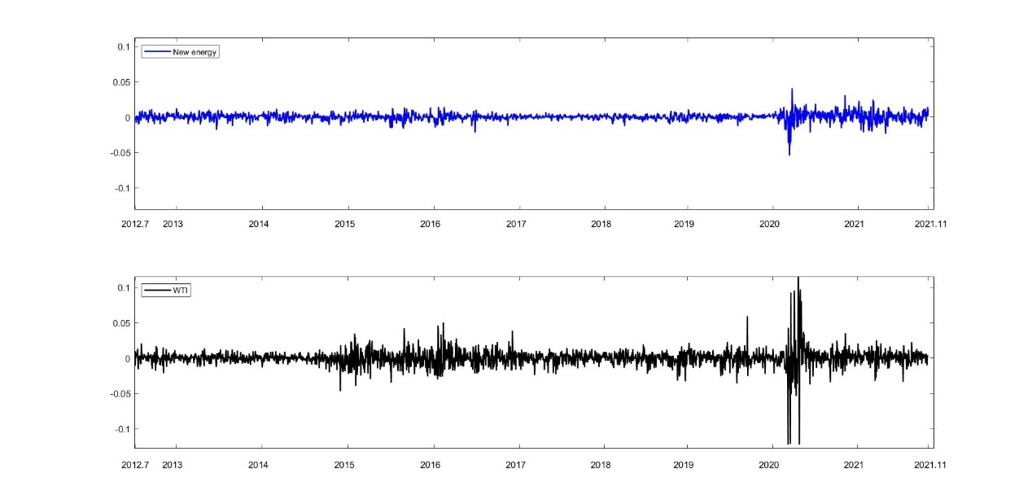
Fig. 1. Dynamics of daily returns of NEX and WTI.
Notes: The blue line plots the returns of NEX over the full sample period, and the black line indicates the WTI future returns. Sample period: July 9, 2012-November 1, 2021.

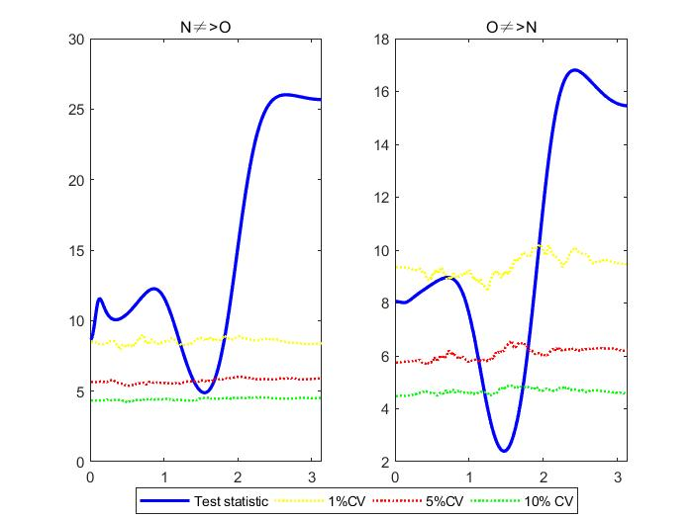
Fig. 2. Conventional frequency-domain Granger causality between NEX and WTI.
Notes: N stands for NEX, and O is WTI. The null hypothesis of $N⇏O$ means N does not Granger-cause O by the conventional method. The blue line denotes the Wald test statistic value. Yellow, red, and green denote bootstrap CVs of 1%, 5%, and 10%, respectively. For example, if the blue line is higher than the red line, then $N$ is said to significantly ‘‘Granger cause’’ the $O$ at frequency ω.
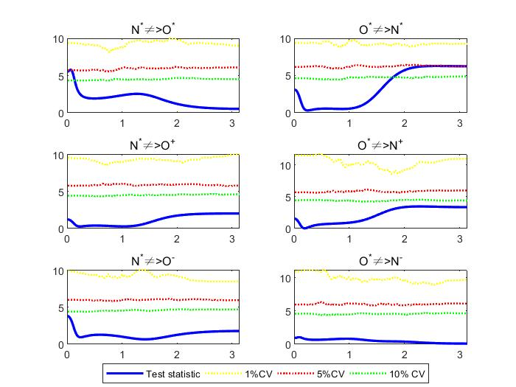
Fig. 3. Frequency-domain Granger causality from normal shocks to different shocks.
Notes: N stands for NEX, and O is WTI. $N^{-}$, $N^{*},$ and $N^{+}$ ($O^{-}$, $O^{*}$ and $O^{+}$) denote the negative extreme, normal, and positive extreme shocks of NEX (WTI), respectively. The blue line denotes the Wald test statistic value. Yellow, red, and green denote bootstrap CVs of 1%, 5%, and 10%, respectively. For example, normal shocks of NEX cannot Granger-cause the normal oil shocks at all frequencies.
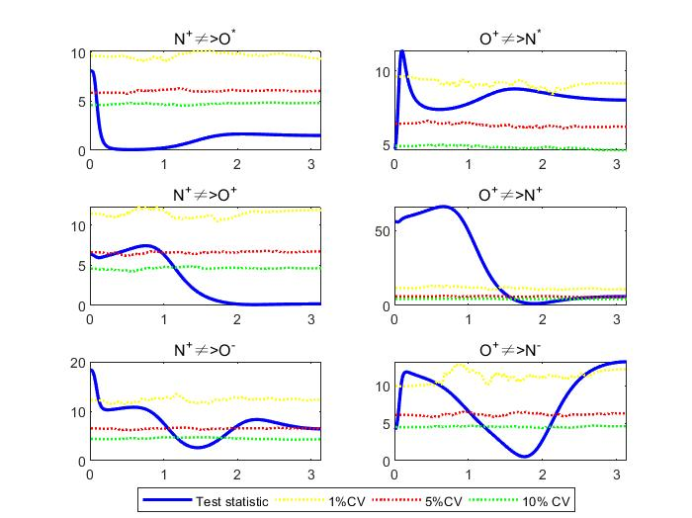
Fig. 4. Frequency-domain Granger causality from extremely positive shocks to different shocks.
Notes: N stands for NEX, and O is WTI. $N^{-}$, $N^{*},$ and $N^{+}$ ($O^{-}$, $O^{*}$ and $O^{+}$) denote the negative extreme, normal, and positive extreme shocks of NEX (WTI), respectively. The blue line denotes the Wald test statistic value. Yellow, red, and green denote bootstrap CVs of 1%, 5%, and 10%, respectively. For example, the null hypothesis of $N^{+}⇏O^{*}$ is difficult to reject at all frequencies.
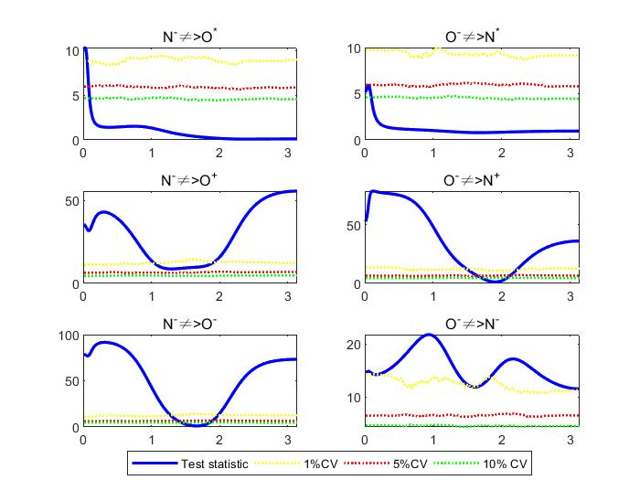
Fig. 5. Frequency-domain Granger causality from extremely negative shocks to different shocks.
Notes: N stands for NEX, and O is WTI. $N^{-}$, $N^{*},$ and $N^{+}$ ($O^{-}$, $O^{*}$ and $O^{+}$) denote the negative extreme, normal, and positive extreme shocks of NEX (WTI), respectively. The blue line denotes the Wald test statistic value. Yellow, red, and green denote bootstrap CVs of 1%, 5%, and 10%, respectively. For example, the null hypothesis of $O^{-}⇏N^{*}$ cannot be rejected at all frequencies.
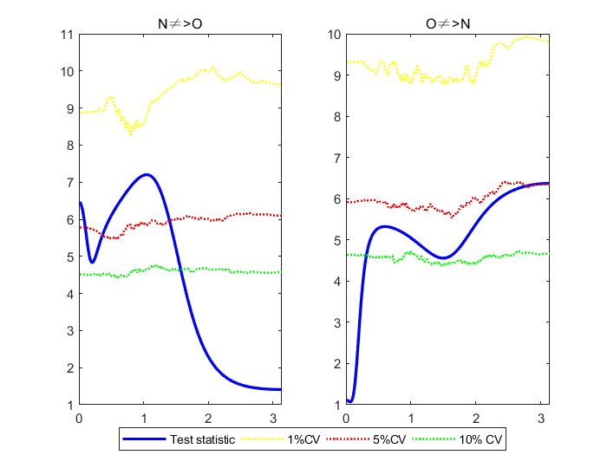
Fig. 6. Conventional frequency-domain Granger causality between NEX and WTI before the COVID-19 pandemic.
Notes: N stands for NEX, and O is WTI. The null hypothesis of $N⇏O$ means N does not Granger-cause O by the conventional method. The blue line denotes the Wald test statistic value. Yellow, red, and green denote bootstrap CVs of 1%, 5%, and 10%, respectively. For example, if the blue line is higher than the red line, then $N$ is said to significantly ‘‘Granger cause’’ the $O$ at frequency ω.

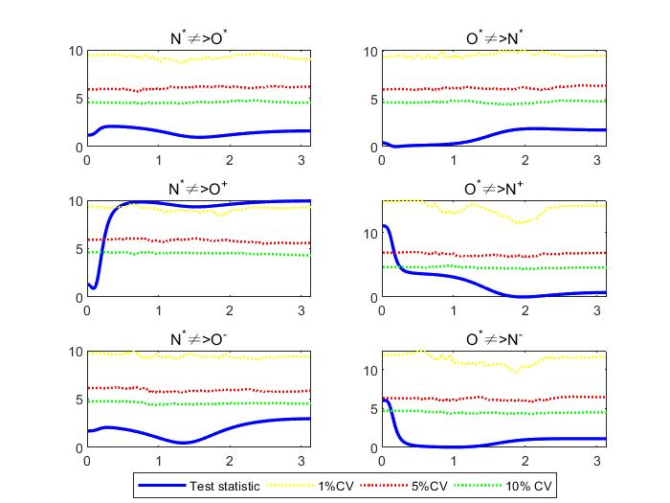
Fig. 7. Frequency-domain Granger causality from normal shocks to different shocks before the COVID-19 pandemic.
Notes: N stands for NEX, and O is WTI. $N^{-}$, $N^{*},$ and $N^{+}$ ($O^{-}$, $O^{*}$ and $O^{+}$) denote the negative extreme, normal, and positive extreme shocks of NEX (WTI), respectively. The blue line denotes the Wald test statistic value. Yellow, red, and green denote bootstrap CVs of 1%, 5%, and 10%, respectively. For example, normal shocks of NEX cannot Granger-cause the normal oil shocks at all frequencies.
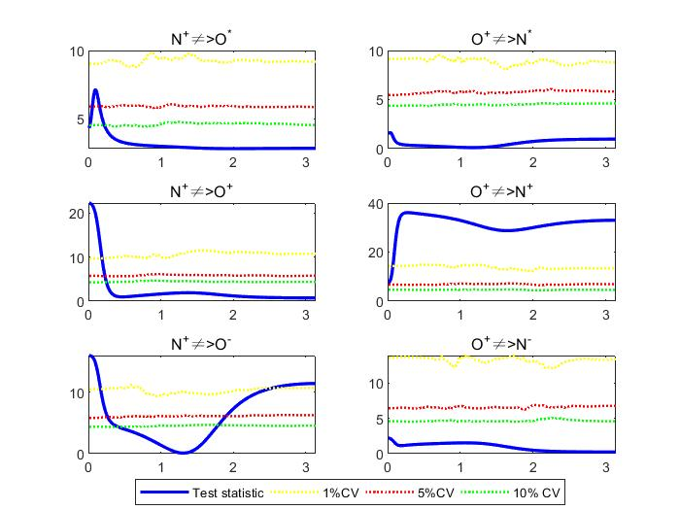
Fig. 8. Frequency-domain Granger causality from extremely positive shocks to different shocks before the COVID-19 pandemic.
Notes: N stands for NEX, and O is WTI. $N^{-}$, $N^{*},$ and $N^{+}$ ($O^{-}$, $O^{*}$ and $O^{+}$) denote the negative extreme, normal, and positive extreme shocks of NEX (WTI), respectively. The blue line denotes the Wald test statistic value. Yellow, red, and green denote bootstrap CVs of 1%, 5%, and 10%, respectively. For example, the null hypothesis of $N^{+}⇏O^{*}$ is difficult to reject at all frequencies.

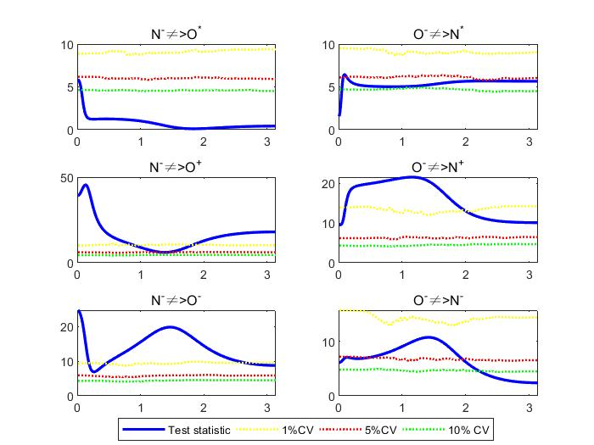
Fig. 9. Frequency-domain Granger causality from extremely negative shocks to different shocks before the COVID-19 pandemic.
Notes: N stands for NEX, and O is WTI. $N^{-}$, $N^{*},$ and $N^{+}$ ($O^{-}$, $O^{*}$ and $O^{+}$) denote the negative extreme, normal, and positive extreme shocks of NEX (WTI), respectively. The blue line denotes the Wald test statistic value. Yellow, red, and green denote bootstrap CVs of 1%, 5%, and 10%, respectively. For example, the null hypothesis of $O^{-}⇏N^{*}$ cannot be rejected at all frequencies.

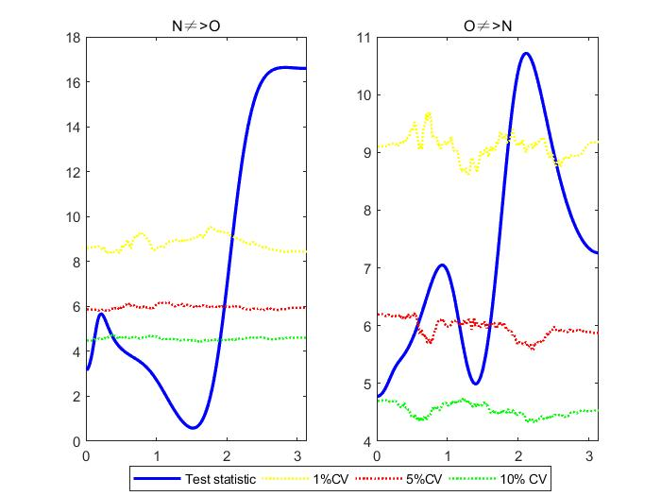
Fig. 10. Conventional frequency-domain Granger causality between NEX and WTI during the COVID-19 pandemic.
Notes: N stands for NEX, and O is WTI. The null hypothesis of $N⇏O$ means N does not Granger-cause O by the conventional method. The blue line denotes the Wald test statistic value. Yellow, red, and green denote bootstrap CVs of 1%, 5%, and 10%, respectively. For example, if the blue line is higher than the red line, then $N$ is said to significantly ‘‘Granger cause’’ the $O$ at frequency ω.
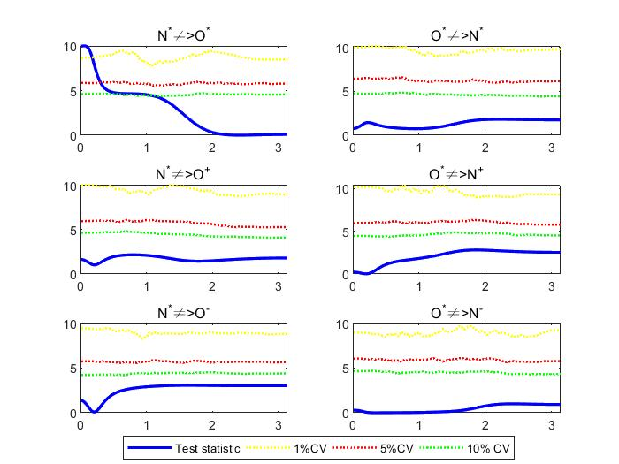
Fig. 11. Frequency-domain Granger causality from normal shocks to different shocks during the COVID-19 pandemic.
Notes: N stands for NEX, and O is WTI. $N^{-}$, $N^{*},$ and $N^{+}$ ($O^{-}$, $O^{*}$ and $O^{+}$) denote the negative extreme, normal, and positive extreme shocks of NEX (WTI), respectively. The blue line denotes the Wald test statistic value. Yellow, red, and green denote bootstrap CVs of 1%, 5%, and 10%, respectively. For example, normal shocks of NEX cannot Granger-cause the normal oil shocks at all frequencies.
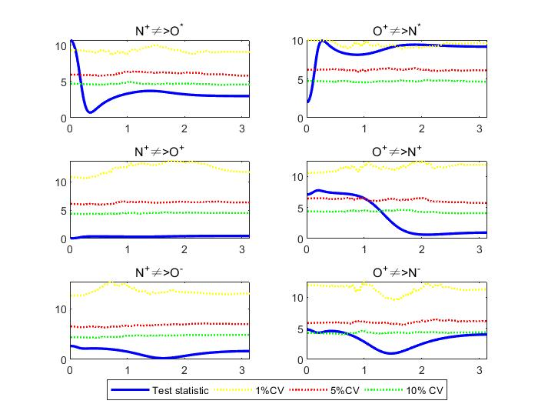
Fig. 12. Frequency-domain Granger causality from extremely positive shocks to different shocks during the COVID-19 pandemic.
Notes: N stands for NEX, and O is WTI. $N^{-}$, $N^{*},$ and $N^{+}$ ($O^{-}$, $O^{*}$ and $O^{+}$) denote the negative extreme, normal, and positive extreme shocks of NEX (WTI), respectively. The blue line denotes the Wald test statistic value. Yellow, red, and green denote bootstrap CVs of 1%, 5%, and 10%, respectively. For example, the null hypothesis of $N^{+}⇏O^{*}$ is difficult to reject at all frequencies.

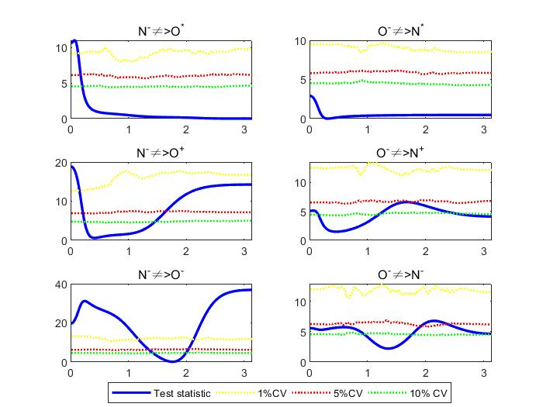
Fig. 13. Frequency-domain Granger causality from extremely negative shocks to different shocks before the COVID-19 pandemic.
Notes: N stands for NEX, and O is WTI. $N^{-}$, $N^{*},$ and $N^{+}$ ($O^{-}$, $O^{*}$ and $O^{+}$) denote the negative extreme, normal, and positive extreme shocks of NEX (WTI), respectively. The blue line denotes the Wald test statistic value. Yellow, red, and green denote bootstrap CVs of 1%, 5%, and 10%, respectively. For example, the null hypothesis of $O^{-}⇏N^{*}$ cannot be rejected at all frequencies.

The information criterion: $HJC=\ln\left(\left|{\hat{Ω}}_{j}\right|\right)+j\left(\frac{n^{2}lnT+2n^{2}ln⁡(lnT)}{2T}\right), j=0, …, p$ (Hatemi-J, 2003).

