Impact of priming interval on reactogenicity, peak immunological response and waning after homologous and heterologous COVID-19 vaccine schedules: Exploratory analyses of Com-COV, a randomised control trial
Robert H Shaw*^^{1,2}, MRCP; Xinxue Liu*¹, PhD; Arabella SV Stuart*^{1,2}, MSc; Melanie Greenland*¹, MSc; Parvinder K Aley¹, PhD; Nick J. Andrews^{3,4}, PhD; J. Claire Cameron⁵, FFPH; Sue Charlton⁶, PhD; Elizabeth A. Clutterbuck, PhD¹; Andrea M Collins⁷, PhD; Wanwisa Dejnirattisai⁸, PhD; Tanya Dinesh¹, MSci; Saul N Faust⁹, PhD; Daniela M Ferreira⁷, PhD; Adam Finn¹⁰,PhD; Christopher A Green¹¹, DPhil; Bassam Hallis⁶, PhD; Paul T Heath¹², FRCPCH; Helen Hill⁷, PhD; Teresa Lambe^{1,13}, PhD; Rajeka Lazarus¹⁴, DPhil; Vincenzo Libri¹⁵, MD; Fei Long¹, MSc; Yama F Mujadidi¹, MSc; Emma L Plested¹; Ella R Morey¹, ; Samuel Provstgaard-Morys¹, BSc; Maheshi N Ramasamy^{1,2}, DPhil; Mary Ramsay⁴, FFPH; Robert C Read⁹ MD; Hannah Robinson¹, RN; Gavin R Screaton^{8,13}, PhD; Nisha Singh¹, DPhil; David PJ Turner¹⁶, PhD; Paul J Turner, PhD¹⁷; Iason Vichos¹, MSc; Laura L Walker¹; Rachel White¹, RN; Jonathan S Nguyen-Van-Tam¹⁸, DM; Matthew D Snape^{1,19^}, MD; and the Com-COV Study Group†
- Oxford Vaccine Group, Department of Paediatrics, University of Oxford, Oxford, UK
- Oxford University Hospitals NHS Foundation Trust, Oxford, UK
- Statistics, Modelling and Economics Department, UK Health Security Agency, London, UK
- Immunisation and Countermeasures Division, National Infection Service, UK Health Security Agency, London, UK
- Public Health Scotland, Glasgow/Edinburgh, Scotland, UK
- UK Health Security Agency, Porton Down, Salisbury, UK
- Liverpool School of Tropical Medicine, Liverpool, UK
- Wellcome Centre for Human Genetics, Nuffield Department of Medicine, University of Oxford, Oxford, UK
- NIHR Southampton Clinical Research Facility and Biomedical Research Centre, University Hospital Southampton NHS Foundation Trust, Southampton, UK; Faculty of Medicine and Institute for Life Sciences, University of Southampton, Southampton, UK
- Bristol Vaccine Centre, Schools of Population Health Sciences and Cellular and Molecular Medicine, University of Bristol, Bristol, UK
- NIHR/Wellcome Trust Clinical Research Facility, University Hospitals Birmingham NHS Foundation Trust, Birmingham, UK
- The Vaccine Institute, St. George's University of London, Cranmer Terrace, London, UK
- Chinese Academy of Medical Science (CAMS) Oxford Institute (COI), University of Oxford, Oxford, UK
- North Bristol NHS Trust, Southmead Road, Bristol BS10 5NB, UK
- NIHR UCLH Clinical Research Facility and NIHR UCLH Biomedical Research Centre, University College London Hospitals NHS Foundation Trust, London, UK
- University of Nottingham, Nottingham, NG7 2RD, UK; Nottingham University Hospitals NHS Trust, Nottingham, UK
- National Heart & Lung Institute, Imperial College London, Dovehouse St, London, UK
- Division of Epidemiology and Public Health, University of Nottingham School of Medicine, Nottingham, NG7 2UH, UK
- Oxford NIHR – Biomedical Research Centre, Oxford University Hospitals NHS Foundation Trust, Oxford, OX3 9DU, UK
*Contributed equally and should be regarded as joint first author
^ Corresponding author - Robert H. Shaw, Oxford Vaccine Group, Department of Paediatrics, University of Oxford, Oxford, UK, robert.shaw@paediatrics.ox.ac.uk, Phone 01865 611400
†Com-COV Study Group authorship - appendix

Abstract

Background

Priming COVID-19 vaccine schedules have been deployed at variable intervals globally, which may influence immune persistence and the relative importance of third-dose ‘booster’ programmes. Here, we report on the impact of 4- versus 12-week priming intervals on reactogenicity and the persistence of immune response up to 6 months following homologous and heterologous priming schedules using BNT162b2 (BNT, tozinameran, Comirnaty, Pfizer/BioNTech) and ChAdOx1 nCoV-19 (ChAd, Vaxzevria, AstraZeneca).

Methods
Com-COV is a participant-blinded, randomised immunogenicity trial. Results are reported here for the ‘General’ cohort, in which adults aged over 50 years were randomised to four homologous and heterologous schedules using BNT and ChAd with 4- or 12-week priming intervals. Immunogenicity analyses were on the intention-to-treat population (ITT), without evidence of COVID-19 infection at baseline or for the trial duration, with the purpose of describing the effect of priming interval on humoral and cellular immune response at peak and later timepoints, in addition to the effects on reactogenicity and safety

Findings
Between 11th–26th Feb 2021, 730 participants were randomised in the general cohort, with 77-89 per arm in the ITT analysis. At 28-days and 6-months post-second dose, the geometric mean concentration (GMC) of anti-SARS-CoV-2 spike IgG was significantly higher in 12- versus 4-week interval arms for homologous schedules. In heterologous arms, there was only a significant difference between intervals for the BNT/ChAd arm at 28-days. Pseudotyped virus neutralisation titres were significantly higher in all 12-week versus 4-week schedules, 28-days post-second dose, with geometric mean ratios 1.4 (95%CI: 1.1-1.8, BNT/BNT), 1.5 (95%CI: 1.2-1.9, ChAd/BNT), 1.6 (95%CI 1.3-2.1, BNT/ChAd) and2.4 (95%CI: 1.7-3.2, ChAd/ChAd). At 6 months post-second dose, anti-spike IgG GMCs fell to 0.17-0.24 of the 28-day post-second dose value across all eight study arms, with only BNT/BNT displaying a slightly slower decay for the 12-week versus 4-week schedule in the adjusted analysis. The rank order of schedules by humoral response was unaffected by interval with BNT/BNT remaining the most immunogenic by antibody response. T-cell responses were reduced in all 12-week priming intervals versus their 4-week counterparts. 12-week schedules for BNT/BNT and ChAd/BNT schedules were up to 80% less reactogenic than 4-week schedules.

Interpretation
These data support flexibility in priming interval in all studied COVID-19 vaccine schedules. Longer priming intervals may result in lower reactogenicity in schedules with BNT as a second-dose and higher humoral immunogenicity in homologous schedules, but overall lower T-cell responses across all schedules. Future vaccines employing these novel platforms may benefit from prolonged-interval schedules. ISRCTN:69254139, EudraCT:2020-005085-33.

Funding
Funded by the UK Vaccine Taskforce and National Institute for Health Research.

Introduction
Com-COV is a participant-blinded randomised study investigating the safety, reactogenicity and immunogenicity of heterologous and homologous primary COVID-19 immunisation schedules using BNT162b2 (tozinameran, Comirnaty, Pfizer/BioNTech, hereafter BNT) and ChAdOx1 nCoV-19 (Vaxzevria, AstraZeneca, hereafter ChAd). Previously reported data from 4-week interval schedules show greater systemic reactogenicity in heterologous schedules (1,2). At 28 days following the second dose, anti-SARS-CoV-2 IgG concentrations were highest in the homologous BNT/BNT and heterologous ChAd/BNT schedules, whereas measured T-cell responses at 14- and 28-days post-second dose were highest in the ChAd/BNT schedule.
Based on the primary findings of Com-COV and other studies (1-4), the World Health Organisation has issued guidance on the use of heterologous COVID vaccination (5) and many national primary immunisation campaigns have deployed schedules using combinations of viral vector and mRNA vaccines (6-8). Pressures on vaccine supply and logistical difficulties in global vaccine distribution (9) have resulted in many national vaccine programmes, including the UK (10), extending the priming interval beyond initial manufacturer recommendations (11). For ChAd/ChAd, this was supported by non-randomised, post-hoc trial analyses suggesting improved immunogenicity and efficacy (12), which contributed to the WHO recommendation to prolong the ChAd/ChAd interval from four to 8-12 weeks (13). Latterly, observational data from the UK Health Security Agency suggest that a prolonged priming interval increases both humoral immunogenicity and vaccine effectiveness for BNT/BNT, but does so less clearly for ChAd/ChAd, although analyses were confounded by significant differences in baseline populations (14).
To date there have been no published randomised data on the impact of short versus long intervals for primary immunisation on reactogenicity and initial immunogenicity of these vaccines, whether given in homologous or heterologous schedules. Similarly, there are no randomised data on the long-term maintenance of immunity against both ancestral and variant strains, which is of particular relevance in the context of many countries choosing to deploy ‘third dose’ booster immunisations due to concerns regarding waning vaccine effectiveness and in countries planning their primary immunisation programmes.
Accordingly, we present secondary analyses from Com-COV, examining the effect of interval on reactogenicity, peak immune response and waning of immune response, as these data are key to guiding national immunisation programmes’ decisions for priming interval as well as if and when to deliver booster programmes. Additionally, we present the effect of prophylactic paracetamol on reactogenicity and immunogenicity given previous concerns about increased reactogenicity following 4-week heterologous versus homologous schedules.

Methods

Trial Design & Oversight, Participants, Laboratory Methods, Treatments, Endpoints, Safety
The trial (ISRCTN: 69254139, protocol available https://comcovstudy.org.uk/ and in supplementary appendix) has been previously reported (2). In brief, two COVID-19 vaccines were used: ChAd and BNT. In the general cohort, participants (N=730) were randomised to one of four permutations of priming schedules (ChAd/ChAd, ChAd/BNT, BNT/BNT, BNT/ChAd), at two priming intervals (4 and 12 weeks). An additional immunology cohort of participants (N=100) were separately randomised to 4-week arms only with extra early study visits to characterise the initial cellular response. Randomisation and masking are described in the appendix. The trial was approved by the South-Central Berkshire Research Ethics Committee (21/SC/0022), the University of Oxford, the Medicines and Healthcare Products Regulatory Agency (MHRA) and the NHS Research Ethics Service (UK Human Research Authority). An independent data safety monitoring board (DSMB) reviewed safety data, and local trial-site physicians provided oversight of all adverse events in real-time.
Given concerns regarding increased reactogenicity with heterologous 4-week schedules, the study protocol was amended to include a voluntary paracetamol sub-study for participants receiving their second dose at a 12-week interval, at the point of their second dose. Consenting participants were randomised to receive advice to take a) paracetamol soon after immunisation, and three further doses over the next 24 hours regardless of symptoms (prophylactic paracetamol) or b) paracetamol if they became symptomatic (reactive paracetamol). Participant e-diaries were monitored with three additional ‘yes-no’ questions regarding the impact on daily activities.
COVID-19 vaccine-naïve adults aged 50 years and older, with no or well-controlled mild-moderate comorbidities and no history of laboratory confirmed SARS-CoV-2 infection were eligible. Full inclusion and exclusion criteria are in the protocol. Adverse events (AEs) were collected as per study protocol.
Anti-spike IgG, T-cell ELISpot and pseudotyped virus neutralising antibody titres, 28 days post-second dose in participants vaccinated at a 4-week interval have already been reported (2). The key outcomes reported in this manuscript are the effects of priming interval on these immunological outcomes and later timepoints.
Of note, the evaluation of persistence was impacted by the rapid roll out of the national third dose ‘booster’ campaign. Although final blood tests were brought forward to accommodate this, the final outcome was that only approximately half of the 4-week interval participants had their final visit and so data from this final visit was not used in the final interval comparison analysis. These comparisons are therefore conducted on the 5-month timepoint, post-second dose for the 4-week participants and a 6-month timepoint for 12-week participants, although the timing of this visit was more variable. The median time post-second dose were 5.1 and 6 months, respectively (hereafter, 6-month was used to refer to the time points in the 4-week and 12-week arms).
Assays have been previously described (2, 15-17). In brief, sera were analysed at Nexelis, (Laval, Canada) to determine SARS-CoV-2 anti-spike IgG concentrations by ELISA and 50% Neutralising Antibody Titre (NT₅₀) for SARS-CoV-2 pseudotype virus neutralisation assay (PNA), using a vesicular stomatitis virus backbone adapted to bear the spike protein of an ancestral SARS-CoV-2 strain (18). The conversion factors to international standard units can be found in the supplementary appendix. Sera were analysed at Porton Down, UK Health Security Agency, by ECLIA (Cobas platform, Roche Diagnostics) to determine anti-SARS-CoV-2 nucleocapsid IgG status. Interferon-gamma secreting T-cells specific to whole spike protein epitopes based on the ancestral Wuhan-Hu-1 sequence (YP_009724390.1) were detected on fresh samples using a modified T-SPOT-Discovery test performed at Oxford Immunotec (Abingdon, UK). The assay was repeated on frozen samples for the Wuhan-Hu-1 sequence as well as Beta (B.1.351) and Delta (B.1.617.2) variants (19). T cell frequencies were reported as spot forming cells (SFC) per 250,000 PBMCs with a lower limit of detection of one in 250,000 PBMCs, and these results multiplied by four to express frequencies per 10⁶ PBMCs. Microneutralisation assays (MNA) to determine 50% focus reduction neutralisation titres (FRNT₅₀) for live SARS-CoV-2 virus lineages (SARS-CoV-2/human/AUS/VIC01/2020, Beta B.1.351, Delta B.1.617.1 and Omicron B.1.1.529) were performed at the University of Oxford.
Participants who tested positive for SARS-CoV2 during the trial (symptomatic or asymptomatic) were reviewed at an additional safety visit.
The study is funded by the UK Government through the National Institute for Health Research (NIHR) and the Vaccine Task Force (VTF). The funders had no role in data collection, analysis, interpretation, analysis of the manuscript or decision to submit.

Statistical analysis
The sample size calculation has been described in the previous report (2). The focus of this further manuscript is an exploratory analysis of the original trial, evaluating the impact of interval on different vaccine schedules and therefore no formal sample size power calculation was conducted for this analysis. All analyses were conducted on an intention-to-treat (ITT) basis. The immunogenicity analysis population consists of participants with no evidence of COVID-19 infection, defined as self-reported COVID-19 infection or anti-nucleocapsid IgG ≥1.0, up until 6-months post second dose. For the 28 days post-second dose timepoint, the geometric mean ratio (GMR) with 95% confidence intervals (CI) was calculated as the antilogarithm of the difference between the mean of the log₁₀ transformed titre in the 12-week interval arm with the 4-week arm as reference, after adjusting for study site as a randomisation stratification variable and paracetamol usage in the first 24 hours post-second dose in the linear regression model (as only 12-week arms were randomised to the paracetamol sub-study). Since the timing of the 6-month post second dose visit was slightly different between 4- and 12-week interval arms, we further adjusted the day post-second dose in the linear regression model to estimate the GMR for the 6-month post-second dose timepoint. Sensitivity analyses included participants in the immunology cohort. The interactions between schedules (heterologous/homologous) and intervals (4-week/12-week) were further explored by the above linear regression model after further adjusting for age, sex and ethnicity. Subgroup analyses were conducted by age, sex and baseline comorbidities. P values for interaction between subgroups and interval were reported using the Wald test, and the two-sided significance level for interaction was set at 0.0014 using Bonferroni correction (36 interaction tests). Due to the rollout of the national 3rd dose ‘booster’ vaccine programme, it was expected the proportion of withdrawals in the 12-week interval group would be higher than the 4-week interval group at the visit conducted 6 months post 2nd dose. Accordingly, the immunogenicity at 28 days and 3 months post 2nd dose were compared between participants with missing versus available data at 6-months to explore any potential bias caused by the missing data.
The analysis population for safety and reactogenicity included all participants who had received at least one dose of study vaccine. To describe the presence/absence of each solicited AE, logistic regression models were fitted, adjusting for study site and any paracetamol use in the first 24 hours to evaluate the impact of interval on reactogenicity. In the paracetamol sub-study amongst 12-week interval participants, the analysis population was all participants consented to the sub-study with available endpoint data. The analyses were conducted on an ITT basis and the comparisons for reactogenicity and immunogenicity between prophylactic and reactive paracetamol use arms were reported following the statistical analysis above using prophylactic paracetamol arm as the reference.

All statistical analyses were carried out using R version 4.1.1 (2021-08-10), SAS v9.4 and Stata 17.

Results

Demographics
Between 11th-26th February 2021, 975 participants were screened at eight study sites across England, of whom 830 were randomised into the study. Of these, 100 participants were separately randomised into the immunology cohort, with a 4-week interval (Supplementary Table 1) and 730 were enrolled into the general cohort (Table 1). Within the general cohort, participants were randomised to one of eight arms. The mean age of participants in the general cohort was 58.0 years (SD 4.7) with 44.2% female participants and 22.6% from non-Caucasian ethnic backgrounds. Baseline characteristics were well-balanced across all arms, with the exception of comorbidity frequency. After excluding 36 participants who were seropositive at baseline and another 30 participants with evidence of COVID-19 infection before 6 months post second dose within the trial, the immunogenicity analysis to compare 4-week and 12-week interval arms included 664 participants (Supplementary Figure 1).

Immunogenicity
Homologous schedules, ChAd/ChAd and BNT/BNT, had significantly increased anti-spike binding IgG titre in 12- versus 4-week schedules at both 28 days and 6 months post-second dose. This was true only at 28 days for BNT/ChAd and there was no statistically significant difference between intervals for ChAd/BNT at either timepoint (Figures 1 & 2, Supplementary Figure 2). All schedules showed a statistically significant increase with the 12-week interval in pseudotyped virus neutralisation titre against the Victoria strain at 28 days post-second dose, with GMRs of 1.4 (95%CI: 1.1-1.8, BNT/BNT), 1.5 (95%CI: 1.2-1.9, ChAd/BNT), 1.6 (95%CI 1.3-2.1, BNT/ChAd) and 2.4 (95%CI: 1.7-3.2, ChAd/ChAd) (Figure 1). Overall, regardless of interval, the rank order of schedules (BNT/BNT, ChAd/BNT, BNT/ChAd followed by ChAd/ChAd) did not change post-second dose. However, the magnitude of difference between both sets of respective homologous and heterologous schedules was reduced in 12-week schedules (Supplementary Table 2). The decay rate of anti-spike IgG between 28 days and 6 months post-second dose were similar between the 4-week and 12-week interval arms, except that the 12-week interval showed a slightly slower decay rate compared with 4-week for BNT/BNT in the adjusted analysis. Similar levels of anti-spike IgG at 28-days and 3-month post-boost between those with and without 6-month post-boost anti-spike IgG data missing in the 12-week interval arms (Supplementary Table 3).
In contrast, T-cell ELISpot counts were all approximately one third lower in 12- vs 4-week schedules in ChAd/ChAd, BNT/BNT and ChAd/BNT, with a greater reduction of two thirds seen in BNT/ ChAd: GMR 0.35 (95% CI: 0.22-0.54). This difference was maintained at 6 months post second dose (Figure 1). Regardless of interval ChAd/BNT generated the highest cellular immune response, however the other three schedules converged at longer timepoints when the longer interval was used. ELISpot counts after the second dose, were comparable between intervals when measured from time after first dose for BNT/BNT, ChAd/BNT and ChAd/ChAd (Supplementary Figure 2).
Consistent results were observed in sensitivity analyses (Supplementary Figure 3) as well as by subgroup analysis for the impact of interval on humoral and cellular immunogenicity (Supplementary Figure 4).
Sera from 12-week participants show apparent reductions in neutralising titre against Beta, Delta and Omicron variants when compared to the Victoria strain at 28 days and 3 months post-second dose, (Supplementary Figure 5). There were no differences in the reduction of neutralising titres against variants of concern between the four arms, and hence no differences in the rank order of schedules. There were no differences in T-cell ELISpot count (Beta and Delta only) elicited across variants (Supplementary Table 4 & Supplementary Figure 6).
The paracetamol sub-study (Figure 3 & Supplementary Table 5 & Supplementary Figure 7) did not show a statistically significant advantage for reactive paracetamol over prophylactic paracetamol in terms of the magnitude of humoral immune response.

Reactogenicity
Extending the interval from 4 to 12 weeks dramatically reduced the frequency of nearly all systemic solicited adverse events in those receiving BNT as a second dose, regardless of prime by up to 80%. ChAd/ChAd reactogenicity was increased in the 12-week schedule, but given the low level of reactogenicity in the 4-week schedule, this absolute increase was small. The frequency of systemic solicited events in those receiving ChAd/BNTwas not affected, nor was the frequency or severity of local symptoms in any schedule (Figure 4). The 12-week heterologous schedules were therefore still associated with greater systemic reactogenicity than homologous schedules, but the magnitude of the difference was generally less than in 4-week schedules (Supplementary Figures 8 & 9), and was still limited to the first 48 hours (Supplementary Figure 10).
Within the paracetamol sub-study, performed amongst 12-week participants only, there was no difference in local symptoms between any study schedule for those advised for prophylactic versus reactive paracetamol. Headache was less frequently reported in all prophylactic paracetamol arms. The adherence of paracetamol usage in the prophylactic group was 88-98%, whereas the rates of reactive paracetamol usage in the first 24 hours varied 29-73% across schedules, mirroring their respective reactogenicity (Supplementary Table 6). BNT/ChAd was the most reactogenic schedule and had the largest reduction in frequency of systemic symptoms with prophylactic paracetamol, (Supplementary Figure 11). Observations were similar when comparing 4-week interval participants to either all 12-week participants or only those randomised to reactive paracetamol.
Advice for prophylactic or reactive paracetamol overall was not shown to affect activities of daily living, ability to attend work or the seeking of medical attention. Absolute numbers of those who were affected in this manner were low across all arms (Supplementary Figure 12).

Safety
Between enrolment and 22nd October 2021 there were 1004 adverse events in 462 participants (Supplementary Table 7), proportionally split across arms. Descriptions of all non-serious AEs of grade 3 or above are presented in Supplementary Table 8. There were five AEs of special interest (excluding SARS-CoV-2/COVID-19 events) (Supplementary Table 9) and eleven serious AEs across all arms (Supplementary Table 10). One of these was deemed possibly related to immunisation (IgA nephropathy/minimal change disease overlap, possibly precipitated by COVID-19 infection soon after first dose of BNT). The participant is under further follow up with regards to an ongoing fall in renal function. Forty participants tested positive for SARS-CoV-2 (all but four cases occurred at least 2 weeks post second dose). Combining over both intervals these were distributed by group as ChAd/ChAd (eleven), ChAd/BNT (nine), BNT/BNT (eleven), BNT/ChAd (seven) (Supplementary Table 11). No participants were hospitalised.

Discussion
Here we report the first randomised data elucidating the impact of interval and prophylactic paracetamol for homologous and heterologous priming schedules deploying ChAd and BNT. Prolonged intervals enhanced the maximal humoral neutralising immune response for all schedules, 28-days post-second dose. Statistically significant increases in binding antibody response were present only for ChAd/ChAd, BNT/BNT and BNT/ChAd at the same timepoint. The difference was maintained at the 6-month timepoint only in homologous schedules. Reduced cellular responses were observed for all schedules with a 12-week interval. Prolonged intervals additionally had a slightly reduced rate of antibody decay in BNT/BNT. Finally, prolonged intervals dramatically reduced second dose systemic reactogenicity in schedules with BNT as the second dose. There were no safety concerns.

Immunogenicity
The rank order of schedules of maximal or later humoral responses was not affected by interval, with the most immunogenic schedule remaining BNT/BNT, i.e. the vaccines which were used as part of the schedule had a greater effect on immunogenicity than changing the interval between doses. The larger proportional increase in humoral response in a prolonged interval for ChAd/ChAd may well translate into increased efficacy, as suggested by non-randomised data from a randomised control trial (12). Contrastingly, although an observational study of immunogenicity and national effectiveness (14) suggested that both of these increased with longer priming intervals for BNT/BNT, the effect was not as evident for ChAd/ChAd. However, this study was not randomised with significant differences between baseline vaccinated populations. This limitation also applies to the UK National COVID survey, which showed a contrasting finding of no impact of interval on effectiveness for BNT/BNT (20).
Despite some statistically significant results within the paracetamol sub-study, the small advantages noted in some assay read-outs are likely due to chance as a result of the large number of comparisons, with prophylactic paracetamol unlikely to have a significant impact on immunogenicity, although further work may be required to clarify this.
T-cell ELISpot counts were lower 28 days post-second dose for those with a 12-week interval than those with a 4-week interval. The biological significance of this reduction is unclear since in the UK programme, which predominantly used prolonged priming intervals, protection against severe disease has been maintained longer than protection against symptomatic infection (21), but these results are consistent with non-randomised studies (14,17). Interestingly, for the commonly used schedules (ChAd/ChAd, ChAd/BNT and BNT/BNT), the T-cell ELISpot level achieved after 12-week boost coincided with the waning level of T-cell response after 4-week schedule and followed the same waning trajectory, suggesting that the time from prime may play an important role in the T-cell response to the second antigenic exposure and this will require further exploratory immunological work to elucidate.

Reactogenicity
Schedules with a BNT second dose have lower reactogenicity with a prolonged interval, whereas ChAd/ChAd, which had a low level of second dose reactogenicity demonstrated a small increase. High rates of reactogenicity seem always to accompany the first exposure to the ChAd vaccine, regardless of whether this is the first or second vaccine dose. There is not a clear association between reactogenicity and immunogenicity.
Within the paracetamol sub-study, the clearest reduction in reactogenicity with prophylactic paracetamol was in the most reactogenic arm (BNT/ChAd), with lower baseline reactogenicity and small group sizes likely contributing to the lack of clear effect in other schedules. Liberal use of paracetamol in the reactive groups likely further reduced measurable differences. This sub-study also potentially confounds the reactogenicity interval comparison, as it will have increased overall paracetamol usage in 12-week schedules, however, comparison of 4-week to 12-week participants randomised to advice for reactive paracetamol revealed similar patterns and the comparisons between intervals were adjusted for paracetamol use. With these caveats, advice for prophylactic paracetamol might be considered for deployment routinely by national immunisation programmes and would be worth assessing in the context of ‘booster’ doses, as there was no substantial effect of advice for prophylactic paracetamol on immunogenicity demonstrated.

Limitations
The sample size of the trial was calculated to assess non-inferiority of the primary endpoints and was therefore not powered to detect significant differences amongst the additional assays conducted to assess immunological activity against variants. T-cell ELISpot assays on variants of concern were performed on frozen samples, by necessity, and this may adversely affect the sensitivity of the assay and therefore its ability to detect differences between variants of concern. Due to sample size and design, as well as low SARS-CoV2 positivity across all arms, our data do not allow comment on vaccine effectiveness. However, a Swedish nationwide cohort study (22) suggests that ChAd/mRNA schedules may be more effective than ChAd/ChAd. The applicability of these findings to a younger cohort is unclear, however, previous efficacy trials suggest the immunogenic differences after two doses, between older and younger adults were minimal, and the similarity with results from the PITCH study, suggests that our results might have broader external validity (17).

Conclusion
In conclusion, our study suggests that the choice of vaccines used in a COVID-19 priming schedule had a greater effect on immunogenicity than the dose interval. Nonetheless, both heterologous and homologous schedules utilising ChAd and BNT induce robust immune responses with a 12-week interval comparable or greater than the schedules with 4-week intervals, allowing for greater flexibility in vaccine deployment, both in terms of which vaccines are included in a schedule and interval. For BNT/BNT, a longer interval had a slightly slower rate of decay than its respective shorter interval counterpart. This may be relevant when considering how the waning of immunity may impact the decision for, and timing of, booster immunisation programmes. This may well indicate a difference in immunological development by challenging the immune response with a second antigenic exposure at a different point in the immune maturation process following priming and requires further investigation to elucidate.
National immunisation programmes will consider many factors when deciding how to deliver vaccine doses, including vaccine availability, risk of disruption to vaccine supply, healthcare infrastructure, current and projected rates of COVID-19 transmission and public health messaging. When comparing shorter to longer intervals, policy makers are faced with a decision for higher antibody levels sooner, which may be preferable in high transmission settings, when rapid deployment of vaccines is essential, logistically possible, and supply is abundant. Alternatively, lower levels of antibody initially, but a higher level subsequently and for longer, may be achievable in lower transmission settings and are potentially better suited to lower vaccine supply rates and constrained logistics. Importantly, this randomised controlled trial provides a robust evidence base on which to base these decisions. These unique data may also be used to optimise immunogenicity and minimise reactogenicity for future deployment of these novel platforms against non-COVID-19 pathogens.

Research in context

Evidence before this study
Rapid global roll out of multiple national COVID-19 immunisation programmes has resulted in a number of countries adopting varying schedules, including heterologous schedules. Vaccine supply and logistical constraints have also results in the interval between first and second doses being inconsistent. Previous Com-COV results have shown good humoral and cellular immune responses to all homologous and heterologous schedules involving ChAd and BNT when given at a 28-day priming interval, however, the impact of priming interval on immunogenicity is not fully understood. The original ChAd efficacy trial shows an increase in immunogenicity and efficacy with a prolonged priming interval and non-randomised data from the PITCH study suggest that prolonging priming interval in BNT/BNT modestly increases the humoral response and may have an impact on the profile of the cellular response, with the proportion of CD4 positive, IL-2 producing T-cells increasing with a prolonged priming – however, it is not clear whether this change in profile is due to the difference in interval difference or the time elapsed since first dose.
We searched PubMed for research articles published between database inception and 1st March 2022 using the search terms (COVID) AND (Vaccin*) AND ((Heterologous) OR (Interval)) NOT (BCG) with no language restrictions. Besides our previously published reactogenicity and immunogenicity results: There were five cohort studies which found variable increases in binding or neutralising antibody titre ranging from 1.5 to 9 times greater in longer compared to shorter interval groups . Additionally, a further cohort study found no difference in antibody response for interval for inactivated vaccines. All these studies were non-randomised with differences in their baseline populations as well as significant variability in the priming intervals received by their participants as well as the timing of antibody level measurement. Aside from the PITCH consortium, all these studies suffered from very low numbers of participants. None of these studies evaluated vaccine schedules other than those including only mRNA vaccines.
Three statistical modelling studies took into account the overall benefit of prolonging priming interval without considering differences in immune response, with one suggesting that delaying the second dose to approximately 12 weeks would have a positive impact on death and hospitalisation in the context of increasing numbers of cases.

Added Value of this study
We report the results on immunogenicity, reactogenicity and safety of the first participant-blinded randomised clinical trial using two vaccines approved by WHO for emergency use, ChAd and BNT, when administered at a 12-week interval in heterologous and homologous vaccine schedules (ChAd/ChAd, ChAd/BNT, BNT/BNT, BNT/ChAd), which more closely mirrors the real-world vaccine roll out across many different countries. We also show the impact of prolonging priming interval on reactogenicity, peak immune response and decay rate of these schedules. The maximal humoral responses in the 12-week schedule were all at least as great as those in the equivalent 4-week schedules and the decay rate of humoral response was reduced in the prolonged BNT/BNT schedule. Reactogenicity at the second dose was dramatically reduced in 12-week schedules with BNT as a second-dose. This lends support to the decision by many national immunisation programmes to add flexibility to the priming interval and informs future vaccine development for non-COVID pathogens. No safety concerns were raised.

Implications of all the available evidence
Delivery of COVID-19 vaccines to large proportions of the world has large logistical implications especially in low and middle income countries whose healthcare and public health infrastructures may not be as robust. The results from this study support flexibility in use both of heterologous priming schedules as well as prolongation of priming interval, which may help to mitigate some of these logistical challenges. There is also evidence that, where feasible, prolonged interval schedules may be preferable in order to increase the magnitude of humoral response and reduce the rate of humoral decay, which may ultimately correlate with better levels of protection against COVID-19 over time. These data will inform the development of future vaccines and vaccine schedules against non-COVID pathogens.

Author Contributions
MDS and JSN-V-T conceived the trial and MDS is the chief investigator. MDS, AS, RHS, and XL contributed to the protocol and design of the study. AS, EP and RHS led the implementation of the study. XL, RHS and MG conducted the statistical analysis and have verified the underlying data. AS, RHS, MG, XL and MDS drafted the report. All other authors contributed to the implementation and data collection. All authors reviewed and approved the final report.

Declaration of interests
MDS acts on behalf of the University of Oxford as an Investigator on studies funded or sponsored by vaccine manufacturers including AstraZeneca, GlaxoSmithKline, Pfizer, Novavax, Janssen, Medimmune, and MCM vaccines. He receives no personal financial payment for this work. JSN-V-T is seconded to the Department of Health and Social Care (DHSC), England. AMC and DMF are investigators on studies funded by Pfizer and Unilever. They receive no personal financial payment for this work. AF is a member of the Joint Committee on Vaccination and Immunisation and Chair of the WHO European Technical Advisory Group of Experts (ETAGE) on Immunisation. He is an investigator and/or provides consultative advice on clinical trials and studies of COVID-19 vaccines produced by AstraZeneca, Janssen, Valneva, Pfizer and Sanofi and of other vaccines from these and other manufacturers including GSK, VPI, Takeda and Bionet Asia. He receives no personal remuneration or benefits for any of this work. SNF acts on behalf of University Hospital Southampton NHS Foundation Trust as an Investigator and/or providing consultative advice on clinical trials and studies of COVID-19 and other vaccines funded or sponsored by vaccine manufacturers including Janssen, Pfizer, AstraZeneca, GlaxoSmithKline, Novavax, Seqirus, Sanofi, Medimmune, Merck and Valneva vaccines and antimicrobials. He receives no personal financial payment for this work. PTH acts on behalf of St. George’s University of London as an Investigator on clinical trials of COVID-19 vaccines funded or sponsored by vaccine manufacturers including Janssen, Pfizer, AstraZeneca, Novavax and Valneva. He receives no personal financial payment for this work. CAG acts on behalf of University Hospitals Birmingham NHS Foundation Trust as an Investigator on clinical trials and studies of COVID-19 and other vaccines funded or sponsored by vaccine manufacturers including Janssen, Pfizer, AstraZeneca, Novavax, CureVac, Moderna, and Valneva vaccines, and receives no personal financial payment for this work. VL acts on behalf of University College London Hospitals NHS Foundation Trust as an Investigator on clinical trials of COVID-19 vaccines funded or sponsored by vaccine manufacturers including Pfizer, AstraZeneca and Valneva. He receives no personal financial payment for this work. TL is named as an inventor on a patent application covering this SARS-CoV-2 vaccine and is an occasional consultant to Vaccitech unrelated to this work. Oxford University has entered into a partnership with AstraZeneca for further development of ChAdOx1 nCoV-19. The views expressed in this manuscript are those of its authors and not necessarily those of DHSC, VTF or NIHR.

Data sharing
The study protocol is provided in the appendix. Individual participant data will be made available when the trial is complete, upon requests directed to the corresponding author; after approval of a proposal, data can be shared through a secure online platform.

Acknowledgments
The study is funded by the UK Government through the National Institute for Health Research (NIHR) and the Vaccine Task Force (VTF). This research was supported by the NIHR Oxford Biomedical Research Centre and delivered through the NIHR funded National Immunisation Schedule Evaluation Consortium (NISEC). MDS and SNF are NIHR Senior Investigators. The views expressed are those of the author(s) and not necessarily those of the NIHR or the Department of Health and Social Care. The investigators express their gratitude for the contribution of all the trial participants, the invaluable advice of the international Data Safety Monitoring Board. We additionally acknowledge the broader support from the various teams within the University of Oxford including the Department of Paediatrics, Clinical Trials Research Governance, Research Contracts and Public Affairs Directorate.

References
1. Shaw RH, Stuart A, Greenland M, Liu X, Van-Tam JSN, Snape MD, et al. Heterologous prime-boost COVID-19 vaccination: initial reactogenicity data. The Lancet [Internet]. 2021 May 12 [cited 2021 May 21];0(0). Available from: http://www.ncbi.nlm.nih.gov/pubmed/33991480
2. Liu X, Shaw RH, Stuart AS v, Greenland M, Aley PK, Andrews NJ, et al. Safety and immunogenicity of heterologous versus homologous prime-boost schedules with an adenoviral vectored and mRNA COVID-19 vaccine (Com-COV): a single-blind, randomised, non-inferiority trial. The Lancet [Internet]. 2021 Aug [cited 2021 Aug 11];0(0). Available from: http://www.thelancet.com/article/S0140673621016949/fulltext
3. Hillus D, Schwarz T, Tober-Lau P, Vanshylla K, Hastor H, Thibeault C, et al. Safety, reactogenicity, and immunogenicity of homologous and heterologous prime-boost immunisation with ChAdOx1 nCoV-19 and BNT162b2: a prospective cohort study. The Lancet Respiratory Medicine [Internet]. 2021 Aug [cited 2021 Aug 20];0(0). Available from: http://www.thelancet.com/article/S221326002100357X/fulltext
4. Borobia A, Carcas A, Pérez-Olmeda M, Castaño L, Bertran M, García-Pérez J, et al. Immunogenicity and reactogenicity of BNT162b2 booster in ChAdOx1-S-primed participants (CombiVacS): a multicentre, open-label, randomised, controlled, phase 2 trial. The Lancet [Internet]. 2021 Jul 10 [cited 2021 Aug 20];398(10295):121–30. Available from: https://pubmed.ncbi.nlm.nih.gov/34181880/
5. World Health Organisation (WHO). Interim recommendations for heterologous COVID-19 vaccine schedules [Internet]. World Health Organisation (WHO). 2021 [cited 2022 Feb 23]. Available from: https://www.who.int/publications/i/item/WHO-2019-nCoV-vaccines-SAGE-recommendation-heterologous-schedules
6. Danish Health Authority (Sundehedsstyrelesn). Denmark continues its vaccine rollout without the COVID-19 vaccine from AstraZeneca [Internet]. Sundehedsstyrelesn. 2021 [cited 2021 May 20]. Available from: https://www.sst.dk/en/english/corona-eng/vaccination-against-covid-19/astrazeneca-vaccine-paused
7. French Health Authority (Haute Autorité de Santé). Covid-19 : quelle stratégie vaccinale pour les moins de 55 ans ayant déjà reçu une dose d’AstraZeneca ? [Internet]. Haute Autorité de Santé. 2021 [cited 2021 May 20]. Available from: https://www.has-sante.fr/jcms/p_3260335/en/covid-19-quelle-strategie-vaccinale-pour-les-moins-de-55-ans-ayant-deja-recu-une-dose-d-astrazeneca
8. Public Health Agency of Sweden (Folkhalsomyndigheten). Information on the use of the Astra Zeneca vaccine in the vaccination of people 65 and older [Internet]. Folkhalsomyndigheten. 2021 [cited 2021 May 20]. Available from: https://www.folkhalsomyndigheten.se/the-public-health-agency-of-sweden/communicable-disease-control/covid-19/vaccination-against-covid-19/information-on-the-continued-use-of-the-astra-zeneca/
9. Ghebreyesus TA. WHO Director-General’s opening remarks at the media briefing on COVID-19 - 4 August 2021 [Internet]. World Health Organisation (WHO). 2021 [cited 2021 Aug 25]. Available from: https://www.who.int/director-general/speeches/detail/who-director-general-s-opening-remarks-at-the-media-briefing-on-covid-4-august-2021
10. UK Government - Department of Health and Social Care (DHSC). Optimising the COVID-19 vaccination programme for maximum short-term impact [Internet]. UK Government - Department of Health and Social Care (DHSC). 2021 [cited 2021 Aug 18]. Available from: https://www.gov.uk/government/publications/prioritising-the-first-covid-19-vaccine-dose-jcvi-statement/optimising-the-covid-19-vaccination-programme-for-maximum-short-term-impact
11. Medicines & Healthcare products Regulatory Agency (MHRA). Summary of Product Characteristics for COVID-19 Vaccine Pfizer/BioNTech [Internet]. Medicines & Healthcare products Regulatory Agency (MHRA). 2021 [cited 2021 Aug 25]. Available from: https://www.gov.uk/government/publications/regulatory-approval-of-pfizer-biontech-vaccine-for-covid-19/summary-of-product-characteristics-for-covid-19-vaccine-pfizerbiontech
12. Voysey M, Costa Clemens SA, Madhi SA, Weckx LY, Folegatti PM, Aley PK, et al. Single-dose administration and the influence of the timing of the booster dose on immunogenicity and efficacy of ChAdOx1 nCoV-19 (AZD1222) vaccine: a pooled analysis of four randomised trials. The Lancet [Internet]. 2021 Mar 6 [cited 2021 May 24];397(10277):881–91. Available from: https://pubmed.ncbi.nlm.nih.gov/33617777/
13. World Health Organisation (WHO). The Oxford/AstraZeneca COVID-19 vaccine: what you need to know [Internet]. World Health Organization (WHO). 2021 [cited 2021 Mar 18]. Available from: https://www.who.int/news-room/feature-stories/detail/the-oxford-astrazeneca-covid-19-vaccine-what-you-need-to-know
14. Amirthalingam G, Bernal JL, Andrews NJ, Whitaker H, Gower C, Stowe J, et al. Serological responses and vaccine effectiveness for extended COVID-19 vaccine schedules in England. Nature Communications [Internet]. 2021 Dec 10 [cited 2021 Dec 20];12(1):1–9. Available from: https://www.nature.com/articles/s41467-021-27410-5
15. Peng Y, Mentzer AJ, Liu G, Yao X, Yin Z, Dong D, et al. Broad and strong memory CD4+ and CD8+ T cells induced by SARS-CoV-2 in UK convalescent individuals following COVID-19. Nature Immunology [Internet]. 2020 Nov 1 [cited 2021 Jan 23];21(11):1336–45. Available from: https://doi.org/10.1038/s41590-020-0782-6
16. Stuart AS v, Shaw RH, Liu X, Greenland M, Aley PK, Andrews NJ, et al. Immunogenicity, safety, and reactogenicity of heterologous COVID-19 primary vaccination incorporating mRNA, viral-vector, and protein-adjuvant vaccines in the UK (Com-COV2): a single-blind, randomised, phase 2, non-inferiority trial. The Lancet [Internet]. 2021 Dec [cited 2021 Dec 13];0(0). Available from: http://www.thelancet.com/article/S0140673621027185/fulltext
17. Payne RP, Longet S, Austin JA, Skelly DT, Dejnirattisai W, Adele S, et al. Immunogenicity of standard and extended dosing intervals of BNT162b2 mRNA vaccine. Cell [Internet]. 2021 Oct [cited 2021 Nov 12];184(23). Available from: https://pubmed.ncbi.nlm.nih.gov/34735795/
18. Bewley KR, Coombes NS, Gagnon L, McInroy L, Baker N, Shaik I, et al. Quantification of SARS-CoV-2 neutralizing antibody by wild-type plaque reduction neutralization, microneutralization and pseudotyped virus neutralization assays [Internet]. Nature Protocols. Nature Research; 2021 [cited 2021 May 28]. p. 1–33. Available from: https://doi.org/10.1038/s41596-021-00536-y
19. Oxford Immunotec. T-Cell Xtend [Internet]. 2017 [cited 2021 Jun 16]. Available from: http://www.oxfordimmunotec.com/international/products-services/t-cell-xtend/
20. Pouwels KB, Pritchard E, Matthews PC, Stoesser N, Eyre DW, Vihta KD, et al. Effect of Delta variant on viral burden and vaccine effectiveness against new SARS-CoV-2 infections in the UK. Nature Medicine [Internet]. 2021 Oct 14 [cited 2021 Nov 12];1–9. Available from: https://www.nature.com/articles/s41591-021-01548-7
21. UK Health Security Agency (UKHSA). SARS-CoV-2 variants of concern and variants under investigation in England. Technical briefing: Update on hospitalisation and vaccine effectiveness for Omicron VOC-21NOV-01 (B.1.1.529). UK Health Security Agency (UKHSA). 2021;
22. Nordström P, Ballin M, Nordström A. Effectiveness of heterologous ChAdOx1 nCoV-19 and mRNA prime-boost vaccination against symptomatic Covid-19 infection in Sweden: A nationwide cohort study. The Lancet Regional Health – Europe [Internet]. 2021 [cited 2021 Oct 18];0(0). Available from: http://www.thelancet.com/article/S2666776221002350/fulltext

Table 1. Baseline demographics and characteristics by cohort and study arm in the general cohort
 | 4-week interval study arms |  |  |  | 12-week interval study arms |  |  |  | Overall  (N=664)
 | ChAd/ChAd  (N=83) | ChAd/BNT  (N=83) | BNT/BNT  (N=84) | BNT/ChAd  (N=83) | ChAd/ChAd  (N=89) | ChAd/BNT  (N=77) | BNT/BNT  (N=87) | BNT/ChAd  (N=78)
Age (years)
Mean (SD) | 58.4 (4.78) | 58.3 (4.76) | 58.3 (4.97) | 57.5 (4.62) | 57.6 (5.06) | 58.8 (4.44) | 58.2 (4.60) | 58.2 (4.41) | 58.2 (4.71)
Median (range) | 57.6 (50.1, 69.1) | 58.1 (50.3, 68.1) | 57.6 (50.2, 69.3) | 56.7 (50.5, 68.9) | 57.7 (50.1, 70.0) | 58.5 (51.2, 72.7) | 57.2 (50.1, 69.8) | 58.4 (50.8, 68.0) | 57.7 (50.1, 72.7)
50-59 years | 50 (60.2%) | 50 (60.2%) | 55 (65.5%) | 61 (73.5%) | 63 (70.8%) | 49 (63.6.5%) | 55 (63.2%) | 50 (64.1%) | 433 (65.2%)
≥60 years | 33 (39.8%) | 33(39.8%) | 29 (34.5%) | 22 (26.5%) | 26 (29.2%) | 28 (36.4%) | 32 (36.8%) | 28 (35.9%) | 231 (34.8%)
Gender
Female | 34 (41.0%) | 36 (43.4%) | 42 (50.0%) | 38 (45.8%) | 42 (47.2%) | 33 (42.9%) | 40 (46.0%) | 29 (37.2%) | 294 (44.3%)
Male | 49 (59.0%) | 47 (56.6%) | 42 (50.0%) | 45 (54.2%) | 47 (52.8%) | 44 (57.1%) | 47 (54.0%) | 49 (62.8%) | 370 (55.7%)
Ethnicity
White | 66 (79.5%) | 62 (74.7%) | 68 (81.0%) | 60 (72.3%) | 68 (76.4%) | 60 (77.9%) | 67 (77.0%) | 62 (79.5%) | 513 (77.3%)
Black | 1 (1.2%) | 1 (1.2%) |  | 2 (2.4%) | 3 (3.4%) | 1 (1.3%) | 2 (2.3%) | 1 (1.3%) | 11 (1.7%)
Asian | 12 (14.5%) | 13 (15.7%) | 6 (7.1%) | 9 (10.8%) | 8 (9.0%) | 10 (13.0%) | 9 (10.3%) | 9 (11.5%) | 76 (11.4%)
Mixed | 4 (4.8%) | 5 (6.0%) | 8 (9.5%) | 9 (10.8%) | 7 (7.9%) | 5 (6.5%) | 6 (6.9%) | 4 (5.1%) | 48 (7.2%)
Other |  | 2 (2.4%) | 2 (2.4%) | 3 (3.6%) | 3 (3.4%) | 1 (1.3%) | 3 (3.4%) | 2 (2.6%) | 16 (2.4%)
Comorbidities
Cardiovascular | 19 (22.9%) | 16 (19.3%) | 16 (19.0%) | 20 (24.1%) | 17 (19.1%) | 21 (27.3%) | 16 (18.4%) | 18 (23.1%) | 143 (21.5%)
Respiratory | 13 (15.7%) | 10 (12.0%) | 9 (10.7%) | 11 (13.3%) | 7 (7.9%) | 8 (10.4%) | 12 (13.8%) | 9 (11.5%) | 79 (11.9%)
Diabetes | 7 (8.4%) | 8 (9.6%) |  | 2 (2.4%) | 2 (2.2%) | 1 (1.3%) | 1 (1.1%) | 4 (5.1%) | 25 (3.8%)
Timing of six month visit (days since second dose)
Mean (SD) | 153 (5) | 154 (7) | 153 (6) | 154 (5) | 176 (19) | 178 (19) | 177 (15) | 176 (17) | 164 (17)
Median (range) | 154 (139, 171) | 154 (142, 198) | 154 (120, 174) | 154 (141, 168) | 180 (138, 225) | 179 (141, 239) | 181 (140, 208) | 176 (138, 223) | 154 (120, 239)
SD: standard deviation

Figure 1. Immune responses between 4-week and 12-week interval at 28 days and 6 months post second dose in the general cohort
Data presented are the geometric means and 95% confidence intervals; Fold changes were calculated by dividing the immune response at 6-months post-second dose by that at the 28-day post-second dose; Geometric mean ratios (GMRs) between schedules with 4- and 12-week intervals were adjusted for study site and paracetamol usage in the first 24 hours post-vaccination (yes/no) for the 28-day data; 6-month visit time (days) was further adjusted for the 6-month data and fold change. The dotted line refers to GMR of one, where there is no difference between 4- and 12-week interval arms.

Figure 2. Kinetics of immune response over time with all schedules normalised by time of second dose in the seronegative general cohort A) Anti-spike IgG titre, B) T-cell ELISpot count
D0 refers to time of second dose; Data points are geometric mean concentrations, with whiskers showing the 95% confidence intervals. Numbers of participants per timepoint are displayed in Supplementary table 12
A)
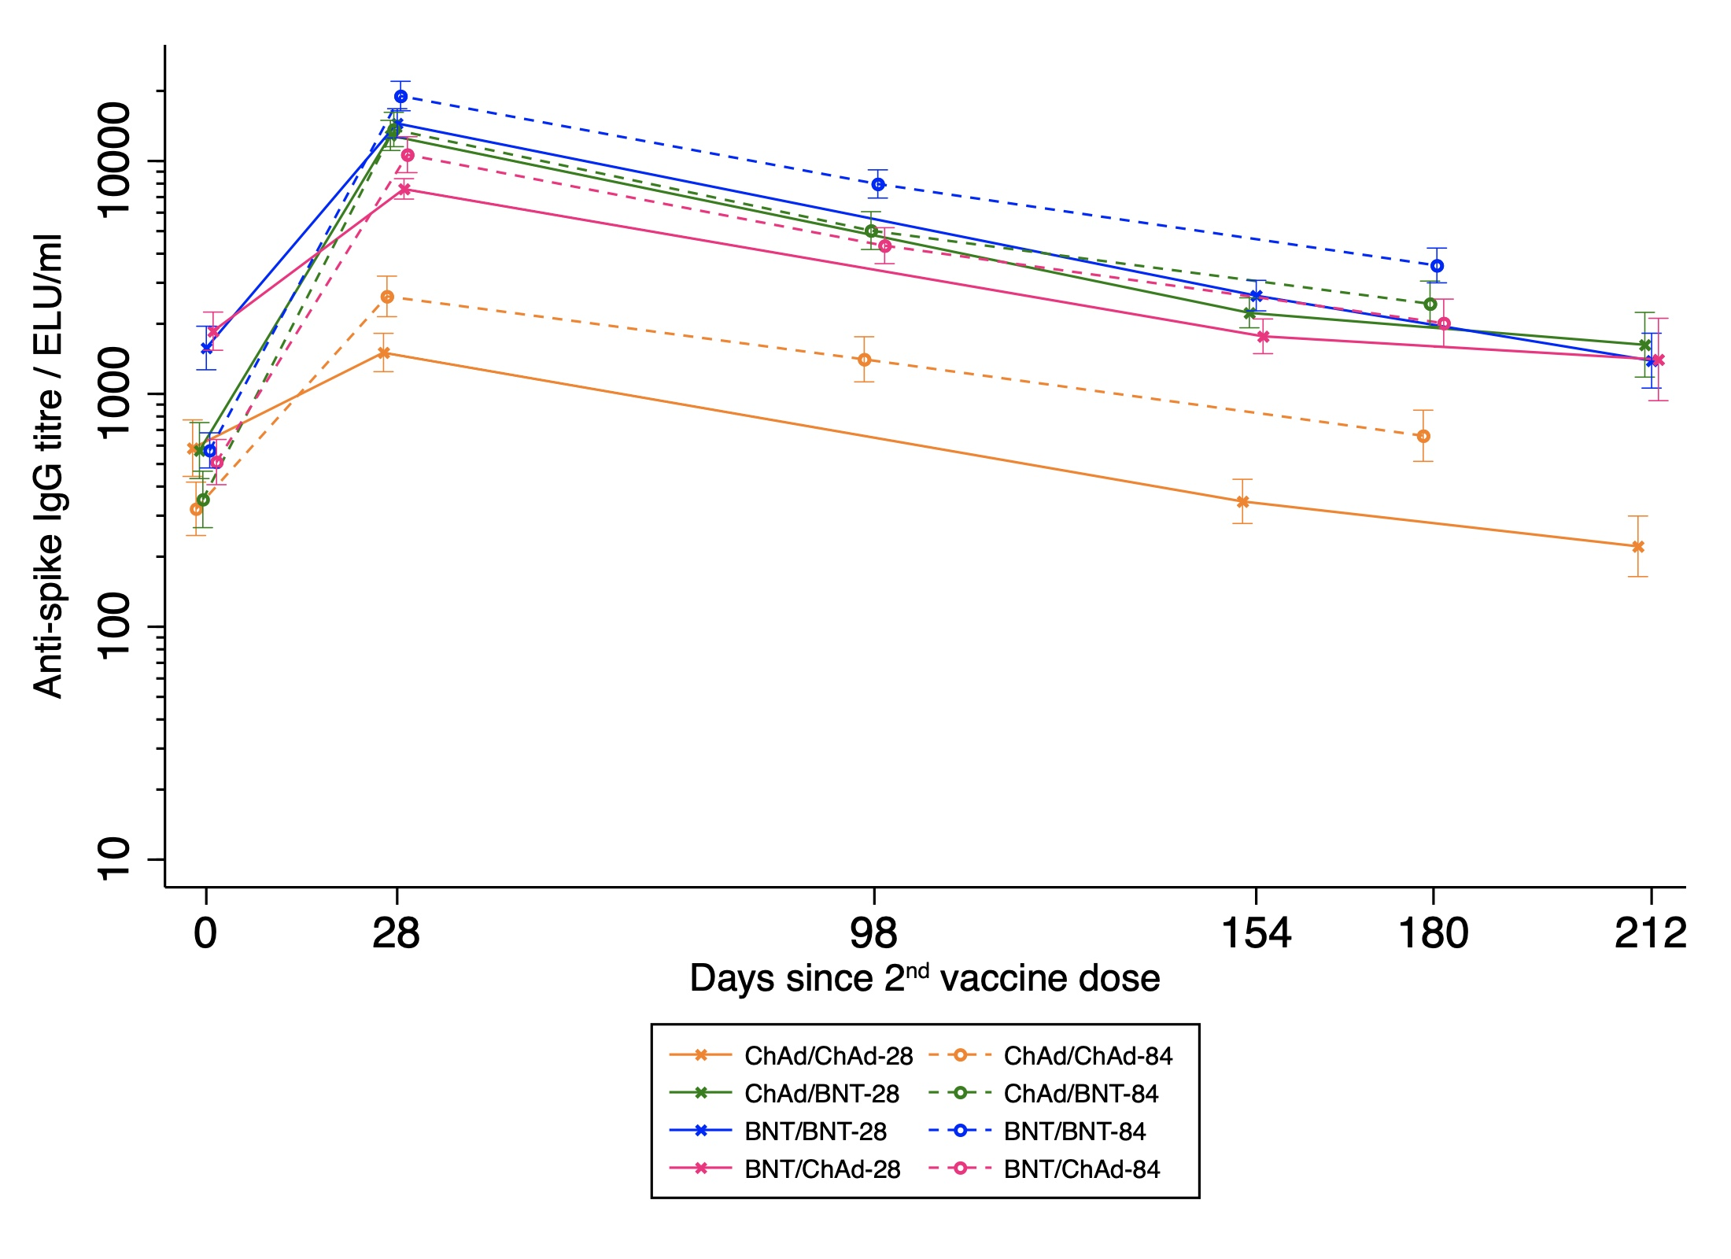
B)
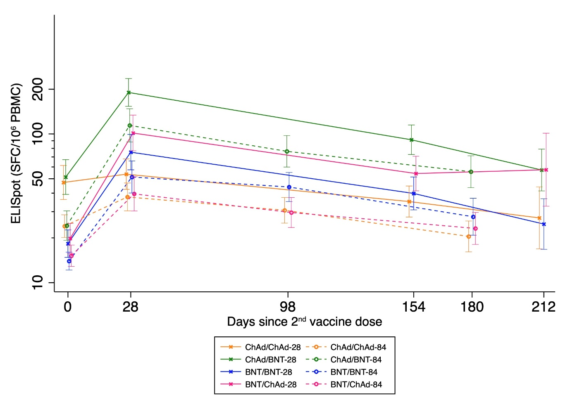

Figure 3. Immune responses between prophylactic and reactive paracetamol use at 28 days, 3 months, and 6 months post second dose in the 12-week interval arms
GM: geometric mean; GMR: geometric mean ratio; NT₅₀: 50% neutralisation titre; FRNT₅₀: 50% Focal reduction neutralisation titre; WT: wild-type; SFC: Spot-forming cells; PBMC: Peripheral blood mononuclear cells; ELU/mL: ELISA units per mL; Data shown are geometric mean (95% Confidence Interval) in the ITT population; GMRs and two-sided 95% CIs were adjusted for study site, age, gender and pre-boost immunogenicity (anti-spike IgG for humoral responses, and ELISpot for cellular response). Numbers of participants per timepoint are displayed in Supplementary table 12

Figure 4. Forest plots of solicited adverse events in days 0-7 post second dose by study arm comparing 12-week interval groups to 4-week interval groups in the general cohort, A) ChAd/ChAd, B) ChAd/BNT, C) BNT/BNT, D) BNT/ChAd
AE: adverse event; CI: confidence interval; OR: odds ratio. Models adjusted for paracetamol recommendation(reactive/prophylactic use). Models with no adjusted OR were non-estimable due to few events in that study arm. The dotted line is the line of no difference between 4- and 12-week interval groups.
A)
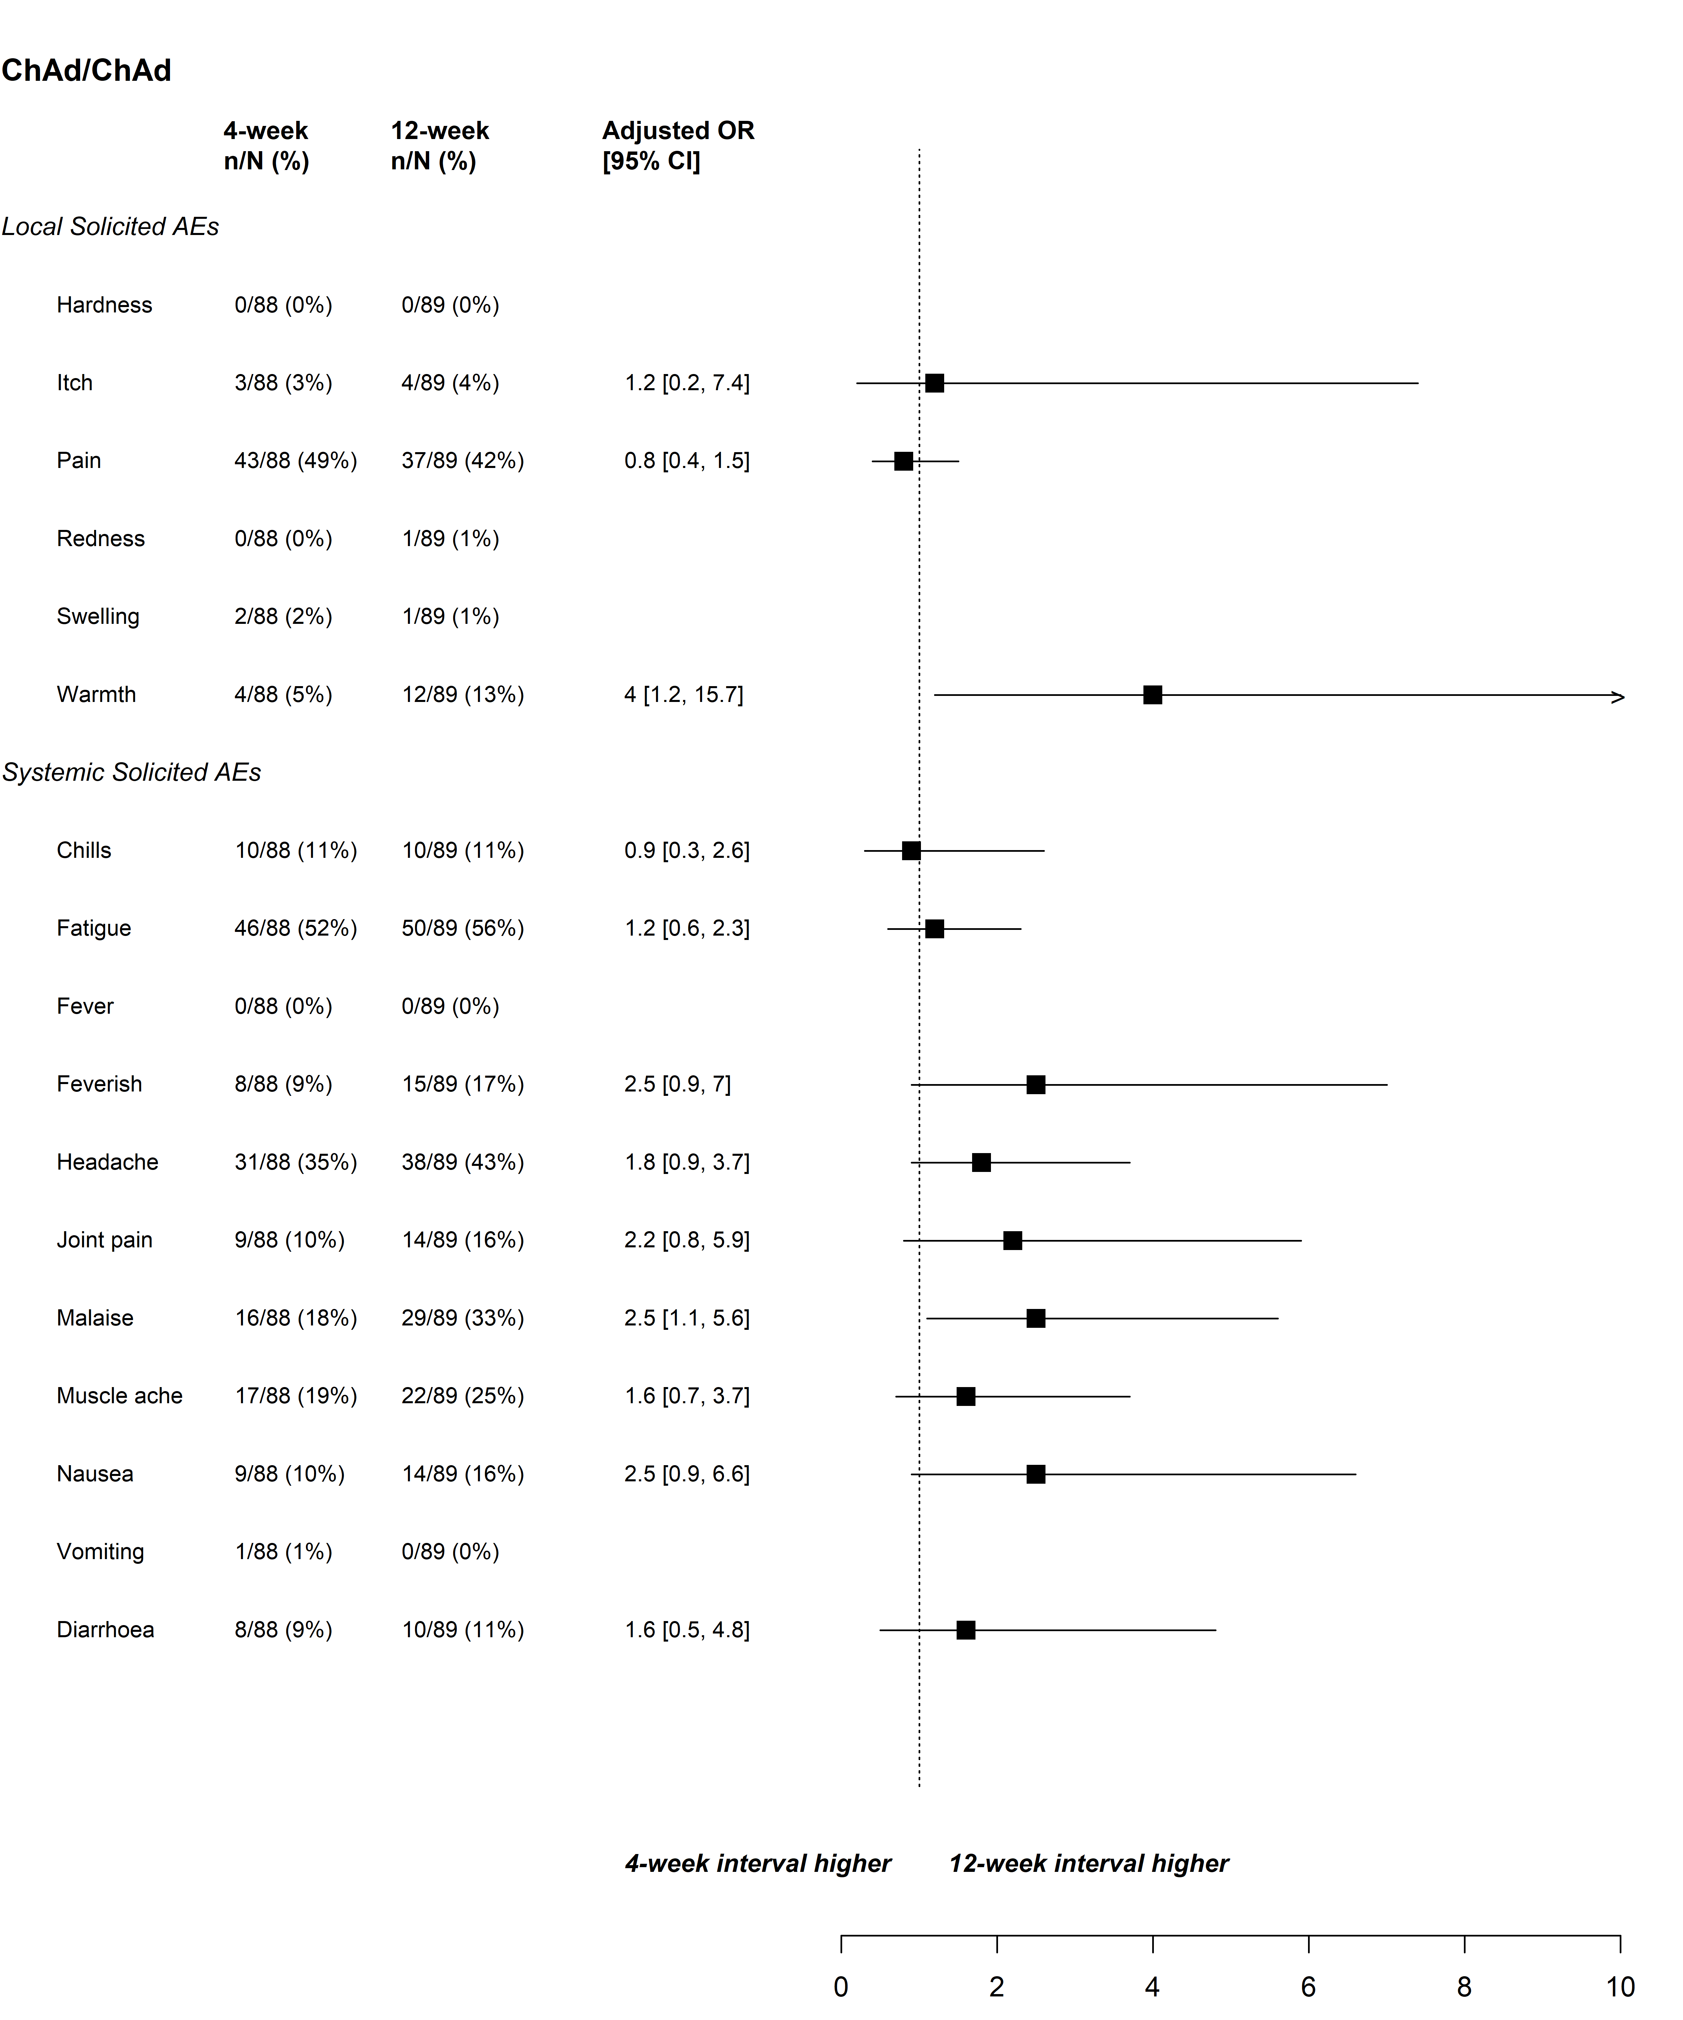

B)
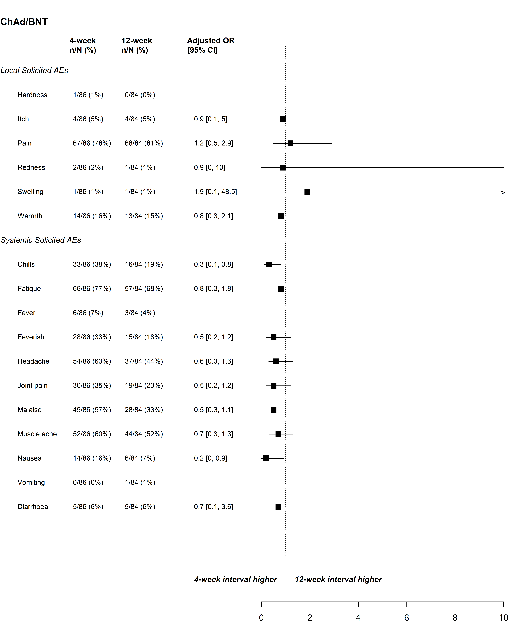

C) 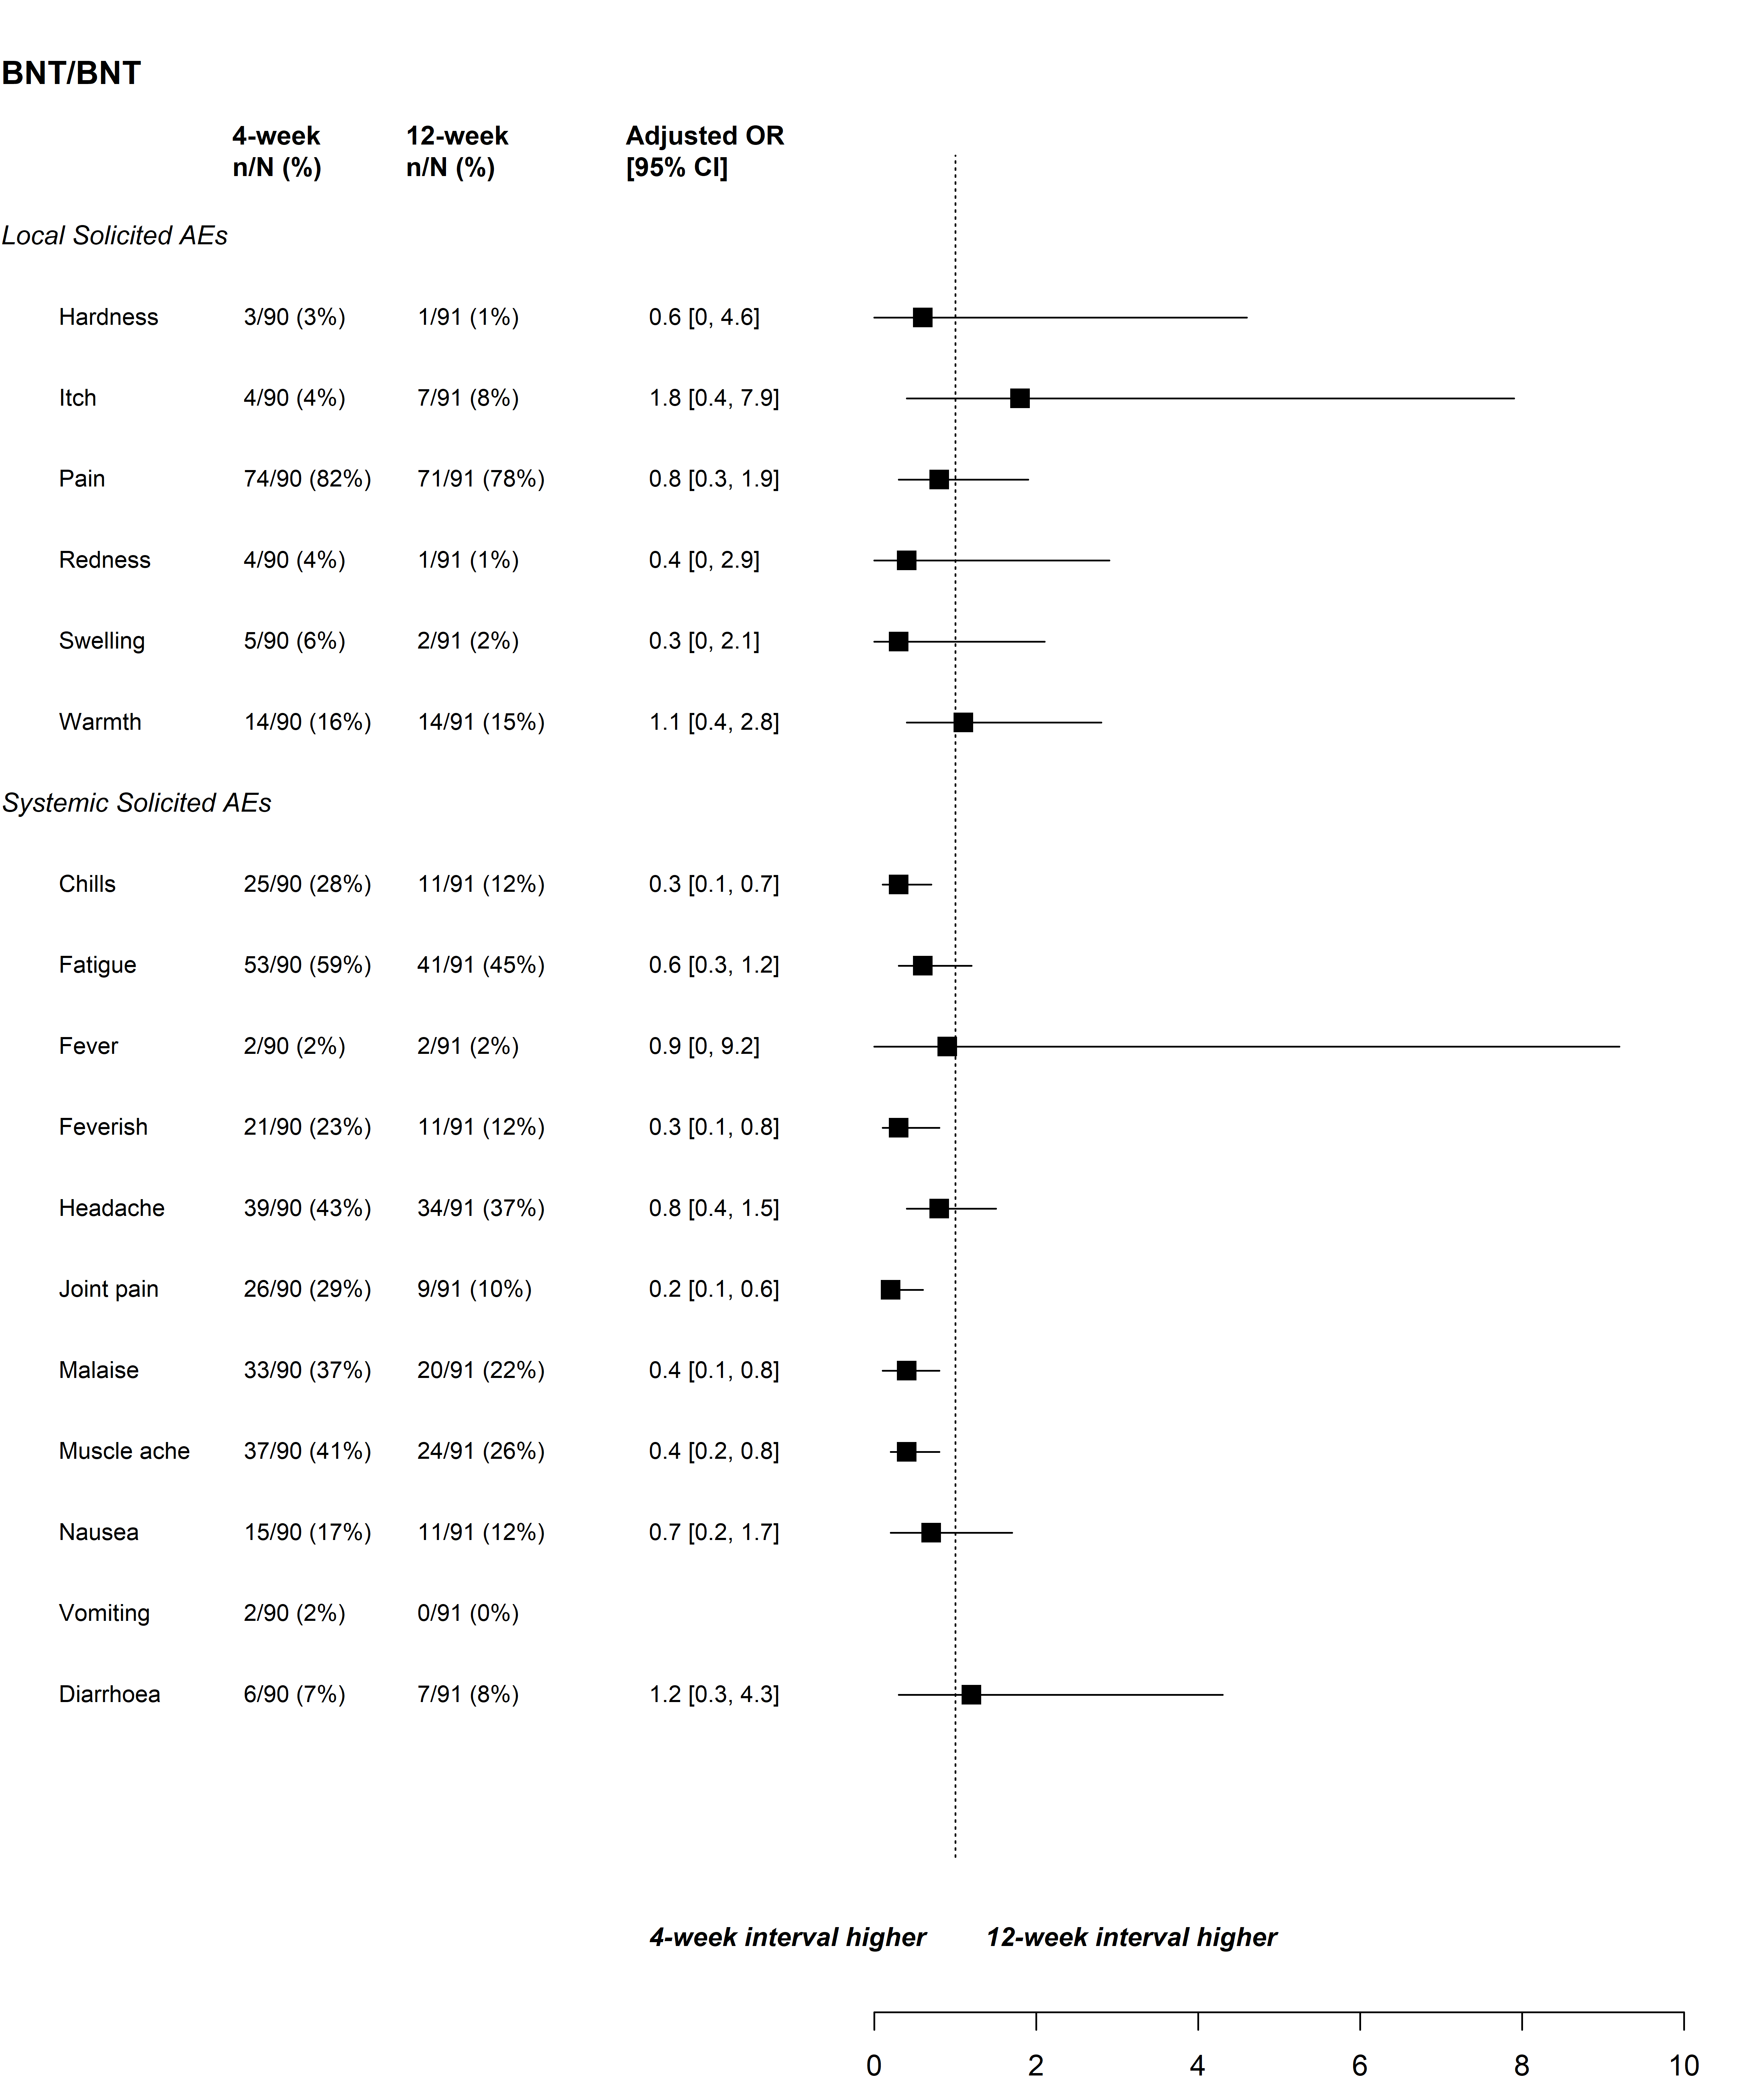

D)
