Supplementary Appendix

Table of Contents

Supplementary Table 1. Baseline demographics and characteristics by study arm in the immunology cohort 3
Supplementary Table 2. Immune responses between heterologous and homologous priming schedules at 28 days and 6 months post second dose in the general cohort 4
Supplementary Table 3. Immunogenicity at 28-day and 3-months post second dose between participants with and without missing data at 6-month post second dose in the 12-week interval arms 5
Supplementary Table 4. Immunogenicity against Beta and Delta variants at 28 days post second dose in the general cohort with a 12-week interval 6
Supplementary Table 5. Baseline demographics and characteristics by study arm for paracetamol sub-study 7
Supplementary Table 6. Paracetamol usage and impact on daily activity in paracetamol sub-study arms in days 0-7 post-second dose 8
Supplementary Table 7. Summary of adverse events in the general and immunology cohorts 9
Supplementary Table 8. Non-serious adverse events of grade ≥3 10
Supplementary Table 9. Adverse events of special interest* in all study arms 13
Supplementary Table 10. Serious adverse events in all study arms 14
Supplementary Table 11. Adverse event of special interest - COVID-19 cases after prime vaccination 15
Supplementary Table 12. Numbers of participants analysed per timepoint for A) Anti-spike IgG from first dose, B) Anti-spike IgG from second dose, C) T-cell ELISpot from first dose and D) T-cell ELISpot from second dose 16
Supplementary Figure 1. Consort Diagram 17
Supplementary Figure 2. Kinetics of immune response over time with all schedules normalised by time of first dose in the seronegative general cohort A) Anti-spike IgG titre, B) T-cell ELISpot count 18
Supplementary Figure 3. Sensitivity analyses for immune responses comparing 4-week and 12-week interval in the general and immunology cohorts 19
Supplementary Figure 4. Subgroup analyses for immune responses comparing 4-week and 12-week intervals among schedules of A) ChAd/ChAd; B) ChAd/BNT; C) BNT/BNT; D) BNT/ChAd, at 28 days post second dose in the general cohort 20
Supplementary Figure 5. Live neutralising antibodies against Victoria, Beta, Delta and Omicron variants at 28 days and 3 months post second dose in the general cohort with a 12-week interval 24
Supplementary Figure 6. Correlation between A) WT & Beta VNA, B) WT & Delta VNA, C) WT & Beta Cellular response, and D) WT & Delta Cellular response at 28 days post boost in the 12-week interval arms 25
Supplementary Figure 7. Consort of paracetamol sub-study participants 26
Supplementary Figure 8. Maximum severity of solicited adverse events in the first seven days post- first dose and post-second dose by study arm in the general cohort. A) Local, and B) Systemic 27
Supplementary Figure 9. Forest plot of any solicited adverse events in days 0-7 post-second dose comparing heterologous to homologous schedules in the general cohort. A) 4-week interval, and B) 12-week interval 29
Supplementary Figure 10. Solicited adverse events in days 0-7 post second dose by day and study arm in the 12-week interval groups. A) Local adverse events, and B) Systemic adverse events 30
Supplementary Figure 11. Solicited adverse events at time of second dose by paracetamol sub-study arm compared to 4-week interval arms in the general cohort. A) local, B) systemic 32
Supplementary Figure 12. Forest plot of any solicited adverse events in days 0-7 post second dose comparing prophylactic to reactive paracetamol use in the paracetamol sub-study of 12-inteval arms for A) ChAd/ChAd; B) ChAd/BNT; C) BNT/BNT; D) BNT/ChAd 34
Randomisation and Blinding 38
Summary of correlation factors for calibration of immune assay readouts (LBA and PNA) with the WHO International Standard (IS) for the Nexelis laboratory 38
Com-COV Study Group 39
Statistical Analysis Plan (SAP) 41

Supplementary Table 1. Baseline demographics and characteristics by study arm in the immunology cohort

 | 4-week interval study arms |  |  |  | Overall  (N=90)
 | ChAd/ChAd  (N=23) | ChAd/BNT  (N=22) | BNT/BNT  (N=21) | BNT/ChAd  (N=24)
Age (years)
Mean (SD) | 55.3 (4.29) | 58.6 (4.59) | 57.3 (5.02) | 57.7 (4.73) | 57.2 (4.74)
Median (range) | 54.8 (50.7, 64.1) | 59.2 (52.6, 68.3) | 55.3 (51.0, 67.2) | 56.2 (51.4, 67.0) | 56.0 (50.7, 68.3)
Gender
Female | 13 (56.5%) | 8 (36.4%) | 10 (47.6%) | 10 (41.7%) | 41 (45.6%)
Male | 10 (43.5%) | 14 (63.6%) | 11 (52.4%) | 14 (58.3%) | 49 (54.4%)
Ethnicity
White | 16 (69.6%) | 15 (68.2%) | 14 (66.7%) | 18 (75.0%) | 63 (70.0%)
Black |  |  | 2 (9.5%) |  | 2 (2.2%)
Asian | 5 (21.7%) | 4 (18.2%) | 3 (14.3%) | 4 (16.7%) | 16 (17.8%)
Mixed | 2 (8.7%) | 3 (13.6%) | 1 (4.8%) | 2 (8.3%) | 8 (8.9%)
Other |  |  | 1 (4.8%) |  | 1 (1.1%)
Comorbidities
Cardiovascular | 6 (26.1%) | 6 (27.3%) | 9 (42.9%) | 7 (29.2%) | 28 (31.1%)
Respiratory | 5 (21.7%) | 6 (27.3%) | 4 (19.0%) | 5 (20.8%) | 20 (22.2%)
Diabetes | 5 (21.7%) | 1 (4.5%) | 1 (4.8%) | 1 (4.2%) | 8 (8.9%)
Timing of six-month visit (days since second dose)
Mean (SD) | 156 (4) | 156 (5) | 153 (4) | 155 (5) | 155 (4)
Median (range) | 154 (152, 165) | 154 (145, 170) | 154 (145, 164) | 154 (148, 165) | 154 (145, 170)

SD: standard deviation.

Supplementary Table 2. Immune responses between heterologous and homologous priming schedules at 28 days and 6 months post second dose in the general cohort

 | ChAdOx1 nCoV-19 arms |  |  |  |  |  | P value for interaction¶
 | 4-week interval |  |  | 12-week interval
 | ChAd/ChAd  N=83 | ChAd/BNT  N=83 | GMR§ | ChAd/ChAd  N=89 | ChAd/BNT  N=77 | GMR§
SARS-CoV-2 anti-spike IgG, ELU/ml, 28-day | 1444 (1205-1732) [n=81] | 12979 (11217-15018) [n=83] | 9.0 (7.1,11.3) | 2622 (2152-3195) [n=88] | 13465 (11391-15917) [n=76] | 5.2 (4.0,6.7) | 0.0069
SARS-CoV-2 anti-spike IgG, ELU/ml, 6-month | 334 (271-411) [n=77] | 2236 (1936-2583) [n=80] | 6.8 (5.3,8.7) | 661 (516-847) [n=61] | 2437 (1957-3035) [n=57] | 3.8 (2.7,5.3) | 0.0088
Pseudotyped virus neutralising antibody, NT₅₀ | 74 (63-89) [n=77] | 529 (450-622) [n=82] | 7.2 (5.7,9.1) | 188 (153-231) [n=86] | 781 (646-946) [n=75] | 4.2 (3.1,5.6) | 0.012
Cellular response – Fresh (WT), SFC/10⁶ PBMCs, 28-day | 48 (38-62) [n=79] | 186 (148-234) [n=83] | 4.0 (2.8,5.5) | 35 (27-44) [n=86] | 110 (83-145) [n=74] | 3.2 (2.2,4.6) | 0.47
Cellular response – Fresh (WT), SFC/10⁶ PBMCs, 6-month | 32 (25-41) [n=74] | 91 (73-114) [n=74] | 2.9 (2.0,4.0) | 17 (12-23) [n=57] | 54 (41-70) [n=54] | 3.2 (2.2,4.8) | 0.68
 | BNT162b2 arms
 | 4-week interval |  |  | 12-week interval
 | BNT/BNT  N=84 | BNT/ChAd  N=83 | GMR§ | BNT/BNT  N=87 | BNT/ChAd  N=78 | GMR§
SARS-CoV-2 anti-spike IgG, ELU/ml, 28-day | 14349 (12470-16511) [n=84] | 7530 (6811-8325) [n=83] | 0.52 (0.44,0.62) | 19011 (16468-21947) [n=85] | 10642 (8936-12673) [n=76] | 0.57 (0.45,0.71) | 0.36
SARS-CoV-2 anti-spike IgG, ELU/ml, 6-month | 2612 (2258-3022) [n=81] | 1748 (1477-2068) [n=81] | 0.66 (0.53,0.82) | 3560 (3009-4213) [n=62] | 2012 (1595-2539) [n=54] | 0.57 (0.43,0.76) | 0.51
Pseudotyped virus neutralising antibody, NT₅₀ | 585 (500-685) [n=83] | 397 (342-460) [n=82] | 0.67 (0.54,0.83) | 899 (770-1051) [n=81] | 645 (529-787) [n=71] | 0.72 (0.56,0.92) | 0.5
Cellular response – Fresh (WT), SFC/10⁶ PBMCs, 28-day | 72 (54-95) [n=84] | 98 (73-131) [n=83] | 1.4 (0.93,2.1) | 49 (37-64) [n=82] | 37 (28-49) [n=73] | 0.80 (0.54,1.2) | 0.073
Cellular response – Fresh (WT), SFC/10⁶ PBMCs, 6-month | 35 (26-47) [n=78] | 52 (40-69) [n=81] | 1.5 (0.97,2.2) | 23 (16-32) [n=55] | 21 (15-28) [n=52] | 0.96 (0.60,1.6) | 0.14

GMR: geometric mean ratio; NT₅₀: 50% neutralisation titre; WT: wild-type; SFC: Spot-forming cells; PBMC: Peripheral blood mononuclear cells; ELU/mL: ELISA units per mL; Data shown are geometric mean (95% Confidence Intervals) in the ITT population;
§ GMRs and two-sided 95% CIs were adjusted for study site;
¶ p values for interaction between vaccine schedule and vaccine interval were adjusted for study site, age at baseline, sex, ethnicity and paracetamol use on day 0 or day 1 post vaccination.
Supplementary Table 3. Immunogenicity at 28-day and 3-months post second dose between participants with and without missing data at 6-month post second dose in the 12-week interval arms

 | ChAdOx1 nCoV-19 arms
 | ChAd/ChAd |  | ChAd/BNT
 | With missing data  N=20 | With no missing data  N=69 | With missing data  N=18 | With no missing data  N=59
SARS-CoV-2 anti-spike IgG (28-day), ELU/ml | 1847 (1233-2767) [n=19] | 2888 (2313-3605) [n=69] | 10801 (7093-16448) [n=17] | 14349 (12020-17128) [n=59]
SARS-CoV-2 anti-spike IgG (3-month), ELU/ml | 1369 (777-2410) [n=16] | 1417 (1116-1800) [n=69] | 4007 (2441-6575) [n=17] | 5365 (4443-6478) [n=59]
 | BNT162b2 arms
 | BNT/BNT |  | BNT/ChAd
 | With missing data  N=22 | With no missing data  N=65 | With missing data  N=22 | With no missing data  N=56
SARS-CoV-2 anti-spike IgG (28-day), ELU/ml | 21869 (16491-29000) [n=20] | 18210 (15420-21503) [n=65] | 11800 (8333-16709) [n=21] | 10230 (8354-12528) [n=55]
SARS-CoV-2 anti-spike IgG (3-month), ELU/ml | 8275 (6294-10879) [n=20] | 7872 (6708-9238) [n=62] | 4845 (3422-6858) [n=20] | 4152 (3391-5083) [n=54]

ELU/mL: ELISA units per mL; Data shown are geometric mean (95% Confidence Intervals) in the ITT population.

Supplementary Table 4. Immunogenicity against Beta and Delta variants at 28 days post second dose in the general cohort with a 12-week interval

 | ChAdOx1 nCoV-19 first dose arms |  | BNT162b2 first dose arms |  | p value¶
 | ChAd/ChAd  N=89 | ChAd/BNT  N=77 | BNT/BNT  N=87 | BNT/ChAd  N=78
Live virus neutralising antibody, FRNT₅₀
WT | 252 (174-365) [n=51] | 1410 (1053-1888) [n=45] | 2392 (1985-2882) [n=47] | 1273 (985-1645) [n=49]
Beta | 51 (33-79) [n=51] | 264 (171-406) [n=45] | 690 (543-876) [n=47] | 360 (260-498) [n=49]
Beta to Victoria ratio§ | 0.29 (0.22-0.39) [n=30] | 0.22 (0.18-0.28) [n=41] | 0.29 (0.25-0.34) [n=47] | 0.29 (0.24-0.35) [n=48] | 0.19
Delta | 88 (59-130) [n=51] | 528 (361-772) [n=45] | 990 (786-1246) [n=47] | 498 (370-670) [n=49]
Delta to Victoria ratio§ | 0.37 (0.31-0.45) [n=40] | 0.39 (0.34-0.46) [n=44] | 0.41 (0.36-0.48) [n=47] | 0.39 (0.33-0.47) [n=49] | 0.86
Cellular response – Frozen cells, SFC/10⁶ PBMC
WT | 24 (17-34) [n=60] | 64 (44-94) [n=56] | 42 (32-55) [n=55] | 32 (22-45) [n=52]
Beta | 26 (19-36) [n=60] | 70 (51-97) [n=56] | 42 (32-55) [n=56] | 29 (21-41) [n=52]
Beta to WT ratio§ | 1.1 (0.90-1.4) [n=60] | 1.1 (0.90-1.3) [n=56] | 0.99 (0.84-1.2) [n=55] | 0.92 (0.79-1.1) [n=52] | 0.43
Delta | 26 (19-35) [n=60] | 71 (52-96) [n=55] | 44 (34-56) [n=55] | 28 (20-40) [n=52]
Delta to WT ratio§ | 1.1 (0.89-1.3) [n=60] | 1.0 (0.89-1.2) [n=55] | 1.0 (0.87-1.2) [n=55] | 0.89 (0.75-1.1) [n=52] | 0.46

FRNT₅₀: 50% focal reduction neutralisation titre; WT: wild-type; SFC: Spot-forming cells; PBMC: Peripheral blood mononuclear cells; Data shown are geometric mean (95% Confidence Intervals) in the ITT population;
§ We defined the cross-protection for a strain by the ratio of the immunogenicity against that strain to wild type or Victoria strain; Data presented are geometric mean (95% CI) among participants with data above LLOD;
¶ The comparison of cross-protection between schedules was conducted using analysis of variance (ANOVA) to test if there is any difference of the cross-protection between four vaccine schedules.
Supplementary Table 5. Baseline demographics and characteristics by study arm for paracetamol sub-study

 | ChAd/ChAd |  | ChAd/BNT |  | BNT/BNT |  | BNT/ChAd
 | Prophylactic  (N=40) | Reactive  (N=40) | Prophylactic  (N=41) | Reactive  (N=39) | Prophylactic  (N=41) | Reactive  (N=39) | Prophylactic  (N=36) | Reactive  (N=36)
Age (years)
Mean (SD) | 57.0 (4.43) | 58.0 (5.54) | 58.6 (4.53) | 58.7 (4.42) | 57.5 (4.27) | 58.4 (4.67) | 59.2 (5.01) | 57.2 (4.47)
Median (range) | 57.7 (50.3, 66.3) | 57.3 (50.1, 70.0) | 58.2 (51.1, 68.0) | 58.7 (51.2, 72.7) | 57.0 (50.1, 67.6) | 57.8 (50.5, 69.8) | 59.7 (50.9, 69.8) | 57.1 (51.0, 68.0)
Gender
Female | 23 (57.5%) | 15 (37.5%) | 14 (34.1%) | 18 (46.2%) | 21 (51.2%) | 15 (38.5%) | 13 (36.1%) | 12 (33.3%)
Male | 17 (42.5%) | 25 (62.5%) | 27 (65.9%) | 21 (53.8%) | 20 (48.8%) | 24 (61.5%) | 23 (63.9%) | 24 (66.7%)
Ethnicity
White | 31 (77.5%) | 33 (82.5%) | 31 (75.6%) | 34 (87.2%) | 34 (82.9%) | 31 (79.5%) | 31 (86.1%) | 30 (83.3%)
Black | 1 (2.5%) | 1 (2.5%) | 1 (2.4%) | - | 1 (2.4%) | - | - | -
Asian | 4 (10.0%) | 3 (7.5%) | 5 (12.2%) | 3 (7.7%) | 2 (4.9%) | 5 (12.8%) | 3 (8.3%) | 3 (8.3%)
Mixed | 2 (5.0%) | 3 (7.5%) | 3 (7.3%) | 2 (5.1%) | 2 (4.9%) | 2 (5.1%) | - | 2 (5.6%)
Other | 2 (5.0%) | - | 1 (2.4%) | - | 2 (4.9%) | 1 (2.6%) | 2 (5.6%) | 1 (2.8%)
Comorbidities
Cardiovascular | 8 (20.0%) | 8 (20.0%) | 9 (22.0%) | 10 (25.6%) | 7 (17.1%) | 8 (20.5%) | 11 (30.6%) | 5 (13.9%)
Respiratory | 3 (7.5%) | 2 (5.0%) | 5 (12.2%) | 5 (12.8%) | 6 (14.6%) | 5 (12.8%) | 3 (8.3%) | 3 (8.3%)
Diabetes | 1 (2.5%) | 1 (2.5%) | - | 1 (2.6%) | - | 1 (2.6%) | 1 (2.8%) | 1 (2.8%)

SD: standard deviation.

Supplementary Table 6. Paracetamol usage and impact on daily activity in paracetamol sub-study arms in days 0-7 post-second dose

 | ChAd/ChAd |  | ChAd/BNT |  | BNT/BNT |  | BNT/ChAd
 | Prophylactic  (N=40) | Reactive  (N=40) | Prophylactic  (N=41) | Reactive  (N=39) | Prophylactic  (N=41) | Reactive  (N=39) | Prophylactic  (N=36) | Reactive  (N=36)
Number of participants with e-diary data* | 39 | 40 | 39 | 39 | 41 | 38 | 34 | 36
At least one dose of paracetamol
Day 0 | 37 (94.9%) | 7 (17.5%) | 33 (84.6%) | 4 (10.3%) | 40 (97.6%) | 6 (15.8%) | 32 (94.1%) | 10 (27.8%)
Day 1 | 28 (71.8%) | 14 (35.0%) | 26 (66.7%) | 18 (46.2%) | 30 (73.2%) | 9 (23.7%) | 30 (88.2%) | 22 (61.1%)
Day 2 | 11 (28.2%) | 7 (17.5%) | 11 (28.2%) | 5 (12.8%) | 11 (26.8%) | 4 (10.5%) | 8 (23.5%) | 8 (22.2%)
Day 3 | 8 (20.5%) | 4 (10.0%) | 4 (10.3%) | 3 (7.7%) | 4 (9.8%) | 2 (5.3%) | 2 (5.9%) | 3 (8.3%)
Day 4 | 4 (10.3%) | 3 (7.5%) | 3 (7.7%) | 2 (5.1%) | 4 (9.8%) | 1 (2.6%) | 2 (5.9%) | 1 (2.8%)
Day 5 | 4 (10.3%) | 3 (7.5%) | 4 (10.3%) | 3 (7.7%) | 2 (4.9%) | 3 (7.9%) | 2 (5.9%) | 1 (2.8%)
Day 6 | 2 (5.1%) | 1 (2.5%) | 3 (7.7%) | 1 (2.6%) | 2 (4.9%) | - | 2 (5.9%) | -
Day 7 | 2 (5.1%) | 2 (5.0%) | 2 (5.1%) | - | 2 (4.9%) | - | 1 (2.9%) | 1 (2.8%)
Any in days 0-1 | 38 (97.4%) | 18 (45.0%) | 35 (89.7%) | 20 (51.3%) | 40 (97.6%) | 12 (31.6%) | 32 (94.1%) | 24 (66.7%)
Any in days 0-7 | 38 (97.4%) | 20 (50.0%) | 36 (92.3%) | 21 (53.8%) | 40 (97.6%) | 14 (36.8%) | 32 (94.1%) | 26 (72.2%)
Impact on daily activity
At least one day where daily activity was impacted | 7 (17.9%) | 8 (20.0%) | 8 (20.5%) | 7 (17.9%) | 6 (14.6%) | 3 (7.9%) | 10 (29.4%) | 13 (36.1%)
Needed more help than usual to perform daily activities, median (IQR) (days) | 0 (0, 0) | 0 (0, 0) | 0 (0, 0) | 0 (0, 0) | 0 (0, 0) | 0 (0, 0) | 0 (0, 0) | 0 (0, 0)
Not able to work as planned†, median (IQR) (days) | 0 (0, 0) | 0 (0, 0) | 0 (0, 0) | 0 (0, 0) | 0 (0, 0) | 0 (0, 0) | 0 (0, 0) | 0 (0, 1)
Sought medical attention or advice due to symptoms, median (IQR) (days) | 0 (0, 0) | 0 (0, 0) | 0 (0, 0) | 0 (0, 0) | 0 (0, 0) | 0 (0, 0) | 0 (0, 0) | 0 (0, 0)

IQR: interquartile range.
*Results are based on those with completed e-diary data.
†Denominator is all participants randomised to study arm including those who answered ‘not applicable’ to work question.
Supplementary Table 7. Summary of adverse events in the general and immunology cohorts

 | 4-week interval arms |  |  |  | 12-week interval arms
 | ChAd/ChAd  (N=115) | ChAd/BNT  (N=114) | BNT/BNT  (N=119) | BNT/ChAd  (N=115) | ChAd/ChAd  (N=92) | ChAd/BNT  (N=90) | BNT/BNT  (N=93) | BNT/ChAd  (N=92) | Total  (N=830)
Number of adverse events* | 127 | 133 | 158 | 154 | 99 | 113 | 98 | 122 | 1004
Number of unique participants with at least one adverse event | 64 (55.6%) | 68 (59.6%) | 61 (51.2%) | 67 (58.2%) | 54 (58.7%) | 55 (61.1%) | 40 (43.0%) | 53 (57.6%) | 462 (48.1%)
Timing of AE
Between first and second doses | 53 (43.1%) | 54 (42.5%) | 59 (38.3%) | 61 (42.4%) | 52 (57.1%) | 63 (57.8%) | 50 (53.2%) | 61 (51.7%) | 453 (47.2%)
Post 1st dose† | 3 (2.4%) |  |  |  |  |  |  | 4 (3.4%) | 7 (0.7%)
Post 2nd dose | 71 (57.7%) | 79 (62.2%) | 99 (64.3%) | 93 (64.6%) | 47 (51.6%) | 50 (45.9%) | 48 (51.1%) | 57 (48.3%) | 544 (56.7%)
Severity
Grade 1 | 57 (46.3%) | 80 (63.0%) | 80 (51.9%) | 69 (47.9%) | 57 (62.6%) | 63 (57.8%) | 60 (63.8%) | 68 (57.6%) | 534 (55.6%)
Grade 2 | 56 (45.5%) | 41 (32.3%) | 71 (46.1%) | 74 (51.4%) | 33 (36.3%) | 42 (38.5%) | 30 (31.9%) | 42 (35.6%) | 389 (40.5%)
Grade 3 | 13 (10.6%) | 10 (7.9%) | 6 (3.9%) | 10 (6.9%) | 9 (9.9%) | 8 (7.3%) | 7 (7.4%) | 11 (9.3%) | 74 (7.7%)
Grade 4 | 1 (0.8%) | 2 (1.6%) | 1 (0.6%) | 1 (0.7%) |  |  | 1 (1.1%) | 1 (0.8%) | 7 (0.7%)
Causality
No relationship | 62 (50.4%) | 49 (38.6%) | 58 (37.7%) | 52 (36.1%) | 45 (49.5%) | 48 (44.0%) | 50 (53.2%) | 63 (53.4%) | 427 (44.5%)
Unlikely | 42 (34.1%) | 52 (40.9%) | 53 (34.4%) | 64 (44.4%) | 30 (33.0%) | 31 (28.4%) | 29 (30.9%) | 32 (27.1%) | 333 (34.7%)
Possible | 13 (10.6%) | 16 (12.6%) | 38 (24.7%) | 23 (16.0%) | 5 (5.5%) | 17 (15.6%) | 11 (11.7%) | 16 (13.6%) | 139 (14.5%)
Probable | 5 (4.1%) | 9 (7.1%) | 8 (5.2%) | 11 (7.6%) | 14 (15.4%) | 14 (12.8%) | 7 (7.4%) | 9 (7.6%) | 77 (8.0%)
Definite | 5 (4.1%) | 7 (5.5%) | 1 (0.6%) | 4 (2.8%) | 5 (5.5%) | 3 (2.8%) | 1 (1.1%) | 2 (1.7%) | 28 (2.9%)

*Denominator for percentage calculations. †Did not receive second dose.

Supplementary Table 8. Non-serious adverse events of grade ≥3

ID | Study Arm | Severity | Causality | Days since first dose | Days since second dose | MedDRA Preferred Term | MedDRA System Order Class
1 | ChAd/ChAd 4-week | Grade 3 | Unlikely | 33 | 5 | Migraine | Vascular disorders
2 | ChAd/ChAd 4-week | Grade 3 | No relationship | 67 | 39 | Chest pain | General disorders and administration site conditions
3 | ChAd/ChAd 4-week | Grade 3 | No relationship | 1 |  | Back pain | Musculoskeletal and connective tissue disorders
4 | ChAd/ChAd 4-week | Grade 3 | No relationship | 0 |  | Cold type haemolytic anaemia | Immune system disorders
5 | ChAd/ChAd 4-week | Grade 3 | Possible | 53 | 23 | Pain in extremity | Musculoskeletal and connective tissue disorders
6 | ChAd/ChAd 4-week | Grade 3 | Unlikely | 48 | 19 | Headache | Nervous system disorders
7 | ChAd/ChAd 4-week | Grade 3 | No relationship | 206 | 176 | Post viral fatigue syndrome | Nervous system disorders
8 | ChAd/ChAd 4-week | Grade 3 | No relationship | 32 | 3 | Limb injury | Injury, poisoning and procedural complications
9 | ChAd/ChAd 4-week | Grade 3 | No relationship | 182 | 153 | Infected dermal cyst | Infections and infestations
10 | ChAd/ChAd 4-week | Grade 3 | No relationship | 3 |  | Environmental exposure~ | Injury, poisoning and procedural complications
11 | ChAd/ChAd 4-week | Grade 3 | Possible | 0 |  | Fatigue | General disorders and administration site conditions
12 | ChAd/ChAd 4-week | Grade 3 | No relationship | 55 | 27 | Back pain | Musculoskeletal and connective tissue disorders
13 | ChAd/ChAd 4-week | Grade 3 | No relationship | 27 |  | Glaucoma | Eye disorders
14 | ChAd/ChAd 12-week | Grade 3 | No relationship | 99 | 15 | Bunion operation | Surgical and medical procedures
15 | ChAd/ChAd 12-week | Grade 3 | No relationship | 257 | 173 | Coronavirus infections | Infections and infestations
16 | ChAd/ChAd 12-week | Grade 3 | No relationship | 31 |  | Tonsillitis | Infections and infestations
17 | ChAd/ChAd 12-week | Grade 3 | No relationship | 81 |  | Tooth abscess | Infections and infestations
18 | ChAd/ChAd 12-week | Grade 3 | No relationship | 62 |  | Thyroid mass | Endocrine disorders
19 | ChAd/ChAd 12-week | Grade 3 | No relationship | 103 | 19 | Vertigo | Ear and labyrinth disorders
20 | ChAd/ChAd 12-week | Grade 3 | Unlikely | 244 | 160 | Abdominal pain | Gastrointestinal disorders
21 | ChAd/ChAd 12-week | Grade 3 | No relationship | 93 | 9 | Migraine | Vascular disorders
22 | ChAd/BNT 4-week | Grade 3 | Definite | 0 |  | Chills§ | General disorders and administration site conditions
23 | ChAd/BNT 4-week | Grade 3 | Unlikely | 92 | 64 | Deep vein thrombosis | Vascular disorders
24 | ChAd/BNT 4-week | Grade 3 | Probable | 1 |  | Meniere's disease | Ear and labyrinth disorders
25 | ChAd/BNT 4-week | Grade 3 | No relationship | 43 | 15 | Back Pain | Musculoskeletal and connective tissue disorders
26 | ChAd/BNT 4-week | Grade 3 | No relationship | 100 | 72 | Basal cell carcinoma | Neoplasms benign, malignant and unspecified (incl cysts and polyps)
27 | ChAd/BNT 4-week | Grade 3 | Unlikely | 15 |  | Fatigue | General disorders and administration site conditions
28 | ChAd/BNT 4-week | Grade 3 | No relationship | 56 | 28 | Abdominal pain | Gastrointestinal disorders
29 | ChAd/BNT 4-week | Grade 3 | No relationship | 38 | 10 | Headache | Nervous system disorders
30 | ChAd/BNT 4-week | Grade 3 | No relationship | 43 | 14 | Foot fracture | Musculoskeletal and connective tissue disorders
31 | ChAd/BNT 4-week | Grade 3 | Unlikely | 48 | 20 | Fatigue | General disorders and administration site conditions
32 | ChAd/BNT 12-week | Grade 3 | No relationship | 108 | 25 | Cluster headache | Nervous system disorders
33 | ChAd/BNT 12-week | Grade 3 | No relationship | 165 | 82 | Radioactive iodine therapy | Surgical and medical procedures
34 | ChAd/BNT 12-week | Grade 3 | Unlikely | 58 |  | Periarthritis | Musculoskeletal and connective tissue disorders
35 | ChAd/BNT 12-week | Grade 3 | No relationship | 8 |  | Urinary tract infection | Infections and infestations
36 | ChAd/BNT 12-week | Grade 3 | No relationship | 109 | 25 | Respiratory tract infection | Infections and infestations
37 | ChAd/BNT 12-week | Grade 3 | Unlikely | 136 | 52 | Renal mass | Renal and urinary disorders
38 | ChAd/BNT 12-week | Grade 3 | Unlikely | 101 | 17 | Lethargy | General disorders and administration site conditions
39 | ChAd/BNT 12-week | Grade 3 | Possible | 0 |  | Tremor | Nervous system disorders
40 | BNT/BNT 4-week | Grade 3 | No relationship | 166 | 138 | Hypertension | Vascular disorders
41 | BNT/BNT 4-week | Grade 3 | No relationship | 26 |  | Pneumonia | Infections and infestations
42 | BNT/BNT 4-week | Grade 3 | Unlikely | 3 |  | Coronavirus infections | Infections and infestations
43 | BNT/BNT 4-week | Grade 3 | No relationship | 48 | 20 | Rotator cuff syndrome | Injury, poisoning and procedural complications
44 | BNT/BNT 4-week | Grade 3 | No relationship | 10 |  | Bursitis | Musculoskeletal and connective tissue disorders
45 | BNT/BNT 4-week | Grade 3 | No relationship | 211 | 181 | Road traffic accident | Injury, poisoning and procedural complications
46 | BNT/BNT 12-week | Grade 3 | Unlikely | 62 |  | Depressed mood | Psychiatric disorders
47 | BNT/BNT 12-week | Grade 3 | Unlikely | 89 | 5 | Diarrhoea | Gastrointestinal disorders
48 | BNT/BNT 12-week | Grade 3 | Unlikely | 102 | 16 | Sinusitis | Respiratory, thoracic and mediastinal disorders
49 | BNT/BNT 12-week | Grade 3 | Unlikely | 104 | 20 | Vertigo | Ear and labyrinth disorders
50 | BNT/BNT 12-week | Grade 3 | No relationship | 2 |  | Rotator cuff repair | Surgical and medical procedures
51 | BNT/BNT 12-week | Grade 3 | No relationship | 109 | 23 | Tooth extraction | Surgical and medical procedures
52 | BNT/ChAd 4-week | Grade 3 | Probable | 29 | 1 | Decreased appetite | Metabolism and nutrition disorders
53 | BNT/ChAd 4-week | Grade 3 | Probable | 31 | 1 | Migraine | Vascular disorders
54 | BNT/ChAd 4-week | Grade 3 | No relationship | 44 | 16 | Pyrexia | General disorders and administration site conditions
55 | BNT/ChAd 4-week | Grade 3 | Unlikely | 47 | 19 | Fatigue | General disorders and administration site conditions
56 | BNT/ChAd 4-week | Grade 3 | No relationship | 28 | 0 | Depressed mood | Psychiatric disorders
57 | BNT/ChAd 4-week | Grade 3 | No relationship | 92 | 64 | Hypersensitivity | Immune system disorders
58 | BNT/ChAd 4-week | Grade 3 | Probable | 28 | 0 | Arthralgia | Musculoskeletal and connective tissue disorders
59 | BNT/ChAd 4-week | Grade 3 | Unlikely | 45 | 17 | Headache | Nervous system disorders
60 | BNT/ChAd 4-week | Grade 3 | Unlikely | 45 | 17 | Viral infection* | Infections and infestations
61 | BNT/ChAd 4-week | Grade 3 | Possible | 33 | 5 | Back Pain | Musculoskeletal and connective tissue disorders
62 | BNT/ChAd 12-week | Grade 3 | No relationship | 87 | 3 | Melanocytic naevus | Skin and subcutaneous tissue disorders
63 | BNT/ChAd 12-week | Grade 3 | Possible | 84 | 1 | Tachycardia | Cardiac disorders
64 | BNT/ChAd 12-week | Grade 3 | No relationship | 80 |  | Skin injury | Injury, poisoning and procedural complications
65 | BNT/ChAd 12-week | Grade 3 | No relationship | 91 | 0 | Trigmeinal palsy | Nervous system disorders
66 | BNT/ChAd 12-week | Grade 4 | No relationship | 56 |  | Transurethral prostatectomy | Surgical and medical procedures
67 | BNT/ChAd 12-week | Grade 3 | Probable | 85 | 0 | Ear pain | Ear and labyrinth disorders
68 | BNT/ChAd 12-week | Grade 3 | Unlikely | 104 | 19 | Upper respiratory tract infection | Infections and infestations
69 | BNT/ChAd 12-week | Grade 3 | Probable | 84 | 0 | Sinus headache | Respiratory, thoracic and mediastinal disorders
70 | BNT/ChAd 12-week | Grade 3 | No relationship | 40 |  | Ligament sprain | Injury, poisoning and procedural complications
71 | BNT/ChAd 12-week | Grade 3 | Unlikely | 14 |  | Anaphylactoid reaction | Immune system disorders
72 | BNT/ChAd 12-week | Grade 3 | No relationship | 99 |  | Knee arthroplasty | Surgical and medical procedures

~ Participant developed respiratory irritation after performing DIY
§ Episode of rigors with fever, entered in unsolicited diary
* Tested for COVID-19 and negative
Supplementary Table 9. Adverse events of special interest* in all study arms

ID | Study arm | Severity | Causality | Serious AE | Days to onset since first dose | Days to onset since second dose | MedDRA Preferred Term | MedDRA System Order Class
1 | ChAd/BNT 4-week | Grade 3 | Unlikely | No | 92 | 64 | Deep vein thrombosis | Vascular disorders
2 | ChAd/BNT 4-week | Grade 4 | Unlikely | Yes - hospitalisation | 84 | 56 | Cardiac failure# | Cardiac disorders
3 | BNT/ChAd 4-week | Grade 3 | No relationship | No | 92 | 64 | Hypersensitivity | Immune system disorders
4 | BNT/ChAd 12-week | Grade 3 | No relationship | No | 91 | 0 | Trigeminal palsy | Nervous system disorders
5 | BNT/ChAd 12-week | Grade 3 | Unlikely | No | 14 |  | Anaphylactoid reaction | Immune system disorders

* Excluding SARS-CoV-2 infection/COVID-19
#Ongoing at time of data-lock

Supplementary Table 10. Serious adverse events in all study arms

ID | Study arm | Severity | Causality | Serious adverse event | Days to onset since first dose | Days to onset since second dose | MedDRA Preferred Term | MedDRA System Order Class
1 | ChAd/ChAd 4-week | Grade 4 | Unlikely | Hospitalisation | 7 |  | Arthritis bacterial | Infections and infestations
2 | ChAd/ChAd 12-week | Grade 2 | Unlikely | Hospitalisation | 106 | 22 | Orchitis | Reproductive system and breast disorders
3 | ChAd/ChAd 12-week | Grade 3 | No relationship | Hospitalisation | 85 | ^ | Tubo-ovarian abscess | Infections and infestations
4 | ChAd/BNT 4-week | Grade 4 | No relationship | An important medical event | 144 | 116 | Cellulitis | Infections and infestations
5 | ChAd/BNT 4-week | Grade 4 | Unlikely | Hospitalisation | 84 | 56 | Cardiac failure | Cardiac disorders
6 | BNT/BNT 4-week | Grade 4 | No relationship | Hospitalisation | 265 | 236 | Ankle fracture | Musculoskeletal and connective tissue disorders
7 | BNT/BNT 12-week | Grade 4 | No relationship | Hospitalisation | 88 | 0 | Acute kidney injury | Renal and urinary disorders
8 | BNT/BNT 12-week | Grade 3 | No relationship | An important medical event | 197 | 113 | Joint dislocation | Musculoskeletal and connective tissue disorders
9 | BNT/ChAd 4-week | Grade 4 | No relationship | Hospitalisation | 109 | 81 | Clavicle fracture | Musculoskeletal and connective tissue disorders
10 | BNT/ChAd 4-week | Grade 2 | No relationship | Hospitalisation | 132 | 104 | Hand fracture | Musculoskeletal and connective tissue disorders
11 | BNT/ChAd 12-week | Grade 3 | Possible | An important medical event | 113 | 29 | IgA nephropathy | Immune system disorders

See protocol for causality assessment guidance
^Second dose at D94

Supplementary Table 11. Adverse event of special interest - COVID-19 cases after prime vaccination

ID | Study arm | Severity | Causality | Days to onset± since first dose | Days to onset± since second dose | Date of onset
1 | ChAd/ChAd 4-week | Grade 1 | No relationship | 149 | 121 | 07/2021
2 | ChAd/ChAd 4-week | Grade 2 | No relationship | 145 | 117 | 07/2021
3 | ChAd/ChAd 4-week | Grade 1 | No relationship | 219 | 191 | 09/2021
4 | ChAd/ChAd 4-week | Grade 2 | No relationship | 124 | 96 | 06/2021
5 | ChAd/ChAd 4-week | Grade 1 | No relationship | 193 | 165 | 08/2021
6 | ChAd/ChAd 4-week | Grade 1 | No relationship | 215 | 187 | 09/2021
7 | ChAd/ChAd 12-week | Grade 3 | No relationship | 257 | 173 | 10/2021
8 | ChAd/ChAd 12-week | Grade 2 | Unlikely | 194 | 110 | 08/2021
9 | ChAd/ChAd 12-week | Grade 2 | No relationship | 228 | 144 | 10/2021
10 | ChAd/ChAd 12-week | Grade 1 | No relationship | 191 | 105 | 08/2021
11 | ChAd/ChAd 12-week | Grade 1 | Unlikely | 225 | 140 | 09/2021
12 | ChAd/BNT 4-week | Grade 1 | No relationship | 188 | 160 | 08/2021
13 | ChAd/BNT 4-week | Grade 1 | No relationship | 210 | 182 | 09/2021
14 | ChAd/BNT 4-week | Grade 1 | No relationship | 149 | 121 | 07/2021
15 | ChAd/BNT 4-week | Grade 2 | No relationship | 53^ |  | 04/2021
16 | ChAd/BNT 4-week | Grade 2 | Unlikely | 139 | 111 | 07/2021
17 | ChAd/BNT 12-week | Grade 1 | No relationship | 265 | 181 | 11/2021
18 | ChAd/BNT 12-week | Grade 2 | Unlikely | 256 | 172 | 11/2021
19 | ChAd/BNT 12-week | Grade 2 | No relationship | 210 | 126 | 09/2021
20 | ChAd/BNT 12-week | Grade 2 | No relationship | 247 | 161 | 10/2021
21 | ChAd/BNT 12-week | Grade 2 | No relationship | 265 | 179 | 11/2021
22 | BNT/ChAd 4-week | Grade 1 | No relationship | 177 | 149 | 08/2021
23 | BNT/ChAd 4-week | Grade 1 | Unlikely | 169 | 141 | 08/2021
24 | BNT/ChAd 4-week | Grade 2 | Unlikely | 196 | 168 | 08/2021
25 | BNT/ChAd 4-week | Grade 1 | No relationship | 156 | 128 | 07/2021
26 | BNT/ChAd 4-week | Grade 2 | No relationship | 235 | 207 | 10/2021
27 | BNT/ChAd 12-week | Grade 1 | No relationship | 253 | 169 | 10/2021
28 | BNT/ChAd 12-week | Grade 1 | No relationship | 196 | 112 | 08/2021
29 | BNT/ChAd 12-week | Grade 2 | No relationship | 6 |  | 02/2021
30 | BNT/BNT 4-week | Grade 3 | Unlikely | 3 |  | 02/2021
31 | BNT/BNT 4-week | Grade 2 | No relationship | 228 | 200 | 10/2021
32 | BNT/BNT 4-week | Grade 1 | No relationship | 148 | 120 | 07/2021
33 | BNT/BNT 4-week | Grade 1 | No relationship | 179 | 151 | 08/2021
34 | BNT/BNT 4-week | Grade 1 | No relationship | 245 | 216 | 10/2021
35 | BNT/BNT 4-week | Grade 2 | Unlikely | 4 |  | 02/2021
36 | BNT/BNT 4-week | Grade 1 | No relationship | 142 | 114 | 07/2021
37 | BNT/BNT 4-week | Grade 2 | Unlikely | 160 | 132 | 07/2021
38 | BNT/BNT 12-week | Grade 1 | No relationship | 147 | 62 | 07/2021
39 | BNT/BNT 12-week | Grade 2 | No relationship | 177 | 92 | 08/2021
40 | BNT/BNT 12-week | Grade 1 | No relationship | 252 | 166 | 10/2021

Severity grading as per protocol.
^ Participant had not received second dose prior to infection, dose delayed due to travel
± Defined by first symptom meeting government testing criteria at that time (https://www.gov.uk/get-coronavirus-test) or by self-reported test positivity, whichever was earlier.
Cases included in this table include both symptomatic and asymptomatic cases.

Supplementary Table 12. Numbers of participants analysed per timepoint for A) Anti-spike IgG from first dose, B) Anti-spike IgG from second dose, C) T-cell ELISpot from first dose and D) T-cell ELISpot from second dose

A | Timepoint from first dose
Arm | 0 | 28 | 56 | 84 | 112 | 182 | 240 | 264
ChAd-ChAd-28 | 79 | 78 | 76 | 0 | 0 | 73 | 34 | 0
ChAd-BNT-28 | 81 | 82 | 82 | 0 | 0 | 79 | 36 | 0
BNT-BNT-28 | 82 | 82 | 82 | 0 | 0 | 79 | 29 | 0
BNT-ChAd-28 | 82 | 82 | 81 | 0 | 0 | 80 | 32 | 0
ChAd-ChAd-84 | 88 | 0 | 89 | 89 | 88 | 85 | 0 | 61
ChAd-BNT-84 | 76 | 0 | 76 | 77 | 75 | 76 | 0 | 57
BNT-BNT-84 | 87 | 0 | 87 | 87 | 85 | 82 | 0 | 62
BNT-ChAd-84 | 78 | 0 | 78 | 77 | 76 | 74 | 0 | 54
Total | 653 | 324 | 651 | 330 | 324 | 628 | 131 | 234

B | Timepoint from second dose
Arm | 0 | 28 | 98 | 154 | 180 | 212
ChAd-ChAd-28 | 78 | 76 | 0 | 73 | 0 | 34
ChAd-BNT-28 | 82 | 82 | 0 | 79 | 0 | 36
BNT-BNT-28 | 82 | 82 | 0 | 79 | 0 | 29
BNT-ChAd-28 | 82 | 81 | 0 | 80 | 0 | 32
ChAd-ChAd-84 | 89 | 88 | 85 | 0 | 61 | 0
ChAd-BNT-84 | 77 | 75 | 76 | 0 | 57 | 0
BNT-BNT-84 | 87 | 85 | 82 | 0 | 62 | 0
BNT-ChAd-84 | 77 | 76 | 74 | 0 | 54 | 0
Total | 654 | 645 | 317 | 311 | 234 | 131

C | Timepoint from first dose
Arm | 0 | 28 | 56 | 84 | 112 | 182 | 240 | 264
ChAd-ChAd-28 | 79 | 78 | 74 | 0 | 0 | 70 | 31 | 0
ChAd-BNT-28 | 81 | 82 | 82 | 0 | 0 | 73 | 35 | 0
BNT-BNT-28 | 81 | 82 | 82 | 0 | 0 | 76 | 29 | 0
BNT-ChAd-28 | 82 | 81 | 82 | 0 | 0 | 80 | 27 | 0
ChAd-ChAd-84 | 88 | 0 | 88 | 88 | 86 | 80 | 0 | 57
ChAd-BNT-84 | 75 | 0 | 76 | 76 | 74 | 72 | 0 | 54
BNT-BNT-84 | 86 | 0 | 86 | 87 | 81 | 82 | 0 | 56
BNT-ChAd-84 | 77 | 0 | 76 | 77 | 73 | 73 | 0 | 52
Total | 649 | 323 | 646 | 328 | 314 | 606 | 122 | 219

D | Timepoint from second dose
Arm | 0 | 28 | 98 | 154 | 180 | 212
ChAd-ChAd-28 | 78 | 74 | 0 | 70 | 0 | 31
ChAd-BNT-28 | 82 | 82 | 0 | 73 | 0 | 35
BNT-BNT-28 | 82 | 82 | 0 | 76 | 0 | 29
BNT-ChAd-28 | 81 | 82 | 0 | 80 | 0 | 27
ChAd-ChAd-84 | 88 | 86 | 80 | 0 | 57 | 0
ChAd-BNT-84 | 76 | 74 | 72 | 0 | 54 | 0
BNT-BNT-84 | 87 | 81 | 82 | 0 | 56 | 0
BNT-ChAd-84 | 77 | 73 | 73 | 0 | 52 | 0
Total | 651 | 634 | 307 | 299 | 219 | 122

Supplementary Figure 1. Consort Diagram
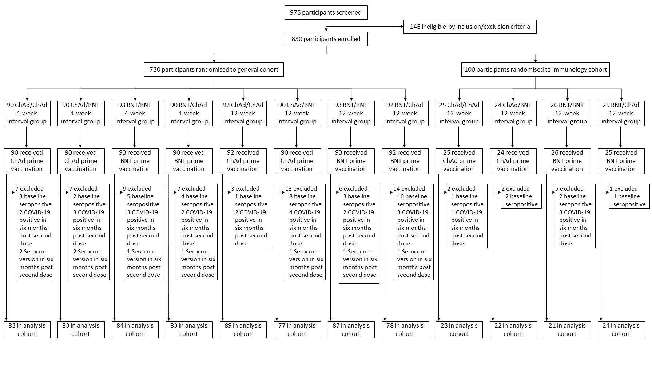
Supplementary Figure 2. Kinetics of immune response over time with all schedules normalised by time of first dose in the seronegative general cohort A) Anti-spike IgG titre, B) T-cell ELISpot count

D0 refers to time of first dose; Data points are geometric mean concentrations, with whiskers showing 95% confidence intervals; Dotted lines are interpolations between Day 28 and Day 56 for the 12-week interval arms only to give a more accurate view of the kinetics, as no Day 28 sample was taken in 12-week interval arms and the Day 28 data in the 4-week interval arms were used to draw dotted lines.

A) 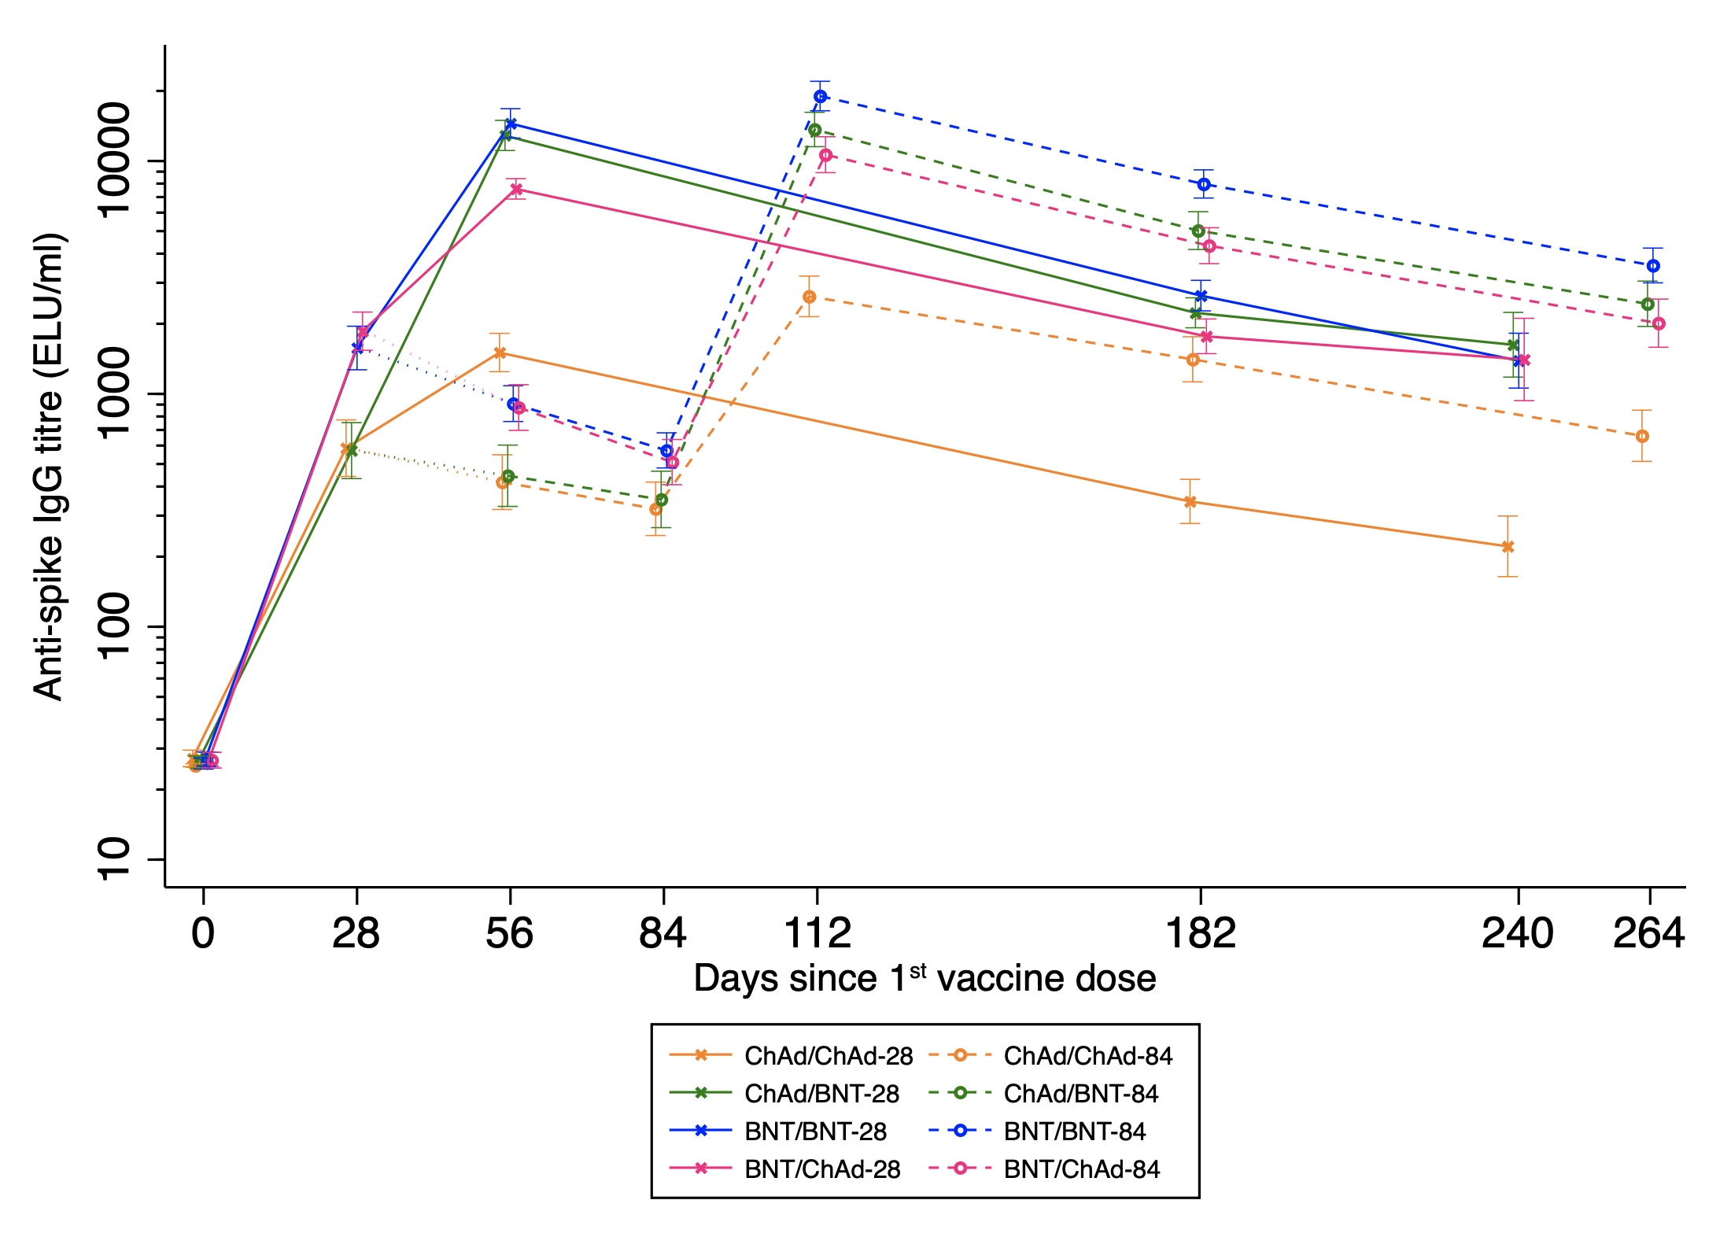
B)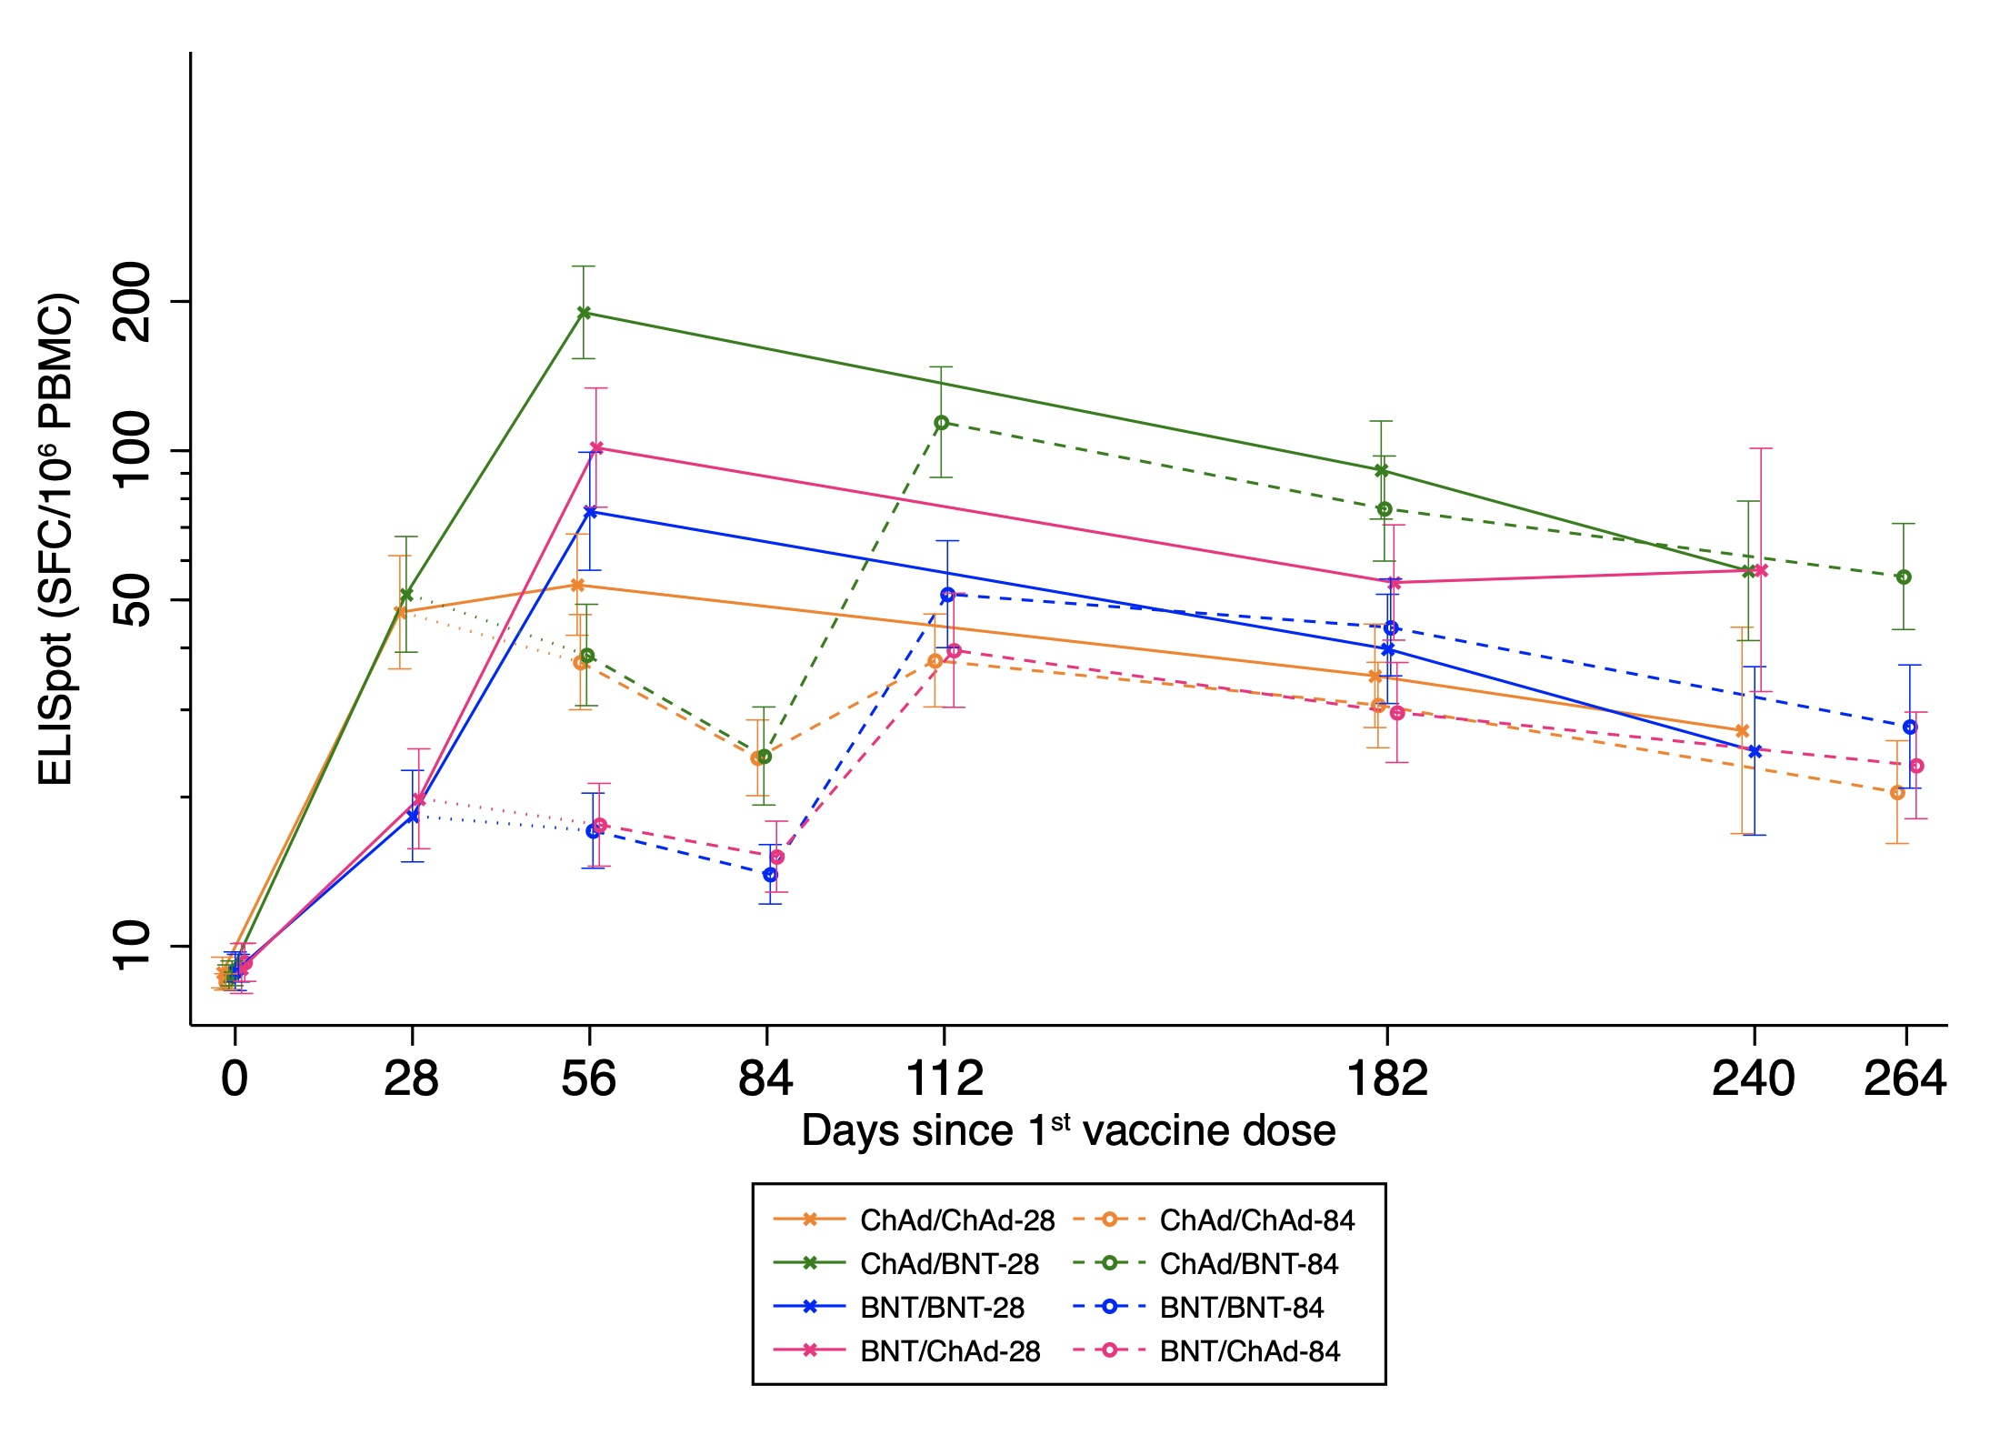

Supplementary Figure 3. Sensitivity analyses for immune responses comparing 4-week and 12-week interval in the general and immunology cohorts

Data presented are the geometric means and 95% confidence interval; Fold changes were calculated by dividing the immune response at 6-months post-second dose by that at 28-day post-second dose; Geometric mean ratios (GMRs) between schedules with 4- and 12-week intervals were adjusted for study site and paracetamol usage in the first 24 hours post vaccination (yes/no) for the 28-day data; 6-month visit time (days) was further adjusted for the 6-month data and fold change. The dotted line refers to a GMR of one, where there is no difference between 4- and 12-week interval arms.

Supplementary Figure 4. Subgroup analyses for immune responses comparing 4-week and 12-week intervals among schedules of A) ChAd/ChAd; B) ChAd/BNT; C) BNT/BNT; D) BNT/ChAd, at 28 days post second dose in the general cohort

Geometric mean ratios (GMRs) were adjusted for study site and paracetamol use on day 0 or day 1 post-vaccination; two-sided 95% CI are presented. The vertical dotted line represents a GMR of one. Comorbidity was defined as presence of any cardiovascular/respiratory disease or diabetes

A) 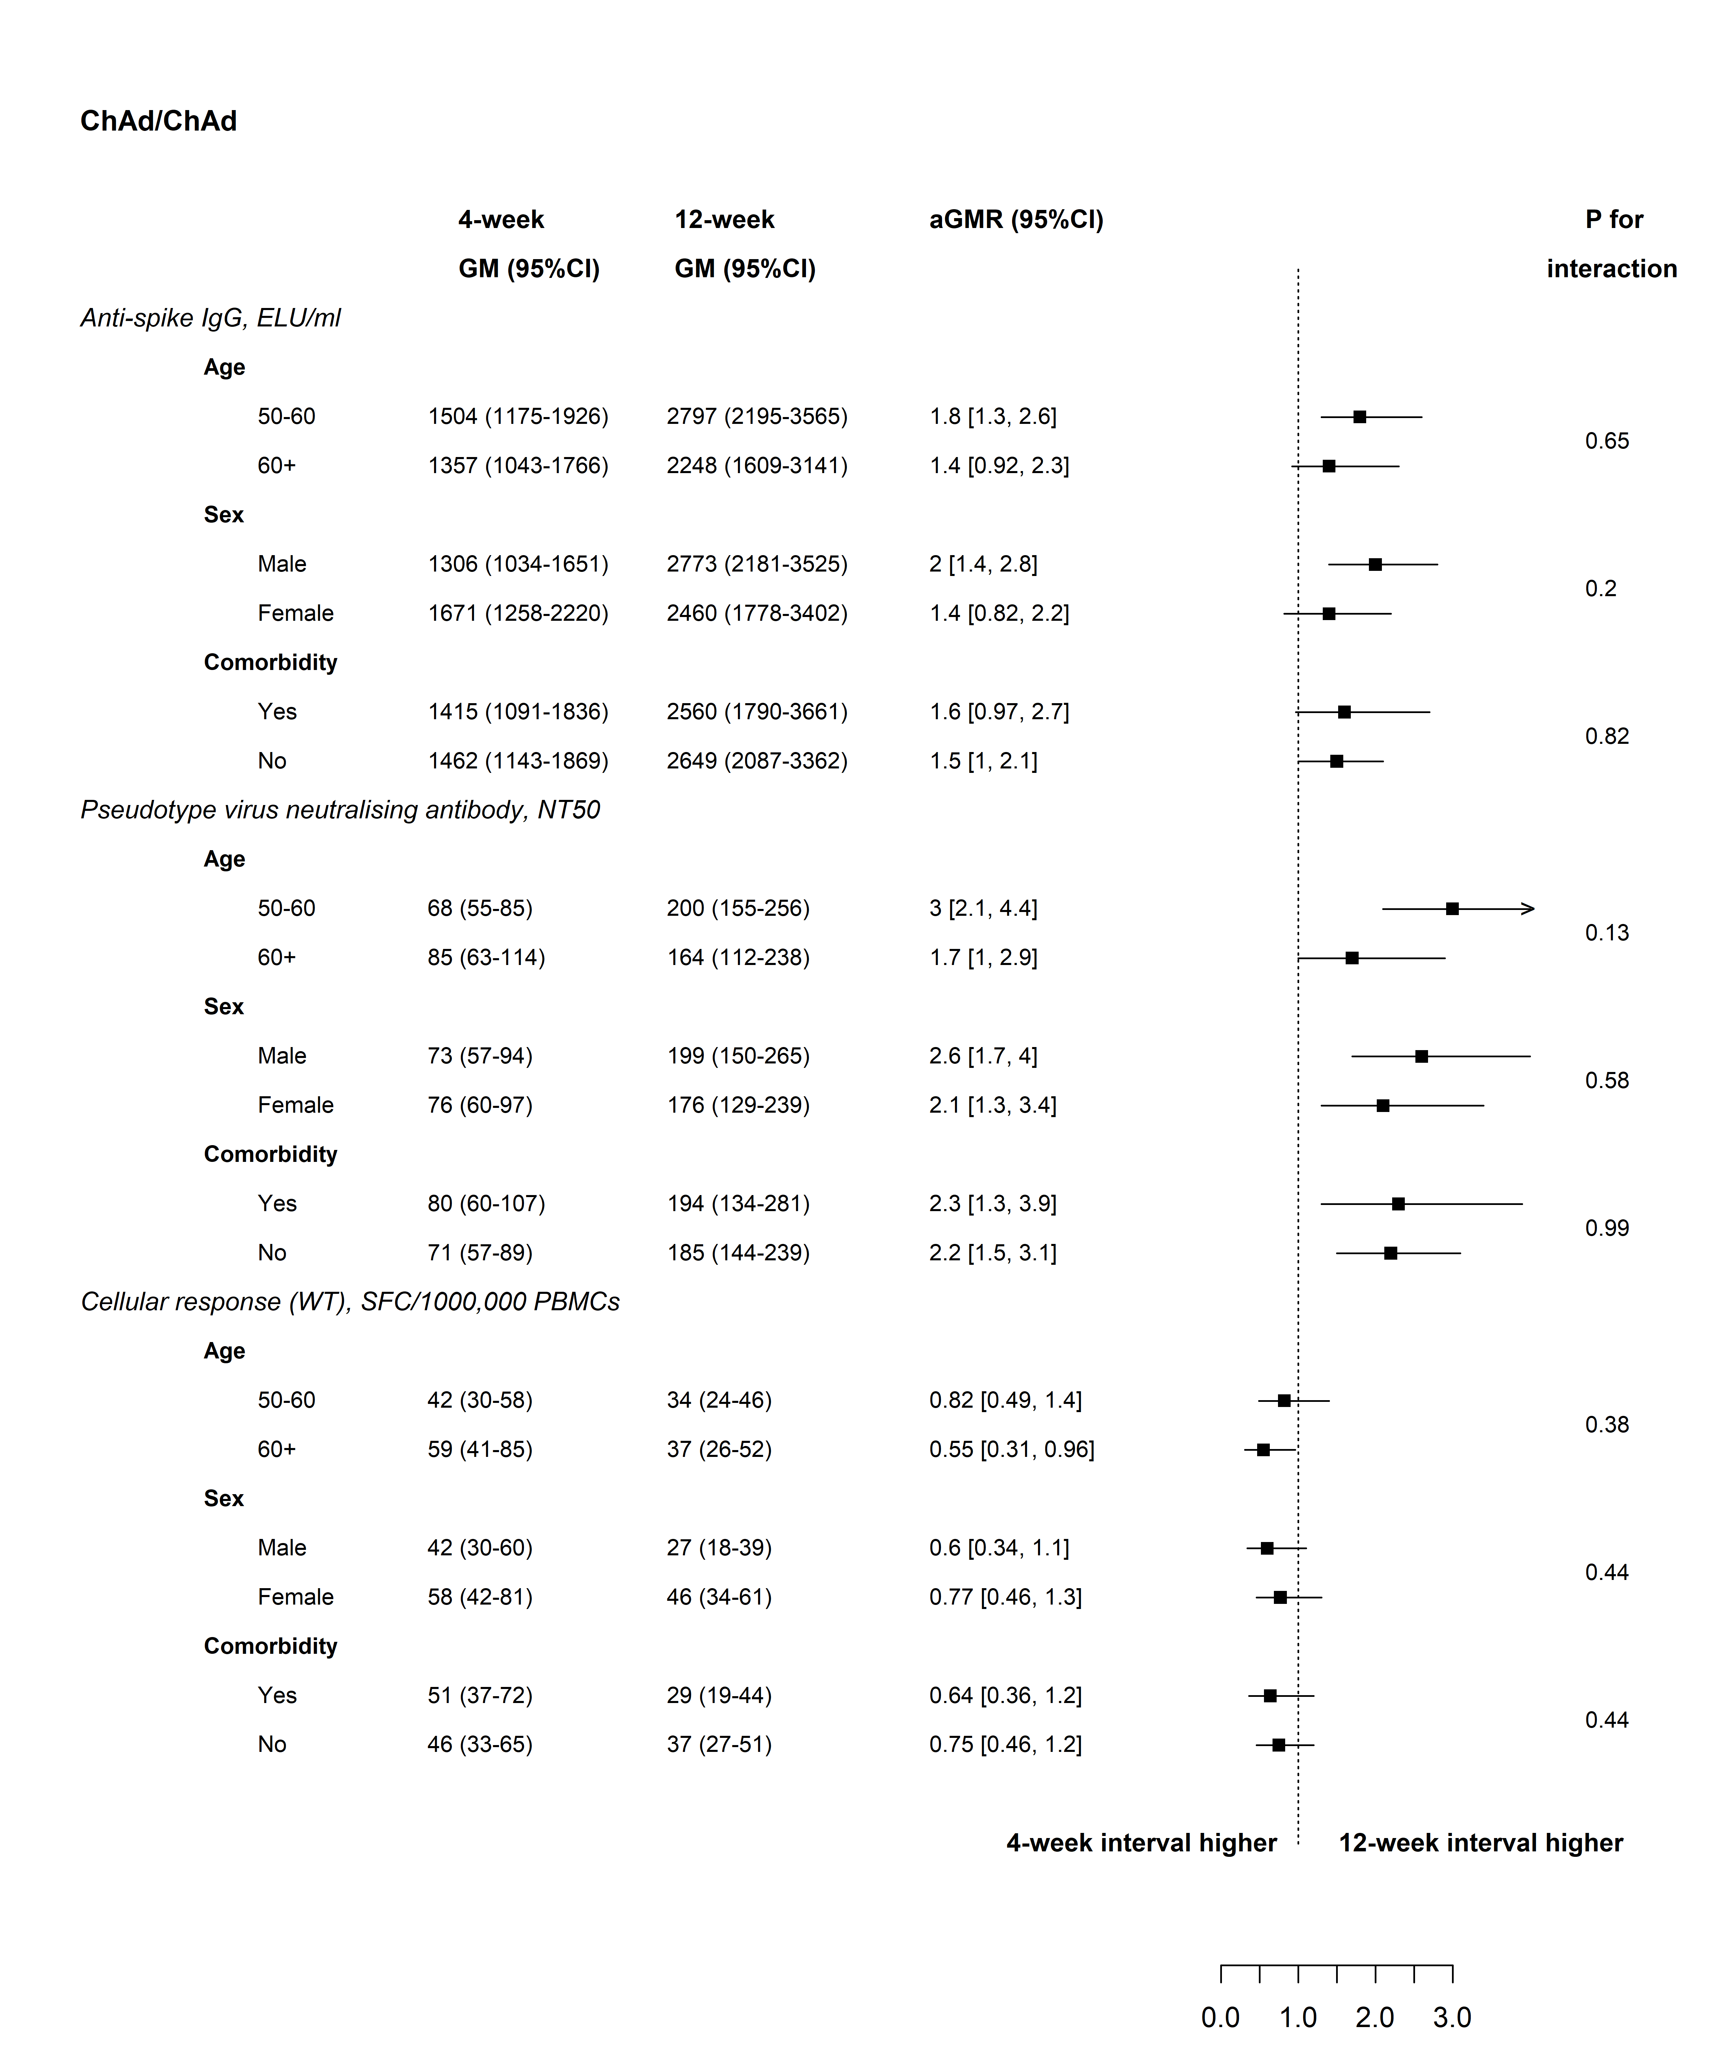
B) 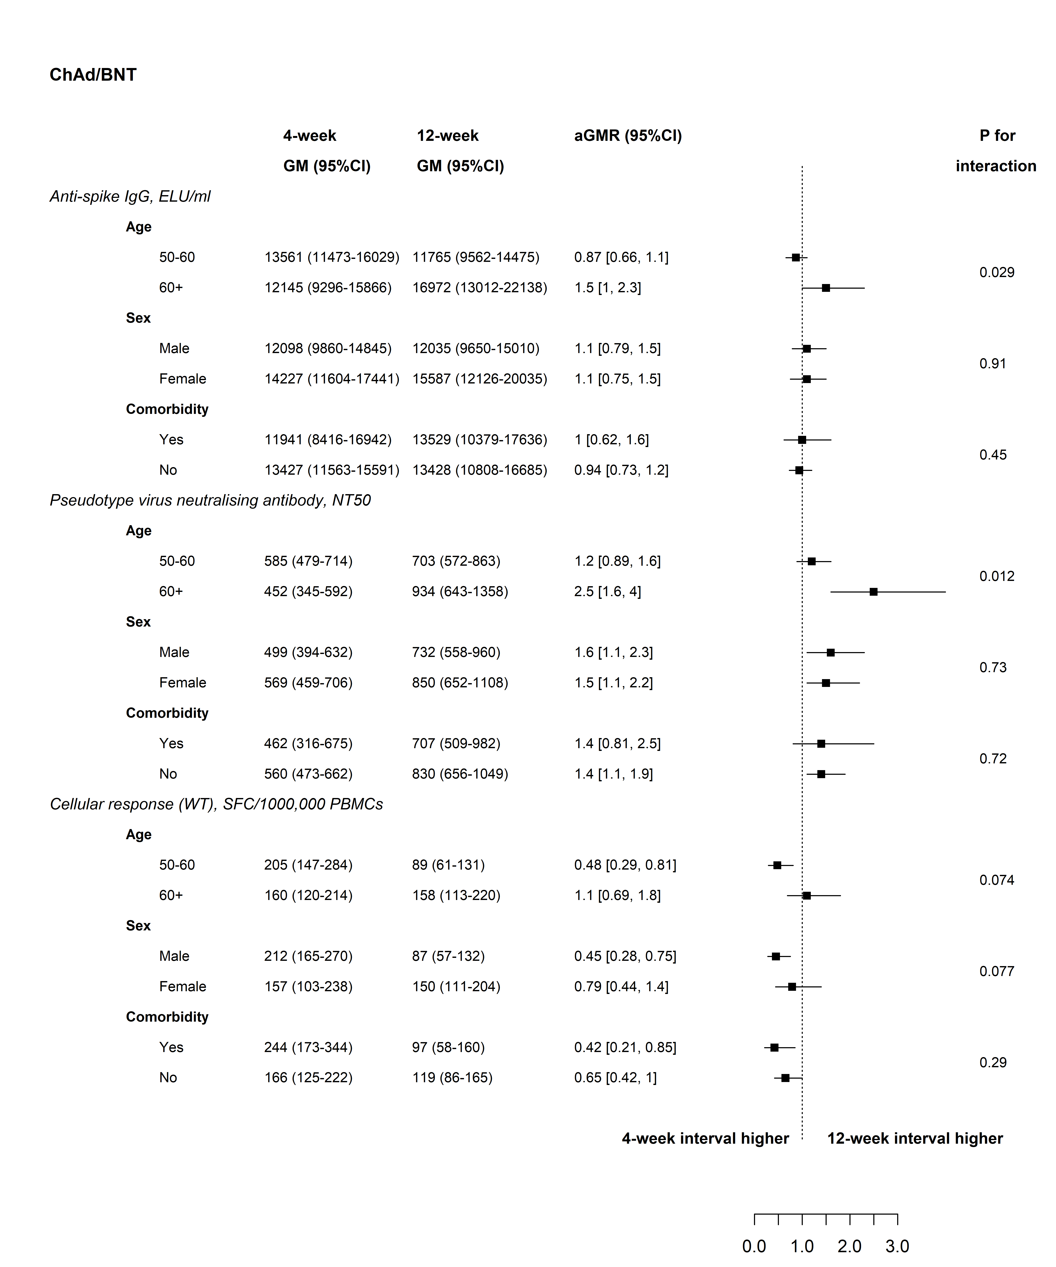
C) 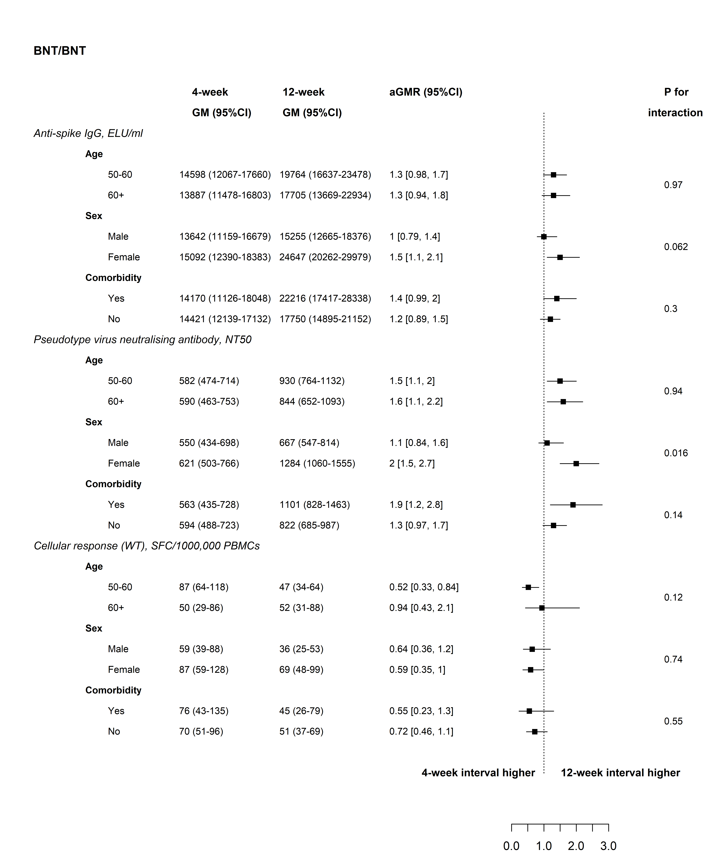

D)
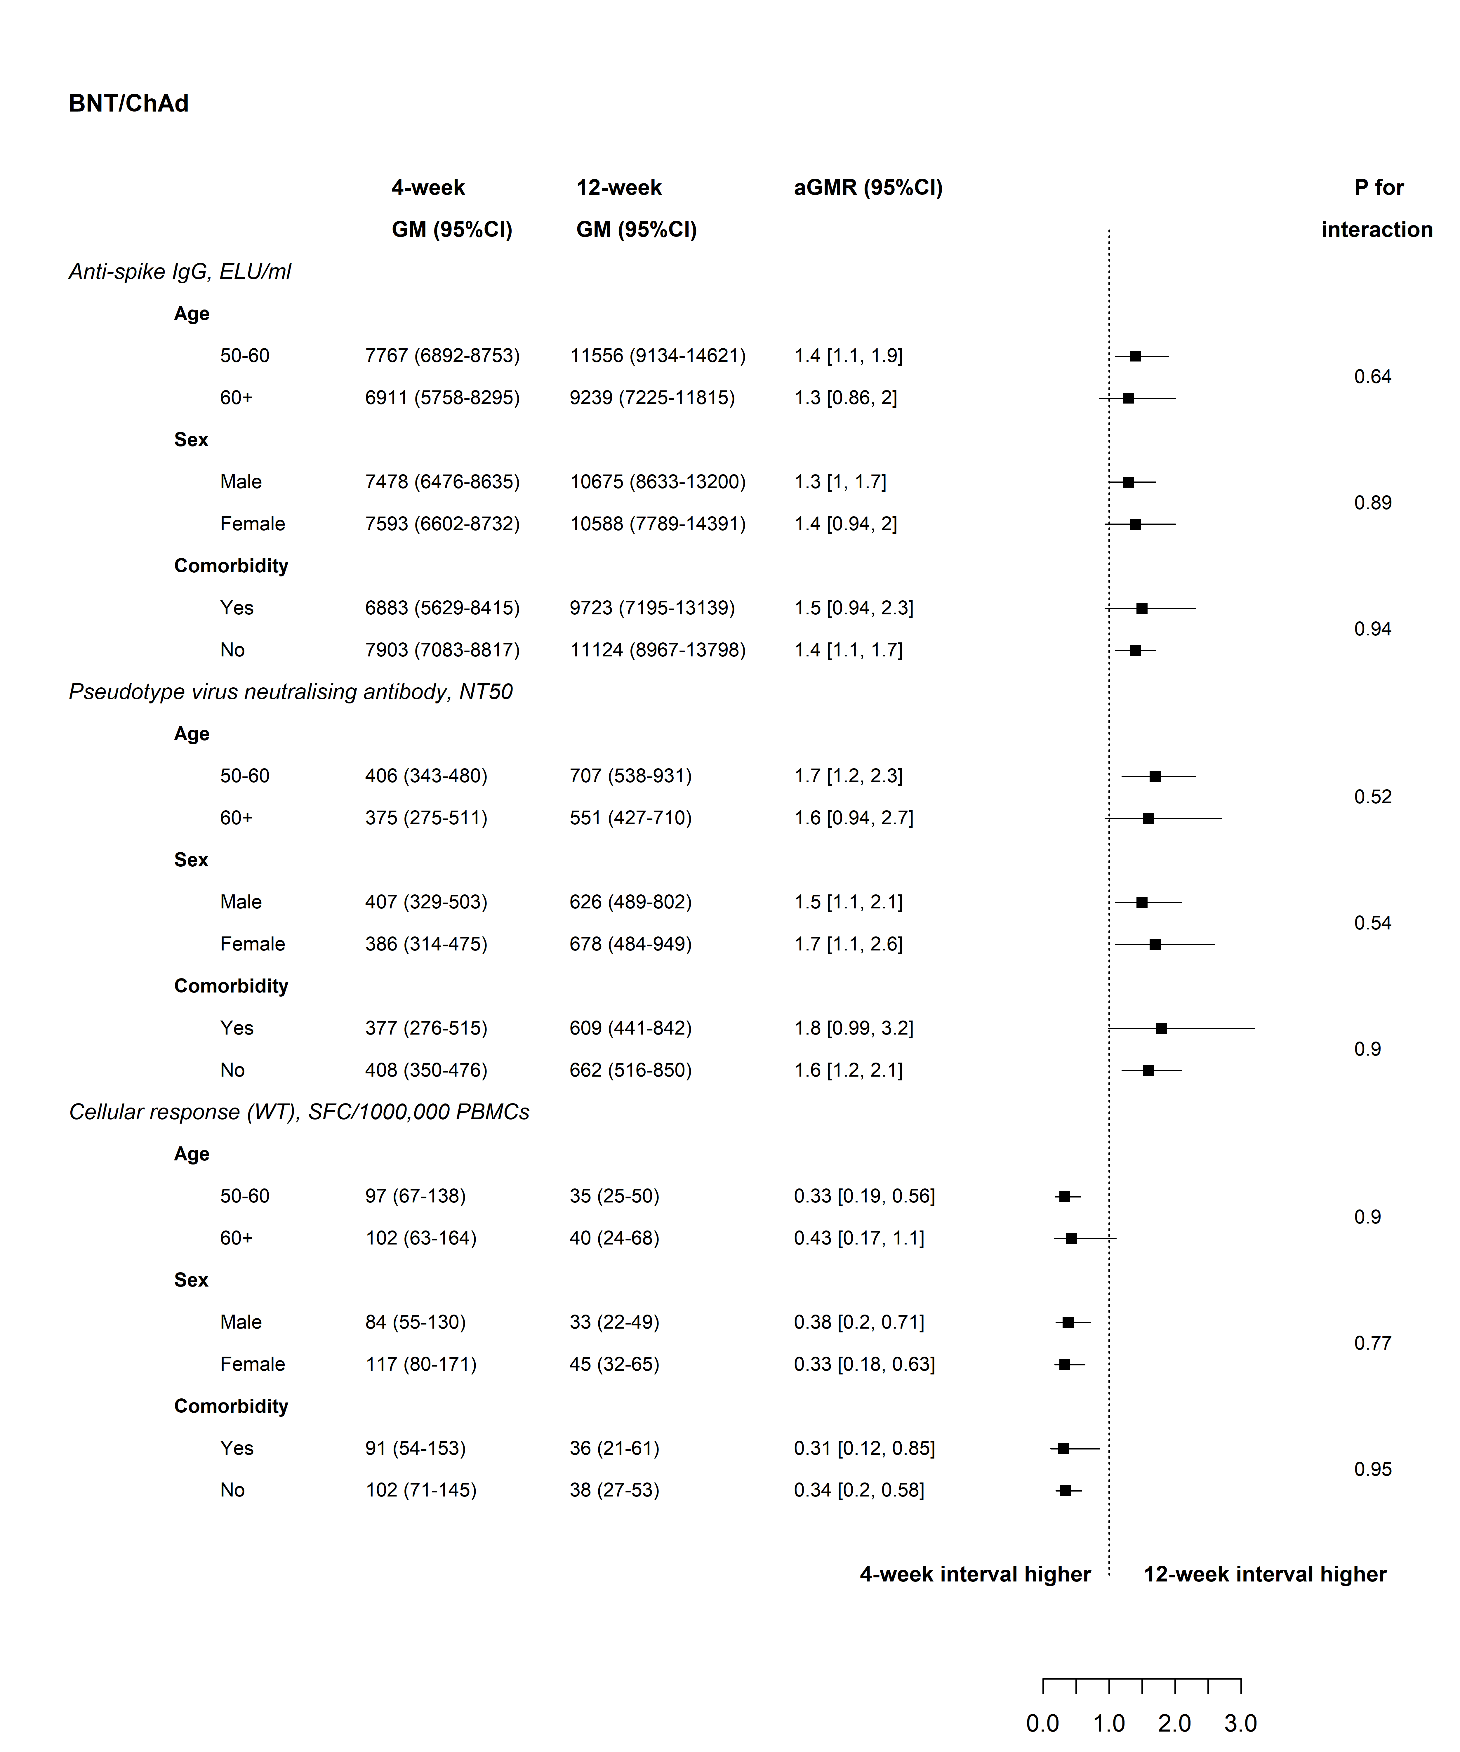
Supplementary Figure 5. Live neutralising antibodies against Victoria, Beta, Delta and Omicron variants at 28 days and 3 months post second dose in the general cohort with a 12-week interval

Dotted lines are the half value of the lower limit of detection; Boxes show median (IQR). 28-day post second-dose data not available for the Omicron variant. The same 50 participants were analysed at each timepoint for each variant.

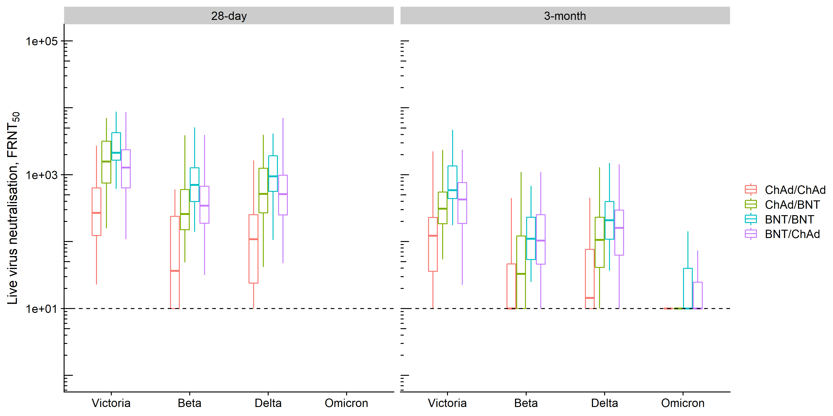
Supplementary Figure 6. Correlation between A) WT & Beta VNA, B) WT & Delta VNA, C) WT & Beta Cellular response, and D) WT & Delta Cellular response at 28 days post boost in the 12-week interval arms

The dotted diagonal line shows the situation when the immunogenicity against a variant of concern (VOC) is the same as that against the WT; the solid lines are the fitted linear regression based on the data above the LLOQ in each schedule. When the fitted line is below the dotted line, the immunogenicity against the VOC is less than that against WT, i.e. the cross-protection ratio is less than one. The closer the cross-protection ratio is to one, the closer the solid fitted line to the dotted diagonal line. When the fitted line is parallel to the dotted diagonal line, the cross-protection ratio does not change with the absolute level of immunogenicity. FRNT₅₀ – 50% Focal reduction neutralisation titre; SFC, spot forming cells; PBMC, peripheral blood mononuclear cell; WT, wild-type

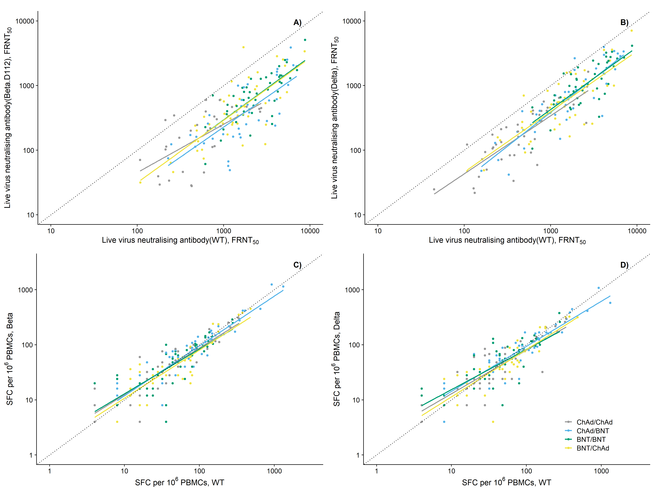

Supplementary Figure 7. Consort of paracetamol sub-study participants
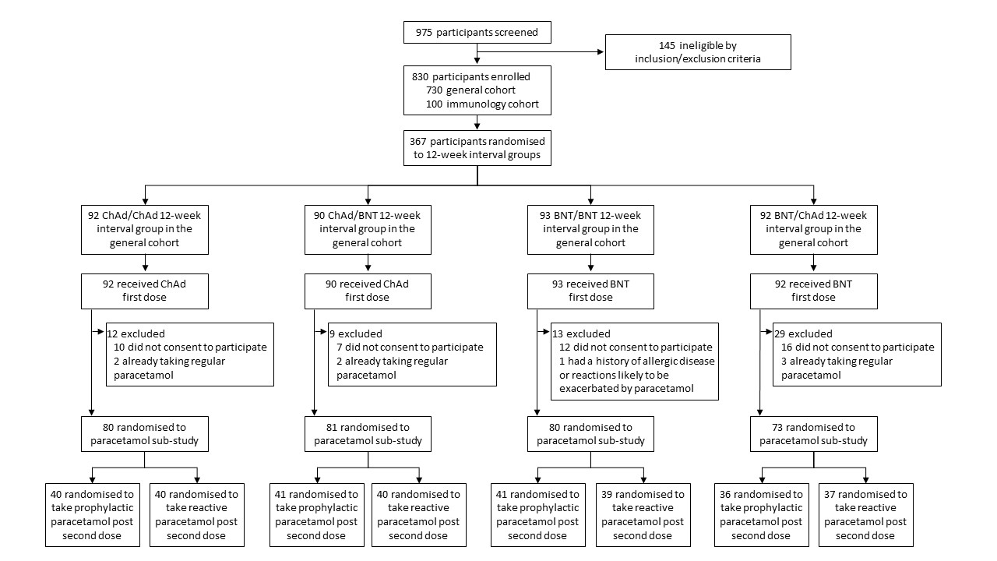

Supplementary Figure 8. Maximum severity of solicited adverse events in the first seven days post- first dose and post-second dose by study arm in the general cohort. A) Local, and B) Systemic

- Local adverse events

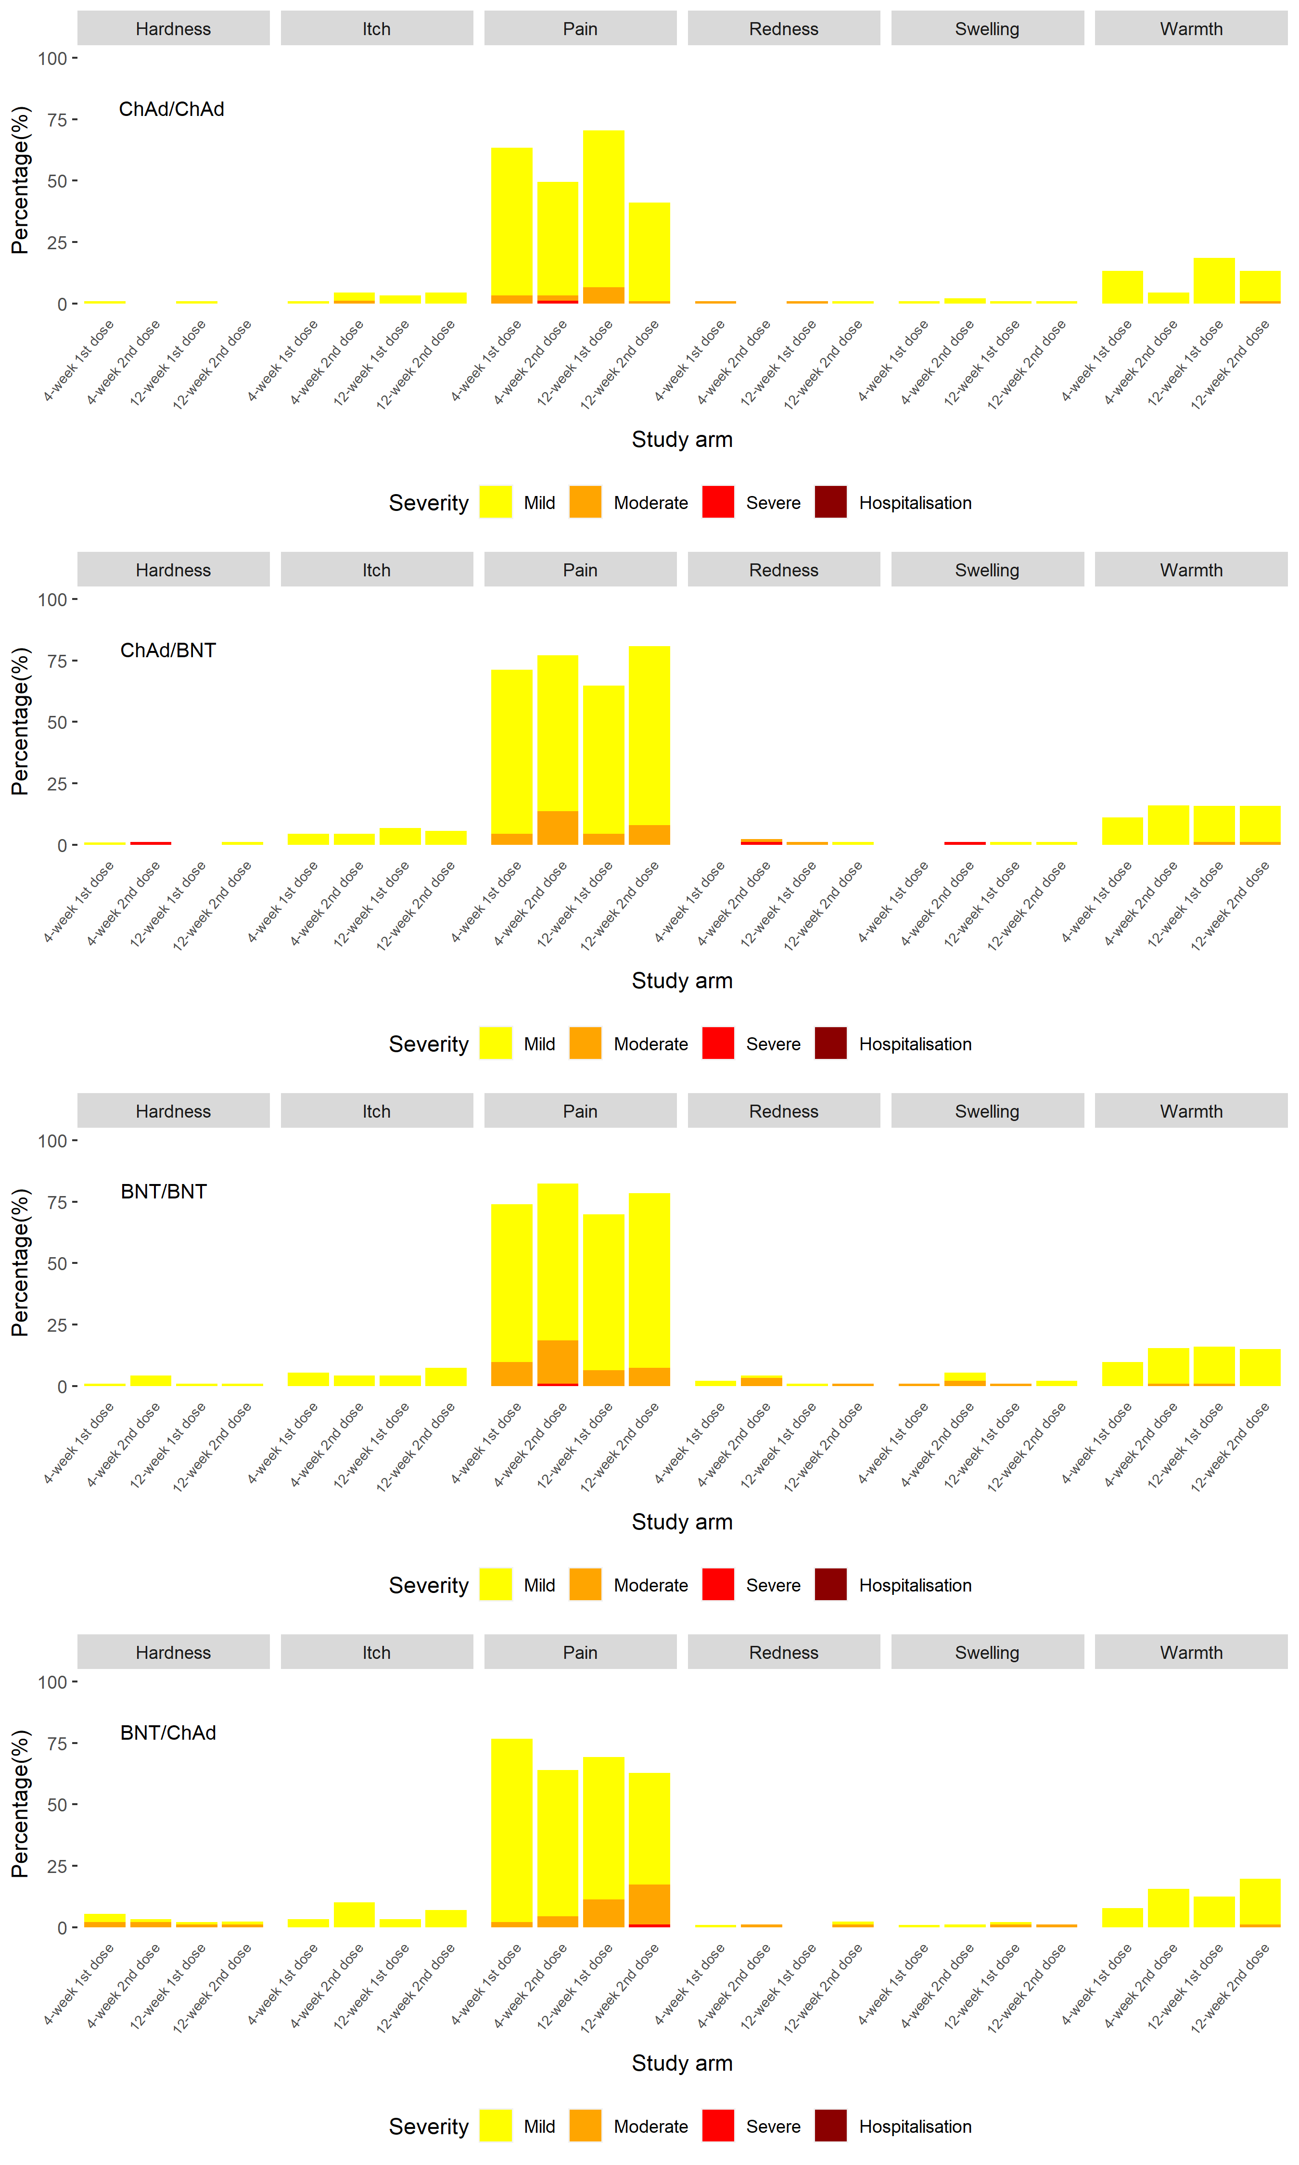
- Systemic adverse events

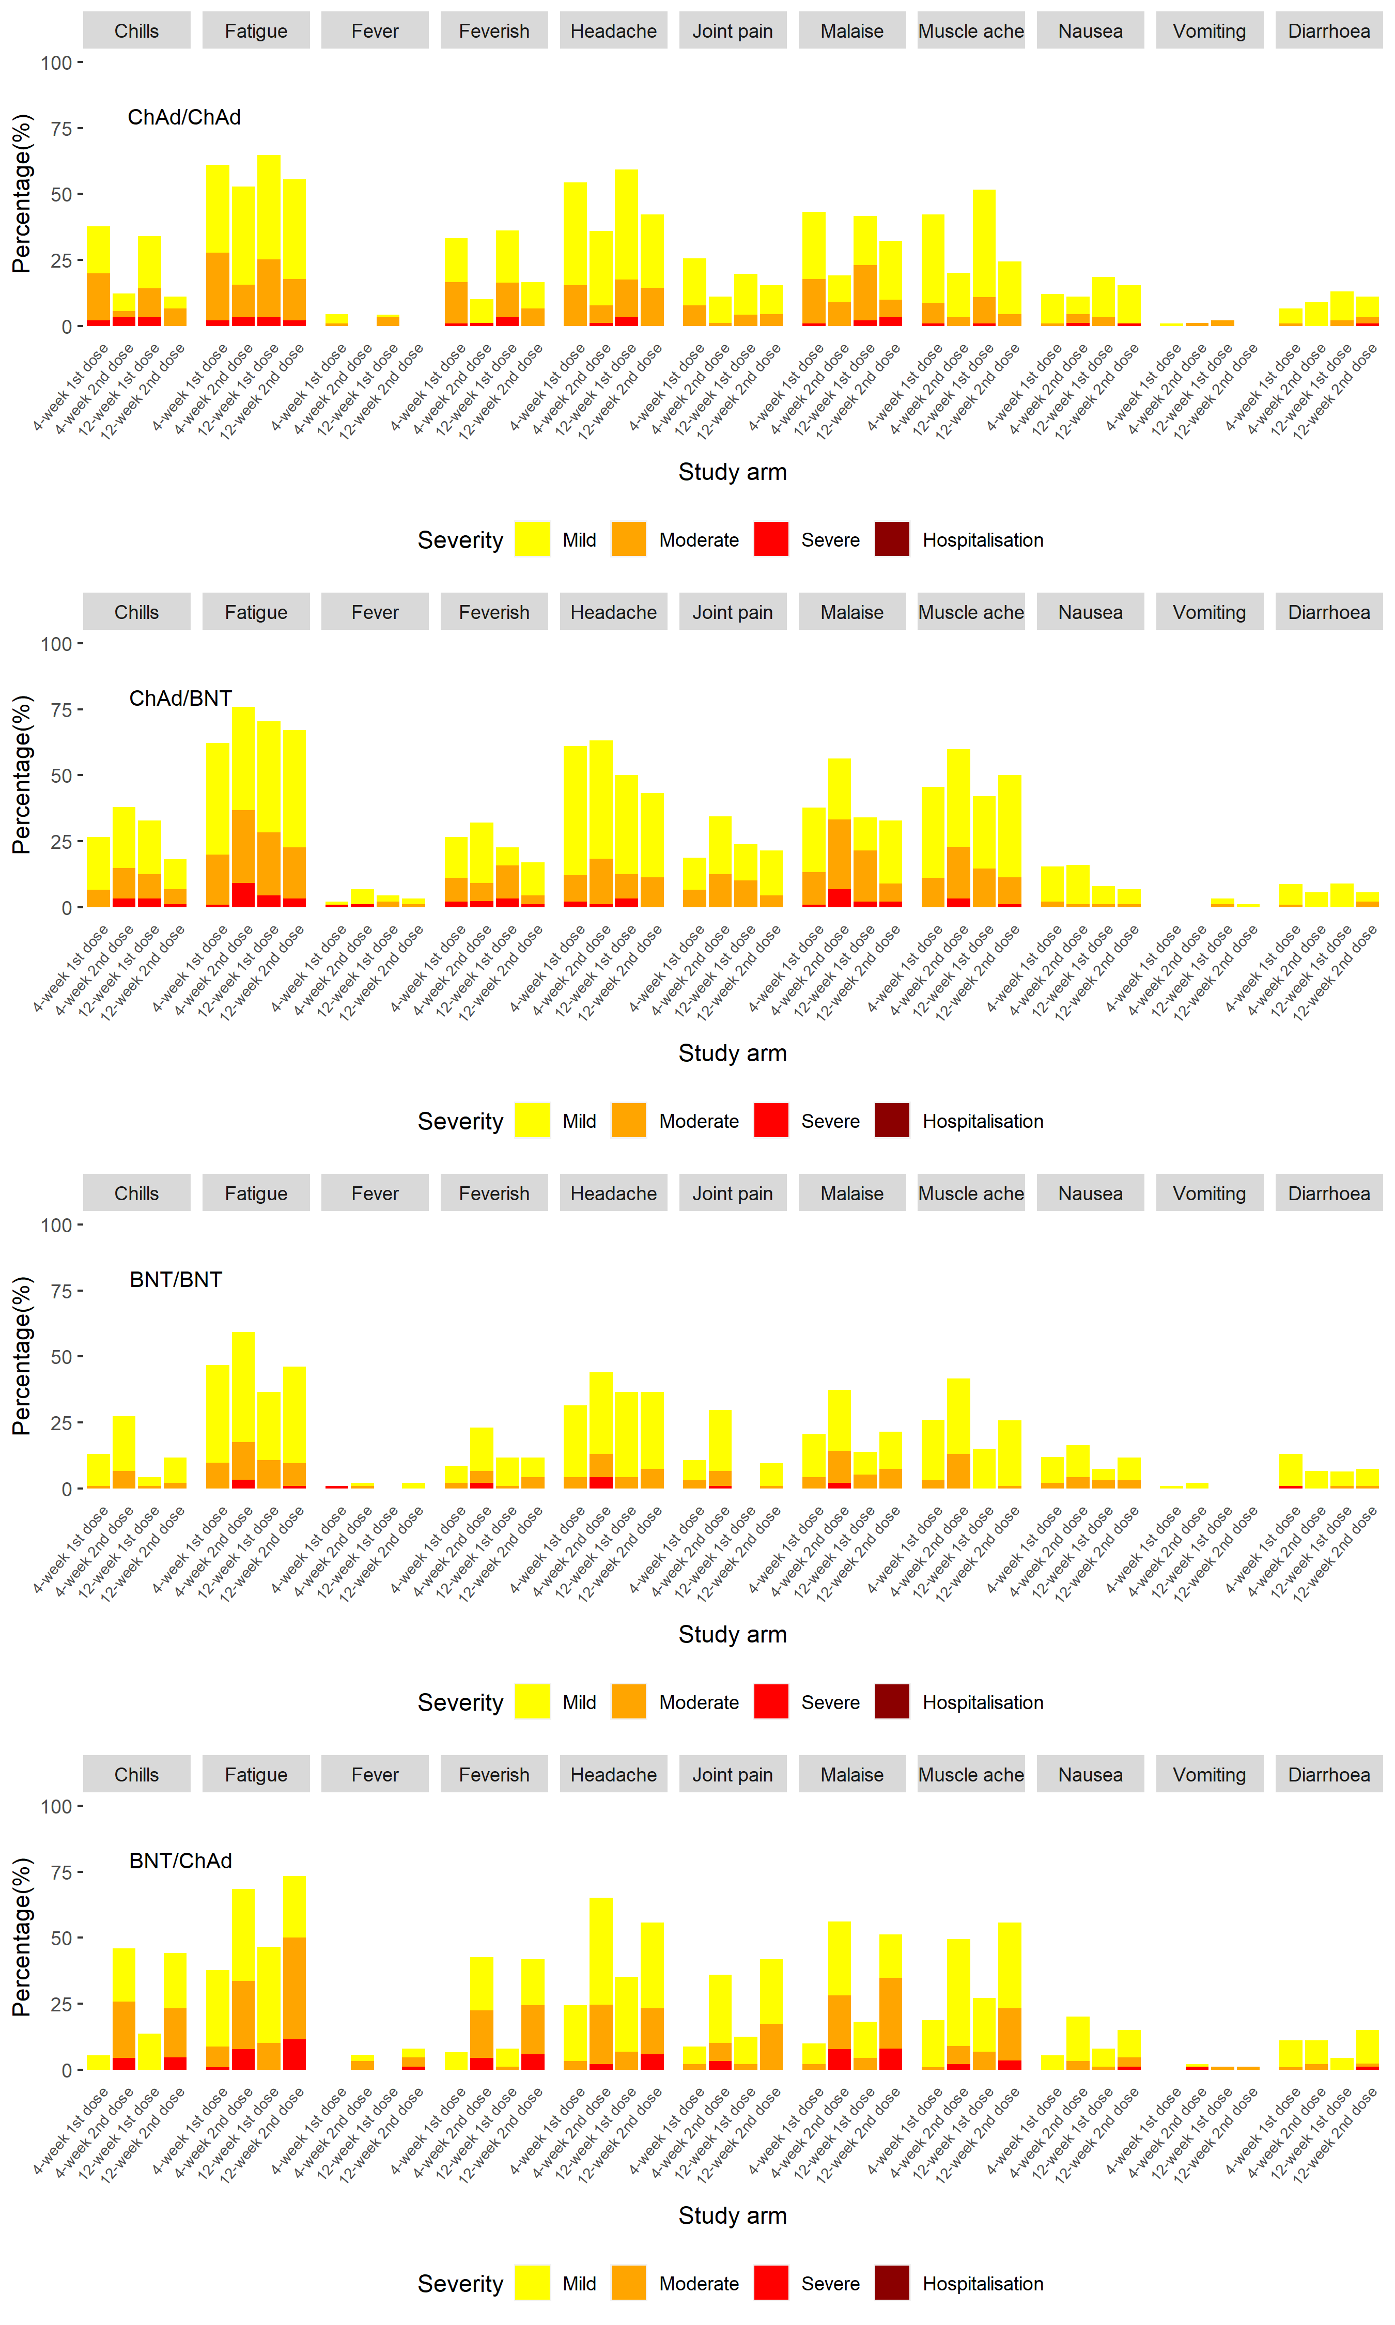

Supplementary Figure 9. Forest plot of any solicited adverse events in days 0-7 post-second dose comparing heterologous to homologous schedules in the general cohort. A) 4-week interval, and B) 12-week interval

AE: adverse event; CI: confidence interval; OR: odds ratio. Models adjusted for paracetamol use in the first 24 hours post-second dose (yes/no) and paracetamol sub-study randomisation (prophylactic/reactive/non-randomised) in the 12-week interval models. Models with no adjusted odds ratio were non-estimable due to no events in that study arm. The dotted line shows the line of no difference between heterologous and homologous schedules.

A)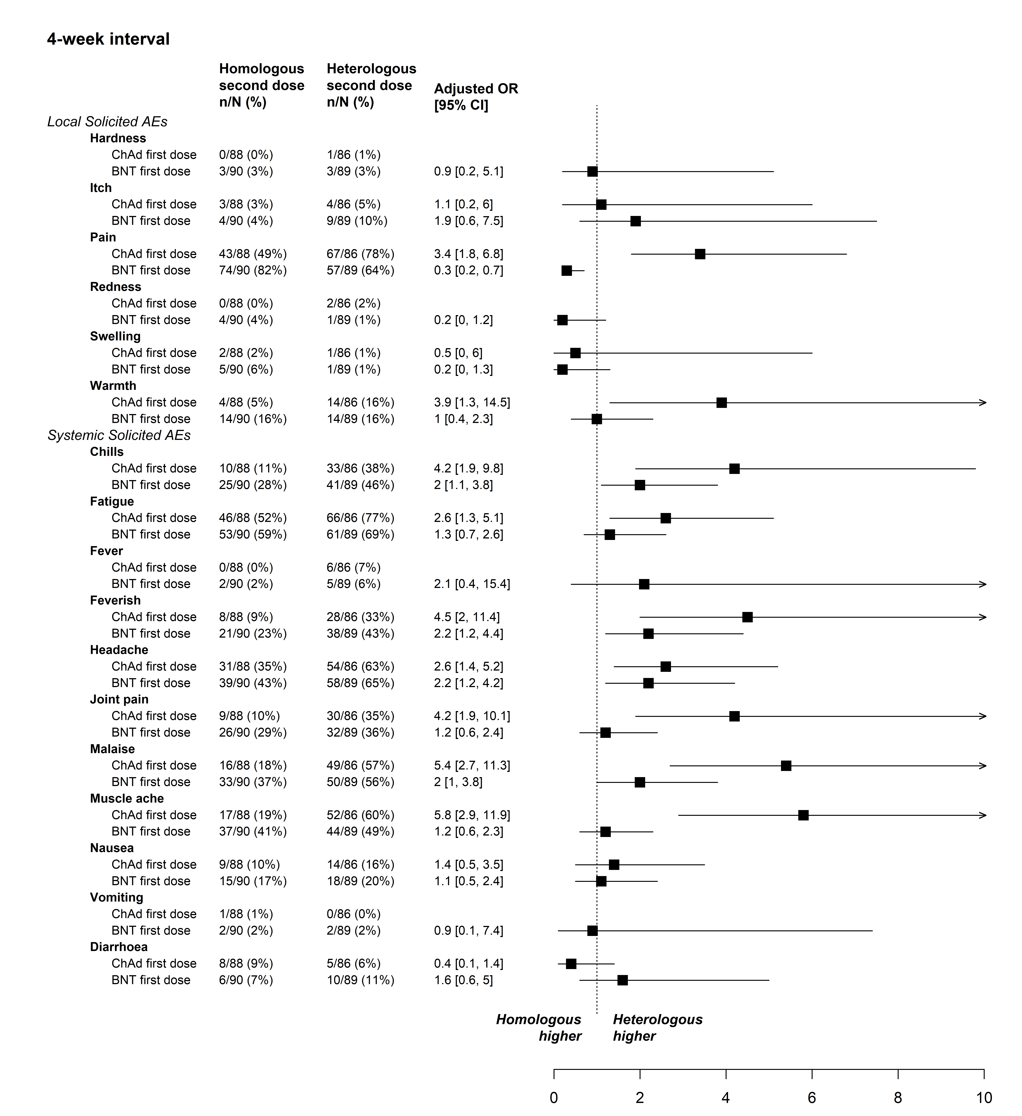B) 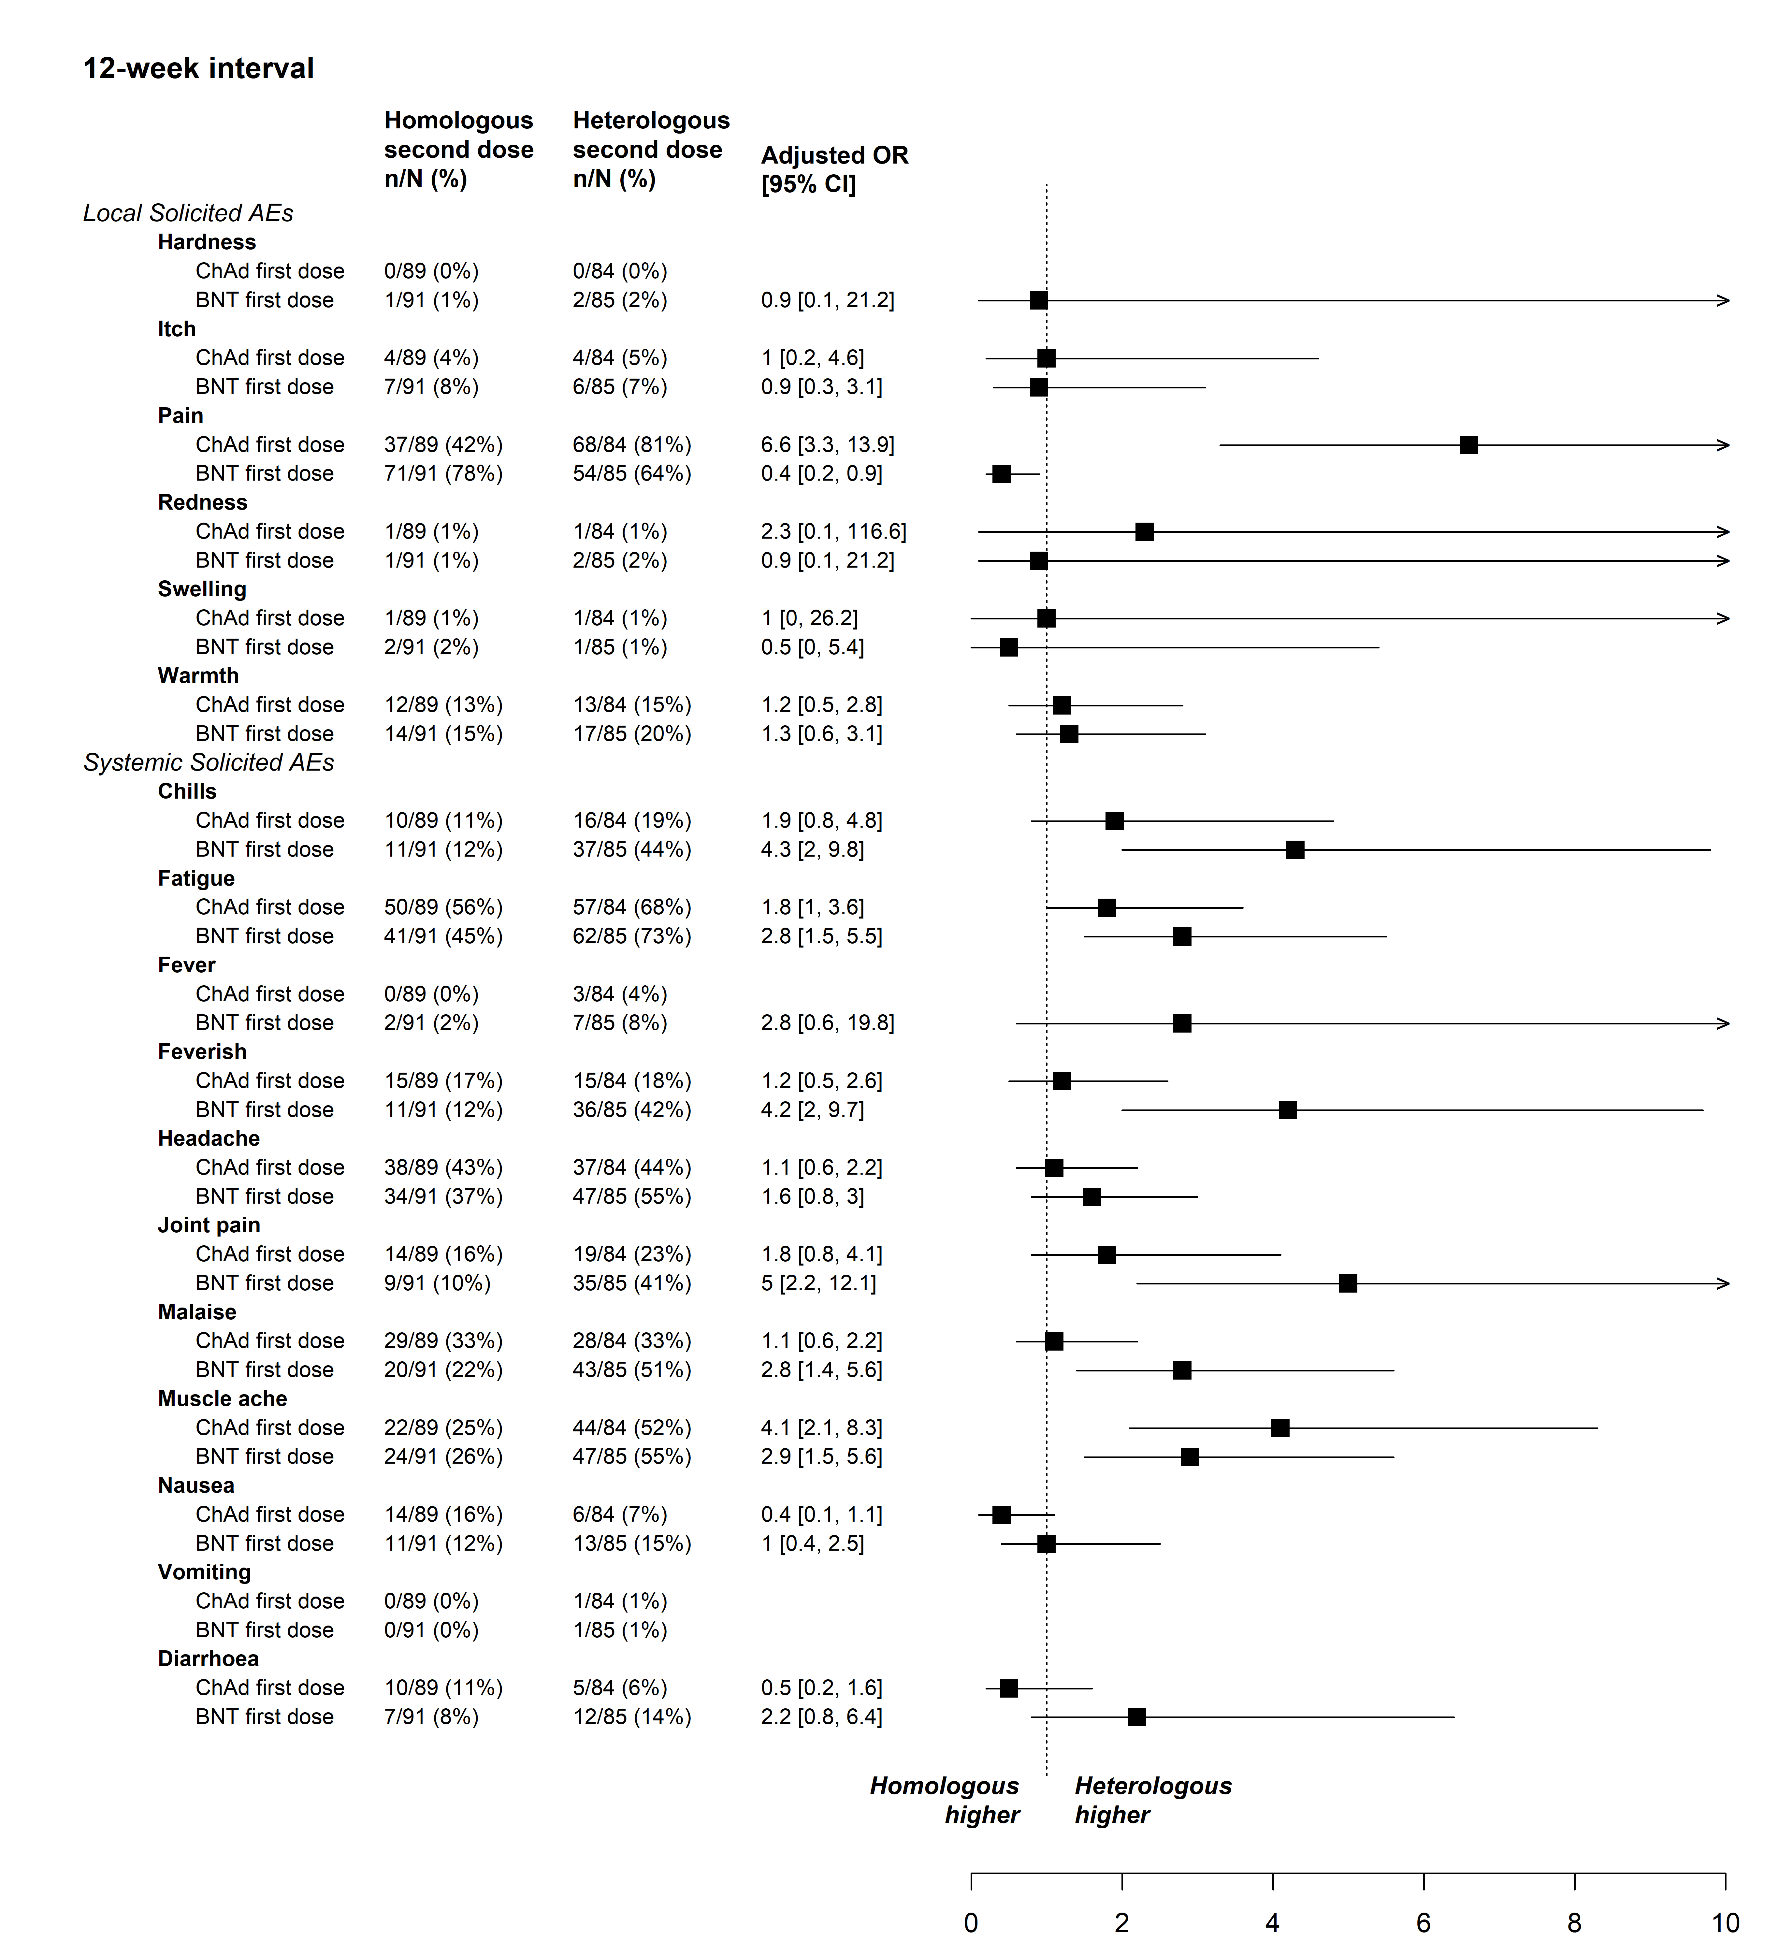

Supplementary Figure 10. Solicited adverse events in days 0-7 post second dose by day and study arm in the 12-week interval groups. A) Local adverse events, and B) Systemic adverse events

- Local adverse events

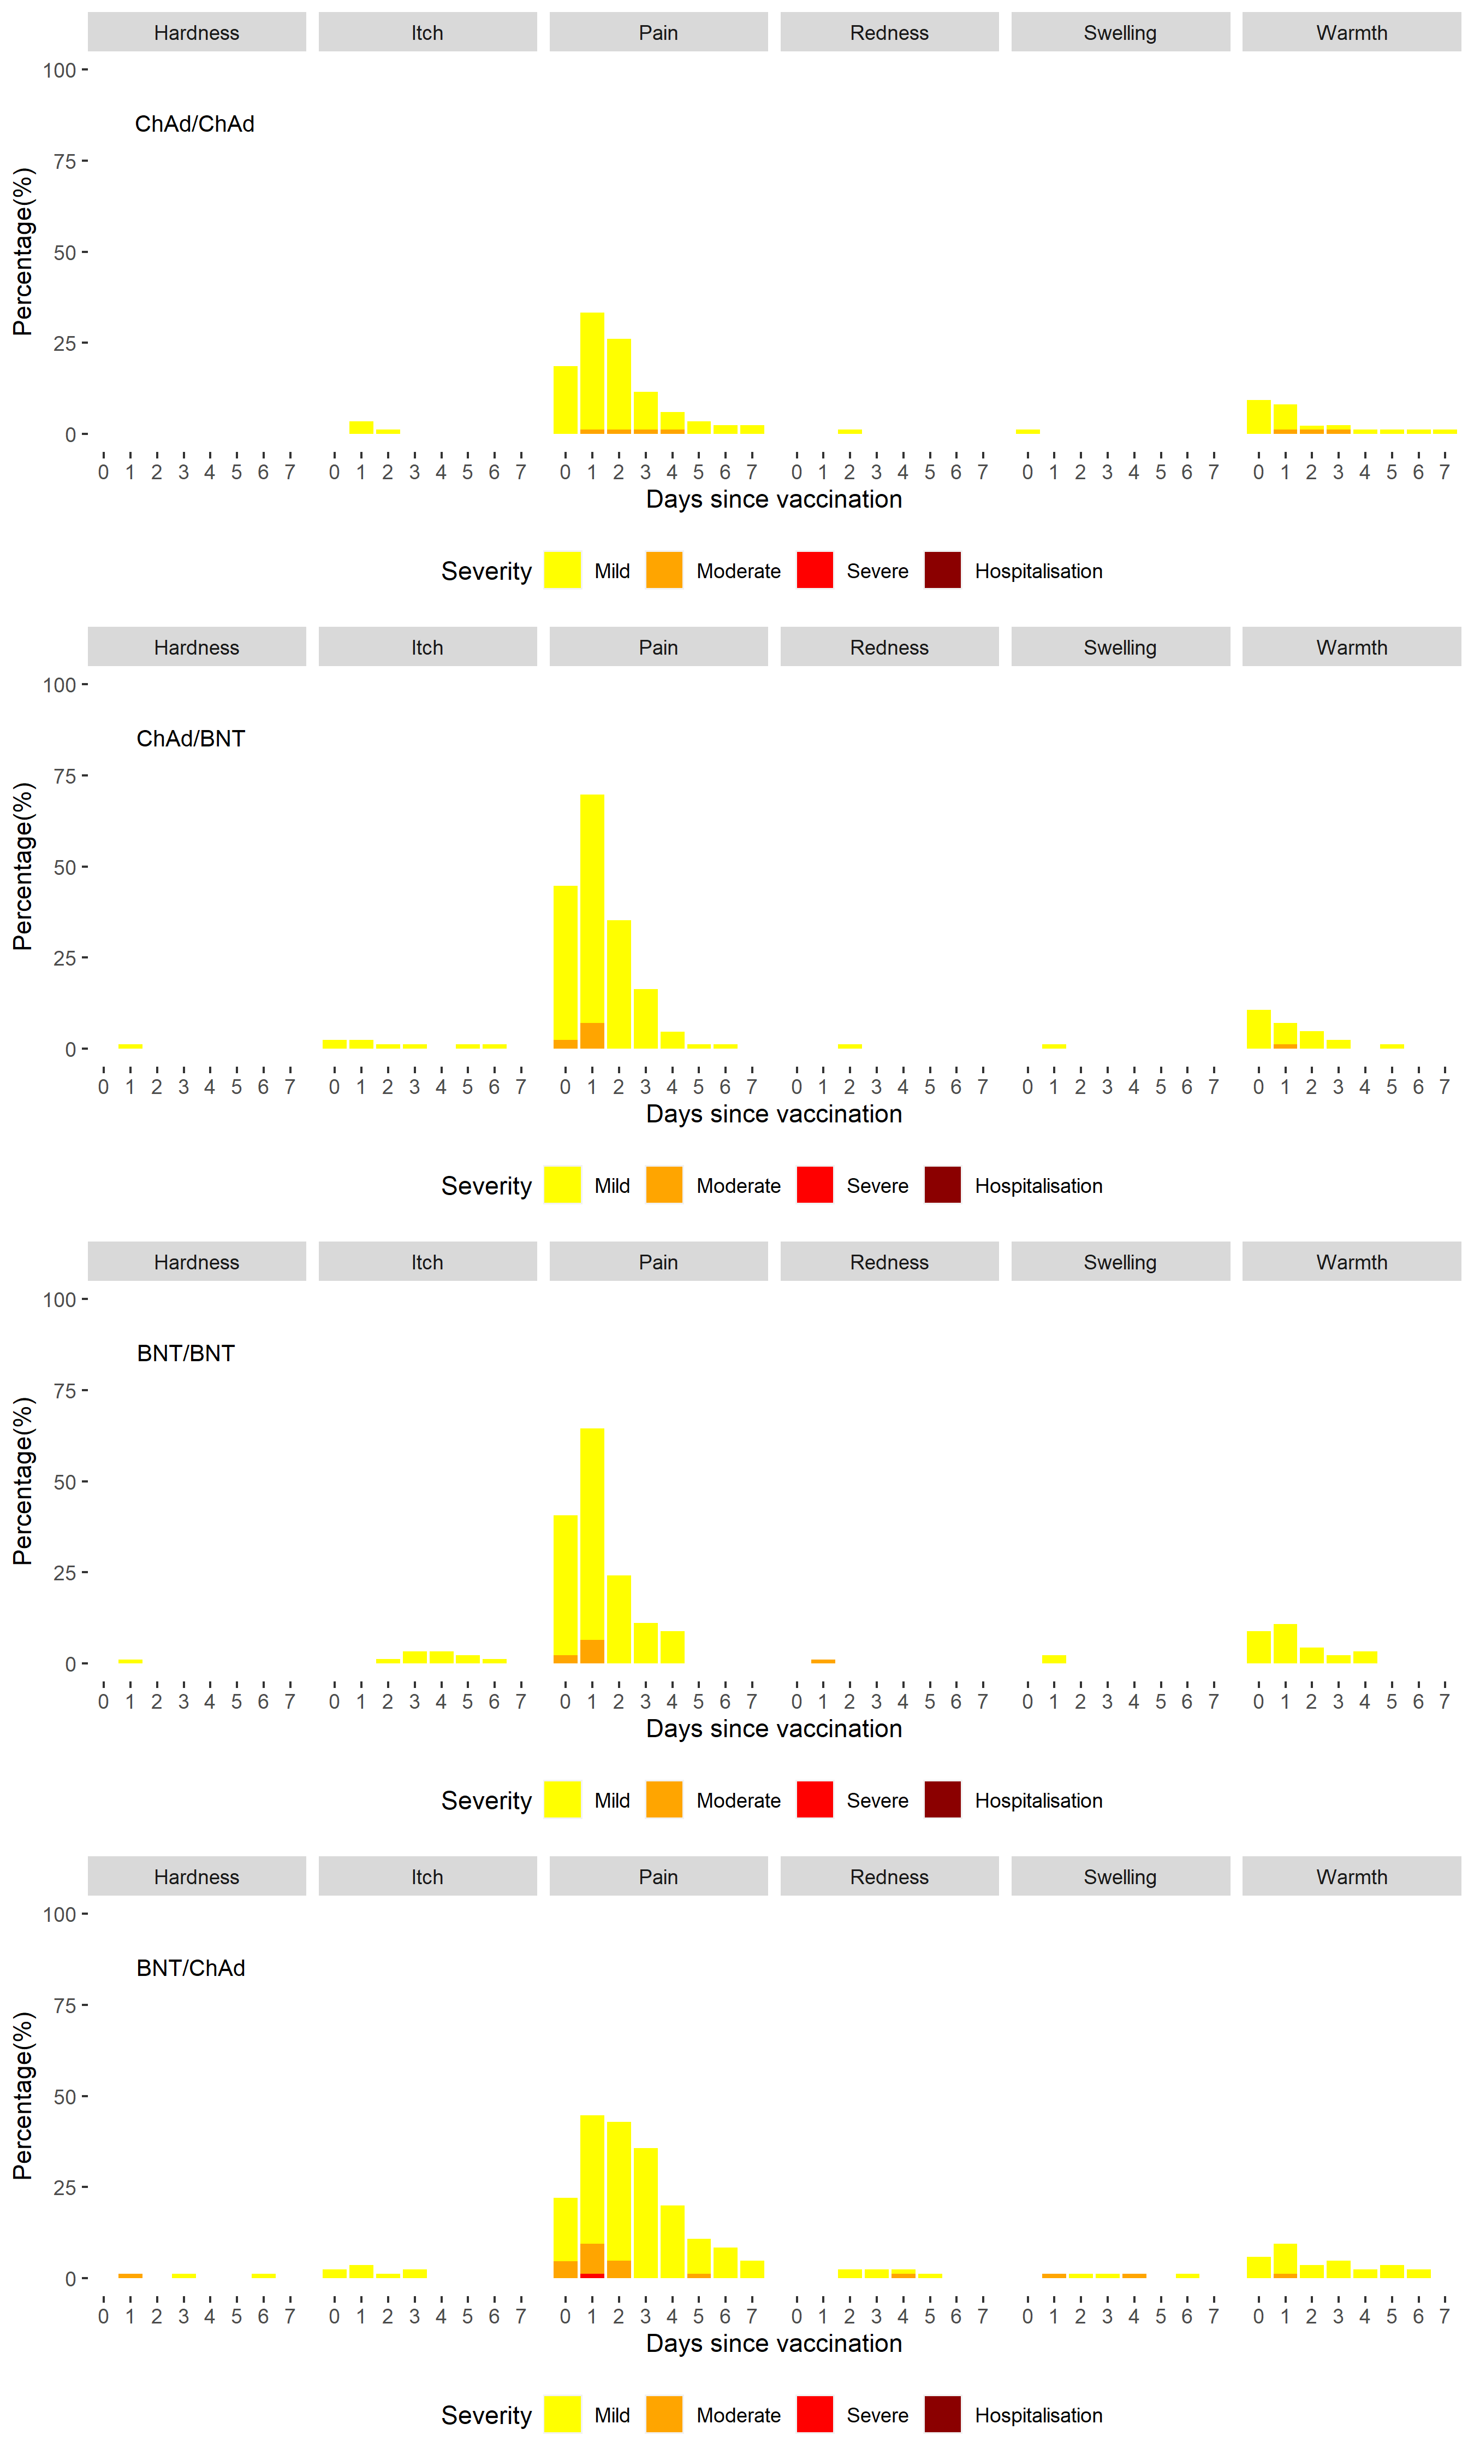

- Systemic adverse events

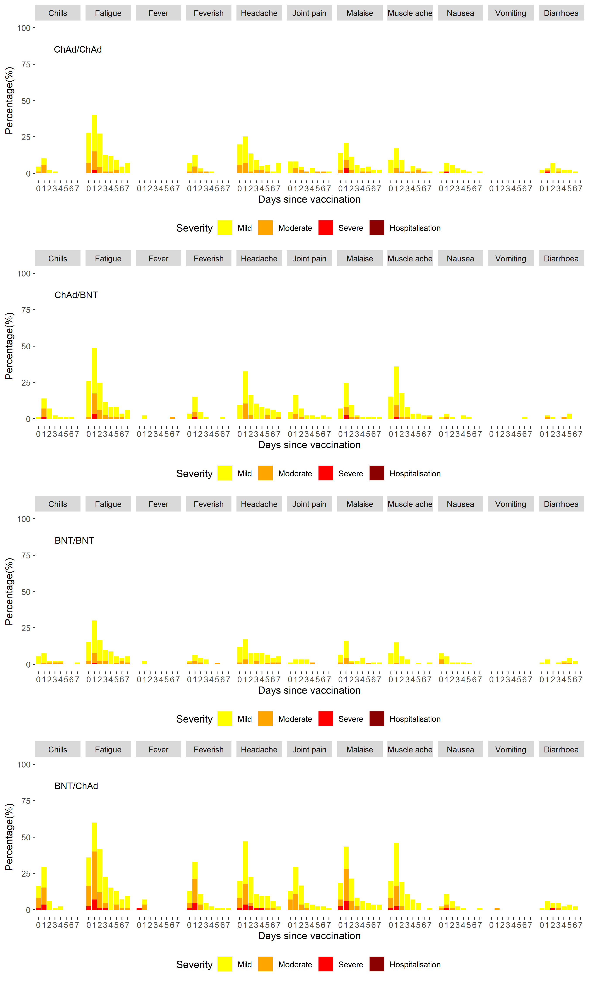

Supplementary Figure 11. Solicited adverse events at time of second dose by paracetamol sub-study arm compared to 4-week interval arms in the general cohort. A) local, B) systemic

Pro: Prophylactic, Rea: Reactive, NR: Non-randomised.

- Local adverse events

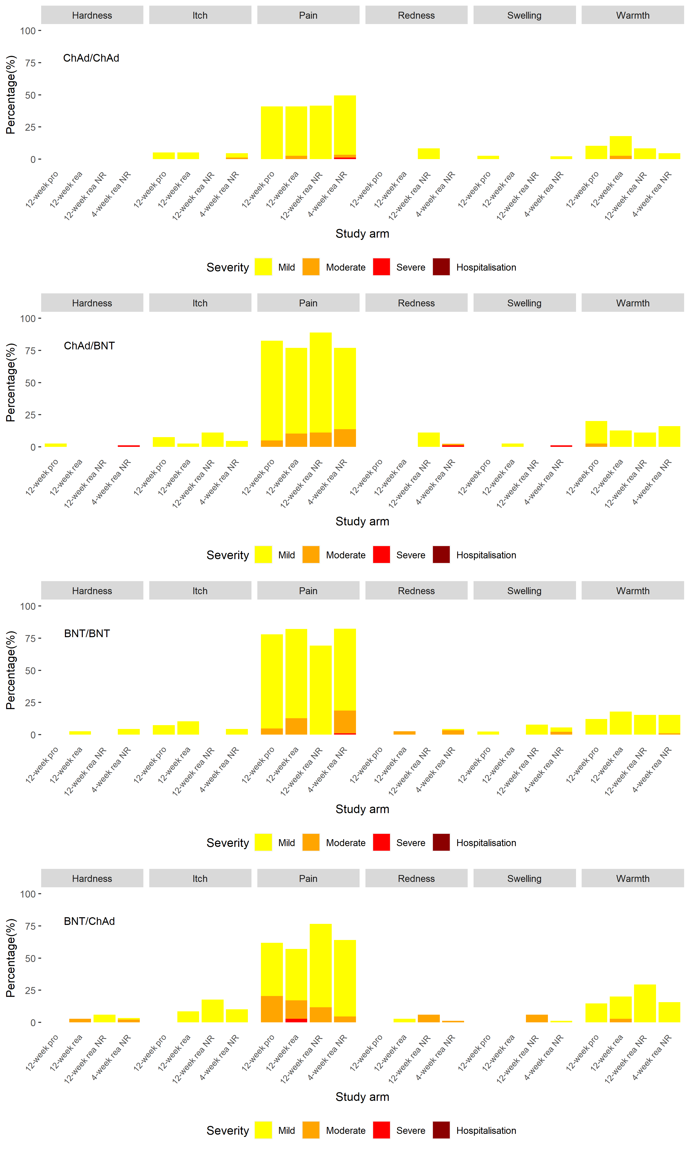

- Systemic adverse events

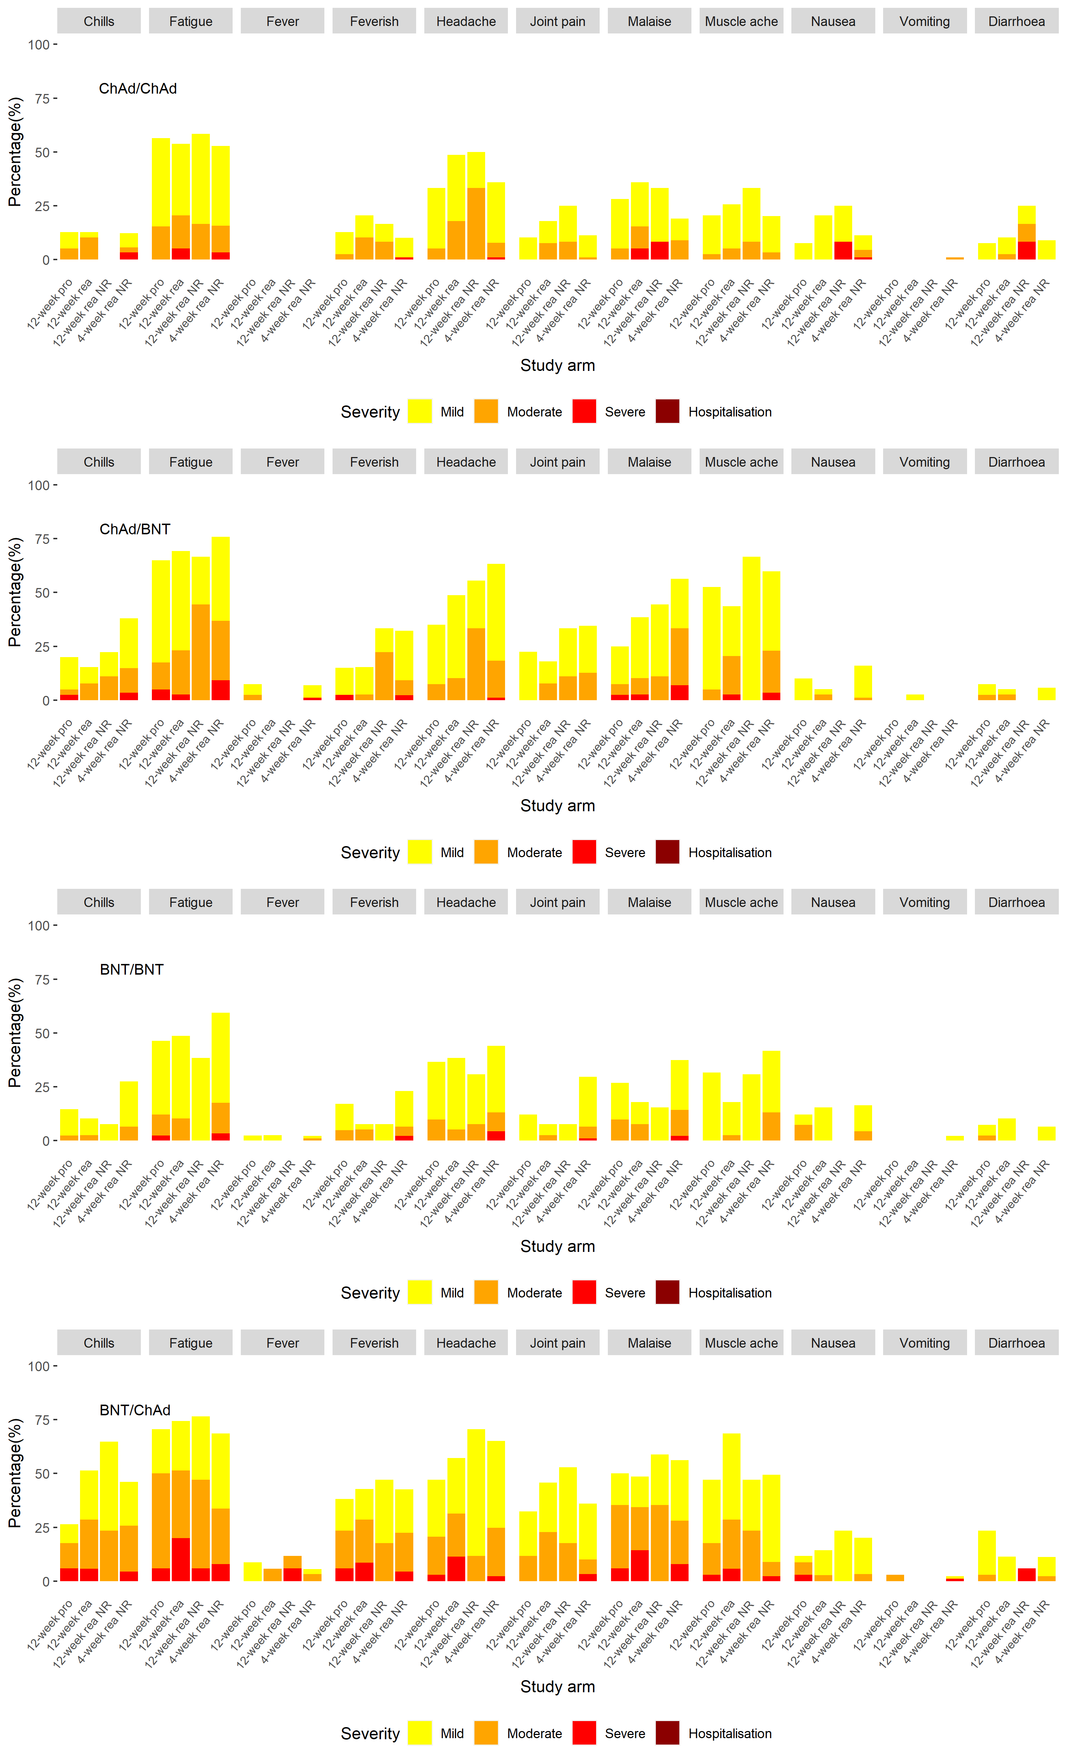

Supplementary Figure 12. Forest plot of any solicited adverse events in days 0-7 post second dose comparing prophylactic to reactive paracetamol use in the paracetamol sub-study of 12-inteval arms for A) ChAd/ChAd; B) ChAd/BNT; C) BNT/BNT; D) BNT/ChAd

AE: adverse event; CI: confidence interval; OR: odds ratio.
Models adjusted for vaccine schedule, age and sex. The dotted line shows the line of no difference between prophylactic and reactive groups

A) 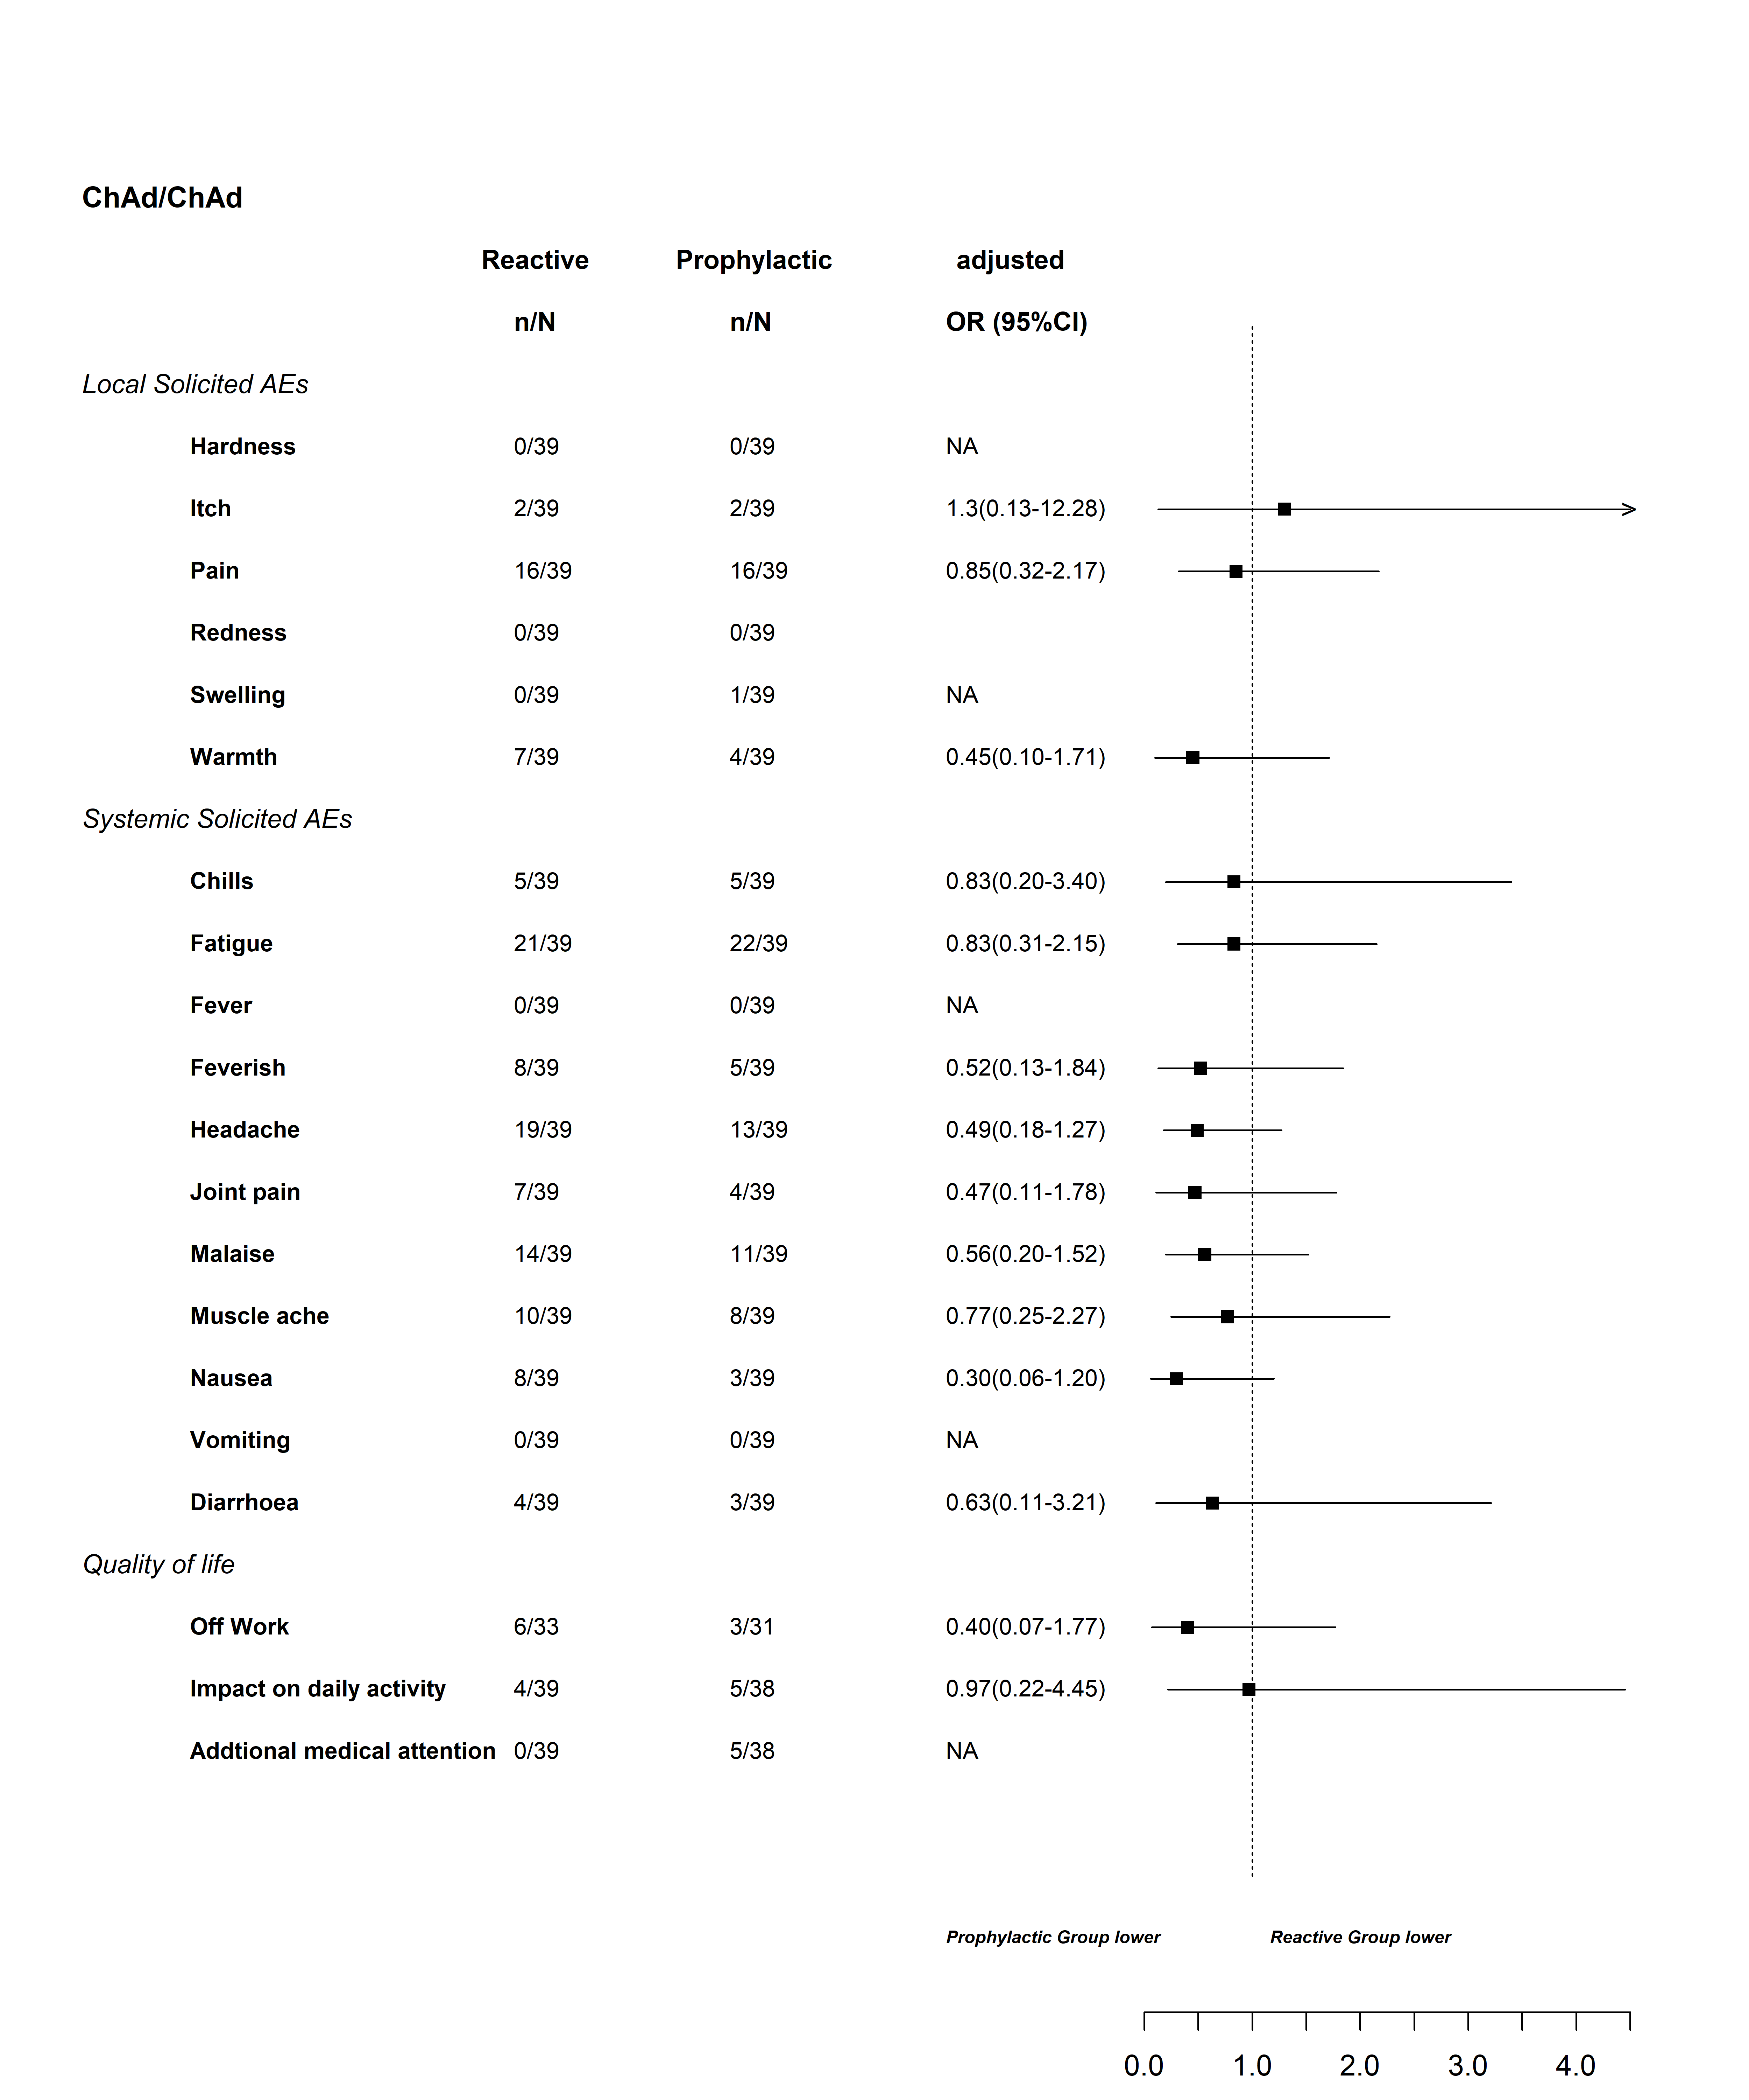
B) 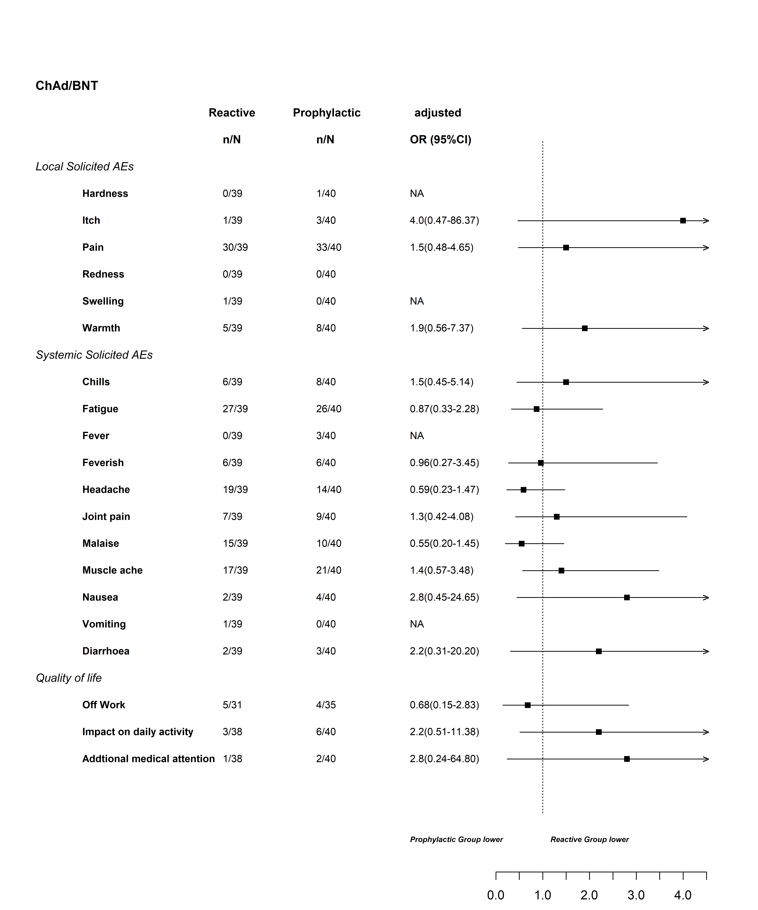
C) 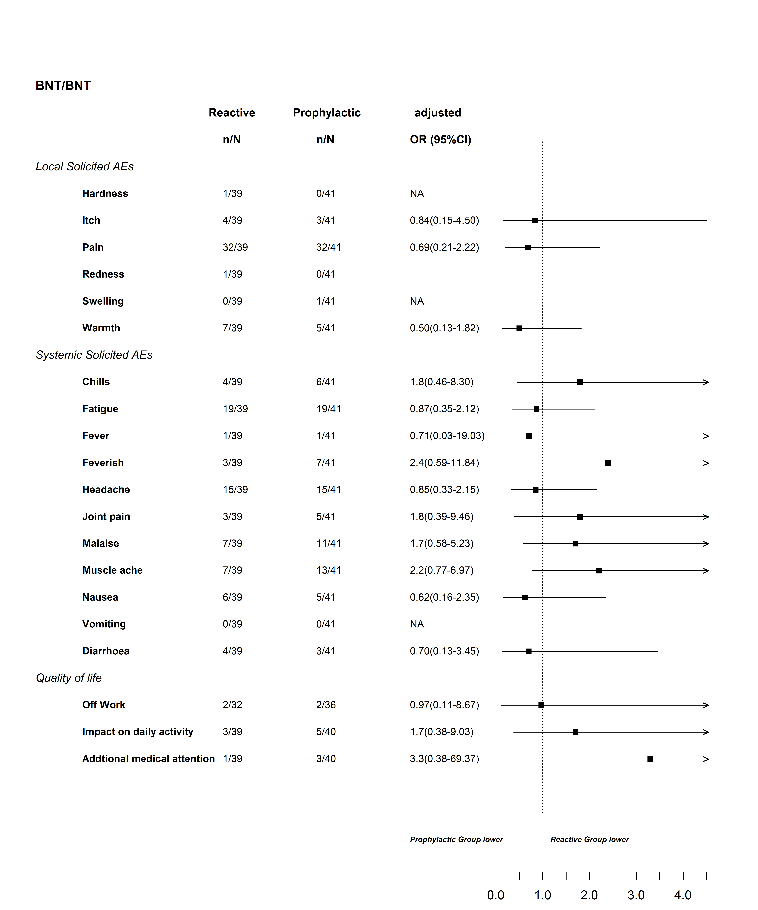
D) 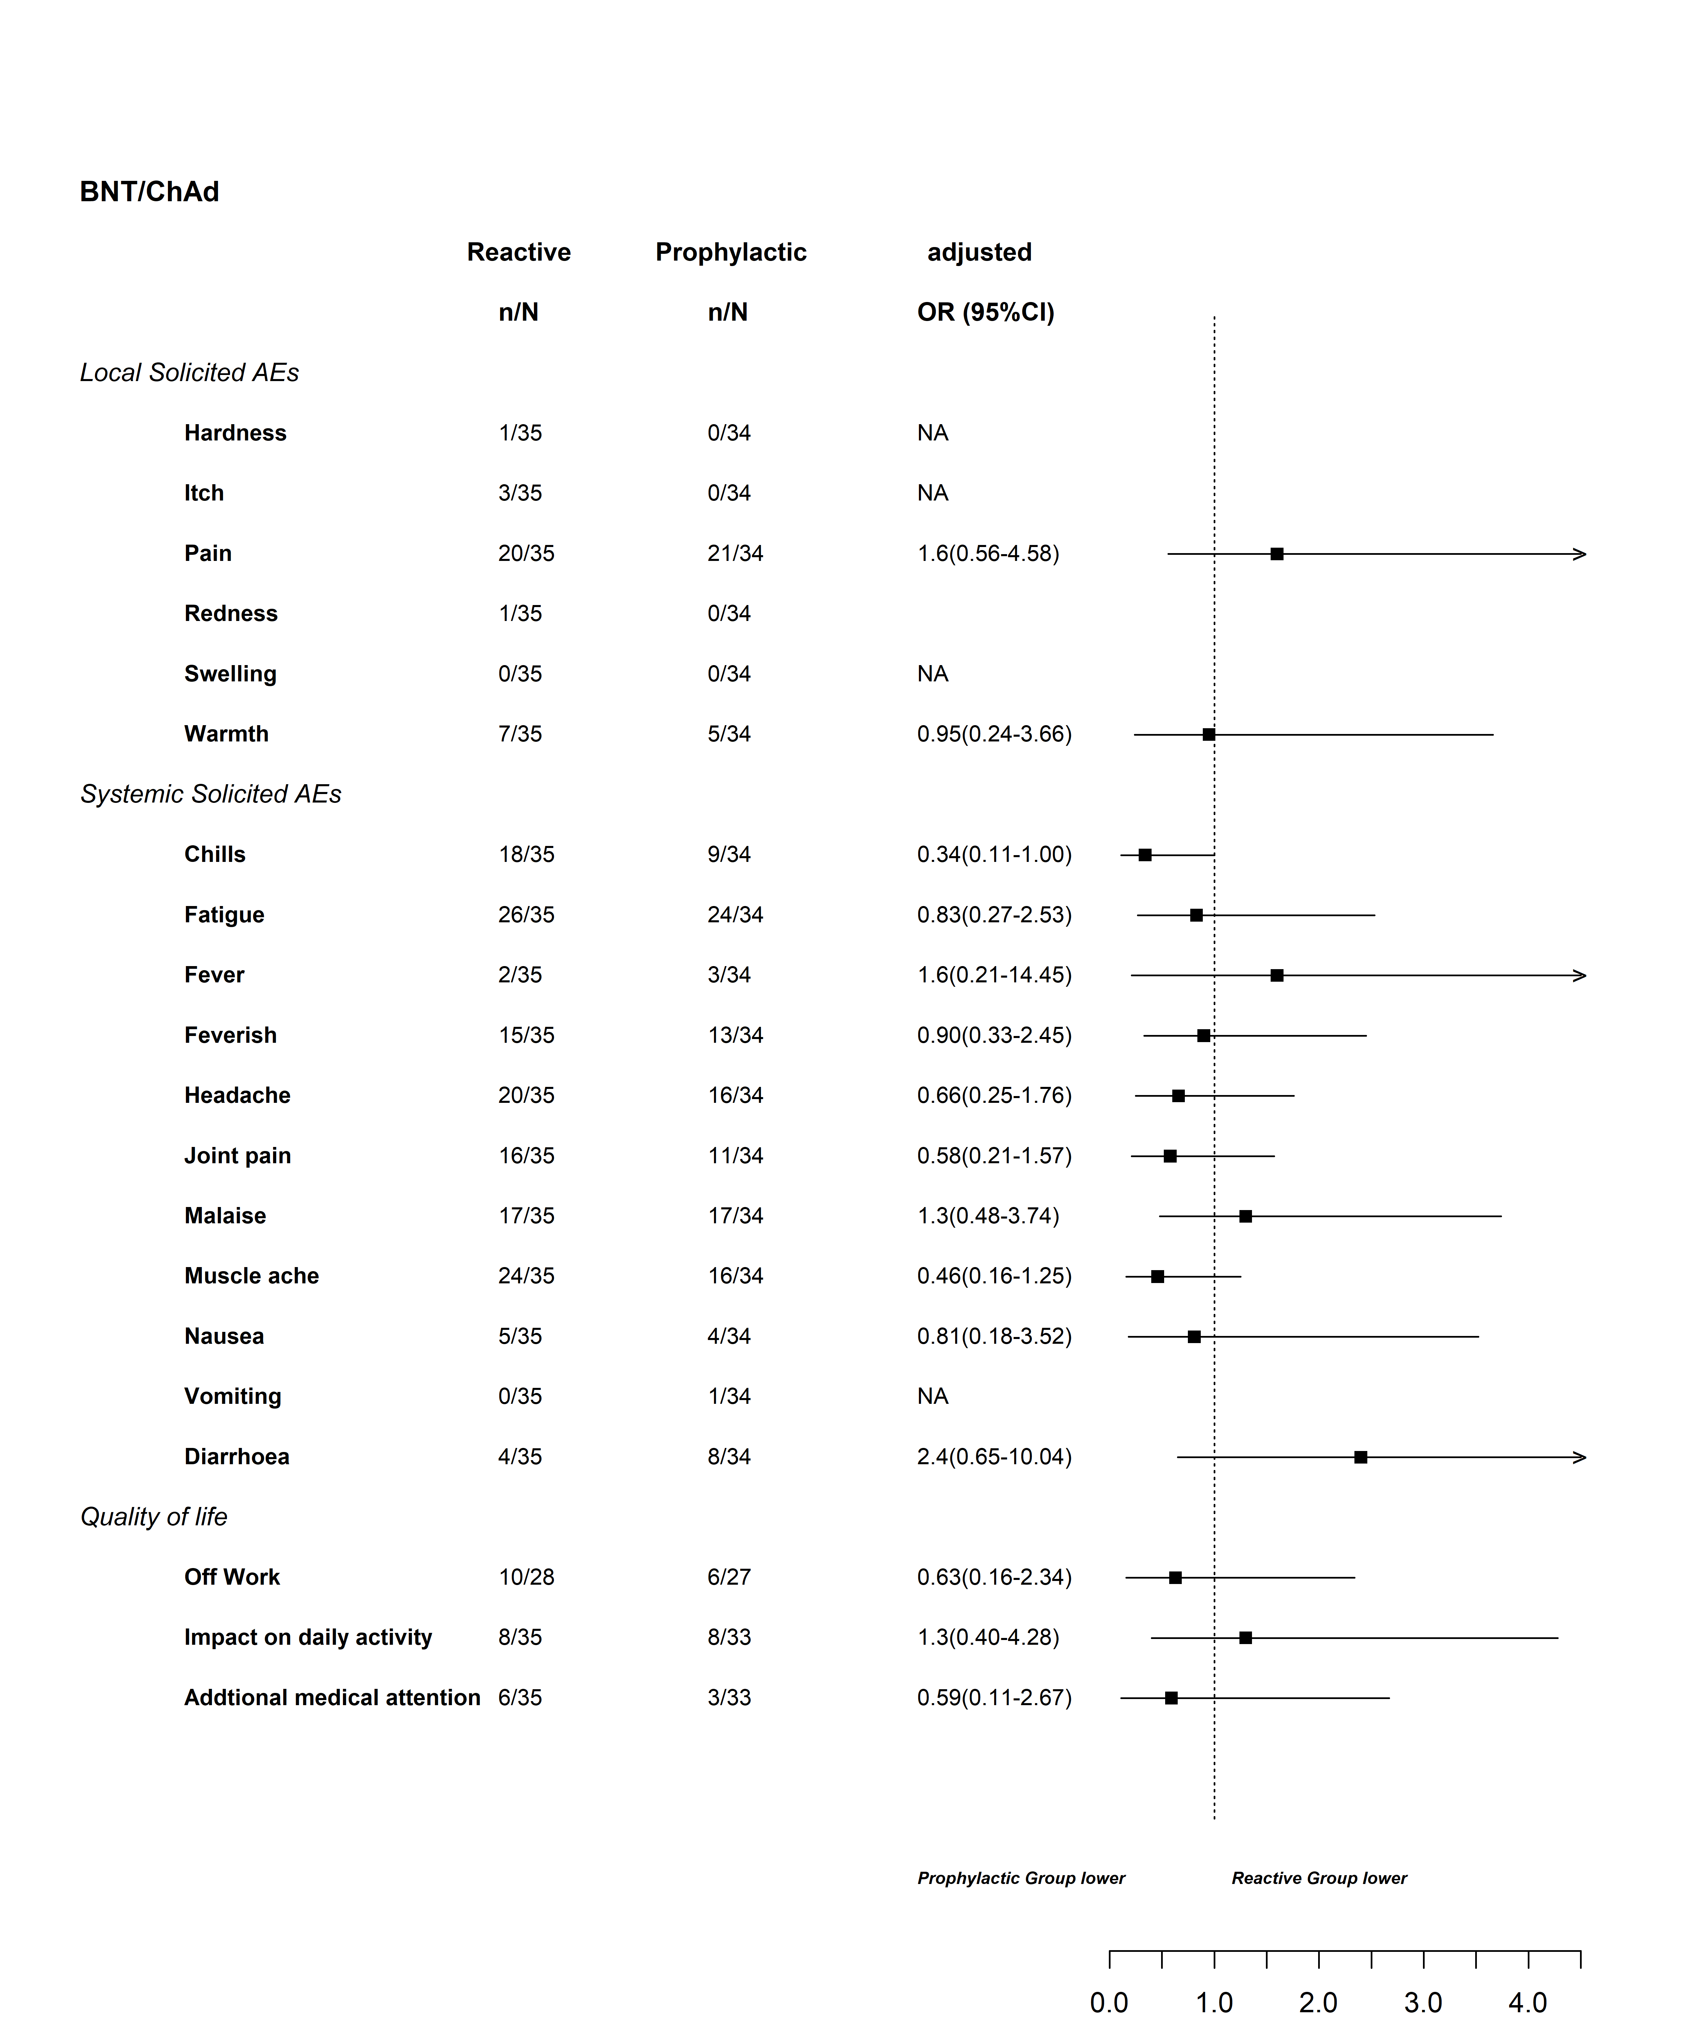

Randomisation and Blinding

Computer-generated randomisation lists were prepared by the study statistician. Participants were block randomised (block size four) 1:1:1:1 within the immunology cohort to ChAd/ChAd, ChAd/BNT, BNT/BNT and BNT/ChAd schedules (boost interval of 28 days). General Cohort participants were block randomised (block size eight) 1:1:1:1:1:1:1:1 to ChAd/ChAd, ChAd/BNT, BNT/BNT and BNT/ChAd schedules at boosting intervals of both 28 and 84 days. Besides the stratification by cohort, randomisation was further stratified by study site. Clinical research nurses who were not involved in safety endpoint evaluation performed the randomisation using REDCapTM (the electronic data capture system) and prepared and administered vaccine.
Participants and laboratory staff processing the immunogenicity endpoints were blinded to vaccines received, but not to prime-boost interval. Participant blinding to vaccines was maintained by concealing randomisation pages, preparing vaccines out of sight and applying masking tape to vaccine syringes to conceal dose volume and appearance. The clinical team assessing the safety endpoints were not blinded.

Summary of correlation factors for calibration of immune assay readouts (LBA and PNA) with the WHO International Standard (IS) for the Nexelis laboratory

The assigned units for the WHO IS are @IU/mL@ for neutralising antibody activity and “BAU/mL” for the quantitation of immunoglobulins.

Human SARS-CoV-2 Pre-Spike IgG ELISA

The results generated for the Human SARS-CoV-2 PreSpike IgG ELISA are reported with concentration units in “ELU/mL”. When required a correlation factor of 1/7.9815 will be applied to convert the reported results from ELU/mL to BAU/mL. For example, a sample with reported anti-PreSpike IgG antibody concentration of 7981.5 ELU/mL will have a concentration equivalent to 1000 BAU/mL.
The following formula may be used for converting concentration units from ELU/mL to BAU/mL:

Result (BAU/mL) = Result (ELU/mL) / 7.9815
Human SARS-CoV-2 Pseudoparticle Neutralisation Assay (PNA)

The results generated for the Human SARS-CoV-2 (PNA) are reported with titer units “NT50”. When required, a correlation factor of 1/1.872 will be applied to convert the reported results from NT50 titer to IU/mL. For example, a sample with reported NT50 titre of 1872 will have a concentration equivalent to 1000 IU/mL.
The following formula may be used for converting NT50 titer to IU/mL:

Result (IU/mL) = Result (NT50 titer) / 1.872

Com-COV Study Group

Alasdair P. S. Munro | NIHR Southampton Clinical Research Facility and Biomedical Research Centre, University Hospital Southampton NHS Foundation Trust, Southampton, UK; Faculty of Medicine and Institute for Life Sciences, University of Southampton, Southampton, UK
Jazz Bartholomew | NIHR Southampton Clinical Research Facility and Biomedical Research Centre, University Hospital Southampton NHS Foundation Trust, Southampton, UK; Faculty of Medicine and Institute for Life Sciences, University of Southampton, Southampton, UK
Laura Presland | NIHR Southampton Clinical Research Facility and Biomedical Research Centre, University Hospital Southampton NHS Foundation Trust, Southampton, UK; Faculty of Medicine and Institute for Life Sciences, University of Southampton, Southampton, UK
Sarah Horswill | NIHR Southampton Clinical Research Facility and Biomedical Research Centre, University Hospital Southampton NHS Foundation Trust, Southampton, UK; Faculty of Medicine and Institute for Life Sciences, University of Southampton, Southampton, UK
Sarah Warren | NIHR Southampton Clinical Research Facility and Biomedical Research Centre, University Hospital Southampton NHS Foundation Trust, Southampton, UK; Faculty of Medicine and Institute for Life Sciences, University of Southampton, Southampton, UK
Sophie Varkonyi-Clifford | NIHR Southampton Clinical Research Facility and Biomedical Research Centre, University Hospital Southampton NHS Foundation Trust, Southampton, UK; Faculty of Medicine and Institute for Life Sciences, University of Southampton, Southampton, UK
Stephen Saich | NIHR Southampton Clinical Research Facility and Biomedical Research Centre, University Hospital Southampton NHS Foundation Trust, Southampton, UK; Faculty of Medicine and Institute for Life Sciences, University of Southampton, Southampton, UK
Kirsty Adams | NIHR UCLH Clinical Research Facility and NIHR UCLH Biomedical Research Centre, London, UK
Marivic Ricamara | NIHR UCLH Clinical Research Facility and NIHR UCLH Biomedical Research Centre, London, UK
Nicola Turner | NIHR UCLH Clinical Research Facility and NIHR UCLH Biomedical Research Centre, London, UK
Nicole Y. Yee Ting | NIHR UCLH Clinical Research Facility and NIHR UCLH Biomedical Research Centre, London, UK
Sarah Whittley | NIHR UCLH Clinical Research Facility and NIHR UCLH Biomedical Research Centre, London, UK
Tommy Rampling | NIHR UCLH Clinical Research Facility and NIHR UCLH Biomedical Research Centre, London, UK
Amisha Desai | NIHR/Wellcome Trust Clinical Research Facility, University Hospitals Birmingham NHS Foundation Trust
Claire H. Brown | NIHR/Wellcome Trust Clinical Research Facility, University Hospitals Birmingham NHS Foundation Trust
Ehsaan Qureshi | NIHR/Wellcome Trust Clinical Research Facility, University Hospitals Birmingham NHS Foundation Trust
Karishma Gokani | NIHR/Wellcome Trust Clinical Research Facility, University Hospitals Birmingham NHS Foundation Trust
Kush Naker | NIHR/Wellcome Trust Clinical Research Facility, University Hospitals Birmingham NHS Foundation Trust
Johanna K. Kellett Wright | North Bristol NHS Trust
Rachel L. Williams | North Bristol NHS Trust
Tawassal Riaz | North Bristol NHS Trust
Florentina D. Penciu | North Bristol NHS Trust
Amy Carson | North Bristol NHS Trust
Claudio Di Maso | Oxford Vaccine Group, Department of Paediatrics, University of Oxford
Gracie Mead | Oxford Vaccine Group, Department of Paediatrics, University of Oxford
Elizabeth G. Howe | Oxford Vaccine Group, Department of Paediatrics, University of Oxford
Iason Vichos | Oxford Vaccine Group, Department of Paediatrics, University of Oxford
Mujtaba Ghulam Farooq | Oxford Vaccine Group, Department of Paediatrics, University of Oxford
Rabiullah Noristani | Oxford Vaccine Group, Department of Paediatrics, University of Oxford
Xin L. Yao | Oxford Vaccine Group, Department of Paediatrics, University of Oxford
Neil J. Oldfield | School of Life Sciences, University of Nottingham
Daniel Hammersley | The University of Nottingham Health Service
Sue Belton | The University of Nottingham Health Service
Simon Royal | University of Nottingham; The University of Nottingham Health Service
Alberto San Francisco Ramos | Vaccine Institute, St. George's, University of London
Cecilia Hultin | Vaccine Institute, St. George's, University of London
Eva P. Galiza | Vaccine Institute, St. George's, University of London
Rebecca Crook | Liverpool School of Tropical Medicine, Liverpool
Marcin Bula | Liverpool School of Tropical Medicine, Liverpool
Fred Fyles | Liverpool School of Tropical Medicine, Liverpool
Hassan Burhan | Liverpool School of Tropical Medicine, Liverpool
Flora Maelin | Liverpool School of Tropical Medicine, Liverpool
Elen Hughes | Liverpool School of Tropical Medicine, Liverpool
Emmanuel Okenyi | Liverpool School of Tropical Medicine, Liverpool

Statistical Analysis Plan (SAP)

STATISTICAL ANALYSIS PLAN

A single-blind, randomised, phase II UK multi-centre study to determine reactogenicity and immunogenicity of heterologous prime/boost COVID-19 vaccine schedules
Short Title: Comparing COVID-19 Vaccine Schedule Combinations (Com-COV)
Ethics Ref: 21/SC/0022
IRAS Project ID: 291055
ISRCTN: 69254139
EudraCT Number: 2020-005085-33
OVG Study Number: OVG 2020/03
Oxford Protocol Date and Version No.: V5.0 26-Apr-2021
Sponsor: University of Oxford
SAP version No: 2.0
Date: 10-May-2021
 | NAME | TITLE | SIGNATURE | DATE
Written by: | Xinxue Liu | Statistician
Reviewed by: | Nick Andrews | Statistician
Approved by: | Matthew Snape | Chief Investigator

Table of Contents
1 Introduction 43
1.1 Description of COM-COV 43
1.2 Purpose and scope of the plan 43
2 Study Methods 44
2.1 Sample size 44
2.2 Randomisation 44
2.3 Blinding and code-breaking 45
2.4 Interim analysis 45
2.5 Objectives and Outcome Measures 46
3 Analysis – General considerations 48
4 Definition of study population 49
5 Primary outcome - Anti-spike immunoglobulins at D28 post boost (4 weeks boost group) 50
5.1 Population for analysis 50
5.2 Statistical analysis 50
5.3 Pooled sensitivity analysis 50
5.4 Subgroup analyses 50
5.5 Missing data 50
6 Secondary Outcomes – Safety 51
6.1 Populations for analysis 51
6.2 Statistical analysis 51
6.3 Missing data 51
7 Secondary Outcomes – Anti-spike immunoglobulins at D28 post boost (4 weeks boost group and 12 weeks boost group) 51
7.1 Populations for analysis 51
7.2 Statistical analysis 51
8 Secondary Outcomes – Further immunogencity outcomes 51
8.1 Population for analysis 51
8.2 Statistical analysis 52

Introduction

Description of COM-COV

The COM-COV trial is a single-blind, randomised, phase II UK multi-centre study to determine reactogenicity and immunogenicity of heterologous prime/boost COVID-19 vaccine schedules, compared with homologous prime/boost schedules. The participants of this trial will be COVID-vaccine naive adults 50 years of age and above and will have no or mild-moderate, well-controlled co-morbidity. The detailed inclusion and exclusion criteria can be found in the protocol.
The study will consist of 2 cohorts, one for more detailed immunological assessment (immunology cohort, N=100, 25 per arm) boosted at Day 28 (randomised 1:1:1:1) and one for main immunology endpoints for participants boosted at Day 28 or at Day 84 (general cohort N=720, 90 per arm) (randomised 1:1:1:1:1:1:1:1).

Cohort | Group | Arm | Prime (Day 0) | Boost (Day 28) | Boost (Day 84) | Visits
Immunology (n=100) | A - ChAdOx1 nCOV-19  (n=50) | IA1 (n=25) | ChAdOx1 nCOV-19 | ChAdOx1 nCOV-19 | - | Day 0, 7, 14, 28, 35, 42, 56, 182, 364
 |  | IA2 (n=25) | ChAdOx1 nCOV-19 | BNT162b2 | -
 | B - BNT162b2  (n=50) | IB1 (n=25) | BNT162b2 | BNT162b2 | -
 |  | IB2 (n=25) | BNT162b2 | ChAdOx1 nCOV-19 | -
General (n=720) | A - ChAdOx1 nCOV-19  (n=180) | GA1-28 (n=90) | ChAdOx1 nCOV-19 | ChAdOx1 nCOV-19 | - | Day 0, 28, 56, 182, 364
 |  | GA2-28 (n=90) | ChAdOx1 nCOV-19 | BNT162b2 | -
 | B - BNT162b2  (n=180) | GB1-28 (n=90) | BNT162b2 | BNT162b2 | -
 |  | GB2 -28 (n=90) | BNT162b2 | ChAdOx1 nCOV-19 | -
 | A - ChAdOx1 nCOV-19  (n=180) | GA1-84 (n=90) | ChAdOx1 nCOV-19 | - | ChAdOx1 nCOV-19 | Day 0, 56, 84, 112, 182, 364
 |  | GA2-84 (n=90) | ChAdOx1 nCOV-19 | - | BNT162b2
 | B - BNT162b2  (n=180) | GB1-84 (n=90) | BNT162b2 | - | BNT162b2
 |  | GB2-84 (n=90) | BNT162b2 | - | ChAdOx1 nCOV-19

Purpose and scope of the plan

This document details the proposed analysis of the main paper(s) reporting results from COM-COV. The results reported in these papers should follow the strategy set out here. The scope of this analysis plan does not extend to include exploratory outcomes. Subsequent analyses of a more exploratory nature will not be bound by this strategy, though they are expected to follow the broad principles set out here. The principles are not intended to curtail exploratory analysis, nor to prohibit accepted practices, but they are intended to establish the principles that will be followed, as closely as possible, when analysing and reporting the trial. This plan will be used to produce the statistical analysis reports and main trial publications. The statisticians should review all the publications based on this plan.

Study Methods

Sample size

The primary analysis of this study will be a non-inferiority comparison between schedules using a homologous versus heterologous boost within each group of approved COVID-19 vaccines, e.g., The group receiving ChAdOx1 nCOV-19/ BNT162b2 will be compared with the group receiving ChAdOx1 nCOV-19 / ChAdOx1 nCOV-19, whilst a separate comparison will be made between the group receiving BNT162b2 / ChAdOx1 nCOV-19 and the group receiving BNT162b2 / BNT162b2. We will combine the immunology cohort (N=100) and the general cohort boosted at D28 (N=360) in the primary analysis.
The below sample size calculation is based on the primary analysis conducted in the participants boosted at D28. The current available data from the ongoing ChAdOx1 nCoV-19 trial suggests that the Geometric mean concentration (GMC) of anti-Spike IgG measured by standardised ELISA is around 500 EU/ml at D56 (4 weeks after booster at Day 28) among participants aged 56-69 years old (n=29) with a standard deviation of 0.4.
The sample calculation is based on the following assumptions:
1. The non-inferiority margin is a 0.63 fold-difference between the GMC in the heterologous boost arm and the homologous boost arm; or a -0.2 absolute difference of GMC on the log scale (base 10).
2. The standard deviation of the GMC on the log scale (base 10) is 0.4 based on the currently available data.
3. The true difference of GMC on the log scale (base 10) is 0.
Based on the above assumptions, the study will need to recruit 86 participants, who are seronegative for SARS-CoV-2 IgG at baseline, into each arm, to achieve 90% power at the one-sided 2.5% significance level. We assume ~25% of study participants will be excluded from the primary analysis due to seropositivity for SARS-CoV-2 IgG at baseline or due to loss of follow-up. Therefore, the sample size in each arm boosted at D28 will be expanded to 115 to accommodate for this. This means that if the study has two vaccines (as is currently the case), the total sample size for participants boosted at D28 will be 460 for four arms. If we decide to add groups to the trial, as new vaccines are made available for use by the Department of Health and Social Care, the sample sizes will be adapted accordingly. The immunology cohort will used for exploratory analyses to generate hypothesis, and thus no formal sample size calculation has been carried out for this cohort. The sample size of 25 per arm was therefore chosen based on logistical and practical constraints. This means we will have approximately 20 seronegative participants per arm for analysis.
Of note, should a correlate of protection against SARS-CoV-2 infection become apparent during the study then the sample size calculations will be re-visited to determine the power to demonstrate non-inferiority based on a margin of 10% between the above stated study arms. This may potentially result in revision of sample size. Based on the sample size anticipated for two vaccines in the study, we have summarised the study power for different proportions of protection at the one-sided significance level of 0.05 (with no adjustment for multiple testing).

Proportion of protection | Study power
0.85 | 58%
0.9 | 71%
0.95 | 91%

We chose the sample size of 360 (effective sample size N=270) in the general cohort who will be boosted at D84 for two reasons: 1) simplifying study management and randomisation; 2) >80% power to test non-inferiority of the heterologous schedule compared with the homologous schedule at one-sided 2.5% significance level, assuming there is no interaction between vaccine schedules and prime-boost intervals. In addition, with a combined analysis (all study population, N=820) to assess the immunogenicity at D28 post boost, the study will have increased power of >95% and the conclusion will have broader generalisability to the UK population.

Randomisation

Computer generated randomisation list will be prepared by the study statistician. Participants will be randomised 1:1:1:1 within the immunology cohort to ChAdOx1 nCOV-19 homologous, ChAdOx1 nCOV-19 heterologous, BNT162b2 homologous and BNT162b2 heterologous groups, using block randomisation. Participants will be randomised 1:1:1:1:1:1:1:1 within the general cohort to ChAdOx1 nCOV-19 homologous, ChAdOx1 nCOV-19 heterologous, BNT162b2 homologous and BNT162b2 heterologous groups at boosting intervals of 28 and 84 days, using block randomisation. Random block sizes of 8 and 16 will be used in the general cohort and a block size of 4 will be used in the immunology cohort. The randomisation will be stratified by study sites.
Sub-study participants will be randomised 1:1 within the general cohort boosted at 84 days, at the time of boost visit, to be advised to take prophylactic paracetamol vs reactive paracetamol, using block randomisation. Random block sizes of 2 or 4 will be used. The randomisation will be stratified by study site and vaccine schedule.

Blinding and code-breaking

The study will be single-blind. Staff involved in study delivery will be aware of which vaccine the participant is receiving (arm allocation); the participant themselves will remain blinded to their vaccine allocation. Vaccines will be prepared out of sight of the participant and the blind will be maintained by applying a masking tape over the vaccine syringe. Laboratory staff will also be blinded to the vaccine schedule received.
If the clinical condition of a participant necessitates unblinding of the participant, this will be undertaken according to a trial specific working instruction and group allocation sent to the attending physician. This will be done if unblinding is thought to be relevant and likely to change clinical management.

Interim analysis

We will carry out an interim analysis to review the seropositivity rate at baseline after D0 immunogenicity data for approximately the first 100 participants becomes available. If there is a significant deviation from our assumption, we will adjust the sample size accordingly.
On 7th April 2021, the MHRA and JCVI updated their guidance regarding the use of ChAdOx1 nCoV-19 in the under-30 age group in the UK, along with the change of guidance in a few other countries worldwide. There is an increased urgency to release the safety data in heterologous schedules. To facilitate the future vaccination strategy worldwide, the study team decided to conduct an interim analysis on the reactogenicity data in the participants boosted at 4 weeks. The analysis will be carried out once the data is cleaned and the SAP is signed off. There will be no stopping rule for this interim analysis and the analysis will not affect the continuation of the trial.
The primary analysis will be carried out when the primary endpoint of D56 anti-spike IgG data become available.

Objectives and Outcome Measures

Objectives | Outcome Measures | Time point(s) | Comparison(s)
Primary
1. To determine whether the immune response in COVID seronegative participants to immunisation with heterologous prime/boost COVID-19 vaccines regimens (boosted at D28) is non-inferior to that observed following immunisation with approved homologous prime-boost regimens (boosted at D28). | Anti-spike immunoglobulins | Day 56 | Primary: Non-inferiority  Secondary: Superiority
Secondary
2. To assess safety of heterologous prime-boost COVID-19 vaccines | Serious adverse events and adverse events of special interest | Throughout the study | Primary: Descriptive  Secondary: Superiority
3. To determine whether the immune response in COVID seronegative participants to immunisation with heterologous prime/boost COVID-19 vaccines regimens across all dosing intervals is non-inferior to that observed following immunisation with approved homologous prime-boost regimens | Immunogenicity: Anti-spike immunoglobulins | 4 weeks post boost (D56 for 28 day boost cohort, D112 for the 84 day boost cohort) | Primary: Non-inferiority  Secondary: Superiority
4. Further characterisation of immunogenicity of heterologous & homologous prime/boost schedules* | Anti-spike immunoglobulins | D0, 7, 14, 28, 35, 84, 112, 182, 364 | Primary: Descriptive  Secondary: Superiority
 | Neutralising antibodies against SARS-CoV-2 | D0, 14, 28, 56, 84, 112, 182, 364 | Primary: Descriptive  Secondary: Superiority/ Non-inferiority
 | Anti-nucleocapsid immunoglobulins | D0, 14, 28, 56, 84, 112, 182, 364 | Primary: Descriptive  Secondary: Superiority
 | Pseudo neutralising antibodies | D0, 14, 28, 56, 84, 112, 182, 364 | Primary: Descriptive  Secondary: Superiority
 | Cellular immune responses by ELISpot | D0, 14, 28, 42, 56, 84, 112, 182, 364 | Primary: Descriptive  Secondary: Superiority
 | Cellular immune responses by ICS (Th1/Th2) | D0, 14, 42 | Primary: Descriptive  Secondary: Superiority
**D7, 14, 35 and 42 analysis only for immunology cohort (n=100)
D28 analysis only for the immunology (n=100) and general cohorts boosted at 28 days (n=360)
D84 analysis only for the general cohorts boosted at 84 days (n=360)
D112 analysis only for the immunology (n=100) and general cohorts boosted at 84 days (n=360)
5. Reactogenicity and safety of heterologous & homologous prime/boost schedules of COVID-19 vaccines | Solicited local reactions | 7 days after each immunisation | Primary: Descriptive  Secondary: Superiority
 | Solicited systemic reactions | 7 days after each immunisation | Primary: Descriptive  Secondary: Superiority
 | Unsolicited reactions | 28 days after each immunisation | Primary: Descriptive
 | Medically attended adverse reactions | Up to 3 months post booster | Primary: Descriptive
 | Changes from baseline in laboratory safety measures | D0, 28, 35, 56 , 84, 112** | Primary: Descriptive  Secondary: Superiority
**D35 safety bloods only for immunology cohort (n=100)
D28 safety bloods only for the immunology (n=100) and general cohorts boosted at 28 days (n=360)
D84, 112 safety bloods only for the general cohorts boosted at 84 days (n=360)
6. Evaluation of immunogenicity, safety and reactogenicity of COVID-19 vaccines in participants seropositive for SARS-CoV-2 IgG at baseline | Immunogenicity, reactogenicity and safety endpoints as outlined above | Time points as outlined above | Primary: Descriptive
7. To characterise COVID-19 infections experienced following administration of vaccination and the immune response to those infections | Anti-spike & anti-nucleocapsid immunoglobulins, neutralising and pseudo-neutralising antibodies, cellular immune response by ICS and ELISpot  Genome sequencing of SARS-CoV-2 viruses isolated from infected participants | From prime dose, and within 1 week of a participant being found to be SARS-CoV-2 positive by external testing | Primary: Descriptive

Analysis – General considerations

The primary outcome analysis will be carried out once all primary outcome data become available. Histograms and boxplots will be used to check the distribution and for possible outliers for continuous variables. Outliers will be examined closely to confirm the validity of the data. Mathematical transformations (log₁₀) will be applied, where appropriate, in order to render a normal distribution. Censored data are expected for immunogenicity endpoints as these assays normally have a lower limit of detection. Data below the lower limit of detection will be imputed by a value half the lower limit of detection, prior to log transformation. Continuous variables that follow an approximately normal distribution will be summarised using means, standard deviations and range values, and number of missing values. Skewed continuous variables will be summarised using medians/geometric mean (where appropriate), inter-quartile ranges and range values, and number of missing values. Categorical/binary variables will be summarised using frequencies and percentages.
Baseline characteristics will be summarised for each arm to describe the study population, stratified by the immunology and general cohort. No formal statistical comparisons of baseline characteristics between randomised groups will be conducted. Participant throughput from screening, enrolment, through randomisation, vaccination, follow up and analysis will be presented in a CONSORT flow diagram(1). This will contain the numbers of participants randomly assigned to each group, receiving prime and boost vaccination, completing the study and analysed for the primary outcome. It will also include a breakdown of reasons for withdrawal and their relative time points.
For the primary and secondary analyses on non-inferiority comparisons (comparing ChAdOx1 nCOV-19 heterologous arm with ChAdOx1 nCOV-19 homologous arm, and comparing BNT162b2 heterologous arm with BNT162b2 homologous arm), the statistical tests will be 1-sided and a p-value less than 0.025 will be considered significant. The significance level for all the other secondary analyses will be 2-sided 0.05, unless specified otherwise in the analysis section below.

Definition of study population

The populations for analyses are defined in Table 1.

- Populations for analysis

Population | Description
All participants | All participants screened for the trial, to be used for reporting CONSORT diagram
Safety analysis population | All randomised participants who received at least 1 dose of study vaccine, including both seronegative and seropositive populations at baseline.  Participants who withdraw consent will be included up to the date of their study termination.  Vaccination error will be accounted for in this analysis set by assigning them to the group of schedule they actually received. Besides the schedules listed in section 1.1, there will potentially be another two additional groups for safety reporting for participants who received only one dose of study vaccine.  This analysis population will be used for safety analyses.
Seronegative non-inferiority analysis population (per-protocol) | All randomised participants meeting the below criteria:  1. Seronegative at baseline (defined as cutoff index <1.0 by the Roche Elecsys anti-Sars-CoV-2 assay at D0);  2. With no confirmed SARS-CoV-2 infection within 14 days (inclusive) post prime vaccination;  3. Received the two doses of study vaccines as randomised;  4. With endpoint data available;  5. No protocol deviation on timing of vaccination or on timing of blood sample for endpoints.
Seronegative superiority analysis population (modified ITT) | All randomised participants meeting the below criteria:  1. Seronegative at baseline (defined as cutoff index <1.0 by the Roche Elecsys anti-Sars-CoV-2 assay at D0);  2. With no confirmed SARS-CoV-2 infection within 14 days (inclusive) post prime vaccination;  3. Randomised;  4. With endpoint data available;  The participants will be analysed according to their randomisation irrespective of the vaccine schedules they have received, according to the intent-to-treat principle.
Seropositive superiority analysis population (modified ITT) | All randomised participants meeting the below criteria:  1. Seropositive at baseline (defined as cutoff index <1.0 by the Roche Elecsys anti-Sars-CoV-2 assay at D0);  2. Randomised;  3. With endpoint data available;  The participants will be analysed according to their randomisation irrespective of the vaccine schedules they have received, according to the intent-to-treat principle.
C19P analysis population | The participants who were confirmed COVID-19 positive outside this trial (self-reported) and whose date of infection >14 days post prime vaccination.

Primary outcome - Anti-spike immunoglobulins at D28 post boost (4 weeks boost group)

Population for analysis

The analysis population for primary outcome will be participants who were randomised to boost at 4 weeks (including both immunology and general cohorts) among the “seronegative non-inferiority analysis population (per-protocol)” in table 1.

Statistical analysis

The primary analyses for the primary outcome are the non-inferiority comparisons between ChAdOx1 nCOV-19 heterologous arm and ChAdOx1 nCOV-19 homologous arms, and between BNT162b2 heterologous arm and BNT162b2 homologous arms. The GMC of each arm will be calculated as the antilogarithm of Σ (log10 transformed titre)/n, i.e., as the antilogarithm transformation of the mean of the log10 transformed titre, where n is the number of participants in that arm. The 95% CI will be calculated as the anti-logarithm transformation of the upper and lower limits for a two-sided CI for the mean of the log10 transformed titres.
Data reported as lower than the detection threshold will be imputed with a value equal to half of the threshold before the transformation.
The Geometric Mean Ratio (GMR) will be calculated as antilogarithm of the difference between the mean of the log10 transformed titre in the heterologous arm and that in the homologous arms (as the reference), after adjusting the study site and cohort (immunology/general) as design variables in the linear regression model. The GMR of the heterologous arm to the homologous arm will be reported separately for the participants who have been primed with ChAdOx1 nCOV-19 and the participants who have been primed with BNT162b2. The one-sided 97.5% confidence interval of the adjusted GMR will be calculated as the antilogarithm transformation of the upper and lower 97.5% CI limits of the adjusted difference of the log10 transformed means. We will claim the heterologous boost arm is non-inferior to the homologous boost arm if the lower CI of the GMR lies above 0.63, i.e. the lower CI of the difference for the log10 transformed means lies above -0.2.
As a secondary analysis, we will calculate the two-sided 95% CI for the GMR in the 4 weeks boost group of the “Seronegative superiority analysis population (modified ITT)” defined in table 1. The design variables of study site and cohort will be adjusted in the linear regression model to estimate the GMR. We will claim the heterologous boost arm is superior to the homologous boost arm if the lower limit of the two-sided 95% CI lies above 1, or claim the homologous boost arm is superior to the heterologous boost arm if the upper limit of the two-sided 95% CI lies below 1.

Pooled sensitivity analysis

Further pooled sensitivity analyses among all participants in 5.1 will be conducted to calculate the GMR and its corresponding one-sided 97.5% CI. We will first test the interaction between schedules (heterologous/homologous) and prime vaccines (ChAdOx1 nCOV-19/ BNT162b2) using multiple regression. The dependent variable will be the log10 transformed titre and the independent variables in the normal errors regression model include age at randomisation, sex, study site, ethnicity, cohort, schedule (heterologous/homologous), prime vaccine (ChAdOx1 nCOV-19/ BNT162b2), and the interaction term between schedules and prime vaccines. If no statistically significant interaction (at significance level of two-sided 0.01) is observed, we will report the pooled GMR as the antilogarithm of the coefficient of the schedule variable in the above model after removing the interaction term.

Subgroup analyses

Subgroup analyses for the primary outcome will be conducted using the model in 5.3 after removing the subgroup variables, where needed. The adjusted GMR and two-sided 95% CI will be presented for each subgroup. If there is no significant interaction in 5.3, the subgroups analyses will be done in all participants in 5.1, including:
- Age (50-59, and 60+)
- Sex (Male and Female)
- Comorbidity (With and without comorbidities at baseline, including cardiovascular diseases, respiratory diseases, and diabetes)

Missing data

There will no missing data (by definition) on outcome in the “seronegative non-inferiority analysis population (per-protocol)” and the “Seronegative superiority analysis population (modified ITT)”. For covariates in the sensitivity analyses and subgroup analyses, missing data will not be imputed and a complete-case analysis will be informed.

Secondary Outcomes – Safety

This section covers outcome 2, outcome 5, and the safety part of outcome 6. The definitions of safety outcomes and the corresponding severity defections can be found in the trial protocol (section 13 Safety Reporting).

Populations for analysis

The population for analysis will follow the “Safety analysis population” in Table 1. For outcome 6, the analysis population will be the seropositive participants at baseline in the “Safety analysis population”.

Statistical analysis

All the safety endpoints will be summarised by the actually received vaccine schedules. Solicited AEs (Day 0 –Day 7) will be reported separately after prime vaccine and after boost vaccine. The primary analysis of safety outcomes will be descriptive and the frequency and proportion will be reported. For solicited AEs, the analysis will be carried out on each day after vaccination. The maximum severity of each solicited AEs across Day 0 – Day 7 post vaccination will also be derived for each participant, and the frequency and proportion of the maximum severity across 7 days will be summarised by vaccine schedules.
The SAEs, AEs (including unsolicited AEs, medically attended AEs), and AESIs will be coded by MedDRA and the frequency will be reported at the Preferred Term level. The proportion and the exact 95% CI will be reported by vaccine schedules for participants with at least one SAE, with at least one AE, and with at least one AESI, respectively.
Fisher's exact test will be used to compare the difference in proportions of safety outcomes between heterologous arm and homologous arm as secondary analyses. For each solicited AE, we will compare the proportions of participants with grade 3/4 AEs across 7 days post vaccination. The comparison will be done separately for participants primed with ChAdOx1 nCOV-19 and BNT162b2.

Missing data

It is expected that there will be missing on the self-reported diary data. The completeness of diary data will be described by vaccine schedules, and there will be no missing data imputation for diary data. The maximum severity will be derived based on all the available data across 7 days. We will exclude participants in the 7-day solicited AEs analysis if they failed to report any diary data at all in the 7 days post vaccination (for prime dose and boost dose, respectively).

Secondary Outcomes – Anti-spike immunoglobulins at D28 post boost (4 weeks boost group and 12 weeks boost group)

Populations for analysis

The primary analysis population will be the “seronegative non-inferiority analysis population (per-protocol)” in table 1, including participants boosted at both 4 weeks and 12 weeks.

Statistical analysis

We will conduct the analyses following section 5. In the pooled sensitivity analysis (section 5.3), an additional independent variable of boost group (4 weeks /12 weeks) will be added into the model. The interaction between schedule and boost group will be further tested with significance level of two-sided 0.01. A further subgroup will be conducted in participants boosted at 12 weeks.

Secondary Outcomes – Further immunogencity outcomes

This section covers outcome 4, the immunogenicity part of outcome 6, and outcome 7.

Population for analysis

The analysis population will be the “Seronegative superiority analysis population (modified ITT)” for outcome 4, “Seropositive superiority analysis population (modified ITT)” for outcome 6, and “C19P analysis population” for outcome 7.

Statistical analysis

The summary of immunogenicity outcomes will be presented by the randomised arms for outcome 4 and outcome 6. For outcome 7, the summary for the whole analysis population will be presented.
The primary analysis will be descriptive. Data transformation will follow section 3. The GMCs with 95% CI will be presented for each arm at each time point. The GMR with 95% CIs between heterologous arm and homologous arm will be calculated separately among participants primed with ChAdOx1 nCOV-19 and BNT162b2 (follows section 5.2). The proportion of participants who have a post-vaccine seroconversion (≥ 4-fold rise in titres from D0 value to 28 days post each dose) as measured by anti-spike immunoglobulins or neutralising antibodies will also be provided by randomised arms. As a high proportion of participants under lower detection threshold is expected at D0, especially in seronegative participants, the proportion of participants with data above the threshold will also be generated for each arm at each time point.
The comparisons of GMC between the heterologous and homologous arms at different time points will be carried out using linear regression model adjusting for study site and cohort as secondary analyses. In cases where a normal distribution cannot be rendered, comparisons will be made using the Mann-Whitney U Test. The significance level is detailed in section 3. As the study is not powered to detect any difference for secondary outcomes, any significant result should be interpreted cautiously, owing to the large number of comparisons within this trial and increased chance of Type I error by multiple testing.
For the endpoint of neutralising antibodies against SARS-CoV-2 at D28 post boost, we will carry out a non-inferiority comparison following 5.1 and 5.2.

amendment history

Amendment No. | SAP Version No. | Date issued | Author(s) of changes | Details of Changes made
 | 1.0 | 20th Apr 2021 | XL/NA/MS | Initial version
1 | 2.0 |  | XL | Change the definition of D0 seronegativity from using anti-S to using anti-N;  Adding cohort as an additional variable to adjust in the model.

Reference
1. Schulz KF, Altman DG, Moher D. CONSORT 2010 Statement: Updated guidelines for reporting parallel group randomised trials. BMJ [Internet]. 2010 Mar 27 [cited 2021 Apr 13];340(7748):698–702. Available from: https://www.bmj.com/content/340/bmj.c332

