Saudi FRAX model v5

Incidence of hip fracture in Saudi Arabia and the development of a FRAX model

Yousef AL Saleh · Riad A Sulimani · Shaker ALomary · Yassmeen I Alnajjar · Liesbeth Vandenput · Enwu Liu · Mattias Lorentzon · Nicholas C Harvey · Eugene V McCloskey · Helena Johansson · John A Kanis and the Saudi FRAX Study Group*

Yousef Al-Saleh | College of Medicine, King Saud bin Abdulaziz University for Health Sciences, Riyadh, Saudi Arabia | Salehy1@ngha.med.sa
 | King Abdullah International Medical Research Center, Riyadh, Saudi Arabia
 | Department of Medicine, King Abdulaziz Medical City, Riyadh, Ministry of National Guard-Health Affairs, Riyadh, Saudi Arabia
 | Chair for Biomarkers of Chronic Diseases, Biochemistry Department, College of Science, King Saud University, Riyadh, Saudi Arabia
Riad Sulimani | Department of Medicine, King Khaled University Hospital, College of Medicine, King Saud University Medical City, King Saud University, Riyadh, Saudi Arabia | sulimanirs@gmail.com
Shaker Alomary | General Directorate of Health Programs and Chronic Diseases,  Ministry of Health, Riyadh, Saudi Arabia | shalomary@moh.gov.sa
Yassmeen Alnajjar | General Directorate of Health Programs and Chronic Diseases, Osteoporosis Program, Ministry of Health, Riyadh, Saudi Arabia | ynajjar@moh.gov.sa
Liesbeth Vandenput | Mary McKillop Institute for Health Research, Australian Catholic University, Melbourne, Australia | liesbeth.vandenput@acu.edu.au
 | Sahlgrenska Osteoporosis Centre, Department of Internal Medicine and Clinical Nutrition, Institute of Medicine, Sahlgrenska Academy, University of Gothenburg, Gothenburg, Sweden
Enwu Liu | Mary McKillop Institute for Health Research, Australian Catholic University, Melbourne, Australia | enwu.liu@acu.edu.au
Mattias Lorentzon | Mary McKillop Institute for Health Research, Australian Catholic University, Melbourne, Australia | mattias.lorentzon@medic.gu.se
 | Sahlgrenska Osteoporosis Centre, Institute of Medicine, University of Gothenburg, Sweden
 | Region Västra Götaland, Geriatric Medicine, Sahlgrenska University Hospital, Mölndal, Sweden
Nicholas C Harvey | MRC Lifecourse Epidemiology Centre, University of Southampton, Southampton, UK | nch@mrc.soton.ac.uk
 | NIHR Southampton Biomedical Research Centre, University of Southampton and University Hospital Southampton NHS Foundation Trust, Southampton, UK
Eugene V McCloskey | Centre for Metabolic Bone Diseases, University of Sheffield, Sheffield, UK | e.v.mccloskey@sheffield.ac.uk
 | Mellanby Centre for Musculoskeletal Research, Department of Oncology and Metabolism, University of Sheffield, Sheffield, UK
Helena Johansson | Mary McKillop Institute for Health Research, Australian Catholic University, Melbourne, Australia | helena@statiq.se
 | Centre for Metabolic Bone Diseases, University of Sheffield, Sheffield, UK
 | Sahlgrenska Osteoporosis Centre, Department of Internal Medicine and Clinical Nutrition, Institute of Medicine, Sahlgrenska Academy, University of Gothenburg, Gothenburg, Sweden
John A Kanis | Mary McKillop Institute for Health Research, Australian Catholic University, Melbourne, Australia | w.j.pontefract@shef.ac.uk
 | Centre for Metabolic Bone Diseases, University of Sheffield, Sheffield, UK

Correspondence: John A Kanis
e-mail: w.j.pontefract@sheffield.ac.uk

*Saudi FRAX Study Group
Name | Affiliation
Nasser M Al-Daghri | Chair of Biomarkers of Chronic Diseases, Biochemistry Department , College of Science, King Saud University, Riyadh, Saudi Arabia
Abdelgadier Ibrahim Jamo | Department of Health Programs and Chronic Diseases, Osteoporosis Prevention Program, Ministry of Health, Riyadh, Saudi Arabia
Abdullah Ahmed Hawsawi | Department of Orthopedic, Prince Sultan Military Medical City, Ministry of Defense Riyadh, Saudi Arabia
Fatima Ali Mohamed | Department of Orthopedic, Prince Sultan Military Medical City, Ministry of Defense, Riyadh, Saudi Arabia
Talha Mohammedsaeed Khojah | Department of Orthopaedics, King Abdulaziz Hospital, Ministry of Health, Makkah, Saudi Arabia
Eman Abdulrahman Sheshah | Endocrine and Diabetes Center, King Salman Hospital, Ministry of Health, Riyadh, Saudi Arabia
Waleed A Hashem | Endocrine Department, King Saud Medical City, Ministry of Health, Riyadh, Saudi Arabia
Abdulgani Omar Hijazi | Department of Orthopedics, King Khaled Hospital, Ministry of Health, Tabuk, Saudi Arabia
Samer Merei Kanani | Department of Orthopaedics, King Khaled Hospital, Ministry of Health, Tabuk, Saudi Arabia
Ashwag Saleh Alfagih | Endocrine and Diabetes Centre, King Fahad Central hospital, Ministry of Health, Jazan,  Saudi Arabia
Kamil Muslim Albouri | Department of Orthopedics, AlQatif Central Hospital, Ministry of Health, AlQatif, Saudi Arabia
Osama Fawaz Alsobyhy | General Directorate of Health Program and Chronic Diseases, Ministry of Health, Aljouf, Saudi Arabia
Mohammed Zayed Almutairi | Department of Medicine, Security Forces Hospital, Ministry of Interior, Riyadh, Saudi Arabia
Mussa Hussain Almalki | Obesity, Endocrinology and Metabolism Center, King Fahad Medical City, Riyadh, Saudi Arabia  College of Medicine, King Fahad Medical City, King Saud Bin Abdulaziz University for Health Sciences, Riyadh, Saudi Arabia
Nadia Abd Elhamid Kassem | Prince Mishari Hospital, Ministry of Health, Baljurashi, Saudi Arabia
Mutaz Mohamed Ali | General Directorate of Health Affairs, Public Health Administration, Ministry of Health, Najran, Saudi Arabia
Fahad A Alamri | Global Center of Mass Gatherings Medicine, Public Health Agency, Ministry of Health, Riyadh, Saudi Arabia
Fahad Mohammed Alshahrani | College of Medicine, King Saudi Bin Abdulaziz University for Health Sciences, Riyadh, Saudi Arabia.  King Abdullah International Medical Research Centre, Riyadh, Saudi Arabia.  Department of Family Medicine, King Abdulaziz Medical City, Ministry of National Guard Health Affairs, Riyadh, Saudi Arabia
Hanan Mohammed AlRayes | Division of Rheumatology, Deaprtment of Medicine, Prince Sultan Military Medical City, Riyadh, Ministry of Defense, Saudi Arabia
Mir Sadat-Ali | Departemnt of Orthopedics, College of Medicine, Imam Abdulrahman Bin Faisal University, Dammam, Saudi Arabia
Mohammed Abdulrahman Alharbi | Department of Orthopedics, Dammam Central Hospital, Ministry of Health, Dammam, Saudi Arabia
Mohammed AlShaker | Department of Family Medicine and Polyclinics, King Faisal Specialist Hospital and research center, Riyadh, Saudi Arabia
Mona A Fouda | Department of Medicine  College of Medicine  King Khalid University Hospital  King Saud University Medical City  Kind Saud University  Riyadh  Saudi Arabia
Salwa Berlian Alaidarous | College of Medicine, King Saud Bin Abdulaziz University for Health Science, Jeddah, Saudi Arabia  King Abdullah International Medical Research Center, Jeddah, Saudi Arabia  Department of Medicine, King Abdulaziz Medical City, Jeddah, Saudi Arabia  Ministry of National Guard Health Affairs, Jeddah, Saudi Arabia
Mohammed Almohaya | Obesity, Endocrinology and Metabolism Center, King Fahad Medical City, Ministry of Health, Riyadh, Saudi Arabia
Najla Alfateh Saleh | King Abdullah International Medical Research Centre, Riyadh, Saudi Arabia  College of Medicine, King Saud bin Abdulaziz University for Health Sciences, Riyadh, Saudi Arabia
Soad Saleh | Cell Biology and Diabetes Research Unit, Department of Cell Biology, King Faisal Specialist Hospital and Research Centre, Riyadh, Saudi Arabia

Abstract

Summary A prospective hospital-based survey in representative regions of Saudi Arabia determined the incidence of fractures at the hip. The hip fracture rates were used to create a FRAX® model to facilitate fracture risk assessment in Saudi Arabia.

Objective This paper describes the incidence of hip fracture in the Kingdom of Saudi Arabia that was used to characterize the current and future burden of hip fracture, to develop a country specific FRAX® tool for fracture prediction and to compare fracture probabilities with neighbouring countries.

Methods During a two year (2017/18) prospective survey in 15 hospitals with a defined catchment population, hip fractures in Saudi citizens were prospectively identified from hospital registers. The number of hip fractures and future burden were determined from national demography. Age- and sex-specific incidence of hip fracture and national mortality rates were incorporated into a FRAX model for Saudi Arabia. Fracture probabilities were compared with those from Kuwait and Abu Dhabi.

Results. The incidence of hip fracture applied nationally suggested that the estimated number of hip fractures nationwide in persons over the age of 50 years for 2015 was 2,949 and is predicted to increase nearly 7-fold to 20,328 in 2050. Hip fracture rates were comparable with estimates from Abu Dhabi and Kuwait. By contrast, probabilities of a major osteoporotic fracture or hip fracture from the age of 70 years were much lower than those seen in Abu Dhabi and Kuwait due to higher mortality estimates for Saudi Arabia.

Conclusion. A country specific FRAX tool for fracture prediction has been developed for Saudi Arabia whichis expected to help guide decisions about treatment.

Keywords FRAX · Fracture probability · Osteoporosis Epidemiology · Hip fracture · Saudi Arabia

Introduction

Osteoporosis is a common, chronic, and costly condition; its principal clinical consequence is fracture. In Europe, the annual cost of fractures associated with osteoporosis exceeded € 37 billion in 2019 [1]; disability due to osteoporosis was greater than that caused by any single cancer, with the exception of lung cancer, and was comparable or greater than that lost to a variety of chronic noncommunicable diseases, such as rheumatoid arthritis, asthma and high blood pressure related heart disease [2, 3, 4]. Fortunately, a wide variety of treatments is available that favourably affect bone mass and thereby decrease the risk of fractures associated with osteoporosis [5]. The use of such interventions by health care practitioners is assisted by instruments that assess patients’ fracture risk to optimise clinical decisions about prevention and treatment. The most widely used web-based tool FRAX® (https://www.sheffield.ac.uk/FRAX/) meets these requirements and computes the 10-year probability of fragility fractures based on several common clinical risk factors and, optionally a DXA scan result [6, 7]. FRAX models are available for 78 countries in 2021 covering more than 80% of the world population at risk [8] and has been incorporated into more than 100 guidelines worldwide [9].

The availability of FRAX has stimulated studies that can be used for the generation of new FRAX models. Specific examples include Brazil, Mexico and Turkey [9]. Currently, the Gulf Cooperation Council (GCC) countries’ osteoporosis societies recommend the use of Kuwait or Abu Dhabi versions for GCC states that do not have a FRAX model, Saudi Arabia included [10]. Hence, the broad aim of the present study was to provide epidemiological information on fracture risk so that a FRAX model could be created for Saudi Arabia. The present report describes the incidence of hip fracture in the Kingdom of Saudi Arabia, the current and future burden of hip fracture, the development of a country specific FRAX® tool for fracture prediction and a comparison of fracture probabilities with neighbouring countries.

the epidemiology of fractures at the hip in Saudi Arabia and the generation of a country-specific FRAX model (now available online; https://www.sheffield.ac.uk/FRAX/tool.aspx?country=84).

Methods
The Kingdom of Saudi Arabia constitutes the bulk of the Arabian Peninsula with a surface area of approximately 2,150,000 km² (830,000 square miles). It is bordered by Jordan, Iraq, Kuwait, Qatar, Bahrain, the United Arab Emirates, Oman and Yemen. Saudi Arabia also has one of the world's youngest populations, with approximately 41 percent of its population of 34.2 million being under 25 years old. Conversely, less than 10% of the population has an age of 55 or more years [11].
The study to define the incidence of hip fracture was developed in collaboration between the Ministry of Health represented by the Directorate for Prevention of Osteoporosis and the Saudi Osteoporosis Society. Representative hospitals were selected from various parts of the country to cover all geographic regions (Riyadh, Dammam, Makkah Al Mokaramah, Jazan, Al-Jouf, Al-Baha, Tabouk, Najran and Hail). A total of 15 hospitals that admitted and operated on patients with hip fractures were selected. The choice of hospital was determined by the willingness of a research officer to collaborate. Champions in these institutions were identified and a meeting was convened in Riyadh to discuss and explain the data collection process. Case report forms were developed to record the patient's age, sex, residence, date, character of injury and ICD -10 code (S72.0, S72.1, S72.2). The group thereafter communicated through social media and met again after 8 months to discuss the progress of data collection, review the accuracy of hip fracture recording, and meet any challenges.
Data on low energy hip fracture were collected on Saudi citizens age 45 years and above with low trauma fractures during 2017 and 2018. Hip fractures associated with road traffic accidents and other major trauma were excluded. Pathological fractures secondary to malignancy and metabolic bone disorders were also excluded. To avoid double counting, further admissions for the same fracture site in the observation time were excluded.
It was estimated that the catchment hospitals captured 12.82% of the total Saudi population based on a Ministry of Health assessment of the total number of orthopaedic beds dealing with hip fracture cases. Thus, the catchment population comprised 4 million Saudi nationals (2,031,601 men and 1,952,734 women) age 45 years or older.
The age and sex-specific incidence in 2017/18 was applied to the population in 2015 to estimate the number of hip fractures nationwide. Additionally, future projections were estimated up to 2050 assuming that the age- and sex-specific incidence remained stable. Population demography was taken from the United Nations using the medium variant for fertility [12].
The data on hip fracture were used to construct the FRAX model. For other major osteoporotic fractures (clinical spine, forearm and humeral fractures) it was assumed that the age- and sex-specific ratios of these fractures to hip fracture risk found in Sweden were comparable to those in Saudi Arabia. This assumption has been used for many of the FRAX models with incomplete epidemiological information. Available information suggests that the age- and sex-stratified pattern of fracture is very similar in the Western world, Australia and Eastern Europe [13, 14, 15, 16].
The development and validation of FRAX have been extensively described [6, 7]. The risk factors used were based on a systematic set of meta-analyses of population-based cohorts worldwide and validated in independent cohorts with over 1 million patient-years of follow-up. The construct of the FRAX model for Saudi Arabia retained the beta coefficients of the risk factors in the original FRAX model with the incidence rates of hip fracture and mortality rates for Saudi Arabia. National mortality rates used data from the Household Health Survey, 2018 [17]. Ten-year fracture probabilities were compared to those of the neighbouring countries where a FRAX model was available (Kuwait and United Arab Emirates (Abu Dhabi)).
In order to compare hip fracture probabilities with those of other regions of the world, the remaining lifetime probability of hip fracture from the age of 50 years was calculated for men and women, as described previously [18]. In the present analysis, values for Saudi Arabia were compared with those of Abu Dhabi, Botswana ,China (Hong Kong), Bulgaria, Canada, Denmark, Finland, France, Germany, Greece, Hungary, Iran, Kazakhstan, Kuwait, Moldova, Morocco, Netherlands, Poland, Portugal, Romania, Russia, Singapore (Indian), South Africa (White and Black), Spain, Sweden, Tunisia, Turkey, Ukraine, United Kingdom, United States (Caucasian and Black) and Uzbekistan [19, 20].

Results
Over the period of two years, 684 low energy hip fractures were identified in men (n=296) and women (n= 388) age 45 years or more. Sites of fracture were neck of femur (43%), pertrochanteric (47%) and subtrochanteric (10%).
The crude annual incidence of low-energy hip fracture in individuals age 45 years or more was 77.5/100,000 in women, and 56.8/100,000 in men (female/male ratio = 1.4). Hip fracture incidence increased with the age up to the age of 90 years in both men and women (Table 1). The incidence in women rose more steeply with age than in men, although not statistically significant. and Age-specific fracture rates were higher in women than in men from the age of 55 years although statistically significant only for age 55-59 years.

Table 1 Population at risk (2017), number of hip fractures (2017/18) and annual hip fracture incidence (per 100,000) with 95% confidence intervals in the male (M) and female (F) population.
Age | Population |  | Number of  hip fractures |  | M |  | F
(years) | M | F | M | F | Incidence | 95%CI | Incidence | 95%CI
45-49 | 71,733 | 67,888 | 4 | 3 | 2.8 | 0.8-7.1 | 2.2 | 0.5-6.5
50-54 | 57,212 | 54,091 | 21 | 18 | 18 | 11-28 | 17 | 9.9-26
55-59 | 44,624 | 40,987 | 19 | 32 | 21 | 13-33 | 39 | 27-55
60-64 | 32,327 | 30,246 | 24 | 33 | 37 | 24-55 | 55 | 38-77
65-69 | 19,670 | 20,869 | 31 | 48 | 79 | 54-112 | 115 | 85-153
70-74 | 14,356 | 14,739 | 46 | 65 | 160 | 117-214 | 221 | 170-281
75-79 | 9,358 | 9,552 | 58 | 72 | 310 | 235-401 | 377 | 295-475
80-84 | 11,173 | 11,967 | 93 | 117 | 416 | 336-510 | 489 | 404-586
 | 260,453 | 250,339 | 296 | 388

The incidence of hip fracture in Saudi Arabia was compared with that from Abu Dhabi and Kuwait shown on a logarithmic scale in Figure 1. Hip fracture rates were rather comparable between these countries.

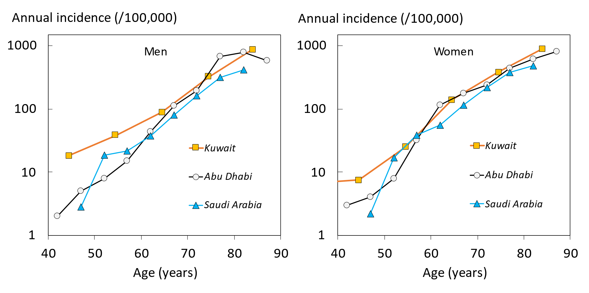

Fig. 1 The incidence of hip fracture by age in men (left panel) and women (right panel) in Saudi Arabia, Abu Dhabi, and Kuwait on a logarithmic scale.

Assuming that the fracture rates in the areas surveyed were representative for the whole country, the estimated number of hip fractures nationwide in persons over the age of 50 years for 2015 was 2,949 and is predicted to increase nearly 7-fold to 20,328 in 2050 (Table 2).
Table 2. Estimated total number of hip fractures in men and in women age 50 years or older in 2015 projected up to 2050 in Saudi Arabia.

 | 2015 | 2020 | 2030 | 2040 | 2050
Men | 1416 | 1870 | 3633 | 6600 | 10,109
Women | 1533 | 1907 | 3338 | 6033 | 10,219
Men and women | 2949 | 3777 | 6971 | 12,633 | 20,328

Probabilities of a hip fracture and major osteoporotic fracture are shown for women in Figure 2. Probabilities rose with age up to the age of 70 years and decreased thereafter due to the competing effect of mortality.

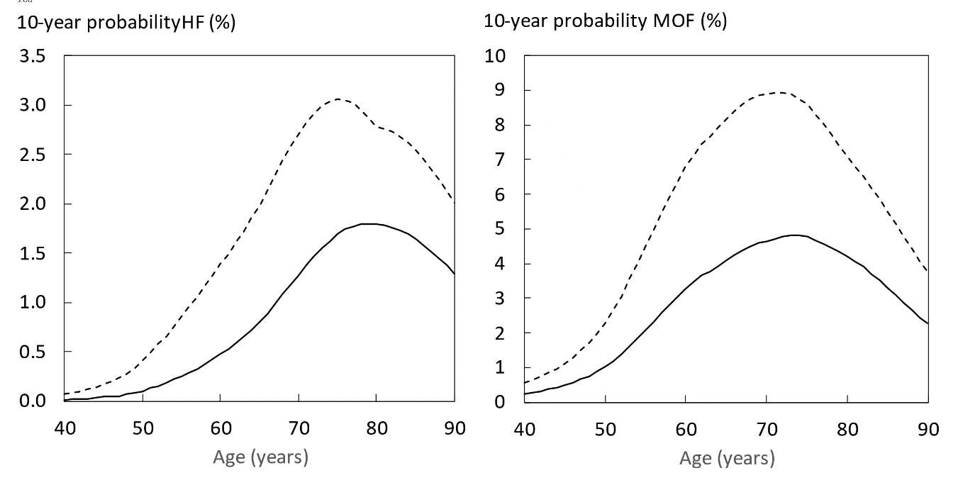
Fig. 2 10-year probability of a major osteoporotic fracture in women by age. The solid line shows probabilities in women with no clinical risk factors and the dotted line shows probabilities in women with a prior fragility fracture. Body mass index was set at 25kg/m².

Fracture probabilities in women with a prior fragility fracture are compared with those derived from the FRAX models for Kuwait and Abu Dhabi in Figure 3. At younger ages fracture probabilities were rather similar between countries but diverged markedly with age. For Kuwait, fracture probabilities increased progressively with age up to the age of 90 years. For Abu Dhabi, fracture probabilities increased up to the age of 80 years. As noted above, probabilities in Saudi women reached a peak at the age of 70 years.
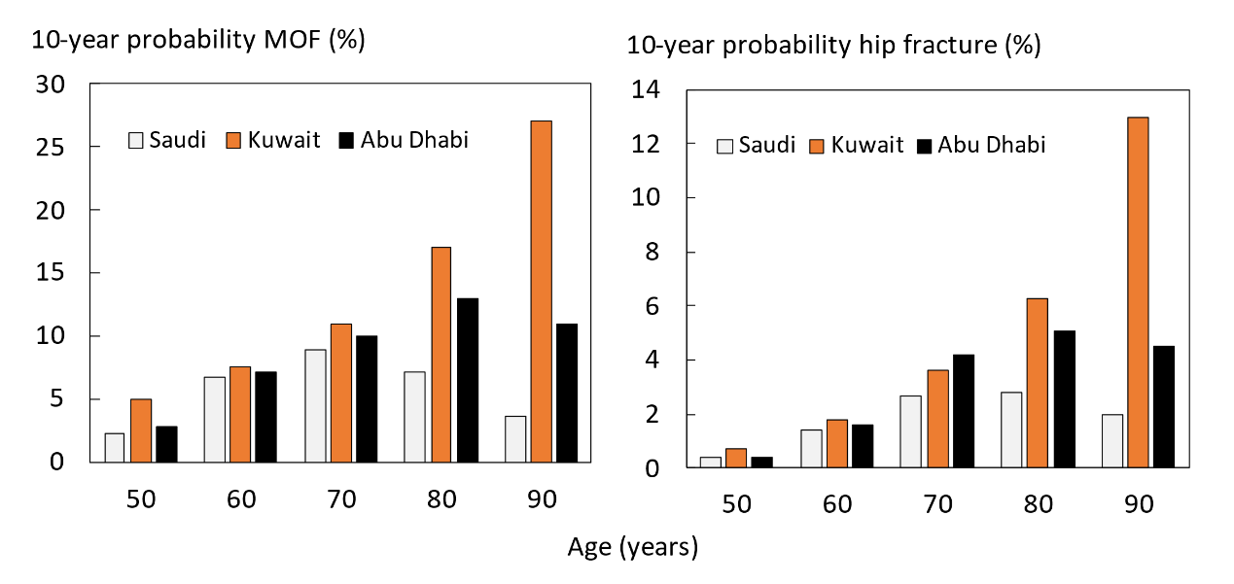

Fig. 3 10-year probability of a major osteoporotic fracture (left hand panel) and hip fracture (right) in women with a prior fracture by age from Saudi, Kuwait and Abu Dhabi. Body mass index set to 25kg/m².

Lifetime probabilities for hip fracture are shown in Table 3. For Saudi Arabia, probabilities were less than 1 in 20, and similar to probabilities in South African blacks and Morocco. As might be expected from the differences in mortality, probabilities were approximately half that estimated for Kuwait and Abu Dhabi.
Table 3. Life-time probability of hip fracture in the Qatari population at the age of 50 years compared with selected countries. Data from [18] unless otherwise indicated.
Country | Life-time risk at 50 years (%)
 | Women | Men
Sweden | 25.6 | 11.0
South Africa (white) | 23.4 | 7.7
Denmark | 23.0 | 11.3
France | 19.3 | 5.9
China (Hong Kong) | 17.7 | 7.6
USA (Caucasian) | 16.1 | 7.5
Turkey | 15.9 | 3.6
Canada | 15.5 | 5.8
Greece | 15.4 | 6.8
Uzbekistan | 14.7 | 8.7
UK | 14.4 | 5.0
Germany | 14.2 | 5.3
Portugal | 13.7 | 4.8
Finland | 12.9 | 6.0
Kazakhstan | 12.6 | 6.0
Spain | 12.6 | 4.2
Netherlands | 12.5 | 5.4
Singapore (Indian) | 12.5 | 5.2
Bulgaria | 11.2 | 4.4
Qatar ª | 11.0 | 8.8
Hungary | 10.8 | 4.2
Poland | 10.1 | 4.2
Moldova | 9.3 | 5.7
Kuwait | 9.2 | 7.6
Abu Dhabi | 8.9 | 8.1
Iran | 8.3 | 5.5
Russia | 7.7 | 3.8
Romania | 7.0 | 3.8
USA (black) | 5.9 | 2.7
Ukraine | 5.6 | 2.9
Saudi Arabia ^{b} | 4.6 | 3.7
South Africa (Black) | 4.5 | 1.9
Morocco | 4.1 | 3.1
Botswana | 1.1 | 1.4
Tunisia | 0.7 | 0.7
ª Johansson 2021 [19]
^{b} Present study

Discussion
This study documented the incidence of hip fracture in a representative sample of the population of Saudi Arabia. As expected, hip fractures were more frequent in women than in men. In both sexes, the incidence increased with age. Assuming that the multiregional incidence was similar to the national incidence, Saudi Arabia belongs to the low-risk countries for hip fracture for men and women [21]. There are relatively few studies of fracture rates in Saudi Arabia [22]. In the case of hip fracture, these date from 1991 [23], 2007 [24] and 2013 [25]. All were regional retrospective studies. The most recent was a survey in 24 of 28 hospitals in the Eastern Province. Crude hip fracture rates were approximately 3-fold higher in men and in women than in the present study. Reasons for the disparity are speculative, though the 2013 survey would have captured the large expatriate as well as the indigenous population.

The number of hip fractures nationwide was estimated at 2,949 in 2015.
Demographic projections indicate that fracture burden is set to increase markedly in the future. It is estimated that the annual number of hip fractures will increase nearly 7-fold over 35 years. The prediction is relatively robust in that all individuals who will be at the aged of 50 years or more in 2050 are currently adults. However, these estimates may be conservative since they assume that the age- and sex-specific risk of hip fracture remains unchanged over this period. If the age- and sex-specific incidence of hip fracture increases, as has been registered in several countries [26], then the number of fractures may be more than doubled [27]. Such projections are important for healthcare planning.

The incidence of hip fracture is rather similar to that reported for Kuwait and Abu Dhabi. There was, however, a very marked difference in fracture probability between the three countries. The explanation for the difference lies in the assumptions for mortality since fracture probability integrates the fracture hazard with the competing effect of mortality. After the age of 70 years, the mortality estimates were much higher in Saudi nationals than for the nationals of Kuwait or Abu Dhabi. These observations emphasise the importance of the death hazard as well as the fracture hazard in the determination of fracture probability.
Whereas the Saudi FRAX model permits the assessment of fracture probability in Saudi citizens, the question arises of how to assess fracture risk in expatriates. This community comprises 38.3% of the total population, according to UN data for 2019 and is ethnically very diverse [12]. Current evidence indicates that expatriates retain the risk characteristics of their country of origin [28, 29], so should be assessed as such.

A minority of countries that have a FRAX model also have robust information on the risk of other major osteoporotic fractures. In the absence of such information, FRAX models are based on the assumption that the age- and sex-specific pattern of these fractures is similar to that observed in Malmo [14]. As already noted, this assumption has been shown to be safe in studies reported from many countries [13, 15, 16, 30, 31, 32], despite differences in incidence between these countries [21]. This commonality of pattern is supported by register studies, which indicate that in those regions where hip fracture rates are high, so too is the risk of forearm fracture and spine fractures (requiring hospital admission) [33, 34].
The limitations of the present study relate predominately to the accuracy of the FRAX model. This in turn is dependent on the accuracy of the fracture and death hazards used in the construction of the FRAX model. Whereas death rates for the general population are likely to be robust, the hip fractures were garnered from approximately 12% of the population at risk and, despite the care in site selection, may not be representative of the Kingdom. The 12% estimate was based on the number of orthopaedic beds dealing with hip fracture and there is no certainty that all facilities have an equal occupancy of hip fracture cases. It may be relevant, however that hip fracture rates were rather similar to those seen in the neighboring UAE and Kuwait. It is relevant, however, that, accuracy errors have little impact on the rank order with which the FRAX tool categorizes risk in a given population [35,36] but they do change the absolute number generated and thus have implications where treatment guidelines are based on cost-effectiveness or the economic burden of disease. In order to address these limitations, populations representative of the general population at risk would need to be studied prospectively, preferably over a 10-year time horizon.

In summary, a FRAX model has been created for the Saudi Arabia based on a estimate of the incidence of low energy hip fractures in a subset of the population. The model should enhance accuracy of determining fracture probability among the Saudi population and help to guide decisions about treatment. Indeed, probability-based assessment of fracture risk using age-specific intervention thresholds have been developed recently for Saudi Arabia to help guide decisions about treatment [37].

Acknowledgements
The authors would like to thank all staff of participating Hospitals in data collection and staff of the General Directorate for Health Programs and Chronic Diseases, Ministry of Health, Saudi Arabia.Sincere thanks to Lilly for supporting the Saudi FRAX Project with an unrestricted Grant.

Conflict of Interest
YAS, RS, SAL YAN, LV, EL, ML, NCH, EVM HJ, and JAK declare that they have no competing interests in relation to this paper. HJ, NCH JAK are the architects of FRAX but have no financial interest.

References

1. | Kanis JA, Norton N, Harvey NC, Jacobson T, Johansson H Lorentzon M, McCloskey EV, Willers C, Borgström F (2021) SCOPE 2021: a new scorecard for osteoporosis in Europe. Archives of Osteoporosis 16: 82. doi.org/10.1007/s11657-020-00871-9
2. | Johnell O and Kanis JA (2006) An estimate of the worldwide prevalence and disability associated with osteoporotic fractures. Osteoporos Int 17:1726-33.
3. | Borgström F, Karlsson L, Ortsäter G, Norton N, Halbout P, Cooper C, McCloskey EV, Harvey NC, Javaid K, Kanis JA for the International Osteoporosis Foundation (2020) Fragility fractures in Europe: Burden, management and opportunities. Arch Osteoporos 15: 59. doi: 10.1007/s11657-020-0706-y.
4. | Hernlund E, Svedbom A, Ivergård M Compston J, Cooper C, Stenmark J, McCloskey EV, Jönsson B, Kanis JA (2013) Osteoporosis in the European Union: Medical Management, Epidemiology and Economic Burden. A report prepared in collaboration with the International Osteoporosis Foundation (IOF) and the European Federation of Pharmaceutical Industry Associations (EFPIA). Arch Osteoporos 8:136. DOI: 10.1007/s11657-013-0136-1.
5. | Kanis JA, Cooper C, Rizzoli R, Reginster J-Y; Scientific Advisory Board of the European Society for Clinical and Economic Aspects of Osteoporosis (ESCEO) and the Committees of Scientific Advisors and National Societies of the International Osteoporosis Foundation (IOF) (2019) European guidance for the diagnosis and management of osteoporosis in postmenopausal women. Osteoporos Int 30: 3-44.
6. | Kanis JA on behalf of the World Health Organization Scientific Group (2007) Assessment of osteoporosis at the primary healthcare level. Technical Report. WHO Collaborating Centre, University of Sheffield, UK. Available at . http://www.shef.ac.uk/FRAX/pdfs/WHO_Technical_Report.pdf. Accessed 26 Feb 2020
7. | Kanis JA, Harvey NC, Cooper C, Johansson H, Oden A, McCloskey EV and The Advisory Board of the National Osteoporosis Guideline Group (2016) A systematic review of intervention thresholds based on FRAX. A report prepared for the National Osteoporosis Guideline Group and the International Osteoporosis Foundation. Archives of Osteoporosis 11:25.
8. | Odén A, McCloskey EV, Kanis JA, Harvey NC, Johansson H (2015) Burden of high fracture probability worldwide: secular increases 2010-2040. Osteoporos Int 26:2243–2248
9. | Kanis JA, Harvey NC, Cyrus Cooper C, Johansson H, Odén A, McCloskey EV, the Advisory Board of the National Osteoporosis Guideline Group (2016) A systematic review of intervention thresholds based on FRAX. A report prepared for the National Osteoporosis Guideline Group and the International Osteoporosis Foundation. Arch Osteoporos 11:25.
10. | Al-Saleh Y, Al-Daghri NM, Sabico S, Alessa T, Al Emadi S, Alawadi F, Al Qasaabi S, Alfutaisi A, Al Izzi M, Mukhaimer J, Suhaili AR, Reginster JY, Sulimani R (2020) Diagnosis and management of osteoporosis in postmenopausal women in Gulf Cooperation Council (GCC) countries: consensus statement of the GCC countries' osteoporosis societies under the auspices of the European Society for Clinical and Economic Aspects of Osteoporosis and Osteoarthritis (ESCEO). Arch Osteoporos 15(1):109.
11. | Central Intelligence Agency (2020) World Factbook https://www.cia.gov/library/publications/the-world-factbook/geos/sa.html. Accessed 24 July 2021
12. | United Nations (2019) Department of Economic and Social Affairs / Population Division. World Population Prospects https://population.un.org/wpp/Download/Standard/Population/ Accessed 11 Jan 2021
13. | Zakroyeva A, Lesnyak O, Cazac V, Groppa L, Russu E, Chislari L, Rotaru L, Johansson H, Harvey NC, McCloskey E, Kanis JA (2020) Epidemiology of osteoporotic fracture in Moldova and development of a country specific FRAX model. Arch Osteoporos.15: 13. doi.org/10.1007/s11657-019-0669-z.
14. | Kanis JA, Odén A, Johnell O, Jonsson B, de Laet C, Dawson A (2001) The burden of osteoporotic fractures: a method for setting intervention thresholds. Osteoporos Int 12:417–427
15. | Siggeirsdottir K, Aspelund T, Johansson H, Gudmundsson EF, Mogensen B, Jonsson BY, Gudnason V, McCloskey E, Oden A, Sigurdsson G, Kanis JA (2014) The incidence of a first major osteoporotic fracture in Iceland and implications for FRAX. Osteoporos Int 25:2445–2451
16. | Lam A, LeslieWD, Lix LM, Yogendran M, Morin SN, Majumdar SR (2014) Major osteoporotic to hip fracture ratios in Canadian men and women with Swedish comparisons: a population-based analysis. J Bone Miner Res 29:1067–1073
17. | General Authority for Statistics (2020) Household Health Survey, 2018 Kingdom of Saudi Arabia https://www.stats.gov.sa/en/search/type/mortality Accessed 5 November 2020
18. | Kanis JA, Johnell O, De Laet C, Jonsson B, Oden A, Ogelsby AK (2002) International variations in hip fracture probabilities: implications for risk assessment. J Bone Miner Res 17:1237–1244
19. | Kebaetse M, Nkhwa S, Mogodi M, Masunge J, Gureja YP, Ramabu M, Mmopelwa T, Sharif I, Orford A, Johansson H, Harvey NC, McCloskey EV, Cauley JA, Kanis JA (2021) Epidemiology of hip fracture in Botswana. Arc Osteoporos 16: 24 DOI: 10.1007/s11657-021-00885-x.
20. | Johansson H, Harvey NC, Lorentzon M, Liu E, Vandenput L, McCloskey EV, Kanis JA (2021) Epidemiology of hip fracture and the development of a FRAX model for Qatar. A report prepared for Dr Nabeel Abdulla.
21. | Kanis JA, Odén A, McCloskey EV, Johansson H, Wahl D, Cyrus Cooper C on behalf of the IOF Working Group on Epidemiology and Quality of Life (2012) A systematic review of hip fracture incidence and probability of fracture worldwide. Osteoporosis International 23: 2239-2256.
22. | Barake M, El Eid R, Ajjour S, Chakhtoura M, Meho L, Mahmoud T, Atieh J, Sibai AM, El-Hajj Fuleihan G (2021) Osteoporotic hip and vertebral fractures in the Arab region: a systematic review. Osteoporos Int 32: 1499-1515.
23. | al-Nuaim AR, Kremli M, al-Nuaim M, Sandkgi S (1995) Incidence of proximal femur fracture in an urbanized community in Saudi Arabia. Calcif Tissue Int 56: 536-8.
24. | Bubshait D, Sadat-Ali M (2007) Economic implications of osteoporosis-related femoral fractures in Saudi Arabian society. Calcif Tissue Int 81: 455-8.
25. | Sadat-Ali M, Al-Dakheel DA, Azam MQ, Al-Bluwi MT, Al-Farhan MF, AlAmer HA, Al-Meer Z, Al-Mohimeed A, Tabash IK, Karry MO, Rassasy YM, Baragaba MA, Amer AS, AlJawder A, Al-Bouri KM, ElTinay M, Badawi HA, Al-Othman AA, Tayara BK, Al-Faraidy MH, Amin AH (2015) Reassessment of osteoporosis-related femoral fractures and economic burden in Saudi Arabia. Arch Osteoporos 10:37. doi: 10.1007/s11657-015-0240-5.
26. | Cooper C, Cole ZA, Holroyd CR, Earl SC, Harvey NC, Dennison EM Melton LJ3, Cummings SR, Kanis JA and the IOF CSA Working Group on Fracture Epidemiology (2011) Secular trends in the incidence of hip and other osteoporotic fractures. Osteoporos Int 22:1277–1288
27. | Gullberg B, Johnell O, Kanis JA (1997) World-wide projections for hip fracture. Osteoporos Int 7: 407-413
28. | Johansson H, Odén A, Lorentzon M, McCloskey E, Harvey N, Kanis JA, Karlsson M Mellström D (2015) Is the Swedish FRAX model appropriate for Swedish immigrants? Osteoporos Int 26: 2617-2622.
29. | Wändell P, Li X, Carlsson AC, Sundquist J, Sundquist K (2021) Osteoporotic fractures in second-generation immigrants and Swedish natives. Osteoporos Int 32: 1343-1350.
30. | Melton LJ, Crowson CS, O’Fallon WM (1999) Fracture incidence in Olmsted County, Minnesota: comparison of urban and with rural rates and changes in urban rates over time. Osteoporos Int 9: 29–37.
31. | Singer BR, McLauchlan CJ, Robinson CM, Christie J (1998) Epidemiology of fracture in 15.000 adults. The influence of age and gender. J Bone Joint Surg 80B: 234–8
32. | Sanders KM, Seeman E, Ugoni AM, Pasco JA, Martin TJ, Skoric B, Nicholson GC, Kotowicz MA (1999) Age- and gender speciﬁc rate of fractures in Australia: a population-based study. Osteoporos Int 10:2 40–7.
33. | Johnell O, Gullberg B, Kanis JA (1997) The hospital burden of vertebral fracture in Europe: a study of national register sources. Osteoporos Int 7: 138-144
34. | Melton LJ (1995) Epidemiology of fractures. In: Riggs BL, Melton LJ (eds) Osteoporosis: etiology, diagnosis and management, 2nd edn. Lippincott-Raven, Philadelphia, pp 225–227
35 | Lesnyak O, Sahakyan S, Zakroyeva A, Bilezikian JP, Hutchings N, Galstyan R, Lebedev A, Johansson H, Harvey NC, McCloskey E, Kanis JA (2017) Epidemiology of fractures in Armenia: Development of a country-specific FRAX model and comparison to its surrogate. Arch Osteoporos 12(1): 98. doi: 10.1007/s11657-017-0392-6.
36. | Kanis JA, Johansson H, Oden A, Dawson-Hughes B, Melton LJ 3rd, McCloskey EV (2010) The effects of a FRAX((R)) revision for the USA. Osteoporos Int 21: 35-40.
37. | Al-Daghri NM, Sabico S, Al-Saleh Y, Sulimani R, Aljohani NJ, Sheshah E, Alodhayani A, Harvey NC, Liu E, Lorentzon M, McCloskey EV, Vandenput L, Johansson H, Kanis JA (2021) The application of FRAX in Saudi Arabia. Arch Osteoporos 16: 166. doi 10.1007/s11657-021-01024-2.

