The MARECA (national study of management of breast cancer locoregional recurrence and oncological outcomes) study: National Practice Questionnaire of United Kingdom multi-disciplinary decision making

Authors: Jenna L Morgan^{1,*}, Vinton Cheng², Peter A Barry³, Ellen Copson⁴, Ramsey I Cutress⁴, Rajiv Dave⁵, Beatrix Elsberger⁶, Patricia Fairbrother⁸, Sue Hartup², Brian Hogan², Kieran Horgan², Cliona C Kirwan^{5,10}, Stuart A McIntosh¹¹, Rachel L O’Connell³, Neill Patani⁷, Shelley Potter¹², Tim Rattay¹³, Lisa Sheehan¹⁴, Lynda Wyld¹, Baek Kim² and on behalf of the MARECA study research collaborative.

Affiliations:
- Department of Oncology and Metabolism, University of Sheffield Medical School, Beech Hill Road, Sheffield, S10 2RX.
- The Breast Unit at the Leeds Cancer Centre, St James’s University Hospital, Leeds Teaching Hospitals NHS Trust, Leeds, LS9 7TF
- Department of Breast Surgery, The Royal Marsden NHS Foundation Trust, Downs Road, Sutton, Surrey, SM2 5PT.
- Cancer Sciences Academic Unit, University of Southampton and University Hospital Southampton, Tremona Road, Southampton, SO16 6YD.
- The Nightingale Breast Cancer Centre, Wythenshawe Hospital, Manchester, M23 9LT.
- Aberdeen Breast Unit, Aberdeen Royal Infirmary, Foresterhill, Aberdeen, AB25 2ZN.
- Department of Breast Surgery, University College London Hospitals NHS Foundation Trust, London, NW1 2BU.
- Trustee, Independent Cancer Patients Voice.
- Department of Breast surgery, St. James’s University Hospital, Leeds, LS9 7TF.
- Division of Cancer Sciences, School of Medical Sciences, Faculty of Biology, Medicine and Health, University of Manchester, Oglesby Cancer Research Building, Manchester Cancer Research Centre, Wilmslow Road, Manchester, M20 4BX.
- Patrick G Johnston Centre for Cancer Research, Queen’s University Belfast, 97 Lisburn Road, Belfast, BT9 7AE.
- Translational Health Sciences, Bristol Medical School, Canynge Hall, Whatley Road, Bristol, BS8 2PS.
- Leicester Cancer Research Centre, Clinical Sciences Building, University of Leicester, Leicester Royal Infirmary, Leicester, LE2 2LX.
- Wessex Deanery, Southern House, Otterbourne, Winchester, SO21 2RU.

*Corresponding author. Department of Oncology and Metabolism, University of Sheffield Medical School, Beech Hill Road, Sheffield, S10 2RX. Email address: j.morgan@sheffield.ac.uk

Abstract

Introduction
Evidence based guidelines for the optimal management of breast cancer locoregional recurrence (LRR) are limited, with potential for variation in clinical practice. This national practice questionnaire (NPQ) was designed to establish the current practice of UK breast multidisciplinary teams (MDTs) regarding LRR management.

Methods
UK breast units were invited to take part in the MARECA study MDT NPQ. Scenario-based questions were used to elicit preference in pre-operative staging investigations, surgical management, and adjuvant therapy.

Results
822 MDT members across 42 breast units (out of 144; 29%) participated in the NPQ (February-August 2021). Most units (95%) routinely performed staging CT scan, but bone scan was selectively performed (31%).

For patients previously treated with breast conserving surgery (BCS) and radiotherapy, few units (7%) always/usually offered repeat BCS. However, in the absence of radiotherapy, most units (90%) always/usually offered repeat BCS. For patients presenting with isolated local recurrence following previous BCS and SLNB (sentinel lymph node biopsy), most units (95%) advocated repeat SLNB. Where SLNs could not be identified, 86% proceeded to a four-node axillary sampling procedure.

For ER+HER2- node negative local recurrence, 10% of units always/usually offered chemotherapy. For ER+HER2- node positive local recurrence, this recommendation increased to 64%. For triple negative breast cancer local recurrence, 90% of units always/usually offered chemotherapy.

Conclusion
This survey has highlighted where consistencies and variations exist in the multidisciplinary management of breast cancer LRR. However, further research is required to determine how these management patterns influence patient outcomes, which will further refine optimal treatment pathways.

Key Words: breast cancer, recurrence, metastases, locoregional

1. Introduction
Breast cancer is newly diagnosed in 55000 women annually in the UK[1] with 5-year survival rates of 86.6%[2]. Whilst survival rates are favourable and continue to improve, locoregional recurrence (LRR) remains a concern for patients diagnosed with breast cancer. Breast cancer LRR is defined as breast cancer recurrence within the conserved breast, the ipsilateral skin or chest wall following mastectomy, or in the ipsilateral regional lymph nodes (axilla, supra- or infra-clavicular, or internal mammary nodes).

Currently, there is a lack of high-quality data and clinical guidance for the optimal management of breast cancer LRR. Recent studies from the Netherlands and UK have shown that 5 year LRR rates have fallen to under 5%[3, 4]. However, recurrences can occur at any time after the original cancer treatment, and a German registry-based study reported a 10 year cumulative LRR incidence of 8%[5]. In the UK, the National Cancer Registration and Analysis Service (NCRAS) and the National Cancer Intelligence Network (NCIN) reported a pilot project for patients diagnosed with recurrent and metastatic breast cancer across 15 breast units over a 6 months period in 2011. They identified 137 patients with LRR only, and 114 patients with both LRR and distant recurrences[6]. However, there was a lack of available data on treatment received by patients with LRR or evaluation of variation in patient management between the participating units.

The American National Comprehensive Cancer Network (NCCN) clinical practice guidelines in oncology[7] advocate a multidisciplinary team (MDT) approach to managing these patients. However, reflecting the relative lack of research, the guideline acknowledges areas of uncertainties in optimal management and highlights the importance of individualising treatment strategies. For instance, studies from Italy, Japan, and Netherlands show that in selected patients with LRR, repeat BCS achieves equivalent oncological outcome to patients receiving mastectomy for LRR[8-10]. These studies differ to the NCCN guideline which does not advocate repeat BCS.

LRR remains a heterogeneous condition with variable locoregional and systemic treatment options based on clinical presentation, tumour biology, previous treatment received, patient’s wishes and unit practice. There is a lack of studies that evaluate the impact of adherence to the NCCN guidelines on the treatment outcome of patients diagnosed with LRR. Optimising the management of patient with LRR was highlighted as one of the research priorities by the Association of Breast Surgery Gap Analysis[11]. In particular, the current knowledge gaps relate to pattern of disease presentation, association with metastatic disease, patient management strategies, and patient prognosis. For instance, patients with LRR who initially received breast conserving surgery (BCS) with radiotherapy were reported to have better prognosis than those patients who initially received mastectomy[12]. LRR after BCS is thought to be due to the growth of previously undetected microscopic tumour foci, which may present on screening mammograms and may therefore be detected early with better subsequent prognosis. However, an adequately powered study is required to further examine the prognostic effect of initial breast cancer surgery on patients diagnosed with LRR. Furthermore, patients diagnosed with LRR may have higher risk of distant metastases and death. This is reflected by a number of single centre studies reporting a poorer 5 year disease free survival (DFS) rate of 48-67%, and overall survival (OS) rate of 61-82%[13]. The CALOR trial recruited patients diagnosed with isolated LRR and reported a similar 5 year DFS of 69% with chemotherapy vs. 57% without chemotherapy[14]. Therefore, there is a clinical need to determine prognostic factors in patients diagnosed with LRR in order to aid treatment tailoring and improve subsequent treatment outcome.

The MARECA (national study of management of breast cancer locoregional recurrence and oncological outcomes) study national practice questionnaire (NPQ) aimed to establish current practice of UK breast MDTs regarding management of LRR, through standardised theoretical patient vignettes. It forms the first phase of the MARECA study; a prospective, observational multicentre longitudinal cohort study examining the management and outcomes of UK breast cancer patients diagnosed with LRR +/- distant metastasis.

2. Methods
UK breast units were invited to participate in the MARECA study by email and to take part in the MDT NPQ. As with previous UK NPQs[15, 16], MDTs were invited to complete the questionnaire between February 2021and August 2021 via national professional and research organisations. These included the Association of Breast Surgery, iBRA-NET, the Mammary Fold (national breast trainees association), Breast Cancer Trainees Research Collaborative Group, and the Association of Breast Clinicians. Further reminder invitations were sent via these organisations during the stated 6 month period to optimise response rates. No information was collected on units that did not take part.

Members of the MARECA steering committee developed the NPQ, which was piloted in two centres and iteratively modified according to feedback to ensure face and content validity and to be user friendly. The final 28-item questionnaire collected data on MDT demographics and the estimated number of patients diagnosed with LRR +/- distant metastasis in the participating unit per year (compared to the estimated number of primary breast cancer managed per year). Scenario-based questions were used to elicit unit preference in pre-operative radiological staging investigations, surgery to the breast (including questions specific to repeat breast conserving surgery and LRR resection in the presence of concurrent distant metastasis), surgery to the axilla (including the unit’s preference on surgical staging of the axilla), decision to offer adjuvant treatment (including chemotherapy and radiotherapy based on modifications to the case scenario), and patient follow up policy. The final version of the questionnaire is provided as supplementary document (see appendices item C). The questionnaire was issued to the participating MDTs via a SurveyMonkey online link (https://www.surveymonkey.co.uk/r/LBZKBFT). Respondents were asked to complete the questionnaire at their unit’s weekly multidisciplinary meeting and also to indicate which members of the MDT were present for the questionnaire completion. The questionnaire was designed to be completed by the MDT as a whole, with cases being presented and a single treatment recommendation being put forward after MDT discussion. The completed questionnaire was submitted by the local lead for the MARECA study (see Appendices Table A for the list of MARECA study collaborators). No ethical approval was required for this NPQ phase of the MARECA study as it was a survey of stated practice using hypothetical MDT cases and did not involve patients.

Descriptive summary statistics were calculated for each questionnaire item; categorical data were summarised by counts and percentages; continuous data were summarised by mean, median, standard deviation and ranges as appropriate. Statistical tests were carried out using IBM SPSS statistics version 25.

3. Results
In total 822 MDT members across 42 UK breast units participated in the NPQ, with 35 (83.3%) having all core members of the MDT at the time of questionnaire completion (including surgeons, radiologists, pathologists, oncologists and nurse specialists). Members of the MDT were evenly represented including breast surgeons (n=167), oncologists (n=114), histopathologists (n=71), and radiologists (n=106). Questionnaire responses were obtained from 42 of the 61 units that registered an expression of interest for the MARECA study (68.9%), out of a total of 144 UK breast units (29.2%). Characteristics of participating centres’ service provision and MDT composition are summarised in Table 1.

There was an even geographical distribution of the participating units across the UK, including 7/44 (16%) from the devolved nations (see Appendices figure B). All units managed patients referred from the breast screening programme. Of the participating units, 78% (n=33) stated they submitted data about patients diagnosed with LRR to the national cancer registry. A majority of units (64%; n=27) did not keep a prospective database of patients diagnosed with LRR. Figure 1 shows the stated number of patients diagnosed with LRR +/- distant metastasis in each unit per year.

Organisation | Number (%)
Teaching Hospital | 23 (55)
District General Hospital | 19 (45)
Service provision
Screening and symptomatic | 42 (100)
Symptomatic only | 0
Unit size | Median number of stated primary breast cancer treated per year (range)
 | 487 (180-1250)
MDT composition | Median number (range)
Consultant breast surgeon | 4 (1-7)
Consultant oncologist | 2 (0-5)
Consultant radiologist | 2 (0-5)
Consultant histopathologist | 1 (0-6)
Breast surgery trainees | 1 (0-4)
Oncology trainees | 0 (0-4)
Breast cancer nurse specialists | 3 (0-7)
Other | 2 (0-20)

Table 1. Demographics of participating breast units and MDT composition

Figure 1. The stated number of patients diagnosed with breast cancer locoregional recurrence in the participating units per year.

3.1 Diagnosis and staging investigations.
All MDTs (42/42; 100%) stated they would always perform axillary ultrasound (USS) for patients presenting with a local recurrence after previous breast conserving surgery (BCS) and sentinel lymph node biopsy (SLNB). Most units (40/42; 95.2%) stated they would always perform axillary USS for patients presenting with a local recurrence after previous BCS and axillary node clearance (ANC), with the remainder saying they would usually do so. Most units (40/42; 95.2%) stated they would always perform staging investigations for patients presenting with a local recurrence in the same quadrant and of the same molecular receptor status as the primary breast cancer, with the remainder saying they would usually do so.

There was greater variation in whether MDTs would perform staging investigations for patients presenting with a local recurrence in a different quadrant with a different molecular receptor status as the primary breast cancer. In this clinical scenario, 27/42 units (64.3%) always performed staging investigations, 11/42 units (26.2%) usually performed them, 3/42 units (7.1%) occasionally performed them and one 1/42 unit (2.4%) never performed staging investigations.

With regards to the type of staging investigations, most units (40/42; 95.2%) would perform CT chest, abdomen, and pelvis, with 5/42 (11.9%) also performing a PET CT. There was variation in whether units would perform bloods tests (including tumour markers) with 50% (21/42) of units doing so. Furthermore, 31% (13/42) would perform an isotope bone scan in addition to CT chest, abdomen, and pelvis. Only 2.4% (1/42) of units would perform bone marrow MRI.

3.2 Surgery in the presence of distant metastasis
No MDTs offered routine resection of an in-breast recurrence if the patient was found to have concurrent distant metastases. The majority of MDTs (39/42; 92.9%) stated they would occasionally offer resection of an in-breast recurrence if the patient was found to have concurrent distant metastases, with the remainder (3/42; 7.1%) stating they would never offer resection of the in-breast recurrence in the context of distant metastases.

3.3 Surgery to the breast
For patients who received previous BCS, MDT recommendation differed depending on whether the patient had previously received whole breast radiotherapy (WBRT). For patients who previously received WBRT, few units (7.1%; 3/42) would always/usually offer repeat BCS (where technically feasible). However, for patients who previously did not receive WBRT (e.g. PRIME2 trial[17] compliant, previous DCIS only or patient choice), 90.5% of units (38/42) always/usually offered repeat BCS (Figure 2).

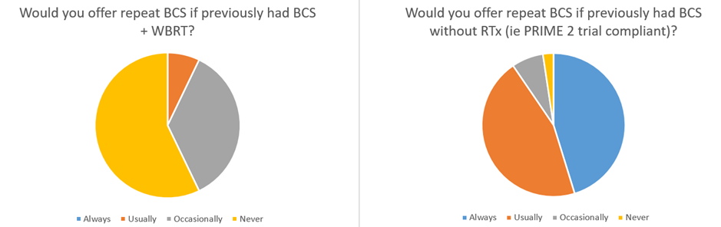

Figure 2. Variation in the MDT decision to offer repeat breast conserving surgery (BCS) in patients who present with an in breast local recurrence after previous BCS +/- whole breast radiotherapy (WBRT)

3.4 Axillary management
Most MDTs (95.2%; 40/42) advocated repeat SLNB for patients presenting with local recurrence following previous BCS and SLNB. However, MDT recommendations varied regarding the use of pre-operative lymphoscintigraphy with 29/42 units (69%) advocating repeat SLNB without lymphoscintigraphy, and 11/42 units (26.2%) recommending repeat SLNB with lymphoscintigraphy. The remaining two units would either offer ANC (2.4%; 1/42) or no further axillary surgery if axillary USS and CT scan were normal (2.4%; 1/42).

In the situation where a sentinel node could not be identified on repeat SLNB, the majority of units (36/42; 85.7%) would recommend proceeding to a four-node axillary sampling procedure[18-20], with a minority (3/42; 7.1%) recommending ANC, and 3/42 (7.1%) recommending no further axillary dissection in the context of a normal pre-operative axillary USS.

3.5 Systemic and locoregional adjuvant treatments
For patients who present with a mastectomy skin flap invasive recurrence (with no previous history of chest wall radiotherapy), 19/42 units (45.2%) would always offer adjuvant chest wall radiotherapy, 19/42 units (45.2%) would usually offer it, 3/42 units (7.1%) would occasionally offer it and only 1 unit (2.4%) would never offer adjuvant chest wall radiotherapy after wide local excision of the recurrence with clear margins.

For patients receiving repeat BCS after previous BCS and WBRT, there was general agreement for not offering repeat breast radiotherapy, with only 3/42 units (7.1%) stating they would occasionally offer further breast radiotherapy, and 35/42 units (83.3%) never offering repeat breast radiotherapy. Four of the 42 (9.5%) units did not provide a response.

MDT recommendations for further chemotherapy to treat patients with local recurrence showed significant variations depending on cancer biology, nodal status, and disease free interval (Figures 3 and 4). Chemotherapy was more likely to be recommended to treat patients with local recurrence if they had associated lymph node involvement (4/42, 9.5% would always offer chemotherapy; 23/42, 54.8% would usually offer chemotherapy), if the local recurrence was a triple negative subtype (27/42, 64.3% would always offer chemotherapy; 11/42, 26.2% would usually offer chemotherapy), or if the local recurrence occurred earlier whilst the patient was still on adjuvant endocrine therapy (28/42, 66.7% would consider offering chemotherapy; Figure 4).

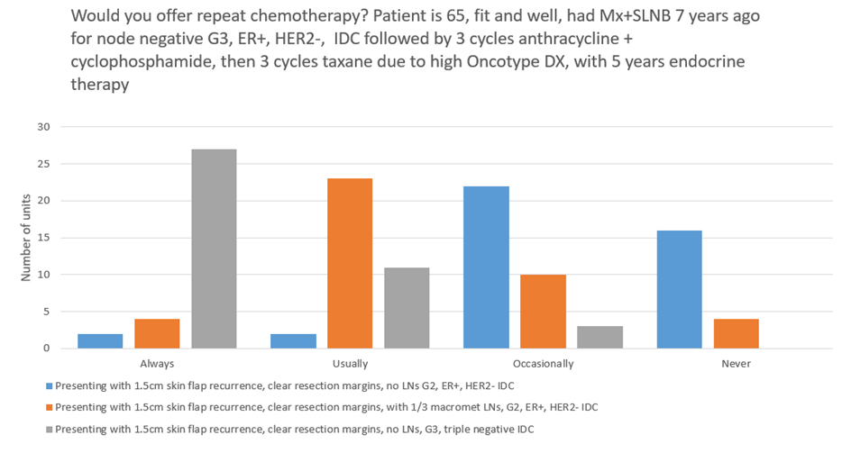
Figure 3. Significant variations in chemotherapy decision making to treat locoregional recurrence depending on modifications to the clinical scenario (Mx: mastectomy; LN: lymph node; G: grade; IDC: invasive ductal carcinoma).

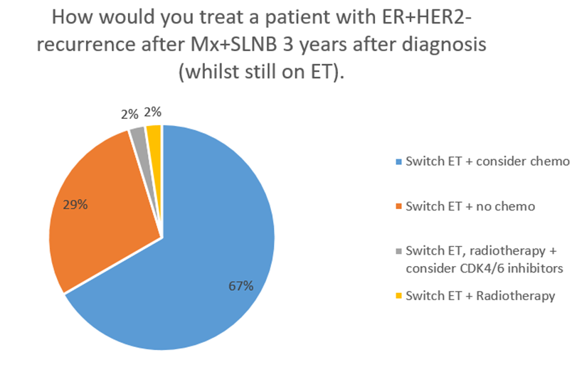
Figure 4. Variation in the decision making for adjuvant therapy if the patient developed node negative ER+HER2- LRR whilst on adjuvant endocrine therapy for primary breast cancer.

Ki-67 assessment on LRR tissue was not commonly utilised to inform chemotherapy decision-making to treat LRR; with 2/42 units (4.8%) always using Ki-67 in the recurrent breast cancer setting to inform chemotherapy decisions, 1/42 unit (2.4%) usually using it, 8/42 units (19.0%) occasionally using it, and 2/42 units (4.8%) never using it. Two thirds of the respondent units (28/42; 66.7%) stated they do not routinely offer Ki-67 testing in any setting (including the management of primary breast cancer). One unit did not answer this question.

3.6 Follow-up
Follow-up protocols were highly variable across the participating units, with 8/42 (19.0%) following patients in surgical clinic, 7/42 (16.7%) following patients in oncology clinic, 14/42 (33.3%) following patients in both surgical and oncology clinics, 3/42 (7.1%) using mammographic follow-up only, 4/42 (9.5%) using open access follow-up protocols, 2/42 (4.8%) not arranging formal follow-up and 4/42 (9.5%) using “other” follow-up arrangements.

Duration of follow-up for patients with locoregional recurrence was also variable, with 20/42 (47.6%) units not having a defined follow-up protocol and using individualised follow-up schedules. Sixteen (38.1%) units follow patients up for a minimum of 5 years following LRR, 1/42 (2.4%) for 1 year, 1/42 (2.4%) having “open access” and 3/42 (7.1%) for an “other” duration.

4. Discussion
This study provides an overview of the incidence and current management of patients presenting with breast cancer LRR in the UK. This is the first national survey of MDTs on their practice of managing patients with breast cancer LRR. Our MDT questionnaire response rate of almost 30% is comparable to other published UK breast cancer MDT NPQ[16]. In terms of the 822 questionnaire participants, there is good geographical representation across the UK, with a wide variety of MDT members who participated. Therefore, the questionnaire response provided is representative and likely to reflect UK MDT management of breast cancer LRR.

This study has demonstrated both consensus and variations in practice at several points within the management pathway. In the UK and Europe, there are no national guidelines for the management of this often heterogeneous group of patients. Although there is a management algorithm within the US NCCN guidelines[7], this questionnaire study has demonstrated particular variations with respect to the range of staging investigations offered, decision for repeat BCS, and the decision to offer chemotherapy to treat patients with LRR.

There is consistency in the type of staging investigations offered, with most units opting for CT chest, abdomen and pelvis as their preferred screening tool. This is consistent with current National Institute for Health and Care Excellence guidelines that suggest a combination of CT, ultrasound and plain radiography for assessment of the presence and extent of visceral metastases and bony windows on CT or MRI or bone scintigraphy for assessment of bony metastases within the axial skeleton[21]. However, our study showed variable use of bone scans and blood tests across the participating units. The MARECA study will aim to determine the diagnostic success rate of each radiological staging modality for the detection of distant metastasis, as well as patterns of distant metastasis at presentation.

There is variation of care in terms of repeat BCS being offered which is greatly influenced by previous breast radiotherapy, with 42.3% either usually or occasionally offering it in the context of previous WBRT. This is in direct contravention to the NCCN guidelines which clearly state that patient who have undergone previous BCS with WBRT should be managed surgically with mastectomy in the event of an in-breast recurrence [7]. A Dutch national survey, with responses from breast surgeons and radiation oncologists, have also shown considerable variation in the decision to offer BCS[22]. Furthermore, studies have shown that repeat BCS in the setting of in-breast recurrence is oncologically safe when compared to salvage mastectomy in selected women[23]. A study by Gentillini and colleagues has demonstrated that patients with a unifocal, small local recurrence and a long recurrence free-interval are likely to be the best candidates for repeat BCS[8].

A systematic review by Walstra and colleagues demonstrated that repeat BCS is a feasible treatment option in selected patients, and highlighted the benefit of re-irradiation in improving oncological outcomes after repeat BCS[10]. The fact that re-irradiation is rarely offered in UK breast units may explain the relatively lower rate of repeat BCS in patients who previously received BCS + WBRT.

There is general consensus surrounding the use of repeat SLNB in the surgical staging of the axilla which is consistent with the NCCN recommendations[7, 24]. A systematic review by Poodt and colleagues has shown that a repeat procedure to identify SLN can be successful in 64.3% of the patients diagnosed with in-breast local recurrence[25]. The MARECA study will determine whether this figure is comparable to the current UK practice and also determine the nodal positivity rate of the repeat SLNB. The SNARB (Sentinel Node and Recurrent Breast Cancer) study has suggested that the nodal status of a repeat SLNB does not have prognostic significance [26]. Our study has also shown the variable use of lymphoscintigram to guide SLNB, presumably as the lymphatic drainage of the local recurrence may be outside the ipsilateral axilla[27]. The stated practice of 4 node sampling when repeat SLNB fails requires further examination as to its prognostic significance and associated potential morbidities. The SNARB study demonstrated that performing axillary lymph node dissection after unsuccessful repeat SLNB did not impact on regional recurrence risk and hence should not be advocated[28].

For patients who present with concurrent distant metastasis, the majority of MDTs would consider resection of the in-breast recurrence as part of the management option. However, these data are limited by the wording of the questionnaire as it is not clear whether this practice is being performed for local control (i.e. in the presence of fungating disease) or not. In the context de novo stage 4 breast cancer, a recent randomised controlled trial by Khan et al[29] demonstrated that resection of the primary breast cancer did not improve survival in patients presenting with metastatic breast cancer. There is however lack of data regarding surgery to the local recurrence in women with concurrent distant metastases. It is unlikely that such data would ever be made available due to the extreme difficulty performing trials in the de novo stage 4 setting, let alone in patients with LRR. Currently in the UK, it is not known how many patients are undergoing LRR resection surgery for local control in the presence of distant metastasis. The MARECA study will capture this information and determine the context of patients who undergo surgery in this situation.

Significant variations were observed in the decision to offer chemotherapy for patients diagnosed with LRR. For patients diagnosed with ER+HER2- local recurrence, although 38% would never offer chemotherapy, 52% would occasionally offer chemotherapy, which is in direct contrast to the results of the CALOR trial which did not support the use of chemotherapy for ER+ LRR[30], but showed benefit for patients with ER- LRR. In keeping with this trial result, in our survey 90% of the units would always or usually offer chemotherapy for ER- LRR. Knowing the lymph node status does seem to influence chemotherapy decision making for ER+ LRR; our survey showed that having a macrometastasis in the axillary lymph node increased the recommendation for chemotherapy (always and usually) from 9.5% (node negative) to 64% (node positive). However, the aforementioned SNARB study demonstrated that the nodal status of a repeat SLNB has no prognostic significance. There was however consistency in the decision to offer radiotherapy for patients who present with mastectomy skin flap invasive recurrence with most units (90.4%) always/usually offering chest wall radiotherapy after wide local excision of the recurrence.

Based on our survey, additional tools, such as Ki-67, are not commonly utilised in the decision making for chemotherapy in the setting of LRR. Furthermore, the validity of tests such as Ki-67 in the decision making for chemotherapy to treat LRR requires future research. None of the multigene arrays have been validated in the context of LRR and therefore may not have value in supporting decision making in this setting.

Our study showed that 22% of the participating units are not submitting LRR data to the UK national cancer registry. There is a need to improve this data submission in order for the national cancer registry data to provide a comprehensive national picture of this patient cohort. The majority of units (64%) also do not keep a prospective database of patients diagnosed with LRR. Therefore, it would be difficult to determine the incidence rate of LRR at individual unit level. This again requires further evaluation at national level. Patient follow up protocol is highly variable. This is a potential concern as patients diagnosed with LRR potentially have poorer prognosis when compared to survival outcome from primary breast cancer[13, 31].

Limitations of this study include the response rate of under 30% which may limit potential generalisability of the results. However, over 800 MDT members participated in the NPQ. There were no distinctions made between clinical and radiation oncologist attendees. In addition, the study recorded ‘stated practice’ by UK breast MDTs and the Likert scales used for the questionnaire items may be open to interpretation. A further constraint is the hypothetical nature of the scenarios which do not take account of complexities in individual clinical practice (e.g. differentiating between a true recurrence versus a new breast primary cancer / decision making for further chemotherapy based on the tolerance of chemotherapy for the primary breast cancer).

In summary, further research is required to gather high quality data on patient management and treatment outcomes, which the full MARECA study will aim to provide. This prospective cohort study will aim to recruit patients newly diagnosed with breast cancer LRR +/- distant metastasis from over 60 UK breast units and provide a comprehensive picture of how this patient group is currently managed with the aim of establishing best practice and informing future national guidelines.

5. Conclusion
This national survey has highlighted where consensus and variations exist in the multidisciplinary management of breast cancer LRR. Repeat BCS was most usually only offered if radiotherapy had not been given previously, whilst repeat SLNB was generally offered in the presence of previous SLNB. Chemotherapy recommendations were generally dependent on the tumour stage and biological subtype of LRR. However, further research is required to determine how these management patterns influence patient outcomes, which will further refine optimal treatment pathways and inform development and update of current existing guidelines.

Conflict of interest
The authors declare no conflict of interest.

Acknowledgements
The MARECA study was funded by grants from the Association of Breast Surgery and Leeds Hospitals Charity. The funders had no role in the design of the study nor collection of data, and had no input into the analysis or interpretation of the data.
References
1. https://www.cancerresearchuk.org/health-professional/cancer-statistics/statistics-by-cancer-type/breast-cancer#heading-Zero.
2. https://www.ons.gov.uk/peoplepopulationandcommunity/healthandsocialcare/conditionsanddiseases/bulletins/cancersurvivalinengland/stageatdiagnosisandchildhoodpatientsfollowedupto2018.
3. van Laar, C., et al., Local recurrence following breast-conserving treatment in women aged 40 years or younger: trends in risk and the impact on prognosis in a population-based cohort of 1143 patients. Eur J Cancer, 2013. 49(15): p. 3093-101.
4. Coles, C.E., et al., Partial-breast radiotherapy after breast conservation surgery for patients with early breast cancer (UK IMPORT LOW trial): 5-year results from a multicentre, randomised, controlled, phase 3, non-inferiority trial. Lancet, 2017. 390(10099): p. 1048-1060.
5. Holleczek, B., et al., Risk of loco-regional recurrence and distant metastases of patients with invasive breast cancer up to ten years after diagnosis - results from a registry-based study from Germany. BMC Cancer, 2019. 19(1): p. 520.
6. http://www.ncin.org.uk/view?rid=1043.
7. https://www2.tri-kobe.org/nccn/guideline/breast/english/breast.pdf.
8. Gentilini, O., et al., Repeating conservative surgery after ipsilateral breast tumor reappearance: criteria for selecting the best candidates. Ann Surg Oncol, 2012. 19(12): p. 3771-6.
9. Yoshida, A., et al., Prognosis after mastectomy versus repeat lumpectomy in patients with ipsilateral breast cancer recurrence: A propensity score analysis. Eur J Surg Oncol, 2016. 42(4): p. 474-80.
10. Walstra, C., et al., Repeat breast-conserving therapy for ipsilateral breast cancer recurrence: A systematic review. Eur J Surg Oncol, 2019. 45(8): p. 1317-1327.
11. Cutress, R.I., et al., Opportunities and priorities for breast surgical research. Lancet Oncol, 2018. 19(10): p. e521-e533.
12. Shenouda, M.N., et al., Clinical outcome of isolated locoregional recurrence in patients with breast cancer according to their primary local treatment. Clin Breast Cancer, 2014. 14(3): p. 198-204.
13. Clemons, M., et al., Locoregionally recurrent breast cancer: incidence, risk factors and survival. Cancer Treat Rev, 2001. 27(2): p. 67-82.
14. Aebi, S., et al., Chemotherapy for isolated locoregional recurrence of breast cancer (CALOR): a randomised trial. Lancet Oncol, 2014. 15(2): p. 156-63.
15. Mylvaganam, S., et al., Variation in the provision and practice of implant-based breast reconstruction in the UK: Results from the iBRA national practice questionnaire. Breast, 2017. 35: p. 182-190.
16. Whitehead, I., et al., The NeST (Neoadjuvant systemic therapy in breast cancer) study: National Practice Questionnaire of United Kingdom multi-disciplinary decision making. BMC Cancer, 2021. 21(1): p. 90.
17. Kunkler, I.H., et al., Breast-conserving surgery with or without irradiation in women aged 65 years or older with early breast cancer (PRIME II): a randomised controlled trial. Lancet Oncol, 2015. 16(3): p. 266-73.
18. Macmillan, R.D., et al., Sentinel node biopsy for breast cancer may have little to offer four-node-samplers. results of a prospective comparison study. Eur J Cancer, 2001. 37(9): p. 1076-80.
19. Gaston, M.S. and J.M. Dixon, A survey of surgical management of the axilla in UK breast cancer patients. Eur J Cancer, 2004. 40(11): p. 1738-42.
20. Forrest, A.P., et al., The Edinburgh randomized trial of axillary sampling or clearance after mastectomy. Br J Surg, 1995. 82(11): p. 1504-8.
21. https://www.nice.org.uk/guidance/CG81.
22. Walstra, C., et al., Repeat breast-conserving treatment of ipsilateral breast cancer recurrence: a nationwide survey amongst breast surgeons and radiation oncologists in the Netherlands. Breast Cancer Res Treat, 2021. 187(2): p. 499-514.
23. Gentile, D., et al., Breast conserving surgery versus salvage mastectomy for ipsilateral breast cancer recurrence: a propensity score matching analysis. Updates Surg, 2021.
24. Yoon, C.I., et al., Repeat Sentinel Lymph Node Biopsy for Ipsilateral Breast Tumor Recurrence After Breast Conserving Surgery With Sentinel Lymph Node Biopsy: Pooled Analysis Using Data From a Systematic Review and Two Institutions. Front Oncol, 2020. 10: p. 518568.
25. Poodt, I.G.M., et al., Repeat Sentinel Lymph Node Biopsy for Ipsilateral Breast Tumor Recurrence: A Systematic Review of the Results and Impact on Prognosis. Ann Surg Oncol, 2018. 25(5): p. 1329-1339.
26. Poodt, I.G.M., et al., Prognostic impact of repeat sentinel lymph node biopsy in patients with ipsilateral breast tumour recurrence. Br J Surg, 2019. 106(5): p. 574-585.
27. Tokmak, H., et al., Management of sentinel node re-mapping in patients who have second or recurrent breast cancer and had previous axillary procedures. World J Surg Oncol, 2014. 12: p. 205.
28. Poodt, I.G.M., et al., Low Risk of Development of a Regional Recurrence After an Unsuccessful Repeat Sentinel Lymph Node Biopsy in Patients with Ipsilateral Breast Tumor Recurrence. Ann Surg Oncol, 2019. 26(8): p. 2417-2427.
29. Khan, S.A., et al., Early Local Therapy for the Primary Site in De Novo Stage IV Breast Cancer: Results of a Randomized Clinical Trial (EA2108). J Clin Oncol, 2022: p. JCO2102006.
30. Wapnir, I.L., et al., Efficacy of Chemotherapy for ER-Negative and ER-Positive Isolated Locoregional Recurrence of Breast Cancer: Final Analysis of the CALOR Trial. J Clin Oncol, 2018. 36(11): p. 1073-1079.
31. Anderson, S.J., et al., Prognosis after ipsilateral breast tumor recurrence and locoregional recurrences in patients treated by breast-conserving therapy in five National Surgical Adjuvant Breast and Bowel Project protocols of node-negative breast cancer. J Clin Oncol, 2009. 27(15): p. 2466-73.

Appendices

Table A. MARECA study list of collaborators and participating centres

Gaural Patel Milton Keynes University Hospital NHS Foundation Trust
Fiona Court Gloucestershire Hospitals NHS Foundation Trust
Elizabeth Clayton Royal Surrey NHS Foundation Trust and St Luke's Cancer Centre
Rachel O'Connell Royal Marsden Hospital
Catherine Tait Bradford Teaching Hospitals
Salena Bains University Hospitals Birmingham NHS Foundation Trust
John Benson Addenbrooke's Hospital, Cambridge
Eleftheria Kleidi Addenbrooke's Hospital, Cambridge
Lee Min Lai West Hertfordshire Hospitals NHS Trust
Stuart McIntosh Belfast City Hospital
Matei Dordea North Tees and Hartlepool NHS Foundation Trust
Alison Luther University Hospital Southampton NHS Foundation Trust
Anita Hargreaves Countess of Chester NHS Foundation Trust
Majid Rashid Ninewells Hospital, Dundee
Isabella Karat Frimley Park Hospital
Amira Helal University Hospital of North Midland
Elizabeth Baker Airedale Hospital
Anita Maria Huws Prince Philip Hospital, Hywel Dda NHS University Health Board
Charlotte Ives Royal Devon and Exeter NHS Foundation Trust
Jenny Piper York Hospital
Dinesh Thekkinkattil Lincoln County Hospital
Shelley Potter North Bristol NHS trust
Peter Kneeshaw Castle Hill Hospital
Lyn Zimmo Brighton and Sussex University Hospital
Victoria Rusius St. James’s University Hospital, Leeds
Helen Mathers Craigavon Area Hospital
Daniel Glassman Mid Yorkshire Hospitals NHS Trust
Brendan Skelly Altnagelvin Area Hospital (Western HSCT)
Richard Frame Calderdale and Huddersfield NHS Foundation Trust
Henry Cain Newcastle upon Tyne Hospital NHS Trust
Biswajit Ray Harrogate District Hospital
Dennis Remoundos Oxford University Hospitals NHS Foundation Trust
Sarah Clark Poole Hospital NHS Foundation Trust
Julia Massey Chesterfield Royal Hospital NHS Foundation Trust
Monika Kaushik University Hospitals of Leicester NHS Trust
Beatrix Elsberger Aberdeen Royal Infirmary
Chris Cartlidge Queen Margaret Hospital, Dunfermline, NHS Fife
Raghavan Vidya The Royal Wolverhampton NHS Trust
Matthew Rowland Royal Liverpool Hospital
Siobhan Laws Hampshire Hospitals
Zoe Goldthorpe Musgrove Park Hospital, Taunton
Amanda Thorne Musgrove Park Taunton, Taunton
Jenna Morgan Doncaster and Bassetlaw Teaching Hospitals
Rajiv Dave Wythenshawe Hospital, Manchester

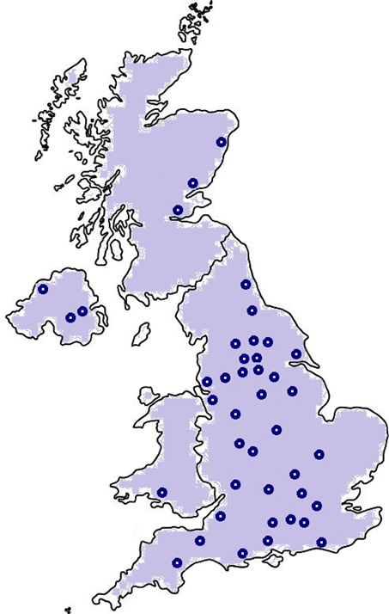
Figure B. Geographical distribution of the participating units demonstrating even distribution across all 4 UK nations.

C. MARECA study National Practice Questionnaire

National Practice Questionnaire on management of breast cancer locoregional recurrence

Management of breast cancer patients who present with locoregional recurrence was highlighted as a key research priority at the Association of Breast Surgery Gap Analysis meeting in 2019. Breast cancer locoregional recurrence is defined as breast cancer recurrence (invasive or DCIS) within the conserved breast, the ipsilateral skin or chest wall following mastectomy, or in the ipsilateral regional lymph nodes (axilla, supra- or infra-clavicular, or internal mammary nodes). Currently there is no UK specific guideline on how these patients should be managed.
This questionnaire will aim to evaluate how UK breast units are managing patients with LRR. This will be followed by the MARECA study- National Study of Management of Breast Cancer Locoregional Recurrence and Oncological Outcome. This is a prospective observational multicentre cohort study which will describe the current management and prognosis of patients diagnosed with breast cancer locoregional recurrence in the UK.
We would like you to answer the National Practice Questionnaire within your entire MDT team (maybe before or after the MDT meeting when all team members are present). The questionnaire will take approximately 20 minutes to complete and consists of questions about the number of cases your unit deals with followed by some scenario based questions designed to capture data on practice variation and areas of uncertainty.

Basic Unit information
- Please state the name of the participating hospital

- Please state the name, email address, and job title of the person entering data for your unit’s questionnaire

- Does your unit treat patients referred from the breast screening programme?
Yes/No

- How many new breast cancers (invasive cancer and DCIS) do you manage per calendar year?

- Does your unit keep a prospective database of patients diagnosed with breast cancer locoregional recurrence?
Yes/No

- Does your trust submit data on breast cancer recurrence to a national database?
Yes/No (If Yes, what data collection system is used? e.g. COSD)

- As an estimate, how many patients with locoregional recurrence (without distant metastasis) do you manage at your unit per year?
-Less than 5 patients per year
-5 to 10 patients per year
-More than 10 patients per year

- As an estimate, how many patients with LRR (with distant metastasis) do you manage at your unit per year?
-Less than 5 patients per year
-5 to 10 patients per year
-More than 10 patients per year

Practice Questionnaire Scenarios
MDT attendance for the National Practice Questionnaire

- Please state the presence and number of participating MDT members;
-Consultant Breast Surgeon (Yes/No; state number present)
-Consultant Oncologist (Yes/No; state number present)
-Consultant Histopathologist (Yes/No; state number present)
-Consultant Radiologist (Yes/No; state number present)
-Breast surgery trainees (Yes/No; state number present)
-Oncology trainees (Yes/No: state number present)
-Breast Care Nurses (Yes/No; state number present)
-Other MDT members (please state role and state number present)

Scenario 1. Diagnosis and staging investigations
- A 50 years old patient presents with a 3cm invasive recurrence in the ipsilateral breast after previous breast conserving surgery (BCS) and sentinel lymph node biopsy (SLNB) 3 years ago. The recurrence is in the same quadrant and has the same molecular receptor status as the original cancer. The tumour does not involve the skin or chest wall. Does your unit perform an axillary ultrasound scan (USS)?
Always/Usually/Occasionally/Never

- If this patient had previous axillary node clearance (ANC) instead of SLNB, does your unit perform an axillary USS?
Always/Usually/Occasionally/Never

- Would your unit offer staging investigations for this patient?
Always/Usually/Occasionally/Never

- If yes, which staging investigations would be recommended (please tick all that apply)?
-CT chest/abdomen/pelvis
-Blood tests (e.g. FBC, U+E, LFTs, Ca, CA15-3)
-Isotope bone scan
-PET CT
-Others (please specify)

- If this patient had instead presented with an invasive recurrence in a different breast quadrant with a different molecular receptor status as the original cancer, would your unit offer staging investigations?
Always/Usually/Occasionally/Never

- If this patient was found to have concurrent distant metastasis, would your MDT offer resection of the in-breast recurrence?
Always/Usually/Occasionally/Never

Scenario 2. Surgery to the breast
A 76 year old patient underwent BCS and SLNB 10 years ago, followed by whole breast radiotherapy (WBRT). The previous histology had shown a 10mm area of grade 2 invasive ductal carcinoma (IDC) which was ER strongly positive and Her-2 negative. She had 3 nodes removed at SLNB of which none were positive. She had 5 years of letrozole treatment after surgery.

- She now presents with a 1cm recurrent grade 1 ER+HER2- IDC 3 cm away from the primary scar. She wears a DD cup bra size and has good symmetry. She is fit and well. Would your MDT offer repeat BCS for this patient?
Always/Usually/Occasionally/Never

- If this patient had not received previous WBRT (she was PRIME 2 compliant), would your MDT offer repeat BCS?
Always/Usually/Occasionally/Never

- If your MDT offers repeat BCS for patients who had previously been treated with BCS and radiotherapy, does your MDT offer repeat breast radiotherapy?
Always/Usually/Occasionally/Never

Scenario 3. Axillary Management
A 40 year old patient underwent BCS and SLNB for a 2.5cm grade 3 ductal cancer 3 years ago in the upper outer quadrant. Disease was resected with a clear margin and none of 2 lymph nodes contained any cancer. The disease was ER+ and Her2 negative. She had post-operative WBRT plus boost, chemotherapy, and 5 years of tamoxifen.

- She now presents with an in-breast invasive local recurrence close to the primary scar measuring 10mm. Her pre-operative axillary assessment is benign clinically and on ultrasound. Staging is clear. What is your MDT’s preferred mode of axillary management?
-Axillary Node Sampling (ANS: 4 node sample)
-Axillary Node Clearance (ANC)
-No axillary surgery
-Repeat SLNB without lymphoscintigram
-Repeat SLNB plus pre-operative lymphoscintigraphy
-Other (please specify)

- If this patient undergoes repeat SLNB and no SLN can be identified using your unit’s standard tracer technique, how do you proceed?
-No further axillary dissection
-ANS
-ANC
-Other (please specify)

Scenario 4. Adjuvant treatment and patient follow up
A fit and well 65 year old patient was treated with mastectomy and SLNB for a grade 3 node negative ER+HER2- 3cm IDC 7 years ago. She received adjuvant chemotherapy (3 cycles of anthracycline + cyclophosphamide, then 3 cycles of taxane) due to high Oncotype Dx score and completed 5 years of endocrine therapy. She did not require post mastectomy radiotherapy.

- She now presents with a 1.5cm mastectomy skin flap invasive recurrence which is mobile. Staging is clear and she undergoes wide local excision of the skin flap and axillary surgery. Her resection margins are clear with negative lymph nodes. If this recurrent cancer was a grade 2 ER+HER2- IDC, would your MDT recommend adjuvant chemotherapy for this patient?
Always/Usually/Occasionally/Never

- If your unit offers Ki-67 testing, does your unit perform Ki-67 testing on the recurrent cancer in order to inform adjuvant chemotherapy decision-making for this patient?
Always/Usually/Occasionally/Never (Ki-67 test only utilised for primary breast cancer)/Not applicable as Ki-67 test not routinely offered at the unit

- Would your MDT recommend radiotherapy to the chest wall for this patient?
Always/Usually/Occasionally/Never

- For this scenario, if the patient had instead developed the ER+HER2- local recurrence 3 years after her primary breast cancer surgery (i.e. whilst still on adjuvant endocrine therapy), what adjuvant treatment(s) would your MDT recommend?
-Continue with current endocrine therapy + consider chemotherapy
-Continue with current endocrine therapy + no chemotherapy
-Switch endocrine therapy + consider chemotherapy
-Switch endocrine therapy + no chemotherapy
-No further endocrine therapy + consider chemotherapy
-No further endocrine therapy + no chemotherapy
-Other (please specify)

- For this scenario, if at the time of the recurrent cancer (ER+HER2- IDC) resection, she was instead found to have 1/3 macrometastasis in her axillary lymph node, would your MDT recommend adjuvant chemotherapy for this patient?
Always/Usually/Occasionally/Never

- For this scenario, if the patient had instead developed a recurrent cancer which was grade 3 triple negative IDC (and node negative), would your MDT recommend adjuvant chemotherapy for this patient?
Always/Usually/Occasionally/Never

Patient follow up policy
- Are patients in your unit followed up in the clinic after treatment for breast cancer LRR?
-No routine follow up
-Surgical clinic
-Oncology clinic
-Both surgical and oncology clinic follow up
-Other (please specify)

- What is the total duration of clinic follow up for these patients?
-1 year
-2 years
-3 years
-4 years
-5 years
-No follow up protocol with individualised follow up
-Other (please specify)

