Using video games to improve the sexual health of young people aged 15-25 years:
A rapid review

Abstract

Background: Sexually transmitted infections and unintended pregnancies among young people remain a public health concern in many countries. To date, interventions to address these concerns have had limited success. The use of serious games as educational tools is increasingly used in health and public professional education. Although acknowledged as having great potential, fewer studies have evaluated the use of serious games in sexual health education among young people and to date, there have been no published reviews of these studies.
Objective: The aim was to assess the effects of video game-based sexual health interventions for risky sexual behavior in young people aged 15-25 years.
Methods: A rapid review of randomized controlled trials (RCTs) and quasi-RCT trials. The search included these bibliographic databases: Cochrane Central Register of Controlled Trials; Embase; Medline; PsycINFO; Scopus. Two reviewers independently screened 50 percent of the articles retrieved at the full-text screening phase.
Results: From a total of 459 citations identified, after removing duplicates, 327 articles were deemed eligible for title/abstract screening. Seventy full-texts were screened, leaving 10 articles (evaluating 11 different games) included in the review. The findings highlighted the considerable diversity in video game-based interventions and in the sexual health outcomes assessed. While there were some promising findings in outcome studies using game-based interventions, results across studies were mixed.
Conclusions: Although game interventions for sexual health have been in existence for almost three decades, there have been relatively few studies evaluating them and the results of previous outcome studies have been mixed. Moreover, there is little clarity about which specific elements of a game facilitate positive outcomes. We provide some recommendations for future researchers developing video game-based interventions to improve sexual health in young people.
Keywords: Sex education, serious games, sexually transmitted infections, rapid review

Introduction

Background
Although contraceptive access and sexual education are more widely available than ever, risky sexual behavior remains an issue for people across all ages, especially younger individuals. More than 1 million sexually transmitted infections (STIs) are acquired each day worldwide among individuals aged 15-49[1,2]. The most common STIs are chlamydia, gonorrhoea, and trichomoniasis, although diagnoses of syphilis have also increased in recent years[1]. In many countries, young people aged 15-24 show the highest rates of STIs [3,4]. Despite global and national efforts to stop the spread of STIs, the WHO recently reported a "concerning lack of progress" in achieving reductions[5].
The best method for preventing the spread of STIs is the correct use of condoms[6]. However, many young people[7] engage in risky sexual behaviors such as having sex with multiple partners without the use of condoms or incorrect/incomplete condom use[8]. Many interventions have been developed to encourage consistent condom use and safer sexual behaviors, but most of these interventions have been shown to have only limited effectiveness and/or are very resource-intensive[9,10].
Adolescent pregnancies are also a global concern in high-, middle-, and low-income countries. Although the last 30 years have seen a global decline in unintended pregnancy rates, a recent review of 166 low- to middle-income countries reported that approximately half of all pregnancies are unintended[11]. Furthermore, although rates of unintended pregnancies in the U.S. and the U.K. have dropped in recent decades[12], adolescent pregnancy rates remain high in many middle- to high-income countries (particularly in the U.S.)[13].
Despite consistent evidence that comprehensive sex education can increase protective behaviors[14], there are still many gaps in knowledge. Furthermore, access to contraceptive and sexual health services for young people in many countries remains limited[4]. Sex education, often delivered in schools as part of a national curriculum, can be a highly contested area, reflecting political, moral and cultural debates. In the U.S., school-based sex education curricula have long been criticised for being sex-negative, often focusing on abstinence, and omitting any mention of non-heterosexual experiences[15,16]. In many countries, traditional gatekeepers such as religious and educational authorities still powerfully restrict access, content and materials used for sex education[4]. Therefore, for many young people, getting reliable information about sex and relationships can be difficult.
The internet has been identified as a potentially valuable resource for comprehensive, interactive and youth-friendly sex education[16]. Young people worldwide are using the internet and social media to access information on sexual and reproductive health and rights[16,17]. Interventions delivered through digital media could particularly help reach marginalized groups such as young people in rural areas, LGBTI+ individuals, people with disabilities, migrant populations, etc.[17].
It has been argued that education through games is more efficient and enjoyable than classroom teaching for several reasons[18]. Firstly, it is predominantly the player who directs activity in games, while in school it is predominantly the teacher who directs activity. This is why serious games use a learner-centred approach, in which learners are involved in the process (learning through doing), in contrast with traditional education, which uses a teacher-centred approach where learners are relatively passive.
Second, children and adolescents often find it difficult to properly engage with school exercises[19] in which the challenge level is not well adjusted to their skills. In one class there are many students with different skills, making it difficult for teachers to engage all students in the class equally. In contrast, video games engage players naturally by gradually adjusting the difficulty level as they progress in the game[20]. Game developers understand that for a game to be successful players of varying abilities need to feel a sense of reward or achievement often enough to retain engagement.
Third, students are sometimes discouraged by the school system as they get penalised for the mistakes they make (e.g., they receive bad grades). However, in games, players are expected to make wrong decisions and do so without being discouraged (ideally, unless the game is poorly designed). In fact, games have the advantage that they allow users to train for real-life decision-making situations where the wrong choice may involve some risk, without having to actually be at risk. For example, pilots often train using Microsoft Flight Simulator, while the military often uses battle simulators to train recruits. This allows players to make and learn from mistakes in a safe environment.
Finally, an important characteristic of educational games is the constant real-time feedback to the user. Players know almost instantly how well a certain move or strategy worked towards the goal of the game. Feedback can take the form of points, lives, levels, scores, ranks or progress bars. Real-time feedback ensures that the users are motivated throughout the game by promising that the goal is achievable.
Authors argue that there is a strong case for integrating video games into sex education, whether that is supplementing sex education classes with existing games that explore sex and sexuality or developing new games for the purpose of sex education[21]. Given the interactive nature of video games, their lack of real consequences, their capacity for privacy, and the familiarity that many adolescents already have with games, when used correctly, games could be a very effective tool for students..

Aims of review
The current review was conducted as part of a larger Erasmus+ funded project (Safe4Play) that aims to develop an innovative tool for sex and reproductive health education for young people, using serious games with Machine Learning features. The aim of the current review was to analyze the core elements and effects of video game-based interventions for improving the sexual health of young people. The findings informed the development of the intervention produced as part of the Safe4Play initiative.

Methods
We conducted a rapid review, following the Cochrane Rapid Reviews Method Group Guidelines[22,23]. A rapid review can be defined as a type of knowledge synthesis in which the usual procedures of a traditional systematic review are streamlined and accelerated in such a way that the most crucial elements are still present, but the research time is considerably abridged[24].

Criteria for study selection

The criteria for selecting studies were selected using the PICOS framework (Population, Intervention, Comparison, Outcomes and Study characteristics).

Population:
Interventions aimed at working with youths (People between 15-25 years of age). Where studies included participants that fell both inside and outside of our target bracket (for example, between 12 and 16 years of age), we tried, where possible, to select the appropriate results from the subset of the sample that met our age criteria; if that was not possible, we captured that specific limitation in narrative form.

Intervention:
Any video game-based sexual health intervention aimed at reducing risky sexual behavior. We considered a "video game-based intervention" as an educational intervention delivered through an electronic or digital medium that relied heavily on game mechanics, aesthetics, or game thinking (competition, cooperation, exploration and storytelling) to engage, motivate action, promote learning, and solve problems[25].

Comparison: Not applicable

Outcomes:
As we were interested in sexual health broadly, we chose to include studies that assessed a broad range of knowledge, attitudinal, and behavioral variables. We defined primary outcomes as any of the following: decrease in unintended pregnancies and STIs; increase in contraceptive use; increase in intentions to use contraceptives; acquisition of new knowledge regarding sexual health; change in the perception of risk of pregnancy; change in the perception of risk of STIs. Secondary outcomes included: change in attitudes towards safe sex; self-efficacy towards sexual health; decrease in the number of sexual partners; increase in safe and consensual relationship practices; increase in adherence to pre-exposure prophylaxis (PrEP).
Where studies reported more than one relevant outcome, each one was captured and reported in narrative form. Where outcomes were provided at multiple follow‐up points, all outcomes were reported for each follow-up point.

Study characteristics:
We included randomised controlled trials (RCTs) and quasi-RCTs (studies in which participants are allocated to different arms of a study using a method of allocation that is not truly random). Publications in either English or Spanish were considered.

Search strategy and search terms

The search strategy was validated with the Safe4Play research team, as well as with an information retrieval specialist from the University of [blinded for review]. It was piloted to analyse the quality and quantity of its results; only small changes were made based on the findings.
We used six databases to identify relevant studies: Cochrane Central Register of Controlled Trials; Embase; Medline; PsycINFO; Scopus. Searches were undertaken on 23 April 2021. In addition, we hand-searched the reference lists of included trials for referenced articles not retrieved by the original search. We also contacted experts in the field for additional, recent publications that the original search might not have identified. For details of search terms used for each of the databases, see Appendix.

Study selection

Two steps were undertaken to assess the eligibility of studies: title and abstract screening and full-text screening. Two reviewers were involved in the process (IFV and CG). Twenty percent of the abstracts were independently screened by both reviewers which served as a pilot to identify any salient issues; the remaining eighty percent of the abstracts were screened by IFV. The inter-rater reliability was found to be moderate (weighted kappa = 0.53)[26]. All cases of uncertainty or discrepancy were resolved by discussion between the two reviewers.
In the full-text screening stage, both reviewers independently screened half of the articles to confirm whether studies identified during the title and abstract screening should be included. The reliability was found to be substantial (kappa = 0.71)[26]. The same procedure for resolving any discrepancies between reviewers was used. The remaining articles were screened solely by IFV.
Data extraction was performed by IFV. All pertinent data were extracted from the full texts using a spreadsheet template. When an intervention was analysed in multiple papers, data from all papers was considered during the extraction.

Results

Search results

As shown in Figure 1, the search strategy produced a total of 449 results. After removing 132 duplicates, 317 articles remained (299 empirical papers and 18 reviews). All systematic reviews were scanned to identify any additional articles to screen; a total of 10 additional articles were found through this process. A total of 327 abstracts were deemed appropriate to be screened.
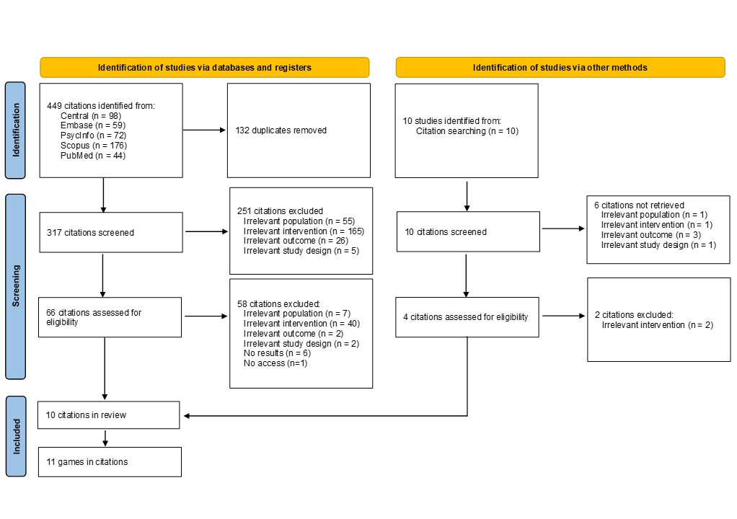
Figure 1. Flow diagram from article selection process
Overall, out of the 327 articles found, 257 were screened out at the title/abstract screening, leaving 70 articles for full-text screening. These 70 articles were downloaded and examined. After this final screening procedure, 60 articles were excluded, leaving a total of 10 articles with suitable games to analyse. Most articles described one game each, although there was one that evaluated two games. The final product of the search was thus 11 games.
In some cases, in order to obtain the information to conduct a proper analysis, we needed to download additional, supplementary materials. Most of these were in the form of protocols for the trials or articles reporting preliminary results. Below we briefly describe each of the identified games. Table 1 presents some key features (sample, location, type of game) of each video game.
Table 1 Key features of included studies
Game name | Target population | Age range | Location and publication date | Console | Type of game
The Baby Game![27] | High school students | 13-18 | Hawaii, USA - 1989 | PC | Management simulator
Romance[27] | High school students | 13-18 | Hawaii, USA - 1989 | PC | Text adventure
VODO[28] | High school students | 15 | New Orleans, USA - 1989 | PC | Text adventure
Choose Your Own Adventure[29] | High school sophomores | 15-16 | Kentucky, USA - 2007 | PC | Dating simulator
SOLVE[30] | MSM | 18-24 | USA - 2013 | PC | 3D dating simulator
HIV risk game[31] | Youth | 15-19 | Cape Town, South Africa - 2015 | PC | Quizzes
Keep it up![32–34] | YMSM | 18-29 | Atlanta, Chicago and Georgia, USA - 2017 | PC | Dating simulator + Mini Games
BattleViro[35,44] | Young ART patients | 14-26 | Mississippi, USA - 2018 | Smartphone (only IOS) | Twin-stick shooter + Quizzes
Viral Combat[36] | YMSM | 18-35 | Mississippi, USA - 2021 | Smartphone (only IOS) | Twin-stick shooter + Quizzes
MyPEEPS[37–39] | Male youth sexually attracted to men | 13-18 | USA - 2019 | PC and Smartphone (Any) (Usable as Web App) | RPG
First Person Scenario Game[40,41] | College Students | 17-27 | Hong Kong – China - 2020 | Smartphone (Non-specified) | 1st Person Dating simulator

Identified games

The Baby Game![27]
The Baby Game is a management simulator where high school students are asked to simulate a budget and schedule based on different scenarios. The students’ task is to establish how many hours they could devote to different activities (e.g., chores, homework, sleep, recreation, and caring for their baby). They receive feedback, printed on a "scorecard", based on how close their schedules are to a hidden "correct" time distribution.
The game aims to provide realistic information about the life changes that would occur if a student had a baby and how the newly added responsibility might affect their lives, the assumption being that this would enhance young people's intentions of delaying parenthood and using contraceptives.

Romance[27]
Romance is a text adventure where high school students write down how they will deal with a set of scenarios of romantic and sexual nature. They then receive feedback in the form of a simulated outcome. At the end of their run, players obtain a final scorecard based on how adequate their decisions were. The exercise aims to improve students' knowledge about sexuality and contraception, increasing their skills for interaction, and serving as practice for responsible sexual decision making.

VODO[28]
VODO is a text adventure game where 15-year-old high school students have to guide the main character through a series of scenarios. The game presents the player with a detailed written description of a situation, for example “You are in your room. It is a sunny room full of things that are important to you. Tell the computer what you want to do?” The players then respond using simple English sentences; the game has an extensive vocabulary and was able to anticipate the responses typically provided by the students. Efforts were made so that even though the player needs to make many choices, decisions are not presented overtly. This was done because the researchers wanted to convey the lesson that one has a choice, even when apparent conditions suggest otherwise.
An important aspect of this game is that it includes a roster of non-player characters (NPCs) with whom a player can interact and even form relationships that may or may not involve sex. Each of the NPCs has different names, personalities, and motives. In cases where the player chooses to have unprotected sex, the game creates a scenario where the character has a child. The child randomly cries for different reasons and requires careful attention, creating tensions between the character and their friends.
VODO was designed to improve participants' decision-making skills by providing a scenario where they are able to rehearse and obtain feedback on their choices. The topics present in the game are broad. Even though they are focused on matters of sexual health (e.g., contraceptive use, STIs and the consequences of unwanted pregnancies), it also includes some other issues that might affect teenagers (e.g., drunk driving, drug use and the ability of being alone without being lonely). Strategies such as complementary quizzes were meant to increase real-life communication about sex within the family.

Choose Your Own Adventure[29]
Choose your own adventure is the name that we have provided for one of the six modules that formed an unnamed intervention aimed at reducing rates of unintended pregnancy and STIs in adolescents from rural areas in the U.S.
The game comprises half of one of the modules. Players are expected to play through a virtual date and make choices that could put them in a situation where their dates want to have sex, but they do not. The game finishes with different positive or negative outcomes, products of the in-game decisions that were taken. In order to make the game more engaging and increase its replay value, the developers built in some remarkable elements. For example, they included more than 150 images of various people, places, and STIs, which are randomly selected at various points in the game so they would be different during each run. Furthermore, all the in-game dialogue was recorded; the NPCs actually spoke to the players. The other half of the module consisted of submitting an original refusal line. The researchers reported that the entire module (Game + refusal line submission) had a completion rate of 41%.

Socially Optimised Learning in Virtual Environments (SOLVE)[30]
SOLVE is a 3D dating simulator aimed at 18 to 24 year old men who have sex with men (MSM) who reported having engaged in recent unprotected anal intercourse (UAI). The settings are constructed around different scenarios that might be faced by young MSM involving some form of sexual decision (e.g., meeting someone at a party, going to their apartment afterwards). In each situation, the player encounters a series of "choice points" where he needs to make self-regulatory decisions (e.g., accept or refuse alcohol or offers of casual sex). After choosing to engage (or not) in virtual sex, there is a customised recap sequence where the player's virtual behavior is shown in sequence so that he can identify the different decisions that led him to a particular outcome (See Figure 2).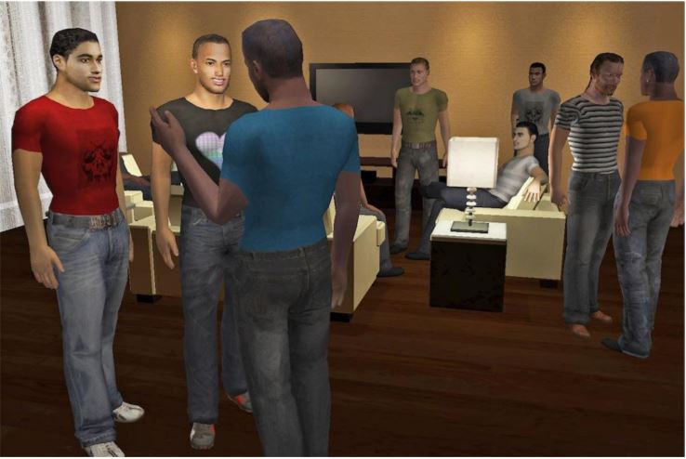
Figure 2. SOLVE avatars[30]
The idea was that, through rehearsal and feedback, players could practice their decision-making skills. Throughout the process, they are guided by different NPCs (peers, one's virtual future self) who instruct them in following a set of guidelines when faced with risky situations.

HIV risk game[31]
This intervention, unnamed in the published article, is a relatively simple game in which youth are expected to identify, between two randomly generated individuals, who was more likely to have HIV. Each participant plays ten rounds of this game. Instead of receiving a direct answer regarding whether they made the right choice or not, the participants received information about HIV and risk and constructed their own learning based on their experimentation.

Keep it up![32–34]
Keep it up! is a seven-module, multi-method intervention (one that includes the use of more than one method of data collection in a study) aimed at improving STI prevention strategies in young MSM in the U.S. The main gaming component is called The Club Game. This game uses a real-life scenario (going to the club) to explore decision-making around using condoms, the steps to use condoms properly, as well as the effects that excessive alcohol consumption, drug use, and sexual arousal might have on decision making. The player goes through five rooms and interacts with other patrons while completing activities related to the above topics. The intervention uses diverse delivery methods (e.g., videos, animation, and games) to improve HIV knowledge, motivate safer behaviors, teach skills, and increase self-efficacy for preventive behaviors.

BattleViro[35]
BattleViro is a twin-stick shooter mobile game aimed at improving anti-retroviral treatment (ART) adherence in young MSM in the U.S. During the game, the players control an avatar that is shrunken down in order to be able to fight viruses and other infections in six levels of increasing challenge. Each level is set on a specific organ, ranging from the lungs to the brain. Throughout the different levels, the player shoots down threats to the host's body while picking up health points in the form of medicine (See Figure 3). The character also receives messages from health care personnel encouraging them to carry on and providing clues in challenging areas of the run. Additionally, the player might answer quizzes from clinician avatars to earn additional points or powers. Wrong answers are corrected and explained. In addition to the game, participants with perfect adherence receive congratulatory texts where the other participants would receive motivational messages encouraging them to carry on.
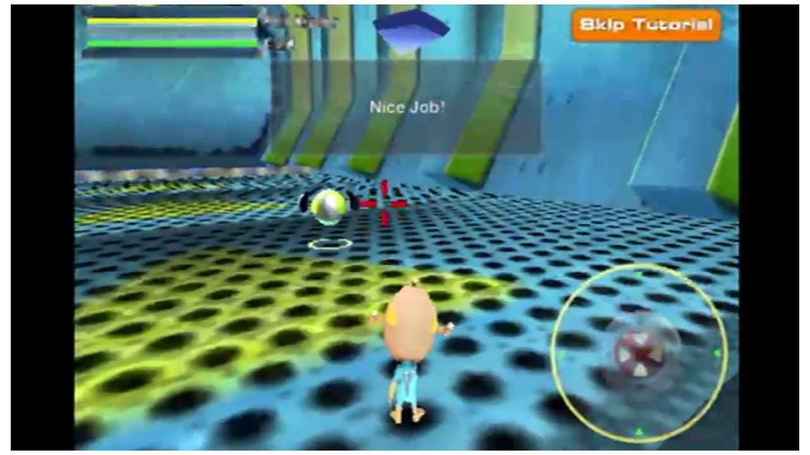
Figure 3. BattleViro gameplay[35]

Viral Combat[36]
Viral Combat was developed by the same team that created BattleViro. However, instead of being targeted to people already with HIV, this game tries to promote PrEP adherence. The levels are slightly different, as are the messages received by doctors and nurses, but the main mechanics are similar. The game includes quizzes that go beyond PrEP adherence, including information about HIV and other STIs.

MyPEEPS[37–39].
MyPEEPS is a role-playing game where young MSM with little to no sexual experience go through different scenarios, guided by four characters (the "peeps") who teach them about sexual health care. The game consists of four sequential modules (PEEPScapades). The completion of the different modules is incentivized by in-app trophies.

First Person Scenario Game (FPSG)[40,41]
FPSG is the name we have provided to a multi-method intervention that aims at protecting university students from the risks of using dating apps. The intervention is composed of short informative videos where students are taught about different risks such as sexual abuse and scams. It includes a first-person simulation game, where the participant is presented with multiple choices when faced with real-life scenarios (See Figure 4). The game was designed with various algorithms that result in positive or adverse outcomes, depending on the character choices.
Figure 4. FPSG example screens[40] (Translation available in Multimedia Appendix)

Results of Studies

Below we discuss the main results of our review, structured around findings related to the target populations, the interventions, the outcomes and the study designs.

Target population
Finding games that were targeted exclusively for youth aged 15-25 was not an easy task. Several identified interventions included some participants outside our selected age bracket, especially at the younger end of the age range. This was likely due, in part, to the physical location where the interventions were delivered. For example, several interventions were conducted in high schools [27–29], including students from both within and outside of our age group. We did not find as many studies that included participants outside the upper end of our age range. We found only one trial where recruitment was done in colleges; however, even in this particular setting, the number of students older than 25 (our upper age limit) was small[40].
Concerning gender and sexual orientation, many recent studies focused on MSM and the prevention of STIs. Seven of the studies had been conducted in the past ten years; five of these were focused exclusively on MSM. All but one of the games were targeted at urban youth; only one focused on rural populations[29].
Based on the target population profiles, we can divide the studies into two broad categories. First, there were those that were based in an educational institution (high school or university), included people from all genders and sexual orientations, and focused on contraception and STIs[27–29,40,41]. The second group was most commonly recruited from youth centres or sexual health clinics, focused exclusively on MSM, and had a clear focus on STI prevention and management[30,32,34–36,42,43].

Interventions
Below, we describe the elements of the 11 games. First, however, it is important to note how little information about the games themselves was readily available in published articles. Authors often devoted little space to describing how the games looked and how they were played. Considering that playing games is such a visual activity, the inclusion of images could have been a valuable way to provide this information. However, with some noteworthy exceptions[27,30,35,40] this was rarely done; most articles did not include any form of visual aids to explain the game. Some articles included links to demos or webpages where the content was said to be available, but in more than one case, the links were broken, or the page had already ceased to exist. Due to the rapid nature of this review, no author/game developers were contacted during the process.

Game age
Regarding the age of the games themselves, we identified a clear bimodal distribution (see Figure 5); one group was created in the very wake of the digital revolution, more than thirty years ago, while the other group was developed just two or three years ago. Earlier games were graphically simpler but in no way less informative. We found it striking that, from very early on, video games were seen as valuable tools to promote learning and attitude change.
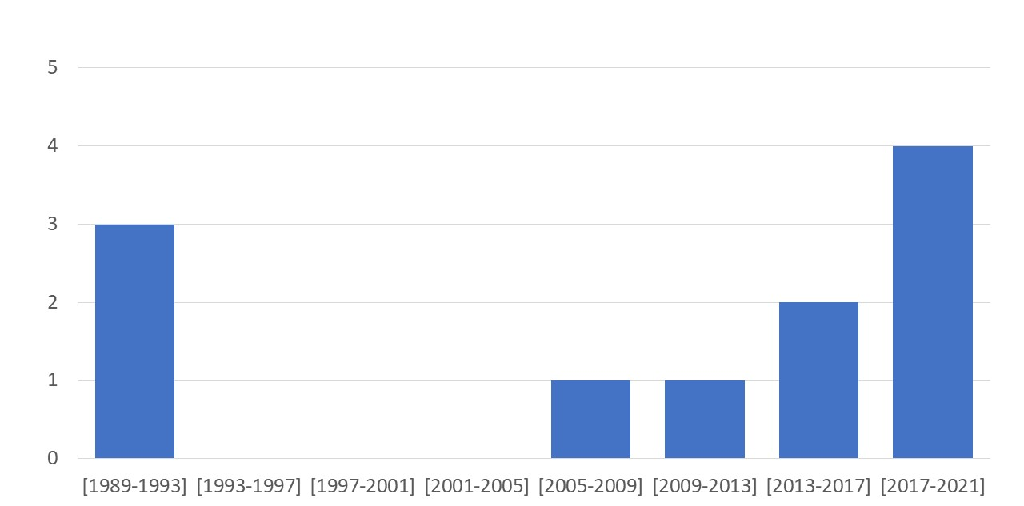
Figure 5. Histogram of game age for selected games

Gaming platform
The interventions made use of different platforms to host their games. Considering the time span across which the games were developed, it is not surprising that the most commonly used platform is that with the longest history, the PC. The changes in the games reflect the technological evolution that has affected this platform. Although popular, tablets were only mentioned for one of the games[33]. As might be expected, when mobile phones became widespread, the idea of using smartphones as a platform for serious gaming became an option. Out of the four reviewed games for mobile phones, two were developed for the iPhone exclusively[35,36], while the other two did not specify which operating system they worked with [37,41]. These later games made use of mobile connectivity to increase participant engagement through push notifications and messages[35,44]. However, it is noteworthy that most interventions did not appear to use patches and updates to freshen up their content, even when they were constantly connected to the internet.

Accessibility and difficulty
One decision that is implicit in the platform selection is that of accessibility. Most interventions aspire to be easily scalable. In order to achieve this, they need to operate on an already popular/ubiquitous platform and use relatively little graphic processing power. We do not have access to the system requirements of any of the listed games. However, based on their description, it appears most operated on or below what was considered average computing power at the time of their release.
Regarding game difficulty, we can place all interventions on a continuum. At one end, there are the games that provide an easy experience; the game is seen as a vehicle through which information can be provided in an entertaining fashion. At the other end, we have those games that provide a very demanding experience. The best example of this in the games we identified is that of VODO. The developers included a section of the game where the player needed to answer two questions about sexual health. If either of these answers were incorrect, the game was over, and the player had to start all over again. This type of failed outcome was a very common scenario of text adventures at the time and motivated the player to replay the game several times, learning all its intricacies. An even more challenging aspect of these questions is that the answers were not provided in-game. The player was meant to search elsewhere for information, or even better, the topic should become a conversation starter for youth to discuss with their friends, parents or teachers. This is an example of how a severely challenging task was used to "frustrate" the players into action.
As could be expected, these extremes in game difficulty are not without their issues. A non-challenging game can be boring and inhibit engagement. At the same time, a too-challenging one can tire a proportion of the players out of the intervention. In an effort to resolve these two positions, some game developers opted for an increasing level of difficulty, i.e., instead of having a flat, low-level difficulty throughout the experience or a series of extreme spikes every so often, these games ramp up the difficulty with every level[35,36].

Expected playthroughs and playing time
There are two related elements to consider here: the expected playthroughs and the expected contact time. In other words, how many times are the players expected to play the game and for how long? As we will discuss later, repetition, rehearsal and feedback play an essential role in learning through games, so it is expected that most games were designed in order to keep the player engaged for more than one run. Unfortunately, there is little information about these aspects in most of the included articles. Among those games that specify an expected playing time, we found periods of less than one hour of gaming. However, it was not always clear if these times were for single or multiple playthroughs.

Type of game and game setting
Games settings can be broadly divided into two types: realistic vs sci-fi. There was a clear preference for the latter in our sample of games. Most games were situated in locations and environments that the player could directly relate to, such as hanging out with friends after school or going to a house party. The idea behind this is that greater similarity between the simulated situation and a plausible real-life event might make it more likely that players will relate to the content and act upon what they have learnt. Game developers have gone to great efforts to create content grounded in reality, where situations that the players have directly experienced are portrayed both didactically and accurately. For example, SOLVE allowed players to personalise their avatar and The Baby Game used actual prices when they calculated the costs of raising a child.
The types of games in the realistic group were very diverse. Table 1 presents a list of all the different styles of games that have been included. We want to highlight three features. First, the variety is notable; as can be seen, games ranged from management simulators to role-playing games. The second feature is the relative preponderance of dating simulators. Four out of the nine non-fiction games were dating simulators. However, even within this specific setting, we found different styles (e.g., text adventures, 3D, chat simulators). Finally, we should mention the role of complementary activities within each game. Mini-games are found in several games, especially in the form of quizzes[29,34,36,44]. This seems to have been one of the main strategies through which game developers delivered specific sexual health knowledge.
However, not all games went down the realistic route. BattleViro and Viral Combat opted instead for a Sci-Fi, action setting[35,36]. In both games, the characters are shrunk down to a microscopic scale and are meant to protect a human body from infections by shooting down viruses, bacteria and vectors of disease. Here the developers tried to create a power fantasy, in which the player can take control of their actions and reach a desirable healthy state. The content and settings still related to the topic of focus (ART and PrEP adherence), but the developers avoided making direct or explicit statements about these.
We can see how there is more than one valid strategy to promote engagement with the material. One school of thought aims to create easy to relate experiences, while the other makes use of a fast-paced game to empower the participants into action.

Single or multiplayer game (private or social experiences)
One element mentioned throughout the different interventions is the contrast between creating a single or a multiplayer experience. In other words, was the game designed to be played alone or with a group? Most games reviewed appear to have been designed for single-player use. However, it should be noted that all single-player experiences can be turned, by players themselves, into a multiplayer experience. Researchers reported that in several cases, games that were not meant to be social experiences were transformed into a group activity when a player spontaneously brought their friends or partner to play the game together and comment about it.
The decision of whether to develop a single or multiplayer game is affected by several factors. The first is the target population. Interventions focused on MSM are very keen on not "outing" their players involuntarily, nor have them openly disclose their health information, so single-player games may be preferred. Second, the game's topic of focus is an important factor to consider. Some topics are easier to work with at an individual than a group level. For example, SOLVE was a game that tried to decrease the feelings of shame that gay or bisexual men might experience regarding their sexual preferences[35]. Considering that many of the players had strong feelings of shame and were reticent to disclose information about their sexual interests, they may not have been comfortable playing a game with others.
A third influence is that of logistical/technological/economic restrictions. When PCs were not an ordinary household item but a specialised piece of hardware, they were not as commonly available as they are now. For that reason, older games tended to be a social experience; many people had to use the same computer in order to make it viable for enough players to play" the game[27,28].
A final reason for choosing single or multiplayer games relates to the learning strategy of choice. Some game developers opted for purposely promoting out-of-game discussion of sexual health topics[28]. The aim was to make the game a topic of discussion with family members, teachers and friends.

Outcome change mechanisms
There are several ways in which we could try to classify the underlying mechanism used in video games to change specific behaviors in users. Here, we divide the mechanisms into three categories: those based on knowledge; those focused on enhancing skills and self-efficacy; and those that motivate change through emotions. These groups are not mutually exclusive; one intervention might have more than one underlying mechanism.
Some games aim at providing knowledge expecting that it will generate a behavior change. For example, some games share facts about contraceptives, their efficacy, and the risk involved in not using them. In these cases, one of the most critical elements is to provide a clear and easy to understand message. It has been noted that most interventions try to make the message grounded in a specific element or situation in the game. Many games focus on providing knowledge have prioritised the provision of immediate and clear feedback, specifying where and when an error was made, and what its potential outcomes might be. The same applies for those decisions that had a positive outcome. For example, in SOLVE, when a player chose to engage (or not) in in-game sex, he was offered a quick recap of all the previous decisions that drove him to his current state (decisions that were not always apparent at the time they were made).
One final element regarding knowledge is how it is constructed. We have previously said that the message has to be clearly stated. However, for some interventions, that did not necessarily mean that the message had to be delivered explicitly. For example, the HIV risk game had a clear message that needed to be delivered: older people were more likely to have HIV than young people. Players played ten rounds of the game in which they made a judgement about which character was more likely to have HIV. As feedback, the players did not receive the correct answer; they only knew if they were right or wrong. This key message was supposed to be inferred (constructed) by the participant based on their in-game experience.
Two of the most frequently used strategies used in games focused on increasing the participants' skills and self-efficacy; this was achieved by a mixture of relatability and rehearsal. By relatability, we mean all the different factors that can make the situation in a game similar to the ones the players face or think they will face. The developers made great efforts to provide experiences grounded in those that the players have had or will experience. The assumption is that, in general, the closer a setting and its characters are to the real world, the easier it will be for the player to assimilate the lesson and put it into practice. That is one of the reasons why several games designed characters with different personalities and stories, so that the player can easily associate one or several of them with their friends and acquaintances. Similarly, one of the reasons why some avatars were customisable was to make it easier for the player to empathise with their in-game presence. The same can be said of the setting where interactions occur. In several cases, the setting is very similar to that currently experienced by the players. One of the clearest cases of relatability is the game FPSG. The player learns about the risks of dating apps by playing a game that uses an instant messaging app as one of its primary interfaces.
In a similar fashion, rehearsal and repetition also play a significant role in improving self-efficacy. The idea is that players will train themselves to make safe decisions in real life because they have made the same correct decision in a virtual world before. The more times a player does something, the more likely it is for him or her to feel (and be) proficient in it.
The final strategy relies on using emotions to generate a reaction in the player. There are several ways in which this has been done in the different games. Some developers have opted to generate negative emotions that will frustrate or scare the player into action. For example, in Romance, if the player initiated unprotected sex, they would have a baby that would cry randomly during the game, negatively affecting their relationships with their friends. Other games made use of positive emotions to inspire the player to act. BattleViro and Viral Combat are good examples of this practice, having used a fast action, increasingly challenging, shooter-style game to empower their players to take control of their treatment. Finally, there were games that aimed to reduce the negative emotions that inhibit the players' ability to do something. The best example of this practice is SOLVE, a game whose main aim was to reduce the feelings of shame that MSM might experience. Through a series of stories and vignettes, the intention was that the player might more consciously acknowledge their desires as something normal, that carries no stigma with it.

Game development
We cover three main topics in this section. We start with a general depiction of the development process of games. We then assess the involvement of stakeholders in the creation of the game: who was invited, when, and in what capacity.

Development process
Published papers provided little information about the development of the game mechanics. There was often no data regarding how long the game design lasted, how much was its budget, who and how many people were involved, nor what programme(s)/engine(s) they used to create it. From conversations with researchers, we know that in some cases, university-based groups were in charge of the software development. However, besides FPSG, very little additional information is readily available from these articles or other related publications on game development.
Some interventions adapted previous activities or interventions in the construction of the new game. In some cases, already existing materials/activities from previous interventions were adapted to a video game form. The details of those interventions were usually left nebulous, but we know that in the case of MyPEEPS, Keep it up! and SOLVE, a considerable part of the content of the games was taken from previous, non-videogame-based interventions. For example, MyPEEPS included four characters (the titular "peeps"), who were a composite of previously existing characters used during the formative phase of the intervention.
The development of other interventions was probably informed by existing games, although few articles provided much detail about this. The only exception to this trend was Viral Combat, heavily influenced by BattleViro[36]. The same team of researchers developed both games, and one might even say that the former is basically an improved version of the latter.
In summary, we find that interventions have been either developed entirely from scratch or based on a previous in-person intervention. Explicit references to previously existing games were unusual in the papers reviewed.

Stakeholder participation
The teams in charge of designing the interventions frequently made considerable effort to involve different stakeholders throughout the process. Among those stakeholders that participated in the design of games were the end users[32,35,40], members of non-governmental organisations concerned with sexual health or youth wellbeing[34], and unspecified community leaders[28]. There is little to no mention of the involvement of parents, teachers or other authority figures. Focus groups[34] and in-depth interviews[32,35] were used to access stakeholders' views.
There were three main reasons for stakeholder involvement. The first reason was to conduct a needs assessment. This allowed the intervention designers to prioritise topics or behaviors that required specific attention. For example, in the development of the FPSG intervention, four focus groups were held by the developer to identify key risks that were causing concern among young people using dating apps in Hong Kong. The second reason to involve stakeholders was to improve the quality of the game itself. For example, Keep it up! conducted interviews with stakeholders to ensure that the situations and language they used in their Club Game were similar to those experienced by young men in their everyday interactions[33]. This allowed them to generate greater engagement with the final users by presenting situations comparable to those they had experienced before. Finally, there is the need for approval from a governing body. By involving community leaders and local authorities, the intervention designers could ensure that they would get support for the subsequent stages of the process. For example, VODO involved people from 30 different local institutions to avoid including content or situations that might have been perceived as unacceptable by the community[28].

Multi-method interventions
One final element to discuss is that, although all interventions relied considerably on video games to achieve their goals, that was not necessarily the only method they used. Three out of the eleven games were meant to be played in conjunction with other activities.
For these specific interventions, the games seem to be one of the few activities in the intervention in which the participants could take agency and act upon the knowledge they receive. For example, when the participants are completing scales or watching videos they are fairly passive; the moments in which they play the games are the only times when they really take control, make decisions and see their results. Although no intervention specified the playing time, nor the time employed in the other modules, it appears that the games were the activities that comprised most of the participants' time.

Outcomes
In this section, we discuss how effective the interventions were in achieving their goals, organized by the outcomes we adopted in our search criteria. Table 2 provides a summary of the results.

Decrease in unintended pregnancies
Rather unexpectedly, none of the studies assessed the number of pregnancies. There are two possible explanations for this. First, almost half of the chosen games were not marketed to women but to MSM. Second, the sample sizes were too small, and the follow-up periods too short, for the relatively low occurrence of pregnancy to become a viable measure of success of an intervention.

Decrease in sexually transmitted infections
Only Keep it up! used STI biomarkers to assess change in STI incidence. The researchers tested for chlamydia and gonorrhoea through rectal swab self-collection. Through matched odds ratios, the control group showed a 55% increase in STI incidence, while the treatment group showed a decrease of 51%. These were significant results, but we must be mindful that this intervention had multiple components, and the video game was only one of them.

Table 2. Summary of results per intervention
 | Decrease in STIs | Increased contraceptive use | Acquisition of new knowledge regarding sexual health | Change in the perception of risk of pregnancy | Change in the perception of risk of STI | Attitudinal change towards safe sex | Self-efficacy toward sexual health | Decrease in the number of sexual partners | Increase in adherence to prophylaxis or treatment
Interventions
The Baby Game |  |  | +
Romance |  |  | + | +
VODO |  |  | - |  |  | +
Choose Your Own Adventure |  | - | + | ‽ | ‽ | + | + + - -
SOLVE |  | -
HIV risk game |  |  |  |  | +
BattleViro |  |  | + |  | - |  | - |  | - - -
Keep it up! | + | + |  |  |  |  |  | -
Viral Combat |  |  | - |  |  |  | - | - | - -
MyPEEPS |  | + |  |  | + |  | + | - | -
FPSG |  |  |  |  |  |  | +
Results
Positive results (+) | 1 | 2 | 4 | 1 | 2 | 2 | 4 | 0 | 0
Negative results (-) | 0 | 2 | 2 | 0 | 1 | 0 | 4 | 3 | 6
Unexpected results(‽) | 0 | 0 | 0 | 1 | 1 | 0 | 0 | 0 | 0
When an intervention used more than one indicator for the same construct, we represent each measure independently.
We considered positive results those in which the treatment produced statistically significant better results than the control group at a 95% confidence level.
Negative results are those in which the treatment did not vary significantly from the control group.
Inverted results are those in which the treatment worked opposite to the expectations. In other words, there were significant differences in favor of the control group.

Increased contraceptive use
Three interventions measured changes in reported contraceptive use. Unfortunately, they did so in very different ways, which limits our ability to compare them. Choose Your Own Adventure asked about condom use at last intercourse and found no effect of their intervention. The other two studies assessed the frequency of UAI with non-primary partners during the last three months. Although SOLVE was unable to show significant differences between their treatment and control groups, Keep it up! reported a significant decrease in the number of UAI events one year after their intervention started.
In summary, studies about the effect of video game interventions in contraceptive use have shown inconsistent results.

Acquisition of new knowledge regarding sexual health
The acquisition of new knowledge was one of the most commonly measured outcomes, but the topics and measures varied significantly between the different interventions. Frequently, ad hoc questionnaires were created to assess the differences between the treatment and control groups. The Baby Game quizzed participants on the costs (in both time and money) involved in taking care of a baby. Romance used the same methodology but compared knowledge about the efficacy of different contraceptive methods. Studies on both of these interventions suggested improved knowledge in the treatment group compared to the control group. However, we should keep in mind that knowledge was assessed only immediately after the game ended, and that no effect size measure was presented. Other interventions also relied on ad-hoc tests, but it was unclear exactly what topics they explored. Choose Your Own Adventure showed positive results (of medium effect size), but VODO failed to do so. Both interventions followed a pretest-posttest design.
A comparable example is that of BattleViro and Viral Combat. They both tested their participants' HIV knowledge, and although they are very similar games, only BattleViro showed positive results. It should be noted that BattleViro tested their participants 16 weeks after the intervention started, while Viral Combat did so at weeks 12 and 24. The extended period between intervention and data collection in Viral Combat, compounded by an attrition of 32% of their original sample, might have somehow biased the intervention results. However, one would also expect that participants that stayed for longer would be more engaged, would have clocked in more hours in the game, and would have a better performance overall.
In conclusion, we do not have enough evidence to clearly state that games have a significant effect on increasing knowledge about sexual health topics. The variety of the topics assessed, the limited amount of information regarding the content of the tests, as well as the large variability in time between intervention and post-intervention assessment precludes our ability to establish a clear, causal relationship between playing and learning.

Changes in perceived risk of pregnancy
Only two games assessed this variable. Romance asked its participants to assess the odds of becoming pregnant when having unprotected sex. Improvements in favour of the treatment group just after they finished playing the game were reported. Unexpectedly, the study on Choose Your Own Adventure found significant differences in favour of the control group. However, the researchers measured a construct called "susceptibility", which merged the perceived risk of pregnancy with the perceived risk of STIs, so there might have been some cross-contamination in the assessment. The authors speculated that their results might be related to the fact that fewer people initiated sexual activities in the treatment group (i.e., they were abstinent) than in the control group, so they did not feel at risk of any adverse outcome related to having sex. They also considered that, since the treatment group was more aware of the risks and the measures they could take against them, they felt better able to protect themselves.

Changes in perceived risk of STIs
Four games addressed this topic. We have already discussed the findings of Choose Your Own Adventure. The entire intervention of this HIV risk game was centred around assessing the risk of someone having HIV based on their age and gender. Positive results were obtained for both men and women. The assessment was done immediately after the intervention and three months later (this last time only for male participants).
BattleViro and MyPEEPS also assessed the perceived risk of STIs, but in an indirect fashion by asking about STI testing. BattleViro measured the types of sexual behavior, the frequency of sex, and the number and gender of partners reported in the past three months. The authors found no differences between the control and treatment groups. MyPEEPS measured the frequency of STI testing and found that post-intervention, those in the treatment group were more likely to get tested than the control participants.

Attitudinal change towards safe sex
Two interventions targeted attitudinal change towards safe sex. VODO measured participants' attitudes towards sex on two axes: liberal vs. conservative and positive vs. negative. Both control and treatment groups shifted to a more liberal position, but the change was greater in the treatment group. The change in this group was sufficient for it to move, on average, from a conservative perspective towards a liberal one. No significant change was found in the positive vs. negative axis.
Choose Your Own Adventure assessed the predisposition towards waiting to have sex and found a significant effect of their intervention among students between 15 and 16 years of age. After completing one or more of its modules, participants were more likely than those in the control group to postpone their sexual initiation.

Self-efficacy toward sexual health
Self-efficacy, be it general or specific to sexuality, was one of the most frequently chosen outcome variables across the different games. Choose Your Own Adventure considered four domains of sexual self-efficacy: condom negotiation self-efficacy, condom use self-efficacy, situational self-efficacy (the ability to control a situation that might be conducive to sex), and refusal self-efficacy (the ability to say no to sexual intercourse). Their findings were mixed. The intervention did increase the participants' self-efficacy towards condom negotiation and situational self-efficacy, but no effects were found regarding condom use or refusal. It is not surprising that condom use self-efficacy did not change considerably between the groups as the intervention did not include any components that directly taught students how to apply and use a condom. However, it did have one activity specifically focused on improving refusal skills and this activity was tightly tied to the game itself. The fact that this activity failed to produce the desired results on this variable, then, is noteworthy.
BattleViro and Viral Combat assessed a similar domain of self-efficacy: the participants' belief that they would be able to stick to a treatment regime. Both interventions found no significant change at either short (12 weeks) or long term (16 weeks and 24 weeks) assessments. MyPEEPS reported positive results when assessing HIV self-efficacy in the short term (3 months). The researchers have yet to publish their results for the long-term assessment (6 months).
We consider that the results regarding self-efficacy are mixed. Considering that the interventions are so varied in methodology and topics and that they have worked on different domains of self-efficacy, this is not a particularly surprising result.

Decrease in the number of sexual partners
Three interventions aimed at reducing the numbers of sexual partners, all of them for MSM – Keep it up!, Viral Combat and MyPEEPS –and none resulted in a reduction in the number of sexual partners in their samples.

Increase in adherence to prophylaxis or treatment
Three interventions focused on increasing adherence to either treatment or PrEP. BattleViro and Viral Combat used a mixture of bio-indicators, self-reported behavior, and electronic device follow-up to assess this outcome. Two bio-indicators were used: HIV-1 viral load in BattleViro and 1ARV (activator protein 1) levels in Viral Combat. BattleViro produced equivalent decreases of HIV-1 viral load in both the treatment and control groups. Viral Combat reported results that favoured the treatment group at both 12 weeks and 24 weeks after the beginning of the intervention; however, these findings were not statistically significant. Treatment adherence, measured by self-report in Viral Combat and by self-report plus electronic device records in BattleViro, showed similar results. No intervention showed better results than the usual treatment in this regard. MyPEEPS also measured PrEP and Post-exposure prophylaxis adherence using self-reported measures, finding no significant differences between their treatment and control groups.

Study designs
Bearing in mind that our search criteria only allowed for RCTs and quasi-RCTs, we found two main study designs. Studies were either posttest only trials[31,36,42] or pretest-posttest trials[27–30,33,35,41,44].
Depending on the study, the control groups received very different treatments. A waiting list control (WLC) was one of the most straightforward control designs. A more complex one was treatment as usual (TAU) where the usual or standard is given to a group of participants.
For example, for The Baby Game, the researchers compared their game with a regular sexual health education class for that specific age group[28]. A similar option was treatment as usual plus (TAU+). Here, participants received TAU and an additional component that was functionally similar but thematically different to the experimental group. For example, since BattleViro provided smartphones so that participants could play the game, they also provided smartphones to the control group. However, these iPhones did not have the specific game installed, but another non-HIV related game[35]. Another form of control group provided more or less the same content as the game but in a delivery mode that had no ludic or interactive elements. For example, Keep it up! provided an internet-based experience, with the same information as their intervention, but using static slides instead of the more dynamic approach taken with the treatment group.
Finally, in reviewing whether studies had adequate sample sizes, we found that samples sizes were, generally, large enough to detect expected differences. Most of the studies, especially the more recent ones, determined their sample size based on a power analysis (although this analysis was usually constructed around educated guesses). Even if the sample size in the studies reviewed was usually large enough, one of the main threats to statistical power was a relatively large attrition rate, especially among those studies with multiple or long follow-ups. The most extreme case of this was in the HIV risk game study, which reported an attrition rate of 66.8%. In the remaining studies, the attrition rate was around 30%.

Discussion

The findings from our review have yielded some important conclusions and implications for future research and for game development. First, the findings have highlighted the considerable diversity in video game-based interventions. Although all of them address similar topics, they do so in fairly distinct ways. The outcomes assessed in studies evaluating the games were also very diverse and, even when similar, were measured differently in each study. Second, we found that game developers have made great efforts to elicit experiences tailored to the specific needs of the targeted population, most often achieving this through regular stakeholder participation activities throughout the game development process.
One of the most surprising findings was the age of the identified games. The fact that the games were developed over such an extended period of time suggests how, even when the graphical complexity and the interface has changed considerably, learning through gaming is and has been seen as a viable and successful strategy.
However, although game interventions for sexual health have been in existence for almost three decades, there have been relatively few studies evaluating them, and the results of previous studies have been mixed. Moreover, there is little clarity about which specific elements of a game facilitate a positive outcome. This is partly because of the diversity of the behavior change mechanisms underlying interventions, the variety of the games themselves, the populations they target, the outcomes measured, and how these are measured. All of these differences make it challenging to identify a clear causal link between playing a game and improvement in an aspect of sexual health. However, although the impact on sexual health is not always clear, the fact that video game-based interventions are of interest to most young people is well established.
Nevertheless, there are other less positive aspects of the research in this area that we need to acknowledge. The first is the lack of information available in published reports about the different games, especially in the gameplay aspect. This ties to another unexpected finding of our review. Although a video game-based interventions are meant to be easily scalable, there are no reports on any of these games being picked up for broad distribution. In fact, only BattleViro was readily available to be downloaded. Moreover, although the interventions were very varied, almost all of them targeted people living in urban areas of the U.S. There were no interventions developed for populations from lower-income countries in mind and almost no interventions aimed at rural populations. Lastly, very few of the interventions were informed by any behavioural theory/model.

Strengths and limitations

Our review had some notable strengths. We followed the Cochrane Rapid Reviews Method Group Guidelines[22,24] in conducting the review and searched several key literature databases. Two reviewers were involved in screening 20% of the articles at the title/abstract screening stage, and 50% of the articles at the full-text screening stage.
Some limitations of our review also need to be acknowledged. Because this review was a rapid one, our search used five databases and thus, we may not have identified all relevant literature. We restricted our age range to 15-25 years old and, in the screening process, noticed that some interesting game-based interventions focused on younger adolescents/children. A final limitation was that we did not exclude studies based on quality.

Conclusions and Recommendations

In conclusion, we do not have enough evidence to clearly state that games have a significant effect on sexual health among young people. The interventions and how they were evaluated are too diverse to reach a clear decision. However, based on the original authors criteria of success, we have compiled a set of recommendations for developing game-based interventions to improve sexual health in young people.
- Stakeholders should be involved in different stages of the game development process. Most successful strategies have used qualitative, participatory methods involving multiple stakeholders.
- A pilot phase in the development of a game is strongly encouraged. This enables specific elements that could otherwise jeopardise the success of the initiative to be identified and modified.
- One of the most crucial decisions during the game development process is whether the intervention participants are expected to go through the game once or multiple times. This will affect the length, difficulty setting and the main mechanics of the game.
- There are several viable ways in which a game can try to change someone's behavior. None has proven markedly better than the others. However, below are some recommendations:
  - Knowledge-based interventions should aim at providing a clear message, but the message does not need to be explicit. In fact, some researchers recommend that the message is not explicitly stated but constructed by the player themselves.
  - Self-efficacy and skill-building interventions aim to provide easily relatable experiences, and ones that feel proximal to the player. The closer the player feels a game experience is to their own experience, the more likely it is that they will act upon it. The game serves as rehearsal for the decisions they will make in real life.
- Disregarding the mechanisms chosen by the developers, some common elements are shared by most strategies:
  - Feedback is better if it is clear, detailed, and immediate. When playing, it is encouraged that users recap their decisions and learn which actions drove them to their current stage (whether positive or not).
  - Repetition (as long as it does not transform into tediousness) is usually favourable, especially for skill-building and knowledge acquisition.
- There are three common threats that plague these interventions:
  - Lack of technical support, especially after the game development phase ends.
  - Stagnation of the content i.e., no updates are provided. No new contents are delivered.
  - The games are not easily found when someone wants to use of them in another context. The created game should be openly available online, if possible.
- Game quality indicators (including playing time) have been registered using self-reported measures. A suitable workaround through in-game data collection is recommended to bypass the social desirability and recall issues that affect purely self-reported information.
- A plan for the implementation of the intervention should be made from an early stage of the project.

Acknowledgements: This study was funded by an Erasmus+ grant (Project Number: 2020-2-UK01-KA205-079645).
Conflicts of Interest: None declared.
Abbreviations:
ART: Anti-retroviral therapy
HIV: Human immunodeficiency virus
MSM: Men who have sex with men
NPCs: Non-player characters
PICOS: Population, intervention, comparison, outcomes and study characteristics
PrEP: Pre-exposure prophylaxis
RCT: Randomised controlled trial
STIs: Sexually transmitted infections
TAU: Treatment as usual
UAI: Unprotected anal intercourse
WLC: Waiting list control
WHO: World Health Organization

References
1. Rowley J, Hoorn S Vander, Korenromp E, Low N, Unemo M, Abu-Raddad LJ, Chico RM, Smolak A, Newman L, Gottlieb S, Thwin SS, Broutet N, Taylor MM. Chlamydia, gonorrhoea, trichomoniasis and syphilis: Global prevalence and incidence estimates, 2016. Bull World Health Organ. 2019. p. 548–562. PMID:31384073
2. World Health Organization. Report on global sexually transmitted infection surveillance. Geneva; 2018.
3. Public Health England. Sexually transmitted infections and screening for chlamydia in England. Heal Prot Rep 2019;13(19):1–37.
4. Woog V, Singh S, Browne A, Philbin J. Adolescent Women’s Need for and Use of Sexual and Reproductive Health Services in Developing Countries. New York; 2015.
5. Mahase E. WHO reports “concerning lack of progress” in stopping STI spread. BMJ. 2019. p. l4124. PMID:31175082
6. Holmes KK, Levine R, Weaver M. Effectiveness of condoms in preventing sexually transmitted infections. Bull World Health Organ 2004;82(6):454–461. PMID:15356939
7. Chanakira E, O’Cathain A, Goyder EC, Freeman J V. Factors perceived to influence risky sexual behaviours among university students in the United Kingdom: A qualitative telephone interview study. BMC Public Health 2014;14(1):1–7. PMID:25300195
8. Sanders SA, Yarber WL, Kaufman EL, Crosby RA, Graham CA, Milhausen RR. Condom use errors and problems: A global view. Sex Health 2012;9(1):81–95. [doi: 10.1071/SH11095]
9. Free C, Roberts IG, Abramsky T, Fitzgerald M, Wensley F. A systematic review of randomised controlled trials of interventions promoting effective condom use. J Epidemiol Community Heal 2011 Feb 1;65(2):100–110. [doi: 10.1136/jech.2008.085456]
10. Denford S, Abraham C, Campbell R, Busse H. A comprehensive review of reviews of school-based interventions to improve sexual-health. Health Psychol Rev [Internet] Health Psychol Rev; 2017 Jan 2 [cited 2021 Jul 13];11(1):33–52. PMID:27677440
11. Bearak J, Popinchalk A, Ganatra B, Moller AB, Tunçalp Ö, Beavin C, Kwok L, Alkema L. Unintended pregnancy and abortion by income, region, and the legal status of abortion: estimates from a comprehensive model for 1990–2019. Lancet Glob Heal 2020;8(9):e1152–e1161. PMID:32710833
12. Scott RH, Wellings K, Lindberg L. Adolescent Sexual Activity, Contraceptive Use, and Pregnancy in Britain and the U.S.: A Multidecade Comparison. J Adolesc Heal 2020. p. 582–588. PMID:32029341
13. Sedgh G, Finer LB, Bankole A, Eilers MA, Singh S. Adolescent pregnancy, birth, and abortion rates across countries: Levels and recent trends. J Adolesc Heal 2015;56(2):223–230. PMID:25620306
14. Kirby DB. The impact of abstinence and comprehensive sex and STD/HIV education programs on adolescent sexual behavior. Sex Res Soc Policy. 2008. p. 18–27. [doi: 10.1525/srsp.2008.5.3.18]
15. Santelli J, Ott MA, Lyon M, Rogers J, Summers D, Schleifer R. Abstinence and abstinence-only education: A review of U.S. policies and programs. J Adolesc Heal. 2006. p. 72–81. PMID:16387256
16. Simon L, Daneback K. Adolescents’ Use of the Internet for Sex Education: A Thematic and Critical Review of the Literature. Int J Sex Heal 2013;25(4):305–319. [doi: 10.1080/19317611.2013.823899]
17. Guse K, Levine D, Martins S, Lira A, Gaarde J, Westmorland W, Gilliam M. Interventions using new digital media to improve adolescent sexual health: A systematic review. J Adolesc Heal 2012;51(6):535–543. PMID:23174462
18. Stapleton AJ. Serious Games : Serious Opportunities. Aust Game Dev Conf Acad Summit 2004.
19. Korteling H, Theunissen N, Helsdingen A. Serious gaming @ work: Learning job-related competencies using serious gaming. Psychol Digit Media Work 2013. p. 129–150. [doi: 10.4324/9780203074145-12]
20. Dondlinger M. Educational Video Game Design: A Review of the Literature. J Appl Educ Technol 2007;4(1):21–31.
21. Beck K. Video games should be used to teach sex education [Internet]. MashableUK. 2018 [cited 2021 Mar 20]. Available from: https://mashable.com/article/video-games-sex-ed/?europe=true
22. Garritty C, Gartlehner G, Nussbaumer-Streit B, King VJ, Hamel C, Kamel C, Affengruber L, Stevens A. Cochrane Rapid Reviews Methods Group offers evidence-informed guidance to conduct rapid reviews. J Clin Epidemiol 2021;130:13–22. PMID:33068715
23. Garritty C, Gartlehner G, Kamel C, King V, Nussbaumer-Streit B, Stevens A, Hamel C, Affengruber L. Cochrane Rapid Reviews. Interim Guidance from the Cochrane Rapid Reviews Methods Group. Cochrane Methods Rapid Rev. 2020.
24. Ganann R, Ciliska D, Thomas H. Expediting systematic reviews: methods and implications of rapid reviews. Implement Sci 2010;5(56):1–10.
25. Kapp K. The gamification of learning and instruction: Game-based methods and strategies for training and education. San Francisco: Pfeiffer; 2012. ISBN:978-1-118-09634-5
26. Landis JR, Koch GG. The Measurement of Observer Agreement for Categorical Data. Biometrics 1977;33(1):159. [doi: 10.2307/2529310]
27. Paperny DM, Starn JR. Adolescent pregnancy prevention by health education computer games: Computer-assisted instruction of knowledge and attitudes. Pediatrics 1989;83(5):742–752. PMID:2654867
28. Alemi F, Cherry F, Meffert G. Rehearsing decisions may help teenagers: An evaluation of a simulation game. Comput Biol Med 1989;19(4):283–290. PMID:2680255
29. Roberto AJ, Zimmerman RS, Carlyle KE, Abner EL. A computer-based approach to preventing pregnancy, STD, and HIV in rural adolescents. J Health Commun 2007;12(1):53–76. PMID:17365349
30. Christensen JL, Miller LC, Appleby PR, Corsbie-Massay C, Godoy CG, Marsella SC, Read SJ. Reducing shame in a game that predicts HIV risk reduction for young adult MSM: a randomized trial delivered nationally over the Web. J Int AIDS Soc 2013;16(3 Suppl 2):1–8. PMID:24242264
31. Datta S, Burns J, Maughan-Brown B, Darling M, Eyal K. Risking it all for love? Resetting beliefs about HIV risk among low-income South African teens. J Econ Behav Organ Elsevier B.V.; 2015;118:184–198. [doi: 10.1016/j.jebo.2015.02.020]
32. Motley DN, Hammond S, Mustanski B. Strategies chosen by YMSM during goal setting to reduce risk for HIV and other sexually transmitted infections: Results from the keep it up! 2.0 prevention trial. AIDS Educ Prev 2017;29(1):1–13. PMID:28195780
33. Mustanski B, Madkins K, Greene GJ, Parsons JT, Johnson BA, Sullivan P, Bass M, Abel R. Internet-Based HIV Prevention With At-Home Sexually Transmitted Infection Testing for Young Men Having Sex With Men: Study Protocol of a Randomized Controlled Trial of Keep It Up! 2.0. JMIR Res Protoc 2017;6(1):e1. [doi: 10.2196/resprot.5740]
34. Mustanski B, Parsons JT, Sullivan PS, Madkins K, Rosenberg E, Swann G. Biomedical and Behavioral Outcomes of Keep It Up!: An eHealth HIV Prevention Program RCT. Am J Prev Med 2018;55(2):151–158. PMID:29937115
35. Whiteley L, Brown LK, Mena L, Craker L, Arnold T. Enhancing health among youth living with HIV using an iPhone game. AIDS Care Taylor & Francis; 2018;30(sup4):21–33. PMID:30626196
36. Whiteley L, Craker L, Haubrick KK, Arnold T, Mena L, Olsen E, Brown LK. The Impact of a Mobile Gaming Intervention to Increase Adherence to Pre-exposure Prophylaxis. AIDS Behav Springer US; 2021;25(6):1884–1889. [doi: 10.1007/s10461-020-03118-3]
37. Kuhns LM, Garofalo R, Hidalgo M, Hirshfield S, Pearson C, Bruce J, Batey DS, Radix A, Belkind U, Jia H, Schnall R. A randomized controlled efficacy trial of an mHealth HIV prevention intervention for sexual minority young men: MyPEEPS mobile study protocol. BMC Public Health BMC Public Health; 2020;20(1):1–6. PMID:31941475
38. Schnall R, Kuhns L, Pearson C, Bruce J, Batey DS, Radix A, Belkind U, Hidalgo MA, Hirshfield S, Ganzhorn S, Garofalo R. Preliminary results from a pragmatic clinical trial of MYPEEPS mobile to improve HIV prevention behaviors in young men. Stud Health Technol Inform 2020;270:1365–1366. PMID:32570661
39. Ignacio M, Garofalo R, Pearson C, Kuhns LM, Bruce J, Batey DS, Radix A, Belkind U, Hidalgo MA, Hirshfield S, Schnall R. Pilot feasibility trial of the MyPEEPS mobile app to reduce sexual risk among young men in 4 cities. JAMIA Open 2019;2(2):272–279. [doi: 10.1093/jamiaopen/ooz008]
40. Wong WCW, Song L, See C, Lau STH, Sun WH, Choi KWY, Tucker J. Using crowdsourcing to develop a peer-led intervention for safer dating app use: Pilot study. J Med Internet Res 2020;22(4). [doi: 10.2196/12098]
41. Wong WCW, Sun WH, Chia SMC, Tucker JD, Mak WPH, Song L, Choi KWY, Lau STH, Wan EYF. Effectiveness of a Peer-Led Web-Based Intervention to Improve General Self-Efficacy in Using Dating Apps among Young Adults: Randomized Clustered Trial. J Med Internet Res 2020;22(10):1–16. PMID:33124987
42. Hidalgo MA, Kuhns LM, Hotton AL, Johnson AK, Mustanski B, Garofalo R. The MyPEEPS Randomized Controlled Trial: A Pilot of Preliminary Efficacy, Feasibility, and Acceptability of a Group-Level, HIV Risk Reduction Intervention for Young Men Who Have Sex with Men. Arch Sex Behav 2015;44(2):475–485. PMID:25135064
43. Gordián-Arroyo A, Garofalo R, Kuhns LM, Pearson C, Bruce J, Batey DS, Radix A, Belkind U, Hidalgo MA, Hirshfield S, Schrimshaw EW, Schnall R. Awareness, Willingness, and Perceived Efficacy of Pre-exposure Prophylaxis among Adolescent Sexual Minority Males. J Urban Heal Journal of Urban Health; 2020;97(5):749–757. PMID:32789625
44. Whiteley L, Mena L, Craker LK, Healy MG, Brown LK. Creating a theoretically grounded gaming app to increase adherence to pre-exposure prophylaxis: Lessons from the development of the viral combat mobile phone game. JMIR Serious Games 2019;7(1):1–15. [doi: 10.2196/11861]

