**Google Trends and Cryptocurrencies: A Nonparametric Causality-In-Quantiles Analysis**

**Abstract:**

This paper analyses the nexus among the Google trends and six cryptocurrencies, namely **Bitcoin, New Economic Movement (NEM), Dash, Ethereum, Ripple, and Litecoin,** utilizing the causality-in-quantiles technique on data comprised of the years January 2016 – March 2021. We aim to uncover the impact of Google trends on cryptocurrency markets beyond Bitcoin during the time of increased attention to altcoins, especially during the COVID-19 pandemic. Our findings show that Google trends cause the Litecoin, Bitcoin, Ripple, Ethereum, and NEM price at the majority of the quantiles except for Dash. The findings will help investors develop a more in-depth understanding of the impact of Google trends on cryptocurrency prices and build successful trading strategies in a more matured digital assets ecosystem.

**Keywords:** *Google trends*; *Cryptocurrencies;* ***Bitcoin;*** *NEM; Ripple; Dash; Ethereum; Litecoin; nonparametric causality-in-quantiles tes*t

1. **Introduction**

Blockchain technology and cryptocurrency have attracted the attention of researchers, industrial communities (Jiang et al., 2021), financial regulators, and policymakers. Cryptocurrency can be defined as an electronic asset (Nasir et al., 2019). It can be used to transfer funds from peer-to-peer without a need to authorize the transaction by any third party or bank (Corbet et al., 2019). European Parliament (EP) (2018) defined cryptocurrency as a numerical representation of value secured by a mechanism known as cryptography. Cryptocurrency is used as a medium of exchange, and the transactions are recorded and verified by a decentralized system (Houben & Syners, 2018). However, crypto enthusiasts and investors often express the views cryptocurrency, and especially Bitcoin (Nakamoto, 2008), can be used as a store of value. Cryptocurrency has numerous advantages, including auditability, decentralized transaction, anonymity, to name but a few (Johnson et al., 2014). However, officials are concerned about using cryptocurrency for illegal actions such as evading tax, embezzling funds, and terrorist financing (Houben & Syners, 2018). For example, the Chinese government announced illegal cryptocurrency transactions, effectively banning all digital tokens, including Bitcoin[1].

The growth and popularity of the cryptocurrency market have become an emerging research field, and a rapid increase in the literature on cryptocurrency has been observed (Li & Wang, 2017; Demir et al., 2020; Raza et al., 2021). The literature related to cryptocurrency has been divided into multiple strands. The first strand of literature studies the hedging properties of cryptocurrencies (Demir et al., 2020; Raza, Ahmed & Aloui, 2022). The second strand examines the association between Bitcoin prices and investors’ attention (Kraaijeveld & De Smedt, 2020; Urquhart, 2018). The third strand studies cryptocurrency efficiencies (Aslan & Sensoy, 2019; Urquhart, 2016). The fourth strand studies bubbles in the cryptocurrency marketplace (Corbet et al., 2018). The fifth strand studies the interconnectedness between cryptocurrencies such as Bitcoin and others (Demir et al. 2020). The last strand explores the predictors of cryptocurrency returns (Hu et al., 2019; Cheng & Yen, 2019).

Regarding the predictors, several predictors have been identified, which include the technical indicators of cryptocurrencies (Gerritsen, Lugtigheid, & Walther, 2020), macroeconomic indicators and situations (Cheng & Yen, 2019), and the media (Philippas, Rjiba, Guesmi, & Goutte, 2019). In addition to these predictors, the trend-spotting in predicting cryptocurrency has recently gained great prominence in the literature. Big data technology supports trend spotting, which provides real-time information to investors and helps them easily make investment decisions. It is now a normal practice for investors to search online for information before making any investment decision. Therefore, search engines are used as a useful tool for obtaining the latest knowledge and information. The Google engine is ranked first among all search engines to obtain the highest traffic (Yu et al., 2019). Hence, by handling a myriad of Google search outcomes, new online big data named Google Trends was created. These trends show people’s sentiment concerning a specific search keyword (Li, Ma, Wang, & Zhang, 2015). Specifically, the Google Trends scale from 0 to 100 is calculated by examining the proportion of a query’s search volume to the total number of Google searches. According to Yu et al. (2019), Google Trends belong to a specific type of big data covering a wide range of information.

The role of Google Trends has been widely used to evaluate macroeconomic variables such as financial assets (Nguyen et al., 2019), energy (Park & Kim, 2018), economic activity (Gotz & Knetsch, 2019; Donadelli & Gerotto, 2019), and unemployment (Nagao et al., 2019). However, the role of Google Trends in forecasting cryptocurrency is in an early stage. In previous studies, sentiment analysis and tweet volumes have been widely used for cryptocurrency price prediction (Shen et al., 2019). Nevertheless, very limited studies have used Google Trends for cryptocurrency price prediction (Arratia & Barrantes, 2021, Dastgir et al., 2019). Furthermore, most of the studies have used Google Trends to predict one type of cryptocurrency, such as Bitcoin or Ethereum (Liang et al. 2020; Kutlu et al. 2017); and ignored other types of cryptocurrency. Therefore, this work analyzes the nexus between GoogleTrends **and cryptocurrency prices.**

This research adds to the literature in a variety of ways. First, it adds to the previous literature on the impact of Google Trends on the cryptocurrencies market, providing evidence beyond Bitcoin. **To our best knowledge, this is** the first study that examines the nexus between Google Trends and **predicting the top six cryptocurrencies’ prices, namely, Bitcoin,** NEM, Ripple, Dash, Ethereum, and Litecoin**. Moreover, previous studies have examined the nexus between Google Trends and cryptocurrencies using linear models and very sparely discussed nonlinear models (**Smuts, 2019). Furthermore, previous studies use techniques such as the Non-Homogeneous Hidden Markov (NHHM) model, VAR, Granger-causality tests, and GARCH, but the nonparametric causality-in-quantiles approach **is not used. Therefore, This** study examines this association using an advanced econometric approach: the nonparametric causality-in-quantiles. The technique was given by Balcilar et al. (2016), and it is preferred over other techniques because of its three novel properties. (i) The nonparametric test explores the underlying dependency between the considered variables and is robust to misspecification errors. (ii) This technique also allows us to test both the causality that lies in the tails of the joint distribution of the variables and the causality-in-mean. Last, this methodology also allows us to study the causal relationship in different quantiles, providing more detailed results.

1. **Literature Review**

While the cryptocurrency literature is growing rapidly, very few studies have examined the association between Google Trends and cryptocurrencies. The majority of papers are focused on Bitcoin only as on cryptocurrency markets leader. However, Katsiampa et al. (2021) noted that it is important to consider Altcoins in the research since the influential power of various assets in the digital asset ecosystem has been changing over time, which became especially evident during the COVID-19 crisis. Early papers in this field include Kristoufek (2013), who examined the nexus between the search terms on Wikipedia and Google Trends and Bitcoin prices. The result shows that the association between the searched terms and Bitcoin prices is positive.

Moreover, the causality result shows that the association among them is bidirectional. Bouoiyour and Selmi ([2015](https://link.springer.com/article/10.1186/s40854-020-00217-x#ref-CR10)) also examined the association between several variables and Bitcoin prices. They reported that only Google searches significantly affect Bitcoin prices among numerous variables such as Bitcoin velocity, gold prices, and Google searches. Finally, Pärlstrand and Rydén (2015) studied the impact of the Google Trends index on cryptocurrency market prices. They stated that cryptocurrency prices are strongly affected by Goggle Trends.

Moreover, Litecoin and Bitcoin prices are highly impacted, whereas Google Trends moderately impact the XRP. Matta et al. (2015) also claimed a significant correlation between Google Trends and Bitcoin prices. Puri (2016) uses monthly data from 2011-2016 and stated that the Google search for the keyword ‘Bitcoin’ has a significant and positive effect on Bitcoin prices.

Panagiotidis et al. ([2018](https://link.springer.com/article/10.1186/s40854-020-00217-x#ref-CR59)) considered twenty-one predictors that can affect Bitcoin returns and concluded that Google Trends is one of the key predictors that affect Bitcoin returns. Ovbetov (2018) studied those factors that can affect top cryptocurrency prices. The study concluded that Google searches are a significant driver for Litecoin, Bitcoin, Monero, and Ethereum prices but not for Dash prices. Moreover, the results show that a 1-unit increase in search popularity according to Google Trends will increase the prices of Litecoin, Bitcoin, Monero, and Ethereum by 0.07, 1.27, 0.05, and 0.24, respectively. Finally, Abraham, Higdon, Nelson, and Ibarra (2018) studied the nexus between cryptocurrency prices and Google Trends. They used a linear model and concluded that the direction of price changes could be accurately predicted using Google Trends data.

Moreover, by using these Google Trends data, a person can make better decisions about selling or buying Ethereum and Bitcoin. Urquhart (2018) studied the role of Google Trends in explaining Bitcoin volume and volatility. They concluded that Bitcoin experiences high trading volume and volatility every time it is searched on Google. Hence, Google acts as a good measure for persons who want to obtain information related to Bitcoin. Cai, Liu, Lim, Tan, and Zheng (2018) examined the influence of Google searches on cryptocurrency returns by utilizing the trading data of 268 cryptocurrencies over 181 days. They indicated that Google searches exert a significantly positive impact on cryptocurrency returns.

Nisar et al. (2019) studied the influence of Google searches on Bitcoin returns and volume predictability. They applied copulas, the VAR, and nonparametric approaches on weekly data from 2013 to 2017. They concluded that the frequency of Google searches positively affects Bitcoin volume and returns. Dastgir et al. ([2019](https://link.springer.com/article/10.1186/s40854-020-00217-x#ref-CR24)) studied the causal linkage between Bitcoin returns and Google Trends and observed a bidirectional relationship. Liang et al. (2019) use multiple predictors to analyze the predictive power of Google Trends for Bitcoin volatility. The results show that among all predictors, the Google Trends model shows the highest R2 value, i.e., 3.282%, which indicates that whenever there is a high fluctuation in Bitcoin, investors pay more attention to market information. Aalborg et al. (2019) also stated that Google searches help predict Bitcoin trading volume. Smuts (2019) studies the predictive power of Telegram and Google Trends concerning two cryptocurrencies’ prices, i.e., Ethereum and Bitcoin. The outcome revealed that both Telegram and Google Trends could predict cryptocurrency price movements in the short run. However, Google Trends is considered a better predictor for Ethereum prices, and Telegram is considered a better predictor for Bitcoin prices. Finally, Bleher and Dimpfl (2019) evaluate the role of Google search volume in predicting volatility and returns of 12 cryptocurrencies and concluded that volatility is partly predictable, whereas returns are not predictable.

Enoksen et al. (2020) study the factors that can predict bubbles in the prices of the top eight cryptocurrencies. They concluded that Google searches are negatively connected with NEM and Dash bubbles and positively connected with Ethereum and Bitcoin bubbles. Zhang and Wang (2020) also analyzed the association between the top twenty cryptocurrencies and Google Trends and observed a bidirectional relationship. Moreover, Google Trends is a significant predictor of cryptocurrency returns and volatility. Alonso-Monsalve et al. (2020) used the four network architectures to predict six cryptocurrencies. They concluded that CNN neural networks are good predictors for Litecoin, Bitcoin, and Ethereum prices. Patel et al. (2020) used the GRU-based hybrid and LSTM prediction scheme for Monero and Litecoin and concluded that this scheme predicts the prices with high accuracy. Arratia and Barrantes (2021) studied the effective predictive power of Google Trends for prices, and they concluded that Google Trends acts as a predictor for Bitcoin prices but not consistently. Arezooji (2021) also stated that search trends significantly predict Ethereum prices. Cavalli and Amoretti (2021) used the One-Dimensional Convolutional Neural Network (1D CNN) to predict the Bitcoin prices. They concluded that this model predicts the bitcoin trend with high accuracy compared to other models. Koki et al. (2022) concluded that the forecasting performance of Ripple, Bitcoin, and Ethereum is best predicted by the Non-Homogeneous Hidden Markov (NHHM) model with four states. Aharon et al. (2022) studied the impact of Twitter Uncertainty on four cryptocurrencies and concluded that any uncertainty discussed in social media effect the cryptocurrency returns. Hamurcu (2022) analyzes Elon Mask’s Twitter posts on two cryptocurrencies, i.e., Bitcoin and Dogecoin, using the EGARCH model. The result shows that the positive Twitter post by ElonMusk increases the trading volume and price of Dogecoins more than bitcoin. Moreover, the negative Tweet affects transaction volumes of both currencies.

**3. Methodology**

In this study, we applied an innovative hybrid technique named causality-in-quantiles suggested by Balcilar et al. (2016) and originated on the methodologies given by Jeong, Härdle, and Song (2012); Nishiyama, Hitomi, Kawasaki, & Jeong (2011). The Google Trends is explained by and cryptocurrencies prices are explained by (Xt). However, as argued by Jeong et al. (2012),  does not lead by  in the θ-quantile, concerning the lag-vector of  if:

 (1)

in the θ-quantile  possibly cause  regarding  if:

 (2)

In Eq (2) symbolizes the quantile of which contingent on , and the quantiles are bound among 0 or 1, i.e., 0 < θ < 1.

Thevectors are defined to explain the causality-in-quantiles test comprehensively. The  defines the conditional distribution which signify the distribution functions *yt* conditioned on vectors andrespectively. The  is supposed to be entirely continuous in  for nearly all 

By denoting andwe construct  having a probability of one. Thus, the hypotheses that need to be tested are mentioned below and are developed based on the equations (1) and (2).





$\text{(3)}$

$\text{(4)}$

As argued by Jeong et al. (2012), is used to measure the distance, where shows the error and the function of marginal density *Zt*−1 is shown by . The null hypothesis displayed in equation 3 holds correct if or  where 1{∙} displays the indicator function. The Jeong et al., (2012) distance function is explained below:

 (5)

Thus, in equation 5, a feasible kernel-based causality in-quantiles test statistic for the fixed θ-quantile is explained as:



(6)

Where, bandwidth is symbolize by sample size is symbolize by , kernel function is symbolize by  lag order is symbolize by . The unknown regression error is symbolize by  and are calculated as:



(7)

Where, calculate the  conditional quantile of given  and  is calculated through the nonparametric kernel approach mentioned below:



(8)

Where described as:

 (9)

In equation 9, the kernel function and bandwidth are symbolized by *L* (∙) and *h* respectively.

Balcilar et al. (2016) develop the 2nd moment causality test by expanding Jeong et al (2012) work. Therefore, the Nishiyama et al. (2011) causality in quantiles methodology is used to investigate causality in higher order moments. Thus, equation 10 and equation 11 explains the causality-in higher order quantiles and are mentioned below:

 (10)

 (11)

The whole concept can be summed up as, we indicated that xt leads in the $θth quantile$ up to $k-th$ moment. To construct the test value for each k in equation 6, we utilize the equation 10. Nishiyama et al. (2011) stated that combining the different statistics for each k = 1, 2..., K into one is difficult since the statistics are equally correlated. Therefore, we use the sequential testing method with a little modification to address this issue. In the first step, we consider K=1 to analyze the existence of causality in the 1st moment. However, the null hypothesis rejection does not indicate that the same result will be find in the 2nd moment.

Nevertheless, it strongly predicts the existence of causality in the 2nd moment. Thus, the test is performed again by taking K=2 (Balcilar et al. 2016). Thus, the real application of analyzing causality through quantiles requires three critical choices (i) lag order (p) which the SIC determines (ii) bandwidth (h) which is selected via the least square cross-validation technique (iii) kernel type for L (∙) and K (∙) which are computed using the Gaussian kernels.

**4. Data and Empirical Analysis**

**4.1 Selection of cryptocurrencies**

The total market capitalization of cryptocurrencies reached $2,226,371,706,048, with approximately 9,234 different currencies in April 2021[2]. Among all cryptocurrencies, Bitcoin is one of the most popular cryptocurrencies. Bitcoin was introduced in 2008 as the first open-source digital currency by the pseudonym of Satoshi Nakamoto (2008). It was constructed using encrypted database technology named blockchain with no controlling or governing authority (Fousekis & Tzaferi, 2021). Bitcoin is a currency where everybody from any place can perform transactions with no interference from a third party (Arratia & López‑Barrantes, 2021; Bouri et al., 2018). It is considered superior to cash as it can be used online and is considerably cheaper than credit card payments. Nevertheless, Bitcoin is more volatile than fiat currencies as the central banks do not regulate it, and its supply is not responsive to demand (Dourado & Brito, 2014). Bitcoin dominates the cryptocurrency market as it has the largest market capitalization of $1,174,603,646,556 (<https://coinmarketcap.com>); and until May 2020, its share was 65% (Demir et al., 2020), followed by altcoins.

Altcoins are considered alternative cryptocurrencies launched after the success of Bitcoin and are released and developed through imitation (Fousekis & Tzaferi, 2021). In the last ten years, numerous altcoins have been introduced, among which seven, i.e., NEM, Stellar, Ripple, Dash, Ethereum, Monero, and Litecoin, are considered major altcoins (Corbet et al., 2020). After Bitcoin, Ethereum has the highest market capitalization of $280,972,021,310; whereas the market shares of NEM, Stellar, Ripple, Dash, Monero, and Litecoin are $4,446,960,347, $14,180,520,213, **$74,809,652,853**, $3,829,305,714, $6,418,100,463, and $21,256,843,949, respectively (<https://coinmarketcap.com>). Therefore, in this paper, apart from Bitcoin, we included the five most tradable altcoins to our sample, Dash, Ethereum, Litecoin, NEM, and Ripple, using the cryptocurrency-Dollar exchange rate for all digital assets in our sample.

**4.2 Google Trends Data**

This paper explores the nexus between Google Trends and the prices of the top six cryptocurrenci**es. We take the monthly price data of the** top six cryptocurrencies from coinmarketcap.com. The Google Trends of the currencies are taken from (<https://trends.google.com/trends/explore>) by using the keywords “price of the named cryptocurrencies” (for example, “price of Bitcoin,” “price of Litecoin,” etc.). The dataset covers the period from January 2016 – to March 2021. Detailed information related to the data is presented in Table 1.

|  |  |  |  |  |  |  |  |
| --- | --- | --- | --- | --- | --- | --- | --- |
| **Table 1: Descriptive statistics** | | | | | | | |
| **Country** | **Mean** | **Median** | **Std. Dev.** | **Skewness** | **Kurtosis** | **J-B** | **ADF test** |
| ***Google Trends*** | | | | | | | |
| **Bitcoin** | 15.238 | 11.000 | 17.060 | 2.755 | 12.084 | 296.313*** | -7.518*** |
| **Dash** | 25.540 | 18.000 | 20.686 | 2.020 | 6.448 | 74.066*** | -9.953*** |
| **Ethereum** | 11.587 | 5.000 | 17.789 | 3.032 | 12.975 | 357.741*** | -6.665*** |
| **Litecoin** | 6.905 | 4.000 | 13.622 | 5.453 | 36.364 | 3234.338*** | -9.879*** |
| **NEM** | 16.921 | 13.000 | 19.953 | 2.229 | 9.088 | 149.456*** | -10.771*** |
| **Ripple** | 6.921 | 3.000 | 16.085 | 4.836 | 26.238 | 1663.030*** | -8.456*** |
|  |  |  |  |  |  |  |  |
| ***Prices of Cryptocurrencies*** | | | | | | | |
| **Bitcoin** | 8231.954 | 6625.560 | 10151.430 | 3.092 | 14.046 | 420.648*** | -0.549 |
| **Dash** | 155.887 | 86.802 | 196.111 | 2.608 | 10.463 | 217.625*** | -7.329*** |
| **Ethereum** | 310.104 | 207.602 | 366.899 | 2.310 | 9.005 | 150.684*** | -6.202*** |
| **Litecoin** | 61.494 | 55.142 | 53.969 | 1.178 | 4.102 | 17.760*** | -9.204*** |
| **NEM** | 0.133 | 0.056 | 0.187 | 2.792 | 12.021 | 295.494*** | -7.952*** |
| **Ripple** | 0.307 | 0.251 | 0.347 | 3.357 | 18.896 | 781.587*** | -11.146*** |
| **Note:** Note: J-B = Jarque-Bera test of Normality, and ADF = augmented Dickey and Fuller (1979) test of stationary. *** denotes the rejection of null hypothesis at the 1%.  **Source:** Authors’ Estimations | | | | | | | |

As the table shows, in the context of cryptocurrencies’ prices, the lowest mean value is for Litecoin, which is 6.905; and the highest mean value is for Dash, which is 25.540. Moreover, regarding Google Trends, the lowest mean value is for NEM, 0.133; and the highest is for Bitcoin, 8231.954. The graphical presentation of the data is also rendered in figure 1 and figure 2 to explain the possible co-movements between the top six **cryptocurrencies’ prices and** Google trends.

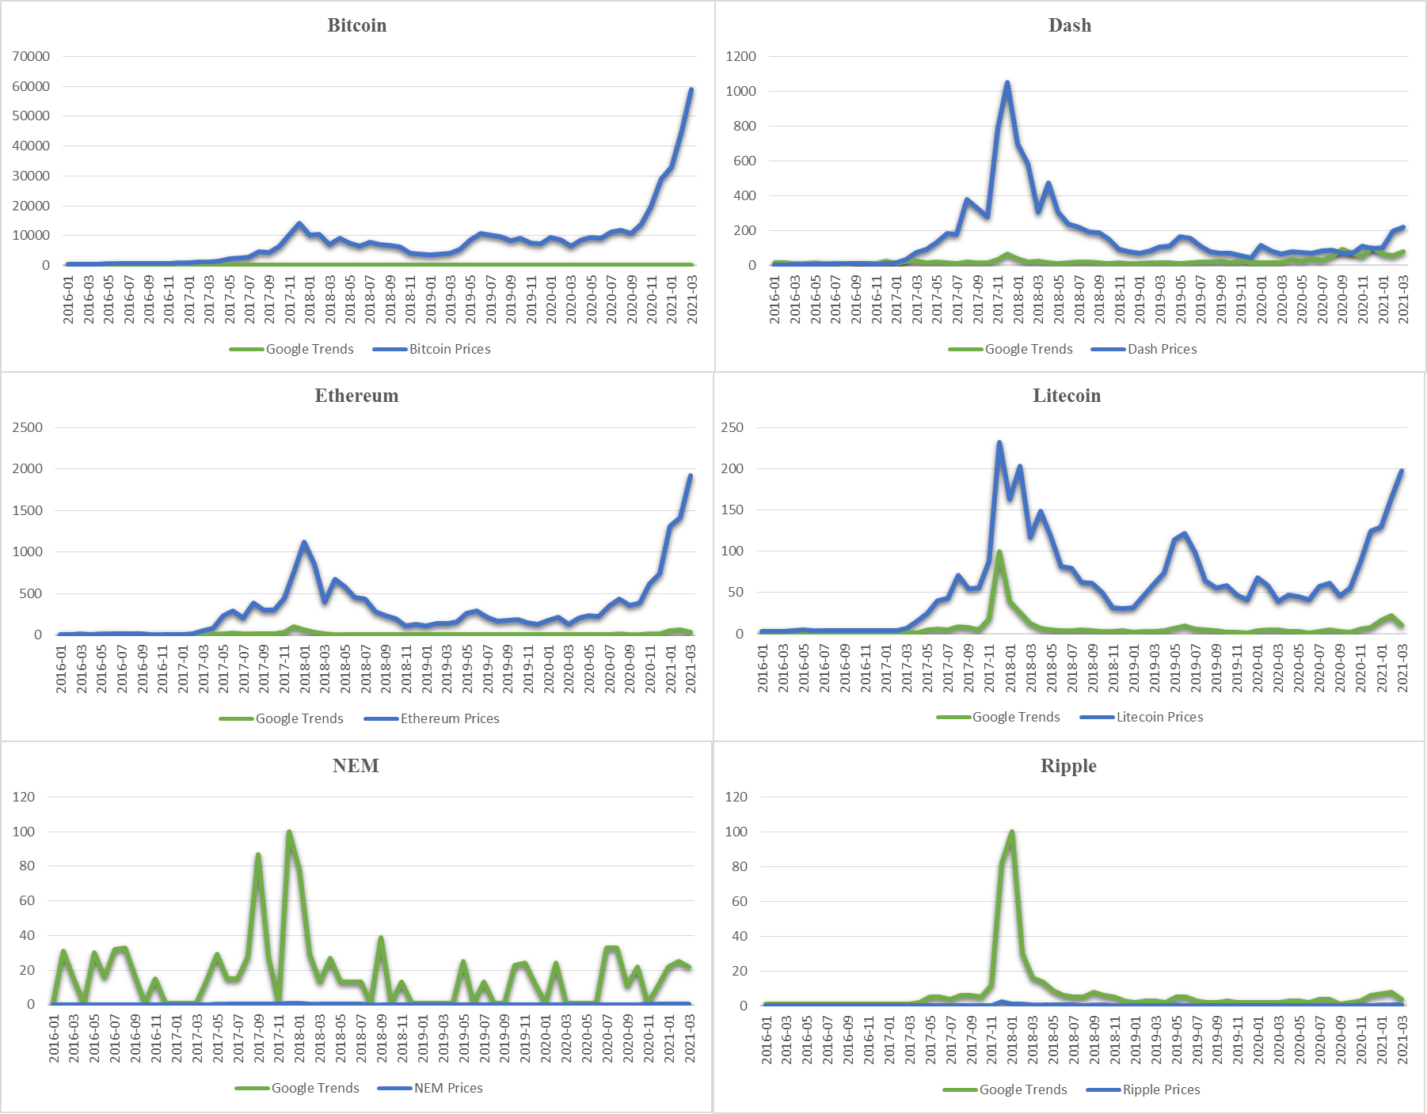

**Fig.1. Time Series of Google-trends and cryptocurrency prices**

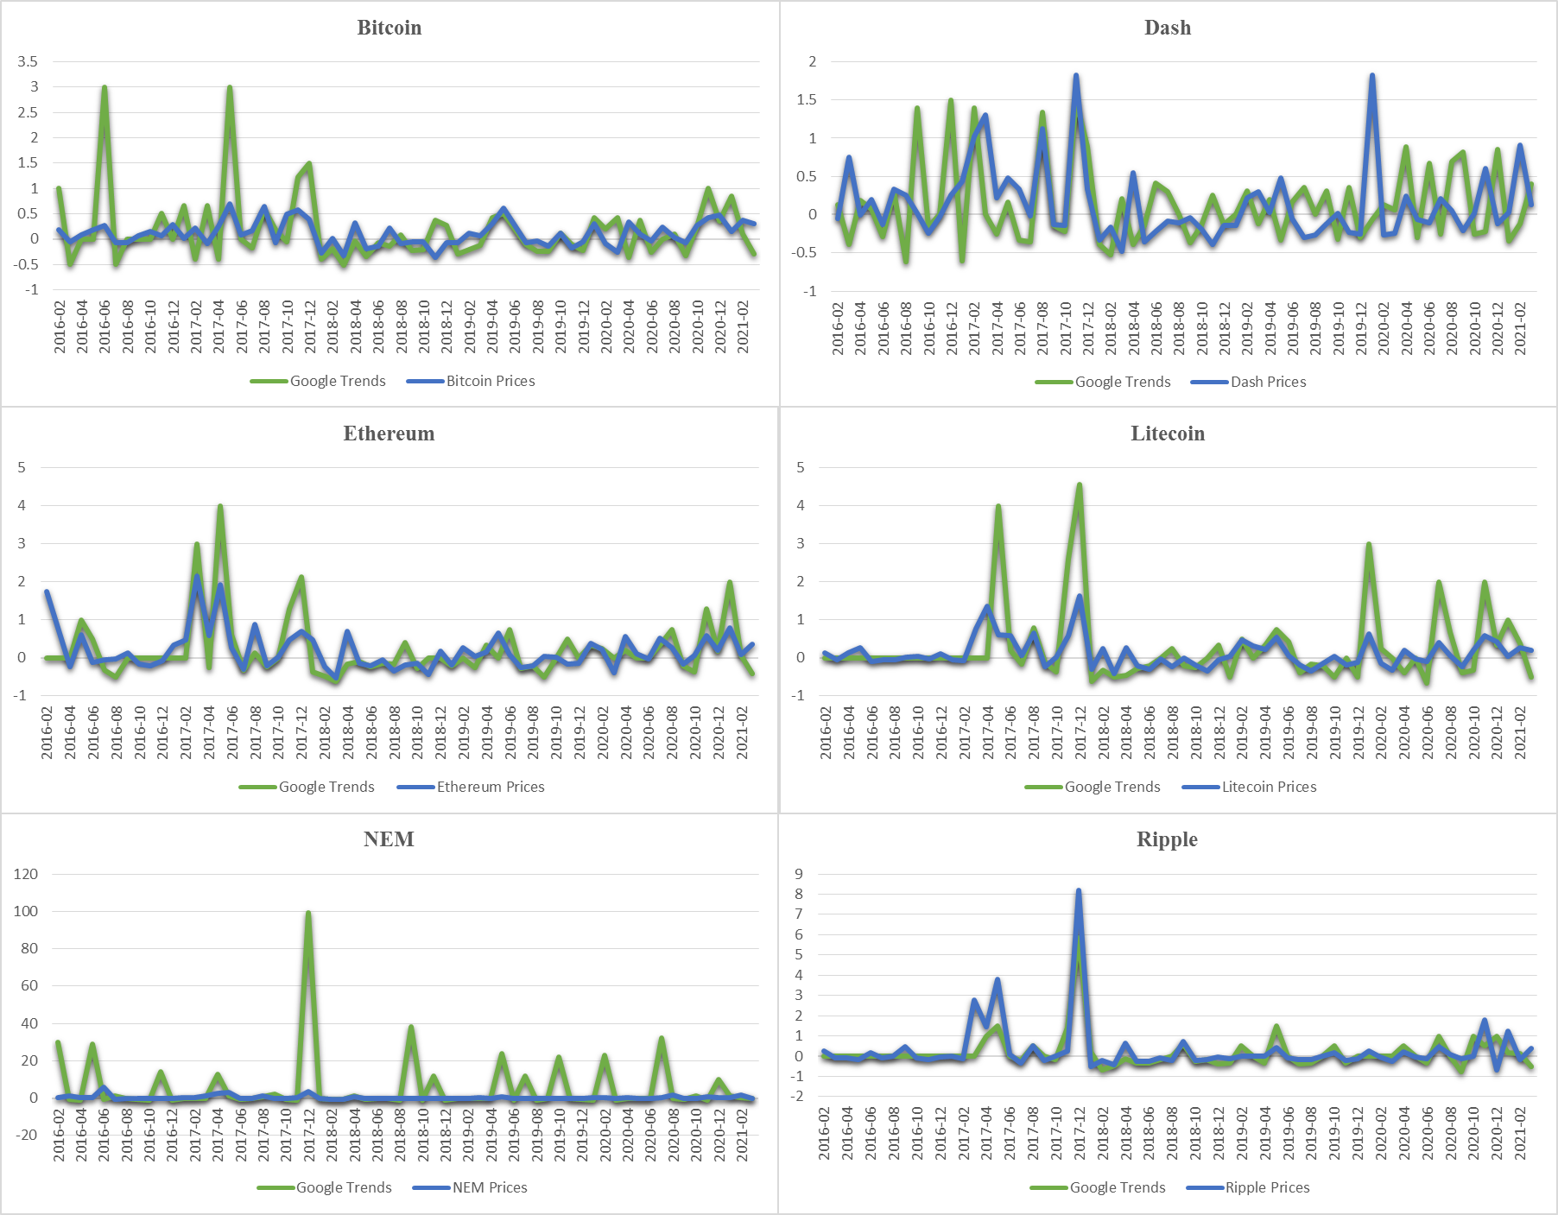

**Fig. 2. Return Series of Google-trends and cryptocurrency prices**

Additionally, the summary statistics reveal that the skewness is positive for both variables. The data are skewed right and not perfectly symmetrical. The JB statistic rejects the null hypothesis of normality, which is also confirmed by the kurtosis and skewness. The kurtosis is above three, indicating a fat-tailed distribution and sharp peaks in the series. The fat-tailed property in the variable series confirms the data’s non-normal distribution, thus affirming the nonparametric causality approach rather than the linear causality technique.

Before applying the nonlinear causality-in-quantile technique, the linearity of the data is tested. We applied the Granger causality test to assess the linear VAR(1) model. Table 2 depicts the test results and shows that the null hypothesis is not rejected at all significance levels.

|  |  |  |  |  |  |  |  |
| --- | --- | --- | --- | --- | --- | --- | --- |
| **Table 2: Linear Granger causality test** | | | | | | | |
| **Country** | | | ***f*-stats** | | | ***p*-value** | |
| **Bitcoin** | | | 3.9073 | | | 0.0258 | |
| **Dash** | | | 0.0701 | | | 0.9324 | |
| **Ethereum** | | | 8.1462 | | | 0.0008 | |
| **Litecoin** | | | 0.3728 | | | 0.6905 | |
| **NEM** | | | 1.0785 | | | 0.3471 | |
| **Ripple** | | | 0.5106 | | | 0.6029 | |
| **Note:** The table reports the F-statistic and prob. value for the no Granger causality restrictions imposed on a linear model under the null hypotheses H0.  All hypotheses indicate acceptance of the null hypothesis of no Granger causality at significance level of 5%. **Source:** Authors’ Estimations | | | | | | | |
| Thus, to affirm the presence of nonlinearity between the Google trends and cryptocurrency prices, the BDS test for nonlinearity given by Broock et al. (1996) is applied. Table 2 depicts the BDS results and shows the null hypothesis rejection at all embedding dimensions (m). The result confirms that the association between the cryptocurrency prices and Google trends is nonlinear. Therefore, the technique emphasizing linear assumptions cannot be considered robust and reliable and lead to misspecification errors (Ajmi et al., 2015).  **Table 3: BDS test for nonlinearity** | | | | | | | |
| **Country** | ***m*=2** | ***m*=3** | | ***m*=4** | ***m*=5** | | ***m*=6** |
| ***Google Trends*** | | | | | | | |
| **Bitcoin** | 8.207 | 7.675 | | 7.139 | 7.001 | | 7.584 |
| **Dash** | 6.745 | 6.908 | | 6.708 | 6.429 | | 6.183 |
| **Ethereum** | 6.750 | 6.221 | | 6.022 | 6.223 | | 7.098 |
| **Litecoin** | 6.343 | 5.767 | | 5.166 | 5.405 | | 6.143 |
| **NEM** | 4.119 | 3.727 | | 3.302 | 2.966 | | 2.711 |
| **Ripple** | 8.007 | 7.635 | | 7.603 | 8.071 | | 8.978 |
|  |  |  | |  |  | |  |
| ***Prices of Cryptocurrencies*** | | | | | | | |
| **Bitcoin** | 9.265 | 8.993 | | 8.751 | 8.548 | | 8.237 |
| **Dash** | 9.827 | 10.235 | | 10.847 | 11.530 | | 12.398 |
| **Ethereum** | 7.755 | 7.617 | | 7.267 | 7.213 | | 7.365 |
| **Litecoin** | 9.475 | 9.040 | | 8.776 | 8.609 | | 9.064 |
| **NEM** | 7.156 | 6.602 | | 7.203 | 8.163 | | 9.159 |
| **Ripple** | 7.875 | 8.586 | | 8.499 | 9.427 | | 9.489 |
| **Note:** The entries indicate the z-statistics BDS test based on the residuals of considered variables. *m* denotes the embedding dimension of the BDS test. All hypothesis are rejected at 1% of significance level.  **Source:** Authors’ Estimations | | | | | | | |

The Andrews (1993) parameter stability test is also applied for the Google trends equation for each cryptocurrency in the VAR model. Table 4 depicts the parameter stability test results and shows the null hypothesis rejection at a 1% significance level for all cryptocurrencies. The Ave-F, Max-F, and Wxp-F tests also support the parameter stability test results. Thus, both the BDS and parameter stability test confirms that the association between the cryptocurrency prices and Google trends is nonlinear. It allows us to apply the causality-in-quantiles test as it is considered robust against structural breaks, jumps, outliers, and nonlinear dependency (Shahbaz et al., 2017). Based on the findings, we used the causality-in-quantiles technique.

|  |  |  |  |  |  |  |
| --- | --- | --- | --- | --- | --- | --- |
| **Table 4: Parameter stability testing** | | | | | | |
| **Country** | **Maximum LR *F* Statistics** | | **Exp LR *F* Statistics** | | **Ave LR *F* Statistics** | |
| **Stats.** | **Prob.** | **Stats.** | **Prob.** | **Stats.** | **Prob.** |
| **Bitcoin** | 83.675 | 0.000 | 39.975 | 0.000 | 50.411 | 0.000 |
| **Dash** | 44.787 | 0.000 | 21.103 | 0.000 | 28.170 | 0.000 |
| **Ethereum** | 37.161 | 0.000 | 15.143 | 0.000 | 16.007 | 0.000 |
| **Litecoin** | 56.740 | 0.000 | 24.905 | 0.000 | 17.659 | 0.000 |
| **NEM** | 14.546 | 0.000 | 4.917 | 0.000 | 3.495 | 0.013 |
| **Ripple** | 66.920 | 0.000 | 29.994 | 0.000 | 9.764 | 0.000 |
| **Note:** Parameter stability test by Andrews (1993) and Andrews and Ploberger (1994) with the null hypothesis of parameter stability. **Source:** Authors’ Estimations | | | | | | |

The findings and the graphical representation of the causality-in-quantiles from Google Trends to cryptocurrencies’ prices are presented in Table 5 and Figure 3. In all six graphs, the test statistics of nonparametric causality are shown on the vertical axis, and the quantiles are shown on the horizontal axis. Thick black dotted lines show the test statistics, and the thin two-dashed lines and the thin horizontal lines show the 10% and 5% critical values 1.65 and 1.96, respectively.

In figure 3, the first graph displays the quantile causality from Bitcoin Google Trends to Bitcoin prices. First, the null hypothesis that Bitcoin Google Trends does not lead Bitcoin prices is rejected at lower and middle quantiles (0.1-0.6). Then, the graph shows that the null hypothesis is accepted. However, the null hypothesis is rejected at the 10% significance level at a wider range of quantiles (0.1 to 0.6). However, at 5%, the quantiles ranging from 0.2 to 0.5 also rejected the null hypothesis. Finally, only the high range quantiles from 0.7-0.9 show that the null hypothesis is accepted. This result is supported by the work of Arratia and Barrantes (2021) and Matta, Lunesu, and Marchesi (2015). This result can be explained by Bitcoin’s incredibly high price gaining attention worldwide, which leads to high search volumes on Google. Additionally, one negative event also increases the number of searches as people want all its details. Therefore, a sudden increase in searching also causes Bitcoin price fluctuations (Garcia et al., 2014).

The second graph in figure 3 displays the quantile causality from Dash Google Trends to Dash prices. The null hypothesis is accepted over the quantiles at the 10% and 5% significance levels. This result is supported by Sovbetov’s (2018) study, which stated that Google search frequency acts as an insignificant predictor for Dash. Alonso-Monsalve et al. (2020) used other prediction models such as LSTM NN model, hybrid CNN–LSTM network, MLP, and radial basis function NN and reported that these model does not predict Dash prices. The primary explanation behind this is that these series may have intrinsically more noise or may result from different temporal behavior.

The third graph in figure 3 displays the quantile causality from Ethereum Google Trends to Ethereum prices. At a 5% significance level, the wider range of quantiles confirms that the null hypothesis is accepted. Only the quantiles 0.2, 0.4, and 0.5 show that the null hypothesis is rejected. At a 10% significance level, the higher quantiles ranging from 0.7-0.9 show that the null hypothesis is accepted. This result is supported by the work of Phillips and Gorse (2018), who stated that Wikipedia views usually lead to Ethereum prices.

The fourth graph displays the quantile causality from Litecoin Google Trends to Litecoin prices. At a 10% significance level, the higher quantiles ranging from 0.7-0.9 show that the null hypothesis is accepted. However, at a 5% significance level, the lower quantiles ranging from 0.3-0.6 show that the null hypothesis is rejected. In the case of quantile causality from Google Trends to **Ripple** prices, at a 10% significance level, the lower quantiles (0.1 to 0.5) show that the null hypothesis is rejected. After those quantiles, the null hypothesis is accepted. Similarly, at a 5% significance level, the wider range of quantiles shows that the null hypothesis is accepted. Only the 0.4 quantile shows that the null hypothesis is rejected. The result is supported by Arratia and Barrantes’s (2021) work which stated that these currencies do not bring huge search volumes and are substitutes for Bitcoin.

The last graph displays the quantile causality from NEM Google Trends to NEM prices. At a 5% significance level, the higher quantiles ranging from 0.6-0.9 show that the null hypothesis is accepted, and the low-ranging quantiles from 0.1-0.5 show that the null hypothesis is rejected. In the case of a 10% significance level, the quantiles ranging from 0.1-0.7 show that the null hypothesis is rejected, except for the higher-ranging quantiles 0.8-0.9, showing that the null hypothesis is accepted. The NEM currency theft in 2018 is considered one of the largest currency thefts (bbc.com/news/world-Asia-42845505); after that, the people search widely to explore whether NEM is a safe cryptocurrency or not. Therefore, apart from Google Trends, another website such as Wallet Investors or Trading Beats is also considered as a reliable source for NEM prediction (<https://www.bitdegree.org/crypto/tutorials/nem-price-prediction>)

|  |  |  |  |  |  |  |
| --- | --- | --- | --- | --- | --- | --- |
| **Table 5: Results of Causality-in-Quantiles test** | | | | | | |
| **Quantile** | **Bitcoin** | **Dash** | **Ethereum** | **Litecoin** | **NEM** | **Ripple** |
| 0.1 | 1.860* | 0.9495 | 1.724* | 1.863* | 3.033** | 1.795* |
| 0.2 | 2.032** | 0.7545 | 1.979** | 1.669* | 2.687** | 1.851* |
| 0.3 | 2.266** | 1.2578 | 1.950* | 6.284** | 3.344** | 1.867* |
| 0.4 | 2.582** | 1.4506 | 2.065** | 4.591** | 2.467** | 2.081** |
| 0.5 | 2.401** | 1.5301 | 2.189** | 3.113** | 2.195** | 1.922* |
| 0.6 | 1.697* | 1.2981 | 1.877* | 2.298** | 1.710* | 1.4266 |
| 0.7 | 1.3138 | 1.0567 | 1.2489 | 1.5079 | 1.699* | 0.8246 |
| 0.8 | 1.3883 | 1.4870 | 1.1298 | 1.1045 | 0.8674 | 0.6379 |
| 0.9 | 0.5999 | 0.7089 | 0.5388 | 0.5628 | 0.6182 | 0.2646 |
| **Note:** Entries correspond to the quantile causality test statistic for the null hypothesis that Google trends of Cryptocurrencies does not Granger cause prices of Cryptocurrencies.  **, * indicates rejection of null of no-causality at 5, and 10 percent levels respectively. **Source:** Authors’ Estimations | | | | | | |

**We also analyze the nonlinear causal association between the variables by employing the nonparametric granger causality test to support the causality-in-quantiles test. The result is depicted in table 6 and the result shows that the null hypothesis is rejected on all embedding dimensions and the result also support the application of the causality-in-quantiles technique.**

|  |  |  |  |  |  |  |
| --- | --- | --- | --- | --- | --- | --- |
| **Table 6: Result for Nonparametric Granger causality test** | | | | | | |
| **Country** | ***m*=2** | | ***m*=3** | | ***m*=4** | |
| **Stats.** | **p-value** | **Stats.** | **p-value** | **Stats.** | **p-value** |
| **Bitcoin** | 2.498** | 0.006 | 2.438** | 0.007 | 2.539** | 0.006 |
| **Dash** | 0.626 | 0.266 | 0.602 | 0.274 | 0.748 | 0.227 |
| **Ethereum** | 2.087** | 0.018 | 1.512* | 0.065 | 1.459* | 0.072 |
| **Litecoin** | 1.678** | 0.041 | 1.673** | 0.041 | 1.649* | 0.050 |
| **NEM** | 1.578* | 0.057 | 1.431* | 0.076 | 1.356* | 0.088 |
| **Ripple** | 1.714** | 0.043 | 1.485* | 0.069 | 1.959** | 0.025 |
| **Note:** *m* denotes the embedding dimension. **, * indicates rejection of null of no-causality at 5, and 10 percent levels respectively. **Source:** Authors' Estimations | | | | | | |

**Fig. 3. Quantile causality from Google Trends to Cryptocurrency prices.**

**5. Conclusion**

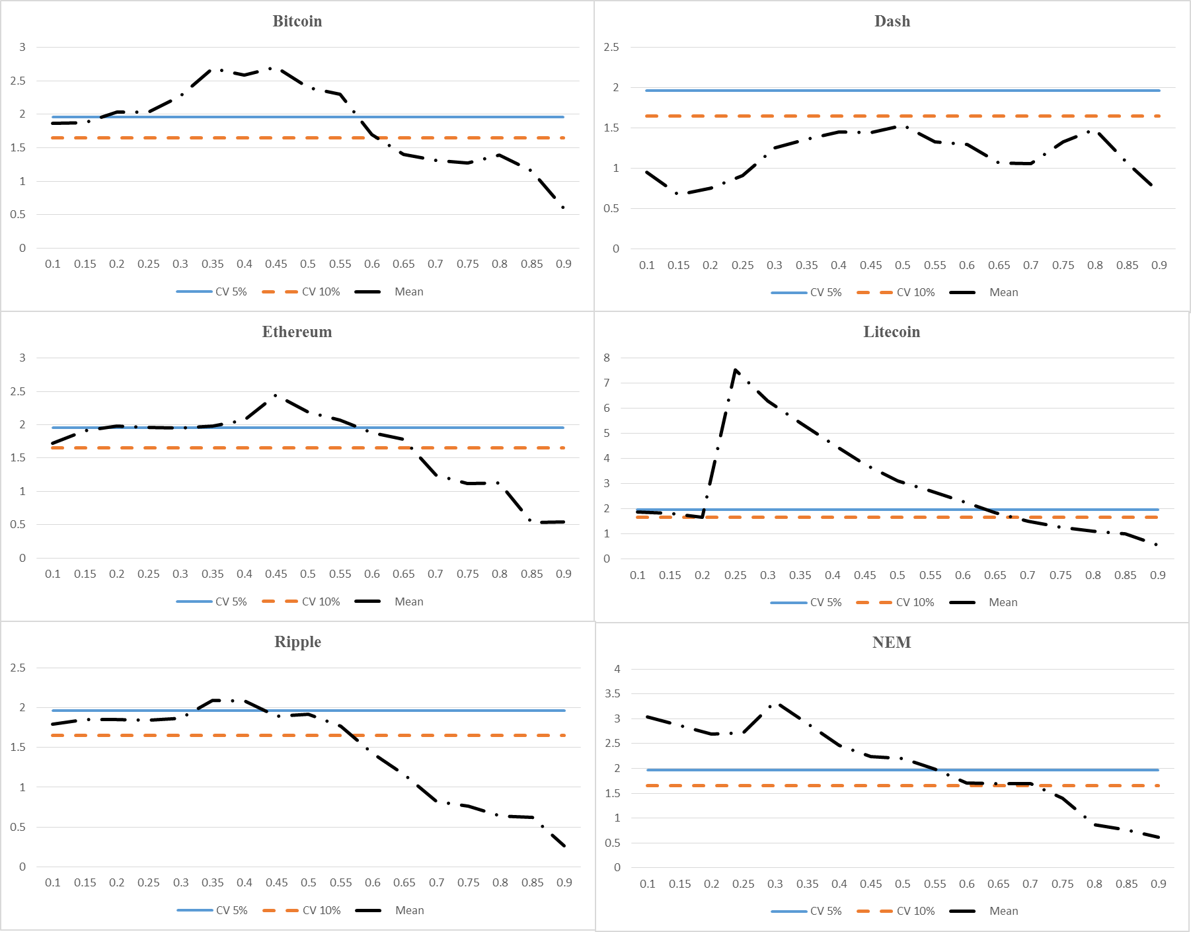In the last few years, cryptocurrencies have gained much popularity, and people have started seeing cryptocurrencies as new currencies far away from the interference of central banks and governments. In addition, some people consider cryptocurrencies a source of protection against inflationary cycles, whereas, for some, cryptocurrencies are just a new addition to the digital era in which we live. Despite this, cryptocurrencies attract the attention of investors and researchers, and several predictors have been identified that can affect cryptocurrencies’ prices. Among all predictors, trend spotting in predicting cryptocurrency has gained great prominence in the literature. Hence, this work aims to test the link between Google Trends and six cryptocurrencies’ prices, namely, Ripple, **Bitcoin,** NEM, Dash, Ethereum, and Litecoin. By applying the causality-in-quantiles technique on data comprised of January 2016 – March 2021, our findings show that Google Trends cause Ripple, Bitcoin, NEM, Ethereum, and Litecoin prices in most of the quantiles.

Furthermore, the results reveal that a strong causal effect from Google Trends to cryptocurrencies’ prices is found at the lower and middle quantiles ranging from 0.1-0.6 except for Dash. In the case of Dash, no causal relationship is found between Dash and Google Trends. The outcome of this study suggests that Google Trends acts as a good predictor of cryptocurrencies’ prices. This implies that as more investors search for cryptocurrency information, greater trading volumes and returns follow. This result suggested that information generated by Google Trends should be incorporated into the market as this swift incorporation will support investment in those currencies and act as predictors for the cryptocurrencies’ volumes and returns. Furthermore, prospective investors should adjust their investment decision relating to which cryptocurrencies they should invest in based on the evidence provided by Google Trends. Moreover, the outcomes will also help the investors optimize their risk-diversification and portfolio allocation between cryptocurrency and conventional assets.

The study encounters some limitations that future researchers can address. First, the relationship between Google Trends and cryptocurrency may vary from country to country depending on governments and their monetary authorities, so more exploration is needed on this topic. The research can be extended by including other asset classes and cryptocurrencies. This study has focused on Google Trends; however, other sources of information such as Reddit, Twitter, and Facebook can also affect cryptocurrencies’ prices. Future studies can extend the number of sources and again analyze the relationship.

Similarly, this study ignores the impact of behavioral factors on cryptocurrencies’ prices; therefore, upcoming studies can combine behavioral factors such as risk appetite sentiments with the considered variables. Furthermore, we have not explored the Google trend-crypto price relationship by splitting them into two phases (pre-covid and post covid period); future studies can also explore this aspect. From the result, it can be concluded that Google trends don’t predict Dash prices, so it is recommended that future studies may consider more specific data generation parameters, different network structures, or window size.

**References**

Aalborg, H. A., Molnár, P., & de Vries, J. E. (2019). What can explain the price, volatility and trading volume of Bitcoin?. *Finance Research Letters*, *29*, 255-265.

Abraham, J., Higdon, D., Nelson, J., & Ibarra, J. (2018). Cryptocurrency price prediction using tweet volumes and sentiment analysis. *SMU Data Science Review*, *1*(3), 1.

Adachi, Y., Masuda, M., & Takeda, F. (2017). Google search intensity and its relationship to the returns and liquidity of Japanese startup stocks. *Pacific-Basin Finance Journal*, *46*, 243-257.

Aharon, D. Y., Demir, E., Lau, C. K. M., & Zaremba, A. (2022). Twitter-Based uncertainty and cryptocurrency returns. *Research in International Business and Finance, 59,* 101546.

Alonso-Monsalve, S., Suárez-Cetrulo, A. L., Cervantes, A., & Quintana, D. (2020). Convolution on neural networks for high-frequency trend prediction of cryptocurrency exchange rates using technical indicators. *Expert Systems with Applications, 149,* 113250.

Arezooji, D. M. (2021). A Big Data Analysis of the Ethereum Network: from Blockchain to Google Trends. *arXiv preprint arXiv:2104.01764*.

Arratia, A., & López-Barrantes, A. X. (2021). Do google trends forecast bitcoins? stylized facts and statistical evidence. *Journal of Banking and Financial Technology*, 1-13.

Aslan, A., & Sensoy, A. (2020). Intraday efficiency-frequency nexus in the cryptocurrency markets. *Finance Research Letters*, *35*, 101298.

Bleher, J., & Dimpfl, T. (2019). Today I got a million, tomorrow, I don’t know: on the predictability of cryptocurrencies by means of Google search volume. *International Review of Financial Analysis, 63,* 147-159.

Bouoiyour, J., & Selmi, R. (2015). Bitcoin price: Is it really that new round of volatility can be on way?.

Bouri, E., Das, M., Gupta, R., & Roubaud, D. (2018). Spillovers between Bitcoin and other assets during bear and bull markets. *Applied Economics*, *50*(55), 5935-5949.

Bouri, E., Gupta, R., & Roubaud, D. (2019). Herding behaviour in cryptocurrencies. *Finance Research Letters*, *29*, 216-221.

Cai, Z., Liu, A. F., Lim, E. T., Tan, C. W., & Zheng, Z. (2018). Unraveling the effects of Google search on volatility of cryptocurrencies. In *Proceedings of the 39th International Conference on Information Systems (ICIS)*. Association for Information Systems. AIS Electronic Library (AISeL).

Cavalli, S., & Amoretti, M. (2021). CNN-based multivariate data analysis for bitcoin trend prediction. *Applied Soft Computing, 101,* 107065.

Cheah, E. T., & Fry, J. (2015). Speculative bubbles in Bitcoin markets? An empirical investigation into the fundamental value of Bitcoin. *Economics letters*, *130*, 32-36.

Cheng, H. P., & Yen, K. C. (2019). Can the Global Economy Activity Predict Cryptocurrency Returns. *Available at SSRN 3488987*.

Corbet, S., Katsiampa, P., & Lau, C. K. M. (2020). Measuring quantile dependence and testing directional predictability between Bitcoin, altcoins and traditional financial assets. *International Review of Financial Analysis*, *71*, 101571.

Corbet, S., Larkin, C., Lucey, B., Meegan, A., Yarovaya, L. (2019). Cryptocurrency Reaction to FOMC Announcements: Evidence of Heterogeneity Based on Blockchain Stack Position. Journal of Financial Stability, https://doi.org/10.1016/j.jfs.2019.100706

Corbet, S., Lucey, B., & Yarovaya, L. (2018). Datestamping the Bitcoin and Ethereum bubbles. *Finance Research Letters*, *26*, 81-88.

D’Amuri, F., & Marcucci, J. (2017). The predictive power of Google searches in forecasting US unemployment. *International Journal of Forecasting*, *33*(4), 801-816.

Dastgir, S., Demir, E., Downing, G., Gozgor, G., & Lau, C. K. M. (2019). The causal relationship between Bitcoin attention and Bitcoin returns: Evidence from the Copula-based Granger causality test. *Finance Research Letters*, *28*, 160-164.

Demir, E., Simonyan, S., García-Gómez, C. D., & Lau, C. K. M. (2020). The asymmetric effect of bitcoin on altcoins: evidence from the nonlinear autoregressive distributed lag (NARDL) model. *Finance Research Letters*, 101754.

Donadelli, M., & Gerotto, L. (2019). Non-macro-based Google searches, uncertainty, and real economic activity. *Research in International Business and Finance*, *48*, 111-142.

Dourado, E., & Brito, J. (2014). Cryptocurrency. En The New Palgrave Dictionary of Economics.(1-9).

Enoksen, F. A., Landsnes, C. J., Lučivjanská, K., & Molnár, P. (2020). Understanding risk of bubbles in cryptocurrencies. *Journal of Economic Behavior & Organization*, *176*, 129-144.

Fousekis, P., & Tzaferi, D. (2021). Returns and volume: Frequency connectedness in cryptocurrency markets. *Economic Modelling*, *95*, 13-20.

Gerritsen, D., Lugtigheid, R. A., & Walther, T. (2020). Can Bitcoin Investors Profit from Buy, Hold, and Sell Recommendations by Crypto Analysts?. *Hold, and Sell Recommendations by Crypto Analysts*.

Götz, T. B., & Knetsch, T. A. (2019). Google data in bridge equation models for German GDP. *International Journal of Forecasting*, *35*(1), 45-66.

Houben, R., & Snyers, A. (2018). Cryptocurrencies and blockchain. *Bruxelles: European Parliament*.

https://bbc.com/news/world-asia-42845505

<https://coinmarketcap.com>

<https://trends.google.com/trends/explore>

<https://www.bitdegree.org/crypto/tutorials/nem-price-prediction>

Hu, A. S., Parlour, C. A., & Rajan, U. (2019). Cryptocurrencies: Stylized facts on a new investible instrument. *Financial Management*, *48*(4), 1049-1068.

HAMURCU, C. Can Elon Mask's Twitter Posts About Cryptocurrencies Influence Cryptocurrency Markets by Creating a Herding Behavior Bias?. *Fiscaoeconomia, 6*(1), 215-228.

Jena, S. K., Tiwari, A. K., Dogan, B., & Hammoudeh, S. (2020). Are the top six cryptocurrencies efficient? Evidence from time-varying long memory. *INTERNATIONAL JOURNAL OF FINANCE & ECONOMICS*.

Jiang, S., Li, X., & Wang, S. (2021). Exploring evolution trends in cryptocurrency study: From underlying technology to economic applications. *Finance Research Letters*, *38*, 101532.

Katsiampa, Paraskevi and Yarovaya, Larisa and Zięba, Damian, High-Frequency Connectedness between Bitcoin and Other Top-Traded Crypto Assets during the COVID-19 Crisis (June 21, 2021). Available at SSRN: https://ssrn.com/abstract=3871405 or http://dx.doi.org/10.2139/ssrn.3871405

Kraaijeveld, O., & De Smedt, J. (2020). The predictive power of public Twitter sentiment for forecasting cryptocurrency prices. *Journal of International Financial Markets, Institutions and Money*, *65*, 101188.

Kristoufek, L. (2013). BitCoin meets Google Trends and Wikipedia: Quantifying the relationship between phenomena of the Internet era. *Scientific reports*, *3*(1), 1-7.

Li, X., & Wang, C. A. (2017). The technology and economic determinants of cryptocurrency exchange rates: The case of Bitcoin. *Decision Support Systems*, *95*, 49-60.

Li, X., Ma, J., Wang, S., & Zhang, X. (2015). How does Google search affect trader positions and crude oil prices?. *Economic Modelling*, *49*, 162-171.

Liang, C., Zhang, Y., Li, X., & Ma, F. (2020). Which predictor is more predictive for Bitcoin volatility? And why?. *International Journal of Finance & Economics*.

Matta, M., Lunesu, I., & Marchesi, M. (2015, June). Bitcoin Spread Prediction Using Social and Web Search Media. In *UMAP workshops* (pp. 1-10).

Nagao, S., Takeda, F., & Tanaka, R. (2019). Nowcasting of the US unemployment rate using Google Trends. *Finance Research Letters*, *30*, 103-109.

Nakamoto S (2008) Bitcoin: a peer-to-peer electronic cash system. Bitcoin.

Nasir, M. A., Huynh, T. L. D., Nguyen, S. P., & Duong, D. (2019). Forecasting cryptocurrency returns and volume using search engines. *Financial Innovation*, *5*(1), 1-13.

Nguyen, C. P., Schinckus, C., & Nguyen, T. V. H. (2019). Google search and stock returns in emerging markets. *Borsa Istanbul Review*, *19*(4), 288-296.

Panagiotidis, T., Stengos, T., & Vravosinos, O. (2018). On the determinants of bitcoin returns: A LASSO approach. *Finance Research Letters*, *27*, 235-240.

Park, S., & Kim, J. (2018). The effect of interest in renewable energy on US household electricity consumption: An analysis using Google Trends data. *Renewable energy*, *127*, 1004-1010.

Pärlstrand, E., & Rydén, O. (2015). Explaining the market price of Bitcoin and other Cryptocurrencies with Statistical Analysis.

Patel, M. M., Tanwar, S., Gupta, R., & Kumar, N. (2020). A deep learning-based cryptocurrency price prediction scheme for financial institutions. *Journal of information security and applications, 55,* 102583.

Philippas, D., Rjiba, H., Guesmi, K., & Goutte, S. (2019). Media attention and Bitcoin prices. *Finance Research Letters*, *30*, 37-43.

Puri, V. (2016). Decrypting Bitcoin prices and adoption rates using Google search.

Raza, S. A., Ahmed, M., & Aloui, C. (2022). On the asymmetrical connectedness between cryptocurrencies and foreign exchange markets: Evidence from the nonparametric quantile on quantile approach. Research in International Business and Finance, 101627.

Raza, S. A., Shah, N., Guesmi, K., & Msolli, B. (2021). How does COVID-19 influence dynamic spillover connectedness between cryptocurrencies? Evidence from non-parametric causality-in-quantiles techniques. Finance Research Letters, 102569.Shen, D., Urquhart, A., & Wang, P. (2019). Does twitter predict Bitcoin?. *Economics Letters*, *174*, 118-122.

Smuts, N. (2019). What drives cryptocurrency prices? an investigation of google trends and telegram sentiment. *ACM SIGMETRICS Performance Evaluation Review*, *46*(3), 131-134.

Sovbetov, Y. (2018). Factors influencing cryptocurrency prices: Evidence from bitcoin, ethereum, Dash, litcoin, and monero. *Journal of Economics and Financial Analysis*, *2*(2), 1-27.

Urquhart, A. (2016). The inefficiency of Bitcoin. *Economics Letters*, *148*, 80-82.

Urquhart, A. (2018). What causes the attention of Bitcoin?. *Economics Letters*, *166*, 40-44.

Yu, L., Zhao, Y., Tang, L., & Yang, Z. (2019). Online big data-driven oil consumption forecasting with Google trends. *International Journal of Forecasting*, *35*(1), 213-223.

Zhang, W., & Wang, P. (2020). Investor attention and the pricing of cryptocurrency market. *Evolutionary and Institutional Economics Review*, *17*(2), 445-468.

1. https://www.bbc.co.uk/news/technology-58678907
2. See <https://coinmarketcap.com> for the most recent statistics.