Maternal and fetal genetic variation in vitamin D metabolism and umbilical cord blood 25-hydroxyvitamin D

Short title: Genetic variation and cord blood vitamin D status
Rebecca J Moon^{1,2+}, Laura D F Cooke³⁺, Stefania D’Angelo¹⁺, Elizabeth M Curtis¹, Philip Titcombe¹, Justin H Davies², Keith M Godfrey^{1,4}, Jane K Cleal³, Rohan M Lewis³, Cyrus Cooper^{1,4,5*}, Nicholas C Harvey^{1,4*}
- MRC Lifecourse Epidemiology Centre, University of Southampton, Southampton, UK
- Paediatric Endocrinology, Southampton Children’s Hospital, Southampton University Hospitals NHS Foundation Trust, Southampton, UK
- The Institute of Developmental Sciences, Human Development and Health, Faculty of Medicine, University of Southampton, Southampton, UK
- NIHR Southampton Nutrition Biomedical Research Centre, University of Southampton and University Hospital Southampton NHS Foundation Trust, Southampton, UK
- National Institute for Health Research (NIHR) Musculoskeletal Biomedical Research Unit, University of Oxford, UK
⁺RJM, LDFC and SD are joint first author; *CC and NCH are joint senior author

Address for correspondence and requests for reprints:
Prof Nicholas Harvey,
MRC Lifecourse Epidemiology Centre,
University of Southampton,
Tremona Road,
Southampton,
SO16 6YD, UK
Tel: 023 8077 7624
Fax: 023 8070 4021
Email: nch@mrc.soton.ac.uk

Keywords: 25-hydroxyvitamin D, DHCR7, GC, single nucleotide polymorphism, umbilical cord blood, vitamin D

Email address and ORCID ID:
Rebecca J Moon PhD rm@mrc.soton.ac.uk 0000-0003-2334-2283
Laura D F Cooke BSc ldfc1n15@soton.ac.uk 0000-0002-8099-9437
Elizabeth M Curtis PhD bc@mrc.soton.ac.uk 0000-0002-5147-0550
Stefania D’Angelo MSc sd@mrc.soton.ac.uk
Philip Titcombe MSc pt@mrc.soton.ac.uk 0000-0002-7797-8571
Justin Davies MD justin.davies@uhs.nhs.uk 0000-0001-7560-6320
Keith Godfrey PhD kmg@mrc.soton.ac.uk 0000-0002-4643-0618
Jane Cleal PhD j.k.cleal@soton.ac.uk 0000-0001-7978-4327
Rohan Lewis PhD rohan.lewis@soton.ac.uk 0000-0003-4044-9104
Cyrus Cooper DM cc@mrc.soton.ac.uk 0000-0003-3510-0709
Nicholas Harvey PhD nch@mrc.soton.ac.uk 0000-0002-8194-2512
Disclosures
RJM, LDFC, SD, JC & RL have nothing to disclose. CC reports personal fees from ABBH, Amgen, Eli Lilly, GSK, Medtronic, Merck, Novartis, Pfizer, Roche, Servier and Takeda, outside the submitted work. NCH reports personal fees, consultancy, lecture fees and honoraria from Alliance for Better Bone Health, AMGEN, MSD, Eli Lilly, Servier, Shire, Consilient Healthcare and Internis Pharma, outside the submitted work. KMG reports reimbursement for speaking at Nestle Nutrition Institute conferences, grants from Abbott Nutrition & Nestec, outside the submitted work; in addition, KMG has a patent Phenotype Prediction pending, a patent Predictive Use of CpG Methylation pending, and a patent Maternal Nutrition Composition pending, not directly related to this work. PT is part of academic research programmes that have received research funding from Abbott Nutrition, Nestec and Danone, outside the submitted work. JHD has received travel bursaries from Novo Nordisk, SANDOZ and Pfizer unrelated to this work. EMC reports lecture fees and travel support from Eli Lilly, Pfizer and UCB, outside the submitted work.

Funding Sources
This work was supported by grants from the Arthritis Research UK (17702), Medical Research Council (MC_PC_21003; MC_PC_21001), Bupa Foundation, National Institute for Health Research (NIHR) Southampton Biomedical Research Centre, University of Southampton and University Hospital Southampton NHS Foundation Trust, and NIHR Musculoskeletal Biomedical Research Unit, University of Oxford. The work leading to these results was supported by the European Union's Seventh Framework Programme (FP7/2007-2013), projects EarlyNutrition and ODIN under grant agreements numbers 289346 and 613977. KMG is supported by the National Institute for Health Research (NIHR Senior Investigator (NF-SI-0515-10042) and NIHR Southampton 1000DaysPlus Global Nutrition Research Group (17/63/154)), the European Union (Erasmus+ Programme ImpENSA 598488-EPP-1-2018-1-DE-EPPKA2-CBHE-JP) and the British Heart Foundation (RG/15/17/3174, SP/F/21/150013). RJM and EMC are funded by NIHR Academic Clinical Lectureships. LDFCC is supported by the Gerald Kerkut Charitable Trust. We are extremely grateful to Merck GmbH for the kind provision of the Vigantoletten supplement in the MAVIDOS trial. Merck GmbH had no role in the trial execution, data collection, analysis or manuscript preparation.

MAVIDOS Trial Registration:
ISRCTN:82927713; EUDRACT:2007-001716-23

Abstract
Context
Single nucleotide polymorphisms (SNPs) in vitamin D metabolism pathway genes are associated with circulating 25-hydroxyvitamin D [25(OH)D] in adults. Less is known about the relationships between mother and offspring SNPs and umbilical cord blood 25(OH)D.
Objective
(1) To undertake a meta-analysis of the relationships of maternal and offspring SNPs in the vitamin D metabolism pathway and cord blood 25(OH)D in pregnant women including novel data; and (2) to examine these relationships in women who received antenatal cholecalciferol supplementation in a clinical trial.
Data Sources
Novel data analysis from an observational mother-offspring cohort study (Southampton Women’s Survey) and the MAVIDOS double-blind randomised placebo-control trial of 1000 IU/day cholecalciferol supplementation in pregnancy, and an electronic literature search of published studies in PubMed up to 31 July 2021.
Study Selection
Studies reporting on associations between rs12785878 (DHCR7), rs10741657 (CYP2R1), rs6013897 (CYP24A1) or rs2282679 (GC) and cord blood 25(OH)D. One published study was included in addition to the novel data analysis.
Data Synthesis
Associations between both maternal and offspring SNPs at rs2282679 (GC) and rs12785878 (DHCR7) and cord blood 25(OH)D were identified. When maternal genotype was adjusted for offspring genotype, and vice versa, there was persisting evidence for associations with maternal rs12785878 (β (95%CI) 1.6nmol/l (0.3, 2.8) per common allele), and offspring rs2282679 (β 3.1nmol/l (2.0, 4.4) per common allele). Maternal and offspring SNPs at rs1074657 and rs613897 were not associated with cord blood 25(OH)D.
Conclusions
Common genetic variation in the vitamin D metabolism pathway is associated with umbilical cord blood 25(OH)D.

Introduction
Vitamin D deficiency at birth is associated with an increased risk of rickets and symptomatic neonatal hypocalcemia, including seizures and cardiomyopathy. This can be prevented with antenatal vitamin D supplementation (1). There is also growing evidence that antenatal vitamin D supplementation might have positive effects on offspring anthropometry, bone mineralization and body composition (2, 3).
Recognised risk factors for vitamin D deficiency include nutritional deficiency, variations in ultraviolet B (UVB) exposure, including, living at northerly latitudes, skin pigmentation, extent of skin covering sunscreen use and also greater adiposity. Genetic variation in the form of single nucleotide polymorphisms (SNPs) in genes in the vitamin D metabolism pathway are also associated with 25-hydroxyvitamin D [25(OH)D] status in both adults (4) and pregnant women (5).
The fetus is dependent on placental transfer of 25(OH)D from the maternal circulation for its source of vitamin D. However, data is currently sparse on whether maternal and/or offspring SNPs in genes in the vitamin D metabolism pathway are associated with fetal 25(OH)D status (as measured in umbilical cord blood), or how this is modified by antenatal vitamin D supplementation. One study by Størdal et al reported associations between maternal and offspring variation in SNPs at rs2282679 in the GC gene (encoding vitamin D binding protein, DBP) and rs12785878 near DHCR7 (involved in the synthesis of vitamin D in the skin) and umbilical cord blood 25(OH)D (6).
In the MAVIDOS randomized placebo-controlled trial of antenatal vitamin D supplementation, we documented an association between rs12785878 (DHCR7) and baseline 25(OH)D in pregnant women, but this association was no longer evident in late pregnancy after cholecalciferol supplementation (5). In contrast, maternal genotype at rs2282679 (GC) and at rs10741657 in the CYP2R1 gene (encoding 25-hydroxylase) were associated with maternal 25(OH)D status in late pregnancy in women who received vitamin D supplementation, but not in the placebo group (5). These finding highlight the importance of assessing the modifying effect of vitamin D supplementation on these relationships.
The aim of this study was twofold: first, to undertake a meta-analysis of the relationships of SNPs in genes in the vitamin D metabolism pathway in mother and offspring and umbilical cord blood 25(OH)D utilising novel data from the Southampton Women’s Survey (SWS) (7) and the placebo arm of the MAVIDOS trial (8) in addition to previously published data, and second, to examine these relationships in women who received cholecalciferol supplementation within a randomised controlled trial (MAVIDOS).

Methods

The meta-analysis includes previously unpublished data from the Southampton Women’s Survey, an observational mother-offspring birth cohort from Southampton, UK and the MAVIDOS trial of vitamin D supplementation in pregnancy, carried out at 3 centres in the UK (Southampton, Sheffield, and Oxford; ISRCTN:82927713; EUDRACT:2007-001716-23). Details of both studies have been published previously (7, 8).

The relationships of umbilical cord blood 25(OH)D with four SNPs in the vitamin D metabolism pathway were considered. These loci were identified as associated with 25(OH)D concentrations in a previous large genome-wide association study (GWAS) (4). These were rs12785878 (DHCR7; 7-dehydrocholesterol reductase), rs10741657 (CYP2R1; 25-hydroxylase), rs6013897 (CYP24A1; 24-hydroxylase) and rs2282679 (GC; DBP).

Southampton Women’s Survey
Women aged 20-34 years were recruited into the study pre-pregnancy (n = 12579), and those that reported a singleton pregnancy (n = 3158) had extensive phenotyping during pregnancy. Maternal venous blood was collected at 34 weeks’ gestation and umbilical cord blood at delivery. Serum was stored at −80°C.

Serum 25(OH)D concentration was assessed by liquid chromatography-tandem mass spectrometry by the Cork Centre for Vitamin D and Nutrition Research laboratory (accredited by the CDC Vitamin D Standardization-Certification program and participates in the Vitamin D External Quality Assessment Scheme (DEQAS)). Briefly, total 25(OH)D was calculated by summation of individually quantified 25(OH)D₂ and 25(OH)D₃ measured by liquid chromatography-tandem mass spectrometry on a Waters Acquity UPLC system coupled to an Acquity Triple Quadrupole (TQD) mass spectrometer detector (Waters, Milford, MA). The limits of detection for 25(OH)D₃ and 25(OH)D₂ were 0.31 and 0.44 nmol/L, respectively. The limits of quantitation for 25(OH)D₃ and 25(OH)D₂ were 1.03 and 1.43 nmol/L, respectively. Intra- and interassay CVs for both metabolites were < 6% and < 5%, respectively.

Maternal genotyping was performed using the Infinium Global Screening Array v.1.0; SNPs rs10741657, rs12785878, and rs2282679 were directly genotyped, and rs6013897 was imputed. Umbilical cord blood (offspring) genotyping was performed using the Infinium OmniExpress-24 v1.2 Array; rs2282679 was directly genotyped and rs10741657, rs12785878, and rs6013897 were imputed. Imputation for offspring and maternal SNPs was performed separately on SANGER imputation servers using the UK10+1000 Genome Phase 3 reference panel, and pre-phased using EAGLE2 pipeline. All imputed SNPs in this study had an INFO score > 0.9, indicating high-quality imputation.

The Maternal Vitamin D Osteoporosis Study
The MAVIDOS study is a double-blind randomized placebo-controlled trial of 1000 IU/day cholecalciferol supplementation during pregnancy. Women with a singleton pregnancy and a baseline serum 25(OH)D 25-100 nmol/l at 11-14 weeks gestation were eligible to participate. Participants were randomized in a 1:1 ratio to either cholecalciferol 1000 IU/day or matched placebo from 14 weeks gestation until delivery. The participants, individuals providing antenatal and intrapartum care, and all field researchers involved in data collection and sample analysis were blinded to the assignment to placebo or intervention. All participants received standard antenatal care and could continue self-administration of dietary supplements containing up to 400 IU/day vitamin D. Detailed phenotyping was undertaken at 11-14 and 34 weeks’ gestation, including assessment of diet, health, lifestyle and anthropometry, and collection of venous blood samples. Umbilical cord blood was collected at delivery and serum stored at −80°C.
25(OH)D concentration was assessed by liquid chromatography-tandem mass spectrometry at the clinical biochemistry laboratory at University Hospital Southampton NHS Foundation Trust, which participates in the Vitamin D External Quality Assessment Scheme (DEQAS)). Briefly, total 25(OH)D was calculated by summation of individually quantified 25(OH)D₂ and 25(OH)D₃ measured by liquid chromatography-tandem mass spectrometry on a Waters TQD system (Waters, Milford, MA). The limits of detection for 25(OH)D3 and 25(OH)D2 were 1.21 and 1.64 nmol/L, respectively. The limits of quantitation for 25(OH)D3 and 25(OH)D2 were 4.05 and 5.26 nmol/L, respectively. Intra- and interassay CVs for both metabolites were < 8% and < 10%, respectively.
Maternal and offspring genotyping was undertaken by LGC Genomics (Hoddeston, UK) using KASP competitive allele-specific polymerase chain reaction.

Search strategy for similar studies
An electronic literature search of published studies was performed on PubMed up to 31 July 2021. The literature search was based on the following search strategy: “vitamin D” and “pregnancy”, together with associated terms, in combination with one of the following: rs12785878, rs10741657, rs6013897, rs2282679, DHCR7, CYP2R1, CYP24A1, GC. After removal of duplicates, 97 abstracts were screened; only 2 studies examined the associations between one or more of the SNPs in either mother or offspring and umbilical cord blood 25(OH)D (6, 9), of which only the work of Størdal et al presented data that could be combined with our data from SWS and MAVIDOS in meta-analysis (6). The other study could not be used due to a different approach to statistical analysis (9).

Statistical analysis

Data were analysed separately for each of the three novel datasets (SWS, MAVIDOS placebo group, MAVIDOS cholecalciferol). For the MAVIDOS study, an intention to treat approach was used with all women analysed in the group to which they were originally assigned.
Characteristics of the participants included for each study, and between the two treatment arms of MAVIDOS were compared using t, Mann-Whitney U, and χ² tests for normally distributed, non-normally distributed and categorical variables, respectively.
For each dataset, Fourier analysis was used to model the seasonal variation in 25(OH)D; from this a deseasonalised cord blood 25(OH)D was generated by subtracting the expected 25(OH)D for the infant’s date of birth from the actual 25(OH)D (10). Linear regression was used to examine the association between SNPs and umbilical cord blood 25(OH)D using an additive model with the homozygous low-frequency allele for the cohort as the reference group. The low frequency alleles were consistent across the three datasets used in this analysis. The additive model thus expresses the change in outcome per additional common allele. Analyses are presented as both unadjusted relationships, and maternal genotype adjusted for fetal genotype at the same SNP and vice-versa, using the same additive model approach.
A meta-analysis including the findings from SWS, MAVIDOS placebo group and the one previously published paper reporting on these relationships (6) was undertaken. Heterogeneity of effect estimates from the three studies was assessed by the Cochran’s Q-statistic and quantified by the I² statistic. The I² measures the percentage of the total variation across the studies due to heterogeneity. As there was no statistical evidence of heterogeneity, the effects were combined in a fixed-effect meta-analysis model to estimate the pooled effect of maternal and offspring genotype and cord blood 25(OH)D. Forest plots were used as graphical representation of the results of the meta-analysis.
All analyses were performed in Stata v17.0 (StataCorp, College Station, TX). A p value of < 0.05 was considered statistically significant.

Results
Maternal characteristics in SWS and MAVIDOS
In the SWS 633 mother-offspring pairs had maternal SNP data and cord blood 25(OH)D measurements and 795 mother-offspring pairs had offspring SNP data and cord blood 25(OH)D. SWS mother-offspring pairs included in this analysis tended to be of slightly older maternal age, higher maternal educational achievement, less likely to smoke in late pregnancy and have higher birth weight than those not included in this analysis (Supplementary Table 1 (11)). Distribution of the SNPs in the cohort are shown in Supplementary Table 2 (11). Mean (SD) umbilical cord blood 25(OH)D for the included mother-offspring pairs was 31.9 (18.3) nmol/l.
965 infants were born to participants of the MAVIDOS study. This analysis included 350 mother-offspring pairs (36%). Those who delivered a liveborn infant but who were not included in this analysis due to missing umbilical cord blood 25(OH)D were of similar age, smoking status, and BMI to those included in the analysis (p > 0.05 for all). Baseline characteristics of the women and their offspring at birth were similar in those randomised to placebo and cholecalciferol (Supplementary Table 3 (11)). The distributions of alleles within the SNPs of interest for both the mother and offspring were also similar between the two groups (Supplementary Table 4 (11)). Umbilical cord blood 25(OH)D was higher in the cholecalciferol group (mean (SD) 42.3 (13.1) nmol/l) than the placebo group (mean (SD) 28.6 (12.1) nmol/l, p < 0.001).

Included data from published studies
One previously published study is included in the meta-analysis (6); this included 1073 mother-offspring pairs living in Norway (95% were of Norwegian origin). Mean (95% CI) cord blood 25(OH)D was 35.2 (33.6, 36.8) nmol/l, higher than observed in SWS and the MAVIDOS placebo arm, but lower than in the infants born to women supplemented with vitamin D in MAVIDOS.

Meta-analysis of relationships between SNPs and umbilical cord blood 25(OH)D
Meta-analysis of unadjusted relationships showed the common alleles in maternal rs2282679 (GC) and rs12785878 (DHCR7) were positively associated with cord blood 25(OH)D (Figure 1A). Similar relationships were observed for the offspring genotype at rs2282679 (GC) and rs12785878 (DHCR7) (Figure 1B). There were no associations of mother or offspring rs1074657 (CYP2R1) and rs6013897 (CYP24A1) with cord blood 25(OH)D (Supplementary Figure 1 (11)).
In meta-analysis of associations where maternal genotype was adjusted for offspring genotype, and vice versa, the association between maternal rs12785878 (DHCR7) remained (β (95%CI) 1.6 (0.3, 2.8) nmol/l per common allele), but the association with the offspring genotype was attenuated (Figure 2A). The association with maternal rs2282679 (GC) was no longer evident after adjustment for the offspring SNP at this locus (β (95%CI) 0.8 (-0.4, 2.1) nmol/l per common allele). In contrast, for the offspring SNPs, the association between rs2282679 (GC) and 25(OH)D remained positive (β (95% CI) 3.1 (2.0, 4.4) nmol/l per common allele) but the association with rs12785878 (DHCR7) was attenuated (β (95%CI) 0.8 (-0.4, 2.1) nmol/l per common allele) (Figure 2B). Similar to the unadjusted models, there were no associations between either maternal or offspring rs1074657 (CYP2R1) or rs6013897 (CYP24A1) and 25(OH)D (Supplementary Figure 2 (11)).

Relationships between SNPs and umbilical cord blood 25(OH)D in pregnancies supplemented with cholecalciferol
Maternal and offspring SNP data were available for 157 and 144 pregnancies supplemented with cholecalciferol, respectively. Only the maternal SNP at rs2282679 (GC) was associated with cord blood 25(OH)D (β (95% CI) 4.1 (1.2, 7.1) nmol/l per common allele), and this was attenuated by adjustment for offspring genotype (Table 1). The only offspring SNP associated with cord blood 25(OH)D was rs12785878 in DHCR7 (β (95% CI) 4.3 (1.1, 7.6) nmol/l per common allele), which similarly was attenuated by adjustment for maternal genotype (Table 1).

Discussion
In this study we have demonstrated associations between maternal and offspring genetic variation in the vitamin D metabolism pathway and umbilical cord blood 25(OH)D. Thus, in women who were not routinely supplemented with vitamin D during pregnancy, a SNP near the maternal DHCR7 gene, which has a role in cutaneous synthesis of vitamin D, and a SNP in the offspring GC gene, encoding DBP, were associated with cord blood 25(OH)D. In contrast, in women who were supplemented with vitamin D during pregnancy as part of an intervention trial, maternal rs2282679 (GC) and offspring rs12785878 (DHCR7) were associated with umbilical cord blood 25(OH)D, although these associations in the supplemented pregnancies were attenuated by mutual adjustment. The effect of each single genetic variation on umbilical cord blood 25(OH)D is small, between 4-7 nmol/l for a homozygous carrier of the common allele compared to the minor allele. Importantly however, we were only able to assess the effects of four selected SNPs within the vitamin D metabolism pathway and the combined effect of these and other SNPs not assessed here (4, 12) might have a clinically important effect size.
Previous studies have demonstrated associations between maternal SNPs in the vitamin D metabolism pathway and maternal circulating 25(OH)D in pregnancy (5, 6, 13), but there is much less evidence pertaining to associations between these SNPs and cord blood 25(OH)D. Only the study by Størdal et al (6), which was included in this meta-analysis, has previously been reported; the findings were consistent with the meta-analysis results. It is perhaps not unsurprising that rs12785878 (DHCR7) genotype in the mother was associated with umbilical cord blood 25(OH)D in the women who did not receive high dose vitamin D supplementation considering the greater relative importance of skin biosynthesis of vitamin D in those not receiving vitamin D supplementation. This gene encodes 7-dehydrocholesterol (7-DHC) reductase, which converts 7-DHC (the precursor to vitamin D₃) to cholesterol, thereby limiting substrate availability for vitamin D synthesis. This is consistent with our previous finding in the MAVIDOS study in which this SNP was associated with maternal serum 25(OH)D status in early pregnancy prior to supplementation, although of slightly smaller magnitude: association with maternal serum 25(OH)D was 3.7 nmol/l per common allele (95% CI 1.5, 5.8) compared with 2.2 nmol/l per common allele (95% CI 1,2, 3.3) for umbilical cord blood 25(OH)D in this meta-analysis (5). There was no association observed between maternal rs12785878 and umbilical cord blood 25(OH)D in the MAVIDOS pregnancies supplemented with cholecalciferol when the relative contribution of cutaneous vitamin D biosynthesis to the total circulating vitamin D pool is lower. This is also similar to our observations with maternal late pregnancy 25(OH)D (5).
The relationship between fetal rs12785878 (DHCR7) genotype and umbilical cord blood 25(OH)D is more intriguing considering the fetus has no exposure to UVB to enable cutaneous vitamin D synthesis. Smith et al also reported an association between this offspring SNP and 25(OH)D on dried blood spots collected within 2 days of birth (14). This relationship may be explained by genetic overlap between mother and offspring as the association was attenuated by the inclusion of maternal genotype in both the meta-analysis of unsupplemented pregnancies and those that received 1000 IU/day cholecalciferol supplementation in MAVIDOS, but also questions whether 7-DHC reductase affects de novo vitamin D synthesis without a requirement for UVB or has other roles in placental function. For example, DHCR7 is important for cholesterol metabolism and gene expression is upregulated in cellular models of placental syncytiotrophoblast development (15) and expression of the transcript for DHCR7 is detected within ex vivo term placental fragments (GEO accession GSE167431; Ashley et al., 2022(16)). Therefore, the effect of the fetal DHCR7 genotype on cord blood 25(OH)D might be through an indirect effect via improved placental function or structure. Traglia et al also identified through GWAS a number of SNPs not in the vitamin D metabolism pathway but with potential roles in immune function and placentation that were associated with neonatal 25(OH)D, although rs12785878 (DHCR7) was not identified in that study (17).
The rs2282679 (GC) SNP has previously been associated with maternal 25(OH)D status in pregnancy in both White and Chinese women (5, 18, 19), with an interaction between genotype and vitamin D supplementation observed (5, 19). This SNP is located within an intron of the GC gene. The exact function of this SNP is unknown, but its intronic position may indicate possible functional effects, alternative splicing or affecting transcript stability (20). This SNP differs to the two most commonly known SNPs in GC, rs4588 and rs7041, which determine the three major polymorphic isoforms of DBP (GC1F, GC1S and GC2). These isoforms vary in terms of serum DBP concentration and associated serum 25(OH)D concentrations (21), and it is possible that the rs2282679 SNP has an additional role in modulating the expression of the DBP isoform. Indeed, in non-pregnant adults, the serum concentration of DBP varies by rs2282679 genotype (the common A allele associated with higher DBP) and DBP concentration is strongly associated with serum 25(OH)D (22, 23). Pregnancy is associated with higher DBP concentrations (24), but the effects of the rs2282679 genotype on DBP concentration in pregnancy is unknown. It is often debated whether total 25(OH)D or the free hormone (fraction not bound to DBP or albumin) is important to clinical outcomes (25). However, the association of the rs2282679 genotype observed in our study, and other SNPs in the GC gene identified through GWAS (12), with cord blood 25(OH)D suggests a possible function of DBP in the transfer of 25(OH)D to or across the placenta. Park et al showed that placental 25(OH)D was correlated with maternal serum 25(OH)D, and this was stronger for total serum 25(OH)D than free 25(OH)D (26), therefore the higher cord blood 25(OH)D might simply reflect greater maternal 25(OH)D. DBP is also present within placental tissue (27) and our recent data suggest that that the interaction of 25(OH)D bound to DBP with megalin/cubilin in the placenta might facilitate uptake of vitamin D into the placenta and its transfer to the fetal circulation(16). Furthermore, maternal plasma DBP levels correlate more strongly with placental gene expression than maternal vitamin D (28).
We did not identify associations between rs10741657 (CYP2R1) nor rs6013897 (CYP24A1) in either mother or offspring and umbilical cord blood 25(OH)D, which was consistent across the three cohorts included in our meta-analysis. Although these SNPs have previously been associated with 25(OH)D in non-pregnant adults (4), the physiological changes to vitamin D metabolism during pregnancy and fetal life differ and may account for these different findings, or these differences may reflect the lack of power of our study to detect small effects.
To our knowledge, this is the most comprehensive study to date characterising associations between SNPs in the vitamin D pathway and umbilical cord 25(OH)D concentrations. However, there are limitations that should be considered in interpretation of our findings: First, the cohorts included in this meta-analysis included women mostly of White ethnicity. Differences in associations between genetic variants and 25(OH)D between ethnic groups have been reported (29) and care should be taken in extrapolating our findings to other ethnicities. Second, due to ethical stipulations, the MAVIDOS study only included women with a baseline 25(OH)D of 25-100 nmol/l. As such, confirmation of these findings in pregnancies of severely vitamin D–deficient women are needed as it is possible that women with specific genotypes were selectively excluded by this inclusion criterion and/or the effect of genetic variation may differ when vitamin D levels are very low. Third, the measures of 25 hydroxyvitamin D reflected different technical approaches across the studies. However, associations were examined within each study and then meta-analysed at the study level which mitigates any effect of differences in terms of absolute levels. Fourth, offspring genotype was assessed on umbilical cord blood samples. While maternal and fetal blood would not be expected to mix, studies using sensitive approaches do suggest that between 0 and 10% of cord blood samples may contain some maternal contamination, but this is more common in low-resource environments with samples collected by inexperienced researchers (30). In MAVIDOS and SWS, samples were collected by experienced research nurses following a carefully designed and standardized protocol; therefore, we would expect cross-contamination to be unlikely, but of course remains a possibility. Fifth, we selected the SNPs to be assessed in the MAVIDOS and SWS cohorts based on findings of their significance in previous GWAS of 25(OH)D, and this enabled meta-analysis with the work of Størdal et al, who had assessed relationships with the same SNPs. The datasets used here do not have sufficient power to enable GWAS and many other SNPs have been associated with 25(OH)D in adults and children, including other loci in or near to the GC, CYP2R1, CYP24A1 and DHCR7 genes (31-33). They were not assessed in these datasets, and their role in vitamin D physiology in pregnancy remains uncertain, whereas our findings are an important contribution to the understanding of vitamin D physiology in pregnancy. Finally, the genotyping in the SWS was imputed using array data rather than directly assessed. However, the relevant checks indicated high quality, reliable imputation.
In conclusion, common genetic variation in the vitamin D metabolic pathway was associated with umbilical cord blood 25(OH)D, but the associations differed for maternal and fetal genotype and in pregnancies with and without vitamin D supplementation. These findings, taken with recent experimental evidence, would be consistent with potential roles for fetal DHCR7 and DBP in vitamin D transport across the placenta.

Acknowledgments
We thank the participants of the studies, and the nursing and support staff at the MRC Lifecouse Epidemiology Centre for their involvement in these studies. RJM, LDFC and SD are joint first author; CC and NCH are joint senior author.

Data Availability Statement
Some or all datasets generated during and/or analyzed during the current study are not publicly available but are available from the corresponding author on reasonable request.

References
1. Moon RJ, Davies JH, Cooper C, Harvey NC. Vitamin D, and Maternal and Child Health. Calcif Tissue Int. 2020;106(1):30-46.
2. Cooper C, Harvey NC, Bishop NJ, Kennedy S, Papageorghiou AT, Schoenmakers I, et al. Maternal gestational vitamin D supplementation and offspring bone health (MAVIDOS): a multicentre, double-blind, randomised placebo-controlled trial. Lancet Diabetes Endocrinol. 2016;4(5):393-402.
3. Brustad N, Garland J, Thorsen J, Sevelsted A, Krakauer M, Vinding RK, et al. Effect of High-Dose vs Standard-Dose Vitamin D Supplementation in Pregnancy on Bone Mineralization in Offspring Until Age 6 Years: A Prespecified Secondary Analysis of a Double-Blinded, Randomized Clinical Trial. JAMA Pediatr. 2020;174(5):419-27.
4. Wang TJ, Zhang F, Richards JB, Kestenbaum B, van Meurs JB, Berry D, et al. Common genetic determinants of vitamin D insufficiency: a genome-wide association study. Lancet. 2010;376(9736):180-8.
5. Moon RJ, Harvey NC, Cooper C, D'Angelo S, Curtis EM, Crozier SR, et al. Response to Antenatal Cholecalciferol Supplementation Is Associated With Common Vitamin D-Related Genetic Variants. J Clin Endocrinol Metab. 2017;102(8):2941-9.
6. Størdal K, Mårild K, Tapia G, Haugen M, Cohen AS, Lie BA, et al. Fetal and Maternal Genetic Variants Influencing Neonatal Vitamin D Status. J Clin Endocrinol Metab. 2017;102(11):4072-9.
7. Inskip HM, Godfrey KM, Robinson SM, Law CM, Barker DJ, Cooper C. Cohort profile: The Southampton Women's Survey. Int J Epidemiol. 2006;35(1):42-8.
8. Harvey NC, Javaid K, Bishop N, Kennedy S, Papageorghiou AT, Fraser R, et al. MAVIDOS Maternal Vitamin D Osteoporosis Study: study protocol for a randomized controlled trial. The MAVIDOS Study Group. Trials. 2012;13:13.
9. Chun SK, Shin S, Kim MY, Joung H, Chung J. Effects of maternal genetic polymorphisms in vitamin D-binding protein and serum 25-hydroxyvitamin D concentration on infant birth weight. Nutrition. 2017;35:36-42.
10. Moon RJ, Crozier SR, Dennison EM, Davies JH, Robinson SM, Inskip HM, et al. Tracking of 25-hydroxyvitamin D status during pregnancy: the importance of vitamin D supplementation. Am J Clin Nutr. 2015;102(5):1081-7.
11. Moon RJ, Cooke LDF, D'Angelo S, Curtis EM, Titcombe P, Davies JH, et al. Maternal and fetal genetic variation in vitamin D metabolism and umbilical cord blood 25-hydroxyvitamin D: Supplementary Tables and Figures. 2022. doi.org/10.5258/SOTON/D2163
12. Sampathkumar A, Tan KM, Chen L, Chong MFF, Yap F, Godfrey KM, et al. Genetic Link Determining the Maternal-Fetal Circulation of Vitamin D. Front Genet. 2021;12:721488.
13. Aji AS, Erwinda E, Rasyid R, Yusrawati Y, Malik SG, Alathari B, et al. A genetic approach to study the relationship between maternal Vitamin D status and newborn anthropometry measurements: the Vitamin D pregnant mother (VDPM) cohort study. J Diabetes Metab Disord. 2020;19(1):91-103.
14. Smith CA, Sun C, Pezic A, Rodda C, Cameron F, Allen K, et al. Determinants of Neonatal Vitamin D Levels as Measured on Neonatal Dried Blood Spot Samples. Neonatology. 2017;111(2):153-61.
15. Azar C, Valentine MC, Trausch-Azar J, Rois L, Mahjoub M, Nelson DM, et al. RNA-Seq identifies genes whose proteins are upregulated during syncytia development in murine C2C12 myoblasts and human BeWo trophoblasts. Physiological Reports. 2021;9(1):e14671.
16. Ashley B, Simner C, Manousopoulou A, Jenkinson C, Hey F, Frost JM, et al. Placental uptake and metabolism of 25(OH)vitamin D determine its activity within the fetoplacental unit. Elife. 2022;11:e70194. doi:10.7554/eLife.71094
17. Traglia M, Windham GC, Pearl M, Poon V, Eyles D, Jones KL, et al. Genetic Contributions to Maternal and Neonatal Vitamin D Levels. Genetics. 2020;214(4):1091-102.
18. Shao B, Jiang S, Muyiduli X, Wang S, Mo M, Li M, et al. Vitamin D pathway gene polymorphisms influenced vitamin D level among pregnant women. Clin Nutr. 2018;37(6 Pt A):2230-7.
19. Wu J, Shao B, Xin X, Luo W, Mo M, Jiang W, et al. Association of vitamin D pathway gene polymorphisms with vitamin D level during pregnancy was modified by season and vitamin D supplement. Clin Nutr. 2021;40(5):3650-60.
20. Ruiz-Ballesteros AI, Meza-Meza MR, Vizmanos-Lamotte B, Parra-Rojas I, de la Cruz-Mosso U. Association of Vitamin D Metabolism Gene Polymorphisms with Autoimmunity: Evidence in Population Genetic Studies. Int J Mol Sci. 2020;21(24):9626.
21. Powe CE, Evans MK, Wenger J, Zonderman AB, Berg AH, Nalls M, et al. Vitamin D-binding protein and vitamin D status of black Americans and white Americans. N Engl J Med. 2013;369(21):1991-2000.
22. Santos BR, Costa NC, Silva TR, Oppermann K, Magalhães JA, Casanova G, et al. Prevalence of vitamin D deficiency in women from southern Brazil and association with vitamin D-binding protein levels and GC-DBP gene polymorphisms. PLoS One. 2019;14(12):e0226215.
23. Leong A, Rehman W, Dastani Z, Greenwood C, Timpson N, Langsetmo L, et al. The Causal Effect of Vitamin D Binding Protein (DBP) Levels on Calcemic and Cardiometabolic Diseases: A Mendelian Randomization Study. PLOS Medicine. 2014;11(10):e1001751.
24. Bouillon R, Van Assche FA, Van Baelen H, Heyns W, De Moor P. Influence of the vitamin D-binding protein on the serum concentration of 1,25-dihydroxyvitamin D3. Significance of the free 1,25-dihydroxyvitamin D3 concentration. J Clin Invest. 1981;67(3):589-96.
25. Banerjee RR, Spence T, Frank SJ, Pandian R, Hoofnagle AN, Argiropoulos B, et al. Very Low Vitamin D in a Patient With a Novel Pathogenic Variant in the GC Gene That Encodes Vitamin D-Binding Protein. J Endocr Soc. 2021;5(9):bvab104.
26. Park H, Wood MR, Malysheva OV, Jones S, Mehta S, Brannon PM, et al. Placental vitamin D metabolism and its associations with circulating vitamin D metabolites in pregnant women. Am J Clin Nutr. 2017;106(6):1439-48.
27. Wookey AF, Chollangi T, Yong HE, Kalionis B, Brennecke SP, Murthi P, et al. Placental Vitamin D-Binding Protein Expression in Human Idiopathic Fetal Growth Restriction. J Pregnancy. 2017;2017:5120267.
28. Cleal JK, Day PE, Simner CL, Barton SJ, Mahon PA, Inskip HM, et al. Placental amino acid transport may be regulated by maternal vitamin D and vitamin D-binding protein: results from the Southampton Women's Survey. Br J Nutr. 2015;113(12):1903-10.
29. Batai K, Murphy AB, Shah E, Ruden M, Newsome J, Agate S, et al. Common vitamin D pathway gene variants reveal contrasting effects on serum vitamin D levels in African Americans and European Americans. Hum Genet. 2014;133(11):1395-405.
30. Morin AM, Gatev E, McEwen LM, MacIsaac JL, Lin DTS, Koen N, et al. Maternal blood contamination of collected cord blood can be identified using DNA methylation at three CpGs. Clin Epigenetics. 2017;9:75.
31. Moy KA, Mondul AM, Zhang H, Weinstein SJ, Wheeler W, Chung CC, et al. Genome-wide association study of circulating vitamin D–binding protein. The American Journal of Clinical Nutrition. 2014;99(6):1424-31.
32. Manousaki D, Dudding T, Haworth S, Hsu Y-H, Liu C-T, Medina-Gómez C, et al. Low-Frequency Synonymous Coding Variation in <em>CYP2R1</em> Has Large Effects on Vitamin D Levels and Risk of Multiple Sclerosis. The American Journal of Human Genetics. 2017;101(2):227-38.
33. Anderson D, Holt BJ, Pennell CE, Holt PG, Hart PH, Blackwell JM. Genome-wide association study of vitamin D levels in children: replication in the Western Australian Pregnancy Cohort (Raine) study. Genes & Immunity. 2014;15(8):578-83.

Figure Legends
Figure 1: Associations between (A) maternal and (B) offspring genotype at rs12785878 and rs2282679 with umbilical cord blood 25(OH)D (nmol/l)
Figure 2: Associations between (A) maternal adjusted for offspring and (B) offspring adjusted for maternal genotype at rs12785878 and rs2282679 with umbilical cord blood 25(OH)D

Table 1: Associations between maternal and offspring single nucleotide polymorphisms in the vitamin D metabolism pathway and umbilical cord blood 25(OH)D in pregnancies supplemented with 1000 IU/day cholecalciferol
Results are shown as beta coefficients (95% confidence interval) representing the change in 25(OH)D (nmol/l) per additional common allele.

 | Maternal SNP |  | Offspring SNP
 | Unadjusted | Adjusted for offspring genotype | Unadjusted | Adjusted for maternal genotype
rs12785878 (DHCR7) | 0.0 (-3.3, 3.3) | 0.7 (-3.4,4.8) | 4.3 (1.1, 7.6) | 3.5 (-0.3,7.2)
rs1074657 (CYP2R1) | 0.0 (-2.9, 2.9) | 0.1 (-3.3,3.5) | 0.2 (-2.7, 3.2) | -0.4 (-3.9,3.1)
rs6013897 (CYP24A1) | 0.6 (-2.8, 4.7) | 1.0 (-3.3,5.3) | -0.6 (-4.8, 3.5) | -1.5 (-6.8,3.8)
rs2282679 (GC) | 4.1 (1.2, 7.1) | 3.4 (-0.3,7.0) | 1.6 (-1.5, 4.8) | -0.0 (-3.7,3.7)

Figure 1: Associations between (A) maternal and (B) offspring genotype at rs12785878 and rs2282679 with umbilical cord blood 25(OH)D (nmol/l)
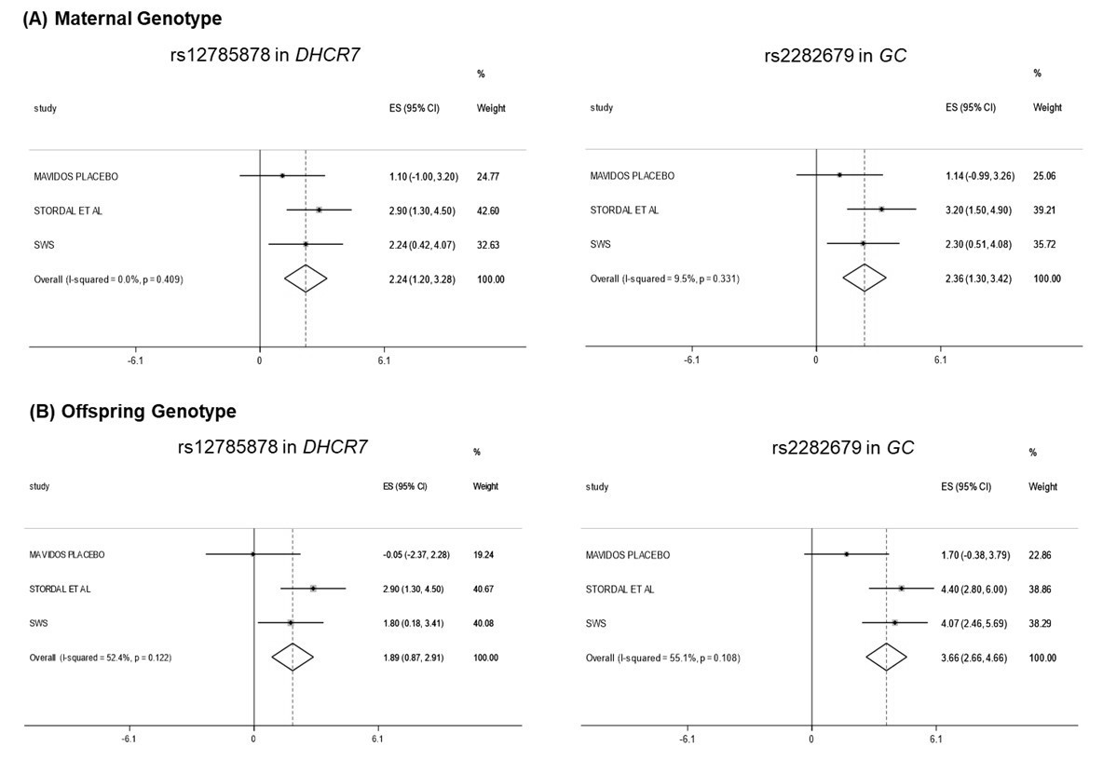
Figure 2: Associations between (A) maternal adjusted for offspring and (B) offspring adjusted for maternal genotype at rs12785878 and rs2282679 with umbilical cord blood 25(OH)D
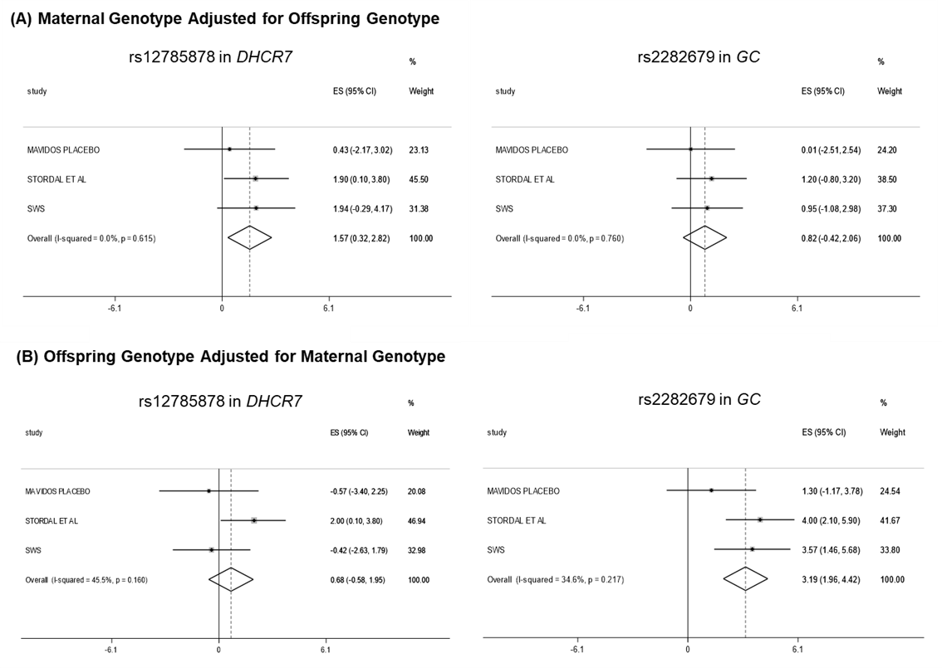

Supplemental Tables and Figures
The supplemental tables and figures are included here for the purpose of review only. On acceptance of the manuscript, this will be uploaded to a research repository.
Supplementary Table 1: Characteristics of mothers and offspring included in the SWS analysis and those not included (without a measure of umbilical cord blood 25(OH)D)
 |  | SWS Not included (n=1140) | SWS Included (n=847) | p
Age (years), mean (SD) |  | 27.6 (3.8) | 28.4 (3.8) | <0.001
Late pregnancy smoking, n (%) |  | 180 (17.1) | 85 (10.8) | <0.001
Educational attainment ≥ A level (high school), n (%) |  | 631 (55.5) | 512 (60.7) | 0.02
Pre-pregnancy BMI (kg/m²), mean (SD) |  | 25.2 (4.7) | 25.5 (4.9) | 0.17
Pregnancy weight gain (kg), mean (SD) |  | 10.6 (4.2) | 10.6 (4.2) | 0.88
Late pregnancy triceps skinfold thickness (mm), mean (SD) |  | 21.6 (6.7) | 21.7 (7.0) | 0.76
Parity 1+, n(%) |  | 594 (52.2) | 426 (50.4) | 0.43
White ethnicity, n(%) |  | 1092 (95.8) | 817 (96.5) | 0.45
Early pregnancy 25(OH)D, nmol/l |  | 64.2 (26.0) | 61.1 (25.5) | 0.02
Late pregnancy 25(OH)D, nmol/l |  | 61.8 (30.6) | 68.6 (31.3) | <0.001
Vitamin D supplement use in late pregnancy, n(%) |  | 486 (46.1) | 417 (52.7) | 0.005
Offspring
Female, n (%) |  | 555 (48.7) | 399 (47.1) | 0.49
Gestation at birth (weeks), median (IQR) |  | 40.1 (39.1,41.0) | 40.1 (39.1,41.1) | 0.77
Birthweight (g), mean (SD) |  | 3456 (516) | 3503 (513) | 0.04
Umbilical cord blood 25(OH)D, nmol/l |  | - | 31.9 (18.3)

Supplementary Table 2: Genotype frequencies in mothers and offspring included in the SWS cohort
 |  | Mothers  N (%) | Offspring  N (%)
rs12785878 (DHCR7), n(%)
 | G:G | 45 (7.1) | 62 (7.8)
 | T:G | 209 (33.1) | 258 (32.5)
 | T:T | 378 (59.8) | 474 (59.7)
rs10741657 (CYP2R1), n (%)
 | A:A | 91 (14.4) | 121 (15.2)
 | G:A | 319 (50.4) | 395 (49.7)
 | G:G | 223 (35.2) | 279 (35.1)
rs6013897 (CYP24A1), n (%)
 | A:A | 18 (2.9) | 40 (5.0)
 | T:A | 213 (33.7) | 238 (30.0)
 | T:T | 401 (63.5) | 516 (65.0)
rs2282679 (GC), n (%)
 | C:C | 54 (8.5) | 61 (7.8)
 | C:A | 263 (41.6) | 342 (43.0)
 | A:A | 316 (49.9) | 392 (49.3)

Supplementary Table 3: Characteristics of mothers and offspring included in the MAVIDOS analysis and those not included
 |  | MAVIDOS Not included | MAVIDOS Included | p
n |  | 615 | 350
Age (years), mean (SD) |  | 30.6 (5.1) | 30.9 (5.2) | 0.48
Late pregnancy smoking, n (%) |  | 41 (7.6) | 17 (5.7) | 0.31
Educational attainment ≥ A level (high school), n (%) |  | 459 (77.4) | 258 (77.7) | 0.91
Pre-pregnancy BMI (kg/m²), mean (SD) |  | 26.3 (5.0) | 26.3 (5.0) | 0.81
Pregnancy weight gain (kg), mean (SD) |  | 9.5 (3.6) | 9.6 (3.7) | 0.75
Late pregnancy triceps skinfold thickness (mm), mean (SD) |  | 21.8 (6.7) | 22.1 (7.5) | 0.57
Parity 1+, n(%) |  | 327 (55.1) | 197 (59.3) | 0.21
Early pregnancy 25(OH)D (nmol/l) |  | 46.2 (17.6) | 46.4 (16.3) | 0.84
White ethnicity, n(%) |  | 563 (94.8) | 317 (94.9) | 0.93
Compliance with study medication (%), median (IQR) |  | 95.5  (88.2,98.9) | 95.6  (88.6,98.9) | 0.95
Offspring
Female, n (%) |  | 276 (44.9) | 172 (49.1) | 0.20
Gestation at birth (weeks), median (IQR) |  | 40.3 (39.3,41.0) | 40.1 (39.1,40.9) | 0.69
Birthweight (g), mean (SD) |  | 3463 (563) | 3565 (459) | 0.004

Supplementary Table 4: Characteristics of participants in the MAVDIOS study
 |  | Placebo | Cholecalciferol 1000 iu/day
n |  | 185 | 165
Age (years), mean (SD) |  | 30.8 (5.4) | 30.9 (5.0)
Late pregnancy smoking, n (%) |  | 8 (5.0) | 9 (6.5)
Educational attainment ≥ A level (high school), n (%) |  | 132 (75.9) | 126 (79.8)
Pre-pregnancy BMI (kg/m²), mean (SD) |  | 26.5 (5.1) | 26.2 (4.8)
Pregnancy weight gain (kg), mean (SD) |  | 9.9 (3.7) | 9.2 (3.7)
Late pregnancy triceps skinfold thickness (mm), mean (SD) |  | 22.7 (7.6) | 21.5 (7.3)
Parity 1+, n(%) |  | 96 (54.6) | 101 (64.7)
White ethnicity, n(%) |  | 165 (93.8) | 152 (96.2)
Compliance with study medication (%), median (IQR) |  | 93.7 (88.2,98.9) | 96.3 (90.2,98.9)
Early pregnancy 25(OH)D (nmol/l) |  | 46.5 (16.3) | 46.2 (16.4)
Late pregnancy 25(OH)D (nmol/l) |  | 44.0 (24.2) | 70.7 (22.9)
Maternal genotype
rs12785878 (DHCR7), n(%)
 | G:G | 16 (9.3) | 8 (5.1)
 | T:G | 59 (34.1) | 61 (39.1)
 | T:T | 98 (56.7) | 87 (55.8)
rs10741657 (CYP2R1), n (%)
 | A:A | 21 (12.4) | 22 (14.0)
 | G:A | 85 (50.0) | 72 (45.9)
 | G:G | 64 (37.7) | 63 (40.1)
rs6013897 (CYP24A1), n (%)
 | A:A | 9 (5.3) | 8 (5.2)
 | T:A | 58 (33.9) | 40 (25.8)
 | T:T | 104 (60.8) | 107 (69.0)
rs2282679 (GC), n (%)
 | C:C | 18 (10.5) | 15 (9.6)
 | C:A | 78 (45.6) | 70 (44.9)
 | A:A | 75 (43.9) | 71 (45.5)
Offspring
Female, n (%) |  | 94 (50.8) | 78 (47.3)
Gestation at birth (weeks), median (IQR) |  | 40.3 (39.3,41.0) | 40.1 (39.1,40.9)
Birthweight (g), mean (SD) |  | 3546 (484) | 3586 (429)
Umbilical cord blood 25(OH)D (nmol/l) |  | 28.6 (12.1) | 42.3 (13.1)
Offspring genotype
rs12785878 (DHCR7), n(%)
 | G:G | 9 (5.6) | 9 (6.3)
 | T:G | 58 (35.8) | 56 (39.2)
 | T:T | 95 (58.6) | 78 (54.6)
rs10741657 (CYP2R1), n (%)
 | A:A | 27 (17.2) | 17 (11.8)
 | G:A | 79 (50.3) | 63 (43.8)
 | G:G | 51 (32.5) | 64 (44.4)
rs6013897 (CYP24A1), n (%)
 | A:A | 4 (2.5) | 2 (1.4)
 | T:A | 53 (33.5) | 39 (27.1)
 | T:T | 101 (63.9) | 103 (71.5)
rs2282679 (GC), n (%)
 | C:C | 17 (10.5) | 12 (8.5)
 | C:A | 69 (42.6) | 64 (45.1)
 | A:A | 76 (46.9) | 66 (46.5)

Supplementary Figure 1: Meta-analysis of associations of (A) maternal and (B) offspring genotype at rs10741657 and rs6013897 with umbilical cord blood 25(OH)D
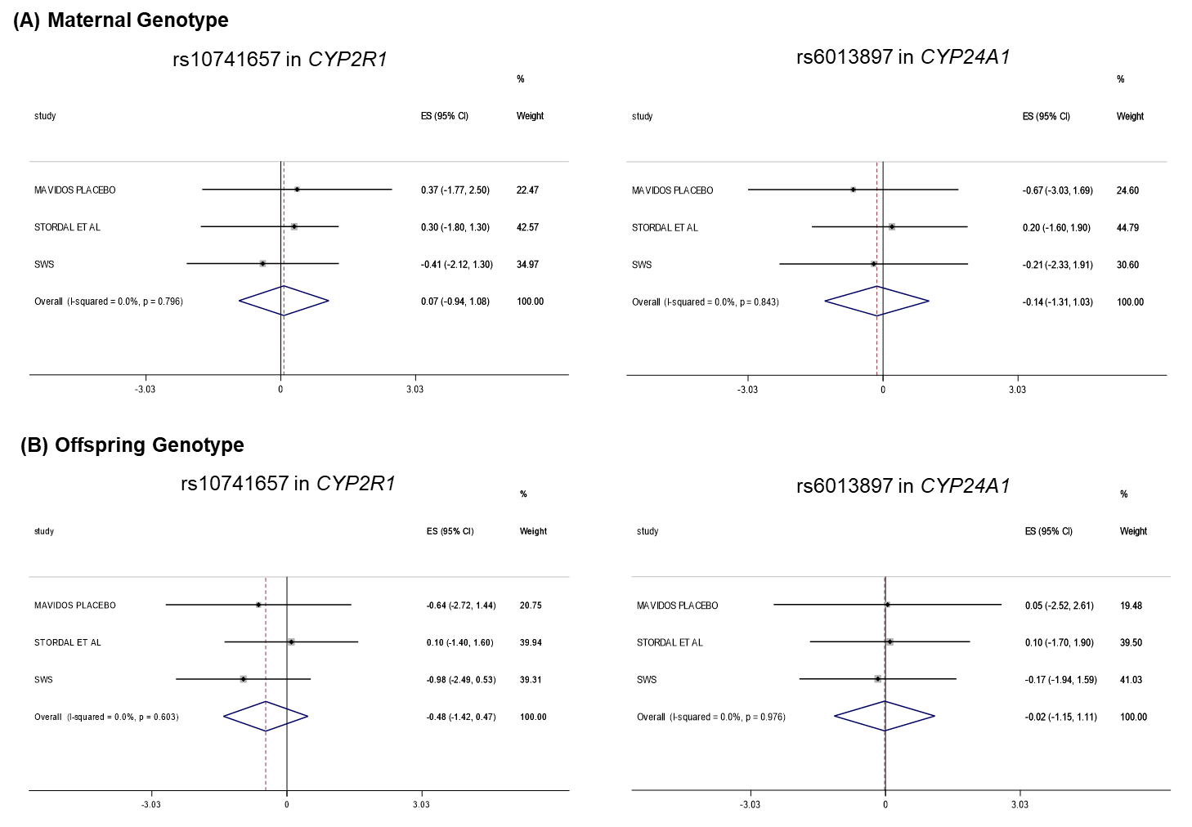

Supplementary Figure 2: Meta-analysis of associations of (A) maternal adjusted for offspring genotype and (B) offspring adjusted for maternal genotype at rs10741657 and rs6013897 with umbilical cord blood 25(OH)D