Predictable Changes in Extreme Sea Levels and Coastal Flood Risk Due To Long-Term Tidal Cycles
Alejandra R. Enríquez¹, Thomas Wahl¹, Hannah E. Baranes², Stefan A. Talke³, Philip M. Orton⁴, James F. Booth⁵, Ivan D. Haigh⁶

¹Department of Civil, Environmental and Construction Engineering, National Center for Integrated Coastal Research, University of Central Florida, Orlando, FL, USA, ²Gulf of Main Research Institute, Portland, ME, USA, ³Department of Civil and Environmental Engineering, California Polytechnic State University, San Luis Obispo, CA, USA, ⁴Davidson Laboratory, Department of Civil, Environmental and Ocean Engineering, Stevens Institute of Technology, Hoboken, NJ, USA, ⁵Department of Earth and Atmospheric Sciences, City College of New York, City University of New York, New York, NY, USA, ⁶School of Ocean and Earth Science, National Oceanography Centre Southampton, University of Southampton, Southampton, UK

Corresponding author: Alejandra R. Enriquez (a.enriquez@ucf.edu)

Key Points:
- Long-term tidal cycles (4.4-yr and 18.6-yr) modulate extreme sea levels and affect estimates of flood risk
- The timing of the peak of both modulations is influenced by the relative importance of each cycle over the total amplitude
- Tidally-induced changes in extreme sea levels affect estimates of total inundation area

Keywords: nodal cycle, tide, flood mapping, flood hazard, extreme sea levels.

Abstract
We demonstrate that long-term tidally-induced changes in extreme sea levels affect estimates of major flood hazard in a predictable way. Long-term variations in tides due to the 4.4-yr and 18.6-yr cycles influence extreme sea levels at 380 global tide gauges out of a total of 581 analyzed. Results show coherent regions where the amplitudes of the modulations are particularly relevant in the 100-year return sea level, reaching more than 20 cm in some regions (western Europe, north Australia, and Singapore). We identify locations that are currently in a positive phase of the modulation and therefore at a higher risk of flooding, as well as when (year) the next peak of the long-term tidal modulations is expected to occur. The timing of the peak of the modulation is spatially coherent and influenced by the relative importance of each cycle (4.4-yr or 18.6-yr) over the total amplitude. An evaluation of four locations suggests that the potentially flooded area in a 100-year event can vary up to ~45% (in Boston) as a result of the long-term tidal cycles; however, the flooded area varies due to local topography and tidal characteristics (6-13%). We conclude that tidally-modulated changes in extreme sea levels can alter the potentially inundated area in a 100-year event and that the traditional, fixed 100-year floodplain is inadequate for describing coastal flood risk, even without considering sea-level rise.

Plain Language Summary
Interannual and decadal (long-term) variations in tides modulate extreme sea levels, increasing the risk of flooding at specific and predictable times. Here, we use a dataset of 581 tide gauges to estimate the magnitude of the long-term tidally induced changes in extreme sea levels as well as to identify the timing of the peak of the modulations. We find significant amplitudes of the long-term tidal modulations in extreme water levels. We conclude that the long-term modulations in tides influence the total inundation area and, therefore, they should be taken into account when assessing coastal vulnerability.

- Introduction
Flooding can severely impact coastal communities, producing large economic losses, damage to critical infrastructure, and casualties. In the United States (U.S.), annual damages caused by extreme sea levels typically exceed tens of billions of dollars (Kron, 2013) and they are expected to increase due to mean sea-level rise and the continued population growth along the coasts (Preston, 2013; Titus et al., 2009). Indeed, hurricane and flood losses, including riverine and coastal, have already tripled over the past fifty years (Gall et al., 2011). Local-scale flood mapping and vulnerability assessments are often developed to aid in adaptation planning (some examples are Gesch et al., 2020; Maloney and Preston, 2014; Rao et al., 2020; Ward et al., 2011). Such flood maps often determine land-use policies, flood mitigation strategies, and infrastructure development. In the United States, the Federal Emergency Management Agency (FEMA) determines flood insurance requirements based on flood maps; owners, renters, and businesses in FEMA-designated zones with a 1% annual recurrence probability of flooding are required to purchase flood insurance on federally-backed loans.
Coastal flood maps and hazard assessments in a regulatory framework are typically developed under the assumption of stationarity. That is, all components of the water-level spectrum (mean sea level variability, astronomical tides, meteorologically induced storm surges, waves, etc.) are assumed to be unaffected by long-term trends or predictable cycles, after removing the effects of mean sea-level rise. However, astronomical tides are a quasi-deterministic part of measured water levels, and they strongly influence coastal water levels at daily, fortnightly, seasonal, interannual, and decadal time scales. Interannual and decadal variations in tides mainly result from the 4.4-yr cycle and 18.6-yr cycle. The 4.4-yr tidal modulations in extreme tide levels are explained in the following (the reader is referred to Ray and Merrifield (2019) for a more detailed explanation): Spring tides result from the astronomical alignment of the Sun, Moon, and Earth, which occurs approximately twice a month. The spring tides are exacerbated when the astronomical alignment coincides approximately with the Moon’s perigee (the least distance between the Moon and the Earth), leading to the so-called “perigean spring tides”. This coincidence happens approximately twice a year. The perigean spring tides are further exacerbated every ~4.4 years. The process leading to the 4.4-yr modulation differs between the semidiurnal and the diurnal tidal regime areas. In the semidiurnal tidal regimes, the perigean spring tides peak when the perigee crosses an equinox (the time when the plane of the Earth’s equator passes through the geometric center of the Sun). This happens every ~4.4 years because the perigee processes in an 8.85-yr cycle, and crosses the equinoxes twice during its cycle. On the other hand, the 4.4-yr modulation in diurnal tidal regimes depends on the Sun declination; the ~ 13.7 day modulation in diurnal tides is maximal when the Sun is at a maximum declination, i.e., the angle between the rays of the Sun and the plane of the Earth’s equator. On the other hand, the 18.6-yr nodal cycle is produced by the relative movement of the plane in which the Moon orbits the Earth. This plane is inclined at 5° 09’ to the plane of the ecliptic (the plane in which the Earth orbits the Sun, (Ray, 2007)) and precesses slowly over a period of ~18.6-yr, affecting the short-period tides at the same frequency (Pugh & Woodworth, 2014b). The 4.4-yr and 18.6-yr tidal cycles are referred to as long-term tidal cycles hereinafter.
Recent studies have shown that the long-term tidal cycles can lead to more recurrent minor tidal flooding, resulting in substantial socio-economic disruptions and damages (Li et al., 2021; Ray & Foster, 2016; Thompson et al., 2021). Long-term tidal cycles have been also reported in high tide levels at a global scale either using numerical models (Haigh et al., 2011) or tide gauge observations (Menéndez & Woodworth, 2010; Peng et al., 2019). However, long-term tidal modulations in low-frequency, high impact extreme sea levels have been only assessed regionally. In the Gulf of Maine, U.S., the 18.6-yr cycle drives decadal-time scale variability in the 10- and 100-yr return levels at a rate exceeding the historical rate of sea-level rise (Baranes et al., 2020; Talke et al., 2018). Along the western Australian coast, the long-term tidal amplitudes in the 20-yr return tide levels can reach 7 and 9 cm, respectively (Eliot, 2010). Sobey (2005) also identified the 18.6-yr cycle in the 10-, 50-, and 100-yr return sea levels at the San Francisco tide gauge.
Here, we assess the impact of long-term tidally-induced variations in flood hazard by studying the 4.4-yr and 18.6-yr cycles in low-frequency extreme sea levels (100-yr return period) using global tide gauge observations. To do so, we use the quasi-nonstationary skew surge joint-probability method (qn-SSJPM) of Baranes et al. (2020). No studies, to our knowledge, have assessed how tidally-induced modulations in extreme sea levels can change the potentially flooded area under given extreme sea levele events, and thus, the consequences for inundation go unaddressed. Hence, we also evaluate how important these variations are for flood inundation.
The study is structured in two main sections, we first assess the long-term tidal cycles in the 100-yr annual extreme sea levels at a global network of 581 tide gauges. To do so, we combine the skew surge levels and the astronomical tides to obtain the amplitude and peak timing of the long-term tidally-induced changes in the annual 100-yr return sea levels at the tide gauges. We also analyze the relative importance of 18.6-yr versus 4.4-yr cycles in the 100-yr return sea levels. In the second part, we assess the tidally-driven variation in the spatial extent of flooding for four U.S. coastal cities: Boston (Massachusetts), Santa Barbara (California), Miami (Florida), and South San Francisco Bay (California), where digital elevation model (DEM) with high spatial resolution are available.

- Data
Two main sources of data are used in this study: (1) water level records, and (2) elevation data. These are described in turn below.

  - Observed water levels
We use hourly water level observations from the Global Extreme Sea Level Analysis (GESLA-3; Haigh et al., 2021). The GESLA-3 database contains 5,119 water level records with hourly or higher temporal frequency from tide gauges located along the global coasts. The tide gauge records in GESLA-3 are retrieved from a range of different sources, including the University of Hawaii Sea Level Center (UHSLC, Caldwell and Merrifield, 2015), the Japan Meteorological Agency (JMA), the National Tidal Centre Australia (NTCA), the National Oceanic and Atmospheric Administration (NOAA), and the British Oceanographic Data Centre (BODC). Out of the 5,119 records in GESLA-3, we select a subset of 581 records according to the following criteria:
- Coastal tide gauges: GESLA-3 includes river, lake, and coastal tide gauges. Only coastal tide gauges are included in the analysis. 4,159 tide gauges remain after removing tide gauges in lakes and rivers.
- Record length and completeness: In order to ensure robust results from the tidal harmonic analysis (Section 3.1), only years with at least 70% data completeness are analyzed. In addition, to evaluate the effect of the 4.4-yr and 18.6-yr cycles, only stations with record lengths >30 years are used. A total of 822 time-series remain after applying these criteria.
- Duplications: For some stations, the same water level information is retrieved from different providers, creating duplications. In such cases, we retain the longest record available. After removing duplicates, 665-time series remain.
- Quality check: After performing the tidal calculation, water level records are visually checked, and physically unrealistic jumps in water levels are removed. Also, tide gauges with visible changes in the datum were removed. After the quality check, the 70% completeness and 30-year length criteria were again applied, resulting in a total of 581 tide gauges. Tide gauges and data removed in the quality check is included in Table S1 (Supplementary Material).

  - Digital elevation models
Digital elevation models (DEM) for Santa Barbara, South San Francisco Bay, Boston, and Miami (U.S.) are based on high-resolution LiDAR data downloaded from the NOAA Digital Coast Data Access Viewer (NOAA, 2021). The name and resolution of the LiDAR dataset used in each study area as well as their horizontal resolution are shown in Table 1. Each LiDAR dataset is composed of several TIFF-format files, from which we only use those including topographic information along the coast. In the case of South San Francisco Bay, we reduce the horizontal point spacing from 0.7 cm (the original point LiDAR resolution) to 3 meters in order to alleviate the computational and time demand when deriving the flooding maps (Section 3.5). The vertical datum of each LiDAR dataset is adjusted to reflect the datum (mean sea level) corresponding to the closest tide gauge included in our dataset (the datums used in the present study can be found in NOAA, 2022).

Table 1. Name and spatial resolution of the LiDAR datasets used in each study case.
Study area | Lidar dataset | Spatial resolution (m)
California | 2002/2003 IfSAR data for Southern California | 3
South San Francisco Bay | 2010 USGS Lidar: San Francisco (CA) | 3
Boston | 2009 Boston & Cambridge (MA) | 1
Miami | 2018 Miami-Dade County ITD Lidar DEM | 1.5

- Methods
  - Tidal analysis
Water levels recorded at each tide gauge (Section 2.1) are the sum of mean sea level, astronomical tide, and the non-tidal residual (i.e., observed water level minus astronomical tide and mean sea level). Given that most cities and tide gauges are located inside estuaries and wave-sheltered embayments, the effect of wave breaking raising mean water levels has a minimal effect on the residual, and thus, we neglect this component. Before performing the tidal analysis, we first remove the influence of mean sea level variation by subtracting a 12-month moving average from the hourly water level time series. Then, two types of astronomical predicted tides are obtained at each site:
- Time series of predicted astronomical tides where the nodal modulation has
been included in the tidal analysis, and therefore, the nodal cycle is not included in the time series of astronomical predicted tides (hereinafter referred as AT);
- Predicted astronomical tides calculated without nodal corrections; thus, the modulation remains in the predicted astronomical tides (referred to as ATNodal).
AT and ATNodal are estimated at each station using the MATLAB U-Tide harmonic analysis tool (Codiga, 2011). U-tide is applied using the least-squares method, white noise floor assumption for confidence intervals, and an automated choice of constituents resulting in 67 tidal constituents per year on average. The tidal analysis was performed on 369 day periods (12.5 lunar months) to consider a time span close to multiples of the synodic periods of the short-term tidal constituents. AT is used to obtain the skew surge levels (Section 3.2) while ATNodal allows us to assess the influence of the long-term tidal cycles in extreme sea levels by combining the skew surge and ATNodal (Section 3.3).

  - Skew surge
Before calculating the skew surge levels, we fit a 6-minute cubic spline function to the hourly measured water levels and AT to reduce the peak truncation by the hourly time resolution (Baranes et al., 2020). For consistency, the 6-minute fitting is also applied to the ATNodal. Skew surges are calculated as the difference between the maximum observed water level (after detrending) and the maximum predicted AT within each tidal cycle, regardless of its timing. Here, tidal cycle refers to the daily or higher frequency cycle of the astronomical tide (see Pugh & Woodworth, 2014b for a detailed description of skew surge).

  - Probability distribution of sea levels
Following Baranes et al. (2020), we use the quasi-nonstationary skew surge joint-probability method (qn-SSJPM) to derive the probability distribution of sea levels (i.e., the sum of the astronomical tide and skew surge above annual mean sea level). The qn-SSJPM method fits separate probability distributions to skew surge and the astronomical tide and convolves the two to obtain the joint sea-level distribution. Here, we use the ATNodal as the astronomical tide in order to account for the long-term tidal cycles.
The probability distribution function is obtained separately for extreme and non-extreme skew surge events. In the present study, we define extreme events as those above the 0.997th percentile calculated at each station (similar thresholds were chosen in past studies: Arns et al., 2013; Baranes et al., 2020; Menéndez & Woodworth, 2010). We derive the empirical probability for the non-extreme skew surge values through the Weibull formula:
${\tilde{F}}_{SS}\left(x_{i}\right)= \frac{i}{n+1}$ (1)
where $x_{i}$ is the ith-largest skew surge and n the total number of skew surges. For values above the threshold, a Generalized Pareto Distribution (GPD) is fitted to represent the upper tail of the distribution:
$G_{ss}\left(x\right)=1-{\left(1+ξ\frac{x-μ}{σ}\right)}^{-1/ξ}$ (2)
where $ξ$ (≠0) and $σ$ (>0) are the shape and scale parameters, respectively, and $μ$ is the threshold. The cumulative distribution function of all skew surges $F_{ss}(x)$ is
$F_{ss}\left(x\right)=\left\{\begin{aligned}{\tilde{F}}_{SS}(x), &x<μ \\ \left(1-0.997\right)*G_{ss}\left(x\right) + 0.997, &x≥μ\end{aligned}\right.$ (3)
The probability distribution of sea levels ($F_{SL}$) is calculated by computing the joint probability of the resulting skew surge distribution function and the ATNodal. Thus, we assume that the skew surge is independent of the tidal cycle, which has been shown to be statistically supported at most (though not all) coastal locations in past studies (Baranes et al., 2020; Batstone et al., 2013; Santamaria-Aguilar & Vafeidis, 2018; Williams et al., 2016). The distribution function for the maximum sea level within a tidal cycle is,
$F_{SL}\left(z\right)= {\left[Π_{t=1}^{M}F_{SS}(z-P_{t})\right]}^{1/M}$ (4)
where $z$ is the sea level, $P_{t}$ is the peak astronomical tide level at each cycle $t$, $M$ is the total number of peak astronomical tide levels, and $F_{SS}$ is the cumulative distribution function of all skew surges. Tides are convolved with 1,000 skew surge GPDs and the 50th quantile of the resulting 1,000 sea levels are used to calculate the annual exceedances.
To satisfy the assumption of independence between extreme sea-level events, we apply the extremal index ($θ(z)$) to each sea level time series, thus removing the possible clustering of high sea levels corresponding to a single extreme event. As pointed out in Batstone et al. (2013), if this dependence between high sea levels is not accounted for, the return period of extreme events could be overestimated. Following Ferro and Segers (2003) and Baranes et al. (2020), the extremal index is the inverse of the mean cluster size:
$\frac{1}{θ_{0}(z)}=\frac{2{\left[\sum_{i=1}^{N-1}{\left(I_{i}-1\right)}\right]}^{2}}{\left(N-1\right)*\sum_{i}^{N-1}{\left[\left(I_{i}-1\right)*\left(I_{i}-2\right)\right]}}$ (5)
where $N$ is the number of measured sea levels exceeding $z$, and $I$ is the inter-exceedance time. The inter-exceedance time varies with the sea level time series and it is defined as the time difference between each value above the threshold. Thus, $θ=1$ when there is no clustering in the time series and $θ<1$ otherwise. We use the top 3,000 high sea levels $(z)$ as thresholds to calculate the extremal index at each tide gauge. Results are then fitted through a least-square regression of the form:
$θ(z)= 1+a*e^{-(b*z)}$ (6)
In the present paper, we focus on the annual extreme sea level corresponding to a 100-yr return period (hereinafter, 100-ESL), i.e., 1% annual chance. The return periods of extreme sea levels $T(z)$ are calculated as,
$T(z)={\left(θ\left(z\right)*N*\left[1-F_{SL}(z)\right]\right)}^{-1}$ (7)
Thus, we obtain time series of annual 100-ESL at each station.

  - Long-term tidal modulations in extreme sea levels
We fit a least-squares regression to the annual 100-ESL to estimate the tidally-induced changes in extreme levels:
$H\left(t\right)=β+β_{1}\left(t\right)+β_{2}\cos\left(\frac{2π}{4.4} t\right)+ β_{3}\sin\left(\frac{2π}{4.4} t\right)+ β_{4}\cos\left(\frac{2π}{18.6} t\right)+ β_{5}\sin\left(\frac{2π}{18.6} t\right)$ (8)
The amplitudes of the 4.4-yr and 18.6-yr modulation in 100-ESL are computed as
$A_{4.4}= \sqrt{β_{2}^{2}+β_{3}^{2}}$ (9)
$A_{18.6}= \sqrt{β_{4}^{2}+β_{5}^{2}}$ (10)
The total amplitude of the long-term tidal modulations in 100-ESL is defined as the sum of $A_{4.4}$ and $A_{18.6}$. The average 100-ESL ($β_{0}+ β_{1}\overline{t})$is then combined with the 4.4-yr and 18.6-yr amplitudes to assess the tidally-induced changes in flood hazard during a crest ($M_{C}$) and a trough ($M_{T}$) of the long-term tidal cycles:
$M_{C }= β_{0}+ β_{1}\overline{t} +A_{4.4}+A_{18.6}$ (11)
$M_{T }= β_{0}+ β_{1}\overline{t}-A_{4.4}-A_{18.6}$ (12)
Finally, the relative importance of the two cycles in modulating 100-ESL is calculated as the ratio of the amplitude of the 18.6-yr modulation in 100-ESL to the combined amplitude of 4.4-yr and 18.6-yr modulations:
$\frac{A_{18.6}}{A_{4.4}+A_{18.6}}$ (13)
The statistical significance of the long-term tidal modulations in 100-ESL is assessed by computing the 0.95 confidence interval of each parameter in Equation 8.

  - Mapping flood hazard
Changes in the flood extension derived from the tidally-induced variations in extreme sea levels are estimated for the four case studies (Section 2.2). We map the area inundated by the water level corresponding to the variation of the 100-ESL due to the long-term tidal cycles. We use a static inundation approach in which areas hydraulically connected with the sea and below a specific water level are considered flooded. The inundation method is developed in MATLAB by making use of a preprocessing image software package. Thus, we can identify the hydrologic connections with the sea and the extension of the flooded areas under different water levels with a low computational cost.
The methodology is based on the identification and delimitation of all independent polygons present in a two-dimensional grid. We convert the positive (land) and negative (water) values in the DEM into a mask of zeros and ones, respectively, transforming the DEM into a black and white image. We then apply the image preprocessing software to find all polygons included in the grid and identify those areas connected to the sea (i.e., included in the polygon defined as “sea”). The flooded area is obtained as the difference between the area of the “sea-polygon” under non-flooding conditions (i.e., the original DEM) and the area of the “sea-polygon” obtained after inundating the DEM (reducing the elevations by a specific water level).
We acknowledge that dynamic inundation models, if run at sufficiently high resolution to resolve urban infrastructure, could produce more accurate absolute results in terms of the flood extent, but our focus here is on assessing the differences when using two 100-ESL values modulated only by long-period tidal fluctuations. Hence the simplistic but computationally more efficient static approach is preferred.
The impact of the long-term tidal modulations in 100-ESL on the estimated flood extent is estimated by comparing the area flooded by a 100-ESL under a positive phase of the modulation and under a negative phase. The area flooded under a positive phase of both cycles, ${AF}_{C}$, is obtained by running the inundation tool under a $M_{C}$ water level, while $M_{T}$ is used to measure the area flooded in a negative phase, ${AF}_{T}$. The difference in the areas is then computed as the ratio in % of change over the largest flooded area:
$∆F= \frac{{AF}_{C}-{AF}_{T}}{{AF}_{C}} x 100$ (14)
Thus, $∆F$ is the ratio of change in flooded area.

- Results
  - Tidally-induced changes in 100-ESL
We find statistically significant long-term tidal modulations in 100-ESL at 380 of the 581 tide gauges (65.4%). The 4.4-yr cycle is present at 240 tide gauges while the 18.6-yr cycle is significant at 292 tide gauges (note that both cycles can be significant at the same tide gauge). Figure 1 shows, as an example, the annual (colored lines) and time-averaged (bold dashed black line) sea level exceedance curves for five sites located in areas with different tidal regimes: 1. Fremantle in Australia (diurnal), 2. San Francisco in the U.S. (mixed mainly semidiurnal), 3. Cristobal in Panama (mixed mainly diurnal), 4. Vigo in Spain (semidiurnal), and 5. Nagoya in Japan (mixed mainly semidiurnal). The tidal regime for each station is shown in Figure S1 (Supplementary Material). In some areas, such as Fremantle and San Francisco, a secular temporal evolution is clear; most recent return period curves are located above the time-averaged curve, i.e., a particular sea level would have a higher probability of occurrence in recent years. In Figure 1, the annual 100-ESL corresponds to those values falling on the vertical red dashed line.
Figure 2 displays the annual 100-ESL (black lines) as well as the harmonic fits (red bold lines) resulting from Equation 8, for the same five locations shown in Figure 1. Note that the long-term tidal modulations in 100-ESL in Freemantle, San Francisco, and Cristobal are out of phase with Vigo and Nagoya. The phases of the 4.4-yr and 18.6-yr signals depend on the form of the tide; based on equilibrium theory, when the nodal modulation of diurnal tides is at a maximum, the nodal modulation of semidiurnal tides is at a minimum (Pugh & Woodworth, 2014b). Thus, the results for Fremantle, Cristobal, Vigo, and Nagoya agree with the equilibrium theory. San Francisco, however, last peaked in 2008, corresponding with the nodal modulation of diurnal tides. This results reflects the strong diurnal signal in San Francisco (Parker, 2007; Zetler & Flick, 1985), the influence of diurnal constituents on Mean Higher High Water (MHHW), and their larger nodal variability. Astronomical forcing induces a 23% and 37.4% variability in the primary K1 and O1 constituents over half a nodal cycle, but only ~7.5% for M2 (Pugh, 1987). Since M2 (0.576 m) is approximately equal to the sum of the K1 and O1 constituents in San Francisco (0.6 m), the diurnal nodal cycle dominates the 100-ESL Similarly, mean tidal range and MHW follow the semidiurnal nodal cycle, whereas MHHW and the Great Diurnal Range follow the diurnal nodal cycle. In addition, within an estuary or confined coastal region, differences in the phase of the nodal modulation in high water levels can result from the bathymetry (Peng et al., 2019) and shallow-water interactions between semidiurnal and diurnal constituents (Andersen et al., 2006; Feng et al., 2015; Ray & Talke, 2019).

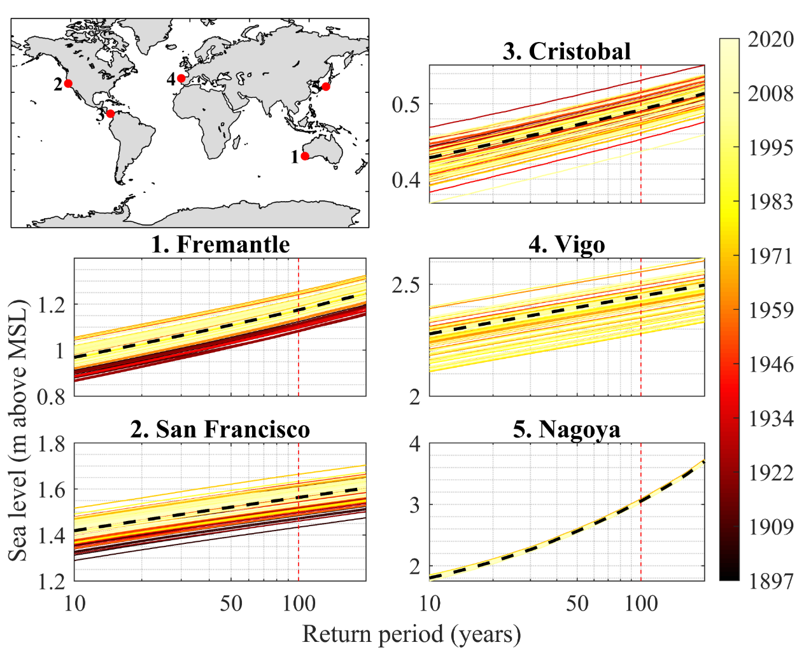
Figure 1. Annual exceedance curves (colored lines) for five locations: 1. Fremantle (Australia), 2. San Francisco (U.S.), 3. Cristobal (Panama), 4. Vigo (Spain), and 5. Nagoya (Japan). The annual exceedance curve for the full period is shown as a dashed black bold line. The annual 100-ESL are the values falling on the red dashed line.
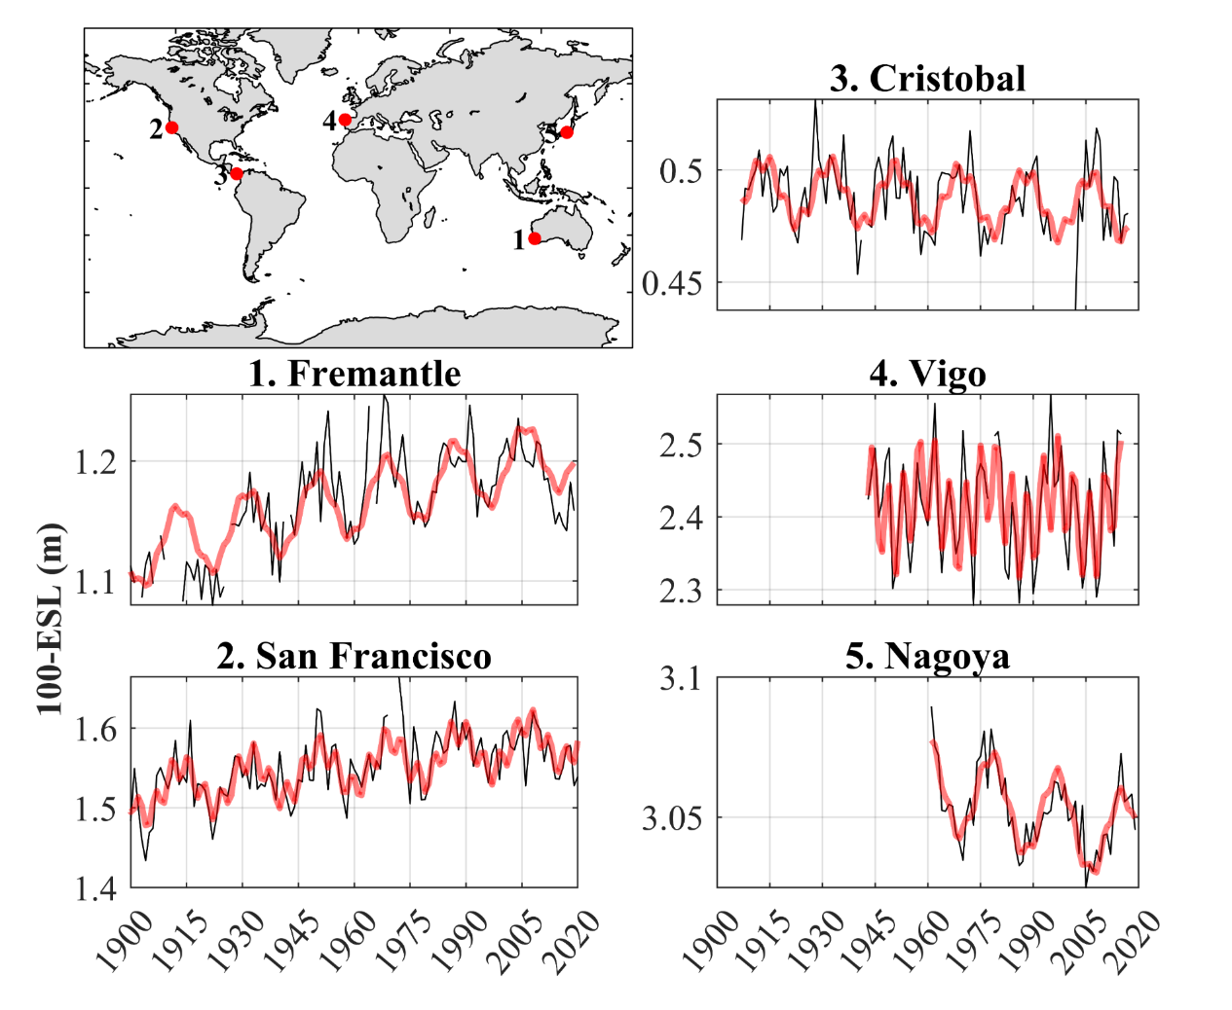
Figure 2. Annual 100-ESL (black line) and the harmonic analysis using 4.4-yr and 18.6-yr periods (red bold lines) for five sites located in different tide regimes: 1. Fremantle (Australia, diurnal tides), 2. San Francisco (U.S., mixed mainly semidiurnal tides), 3. Cristobal (Panama, mixed mainly diurnal tides), 4. Vigo (Spain, semidiurnal tides), and 5. Nagoya (Japan, mixed mainly semidiurnal tides).

The long-term tidal modulations in 100-ESL significantly increase the flood hazard during their positive phases and peaks. Identifying the timing of these peaks can help prepare for and mitigate coastal flood risk. Figure 3a shows the absolute value of the time difference (in years) between the year 2021 and the closest peak of the modulations. Peaks are defined as the highest value of the long-term tidal modulations in 100-ESL within the 18.6-yr cycle. When the 18.6-yr modulation in 100-ESL is statistically insignificant, the highest value within a 4.4-yr period is considered. An example of this methodology is shown in Figure S2 and Figure S3 (Supplementary Material). Note that the closest peak could occur before (black-red colors in Figure 3a) or after 2021 (green-yellow colors in Figure 3a). Only sites where the modulations in 100-ESL are significant are shown in Figure 3a. In general, there is regional coherence in the timing of the peak of the modulations in 100-ESL. Locations that will peak after 2021 are currently in an ascending phase of the modulation and therefore at a higher risk of flooding. Locations that peaked before 2021 are in the descending phase of the long-term tidal modulations in 100-ESL. White and light colors in Figure 3a show places where the modulations are peaking or close to the peak. Figure 3b shows the year of the next expected peak of the 4.4-yr and 18.6-yr, or both cycles, depending on which cycle is significant at each station. Stations where only the 4.4-yr cycle is significant are shown in light colors in both Figure 3a and Figure 3b because the cycle is shorter. On the other hand, a longer time scale is often observed at locations where the 18.6-yr cycle dominates. The timing of when the 18.6 year cycle peaks is not always perfectly phased with the semidiurnal or diurnal cycle, because of the contribution of both bands to extreme tides. Finally, places where both modulations are present take longer to peak, and the time span where the 100-ESL is higher due to the modulations, lasts longer. The San Francisco tide gauge shows a clear example of this (Figure S2, Supplementary Material). The relative importance of the 4.4-yr and 18.6-yr modulations in 100-ESL is shown in Figure 5.
Thompson et al. (2021) studied the influence of the long-term tidal cycles in the frequency of high-tide flooding along the U.S. coast, identifying a pronounced inflection before mid-century. Our results agree with theirs; the next peak of the next long-term tidal modulations in 100-ESL is expected to occur before mid-century along the U.S. coast (Figure 3b). However, some differences are found in our analysis. For example, Thompson et al. (2021) showed that the long-term tidal cycles peak just before 2024 in St Petersburg (western Florida) while our results indicate that the long-term tidal modulations in 100-ESL will peak in 2026.

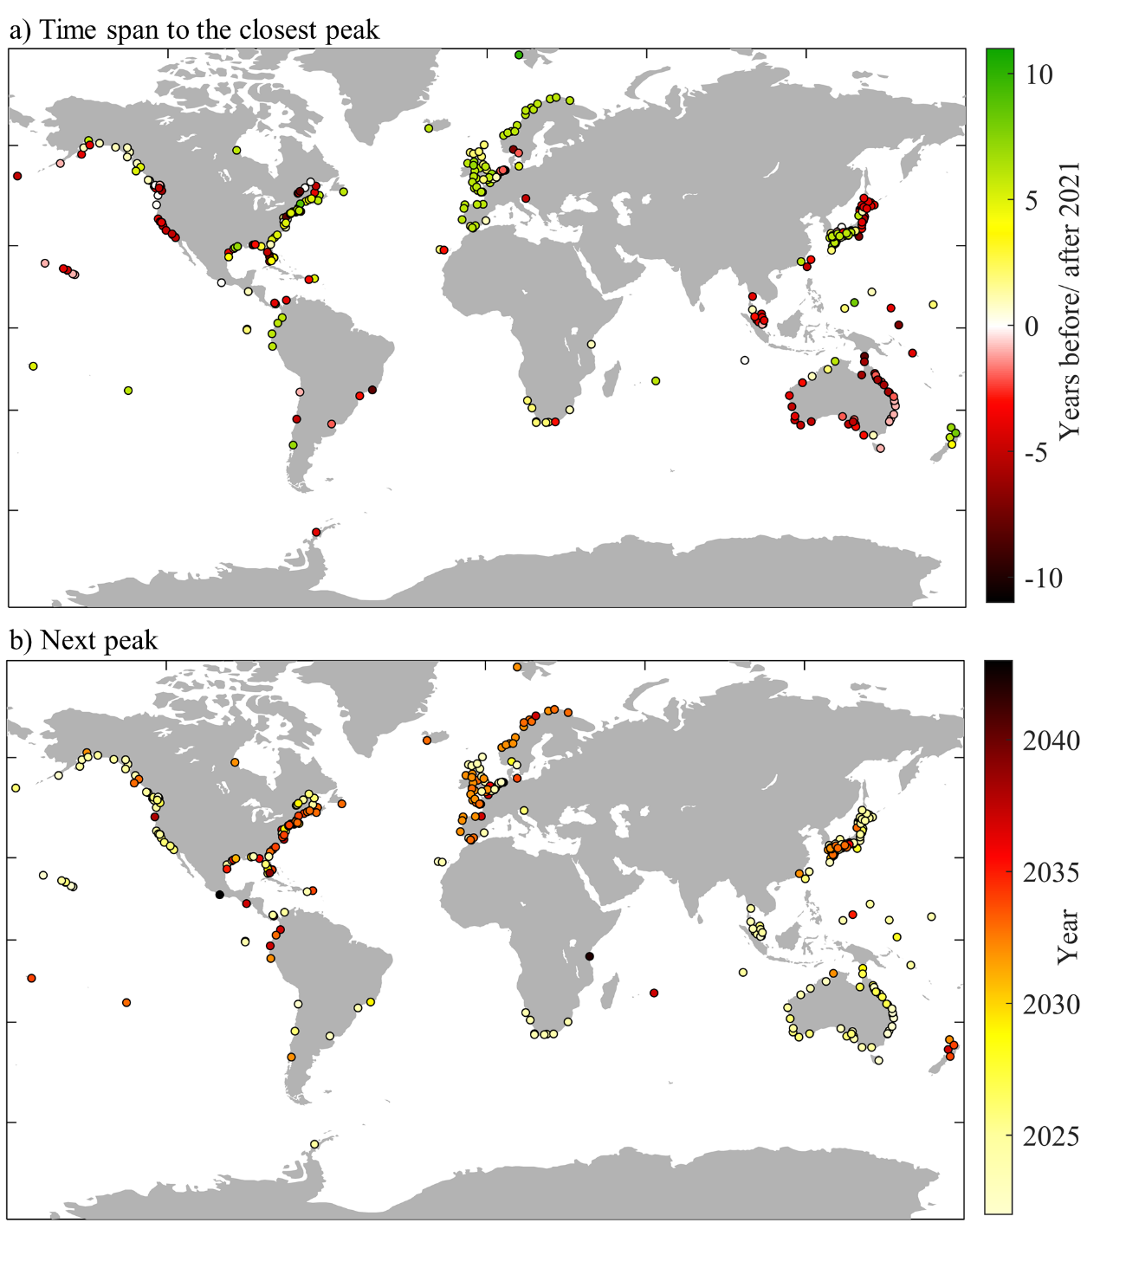
Figure 3. a) Time difference in years between the closest peak of the long-term tidal modulations in 100-ESL and the year 2021. Black-red colors indicate sites where the modulation peaked before and in 2021 while green-yellow colors show places where the modulation peaks after 2021. b) Timing (in years) of the next peak of the long-term tidal cycles. Tide gauges where the modulations in 100-ESL are statistically insignificant are not included in the figure.

The total amplitudes of the long-term tidal modulations in 100-ESL are plotted for all stations in Figure 4. The maximum influence of the signal is located in western Europe, northern Australia, and Singapore, where it can increase/decrease the 100-ESL by more than 20 cm. The modulations are also relevant in the eastern coast of China (~13cm), the Pacific coast of Panama (~18cm), southern Alaska (~14cm), and at some locations in the Gulf of Mexico (~18cm). In order to show the spatial variability of the modulations in the 100-ESL, the results are shown separately for six regions in figures S5 to S10 (Supplementary Material). Overall, areas with higher influence of the long-term tidal modulations in 100-ESL overlap with areas where the modulations are also important in the annual maxima of astronomical tides (Figure S4, Supplementary Material). There are two exceptions, the tide gauges of Galveston and Sabine Pass, where the amplitude of the long-term tidal modulations are ~3cm in the annual maxima predicted tides (Figure S1) but increases up to ~11cm in the 100-ESL (Figure 4). Tide gauges with statistically insignificant long-term tidal modulations in 100-ESL are located mainly in the Baltic Sea and the Gulf of Bothnia, where tides are small (Medvedev et al., 2013; Medvedev et al., 2016). Results agree with the small 4.4-yr and 18.6-yr modulations in the annual predicted astronomical tides in the Baltic Sea and the Gulf of Bothnia (Figure S4).
Although the results are not directly comparable due to differences in defining extreme water levels and in the methodology, the spatial patterns of the long-term tidal modulations in 100-ESL agree with those found in monthly mean high water levels by Peng et al. (2019). These authors used water level records from tide gauges located along the global coasts. Similar to what we show here, Peng et al. (2019) found a strong effect of the 18.6-yr cycle on the Bay of Fundy, Gulf of Alaska, Panama, and southern Chile. They also found a strong influence of the 18.6-yr signal in the Gulf of Tonkin; however, we don’t have tide gauges in that area due to our data selection criteria. In Europe, Peng et al. (2019) showed that the amplitude of the long-term tidal modulation in the monthly mean high water levels was large (compared to the neighboring sites) in the Bristol area and the English channel. Our results show that the amplitudes of the modulations in 100-ESL are also large in many other tide gauges located along the west coast of Europe. In Australia, Peng et al. (2019) found a large influence of the 18.6-yr signal on the northwestern coast while we also find a high amplitude of the long-term tidal modulations along the northeastern coast.
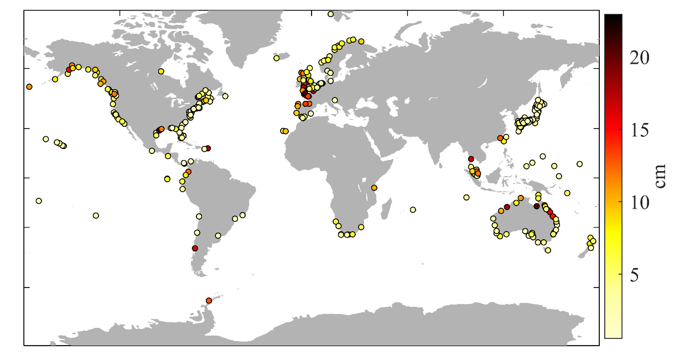
Figure 4. Amplitude (cm) of the long-term tidal modulations in 100-ESL. Tide gauges where the long-term tidal modulations in 100-ESL are statistically insignificant are not included in the figure.

We also analyze the relative importance of the two cycles in modulating 100-ESL by calculating the relative contribution of the nodal cycle to the total amplitude of the 4.4-yr versus 18.6-yr signals (Equation 13, Section 3.4). Figure 5 shows spatial coherence across sites and a general agreement with the diurnal and semidiurnal spatial pattern of tides (Figure S1, Supplementary Material). Note that, although there is a general tendency for the 4.4-yr cycle to influence sea levels in semidiurnal tidal zones and the 18.6-yr cycle to influence sea levels in diurnal tides zones, both modulations may be present for either tidal regime. The 100-ESL in Europe are predominantly modulated by the 4.4-yr cycle; however, the 18.6-yr modulation is more prominent in the North Sea, and along the west and north coasts of Norway (both semidiurnal regions).
The coasts of Japan also show spatial coherence in the long-term tidal modulations in 100-ESL, with two clusters; the northern coast is dominated by the 18.6-yr signal while the 4.4-yr signal is more relevant in the south. The 18.6-yr modulation is again more predominant along the coast of Taiwan and its surroundings with the exception of Xiamen in China. Spatial coherent clusters are found along the coasts of Australia; the southern coast is predominantly influenced by the 18.6-yr cycle while the 4.4-yr is more important in the north and east. Overall, the 18.6-yr cycle is the predominant modulation in 100-ESL on the southeastern coast of the U.S. and Canada and the 4.4-yr modulation becomes relevant on the northern and eastern coast of Canada. Finally, the 100-ESL in South Africa are predominately dominated by the 4.4-yr cycle. The spatial coherence of the long-term tidal signal in 100-ESL is more difficult to assess in South Africa, South America, and the Pacific islands due to the scattered locations where the long-term tidal modulations are statistically significant in 100-ESL.

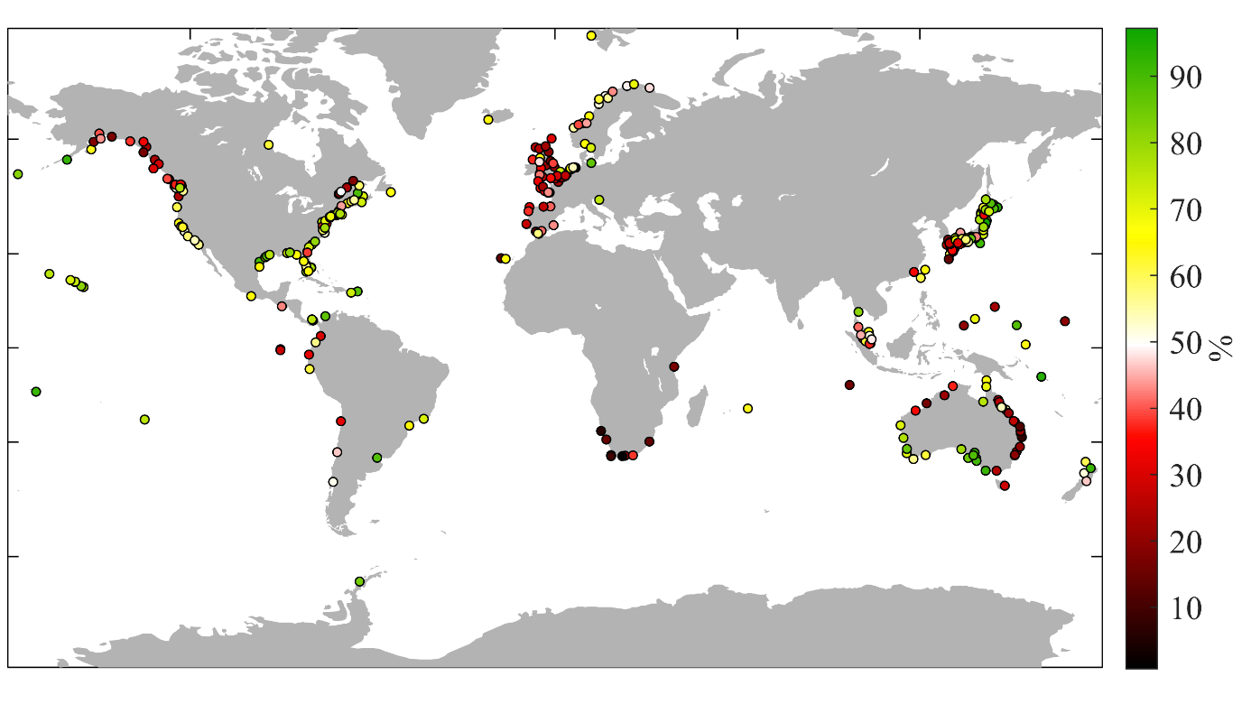
Figure 5. Relative importance (in %) of the 18.6-yr signal to the total amplitude of the long-term tidal modulations in 100-ESL at sites where the overall amplitude is significant. Green-yellow colors indicate a higher influence of the 18.6-yr nodal signal while black-red colors indicate a higher influence of the 4.4-yr signal in 100-ESL. White color represents an equal presence of both cycles (50%).

  - Influence of long-term tidal modulations in 100-ESL in inundation modeling
Finally, we evaluate the impact of the long-term tidal modulations in 100-ESL on the estimated flood extent for four case study sites: Boston, Miami, South San Francisco Bay, and Santa Barbara. As an example, the difference between the area flooded under a positive (${AF}_{C}$) and a negative (${AF}_{T}$) phase is shown for San Francisco Bay in Figure 6.
We calculate how much area is flooded under a positive phase of the long-term modulations in comparison with the area flooded under a negative phase of both signals in % ($∆F$, Equation 14, Section 3.5). Note that the positive phase is defined as the peak of the combined 4.4-yr and 18.6-yr modulations in ESL (Section 3.4), thus representing the worst case scenario regarding flood risk resulting from the long-term modulations. Table 2 shows the area covered by the DEM used for each case study, the range of the long-term tidal modulations in 100-ESL found in the closest tide gauge to each site, and the resulting $∆F$.
Results show that changes in 100-ESL derived from long-term tidal variations lead to differences in potential flood extents of up to ~45% in Boston. This is almost four times the relative contribution of mean sea-level rise (0.82 m under an RCP8.5 scenario by 2100, relative to the period of 1986-2005, IPCC, 2013) to the area vulnerable to flooding under a category 3 storm on the coast of Massachusetts (12.2%, Figure 4 in Maloney and Preston, 2014). Changes for the other locations are smaller; 12.9% in South San Francisco Bay, 6% in Santa Barbara, and 11% in Miami. Differences among sites arise from the variation in characteristics of each area, including the amplitude of the 4.4-yr/18.6-yr modulations in 100-ESL and the steepness of the coastal topography. For example, tidal constituents are small in Miami and the 18.6-yr cycle is not prominent (M₂ ~ 0.3m, Haigh et al., 2011). The difference between Santa Barbara and San Francisco, both in California with similar mixed, semidiurnal forcing, demonstrates the influence of local variations. The greater potential inundation in South San Francisco Bay is likely attributable to generally steeper topography in Santa Barbara (see also Barnard et al. (2019)). Note that the flooded areas are zones below the 100-ESL elevation and hydraulically connected to the sea according to the DEM; however, the actual inundation area is also affected by flood pathways, drainage, pumps, and other civil infrastructure, which is not accounted for here.

Table 2. The area flooded (km²) by 100-ESL under a positive and negative long-term tidal cycles. The first column depicts the area over which the flood mapping analysis is performed. The range (cm) of the long-term tidal modulations in 100-ESL is shown in the second column. The ratio between the area flooded under a positive and negative phase is shown in the last column (∆F, in % of change, Equation 14).
 | Study area (km²) | Range of 4.4-yr/18.6-yr modulations in 100-ESL (cm) | ∆F (%)
Boston | 98.3 | 10.5 | 44.7
South San Francisco Bay | 2,435 | 7.9 | 12.9
Santa Barbara | 178.2 | 12.4 | 6.4
Miami | 330 | 3.1 | 11.1

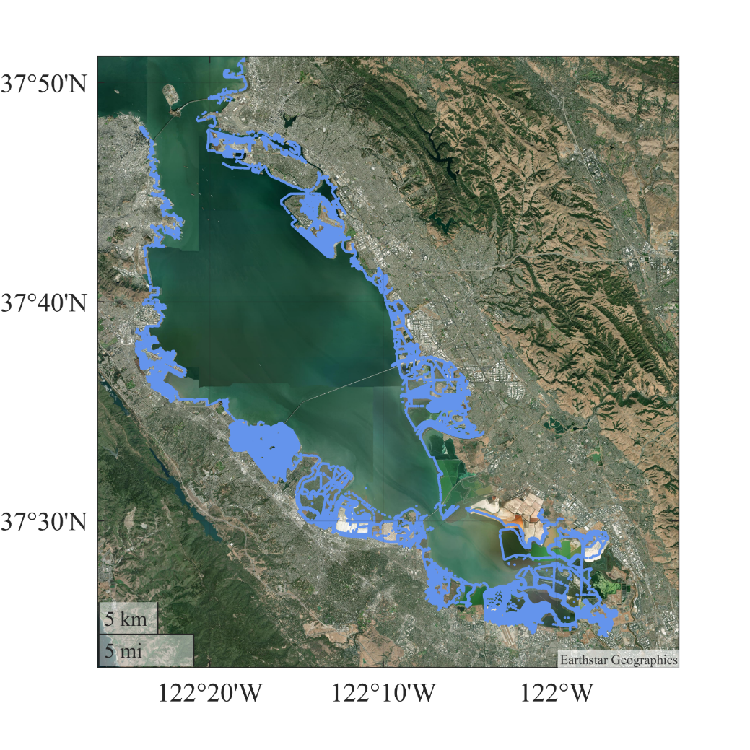
Figure 6. Difference between the area flooded under a positive (${AF}_{C}$) and a negative (${AF}_{T}$) phase is shown for San Francisco Bay South San Francisco Bay. Note that this is not the total flood area but the difference in the area flooded by a 100-ESL event occurring under a peak and a trough of the long-term tidal modulations.

4. Conclusions
In this paper, we have assessed the modulations of the 4.4-yr and 18.6-yr tidal modulations (long-term tidal cycles) in the 100-yr return period sea levels (100-ESL) at 581 tide gauges located along the global coasts. We have used the qn-SSJPM method (Baranes et al., 2020) to estimate the annual sea level exceedance curves, retaining the long-term astronomical tide modulations and thus allowing us to assess the influence of long-term tides on 100-ESL.
Our results show that the long-term tidal modulations impact the flood hazard on interannual to decadal time scales at 380 tide gauges, at roughly 2/3 of evaluated sites. The amplitude of the long-term tidal modulations in 100-ESL greatly varies across stations, reaching up to more than 20 cm in western Europe, Singapore, and north Australia. Other places with high amplitude of the long-term tidal modulations in 100-ESL are found in the eastern coast of China, southern Alaska, and the Pacific coast of Panama. Further research is needed to assess the changes in the amplitude of the long-term tidal modulations in extreme sea levels at lower return periods, as opposed to the 100-year return levels we focused on in the present study.
Identifying the years of higher risk of flooding due to the long-term tidal modulations in extreme water levels can help coastal risk management. We have detected the year of the next expected peak of the modulations across the stations. Some examples of places where the long-term tidal modulations are currently peaking, or are expected to peak relatively soon, are located in South Africa, northern Japan, Australia, Hawaii, and the western coast of Canada and the U.S. In this context, we have identified a regional coherence in the timing of the peak of the long-term tidal modulations in 100-ESL. We have assessed the relative contribution of the 4.4-yr versus 18.6-yr cycles to the total amplitude of the modulation in 100-ESL. Overall, results show spatial similarities and a general agreement with the prevailing tidal regime. Our results highlight the importance of accounting for both cycles when assessing the timing of the long-term tidal peak modulations.
The tidally-induced changes in 100-ESL also affect estimates of the flood surface area. We find that long-term tidal modulations in 100-ESL can lead to changes in the area of the 100-year flood of up to ~45%, for example in Boston, U.S. The changes in flood area caused by long-term fluctuations in tidal amplitudes vary with the steepness of coastal topography and the amplitude of the long-term tidal modulations in 100-ESL.
In the present study, we have shown that the long-term tidal modulations influence low-frequency events (100-year return level) along the global coasts, leading to important variations in flood hazard and potentially flooded surface area. Although further research is required to assess the influence of the tidally-induced changes in flood hazard maps in specific study areas, our results highlight the importance of integrating these tidally-induced and predictable changes in 100-ESL into coastal vulnerability assessments and adaptation plans.

Acknowledgments
We thank GESLA‐3 (http://www.gesla.org/) for providing tide gauge datasets. The code used to calculate the extreme sea-level annual exceedances is a modified version of that used in Baranes et al. (2020), which is publicly available (https://zenodo.org/record/3898657). This work was funded by NSF PREEVENTS award numbers 1854896 (TW and ARE), 94267271 (JFB), 1855037 (PMO) and 2013280 (SAT). SAT was also funded by the National Science Foundation Award number 1455350.

References
Andersen, O. B., Egbert, G. D., Erofeeva, S. Y., & Ray, R. D. (2006). Mapping nonlinear shallow-water tides: A look at the past and future. Ocean Dynamics, 56(5–6), 416–429. https://doi.org/10.1007/s10236-006-0060-7
Arns, A., Wahl, T., Haigh, I. D., Jensen, J., & Pattiaratchi, C. (2013). Estimating extreme water level probabilities: A comparison of the direct methods and recommendations for best practise. Coastal Engineering, 81, 51–66. https://doi.org/10.1016/j.coastaleng.2013.07.003
Baranes, H. E., Woodruff, J. D., Talke, S. A., Kopp, R. E., Ray, R. D., & DeConto, R. M. (2020). Tidally Driven Interannual Variation in Extreme Sea Level Frequencies in the Gulf of Maine. Journal of Geophysical Research: Oceans, 125(10). https://doi.org/10.1029/2020JC016291
Barnard, P. L., Erikson, L. H., Foxgrover, A. C., Hart, J. A. F., Limber, P., O’Neill, A. C., et al. (2019). Dynamic flood modeling essential to assess the coastal impacts of climate change. Scientific Reports, 9(1), 1–13. https://doi.org/10.1038/s41598-019-40742-z
Batstone, C., Lawless, M., Tawn, J., Horsburgh, K., Blackman, D., McMillan, A., et al. (2013). A UK best-practice approach for extreme sea-level analysis along complex topographic coastlines. Ocean Engineering, 71, 28–39. https://doi.org/10.1016/j.oceaneng.2013.02.003
BODC, B. O. D. D. (n.d.). UK Tide Gauge Network. Retrieved from https://www.bodc.ac.uk/data/hosted_data_systems/sea_level/uk_tide_gauge_network/
Caldwell, P., & Merrifield, M. (2015). Joint Archive for Sea Level (JASL). Data Report: October 2015. JIMAR Contribution No. 15-392. Data Report No. 24.
Codiga, D. L. (2011). Unified Tidal Analysis and Prediction Using the UTide Matlab Functions, (September), 59. https://doi.org/10.13140/RG.2.1.3761.2008
Eliot, M. (2010). Influence of interannual tidal modulation on coastal flooding along the Western Australian coast. Journal of Geophysical Research: Oceans, 115(11), 1–11. https://doi.org/10.1029/2010JC006306
Feng, X., Tsimplis, M. N., & Woodworth, P. L. (2015). Nodal variations and long-term changes in the main tides on the coasts of China. Journal of Geophysical Research: Oceans, 120(2), 1215–1232. https://doi.org/10.1002/2014JC010312
Ferro, A. T. C., & Segers, J. (2003). Inference for Clusters of Extreme Values. Royal Statistical Society, 65(2), 545–556.
Gall, M., Borden, K. A., Emrich, C. T., & Cutter, S. L. (2011). The unsustainable trend of natural hazard losses in the United States. Sustainability, 3(11), 2157–2181. https://doi.org/10.3390/su3112157
Gesch, D., Palaseanu-Lovejoy, M., Danielson, J., Fletcher, C., Kottermair, M., Barbee, M., & Jalandoni, A. (2020). Inundation exposure assessment for majuro atoll, republic of the Marshall islands using a high-accuracy digital elevation model. Remote Sensing, 12(1). https://doi.org/10.3390/rs12010154
Haigh, I D, Marcos, M., Talke, S. A., Woodworth, P. L., Hunter, J. R., Hague, B. S., et al. (2021). GESLA Version 3 : A major update to the global, (released), 1–34.
Haigh, Ivan D., Eliot, M., & Pattiaratchi, C. (2011). Global influences of the 18.61 year nodal cycle and 8.85 year cycle of lunar perigee on high tidal levels. Journal of Geophysical Research: Oceans, 116(6), 1–16. https://doi.org/10.1029/2010JC006645
IPCC. (2013). Climate Change 2013: The Physical Science Basis, Contribution ofWorking Group I to the Fifth Assessment Report of the Intergovernmental Panel on Climate Change. Cambridge University Press. Retrieved from http://www.climatechange2013.org/report/full-report/
JMA, J. M. A. (n.d.). Japan Meteorological Agency. Retrieved from http://www.jma.go.jp/jma/indexe.html
Kron, W. (2013). Coasts: The high-risk areas of the world. Natural Hazards, 66(3), 1363–1382. https://doi.org/10.1007/s11069-012-0215-4
Li, S., Wahl, T., Talke, S. A., Jay, D. A., Orton, P. M., Liang, X., et al. (2021). Evolving tides aggravate nuisance flooding along the U.S. coastline. Science Advances, 7(10), 1–10. https://doi.org/10.1126/sciadv.abe2412
Maloney, M. C., & Preston, B. L. (2014). A geospatial dataset for U.S. hurricane storm surge and sea-level rise vulnerability: Development and case study applications. Climate Risk Management, 2(July 2014), 26–41. https://doi.org/10.1016/j.crm.2014.02.004
Medvedev, I. P., Rabinovich, A. B., & Kulikov, E. A. (2013). Tidal oscillations in the Baltic Sea. Oceanology, 53(5), 526–538. https://doi.org/10.1134/S0001437013050123
Medvedev, Igor P., Rabinovich, A. B., & Kulikov, E. A. (2016). Tides in three enclosed basins: The baltic, black, and caspian seas. Frontiers in Marine Science, 3(APR), 1–7. https://doi.org/10.3389/fmars.2016.00046
Menéndez, M., & Woodworth, P. L. (2010). Changes in extreme high water levels based on a quasi-global tide-gauge data set. Journal of Geophysical Research: Oceans, 115(10), 1–15. https://doi.org/10.1029/2009JC005997
NOAA. (n.d.). NOAA Tides & Currents. Retrieved September 22, 2021, from https://tidesandcurrents.noaa.gov/
NOAA. (2021). Lidar Datasets at NOAA Digital Coast. Retrieved August 24, 2021, from https://coast.noaa.gov/htdata/lidar1_z/
NTCA, N. T. C. A. (n.d.). National Operations Centre (NOC) Tidal Unit. Retrieved from http://www.bom.gov.au/oceanography/projects/ntc/ntc.shtml
Parker, B. B. (2007). Chapter 6. Nonharmonic Analysis of Water Level and Current Data. In Tidal Analysis and Prediction. Silver Spring, Maryland: NOAA Special Publication NOS CO-OPS 3.
Peng, D., Hill, E. M., Meltzner, A. J., & Switzer, A. D. (2019). Tide Gauge Records Show That the 18.61-Year Nodal Tidal Cycle Can Change High Water Levels by up to 30 cm. Journal of Geophysical Research: Oceans, 124(1), 736–749. https://doi.org/10.1029/2018JC014695
Preston, B. L. (2013). Local path dependence of U.S. socioeconomic exposure to climate extremes and the vulnerability commitment. Global Environmental Change, 23(4), 719–732. https://doi.org/10.1016/j.gloenvcha.2013.02.009
Pugh, D., & Woodworth, P. (2014a). Storm surges, meteotsunamis and other meteorological effects on sea level (Chapter 7). In Sea-level science: understanding tides, surges, tsunamis and mean sea-level changes. Cambridge University Press.
Pugh, D., & Woodworth, P. (2014b). Tidal forces (Chapter 3). In Sea-level science: understanding tides, surges, tsunamis and mean sea-level changes. Cambridge University Press.
Pugh, D. T. (1987). Tides, surges and mean sea level.
Rao, A. D., Upadhaya, P., Ali, H., Pandey, S., & Warrier, V. (2020). Coastal inundation due to tropical cyclones along the east coast of India: an influence of climate change impact. Natural Hazards, 101(1), 39–57. https://doi.org/10.1007/s11069-020-03861-9
Ray, R., & Foster, G. (2016). Future nuisance flooding at Boston caused by astronomical tides alone. Earth’s Future, 4(12), 578–587. https://doi.org/10.1002/2016EF000423
Ray, R. D., & Merrifield, M. A. (2019). The Semiannual and 4.4-Year Modulations of Extreme High Tides. Journal of Geophysical Research: Oceans, 124(8), 5907–5922. https://doi.org/10.1029/2019JC015061
Ray, R. D., & Talke, S. A. (2019). Nineteenth-Century Tides in the Gulf of Maine and Implications for Secular Trends. Journal of Geophysical Research: Oceans, 124(10), 7046–7067. https://doi.org/10.1029/2019JC015277
Ray, Richard D. (2007). Decadal climate variability: Is there a tidal connection? Journal of Climate, 20(14), 3542–3560. https://doi.org/10.1175/JCLI4193.1
Santamaria-Aguilar, S., & Vafeidis, A. T. (2018). Are Extreme Skew Surges Independent of High Water Levels in a Mixed Semidiurnal Tidal Regime? Journal of Geophysical Research: Oceans, 123(12), 8877–8886. https://doi.org/10.1029/2018JC014282
Sobey, R. J. (2005). Extreme low and high water levels. Coastal Engineering, 52(1), 63–77. https://doi.org/10.1016/j.coastaleng.2004.09.003
Talke, S. A., Kemp, A. C., & Woodruff, J. (2018). Relative Sea Level, Tides, and Extreme Water Levels in Boston Harbor From 1825 to 2018. Journal of Geophysical Research: Oceans, 123(6), 3895–3914. https://doi.org/10.1029/2017JC013645
Thompson, P. R., Widlansky, M. J., Hamlington, B. D., Merrifield, M. A., Marra, J. J., Mitchum, G. T., & Sweet, W. (2021). Rapid increases and extreme months in projections of United States high-tide flooding. Nature Climate Change, 11(7), 584–590. https://doi.org/10.1038/s41558-021-01077-8
Titus, J. G., Hudgens, D. E., Trescott, D. L., Craghan, M., Nuckols, W. H., Hershner, C. H., et al. (2009). State and local governments plan for development of most land vulnerable to rising sea level along the US Atlantic coast. Environmental Research Letters, 4(4). https://doi.org/10.1088/1748-9326/4/4/044008
Ward, P. J., Marfai, M. A., Yulianto, F., Hizbaron, D. R., & Aerts, J. C. J. H. (2011). Coastal inundation and damage exposure estimation: A case study for Jakarta. Natural Hazards, 56(3), 899–916. https://doi.org/10.1007/s11069-010-9599-1
Williams, J., Horsburgh, K. J., Williams, J. A., & Proctor, R. N. F. (2016). Tide and skew surge independence: New insights for flood risk. Geophysical Research Letters, 43(12), 6410–6417. https://doi.org/10.1002/2016GL069522
Woodworth, P. L., Hunter, J. R., Marcos, M., Caldwell, P., Menéndez, M., & Haigh, I. (2016). Towards a global higher‐frequency sea level dataset. Geoscience Data Journal, 3(2), 50–59.
Zetler, B. D., & Flick, R. E. (1985). Predicted extreme high tides for mixed-tide regimes. Journal of Physical Oceanography, 15(3), 357–359.

