Temperature-independent vibration sensor based on Fabry-Perot interferometer using a Fiber Bragg Grating approach
Muhammad Syamil Mohd Sa'ad, ª Mohammad Faizal Ismail, ª Muhammad Khairol Annuar Zaini, ª Kenneth T.V. Grattan, ^{b} B.M. Azizur Rahman, ^{b} Gilberto Brambilla, ^{c} Lim Kok Sing, ª Harith Ahmad ^{a,d,e,*}
ªUniversiti Malaya, Photonics Research Center, Kuala Lumpur, Malaysia, 50603
^{b}City, University of London, School of Mathematics, Computer Science & Engineering, London, United Kingdom, EC1V 0HB
^{c}University of Southampton, Optoelectronics Research Centre, Southampton, United Kingdom, SO17 1BJ,
^{d}Universiti Malaya, Faculty of Science, Physics Department, Kuala Lumpur, Malaysia, 50603
^{e}Airlangga University, Faculty of Science and Technology, Department of Physics, Surabaya, Indonesia, 60115

Abstract. An innovative vibration sensor based on a Fabry-Perot Interferometer (FPI) using Fiber Bragg Grating (FBG) reflectors was demonstrated in this work. The sensor was designed to be compact and easy to fabricate, independent of temperature, to overcome limitations seen in previous designs, providing an effective correction for temperature effects in FBG-based FPI (FBG-FPI) sensors. A laser source with a peak wavelength of 1547.42 nm obtained from the FBG reflective peak was used to illuminate the FBG-FPI so that the light source was always within the FBG-FPI optimum wavelength operating range of 1547.15 nm – 1547.80 nm. The sensor was shown to capture a 3 kHz burst signal from a signal generator in 1 Hz, 2 Hz, and 3 Hz intervals. In addition, the work carried out has revealed that the sensor could be used to capture sinusoidal signals at frequencies up to 9 kHz, creating a performance comparable with many existing conventional piezoelectric sensors. Furthermore, the ability to operate regardless of any ambient temperature changes (from 26.5°C (room temperature) up until 80°C) opens the way to use such a sensor system over a wide range of engineering applications taking advantage of the next generation of FBG-based FPIs.

Keywords: Fabry-Perot Interferometer, Fiber Bragg Gratings, vibration sensor, temperature-independent

*Harith Ahmad, E-mail: harith@um.edu.my

- Introduction

Vibration measurement is of critical concern in many current engineering applications. For example, excessive vibration or vibration at particular frequencies can have a series of effects on the performance and safety of many engineering structures, such as aircraft or buildings. Hence, accurate measurement and monitoring must be done precisely and easily to detect anomalous events and warn of potential infrastructure damage.¹ Vibration sensors based on piezoelectric,^{2,3} magnetostrictive,⁴ capacitive,⁵, and inductive⁶ technologies, among others, are already available and widely used by engineers in the industry. However, there are problems for many important applications – traditional vibration sensors suffer from electromagnetic (E.M.) interference, making them unsuitable when applied to many challenging situations. In addition, electrical sensors may be inappropriate for use in certain safety-critical areas, e.g., where explosive or explosive or flammable gases are present. Furthermore, with the developing needs in modern engineering measurement, there is a requirement for new designs that can overcome limitations of the monitoring distance experienced in some applications (e.g., civil infrastructure) and the expensive maintenance costs required for some designs of sensor systems.
Optical fiber-based systems offer new opportunities for better sensor design, and these have received significant attention in research to address a wide range of applications over the last several decades, taking advantage of their being lightweight, operational over considerable lengths (through multiplexing of the sensors along with the optical network), potentially high accuracy, having good signal transmission security and due to their configuration, relatively easy installation, as well as corrosion resistance (not being metallic) and immunity to electromagnetic (E.M.) interference.^{7,8} These features emphasize their potential to be used in harsh environments⁹ where conventional sensors are often limited. Building on the low cost of many fiber optic components (due to their widespread use in telecommunications), these are well suited to many different areas of optical fiber sensing, with key examples already proven to be strain sensors,^{10–12} temperature sensors,^{13,14} and vibration sensors,^{15,16} often showing high sensitivity.¹⁷
A fiber-optic vibration sensor can typically be based on the modulation of the light properties in the optical fiber, such as intensity, phase, polarization state, and frequency, where these are (mainly) caused by externally applied vibration (and compensation for extraneous effects such as temperature can be included). The most common types of fiber-optic vibration sensors discussed in the literature are point,^{18–21} quasi-distributed,²² and distributed sensors^{23,24} where for each of those, different (and often complementary) optical techniques can be employed. For vibration measurement, several point sensor schemes such as Fiber Bragg Gratings (FBGs), Fabry–Pérot interferometers,^{25,26} self-mixing of optical signals,²⁷ and Doppler vibrometry^{28,29} have been reported in the literature. Furthermore, because of inherent features of the optically-based technique such as low noise, ease of being embedded in a structure, and the ability to be multiplexed to form a quasi-distributed sensor array, FBG vibration sensors have become a rapidly growing scientific research topic^{30,31} to meet the range of new engineering applications, both current and under development, where better vibration measurement is needed.
Amongst the wide range of FBG-based sensors that have already been proposed, relatively few FBG-based Fabry-Perot Interferometer (FPI) sensors have been discussed in the literature.^{32–35} Amongst these, Wada et al.^{32,33} used a tunable laser diode to illuminate the FBG-FPI sensor, subjected to a sinusoidal vibration. In addition, Zaini et al.³⁵ have used an edge filter interrogation method, where a further FBG-FPI was included to filter the output signal from the FBG-FPI used as the sensor. In these designs in the literature,^{32,33,35} while an effective FBG-FPI based vibration sensor has been developed, but without an explicit temperature compensation scheme. Rao et al.³⁴ have discussed an FBG-FPI based design to monitor strain, temperature, and vibration simultaneously, and although in that work, the FBG-based sensor was used from room temperature to 50°C, temperature effects were not fully eliminated when making vibration measurements using this FBG-based approach.
This work developed a temperature-independent vibration sensor using a Fabry-Perot interferometer approach and based on FBG technology to overcome the current limitations. This new sensor approach can detect burst signals at low frequencies and can find applications in areas such as ground/slope monitoring and structural vibrations as in structural health monitoring. The target performance specification of the sensor design proposed was to detect a ~3kHz burst at 1Hz, 2Hz, and 3Hz frequencies, doing so over a range of temperatures while eliminating any temperature effects. Furthermore, the results obtained have shown that the sensor can monitor sinusoidal signals, at frequencies up to ~9kHz, independent of temperature in the detection of low-frequency burst signals and high-frequency sinusoidal waves, in this way creating a sensor scheme that potentially addressed important sensing needs for the next generation of FBG-based FPI devices.

- Methodology

  - Fabrication of the Fiber Bragg Gratings (FBGs).

The FBGs used in this study were fabricated by inscribing uniform gratings in conventional single-mode fiber (SMF) core, using the phase mask technique. Before this, the optical fiber was sensitized by hydrogen-loading the SMF used for five days in a high-pressure hydrogen chamber. Following that, the gratings were inscribed at a length of ~10 mm inside the fiber core by using light from a Krypton Fluoride (KrF*) excimer laser, operating at a wavelength of 248 nm. Finally, the fiber samples containing the inscribed gratings were heated in an oven at 70°C to 80°C for about seven hours to remove any remaining hydrogen present and stabilized the gratings.
For every FBG inscribed in a single-mode fiber (SMF), the shift of the Bragg wavelength can be linearly related with the change of strain, $ε$, and temperature, T, as described by the following relationship:
 | $$\frac{{∆λ}_{B}}{λ_{B}}=(1-p_{eff})∆ε+(α+ξ)∆T$$ | (1)
where $λ_{B}$ represent the Bragg wavelength, while $p_{eff , } α$, and $ξ$ are for the photo-elastic parameter, thermal expansion coefficient, and thermo-optic coefficient of the fiber, respectively.

  - Fabrication of in-fiber FPI

In a way similar to the fabrication of the FBGs themselves, the in-fiber FPI was formed by using two identical gratings, forming extremely narrow fringes that were linearly shifted with the change of temperature and strain applied to the FBG-FPI. The FBG-FPI was formed by two short uniform gratings as illustrated in Fig. 1, where in this case, the gratings of equal lengths (L_{FBG}) of 2 mm were separated by a length of 15 mm, L_{FPI}, to produce the interferometric spectra. Fig. 2(a) shows the reflection spectra of an individual grating reflector (a single grating FBG, operating at 1547.42 nm). The bare fiber between the two grating reflectors creates the cavity for the resonating optical wave between the two reflectors, producing the interferometric output spectra, as illustrated in Fig. 2(b).
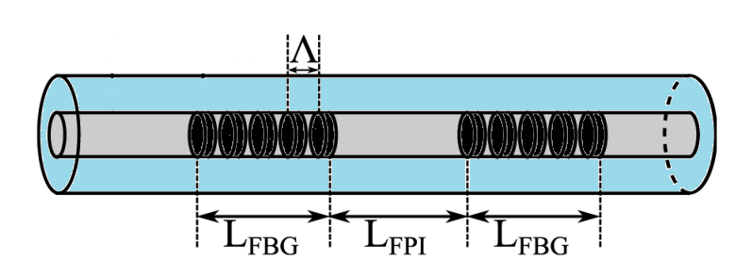
Fig. 1 Illustration of the FBG-FPI created in this work where L_{FBG} is the length of the grating used (of period Λ) and L_{FPI} is the separation of the gratings, and thus the interferometric cavity length.
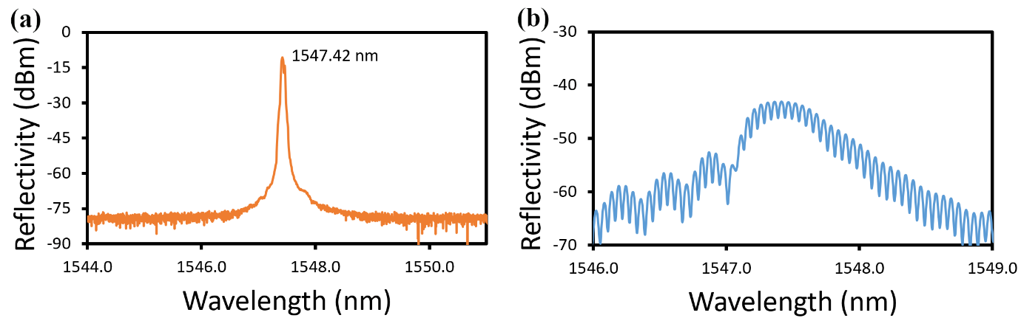
Fig. 2 Illustrations of (a) a single FBG spectrum of wavelength 1547.42 nm and (b) a typical spectrum of the FBG-FPI.

  - Experimental Design

The experimental setup used is illustrated in Fig. 3(a), where two types of the sensor were used – the first being a 'normal' FBG with a reflection peak wavelength of 1547.42 nm, while the second was an FBG-based Fabry-Perot interferometer (denoted as FBG-FPI) with an optimum operating wavelength range of 1547.15 nm – 1547.80 nm. Both FBG and FBG-FPI have a reflectivity value of 80%. A 980nm laser diode was used to pump a 0.3 m erbium-doped fiber through a 980/1550 nm wavelength division multiplexer (WDM) to produce a broad amplified spontaneous emission (ASE) over the range of 1520-1570 nm. This emission passes through the FBG connected to the Port 1 of a 3-port optical circulator (C1). The signal at the FBG reflective wavelength will be fed back to the gain medium, again passing through the WDM to the Port 2 of another 3-port circulator (C2) that acted as a mirror by returning all the signal towards the WDM, then to the erbium-doped fiber and the FBG. This repetitive process produced a laser at the FBG reflective wavelength. This output was connected to Port 1, which was then emitted at Port 2 and traveled to the FBG-FPI of the circulator C1. The reflected light from the FBG-FPI then exited at Port 3, connected to a photodetector and a 2.5 G/s 500 MHz oscilloscope.
In the design of the FBG-FPI, these two gratings must be spaced closely together and have the same range of wavelength peak (or at least to be so within ~0.1 nm). This is because the sensitivity of the FBG-FPI would be negatively affected if the wavelength of the light source did not match the optimum operating range of the FBG-FPI; indeed, a severe mismatch would render the sensor ineffective. Moreover, as the FBG responds directly to strain and temperature variations, when the surrounding temperature changes, the wavelength shift for the FBG will be identical to that of the FBG-FPI cavity, simultaneously changing the laser wavelength to be always within the FBG-FPI optimum operating range, in that way will offset any temperature change. This feature would enable the sensor to achieve thermal stability where the light source wavelength does not have to be manually tuned when a temperature variation occurs. Finally, a piezoelectric transducer was placed on top of the FBG-FPI, separated by a 20x20x1 mm plastic sheet as shown in Fig. 3(b), illustrating a seismic scenario activity occurred will be detected.
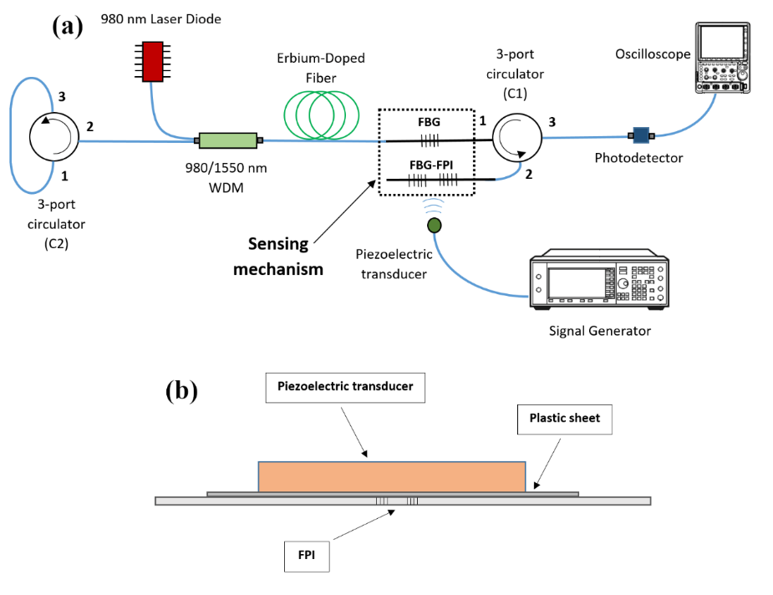
Fig. 3 Illustration of the (a) experimental setup for verifying the performance of the FBG-FPI cavity subjected to a simulated seismic-induced vibration and (b) a closer look from the side view of the signal transfer setup at the FBG-FPI.
The output spectrum obtained from the experimental setup shown in Fig. 3 is illustrated in Fig. 4, obtained by connecting an optical spectrum analyzer (OSA) to Port 3 of the circulator C1 instead of the oscilloscope. As indicated above, the peak (1547.42 nm) is within the optimum operating range of the FBG-FPI (1547.15 – 1547.80 nm).
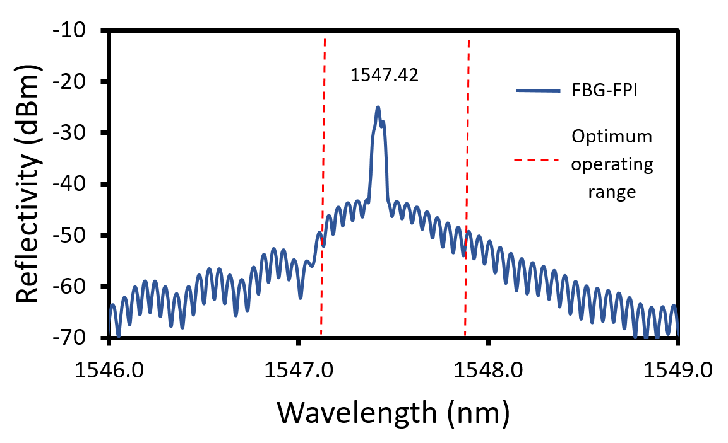
Fig. 4 The output spectrum of FBG and FBG-FPI from Port 3 of the circulator when connected to an Optical Spectrum Analyzer.

  - Burst Signal at Low-Frequency Interval

Regarding Fig. 3(b), a 0.5 V peak-to-peak voltage (V_{pp}) 3 kHz burst signal from the ROHDE & SCHWARZ RTM3004 signal generator was applied to the FBG-FPI, using a piezoelectric transducer where the frequency of the burst interval was varied from 1 Hz, 2 Hz, and 3 Hz.

  - High Frequency of Sinusoidal Wave

Using the same setup as discussed above, a 3 kHz sine wave with 5 V_{pp} from the signal generator was applied to the FBG-FPI through the piezoelectric transducer. The input frequency was varied up to a maximum of 9 kHz in 3 kHz intervals. To allow a cross-comparison, the experiment was repeated using a conventional piezoelectric sensor to compare the performance characteristics of the two approaches used to monitor vibration.

  - Temperature Monitoring and correction for temperature effects

The procedures above were carried out by placing the experimental setup on a hot plate to investigate the effect of temperature on the FBG-FPI sensor. Due to the small size of the device illustrated schematically in Fig. 3, as the wavelength shifts due to the temperature of the FBGs used are the same for each, there should then be no changes in the ability of the FBG-FPI to operate as an interferometer and thus capture the vibration waveforms (generated in this test by the signal generator at known frequencies). An illustration of the experimental setup used for calibration of the system is shown in Fig. 5, where both the FBGs and the FBG-FPI were placed on top of a hot plate and between the piezoelectric transducers. A thermocouple was utilized in this calibration to monitor the temperature of the hot plate, which when it was raised from ~26°C to 80°C in 10°C intervals, the wavelength spectrum of the FBG-FPI from port 3 of the circulator C1 was observed and recorded by the OSA. Such calibration is required and a pre-condition for the sensor system in vibration monitoring. The FBG-FPI continues to work well over this temperature range, showing that both gratings' wavelength shift (due to changes in the temperature) is essentially identical (with a sensor of this small size). The burst signals at low frequency and sinusoidal signals at high frequency, as mentioned in sections 2.4 and 2.5, were performed from ~26°C to 80°C, at 10°C intervals, and the waveforms from FBG-FPI were recorded using an oscilloscope.
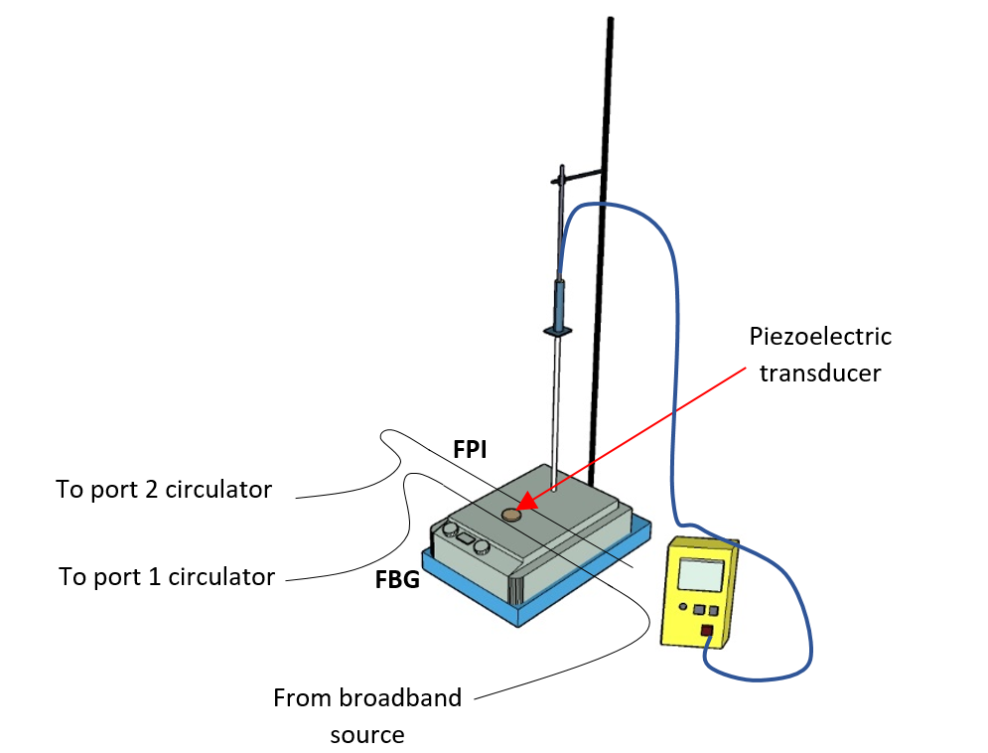
Fig. 5 Experimental setup for the calibration of the FBG-FPI sensor over a wide temperature range, from ~26°C to 80°C, at 10°C intervals

- Results and Discussions

The output signals (generated directly from the signal generator in the system calibration setup shown in Fig. 3) are depicted in Fig. 6. Fig. 6(a) shows the 3 kHz burst signal in a 1-second interval (1Hz), and Fig. 6(b) illustrates the 3 kHz sine signal. After being exposed to the 3 kHz burst signal, the responses of the FBG-FPI sensor to the burst signal are shown in Fig. 7. This allows a comparison between the output signal of the signal generator and (what should then be a similar) output signal detected by the FBG-FPI. Fig. 7(a), (b), and (c) represent the FBG-FPI response to the 3 kHz burst signal in 1 Hz, 2 Hz, and 3 Hz intervals, respectively.
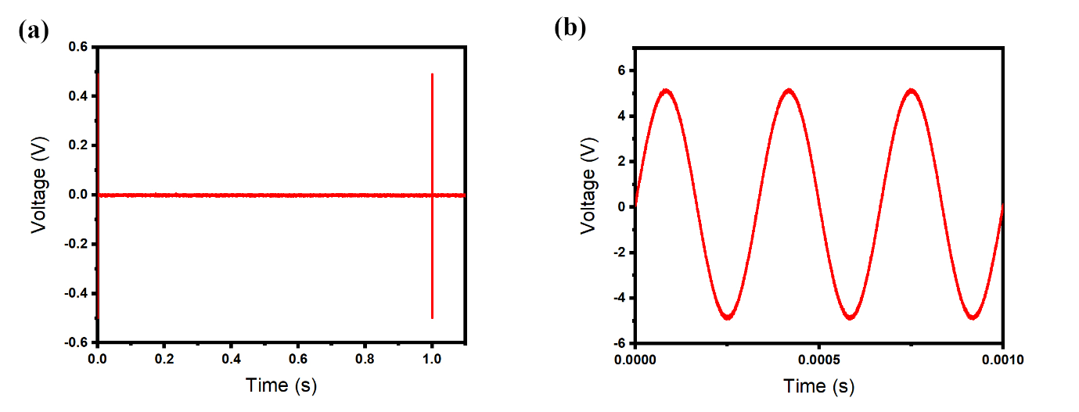
Fig. 6 (a) Signals directly from the signal generator: 3 kHz burst at a 1 Hz interval, and (b) 3 kHz sine wave, generated by the signal generator.

As shown in Fig. 7, there is minimal background noise in the output reading, primarily due to the suitable nature of the input broadband source.³⁵ Compared to the output obtained directly from the signal generator (Fig. 6), a small voltage (amplitude) difference between the signal generator output (0.5 V_{pp}) and the FBG-FPI output (~0.2 - 0.3 V_{pp}) is due to the energy loss experienced by the sensor. However, the similarity in the structure of the pulses demonstrates that the FBG-FPI performed well in detecting the burst signals at low-frequency intervals.

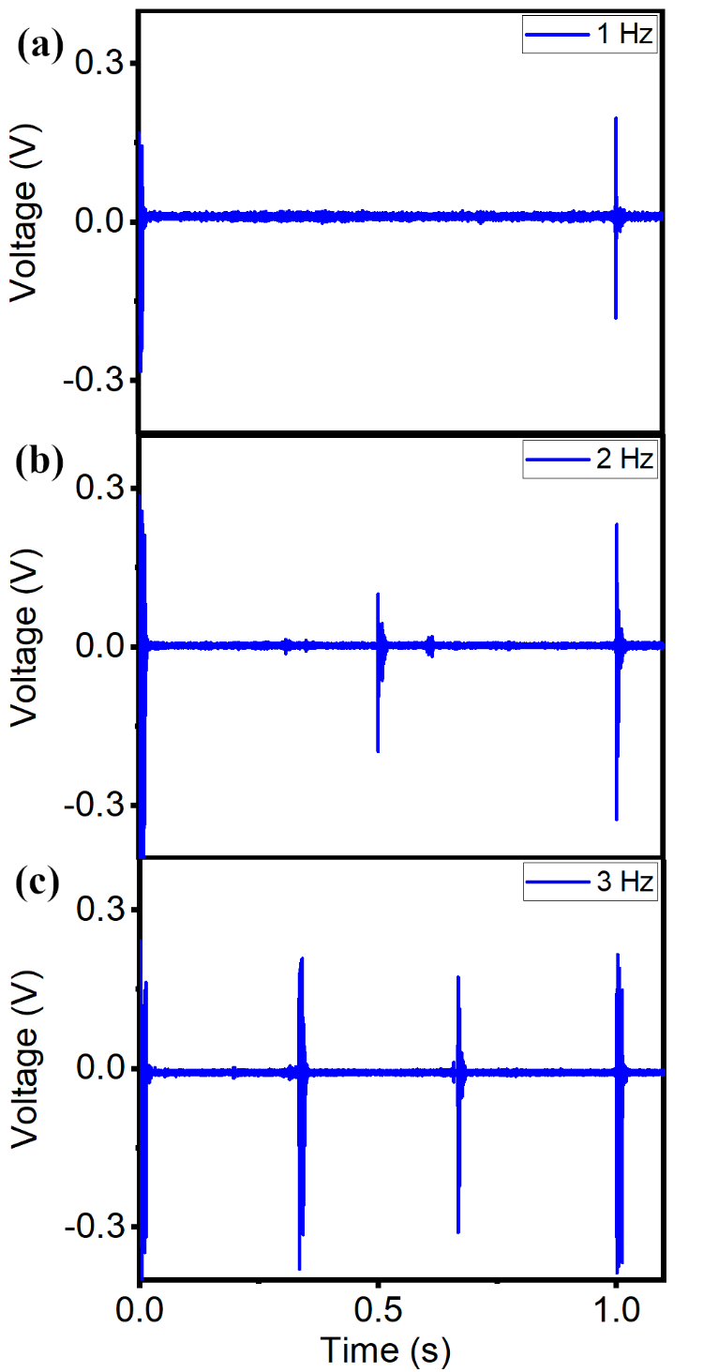
Fig. 7 The comparison between the output signal of the signal generator and the output signal from the FBG-FPI: 3 kHz burst at (a) 1 Hz, (b) 2 Hz, and (c) 3 Hz intervals detected by the FBG-FPI.

Fig. 8 showed the response of the piezoelectric sensor compared to the FBG-FPI when both were subjected to the 3 kHz sine wave from the signal generator. Compared to the 3 kHz output directly from the signal generator in Fig. 6(b), both sensors record an observable loss in input voltage (as elastic waves lose energy as they travel through a material) where in this case, a plastic sheet divides the sensor and the transducer (the vibration source). The small distortion is seen in the sine wave of the FBG-FPI output signal (in Fig. 8(b)) seems likely to have been caused by the vibration of the fiber itself – the conventional piezoelectric sensor illustrates the sine wave shape better because the sensor plate was metal (likely aluminum), providing a good response to elastic waves. The data show that the FBG-FPI sensor can detect high-frequency resonance similarly to conventional vibration sensors.
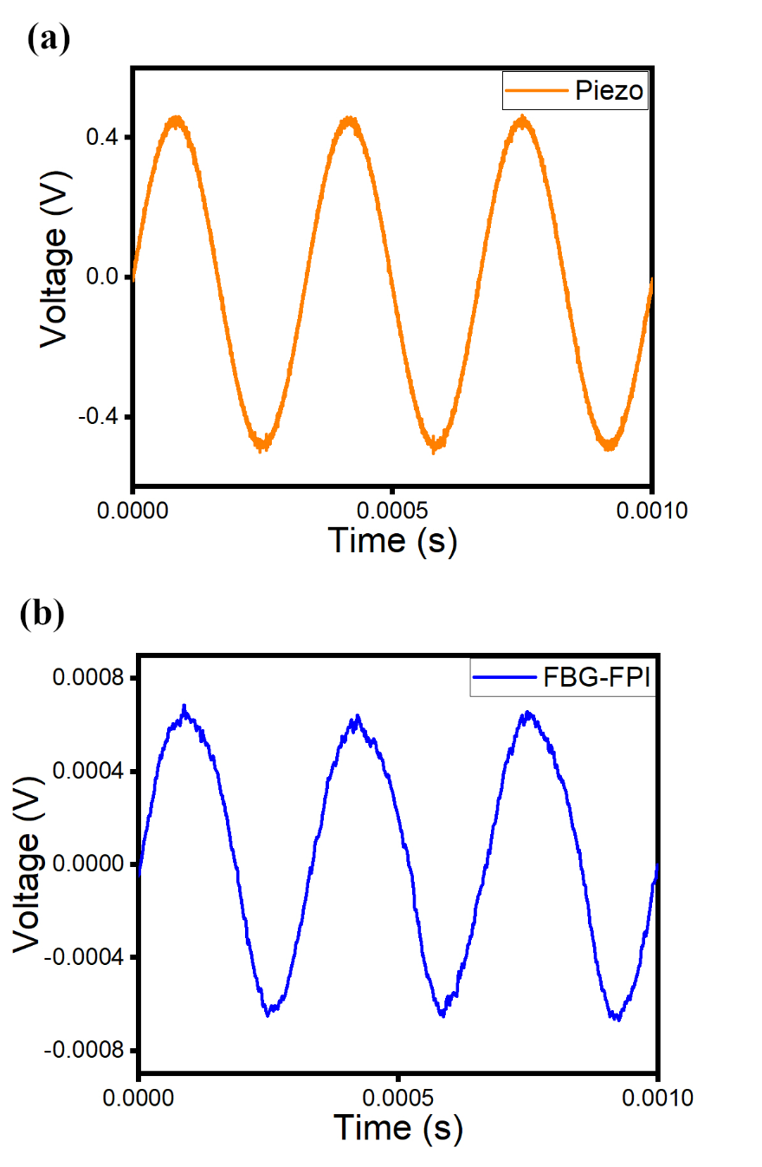
Fig. 8 Output signal detected by (a) the piezoelectric sensor and (b) the FBG-FPI sensor: both were subjected to a similar 3 kHz sine wave.
In addition to the test carried out, where the results are illustrated in Fig. 8, a comparison was also made between the output signal directly from the signal generator (S.G.), the piezoelectric sensor, and the FBG-FPI sensor, as shown in Fig. 9. The results shown illustrated the output waveform from each sensor when they were subjected to a sinusoidal wave at a series of frequencies of (a) 3 kHz, (b) 6 kHz, and (c) 9 kHz, where it is evident that FBG-FPI can detect the waveforms at the high-frequency region with high fidelity.

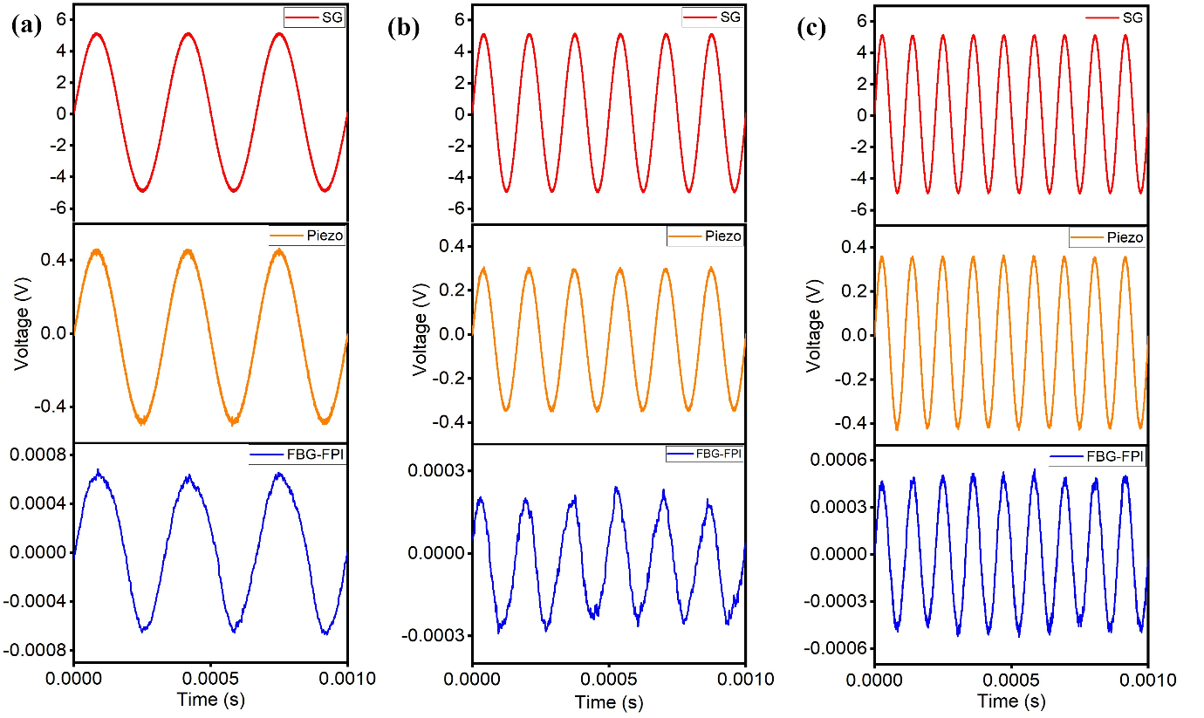
Fig. 9 Output signal comparison between the signal generator (S.G. – in red), the piezoelectric sensor (Piezo – in orange), and the FBG-FPI sensor (FBG-FPI in blue) for three different frequencies (a) 3 kHz, (b) 6 kHz, and (c) 9 kHz.
The FBG-FPI sensor was subjected to changes in the temperature, over the range from ~26°C (room temperature) to 80°C, to investigate the temperature dependency. To ensure that the temperature parameter can be eliminated as the objective of this work, The output spectra obtained during these tests were recorded at Port 3 of the circulator C1 using the OSA, and Fig. 10(a) illustrates the spectra obtained during the temperature rise until 80°C. It can be inferred that the sensor works well across this temperature range as the laser source was always within the optimum operating range of the FBG-FPI (as the FBG and the FBG-FPI were placed closely together hence, experience temperature changes simultaneously), enabling the FBG-FPI to always detect the waveforms regardless of surrounding temperature changes. The linear relationship was obtained for the FBG-FPI output wavelength against the temperature rise, as shown in Fig 10(b) was used as the calibrated graph. A sensitivity of 0.0153nm shifts per degree Celsius was obtained from the calibration with an R² value of 0.9964, indicating the linear response.
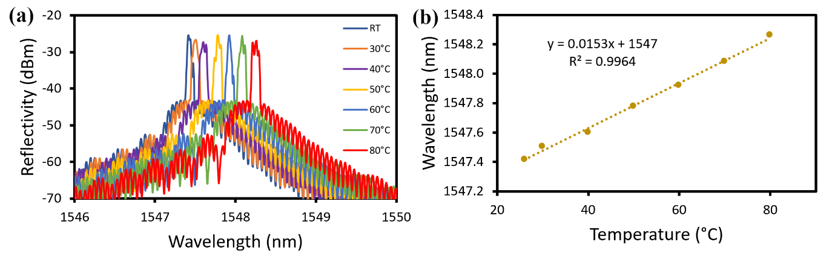
Fig. 10 (a) Output spectra of the FBG-FPI when subjected to different temperatures and (b) the linear response of the FBG-FPI when it is subjected to different temperatures from 26°C to 80°C in 10°C intervals.
To further validate that the FBG response towards temperature was identical to the FBG-FPI, the spectra for each response of FBG and FBG-FPI towards temperature are depicted in Fig 11(a). The figure shows the spectral responses of both the FBG (top) and the FBG-FPI (bottom) at temperatures of 30, 40, 50, 60, 70, and 80°C showing that the wavelength shifts of the FBG themselves and that of the FBG-FPI were simultaneous and in tandem when they were subjected to the same temperature changes. Fig 11(b) shows the linear response of both FBG and FBG-FPI simultaneously towards temperatures change. The FBG and FBG-FPI shifted linearly, almost identical with 0.0153 nm/°C and 0.0151 nm/°C, respectively. The slight difference of 0.0002 nm/°C is probably due to the grating structure of the FBG and FBG-FPI itself, with FBG-FPI having an interferometric region between the grating. However, this would be insignificant as even at a temperature as high as 80°C, the laser source was still within the optimum operating range of the FBG-FPI, thus indicating that the sensor was sensitive. Thus, Figs. 10 and 11 verify that temperature changes would not affect the ability of the FBG-FPI to detect burst and sine signals, as the laser source is always within the FPI operating range over the temperature excursion range studied.
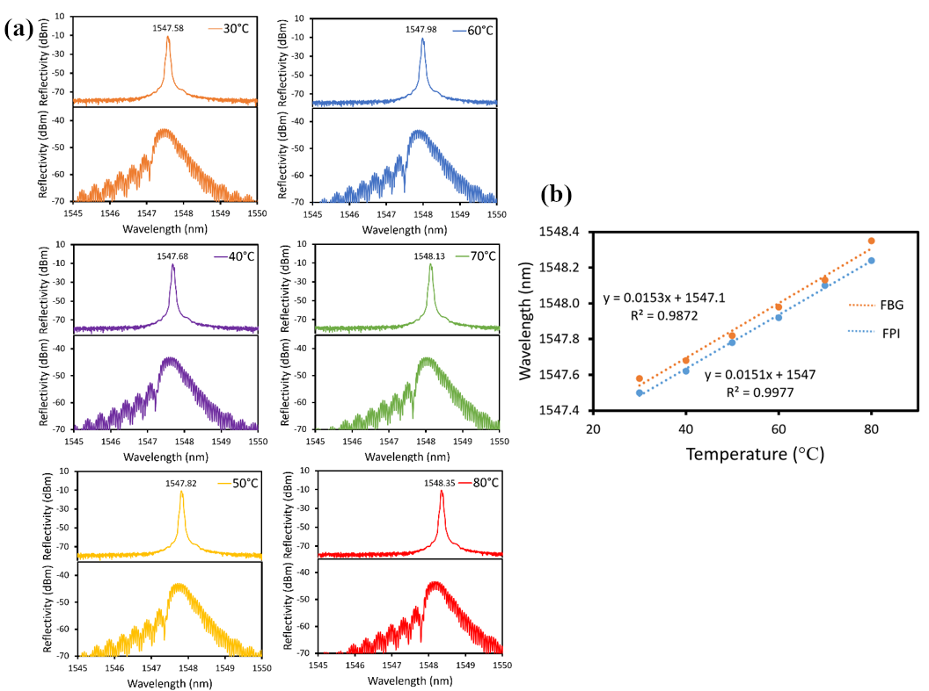
Fig. 11 (a) Response spectra of each FBG and FPI at 30, 40, 50, 60, 70, and 80°C and (b) the linear relationship for both FBG and FBG-FPI simultaneously when they were subjected to different temperature parameters.
Fig. 12 shows the FBG-FPI responses to a 3kHz burst at (a) 1 Hz, (b) 2 Hz, and (c) 3 Hz at room temperature (blue) and 80°C (red). It is clear from Fig. 12(a) that the FBG-FPI can detect the burst signal pattern over all the temperatures in the range shown. Further, similar response patterns can be observed for bursts at 2 Hz and 3 Hz in (b) and (c), respectively. This observation shows that the method proposed can allow the FBG-FPI to detect burst signals at these low frequencies, regardless of the temperature change.
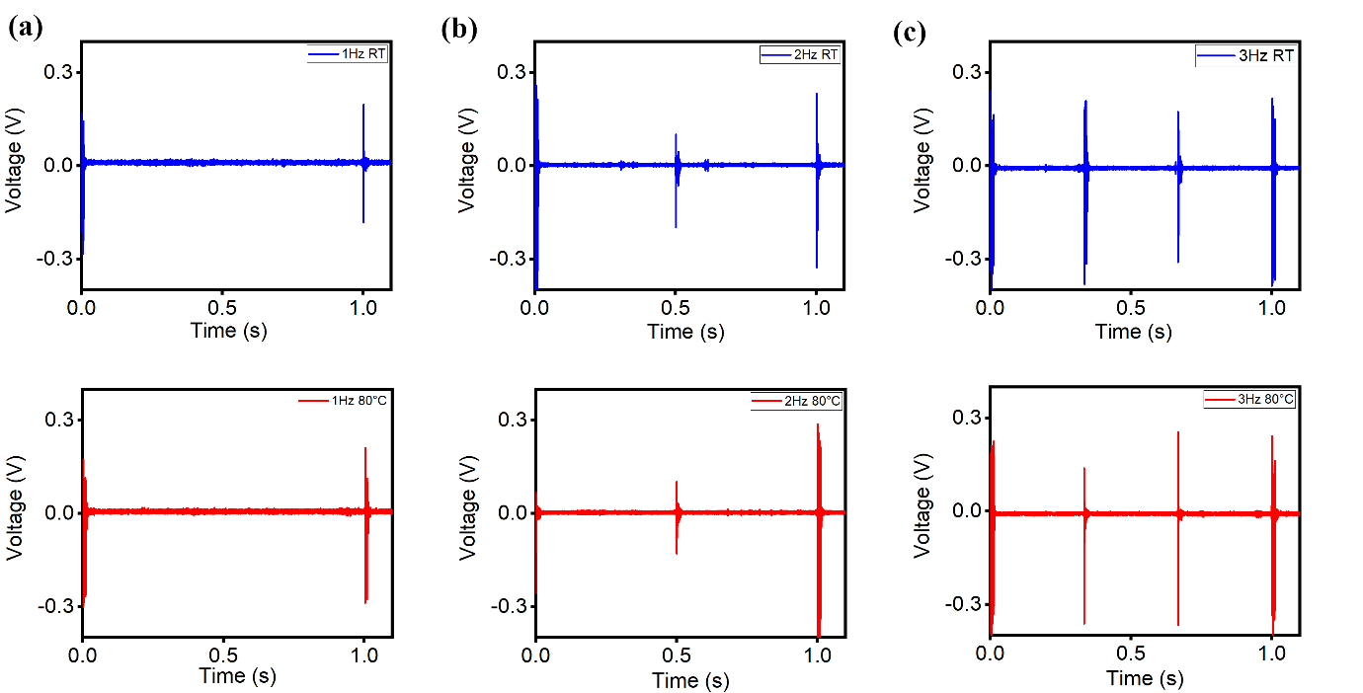
Fig. 12 The response of the FBG-FPI towards 3kHz bursts at (a) 1 Hz, (b) 2 Hz, and (c) 3 Hz intervals at room temperature (blue) compared to at 80°C (red).
In addition to that, the response of the FBG-FPI to any temperature changes in high-frequency sine waves can be observed in Fig. 13. For example, fig. 13 (a) shows the FBG-FPI can detect the 3 kHz sine waves at temperatures both of 40°C and 80°C, and they exhibit similar responses towards temperature for frequencies of 6 kHz and 9 kHz, as shown in (b) and (c) respectively. There is also no observable difference in the amplitude response whenever the FBG-FPI was subjected to different temperatures.

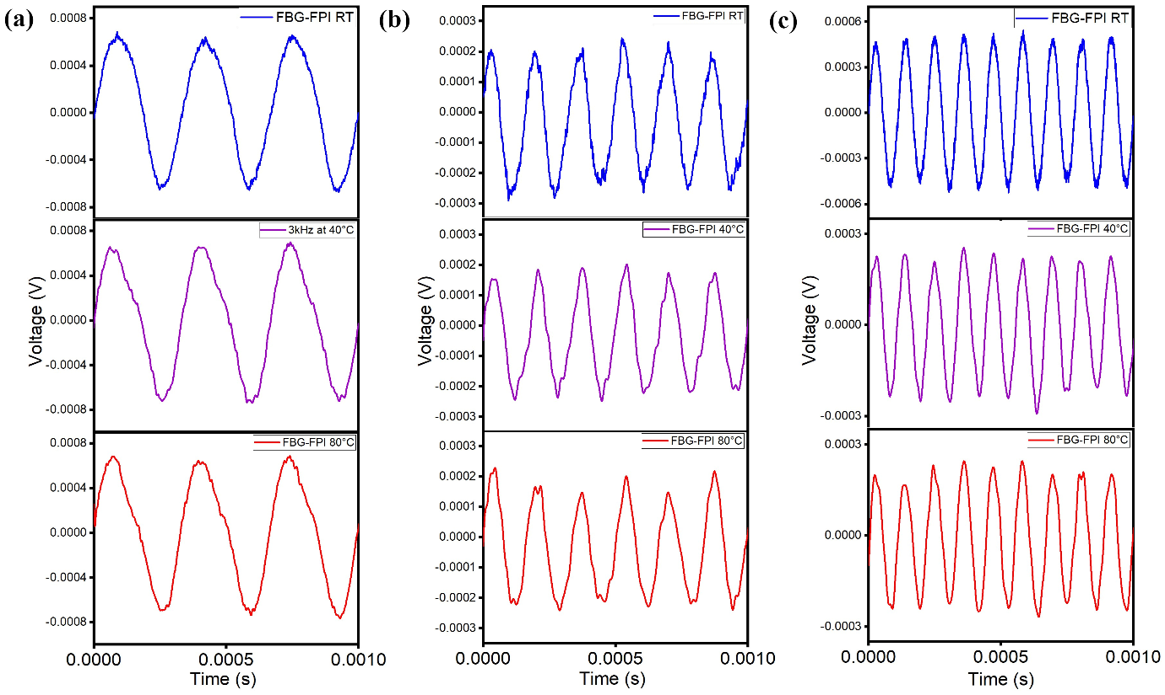
Fig. 13 The response of the FBG-FPI towards (a) 3 kHz, (b) 6 kHz, and (c) 9 kHz sine waves at room temperature (blue), 40°C (purple), and 80°C (red).
- Conclusions

This work demonstrates a highly effective FBG-FPI sensor that can detect burst signals at low-frequency intervals of 1 Hz, 2 Hz, and 3 Hz, as well as sinusoidal waves at the high-frequency region of 3 kHz to 9 kHz. Such frequencies were applied to the sensor to imitate seismic waves that are present during earthquakes or landslides. From the results shown above, it has been proven that the sensor was effective over the temperature range of 26°C to 80°C and was independent of the temperature changes. This was primarily due to the design where the FBG and the FBG-FPI were placed and aligned closely, causing the light source to always be within the optimum wavelength range to suit the FBG-FPI operating as an interferometer.
Such a small, lightweight, all-optical, and temperature-independent vibration sensor capable of detecting the waveforms of vibration over this frequency range opens up a variety of engineering applications, including structural health monitoring (SHM) and ground movement monitoring others, both particularly important in structural engineering today.

- Disclosures

The authors declare that they have no known competing financial interest or personal relationships that could have appeared to influence the work reported in this paper.

Acknowledgements

The authors are pleased to acknowledge support from the British Council-MIGHT NUOF (IF022-2020) and Universiti Malaya (UM-Innovate and TOP100PRC). Grattan acknowledges the support from the Royal Academy of Engineering.

References
1. A. P. Adewuyi, Z. Wu, and N. H. M. Kammrujaman Serker, "Assessment of vibration-based damage identification methods using displacement and distributed strain measurements," Structural Health Monitoring 8(6), 443–461 (2009) [doi:10.1177/1475921709340964].
2. Z. Abas et al., "Characterization of Electro-Active Paper Vibration Sensor by Impact Testing and Random Excitation," International Journal of Applied Mechanics 7(4), 1–18 (2015) [doi:10.1142/S1758825115500659].
3. S. Tadigadapa and K. Mateti, "Piezoelectric MEMS sensors: State-of-the-art and perspectives," measurement Science and Technology 20(9) (2009) [doi:10.1088/0957-0233/20/9/092001].
4. H. C. Lee and W. H. Bae, "Study on the Elimiation of Irreversible Magnetic Components Using Anhysteretization in a Magnetostrictive Vibration Sensor," Transactions of the Korean Society for Noise and Vibration Engineering 20(9), 841–848 (2010) [doi:10.5050/ksnve.2010.20.9.841].
5. C. T. Chiang, C. I. Chang, and W. Fang, "Design of a digitized vibration detector implemented by CMOS digitized capacitive transducer with in-plane SoI accelerometer," IEEE Sensors Journal 14(8), 2546–2556, IEEE (2014) [doi:10.1109/JSEN.2014.2303646].
6. X. Liu et al., “Distributed fiber-optic sensors for vibration detection,” Sensors (Switzerland) 16(8) (2016) [doi:10.3390/s16081164].
7. P. Kishore et al., "Vibration sensor using 2 × 2 fiber optic coupler," Optical Engineering 52(10), 107104 (2013) [doi:10.1117/1.oe.52.10.107104].
8. Z. Zhang and X. Bao, "Continuous and damped vibration detection based on fiber diversity detection sensor by Rayleigh backscattering," Journal of Lightwave Technology 26(7), 832–838 (2008) [doi:10.1109/JLT.2008.919446].
9. N. Linze et al., "Development of a multi-point polarization-based vibration sensor," Optics Express 21(5), 5606 (2013) [doi:10.1364/oe.21.005606].
10. H. Ohno et al., "Industrial Applications of the BOTDR Optical Fiber Strain Sensor," Optical Fiber Technology 7(1), 45–64 (2001) [doi:10.1006/ofte.2000.0344].
11. J. Villatoro, V. P. Minkovich, and D. Monzón-Hernández, “Temperature-independent strain sensor made from tapered holey optical fiber,” Optics Letters 31(3), 305 (2006) [doi:10.1364/ol.31.000305].
12. A. Masoudi, M. Belal, and T. P. Newson, "A distributed optical fibre dynamic strain sensor based on phase-OTDR," measurement Science and Technology 24(8) (2013) [doi:10.1088/0957-0233/24/8/085204].
13. C. Li et al., “Er³⁺-Yb³⁺ co-doped silicate glass for optical temperature sensor,” Chemical Physics Letters 443(4–6), 426–429 (2007) [doi:10.1016/j.cplett.2007.06.081].
14. A. Irace and G. Breglio, "All-silicon optical temperature sensor based on Multi-Mode Interference," Optics Express 11(22), 2807 (2003) [doi:10.1364/oe.11.002807].
15. Z. Zhang and X. Bao, "Distributed optical fiber vibration sensor based on spectrum analysis of Polarization-OTDR system," Optics Express 16(14), 10240 (2008) [doi:10.1364/oe.16.010240].
16. J. Villatoro et al., "Miniature multicore optical fiber vibration sensor," Optics Letters 42(10), 2022 (2017) [doi:10.1364/ol.42.002022].
17. R. Sifta et al., "Distributed fiber-optic sensor for detection and localization of acoustic vibrations," Metrology and Measurement Systems 22(1), 111–118 (2015) [doi:10.1515/mms-2015-0009].
18. H. J. Bang, S. M. Jun, and C. G. Kim, "Stabilized interrogation and multiplexing techniques for fibre Bragg grating vibration sensors," Measurement Science and Technology 16(3), 813–820 (2005) [doi:10.1088/0957-0233/16/3/024].
19. T. C. Liang and Y. L. Lin, "Ground vibrations detection with fiber optic sensor," Optics Communications 285(9), 2363–2367, Elsevier B.V. (2012) [doi:10.1016/j.optcom.2012.01.037].
20. L. Lu et al., "Self-mixing signal in Er³⁺-Yb³⁺ codoped Distributed Bragg Reflector fiber laser for remote sensing applications up to 20 Km," IEEE Photonics Technology Letters 24(5), 392–394 (2012) [doi:10.1109/LPT.2011.2179922].
21. L. Lu et al., "Self-mixing interference in an all-fiberized configuration Er³⁺-Yb³⁺ codoped distributed Bragg reflector laser for vibration measurement," Current Applied Physics 12(3), 659–662 (2012) [doi:10.1016/j.cap.2011.09.018].
22. C. Wang et al., "Quasi-distributed fiber sensor based on Fresnel-reflection-enhanced Incomplete-POTDR system," 24th International Conference on Optical Fibre Sensors 9634, 96347F (2015) [doi:10.1117/12.2194481].
23. M. Ren et al., "Theoretical and Experimental Analysis of Φ-OTDR Based on Polarization Diversity Detection," IEEE Photonics Technology Letters 28(6), 697–700 (2016) [doi:10.1109/LPT.2015.2504968].
24. Y. Muanenda et al., "A Cost-Effective Distributed Acoustic Sensor Using a Commercial Off-the-Shelf DFB Laser and Direct Detection Phase-OTDR," IEEE Photonics Journal 8(1), 1–10, IEEE (2016) [doi:10.1109/JPHOT.2015.2508427].
25. Q. Zhang et al., "All-fiber vibration sensor based on a Fabry–Perot interferometer and a microstructure beam," Journal of the Optical Society of America B 30(5), 1211 (2013) [doi:10.1364/josab.30.001211].
26. N. Sathitanon and S. Pullteap, "A Fiber Optic Interferometric Sensor for Dynamic Measurement," International Journal of Mechanical and Mechatronics Engineering 1(11), 667–670 (2007) [doi:10.5281/zenodo.1061607].
27. G. Giuliani et al., "Laser diode self-mixing technique for sensing applications," Journal of Optics A: Pure and Applied Optics 4(6) (2002) [doi:10.1088/1464-4258/4/6/371].
28. A. Chijioke and J. Lawall, "Laser Doppler vibrometer employing active frequency feedback," Applied Optics 47(27), 4952–4958 (2008) [doi:10.1364/AO.47.004952].
29. P. Castellini, M. Martarelli, and E. P. Tomasini, "Laser Doppler Vibrometry: Development of advanced solutions answering to technology's needs," Mechanical Systems and Signal Processing 20(6), 1265–1285 (2006) [doi:10.1016/j.ymssp.2005.11.015].
30. H. F. Lima et al., "Structural health monitoring of the church of santa casa da misericórdia of Aveiro using FBG sensors," IEEE Sensors Journal 8(7), 1236–1242 (2008) [doi:10.1109/JSEN.2008.926177].
31. U. Tiwari et al., "Health monitoring of steel and concrete structures using fibre Bragg grating sensors," Current Science 97(11), 1539–1542 (2009).
32. A. Wada, S. Tanaka, and N. Takahashi, "High-sensitivity vibration sensing using in-fiber Fabry-Perot interferometer with fiber-Bragg-grating reflectors," 20th International Conference on Optical Fibre Sensors 7503, 75033L (2009) [doi:10.1117/12.834166].
33. A. Wada, S. Tanaka, and N. Takahashi, "Optical fiber vibration sensor using FBG Fabry-Perot interferometer with wavelength scanning and fourier analysis," IEEE Sensors Journal 12(1), 225–229 (2012) [doi:10.1109/JSEN.2011.2141984].
34. Y. J. Rao et al., "Simultaneous strain, temperature and vibration measurement using a multiplexed in-fibre-Bragg-grating/fibre-Fabry-Perot sensor system," Electronics Letters 33(24), 2063-2064(1), Institution of Engineering and Technology (1997).
35. M. K. A. Zaini et al., "In-fiber Fabry Perot interferometer with narrow interference fringes for enhanced sensitivity in elastic wave detection," Optical Fiber Technology 53(February) (2019) [doi:10.1016/j.yofte.2019.102021].

Biographies
Muhammad Syamil Mohd Sa'ad received the Bachelor of Science (Hons) in Pure Physics from the Faculty of Science, University of Malaya in 2019. He is currently a postgraduate student and a research assistant at the Photonics Research Centre, University of Malaya. His research interest focuses on fiber optic sensors mainly on fiber Bragg gratings.

Mohammad Faizal Ismail obtained his Bachelor of Engineering (Telecommunication) from the Faculty of Engineering, University of Malaya in 1999 and Master of Engineering (Science) from the Faculty of Engineering, University of Malaya in 2004. He obtained a PhD from the same university in 2021 where his research focuses on pulsed, multiwavelength fiber lasers and waveguide.

Muhammad Khairol Annuar Zaini received the bachelor's degree from the Department of Physics, Faculty of Science, University Putra Malaysia, Malaysia, in 2015, followed by a PhD from University of Malaya. His current research interest includes fiber Bragg grating sensors, and Spatial Division Multiplexing.

Kenneth T.V. Grattan graduated in Physics from Queen's University Belfast with a BSc (First Class Honours) in 1974, followed by a PhD in Laser Physics. He obtained the degree of Doctor of Science (DSc) from City University in 1992 for his sensor work. His research interests have expanded to include the development and use of fiber optic and optical systems in the measurement of a range of physical and chemical parameters.
B.M. Azizur Rahman received BSc Eng and MSc Eng degrees in Electrical Engineering with distinctions from Bangladesh University of Engineering and Technology (BUET), Dhaka, Bangladesh, in 1976 and 1979, respectively He received his PhD degree in Electronic Engineering from University College, London in 1982. At City University, he leads the research group on Photonics Modelling.
Gilberto Brambilla is a professor at the Optoelectronics Research Centre and, co-Director and General Manager of the Future Photonics Hub. He obtained his MSc (Engineering) with honors from Politecnico di Milano (Italy) in 1996 and his PhD degree in Optoelectronics from the University of Southampton in 2002. His research interests include optical fiber sensors; optical fiber structuring using fs lasers; specialty and polymer fibers; new fiber fabrication technologies and fibers for nuclear sensing.
Lim Kok Sing received the B.E. degree from the Department of Electrical Engineering, Faculty of Engineering, Universiti Malaya, Malaysia, in 2008, and the Ph.D. degree from the Photonics Research Centre, Universiti Malaya, in 2012. He is currently a Senior Lecturer with the Photonics Research Centre, University of Malaya. He is a Corporate Member of the Institute of Engineers Malaysia (IEM), a registered Professional Engineer (Telecommunication) of the Board of Engineers Malaysia (BEM), and a member of OSA.
Harith Ahmad received the PhD in laser technology from the University of Wales, Swansea, U.K. in 1983. He is currently a Professor with the Department of Physics and director of the Photonics Research Center, Universiti Malaya where he had actively pursued research activities in the field of photonics since 1983. He has authored more than 400 professional papers in international journals and conference. His research interests are in lasers, fiber-based devices for telecommunications, and fiber-based sensor devices.

