Microvillous tip vesicles may be an origin of placental extracellular vesicles

Rebecca Davies¹, Catherine Griffiths², Kathryn Askelund³, Eleni Palaiologou¹, Jane K Cleal^{1,4}, Anton Page², David S Chatelet², Patricia Goggin², Larry Chamley^{3,4}, Rohan M Lewis^{1, 5}

¹ University of Southampton, Faculty of Medicine
² University of Southampton, Faculty of Medicine, Biomedical Imaging Unit
³ Department of Obstetrics and Gynaecology, University of Auckland
⁴ Hub for Extracellular Vesicle Investigations, University of Auckland
⁵ University of Southampton, Institute for life Sciences

* Corresponding Author: Rohan M Lewis, MP 887, IDS Building University of Southampton, Faculty of Medicine, Southampton General Hospital, rohan.lewis@soton.ac.uk
Keywords: extracellular vesicle; maternal-fetal signalling; micro-vesicle; exosome, plasma membrane, microvilli
Target journals: Placenta or Journal of Anatomy should be happy to take it, but happy to entertain suggestions for higher impact journals that might overlook the absence of any mechanisms.

Abstract
Introduction: Extracellular vesicles are now believed to be important mediators of placental-maternal communication. However, little is known about the formation of extracellular vesicles by human placenta. This study uses nanoscale 3D imaging to investigate how and where placental extracellular vesicles form.
Methods: Term and first trimester human placental villi were imaged by serial block face scanning electron microscopy. These images were analysed to quantify vesicle surface density. Segmentation was performed to reconstruct three-dimensional images of extracellular vesicles. Live imaging light microscopy of first trimester villous explants was performed.
Results: Vesicles were observed on the tips of placental microvilli in term and first trimester placenta. In term placenta these microvillous tip vesicles had a median size of 0.55 µm and their surface area density exceeded 22000 per mm². Microvillous tip vesicle membranes had a lower electron density than the microvillous plasma membrane. Thirty seven percent of vesicles had a complex membrane structure including double membranes, internal vesicles and vesicle chains. Budding of smaller secondary vesicles from microvillous tip vesicle membranes was observed. Live imaging of a first trimester villus explant observed formation of vesicles which were larger but visually similar to the secondary vesicles observed by electron microscopy.
Discussion: These observations suggest that extracellular vesicles are forming on the tips of placental microvilli prior to release into maternal blood. However, it cannot be discounted that there are maternal extracellular vesicles that have bound to microvilli. In either case, the high surface area density of microvillous tip vesicles is consistent with an important role in placental-maternal signalling.
Introduction
Signalling from the placenta to the mother mediates adaptations of maternal physiology and anatomy to support the pregnancy. Extracellular vesicles are membrane-bound particles which are extruded into the blood and carry messages between tissues [1, 2]. In addition to placental hormones, extracellular vesicles are now recognised as mediators of placental to maternal communication [3, 4].
Extracellular vesicles are observed with a wide range of sizes and are likely to be produced by different cellular processes. Exosomes are small extracellular vesicles ranging from 10 to 100 nm that are produced in multivesicular bodies (part of the late endosomal system) and released by exocytosis [5]. Extracellular vesicles in the range of 100 - 1500 nm (sometimes called micro-vesicles or ectosomes ) are thought to be produced by outward budding of the cytoplasmic membrane although the mechanisms involved are less well defined than for the biogenesis of exosomes. Most cells secrete more than one type of extracellular vesicle and extracellular vesicles from a single cell type can take a range of morphological forms [6]. Extracellular vesicles are not only released into blood but also into the stromal compartments between cells [7].
Placental extracellular vesicles have been purified from perfused placenta and villous explants and can be detected at first trimester and term [8]. There is increasing evidence that placenta-derived extracellular vesicles mediate communication to maternal tissues and contain biomarkers of placental health [4, 9]. Placental extracellular vesicles are released throughout gestation and have been implicated in the regulation of immune tolerance, endothelial function and parturition [3, 4, 10, 11]. There is evidence that their release from the placenta can be regulated by cytokines [12]. The placenta also produces stromal macrovesicles whose role remains uncertain [13].
Extracellular vesicles are also associated with disease states in pregnancy [14, 15]. Maternal adaptation to pregnancy is key to the success of the pregnancy, and failure of maternal adaptation may lead to fetal growth restriction, and long-term consequences for the health of the offspring [16, 17].
The placenta is a fetal tissue in direct contact with maternal blood. Placental villi mediate the exchange of nutrients and wastes between the mother and fetus. The maternal facing surface of the villi is densely covered in microvilli, and it is not clear where extracellular vesicles are released from this surface.
Research into placental extracellular vesicles has focused on their effects on maternal tissues. However, we currently do not understand how placental extracellular vesicles form or how their composition is regulated. These questions are important as they will determine how extracellular vesicles target specific maternal cells and what messages they communicate to the mother.
This study used serial block-face scanning electron microscopy (SBFSEM) to visualise the microvillous membrane in three dimensions and to identify potential sites of extracellular vesicle production and release. We present evidence of microvillous tip vesicles on placental microvilli, which are likely to be released into maternal blood as extracellular vesicles.
Methods
Ethics and tissue collection
Tissue was collected in Southampton, United Kingdom, after vaginal delivery from term placenta from uncomplicated pregnancies with written informed consent and ethical approval from the Southampton and Southwest Hampshire Local Ethics Committee (11/SC/0529).
First trimester placental tissue was collected in Auckland, New Zealand, following termination of pregnancy with written informed consent and ethical approval from the Northern A Health and Disability Ethics Committee (NTX/12/06/057/AM07).
Tissue collection and fixation for electron microscopy
Villous samples were collected as soon as possible after delivery and small pieces (≈ 2 mm³) were fixed in 3% glutaraldehyde in 0.1 M cacodylate buffer at pH 7.4 at RT and then stored at 4°C for at least 24 hours until processing for either SBFSEM or TEM.
Serial block face scanning electron microscopy (SBFSEM)
Processing of samples for SBFSEM has been described in detail previously but briefly involved staining with heavy metals, embedding in resin and being trimmed and mounted onto a pin [13]. Blocks were imaged using a Gatan 3View® (Gatan, Abingdon, UK) inside an FEI Quanta 250 FEGSEM (ThermoFisher, Eindhoven, NL) at 3.0 kV accelerating voltage, spot size 3 and with a vacuum level of 40 Pa. Image stacks were analysed from 5 different placentas with a median of 1139 serial images per placenta (range 300 to 1932 images), 5013 in total. The voxel dimensions were 50 nm in z and 3-20 nm in x-y. Stacks were pre-processed using the image analysis software Fiji [NIH, USA; http://rsb.info.nih.gov/ij; 18] using a Gaussian blur filter (sigma radius 2) and enhanced contrast (0.1% saturated pixels).
TEM processing and imaging
TEM processing and imaging are described in detail elsewhere [19, 20]. Briefly, glutaraldehyde fixed placental fragments were washed in 0.1M sodium cacodylate buffer and then postfixed in 2% osmium tetroxide in 0.1 M sodium cacodylate buffer, block-stained with 2% aqueous uranyl acetate, dehydrated in a graded ethanol series and embedded in Agar low viscosity resin (Agar Scientific, Stansted, UK). Ultra-thin sections (90 nm) were placed on Cu/Pd 200 mesh grids and stained with Reynold’s lead stain for 5 min. After washing and drying they were imaged on FEI Tecnai 12 TEM at 80kV (ThermoFisher, Eindhoven, NL) using a Morada camera (EMSIS, Muenster, Germany).
Manual segmentation of microvillous tip vesicles
Selected vesicles were identified and manually labelled (segmented) to allow three-dimensional reconstruction. Segmentation of vesicles and microvilli was performed using the software Avizo 9.3.0 (ThermoFisher, Eindhoven, NL).
Quantification of microvillous tip vesicle numbers
An Initial qualitative study of microvillous tip vesicles in SBFSEM image stacks was performed to identify their characteristics. A range of structures was identified, including those that were obviously vesicles and others that were less clearly defined. To allow quantitative analysis, the following criteria were developed to determine if structures should be counted as microvillous tip vesicles: 1) The microvillous tip vesicle was not continuous with the cytoplasm of the microvillus and had a defined pinch point where it was connected to a microvillus, 2) The membrane of the microvillous tip vesicle was less electron dense than that of the microvillus it was attached to, and 3) where there was uncertainty then the object was not included in the count. All vesicles were counted by one person (RD) using the Region of Interest manager in Fiji to prevent double counting. To avoid overcounting, incomplete vesicles (where the vesicle overlapped the top or bottom of the stack) were not counted if they overlapped the first image in the stack but were counted if they intersected with the last slice. An estimate of vesicle size in the z dimension (as determined by stack orientation) was calculated by multiplying the number of serial images in which the vesicle (and any secondary vesicles attached to it) appeared by the slice thickness. Where the microvillous tip vesicle had a double membrane or formed a vesicle chain, this was also recorded.
Surface area (SA) of the maternal facing membrane of the syncytiotrophoblast was measured in Avizo for all blocks studied. In each stack the surface of the villus was outlined across the top of the microvilli to generate an external surface every 10 images and interpolated across the intervening images. The SA of the tissue was then calculated using the ‘Surface generation’ (with smoothing of 9) and ‘Volume surface area’ modules within Avizo. As the surface area of the volume included both the microvillous membrane and the surfaces where tissue intersected with the sides of the block, which were not microvillous membrane, the surface area of the flat edge surfaces was calculated and subtracted from the total surface area of the tissue volume to give the smoothed surface area of the microvillous membrane.
Live imaging of first trimester villous explants
Explants of approximately 200 mg wet weight were dissected from first trimester placentae and three explants from each placenta were placed into 35 mm diameter glass-bottom culture dishes (IBIDI) in DMEM/F12 containing 10% FBS, 5 µg/ml insulin, 10 µg/ml transferrin, 400 U/L hCG, 0.25 µg/ml amphotericin, 50 µg/ml gentamycin, 1% penicillin/streptomycin and 1% l-glutamine. The explants were immediately cultured in the incubation chamber of a BioStation™IM livecell recorder (Nikon, Japan) at 37°C in a humidified ambient atmosphere and imaged with a 40 x objective every 3 min for 20 hours.

Results
Electron microscopy of microvillous tip vesicles
In term placenta, vesicles were observed forming at or near the tip of placental microvilli in samples from 5 different placentas. These microvillous tip vesicles typically had a lower electron density than the microvilli that they were attached to (Figure 1B). However, the thin tether or pinch point connecting them often had a higher electron density than the rest of the vesicle. There was no obvious channel connecting the cytoplasm of the microvilli and the lumen of the vesicles. The vesicle lumens had a very low electron density and did not contain any contents suggestive of cytoplasm. The only visible contents were internal membranes in double vesicles and smaller vesicles. There was a wide range of vesicle sizes and forms (Figure 1C).
Vesicles were observed in various forms, including single vesicles, vesicles with internal double membranes, and vesicle chains where one or more vesicles were attached to the primary vesicle connected to the microvillus (Table 1). In addition, small vesicles were observed pinching off from and trapped within other vesicles (Figure 2A, B &E).
Microvillous tip vesicles were observed in two SBFSEM stacks from the same first-trimester placenta (Figure 3A & B). While it is not possible to identify a vesicle with certainty in a two-dimensional TEM image, structures likely to be two-dimensional cross-sections of microvillous tip vesicles were observed in 3 out of 4 first trimester samples (Figure 3C & D). These vesicles were similar in appearance to those observed in term placenta.
Quantitative analysis of term placental microvillous tip vesicles
Microvillous tip vesicle numbers, surface density and characteristics from image stacks from 5 term placentas are shown in Table 1. The z-axis length of microvillous tip vesicles estimated from the z-axis was (median (range)) 550 nm (150 - 2800 nm) for the 317 vesicles counted (Figure 4) or based on the average for five placentas was 570 nm (470 - 810 nm). Based on a placental villous surface area of 10 m² [21] and assuming an equal distribution of vesicles across this surface, the total number of microvillous tip vesicles in term placenta would be in the order of 150 billion (1.5 x 10¹¹).

Video analysis of first trimester placental villous explant
Timelapse light microscopy imaging of an explant from a placenta of 10 weeks gestation demonstrated the formation of vesicle-like structures from the syncytiotrophoblast (Figure 5, supplementary video). These structures were first seen approximately 30 min into the timelapse sequence. Analysis of vesicles was limited as only those forming on the edge could be measured clearly. The vesicle highlighted in figure 5 appeared at ≈ 4 μm in diameter and then grew over 7 frames (3 min apart) to reach 10-11 μm in diameter. For this vesicle, using the diameter to estimate surface area, then surface area plotted against time growth was linear up to 21 min before reaching a plateau (Supplementary figure 1). A second vesicle that was able to be measured appeared with a diameter of ≈ 4 μm but did not grow further.

Discussion
This study demonstrates the presence of vesicles on the tips of placental microvilli and provides a quantitative analysis of their numbers. Shedding of these vesicles into maternal blood would produce placentally derived extracellular vesicles, and this study provides a novel mechanism by which placental extracellular vesicles may be derived.
The ability to image villous ultrastructure in three dimensions has allowed us to clearly demonstrate that presence of vesicles in three dimensions. This three-dimensional ultrastructural imaging has allowed us to identify a range of structures not evident in two-dimensional images, including inter-endothelial protrusions, stromal macrovesicles, erythrocytes protruding through pores in the syncytiotrophoblast and the arrangement of pericytes on the capillary endothelium [13, 21-23].
Microvillous tip vesicles were observed in term and late first-trimester placenta suggesting they may be a feature of microvilli across the majority of gestation. The median size of the microvillous tip vesicles was in line with diameter of extracellular vesicles collected from perfused placenta and measured by nanoparticle tracking analysis of 100 - 1000 nm [8]. We did observe a significant proportion of vesicles > 1000 nm, and these larger vesicles may break up in the circulation. Alternatively, it may be that vesicles are released after budding off a primary vesicle attached to the microvillus, as suggested by the observation that 30% of vesicles had secondary vesicles attached.
Our estimate of the number of vesicles forming on the term placenta at any one time was in the order of 150 billion. Our analysis was of terminal villi, and if the vesicle density is different in other regions this would affect the estimate, but our data suggest that microvillous tip vesicles are present on the villous surface in large numbers. Depending on the relative rates of production and release, this mechanism could deliver a considerable number of placental derived extracellular vesicles into the maternal circulation. The large numbers of vesicles available for release into the maternal circulation from microvillous tips suggests a significant capacity for signalling from the placenta to the mother. Future work needs to address how this process is regulated and how the composition of the vesicles is regulated.
Extracellular vesicles in the 100 - 1500 nm size range are thought to form by pinching the existing plasma membrane and blebbing of plasma membrane vesicles to form EVs, a process which has been observed by cryo-EM in monocytes [24]. However, for the primary microvillous tip vesicles a substantively different process appears to be occurring. The microvillous tip vesicles have membranes with a lower electron density than the microvilli. Furthermore, the complex double-membrane structures and secondary vesicles would not be expected to form from pinching off or blebbing of the existing plasma membrane.
Traditionally, extracellular vesicles in the 10-100 nm size range were considered to be made intracellularly [5]. However, more recent evidence demonstrates that the majority of these small extracellular vesicles are actually produced from the plasma membrane with only a small proportion of small extracellular vesicles (exosomes) being derived from the endosomal multivesicular bodies [25]. In this study vesicles in the 100 nm range were observed budding from larger microvillous tip vesicles. This raises the possibility that in the placenta, as in other cells, there is an extracellular pathway for the generation of small extracellular vesicles.
These observations suggest that the vesicles grow at the tips of microvilli, most likely resulting in a distinct lipid and protein composition of their membranes. This growth could occur by exteriorising inner membrane phospholipid (for instance, by the action of flippases [26]). This could be investigated further by comparing the lipid and protein compositions of placental extracellular vesicles to purified microvillous membrane preparations [27]. Membrane structures associated with HEP C virus replication show similarities to the vesicles we observe, in particular with regard to internal membranes, and it is possible that similar mechanisms are involved [28]. Live-cell studies using super-resolution light microscopy could help establish the underlying mechanisms [29].
The electron microscopy images of villus tip vesicles show interesting similarities to live cell imaging of vesicle formation in first trimester placental tissue. Some vesicles imaged live appeared to grow over time, and in one where we were able to obtain measurements the growth in vesicle surface area was linear when plotted against time. This observation suggests that there is a biological process by which vesicles can grow on the plasma membrane surface rather than forming by pinching of the plasma membrane. While the vesicles observed live were much larger than that those observed by electron microscopy, the similarities do suggest a related underlying process and further investigation with super-resolution microscopy may allow this to be demonstrated more conclusively. Vesicle size in cultured tissue could also reflect static culture conditions lacking shear stress and this should be considered in future studies [30].
Release of microvillous tip vesicles to form extracellular vesicles could occur due to an active process or shear stresses. Thirty-seven percent of the vesicles on the tips of microvilli had other vesicles attached to them, and smaller vesicles (< 200 nm) were observed either budding from or within the primary vesicle. These small vesicles budding from primary vesicles could be released directly into the maternal circulation. This budding from a parent vesicle could be an inherent property of the vesicle membrane structure once they reach a certain size. This could relate to the biophysical properties of the membrane or be facilitated by membrane proteins.
It is possible that some, or all, of the observed microvillous tip vesicles are derived from maternal blood and are adhering to microvillous tips. However, we do not believe that this is the most likely explanation. That said, anchoring to microvilli could certainly facilitate uptake of larger maternal extracellular vesicles. Further studies are needed to address this question either using super-resolution light microscopy or immunogold electron microscopy staining for placental specific extracellular vesicle markers [31].
A limitation of the current study was the surface area studied. Even though over 5000 SBFSEM images were analysed for this study, this only represented a villous surface area of 0.014 mm², and our estimates of total vesicle numbers need to be understood in this context. However, vesicles were observed in all the placentas studied, and we are confident that they are common. Another limitation is that smaller vesicles may be undercounted as these are less clearly defined or were secondary vesicles counted with the primary vesicle. Perhaps the major limitation of this study is that the techniques used did not allow us to determine how these vesicles were formed or to demonstrate their release, and future studies will be required to achieve this.
The formation and release of placental extracellular vesicles is not well characterised. Improving our understanding of this process will shed light on the underlying mechanisms and regulation, leading to a better understanding of their roles in physiological and pathophysiological processes. Fetal-maternal signalling is essential for both maternal and fetal health, and the ability to intervene in extracellular vesicle production could be an important therapeutic advance in pregnancy disorders [14, 15].
In conclusion, this study describes the three-dimensional structure and quantification of microvillous tip extracellular vesicles for the first time and suggests that these are a source of placentally-derived extracellular vesicles. Extracellular vesicles may be derived from shedding of primary vesicles or pinching off smaller vesicles from the membrane of the primary vesicle. Determining the processes involved in placentally-derived extracellular vesicle formation is important for understanding their physiological and pathophysiological roles.
Acknowledgements
We would like to thank the staff and patients at Princess Anne Hospital and Epsom Day Unit Green Lane Hospital for their support in the collection of these tissues. Equipment in the Biomedical Imaging Unit was supported by MR/L012626/1 Southampton Imaging under MRC UKRMP Funding. The authors acknowledge the use of the IRIDIS High Performance Computing Facility, and associated support services at the University of Southampton, in the completion of this work. The authors have no conflicts of interest.
References
[1] H.M. Li, X. Tan, S. Zhang, J. Yao, H.G. Li, Transfer- or 'transmission'-RNA fragments? The roles of tsRNAs in the reproductive system, Mol Hum Reprod 27(5) (2021).
[2] M. Yanez-Mo, P.R. Siljander, Z. Andreu, A.B. Zavec, F.E. Borras, E.I. Buzas, K. Buzas, E. Casal, F. Cappello, J. Carvalho, E. Colas, A. Cordeiro-da Silva, S. Fais, J.M. Falcon-Perez, I.M. Ghobrial, B. Giebel, M. Gimona, M. Graner, I. Gursel, M. Gursel, N.H. Heegaard, A. Hendrix, P. Kierulf, K. Kokubun, M. Kosanovic, V. Kralj-Iglic, E.M. Kramer-Albers, S. Laitinen, C. Lasser, T. Lener, E. Ligeti, A. Line, G. Lipps, A. Llorente, J. Lotvall, M. Mancek-Keber, A. Marcilla, M. Mittelbrunn, I. Nazarenko, E.N. Nolte-'t Hoen, T.A. Nyman, L. O'Driscoll, M. Olivan, C. Oliveira, E. Pallinger, H.A. Del Portillo, J. Reventos, M. Rigau, E. Rohde, M. Sammar, F. Sanchez-Madrid, N. Santarem, K. Schallmoser, M.S. Ostenfeld, W. Stoorvogel, R. Stukelj, S.G. Van der Grein, M.H. Vasconcelos, M.H. Wauben, O. De Wever, Biological properties of extracellular vesicles and their physiological functions, J Extracell Vesicles 4 (2015) 27066.
[3] S. Nair, C. Salomon, Extracellular vesicles as critical mediators of maternal-fetal communication during pregnancy and their potential role in maternal metabolism, Placenta 98 (2020) 60-68.
[4] M. Tong, L.W. Chamley, Placental extracellular vesicles and feto-maternal communication, Cold Spring Harb Perspect Med 5(3) (2015) a023028.
[5] M. Mathieu, L. Martin-Jaular, G. Lavieu, C. Thery, Specificities of secretion and uptake of exosomes and other extracellular vesicles for cell-to-cell communication, Nat Cell Biol 21(1) (2019) 9-17.
[6] D. Zabeo, A. Cvjetkovic, C. Lasser, M. Schorb, J. Lotvall, J.L. Hoog, Exosomes purified from a single cell type have diverse morphology, J Extracell Vesicles 6(1) (2017) 1329476.
[7] K. Rilla, A.M. Mustonen, U.T. Arasu, K. Harkonen, J. Matilainen, P. Nieminen, Extracellular vesicles are integral and functional components of the extracellular matrix, Matrix Biol 75-76 (2019) 201-219.
[8] C.W. Redman, D.S. Tannetta, R.A. Dragovic, C. Gardiner, J.H. Southcombe, G.P. Collett, I.L. Sargent, Review: Does size matter? Placental debris and the pathophysiology of pre-eclampsia, Placenta 33 Suppl (2012) S48-54.
[9] D. Tannetta, G. Collett, M. Vatish, C. Redman, I. Sargent, Syncytiotrophoblast extracellular vesicles - Circulating biopsies reflecting placental health, Placenta 52 (2017) 134-138.
[10] C. Salomon, Z. Nuzhat, C.L. Dixon, R. Menon, Placental exosomes during gestation: liquid biopsies carrying signals for the regulation of human parturition, Curr Pharm Des (2018).
[11] K. Bai, X. Li, J. Zhong, E.H.Y. Ng, W.S.B. Yeung, C.L. Lee, P.C.N. Chiu, Placenta-Derived Exosomes as a Modulator in Maternal Immune Tolerance During Pregnancy, Front Immunol 12 (2021) 671093.
[12] L.M. Chen, B. Liu, H.B. Zhao, P. Stone, Q. Chen, L. Chamley, IL-6, TNFalpha and TGFbeta promote nonapoptotic trophoblast deportation and subsequently causes endothelial cell activation, Placenta 31(1) (2010) 75-80.
[13] E. Palaiologou, O. Etter, P. Goggin, D.S. Chatelet, D.A. Johnston, E.M. Lofthouse, R. Doherty, J. Pearson-Farr, B.G. Sengers, C. Torrens, J.K. Cleal, A.M. Page, R.M. Lewis, Human placental villi contain stromal macrovesicles associated with networks of stellate cells, Journal of anatomy 236(1) (2020) 132-141.
[14] S. Nair, V. Ormazabal, M. Lappas, H.D. McIntyre, C. Salomon, Extracellular vesicles and their potential role inducing changes in maternal insulin sensitivity during gestational diabetes mellitus, American journal of reproductive immunology 85(2) (2021) e13361.
[15] C. Palma, J. Jellins, A. Lai, A. Salas, A. Campos, S. Sharma, G. Duncombe, J. Hyett, C. Salomon, Extracellular Vesicles and Preeclampsia: Current Knowledge and Future Research Directions, Subcell Biochem 97 (2021) 455-482.
[16] M.A. Hanson, C. Cooper, A. Aihie Sayer, R.J. Eendebak, G.F. Clough, J.R. Beard, Developmental aspects of a life course approach to healthy ageing, The Journal of physiology 594(8) (2016) 2147-60.
[17] R.M. Lewis, J.K. Cleal, M.A. Hanson, Review: Placenta, evolution and lifelong health, Placenta 33 (2012) S28-S32.
[18] J. Schindelin, I. Arganda-Carreras, E. Frise, V. Kaynig, M. Longair, T. Pietzsch, S. Preibisch, C. Rueden, S. Saalfeld, B. Schmid, J.Y. Tinevez, D.J. White, V. Hartenstein, K. Eliceiri, P. Tomancak, A. Cardona, Fiji: an open-source platform for biological-image analysis, Nature Methods 9(7) (2012) 676-82.
[19] E. Palaiologou, O. Etter, P. Goggin, D.S. Chatelet, D.A. Johnston, E.M. Lofthouse, R. Doherty, J. Pearson-Farr, B.G. Sengers, C. Torrens, J.K. Cleal, A.M. Page, R.M. Lewis, Human placental villi contain stromal macrovesicles associated with networks of stellate cells, Journal of Anatomy 236(1) (2020) 132-141.
[20] E. Palaiologou, P. Goggin, D.S. Chatelet, R. Ribeiro de Souza, W. Chiu, B. Ashley, E.M. Lofthouse, B.G. Sengers, C. Torrens, A.M. Page, J.K. Cleal, R.M. Lewis, Serial block-face scanning electron microscopy reveals novel intercellular connections in human term placental microvasculature, Journal of Anatomy 10.1111/joa.13191 (2020).
[21] S.E. Harris, K.S. Matthews, E. Palaiologou, S.A. Tashev, E.M. Lofthouse, J. Pearson-Farr, P. Goggin, D.S. Chatelet, D.A. Johnston, M.S. Jongen, A.M. Page, J.K. Cleal, R.M. Lewis, Pericytes on placental capillaries in terminal villi preferentially cover endothelial junctions in regions furthest away from the trophoblast, Placenta 104 (2021) 1-7.
[22] E. Palaiologou, P. Goggin, D.S. Chatelet, E.M. Lofthouse, C. Torrens, B.G. Sengers, J.K. Cleal, A. Page, R.M. Lewis, Serial block-face scanning electron microscopy of erythrocytes protruding through the human placental syncytiotrophoblast, Journal of anatomy 231(4) (2017) 634-637.
[23] E. Palaiologou, P. Goggin, D.S. Chatelet, R. Ribeiro de Souza, W. Chiu, B. Ashley, E.M. Lofthouse, B.G. Sengers, C. Torrens, A.M. Page, J.K. Cleal, R.M. Lewis, Serial block-face scanning electron microscopy reveals novel intercellular connections in human term placental microvasculature, Journal of anatomy 237(2) (2020) 241-249.
[24] N. Koifman, I. Biran, A. Aharon, B. Brenner, Y. Talmon, A direct-imaging cryo-EM study of shedding extracellular vesicles from leukemic monocytes, J Struct Biol 198(3) (2017) 177-185.
[25] M. Mathieu, N. Nevo, M. Jouve, J.I. Valenzuela, M. Maurin, F.J. Verweij, R. Palmulli, D. Lankar, F. Dingli, D. Loew, E. Rubinstein, G. Boncompain, F. Perez, C. Thery, Specificities of exosome versus small ectosome secretion revealed by live intracellular tracking of CD63 and CD9, Nat Commun 12(1) (2021) 4389.
[26] K.B. Beer, J. Rivas-Castillo, K. Kuhn, G. Fazeli, B. Karmann, J.F. Nance, C. Stigloher, A.M. Wehman, Extracellular vesicle budding is inhibited by redundant regulators of TAT-5 flippase localization and phospholipid asymmetry, Proceedings of the National Academy of Sciences of the United States of America 115(6) (2018) E1127-E1136.
[27] J.D. Glazier, C.P. Sibley, In vitro methods for studying human placental amino acid transport: placental plasma membrane vesicles, Methods in molecular medicine 122 (2006) 241-52.
[28] I. Romero-Brey, A. Merz, A. Chiramel, J.Y. Lee, P. Chlanda, U. Haselman, R. Santarella-Mellwig, A. Habermann, S. Hoppe, S. Kallis, P. Walther, C. Antony, J. Krijnse-Locker, R. Bartenschlager, Three-dimensional architecture and biogenesis of membrane structures associated with hepatitis C virus replication, PLoS Pathog 8(12) (2012) e1003056.
[29] R.M. Lewis, J.E. Pearson-Farr, Multiscale three-dimensional imaging of the placenta, Placenta 102 (2020) 55-60.
[30] N. Kupper, E. Pritz, M. Siwetz, J. Guettler, B. Huppertz, Placental Villous Explant Culture 2.0: Flow Culture Allows Studies Closer to the In Vivo Situation, Int J Mol Sci 22(14) (2021).
[31] L.E. Villegas-Hernandez, M. Nystad, F. Strohl, P. Basnet, G. Acharya, B.S. Ahluwalia, Visualizing ultrastructural details of placental tissue with super-resolution structured illumination microscopy, Placenta 97 (2020) 42-45.

Tables and figures
Table 1: Placental microvillous tip vesicle numbers, surface area density and characteristics in term placenta
Vesicle parameter
(n = 5 placentas)
Total number of microvillous tip vesicles counted | 317
Total surface area studied over 5 placentas μm² | 14128
Surface area per placenta (median (range)) μm² | 2243 (603, 7892)
Microvillous tip vesicles per mm² (median (range)) | 20837 (8294, 30758)
% of vesicles with a double membrane | 21.3%
% of vesicles with attached vesicles (chain) | 21.0%
% of vesicles with both double membrane and chain | 4.1%
% of complex vesicles | 37.3%

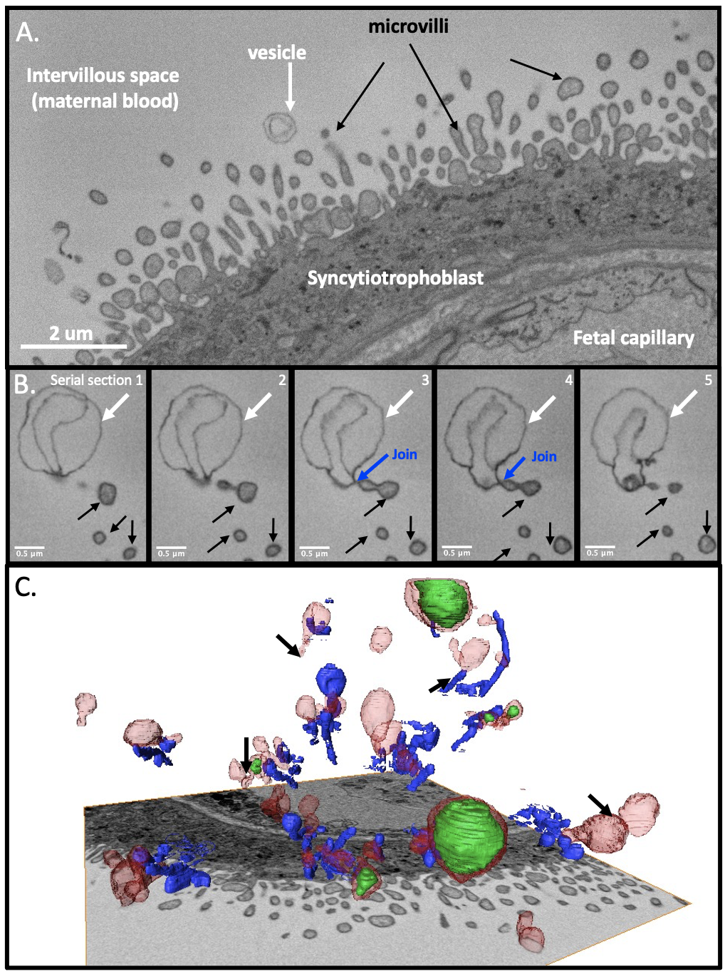
Figure 1, Microvillous tip vesicles in term placenta. A, a cross section of syncytiotrophoblast showing the microvilli and a microvillous tip vesicle. B, shows a series of images though a microvillous tip vesicle with a double membrane (white arrow) showing the connection to the microvillus (blue arrow) and the microvillus itself (black arrows). C, a three-dimensional reconstruction of microvilli (blue) and microvillous tip vesicles with outer membranes (red) and inner membranes (green). Arrows indicate examples of chains of connected vesicles. This region has an atypically high vesicle density but provides an illustration of the diversity of vesicle size and shape.
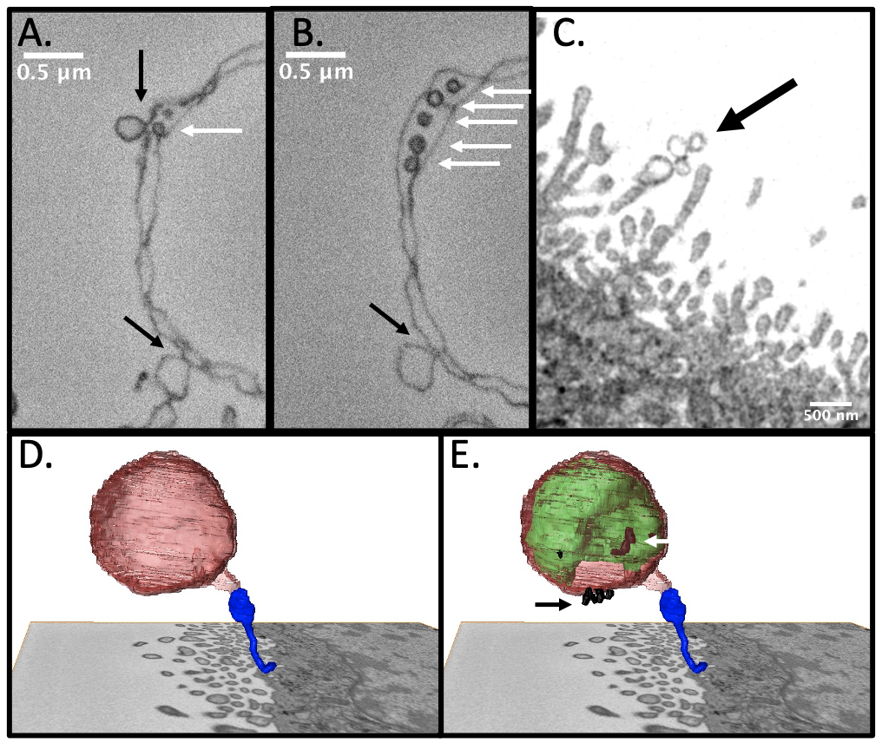
Figure 2, Images of complex microvillous tip vesicles including double membranes, daisy chains and budding of smaller vesicles. A-B, SBFSEM images showing a section of a microvillous tip vesicle including smaller vesicles pinching off the inner and outer membrane and trapped between the inner and outer membrane (white arrows). C, a daisy chain of small microvillous tip vesicles (black arrow). D, the outside of a large spherical microvillous tip vesicle (red) attached to a microvillus (blue). E, the microvillous tip vesicle shown in D including its inner membrane (green) and small vesicles (black) on the inner (white arrow) and outer (black arrow) membranes. The inner membrane is more convoluted than the outer more spherical membrane.
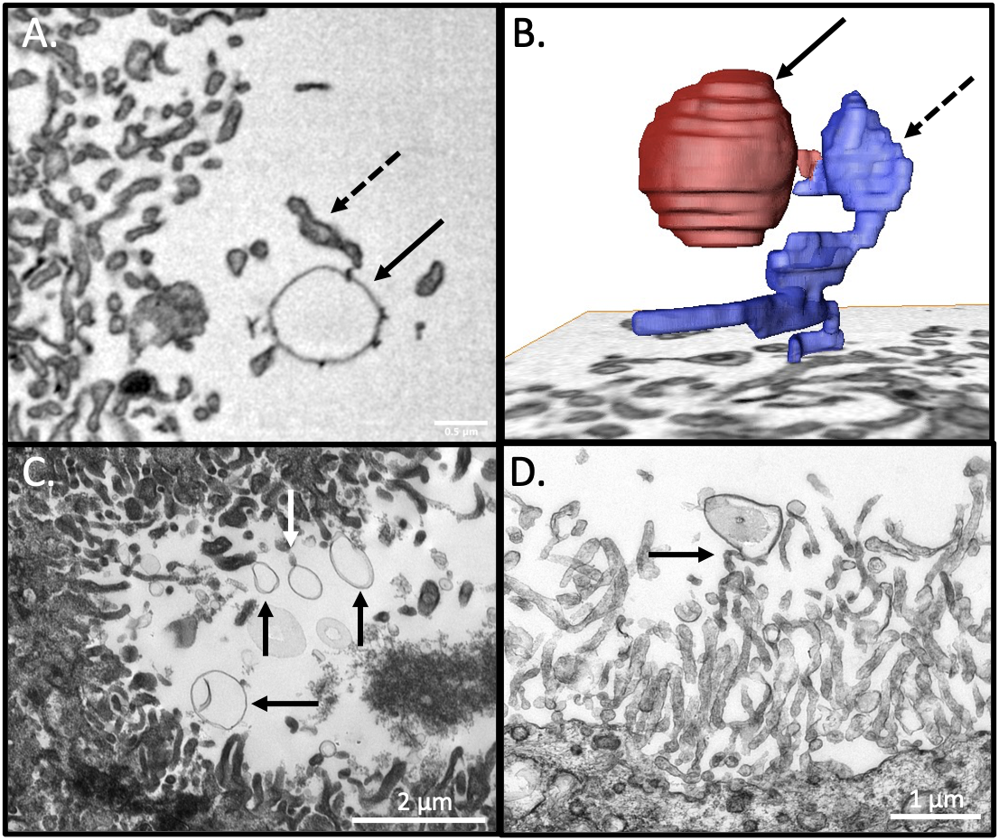
Figure 3, Microvillous tip vesicles in first trimester (week 10/11) placenta. A, an SBFSEM image of a vesicle (solid arrow) attached to the tip of a microvillus (dashed arrow). A second microvillus is in contact with the vesicle (bottom left) but whether it is connected is unclear. B, A three-dimensional reconstruction of the vesicle shown in A (red, solid arrow) and the microvillus it is attached to (blue, dashed arrow). C, A TEM image showing several microvillous tip vesicles. One vesicle has a connection to a microvillus (white arrow) reminiscent of what is seen in SBFSEM stacks. D, TEM showing vesicle on the tip of a microvillus (black arrow).
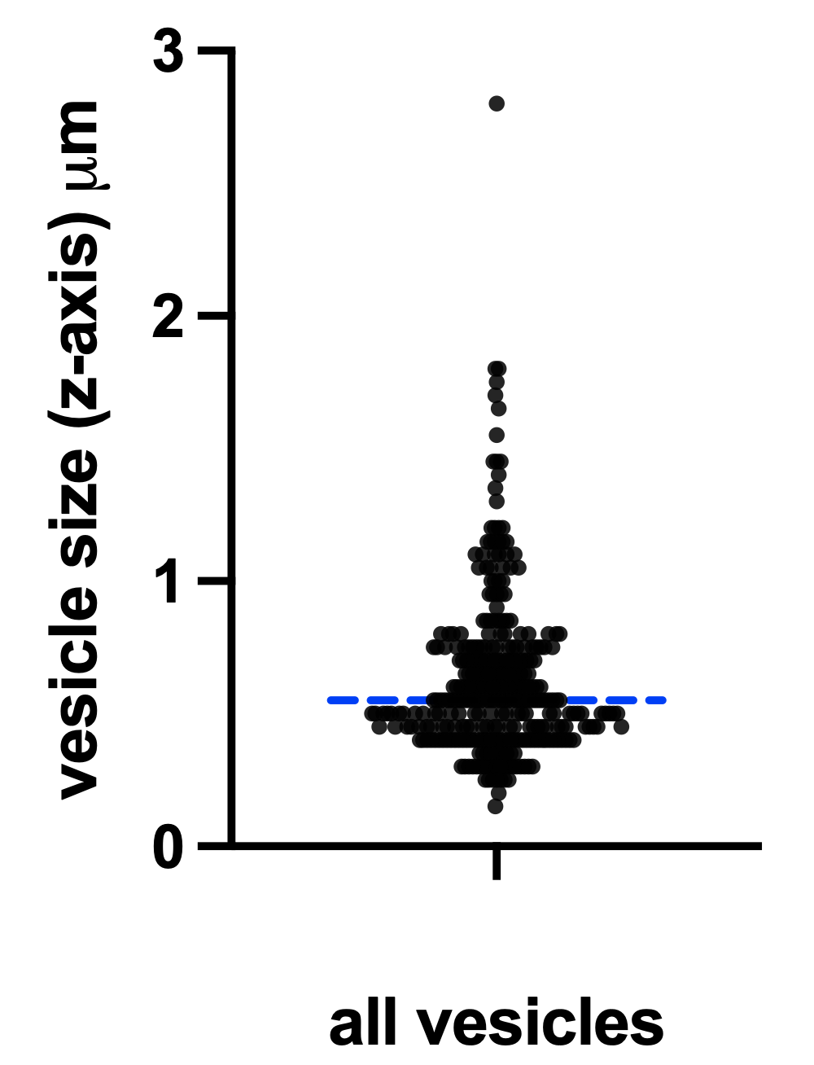
Figure 4, Microvillous tip vesicle size distribution showing all vesicles identified in the 5 term placentas. The dashed line indicates the median value.
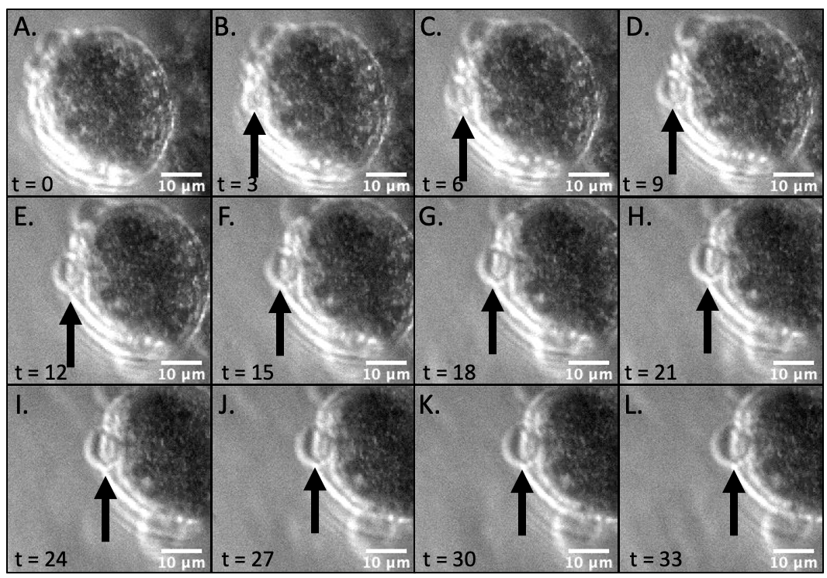
Figure 5, Time lapse sequence (A-L) of an explant from a placenta of 10 weeks gestation demonstrating the formation of a vesicle on a villous tip or syncytial nuclear aggregate (still attached to the villous surface). Arrows point to one of these protrusions as it forms between A and B. Size of the vesicle increases until a plateau is reached after 24 min. The time lapse movie can be viewed in the supplementary data.

