The resilience of biofilm-bound sandy systems to cyclic changes in shear stress

Xindi Chen1, Changkuan Zhang2, Ian H. Townend3, Zheng Gong2, Qian Feng4 and Xiping Yu5

1 State Key Laboratory of Hydroscience and Engineering, Department of Hydraulic Engineering, Tsinghua University, Beijing 100084, China.

2 State Key Laboratory of Hydrology-Water Resources and Hydraulic Engineering, College of Harbor, Coastal and Offshore Engineering, Hohai University, Nanjing 210098, China.

3 School of Ocean & Earth Sciences, University of Southampton, Southampton SO14 3ZH, UK.

4 Key Laboratory for Integrated Regulation and Resources Exploitation on Shallow Lakes of Ministry of Education, College of Environment, Hohai University, Nanjing 210098, China.

5 Department of Ocean Science and Engineering, Southern University of Science and Technology, Shenzhen 518055, China

Corresponding author: Xiping Yu ([yuxp@sustech.edu.cn)](mailto:yuxp@sustech.edu.cn))

Key Points:

* Antecedent microbial conditions can significantly influence the resilience of a biofilm-bound sandy system.
* Biostabilization can be disturbance-stimulated rather than disturbance-limited.
* A framework is proposed for bio-sandy systems developed under cyclic shear to acknowledge the effect of growth history.

Abstract

Sand-attached benthic biofilms drive many important biogeological processes and serve as cooperative “ecosystem engineers”. In aquatic environments, biofilms undergo periodic detachment and re-colonization due to the regular changes in hydrodynamic forcing. However, legacy impacts of past microbial actions on current biofilm formation and the biostabilization of the substratum sands are yet to be fully understood. In this study, a systematic set of flume experiments were conducted to investigate the effects of different depositional histories. Changes in the erosion threshold and rate of erosion were determined from the time sequences of suspended sediment concentrations. The contents of extracellular polymeric substances (EPS) and particle morphology of the biofilm-bound sandy matrix were analyzed. Surprisingly, biostabilization is disturbance-stimulated, rather than disturbance-limited, as previously thought. Bio-sandy beds cultivated under intensive disturbance presented an EPS accumulation in each cycle, and showed a more rapid increase in bed strength and stability than when rarely disturbed. All colonies from previous cycles exhibited traces of EPS as “footprints”. These stimulated and possibly accelerated the process of recolonization, thereby enhancing the erosion resistance of the bed. In contrast, a stabilized bed was better suited to mature microbial communities. A modified “Windows of Opportunity” framework was therefore put forward. Although biostabilization was not established within short quiescent periods, the system created the “opportunity” to become established in subsequent “windows” by seeding the colonization process. The stabilization, destabilization and re-stabilization of biofilm may imply a much more important role as ecosystem engineers and is relevant for a range of engineered bio-systems.

**Plain Language Summary**

“How can I stand on the ground every day and not feel its power? How can I live my life stepping on this stuff and not wonder at it?” -- *W. B. Logan*. As the evidence for early life in the earth’s sedimentary environment has shown, microorganisms are at least 3,770 million years old in sedimentary rocks, while each sand grain can harbor a highly diverse bacterial community. It is well known that biofilms, a heterogeneous matrix consisting of microbial communities and their secreted extracellular polymeric substances, can be critical in stabilizing sediments (defined as “biostabilization”), making the benthic stratum more habitable. However, legacy impacts of past microbial actions on current biofilm formation and the biostabilization of the substratum sands are yet to be fully understood. In this study, systematic flume experiments were conducted to investigate the effects of different depositional histories. Our findings highlight the resilience of bio-sandy beds in response to changing shear. The fascinating interactions between biofilms and sands may help wetlands to survive sea-level rise by inhibiting bed erosion and thereby enhancing their stability. This provides an important piece of information for the re-assessment of wetland vulnerability in the face of global change.

1 Introduction

Biofilms, a heterogeneous matrix consisting of microbial communities and their secreted extracellular polymeric substances (EPSs), as the oldest, most successful, and most widely distributed form of life on earth, are ubiquitous in most ecosystems (Flemming *&* Wingender, 2010; Flemming, 2011; Flemming *&* Wuertz, 2019; Wingender *et al.*, 1999). They play a role in many persistent infections, in biotechnological applications and in biogeochemical cycles (Bar-On *&* Milo, 2019). Microbial assemblages are also considered as cooperative “ecosystem engineers”: the ability to interactively and strongly modulate their physical living environments, e.g., their benthic substratum comprising natural sediments (Gerbersdorf *et al.*, 2020; Jones *&* Shachak, 1994). As the evidence for early life in the earth’s sedimentary environment has shown, microorganisms are at least 3,770 million years old in sedimentary rocks (Dodd *et al.*, 2017). Globally, marine surface sediments constitute a habitat for an estimated 1.7 × 1028 prokaryotes, while each sand grain can harbor a highly diverse bacterial community (Probandt *et al.*, 2018). By decreasing sediment erodibility, they promote primary succession on terraces which are less perturbed (Roncoroni *et al.*, 2019). In this respect, a phenomenon called “biostabilization” has been defined as a hindered sediment erosion caused by biological action (Paterson *&* Daborn, 1991).

The main role of biofilms as “bio-anchorages” is to provide cell-to-cell scaffolding, formed by an EPS matrix, while securing irreversible attachment to the sand grain surface (Gerbersdorf *et al.*, 2020; Hagadorn *&* Mcdowell, 2012; Mariotti *et al.*, 2014). The accumulation of EPS, which is a metabolic production of microbial cells, is tightly associated with biofilm growth and maturation. Despite the many studies that have investigated biofilms *in situ* (Montanie *et al.*, 2014; Orvain *et al.*, 2014; Passarelli *et al.*, 2015; Underwood *&* Paterson, 1993), much of our understanding has come from laboratory experiments, where the biological effect was quantified by comparing the erosion threshold of bio-sediments that were cultivated with different incubation periods, with that of clean sediments (Chen *et al.*, 2017a; Chen *et al.*, 2017b; Fang *et al.*, 2017; Tolhurst *et al.*, 2008).

Examining bio-sedimentary beds developed from an abiotic condition is a natural place to start when studying biostabilization. However, in the real world, sediments developed from a purely bare sediment into the biological condition are rare. What is more common is a quasi-abiotic condition, where sands have been colonized by microorganisms but then detached due to changing environmental conditions, followed by re-colonization (Chen *et al.*, 2019; Flemming, 2020). Such attached-detached-reattached cycles, induced by the regular shifts between high and low applied shear forces, can be widely observed in many aquatic environments, *e.g.*, rivers, floodplains, estuaries and coastal environments (Keyvani *&* Strom, 2014). In riverine systems, the shift between erosion events and quiescent periods occurs regularly due to variations in river discharge and human activities such as damming (periodic impounding and flushing). In coastal zones, a major feature of intertidal systems is the exposure to repeated cycles of high and low shear created by wave and tidal conditions, and also less predictable but more extreme episodic events such as storms (Agogue *et al.*, 2014; Mariotti *&* Fagherazzi, 2012; Valentine *et al.*, 2014; Zhao *et al.*, 2019). Therefore, the consequences with respect to biostabilization in natural settings are debatable. Once the sediments have been colonized by microbial communities, whether sediment layers with the same incubation period but different depositional histories can have significantly different resistance to erosion remains as an open question (Chen *et al.*, 2019; Stone *et al.*, 2008).

In this study, the question of how growth history influences the ability of biofilm colonization and the strength of the bio-sandy beds under multiple cycles of high-low applied shear has been examined in detail through a systematic set of flume experiments. Changes in the EPS contents and particle morphology of the biological sands, which were cyclically eroded and re-deposited were determined. Changes in the erosion threshold and rate of erosion were quantified by analyzing the time sequences of suspended sediment concentrations (SSCs). We compared results obtained from repeated erosion test sequences that have different disturbance frequencies, with a constant shear condition that was studied in our previous work. This study was aimed at understanding biostabilization developed on previously formed and then eroded bio-sandy beds, and the potential resilience of the bio-sandy system to exhibit in response to cyclic disturbances.

2 Materials and Methods

2.1 Experimental setup

In our previous studies, bacterial biofilms (*Bacillus subtilis*) were cultivated on clean sandy beds for different growth periods (*i.e.*, 5, 10, 16, 22 days) in experimental chambers (Chen *et al.*, 2017a; Chen *et al.*, 2017b). The bio-sandy beds were incubated under a low constant bottom shear stress before erosion tests were conducted. This cultivation model is termed the “single cycle” test, and in contrast, a “repeated erosion” test was introduced in this study. Benthic chambers with rotating paddles were applied for both biofilm cultivation and in-situ erosion (see **Figure S1** for the detailed information about the chamber). Four identical experimental chambers (A-D) were used. Two repeated erosion modes with different disturbance frequencies were tested, *i.e.*, cycle periods of 5 days (**Figure** **1a**) and 10 days (**Figure** **1b**), in Chamber A and B, respectively. In Chamber A, with a period of 5 days, the bio-bed was first developed on a bed of pure sand under low shear for 5 days (referred to as “bio-bed growth”, **Figure 1**), and then eroded by increasing the shear from low to high *in* *situ* (“bio-bed erosion”, **Figure 1**). The eroded sediment was then allowed to settle and the biofilm re-grow for another 5 days (**Figure 1**). The bed in Cycle 1 was developed from an initial abiotic state, while the beds in the next cycles experienced re-colonization of biofilms with prior growth history. This sequence of bed incubation/biofilm colonization followed by erosion was repeated 4 times, with a total run period of 5 $×$ 4 = 20 days. In Chamber B, with a period of 10 days, the bed was eroded every 10-days and the sequence was repeated twice, again giving a 20-day running time in total. The selected periods of 5 and 10 days were chosen because they are comparable with the range of high shear events that can occur over relatively sheltered intertidal areas (Mariotti *&* Fagherazzi, 2012). Meanwhile, Chambers C and D, mirrored the experimental protocol used for Chambers A and B, respectively, and were used for the extraction of sediment samples (every 5 days).

The experimental sediment was collected from the lower intertidal zone of tidal flats in Yancheng, Jiangsu Province, China (see **Text S1** for the site information). The sampled sediment was washed with hydrogen peroxide to remove organisms and organic material. The sediment was then sieved to remove the cohesive fraction (sieve 30 μm), retaining the non-cohesive sand for use in this study. The median grain diameter (*D50*) after treatment was 108 μm, with no cohesive fraction (see **Figure S2** for the grain size distribution). All bio-sandy beds were developed from clean sands by incubation of selected bacteria (*Bacillus subtilis*) in artificial seawater (ASW) with added nutrients (see **Text S2** for the component of the substrate media). Except for hydraulic differences, other environmental factors such as the temperature, the nutrients in artificial sea water, the bacterial culture and abundance were kept the same for the “single cycle” test and the “repeated erosion” test (see detailed experimental setup in **Text S2**). A constant value of 0.06 Pa was adopted as the bed shear stress (BSS) for the bio-beds incubation. A BSS of 0.06 Pa was taken as representing conditions during neap tides, allowing biofilm growth and was lower than the critical shear stress to avoid the re-suspension of the constituent sand grains (Shi *et al.*, 2016). During biofilm growth, scanning electron microscopy (SEM, HITACHI S-3000N, 25 kV, using freeze drying for sample preparation) was employed to visualise the microstructure of the bed.

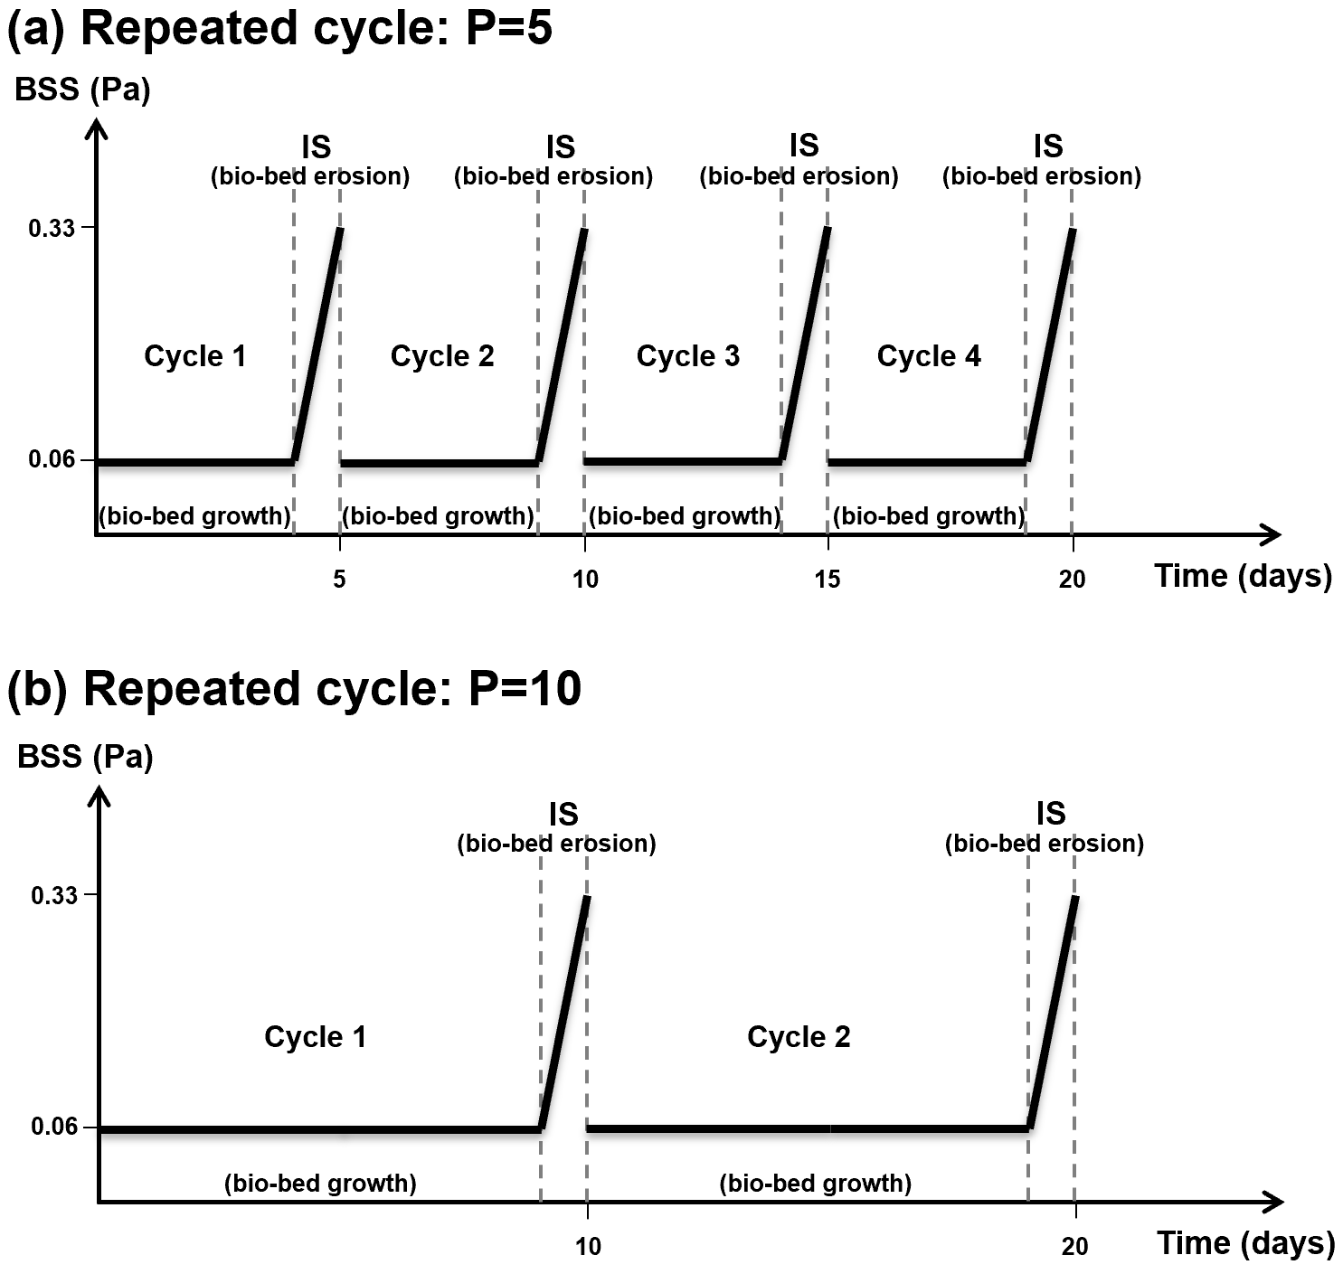

**Figure 1.** Sequence of experiments with repeated-cycles of colonization (applying low shear stress) and erosion (applying shear stress increasing from low-0.06 Pa to high-0.33 Pa). (**a**) The frequent hydrodynamic disturbance test, where repeated cycle with a quiescent period of 5 days (P=5) was applied. The sequence contains 5 days of low stress followed by a high stress event (stepwise increments of increasing shear stresses), settling and deposition, repeated for 4 cycles = 20 days. (**b**) Repeated cycle with a period of 10 days (P=10), *i.e.*, 10-day quiet period followed by a high stress event, repeated for 2 cycles = 20 days. The abbreviations used in this schematic plot are: “Bio-bed” = bio-sandy bed; “BSS” = bed shear stress; “IS” = stepwise increments of shear stress.

2.2 EPS analysis

Sediment cores (50 mm in diameter) were taken from a different region in Chamber C and D every 5 days, and the top 2-mm-layer of sediments with attached biofilms was used for analysis of EPS content and composition. Sediment samples taken following the last cycle of erosion were used to obtain the scanning electron microscopy images of sandy bed micro-morphology (SEM, HITACHI S-3000N, 25 kV, freeze drying method was used for sample preparation). Here, while the presence of EPS in SEM images can provide evidence of the matrix structure, such images must be viewed with caution because the sampling process, using the freeze-drying method, is destructive (Perkins *et al.*, 2006).

The extraction of EPS, to determine its composition, followed an established analysis protocol. The EPS were extracted from the fresh sediment sample (5 mL) before analyzing the content, by a modified method from Liang *et al.* (2010), Orvain *et al.* (2014) and Li *et al.* (2008). The sediment sample was placed in a 50 mL centrifugation tube. The sediment was mixed with the artificial sea water (ASW, 0.2 μm filtered and sterilized) to a total volume of 30 mL, and was suspended by vortexing. The tubes were then centrifuged (3, 000 g, 10 min, 4 °C), after which 0.06 mL formamide (37 %) was added into the mixture (Sunil *&* Lee, 2008). In addition, ~1 g of cation exchange resin (CER-Na+) was added to the sediment. After resuspension (to 30 mL in total with ASW), the tube was gently agitated (150 rpm) in an orbital shaking incubator for 1 h at 4 °C in the dark. The supernatant was extracted from the mixture and then centrifuged at high speed (4 °C, 10, 000 g, 15 min) to remove the suspended solids. The resultant supernatant contained the total EPS, including both the colloidal and bound EPS.

The main composition of EPS yields are polysaccharides and proteins (Gao *et al.*, 2008). The Anthrone method was adopted to quantify the contents of EPS polysaccharides, using glucose as a standard (Raunkjaer *et al.*, 1994). The EPS proteins were measured by the Lowry method with bovine serum albumin as the respective standards (Lowry *et al.*, 1951).

2.3 Erosion test

After incubation, the developed bio-sandy bed was immediately exposed to a series of stepwise increments of BSS (IS from 0.06 to 0.33 Pa) for approximately 12 min in total. This phase is referred to as “bio-bed erosion” in this study (**Figure** **1**). Bed erosion was determined by the same stepwise increment shear stress as for the single-cycle test sequence. An optical backscatter sensor (OBS-3+) was employed to obtain the temporal variations of the suspended sediment concentrations (SSCs) (see **Figure S1** for details about the location and **Figure S3** for the calibration of the OBS). The maximum SSC in this study was 60 kgm-3 (3.5% by volume).

Erosion rate per unit area of sediment bed is regarded as a robust measure of sediment stability and can reflect the nature of sediments (Amos *et al.*, 2010). Through analysis of the erosion rates, the changes in the behavior of bio-sandy beds can be further illustrated. The erosion rate can be obtained from the time sequences of SSC and shear stress. In the enclosed chambers used in this study, the rate of erosion, *E*, is defined as:

 (1)

where $C_{t}$ represents *SSC* at time *t*, *V* is the volume of water under consideration, and $α$ is the bed area in the chamber.

3 Results and discussion

3.1 The erosional behavior of bio-sandy beds with different depositional histories

Erosional results of repeated cycles (with different quiescent periods of P=5 days and P=10 days) were compared with the single-cycle results obtained from our previous study, with clean sands as the control (**Figure 2**, see Chen *et al.*, 2017b for the full dataset of the single-cycle test results). Although the erosion of sediments is a very stochastic process, the difference observed here goes beyond the natural variation between experiments (**Figure S4**). Curves of the repeated cycle (P=5) and the single-cycle tests both resulted from the erosion of biofilms first established on a clean sedimentary bed without any colonization history (**Figure 2a**). As might be expected, given that after 5 days the experimental conditions are the same, the two bio-bed curves are similar, with some small initial differences that are probably due to the natural variation between cultivations. Nevertheless, higher SSC was noted for both bio-bed cases after 5 days of incubation, as compared to the control.

After 10 days, the erosion curve of the repeated-cycle test (P=10) (in blue, **Figure** **2b**) overlapped the one obtained from the previous study (bed of single cycle after 10 days, in orange, **Figure** **2b**). There was a visible increase in both the incipient shear stress and the suppression of the erosion from the bed layers below the surface. Surprisingly, the critical shear stress was obviously increased in the second cycle of repeated-cycle test P=5 (curve in green, **Figure** **2b**). The bed surface, that was eroded in Cycle 1, was re-established as a stable bed after only 5 days of quiescent conditions. An increase of SSC was not observed until a higher BSS up to 0.29 Pa, which is 45% higher than the threshold of 0.20 Pa observed in the bed developed with no disturbance incubation of 10 days (orange curve, single-cycle test in **Figure 2b**).

A more rapid growth of the bed strength was again observed in the case of repeated-cycle P=5 (green curve in **Figure 2c**), after 3 repeated cycles (*i.e.*, 5 $×$ 3 = 15 days). The erosion only began at the final step of applied BSS (0.3 Pa) when approaching the end of the erosion test. This indicated that the bed was almost able to “survive” the whole erosion event. In contrast, massive erosion occurred after 5 min of erosion for the bio-bed developed under a single cycle (orange curve in **Figure 2c**), despite a longer running time in total, *i.e.*, 16 days *vs.* 15 days. A similar phenomenon was observed in a previous study that examined the repeated erosion of cohesive sediments with biofilms (Valentine *et al.*, 2014; Mariotti *et al.*, 2015).

The erosion curves showed obvious divergence after 20/22 days, revealing that the repeated-cycle test encouraged biofilm stabilization, manifested as the significant decrease in erodibility of the bed (**Figure 2d**). The “biostabilization” was far stronger with regular disturbance, than that developed under constant flow. The beds developed under two cyclic modes showed better performance in all the erosion tests, and as time increased, the improved resistance to erosion became even more obvious. The bed of the repeated cycle test P=10 after 2 cycles, *i.e.*, 20 days, withstood two more steps of the applied BSS than the one developed under single-cycle test (after 22 days). However, from the inception of erosion, the rate of erosion is comparable (same slope) to the single-cycle condition (blue scatters in **Figure 2d**). In contrast, the bed subjected to a repeat-cycle with P=5 remained stable until the end of the test.

The erosion rates and erosion patterns better reflect the nature of the sediment profile, through which the changes in the behavior of bio-sedimentary beds can be clearly described (**Figure 3**). The frequent disturbance in this study (in repeated cycle P=5) which was assumed to limit biofilm colonization, turned out to accelerate bed stability. This was indicated by the increased resistance to erosion after only the first 5-day cycle, and further increases after each subsequent cycle (see erosion rates and erosion patterns in the first column, **Figure 3**). After 3 to 4 cycles, the bed became strong enough to withstand the whole erosion test (bottom two figures in the first column, **Figure 3**). Here, note that 5 days was considered as a time period that was not long enough to show a biostabilization under constant flow, indicated by the high erosion rates (the second Figure in the third column, **Figure 3**). Further comparison between different repeating modes, *i.e.*, repeated-cycle P=5 and repeated-cycle P=10, suggests that more frequent disturbance favours the increase of bed stability, demonstrated by a better erosion resistance of P=5 than P=10 (the first and second column in **Figure 3**).

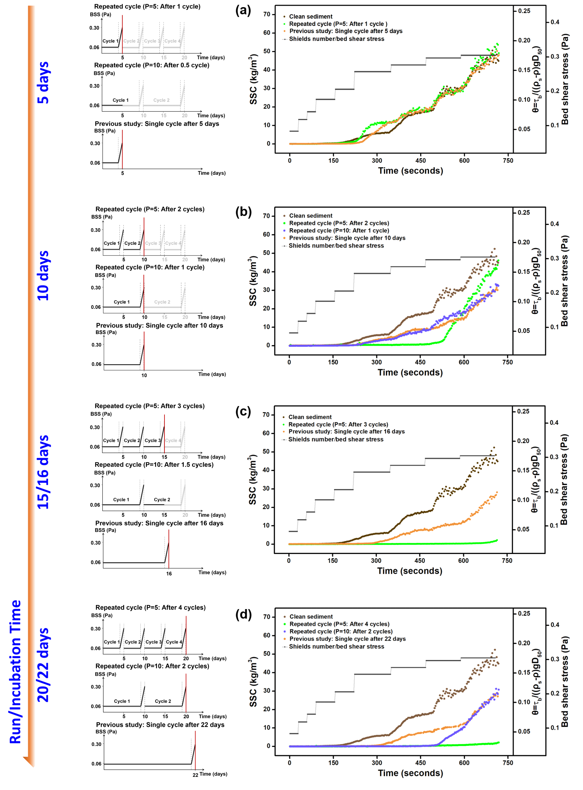

**Figure 2.** Erosion curves of bio-sandy beds represented by suspended sediment concentration (SSC) values increasing with stepwise increments of shear stress (and nondimensional Shields number) during the entire erosion experiment (the right column). Results for the beds developed in the repeated cycle tests using different repeat periods of 5 days (P=5) and 10 days (P=10), are compares with the results under a single-cycle test with different ages, using clean sediment (pure sands) results as the control (Chen *et al.*, 2017a). Erosional results under the different test sequences with experimental run/ incubation time of 5 days (**a**), 10 days (**b**), 15/16 days (**c**) and 20/22 days (**d**) are shown, with different sequences corresponded in the left column, where the red line represents the point at which the erosion test is applied.

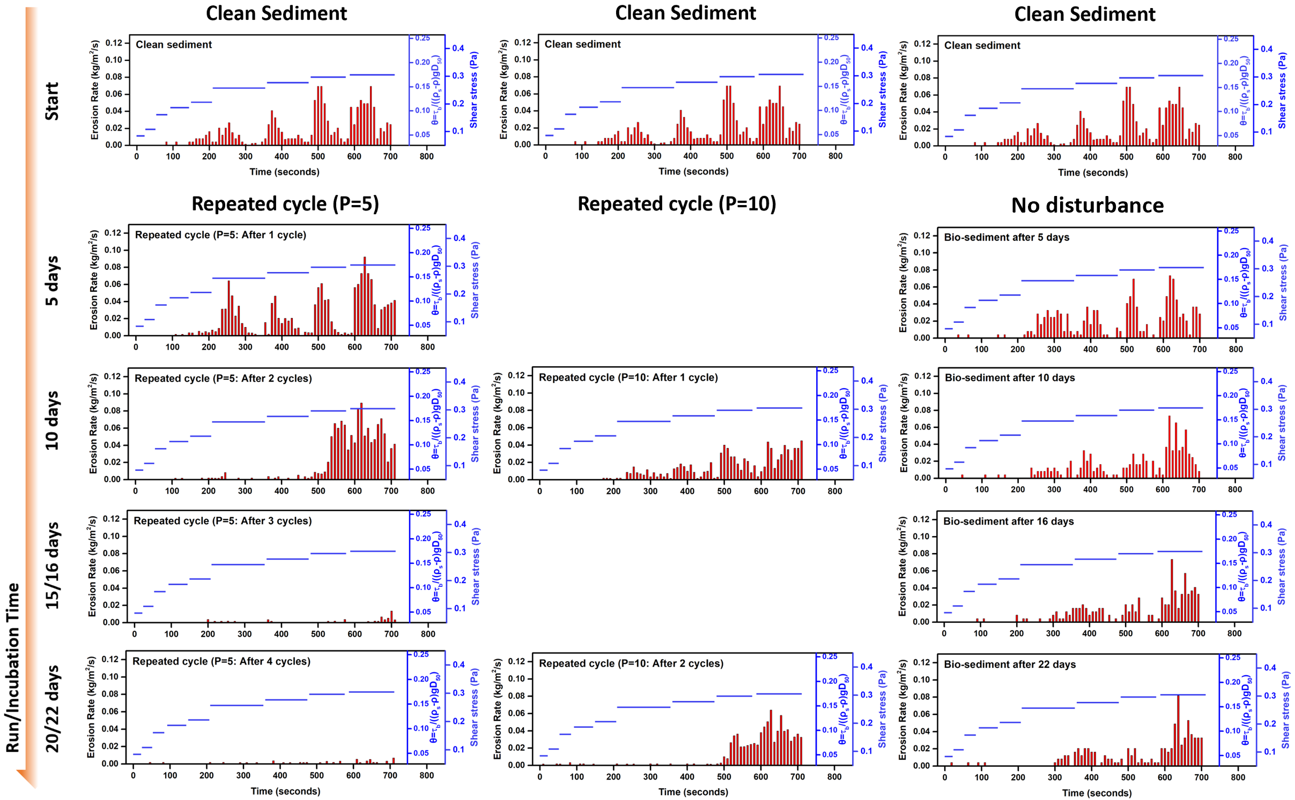

**Figure 3.** Time series of erosion rates with applied shear stress (and nondimensional Shields number) for bio-sandy beds developed under different test sequences, with repeated cycles (P=5 and P=10), and in a single-cycle (with no disturbance before erosion test applied, from our previous study Chen *et al.*, 2017a), using the clean sediment result as the control.

Although the bio-sands exhibited an obvious increase in critical bed shear stress, the biofilm did not stabilize the sub-layers, as indicated by the higher erosion rates observed after sand initiation (*τ* > *τcr*) (**Figure 2b**, where SSC for P=5 increased more than P=10, though still lower than the control). This is possibly because the microbial response to disturbance also introduced a horizontal variation of erodibility, caused by the natural heterogeneity in distribution of biofilms at the early stage (**Figure S5a**). At higher shear stress (over 0.27 Pa), mass erosion began from the “weakest points” and expanded over the bed (**Figure S6b**). This indicated the failure of the bio-sandy bed structure, which subsequently led to an immediate erosion of larger amounts of sediment, as suggested by a sharp increase in the SSC (**Figure 2b**). This was quite different from clean sand erosional behavior, where ripples formed and evolved (**Figure S6a**), and the SSC gradually increased (indicated by the clear step in the erosion curve at each increment, **Figure 2**-clean sediment). In addition, it is important to note that these are preliminary findings, necessarily limited by the range of conditions examined and the lack of replicates in our erosion experiments.

3.2 The changes of EPS in biofilms

In the case of repeated-cycle P=5, the accumulation of total EPS in the upper 2 mm layer of sediments in Cycle 2 (at Day 10) was twice the content in Cycle 1 (at Day 5), 240 *vs.* 120 μg g-1 DW (**Figure 4a**). However, a decrease in the total EPS content was observed in Cycle 3 (190 μg g-1 DW) (**Figure 4a**). While biofilms can regrow in the short quiescent periods (5 days), during which the production of EPS was stimulated, a thick mat was formed that was loosely attached to the bed surface (**Figure S5**). Different type of erosion process can contribute to changes in bed stability, including (i) the peeling off of the thin stable biofilm followed by mass erosion and (ii) the gradual detachment of the looser 'fluffy' biofilm. This echoes previous studies on biofilm strength associated with their thickness and structure. Thin biofilms can show a more compact structure with better uniformity than thick but loosely attached biofilms (Araújo *et al.*, 2016; Battin *et al.*, 2003; Risse-Buhl *et al.*, 2017). In addition, the functional role played by different EPS compositions may be important as well. Recent research has revealed that while the polysaccharides dominate the cohesion of the biofilm, protein contributes more to the structural integrity of the biofilm matrix (Flemming *&* Wingender, 2010; Gerbersdorf *et al.*, 2008; Gerbersdorf *&* Wieprecht, 2015; Pennisi, 2002). In this study, the raised amount of the total EPS in Cycle 2 was mainly attributed to the rapid accumulation of the total polysaccharides, while the protein concentration was still low as compared to that in Cycle 3 (**Figure 4a**). Subsequent variations of both the contents of polysaccharide and protein after Cycle 3 (after 15 days) and Cycle 4 (after 20 days) were small.

In the case of repeated-cycle P=10, both polysaccharide and protein in total EPS accumulated up to 150 μg g-1 DW in the first cycle (from the beginning to Day 10, **Figure 4b**). Erosion occurred and then biofilm re-formed for another 10 days (from Day 10 to Day 20), during which the total EPS increased to around 180 μg g-1 DW at Day 20. The final total EPS contents in the case of P=5 and P=10 at Day 20 were similar, but varied in the protein/polysaccharide ratio, *i.e.*, 1/2 and 1/3, respectively (**Figure 4**). The bed erodibility (Day 20) showed difference, where the bed (in the case of P=5) endured the whole erosion event while the bed (P=10) was eroded when the BSS reached 0.27 Pa (**Figure 2d**). This suggests that biostabilization is not simply dependent on the total EPS content, but a complicated relationship between bed stability and microbiological effects, where EPS total content, fraction ratio (*e.g.*, protein/polysaccharide), internal structure of the biofilm matrix, *etc.*, may all contribute.

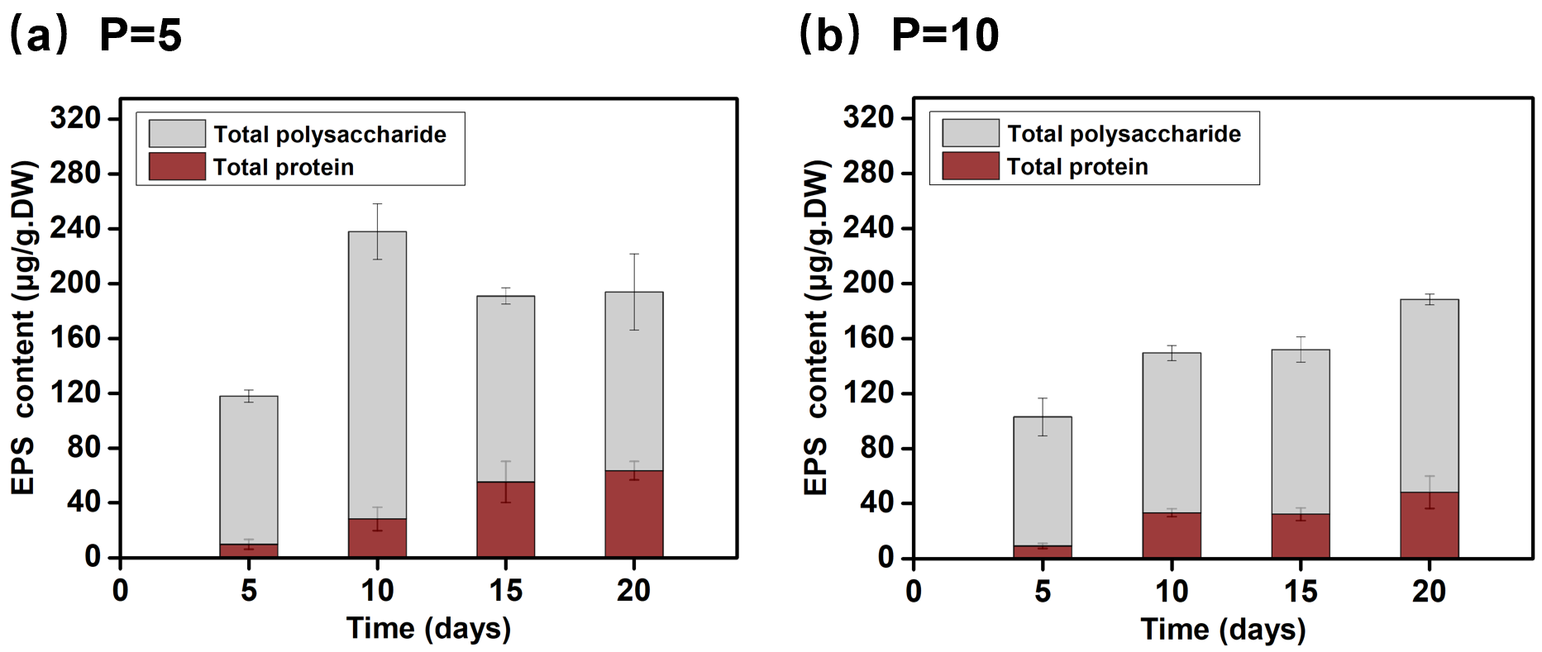

**Figure 4.** EPS contents in the upper 2 mm layer (total polysaccharide and protein) show the variation during the biofilm growth under the repeated-cycle test sequence, with different quiescent periods of (**a**) P=5 and (**b**) P=10 days.

3.3 The “footprints”

Whilst the bio-sandy matrix was destroyed during high shear events, the EPS attached to the sand grains were not entirely removed as sediment was eroded and moved into suspension. Instead, small patches of aggregate, comprising broken biofilms and bacterial cells, remained and were visible on the sand grains after erosion (**Figure 5**). These organic remains altered the texture and surficial properties of the particle. As the matrix exhibited a more complex ultrastructure, the possibilities for potential attachment were therefore improved. Due to the plentiful contact surface as ‘hot-spots’ formed within the matrix, more binding sites were available for the floating bacterial cells to adhere to. The matrix also “houses” and shelters the cells, which guarantees a more successful and efficient initial adhesion, and thereby a rapid maturing of biofilms (Shen *et al.*, 2015). These remnants of previous cycles therefore define a “footprint” on which subsequent colonization phases can build. Phenomenon under a similar mechanism has been reported in a previous study on the role of cell and particle characteristics in the adhesion of *E.coli* bacteria to suspended intertidal sediments (Wyness *et al.*, 2018). Results showed that all strains adhered more efficiently to the organic mud sediments than other sediment types (*i.e.*, mud or mixed sands), as organic mud sediments presented a well-developed conditioning film, evidenced by greater EPS concentrations typically found inside.

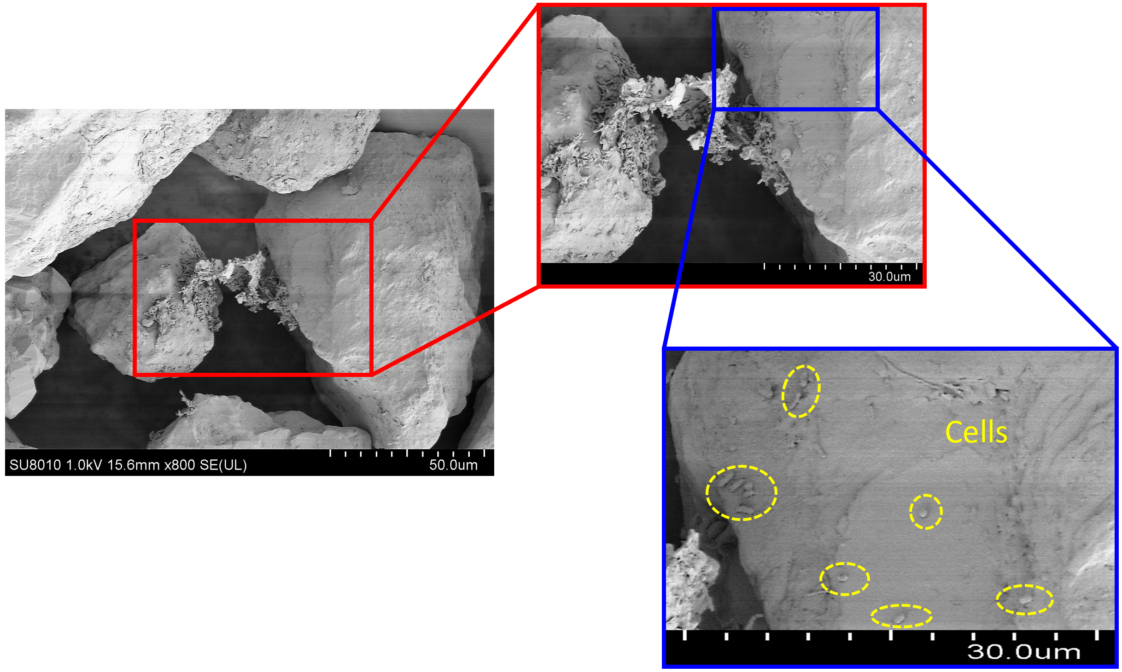

**Figure 5.** SEM images presenting the micromorphology of sand grains after erosion of 4 repeated cycles in P=5 test. “Footprints” such as the fragments of biofilm remained between grains. Single cells were also visualized attaching to the surface of individual particle. The biological legacies acted as the precursor which provided more “hot spots” for the initial attachment in the next cycle of re-colonization, and stimulated a rapid return of biofilms.

After each colonization and detachment, such “footprints” may remain on the grains, which can help other, free-floating, bacteria to quickly re-attach to the surface. All colonies exhibited traces of EPS surrounding them, however, the signals from EPS were not only concentrated in single colonies but also extended along the substrate matrix, connecting clusters (Escudero *et al.*, 2018). Intercellular communication is also expected in such clusters *(Davies et al.*, 1998; Flemming *&* Wuertz, 2019). For the surface without previous colonisation, initial attachment begins with transient interactions of planktonic cells with sediments (reversible attachment). While under repeated disturbance, after each successive attachment/detachment event, the levels of ‘footprint’ gradually increase, and a ‘surface-sensing system’ is developed. Similar to many other microbial behaviors, such as pathogenic infection, toxin production, drug resistance, biofouling and pipe blockage, the amazing ability of a rapid return, as shown in this study, could be the result of signal communication and cooperation when subject to adverse conditions (Nadell *et al.*, 2009; Bassler *&* Losick, 2006; Donlan *&* Costerton, 2002; Cao *et al.*, 2020).

3.4 The biostabilization in response to cyclic disturbances

Understanding the mechanisms limiting and facilitating bio-sandy establishment is of widespread significance, because the biofilms associated with sedimentary deposits play an important role in many ecosystem functions. Flow-biofilm-sediment dynamics have been investigated by many previous studies, but the mechanisms that enable or disable the establishment of the system are still understudied (Gerbersdorf *et al.*, 2020). In recent years, the “Windows of Opportunity” (WoO) concept has been proposed as a framework providing an explanation for the initial establishment of bio-geomorphic ecosystems and the role of physical disturbance. The theory has been successfully applied to intertidal salt-marsh systems (Balke *et* *al.*, 2014; Hu *et al.*, 2015). Such theory proposes a “survival model”, suggesting that disturbance-free periods of a defined minimum duration can be identified from time series analysis and used to hindcast and potentially predict colonization events in ecosystems where new establishment is dependent on the frequency of disturbance (Balke *et al.*, 2011). Early attempts have been made to employ this theory to simulate the development of biofilms on sedimentary systems in natural environments (Mariotti *&* Fagherazzi, 2012). Based on this disturbance-free assumption, once exposed to frequent hydrodynamic disturbance, the biofilm growth may be limited, resulting in decay to the abiotic condition (**Figure 6a**).

Our results from erosion tests suggest that the colonization of biofilms on sands and subsequent stability are stimulated by disturbances (**Figure 2** and **Figure 3**). Having only tested two disturbance cycles, we are not able to determine any limits to the frequency and/or magnitude of disturbance. However, the disturbance intervals tested did not lead to a return to the abiotic state, as might be expected if the disturbance-free concept were to apply to the ongoing state (accepting that the WoO might only apply to the initial formation of the matrix).

Herein, we propose a modified WoO model reflecting the self-adaptation of the biofilms (**Figure 6b**). In this model,disturbance destroys the established matrix and any associated biostabilization, but triggers a defence system. The ability to boost the resistance to erosion was found to be related to the erosion frequency. The shorter quiescent period stimulated the resilience of the matrix more than less frequent disturbance. This echoes a previous study on the biofilm survival mechanisms of clinically relevant microorganisms, pointing out that, perhaps the first surprise, bacteria form biofilms preferentially in very high shear environments (*i.e.*, rapidly flowing milieus) (Donlan *&* Costerton, 2002). This behaviour allows the bacterial community to be sustained over periods that are considerably longer than the frequency of disturbance. Although biostabilization was not established within short quiescent periods, the system created the “opportunity” to become established in subsequent “windows” by seeding the colonization process (**Figure 6b**). It differs from the disturbance-free requirement of WoO because the requirement is not to gain an initial foothold but rather to maintain a community under repeated disturbance. With *τcr* increased after every erosion event, this simple model could be incorporated in other more complex bio-geo-morphologic models (*e.g.*, the model proposed by Mariotti *&* Fagherazzi (2012)).

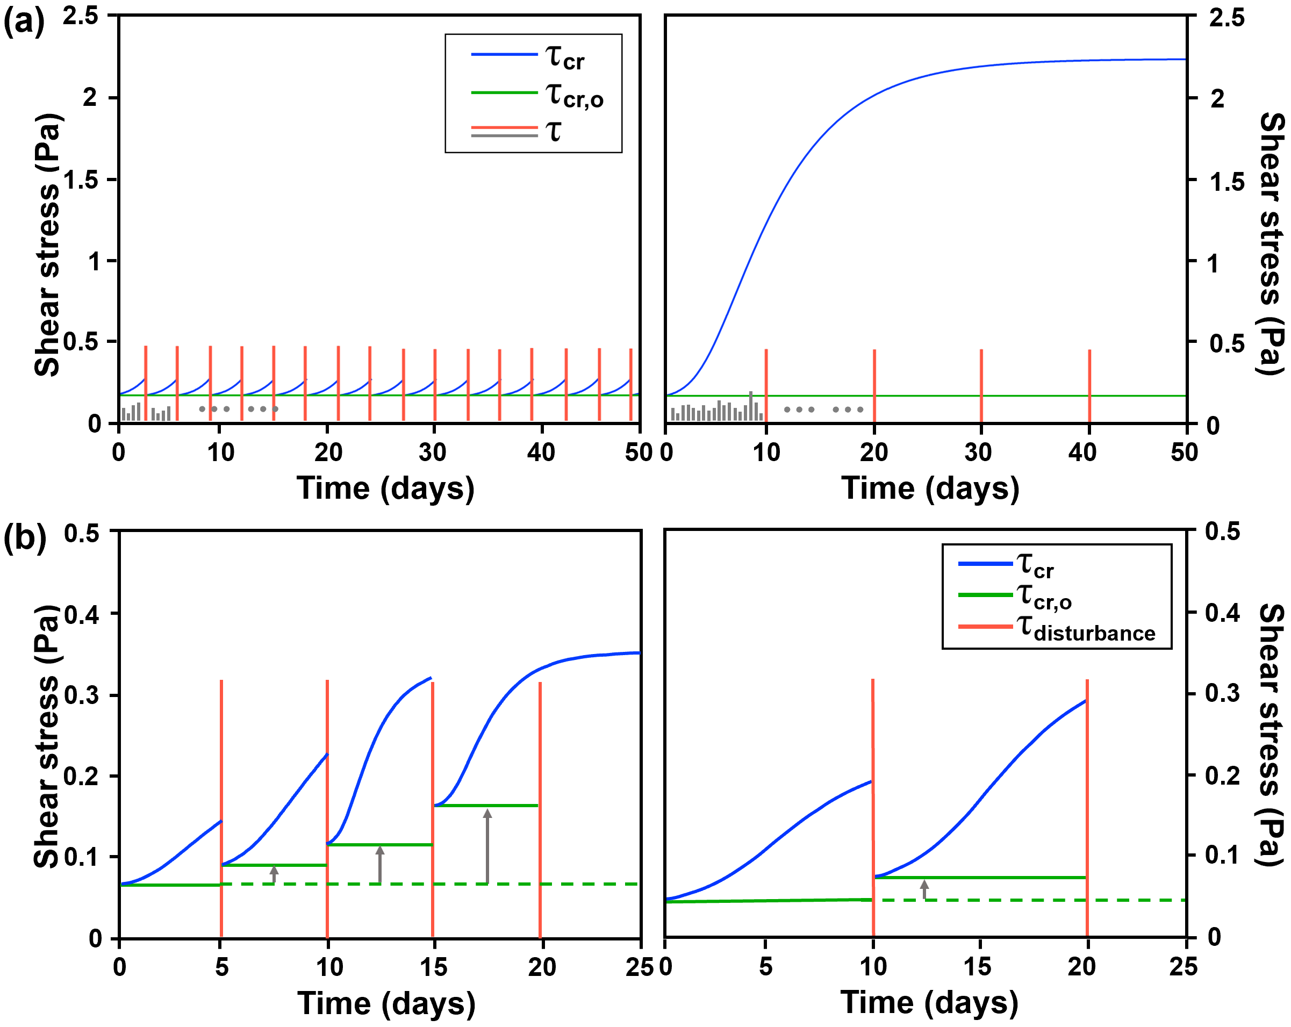

**Figure 6.** Flow-biofilm-sand dynamics under cyclic disturbances. $τ$ is the BSS applied, $τ_{cr}$ is the critical shear stress of the bio-sandy bed and $τ_{cr, 0}$ is the initial critical shear stress. The colonization of biofilms begins when the BSS (the grey lines) stays lower than the $τ_{cr, 0}$ (the green line). $τ_{cr}$ increases with biofilm growth because of biostabilization (the blue curves), until disturbance of high BSS occurs (the red lines). (**a**) According to the traditional WoO concept, a newly settled biofilm can be periodically detached due to frequent disturbance (left), because of the limited time for biofilm growth. Only with rare disturbances (right), can the biofilms increase the sand resistance, so that no erosion occurs during the high shear events. (**b**) A modified WoO theory is proposed to acknowledge the influences of depositional history and the legacies from biofilm attachment in previous cycles. An enhancement of the bed strength occurs from one cycle to the next.

3.5 The dynamic of bio-sandy system under repeated disturbance

Our previous work has demonstrated that biostabilization by bacterial biofilms (*Bacillus subtilis*) reached (or approached) a stable equilibrium state after 2 weeks of incubation under steady flow condition (Chen *et al.*, 2017a). However, in natural settings where applied shear stress, temperature, light, *etc.*, vary temporally, different periods might be needed to reach equilibrium, and a true equilibrium may never be reached due to natural perturbations. Therefore, most colonization of biofilms on sands is likely to be closer to the state described by Stages A and B (**Figure 7**), where biofilms are regularly detached by external forces other than natural aging. The colonization of biofilms starts either on a pure abiotic sandy bed (Stage A, an idealised condition), or a bed with depositional histories (Stage B, more common settings).

The stabilization-destabilization-re-stabilization sequence (Stage B) can repeat for several cycles (**Figure 7**). Bed stability is gradually enhanced between cycles (**Figure 6b**), due to the accumulation of “footprints”, where a biofilm legacy remains from the previous cycle (**Figure 5**). The suspended cells (or transparent exopolymer particles, TEP) can be quickly captured by the bed, while the residence time of the newly deposited microbes is also increased. The “stimuluses” of the settled cells/TEP acting as EPS precursors further enhance this process in the next cycle of biofilm re-building (Chen *et al.*, 2019). The positive feedback leads to a rapid recovery of the system. Consequently, the time taken to develop a matrix that is capable of increasing the erosion resistance is accelerated. As this now takes place within the bed, as well as on the surface, the subsequent depth of erosion for a given shear stress is also reduced. The bed state may then enter Stage C, where erosion is completely inhibited until a stronger hydrodynamic event breaks the balance and initiates a new response. From an ecological point of view, biofilms exhibit an ability to turn unfavorable conditions (a substratum often reworked) into a more stable environment, acting as the “first colonisers” and “ecosystem engineers” who create a more favorable habitat for other settlers and ecological processes such as the seeding of vegetation.

Although in this study, erosion inhibition was rapidly achieved, uncertainties remain, especially in relation to other biological activities present in the real-world conditions. Consequently, it is not clear for how long this “equilibrium” or stable system can be maintained, and what the depth accumulation of EPS down into the bed contributes to the resultant state. In this study, cyclic events did not enable a deeper distribution of vertical matrix of EPS inside the sands, because from the inception of erosion, the rate of erosion is comparable to the single-cycle condition (**Figure 3**, alsoindicated by thesame slope in **Figure 2d**). This is different from what has been found in natural intertidal systems. For example, on the bare flat area of the Jiangsu Coast, China, the top 4 cm of the bed contained EPS (0.02~0.1%, **Figure S6a**, see **Text S1** for site information). While in intertidal areas with natural marshes, sediments below the bed surface can have high concentrations of EPS. Samples taken at a depth of 4 cm below the marsh in the Eden Estuary, UK contained up to 0.08%~0.3% EPS, which is more than 10 times higher than the maximum value of ~0.02% observed in this study (**Figure 4** and **Figure S6b**, see **Text S3** for site information). Non-destructive 3D image of a representative sample indicates the extent of the hydrated biofilm-sedimentary matrix over depth using CT scanning technology(Chen *et al.*, 2021; Zhang *et al.*, 2018). Such structures imply that in the natural ecosystems, more complex interactions exist between the microbial communities, vegetation and other benthos, where sediments may be affected by the various biological actors to various depths below the surface.

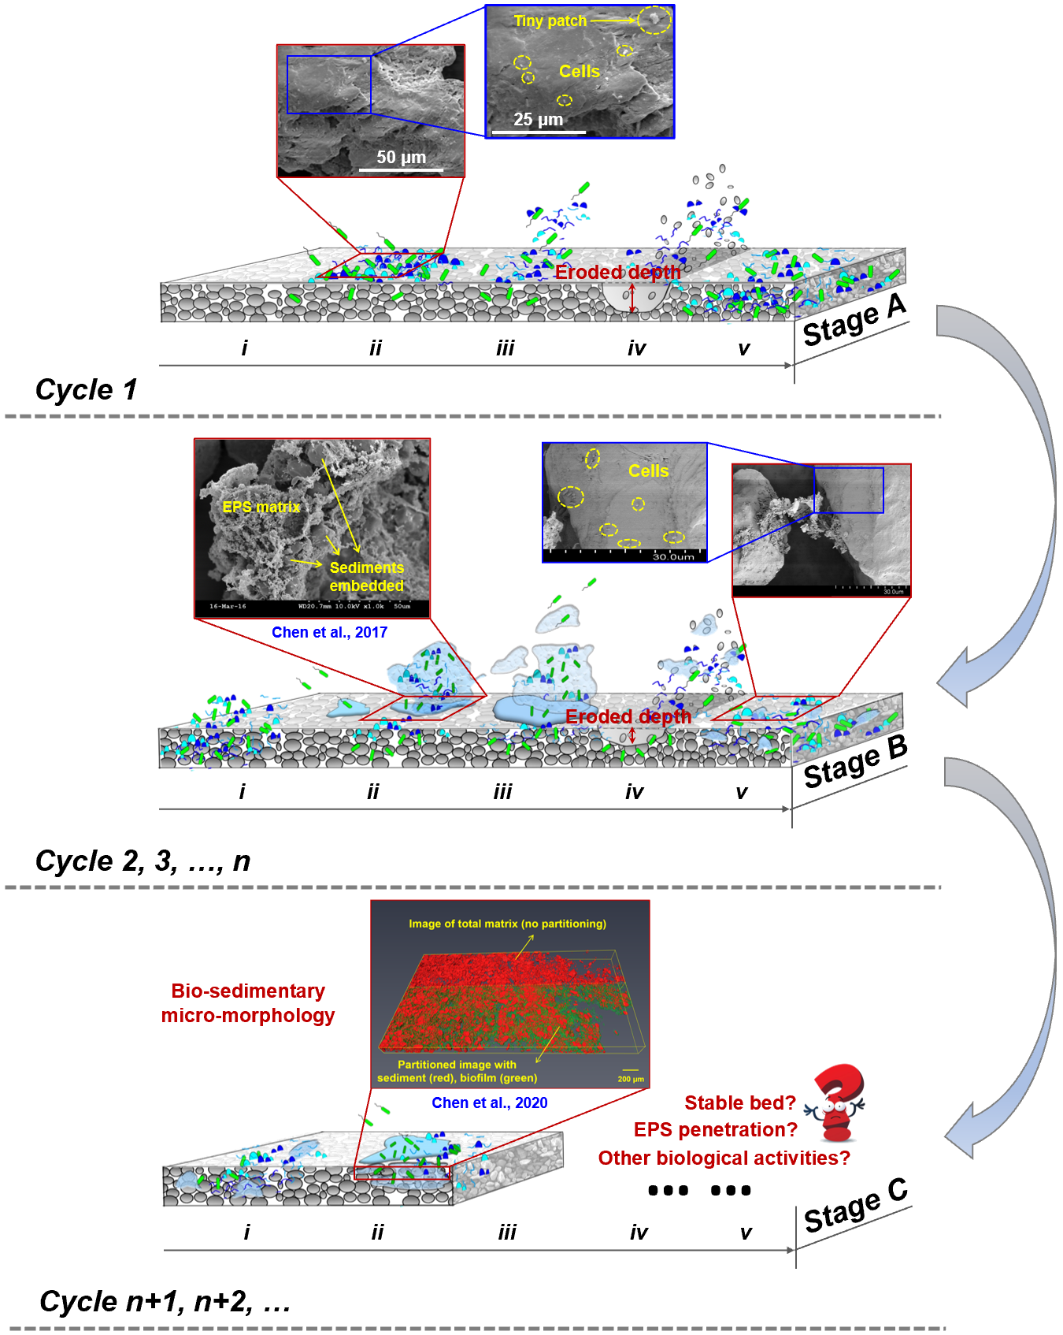

**Figure 7.** An improved framework highlights the effect of growth history and the positive bond built between the environmental shock and the bio-sands stability. Stage A illustrates an ideal situation where the microbial colonization starts on a clean sandy bed. Stage B describes a more common setting in natural environments, where biostabilization establishes on beds with pre-colonization histories. The bio-sandy system enters Stage C when its erosion threshold increases sufficiently to completely hinder erosion, and a stable bed is formed. Different extents of extracellular polymeric substances (EPS) penetrate during the incubation states from *ⅰ* to *ⅴ*. The eroded depth decreases due to the increase of the resistance after several cyclic actions. However, the final state can be associated with other biological actions such as rooting of vegetation or bioturbations by benthos. [Graphic design by Dr. Xueer Zhang]

It should be noted that in this experiment an extreme case (a closed system) is studied, in which all eroded biomaterial is re-deposited. In natural settings, some of the biomaterial might be washed out of any given area. Aother extreme case is when all the eroded bio-material is washed away, and the sands start from fresh/abiotic/quasi-abiotic states. Therefore, there may exist a spatial-feedback dependent on the areal extent of the biofilm colonization. If the area colonized by biofilm is small compared to the area spanned by the transport mechanisms (*e.g.*, 100 m2 within a 100 km2 tidal flat or estuary), it is more likely that the eroded bio-material will be washed away and in practice not re-deposited in the area initially covered with biofilm. If the area of biofilm colonization is very large, then most of the material is more likely to re-deposit within the patch.

In addition, the biological processes in the real-world are much more complex than in our laboratory incubation. The development of bio-sandy systems is clearly related to the variations in coastal environmental conditions and related ecology. As the abiotic factors such as temperature, nutrient supply, applied shear stress, and irradiance, *etc*. vary temporally, an inevitable factor is the higher biodiversity of the mixed assemblages. As a result of such complex physical-chemical-biological interactions, different periods might be needed to re-establish the bio-sandy bed, and a well-developed matrix may never be reached due to natural perturbations.

4 Conclusions

In this study, a systematic set of flume experiments were conducted to investigate how different depositional histories affect the formation of a bio-sandy system and the establishment of biostabilization under cyclic high shear events. Results showed that legacy influences of past microbial actions on current biofilm formation and the stabilization of the substratum sands were significant. With repeated disturbance, the next cycle of formation did not repeat the previous one and a different ultimate state of stability was achieved. To our surprise, bio-sandy beds, cultivated under more frequent disturbance, exhibited a greater ability to resist erosion than beds cultivated with less frequent disturbance. This indicated that the colonization of biofilms on sands can be enhanced by the stimulus of disturbance. The depositional history, provided by remnant fractions of biofilm, which enable a rapid recognition and location of the surface by floating cells. A conceptual erosion framework is proposed for bio-sandy systems recognizing the variation of growth histories and cyclic effects.

Nevertheless, links between this disturbance-stimulated ability of microbial communities coping with their environment, and the vast numbers of microbially produced, small organic molecules with intercellular signalling activity await discovery. Effective management of water bodies requires advancing further in-depth understanding of how different hydrodynamic conditions influences biofilm-bound sands. The stabilization, destabilization and re-stabilization of bio-sandy system is relevant for different engineered bio-systems. Therefore, more efforts are needed to link laboratory-scale observations to larger scales relevant for the management of water bodies.

Acknowledgments

Funding for this project was provided by the National Natural Science Foundation of China (41961144014, 52101318), and the China Postdoctoral Science Foundation (2021T140383, 2020M680580). Our thanks go to Jia Xu, Shibai Yu and all our laboratory assistants for their help with the flume setup. Our thanks also go to Dr. Xueer Zhang for designing Figure 7. The authors declare that they have no known competing financial interests or personal relationships that could have appeared to influence the work reported in this paper. Data presented in this study can be obtained through Mendeley Data online (doi: 10.17632/69xc2s9whw.1, https://data.mendeley.com/datasets/69xc2s9whw/1).

References

Agogue, H., Mallet, C., Orvain, F., De Crignis, M., Mornet, F., & Dupuy, C. (2014). Bacterial dynamics in a microphytobenthic biofilm: A tidal mesocosm approach. *J Sea Res*, *92*(SI), 36-45. doi: 10.1016/j.seares.2014.03.003.

Amos, C. L., Umgiesser, G., Ferrarin, C., Thompson, C. E. L., Whitehouse, R. J. S., & Sutherland, T. F. et al. (2010). The erosion rates of cohesive sediments in Venice lagoon, Italy. *Cont Shelf Res*, *30*(8SI), 859-870. doi: 10.1016/j.csr.2009.12.001.

Araújo, P. A., Malheiro, J., Machado, I., Mergulhão, F., & Simões, M. (2016). Influence of flow velocity on the characteristics of pseudomonas fluorescens biofilms. *J Environ Eng*, *142*(7), 4016031.

Balke, T., Bouma, T. J., Horstman, E. M., Webb, E. L., Erftemeijer, P. L. A., & Herman, P. M. J. (2011). Windows of opportunity: Thresholds to mangrove seedling establishment on tidal flats. *Mar Ecol Prog Ser*, *440*, 1-9. doi: 10.3354/meps09364.

Balke, T., Herman, P. M. J., & Bouma, T. J. (2014). Critical transitions in disturbance-driven ecosystems: Identifying Windows of Opportunity for recovery. *J Ecol*, *102*(3), 700-708. doi: 10.1111/1365-2745.12241.

Bar-On, Y. M., & Milo, R. (2019). Towards a quantitative view of the global ubiquity of biofilms. *Nature reviews. Microbiology*, *17*(4), 199-200. doi: 10.1038/s41579-019-0162-0.

Bassler, B. L., & Losick, R. (2006). Bacterially speaking. *Cell*, *125*(2), 237-246. doi: https://doi.org/10.1016/j.cell.2006.04.001.

Battin, T. J., Kaplan, L. A., Newbold, J. D., & Hansen, C. M. E. (2003). Contributions of microbial biofilms to ecosystem processes in stream mesocosms. *Nature*, *426*(6965), 439-442.

Cao, Y., Jana, S., Tan, X., Bowen, L., Zhu, Y., & Dawson, J. et al. (2020). Antiwetting and antifouling performances of different Lubricant-Infused slippery surfaces. *Langmuir*, *36*(45), 13396-13407.

Chen, X., Zhang, C., Paterson, D. M., Townend, I. H., Jin, C., & Zhou, Z. et al. (2019). The effect of cyclic variation of shear stress on non-cohesive sediment stabilization by microbial biofilms: The role of ‘biofilm precursors’. *Earth Surf Proc Land*, *44*, 1471-1481. doi: 10.1002/esp.4573.

Chen, X. D., Zhang, C. K., Paterson, D. M., Thompson, C. E. L., Townend, I. H., & Gong, Z. et al. (2017a). Hindered erosion: The biological mediation of noncohesive sediment behavior. *Water Resour Res*, *53*, 4787-4801. doi: 10.1002/2016WR020105.

Chen, X. D., Zhang, C. K., Zhou, Z., Gong, Z., Zhou, J. J., & Tao, J. F. et al. (2017b). Stabilizing effects of bacterial biofilms: EPS penetration and redistribution of bed stability down the sediment profile. *Journal of Geophysical Research Biogeosciences*, *122*, 3113-3125. doi: 10.1002/2017JG004050.

Chen, X. D., Zhang, C. K., Townend, I., Paterson, D. M., Gong, Z., & Jiang, Q. et al. (2021). Biological cohesion as the architect of bed movement under wave action. *Geophys Res Lett*, *48*, e2020G-e92137G. doi: 10.1029/2020GL092137.

Dodd, M. S., Papineau, D., Grenne, T., Slack, J. F., Rittner, M., & Pirajno, F. et al. (2017). Evidence for early life in Earth’s oldest hydrothermal vent precipitates. *Nature*, *543*, 60-64. doi: 10.1038/nature21377.

Donlan, R. M., & Costerton, J. W. (2002). Biofilms: Survival mechanisms of clinically relevant microorganisms. *Clin Microbiol Rev*, *15*(2), 167.

Escudero, C., Vera, M., Oggerin, M., & Amils, R. (2018). Active microbial biofilms in deep poor porous continental subsurface rocks. *Sci Rep-Uk*, *8*(1), 1538.

Fang, H. W., Lai, H. J., Cheng, W., Huang, L., & He, G. J. (2017). Modeling sediment transport with an integrated view of the biofilm effects. *Water Resour Res*, *53*(9).

Flemming, H., & Wingender, J. (2010). The biofilm matrix. *Nat Rev Microbiol*, *8*(9), 623-633.

Flemming, H. (2011). The perfect slime. *Colloids and Surfaces B: Biointerfaces*, *86*(2), 251-259. doi: 10.1016/j.colsurfb.2011.04.025.

Flemming, H., & Wuertz, S. (2019). Bacteria and archaea on Earth and their abundance in biofilms. *Nat. Rev. Microbiol.* doi: 10.1038/s41579-019-0158-9.

Flemming, H. (2020). Biofouling and me: My Stockholm syndrome with biofilms. *Water Res*, *173*, 115576. doi: 10.1016/j.watres.2020.115576.

Gao, B., Zhu, X., Xu, C., Yue, Q., Li, W., & Wei, J. (2008). Influence of extracellular polymeric substances on microbial activity and cell hydrophobicity in biofilms. *J Chem Technol Biot*, *83*(3), 227-232. doi: 10.1002/jctb.1792.

Gerbersdorf, S. U., Jancke, T., Westrich, B., & Paterson, D. M. (2008). Microbial stabilization of riverine sediments by extracellular polymeric substances. *Geobiology*, *6*(1), 57-69. doi: 10.1111/j.1472-4669.2007.00120.x.

Gerbersdorf, S. U., & Wieprecht, S. (2015). Biostabilization of cohesive sediments: Revisiting the role of abiotic conditions, physiology and diversity of microbes, polymeric secretion, and biofilm architecture. *Geobiology*, *13*(1), 68-97. doi: 10.1111/gbi.12115.

Gerbersdorf, S. U., Koca, K., Debeer, D., Chennu, A., & Terheiden, K. (2020). Exploring flow-biofilm-sediment interactions: Assessment of current status and future challenges. *Water Res*, *185*, 116182.

Hagadorn, J. W., & Mcdowell, C. (2012). Microbial influence on erosion, grain transport and bedform genesis in sandy substrates under unidirectional flow. *Sedimentology*, *59*(3), 795-808. doi: 10.1111/j.1365-3091.2011.01278.x.

Hu, Z., Belzen, J., Wal, D., Balke, T., Wang, Z. B., & Stive, M. et al. (2015). Windows of opportunity for salt marsh vegetation establishment on bare tidal flats: The importance of temporal and spatial variability in hydrodynamic forcing. *Journal of Geophysical Research Biogeosciences*, *120*(7), 1450-1469.

Jones, C. G., & Shachak, L. M. (1994). Organisms as ecosystem engineers. *Oikos*, *69*(3), 373-386.

Keyvani, A., & Strom, K. (2014). Influence of cycles of high and low turbulent shear on the growth rate and equilibrium size of mud flocs. *Mar Geol*, *354*, 1-14. doi: 10.1016/j.margeo.2014.04.010.

Li, T., Bai, R., & Liu, J. (2008). Distribution and composition of extracellular polymeric substances in membrane-aerated biofilm. *J Biotechnol*, *135*(1), 52-57. doi: 10.1016/j.jbiotec.2008.02.011.

Liang, Z., Li, W., Yang, S., & Du, P. (2010). Extraction and structural characteristics of extracellular polymeric substances (EPS), pellets in autotrophic nitrifying biofilm and activated sludge. *Chemosphere*, *81*(5), 626-632. doi: 10.1016/j.chemosphere.2010.03.043.

Lowry, O. H., Rosebrough, N. J., Farr, A. L., & Randall, R. J. (1951). Protein measurement with the Folin phenol reagent. *The Journal of biological chemistry*, *193*(1), 265-275.

Mariotti, G., & Fagherazzi, S. (2012). Modeling the effect of tides and waves on benthic biofilms. *J Geophys Res-Biogeo*, *117*, G4010. doi: 10.1029/2012JG002064.

Mariotti, G., Pruss, S. B., Perron, J. T., & Bosak, T. (2014). Microbial shaping of sedimentary wrinkle structures. *Nat Geosci*, *7*(10), 736-740. doi: 10.1038/NGEO2229.

Mariotti, G., Valentine, K., & Fagherazzi, S. (2015). Time-dependent behavior of a placed bed of cohesive sediment subjected to erosion and deposition cycles. *Ocean Dynam*, *65*(2):287-294. doi: 10.1007/s10236-014-0798-2.

Montanie, H., Ory, P., Orvain, F., Delmas, D., Dupuy, C., & Hartmann, H. J. (2014). Microbial interactions in marine water amended by eroded benthic biofilm: A case study from an intertidal mudflat. *J Sea Res*, *92*(SI), 74-85. doi: 10.1016/j.seares.2013.11.011.

Nadell, C. D., Xavier, J. B., & Foster, K. R. (2009). The sociobiology of biofilms. *Fems Microbiol Rev*, *33*(1), 206-224.

Orvain, F., De Crignis, M., Guizien, K., Lefebvre, S., Mallet, C., & Takahashi, E. et al. (2014). Tidal and seasonal effects on the short-term temporal patterns of bacteria, microphytobenthos and exopolymers in natural intertidal biofilms (Brouage, France). *J Sea Res*, *92*(0), 6-18. doi: 10.1016/j.seares.2014.02.018.

Passarelli, C., Meziane, T., Thiney, N., Boeuf, D., Jesus, B., & Ruivo, M. et al. (2015). Seasonal variations of the composition of microbial biofilms in sandy tidal flats: Focus of fatty acids, pigments and exopolymers. *Estuar Coast Shelf S*, *153*, 29-37. doi: 10.1016/j.ecss.2014.11.013.

Paterson, D. M., & Daborn, G. R. (1991), *Sediment stabilisation by biological action: Significance for coastal engineering*, 111-119 pp., University of Bristol Press, Bristol, UK.

Pennisi, E. (2002). Materials science – biology reveals new ways to hold on tight. *Science*, *296*, 250-251.

Perkins, R. G., Davidson, I. R., Paterson, D. M., Sun, H., Watson, J., & Player, M. A. (2006). Low-temperature SEM imaging of polymer structure in engineered and natural sediments and the implications regarding stability. *Geoderma*, *134*(1–2), 48-55.

Probandt, D., Eickhorst, T., Ellrott, A., Amann, R., & Knittel, K. (2018). Microbial life on a sand grain: From bulk sediment to single grains. *Isme J*, *12*(2), 623-633.

Raunkjaer, K., Hvitved-Jacobsen, T., & Nielsen, P. H. (1994). Measurement of pools of protein, carbohydrate and lipid in domestic wastewater. *Water Res*, *28*, 251-262.

Risse-Buhl, U., Anlanger, C., Kalla, K., Neu, T. R., Noss, C., & Lorke, A. et al. (2017). The role of hydrodynamics in shaping the composition and architecture of epilithic biofilms in fluvial ecosystems. *Water Res*, *127*(dec.15), 211-222.

Roncoroni, M., Brandani, J., Battin, T. I., & Lane, S. N. (2019). Ecosystem engineers: Biofilms and the ontogeny of glacier floodplain ecosystems. *Wiley interdisciplinary reviews. Water*, *6*(6), n/a-n/a. doi: 10.1002/wat2.1390.

Shen, Y., Monroy, G. L., Derlon, N., Janjaroen, D., Huang, C., & Morgenroth, E. et al. (2015). Role of Biofilm Roughness and Hydrodynamic Conditions in Legionella pneumophila Adhesion to and Detachment from Simulated Drinking Water Biofilms. *Environ Sci Technol*.

Shi, B., Wang, Y. P., Yang, Y., Li, M., Li, P., & Ni, W. et al. (2016). Determination of critical shear stresses for erosion and deposition based on in situ measurements of currents and waves over an intertidal mudflat. *J Coastal Res*, *31*(6), 1344-1356.

Stone, M., Krishnappan, B. G., & Emelko, M. B. (2008). The effect of bed age and shear stress on the particle morphology of eroded cohesive river sediment in an annular flume. *Water Res*, *42*(15), 4179-4187. doi: 10.1016/j.watres.2008.06.019.

Sunil, S. A., & Lee, D. J. (2008). Extraction of extracellular polymeric substances from aerobic granule with compact interior structure. *J. Hazard. Mater*, *154*, 1120-1126.

Tolhurst, T. J., Consalvey, M., & Paterson, D. M. (2008). Changes in cohesive sediment properties associated with the growth of a diatom biofilm. *Hydrobiologia*, *596*, 225-239. doi: 10.1007/s10750-007-9099-9.

Underwood, G. J. C., & Paterson, D. M. (1993). Seasonal changes in diatom biomass, sediment stability and biogenic stabilization in the Severn Estuary. *J Mar Biol Assoc Uk*, *73*(4), 871-887.

Valentine, K., Mariotti, G., & Fagherazzi, S. (2014). Repeated erosion of cohesive sediments with biofilms. *Advances in Geosciences*, *39*, 9-14.

Wingender, J., Neu, T. R., & Flemming, H. C. (1999), *Microbial extracellular polymeric substances*, 45-53 pp., Springer Berlin Heidelberg.

Wyness, A. J., Paterson, D. M., Defew, E. C., Stutter, M. I., & Avery, L. M. (2018). The role of zeta potential in the adhesion of E. Coli to suspended intertidal sediments. *Water Res*, *142*, 159-166.

Zhang, N., Thompson, C. E. L., Townend, I. H., Rankin, K. E., Paterson, D. M., & Manning, A. J. (2018). Nondestructive 3D imaging and quantification of hydrated Biofilm-Sediment aggregates using x-ray microcomputed tomography. *Environ Sci Technol*, *52*(22), 13306-13313. doi: 10.1021/acs.est.8b03997.

Zhao, K., Gong, Z., Xu, F., Zhou, Z., Zhang, C. K., & Perillo, G. M. E. et al. (2019). The role of collapsed bank soil on tidal channel evolution: A Process-Based model involving bank collapse and sediment dynamics. *Water Resour Res*, *55*(11), 9051-9071. doi: 10.1029/2019WR025514.