**A systematic review of clinical guidelines for preconception care**

Dr. Edwina Dorney 1

Faculty of Medicine and Health, Central Clinical School

The Tavern, Medical Foundation Building K25

The University of Sydney

Sydney, NSW, 2006

edwina.dorney@sydney.edu.au

+61 422 259 294

ORCID ID: 0000-0002-2891-4782

Associate Professor Jacqueline A Boyle2

Monash Centre for Health Research and Implementation, School of Public Health and Preventative Medicine

Monash University   
Level 1, 43-51 Kanooka Grove,

Clayton VIC 316

Jacqueline.boyle@monash.edu

Dr Ruth Walker2

Monash Centre for Health Research and Implementation, School of Public Health and Preventative Medicine

Monash University   
Level 1, 43-51 Kanooka Grove,

Clayton VIC 316

ruth.walker@monash.edu

ORCHID ID: 0000-0002-1595-0178

Dr Karin Hammarberg3

Global and Women’s Health, School of Public Health and Preventative Medicine

Monash University,

Level 4, 553 St Kilda Rd

Melbourne, Victoria, 3004

Karin.hammarberg@monash.edu

ORCID ID: 0000-0002-5988-5865

Loretta Musgrave4

Centre for Midwifery, Child and Family Health, School of Nursing and Midwifery, Faculty of Health,

University of Technology Sydney,

Level 11, 235 Jones St, Ultimo, NSW, 2007, Australia.

[loretta.musgrave@uts.edu.au](mailto:loretta.musgrave@uts.edu.au)

ORCHID ID: 0000-0002-1337-092X

Dr Danielle Schoenaker5,6

School of Primary Care, Population Sciences and Medical Education,

University of Southampton,

Southampton

United Kingdom

d.schoenaker@soton.ac.uk

ORCHID ID: 0000-0002-7652-990X

Professor Brian Jack7

School of Medicine, Boston University Medical School,

Boston University

United States of America

brian.jack@bmc.org

Professor Kirsten I Black 1

Faculty of Medicine and Health, Central Clinical School

The Tavern, Medical Foundation Building K25

The University of Sydney

Sydney, NSW, 2006

kirsten.black@sydney.edu.au

+61 2 9036 3125

1. Faculty of Medicine and Health, The University of Sydney, NSW, Australia
2. Monash Centre for Health Research and Implementation, School of Public Health and Preventative Medicine, Monash University, Melbourne, Victoria, Australia
3. Global and Women’s Health, School of Public Health and Preventative Medicine, Monash University, Victoria, 3004 Australia



1. School of Primary Care, Population Sciences and Medical Education, Faculty of Medicine, University of Southampton, Southampton, UK
2. NIHR Southampton Biomedical Research Centre, University of Southampton and University Hospital Southampton NHS Foundation Trust, Southampton, UK

**AUTHORS STATEMENT OF CONTRIBUTION:**

I / we certify that:

1. All information is truthful and as complete as possible.
2. All authors have participated in planning of the project.
3. All authors have been responsible for the writing of the manuscript.
4. Research was conducted in accordance with the ethical and research arrangements of the organisational institutions involved.

Competing Interests:

We declare no financial or other support, or any financial or professional relationships which may pose a competing interest.

**List of Tables, Figures and Supplementary Files**

Tables

** All Tables are within the main document and in the additional Excel File**

Table 1: Levels of evidence and grade of recommendation

Table 2: Characteristics of included guidelines

Table 3: Scaled AGREE-II domain scores and overall guideline assessment

Table 4: Level of evidence and grade of recommendations

Table 5: Components of Preconception Care (PCC) included in Clinical Practice Guidelines (CPGs)

Figures:

Figure 1: Search Results

Supplementary Files:

Supplementary File A: Search strategy

Supplementary File B: Data Extraction – Summary of Recommendations and Levels of Evidence

**MeSH keywords:** preconception, pre-pregnancy, clinical practice guideline, policy, systematic review

**Abstract**

Preconception care (PCC) involves a wide-ranging set of interventions to optimise health prior to pregnancy. These interventions seek to enhance conception rates, pregnancy outcomes, childhood health and the health of future generations. To assist health care providers to exercise high quality clinical care in this domain, clinical practice guidelines (CPGs) from a range of settings have been published. This systematic review sought to identify existing freely accessible international guidelines, assess these in terms of their quality using the AGREE II tool, and assess the summary recommendations and the evidence level on which they are based. We identified 11 guidelines that focused on PCC. Ten of these were classified as moderate quality (scores ranging from 3.5 to 4.5 out of 7) and only one was classified as very high-quality, scoring 6.5. The levels of evidence for recommendations ranged from the lowest possible level of evidence (III) to the highest (I-a). The highest quality evidence available for folic acid supplementation to reduce risk of neural tube defects and the role of antiviral medication to prevent HIV transmission. This systematic review identified that high quality guidelines on PCC are lacking and that few domains of PCC recommendations are supported by high-quality evidence.

**Introduction**

*What is preconception care and why is it important?*

Preconception care (PCC) entails a comprehensive set of interventions that aim to optimise health prior to pregnancy. (1) These include the identification, education and modification of behavioural, biomedical, and social risk factors that can adversely affect the health of parents and their offspring. (2) While many women seek care when pregnant, interventions delivered during pregnancy alone do not achieve the best health outcomes for women and their babies. (3) Optimising the health of women and their partners prior to pregnancy improves conception rates, pregnancy outcomes, childhood health and the health of future generations. (3)

*Who needs preconception care?*

While the entire population stands to benefit from good preconception health, certain priority groups endure higher risk and therefore require targeted attention. Priority populations are considered to be populations that experience health inequity and disadvantage in accessing health care. (4) This can be due to demographic, social, and cultural factors, and the broader social determinants of health. Priority populations experience increased rates of adverse health outcomes, and their needs must be recognised in the health service delivery and policy implementation to reduce health disparities. (4)

However, several barriers have been identified in the delivery of PCC for those who are able to access it. In the primary care setting, these barriers include time constraints, lack of access to health care providers and a lack of resources for assisting in the delivery of PCC. (5, 6)

### *Clinical practice guidelines and impact on clinical care*

In 2008, the clinical workgroup for the Select Panel on PCC identified over 80 clinical content areas to be addressed in PCC. (7) Given there is such range of care areas to be covered in the provision of PCC, education and resources for health care providers are required to facilitate the provision of PCC. Clinical practice guidelines (CPGs) are evidence-based resources designed to assist health care providers deliver high quality clinical care. (8) They promote supported, shared decision making for specific clinical scenarios. High quality, accessible CPGs can enhance the delivery of PCC by providing health care providers with evidence-based recommendations and increase consistency of care. (9) Global resources that facilitate the sharing of knowledge and information have been suggested as a means to improve education and support practitioners in low- and middle-income countries (LMICs) to deliver PCC. (10)

*Rationale and objectives*

This systematic review aims to identify and assess the quality of existing CPGs for PCC. It also aims to appraise the level of evidence underpinning these guidelines and assess if they support the delivery of equitable PCC by incorporating the needs of priority populations. The findings can inform strategies to improve delivery of comprehensive PCC.

**Methods**

This review was registered with the International Prospective Register of Systematic Reviews (PROSPERO, CRD42021268130) and follows the recommendations in the Preferred Reporting Items for Systematic Reviews and Meta Analyses (PRISMA-2020) guidelines. (11)

*Inclusion criteria*

CPGs, or documents providing guidance on preconception care to health care providers, such as consensus or position statements from a national or international organization, were eligible for inclusion if they were evidence based (reference list available), published since 2008 in English or an English translation was available, and freely accessible to an international audience. Documents authored by private organisations or that were local or regional in their focus were excluded. Eligible documents were grouped into five categories determined by their practical application for the health care providers providing PCC.

*Search strategy*

We conducted a systematic, online search across four academic health databases (OVID Medline, EBM Reviews Complete, EMBASE, CINAHL), nine international clinical guideline registers (National Institute for Health and Care Excellence (NICE) Guidelines, Scottish Intercollegiate Guideline Network, National Guideline Clearinghouse (Agency for Healthcare and Research Quality), National Health and Medical Research Council Australia Guidelines Portal, International Guidelines Registry, World Health Organization, International Practice Guideline Registry Platform, Geneva Foundation for Medical Education and Research – Obstetrics and Gynecology Guidelines), ten related professional organisations (Centre for Disease Control and Prevention (CDC), National Academy of Medicine (NAM), American College of Obstetricians and Gynaecologists (ACOG), American Academy of Family Physicians (AAFP) Royal College of Obstetricians and Gynaecologists (RCOG) United Kingdom (UK), Faculty of Sexual and Reproductive Health UK, College of Family Physicians of Canada, Royal Australian & New Zealand College of Obstetricians and Gynaecologists (RANZCOG), Royal Australian College of General Practitioners (RACGP), Federation of Obstetric and Gynecologic Societies of India (FOGSI)) and two widely available online platforms (Google and Google Scholar).

Professional organisations searched were in the fields of primary care, reproductive health, public health, or family medicine, from the USA, UK, Canada, Australia, and India. These professional organisations were selected as they are organisations from nations with a demonstrated interest in preconception care and established preconception care programs. The complete list of search terms used for PCC and CPGs for each platform is outlined in Supplementary File A. Search terms were adjusted to align with different database requirements. Searches were conducted in August 2021.

*Review process*

Titles and abstracts were screened by two independent reviewers (ED and either RW, KH, or LM) and any conflicts resolved by a third reviewer (KB). Full text review was conducted by ED and either RW, LH, or LM, and any conflicts again resolved by KB. Reference lists and available supplementary files for CPGs were examined to identify any additional documents for inclusion.

*Assessment of guideline quality*

The AGREE-II tool was used to assess the quality of each guideline. (12) The AGREE II tool assesses 23 aspects of guideline quality across six domains, and two overall assessments of guideline quality with a maximum possible score of seven. Three reviewers appraised each guideline (ED and either RW, KH, or KB). AGREE-II domain scores were calculated individually, and all domains were weighted equally. The threshold for determining a high-quality domain score was set at >80% (equates to domain scores of 5.5-6) as adopted by other studies using the AGREE II tool. (13, 14)

*Data extraction*

The following data were extracted from each document; guideline authorship and publication information, target population, inclusion of men, inclusion of priority populations, consumer input, summary of recommendations.

*Assessment of level of evidence*

We assessed the level of evidence informing each recommendation and determined the grade of each recommendation. For recommendations that were not directly referenced within the text the reference list for the guideline document was searched and all related citations assessed. For consistency and comparison, we used the criteria shown in Table 1 which was previously employed in a review of the components of PCC to assess the levels of evidence for each recommendation. (15) Each component was extracted by one reviewer (ED), and cross checked by a second reviewer (JB).

|  |  |
| --- | --- |
| **Table 1: Level of evidence and grade of recommendation** | |
| **Level of evidence** | |
| **I-a** | Evidence was obtained from at least one properly conducted randomized controlled trial that was done before pregnancy |
| **I-b** | Evidence was obtained from at least one properly conducted randomized controlled trial that was done not necessarily before pregnancy |
| **II-1** | Evidence was obtained from well-designed controlled trials without randomization |
| **II-2** | Evidence was obtained from well-designed cohort or case-control analytic studies, preferably from one center of research |
| **II-3** | Evidence was obtained from multiple-time series with or without the intervention. Dramatic results in uncontrolled experiments could also be regarded as this type of evidence. |
| **III** | Opinions were gathered from respected authorities, based on clinical experience, descriptive studies and case reports, or reports of expert committees. |
|  |  |
| **Grade of recommendation** | |
| **A** | There is good evidence to support the recommendation that the condition be considered specifically in a PCC evaluation. |
| **B** | There is fair evidence to support the recommendation that the condition be considered specifically in a PCC evaluation. |
| **C** | There is insufficient evidence to recommend for or against the inclusion of the condition in a PCC evaluation, but recommendation to include or exclude may be made on other grounds. |
| **D** | There is fair evidence to support the recommendation that the condition be excluded in a PCC evaluation. |
| **E** | There is good evidence to support the recommendation that the condition be excluded in a PCC evaluation. |

**Results**

*Guideline identification and selection*

Searches identified 6340 documents for screening. Of these, five documents were found in searches across international guideline registers and three on professional organisations’ websites. Of the 188 documents selected for full text review, eight could not be retrieved. Some CPGs were not freely available to an international audience including two CPGs focused on PCC, one from China, (16) and the NICE Clinical Knowledge Summary on PCC from the UK. (17) A further 110 documents were excluded with reasons shown in Figure 1. The remaining 70 documents were classified under the following headings determined by their content and how they are relevant to health care providers.

* PCC focused CPG
* relevant but not a focused PCC CPG
* condition-specific CPG with a brief section on PCC
* condition-specific CPG with a comprehensive section on PCC
* health behaviour issue that can be incorporated in PCC.

Given the variation in these guideline categories, and the extensive processes required to analyse their content, we limited our analysis for the current review to the 11 documents identified as PCC focused CPGs.

*Characteristics of PCC focused CPGs*

The characteristics of the 11 PCC CPGs are shown in Table 2. Five documents were from the USA, (18-22) two each from Canada (23, 24) and Australia, (25, 26) one from India (27) and one was an international collaboration from the International Federation of Obstetrics and Gynaecology (FIGO). (28) Four guidelines had limited scope with two offering guidance on Zika virus only, (21, 22) one guideline related to non-communicable diseases, (28) and one for people living with Human Immuno-Deficiency virus (HIV). (23) Three included guidance specifically for priority populations, (23, 24, 26) three acknowledged additional needs of priority populations, (19, 27, 28) and the remaining five guidelines did not differentiate care for priority populations. (18, 20-22, 25)

*Assessment of guideline quality*

The scaled scores for each domain of the AGREE-II tool are shown in Table 3. There was significant variation in all aspects of guideline quality, with the minimum range of 47 percentage points across the six domain scores. Domain 6, Editorial Independence had the widest range of 86 percentage points. Domains 3 Rigour of Development and 5 Applicability were the lowest scoring domains across the sample.

Ten guidelines were classified of moderate quality (overall assessment 3.5 – 4.5) with only one guideline classified as very high-quality scoring 6.5.

|  |  |  |  |  |  |  |  |
| --- | --- | --- | --- | --- | --- | --- | --- |
| **Table 2: Characteristics of the included guidelines** | |  |  |  |  |  |  |
|  |  |  |  |  |  |  |  |
| **Guideline Title** | **Year of Publication** | **Authorship/Organisation** | **Intended audience** | **General or specific scope of guidance** | **Inclusion of men** | **Inclusion of priority populations** | **Consumer input** |
| Prevention of noncommunicable diseases by interventions in the preconception period: A FIGO position paper for action by healthcare practitioners. | 2020 | Jacob, C. M., et al.  International Journal of Gynaecology & Obstetrics | All health care providers, healthcare delivery organisations, public health policy makers | Specific  Non-communicable diseases | Yes | Acknowledged  (Social determinants of health, LMICs*) | No |
| Committee Opinion No. 762: Prepregnancy Counselling. | 2019 | American College of Obstetricians and Gynecologists (ACOG) | Obstetricians and Gynaecologists | General | Acknowledged | Acknowledged  LGBTQIA+ƚ, socio-economic status | No |
| Zika virus and sexual transmission: updated preconception guidance. | 2018 | Chen, L. H. and D. H. Hamer Journal of Travel Medicine | Travel Medicine Specialists | Specific  Zika Virus | Yes | No | No |
| No. 354-Canadian HIV Pregnancy Planning Guidelines. | 2018 | Loutfy, M., et al. Journal of obstetrics and gynaecology Canada | All health care providers seeing women and men of reproductive age living with HIV | Specific  People living with HIV | Yes | Yes  Social determinants of health, sexual diversity, ethnocultural backgrounds and religion. | No |
| Update: Interim Guidance for Preconception Counselling and Prevention of Sexual Transmission of Zika Virus for Men with Possible Zika Virus Exposure - United States, August 2018 | 2018 | Polen, K. D., et al. Morbidity and mortality weekly report. USA | Medical professionals | Specific  Zika Virus | Yes | No | No |
| Preconception Care in Family-centred maternity and newborn care: National guidelines. | 2018 | Public Health Agency of Canada (PHAC) | All health care providers, community health centres, allied health | General | Yes | Yes  Social determinants of health, indigenous, ethnocultural backgrounds, LGBTQǂ. | No |
| Pre-pregnancy counselling (C-Obs3a) | 2017 | Royal Australian and New Zealand College of Obstetrics and Gynaecology (RANZCOG) | All health care providers providing care to women before pregnancy | General | No | No | Yes |
| Guidelines for preventive activities in general practice | 2017 | Royal Australian College of General Practitioners (RACGP) | Family physicians | General | No | Yes  Indigenous, CALD§, rural and remote, socio-economic status. | No |
| Good Clinical Practice Recommendations on Preconception Care | 2016 | Federation of Obstetric Gynecological Societies of India (FOGSI) | All health care providers seeing women and men of reproductive age | General | Yes | Acknowledged  Socio-economic status | No |
| Preconception Care (Position Paper) | 2015 | American Academy of Family Physicians (AAFP) | Family physicians | General | Yes | No | No |
| Recommendations for preconception counselling and care. | 2013 | Farahi, N. and A. Zolotor American Family Physician | Family physicians | General | No | No | No |
|  |  |  |  |  |  |  |  |
| *LMICs: low and middle income countries | | | | | | | |
| ƚLGBTQIA+: lesbian, gay, bisexual, queer, intersex, asexual and gender non conforming | | | | | | | |
| ǂLGBTQ: lesbian, gay, bisexual, queer |  |  |  |  |  |  |  |
| § CALD: culturally and linguistically diverse |  |  |  |  |  |  |  |

|  |  |  |  |  |  |  |  |
| --- | --- | --- | --- | --- | --- | --- | --- |
| **Table 3 Scaled Domain Scores and Overall Guideline Quality Assessment** | | | | | | | |
| **Guideline** | **Domain 1 Scope and purpose** | **Domain 2 Stakeholder involvement** | **Domain 3  Rigour of development** | **Domain 4  Clarity of presentation** | **Domain 5  Applicability** | **Domain 6  Editorial independence** | **Overall Assessment  Score out of 7** |
| Jacob et al.: Prevention of noncommunicable diseases by interventions in the preconception period: A FIGO position paper for action by healthcare practitioners. | 78% | 59% | 27% | 80% | 29% | 86% | 4.0 |
| ACOG: Committee Opinion No. 762: Prepregnancy Counselling. | 91% | 39% | 6% | 65% | 18% | 0% | 4.5 |
| Chen & Hamer: Zika virus and sexual transmission: updated preconception guidance. | 76% | 17% | 25% | 83% | 21% | 50% | 4.0 |
| Loutfy et al.: No. 354-Canadian HIV Pregnancy Planning Guidelines. | 100% | 89% | 72% | 98% | 64% | 83% | 6.5 |
| Polen et al. : Update: Interim Guidance for Preconception Counselling and Prevention of Sexual Transmission of Zika Virus for Men with Possible Zika Virus Exposure - United States, August 2018 | 94% | 24% | 28% | 65% | 11% | 61% | 4.0 |
| PHAC: Preconception Care in Family-centred maternity and newborn care: National guidelines. | 48% | 63% | 24% | 54% | 25% | 0% | 4.0 |
| RANZCOG: Pre-pregnancy counselling (C-Obs3a) | 58% | 54% | 24% | 51% | 9% | 81% | 3.5 |
| RACGP: Guidelines for preventive activities in general practice | 72% | 53% | 17% | 61% | 6% | 54% | 4.0 |
| FOGSI: Good Clinical Practice Recommendations on Preconception Care | 69% | 24% | 19% | 80% | 13% | 0% | 3.5 |
| AAFP: Preconception Care (Position Paper) | 43% | 30% | 15% | 69% | 15% | 0% | 3.5 |
| Farahi et al.: Recommendations for preconception counselling and care. | 63% | 50% | 26% | 67% | 3% | 17% | 4.5 |

*Guideline content*

The content and number of recommendations varied significantly across the guidelines. The number of recommendations from the CPGs ranged from 2 – 113 (Table 4), which posed some challenges in drawing comparisons and summarising the guideline advice. Given this variation, an analysis was made using the previously defined 82 clinical content areas of PCC and is shown in Table 5. (7) Only one new clinical content area of Zika virus was identified bringing the total number of content areas to 83 (the guideline with 113 recommendations had several recommendations within a given content area). No CPG addressed all 83 content areas, the range of content areas addressed ranged from 3 – 58.

*Assessment of level of evidence*

The level of evidence supporting each recommendation within each guideline is shown in Table 4 (the full data extraction template is available in Supplementary File B). Where a CPG referenced a lower level of evidence to support a recommendation, even when there is known higher-level evidence to support the recommendation (e.g., a level III document was cited, rather than a level I-a), the cited level of evidence was used. Where a CPG referenced the document by Jack et al on the clinical content of PCC, (7) we used the stated level of evidence within this document as the lead author (BJ) is an author for this review and we could be certain of the level of evidence. Where a CPG had more than one content area within a recommendation, the range of the level of evidence was provided, with documentation of the content are that had the highest level of evidence. One guideline could not be assessed because it did not reference its recommendations and had a limited reference list. (27)

Given that there was significant variation in the phrasing and categorisation of recommendations across the 11 included CPGs, data for the levels of evidence have been reported in the following ways: level of evidence within a given CPG (Table 4), and level of evidence to support each clinical content area of PCC (Table 5). The levels of evidence in Table 5 were compared with the levels of evidence for each clinical content area reported in 2008 (7) to assess if there has been advancement in the evidence to support PCC. This occurred across the six clinical content areas of family planning and reproductive life planning, weight status, HIV, diabetes mellitus, vitamin D and Zika virus.

The levels of evidence ranged from I-a – III with the highest quality evidence available for folic acid supplementation to reduce the risk of neural tube defects and antiviral medication to prevent HIV transmission.

|  |  |  |  |  |
| --- | --- | --- | --- | --- |
| **Table 4: Levels of evidence and grade of recommendations** | | | | |
|  |  |  |  |  |
| **Guideline Title** | **Number of recommendations** | **Number of references** | **Level of included evidence** | **Grade of Recommendations** |
| Jacob et al.: Prevention of noncommunicable diseases by interventions in the preconception period: A FIGO position paper for action by healthcare practitioners. | 10 | 77 | I-b - III | A |
| ACOG: Committee Opinion No. 762: Prepregnancy Counselling. | 16 | 75 | II-2 - III | A-C** |
| Chen & Hamer: Zika virus and sexual transmission: updated preconception guidance. | 2 | 11 | II-3 | A |
| Loutfy et al.: No. 354-Canadian HIV Pregnancy Planning Guidelines. | 36 | 103 | I-a - III | A-C |
| Polen et al.: Update: Interim Guidance for Preconception Counselling and Prevention of Sexual Transmission of Zika Virus for Men with Possible Zika Virus Exposure - United States, August 2018 | 5 scenario-based recommendations | 42 | II-3 | A |
| PHAC: Preconception Care in Family-centred maternity and newborn care: National guidelines. | 12 | 228 | I-a - III | A-B |
| RANZCOG: Pre-pregnancy counselling (C-Obs3a) | 4 | 13 | II-2 - III | A-B |
| RACGP: Guidelines for preventive activities in general practice | 15 | 39 | I-a - III | A-B Unable to assess all* |
| FOGSI: Good Clinical Practice Recommendations on Preconception Care | 113 | 8 | Unable to assessƚ | Unable to assessƚ |
| AAFP: Preconception Care (Position Paper) | 17 (women) 10 (men) | 74 | I-a - III | A-C |
| Farahi et al.: Recommendations for preconception counselling and care. | 7 | 57 | I-a - III | A-B |
|  |  |  |  |  |
| *Unable to assess with the specified criteria of this systematic review. Level of evidence and grade of recommendation provided within the guideline | | | | |
| ƚNot all recommendations were referenced and some were unable to be graded. | |  |  |  |

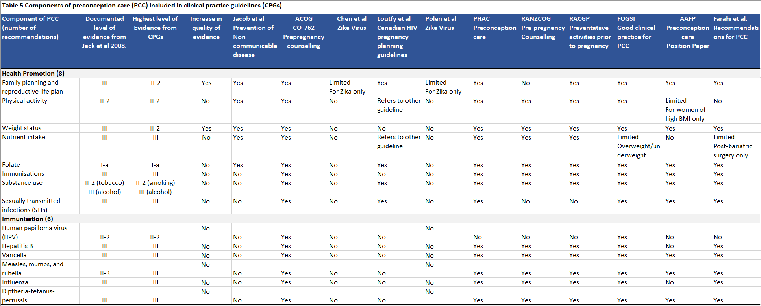

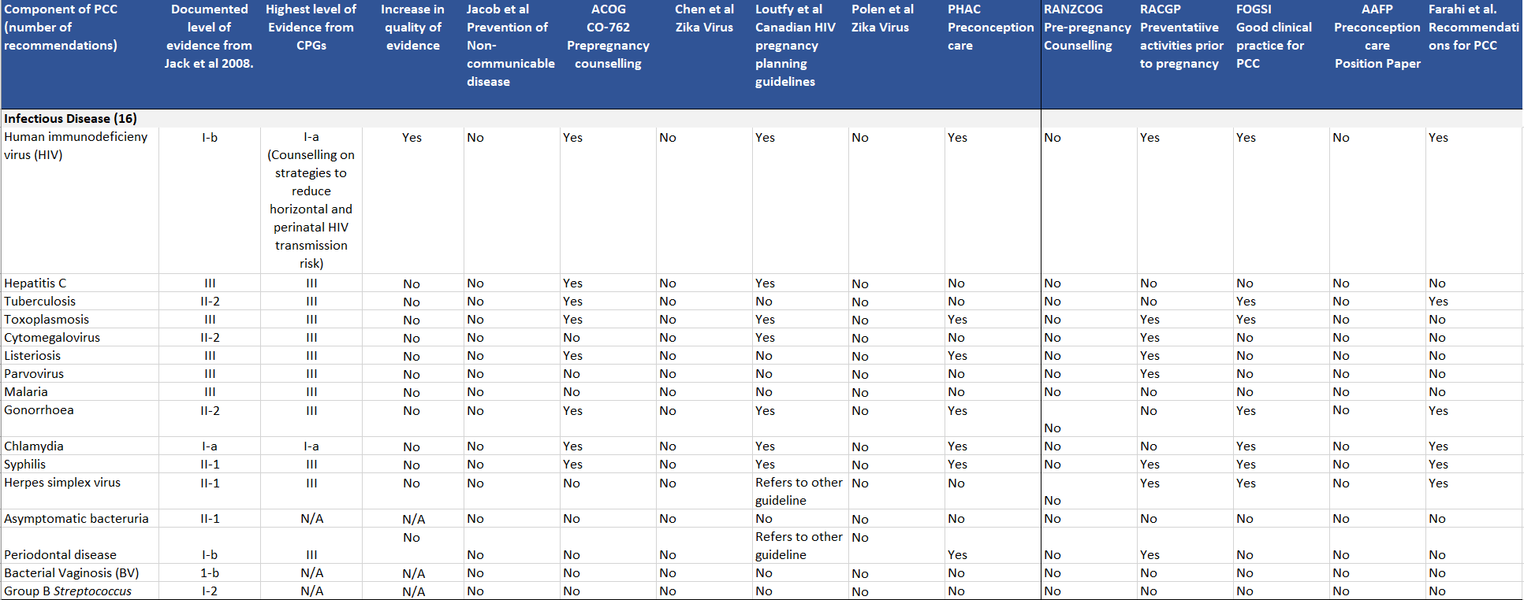

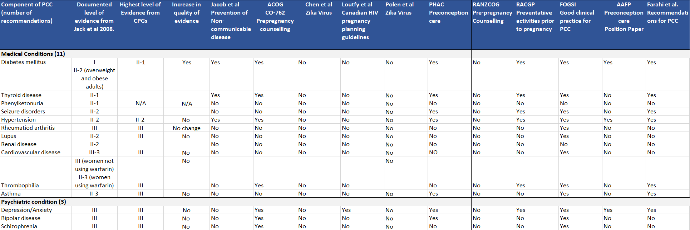

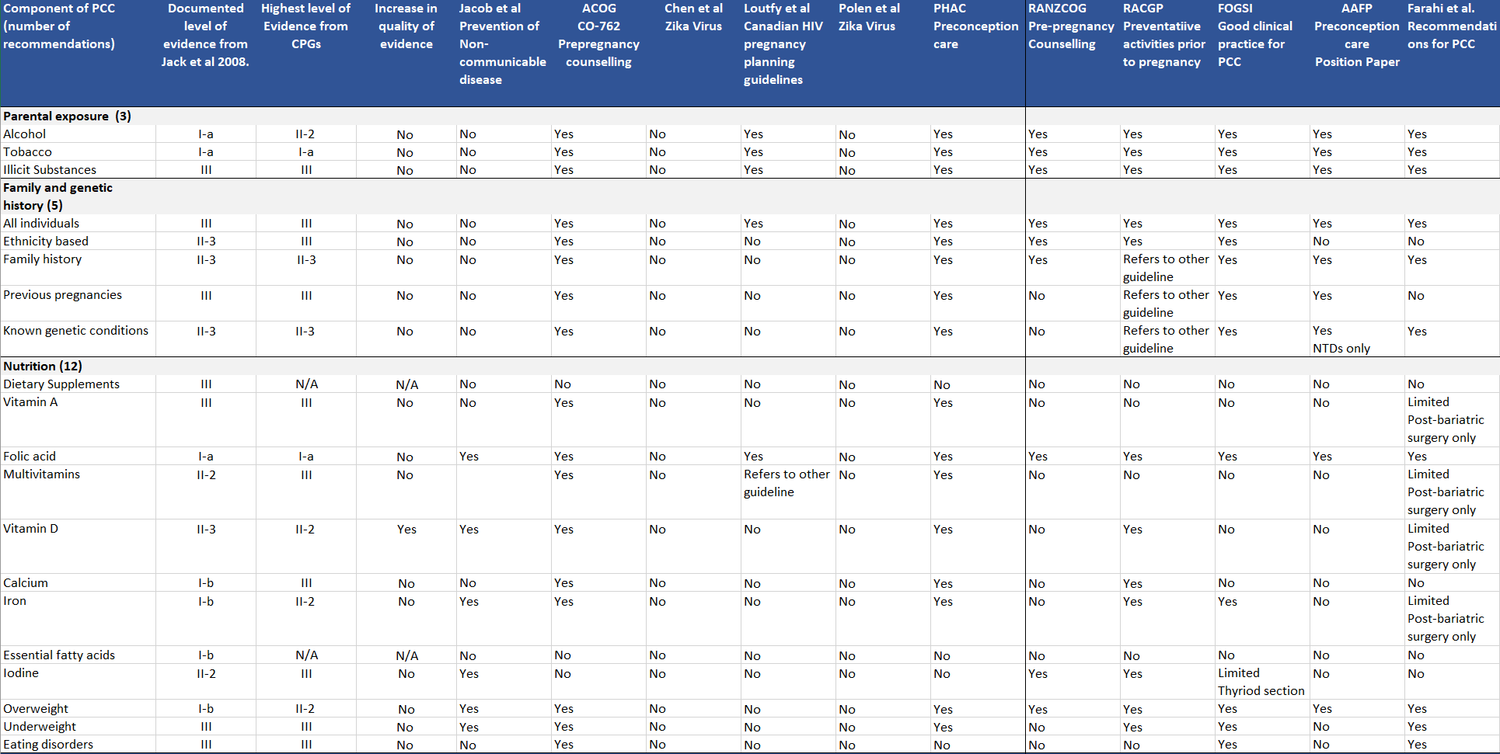

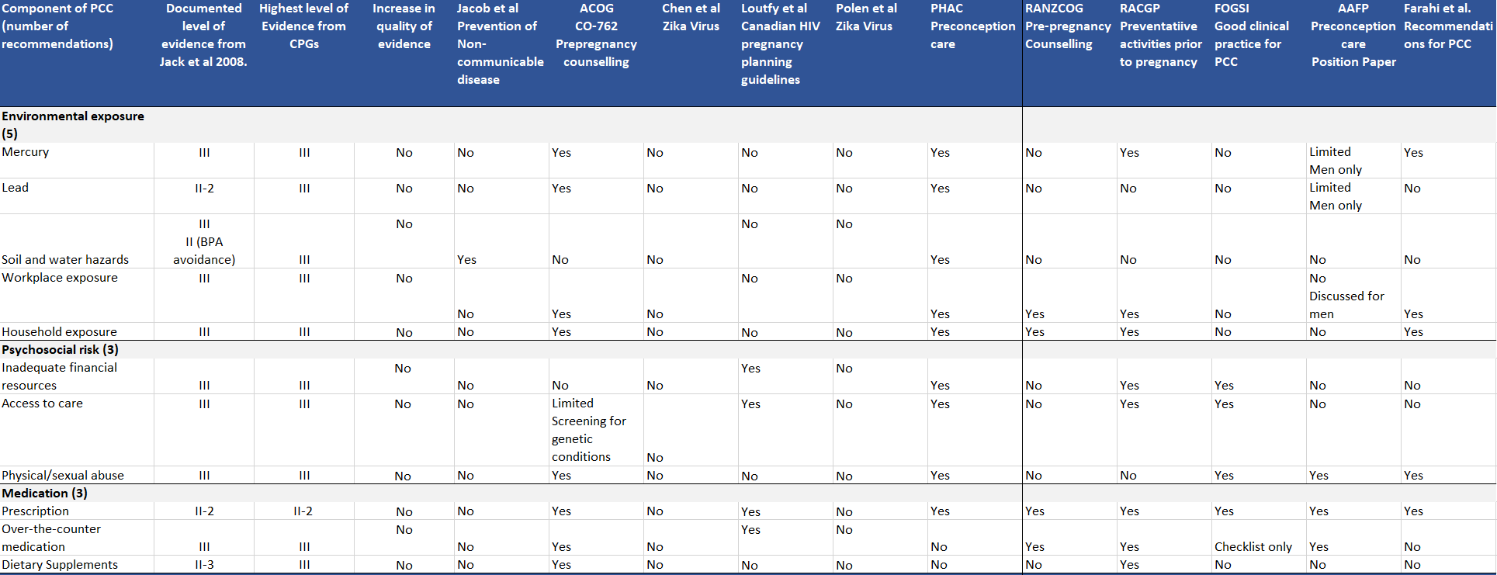

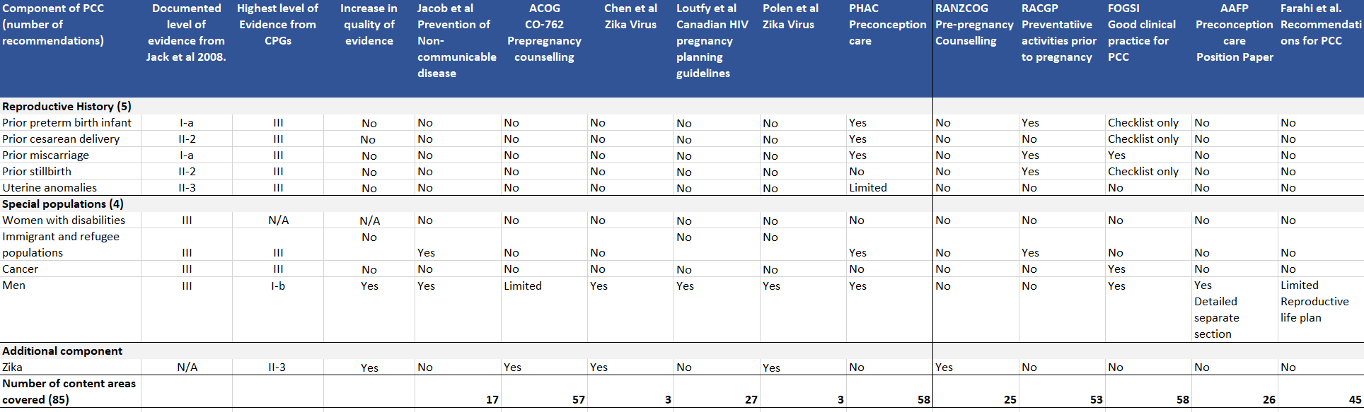

**Discussion**

This systematic review aimed to assess the availability and quality of guidelines for PCC. Whilst a plethora of guidelines that refer to preconception were identified, only 11 focused primarily on PCC. Most were of moderate quality with inconsistent adherence to AGREE-II criteria. Four of the 11 CPGs focused on particular areas of health such as Zika virus, non-communicable diseases and people living with HIV. The number of recommendations varied significantly between the CPGs and no one document covered all the recognized clinical content areas of PCC. Several CPGs acknowledged content areas that were not covered and offered links to other guidelines for this information.

*Guideline quality*

Ten guidelines were assessed as moderate quality with only one assessed as high quality. This was the Canadian HIV Pregnancy Planning guideline, which scored highly across five domains, receiving its lowest score in Domain 5, Applicability. The authors note the additional development and publication of a Best Practice document in 2020 to address the application of the CPG. (29) This document repackaged the 36 guideline recommendations in five standards of care for ease of use. This Best Practice document was designed to further support health care providers in the application of this guideline and highlights the potential value of guideline implementation tools to increase use and consistent application of recommendations within CPGs. The AGREE-II provides a methodological framework for the development of high-quality CPGs. Future CPGs in PCC must adhere to this framework, across all six domains, to produce robust CPGs to enhance the delivery of PCC.

*Level of supporting evidence*

The level of evidence on which the recommendations were based was variable with high quality evidence available for only a few recommendations, namely folic acid supplementation and HIV transmission prevention. Six clinical content areas have seen an increase in the level of supporting evidence since the previous comprehensive assessment in 2008. (7) This aspect of the analyses highlighted areas where additional research is required. Recommendations for 54 of the 83 content areas were based on the consensus of clinical experience, descriptive studies and case reports or reports of expert committees. It may not be feasible, ethical, or necessary to conduct RCTs in all these areas to attain the highest levels of evidence possible. Researchers and funding bodies should consider identifying and targeting aspects of PCC where the most significant gains can be made, particularly for priority populations. CPGs need to be updated with the most recent evidence to encourage uptake and translation to care. Monitoring the uptake of CPGs and improvements in population-level preconception health indicators is needed to track progress, and evaluate translation to care, health improvements and reduced inequalities. (30)

*Populations addressed within PCC CPGs*

The WHO acknowledges that PCC stands to benefit women and men, regardless of pregnancy intention. (1) Only six of the 11 included documents provided PCC guidance for men, with a further two documents acknowledging men’s PCC health. The CPG from the AAFP contained a dedicated section for men, including a table outlining recommendations for preconception interventions for men. The CPGs pertaining to Zika virus, and the HIV pregnancy planning guideline contained specific recommendations for men embedded within other recommendations. Evidence suggests that men of reproductive age are not receiving PCC (31-33). A recent survey of over 500 men in the UK found that they wanted to engage in positive preconception health behaviours. Almost one in five of the men surveyed had visited a primary health provider for preconception health advice and those who had received advice were more likely to adopt positive health behaviours prior to pregnancy. (33) Therefore, not including men in strategies to improve provision of PCC is a missed opportunity to improve preconception health globally. Consistently including men’s preconception health in PCC CPGs may support and empower healthcare providers to ask men about their reproductive intentions and provide them with PCC, along with their partner.

The degree to which guidelines included content relating to disadvantaged populations was assessed through data extraction and items within Domains 1, 3 and 5 of the AGREE-II tool. Only three CPGs included priority populations in their recommendations, with a further three CPGs acknowledging additional needs in care. The RANZCOG CPG detailed a section on health inequity, outlining strategies to assist family physicians to deliver equitable PCC. The CPG from Public Health Canada contained multiple segments addressing the needs of priority populations including a segment on the determinants of health, with other sections for indigenous women and women with specific needs. The HIV pregnancy planning guideline embedded recommendations for people from priority populations within other recommendations. Women and men from priority populations experience increased rates of adverse health outcomes. (4, 34)They also face barriers to accessing health care. PCC guidelines must incorporate guidance on the specific needs of priority populations to allow health care providers to deliver equitable health care.

Women from priority populations are keen to engage in opportunities to receive PCC, yet challenges exist in its delivery. (35, 36). Education and training for health care providers have been suggested to enhance the delivery of equitable PCC. Therefore, further work in education and training for health care providers and implementation guideline tools that promote culturally appropriate provision of PCC are required to address the needs of priority populations.

*CPGs in practice*

The presentation of a CPG, from its title to its display of recommendations is key to its accessibility, implementation and use.(9) A study on guideline development in Australia demonstrated the importance of end-user input to develop focused clinical questions that respond to clinical need. (37) Such input can help focus evidence-based recommendations thereby increasing their relevance, acceptability and feasible implementation in clinical practice. Given that the target population for PCC is all people of reproductive age, and that PCC is often delivered opportunistically across different levels of care and even social care, it is necessary to have comprehensive CPGs that answer clinical questions, promote collaboration and provision of high-quality and consistent care. The scope of clinical content to be covered by PCC should be clear and where a CPG does not address all PCC content areas, acknowledgment of and reference to other guidelines that cover missing content should be included. As PCC needs of individuals vary widely, the care delivered using comprehensive CPGs can subsequently be tailored to an individual’s physical and mental health conditions, health behaviours and social context.(38)

**Strengths and limitations**

Only guidelines that were freely accessible to an international audience were included in this systematic review. This was to mimic the clinical scenario of when a clinician may search for information to augment care within a consultation. However, this inclusion criteria limited the number of CPGs included in the study.

Strengths included the involvement of an international panel of PCC experts during protocol development, title and abstracts screening, study selection and assessment of quality and level of evidence. Comprehensive data extraction and analyses aligned with the previously identified 82 clinical content areas of PCC (7) and built on existing understanding of PCC globally.

**Conclusion**

Preconception care is a key component of preventative health care that should be provided to all people of reproductive age, with care taken to ensure the inclusion of men and priority populations. This systematic review identified that current guidelines on PCC can be improved with inclusion of a more comprehensive set of clinical content areas, more rigorous development processes and strategies to improve feasible and acceptable guideline application.

**References**

1. World Health Organization. Preconception care: Maximizing the gains for maternal and child health. A Policy Brief. Geneva 2013.

2. Dorney E, Black KI. Preconception care. Australian journal of general practice. 2018;47(7):424-9.

3. Stephenson J, Heslehurst N, Hall J, Schoenaker D, Hutchinson J, Cade JE, et al. Before the beginning: nutrition and lifestyle in the preconception period and its importance for future health. Lancet. 2018;391(10132):1830-41.

4. Agency for Healthcare Research and Quality. About Priority Populations.

Rockville, MD.2019 [updated June 2021 Available from: <https://www.ahrq.gov/priority-populations/about/index.html>

5. Mazza D, Chapman A, Michie S. Barriers to the implementation of preconception care guidelines as perceived by general practitioners: a qualitative study. BMC Health Services Research. 2013;13(1):36-.

6. Heyes T, Long S, Mathers N. Preconception care: practice and beliefs of primary care workers. Family practice. 2004;21(1):22-7.

7. Jack BW, Atrash H, Coonrod DV, Moos MK, O'Donnell J, Johnson K. The clinical content of preconception care: an overview and preparation of this supplement. American Journal of Obstetrics and Gynecology. 2008;199(6 SUPPL. B):S266-S79.

8. Clinical Practice Guidelines We Can Trust. In: Graham R MM, Miller Wolman D, et al., editor. Institute of Medicine (US) Committee on Standards for Developing Trustworthy Clinical Practice Guidelines. Washington (DC): National Academies Press (US); 2011.

9. Biezen R, Roberts C, Buising K, Thursky K, Boyle D, Lau P, et al. How do general practitioners access guidelines and utilise electronic medical records to make clinical decisions on antibiotic use? Results from an Australian qualitative study. BMJ Open. 2019;9(8):e028329.

10. Mason E, Chandra-Mouli V, Baltag V, Christiansen C, Lassi ZS, Bhutta ZA. Preconception care: advancing from ‘important to do and can be done’ to ‘is being done and is making a difference’. Reproductive health. 2014;11(3):S8.

11. Page MJ, McKenzie JE, Bossuyt PM, Boutron I, Hoffmann TC, Mulrow CD, et al. The PRISMA 2020 statement: an updated guideline for reporting systematic reviews. BMJ. 2021;372:n71.

12. Brouwers MC, Kho ME, Browman GP, Burgers JS, Cluzeau F, Feder G, et al. AGREE II: advancing guideline development, reporting and evaluation in health care. CMAJ : Canadian Medical Association journal = journal de l'Association medicale canadienne. 2010;182(18):E839-42.

13. Chiappini E, Bortone B, Galli L, de Martino M. Guidelines for the symptomatic management of fever in children: systematic review of the literature and quality appraisal with AGREE II. BMJ Open. 2017;7(7):e015404.

14. Quintyne KI, Kavanagh P. Appraisal of International Guidelines on Smoking Cessation using the AGREE II Assessment Tool. Irish medical journal. 2019;112(2):867.

15. Atrash H Jack B. Preconception Care to Imporve Pregnancy Outcomes: The Science Journal Of Human Growth and Development 2020;30(3):355-62.

16. Guideline of preconception and prenatal care(2018). [Chinese]. Zhonghua fu chan ke za zhi. 2018;53(1):7-13.

17. National Institute for Health Care and Excellence. Pre-conception - advice and management. 2019 [Available from: <https://cks.nice.org.uk/pre-conception-advice-and-management#!topicsummary>.

18. American Academy of Family Physicians. Preconception Care (Position Paper) 2015 [Available from: <https://www.aafp.org/about/policies/all/preconception-care.html>.

19. Gynecologists ACoOa. ACOG Committee Opinion No. 762: Prepregnancy Counseling. Obstetrics and gynecology. 2019;133(1):E78-E89.

20. Farahi N, Zolotor A. Recommendations for preconception counseling and care. American family physician. 2013;88(8):499-506.

21. Polen KD, Gilboa SM, Hills S, Oduyebo T, Kohl KS, Brooks JT, et al. Update: Interim Guidance for Preconception Counseling and Prevention of Sexual Transmission of Zika Virus for Men with Possible Zika Virus Exposure - United States, August 2018. Mmwr. 2018;Morbidity and mortality weekly report. 67(31):868-71.

22. Chen LH, Hamer DH. Zika virus and sexual transmission: updated preconception guidance. J Travel Med. 2018;25(1):01.

23. Loutfy M, Kennedy VL, Poliquin V, Dzineku F, Dean NL, Margolese S, et al. No. 354-Canadian HIV Pregnancy Planning Guidelines. Journal of obstetrics and gynaecology canada. 2018;40(1):94-114.

24. Shaw E, et al. Preconception Care in Family-centred maternity and newborn care: National guidelines: Public Health Agency of Canada; 2018.

25. Royal Australian and New Zealand College of Obstetricians and Gynaecologists (RANZCOG). Pre-pregnancy counselling (C-Obs3a). Melbourne; 2017

26. Royal Australian College of General Practitioners. Guidelines for preventive activities in general practice Melbourne: RACGP; 2017.

27. Federation of Obstetric Gynecological Societies of India (FOGSI). Good Clinical Practice Recommendations on Preconception Care. Mumbai; 2016.

28. Jacob CM, Killeen SL, McAuliffe FM, Stephenson J, Hod M, Diaz Yamal I, et al. Prevention of noncommunicable diseases by interventions in the preconception period: A FIGO position paper for action by healthcare practitioners. Int J Gynaecol Obstet. 2020;151 Suppl 1:6-15.

29. Loutfy M, Kennedy VL, Boucoiran I, Poliquin V, Elwood C, Kaida A, et al. A clinical practice guide: What HIV care providers need to know about HIV pregnancy planning to optimize preconception care for their patients. Jammi. 2020;5(1):8-20.

30. Schoenaker D, Stephenson J, Connolly A, Shillaker S, Fishburn S, Barker M, et al. Characterising and monitoring preconception health in England: a review of national population-level indicators and core data sources. J Dev Orig Health Dis. 2021:1-14.

31. Keith A. Frey RE, and Brie Noble,. Preconception healthcare: what do men know and believe? Journal of Men's Health. 2012;9(1):25-35.

32. Hogg K, Rizio T, Manocha R, McLachlan RI, Hammarberg K. Men's preconception health care in Australian general practice: GPs' knowledge, attitudes and behaviours. Aust J Prim Health. 2019;25(4):353-8.

33. Shawe J, Patel D, Joy M, Howden B, Barrett G, Stephenson J. Preparation for fatherhood: A survey of men's preconception health knowledge and behaviour in England. PloS one. 2019;14(3):e0213897.

34. Jardine J, Walker K, Gurol-Urganci I, Webster K, Muller P, Hawdon J, et al. Adverse pregnancy outcomes attributable to socioeconomic and ethnic inequalities in England: a national cohort study. The Lancet. 2021.

35. Tuomainen H, Cross-Bardell L, Bhoday M, Qureshi N, Kai J. Opportunities and challenges for enhancing preconception health in primary care: qualitative study with women from ethnically diverse communities. BMJ Open. 2013;3(7):e002977.

36. Hawkey AJ, Ussher JM, Perz J. What do women want? Migrant and refugee women's preferences for the delivery of sexual and reproductive healthcare and information. Ethn Health. 2021:1-19.

37. Chakraborty S, Brijnath B, Dermentzis J, Mazza D. Defining key questions for clinical practice guidelines: a novel approach for developing clinically relevant questions. Health Research Policy and Systems. 2020;18(1):113.

38. Stephenson J, Schoenaker DA, Hinton W, Poston L, Barker M, Alwan NA, et al. A wake-up call for preconception health: a clinical review. Br J Gen Pract. 2021;71(706):233-6.