Photosensitivity response of pulsed 213 nm light in planar Bragg grating writing

Q. Salman Ahmed*, James W. Field, Paul C. Gow, Swe Zin Oo, Christopher Holmes, Rex H.S. Bannerman, Paolo L. Mennea, Corin B. E. Gawith, Peter G.R. Smith, and James C. Gates
Optoelectronics Research Centre, University of Southampton, Southampton, SO17 1BJ, UK
qazi.salman.ahmed@soton.ac.uk

Abstract: We investigate the dynamics of pulsed 213 nm planar Bragg grating writing for a range of powers and fluences. We report the regime for achieving high index contrast, and where damage is likely to occur.

1. Introduction
Pulsed 213 nm direct UV writing has been shown as a promising alternative to longer UV wavelength CW sources, with potential for higher index contrast [1] and avoiding hydrogen loading [1-2]. Using such high energy sources to define waveguides and gratings can lead to significant levels of ablation and subsurface damage to samples [3]. Therefore, it is essential to discern the optimal regimes to use these laser sources without causing damage. In several attempts to find the optimal writing regimes of 213 nm laser, we observe that photosensitive response and grating features behave differently depending upon the power of the writing beam. In this work, we use a broad range of average beam powers to explore the characteristics of SSDUW, investigating the change in negative refractive index and onset of damage in response to writing power and fluence.
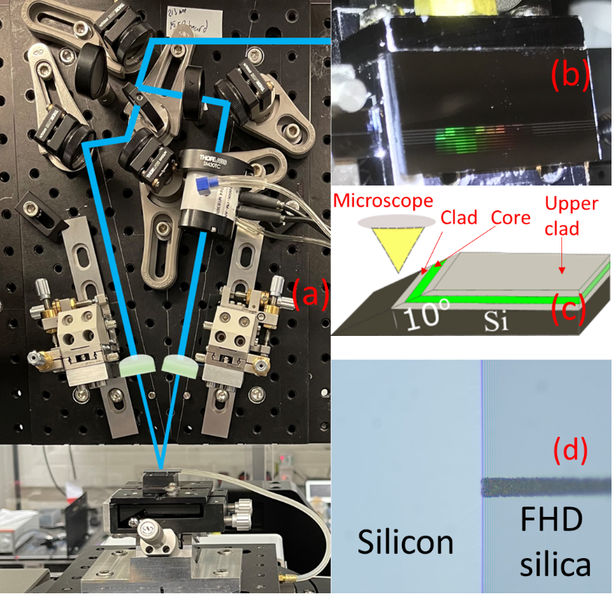
Fig.1(a) Photograph of holographic UV writing setup. (b) Photograph of UV written chip illuminated by a white light source and showing the diffraction pattern from the gratings. (c) Schematic of microscopy for a diced and angled-polished chip to reveal silica-silicon interface. (d) Microscopic image of an angle polished end-facet showing the damaged surface of the silicon.

2. Experimental method and results

Pulsed 213 nm laser light was used to simultaneously inscribe waveguides and gratings in the core layer of hydrogen loaded Ge-doped silica [3-4] chips. Fig.1 (a) shows the holographic UV writing setup used to define gratings operating at telecommunication wavelengths; details of the system can be found in [2-4]. The repetition rate of the laser was fixed at 10 kHz to achieve average powers up to 14 mW (at the chip surface). Fig. 1 (b) shows a UV fabricated chip that contains nine waveguides written at different laser powers ranging from 1 to 14 mW in ascending order. Each waveguide contains ten 1 mm long uniform gratings; the Bragg wavelength of these gratings was targeted between 1520 nm and 1587.5 nm. The writing fluences for each grating were varied from 0.36 kJcm⁻² to 3.65 kJcm⁻² in a pseudo-random order by controlling the translation speed of air-bearing stages (Aerotech ABL9000). All waveguides written with more than 2 mW of average laser power displayed surface damage visible by eye. Microscopy was performed after angle polishing the end-facet of a chip to reveal the different layers of FHD silica and silicon (as shown in Fig. 1(c)). Fig.1 (d) shows the micrograph of a waveguide written at 14 mW of laser power. We believe that damage at higher peak power densities is due to the amorphization of the silicon, however no associated shift has been detected observed under Raman spectroscopy.
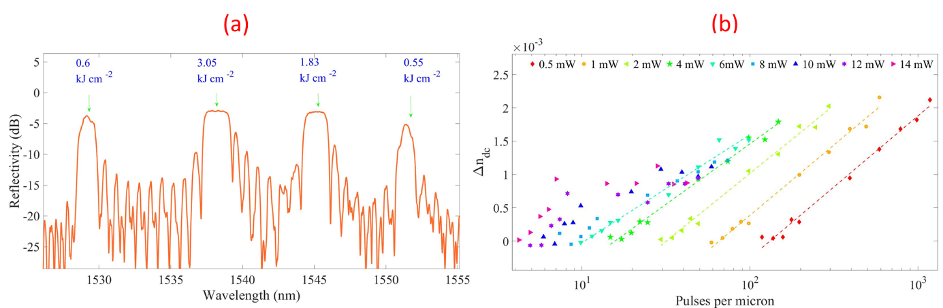
Fig.2 (a) Reflection spectra from a waveguide containing ten 1-mm long uniform gratings written at 0.5 mW of laser power. (b) Plot of change in refractive index versus pulses per micron at writing laser powers ranging from 0.5 to 14 mW. The fluence was plotted on a log scale in pulses per micron, this adds a small amount of horizontal separation to datasets, making trends more clear and showing the variation in gradient for varying laser power.

An Er-doped fiber amplified spontaneous emission (ASE) source was used for grating characterization in reflection. Fig. 2(a) shows the reflection spectra from the waveguide and gratings written at 0.5 mW of laser power. The gratings peak profile written at fluences of 1.83 and 3.05 kJcm⁻² are flat-topped due to their strong reflectivity. Effective indices were calculated and (after dispersion compensation) used to establish the change in DC refractive index (Δn_{dc}). Fig. 2(b) shows a plot of Δn_{dc} (relative to the lowest fluence grating in each waveguide) as a function of pulses per micron for different writing powers and fluences. The photosensitivity response is linear in a log scale at low fluence and low power. At powers above 2 mW (where damage is observed) the refractive index trend begins at the same rate. However, this quickly changes to a lower rate of growth at higher fluence, resulting in a smaller achievable index contrast. We observed that the greatest index change (2.1×10⁻³) was achieved with the lower powers (0.5-2 mW) and the highest fluence of 3.65 kJ cm⁻². We will present our findings and discuss how the results compare to the literature.

3. Conclusion
We have reported on some of the photosensitivity dynamics of UV inscription using a pulsed 213 nm laser in planar silica. We observed that powers above 2 mW always leads to damage and optimum change in refractive index is achieved for low powers (0.5-2 mW) and very high fluences. We will present a more detailed comparison of the suitable writing regimes for the fabrication of waveguides and planar Bragg gratings. We will also discuss the role of silicon damage and effects of higher peak power densities on photosensitivity response.
4. References

[1] M. Gagné, R. Kashyap, “New nanosecond Q-switched Nd:VO₄ laser fifth harmonic for fast hydrogen-free fiber Bragg gratings fabrication". Opt. Commun. 283, 5028– 5032 (2010).
[2] Q. S. Ahmed, P. C. Gow, P. L. Mennea, R. H. S. Bannerman, D. H. Smith, C. Holmes, J. C. Gates, and P. G. R. Smith, “Direct 213 nm UV written Bragg gratings and waveguides in planar silica without hydrogen loading,” in Integrated Photonics Research, Silicon and Nanophotonics, Advanced Photonics Congress, (Optical Society of America, 2020), pp. IW2A-4.
[3] Q. S. Ahmed, P. C. Gow, C. Holmes, P. L. Mennea, J. W. Field, R. H. S. Bannerman, D. H. Smith, C. B. E. Gawith, P. G. R. Smith, and J. C. Gates, “Direct UV written waveguides and Bragg gratings in doped planar silica using a 213 nm laser,” Electron. Lett 57(8), 331-333 (2021).
[4] P. C. Gow, Q. S. Ahmed, J C. Gates, P. G.R. Smith, and C., Holmes, “Microwave consolidation of photosensitive planar glass layers” Opt. Mater. Express Materials Express 11(6), 1835-1841, (2021).

