Investigation into multi-pass exposure of 213 nm pulsed UV writing for improved writing response

Q. Salman Ahmed, James W. Field, Paul C. Gow, Christopher Holmes, Rex H.S. Bannerman, Paolo L. Mennea, Corin B. E. Gawith, Peter G.R. Smith, and James C. Gates
Optoelectronics Research Centre, University of Southampton, Southampton, SO17 1BJ, UK
qazi.salman.ahmed@soton.ac.uk

Abstract: We demonstrate an increase in achievable refractive index change of 1.2×10⁻³ in Ge-doped silica in writing waveguides and gratings using pulsed 213 nm light to deposit the same total fluence over multiple writing passes.

1. Introduction
Direct UV writing can simultaneously fabricate waveguides and Bragg gratings in doped silica [1], enabling complex devices. However, the possible change in the refractive index of waveguides, (up to 5.1×10⁻³ [2]) is typically weaker than that of etched devices, and it is desirable to find routes to enhance this refractive index change. The dynamics of refractive index growth in pulsed 213nm laser writing are more complex than continuous-wave UV writing. Here we investigate a writing regime where UV radiative fluence is built up over multiple passes, reducing the peak fluence. In multi-pass writing, we observe a significant increase in achieved effective refractive index and grating strength compared to single-pass writing. Multi-pass writing also offers the benefit of reducing artifacts associated with hydrogen outgassing. This approach improves the fabrication efficiency of grating-based devices; desirable for integrated optics.
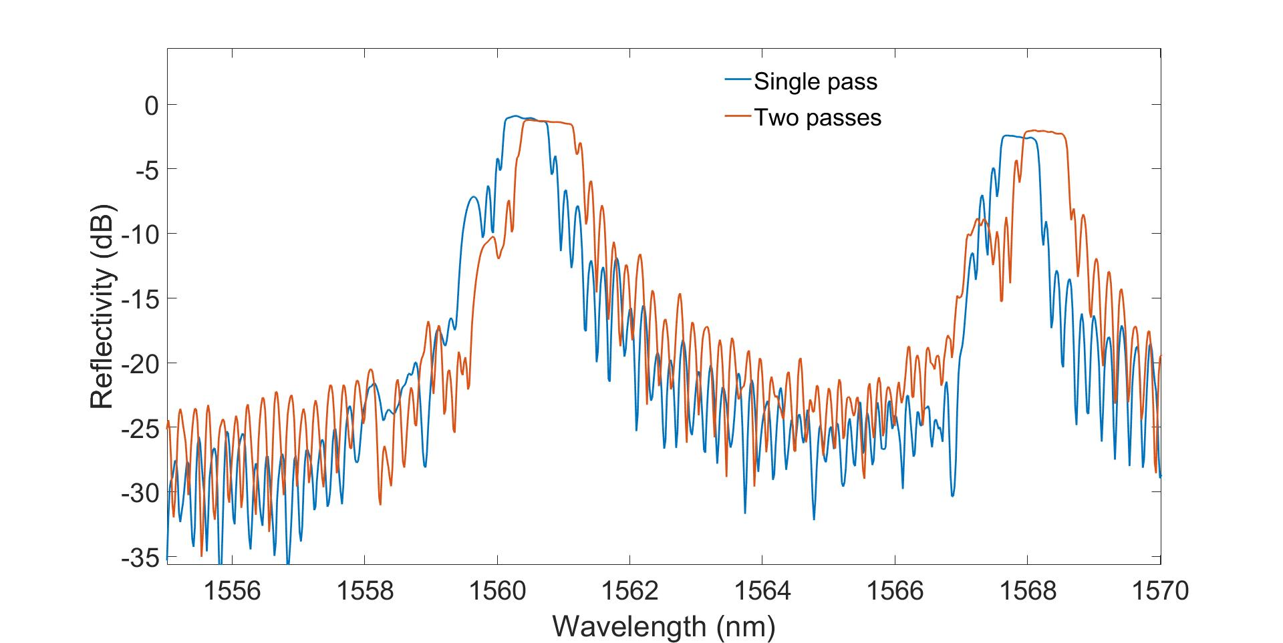
Fig.1. Reflection spectra from gratings in two different waveguides. Both waveguides and gratings were written at a total fluence of
2 kJcm²; one with a single pass and the other with two exposures of 1 kJ cm⁻².

2. Experimental method and results
Small-spot direct UV writing was used to inscribe channel waveguides and gratings in FHD doped silica [3-5]. Prior to writing, samples were hydrogen loaded for five days at a pressure of 120 bar. All the devices were fabricated at the same total fluence of 2 kJ cm⁻²; however, this energy was delivered over a number of writing passes. In the first investigation, devices were written in two passes, changing the combination of writing fluences in pseudo-random order (i.e., 0.2+1.8, 1.6+0.4, 1.2+0.8 kJ cm⁻²). Secondly, the fluence of 2 kJ cm⁻² was divided between 4, 6, 8, 10, 20 and 40 passes. A waveguide written with a fluence of 2 kJ cm⁻² was inserted both at the start and end of writing to rule out spatial dependencies and the effect of hydrogen outgassing; this also allows a comparison between multi-pass writing and single-pass writing.

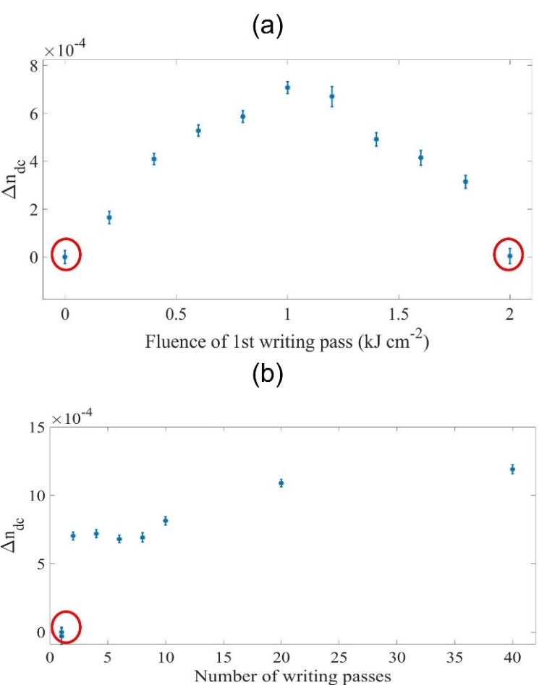
Fig.2 Change in effective refractive index for waveguides written with a total fluence of 2 kJ/cm² over 2 passes. (a) Plotted as a function of the first pass fluence for double pass writing. (b) Change in refractive index versus the number of overwriting passes. In both plots, identical waveguides were written in a single pass at the start, and end of writing showed the same induced change in refractive index, circled in red.

An Er-doped fiber amplified spontaneous emission (ASE) source was used for grating characterization in reflection. Fig. 1 shows the reflection spectra of the gratings written in a single pass and two passes, fixed at the same total energy density. The gratings overwritten in multiple passes show a broadening and redshift in the central wavelength compared to those written in a single pass. This demonstrates a higher refractive index, and improved grating strength can be achieved by overwriting. Fig. 2(a) shows that for overwriting with two passes for a total fluence of 2 kJ cm⁻², the greatest enhancement is achieved when the fluences are equal. Figure 2(b) shows that increasing the number of overwriting passes leads to diminishing returns for refractive index enhancement, possibly due to limits on the stability of the interferometric UV writing system and air bearing stages.
3. Conclusion
We have investigated an alternative UV writing methodology by using multiple writing passes to obtain an increase in the induced refractive index change of up to 1.2×10⁻³. We will discuss the dependence of grating strength upon the number of writing passes, including the role of system stability (interferometric and stage) and the benefit of increased fabrication lifetime from reducing out-gassing effects.
4. References

[1] C. Sima, J. C. Gates, H. L. Rogers, P. L. Mennea, C. Holmes, M. N. Zervas, P. G. R. Smith, “Ultra-wide detuning planar Bragg grating fabrication technique based on direct UV grating writing with electro-optic phase modulation,” Opt. Express 21(13), 15747-15754 (2013).
[2] P. C. Gow, Q. S. Ahmed, P. L. Mennea, R. H. S. Bannerman, A. Jantzen, C. Holmes, J. C. Gates, C. B. E. Gawith, and P. G. R. Smith, “213 nm laser written waveguides in Ge-doped planar silica without hydrogen loading,” Opt. Express, 28(21), 32165-32172 (2020).
[3] Q. S. Ahmed, P. C. Gow, C. Holmes, P. L. Mennea, J. W. Field, R. H. S. Bannerman, D. H. Smith, C. B. E. Gawith, P. G. R. Smith, and J. C. Gates, “Direct UV written waveguides and Bragg gratings in doped planar silica using a 213 nm laser,” Electron. Lett 57(8), 331-333 (2021).
[4] P. C. Gow, Q. S. Ahmed, J C. Gates, P. G.R. Smith, and C., Holmes, “Microwave consolidation of photosensitive planar glass layers” Opt. Mater. Express Materials Express 11(6), 1835-1841, (2021).
[5] Q. S. Ahmed, P. C. Gow, P. L. Mennea, R. H. S. Bannerman, D. H. Smith, C. Holmes, J. C. Gates, and P. G. R. Smith, “Direct 213 nm UV written Bragg gratings and waveguides in planar silica without hydrogen loading,” in Integrated Photonics Research, Silicon and Nanophotonics, Advanced Photonics Congress, (Optical Society of America, 2020), pp. IW2A-4.

