Holographically fabricated blazed chirped gratings for out-of-plane integrated beam focusing

Q. Salman Ahmed, James W. Field, Paul C. Gow, Christopher Holmes, Dong-Woo Ko, Peter Horak, Corin B.E. Gawith, Peter G.R. Smith, and James C. Gates
Optoelectronics Research Centre, University of Southampton, Southampton, SO17 1BJ, UK
qazi.salman.ahmed@soton.ac.uk

Abstract: We demonstrate out-of-plane coupling of large (mm scale) and small (focusing) beams using holographically fabricated blazed-chirped gratings in doped silica at a 45° angle via a prism coupling mechanism.

1. Introduction
In integrated optics, etched grating couplers are conventionally used to provide free space beams and interact with optical systems [1]. However, it is typically challenging to achieve high fabrication accuracies in etched grating components [2]. Etched lithographic waveguides and gratings possess small-scale imperfections, often exacerbated by the high index contrast of these devices, these can lead to effective index variations which result in phase errors across fabricated devices. These typically restrict the size of successful devices to a sub-millimeter length. To avoid this limitation, here we use a holographic UV interferometer to define blazed-chirped gratings at 45° inside the photosensitive core of silica to focus the beam coupling out of the core layer; schematically shown in Fig. 1(a). A prism coupling approach was used to interfere two UV beams at 45° angle inside the core layer [3]. Our writing technique relies on a precision air-bearing stage system (Aerotech ABL9000) to fabricate gratings and channel waveguides simultaneously via phase-modulation in one of the interferometric UV beams [4-5]. Using 45° blazed gratings in a silica-on-silicon platform, we show the potential to fabricate fiber-coupled compact devices to deliver IR beams for atoms/ion trap applications.
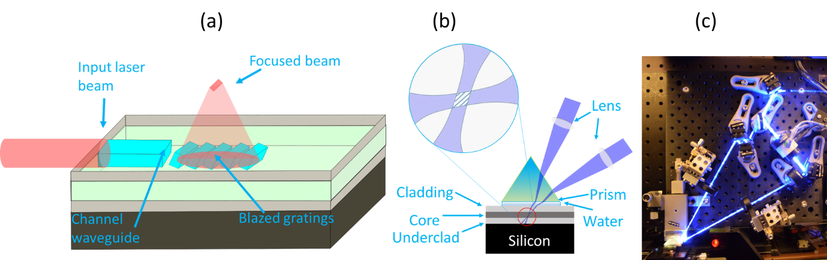
Fig.1(a) Schematic of the out-of-plane focusing beam using blazed gratings. (b) Schematic of dual-beam interferometry inside the FHD core layer through prism coupling, water is used as index matching layer. (c) Photograph of the holographic UV writing setup to inscribe 45° blazed gratings.

2. Experimental method and results
Flame Hydrolysis Deposition (FHD) was used to deposit a 3.3 µm thick core layer of B/Ge doped silica onto a 15 µm thermal oxide silicon substrate. The core layer was capped by a 17.7 µm cladding layer of B/P doped silica. We diced the wafer into 20×10 mm chips which were loaded into a 120 bar hydrogen cell for five days. A prism coupling scheme was used to bring the two beams of the UV writing laser into the core layer at a large angle to the chip surface normal, without the prism the beams are highly attenuated due to Fresnel reflection. In addition to the prism, a few hundred micron thick layer of de-ionized water was used to refractive index match between the prism and the sample, allowing the beams to interfere in the core layer. Using this prism approach, we have fabricated 45° blazed gratings at a period of ~530 nm to couple 780 nm light out of the chip, normal to the surface. By applying a phase modulation in one arm of the interferometer, we fabricated blazed gratings with a chirped profile, using a detuning approach to change the grating period and to provide focusing of the out-coupled beam [6].

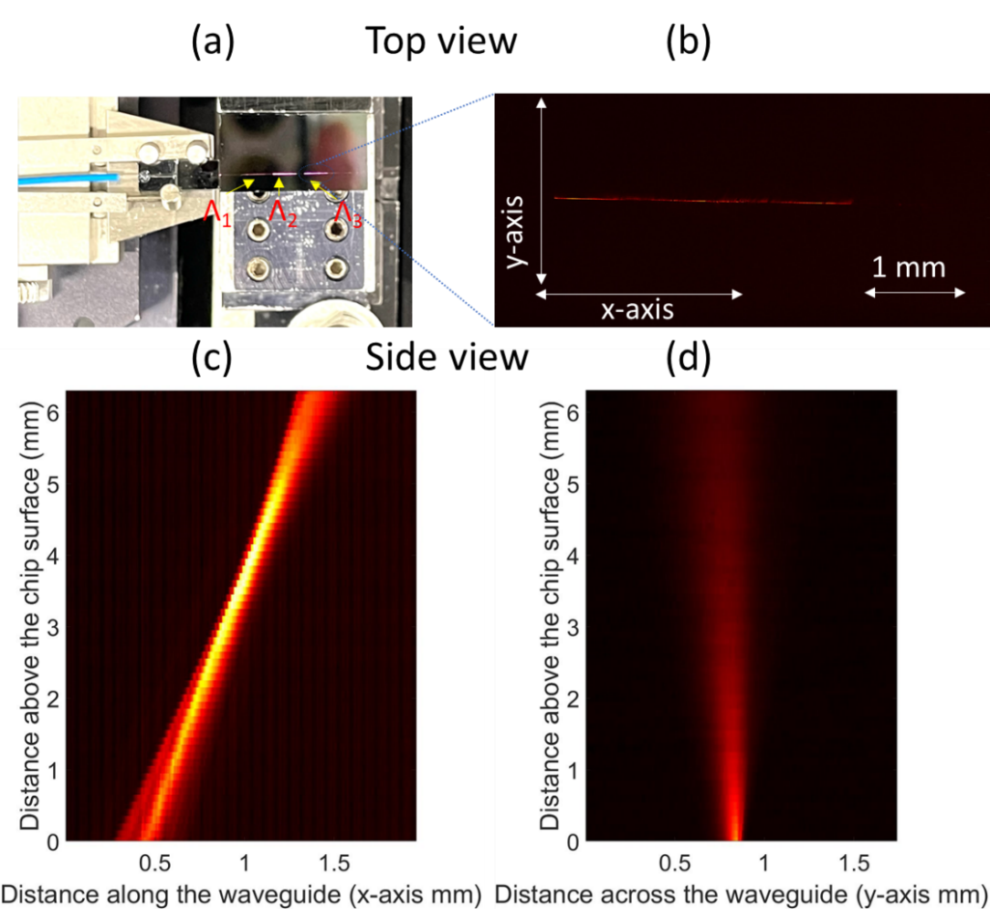

Fig.2 (a) Photograph of fabricated chip demonstrates the out-coupling of 780 nm light from three 3-mm long uniform-apodized blazed gratings holographically written with different grating periods. (b) Closer image of the 780 nm light coupling-out of a single 3-mm long grating. (c) Characterization data of light focusing out of the chip in the x-direction from a 2-mm chirped grating. (d) Characterization data of the light diffracting from the same 2-mm chirped grating in the y-direction.

We characterized the device by launching 780 nm light into the channel waveguides using a fiber V-groove assembly, a photo of which is shown in Fig 2(a). The photograph demonstrates the out-of-plane coupling of 780 nm light from three uniform gratings inscribed at different periods. The free-space beam was analyzed by an Ophir Spiricon beam profiling camera (model L11059), normal to the top surface of the chip. Fig. 2 (c) shows the characterized data in a digitally processed image of light focusing (in the x-direction) from 2-mm long chirped grating. Fig. 2(d) demonstrates the beam diffraction from the same grating in the y-direction.
3. Conclusion
For the first time, we have demonstrated out-of-plane focusing of 780 nm light using holographically written blazed gratings and channel waveguides in doped planar silica, using a prism coupling mechanism. We characterized the out-coupled beams by launching 780 nm light into the waveguides and imaging the out-coupled light using a beam profiling camera. We will provide details of the fabrication setup, including the advantages of the prism coupling approach and also its restrictions. We will also present our most recent experiments improving the coupling efficiency of these blazed gratings.
4. References
[1] S. Kim, D. A. Westly, B. J. Roxworthy, Q. Li, A. Yulaev, K. Srinivasan, and V. A. Aksyuk, “Photonic waveguide to free-space Gaussian beam extreme mode converter,” Light Sci. Appl. 7(1), 1-13 (2018).
[2] L. Chrostowski and M. Hochberg, “Silicon photonics design: from devices to systems,” (Cambridge University Press, 2015).
[3] S. M. Schultz, E. N. Glytsis, T. K. Gaylord, “Volume grating preferential-order focusing waveguide coupler,”. Opt. Lett. 24(23), 1708-1710 (1999).
[4] Q. S. Ahmed, P. C. Gow, C. Holmes, P. L. Mennea, J. W. Field, R. H. S. Bannerman, D. H. Smith, C. B. E. Gawith, P. G. R. Smith, and J. C. Gates, “Direct UV written waveguides and Bragg gratings in doped planar silica using a 213 nm laser,” Electron. Lett 57(8), 331-333 (2021).
[5] P. C. Gow, Q. S. Ahmed, J C. Gates, P. G.R. Smith, and C., Holmes, “Microwave consolidation of photosensitive planar glass layers” Opt. Mater. Express Materials Express 11(6), 1835-1841, (2021).
[6] J. W. Field, S.A. Berry, R. H. S. Bannerman, D. H. Smith, C. B. E. Gawith, P. G. R. Smith, and J. C. Gates, “Highly-chirped Bragg gratings for integrated silica spectrometers,” Opt. Express 28(14), 21247-21259 (2020).

