Title: Efficacy and Safety of a Recombinant Plant-Based, Adjuvanted COVID-19 Vaccine

Authors: Karen Joyce Hager, MSc¹, Gonzalo Pérez Marc, MD², Philipe Gobeil, PhD¹, Ricardo Sobhie Diaz, MD³, Gretchen Heizer, MSc¹, Conrado Llapur, MD⁴, Alexander I. Makarkov, PhD¹, Eduardo Vasconcellos, MD⁵, Stéphane Pillet, PhD¹, Fernando Riera, MD⁶, Pooja Saxena, PhD¹, Priscila Geller Wolff, MD⁷, Kapil Bhutada, MSc¹, Garry Wallace, MD⁸, Hessam Aazami, MD⁹, Christine E. Jones, PhD¹⁰, Fernando P. Polack, MD¹¹, Luciana Ferrara, MSc³, Judith Atkins, PhD¹, Iohann Boulay, MSc¹, Jiwanjeet Dhaliwall, MSc¹, Nathalie Charland, PhD¹, Manon M.J. Couture, PhD¹, Julia Jiang-Wright, BSc¹, Nathalie Landry, MSc¹, Sophie Lapointe, MSc¹, Aurélien Lorin, PhD¹, Asif Mahmood, MD¹, Lawrence H. Moulton, PhD¹², Emmy Pahmer¹, Julie Parent, PhD¹, Annie Séguin, PhD¹, Luan Tran, MSc¹, Thomas Breuer, MD¹³, Maria Angeles Ceregido, PhD¹³, Marguerite Koutsoukos, PhD¹³, François Roman, MD¹³, Junya Namba, BA¹, Marc-André D’Aoust, PhD¹, Sonia Trepanier, PhD¹, Yosuke Kimura, PhD¹, and Brian J. Ward, MDCM^{1,14}* for The CoVLP Study Team.

¹ Medicago Inc., 1020 route de l’Église, Bureau 600, Québec, QC, Canada, G1V 3V9
² Hospital Militar Central Cirujano Mayor Dr. Cosme Argerich, Av. Luis Maria Campos 726, Buenos Aires Buenos Aires C1426, Argentina
³ Infectious Diseases Division, Paulista School of Medicine, Federal University of Sao Paulo, Brazil, and Azidus Brasil Pesquisa e Desenvolvimento Ltda, Valinhos São Paulo 13271-130, Brazil
⁴ Clinica Mayo de UMCB SRL, Combate de San Lorenzo 449, San Miguel de Tucumán Tucumán T4000, Argentina
⁵ Instituto de Pesquisas Clinicas L2IP, SGAS 613 ‐ lote 95 ‐ Bloco A, Sala 6, Ed. L2 Complexo Médico Hospitalar, DF 70200-730, Brazil
⁶ Sanatorio Allende, Av. Hipolito Yrigoyen 384, Cordoba, Cordoba 5000, Argentina
⁷ IBPClin Instituto Brasil de Pequisa Clinica, R. Da Gloria, 344 – Gloria, Rio de Janeiro RJ 20241-180, Brazil
⁸ Dawson Clinical Research Inc., 83 Dawson Road, Guelph, Ontario N1H 1B1, Canada
⁹ Hope Clinical, 22030 Sherman Way, Canoga Park, California 91303, United States
¹⁰ Clinical and Experimental Sciences, University of Southampton and NIHR Southampton Clinical Research Facility and Biomedical Research Centre, University Hospital Southampton NHS Foundation Trust, Tremona Road, Southampton, SO16 6YD, United Kingdom
¹¹ Fundacion INFANT, Gavilán 15, Buenos Aires, Argentina
¹² Department of International Health, Johns Hopkins Bloomberg School of Public Health, 615 N. Wolfe St., Baltimore, MD 21205, USA.
¹³ GlaxoSmithKline Vaccines, Wavre, Belgium
¹⁴ Research Institute of the McGill University Health Center, 1001 Decarie St, Montréal, QC, Canada H4A 3J1

* Corresponding author:
Brian J. Ward
1020 Route de l’Église, Bureau 600
Québec, QC, Canada
G1V 3V9
Tel. 418 658 9393
Fax. 418 658 6699
wardb@medicago.com

Keywords: Phase 3, SARS-CoV-2, COVID-19 Vaccine, Virus-Like Particles, Nicotiana benthamiana, Safety, Efficacy, Variants, Delta, Gamma, Cross-Protection.

Abstract
Background: CoVLP is a coronavirus-like particle produced in plants displaying the prefusion spike glycoprotein of ancestral SARS-CoV-2 adjuvanted with AS03.
Methods: This Phase 3 randomized (1:1), observer-blind, placebo-controlled trial was conducted at 85 centers. Adults ≥18 years of age received two IM injections of 3.75μg CoVLP+AS03 or placebo, 21 days apart. The primary efficacy endpoint was prevention of symptomatic COVID-19 beginning ≥7 days after the second injection and was triggered by identification of ≥160 cases. Safety was also assessed.
Results: 24,141 volunteers participated (median 29 years). 83% received both doses and 14.8% were baseline seropositive. COVID-19 was PCR-confirmed in 165 participants in the intention-to-treat set: 100% were variants when successfully sequenced. Overall, vaccine efficacy was 69.5% (95% confidence interval (CI): 56.7,78.8). Vaccine efficacy against moderate-to-severe disease (post hoc) was 78.8% (95% CI: 55.8,90.8) and 74.0% (95% CI: 62.1,82.5) in those seronegative at recruitment and no severe cases occurred in the CoVLP+AS03 group. Median viral load in the CoVLP+AS03 breakthrough cases was >100-fold lower than placebo cases. Solicited local and systemic adverse events in a subset (4,136 CoVLP+AS03:3,683 placebo) were mostly mild-to-moderate and transient, occurring more frequently in the CoVLP+AS03 (92.3%/87.3%) compared to placebo recipients (45.5%/65.0%), post-first and -second doses respectively. Unsolicited adverse events in 24,076 participants were similar between groups up to 21 days post-each dose (22.7% and 20.4%) and between Days 43-201 (4.2% and 4.0%).
Conclusions: The vaccine efficacy of CoVLP+AS03 in preventing symptomatic infection caused by a spectrum of variants was 69.5% and breakthrough cases had much lower viral loads suggesting significant virologic impact.

Introduction
Since its emergence in 2019¹, SARS-CoV-2 has caused >430 million cases of COVID-19 with >5.92 million deaths globally². The scientific community responded to this threat with development of an unprecedented diversity of vaccines³. The spike (S) glycoprotein is the antigen in most of these vaccines and S-specific neutralizing antibodies (NAb) are correlated with protection⁴. Trials conducted early in the pandemic generally demonstrated high vaccine efficacy against the ancestral strain^{5,6}. Several vaccines have since been deployed with success⁷ and acceptable safety profiles despite rare, platform-related adverse events^{8,9}. More recently, reduced protection due to waning immunity and emergence of variants has been reported¹⁰. Booster doses are being deployed to restore NAb levels and improve cross-protection¹¹. Tensions created by the demand for boosters in populations with high levels of vaccination and the need for primary vaccination in unvaccinated populations¹² suggest that additional vaccines are needed to meet global demand. Vaccines stable at refrigerator temperatures or that can overcome concerns of the vaccine-hesitant¹³ could also be useful.

The coronavirus virus-like particle (CoVLP) vaccine in the current study is produced in a plant-based platform that has been used to generate a number of viral vaccines including influenza candidates that demonstrated substantial immunogenicity and efficacy^{14,15}. Expression of the SARS-CoV-2 S protein leads to formation of 100-150 nm virus-like particles in the cells of the plant leaves that, once harvested and purified, are stable for at least 6 months at 2-8°C. Adjuvant System 03 (AS03: GlaxoSmithKline) initiates a transient innate response¹⁶ and increases the magnitude, quality and durability of adaptive responses¹⁷. AS03 has been used in pandemic influenza vaccines as well as other licensed vaccines/candidates¹⁸. In early studies, CoVLP+AS03 induced strong and durable NAb responses and a balanced IFN-γ/IL-4 T-cell response^{19,20}, both of which could contribute to protection²¹. Here, we report early results of a pivotal Phase 3 efficacy study in adults recruited between March 15th, 2021, and September 2nd, 2021.

Methods

Trial Oversight and Objectives
Details of trial oversight are provided in the Appendix. The primary objectives of this randomized, observer-blinded, placebo-controlled trial were determination of efficacy and safety of CoVLP+AS03. The trial involved 85 sites in Argentina, Brazil, Canada, Mexico, the United Kingdom, and the USA. Once ≥160 laboratory-confirmed COVID-19 cases (≥7 days post-second vaccination) were identified, and a median safety follow-up of ≥2 months was achieved in all participants, the database was cleaned and primary vaccine efficacy results were calculated. The cut-off dates for the efficacy and safety analyses were August 20th and October 25th, 2021, respectively.

Participants and Randomization
Study participants were adults aged ≥18 years including those with significant comorbidities. Participants had to be SARS-CoV-2 vaccine-naive with no history of confirmed COVID-19 (full inclusion and exclusion criteria in Appendix:Protocol). Participants were assigned 1:1 to receive CoVLP+AS03 or placebo and blinded staff were responsible for all safety evaluations. The intention-to-treat and safety analysis sets (ITT and SAS respectively) included all randomized participants and those in the SAS also had to have received ≥1 study injection. The per-protocol population included all participants who received two study injections as scheduled and had no major protocol deviations.

Trial Vaccine
CoVLP, previously described in detail^{20,22}, displays full-length, pre-stabilized S glycoprotein trimers from SARS-CoV-2 (hCoV-19/USA/CA2/2020) expressed in Nicotiana benthamiana. The vaccine contained 3.75µg of CoVLP combined with AS03, containing DL-α-tocopherol and squalene and administered intramuscularly; final volume 0.5 mL; two doses 21 days apart. The placebo was 0.5 mL PBS with polysorbate-80.

Safety Assessments
The Safety Analysis Set used to evaluate unsolicited data comprised 24,076 participants (12,036 CoVLP+AS03; 12,040 placebo). At the time of writing, solicited adverse events data were available for a subset (4,136 CoVLP+AS03; 3,683 placebo) who had received both doses per-Protocol and completed ≥2 months of follow-up post-second dose. Solicited local and systemic adverse events within 7 days of each dose were collected using paper/electronic diaries. Unsolicited adverse events were monitored for 21 days after each dose, while serious adverse events, medically attended adverse events, adverse events leading to withdrawal, adverse events of special interest including vaccine-associated enhanced (respiratory) disease (VAED/VAERD), anaphylaxis/severe allergic reactions, potential Immune Mediated Disorders (pIMD), and deaths are being monitored throughout the study. Adverse event grading and stopping rules are detailed in the Appendix:Protocol.

Efficacy Assessments
The primary vaccine efficacy endpoint was prevention of symptomatic COVID-19 occurring ≥7 days after the second dose. Cases adjudicated by a blinded sub-committee of the Independent Data Monitoring Committee were defined by the presence of ≥1 COVID-19-compatible symptom and a positive SARS-CoV-2 (nasopharyngeal/nasal swab) reverse-transcriptase polymerase chain reaction test (PCR) (ViroClinics-DDL, Rotterdam, Netherlands) that provided both qualitative and quantitative results (i.e., viral load: copies/mL). Additional efficacy assessments reported are prevention of severe or moderate-to-severe COVID (post hoc), viral load at diagnosis, and variant-specific efficacy. Severity assessments were based on FDA criteria²³. The study’s primary, secondary and exploratory objectives are listed in Table S1.

Statistical Analysis
The statistical analysis plan is provided (Appendix:SAP). Vaccine efficacy was calculated as 100×(1 – incidence rate ratio (IRR)) where the IRR is defined as the ratio of person-years rate of COVID-19 cases in the CoVLP+AS03 group relative to cases in the placebo group. The null hypothesis of no difference in vaccine efficacy in treatment groups was rejected if the point estimate for vaccine efficacy is ≥50% and the lower limit of the 95% confidence interval (CI) is > 30% using a binomial probability conditional on the observed case margin. Safety analyses (descriptive) are summarized as counts and percentages. Analyses include solicited and unsolicited adverse events coded per Medical Dictionary for Regulatory Activities v24.0.

Results
This study differed substantially from many earlier trials due to vaccine roll-out, circulation of multiple variants and use of a single symptom to trigger PCR testing (Appendix:Context).

Demographic and baseline clinical characteristics
Participant disposition is presented in Figure 1. Participant demographics in ITT and per-protocol sets are presented in Tables S2 and S3. The ITT set was composed of 21,651 healthy younger adults (89.7%), 127 healthy older adults (0.5%), and 2,361 adults with comorbidities (9.8%) (Table S4). 12,293 were male (50.9%) and 11,846 were female (49.1%). Participants were predominantly White/Caucasian (88.8%) and reported Hispanic/Latinx ethnicity (82.0%) (Table S2). The relevance and representativeness of the study populations are discussed in Table S5. Both sexes were equally represented and, despite an effort to enroll adults with comorbidities and the elderly, these populations were underrepresented due to the timing of this study. The high representation of Hispanic/Latinx participants reflected contributions from clinical sites in Central/South America. The median age was 29 (range 18-86) years and 14.8% were baseline seropositive. The study’s timing also led many participants to exercise their Protocol-sanctioned option to withdraw or be unblinded to access another vaccine. This resulted in a progressive imbalance between the CoVLP+AS03 and placebo groups (Figure 1) that was managed using person-year denominators to calculate efficacy outcomes. The participants who discontinued were more likely to be male or to identify as White or Caucasian but there were no major differences between groups (Table S6).

Efficacy
As of August 20th, 2021, 176 cases predicted to contribute to the primary vaccine efficacy endpoint had been identified. Adjudication confirmed 165 cases. Ten (9 in the vaccine group) were removed per-Protocol due to unblinding before symptom onset; 1 failed to meet the primary vaccine efficacy criteria. An additional 7 (all placebo) subsequently adjudicated as having met the primary vaccine efficacy criteria were not included in the analysis due to incomplete information at the data cut-off. The primary vaccine efficacy analysis was based on the 165 (ITT) [157 (per-protocol)] cases. The median duration of time to censoring for the efficacy analysis (ITT) was 1.5 (25th:75th percentiles 0.8:2.0) months and 1.4 (25th:75th percentiles 0.8:1.9) months for the CoVLP+AS03 and placebo arms respectively.
Among the 165 cases, 125 and 40 occurred in the placebo and CoVLP+AS03 groups yielding incidence rates of 0.080 (95% CI: 0.068,0.096) and 0.025 (95% CI: 0.018,0.033) per person-years respectively. The overall vaccine efficacy (ITT) was 69.5% (95% CI: 56.7,78.8; Figure 2) regardless of Day 0 serostatus. In the per-protocol set, 118 and 39 cases occurred in the placebo (N=9,536) and CoVLP+AS03 (N=10,554) groups respectively yielding a vaccine efficacy of 71.0% (95% CI: 58.7,80.0: Table S7).

The vaccine efficacy point estimates were 68.9% (95% CI: 55.0,78.9) and 78.7% (95% CI: 30.2,95.1) for healthy adults aged ≤64 years and for adults with comorbidities, respectively (ITT: Figure 2a); [per protocol: 70.9% (95% CI: 57.7,80.4) and 76.8% (95% CI: 21.5,94.8) (Table S7)]. Only two cases were identified in adults ≥65 years (ITT), one in each treatment group. Three severe cases occurred in the ITT set with 2 hospitalizations; all in placebo recipients.

Overall vaccine efficacy in preventing moderate-to-severe disease (post hoc analysis) was 78.8% (95% CI: 55.8,90.8) (ITT). In baseline seronegative subjects, the vaccine efficacy against moderate-to-severe disease was 86.0% (95% CI: 66.2,95.1). There were no COVID-related deaths. Vaccine efficacy determined by sex, race, and serostatus are presented in Figure 2a (ITT). The cumulative incidence curves for all cases and for Delta and Gamma cases are presented in Figure 3.

Variant-Specific Efficacy
Based on sequences shared via GISAID, the global data science initiative²⁴, circulating variants differed between countries (Figure S1): Delta and Gamma dominated in Argentina and Brazil while Alpha and Delta dominated in North America and the UK. Cases in the primary vaccine efficacy analysis were largely from Argentina (n=59), Brazil (n=53), and the USA (n=47).

Of the 165 cases in the primary vaccine efficacy analysis (ITT), sequence data were available at the time of writing for 122 (73.9%) and 21 (12.7%) could not be sequenced. All sequenced strains were variants: Delta (n=56;45.9%), Gamma (n=53;43.4%), Alpha (n=6;4.9%), Mu (n=4;3.3%) and Lambda (n=3;2.5%).

When the viral load in the upper respiratory tract was sufficient to permit sequencing, the overall variant-specific efficacy estimates were 74.0% (95% CI: 51.7,86.8) and 87.8% (95% CI: 73.0,95.3) for Delta and Gamma respectively and 100% for Alpha, Lambda and Mu (ITT: Figure 2b). These values likely overestimate the true variant-specific efficacy however, since PCR-positive but Sequence-negative/failure (PCR⁺Seq⁻) cases were asymmetrically distributed (14 CoVLP+AS03: 7 placebo). The implications of these missing data for the variant-specific efficacy estimates are discussed in Appendix:Statistical Considerations.

Although measurement of viral load over time after diagnosis was a pre-specified outcome, the 2-fold difference in sequencing success between CoVLP+AS03 and placebo cases prompted analysis of viral load at diagnosis that revealed a >100-fold difference between CoVLP+AS03 and placebo cases (3.46 log10 versus 5.65 log10 copies/mL respectively; Figure 4). The median viral load in PCR⁺Seq⁻ cases was at the limit of detection (2.08 log10 or 120 copies/mL) compared to >500,000 copies/mL in PCR⁺Seq⁺ cases. Viral loads in the breakthrough CoVLP+AS03 Delta and Gamma cases were 42-fold and 269-fold lower than in placebo cases (3.65 log10 versus 5.27 log10 and 3.78 log10 versus 6.21 log10 respectively; Figure 4). A similar trend of lower viral loads was observed in breakthrough cases classified as mild (138-fold) or moderate (426-fold).

Safety
Solicited adverse events up to 7 days after each dose were analyzed for 7,819 participants (Figure 5; Appendix:Safety for follow-up duration). Both solicited local and systemic adverse events were predominantly mild-to-moderate and transient, lasting only 1-3 days. More local and systemic adverse events were reported after the first and/or second dose in CoVLP+AS03 participants (3,819;92.3% and 3,612;87.3% respectively) compared to placebo recipients (1,677;45.5 % and 2,394;65.0% respectively). Local reactogenicity was primarily injection site pain (Table S9) and the most common systemic adverse events were headache, fatigue, myalgia and a feeling of general discomfort (Table S10). Grade 2 and 3 local adverse events occurred more frequently after the second dose. Grade 3 (severe) local adverse events were reported in 2.8% and <0.1% in the CoVLP+AS03 and placebo groups, respectively. Grade 3 systemic reactions after the second dose were reported in 3.1% and 0.5% in the CoVLP+AS03 and placebo groups, respectively. No Grade 4 (life-threatening) local adverse events were reported but 3 participants reported Grade 4 systemic adverse events after the second dose: 2 (<0.1%) and 1 (<0.1%) in the CoVLP+AS03 and placebo groups, respectively.

The occurrence, intensity, and relationship of unsolicited adverse events as well as serious and medically attended adverse events, events leading to withdrawal, events of special interest and deaths are presented in Tables S11 and S12. The incidence of unsolicited adverse events post-first and/or -second dose was slightly higher in the CoVLP+AS03 group (22.7% vs 20.4% in placebo recipients up to 21 days post-second dose, and 4.2% vs 4.0% between Days 43-201). Unsolicited Preferred Term events with frequency ≥1% post-first and/or -second dose are listed in Table S13. The frequencies of serious adverse events were similar between CoVLP+AS03 and placebo recipients up to 21 days post-first and/or -second doses (24: 0.2% versus 16: 0.1%) and between Days 43-201 (19 (0.2%) and 22 (0.2%)) respectively. One subject in the placebo group reported two serious adverse events (aortic thrombosis and peripheral artery thrombosis) considered by the site investigator to be related. No deaths were related to CoVLP+AS03 in the study.

Discussion
This study demonstrated that CoVLP+AS03 provided substantial protection against COVID-19 caused by a range of variants. The overall vaccine efficacy was ~70% against any symptomatic disease in a young adult population, almost 10% of whom had high-risk comorbidities, irrespective of baseline serostatus. Vaccine efficacy in adults ≥65 years could not be determined. However, previous work suggests that CoVLP+AS03 induces similar immune responses in both young and older adults¹⁹.

Prevention of severe disease and limiting transmission are critical objectives of ongoing vaccination efforts. While few severe cases were noted in this trial, all were in the placebo group and overall vaccine efficacy against moderate-to-severe disease (post hoc analysis) was 78.8% (86.0% in those seronegative on Day 0). Since the concentration of virus in the upper respiratory tract is a determinant of both sequencing success and transmission risk, the ~2-fold difference in obtaining sequence data between CoVLP+AS03 and placebo cases suggested that the viral load in PCR⁺Seq⁻ ‘breakthrough’ cases might be low, which proved to be true (median: 120 copies/mL). Although the relationship between viral load at diagnosis and disease progression/severity remains unclear²⁵, all PCR⁺Seq⁻ cases in the current study were mild with a mean viral load ~3715x lower than the PCR⁺Seq⁺ placebo cases (Figure 4). Although viral load at diagnosis was not widely used in prior efficacy trials, a recent study in the United Kingdom suggests that low viral load cases can have a dilutive effect on vaccine efficacy estimates²⁶. In that study conducted during the Delta wave, the efficacy of an mRNA vaccine for high viral load cases was 86% (Ct values <30) but fell to 71% when the viral load was low (Ct values ≥30). The use of a single COVID-19 symptom to initiate PCR testing in the current study may have resulted in the inclusion of more mild cases than studies that used more restrictive criteria to trigger testing. Analysis of every-other-day swabs from these cases is ongoing but the difference in viral load at diagnosis raises the possibility that CoVLP+AS03 had significant virologic impact even in breakthrough cases with possible implications for disease severity and reduced transmission.

CoVLP+AS03, like all currently deployed vaccines, was designed to target the ancestral strain, but no case caused by this strain was identified. Although some vaccines tested early in the pandemic reported efficacies >90%^{5,6}, more recent RCTs and real-world-effectiveness studies have demonstrated lower vaccine efficacy, although prevention of severe disease has been better preserved. A recent meta-analysis of vaccine efficacy against the Delta variant by platform²⁷ suggested performance of 59% (95% CI: 26.1,100) for inactivated vaccines, 67.7% (95% CI: 62.3,72.5) for Adenovirus-vectored vaccines, and 77.7% (95% CI: 68.22,88.59) for mRNA-based vaccines. Although randomized trial and real world effectiveness results should be compared with caution and the latter are often influenced by both strain and time post-vaccination¹⁰, the context in which vaccines are currently being tested has clearly changed. The overall vaccine efficacy for CoVLP+AS03 of 69.5% (74.0% in baseline seronegative individuals) with strain-specific vaccine efficacy in the PCR⁺Seq⁺ cases of at least 74% appears comparable to the reported performance of other candidate and deployed vaccines against highly-transmissible and/or immune-evasive strains^{10,27}. As noted above, the variant-specific vaccine efficacies reported here may be over-estimates since 12.7% of cases had viral loads too low to be sequenced. A sensitivity analysis performed to assess the possible impact of these missing data suggested that efficacy could have been as low as 63.8% and 71.6% for Delta and Gamma variants respectively and between 72% to 92.5% for the other variants (Table S8). Unfortunately, the viral diversity in the current study continues to expand with emergence of Omicron and many of the cases identified after the primary vaccine efficacy data cut-off are likely to have been caused by this new variant. Omicron-specific efficacy of CoVLP+AS03 will be reported separately once sequencing and adjudication have been completed.

Overall, the safety profile of CoVLP+AS03 in the current trial confirmed observations from earlier studies^{19,20}. Most CoVLP+AS03 recipients reported ≥1 local or systemic adverse event, the large majority of which were Grade 1/2, transient and consistent with past reports of AS03-adjuvanted vaccines¹⁸. As observed with several other vaccines^{5,6,28,29}, the frequency and severity of solicited adverse events increased with the second dose. No safety concerns were identified up to the safety cut-off date. Although the number of participants exposed to CoVLP+AS03 (~13,000) and the period of follow-up are modest to date, no suggestion of VAED/VAERD was seen in either a primate challenge study³⁰ or the clinical trials^{19,20} and no episodes of anaphylaxis or imbalances in myocarditis or thrombotic events have been observed.

Licensed in Canada on February 24th, 2022, CoVLP+AS03 (CovifenzTM) is the first plant-based vaccine approved for human use and one amongst a small number of plant-produced biopharmaceuticals. Although downstream processing and purification procedures are similar across all recombinant vaccine platforms, the upstream processes for plant-produced vaccines are based on sunlight, tightly controlled water and growth substrate to support the living plant ‘bioreactor’. Like several of the new vaccine platforms introduced during the pandemic, plant-based vaccines targeting new variants can be produced within a few months and can potentially be manufactured at distribution sites³¹. The potential impact of this plant-based technology in the current pandemic will be greatly influenced by the evolution of the pandemic itself. However, the availability and further development of this platform could have important implications for pandemic readiness. CoVLP is stable at refrigerator temperatures (2-8°C), making it easy to use in remote communities and in low/middle-income countries³¹. The more traditional format of CoVLP+AS03³² may be reassuring for individuals with beliefs or concerns about some currently available vaccines¹³. CoVLP+AS03 may also have a role as a booster following primary immunization with other products¹¹ and booster studies in children and adults are underway/planned.

Author Contributions
All authors contributed significantly to the submitted work. KJH, GH, AIM, AM, JA, JN, ST, MAD, YK, BJW contributed to all aspects of the clinical study from conception to completion. PG, SP, KB, LD, SL, PS, IB, AL, JP, JJW, EP, LT, ASE, LHM contributed to design and execution of the study as well as analysis and presentation of the data. GPM, RSD, EV, FR, RGW, GW, HA, CJ, TB, MAC, MK, FR, FPP contributed to design and oversight of the conduct of the study. All authors contributed to critical review of the data and the writing of the manuscript. All Medicago authors had full access to the data. YK, MAD, BJW made the final decision to submit the manuscript.

Acknowledgements
The authors acknowledge all the volunteers who participated in the study as well as the site investigators and their staff for conducting the studies with a high degree of professionalism. The authors also wish to acknowledge all the employees and contractors of Medicago and GSK who supported the study, directly or indirectly. With regard to Figure S1, we gratefully acknowledge all data contributors (the authors, their originating laboratories responsible for obtaining the specimens, and the submitting laboratories) for generating the genetic sequence and metadata and sharing it via the GISAID Initiative, on which this Figure is based.

Funding Statement
The study was sponsored by Medicago Inc.

Data Availability
Medicago Inc. is committed to providing access to anonymized data collected during the trial that underlie the results reported in this article, at the end of the clinical trial, which is currently scheduled to be 1 year after the last participant is enrolled, unless granted an extension. Medicago Inc. will collaborate with its partner (GlaxoSmithKline, Wavre, Belgium) on such requests before disclosure. Proposals should be directed to wardb@medicago.com or daoustma@medicago.com. To gain access, data requestors will need to sign a data access agreement and access will be granted for non-commercial research purposes only.

Figure Legends

Figure 1: Trial Profile – Participant Disposition
Data cut-off for the primary vaccine efficacy analysis occurred on August 20th, 2021. Of the 25,170 individuals recruited, 24,141 were randomized in the intention-to-treat (ITT) population. These ITT participants had no virologic evidence of COVID-19 prior to injection. The safety analysis set (SAS) included 24,076 participants who had one or more study injections. The per-protocol population included 20,090 participants who received two study injections as scheduled and had no major protocol deviations. Note that participants may have discontinued after qualification as part of the per protocol population (shown in the bottom set of boxes). An additional 10 participants left the study (4 in the CoVLP+AS03 group and 6 in the placebo group) for whom the time of discontinuation (by Day 21, by Day 42 or after Day 42) could not be ascertained with confidence. For details on participant demographics, see Table 1. Removed “due to deployed vaccine” denotes participants leaving the study to receive an authorized vaccine.

Figure 2: Subgroup and Variant Analysis of Vaccine Efficacy of CoVLP+AS03 to Prevent COVID-19
Efficacy of CoVLP+AS03 vaccine in preventing COVID-19 in (a) various subgroups and (b) by variant within the intention to treat (ITT) population. Overall and sub-group vaccine efficacy were estimated as 100 x (1- IRR) where IRR is the incidence rate ratio calculated as the ratio of COVID-19 cases per person-years of follow-up in the vaccine group divided by corresponding ratio in the placebo group. The null hypothesis of no difference in vaccine efficacy in treatment groups is rejected if the point estimate for vaccine efficacy is ≥50% and the lower limit of the 95% confidence interval (CI) is > 30% using a binomial probability conditional on the observed case margin. For subgroups, values prior to the parentheses indicate the number of positive cases and total number of participants in the subgroup and values in parentheses indicate the incidence rate per person years. For variants, values prior to the parentheses indicate the number of sequenced cases assigned to the variant and values in parentheses the incidence rate per person years. Note that variant-specific values likely overestimate the true efficacy since PCR-positive but Sequence-negative/failure (PCR⁺Seq⁻) cases were asymmetrically distributed (14 CoVLP+AS03 : 7 placebo ). The implications of these missing data for the variant-specific efficacy estimates are discussed in the Appendix:Statistical Considerations. Pos: Positive, yrs: years; NA: not applicable.

Figure 3: Cumulative Incidence of COVID-19 in CoVLP+AS03 Vaccinated and Placebo Control Study Participants
Cumulative incidence of adjudicated COVID-19 events in the (a) intention to treat (ITT) and (b) per protocol populations starting 7 days after the second vaccination. The bottom panel (c) indicates cumulative incidence curves for the gamma and delta variants in the ITT population. Vaccine efficacy was calculated as 100 × (1 – incidence rate ratio) where the incidence rate ratio is defined as the ratio of person-years rate of COVID-19 cases in the CoVLP+AS03 group relative to the COVID-19 cases in the placebo group. Events (tick marks) are COVID-19 cases from PCR-positive nasopharyngeal swabs independently confirmed and adjudicated by an IDMC sub-committee.

Figure 4: Viral Load at the time of COVID-19 Diagnosis in Breakthrough versus Placebo Cases
Viral loads are presented in violin plots in (a). Within each violin plot, quartiles are indicated in dotted lines while medians are indicated in dashed lines. The dotted line on each graph indicates the lower limit of detection (LLOD). In (b), mean viral loads, presented in log virus copies per mL, are provided for both placebo and CoVLP+AS03 recipients by subgroup. Confidence intervals (CIs) were calculated based on assuming a t-distribution for the difference in means with degrees of freedom based on Satterthwaite’s correction. All analyses were based on the intention-to-treat (ITT) population set. 1- Viral load for the ‘sequencing failures’ were determined independently of the remaining sera; these include samples other than the 128 total sequencing samples presented in the remainder of 4(b). NE: not estimable, /person-yr: per person-years. P.- C.A: Placebo minus CoVLP+AS03.

Figure 5: Solicited Local and Systemic Adverse Events during the 7-Days After the First or Second Doses in CoVLP+AS03 versus Placebo Recipients
Participants were monitored for solicited local and systemic Adverse Events (AEs) from the time of vaccination through 7 days after vaccine administration. Participants who reported no AEs or for whom data are lacking make up the remainder of the 100% calculation (not shown). For each category, AEs are classified as follows: Grade 1 = Mild; Grade 2 = Moderate; Grade 3 = Severe; Grade 4 = Potentially life threatening. If a participant had the same AE but with different grades, the highest grade was reported. If any of the solicited AEs persisted beyond Day 7 after vaccination, it was recorded as an unsolicited AE. Fever was defined as oral temperature ≥38.0 °C.

Figures

Figure 1: Trial Profile – Participant Disposition (CONSORT Flow Diagram)
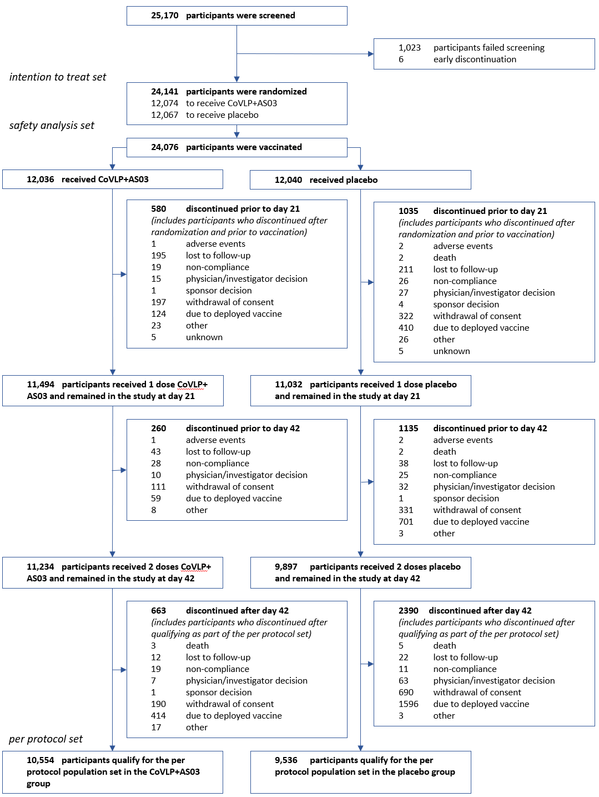

Figure 2: Subgroup and Variant Analysis of Vaccine Efficacy of CoVLP+AS03 to Prevent COVID-19 (ITT set)
(a)
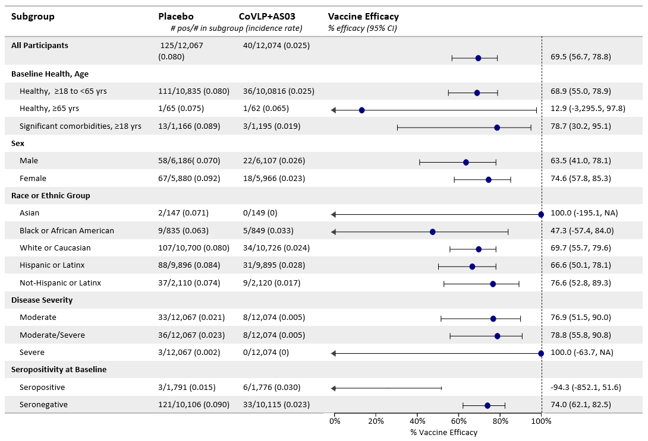

(b)
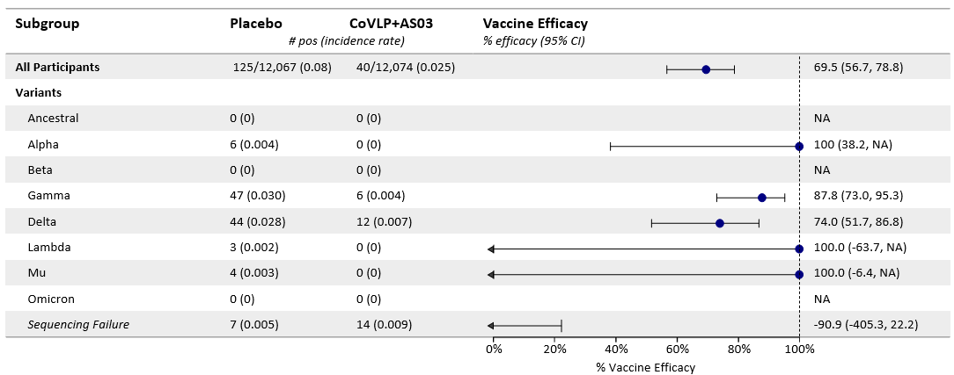

Figure 3: Cumulative Incidence of COVID-19 in CoVLP+AS03 Vaccinated and Placebo Control Study Participants
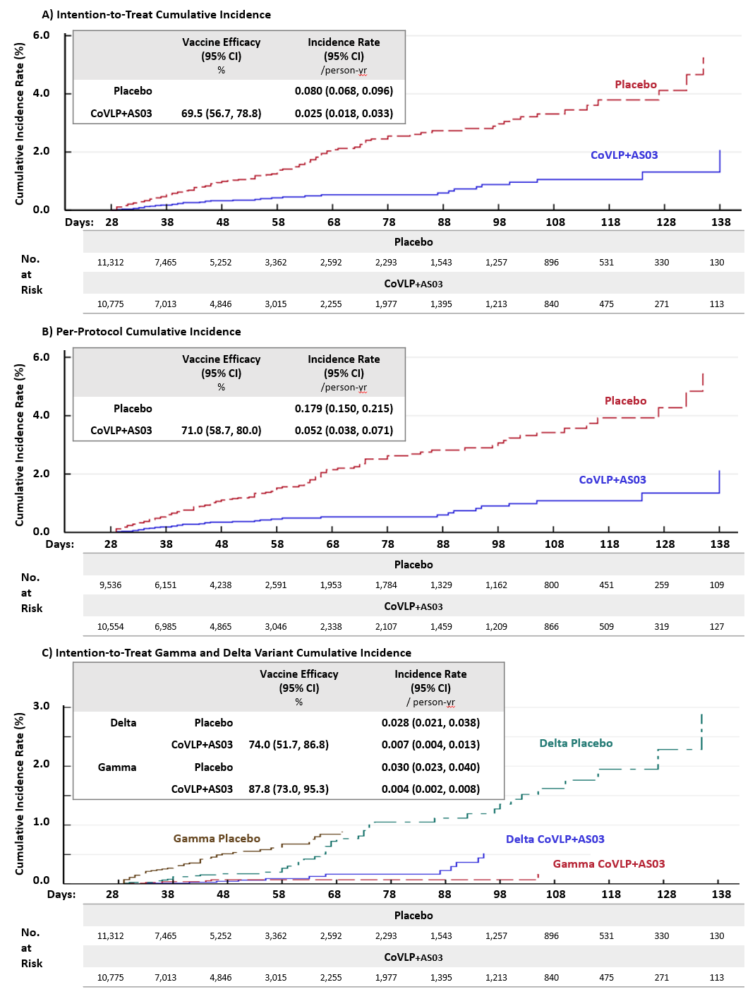

Figure 4: Viral Load at the time of COVID-19 Diagnosis in Breakthrough versus Placebo Cases

(a)

(b)

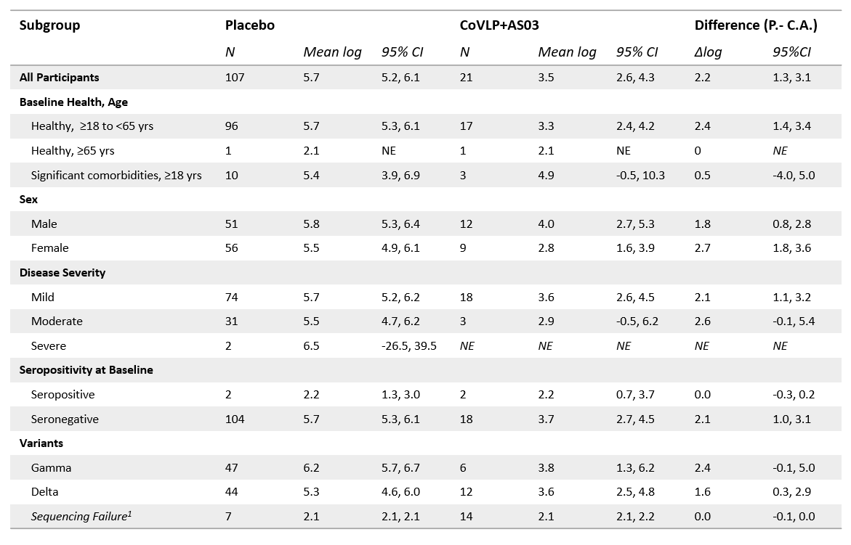

Figure 5: Solicited Local and Systemic Adverse Events during the 7-Days After the First or Second Doses in CoVLP+AS03 versus Placebo Recipients
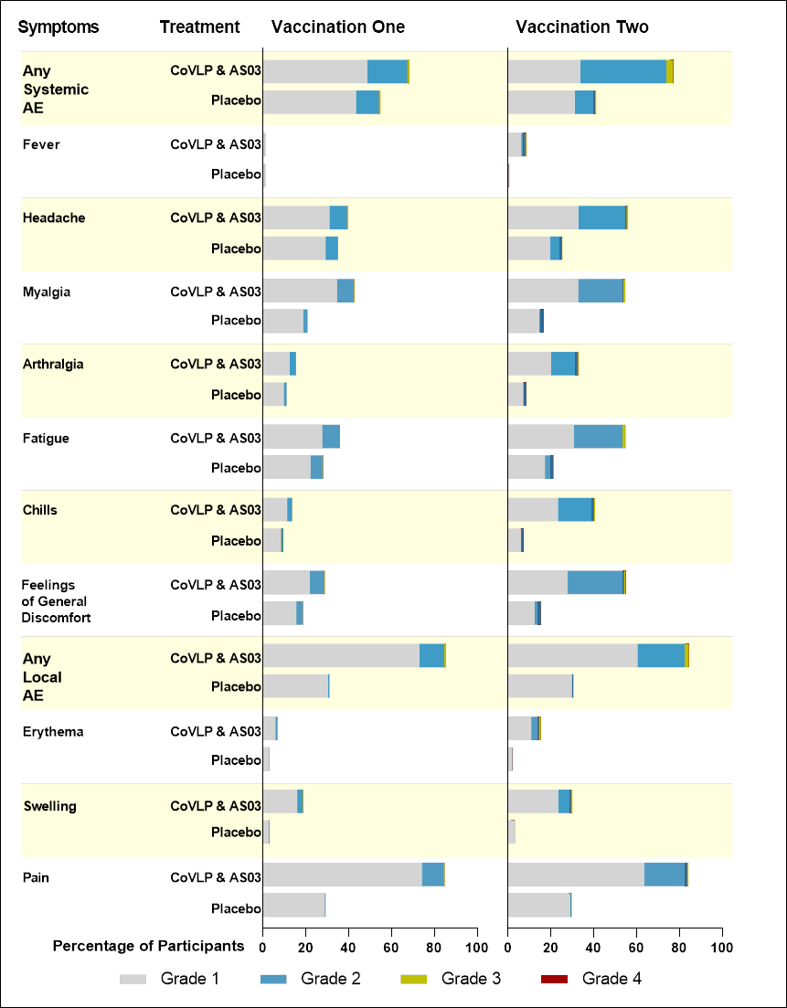

References
1. Zhou P, Yang X-L, Wang X-G, et al. A pneumonia outbreak associated with a new coronavirus of probable bat origin. Nature 2020;579:270-3.
2. WHO Coronavirus Disease (COVID-19) Dashboard. 2021. (Accessed February 28th, 2022, at .)
3. Funk CD, Laferriere C, Ardakani A. Target Product Profile Analysis of COVID-19 Vaccines in Phase III Clinical Trials and Beyond: An Early 2021 Perspective Viruses 2021;13.
4. Harvey WT, Carabelli AM, Jackson B, et al. SARS-CoV-2 variants, spike mutations and immune escape. Nat Rev Microbiol 2021;19:409-24.
5. Polack FP, Thomas SJ, Kitchin N, et al. Safety and Efficacy of the BNT162b2 mRNA Covid-19 Vaccine. N Engl J Med 2020;383:2603-15.
6. Baden LR, El Sahly HM, Essink B, et al. Efficacy and Safety of the mRNA-1273 SARS-CoV-2 Vaccine. N Engl J Med 2021;384:403-16.
7. Rotshild V, Hirsh-Raccah B, Miskin I, Muszkat M, Matok I. Comparing the clinical efficacy of COVID-19 vaccines: a systematic review and network meta-analysis. Sci Rep 2021;11:22777.
8. Castiello T, Georgiopoulos G, Finocchiaro G, et al. COVID-19 and myocarditis: a systematic review and overview of current challenges. Heart Fail Rev 2021:1-11.
9. Greinacher A, Thiele T, Warkentin TE, Weisser K, Kyrle PA, Eichinger S. Thrombotic Thrombocytopenia after ChAdOx1 nCov-19 Vaccination. N Engl J Med 2021;384:2092-101.
10. Fiolet T, Kherabi Y, MacDonald CJ, Ghosn J, Peiffer-Smadja N. Comparing COVID-19 vaccines for their characteristics, efficacy and effectiveness against SARS-CoV-2 and variants of concern: A narrative review. Clin Microbiol Infect 2021.
11. Munro APS, Janani L, Cornelius V, et al. Safety and immunogenicity of seven COVID-19 vaccines as a third dose (booster) following two doses of ChAdOx1 nCov-19 or BNT162b2 in the UK (COV-BOOST): a blinded, multicentre, randomised, controlled, phase 2 trial. Lancet 2021;398:2258-76.
12. Wouters OJ, Shadlen KC, Salcher-Konrad M, et al. Challenges in ensuring global access to COVID-19 vaccines: production, affordability, allocation, and deployment. Lancet 2021;397:1023-34.
13. Aw J, Seng JJB, Seah SSY, Low LL. COVID-19 Vaccine Hesitancy-A Scoping Review of Literature in High-Income Countries. Vaccines (Basel) 2021;9.
14. Pillet S, Aubin É, Trépanier S, et al. Humoral and cell-mediated immune responses to H5N1 plant-made virus-like particle vaccine are differentially impacted by alum and GLA-SE adjuvants in a Phase 2 clinical trial. npj Vaccines 2018;3:3.
15. Ward BJ, Makarkov A, Séguin A, et al. Efficacy, immunogenicity, and safety of a plant-derived, quadrivalent, virus-like particle influenza vaccine in adults (18-64 years) and older adults (≥65 years): two multicentre, randomised phase 3 trials. The Lancet 2020.
16. Morel S, Didierlaurent A, Bourguignon P, et al. Adjuvant System AS03 containing α-tocopherol modulates innate immune response and leads to improved adaptive immunity. Vaccine 2011;29:2461-73.
17. Budroni S, Buricchi F, Cavallone A, et al. Antibody avidity, persistence, and response to antigen recall: comparison of vaccine adjuvants. npj Vaccines 2021;6:78.
18. Cohet C, van der Most R, Bauchau V, et al. Safety of AS03-adjuvanted influenza vaccines: A review of the evidence. Vaccine 2019;37:3006-21.
19. Gobeil P, Pillet S, Séguin A, et al. Interim Report of a Phase 2 Randomized Trial of a Plant-Produced Virus-Like Particle Vaccine for Covid-19 in Healthy Adults Aged 18-64 and Older Adults Aged 65 and Older. medRxiv 2021:2021.05.14.21257248.
20. Ward BJ, Gobeil P, Séguin A, et al. Phase 1 randomized trial of a plant-derived virus-like particle vaccine for COVID-19. Nature Medicine 2021;27:1071-8.
21. Sette A, Crotty S. Adaptive immunity to SARS-CoV-2 and COVID-19. Cell 2021;184:861-80.
22. D'Aoust MA, Couture MM, Charland N, et al. The production of hemagglutinin-based virus-like particles in plants: a rapid, efficient and safe response to pandemic influenza. Plant Biotechnol J 2010;8:607-19.
23. FDA. Guidance for Industry: COVID-19: Developing Drugs and Biological Products for Treatment or Prevention. 2020.
24. Khare S, Gurry C, Freitas L, et al. GISAID's Role in Pandemic Response. China CDC Wkly 2021;3:1049-51.
25. El Zein S, Chehab O, Kanj A, et al. SARS-CoV-2 infection: Initial viral load (iVL) predicts severity of illness/outcome, and declining trend of iVL in hospitalized patients corresponds with slowing of the pandemic. PLoS One 2021;16:e0255981.
26. Pouwels KB, Pritchard E, Matthews PC, et al. Effect of Delta variant on viral burden and vaccine effectiveness against new SARS-CoV-2 infections in the UK. Nat Med 2021.
27. Cai C, Liu Y, Zeng S, Shen H, Han Y. The efficacy of COVID-19 vaccines against the B.1.617.2 (delta) variant. Mol Ther 2021;29:2890-2.
28. Heath PT, Galiza EP, Baxter DN, et al. Safety and Efficacy of NVX-CoV2373 Covid-19 Vaccine. N Engl J Med 2021;385:1172-83.
29. Voysey M, Clemens SAC, Madhi SA, et al. Safety and efficacy of the ChAdOx1 nCoV-19 vaccine (AZD1222) against SARS-CoV-2: an interim analysis of four randomised controlled trials in Brazil, South Africa, and the UK. Lancet 2021;397:99-111.
30. Pillet S, Arunachalam PS, Andreani G, et al. Safety, immunogenicity and protection provided by unadjuvanted and adjuvanted formulations of recombinant plant-derived virus-like particle vaccine candidate for COVID-19 in non-human primates. bioRxiv 2021:2021.05.15.444262.
31. AboulFotouh K, Cui Z, Williams RO, 3rd. Next-Generation COVID-19 Vaccines Should Take Efficiency of Distribution into Consideration. AAPS PharmSciTech 2021;22:126.
32. Hotez PJ, Bottazzi ME. Whole Inactivated Virus and Protein-Based COVID-19 Vaccines. Annu Rev Med 2021.

