QUANTIFYING THE POPULATION BURDEN OF MUSCULOSKELETAL DISORDERS, INCLUDING IMPACT ON SICKNESS ABSENCE: ANALYSIS OF NATIONAL SCOTTISH DATA

Karen Walker-Bone^{1,2}, Helen Storkey³, Julie Peacock³, Benjamin Ellis^{4,5}, Michael Ly⁴, Jonathan Hill⁶, James O’Malley⁴

¹MRC Versus Arthritis Centre for Musculoskeletal Health and Work, University of Southampton, Southampton, UK
²MRC Lifecourse Epidemiology Centre, University of Southampton, Southampton, UK
³Public Health Scotland, Edinburgh, Scotland
⁴Versus Arthritis, London, UK
⁵Imperial College Healthcare NHS Trust, London, UK
⁶School of Medicine, Primary Care Centre Versus Arthritis, Keele University, Keel, UK

Word count: 3495

Name and address for correspondence:
Professor Karen Walker-Bone, Professor of Occupational Rheumatology
Director, MRC Versus Arthritis Centre for Musculoskeletal Health and Work
MRC Lifecourse Epidemiology Centre,
Southampton General Hospital,
Southampton, SO16 6YD, UK.
Tel: +44 (0) 23 80 777624 E-mail: kwb@mrc.soton.ac.uk
ORCID ID: 0000-0002-5992-1459

ABSTRACT
Objectives:
Musculoskeletal disorders (MSDs) account for the greatest burden of years lived with disability globally. To prevent disability, good-quality services need to be commissioned appropriate for local need. We analysed data collected systematically from a new musculoskeletal service serving 70% of the population of Scotland to evaluate: age- and sex-specific occurrence; anatomical distribution; impact and effect on work ability.
Methods:
A new centralised telephone-based triage for people with musculoskeletal disorders was set up in Scotland in 2015. Available to most of the population aged > 16 years, (over 3 million people), data were collected systematically on to a database detailing: anatomical site, nature of onset, duration, impact/risk (modified STarT score), deprivation level and, for those in employment, sickness absence.
Results:
Data were available from 219,314 new callers, 2015-18. Calls were more frequently from women (60%), increased with age until the eighth decade and 66% reported symptoms which had been present >6 weeks. Callers were more likely living in more deprived areas in each age band between 20-64 years and tended to have higher-impact symptoms. The majority (53%) of callers were in employment and 19% of these were off sick because of their symptoms. Sickness absence was more common amongst those with highest-impact/risk scores from deprived areas with more acute symptoms.
Discussion:
Large-scale systematic data collection for MSDs emphasises the size and impact of the burden amongst adults aged >16 years. A socio-economic gradient is evident in terms of prevalence and impact of MSDs, particularly for sickness absence.

Key words: Musculoskeletal disorders; burden; systematic data; prevalence; sickness absence; deprivation

Key messages:
1. Systematic data collection about musculoskeletal disorders facilitates targeted local prevention strategies and care pathways
2. Deprivation is associated with a greater prevalence of, and impact/risk from, musculoskeletal disorders
3. MSDs cause substantial sickness absence and there is a socio-economic gradient

Background
Musculoskeletal disorders (MSDs) are the most significant contributors to disability worldwide (1), causing at least 17% of years lived with disability (2). Healthcare costs for MSDs are massive (amongst the top 5 costliest of all conditions classified by the International Classification of Diseases) (3). Moreover, it is widely predicted that the prevalence and impact of MSDs will increase (4), as a result of population ageing, increasing prevalence of other non-communicable diseases and their modifiable risk factors (e.g. obesity), and increasing rates of fractures associated with bone fragility, falls and road traffic accidents. Consequently, finding ways to prevent disability from MSDs is a major and important challenge (5).

In the UK, pathways of care for MSDs have not always been clear or effective, leading to avoidable costs and poor patient and work outcomes (6,7), despite an annual spend exceeding £5 billion in England (population 56 million) (5) and £353 million in Scotland (population 6 million) (8). Even so, Scottish data from 2016 showed that low back and neck pain were the second largest cause of years lived with disability (totalling 67,900 years) (9). There is considerable evidence about what works to improve musculoskeletal health (10). However, to provide comprehensive, effective services for the prevention and treatment of MSDs, healthcare providers and policy-makers need local data about the prevalence of these conditions, and their impact and risk factors. Data collection in routine musculoskeletal services has been found incomplete, unstandardised and non-systematic (5). Whilst useful data are available from primary care databases such as the Clinical Practice Research datalink (CPRD), they provide no information about impact/risk and there are a number of methodological and coding issues, which particularly hamper interpretation of data about some of the most common conditions (e.g. regional pain disorders and osteoarthritis) (11,12).

UK healthcare services were devolved 2015-16, giving individual countries opportunities to control their budgets and prioritise service provision. In Scotland, a new triage service for musculoskeletal symptoms was incepted, serving the majority of the adult population, which created an opportunity to analyse large-scale systematically collected data from new calls over three years to better understand: the (a) age- and sex-specific occurrence; (b) anatomical distribution; (c) impact/risk status; and (d) effect on work, taking account of levels of population deprivation.

Methods
A new centralised telephone triage service (the MSK Helpline) was introduced in 2015 for people aged >16 years with MSD symptoms in Scotland. It was advertised as the first point of contact for people experiencing symptoms of musculoskeletal disorders (e.g. back pain and sports injuries) through GP surgeries, health boards and on-line. In some areas, people with MSDs could only get musculoskeletal healthcare if they contacted the helpline, but more latitude was seen in other areas. Operated by the Musculoskeletal Advice and Triage Service, calls were answered by trained operators, supported by nurses and physiotherapists. Information was collected systematically using a pre-defined script which initially screened for signs of: abdominal aortic aneurysm; deep vein thrombosis and cauda equina syndrome (all referred urgently to GP if screening questions positive). Subsequent “high-level” musculoskeletal screening questions were asked covering symptoms consistent with the “red flags” (11) and in the event of positive responses, the call was transferred to a clinically-trained member of staff. For everyone else, questions were asked about their current main MSD: its anatomical site; its duration (< 1 week, 1-2 weeks, 2-3 weeks, 4-6 weeks, 6-12 weeks, > 3 months); pattern of onset (gradual onset without specific trigger; accident/injury; a sudden onset without specific trigger; had pain off and on for a long time) and whether or not it was recurrent. They were also asked if they were currently working and if yes, whether they were off sick because of their symptoms. In Scotland, health services are delivered through 14 geographical health boards. At the time of data collection, this service was available to people living in areas covered by 9 of the 14 Scottish Health Boards, serving a population of 3.17 million people aged >16 years out of the total 4.52 million >16 years (70% of the total) resident in Scotland.

Every caller was asked 9 questions. Seven of these were very close to the questions in the validated STarT Back tool (14,15) but were modified to be asked by the telephone operator instead of self-reported and to be relevant to musculoskeletal pain at any site, rather than only the back (wording “back pain” altered to “pain”). Two questions were additionally modified so that “pain has spread down my leg” was altered to “pain in more than one part of the body” and “pain in the shoulder or neck” was modified to “has the most painful area been in your hand, wrist or elbow?”. Therefore, the questions explored, in relation to symptoms over the past 2 weeks: functional impact; pain at more than one site; beliefs about pain and activity; worrying thoughts; lack of enjoyment; catastrophisation and bothersomeness (options: Not at all; Slightly; Moderately; Very Much; Extremely). Based upon their responses, the caller was triaged as low- (total score ≤3), medium- (total score ≥4 and sub-score from questions 5-9 <3) or high-risk (total score >4 and sub-score ≥4). Generally, callers with a low-risk score were triaged to information to support self-management whilst those with medium- or high-risk scores were offered referral or requested to make an appointment with their GP.

The Scottish Index of Multiple Deprivation (SIMD) 2016 uses updated 2011 Census data to produce an area-based relative measure of deprivation. The index takes into account seven domains: income, employment, education, health, access to services, crime and housing. It has been calculated and ranked for 6796 areas of Scotland (data zones), each of which includes on average 760 people. The SIMD quintiles split the ranked data zones into 5 groups, each containing 20% of Scotland’s data zones (quintile 1 – most deprived). The SIMD was calculated from the postcode of each new caller.

Statistical analysis
Data about all new callers to the MSK helpline between 2015-18 were analysed. Descriptive statistics were used to report the age- and sex-specific rates of new callers per 1000 population, the reported duration of the main symptom and pattern of onset. Rates of calls per 1000 for anatomical site of the main symptom were also described by age and gender. Rates of new calls to the helpline per 1000 population were summarised graphically by quintile of deprivation. A modified STarT score was assigned to the main musculoskeletal symptom of each new caller and these scores were then summarised graphically for men and women by quintile of deprivation. The STarT Back scoring system has been validated in various settings for people with back pain (14,16-18) and therefore the range of STarT scores by deprivation quintile for people whose main problem was back pain (with/without leg pain) was also explored. Amongst those currently working, the proportion off sick because of their MSD was calculated and these data were presented in relation to duration of symptoms and stratified by the modified STarT score. Finally, the proportion of employed callers off sick were summarised by symptom duration and quintile of deprivation.

The de-identified analyses were carried out within NHS 24, NHS Scotland and permission was granted for us to publish the data by the owners, NHS 24 Service delivery team, NHS Scotland, 28th September 2020.

Results
A total of 302,045 calls were made to the MSK Helpline 2015-18. After exclusion of invalid calls, repeat callers, duplicate records or calls for whom essential data fields were missing, data were available for analysis from 219,314 new calls (73%). Around 50,000 calls were received annually (range: 50,481-63,213) from approximately 1.7% of the eligible population. More calls were made by women (60%) than men (40%) at all ages. Figure 1 summarises the rates of new calls by age and quintile of deprivation. The numbers of calls increased by age-band until a peak aged 50-54 years in women and 55-59 years in men. With the exception of the youngest age group (16-19 years), there was a consistent trend for more calls from people living in more deprived areas until aged 60-64, beyond which the opposite was observed and calls were more common from those living in less deprived areas. Amongst men, for example, 12% of the calls aged >60 years were from the most deprived quintile as compared with 23% from the least deprived quintile.

Table 1 summarises the rates of new calls by anatomical site of the main musculoskeletal symptom and age. Back pain (with/without leg pain) was the most common (n=62,956 (29%) calls) and shoulder pain was the next most common (37,644 (17%) calls), followed by knee pain (33,683 (15%) calls). Elbow, ankle and foot made up > 50% of the calls labelled as “other joint” (approximately 17,000 calls). 3051 (1.4%) callers wanted to access a walking aid or splint. Hip and shoulder symptoms were more common with increasing age. Most common in the youngest age group were symptoms in the back (39%) and knee (18%). Supplementary Table 1 shows the rates of new calls by gender and anatomical site: women reported MSDs at all sites more commonly than men but the anatomical sites affected were proportionately similar.

The majority (66%) of new callers had experienced symptoms for >6 weeks and 50% for >3 months prior to calling. Symptom duration did not vary by age band, gender, anatomical site or calendar year (data not shown). When asked about the pattern of symptom onset, the commonest response was gradual onset without specific trigger (30%); 24% ascribed their symptoms to accident/injury; 25% reported sudden onset without specific trigger; and the remainder (20%) reported pain off and on for a long time. The age groups which most commonly reported accidents and injuries as the cause were those aged <40 years but there was another smaller increase in accidents/injuries amongst those aged >70 years compared to those aged 60-69 years.

Using the modified STarT scoring system, >52,000 callers were identified as low-risk (24%), almost 77,000 (35%) as medium-risk and the remaining 90,000 (41%) as high-risk. As mandated, most of those in the low-risk group received advice to self-manage (73%) or advice to self-manage with a referral (14%), 7% received “other” and 6% were provided with a walking aid or splint. In contrast, 98% of those in the medium- and high-risk groups received onward referral, with just 2% advised to self-manage or provide with a walking aid/splint.

Figure 2 summarises the modified STarT scores by quintiles of SIMD. A clear gradation was seen such that those in the three most deprived quintiles amongst men and women were considerably more likely to have the highest risk scores. In contrast, approximately one-third of those in the least deprived quintile had high-, medium- and low-risk scores. These relationships are also shown in Figure 3, in which the STarT scores amongst callers reporting back pain (with or without leg pain) are summarised by age and quintiles of deprivation (men and women combined). No matter the age or gender of the caller, more calls about back pain were made from people living in the most deprived areas.

In total, 116,116 (57%) new callers reported current employment (55% of women and 59% of men). Confining to those of traditional working age, 75.5% of women aged 25-59 years and 76.9% of men aged 25-64 years were working. Amongst these, 22,191 (19%) of callers were off sick because of their MSD. Table 2 summarises the proportions of people off sick (for those in employment), stratified by modified STarT score and duration of MSK symptoms. Rates of sickness absence increased with modified STarT score so that 1 in 4 workers with high risk scores were currently off sick because of their MSD. Rates of sickness absence were generally higher amongst those with more recent-onset symptoms (46% of those in employment with MSK problem <1 week). However, 12% of employed callers reported sickness absence with symptoms that had been present for >3 months.

Figure 4 shows, by gender, the rates of sickness absence associated with high- medium- and low- risk modified STarT scores comparing those in SIMD 1 (most deprived) with those in SIMD 5 (least deprived). Whilst employment rates were lower amongst people living in more deprived areas, higher rates of sickness absence were reported by workers in SIMD 1 with effects apparently greater among men (72% vs 50% off sick with highest-risk scores duration of symptoms < 1 week) than women (58% vs 48% off sick with highest-risk scores and duration of symptoms < 1 week).

Discussion
This analysis of systematically-collected data from new callers to the MSK helpline provides insight about the size of the burden of MSDs in a defined adult population of 3.2 million people (>70% of the total) in Scotland. In total, over 3 years, 1.7% of the eligible population made a new call. More calls were made by women than men (60% vs 40%) and the commonest symptom was back pain (with/without leg pain). Most callers reported long-term symptoms (66% > 6 weeks and 50% >3 months). Grading impact/risk using a modified STarT score (14,15), only a minority of callers (24%) were defined as low risk and the largest group (41%) were high risk. Considering the STarT scores alongside SIMD showed a consistent relationship between higher risk scores and living in a more deprived area amongst male and female callers up until age 65 years but beyond, the opposite relationship was seen. Confining the analysis only to callers with back pain, and using the STarT Back scoring system as validated (14-19), similar relationships were seen between highest risk scores and deprivation throughout the age range. Just over half of callers were in employment and, of these, almost one in five (19%) were currently off sick because of their MSD. Sickness absence was more common amongst those with shorter duration of symptoms (particularly <1 week) but, no matter what the duration of symptoms, was consistently more common amongst those with high-risk modified STarT scores and amongst people living in more deprived areas.

These data must be considered alongside some limitations. Musculoskeletal pain is known to be highly prevalent in the general population and there are multiple ways in which people can access primary care for MSDs. For example, some patients may have chosen to see their GP, private provider, or to attend A&E services, rather then use the telephone helpline, It is clear therefore that 220,000 calls from new callers over 3 years from 3 million people will not be capturing all people with MSK symptoms who were seeking care. In addition, the helpline was not adopted simultaneously across all of Scotland in 2015 and some of the health boards incepted the service during the period of data collection. Therefore, the data are presented per 1000 population who had access to the service at each point in time. However, not only was the commissioning of the service variable by health board but so was the method of dissemination or publicising of the helpline. In some health boards, the service was implemented so that people with MSDs could only get musculoskeletal healthcare if they contacted the helpline, but this was not the case everywhere. Therefore, although the denominator is accurate in terms of exactly which population groups were able to access the service, these will be relative under-estimates of the actual demand. Notably, because Greater Glasgow and Clyde was one of the 5 health boards who did not commission this service, the total adult population living in SIMD1 (most deprived) were slightly under-represented (15% of the population were in SIMD1 in these analyses vs 19% for the entire Scottish population). Importantly, this analysis focused only on new callers (73% of total calls). Repeat callers may be more likely to have long-term conditions, chronic pain or more troublesome symptoms and it is important to bear in mind therefore that the data presented here represent only a tip of the iceberg. The Commissioners of the Scotland MSK helpline chose to adapt the STarT Back tool to make it suitable for callers with any type of musculoskeletal pain condition. Whilst STarT Back has been well-validated and widely used, this modified tool has not been validated. However, colleagues at the University of Keele have recently developed and validated the Keele STarT MSK tool with 10 questions aiming to rate risk of poor outcomes in 3 categories (low, medium and high) creating a valid tool similar to that employed here (20). There were some missing data from the helpline. For these analyses, calls missing a “new caller” status were excluded but we included all other calls. For most variables, few data were missing (<5%) but in 2018, one health board elected to stop asking about employment and this resulted in 13% of all callers that year having missing data about employment status and sick leave. In consequence, the rates of sickness absence attributable to MSDs presented here are likely to be an under-estimate although we do not believe that this will have had a selective effect on the rates of sickness absence by SIMD. Finally, area-level deprivation scores such as SIMD can be criticised as not every person living in any one area will be the same. Socio-economic position varies widely depending upon pre- and post-natal environment and parental circumstances, as well as the domains captured and summarised in SIMD. Reassuringly, one US study of relocations found that 78% of people moved to a neighbourhood in a similar deprivation quintile with only a 2-13% chance that an individual moved outside their quintile annually (21). However, clearly the 760 people living in one area cannot all be the same. Of course this limitation would tend to push our findings towards the null hypothesis (that deprivation was not important), so that it is striking that we have found the trends summarised here with quintiles of deprivation.

The finding that such a high proportion of callers were graded as “high risk” according to the modified STarT tool was interesting and unexpected when compared with findings from other studies in which the largest group are usually “low risk” (14-19). Of course, the tool was modified in its administration/questions and this may have impacted our findings. Certainly, for this population-based screening tool, the developers were aiming not to reassure too many callers inappropriately. However, another possibility is that people with more trivial symptoms trying to access care do not choose to telephone the helpline and opt instead to self-manage their symptoms or access care privately or choose complementary or alternative healthcare.

Whilst a social gradient was not unexpected, it is interesting that the social gradient of calls appeared to switch at around age 65 years (more calls from least deprived quintiles >65 years). It could be that this is explained by higher rates of mortality amongst those from deprived backgrounds, or that older people from deprived areas are less aware of, or less able to access, this service. An alternative explanation might be that individuals with higher levels of deprivation have already been identified elsewhere in the healthcare system as “high risk” and been referred through other channels for care (e.g. pain clinics, elderly medicine, orthopaedics or rheumatology). Another hypothesis is that after retirement, social factors become less important and biological factors become more important, or that inequalities at older ages are more effectively narrowed by welfare programmes and/or social policies (22). However, the cumulative inequality theory would suggest that rates of inequality increase throughout the life-course as risk factors accumulate (23,24). Interestingly, Swedish researchers who explored the effects of age, socio-economic factors and birth cohort on pain, distress and dental health found similar results for pain (25). Their analysis showed that, although relative inequalities declined in later life (>75 years), absolute inequalities remained substantial but that cumulative disadvantage continued to drive differences up to 45–64 years, but beyond this, factors related to ageing started to impact in the opposite direction, thereby somewhat reducing the socioeconomic gap (25).

That there is a socio-economic gradient in MSDs is not a new finding. Chronic pain, for example, is more prevalent and burdensome amongst people with poorer socio-economic circumstances (26). Back pain has been found more disabling amongst less well educated people (27) and more intense with less advantaged job position (28). Moreover, people with rheumatoid arthritis and other chronic musculoskeletal conditions having poorer educational attainment were found to have 2-3 times higher mortality rates (29,30). Likewise, higher rates of mortality were found amongst white people aged 25-64 years with SLE with poorer educational attainment (31). However, rarely are data available for the whole breadth of MSDs for a population >3 million people. The socio-economic gradient shown here both for rates of new calls to the helpline but also for impact according to the modified STarT score is striking. Moreover, although rates of employment were lower amongst those from more deprived areas, rates of sickness absence caused by MSDs were higher. This funding is important since, at least amongst people off sick with low back pain, duration of absence was importantly associated with the chances of ever working again: people off sick <4 weeks had a 93% chance of returning whilst people absent >6 months had a 68% chance of ever returning (32). Employment has a pivotal role in reducing health inequalities (33) and unemployment is associated with poorer health, increased risk of self-harm and suicide and increased healthcare needs (34-38). For this reason, early intervention amongst people off sick with MSDs is emphasised (39). According to our results, over 22,000 people were off sick with MSDs in Scotland 2015-18 and 12% of these reported an MSD of >3 months’ duration with a social gradient in sickness absence. There are two possible explanations for this: firstly, physically demanding jobs have been found to increase the risk of consultation for MSDs (40). Secondly, people with poorer educational attainment are more likely to be employed in physically-demanding jobs (e.g. construction, manufacturing) and could find themselves more work-disabled by a painful MSD than an individual whose job is sedentary and who has some flexibility and/or autonomy at work. Overall, these analyses suggest a substantial need for services to prevent MSDs and, where necessary, deliver tailored, prompt evidence-based treatment, targeted to the most deprived areas, not only to improve health, but also to enable employment, reduce inequalities and save health and welfare costs.

In summary, analysing systematically collected data, we have found effects of age and gender but also a socio-economic gradient, not only for prevalence but also for impact, including sickness absence from work.

Funding
This work was supported by Versus Arthritis on behalf of the MRC Versus Arthritis Centre for Musculoskeletal Health and Work (Ref: 22090).

Conflicts of Interest
All authors confirm that they have no conflicts of interest in respect of the content of this manuscript.

Ethics
This research was carried out in accord with the declaration of Helsinki. Anonymised, routinely-collected data were analysed. Approval for the analysis and write-up were attained from NHS 24 (23rd Sept 2020).

Data statement
These data are not currently freely available. Researchers interested in accessing the data would need to apply to NHS 24.

Table 1 Anatomical distribution of current musculoskeletal problem reported to MSK helpline by age group
Body site | 16-29 |  | 30-39 |  | 40-49 |  | 50-59 |  | 60-69 |  | 70 or over |  | All ages  (16 or over)
 | No | % of  Total | No | % of  Total | No. | % of  Total | No | % of  Total | No | % of  Total | No | % of  Total | No | % of  Total
Shoulder(s) | 2,678 | 10% | 3,742 | 12% | 7,006 | 18% | 9,486 | 21% | 8,095 | 19% | 6,637 | 19% | 37,644 | 17%
Back only | 6,966 | 26% | 6,881 | 22% | 5,901 | 15% | 5,687 | 12% | 4,648 | 11% | 4,091 | 12% | 34,174 | 16%
Back + leg(s) | 3,376 | 13% | 4,861 | 16% | 5,275 | 14% | 5,587 | 12% | 5,222 | 13% | 4,461 | 13% | 28,782 | 13%
Neck only | 666 | 2% | 875 | 3% | 1,161 | 3% | 1,417 | 3% | 1,530 | 4% | 1,693 | 5% | 7,342 | 3%
Neck + arm(s) | 804 | 3% | 1,538 | 5% | 2,395 | 6% | 2,887 | 6% | 2,402 | 6% | 1,774 | 5% | 11,800 | 5%
Knee(s) | 4,908 | 18% | 4,024 | 13% | 4,876 | 13% | 6,897 | 15% | 7,243 | 17% | 5,735 | 16% | 33,683 | 15%
Other limb/joint(s) | 4,185 | 16% | 4,737 | 15% | 6,763 | 18% | 7,667 | 17% | 5,833 | 14% | 4,359 | 12% | 33,544 | 15%
Hip(s) | 1,441 | 5% | 1,620 | 5% | 2,023 | 5% | 2,966 | 6% | 3,688 | 9% | 3,727 | 10% | 15,465 | 7%
Other | 1,675 | 6% | 2,073 | 7% | 2,271 | 6% | 2,824 | 6% | 2,492 | 6% | 2,175 | 6% | 13,510 | 6%
Walking aid | 198 | 1% | 259 | 1% | 465 | 1% | 663 | 1% | 616 | 1% | 850 | 2% | 3,051 | 1%
All body sites | 26,897 |  | 30,610 |  | 38,136 |  | 46,081 |  | 41,769 |  | 35,502 |  | 218,995

Table 2 Rates of sickness absence by modified STarT score and by duration of musculoskeletal problem amongst employed callers to the MSK helpline
 | Men |  |  | Women |  |  | All
Modified STarT score | No in work | No off sick | % off sick | No in work | No off sick | % off sick | No in work | No off sick | % off sick
Low risk | 10633 | 1039 | 9.8% | 14849 | 1037 | 7.0% | 25482 | 2076 | 8.1%
Medium risk | 16954 | 3403 | 20.0% | 25106 | 4162 | 16.6% | 42060 | 7565 | 18.0%
High risk | 20227 | 5825 | 28.8% | 26407 | 6557 | 24.8% | 46634 | 12382 | 26.6%
Duration of MSK problem
< 1 week | 3319 | 1643 | 49.5% | 3941 | 1670 | 42.4% | 7260 | 3313 | 45.6%
1-2 weeks | 3485 | 1397 | 40.0% | 4641 | 1575 | 33.9% | 8126 | 2972 | 36.6%
2-3 weeks | 6320 | 1876 | 29.7% | 8444 | 2193 | 26.0% | 14764 | 4069 | 27.6%
4-6 weeks | 4563 | 1048 | 23.0% | 6253 | 1237 | 19.8% | 10816 | 2285 | 21.1%
6-12 weeks | 8217 | 1326 | 16.1% | 10962 | 1588 | 14.5% | 19179 | 2914 | 15.2%
>3 months | 21910 | 2977 | 13.6% | 32121 | 3493 | 10.9% | 54031 | 6470 | 12.0%

References
(1) Cieza A, Causey K, Kamenov K, Wulf Hanson S, Chetterji S, Vos T. Global estimates of the need for rehabilitation based on the global burden of disease study 2019: a systematic analysis for the global burden of disease study 2019. Lancet 2021;396:2006-2017. 10.1016/S0140-6736(20)32340-0
(2) Blyth FM, Briggs AM, Schneider CH, Hoy DJ, March LM. The global burden of musculoskeletal pain-where to from here? Am J Public Health 2019;109:35–40. 10.2105/AJPH.2018.30474
(3) Organisation for Economic and Co-operation Development. Health spending: expenditure by disease, age and gender. Paris: OECD, 2016.
(4) Briggs AM, Huckel Schneider C, Slater H, Jordan JE, Paramba S, Young JJ, et al. Health systems strengthening to arrest the global disability burden: empirical development of prioritised components for a global strategy for improving musculoskeletal health. BMJ Glob Health. 2021;6(6):e006045.
(5) NHS England, NHS Improvement and Health Education England. Musculoskeletal Health: 5-year strategic framework for prevention across the lifecourse. June 2019. Available from: https://assets.publishing.service.gov.uk/government/uploads/system/uploads/attachment_data/file/810348/Musculoskeletal_Health_5_year_strategy.pdf. (Last accessed August 2021)

(6) Porcheret M, Jordan K, Jinks C, Croft P, Primary Care Rheumatology Soc. Primary care treatment of knee pain—a survey in older adults. Rheumatology 2007;46:1694–700.

(7) Somerville S, Hay E, Lewis M, Barber J, van der Windt D, Hill J, et al. Content and outcome of usual primary care for back pain: a systematic review. Br J Gen Pract 2008;58:790–7.

(8) The Scottish Government (2015). programme budgeting data http://www.gov.scot/Publications/2015/08/4735/4

(9) ScotPHO: Public Health Information for Scotland. Scottish Burden of Disease 2016. Available from: https://www.scotpho.org.uk/media/1733/sbod2016-overview-report-sept18.pdf (Last accessed Sept 2021).

(10) Babatunde OO, Jordan JL, Van der Windt DA, Hill JC, Foster NE, Protheroe J. Effective treatment options for musculoskeletal pain in primary care: A systematic overview of current evidence. PLoS One. 2017;12(6):e0178621

(11) Jordan KP, Tan V, Edwards JJ, Chen Y, Englund M, Hubertsson J, et al. Influences on the decision to use an osteoarthritis diagnosis in primary care: a cohort study with linked survey and electronic health record data. Osteoarthritis Cartilage. 2016 ;24(5):786-93.

(12) Carreira H, Williams R, Strongman H, Bhaskaran K. Identification of mental health and quality of life outcomes in primary care databases in the UK: a systematic review. BMJ Open. 2019;9(7):e029227.

(13) Clinical Standards Advisory Group on Back Pain. Back pain. London: HMSO, 1994.

(14) Hill JC, Dunn KM, Lewis M, Mullis R, Main CJ, Foster NE, et al. A primary care back pain screening tool: identifying patient subgroups for initial treatment. Arthritis Rheum. 2008;59(5):632-41.

(15) Hill J, D Whitehurst, Lewis M, Bryan S, Dunn K, Foster N, et al. A randomised controlled trial and economic evaluation of stratified primary care management for low back pain compared with current best practice: The STarT Back trial. The Lancet 2011; 378 (9802): 1560 – 1571.

(16) Billis E, Fousekis K, Tsekoura M, Lampropoulou S, Matzaroglou C, Hill JC. Cross-cultural validation of the STarT back screening tool in a Greek low back pain sample. Musculoskeletal Science and Practice 2021; 53, 102352

(17) Ben Ami N, Weisman A, Yona T, Shashua A, Hill J, Pincus, T. STarT back tool retained its predicting abilities in patients with acute and sub-acute low back pain after a transcultural adaptation and validation to Hebrew. Musculoskelet Sci Pract 2020, 46, 102134.

(18) Simula AS, Ruokolainen O, Oura P, Lausmaa M, Holopainen R, Paukkunen M, et al. Association of STarT Back Tool and the short form of the Örebro Musculoskeletal Pain Screening Questionnaire with multidimensional risk factors. Sci Rep. 2020;10(1):290.

(19) Foster N, Mullis R, Hill J, Lewis M, Whitehurst D, Doyle C, et al. Effect of Stratified Care for Low Back Pain in Family Practice (IMPaCT Back): A Prospective Population-Based Sequential Comparison. Ann Fam Med 2014; 12:102-11

(20) Dunn KM, Campbell P, Lewis M, Hill JC, van der Windt DA, Afolabi E, et al. Refinement and validation of a tool for stratifying patients with musculoskeletal pain. European J of Pain 2021;25:2081-93.

(21) Knighton AJ. Is a Patient's Current Address of Record a Reasonable Measure of Neighborhood Deprivation Exposure? A Case for the Use of Point in Time Measures of Residence in Clinical Care. Health Equity. 2018;2(1):62-69.

(22) Hoffmann R. Illness, not age, is the leveler of social mortality differences in old age. J Gerontol B Psychol Sci Soc Sci 2011;66:374–9.

(23) Ferraro KF, Shippee TP. Aging and cumulative inequality: how does inequality get under the skin? Gerontologist 2009;49:333–43.

(24) Leopold L. Cumulative advantage in an Egalitarian country? socioeconomic health disparities over the life course in Sweden. J Health Soc Behav 2016;57:257–73.

(25) Celeste RK, Fritzell J. Do socioeconomic inequalities in pain, psychological distress and oral health increase or decrease over the life course? Evidence from Sweden over 43 years of follow-up. J Epidemiol Community Health 2018;72:160-167.

(26) Mills SEE, Nicolson KP, Smith BH. Chronic pain: a review of its epidemiology and associated factors in population-based studies. Br J Anaesth. 2019;123(2):e273-e283.

(27) Dionne CE, Von Korff M, Koepsell TD, Deyo RA, Barlow WE, Checkoway H. Formal education and back pain: a review. J Epidemiol Community Health. 2001; 55(7):455-68.

(28) Fliesser M, De Witt Huberts J, Wippert PM. Education, job position, income or multidimensional indices? Associations between different socioeconomic status indicators and chronic low back pain in a German sample: a longitudinal field study. BMJ Open. 2018;8(4):e020207.

(29) Kiadaliri AA, Petersson IF, Englund M. Educational inequalities in mortality associated with rheumatoid arthritis and other musculoskeletal disorders in Sweden. BMC Musculoskelet Disord. 2019;20(1):83.

(30) Moreno-Betancur M, Sadaoui H, Piffaretti C, Rey G. Survival analysis with
multiple causes of death: extending the competing risks model. Epidemiology. 2017;28(1):12–9.

(31) Ward MM. Education level and mortality in systemic lupus erythematosus (SLE): evidence of under ascertainment of deaths due to SLE in ethnic minorities with low education levels. Arthritis Rheum. 2004;51(4):616-24.
(32) Wynne-Jones G, Cowen J, Jordan JL, Uthman O, Main CJ, Glozier N, et al. Absence from work and return to work in people with back pain: a systematic review and meta-analysis. Occup Environ Med. 2014;71(6):448-56.
(33) Marmot M. Social determinants of health inequalities. Lancet. 2005; 365(9464): 1099-104
(34) Moser KA, Fox AJ, Jones DR. Unemployment and mortality in the OPCS Longitudinal Study. Lancet. 1984;2(8415):1324-9.
(35) Kposowa AJ. Unemployment and suicide: a cohort analysis of social factors predicting suicide in the US National longitudinal Mortality Study. Psychol Med 2001;31:127-38.
(36) Nylen L, Voss M, Folderus B. Mortality among women and men relative to unemployment, part-time work, overtime work, and extra work: a study based on data from the Swedish twins register. Occup Environ Med 2001;58:52-7.
(37) Mason V. The prevalence of back pain in Great Britain. Office of Population Censuses and surveys, HMSO, 1994.
(38) Waddell G, Burton K. Is work good for your health and wellbeing? An independent review. (2006). Department for Work and Pensions.
(39) Black C. Working for a healthier tomorrow. Dame Carol Black’s Review of the Health of Britain’s Working Age Population, 2008. www.dwp.gov.uk/docs/hwwb-working-for-a-healthier-tomorow.pdf (24 June 2021, date last accessed).
(40) Halonen JI, Shiri R, Mänty M, et al. Exposure to heavy physical work from early to later adulthood and primary healthcare visits due to musculoskeletal diseases in midlife: a register linked study. BMJ Open 2019;9:e031564.

Figure 1 Rates of new calls to the MSK helpline 2015-18 per 1000 population by quintile of deprivation for (a) men and (b) women
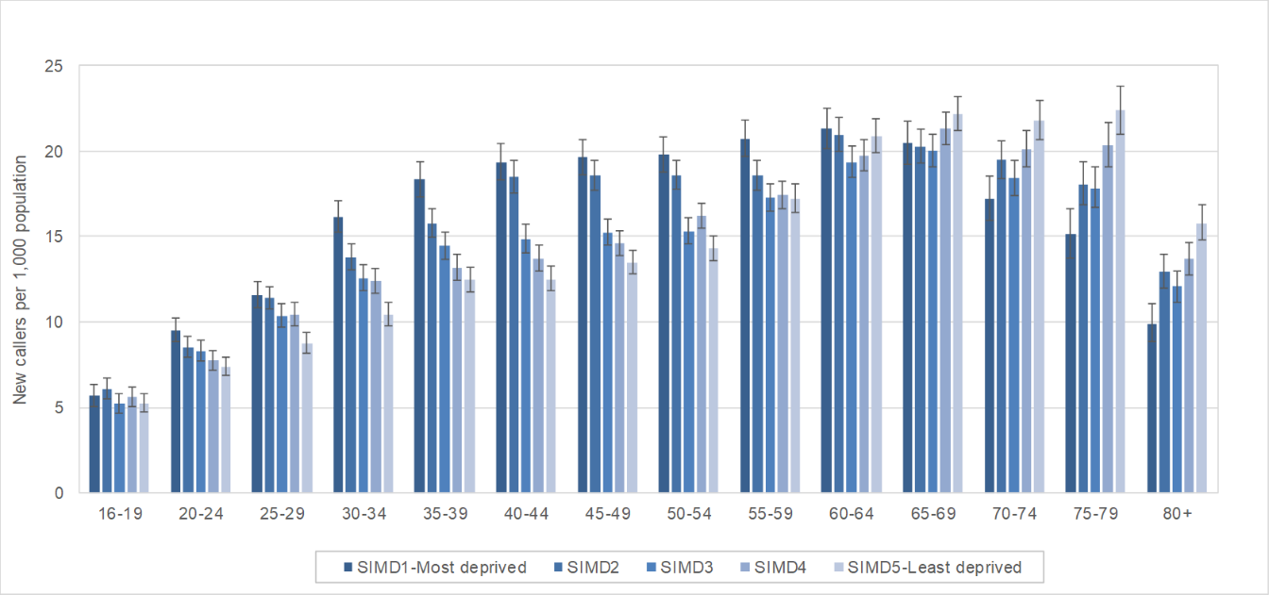
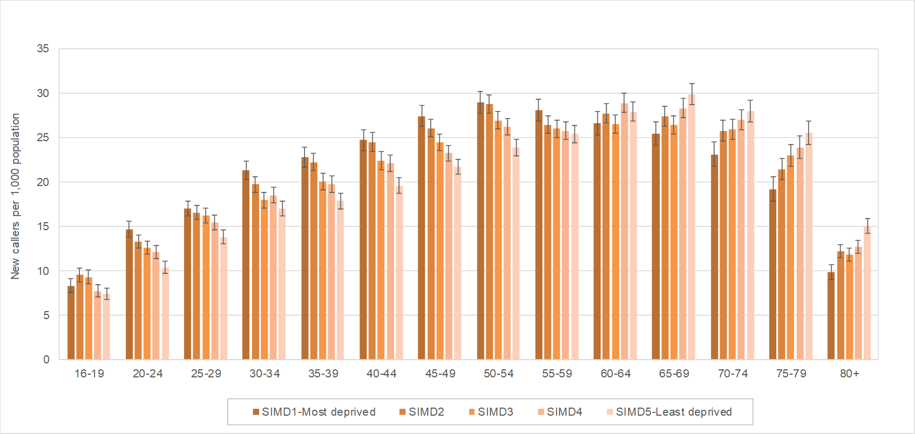
(a)

(b)

Figure 2 Summary of modified STarT scores by SIMD quintiles of deprivation amongst (a) men and (b) women
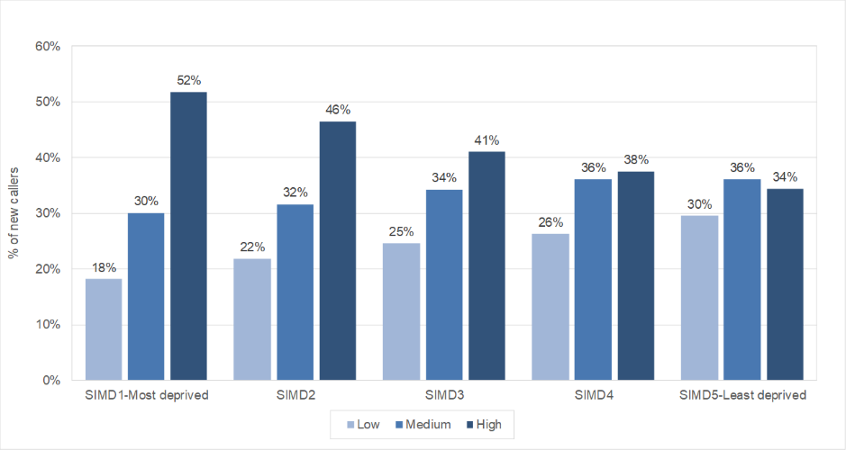
(a) MEN

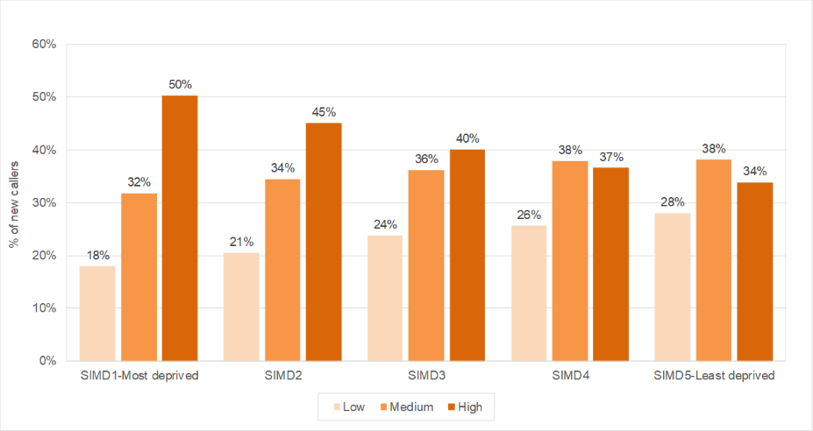
(b) WOMEN

Figure 3 STarT Back scores for new callers to the MSK helpline with back pain (with or without leg pain) by age band and quintiles of deprivation (men and women combined)
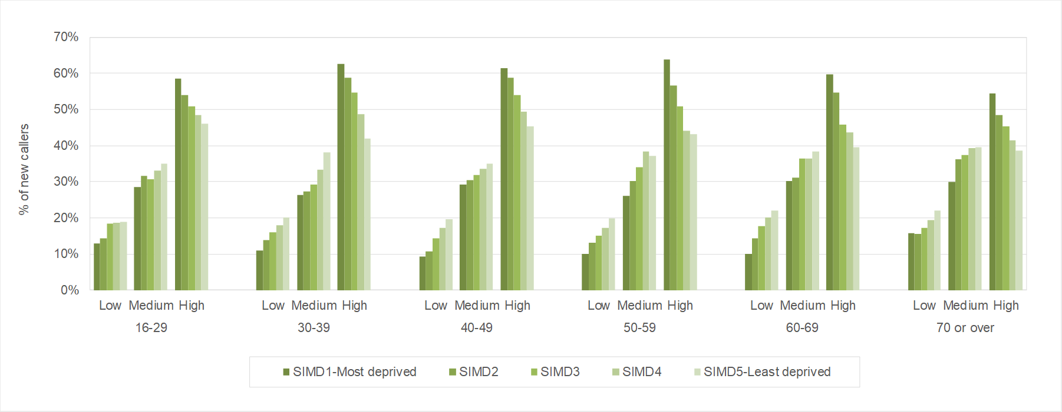

Figure 4 Comparison of the proportion of men and women reporting that they have taken sick leave because of their pain in relation to duration of symptoms and modified STarT score amongst those in the SIMD quintiles 1 and 5
WOMEN – SIMD 1 (MOST DEPRIVED)
MEN – SIMD 1 (MOST DEPRIVED)
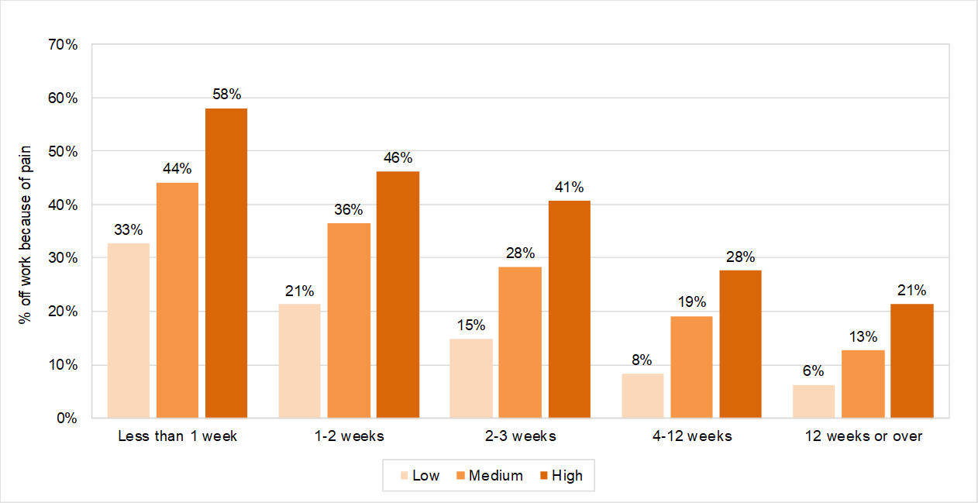
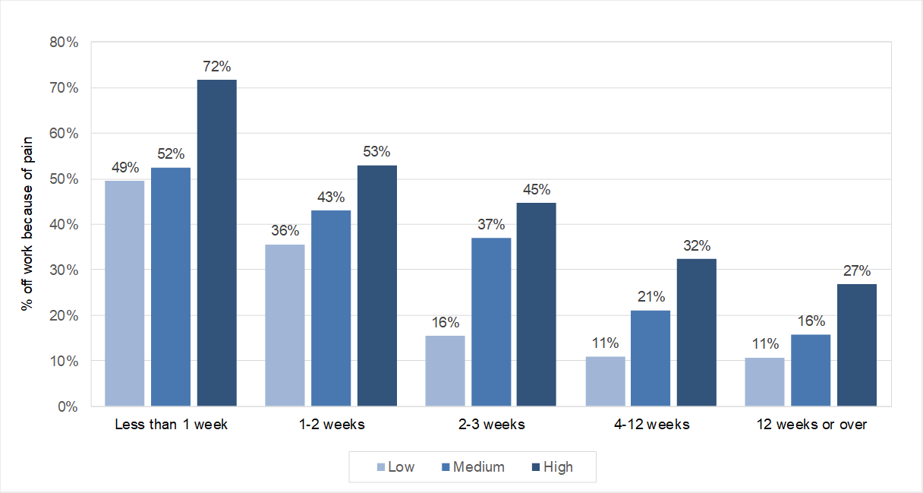

WOMEN – SIMD 5 (LEAST DEPRIVED)
MEN – SIMD 5 (LEAST DEPRIVED)
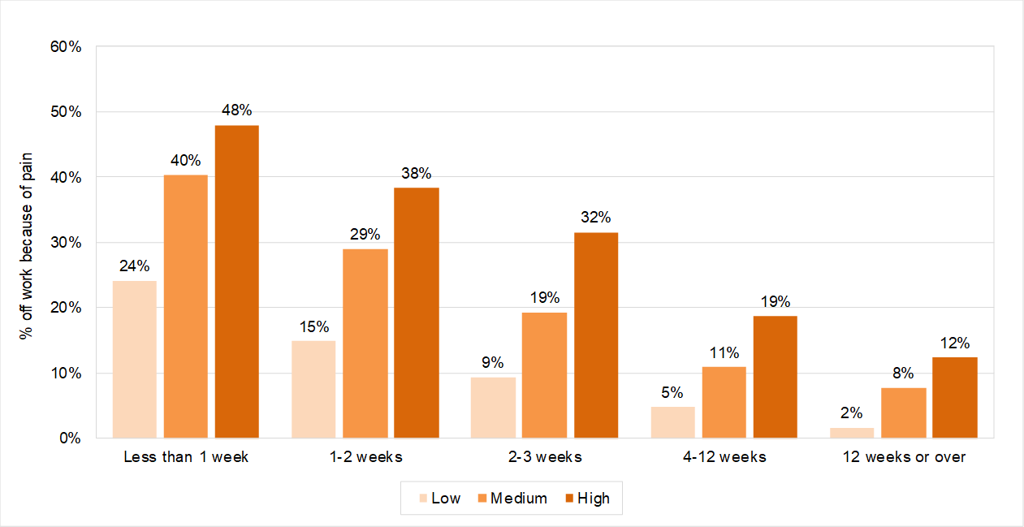
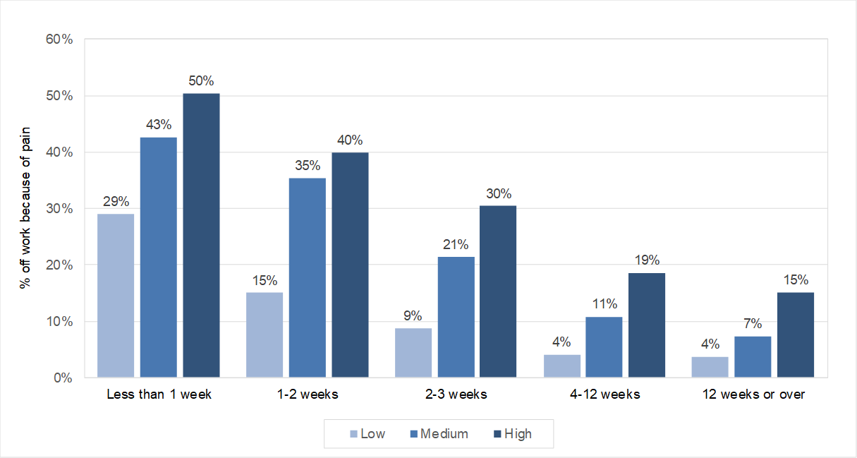

Supplementary Table 1 Rates of new calls to MSK helpline 2015-18 by anatomical site of current musculoskeletal disorder for men and women
Body Site (Main problem calling about) | Men |  | Women
 | Number | % of  Total | Number | % of  Total
Back only | 14,064 | 16% | 20,110 | 15%
Back and one leg | 7,971 | 9% | 12,801 | 10%
Back and both legs | 2,776 | 3% | 5,234 | 4%
Neck only | 3,022 | 3% | 4,320 | 3%
Neck and one arm | 3,230 | 4% | 5,770 | 4%
Neck and both arms | 955 | 1% | 1,845 | 1%
Shoulder - Single | 15,026 | 17% | 19,571 | 15%
Shoulder - Bilateral | 1,460 | 2% | 1,587 | 1%
Knee - Single | 12,029 | 14% | 14,785 | 11%
Knee - Bilateral | 2,652 | 3% | 4,217 | 3%
Hip - Single | 3,936 | 5% | 8,645 | 7%
Hip - Bilateral | 738 | 1% | 2,146 | 2%
Other limb/joint – Single (elbow, wrist/hand ankle, foot) | 11,209 | 13% | 16,763 | 13%
Other limb/joint – Both (elbow, wrist/hand, ankle, foot) | 1,964 | 2% | 3,608 | 3%
Other | 4,826 | 6% | 8,684 | 7%
Walking aid | 1,090 | 1% | 1,961 | 1%
All body sites | 86,948 |  | 132,047
Footnote: Final number is not 219,314 as this information was missing from some calls

