Artistic Biography as Field Theory:
the Case of Ithell Colquhoun – Magician, Surrealist, Feminist?

Michael Grenfell
Trinity College, University of Dublin, Ireland

Abstract: Recent years have seen a growth of interest in the work of the British surrealist painter Ithell Colquhoun (1906-1988). This interest has been lead by two constituencies: one feminist and the other esoteric. Both match dispositional characteristics of her work and address its significance within national and internal Surrealist movements. Rather than focus on feminist critiques or esoteric appraisals of Colquhoun, this article bases itself on the socio-cultural aspects of her life and works. It builds on other studies from the author, which have employed the methodology developed by the French socio-cultural theorist Pierre Bourdieu to the art “field”. Issues of research object construction are to the fore, together with analyses of the art and esoteric “fields” which Involved Colquhoun. The article presents both Colquhoun’s empirical biography (“habitus”), the networks she formed and their relationship with the dominant “field” of cultural reproduction. Critical moments in her life trajectories are explored, detailing the breadth and focus of her influence with respect to the “Capitals” – “Social”, “Cultural” and “Economic” – these levels of activities involved. Such analyses are set against exemplars from her painting as a way to compare the development of an esoteric aesthetic with her biographical experience. Issues of the artistic avant-gardes are also considered as exemplified in her case. The article seeks to develop an understanding of the expressive impulse as it is manifested in trans-historic fields and the necessity of human creativity immanent within them.

Key words: Artistic Biography, Colquhoun, Bourdieu, Field Theory, Surrealism, Esotericism

Introduction

There are two salient traditions in the construction of artistic biographies (of writers, painters, musicians, etc.): ‘internalist’ and ‘externalist’. The first internalist treatment accepts artists on their own terms and responds to creative productions in personal and empirical ways. The second emerges from professional and academic contexts, and defines artists with respect to broader social, political, and aesthetic issues salient with an identified artistic generation. The problem with both approaches is that the particular relation that the biographer holds with respect to the their subject often passes unnoticed, together with the skews and biases involved. In this article, it is not my intention to necessarily oppose either tradition. I want instead to develop an argument taking both into account: considering the socio-cultural conditions of production of artistic production – in this instant the case of the British Surrealist painter Ithell Colquhoun - but as an instantiation of personal artistic dispositions gained in the course of life trajectory. My analytic tools for this approach are grounded in the ‘theory of practice’ of the French social philosopher Pierre Bourdieu; in particular, ‘field theory’ and ‘field analysis’, and his understanding of the artistic avant-garde.

Ithell Colquhoun was born in India in 1906 and died in relative obscurity in Cornwall in 1988. Yet, for a time, she was a leading figure of the British Surrealist movement and was familiar with all its main exponents. In fact, she was present at the first Surrealist exhibition in London in 1936, when the Spanish painter Salvador Dali turned up and gave a talk whilst wearing in a deep-sea diver’s suit. The range of media of her own work – painting, poetry, drama, anthropological study, fiction – is extraordinary enough, especially when placed next to the range of her interests in history, psychology, and the traditions of Western Esotericism – in general and in the particular (Shillitoe 2009). Added to this is her own gender-based perspective, as a woman born at a particular time and place and the experiences these afforded her. It is therefore perhaps difficult to ‘situate’ Colquhoun within normal artistic and literary narratives of one and/ or another. It is obviously not too fanciful to place her as part of the history of British Hermeticism, which stretches back to the Romantic poetry of William Blake and beyond. Artistically, Colquhoun’s encounter with Surrealism was relatively brief; whilst her involvement with spiritualism extended beyond drawing upon its visual imagery, to a full-blown near academic study of its many sub-disciplines for her entire life. And, yet she died in obscurity, never attaining the celebrity of an Eileen Agar or Dorothea Tanning, both of whom shared many of her dispositional traits. Why?

Since her ‘rediscovery’ in recent years, Colquhoun and her work have been particularly significant for two constituencies. Firstly, those who themselves have been drawn to esotericism and art, and find inspiration in her example (Ratcliffe 2007, Nicholls 2007). Second, those who see in her quest, a ‘proto-feminist’ struggle to mount an alternative aesthetic in the face of masculine dominance within the art field and beyond (Ades 1980, Ferentinou 2011). Some attempt a mixture of both under an ‘earth goddess’ banner (Hale 2020). The contention lying behind this article is that by adopting a particular narrative, these biographers go a long way to reproducing their own relationship to the subject of research, without acknowledging it: in short, by over-extending their interpretative account, they undermine Colquhoun’s real achievement.

Methodology

The methodological approach in this paper is constituted as an attempt to synthesis both these internalist and externalist readings of Colquhoun’s work and its sources by exploring the boundaries between the subject and the object – indeed, at base is really an exploration of the philosophy of the object. It therefore sets her biography and artistic output within the socio-cultural context of the day in order to demonstrate how moral forces of aesthetic expression emerged as part of an art field which was itself embedded in broader social political and economic structures.

Bourdieu’s approach (Bourdieu 1977) sought to offer a kind of ‘existential analytics’ of social phenomena; defined as a ‘science of dialectical relations between objective structures…and the subjective dispositions within which these structures are actualized and tend to reproduce them’ (ibid.: 3) . This view of the social world was essentially relational, both phenomenologically and sociologically, and one with which he studied a number of social constituencies: education, law and the media, including culture and art (see Bourdieu, 1984, 1990, 1993a and b, 1996, 2017). Central to this methodology is to conceive and study such constituencies as ‘fields’, that is objective, bounded social spaces with definable positions, and positional patternings within them (Bourdieu 1992, 72). Any one position is then determined by an individual’s habitus (Bourdieu 1989, 43), that is their subjective/ biographical trajectory and the consequent dispositions it constituted. The synthesis of object and subject is therefore achieved by ‘seeing’ in terms of structural relations, where structure is both structured and structuring, that is cognitive and material (Grenfell 2014).

Furthermore, for Bourdieu specific placement within the field is the outcome of acquiring – consciously and unconsciously – specific forms of symbolic capital, where both its quantity and configuration are critical to holding acknowledged and recognized positions of a particular field within social space. Capital (Bourdieu 2006) was the medium of fields. Although all are equally symbolic, capital comes in three basic forms: economic capital (straight money), cultural capital (educational qualifications, but also culturally valued objects, and aspects of ‘taste’ – clothes, accent, behavior), and social capital (networks of social contacts).

Any one field is then characterized by the dominant forms of capital it displays Bourdieu 2006). Individuals are successful in locating themselves within the field to the extent to which their capital holdings mirror these dominant forms (Grenfell and Hardy 2003, 2007).

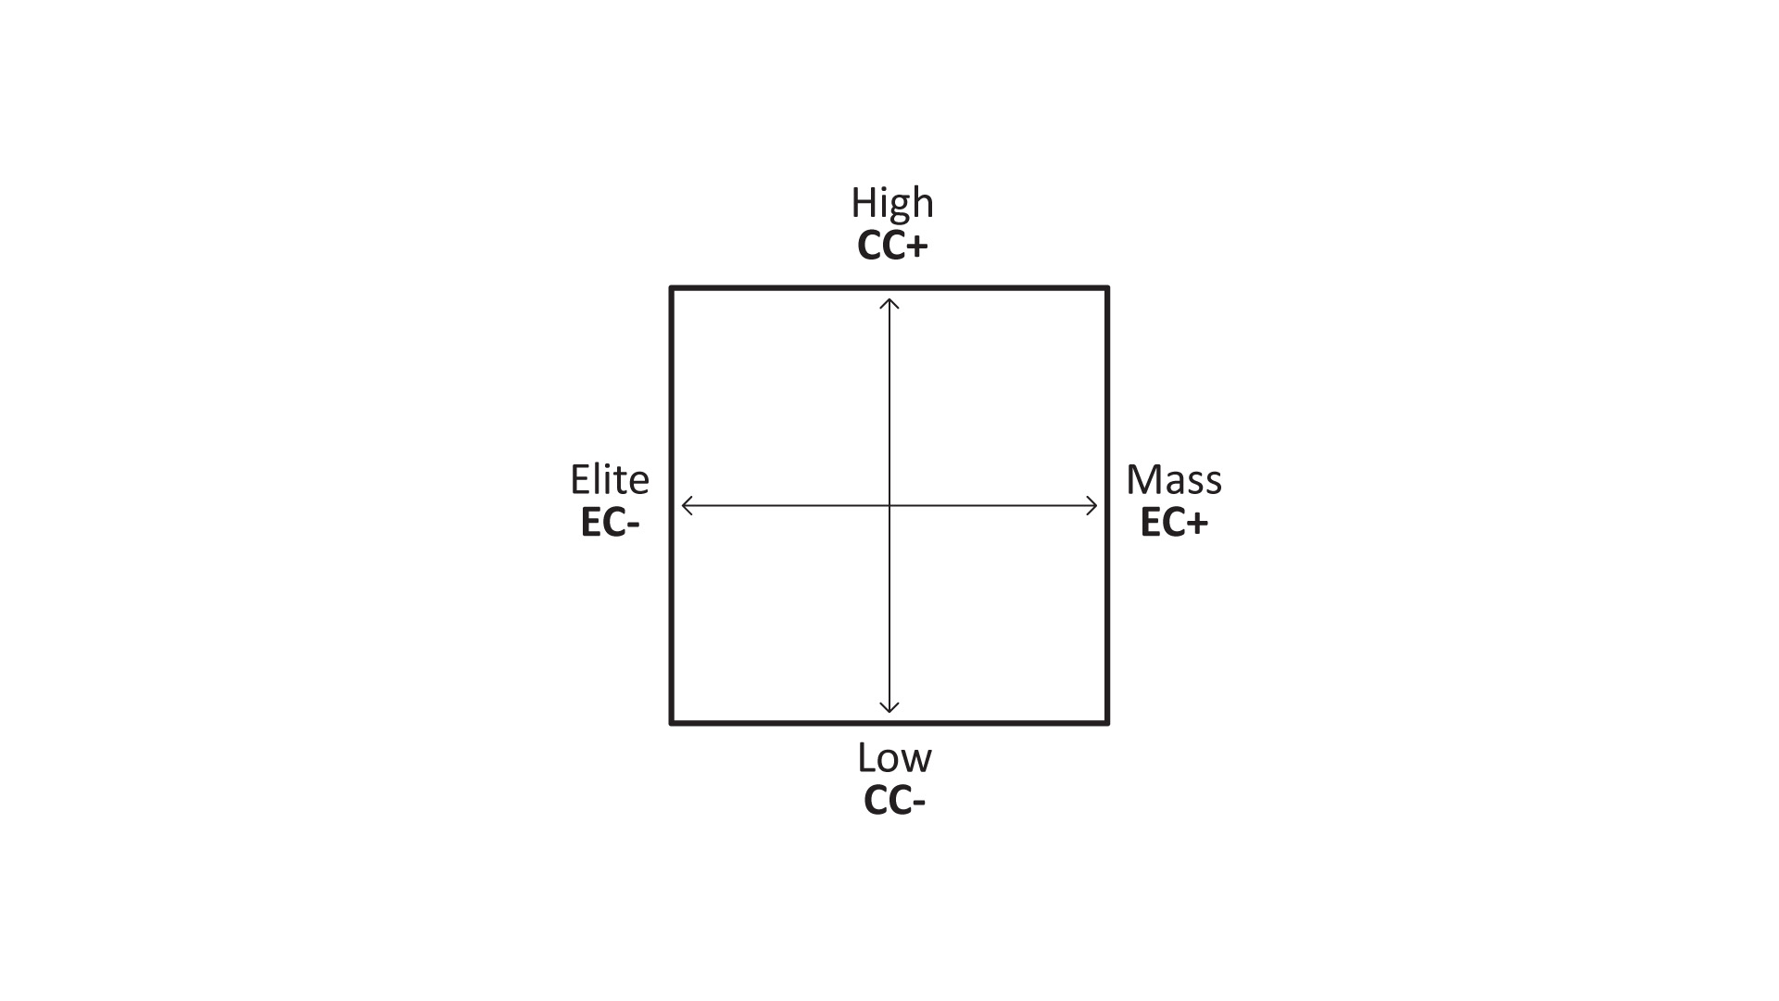

Figure 1: Volumes of Capital within the Cultural Field

There are two further methodological points to make. Firstly, we need to see any approach using Bourdieu concepts in terms of three phases: the construction of the research object; field analysis; and participant objectivation (Grenfell 2012). The first phase involves ‘reconstructing the object’ – in this case Ithell Colquhoun and her work - in terms of field, habitus and capital. The third of these involves researcher reflexivity to which I shall return in my conclusion. The second phase is field analysis and involves three levels of analysis:

- Level 1: the field and the field of power;
- Level 2: the field itself;
- Level 3: and the habitus of those within the field.

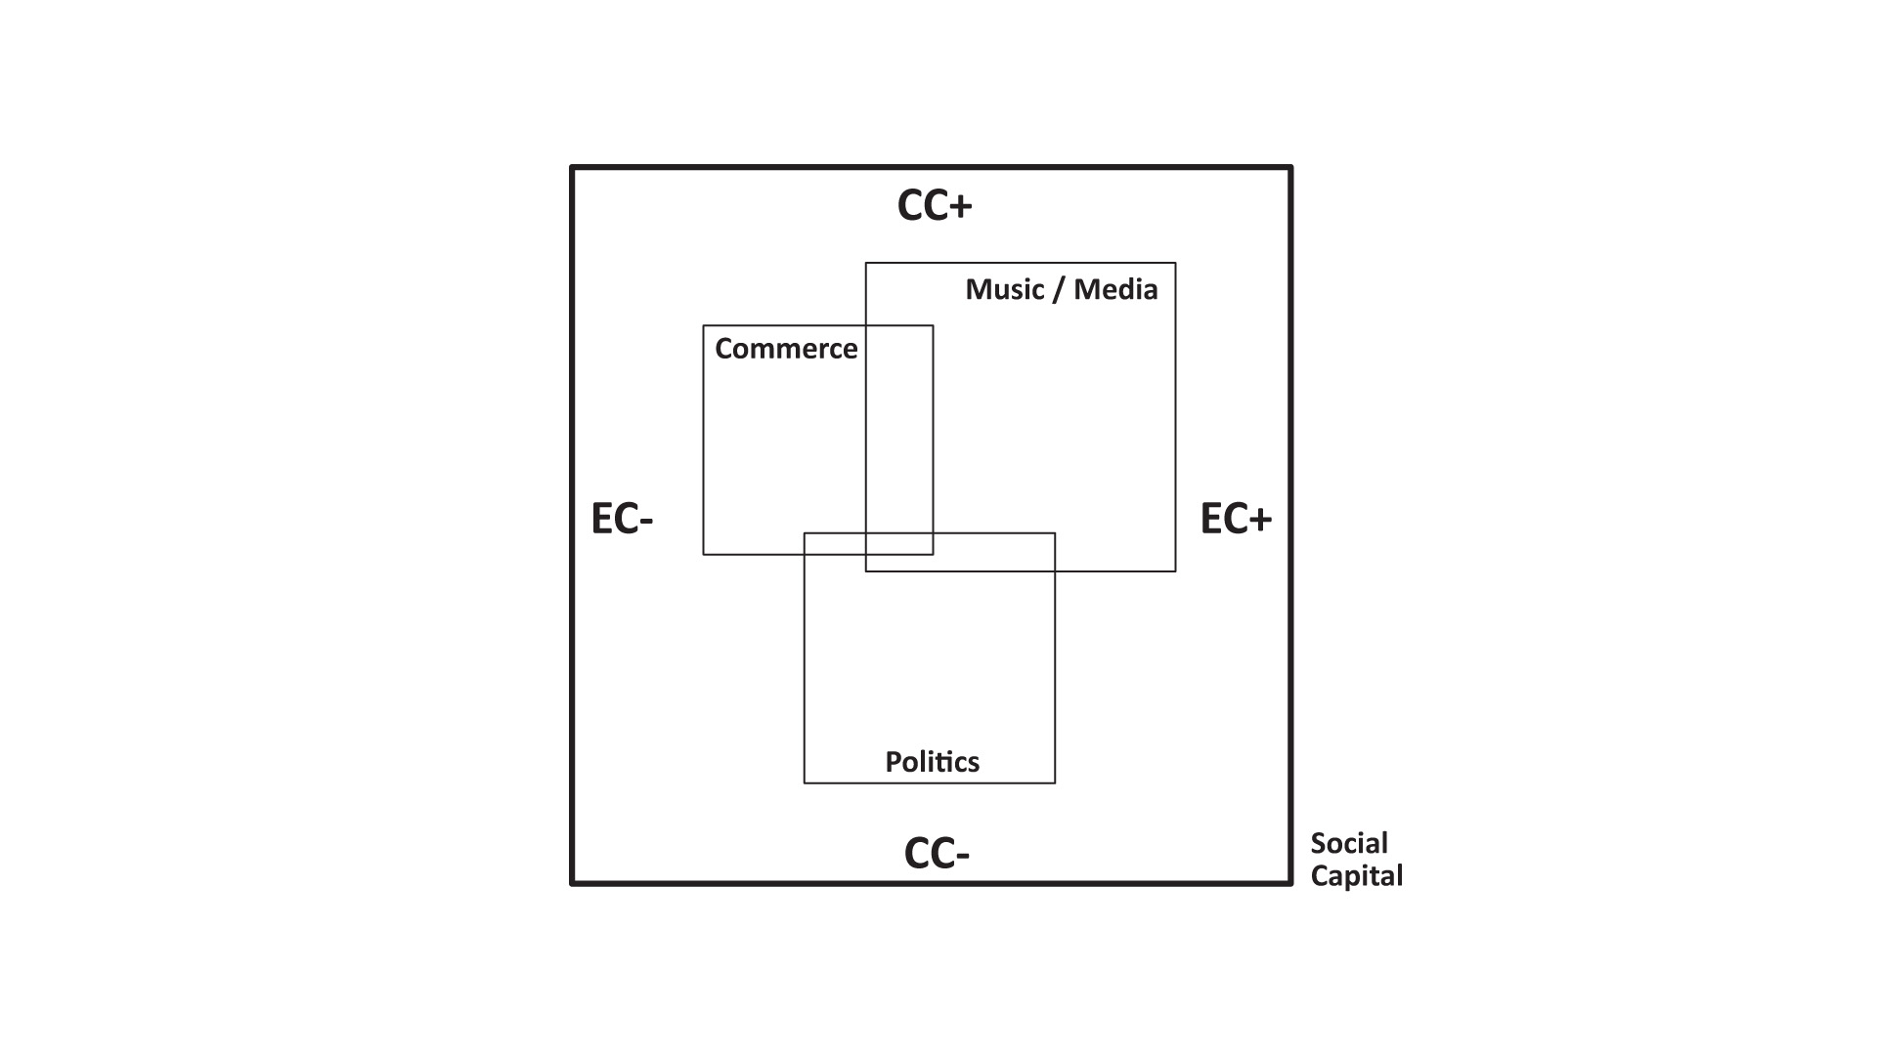

Figure 2: Level 1: The Field and the Field of Power

It is this basic methodology I propose to use for the rest of this article. Of course, these levels cannot always be held as distinct; one necessarily implicates another. Nevertheless, in order to guide the reader with my underlying rationale, I shall make reference to these levels and capital forms at points in the discussion. The whole might be seen as an analysis of structural relations and their interpenetration across a subjective/ objective continuum.

Ithell Colquhoun:

The Empirical Habitus - Background and Symbolic Capital: (Level 3)

In terms of genealogical habitus, Ithell Colquhoun’s background seems solidly middle class with both her mother and father originating from military families with notable figures featuring in Imperial campaigns (1). Her Grandfather on her mother’s side distinguished himself by winning both the Victorian and Iron Cross.

Her mother Georgia Frances Ithell Manley (1873-1961) was born in Woolwich but the family came from Cheltenham with ancestry coming from both Ireland and Devon. Her father Henry Archibald Colebrooke Colquhoun was born in Peshwar, Bengal, India and educated at Wellington College, and then Merton College Oxford (2). In 1895, he took up a post in the colonial civil service as a commissioner in Assam, India, where he married his wife in 1905. Ithell was born there one year later. It is said that the family returned to live in Cheltenham in 1907. In fact, Colquhoun was less than two years old when she and her pregnant mother travelled to England. After the birth of her brother, Robin, the children were raised by an elderly spinster aunt in Ventnor on the Isle of Wight and her mother returned to India to be with her husband. The parents then returned to England in time for Ithell to go to Cheltenham Ladies College.

Such a background would bestow a degree of social, economic and cultural capital: the confidence to move in educated networks, the cultural acquisitions that Colquhoun’s education at Cheltenham Ladies College ingrained, and of course, the financial security and acumen that money wealth provides – an allowance from her father seems to have sustained Ithell for most of her life. At first comfortably off, inflation ate into its real value, leading to the kind of aristocratic poverty that was endemic in her artistic generation. Later in life a degree of penury necessitated a fairly frugal life style.

If Ithell’s parents were firmly located in the Victorian époque, with all that entailed in terms of colonial attitudes, her childhood took her from the so-called Edwardian period – where ladies wore big hats but did not vote, and ‘the sun never set on the British Empire’. In the art world, Roger Fry organized the Manet and the Post-Impressionists London exhibition in 1910, which brought the latest generation of French painters of the Belle Epoque to public attention. The First World War, of course, blew all that away but also created the conditions for a new form of social progressivism. 1918 marked the end of the war, and also the granting of full women’s suffrage. What followed was a decade that has become to be known as ‘the roaring twenties’, since it marked such a paradigm shift in social, economic and cultural behaviours. Increased prosperity brought with it enormous expansion in socio-cultural activities.

Colquhoun’s Fields of Influence: the Esoteric and the Artistic (Level 2)

In Bourdieu socio-cultural approach, artistic generations are seen in terms of movements between various avant-garde: the rear-garde, consecrated avant-garde, the avant-garde and the aspiring (new) avant-garde. It is always the ambition of an artist to gain recognition within the standing cultural field.

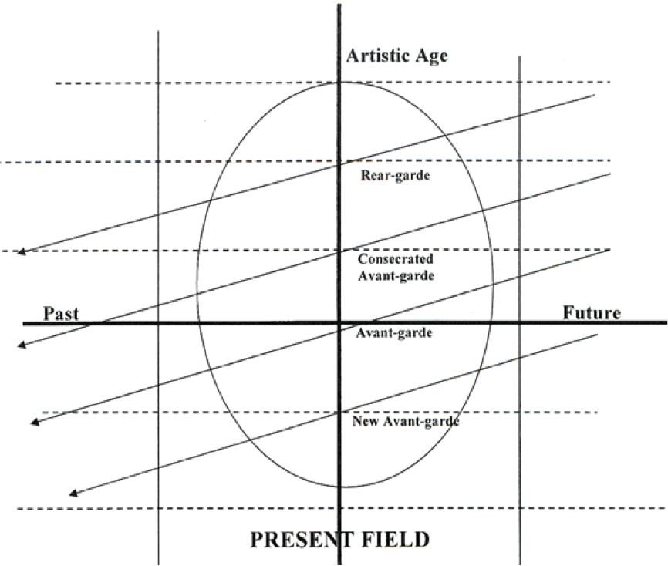

Figure 3: Artistic Generations of Field of Cultural Reproduction

The diagram is an attempt to offer a graphic of the dynamic of such a cultural field of production, of which the art/ esoteric fields are each one manifestation. It demonstrates one possible way that artistic generations relate to each other and, indeed, the possible destinies of individuals who pass through the cultural field. It is predicated on six sorts of time. Firstly, there is actual time with a past, present and future. Secondly, these are accountable in terms of recognised dates: days, weeks, months and years. Thirdly, there is individual time: that any one person is born at one time and dies at another. Fourthly, is the presence of any individual in the cultural field – inevitably linked, if only by association (or indeed, non-association), with a certain state of the field at a specific time and place. Fifthly, is the recognised position of individuals at a point in time within the field. Sixthly, is the acknowledged significance of a particular individual or group within the field and across generations and their journey through them(3). The diagram is therefore conceived as in flux, with a movement from bottom to top, with everyone – individually and/or as part of a group – acting for recognition, and thus valued value, within the field. One further aspect of the ellipse diagram is that both between and within generational lines, time differences can expand and contract: years may pass by with little generational distinctiveness, or may contain many movements and sub-movements in a short period of time. Individuals may also be able to operate with a degree of inter-generational lassitude, or be closely defined according to a particular point in time. It is in the nature of the diagram that at a time of dramatic change – the arrival of French modernism into the British art field in the early twentieth century and surrealism in the 1930s, for example, or indeed, paradigm shifts within the esoteric field - changes in artistic practice are very time sensitive. Someone might easily ‘miss the boat’ by being out by a few weeks or months.

- The Esoteric Field (Levels 2 and 3)

The history of esotericism is beyond the scope of a single paper. However, some preliminary remarks are needed in the light of Colquhoun’s interest in and inspiration from this tradition. In 1923, she apparently read an article on Aleister Crowley’s Thelema and, later in 1926, wrote a one-act play Bird of Hermes whilst still at Cheltenham School of Arts and Craft. However, if we consider the key occult society of the day – the Hermetic Order of the Golden Dawn – it gives some indication of what was symbolically valued by those who were drawn to it, as well as their social provenance. The Golden Dawn was founded in 1887 on the basis of the Cipher Manuscripts that had been passed down from mid-Victorian masons Kenneth MacKenzie (1833 – 1886) and the Rev. A Woodford (1821-1887) (social capital). These manuscripts outlined prescribed areas of esoteric study: Hermetic Qabalah, astrology, tarot, geomancy and alchemy. Its roots therefore go back to the English Romantic period, medieval magic and the whole Hermetic tradition (consecrated symbolic capital) (Torrens 1969).

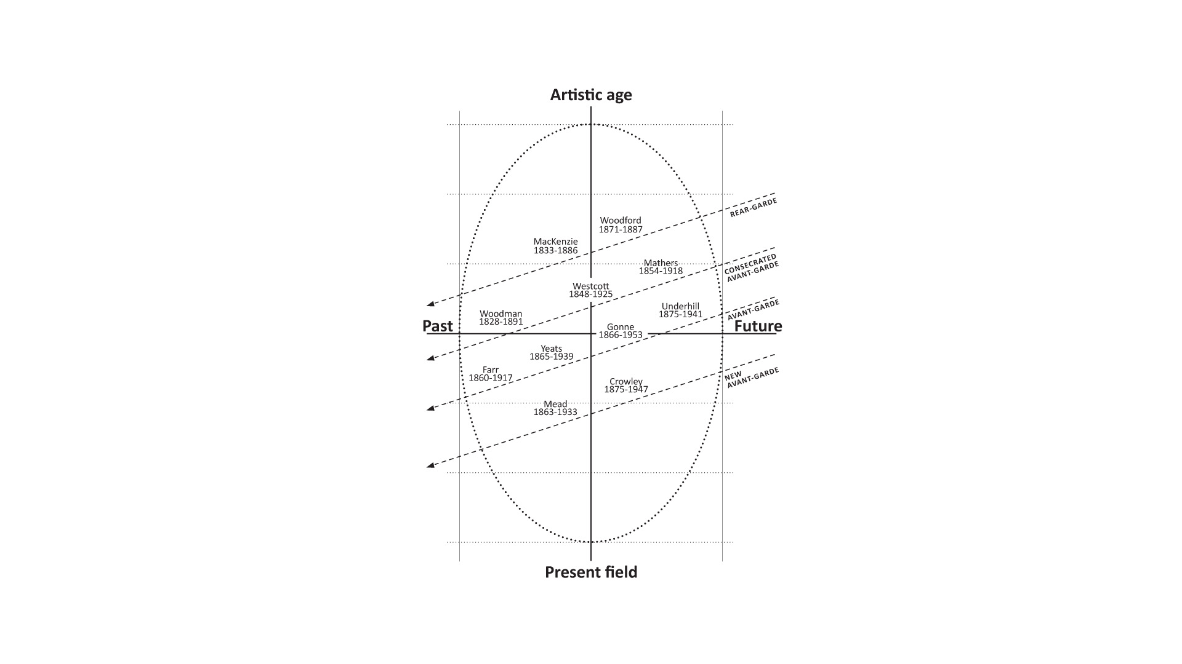

Figure 4: Esoteric Field C19/C20

The acknowledged founders of the Golden Dawn were similarly masons and men of letters (social, economic and cultural capital): William Robert Woodman (1828-1891 - Medicine), William Wynn Westcott (1848-1925 - law), and Samuel Liddell MacGregor Mathers (1854-1918 - history). The growth of the Golden Dawn also needs to be set against the general air of imperial prosperity that characterized the age (field of power), at least in metropolitan centres. By the mid-1890s, its membership had increased to over one hundred and included the illuminati of the cultural field: Florence Farr (1860-1917 – actress – who, incidentally, also went to Cheltenham Ladies College; Maud Gonne (1866-1953 – poet/ actress/ radical politician), W B Yeats (1865-1939 – poet); and Evelyn Underhill (1875-1941 – spiritual writer). But, the more youthful punk pretender (avant-garde) was Aleister Crowley (1875-1947), whose actions led to the dissolution of the Golden Dawn in 1900. Mathers had taken control of the Order in 1897 but by 1900, with Crowley at the centre, splits occurred which led to various splinter groups forming: Isis-Urania Temple and Alpha et Omega (under Mathers) (see Colquhoun 1975). Subsequently, Crowley took on an international profile developing his own Thelema philosophy, having had the Book of Law ‘dictated’ to him in 1904 by the spiritual messenger of Horus, Aiwass in Egypt, with its dictum of ‘Do what thou wilt shall be the whole of the law’. By the early 1920s, Crowley had established an Abbey of Thelema in Italy as a place for his followers to go to practice his forms of ceremonial magic, which earned him the title of ‘the beast’ (symbolic capital), and ‘the wickedest man in England’ from the British press (1923). If such circumstances may have seemed an exciting story for Colquhoun, it is obvious that this was more than a passing adolescent titillation since she was soon pursuing her own esoteric readings – and writings.

Geographical locale is an important aspect of capital holdings and consequent field placement, so in 1928 it was a significant decision on the part of Colquhoun to move to London (now aged 22) which, at the time, continued to act as a hotbed of cultural pursuit (including the esoteric) (social and cultural capital) (4). Here, she was able to join the Quest Society (1928) and later contributed an article – The Prose of Alchemy (1930) – to the Quest magazine.

Quest had been founded in 1909 by G R S Mead (1863-1933), one time secretary to Helena Blavatsky (1831 – 1891), who had inaugurated the modern Theosophical Society in 1875 (Goodricke-Clarke and Goodricke-Clarke 2005). The term ‘Theosophy’ can itself be traced back to the 3rd century and, in many ways, runs in parallel and even crosses Qabalah and Western Hermeticism. However, in the modern context, it is/ was less concerned with ceremonial magic that occult groups such as the Golden Dawn and its associates practiced, and possessed a more outward looking philosophy that included the relationships between men and nature, medicine, the ‘awakening’ of the inner-life, and divine aspects of being human. It too was influential amongst artists and musicians who sought new systems of thought in pursuing their creative endeavours: Rudolf Steiner (1861-1925), Kandinsky (1866-1944), Mondrian (1872-1944), Scriabin (1872-1915). G R S Mead’s own special interests – history and Gnostic (5) religions - also attest to the closer links between Theosophy and Christian philosophies. En passant, it is worth noting that Mead’s own habitus and capital dispositions would find resonance with Colquhoun’s: born into a military family, education in Cambridge, teaching. He was also an influence on a range of figures, who might in turn find associations (even direct) with Colquhoun’s own enquiries: Ezra Pound, W B Yeats, Hermann Hesse, Carl Jung. In London, Colquhoun was also able to meet up with her distant cousin E J L Garstin, who had taken control of the Golden Dawn offshoot Alpha et Omega when Mathers’ widow Moina died in 1928. Both these sources gave her informed access to a range of ideas and documents within the Hermetic traditions and its various factions. Here, we can place Colquhoun as a young member in a generational field of occultists, many of whom typified the same sort of educated middle class from which she had originated herself: ex-imperial, ecclesiastical, and financially comfortable. This led to a progressive outlook when non-conformist breaks with both Victorian and, in its turn, Edwardian society were needed and indeed made. Thus, within the esoteric field, Colquhoun’s own background (habitus) and education (cultural capital) allowed her to develop a network of social relations that built up significant social capital, since economic capital was provided for from her family allowance.

- The Artistic Field (Levels 1 and 2)

From late Victorian to Edwardian society and beyond, changes within the art field were no less turbulent. It is possible to see these also in generational terms as per figure 3, with the interaction between economic and social capital, and the way it played out in terms of cultural aesthetic capital. For example, the Tate Gallery had opened in 1889 with a donation of sum £80,000 (economic capital - equivalent to £10 million in today’s value) from the industrialist Henry Tate, who also donated 65 paintings from Pre-Raphaelite artists (6) - that recent English renaissance in romantic art, for whom he was a great patron. Significant financial contributions (economic capital) were also made by Sir Joseph Joel Duveen (1843-1908) and his son Lord Joseph Duveen (1869 – 1939), who made their wealth in the commercial export/ import business (commercial capital), and were originally members of Sephardic Jewish immigrants (social and cultural capital). The success of the Tate demonstrates the rise of new wealthy social classes and the aesthetics they sought as an expression of their distinction. Lord Duveen used the commercial experience of his family’s business in Europe to buy European art as the continent opened up. He would then sell it on to middle and upper class patrons in the UK and USA, making himself extremely rich in the process.

Over the first two decades of the twentieth century, traditional social realism in British Victorian art gave way to a new expressionism, as epitomized by French Impressionism. When artist and critic Roger Fry (1866 – 1934) – a key member of the cultural aristocracy – organized the Manet exhibition of 1910, a new avant-garde was very much announced to the British public; many of whom, incidentally, responded in the same way as the French public had done earlier to the Impressionists, that is, by finding in them a ‘moral outrage’. Indeed, Fry was publically ostracized for a while, and others were quick to note that his wife had actually been committed to an asylum. Moreover, it is worth pointing out that the exhibition included a very wide range of styles from the ‘pre-impressionism‘ of Manet to the exoticism of Picaaso’s Blue, Rose and African periods, as well as paintings by Cézanne, Gauguin, Matisse and Van Gogh (so-called Post-Impressionists of the next generation). The exhibition was held in the Grafton galleries at the heart of affluent Mayfair, where Paul Durand-Ruel had already staged the first major show of Impressionist paintings in 1905 (Patry 2015)). The significance of the Post-impressionist exhibition was captured by Virginia Woolf: ‘On or about December 1910 human character changed’ (Stansky 1996).

From the turn of the century, Roger Fry also taught at the Slade School of Art, in London, thus gaining important cultural capital in recognition of his position in the art field. The Slade, like the Tate, had its roots in philanthropic endeavor; most noticeably when the lawyer Felix Slade (1788-1868) bequeathed funds to establish three chairs in Fine Art at Oxford, London and Cambridge (economic and cultural capital). By the turn of the century it had become the site for the contemporary British artistic avant-garde: summed up (Haycock 2009) as ‘crises of brilliance’. The first ‘crisis’, just before the turn of the century, included Augustus John (1878-1961), William Orpen (1878-1931) and Percy Wyndham Lewis (1882-1957). The second crisis included Dora Carrington (1893-1932), Mark Gertler (1891-1939), Paul Nash (1889-1946), C.R.W. Nevison (1889-1946) and Sir Stanley Spencer (1891-1959). Clearly, examples of artistic generations can be placed on an elliptical diagram as given in Figure 6.

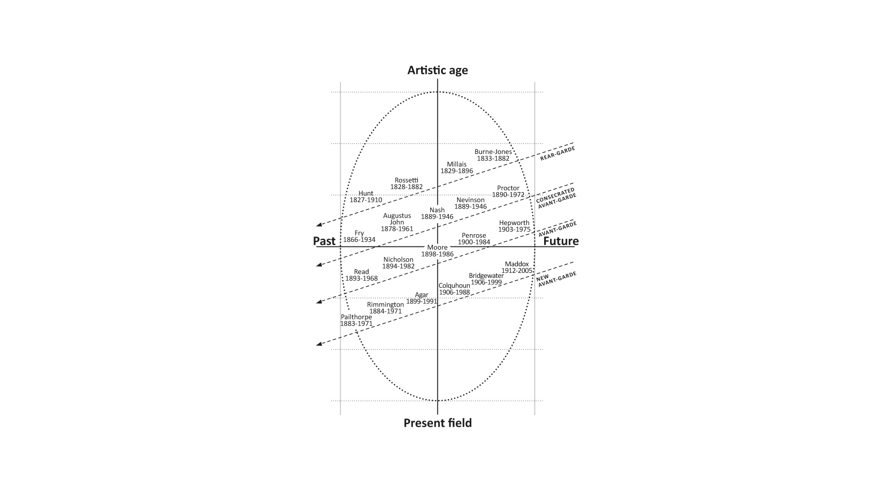

Figure 5: The Art Field C19-> C20

Of course, it would be further possible to track the different forms of capital each of these artists displayed as part of their formative early lives (habitus) and resultant capital, and the dispositions these formed. Perhaps nothing is more significant, however, than simple date of birth. Generational positions and movements are very sensitive to time, and it is possible to miss the boat by a few years, as we shall see. Even in terms of the youngest of these two important generations of British art, they would have been some fifteen years older than Ithell Colquhoun. Most of them were deeply touched by the First World War, indeed, even witnessed it at first hand. In contrast, Colquhoun would have been approximately eight when it began and twelve when it ended. The mid-twenties, however, marked her ‘coming of age’, and at a time that saw the sweeping away of the ‘old order’ have its full impact on every level of society. Art was an expanding sector of this new world. In terms of physical locale, Cork Street in London, already known for its heritage of style and chic from the days of Beau Brummell (1778-1840), and a stone’s throw away from the Royal Academy of Art in Piccadilly (cultural capital with economic capital consequences), became the centre of modern/ contemporary commercial art galleries. Meanwhile, student numbers at the Slade increased exponentially from the turn of the century and took a sharp rise in the 20s: sheer size is a key condition for field changes in Bourdieu’s approach. Furthermore, the proportion of women students also increased, even if they were still taught separately from men. Egyptology, we are told, was particularly popular, which possibly attests to a growing sense of the exotic in art.

Colquhoun’s artistic education at the Slade offered her consecrated symbolic capital (social and cultural), and yet this institution remained an epitome of classicism and aestheticism. At one point, she complained that the teachers wanted then to ‘draw like Michaelangelo and paint like the Impressionists’, later stating, ‘I could not see how to combine these disparate modes, so I painted to match the drawings in monochrome with superimposed glazes of colour’ (Colquhoun 1976). What is clear from her work there is that Colquhoun could paint and draw with draughtsman like precision, winning first prize in the Slade Summer Composition with Judith Showing the Head of Holofernes.

Of course, the subject of Judith was set by the College, but there is little reason to believe that its classical allusions would have been unattractive to Ithell. After all, she herself had received a classical education, and her budding esotericism was mostly based on knowledge from antiquity. Surrealism itself, to which she would eventually be drawn, also frequently drew on classical myth as if to underline the universal significance of its images. Still, Slade clearly represented a kind of active-denying dialectic for Colquhoun, out of which a third creative force would immerge, one fueled by the alchemy of esotericism and the expression of the surreal.

Colquhoun in the field: Surrealism (Levels 2 and 3)

A full account of the provenance and development of Surrealism is, of course, beyond the scope of this article. There are, however, several key points to make. Firstly, Surrealism itself needs to be seen in terms of artistic generational shifts within the avant-garde (as per figures 3 and 5), and these would be horizontal as well as vertical. Secondly, as such, possible antecedents can be traced back to Impressionism and beyond; for example, Picasso, who exhibited at both the 1910 Post-impressionist and 1936 Surrealist exhibition in London, is now most obviously associated with Cubism (not Surrealism). Thirdly, these movements only crystalise in retrospect, and the whole thrust of fine art aesthetic needs to be seen as a fluid movement in years in which individual styles shifted with fashion in the light of those gaining prominence within the fields of cultural production. Fourthly, the very style and content of Surrealism needs also to be considered just as much in terms of the social, economic, and political (as fields and the forms of capital they held) as much as the aesthetic.

The Field of Surrealism and the Field of Power: (Level 1 and 2)

The socio-seismic shifts in Europe in the late nineteenth century, and the total trauma of the First World War are to be set against the loosening of moral strappings so characteristic of belle époque decadence. Moreover, if the Great Exhibition of 1889, itself celebrating the great humanist revolution of 1789, had opened up Europe to the exoticism of overseas cultures and to a vision of modern technology, the strength of the ‘cultural arbitrary’ grew as the certainties of the past were laid bare: and this was often experienced at an intimate level, especially by those – artists and writers for example – who originated in comfortably placed families not faced with the imperatives of domestic survival, even if they subsequently pursued bohemian life styles. Furthermore, as ‘foreign’ cultures and religions opened up the possibility of alternative beliefs and values, the contemporary prominence of the writings of Sigmund Freud (1856-1939) amongst the educated classes offered the exciting prospect of exploring the unconscious trappings of the human mind, especially with respect to its primitive impulses.

It is possible, therefore, to see Surrealism as the confluence of social, cultural and psychological energies being played out in the political economic contexts of the day: and at base, in Europe, this amounted to an acute crisis in Western Civilisation as the belle époque and Roaring Twenties collapsed into severe economic depression following the Wall Street Crash of 1929. If the First World War had called into question the validity of Western logic and rationality, allowing Dadaism to offer nonsense and irrationality as a credible alternative, Surrealism only amplified this aesthetic response, with its focus on the ‘uncontrolled’ pathways of the mind. Both drew on advances in forms founded by Impressionism, Abstraction and Cubism, as well as pushing further artists’ appropriation of techniques other than those for which trained they had been trained at conventional art schools (collage, for example); although, ironically, in some works, those standard techniques were deployed in extremis to convey content that bore only passing reference to the traditional subjects of art. Bourdieu makes the point that a major distinction between popular and bourgeois art is that the former tolerates no ambiguity between content and form; the Surrealists, pushed these as wide apart as they dared in their own prise de distance from the ruling artistic elites. All this is to be seen as the epicenter of inter- and intra- generational competitiveness within the art field of the day, with groups earning various amounts of economic and cultural capital corresponding to their position with respect to the symbolic rules of scarcity of demand.

It is therefore unsurprising that André Breton (1896-1966), the so-called ‘founder’ of Surrealism, and who wrote both the First and the Second Surrealist Manifestos of 1924 and 1929 (Danchev 2011), in which he referred to it as ‘pure psychic automatism’, came from bourgeois stock and trained as a medic in psychiatry (habitus), and routinely employed Freud’s methods of psychoanalysis. Mute objects were seen as ‘symbolically functional’ in ways not altogether different from esoteric iconography, with their power to both stimulate and exacerbate the exegetic morphology of thoughts and desires, and their expressions. Breton and his associates were preaching revolution – both psychological and political. It is therefore unsurprising that artists drawn into its sphere of influence could trope one or other, or indeed both, as the socio-economic crises of the 1920 and 30s deepened.

(Level 2 and 3 and 1)

Given the amorphous boundaries between artistic movements and their styles – at least in their formative periods – it is perhaps unsurprising if some artists became ‘Surrealists’ almost by accident. Eileen Agar (1899-1991), for example, the sole British female to exhibit at the 1936 London exhibition, only became involved as a Surrealist when one of the organisers, Roland Penrose (1900-1984), declared her to be so (an act of consecration or imposed form) (Remy 2017). Along with Herbert Read, both organisers were from strong bourgeois stock with significant cultural, economic and social capital of their own. Penrose was the son of a successful portrait painter and the daughter of a wealthy banker (economic capital), studying at private schools and Cambridge University (social and cultural capital). A conscientious objector in the First World War, he moved to France in 1922, married the poet Valentine Boué in 1925 and became good friends with Max Ernst, Wolfgang Paalen and Pablo Picasso, all of whom both influenced the Surrealists and were the most exhibited in the 1936 show (social and cultural capital). This fact demonstrates how ‘polysemic’ the surrealist rubric was: Picasso would never have claimed it as a description for his work.

Penrose’s case shows how a high level of economic and cultural capital was gained through and enhanced by his social capital, affording him both acknowledged and recognised consecration as a ‘hub individual’ within the field of cultural reproduction. As Bourdieu would argue: ‘There are positions in a field that admit only one occupant but command the whole structure’ (Bourdieu and Wacquant 1992, 243). Returning to England in 1936, Penrose settled in Hampstead (cultural capital) where he would have rubbed shoulders with the likes of Ben Nicholson (1894-1982), Barbara Hepworth (1903-1975) and Naum Gabo (8) (1890-1977) (social capital). He also opened a Gallery in Cork Street (cultural, social and economic capital), selling the work of these painters and other surrealists, becoming friends also with Eileen Agar, Lee Miller (1907-1977), Man Ray (1990-1976), Edouard Mesens (1903-1971), Paul Eluard (1895-1952) and Joseph Bard (1922-1975) – all of whom shared significant aspects of his own habitus. In 1937 he then became the lover of Colquhoun’s younger contemporary, surrealist painter Leonora Carrington; someone who also held considerable capital holdings, being the daughter of a successful Northern manufacturer. A year later (1938), Penrose had an affair with millionairess, art collector Peggy Guggenheim (1898-1979) (9); and the American art photographer Lee Miller one year after that (they eventually married in 1947). Social, economic and cultural capital was therefore closely inter-related in the personal lives, work and expression of the artistic styles of the day (see Chadwick 1985, 2017; Greer 1995).

Bourdieu argues that all art movements need writers to express their aesthetic. The French intellectual-poet Mallarmé (1842-1898) provided this role for the French Impressionists in the second half of the nineteenth century. For the British surrealists in the 1930s, it was Herbert Read. His is another story of position defined in terms of his background – habitus – and how he used it to accrue further forms of symbolic capital which allowed for his prominent position within the art field. Read was born into a wealthy farming family. However, by his early twenties he was already publishing his own poetry and that of others, for example, T. S. Eliot (symbolic capital). In fact, he was a champion of English Romantic and Metaphysical poetry (consecrated avant garde), which seems to have chimed with his interest in fine arts. By the early 1930s, he was teaching arts at the University of Edinburgh (cultural capital). He was also friend and supporter of painters such as Nash, Hepworth and Nicholson (social capital), and the contemporary arts group Unit One (10). Therefore, he possessed significant levels of economic and social capital that, invested well, could only offer further good capital returns. He also became a trustee of the Tate, curator of the London based Victoria and Albert Museum, and founded the Institute of Contemporary Arts in 1947 (cultural and social capital) together with Penrose. From 1933-38, he was editor of the Burlington Magazine, that very pillar of the art establishment. In 1936, he had published a book on Surrealism to which Breton contributed. He therefore had a perfect hand of symbolic capital – social, economic and cultural – both to legitimate and consecrate his position in the field.

If we place Ithell Colquhoun in this context, in London in the mid-1930s, we see, therefore, a social space with a number of salient influences. All of these need to be understood generationally and in terms of the relevant forms of capital they implied. One might say that the old world - Edwardian and Victorian – had died, but the new world was struggling to be born (it took another world war to do so) – to use an allusion of the Italian Marxist, Antonio Gramsci (1971, 276). For Colquhoun, however, there was one further significant factor: as well as imbibing, both personally and aesthetically, these socio-cultural conditions, there was already established a deep affinity (elective affinity) to esoteric traditions referred to above, many of which struggled with similar forces, expressing them in different ways and yet reflecting the same changes in the relationship between the individual and the social and psychic worlds that surrounded them. Colquhoun met with Meredith Starr (born Herbert Close in 1890-1971), a man born of landowning parents, and who was instrumental in bringing the Indian Guru Mehar Baba to the UK. He wrote for the Occult Review, along with Crowley and other leading occultists; and then in turn wrote for Crowley’s own Equinox. It is said she was impressed by him, and it may well be that this man, renown for his lack of humour, offered her an example of seriousness and discipline that was close to her own dispositional intent as she considered her artistic work.

Colquhoun had already encountered Surrealism when she lived in Paris for a short period in 1931, and subsequently read Peter Neagoe’s What is Surrealism when it was published in 1932. But, it is the first 1936 Surrealist exhibition in London that mostly marked her commitment to this approach in art. The age difference between her and Eileen Agar was seven years, so she was too young to be included in the exhibition. Nevertheless, the event would have given impetus to her rapidly expanding artistic dispositions, the knowledge and functional skills of which she had spent her previous life acquiring. Networking (social capital) would also have been important. In the same year, she had her first solo exhibition in Cheltenham: Decorations, Paintings and Drawings. She was therefore becoming a successful artist within the surrealist movement, with a growing body of impressive work.

What happened next needs again to read against the socio-political climate of the day, and indeed the response of the socio-cultural. A deepening international political situation meant that everyone was somehow obliged to take up a position when confronted with alternatives: fascism or communism, capitalism or nationalism, the Spanish Civil war, the French Popular Front, Munich?
By January 1939, Colquhoun was included in the Living Art in England exhibition at the London Gallery, along with Eileen Agar, Grace Pailthorpe, Edith Rimmington, Conroy Maddox and Roland Penrose. Just to share this company was symbolic capital for her, acknowledgement of her position within the field – a kind of consecration. As the exhibition included both surrealists and constructivists, as well as English and international artists (Gabo, Mondrian, Kokoshka), its organizer E L T Mesens, was able to offer a united front against fascism and highlight overseas artists now as refugees in London. Exhibitions of Surrealist-only artists later in the same year included Colquhoun’s two-person show with Roland Penrose at Mayor Gallery (Cork Street). Colquhoun then again travelled to France where she met with Breton. He would certainly have shared her interests in adopting automatic methods in paintings, which could tap the unconscious images of the mind, somewhere between ‘waking and sleeping’. Methods would become increasingly significant for Colquhoun from this period on, and included Decalcomania, Fumage, Parsemage, Stillomany, Frottage and Entoptic graphomania. Frazer’s The Golden Bough (2009/ 1890) and Graves’ The White Goddess (1948) were also seminal texts for her in the exploration of myths and religions.

After having delivered his major critique of Kantian aesthetics in Distinction (Bourdieu 1984), which amounts to a ‘sociological deconstruction’ of the Kantian ‘pure gaze’, Bourdieu writes of ‘return of the repressed’ (p. 486), by which he means the need to consider the form and content of the products of art and culture in themselves as exemplified in such techniques. The key period for Colquhoun was from 1936-1947, and it was during this time that some of her most renowned ‘epic’ pieces were accomplished, for example, Scylla (1938) and The Pine Family (1940).

In Dreaming Leaps: in Homage to Sonia Araquistain, which was painted in 1945, Colquhoun attempted to celebrate the life and work of a fellow traveller on the surrealist/ esoteric road after the death of Ariquistain who was the daughter of the ex-Spanish Republic’s ambassador to Paris and Berlin.

In fact, Araquistain threw herself naked eighty feet to her death from a London apartment, apparently on impulse after making a phone call. Of course, this could be seen as an ultimate act of artistic defiance in the face of the modern world. For the Judge at her inquest, however, it was a clear sign of the ‘dangers of mental instability’ that certain readings and interests could invoke. Freud, painting and psychoanalysis had led Ariquistain to declare she had ‘supernatural powers’, that she was the ‘missing link between man and animals’, and would give birth to ‘a new race of immortal beings’. The Judge declared, ‘it was a field that suits no one and that no one should wish to explore’. However, such a judgment was an affront to Colquhoun, who clearly was more likely to see it as the heroism of a Surrealist comrade in arms. It is a remarkable painting and Remy (1999, 278ff) links its composition to the last three stages of the alchemical process: ‘exaltation, multiplication and projection’ where ‘the lower liberates the higher’, ‘the fall of forms and ascension of colours’, ‘the body’s descent and the rising of essences’, ‘detaches death from its finality and plunges the viewer into pure otherness’…’stripped of its trappings, the subject faces its own subversion. For Colquhoun, it therefore needed to be seen as a homage to the growth of a subject rather than its death.

With so many issues – aesthetic, political, psychological, social, spiritual - in flux it would be surprising if groups did not take sides, and indeed individuals oppose one another - and so they did. Things had come to a head for the British surrealists in April 1940 in the Barcelona Restaurant in Beak Street, London, where all those currently living and available were present. Three conditions for continuing ‘membership’ of the Surrealist group were set out: that they should adhere to the ‘proletarian revolution’; that they should boycott any non-surrealist activity/ associations/ groups; that they should boycott any non-surrealist exhibitions. Colquhoun objected to each. In particular, she wished to continue her explorations of the ‘occult’ (Lepetit 2014).

In a way, Colquhoun veered in the direction of non-conformism, which, ironically for a so-called dissident group, could only be tolerated so far. As is often the fate of avant-garde marginals, she fell out with a group, of which she was only a partial member to begin with, in terms of outlook, sources and dispositions. That did not mean it did not hurt, or that her objections did not have consequences. She later commented that Mesens stated they ‘could still be friends’. However, she thought she had ‘cooked her goose’, and so it proved to be when a successful Surrealist exhibition was held without her one month later in the Zwemmer Gallery.

As a relative ‘outsider’, now even more so, it is perhaps unsurprising that Colquhoun also gravitated towards another outsider: Toni del Renzio.

Del Renzio had arrived in Britain around the same time as the Barcelona restaurant meeting, by way of North Africa, Italy, Spain and France. Faced with the dispersal of the Surrealists, he attempted his own régroupement, launching the Arson journal in 1942. After initial antipathy between them, he and Colquhoun began living together and eventually married in 1943. The marriage however only lasted a few years – they divorced in 1947. He claimed she was jealous and self-centred; she described him as a ‘con-man on the dole’ and took her anger with him to her grave.

Colquhoun, however, was by then already visiting Cornwall, drawn to its Celtic mysteries as her sketches of Lanyon Quoit and the Merry Maidens attest. In 1949, she bought something that was not much more than a shed in Lamorna and lived there in relative isolation before later moving to Paul, near Mousehole – the next harbor East along. At first, she seems to have shared her time between London and Cornwall, but slowly the latter became her permanent home.

In Summary

There is a lot more to say about Ithell Colquhoun. In Cornwall, she increasingly submerged herself in her occult studies, producing a voluminous series of writings, poems, plays, essays, ceremonies, and novels – most of which went unpublished; although one novel did appear in 1961 - Goose of Hermongenes (2003/ 1961) based on alchemical sequencing - and two travelogues of Cornwall and Ireland (Colquhoun 1954, 1957). She also engaged – somewhat vainly – in a search amongst various esoteric and occult groups for individuals with whom she might share such interests. Many of them sadly seem not to have matched her level of seriousness and depth of knowledge. In her case, there seemed never to be the mobilizing of social and cultural capital, say in the ways that Carrington, Tanning and Agar did in order to grow their status with the art field. Of course, Cornwall, at least from the 50s – 70s was quite unconnected and therefore not the best place to manage a successful artistic career.

In this article, I have offered a preliminary sketch of salient features within the personal and professional biography of the British surrealist painter Ithell Colquhoun as framed by a consideration of the socio-cultural conditions of her artistic production as it emerged in relation to her own empirical habitus. By using the social theory of Pierre Bourdieu, I have attempted to uncover something of the generating forces, which shaped her creativity. Central to such an account has been an examination of the fields through which she passed – mostly esoteric and artistic – and how she interacted with them in ways which influenced her own aesthetic. These fields and reactions have also been presented as the utilization and otherwise of forms of symbolic capital – economic, social and cultural.

I began the article by distinguishing my own work from salient traditions in artistic biography – which I typified as ‘internalist’ and ‘externalist’ – and suggested a Bourdieusian approach seeks to go beyond both and unify both. This is a critical issue, especially for researchers when adopting a reflexive relationship to the object of their study and understanding the need to objectify the biases of the academic field they represent. The Bourdieusian ‘theory of practice’ and its active methodology thus offer insight both to the object and subject of artistic research and the nature of the relationship which brings it together.

It allows us to engage with the necessity to escape the orthodoxy of conventional accounts and the limitations they impose on our understanding of what I have called the ‘expressive impulse in trans-historic and trans-national fields’. More than this, the approach aims to construct the foundations of a kind of ‘reflexive objectivity’, or ‘reflexive aesthetics’, which goes beyond both the application of pre-constructed disciplinary narratives and the transcendent sense of the ineffable so present in Hölderlinian charismatic poetics. This endeavor, ultimately, must surely be so much more ‘reassuring, more humane, than belief in the miraculous virtues of pure interest and pure form’ (Bourdieu 1993, 188).

List of Figures

- Volumes of Capital within the Cultural Field
- The Field and the Field of Power
- Artistic Generations in the Field of Cultural Reproduction
- Esoteric Field: C19/ C20
- Art Field: C19->C20

Footnotes

1. The father of her mother’s side was William George Nicholson Manley (1831 – 1901). Born in Dublin (17th December) and second son to Reverend William Nicholas Manley (b.1799). His mother was Elizabeth Browne (b.1802) – Daughter of Dr. Browne (Army Medical Staff). William George trained as a surgeon. He was the only surviving officer of the Battle of Gate Pā, Pukehinahina, New Zealand on the 29th April 1864. He also fought in the Crimea and Afghanistan, and was awarded both the Victoria Cross and the Iron Cross. The family lived in Cheltenham, and George was the fourth of eight children.

2. Ithell’s father was Henry Archibald Colebrook Colquhoun, born in Peshwar, in Bengal, India on January 10th 1873. He died in Cheltenham in the summer of 1942. His brother (IC’s uncle) was born in 1871 in Fort William. Her Grandmother on her father’s side was Louisa Barbara Sutherland. IC’s Grandfather on her father’s side was James Andrew Sutherland Colquhoun who was born in Fort William (Calcutta) Bengal, India on 30th November 1839. His father – IC’s Great Grandfather – was James Colquhoun, born in Luss, Dumbarton, Scotland (the traditional centre of the Clan Colquhoun and their Baronecrey).

3. Of course, the way that ‘time’ features in Colquhoun’s work would be a study in itself. She certainly acknowledges the various ‘times’ featured in esoteric histories; for example, Crowley’s ‘4 Aeons’, which were similar to the ‘Yugas’ of Hindouism, as well as the ‘Ages’ of Western thought (see The Dying Kick of the Dying God – The London Broadsheet, 1955). She also knew about ‘creative time’ – pre-cognition – where, in the creative act, the future can ‘lean back to the present’. For the esoteric teacher J G Bennett, a disciple of Gurdjieff, such time was referred to as hyparxis (Bennett 1961).

4. The significance of physical placement is underlined by comparing the relative experiences of Colquhoun and Emmy Bridgwater. The latter was also born in 1906 but gravitated more towards what later would be known as the Birmingham Surrealists (see Rüll 2000).

5. Second century heretic Christian groups who defined ‘gnosis’ as ‘inner knowledge’ (of oneself). https://en.wikipedia.org/wiki/Gnosticism

6. The Pre-Raphaelite Brotherhood were a mid to late nineteenth century art group who rejected classicism and the academic teaching of art in favour of a return Quattrocentro Italian art, with an emphasis on vivid colour and mythological subjects. They were very influential on William Morris (1834-1896), who himself was closely allied to the British Arts and Crafts Movement with its focus on traditional crafts and art subject – folk tales and decorations.

7. The first exhibition of Cubism took place in 1911 in the Salon des Indépendants (a kind of later version of the Salon des Refusés (1863)), which launched the Impressionists (although they were not known as such in the day). The Société des Artistes Indépendants were formed in 1884 for artists ‘without jury or reward’, underlying their stance of distinction from established cultural institutions, and subsequently becoming associated with major Post-impressionist art movements in the late nineteenth and early twentieth centuries (Fauvism, Orphism, Symbolism).

8. Interestingly, Nicholson, Hepworth and Gabo did not exhibit in the 1936 exhibition, even though one might think they were eminently qualified to do so; suggesting perhaps that they were going more for a pure narrative of ‘art for art’s sake’. Nicholson, along with Christopher Wood (1901-1930) had discovered Alfred Wallis (1855-1942) in St Ives in 1928, and saw his work as an epiphanic return to a naïve aesthetic innocence, possibly as their own response to turbulent times. (See Grenfell and Hardy, 2003)

9. The same year he helped organize the tour of Picasso’s Guernica in Britain – somewhat underling the consecration he achieved by accruing to himself a high level of symbolic capital.

10. Unit One was active from 1933-1935 and included a group of English modernist painters, architects and sculptors. It was founded by Paul Nash and based in the Mayor Gallery in Cork Street. Its members included Nicholson, Armstrong, Hepworth, Moore, Burra, Frances Hodgkins, and Tristram Hillier.

11. It is debatable as to the extent to which Colquhoun was ever a surrealist per se. Although she seemed happy to use this rubric up to a retrospective exhibition in Newlyn in 1976, there is the suspicion this was mostly for commercial reasons (Colquhoun 1976).

References
Ades, D. 1980. ‘Two Women Surrealist painters: Eileen Agar and Ithell Colquhoun.” Oxford Art Journal 3 (1): 36-42. Available at: https://www.jstor.org/stable/1360177
Bourdieu, P .1977/72. Outline of a Theory of Practice. Translated by Richard Nice. Cambridge: CUP.
- Esquisse d'une théorie de la pratique. Précédé de trois études d'ethnologie kabyle. Geneva: Droz.
Bourdieu, P. 1984/79. Distinction. Translated by Richard Nice. Oxford: Polity.
- La Distinction. Critique sociale du jugement. Paris: Editions de Minuit.
Bourdieu, P. (with L Wacquant). 1989. 'Towards a reflexive sociology: a workshop with Pierre Bourdieu', Sociological Theory 7 (1) 26-63. Available at:
https://doi.org/10.2307/202061
Bourdieu, P. (with Darbel, A and Schnapper, D). 1990/1966. The Love of Art. European Art Museums and their Public. Translated by C Beattie and N Merriman. Oxford: Polity Press.
- L'Amour de l'art, les musées d'art et leur public. Paris: Les Editions de Minuit.
Bourdieu, P. (with Wacquant, L). 1992. An Invitation to Reflexive Sociology. Translated by Loic Wacquant). Oxford: Polity Press.
- Réponses. Pour une anthropologie réflexive. Paris: Seuil.
Bourdieu, P. 1993a. The Field of Cultural Production: Essays on Art and Literature. Oxford: Polity Press.
Bourdieu, P. 1993b. ‘Principles of sociology of cultural works.’ In S. Kemnal and I. Gaskell (eds.) Explanation and Value in the Arts. Cambridge: Cambridge University Press.
Bourdieu, P. 1996/92. The Rules of Art. Translated by S. Emanuel. Oxford: Polity Press.
- Les règles de l'art. Genèse et structure du champ littéraire. Paris: Seuil.
Bourdieu, P. 2006. ‘The Forms of Capital.’ In H. Lauder, P. Brown, J-A Dillabough & A. H. Halsey (Eds.), Education, Globalisation and Social Change, Oxford: Oxford University Press.
Bourdieu, P. 2017/ 2013. Manet: une revolution symbolique. Paris: Edition de Seuil.
- Manet: A Symbolic Revolution. Oxford: Polity Press.
Chadwick, W. 1985. Women Artists and the Surrealist Movement. New York: Thames and Hudson.
Chadwick, W. 2017. The Militant Muse. London: Thames and Hudson.
Colquhoun, I. 1975. Sword of Wisdom: MacGregor Mathers and the ‘Golden dawn’. New York: G. P. Putnam’s Sons.
Colquhoun, I. 1976). Surrealism – Ithell Colquhoun: Paintings, Drawings, collages 1936-1979. Newlyn: Orion Gallery.
Colquhoun, I. 2003/ 1961. Goose of Hermongenes. London: Peter Owen.
Colquhoun, I. 2016a/ 1957. The Living Stones: Cornwall. London: Peter Owen.
Colquhoun, I. 2016b/ 1954. The Crying of the Wind: Ireland. London: Peter Owen.
Danchev, A (ed.). 2011. 100 Artists’ Manifestos. London: Penguin.
Ferentinou, V. 2011. “Ithell Colquhoun, Surrealism and the Occult.” Papers in Surrealism Issue 9, Summer. Mimeograph.
Frazer, J G. 2009/ 1890. The Golden Bough: A Study in Magic and Religion. Oxford: OUP.
Goodrick-Clarke, C and Goodricke-Clarke, N. 2005. G R S Mead and the Gnostic Quest. Berkeley: North Atlantic Books.
Greer, M K . 1995. Women of the Golden Dawn: Rebels and Priestesses. Rochester: Park Street Press.
Gramsci, A (1971) Selections from Prison Notebooks. London: Lawrence and Wishart.
Graves, Robert. 1948. The White Goddess: A historical Grammar of Poetic Myth. London: Faber.
Grenfell, M. 2004. Pierre Bourdieu: Agent Provocateur. London: Continuum.
Grenfell, M. 2012. Pierre Bourdieu: Key Concepts (2nd Edition). London: Routledge.
Grenfell, M and Hardy, C. 2003. “Field manoeuvres: Bourdieu and the Young British Artists.” Space and Culture 6 (1): 19-34. Available at: https://doi.org/10.1177/1206331202238960
Grenfell, M and Hardy, C. 2007. Art Rules. Pierre Bourdieu and the Visual Arts. Oxford: Berg.
Hale, A. 2020. Ithell Colquhoun: Artist and Occultist. Strange Attractor Press.
Haycock, D B. 2009).A Crisis of Brilliance: Five Young English Artists and the Great War. London: Old Street Publishing.
Lepetit, P. 2014. The Esoteric Secrets of Surrealism: Origins, Magic, and Secret Societies. Rochester: Inner Traditions.
Nichols, S (ed.). 2007. The Magical Writings of Ithell Colquhoun. Nichols.
Patry, S. 2015. Inventing Impressionism: Paul Durand-Ruel and the Modern Art Market. London: National Gallery.
Ratcliffe, E. 2007. Ithell Colquhoun: Pioneer Surrealist Artist, Occultist, Artist, Writer and Poet. Oxford: Mandrake
Remy, M. 1999. Surrealism in Britain. Aldershot: Lund Humphries.
Remy, M. 2017. Eileen Agar: Dreaming Oneself Awake. London: Reaktion Books.
Shillitoe, R. 2009. Ithell Colquhoun: Magician Born in Nature. Shillitoe.
Stanksky, P. 1996. On or about December 1910: Early Bloomsbury and its Intimate World. Cambridge, Mass.: Harvard University Press.
Torrens, R G. 1969. The Golden Dawn: The Inner Teachings. New York: Samuel Weisser.

About the Author

Michael Grenfell is Adjunct Professor, Trinity College, University of Dublin, Dublin, Republic of Ireland.

Corresponding Author: Michael Grenfell, School of Education, Trinity College, University of Dublin, Dublin, 2, Ireland. Email: Grenfell@soton.ac.uk

