Title:
Predictors of maternal dietary quality and dietary inflammation during pregnancy: an individual participant data meta-analysis of seven European cohorts from the ALPHABET consortium
Author names and affiliations (including degrees and institutional/professional affiliations):
Adrien M. Aubert¹, MSc, Ling-Wei Chen^{2,3,4}, PhD, Nitin Shivappa⁵, Cyrus Cooper^{6,7,8}, Sarah R. Crozier^{6,9}, Liesbeth Duijts^{10,11,12}, Anne Forhan¹, MSc, Wojciech Hanke¹³, PhD, Nicholas C. Harvey^{6,7}, Agnieszka Jankowska¹⁴, MPH, Cecily C. Kelleher², Blandine de Lauzon-Guillain¹, PhD, Fionnuala M. McAuliffe¹⁵, Sara M. Mensink-Bout^{10,11}, Kinga Polanska¹⁴, Caroline L. Relton¹⁶, Matthew Suderman¹⁶, James R. Hebert⁵, Catherine M. Phillips², PhD, Jonathan Y. Bernard^{1,4 †}, PhD, and Barbara Heude^{1 †}, PhD

¹Université Paris Cité, Inserm, INRAE, Centre for Research in Epidemiology and StatisticS (CRESS), F-75004 Paris, France; adrien.aubert@inserm.fr (A.M.A.); anne.forhan@inserm.fr (A.F.); blandine.delauzon@inserm.fr (B.d.L.-G.); jonathan.bernard@inserm.fr (J.Y.B.); barbara.heude@inserm.fr (B.H.)
²School of Public Health, Physiotherapy, and Sports Science, University College Dublin, Belfield, Dublin 4, Ireland; ling-wei.chen@ucd.ie (L.-W.C.); cecily.kelleher@ucd.ie (C.C.K.); catherine.phillips@ucd.ie (C.M.P.)
³Institute of Epidemiology and Preventive Medicine, College of Public Health, National Taiwan University, Taipei, Taiwan
⁴Singapore Institute for Clinical Sciences (SICS), Agency for Science, Technology and Research (A*STAR), 117609 Singapore, Singapore
⁵Department of Epidemiology and Biostatistics and Cancer Prevention and Control ProgramArnold School of Public Health, University of South Carolina, Columbia, SC 29208, USA; shivappa@email.sc.edu (N.S.); jhebert@mailbox.sc.edu (J.H.H.)
⁶MRC Lifecourse Epidemiology Centre, University of Southampton, Southampton General Hospital Southampton, Southampton SO16 6YD, UK; cc@mrc.soton.ac.uk (C.C.); src@mrc.soton.ac.uk (S.R.C.); nch@mrc.soton.ac.uk (N.C.H.)
⁷NIHR Southampton Biomedical Research Centre, University of Southampton and University Hospital Southampton NHS Foundation Trust, Southampton SO16 6YD, UK
⁸NIHR Oxford Biomedical Research Centre, University of Oxford, Oxford OX1 2JD, UK
⁹NIHR Applied Research Collaboration Wessex, Southampton Science Park, Innovation Centre, Southampton SO16 7NP, UK
¹⁰The Generation R Study Group, Erasmus MC, University Medical Center Rotterdam, 3000 CA Rotterdam, the Netherlands; l.duijts@erasmusmc.nl (L.D.); s.mensink-bout@erasmusmc.nl (S.M.M.-B.)
¹¹Department of Pediatrics, Division of Respiratory Medicine and Allergology, Erasmus MC, University Medical Center Rotterdam, 3000 CB Rotterdam, the Netherlands
¹²Department of Pediatrics, Division of Neonatology, Erasmus MC, University Medical Center Rotterdam, 3000 CB Rotterdam, the Netherlands
¹³Department of Environmental Epidemiology, Nofer Institute of Occupational Medicine, 91-348 Lodz, Poland; wojciech.hanke@imp.lodz.pl (W.H.)
¹⁴Department of Environmental and Occupational Health Hazards, Nofer Institute of Occupational Medicine, 91-348 Lodz, Poland; agnieszka.jankowska@imp.lodz.pl (A.J.); kinga.polanska@imp.lodz.pl (K.P.)
¹⁵UCD Perinatal Research Centre, School of Medicine, University College Dublin, National Maternity Hospital, Dublin 2, Ireland; fionnuala.mcauliffe@ucd.ie (F.F.M.)
¹⁶MRC Integrative Epidemiology Unit, Population Health Sciences, Bristol Medical School, University of Bristol, Bristol BS8 2BN, UK; caroline.relton@bristol.ac.uk (C.L.R.); matthew.suderman@bristol.ac.uk (M.S.)
†The authors contributed equally to this article.

Corresponding Author:
Jonathan Y. Bernard, PhD.
CRESS – equipe EAROH, 16 av Paul Vaillant-Couturier, 94807 Villejuif cedex, France. Tél: +33 1 45 59 50 07. Email: jonathan.bernard@inserm.fr

Keywords: prenatal diet, correlates, pregnancy, risk factors, DASH, E-DII

List of abbreviations used in the manuscript
ALSPAC, Avon Longitudinal Study of Parents and Children
BMI, Body Mass Index
CI, Confidence Interval
DASH, Dietary Approaches to Stop Hypertension
DOHaD, Developmental Origins of Health and Disease
EDEN, the study on the pre- and early postnatal determinants of child health and development
E-DII, Energy-adjusted Dietary Inflammatory Index
FFQ, Food Frequency Questionnaire
Generation R, The Generation R study
Lifeways, Lifeways Cross-Generation Cohort Study
REPRO_PL, Polish Mother and Child Cohort
ROLO, Randomised cOntrol trial of LOw glycaemic index diet during pregnancy study
SD, Standard Deviation
SWS, Southampton Women’s Survey

Abstract

Background & Aims
Maternal diet during pregnancy is a modifiable behaviour which plays an important role in maternal, neonatal and child health outcomes. Thus, knowledge of predictors of dietary quality and dietary inflammatory potential in European countries may contribute to developing maternal diet-related public health policies that target specific at-risk populations in Europe.

Methods
We used harmonised data from >26,000 pregnant women enrolled in the ALSPAC, EDEN, Generation R, Lifeways, REPRO_PL, ROLO and SWS cohorts, as part of the ALPHABET consortium. Maternal dietary quality and inflammatory potential were assessed using the Dietary Approaches to Stop Hypertension (DASH) and the energy-adjusted Dietary Inflammatory Index (E-DII). We conducted an individual participant data meta-analysis to investigate the maternal sociodemographic, health and behavioural predictors of maternal diet before and during pregnancy.

Results
DASH and E-DII scores were moderately correlated: from -0.63 (95% CI: -0.66, -0.59) to -0.48 (95% CI: -0.49, -0.47) across cohorts. Higher maternal age, education, household income, and physical activity during pregnancy were associated with a better dietary quality and a more anti-inflammatory diet. Conversely, multiparity and smoking during pregnancy were associated with a poorer dietary quality and a more proinflammatory diet. Women with obesity had a poorer pregnancy dietary quality than women with a normal body mass index range.

Conclusions
The results will help identify population subgroups who may benefit from targeted public health strategies and interventions aimed at improving women’s dietary quality during pregnancy.

Introduction
The Developmental Origins of Health and Disease (DOHaD) paradigm postulates that environmental exposures during the periconceptional period may alter later health in childhood and adulthood.^{1,2} Maternal dietary quality, even before pregnancy, may influence both pregnancy and child outcomes.^{1,3} Indeed, several studies have highlighted its potential impact on pregnancy complications (e.g., risk of pre-eclampsia), birth outcomes (e.g., risk of preterm birth and low birth weight) and offspring physical and mental health and development (e.g., obesity, neurocognitive development).^{4–7} The quality of diet during pregnancy varies considerably between women,^{8,9} and especially according to age, education and income, however the evidence regarding parity, ethnicity or other factors are less clear.¹⁰
Pregnancy is a period of life when changes in dietary habits may occur.^{11,12} It is considered as a window of opportunity for interventions to improve dietary quality and maternal, neonatal and child health outcomes.^{5,7} The development of public health strategies aimed at promoting a healthy diet during pregnancy should rely on evidence-based knowledge regarding the predictors of a healthy diet in the population, to target specific at-risk populations and develop more effective tailored interventions.¹³
To investigate maternal diet, the ALPHABET consortium derived two scores: the Dietary Approaches to Stop Hypertension (DASH)¹⁴ and the energy-adjusted Dietary Inflammatory Index (E-DII)¹⁵ within its seven European cohorts. These scores rely on two different approaches to examine diet: the former considers the diet as a whole, while the latter uses a primarily nutrient-based approach to estimate pro- or anti-inflammatory dietary potential. Both scores have been associated with a wide range of health outcomes and markers throughout the life course,^{16,17} but also specifically on pregnancy, its outcomes and child health and development.^{17–21}
Using data from >26,000 women from seven European cohorts and combined in an individual participant data meta-analysis, this study aims to i) describe and compare maternal DASH and the E-DII indexes; and ii) examine maternal sociodemographic, health and behavioural predictors associated with dietary quality and dietary inflammatory potential before and during pregnancy across cohorts. In this second aim, we adopted the framework put by Schooling and Jones,²² and Hernán et al.,²³ where the term “predictor” is used, as a synonym of “factors associated with”, for variables that statistically predict women’s dietary quality, regardless of whether it implies causation. Conducting an individual participant data meta-analysis based on harmonized data is a strategy method which reduces clinical heterogeneity and yields more robust evidence than the more traditional aggregate data meta-analysis.²⁴

Methods

Study Design and Participants
The European ALPHABET consortium, created specifically to investigate early-life nutritional programming of childhood health,¹⁷ comprised seven longitudinal mother-offspring cohort studies: the Avon Longitudinal Study of Parents and Children (ALSPAC),^{25,26} the study on the pre- and early postnatal determinants of child health and development (EDEN),²⁷ the Generation R study (Generation R),²⁸ the Lifeways Cross-Generation Cohort Study (Lifeways),²⁹ the Polish Mother and Child Cohort (REPRO_PL),³⁰ the Randomised Control Trial of Low Glycaemic Index Diet study (ROLO),³¹ and the Southampton Women’s Survey (SWS).³²
The main characteristics of each cohort included for current analysis are presented in Table 1. In brief, out of the seven studies, two were based in Ireland, two in the United Kingdom, and the last three were from Poland, the Netherlands and France. ALSPAC was the first launched study (enrolment in 1990-1992), whereas REPRO_PL and ROLO (enrolment in 2007-2011) were the most recent. The sample size ranged from 759 (ROLO) to 14,541 (ALSPAC).
All participating cohorts have obtained relevant institutional ethical approvals and research to date has been conducted according to the guidelines laid down in the Declaration of Helsinki (Supplementary materials).

Dietary data collection and indices of dietary quality and inflammatory potential

Maternal dietary assessment: Dietary information was collected by self-administered semi-quantitative (EDEN, Generation R, Lifeways, ROLO),^{33–36} and non-quantitative (ALSPAC, REPRO_PL, SWS)^{37,30,38} Food Frequency Questionnaires (FFQs) (except SWS which used nurse-administered FFQs). Maternal diet was assessed in pre-pregnancy in two studies (EDEN and SWS) and during pregnancy in all studies. Of note, maternal diet was assessed twice during pregnancy in SWS: early and late pregnancy measures were averaged to reflect overall pregnancy diet.

Maternal dietary quality – Dietary Approaches to Stop Hypertension (DASH) score: As previously described in detail,¹⁴ the DASH score was adapted to the data collected within the cohorts of the ALPHABET consortium (Supplemental table S1), using eight food components (seven food groups and one nutrient) combined into a score based on cohort-quintile rankings.³⁹ For intakes of total grains, vegetables (excluding potatoes and condiments), fruits, non-full-fat dairy products, and nuts/seeds/legumes, women received a score from 1 (lowest quintile) to 5 (highest quintile). Inversely, for intakes of red and processed meats, sugar-sweetened beverages/sweets/added sugars, and sodium, women received a score from 5 (lowest quintile) to 1 (highest quintile). Finally, component scores were summed up and an overall DASH score for each participant was calculated, ranking from 8 to 40 points with a higher score characterizing a higher dietary quality.

Maternal dietary inflammatory potential – energy-adjusted Dietary Inflammatory Index (E-DII): A complete description of the method used to build the E-DII is available elsewhere.^{15,40} Briefly, a total of 1,943 articles were peer-reviewed and scored. Scoring for each food parameter was based on its inflammatory potential on six inflammatory biomarkers including C-reactive protein, IL-1β, IL-4, IL-6, IL-10, and tumor necrosis factor-alpha. The dietary information on each participant was first linked to food consumption data sets from 11 countries around the world to estimate the average and standard deviation for each of the 45 food parameters. Z scores were calculated by subtracting the global standard average from the amount reported and dividing by the global standard deviation. To limit influence from highly skewed data each Z score was converted to proportions (i.e., with values ranging from 0 to 1). These proportions were then “centered” on zero by multiplying each by 2 and subtracting 1.⁴⁰ Each obtained value was multiplied by the corresponding food parameter effect score. All of the food parameter-specific E-DII scores were summed to obtain the overall E-DII score. In ALPHABET, the E-DII score was generated from 24-28 dietary parameters (out of the 44 possible excluding energy intake; as the E-DII has been intrinsically adjusted for energy intake, it is not considered as a distinct parameter) in all cohorts except for Generation R, which included 20 dietary parameters (Supplemental table S1). Positive scores indicated a more proinflammatory diet, whereas negative scores indicated a more anti-inflammatory diet.

Maternal predictors
Information on maternal sociodemographic, health and behavioural predictors was collected by questionnaires (self- or interviewer-administered) or abstracted from obstetrical and birth records during pregnancy and after childbirth. Concerning maternal sociodemographic predictors, we considered age at childbirth (continuous), educational level (low: ≤lower secondary; medium: upper secondary or post-secondary non-tertiary; high: ≥tertiary) (adapted from the International Standard Classification of Education – 2011 levels),⁴¹ household income (low; medium; high, defined as cohort-specific tertiles), parity (primiparous; multiparous) and birthplace/maternal ethnicity (European-born/White; non-European-born/non-White). We also investigated maternal health and behavioural predictors including pre-pregnancy Body Mass Index (BMI) (underweight [<18.5 kg/m²]; normal range [18.5-24.9 kg/m²]; overweight [25-29.9 kg/m²]; obesity [≥30 kg/m²]),⁴² smoking status during pregnancy (non-smoker; smoker), alcohol consumption during pregnancy (no; yes), and physical activity during pregnancy (low; medium; high, defined as cohort-specific tertiles).

Statistical analyses
We present means and standard deviations (SD) and proportions to describe the maternal factors for continuous variables or categorical variables, respectively. We examined the rank correlations between DASH and E-DII scores using Spearman’s correlation coefficients.
The associations between predictors and DASH and E-DII scores were analysed by a two-stage individual participant data meta-analysis: first, cohort-specific effect estimates were obtained by multiple linear regression (mutually controlling for all other predictors), then, the effect estimates were pooled using random-effects meta-analysis, which considers both within- and between-study variability.^{24,43} Because of different missing/available data patterns between predictors and cohorts (Supplemental table S2), we organized analyses of associations into two parts: i) a main analysis on the seven predictors available for all cohorts (age, educational level, parity, birthplace/maternal ethnicity, pre-pregnancy BMI, smoking status and alcohol consumption during pregnancy) (Figures 2A-2G); ii) a secondary analysis additionally looking at household income and physical activity during pregnancy with adjustment for the seven predictors of the main analysis (Figures 3A-3B). We additionally realized a sensitivity analysis restricted to the three cohorts with the nine predictors available throughout a model adjusted for all the nine predictors (ALSPAC, EDEN, and Lifeways) (Supplemental table S3-4). Another sensitivity analysis was conducted with both adjustment for energy intake (kcal/day) for models with DASH (to follow the same logic as for the E-DII intrinsically adjusted for energy intake) and the exclusion of participants with likely implausible energy intake (<500 or >3,500 kcal/day) which could induce extreme misreporting (Supplemental table S5-6).^{44,45} Statistical heterogeneity among included studies was assessed using the Cochran Q test and I²-statistic.^{46,47} Data are presented alongside study weight (%), I² statistics, and expressed as standardized regression coefficient (β) changes in DASH and E-DII scores and their 95% confidence intervals (CI). All analyses were carried out using the statistical software Stata version 15.1 (StataCorp, College Station, TX, USA).

Results
Characteristics of the 26,410 participants are summarised in Table 2. The mean (SD) maternal age at delivery ranged from 28.3 (4.9) (ALSPAC) to 32.2 (4.1) (ROLO) years. Differences in education levels were observed: from 26.2% (Generation R) to 78.1% (ROLO) of women had tertiary education. With the exception of ROLO where second gravida was an inclusion criterion, 44.6% (EDEN) to 58.9% (REPRO_PL) were nulliparous. In Generation R, 34.3% of women were non-European-born/non-white. Most women in the other cohorts were European-born/white: i.e., from 95.1% (ALSPAC) to 97.8% (ROLO) (100% for Lifeways and REPRO_PL where it was an inclusion criterion). Household income was not available in three cohorts, namely REPRO_PL, ROLO and SWS. The prevalence of women with pre-pregnancy BMI in the normal range varied from 43.4% (ROLO) to 72.6% (REPRO_PL); 3.6% (ROLO) to 26.9% (EDEN) of women were smokers, and 6.4% (REPRO_PL) to 68.9% (ROLO) consumed alcohol during pregnancy. Data on physical activity during pregnancy were available for all cohorts except Generation R.

DASH & E-DII scores
Mean (SD) of DASH scores ranged from 23.7 (4.6) to 24.1 (4.4) depending on cohorts and periods, as expected by construction. ALPHABET’s average E-DII scores were 0.2 (1.7) and 0.3 (1.7) for the pre-pregnancy and pregnancy periods, respectively; some differences between cohorts and periods were observed, however, with a range from -1.1 (1.5) (REPRO_PL, pregnancy) to 0.9 (1.7) (EDEN, pregnancy) (Table 2). Spearman correlations between DASH and E-DII scores (Figure 1) were negative and mostly moderate, with small variations depending on cohorts and periods; it ranged from -0.63 (95% CI: -0.66, -0.59) and -0.63 (-0.65, -0.60) for Lifeways and SWS, respectively, to -0.48 (-0.49, -0.47) for ALSPAC.

Maternal predictors associated with DASH and E-DII scores
Regarding maternal sociodemographic predictors, older age (Figure 2A) and higher educational level (Figure 2B) were consistently associated with a better dietary quality and an anti-inflammatory diet during both pre-pregnancy and pregnancy periods. Indeed, associations of older maternal age with the DASH were found in all cohorts but REPRO_PL, and associations of medium (vs high) educational level with both the DASH and E-DII scores were found in all cohorts but ROLO. Overall, multiparity was associated with a lower dietary quality and a more proinflammatory diet (Figure 2C), although not in SWS in pre-pregnancy and REPRO_PL during pregnancy. Maternal birthplace/ethnicity was not associated with neither dietary quality nor inflammatory potential (Figure 2D). In analyses restricted to the four cohorts with information on household income (Figure 3A), low (vs high) household income was associated with a lower dietary quality during pregnancy, whereas both low and medium household income were associated with a more proinflammatory diet before and during pregnancy.
Examining maternal health and behavioural predictors, obese women before pregnancy had lower pregnancy DASH score than women with normal BMI in two cohorts only (ALSPAC and Generation R) (Figure 2E). E-DII scores did not differ significantly by pre-pregnancy BMI. Women who smoked during pregnancy had poorer dietary quality and more proinflammatory dietary scores before and during pregnancy (Figure 2F). Maternal alcohol consumption during pregnancy was associated with a more anti-inflammatory diet during the pre-pregnancy period, but a more proinflammatory diet during the pregnancy period (Figure 2G). Maternal alcohol consumption was not related to dietary quality before or during pregnancy. Finally, low physical activity level during pregnancy was associated with a lower dietary quality and a more proinflammatory diet during pregnancy (Figure 3B).
Sensitivity analyses accounting for the nine predictors (including household income and physical activity) available only in three cohorts (ALSPAC, EDEN, and Lifeways) yielded similar results and conclusions than the main analyses accounting for only the seven predictors available in all cohorts (Supplemental table S3-4). In models with the DASH as the outcome, sensitivity analysis with further adjustment for energy intake and exclusion of participants with implausible energy intake also yielded similar results, overall (Supplemental table S5). Two slight changes should be noted (Supplemental table S6). Parity remained associated with the pre-pregnancy DASH in one out of two studies but became non-significant, overall. Maternal birthplace/ethnicity remained not associated with the pregnancy DASH in three out of five studies but the overall effect became significant. In both cases, we did not observe changes in the other periods and scores.

Discussion

Findings summary
Using dietary data from seven European pregnancy cohorts, we report that DASH scores (higher values indicating better dietary quality) and E-DII scores (lower values indicating less inflammatory diets) were moderately and negatively correlated with each other. We identified consistent associations between older maternal age, higher educational level, higher household income, and higher physical activity level during pregnancy with a greater dietary quality and anti-inflammatory potential. Conversely, multiparity and smoking during pregnancy were associated with a lower dietary quality and a more proinflammatory diet. Maternal obesity was related to poorer dietary quality during pregnancy but not to dietary inflammatory potential; while maternal alcohol consumption during pregnancy was associated with E-DII score only (with an anti-inflammatory potential pre-pregnancy and proinflammatory potential in the pregnancy period).

Dietary data and predictors of dietary quality and dietary inflammatory potential
Correlations between DASH and E-DII scores observed in our study (from -0.63 to -0.48) are in concordance with the literature. A previous study comparing the DII with other diet scores reported a similar correlation with DASH (r=-0.52).⁴⁸ Collectively, this suggests that both scores are complementary for assessing the complexity of diet.⁴⁸
We found that maternal age, education level and household income were consistently and positively associated with dietary quality and anti-inflammatory potential. These results reinforce findings already described in the literature.^{10,49,50}In our study, multiparity was mostly associated with a lower dietary quality and more proinflammatory potential. This association has been suggested in some studies (e.g., with “Alternate Healthy Eating Index” or “Western diet”)^{8,51} but seems inconsistent overall.¹⁰ We report null findings for maternal birthplace/ethnicity and both dietary scores before and during pregnancy, except with the DASH during pregnancy after adjustment for energy intake and exclusion of participants with likely implausible energy intake. This sensitivity analysis changed slightly the effect for Generation R (remaining not associated in three out of five studies) and resulted in an overall effect which became significant. The literature is inconsistent in this regard,^{49,52,53} and our finding may be explained by the adjustment for other sociodemographic factors including maternal age, educational level or parity.¹⁰ Moreover, the “non-European-born/non-white” group is not homogenous in the ALPHABET consortium and probably constituted of various ethnic groups. Last and already discussed in another article of the consortium,¹⁹ the FFQs were mainly validated in European-born/White women (e.g., in Generation R), introducing potential heterogeneity and measurement error for non-European-born/non-White women.
Obesity, but not overweight, was associated with poorer dietary quality during pregnancy but not with the dietary inflammatory potential. In the literature, the association between diet and BMI categories has already been presented as inconsistent.^{52,54,55} Indeed, the relation between pre-pregnancy BMI and prenatal diet is difficult to interpret because BMI could be a determinant but also a consequence of dietary quality.¹⁰ In addition, anthropometric measures were assessed at different times depending on the cohort and self-reported weight is known to be subject to misestimation,⁵⁶ which could affect associations. Detrimental behaviours such as smoking during pregnancy has been associated with poorer dietary quality in several studies.^{49,57,58} We also found smoking during pregnancy associated with poorer dietary quality and a more proinflammatory score, for both periods. Less commonly examined,¹⁰ maternal alcohol consumption was associated with the E-DII, but not the DASH score, and in different directions depending on the period (positively at pre-pregnancy and negatively during pregnancy). These discrepancies might be explained by the methodological variations of when/how the behaviour was assessed, the inconsistency of association between alcohol consumption during pregnancy and sociodemographic variables,⁵⁹ and the differences of consumption between countries and periods.^{60–62} Last, alcohol consumption was dichotomized and these results could be different with information on the quantity. Physical activity during pregnancy, already found to be positively associated with diverse dietary quality scores,^{57,63} was associated in this study with a better dietary quality and a higher anti-inflammatory potential during pregnancy. Indeed, associations of low (vs high) physical activity level with dietary scores during pregnancy were found in all cohorts (excluding Generation R without this information) but REPRO_PL.
Our dietary score-specific findings (e.g., parity, maternal alcohol consumption during pregnancy) highlight potential benefits of using complementary tools to characterize diet in nutritional epidemiological studies. Furthermore, differences between dietary scores could also explain between-study discrepancies in determinants of dietary patterns and dietary quality, as revealed by the systematic review of Doyle et al.¹⁰ Three main points could explain the high heterogeneity of some of the presented results. First, the cohorts represent different generational cohorts because recruitment periods ranged from 1990 to 2011; some behaviours including smoking status and alcohol consumption have evolved importantly over decades in some countries.^{60,62} Second, differences in maternal sociodemographic characteristics including age, educational level or birthplace/ethnicity between cohorts highlight diverse populations. Finally, some of the variability between cohorts can be explained by the methodological recall of some covariates. Harmonisation of certain variables (e.g., educational level)⁴¹ is straightforward, whereas other maternal health and behavioural factors may differ between cohorts, depending on timing and how the questions were worded (e.g., smoking status asked during the 1st or the 2nd trimester of pregnancy). However, using an individual participant data meta-analysis process in two-steps permits adjustment for cohort effect and limits the impact of such variability on our results.

Strengths and limitations
The main strengths of this study include its large sample size of >26,000 pregnant women from seven cohorts conducted in five European countries, the availability of individual data which permits to proceed to an individual participant data meta-analysis with several common covariates, and the consistency of the main results. Despite its strengths, the study has limitations. Dietary quality has been measured based on self-reported FFQs, which are subject to recall biases. However, most tools were validated within each cohort and, as highlighted by Olsen et al.⁶⁰ (when merging dietary data from the world’s two largest pregnancy cohorts), tool differences could lead to some differences in food and nutrient intake estimates. However, these variations would be systematic within each cohort and adjustment for this “cohort effect” in analyses might (at least partially) offset disparities. In addition, our overall population is mainly composed of European-born/White women; so, our results may only partly be generalizable to other populations. A final limitation is the observational design and measurement of the different predictors at the same time as dietary quality.
This work may open important perspectives for research and in public health. Since our objective was to identify predictors of maternal dietary quality, and not to determine causality,²³future observational and interventional studies are needed to better decipher whether some of the identified predictors may be causal, and understand the causal cascade at play. Still, the estimates reported in our study are clinically meaningful: we found that low (vs high) education was associated with a 2.58-point decrease (i.e., 0.61-SD) and 0.66-point increase (i.e., 0.39-SD) in maternal pregnancy DASH and E-DII scores, respectively. Taking previous results from the ALPHABET consortium as an illustration, a 1-SD increase in the DASH (4.2 points) or decrease in the E-DII (1.7 points) has been found to be associated with a 13% and 18% lower risk of small-for-gestational risk, respectively.¹⁸ However, some of the potential causal predictors may not be directly modifiable, reason why the most important perspective derived from our study is not about determining causality. Indeed, our work identify commonly available predictors consistently associated with maternal dietary quality and dietary inflammation across European countries, which paves the way for large-scale dietary interventions targeting the women the most at-risk of having poorer diet before and during pregnancy. Because the different cohort studies included in the ALPHABET consortium have been selected a priori to specifically investigate maternal dietary quality and inflammatory potential, and associations with child health and development,¹⁷ results must not be seen as deriving from a systematic review of the literature. Last, the use of an individual participant data meta-analysis based on harmonized data yields more reliable and robust evidence than aggregate data meta-analysis.²⁴

Conclusion
To our knowledge, this study is the largest meta-analysis of the predictors of dietary quality conducted in pregnant women enrolled in European mother-child cohorts. Our findings may help health professionals and policy makers identify specific population subgroups who could benefit from targeted public health messages and to design interventions to improve maternal nutrition quality before and during pregnancy. It could subsequently translate into improved clinical outcomes for the mothers and their offspring given the importance of nutrition over the first 1,000 days of life.

Supplemental tables:
1/ Supplemental table S1. Descriptive summary of food frequency questionnaires and DASH and E-DII scores in the ALPHABET consortium, overall and by cohort.
2/ Supplemental table S2. Missing/available data patterns by cohort and factor.
3/ Supplemental table S3. Comparison of the results between the main analysis (MA) adjusted for the seven predictors, and the sensitivity analysis (SA) adjusted for the nine predictors available for three cohorts – associations between predictors and DASH score during pregnancy.
4/ Supplemental table S4. Comparison of the results between the main analysis (MA) adjusted for the seven predictors, and the sensitivity analysis (SA) adjusted for the nine predictors available for three cohorts – associations between predictors and E-DII score during pregnancy.
5/ Supplemental table S5. Comparison of the results between the main analysis (MA), and the sensitivity analysis (SA) with adjustment for energy intake for the DASH models and exclusion of participants with implausible energy intake (<500 or >3,500 kcal/day).
6/ Supplemental table S6. Comparison of the results between the main analysis (MA), and the sensitivity analysis (SA) with adjustment for energy intake for the DASH models and exclusion of participants with implausible energy intake (<500 or >3,500 kcal/day) – focus on parity and birthplace/ethnicity.
Ethical approvals: Specific cohort approvals are as follows: ALSPAC: ALSPAC Ethics and Law Committee (IRB00003312) and Local Research Ethics Committees; EDEN: Ethics Committee (CCPPRB) and CNIL (Commission Nationale Informatique et Liberté), the French data privacy institution; Generation R: Medical Ethical Committee of the Erasmus Medical Center, Rotterdam; Lifeways: University College Dublin Research Ethics Committee and St. Vincent’s University Hospital Research Ethics Committee; REPRO_PL: Ethical Committee of the Nofer Institute of Occupational Medicine, Łódź, Poland (Decision No. 7/2007); ROLO: Ethics Committee of the National Maternity Hospital, Dublin, Ireland; SWS: Southampton and South West Hampshire Research Ethics Committee, ALSPAC Law and Ethics Committee, and the Local Research Ethics Committees.

Author Contributions:
Adrien M. Aubert: Conceptualization, Data curation, Formal analysis, Methodology, Software, Visualization, Writing – original draft, Writing – review and editing.
Ling-Wei Chen: Conceptualization, Software, Validation, Writing – review and editing.
Nitin Shivappa: Conceptualization, Validation, Writing – review and editing.
Cyrus Cooper: Writing – review and editing.
Sarah R. Crozier: Writing – review and editing.
Liesbeth Duijts: Funding acquisition, Investigation, Resources, Writing – review and editing.
Anne Forhan: Conceptualization, Data curation, Formal analysis, Methodology, Software, Writing – review and editing.
Wojciech Hanke: Data curation, Funding acquisition, Investigation, Resources, Writing – review and editing.
Nicholas C. Harvey: Funding acquisition, Investigation, Resources, Writing – review and editing.
Agnieszka Jankowska: Data curation, Writing – review and editing.
Cecily C. Kelleher: Writing – review and editing.
Blandine de Lauzon-Guillain: Data curation, Writing – review and editing.
Fionnuala M. McAuliffe: Writing – review and editing.
Sara M. Mensink-Bout: Writing – review and editing.
Kinga Polanska: Data curation, Funding acquisition, Investigation, Resources, Writing – review and editing.
Caroline L. Relton: Funding acquisition, Investigation, Resources, Writing – review and editing.
Matthew Suderman: Data curation, Funding acquisition, Investigation, Resources, Writing – review and editing.
Catherine M. Phillips: Conceptualization, Funding acquisition, Investigation, Project administration, Resources, Writing – review and editing.
James H. Hebert: Conceptualization, Validation, Writing – review and editing.
Jonathan Y. Bernard: Conceptualization, Methodology, Project administration, Software, Supervision, Validation, Writing – original draft, Writing – review and editing.
Barbara Heude: Conceptualization, Funding acquisition, Investigation, Methodology, Project administration, Resources, Software, Supervision, Validation, Writing – original draft, Writing – review and editing.
Jonathan Y. Bernard and Barbara Heude contributed and supervised equally the work of this article.
Funding: ALPHABET: This research was supported by an award from the European Union’s Horizon 2020 research and innovation programme under the ERA-Net Cofund of the Joint Programming Initiative Healthy Diet for Healthy Life (JPI-HDHL) (http://www.healthydietforhealthylife.eu) action number 696295 (Biomarkers for Nutrition and Health). Co-funding was provided by Science Foundation Ireland, Ireland (Grant Number SFI/16/ERA-HDHL/3360), the UK Biotechnology and Biological Sciences Research Council (ERA-HDHL Biomarkers: BBSRC: BB/P028179/1 and BB/P028187/1), the National Centre for Research and Development (ERA-HDHL/01/ALPHABET/1/2017), the ZonMW The Netherlands (no 529051014; 2017)) ALPHABET project (no 696295; 2017), and the French National Agency of Research (reference AnrR16227KK).The APC was funded by the French National Agency of Research (reference AnrR16227KK). ALSPAC: The UK Medical Research Council and Wellcome (Grant ref: 217065/Z/19/Z) and the University of Bristol provide core support for ALSPAC. This publication is the work of the authors, and Matthew Suderman will serve as guarantor for the contents of this paper. EDEN: The EDEN study was supported by Foundation for medical research (FRM), National Agency for Research (ANR), National Institute for Research in Public health (IRESP: TGIR cohorte santé 2008 program), French Ministry of Health (DGS), French Ministry of Research, INSERM Bone and Joint Diseases National Research (PRO-A), and Human Nutrition National Research Programs, Paris-Sud University, Nestlé, French National Institute for Population Health Surveillance (InVS), French National Institute for Health Education (INPES), the European Union FP7 programmes (FP7/2007–2013, HELIX, ESCAPE, ENRIECO, Medall projects), Diabetes National Research Program (through a collaboration with the French Association of Diabetic Patients (AFD)), French Agency for Environmental Health Safety (now ANSES), Mutuelle Générale de l’Education Nationale a complementary health insurance (MGEN), French national agency for food security, French-speaking association for the study of diabetes and metabolism (ALFEDIAM). Generation R: The Generation R Study is made possible by financial support from the Erasmus Medical Centre, Rotterdam, the Erasmus University Rotterdam, and The Netherlands Organization for Health Research and Development. Dr Liesbeth Duijts received funding from the European Union's Horizon 2020 co-funded programme ERA-Net on Biomarkers for Nutrition and Health (ERA HDHL) (ALPHABET project (no 696295; 2017), ZonMW The Netherlands (no 529051014; 2017)). The project received funding from the European Union's Horizon 2020 research and innovation programme (LIFECYCLE project, grant agreement no 733206; 2016). The study sponsors had no role in the study design, data analysis, interpretation of data, or writing of this report. The Generation R Study is conducted by the Erasmus Medical Centre in close collaboration with the School of Law and the Faculty of Social Sciences at the Erasmus University, Rotterdam, the Municipal Health Service, Rotterdam area, and the Stichting Trombosedienst and Artsenlaboratorium Rijnmond (Star-MDC), Rotterdam. Lifeways: The Lifeways Cross-Generation Cohort Study is funded by the Irish Health Research Board (reference HRC/2007/13) and is overseen by an inter-disciplinary steering group. REPRO_PL: The REPRO_PL cohort was mainly supported by the Ministry of Science and Higher Education, Poland (PBZ-MEiN-/8/2/2006; contract no. K140/P01/2007/1.3.1.1); by the grant PNRF-218-AI-1/07 from Norway through the Norwegian Financial Mechanism within the Polish- Norwegian Research Fund and the National Science Centre under the call JPI HDHL Nutrition and Cognitive Function (2015/17/Z/NZ7/04273). ROLO: ROLO study is supported by Health Research Board Health Research Centre for Diet and Health Research Ireland and The National Maternity Hospital Medical Fund, and The European Union’s Seventh Framework Programme (FP7/2007–2013). SWS: This work was supported by grants from the Medical Research Council, British Heart Foundation, Arthritis Research UK, Food Standards Agency, and the European Union’s Seventh Framework (FP7/2007–2013), projects EarlyNutrition and ODIN under grant agreement numbers 289346 and 613977.
Acknowledgements: ALPHABET: Authors acknowledge all investigators working on the ERA-HDHL ALPHABET Project and are grateful to all the participating families in England, France, The Netherlands, Poland, and Republic of Ireland, who take part in this ongoing cohort study. ALSPAC: We are extremely grateful to all the families who took part in this study, the midwives for their help in recruiting them, and the whole ALSPAC team, which includes interviewers, computer and laboratory technicians, clerical workers, research scientists, volunteers, managers, receptionists, and nurses. Please note that the ALSPAC study website contains details of all available data is available through a fully searchable data dictionary and variable search tool (http://www.bristol.ac.uk/alspac/researchers/our-data/). EDEN: The authors thank the EDEN mother-child cohort study group, whose members are I. Annesi-Maesano, J.Y. Bernard, J. Botton, M.A. Charles, P. Dargent-Molina, B. de Lauzon-Guillain, P. Ducimetière, M. de Agostini, B. Foliguet, A. Forhan, X. Fritel, A. Germa, V. Goua, R. Hankard, B. Heude, M. Kaminski, B. Larroque†, N. Lelong, J. Lepeule, G. Magnin, L. Marchand, C. Nabet, F Pierre, R. Slama, M.J. Saurel-Cubizolles, M. Schweitzer, and O. Thiebaugeorges. Generation R: We gratefully acknowledge the contribution of children and their parents, general practitioners, hospitals, midwives, and pharmacies in Rotterdam. Lifeways: We would like to thank all members of the Lifeways cohort for their valuable contribution to the study. The participation of families is much appreciated. REPRO_PL: We gratefully acknowledge the contribution of children and their parents, hospitals, physicians, and midwives. ROLO: We are grateful to the participating mothers, children, and to the research and clinical staff who enabled us recruit this pregnancy and birth cohort. SWS: We are grateful to the women of Southampton and their children, who gave their time to take part in this study, and to the research nurses and other staff who collected and processed the data.
Conflicts of Interest: Dr. James R. Hébert owns controlling interest in Connecting Health Innovations LLC (CHI), a company that has licensed the right to his invention of the dietary inflammatory index (DII) from the University of South Carolina in order to develop computer and smart phone applications for patient counselling and dietary intervention in clinical settings. Dr. Nitin Shivappa is an employee of CHI. All other authors declare no support from any organisation for the submitted work other than those described above; no financial relationships with any organisations that might have an interest in the submitted work in the previous three years; no other relationships or activities that could appear to have influenced the submitted work.

References
1. Godfrey KM, Costello PM, Lillycrop KA. The developmental environment, epigenetic biomarkers and long-term health. J Dev Orig Health Dis. 2015;6(5):399-406. doi:10.1017/S204017441500121X
2. Haugen AC, Schug TT, Collman G, Heindel JJ. Evolution of DOHaD: the impact of environmental health sciences. J Dev Orig Health Dis. 2015;6(2):55-64. doi:10.1017/S2040174414000580
3. Procter SB, Campbell CG. Position of the Academy of Nutrition and Dietetics: nutrition and lifestyle for a healthy pregnancy outcome. J Acad Nutr Diet. 2014;114(7):1099-1103. doi:10.1016/j.jand.2014.05.005
4. Knudsen VK, Orozova-Bekkevold IM, Mikkelsen TB, Wolff S, Olsen SF. Major dietary patterns in pregnancy and fetal growth. Eur J Clin Nutr. 2008;62(4):463-470. doi:10.1038/sj.ejcn.1602745
5. Chen X, Zhao D, Mao X, Xia Y, Baker PN, Zhang H. Maternal Dietary Patterns and Pregnancy Outcome. Nutrients. 2016;8(6). doi:10.3390/nu8060351
6. Shapiro ALB, Kaar JL, Crume TL, et al. Maternal diet quality in pregnancy and neonatal adiposity: the Healthy Start Study. Int J Obes. 2016;40(7):1056-1062. doi:10.1038/ijo.2016.79
7. Borge TC, Aase H, Brantsæter AL, Biele G. The importance of maternal diet quality during pregnancy on cognitive and behavioural outcomes in children: a systematic review and meta-analysis. BMJ Open. 2017;7(9):e016777. doi:10.1136/bmjopen-2017-016777
8. Rifas-Shiman SL, Rich-Edwards JW, Kleinman KP, Oken E, Gillman MW. Dietary quality during pregnancy varies by maternal characteristics in Project Viva: a US cohort. J Am Diet Assoc. 2009;109(6):1004-1011. doi:10.1016/j.jada.2009.03.001
9. Harrington J, Fitzgerald AP, Layte R, Lutomski J, Molcho M, Perry IJ. Sociodemographic, health and lifestyle predictors of poor diets. Public Health Nutr. 2011;14(12):2166-2175. doi:10.1017/S136898001100098X
10. Doyle IM, Borrmann B, Grosser A, Razum O, Spallek J. Determinants of dietary patterns and diet quality during pregnancy: a systematic review with narrative synthesis. Public Health Nutr. 2017;20(6):1009-1028. doi:10.1017/S1368980016002937
11. Fowles ER, Fowles SL. Healthy eating during pregnancy: determinants and supportive strategies. J Community Health Nurs. 2008;25(3):138-152. doi:10.1080/07370010802221727
12. Forbes LE, Graham JE, Berglund C, Bell RC. Dietary Change during Pregnancy and Women’s Reasons for Change. Nutrients. 2018;10(8). doi:10.3390/nu10081032
13. Beauchamp A, Backholer K, Magliano D, Peeters A. The effect of obesity prevention interventions according to socioeconomic position: a systematic review. Obes Rev Off J Int Assoc Study Obes. 2014;15(7):541-554. doi:10.1111/obr.12161
14. Aubert AM, Forhan A, de Lauzon-Guillain B, et al. Deriving the Dietary Approaches to Stop Hypertension (DASH) Score in Women from Seven Pregnancy Cohorts from the European ALPHABET Consortium. Nutrients. 2019;11(11). doi:10.3390/nu11112706
15. Shivappa N, Steck SE, Hurley TG, Hussey JR, Hébert JR. Designing and developing a literature-derived, population-based dietary inflammatory index. Public Health Nutr. 2014;17(8):1689-1696. doi:10.1017/S1368980013002115
16. Siervo M, Lara J, Chowdhury S, Ashor A, Oggioni C, Mathers JC. Effects of the Dietary Approach to Stop Hypertension (DASH) diet on cardiovascular risk factors: a systematic review and meta-analysis. Br J Nutr. 2015;113(1):1-15. doi:10.1017/S0007114514003341
17. Phillips CM, Chen LW, Heude B, et al. Dietary Inflammatory Index and Non-Communicable Disease Risk: A Narrative Review. Nutrients. 2019;11(8). doi:10.3390/nu11081873
18. Chen LW, Aubert AM, Shivappa N, et al. Associations of maternal dietary inflammatory potential and quality with offspring birth outcomes: An individual participant data pooled analysis of 7 European cohorts in the ALPHABET consortium. PLoS Med. 2021;18(1):e1003491. doi:10.1371/journal.pmed.1003491
19. Chen LW, Aubert AM, Shivappa N, et al. Maternal dietary quality, inflammatory potential and childhood adiposity: an individual participant data pooled analysis of seven European cohorts in the ALPHABET consortium. BMC Med. 2021;19(1):33. doi:10.1186/s12916-021-01908-7
20. Polanska K, Kaluzny P, Aubert AM, et al. Dietary Quality and Dietary Inflammatory Potential During Pregnancy and Offspring Emotional and Behavioral Symptoms in Childhood: An Individual Participant Data Meta-analysis of Four European Cohorts. Biol Psychiatry. 2021;89(6):550-559. doi:10.1016/j.biopsych.2020.10.008
21. Mensink-Bout SM, van Meel ER, de Jongste JC, et al. Maternal diet in pregnancy and child’s respiratory outcomes: an individual participant data meta-analysis of 18 000 children. Eur Respir J. Published online September 9, 2021:2101315. doi:10.1183/13993003.01315-2021
22. Schooling CM, Jones HE. Clarifying questions about “risk factors”: predictors versus explanation. Emerg Themes Epidemiol. 2018;15:10. doi:10.1186/s12982-018-0080-z
23. Hernán MA, Hsu J, Healy B. A Second Chance to Get Causal Inference Right: A Classification of Data Science Tasks. CHANCE. 2019;32(1):42-49. doi:10.1080/09332480.2019.1579578
24. Riley RD, Lambert PC, Abo-Zaid G. Meta-analysis of individual participant data: rationale, conduct, and reporting. BMJ. 2010;340:c221. doi:10.1136/bmj.c221
25. Boyd A, Golding J, Macleod J, et al. Cohort Profile: The ‘Children of the 90s’—the index offspring of the Avon Longitudinal Study of Parents and Children. Int J Epidemiol. 2013;42(1):111-127. doi:10.1093/ije/dys064
26. Fraser A, Macdonald-Wallis C, Tilling K, et al. Cohort Profile: the Avon Longitudinal Study of Parents and Children: ALSPAC mothers cohort. Int J Epidemiol. 2013;42(1):97-110. doi:10.1093/ije/dys066
27. Heude B, Forhan A, Slama R, et al. Cohort Profile: The EDEN mother-child cohort on the prenatal and early postnatal determinants of child health and development. Int J Epidemiol. 2016;45(2):353-363. doi:10.1093/ije/dyv151
28. Kooijman MN, Kruithof CJ, van Duijn CM, et al. The Generation R Study: design and cohort update 2017. Eur J Epidemiol. 2016;31(12):1243-1264. doi:10.1007/s10654-016-0224-9
29. O’Mahony D, Fallon UB, Hannon F, et al. The Lifeways Cross-Generation Study: design, recruitment and data management considerations. Ir Med J. 2007;100(8):suppl 3-6.
30. Polańska K, Hanke W, Gromadzińska J, et al. Polish mother and child cohort study--defining the problem, the aim of the study and methodological assumption. Int J Occup Med Environ Health. 2009;22(4):383-391. doi:10.2478/v10001-009-0037-0
31. Walsh JM, McGowan CA, Mahony R, Foley ME, McAuliffe FM. Low glycaemic index diet in pregnancy to prevent macrosomia (ROLO study): randomised control trial. The BMJ. 2012;345. doi:10.1136/bmj.e5605
32. Inskip HM, Godfrey KM, Robinson SM, Law CM, Barker DJ, Cooper C. Cohort Profile: The Southampton Women’s Survey. Int J Epidemiol. 2006;35(1):42-48. doi:10.1093/ije/dyi202
33. Deschamps V, de Lauzon-Guillain B, Lafay L, Borys JM, Charles MA, Romon M. Reproducibility and relative validity of a food-frequency questionnaire among French adults and adolescents. Eur J Clin Nutr. 2009;63(2):282-291. doi:10.1038/sj.ejcn.1602914
34. Klipstein-Grobusch K, den Breeijen JH, Goldbohm RA, et al. Dietary assessment in the elderly: validation of a semiquantitative food frequency questionnaire. Eur J Clin Nutr. 1998;52(8):588-596.
35. Murrin C, Shrivastava A, Kelleher CC, Lifeways Cross-generation Cohort Study Steering Group. Maternal macronutrient intake during pregnancy and 5 years postpartum and associations with child weight status aged five. Eur J Clin Nutr. 2013;67(6):670-679. doi:10.1038/ejcn.2013.76
36. Horan MK, McGowan CA, Doyle O, McAuliffe FM. Well-being in pregnancy: an examination of the effect of socioeconomic, dietary and lifestyle factors including impact of a low glycaemic index dietary intervention. Eur J Clin Nutr. 2014;68(1):19-24. doi:10.1038/ejcn.2013.212
37. Rogers I, Emmett P. Diet during pregnancy in a population of pregnant women in South West England. ALSPAC Study Team. Avon Longitudinal Study of Pregnancy and Childhood. Eur J Clin Nutr. 1998;52(4):246-250.
38. Robinson S, Godfrey K, Osmond C, Cox V, Barker D. Evaluation of a food frequency questionnaire used to assess nutrient intakes in pregnant women. Eur J Clin Nutr. 1996;50(5):302-308.
39. Fung TT, Chiuve SE, McCullough ML, Rexrode KM, Logroscino G, Hu FB. Adherence to a DASH-style diet and risk of coronary heart disease and stroke in women. Arch Intern Med. 2008;168(7):713-720. doi:10.1001/archinte.168.7.713
40. Hébert JR, Shivappa N, Wirth MD, Hussey JR, Hurley TG. Perspective: The Dietary Inflammatory Index (DII)-Lessons Learned, Improvements Made, and Future Directions. Adv Nutr Bethesda Md. 2019;10(2):185-195. doi:10.1093/advances/nmy071
41. UNESCO Institute for Statistics. International Standard Classification of Education: ISCED 2011. UNESCO Institute for Statistics; 2012. http://uis.unesco.org/sites/default/files/documents/international-standard-classification-of-education-isced-2011-en.pdf
42. WHO. Global Database on Body Mass Index. World Health Organization. Published 2006. Accessed April 22, 2018. http://apps.who.int/bmi/index.jsp?introPage=intro_3.html
43. Fisher DJ. Two-stage Individual Participant Data Meta-analysis and Generalized Forest Plots. Stata J. 2015;15(2):369-396. doi:10.1177/1536867X1501500203
44. Tobias DK, Hu FB, Chavarro J, Rosner B, Mozaffarian D, Zhang C. Healthful dietary patterns and type 2 diabetes mellitus risk among women with a history of gestational diabetes mellitus. Arch Intern Med. 2012;172(20):1566-1572. doi:10.1001/archinternmed.2012.3747
45. Qiu C, Zhang C, Gelaye B, Enquobahrie DA, Frederick IO, Williams MA. Gestational Diabetes Mellitus in Relation to Maternal Dietary Heme Iron and Nonheme Iron Intake. Diabetes Care. 2011;34(7):1564-1569. doi:10.2337/dc11-0135
46. Higgins JPT, Thompson SG, Deeks JJ, Altman DG. Measuring inconsistency in meta-analyses. BMJ. 2003;327(7414):557-560. doi:10.1136/bmj.327.7414.557
47. Higgins JPT, Thompson SG. Quantifying heterogeneity in a meta-analysis. Stat Med. 2002;21(11):1539-1558. doi:10.1002/sim.1186
48. Wirth MD, Hébert JR, Shivappa N, et al. Anti-inflammatory Dietary Inflammatory Index scores are associated with healthier scores on other dietary indices. Nutr Res N Y N. 2016;36(3):214-219. doi:10.1016/j.nutres.2015.11.009
49. Gomes CB, Malta MB, Papini SJ, Benício MHD, Corrente JE, Carvalhaes MABL. Adherence to dietary patterns during pregnancy and association with maternal characteristics in pregnant Brazilian women. Nutr Burbank Los Angel Cty Calif. 2019;62:85-92. doi:10.1016/j.nut.2018.10.036
50. Martin JC, Zhou SJ, Flynn AC, Malek L, Greco R, Moran L. The Assessment of Diet Quality and Its Effects on Health Outcomes Pre-pregnancy and during Pregnancy. Semin Reprod Med. 2016;34(2):83-92. doi:10.1055/s-0036-1571353
51. Wesołowska E, Jankowska A, Trafalska E, et al. Sociodemographic, Lifestyle, Environmental and Pregnancy-Related Determinants of Dietary Patterns during Pregnancy. Int J Environ Res Public Health. 2019;16(5). doi:10.3390/ijerph16050754
52. Völgyi E, Carroll KN, Hare ME, et al. Dietary patterns in pregnancy and effects on nutrient intake in the Mid-South: the Conditions Affecting Neurocognitive Development and Learning in Early Childhood (CANDLE) study. Nutrients. 2013;5(5):1511-1530. doi:10.3390/nu5051511
53. Kritsotakis G, Chatzi L, Vassilaki M, et al. Social capital, tolerance of diversity and adherence to Mediterranean diet: the Rhea Mother-Child Cohort in Crete, Greece. Public Health Nutr. 2015;18(7):1300-1307. doi:10.1017/S136898001400144X
54. Tsigga M, Filis V, Hatzopoulou K, Kotzamanidis C, Grammatikopoulou MG. Healthy Eating Index during pregnancy according to pre-gravid and gravid weight status. Public Health Nutr. 2011;14(2):290-296. doi:10.1017/S1368980010001989
55. Fowler JK, Evers SE, Campbell MK. Inadequate dietary intakes among pregnant women. Can J Diet Pract Res Publ Dietit Can Rev Can Prat Rech En Diet Une Publ Diet Can. 2012;73(2):72-77. doi:10.3148/73.2.2012.72
56. Seijo M, Minckas N, Cormick G, Comandé D, Ciapponi A, BelizÁn JM. Comparison of self-reported and directly measured weight and height among women of reproductive age: a systematic review and meta-analysis. Acta Obstet Gynecol Scand. 2018;97(4):429-439. doi:10.1111/aogs.13326
57. Cucó G, Fernández-Ballart J, Sala J, et al. Dietary patterns and associated lifestyles in preconception, pregnancy and postpartum. Eur J Clin Nutr. 2006;60(3):364-371. doi:10.1038/sj.ejcn.1602324
58. Arkkola T, Uusitalo U, Kronberg-Kippilä C, et al. Seven distinct dietary patterns identified among pregnant Finnish women--associations with nutrient intake and sociodemographic factors. Public Health Nutr. 2008;11(2):176-182. doi:10.1017/S1368980007000420
59. Skagerstróm J, Chang G, Nilsen P. Predictors of Drinking During Pregnancy: A Systematic Review. J Womens Health. 2011;20(6):901-913. doi:10.1089/jwh.2010.2216
60. Olsen SF, Birgisdottir BE, Halldorsson TI, et al. Possibilities and considerations when merging dietary data from the world’s two largest pregnancy cohorts: the Danish National Birth Cohort and the Norwegian Mother and Child Cohort Study. Acta Obstet Gynecol Scand. 2014;93(11):1131-1140. doi:10.1111/aogs.12513
61. Popova S, Lange S, Probst C, Gmel G, Rehm J. Estimation of national, regional, and global prevalence of alcohol use during pregnancy and fetal alcohol syndrome: a systematic review and meta-analysis. Lancet Glob Health. 2017;5(3):e290-e299. doi:10.1016/S2214-109X(17)30021-9
62. Tebeka S, De Premorel Higgons A, Dubertret C, Le Strat Y. Changes in alcohol use and heavy episodic drinking in U.S. Women of childbearing-age and peripartum between 2001-2002 and 2012-2013. Addict Behav. 2020;107:106389. doi:10.1016/j.addbeh.2020.106389
63. Laraia BA, Bodnar LM, Siega-Riz AM. Pregravid body mass index is negatively associated with diet quality during pregnancy. Public Health Nutr. 2007;10(9):920-926. doi:10.1017/S1368980007657991

Table 1. Characteristics of the cohorts part of the ALPHABET consortium.
Cohort | Location, Country | Enrolment period | Number of recruited women | Food Frequency Questionnaires
 |  |  |  | Period of assessment | Target period | n
ALSPAC | Bristol, The United Kingdom | 1990-1992 | 14,541 | around 32 WG | late pregnancy | 11,964
EDEN | Nancy and Poitiers, France | 2003-2006 | 2,002 | 24-28 WG | pre-pregnancy | 1,964
 |  |  |  | birth | late pregnancy | 1,849
Generation R | Rotterdam, The Netherlands | 2002-2006 | 9,778 | <24 WG | early pregnancy | 6,246
Lifeways | Multicentric, Republic of Ireland | 2001-2003 | 1,132 | 12-16 WG | early pregnancy | 1,121
REPRO_PL | Multicentric, Poland | 2007-2011 | 1,451 | 20-24 WG | early pregnancy | 1,314
ROLO | Dublin, Republic of Ireland | 2007-2011 | 759 | ≤28 WG | early pregnancy | 631
SWS | Southampton, The United Kingdom | 1998-2002 | 12,583 | pre-pregnancy | pre-pregnancy | 3,156^{b}
 |  |  |  | 11 WG | early pregnancy | 2,222
 |  |  |  | 34 WG | late pregnancy | 2,642
Abbreviations: WG, Weeks of Gestation.
ªWomen included in these analyses.
^{b}12,572 women had available dietary information in pre-pregnancy but only 3,158 pregnant women delivered a live singleton baby and were included in the present study.

Table 2. Characteristics of participants of the ALPHABET cohort studies overall and by cohort (n=26,410).
 | ALPHABET |  | ALSPAC |  | EDEN |  | Generation R |  | Lifeways |  | REPRO_PL |  | ROLO |  | SWS
 | 26,410 |  | 11,964 |  | 1,978 |  | 6,246 |  | 1,121 |  | 1,314 |  | 631 |  | 3,156
Maternal dietary indices
Pre-pregnancy DASH | 24.0 | (4.4) | n.a. |  | 24.0 | (4.3) | n.a. |  | n.a. |  | n.a. |  | n.a. |  | 24.1 | (4.4)
Pregnancy DASH | 24.0 | (4.2) | 24.0 | (4.0) | 23.9 | (4.3) | 24.0 | (4.5) | 23.7 | (4.6) | 24.1 | (4.4) | 24.0 | (4.1) | 24.1 | (4.1)
Pre-pregnancy E-DII | 0.2 | (1.7) | n.a. |  | 0.5 | (1.7) | n.a. |  | n.a. |  | n.a. |  | n.a. |  | 0.0 | (1.7)
Pregnancy E-DII | 0.3 | (1.7) | 0.6 | (1.8) | 0.9 | (1.7) | -0.3 | (1.1) | 0.4 | (1.8) | -1.1 | (1.5) | 0.2 | (1.7) | 0.5 | (1.4)
Maternal sociodemographic factors
Age (years) | 29.2 | (4.9) | 28.3 | (4.9) | 29.5 | (4.9) | 30.1 | (5.1) | 29.8 | (5.9) | 29.0 | (4.2) | 32.2 | (4.1) | 30.2 | (3.9)
Educational level
Low | 22.3 | (5,779) | 29.8 | (3,543) | 7.6 | (144) | 22.7 | (1,355) | 18.3 | (200) | 8.4 | (110) | 5.3 | (33) | 12.5 | (394)
Medium | 51.3 | (13,307) | 57.3 | (6,818) | 38.9 | (742) | 51.1 | (3,054) | 32.3 | (353) | 28.4 | (373) | 16.6 | (104) | 59.2 | (1,863)
High | 26.5 | (6,867) | 12.9 | (1,533) | 53.5 | (1,021) | 26.2 | (1,562) | 49.5 | (541) | 63.2 | (831) | 78.1 | (488) | 28.3 | (891)
Missing | 1.7 | (457) | 0.6 | (70) | 3.6 | (71) | 4.4 | (275) | 2.4 | (27) | 0.0 | (0) | 1.0 | (6) | 0.3 | (8)
Household income
Low | 32.2 | (5,563) | 33.7 | (3,101) | 46.7 | (892) | 21.1 | (1,091) | 47.6 | (479) | n.a. |  | n.a. |  | n.a.
Medium | 28.2 | (4,877) | 33.0 | (3,041) | 26.2 | (501) | 19.5 | (1,008) | 32.5 | (327) | n.a. |  | n.a. |  | n.a.
High | 39.6 | (6,856) | 33.3 | (3,062) | 27.1 | (517) | 59.4 | (3,077) | 19.9 | (200) | n.a. |  | n.a. |  | n.a.
Missing | 34.5 | (9,114) | 23.1 | (2,760) | 3.4 | (68) | 17.1 | (1,070) | 10.3 | (115)
Parityª
Primiparous | 48.4 | (12,505) | 44.9 | (5,181) | 44.6 | (847) | 58.0 | (3,605) | 45.3 | (489) | 58.9 | (771) | 0.0 | (0) | 51.1 | (1,612)
Multiparous | 51.6 | (13,317) | 55.1 | (6,347) | 55.4 | (1,054) | 42.0 | (2,615) | 54.7 | (591) | 41.1 | (537) | 100.0 | (631) | 48.9 | (1,542)
Missing | 2.2 | (588) | 3.6 | (436) | 3.9 | (77) | 0.4 | (26) | 3.7 | (41) | 0.5 | (6) | 0.0 | (0) | 0.1 | (2)
Birthplace/ethnicity^{b,c}
European-born/White | 88.7 | (22,818) | 95.1 | (11,019) | 95.5 | (1,714) | 65.7 | (4,018) | 100.0 | (1,121) | 100.0 | (1,314) | 97.8 | (617) | 95.5 | (3,015)
Non-European-born/Non-White | 11.3 | (2,909) | 4.9 | (573) | 4.5 | (80) | 34.3 | (2,101) | 0.0 | (0) | 0.0 | (0) | 2.2 | (14) | 4.5 | (141)
Missing | 2.6 | (683) | 3.1 | (372) | 9.3 | (184) | 2.0 | (127) | 0.0 | (0) | 0.0 | (0) | 0.0 | (0) | 0.0 | (0)
Maternal health and behavioural factors
Pre-pregnancy BMI^{d}
Underweight | 7.3 | (1,779) | 11.5 | (1,185) | 8.6 | (163) | 3.8 | (230) | 3.4 | (31) | 8.9 | (115) | 0.5 | (3) | 1.7 | (52)
Normal range | 65.8 | (15,933) | 68.0 | (7,002) | 64.8 | (1,225) | 67.5 | (4,075) | 68.2 | (627) | 72.6 | (942) | 43.4 | (273) | 57.0 | (1,789)
Overweight | 18.3 | (4,421) | 14.0 | (1,439) | 17.7 | (335) | 19.6 | (1,183) | 19.7 | (181) | 14.9 | (193) | 37.7 | (237) | 27.2 | (853)
Obesity | 8.6 | (2,078) | 6.5 | (670) | 8.8 | (167) | 9.2 | (553) | 8.8 | (81) | 3.7 | (48) | 18.4 | (116) | 14.1 | (443)
Missing | 8.3 | (2,199) | 13.9 | (1,668) | 4.5 | (88) | 3.3 | (205) | 17.9 | (201) | 1.2 | (16) | 0.3 | (2) | 0.6 | (19)
Smoking status during pregnancy
Non-smoker | 77.1 | (19,424) | 75.0 | (8,724) | 73.1 | (1,400) | 74.7 | (4,211) | 78.4 | (876) | 86.5 | (1,101) | 96.4 | (608) | 83.8 | (2,504)
Smoker | 22.9 | (5,762) | 25.0 | (2,903) | 26.9 | (515) | 25.3 | (1,423) | 21.6 | (242) | 13.5 | (172) | 3.6 | (23) | 16.2 | (484)
Missing | 4.6 | (1,224) | 2.8 | (337) | 3.2 | (63) | 9.8 | (612) | 0.3 | (3) | 3.1 | (41) | 0.0 | (0) | 5.3 | (168)
Alcohol consumption during pregnancy
Non-consumer | 51.8 | (12,770) | 42.3 | (5,059) | 73.9 | (1,461) | 59.3 | (3,355) | 51.4 | (565) | 93.6 | (1,230) | 31.1 | (189) | 44.4 | (911)
Consumer | 48.3 | (11,908) | 57.7 | (6,905) | 26.1 | (517) | 40.8 | (2,307) | 48.6 | (535) | 6.4 | (84) | 68.9 | (419) | 55.6 | (1,141)
Missing | 6.6 | (1,732) | 0.0 | (0) | 0.0 | (0) | 9.4 | (584) | 1.9 | (21) | 0.0 | (0) | 3.7 | (23) | 35.0 | (1,104)
Physical activity level during pregnancy
Low | 37.6 | (6,349) | 36.6 | (3,628) | 50.3 | (964) | n.a. |  | 37.3 | (345) | 36.6 | (318) | 33.6 | (212) | 33.4 | (882)
Medium | 33.8 | (5,714) | 34.1 | (3,381) | 28.4 | (545) | n.a. |  | 31.5 | (291) | 42.2 | (367) | 34.5 | (218) | 34.5 | (912)
High | 28.7 | (4,845) | 29.4 | (2,914) | 21.3 | (408) | n.a. |  | 31.2 | (289) | 21.3 | (185) | 31.9 | (201) | 32.1 | (848)
Missing | 36.0 | (9,502) | 17.1 | (2,041) | 3.1 | (61) |  |  | 17.5 | (196) | 33.8 | (444) | 0.0 | (0) | 16.3 | (514)
Abbreviations: DASH, Dietary Approaches to Stop Hypertension. E-DII, energy-adjusted Dietary Inflammatory Index. BMI, Body Mass Index. n.a., not available.
Values are mean (SD) for continuous variables and % [excluding missing values] (n) for categorical variables.
ªSecond gravida was a recruitment criterion for ROLO.
^{b}For EDEN, maternal ethnicity was proxied by place of birth using the question “Are you born in Europe? Outside Europe?”, because specific question on ethnicity was not allowed.
^{c}“White Irish” and “European white” were recruitment criteria for Lifeways and REPRO_PL, respectively.
^{d}Weight measured or reported at inclusion or during early pregnancy follow-up has been used, when available, to impute missing values: EDEN: 9 cases (Gestational age (GA)= 12.6 ± 1.1 [mean ± sd]), Generation R: 575 cases (GA= 14.1 ± 1.6), REPRO_PL: 5 cases (GA= 10.3 ± 1.7), ROLO: 629 cases (all the sample) (GA= 12.8 ± 2.3), SWS: 8 cases (GA= 12.2 ± 1.1).

Figure 1. Forest plot of Spearman’s correlation coefficients between DASH and E-DII scores by cohort and period in ALPHABET.

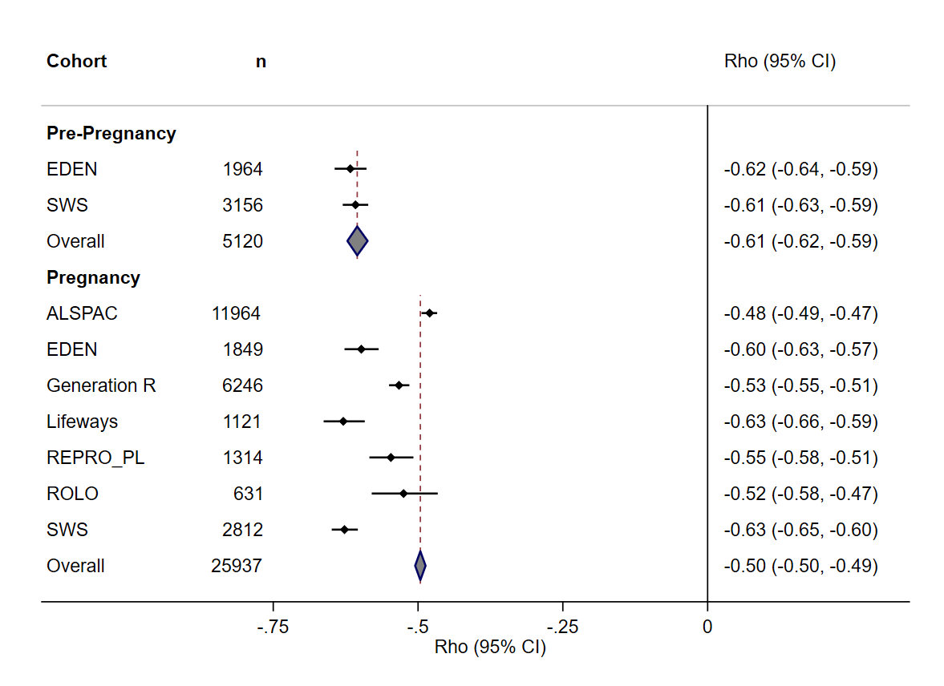
Abbreviations: DASH, Dietary Approaches to Stop Hypertension. E-DII, energy-adjusted Dietary Inflammatory Index.
Mean score of early pregnancy and late pregnancy when both available for SWS.

Figure 2A. Adjusted associations of age (in years) with maternal dietary quality and dietary inflammatory potential.
Cohorts | DASH score |  | β (95% CI) | Weight (%) |  | E-DII score |  | β (95% CI) | Weight (%)
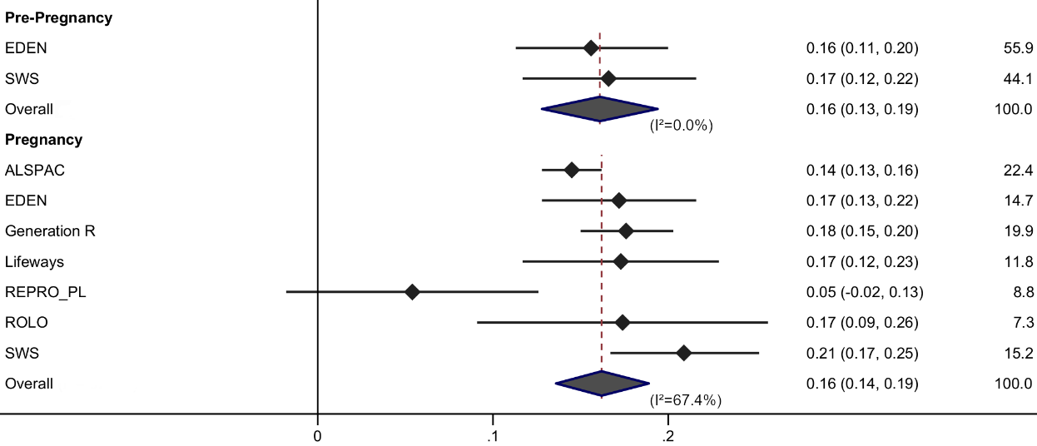
Abbreviations: DASH, Dietary Approaches to Stop Hypertension. E-DII, energy-adjusted Dietary Inflammatory Index.
Values are standardized regression coefficients (β), and their 95% confidence intervals (CI), study weights (%) and I² statistics. Regression coefficients are expressed as changes in standardized DASH/E-DII scores per 1 year increment in maternal age. Models were adjusted for only the seven predictors available in all cohorts: age, educational level, parity, ethnicity/birthplace, pre-pregnancy body mass index (BMI), smoking status during pregnancy, and alcohol consumption during pregnancy.

Figure 2B. Adjusted associations of educational level (reference = high) with maternal dietary quality and dietary inflammatory potential.
Cohorts | DASH score |  | β (95% CI) | Weight (%) |  | E-DII score |  | β (95% CI) | Weight (%)
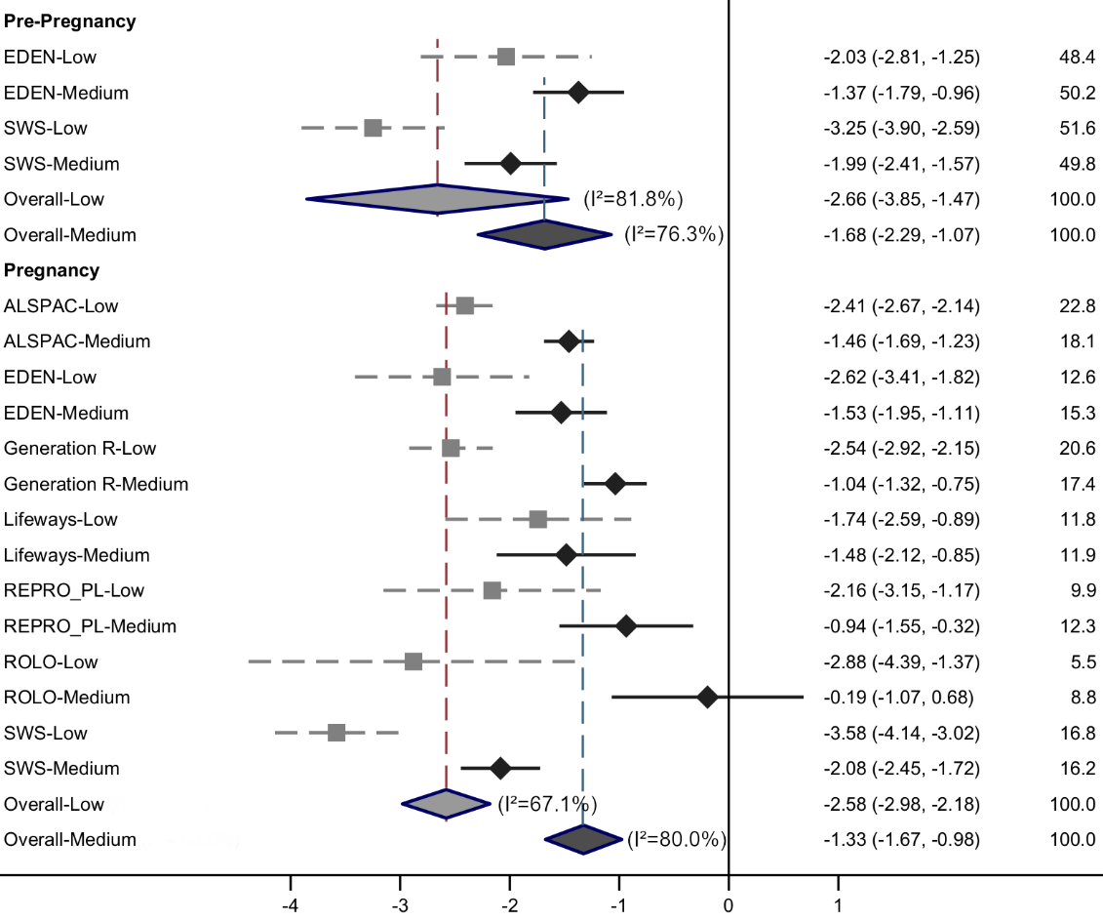 |  |  |  |  | 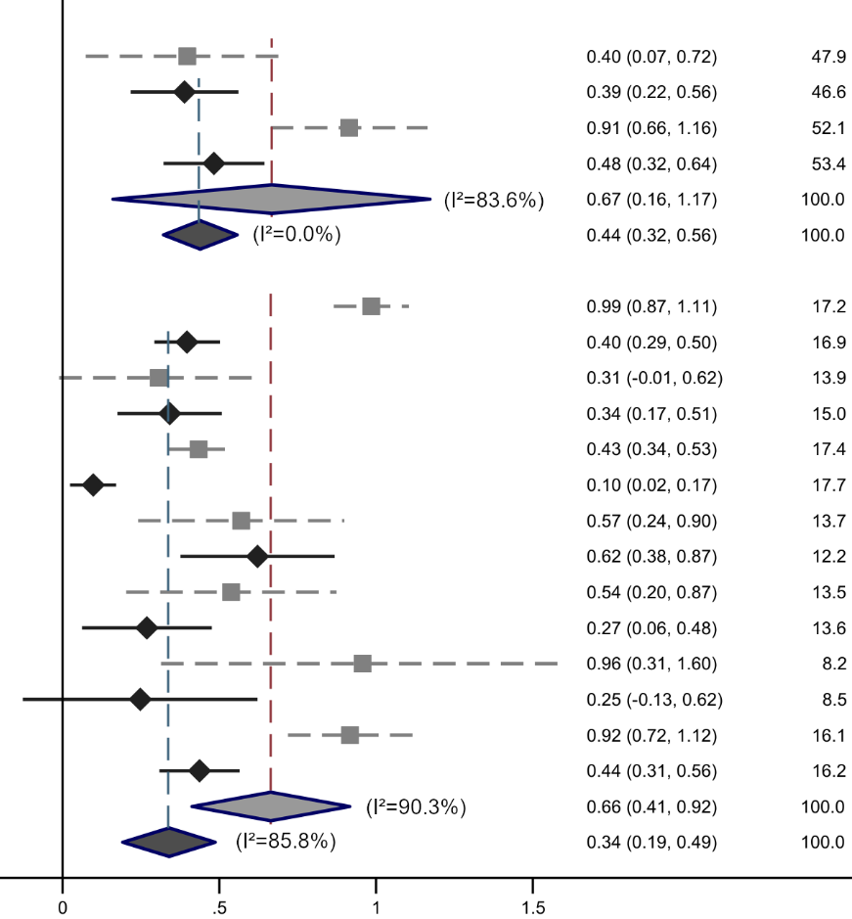
Abbreviations: DASH, Dietary Approaches to Stop Hypertension. E-DII, energy-adjusted Dietary Inflammatory Index.
Values are standardized regression coefficients (β), and their 95% confidence intervals (CI), study weights (%) and I² statistics. Regression coefficients are expressed as changes in standardized DASH/E-DII scores per category of educational (low category – gray square or medium category – black lozenge, in comparison with the high category – reference category). Models were adjusted for only the seven predictors available in all cohorts: age, educational level, parity, ethnicity/birthplace, pre-pregnancy body mass index (BMI), smoking status during pregnancy, and alcohol consumption during pregnancy.

Figure 2C. Adjusted associations of parity (reference = primiparous) with maternal dietary quality and dietary inflammatory potential.
Cohorts | DASH score |  | β (95% CI) | Weight (%) |  | E-DII score |  | β (95% CI) | Weight (%)
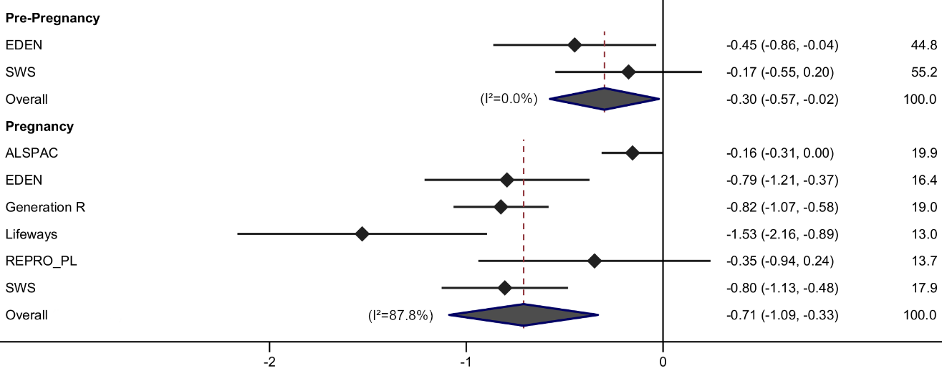 |  |  |  |  | 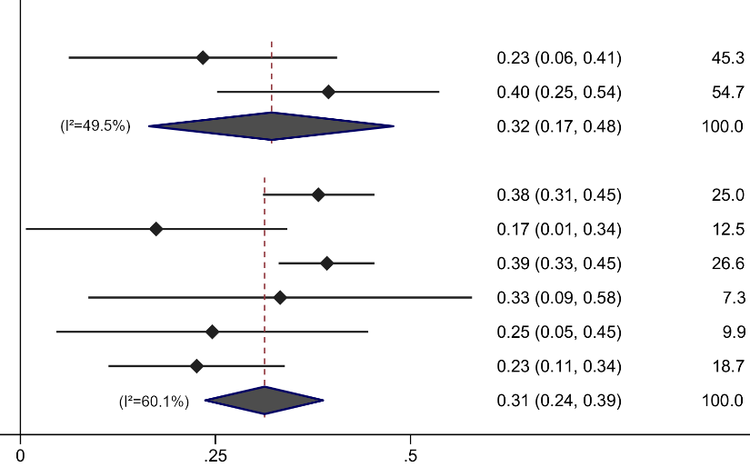
Abbreviations: DASH, Dietary Approaches to Stop Hypertension. E-DII, energy-adjusted Dietary Inflammatory Index.
Values are standardized regression coefficients (β), and their 95% confidence intervals (CI), study weights (%) and I² statistics. Regression coefficients are expressed as changes in standardized DASH/E-DII scores for multiparous mothers in comparison to primiparous mothers (reference category). Models were adjusted for only the seven predictors available in all cohorts: age, educational level, parity, ethnicity/birthplace, pre-pregnancy body mass index (BMI), smoking status during pregnancy, and alcohol consumption during pregnancy.
Second gravida was a recruitment criterion for ROLO.

Figure 2D. Adjusted associations of birthplace/ethnicity (reference = European-born/White) with maternal dietary quality and dietary inflammatory potential.
Cohorts | DASH score |  | β (95% CI) | Weight (%) |  | E-DII score |  | β (95% CI) | Weight (%)
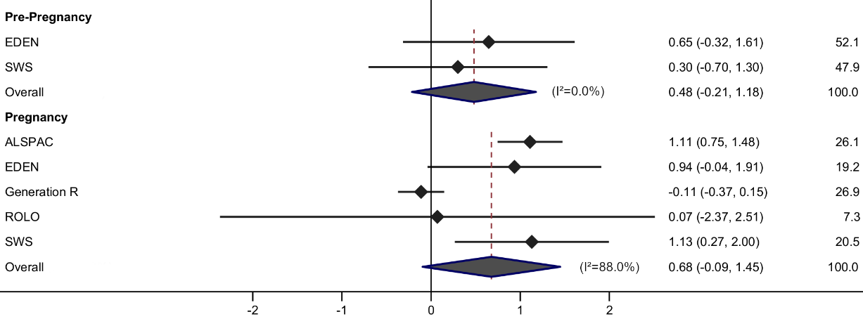 |  |  |  |  | 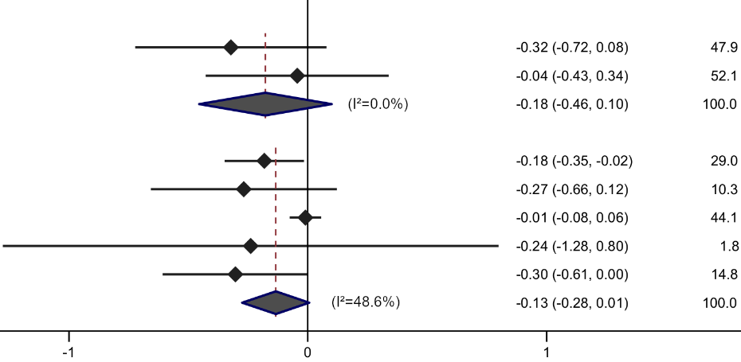
Abbreviations: DASH, Dietary Approaches to Stop Hypertension. E-DII, energy-adjusted Dietary Inflammatory Index.
Values are standardized regression coefficients (β), and their 95% confidence intervals (CI), study weights (%) and I² statistics. Regression coefficients are expressed as changes in standardized DASH/E-DII scores for Non-European-born/Non-White mothers in comparison to European-born/White mothers (reference category). Models were adjusted for only the seven predictors available in all cohorts: age, educational level, parity, ethnicity/birthplace, pre-pregnancy body mass index (BMI), smoking status during pregnancy, and alcohol consumption during pregnancy.
For EDEN, maternal ethnicity was proxied by place of birth using the question “Are you born in Europe? Outside Europe?”, because specific question on ethnicity was not allowed.
“White Irish” and “European white” were recruitment criteria for Lifeways and REPRO_PL, respectively.

Figure 2E. Adjusted associations of pre-pregnancy BMI (reference = normal range) with maternal dietary quality and dietary inflammatory potential.
Cohorts | DASH score |  | β (95% CI) | Weight (%) |  | E-DII score |  | β (95% CI) | Weight (%)
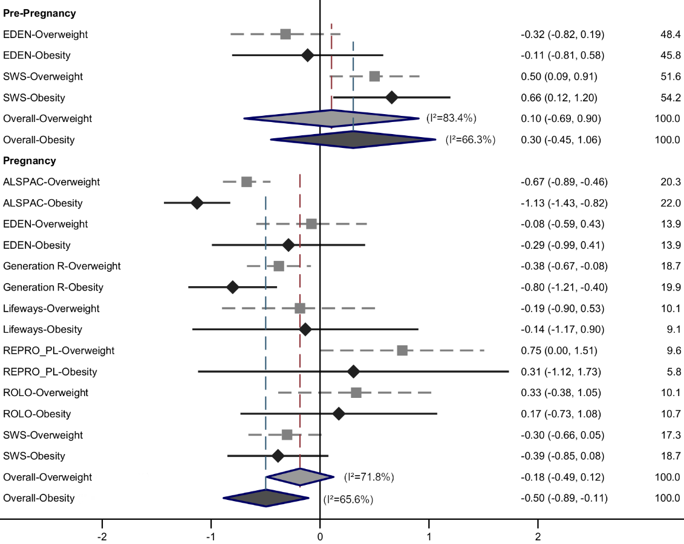 |  |  |  |  | 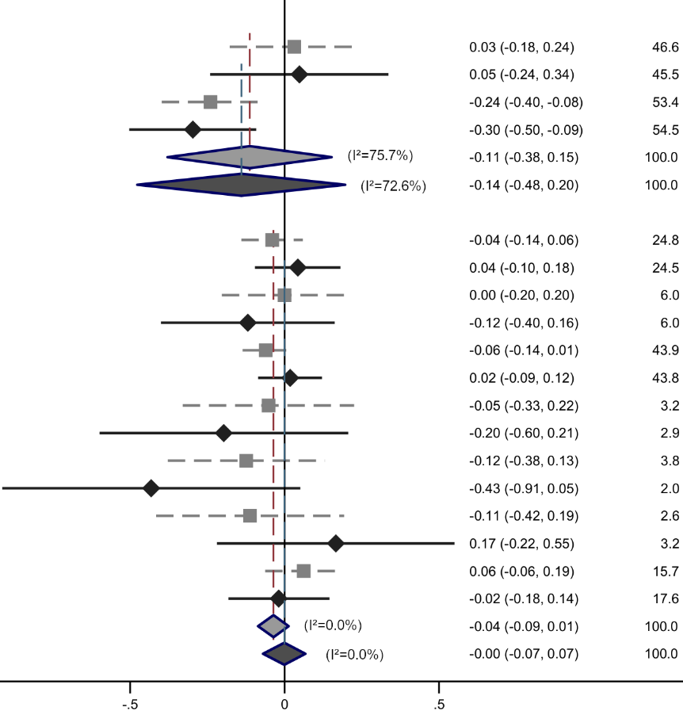
Abbreviations: DASH, Dietary Approaches to Stop Hypertension. E-DII, energy-adjusted Dietary Inflammatory Index. BMI, body mass index.
Values are standardized regression coefficients (β), and their 95% confidence intervals (CI), study weights (%) and I² statistics. Regression coefficients are expressed as changes in standardized DASH/E-DII scores per category of pre-pregnancy BMI (overweight category – gray square or obesity category – black lozenge, in comparison with the normal range category – reference category). Models were adjusted for only the seven predictors available in all cohorts: age, educational level, parity, ethnicity/birthplace, pre-pregnancy BMI, smoking status during pregnancy, and alcohol consumption during pregnancy.
Because the first category of BMI "underweight" was not significantly associated and with small frequencies in most cohorts, it is not represented in this forest plot for the sake of readability.
Weight measured or reported at inclusion or during early pregnancy follow-up has been used, when available, to impute missing values: EDEN: 9 cases (Gestational age (GA)= 12.6 ± 1.1 [mean ± sd]), Generation R: 575 cases (GA= 14.1 ± 1.6), REPRO_PL: 5 cases (GA= 10.3 ± 1.7), ROLO: 629 cases (all the sample) (GA= 12.8 ± 2.3), SWS: 8 cases (GA= 12.2 ± 1.1).

Figure 2F. Adjusted associations of smoking status during pregnancy (reference = non-smoker) with maternal dietary quality and dietary inflammatory potential.
Cohorts | DASH score |  | β (95% CI) | Weight (%) |  | E-DII score |  | β (95% CI) | Weight (%)
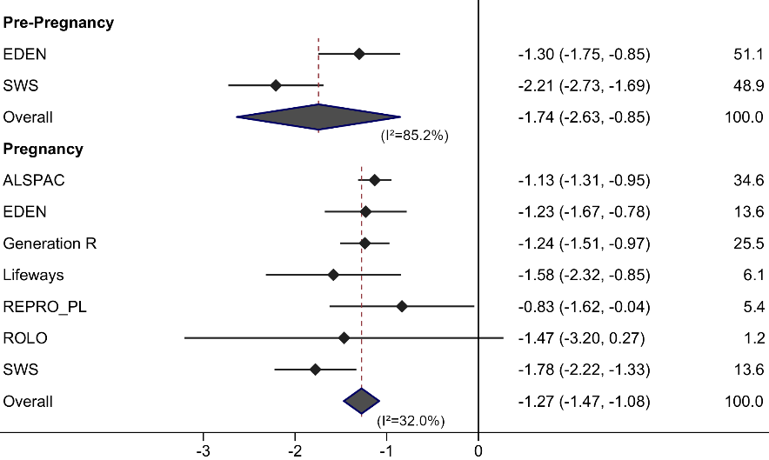 |  |  |  |  | 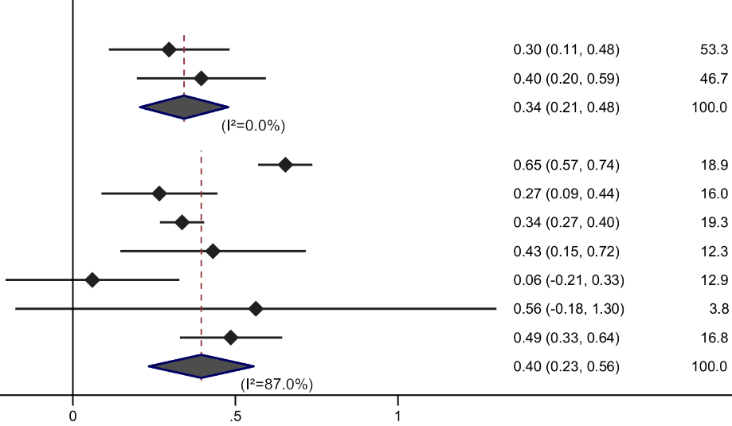
Abbreviations: DASH, Dietary Approaches to Stop Hypertension. E-DII, energy-adjusted Dietary Inflammatory Index.
Values are standardized regression coefficients (β), and their 95% confidence intervals (CI), study weights (%) and I² statistics. Regression coefficients are expressed as changes in standardized DASH/E-DII scores for smoker mothers in comparison to non-smoker mothers (reference category). Models were adjusted for only the seven predictors available in all cohorts: age, educational level, parity, ethnicity/birthplace, pre-pregnancy body mass index (BMI), smoking status during pregnancy, and alcohol consumption during pregnancy.

Figure 2G. Adjusted associations of alcohol consumption during pregnancy (reference = non-consumer) with maternal dietary quality and dietary inflammatory potential.
Cohorts | DASH score |  | β (95% CI) | Weight (%) |  | E-DII score |  | β (95% CI) | Weight (%)
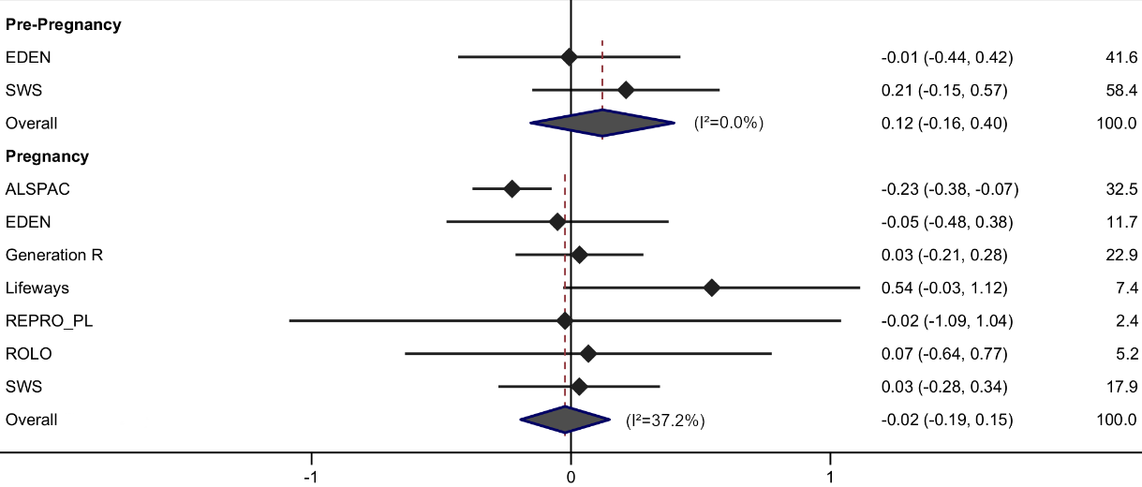 |  |  |  |  | 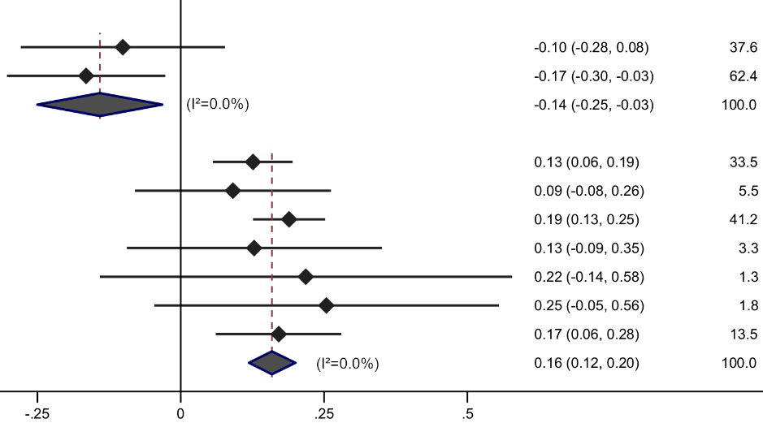
Abbreviations: DASH, Dietary Approaches to Stop Hypertension. E-DII, energy-adjusted Dietary Inflammatory Index.
Values are standardized regression coefficients (β), and their 95% confidence intervals (CI), study weights (%) and I² statistics. Regression coefficients are expressed as changes in standardized DASH/E-DII scores for alcohol consumer mothers in comparison to non-consumer mothers (reference category). Models were adjusted for only the seven predictors available in all cohorts: age, educational level, parity, ethnicity/birthplace, pre-pregnancy body mass index (BMI), smoking status during pregnancy, and alcohol consumption during pregnancy.

Figure 3A. Adjusted associations of household income (reference = higher tertile) with maternal dietary quality and dietary inflammatory potential.
Cohorts | DASH score |  | β (95% CI) | Weight (%) |  | E-DII score |  | β (95% CI) | Weight (%)
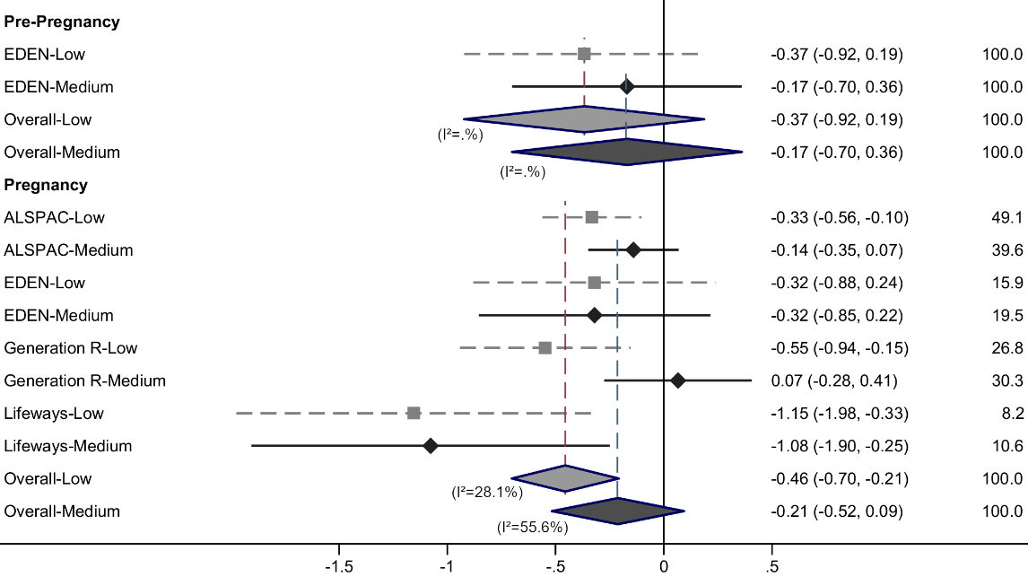 |  |  |  |  | 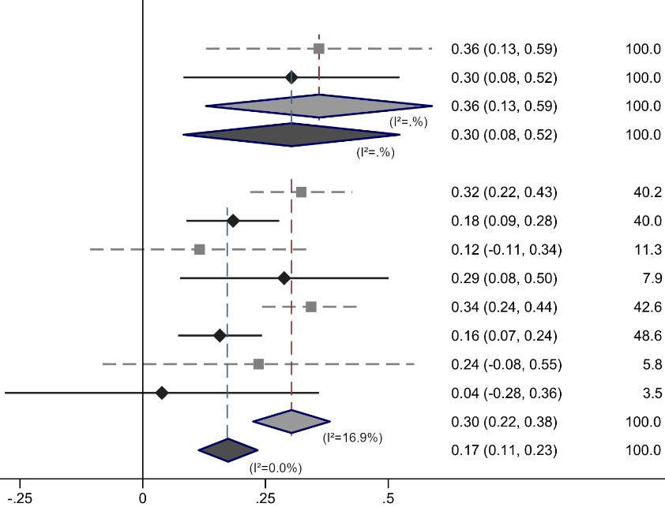
Abbreviations: DASH, Dietary Approaches to Stop Hypertension. E-DII, energy-adjusted Dietary Inflammatory Index.
Values are standardized regression coefficients (β), and their 95% confidence intervals (CI), study weights (%) and I² statistics. Regression coefficients are expressed as changes in standardized DASH/E-DII scores per category of household income (defined as cohort-specific tertiles) (low category – gray square or medium category – black lozenge, in comparison with the high category – reference category). Models were adjusted for the seven predictors available in all cohorts: age, educational level, parity, ethnicity/birthplace, pre-pregnancy body mass index (BMI), smoking status during pregnancy, and alcohol consumption during pregnancy; and additionally adjusted for household income (available for ALSPAC, EDEN, Generation R, and Lifeways only).

Figure 3B. Adjusted associations of physical activity level during pregnancy (reference = higher tertile) with maternal dietary quality and dietary inflammatory potential.
Cohorts | DASH score |  | β (95% CI) | Weight (%) |  | E-DII score |  | β (95% CI) | Weight (%)
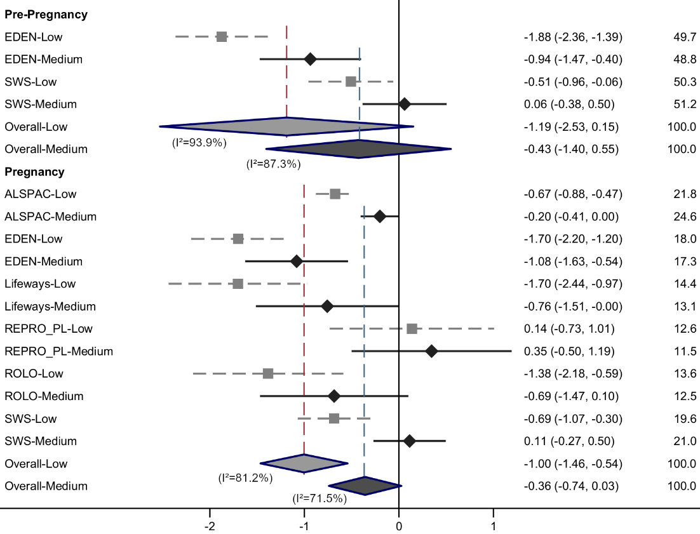 |  |  |  |  | 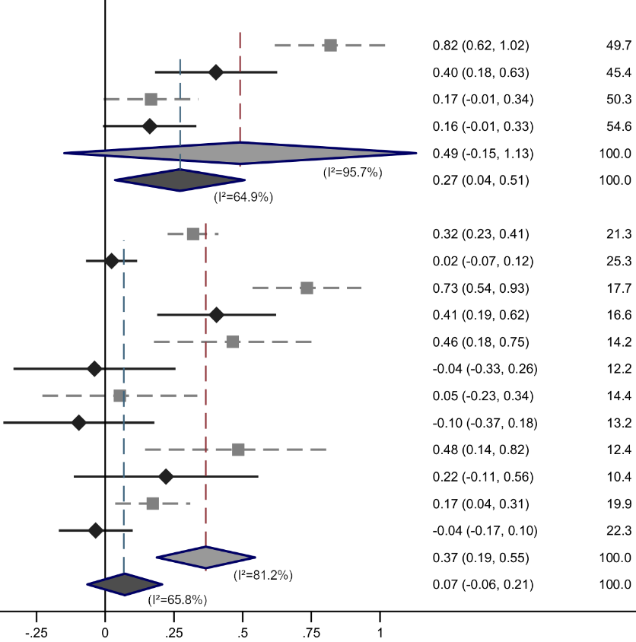
Abbreviations: DASH, Dietary Approaches to Stop Hypertension. E-DII, energy-adjusted Dietary Inflammatory Index.
Values are standardized regression coefficients (β), and their 95% confidence intervals (CI), study weights (%) and I² statistics. Regression coefficients are expressed as changes in standardized DASH/E-DII scores per category of physical activity level during pregnancy (defined as cohort-specific tertiles) (low category – gray square or medium category – black lozenge, in comparison with the high category – reference category). Models were adjusted for the seven predictors available in all cohorts: age, educational level, parity, ethnicity/birthplace, pre-pregnancy body mass index (BMI), smoking status during pregnancy, and alcohol consumption during pregnancy; and additionally adjusted for physical activity level during pregnancy (not available for Generation R only).

Supplemental table S1. Descriptive summary of food frequency questionnaires and DASH and E-DII scores in the ALPHABET consortium, overall and by cohort.
 | ALPHABETª | ALSPAC | EDEN | Generation R | Lifeways | REPRO_PL | ROLO | SWS
FFQ
FFQ total of food items | 137.0 | 43 | 137 | 293 | 158 | 66 | 158 | 104
FFQ total of food items without alcohol | 132.1 | 43 | 130 | 283 | 154 | 62 | 154 | 99
FFQ response categories | 7.6 | 5 | 7 | 9 | 9 | 6 | 9 | ≥8
DASH
Total of food items selected for the DASH | 71.3 | 34 | 65 | 136 | 85 | 36 | 85 | 58
% items selected/total food items without alcohol | 57.8% | 79.1% | 50.0% | 48.1% | 55.2% | 58.1% | 55.2% | 58.6%
Food components with higher intakes recommended
Total grains | 10.7 | 7 | 7 | 20 | 14 | 5 | 14 | 8
Vegetables (excluding potatoes and condiments) | 18.6 | 5 | 16 | 33 | 24 | 12 | 24 | 16
Fruits | 11.9 | 3 | 12 | 20 | 13 | 10 | 13 | 12
Non-full-fat dairy products | 6.9 | 3 | 6 | 18^{b} | 7 | 2 | 7 | 5
Nuts, seeds, legumes | 5.6 | 7 | 4 | 14 | 5 | 2 | 5 | 2
Food components with lower intakes recommended
Red and Processed meat | 12.0 | 4 | 12 | 20 | 17 | 4 | 17 | 10
Sugar-sweetened beverages, sweets, and added sugars | 5.7 | 5 | 8 | 11 | 5 | 1 | 5 | 5
Sodium | Available in g/day | Available in g/day | Available in g/day | Available in g/day | Available in g/day | Available in g/day | Available in g/day | Available in g/day
E-DII
Number of dietary parameters used | 25.9 | 28 | 25 | 20 | 28 | 28 | 28 | 24
% dietary parameters used  /44 dietary parameters possible (excluding energy intake) | 58.9% | 63.6% | 56.8% | 45.5% | 63.6% | 63.6% | 63.6% | 54.5%
Abbreviations: DASH, Dietary Approaches to Stop Hypertension. E-DII, energy-adjusted Dietary Inflammatory Index. FFQ, Food Frequency Questionnaire.
Values are frequencies and percentages (rounded to one decimal point)
ªFor the ALPHABET column, values are means from the seven other columns/cohorts.
^{b}By combining items on foods and items on types of milk consumed.

Supplemental table S2. Missing/available data patterns by cohort and factors.
 | ALSPAC | EDEN | Generation R | Lifeways | REPRO_PL | ROLO | SWS | Total available by factor, % (n)
Maternal sociodemographic factors
Age | 0.0% | 3.7% | 0.0% | 2.9% | 15.7% | 0.0% | 0.1% | 98.8% (26,096)
Educational level | 0.6% | 3.6% | 4.4% | 2.4% | 0.0% | 1.0% | 0.3% | 98.3% (25,953)
Household income | 23.1% | 3.4% | 17.1% | 10.3% | SM | SM | SM | 65.5% (17,296)
Parity | 3.7% | 3.9% | 0.4% | 3.7% | 0.5% | 0.0% | 0.1% | 97.8% (25,821)
Birthplace/ethnicity | 3.1% | 9.3% | 2.0% | 0.0% | 0.0% | 0.0% | 0.0% | 97.4% (25,726)
Maternal health and behavioural factors
Pre-pregnancy BMI | 13.9% | 4.5% | 3.3% | 17.9% | 1.2% | 0.3% | 0.6% | 91.7% (24,211)
Smoking status during pregnancy | 2.8% | 3.2% | 9.8% | 0.3% | 3.1% | 0.0% | 5.3% | 95.4% (25,186)
Alcohol consumption during pregnancy | 0.0% | 0.0% | 9.4% | 1.9% | 0.0% | 3.7% | 35.0% | 93.4% (24,678)
Physical activity level during pregnancy | 17.1% | 3.1% | SM | 17.5% | 33.8% | 0.0% | 16.3% | 64.0% (16,908)
Total available by cohort for the main analysisª, % (n) | 80.3% (9,612) | 87.9% (1,739) | 86.8% (5,419) | 76.8% (861) | 83.6% (1,098) | 95.6% (603) | 64.4% (2,031) | 80.9% (21,363)
SM, Systematically Missing. BMI, Body Mass Index. Values are % rounded to one decimal and frequencies (n).
ªMain analysis including the seven factors available in all cohorts: age, educational level, parity, birthplace/ethnicity, pre-pregnancy body mass index (BMI), smoking status during pregnancy, and alcohol consumption during pregnancy, and energy intake (for DASH analysis only).

Supplemental table S3.Comparison of the results between the main analysis (MA) adjusted for the seven predictors, and the sensitivity analysis (SA) adjusted for the nine predictors available for three cohorts – associations between predictors and DASH score during pregnancy.
 |  |  | ALSPAC |  |  | EDEN |  |  | Lifeways |  |  | Pooled
 |  |  | β | (95% CI) | Wgt(%) | β | (95% CI) | Wgt(%) | β | (95% CI) | Wgt(%) | β | (95% CI) | I²(%)
Maternal sociodemographic predictors
Age (Years) |  | MA | 0.14 | (0.13, 0.16) | 22.4% | 0.17 | (0.13, 0.22) | 14.7% | 0.17 | (0.12, 0.23) | 11.8% | 0.16 | (0.14, 0.19) | 67.4%
 |  | SA | 0.15 | (0.13, 0.17) | 74.3% | 0.17 | (0.12, 0.21) | 16.9% | 0.17 | (0.11, 0.23) | 8.7% | 0.15 | (0.14, 0.17) | 0.0%
Educational level (High) | Low | MA | -2.41 | (-2.67, -2.14) | 22.8% | -2.62 | (-3.41, -1.82) | 12.6% | -1.74 | (-2.59, -0.89) | 11.8% | -2.58 | (-2.98, -2.18) | 67.1%
 |  | SA | -2.34 | (-2.66, -2.01) | 50.6% | -2.18 | (-3.00, -1.35) | 27.3% | -1.22 | (-2.21, -0.23) | 22.1% | -2.05 | (-2.63, -1.46) | 54.7%
 | Medium | MA | -1.46 | (-1.69, -1.23) | 18.1% | -1.53 | (-1.95, -1.11) | 15.3% | -1.48 | (-2.12, -0.85) | 11.9% | -1.33 | (-1.67, -0.98) | 80.0%
 |  | SA | -1.40 | (-1.66, -1.13) | 67.6% | -1.36 | (-1.81, -0.91) | 22.9% | -1.23 | (-1.93, -0.52) | 9.5% | -1.37 | (-1.59, -1.15) | 0.0%
Household incomeª (High) | Low | MA | -0.33 | (-0.56, -0.10) | 49.1% | -0.32 | (-0.88, 0.24) | 15.9% | -1.15 | (-1.98, -0.33) | 8.2% | -0.46 | (-0.70, -0.21) | 28.1%
 |  | SA | -0.39 | (-0.63, -0.14) | 70.0% | -0.32 | (-0.87, 0.23) | 20.9% | -1.07 | (-1.95, -0.20) | 9.0% | -0.43 | (-0.70, -0.16) | 14.7%
 | Medium | MA | -0.14 | (-0.35, 0.07) | 39.6% | -0.32 | (-0.85, 0.21) | 19.5% | -1.08 | (-1.90, -0.25) | 10.6% | -0.21 | (-0.52, 0.09) | 55.6%
 |  | SA | -0.18 | (-0.40, 0.04) | 60.3% | -0.36 | (-0.89, 0.17) | 27.3% | -0.98 | (-1.86, -0.09) | 12.4% | -0.33 | (-0.67, 0.01) | 37.0%
Parity (Nulliparous) |  | MA | -0.15 | (-0.31, 0.00) | 19.9% | -0.79 | (-1.21, -0.37) | 16.4% | -1.53 | (-2.16, -0.89) | 13.0% | -0.71 | (-1.09, -0.33) | 87.8%
 |  | SA | -0.11 | (-0.30, 0.08) | 37.4% | -0.75 | (-1.16, -0.33) | 34.2% | -1.56 | (-2.26, -0.85) | 28.5% | -0.74 | (-1.48, 0.00) | 90.2%
Birthplace/ethnicity (European-born/White) |  | MA | 1.11 | (0.75, 1.47) | 26.1% | 0.94 | (-0.04, 1.91) | 19.2% | RC |  |  | 0.68 | (-0.09, 1.45) | 88.0%
 |  | SA | 1.09 | (0.61, 1.57) | 80.6% | 1.19 | (0.21, 2.17) | 19.4% | RC |  |  | 1.11 | (0.68, 1.54) | 0.0%
Maternal health and behavioural predictors
Pre-pregnancy BMI (Normal) | Underweight | MA | 0.61 | (0.38, 0.85) | 23.3% | -0.91 | (-1.61, -0.20) | 18.5% | -0.77 | (-2.42, 0.88) | 9.1% | -0.19 | (-0.82, 0.43) | 76.2%
 |  | SA | 0.70 | (0.42, 0.98) | 42.1% | -0.83 | (-1.53, -0.13) | 37.9% | -0.13 | (-2.15, 1.90) | 20.0% | -0.05 | (-1.29, 1.20) | 87.6%
 | Overweight | MA | -0.67 | (-0.89, -0.46) | 20.3% | -0.08 | (-0.59, 0.43) | 13.9% | -0.19 | (-0.90, 0.53) | 10.1% | -0.18 | (-0.49, 0.12) | 71.8%
 |  | SA | -0.67 | (-0.93, -0.41) | 43.5% | 0.00 | (-0.50, 0.51) | 33.3% | -0.06 | (-0.83, 0.71) | 23.2% | -0.30 | (-0.82, 0.21) | 70.4%
 | Obesity | MA | -1.13 | (-1.43, -0.82) | 22.0% | -0.29 | (-0.99, 0.41) | 13.9% | -0.14 | (-1.17, 0.90) | 9.1% | -0.50 | (-0.89, -0.11) | 65.6%
 |  | SA | -0.96 | (-1.32, -0.59) | 40.5% | -0.13 | (-0.83, 0.57) | 33.9% | 0.58 | (-0.52, 1.68) | 25.6% | -0.28 | (-1.15, 0.58) | 79.2%
Smoking status during pregnancy (Non-smoker) |  | MA | -1.13 | (-1.31, -0.95) | 34.6% | -1.23 | (-1.68, -0.78) | 13.6% | -1.58 | (-2.32, -0.84) | 6.1% | -1.28 | (-1.47, -1.08) | 32.0%
 |  | SA | -1.24 | (-1.46, -1.01) | 75.6% | -1.19 | (-1.64, -0.74) | 19.1% | -1.53 | (-2.37, -0.68) | 5.3% | -1.24 | (-1.44, -1.05) | 0.0%
Alcohol consumption during pregnancy (Non-consumer) |  | MA | -0.23 | (-0.38, -0.07) | 32.5% | -0.05 | (-0.48, 0.38) | 11.7% | 0.54 | (-0.03, 1.12) | 7.4% | -0.02 | (-0.19, 0.15) | 37.2%
 |  | SA | -0.22 | (-0.40, -0.04) | 47.2% | -0.14 | (-0.57, 0.28) | 31.5% | 0.57 | (-0.06, 1.20) | 21.3% | -0.03 | (-0.40, 0.35) | 64.1%
Physical activity level during pregnancyª (High) | Low | MA | -0.67 | (-0.88, -0.47) | 21.8% | -1.70 | (-2.20, -1.20) | 18.0% | -1.70 | (-2.44, -0.97) | 14.4% | -1.00 | (-1.46, -0.54) | 81.2%
 |  | SA | -0.67 | (-0.90, -0.45) | 37.0% | -1.71 | (-2.21, -1.21) | 33.6% | -1.87 | (-2.62, -1.12) | 29.4% | -1.37 | (-2.23, -0.52) | 90.2%
 | Medium | MA | -0.20 | (-0.41, 0.00) | 24.6% | -1.08 | (-1.63, -0.54) | 17.3% | -0.76 | (-1.51, 0.00) | 13.1% | -0.36 | (-0.74, 0.03) | 71.5%
 |  | SA | -0.16 | (-0.39, 0.07) | 39.7% | -1.08 | (-1.62, -0.54) | 33.0% | -0.93 | (-1.70, -0.15) | 27.3% | -0.67 | (-1.36, 0.02) | 83.0%
Values are standardized regression coefficients (β), and their 95% confidence intervals (CI), study weights (%) and I² statistics. Regression coefficients are expressed as changes in standardized DASH scores per year (for maternal age) or change in the category in comparison with the reference category. Models were adjusted for the seven predictors available in all seven cohorts for the main analysis (MA): age, educational level, parity, ethnicity/birthplace, pre-pregnancy body mass index (BMI), smoking status during pregnancy, and alcohol consumption during pregnancy; and adjusted for the nine predictors available in three cohorts for the sensitivity analysis (SA).
RC, recruitment criteria: “White Irish” was a recruitment criterion for Lifeways.
ªMain analysis (MA) additionally adjusted for household income (available for ALSPAC, EDEN, Generation R, and Lifeways only) and for physical activity level during pregnancy (not available for Generation R only), respectively.

Supplemental table S4:Comparison of the results between the main analysis (MA) adjusted for the seven predictors, and the sensitivity analysis (SA) adjusted for the nine predictors available for three cohorts – associations between predictors and E-DII score during pregnancy.
 |  |  | ALSPAC |  |  | EDEN |  |  | Lifeways |  |  | Pooled
 |  |  | β | (95% CI) | Wgt(%) | β | (95% CI) | Wgt(%) | β | (95% CI) | Wgt(%) | β | (95% CI) | I²(%)
Maternal sociodemographic predictors
Age (Years) |  | MA | -0.08 | (-0.08, -0.07) | 17.6% | -0.08 | (-0.10, -0.06) | 14.6% | -0.08 | (-0.10, -0.06) | 13.2% | -0.07 | (-0.08, -0.05) | 87.1%
 |  | SA | -0.07 | (-0.08, -0.06) | 68.9% | -0.08 | (-0.09, -0.06) | 20.5% | -0.08 | (-0.11, -0.06) | 10.6% | -0.07 | (-0.08, -0.07) | 0.0%
Educational level (High) | Low | MA | 0.99 | (0.87, 1.11) | 17.2% | 0.31 | (-0.01, 0.62) | 13.9% | 0.57 | (0.24, 0.90) | 13.7% | 0.66 | (0.41, 0.92) | 90.3%
 |  | SA | 0.87 | (0.73, 1.02) | 37.0% | 0.14 | (-0.19, 0.47) | 32.5% | 0.49 | (0.09, 0.88) | 30.5% | 0.52 | (0.04, 1.00) | 88.5%
 | Medium | MA | 0.40 | (0.29, 0.50) | 16.9% | 0.34 | (0.18, 0.51) | 15.0% | 0.62 | (0.38, 0.87) | 12.2% | 0.34 | (0.19, 0.49) | 85.8%
 |  | SA | 0.39 | (0.27, 0.51) | 48.7% | 0.28 | (0.10, 0.46) | 33.1% | 0.60 | (0.32, 0.87) | 18.2% | 0.39 | (0.25, 0.53) | 41.7%
Household incomeª (High) | Low | MA | 0.32 | (0.22, 0.43) | 40.2% | 0.12 | (-0.11, 0.34) | 11.3% | 0.24 | (-0.08, 0.55) | 5.8% | 0.30 | (0.22, 0.38) | 16.9%
 |  | SA | 0.35 | (0.24, 0.46) | 49.2% | 0.11 | (-0.11, 0.33) | 32.1% | 0.13 | (-0.22, 0.48) | 18.7% | 0.23 | (0.05, 0.41) | 55.6%
 | Medium | MA | 0.18 | (0.09, 0.28) | 40.0% | 0.29 | (0.08, 0.50) | 7.9% | 0.04 | (-0.28, 0.36) | 3.5% | 0.17 | (0.11, 0.23) | 0.0%
 |  | SA | 0.19 | (0.09, 0.29) | 61.7% | 0.31 | (0.10, 0.51) | 26.8% | -0.04 | (-0.40, 0.31) | 11.5% | 0.20 | (0.07, 0.32) | 28.8%
Parity (Nulliparous) |  | MA | 0.38 | (0.31, 0.45) | 25.0% | 0.17 | (0.01, 0.34) | 12.5% | 0.33 | (0.09, 0.58) | 7.3% | 0.31 | (0.24, 0.39) | 60.1%
 |  | SA | 0.32 | (0.23, 0.40) | 55.7% | 0.15 | (-0.02, 0.31) | 30.3% | 0.31 | (0.03, 0.59) | 14.0% | 0.27 | (0.15, 0.38) | 39.1%
Birthplace/ethnicity (European-born/White) |  | MA | -0.18 | (-0.35, -0.02) | 29.0% | -0.27 | (-0.66, 0.12) | 10.3% | RC |  |  | -0.13 | (-0.27, 0.01) | 48.6%
 |  | SA | -0.07 | (-0.29, 0.15) | 65.7% | -0.36 | (-0.75, 0.03) | 34.3% | RC |  |  | -0.17 | (-0.44, 0.10) | 39.7%
Maternal health and behavioural predictors
Pre-pregnancy BMI (Normal) | Underweight | MA | 0.17 | (0.06, 0.28) | 53.1% | 0.33 | (0.04, 0.61) | 7.8% | -0.24 | (-0.88, 0.40) | 1.5% | 0.16 | (0.08, 0.24) | 0.0%
 |  | SA | 0.12 | (-0.01, 0.25) | 69.4% | 0.29 | (0.01, 0.57) | 26.7% | -0.32 | (-1.13, 0.48) | 3.9% | 0.15 | (-0.01, 0.31) | 20.5%
 | Overweight | MA | -0.04 | (-0.14, 0.06) | 24.8% | 0.00 | (-0.20, 0.20) | 6.0% | -0.05 | (-0.33, 0.22) | 3.2% | -0.04 | (-0.09, 0.01) | 0.0%
 |  | SA | 0.00 | (-0.12, 0.12) | 67.1% | -0.03 | (-0.23, 0.17) | 23.1% | -0.14 | (-0.45, 0.16) | 9.8% | -0.02 | (-0.12, 0.07) | 0.0%
 | Obesity | MA | 0.04 | (-0.10, 0.18) | 24.5% | -0.12 | (-0.40, 0.16) | 6.0% | -0.20 | (-0.60, 0.21) | 2.9% | 0.00 | (-0.07, 0.07) | 0.0%
 |  | SA | 0.04 | (-0.12, 0.21) | 47.7% | -0.18 | (-0.46, 0.10) | 32.9% | -0.38 | (-0.82, 0.05) | 19.4% | -0.11 | (-0.34, 0.12) | 52.8%
Smoking status during pregnancy (Non-smoker) |  | MA | 0.65 | (0.57, 0.74) | 18.9% | 0.27 | (0.09, 0.44) | 16.0% | 0.43 | (0.15, 0.72) | 12.3% | 0.40 | (0.23, 0.56) | 87.0%
 |  | SA | 0.61 | (0.51, 0.71) | 39.4% | 0.25 | (0.08, 0.43) | 35.3% | 0.37 | (0.03, 0.70) | 25.2% | 0.42 | (0.15, 0.69) | 84.1%
Alcohol consumption during pregnancy (Non-consumer) |  | MA | 0.13 | (0.06, 0.20) | 33.5% | 0.09 | (-0.08, 0.26) | 5.5% | 0.13 | (-0.09, 0.35) | 3.3% | 0.16 | (0.12, 0.20) | 0.0%
 |  | SA | 0.15 | (0.07, 0.23) | 74.3% | 0.13 | (-0.04, 0.30) | 17.7% | 0.06 | (-0.19, 0.31) | 8.1% | 0.14 | (0.07, 0.21) | 0.0%
Physical activity level duringª pregnancy (High) | Low | MA | 0.32 | (0.23, 0.41) | 21.3% | 0.73 | (0.54, 0.93) | 17.7% | 0.46 | (0.18, 0.75) | 14.2% | 0.37 | (0.19, 0.54) | 81.2%
 |  | SA | 0.31 | (0.21, 0.42) | 38.2% | 0.73 | (0.54, 0.93) | 33.8% | 0.49 | (0.19, 0.78) | 28.1% | 0.50 | (0.21, 0.79) | 85.7%
 | Medium | MA | 0.02 | (-0.07, 0.12) | 25.3% | 0.41 | (0.19, 0.62) | 16.6% | -0.04 | (-0.33, 0.26) | 12.2% | 0.07 | (-0.06, 0.21) | 65.8%
 |  | SA | 0.00 | (-0.10, 0.10) | 39.7% | 0.40 | (0.18, 0.62) | 33.1% | 0.04 | (-0.26, 0.35) | 27.2% | 0.14 | (-0.12, 0.41) | 81.5%
Values are standardized regression coefficients (β), and their 95% confidence intervals (CI), study weights (%) and I² statistics. Regression coefficients are expressed as changes in standardized E-DII scores per year (for maternal age) or change in the category in comparison with the reference category. Models were adjusted for the seven predictors available in all seven cohorts for the main analysis (MA): age, educational level, parity, ethnicity/birthplace, pre-pregnancy body mass index (BMI), smoking status during pregnancy, and alcohol consumption during pregnancy; and adjusted for the nine predictors available in three cohorts for the sensitivity analysis (SA).
RC, recruitment criteria: “White Irish” was a recruitment criterion for Lifeways.
ªMain analysis (MA) additionally adjusted for household income (available for ALSPAC, EDEN, Generation R, and Lifeways only) and for physical activity level during pregnancy (not available for Generation R only), respectively.

Supplemental table S5:Comparison of the results between the main analysis (MA), and the sensitivity analysis (SA) with adjustment for energy intake for the DASH models and exclusion of participants with implausible energy intake (<500 or >3,500 kcal/day).
 |  |  | Overall associations with  pre-pregnancy DASH |  |  | Overall associations with pregnancy DASH |  |  | Overall associations with  pre-pregnancy E-DII |  |  | Overall associations with pregnancy E-DII
 |  |  | β | (95% CI) | I²(%) | β | (95% CI) | I²(%) | β | (95% CI) | I²(%) | β | (95% CI) | I²(%)
Maternal sociodemographic predictors
Age (Years) |  | MA | 0.16 | (0.13, 0.19) | 0.0 | 0.16 | (0.14, 0.19) | 67.4 | -0.08 | (-0.09, -0.06) | 0.0 | -0.07 | (-0.08, -0.05) | 87.1
 |  | SA | 0.17 | (0.14, 0.21) | 0.0 | 0.17 | (0.15, 0.20) | 57.3 | -0.08 | (-0.09, -0.06) | 0.0 | -0.06 | (-0.08, -0.05) | 83.9
Educational level (High) | Low | MA | -2.66 | (-3.85, -1.47) | 81.8 | -2.58 | (-2.98, -2.18) | 67.1 | 0.67 | (0.16, 1.17) | 83.6 | 0.66 | (0.41, 0.92) | 90.3
 |  | SA | -2.66 | (-3.88, -1.44) | 80.7 | -2.59 | (-3.01, -2.16) | 66.0 | 0.65 | (0.13, 1.17) | 82.4 | 0.65 | (0.42, 0.88) | 85.6
 | Medium | MA | -1.68 | (-2.29, -1.07) | 76.3 | -1.33 | (-1.67, -0.98) | 80.0 | 0.44 | (0.32, 0.56) | 0.0 | 0.34 | (0.19, 0.49) | 85.8
 |  | SA | -1.65 | (-2.34, -0.96) | 80.7 | -1.29 | (-1.64, -0.95) | 77.0 | 0.44 | (0.32, 0.56) | 0.0 | 0.31 | (0.17, 0.45) | 81.0
Household incomeª (High) | Low | MA | -0.37 | (-0.92, 0.19) | n.a. | -0.46 | (-0.70, -0.21) | 28.1 | 0.36 | (0.13, 0.59) | n.a. | 0.30 | (0.22, 0.38) | 16.9
 |  | SA | -0.36 | (-0.93, 0.22) | n.a. | -0.46 | (-0.78, -0.13) | 44.4 | 0.33 | (0.09, 0.57) | n.a. | 0.26 | (0.15, 0.37) | 43.4
 | Medium | MA | -0.17 | (-0.70, 0.36) | n.a. | -0.21 | (-0.52, 0.09) | 55.6 | 0.30 | (0.08, 0.52) | n.a. | 0.17 | (0.11, 0.23) | 0.0
 |  | SA | -0.23 | (-0.78, 0.32) | n.a. | -0.21 | (-0.60, 0.18) | 68.2 | 0.33 | (0.10, 0.56) | n.a. | 0.16 | (0.09, 0.22) | 0.0
Parity (Nulliparous) |  | MA | -0.30 | (-0.58, -0.02) | 0.0 | -0.71 | (-1.09, -0.33) | 87.8 | 0.32 | (0.17, 0.48) | 49.5 | 0.31 | (0.24, 0.39) | 60.1
 |  | SA | -0.27 | (-0.57, 0.04) | 13.2 | -0.78 | (-1.13, -0.43) | 82.6 | 0.29 | (0.12, 0.47) | 55.9 | 0.30 | (0.20, 0.40) | 71.1
Birthplace/ethnicity (European-born/White) |  | MA | 0.48 | (-0.21, 1.18) | 0.0 | 0.68 | (-0.09, 1.45) | 88.0 | -0.18 | (-0.45, 0.10) | 0.0 | -0.13 | (-0.27, 0.01) | 48.6
 |  | SA | 0.16 | (-0.57, 0.90) | 0.0 | 0.72 | (0.09, 1.35) | 72.5 | -0.10 | (-0.39, 0.20) | 0.0 | -0.16 | (-0.33, 0.01) | 48.0
Maternal health and behavioural factors
Pre-pregnancy BMI (Normal) | Underweight | MA | -0.27 | (-1.09, 0.55) | 21.5 | -0.19 | (-0.82, 0.43) | 76.2 | 0.43 | (0.15, 0.71) | 6.1 | 0.16 | (0.08, 0.24) | 0.0
 |  | SA | -0.32 | (-1.02, 0.37) | 0.0 | -0.18 | (-0.77, 0.42) | 68.1 | 0.33 | (0.04, 0.62) | 0.0 | 0.11 | (0.02, 0.21) | 0.0
 | Overweight | MA | 0.10 | (-0.70, 0.90) | 83.4 | -0.18 | (-0.49, 0.12) | 71.8 | -0.11 | (-0.38, 0.15) | 75.7 | -0.04 | (-0.09, 0.01) | 0.0
 |  | SA | 0.08 | (-0.67, 0.83) | 80.2 | -0.18 | (-0.54, 0.17) | 75.3 | -0.09 | (-0.37, 0.18) | 75.6 | -0.02 | (-0.07, 0.03) | 0.0
 | Obesity | MA | 0.30 | (-0.45, 1.06) | 66.3 | -0.50 | (-0.89, -0.11) | 65.6 | -0.14 | (-0.48, 0.20) | 72.6 | 0.00 | (-0.07, 0.07) | 0.0
 |  | SA | 0.24 | (-0.58, 1.06) | 69.2 | -0.42 | (-0.80, -0.03) | 57.5 | -0.08 | (-0.48, 0.33) | 79.3 | 0.02 | (-0.06, 0.09) | 2.7
Smoking status during pregnancy (Non-smoker) |  | MA | -1.74 | (-2.63, -0.85) | 85.2 | -1.28 | (-1.47, -1.08) | 32.0 | 0.34 | (0.21, 0.48) | 0.0 | 0.40 | (0.23, 0.56) | 87.0
 |  | SA | -1.74 | (-2.52, -0.96) | 79.2 | -1.33 | (-1.51, -1.15) | 12.1 | 0.33 | (0.19, 0.47) | 0.0 | 0.38 | (0.25, 0.50) | 70.9
Alcohol consumption during pregnancy (Non-consumer) |  | MA | 0.12 | (-0.16, 0.40) | 0.0 | -0.02 | (-0.19, 0.15) | 37.2 | -0.14 | (-0.25, -0.03) | 0.0 | 0.16 | (0.12, 0.20) | 0.0
 |  | SA | 0.00 | (-0.35, 0.36) | 34.8 | -0.04 | (-0.29, 0.21) | 62.5 | -0.12 | (-0.23, -0.01) | 0.0 | 0.19 | (0.14, 0.23) | 0.0
Physical activity level during pregnancyª (High) | Low | MA | -1.19 | (-2.53, 0.15) | 93.9 | -1.00 | (-1.46, -0.54) | 81.2 | 0.49 | (-0.15, 1.13) | 95.7 | 0.37 | (0.19, 0.54) | 81.2
 |  | SA | -1.20 | (-2.53, 0.13) | 93.3 | -1.00 | (-1.43, -0.57) | 73.5 | 0.48 | (-0.12, 1.08) | 94.7 | 0.35 | (0.16, 0.54) | 79.4
 | Medium | MA | -0.43 | (-1.40, 0.55) | 87.3 | -0.36 | (-0.74, 0.03) | 71.5 | 0.27 | (0.04, 0.51) | 64.9 | 0.07 | (-0.06, 0.21) | 65.8
 |  | SA | -0.40 | (-1.32, 0.51) | 84.4 | -0.32 | (-0.71, 0.08) | 67.8 | 0.24 | (0.08, 0.40) | 21.4 | 0.06 | (-0.08, 0.21) | 64.0
Values are standardized regression coefficients (β), and their 95% confidence intervals (CI), study weights (%) and I² statistics. Regression coefficients are expressed as changes in standardized DASH/E-DII scores per year (for maternal age) or change in the category in comparison with the reference category. Models were adjusted for the seven predictors available in all seven cohorts for the main analysis (MA): age, educational level, parity, ethnicity/birthplace, pre-pregnancy body mass index (BMI), smoking status during pregnancy, and alcohol consumption during pregnancy; and with adjustment for energy intake for the DASH models and exclusion of participants with implausible energy intake (<500 or >3,500 kcal/day) for the sensitivity analysis (SA).
n.a., not applicable: Overall estimates based on the EDEN results only (predictor not available for SWS).
ªMain analysis (MA) additionally adjusted for household income (available for ALSPAC, EDEN, Generation R, and Lifeways only) and for physical activity level during pregnancy (not available for Generation R only), respectively.

Supplemental table S6. Comparison of the results between the main analysis (MA), and the sensitivity analysis (SA) with adjustment for energy intake in the DASH models and exclusion of participants with implausible energy intake (<500 or >3,500 kcal/day) – focus on parity and birthplace/ethnicity.
 | Adjusted associations between parity  (reference = primiparous) and DASH score |  |  |  |  |  | Adjusted associations between ethnicity/birthplace  (reference = European-born/White) and DASH score
 | Main analysis |  |  | Sensitivity analysis |  |  | Main analysis |  |  | Sensitivity analysis
 | β | (95% CI) | Wgt(%) | β | (95% CI) | Wgt(%) | β | (95% CI) | Wgt(%) | β | (95% CI) | Wgt(%)
Pre-pregnancy DASH
EDEN | -0.45 | (-0.86, -0.04) | 44.8 | -0.44 | (-0.87, -0.01) | 44.4 | 0.65 | (-0.32, 1.61) | 52.1 | 0.06 | (-1.01, 1.12) | 47.4
SWS | -0.17 | (-0.55, 0.20) | 55.2 | -0.12 | (-0.51, 0.26) | 55.6 | 0.30 | (-0.70, 1.30) | 47.9 | 0.26 | (-0.76, 1.27) | 52.6
Overall | -0.30 | (-0.57, -0.02) | (I²=0.0%) | -0.27 | (-0.57, 0.04) | (I²=13.2%) | 0.48 | (-0.21, 1.18) | (I²=0.0%) | 0.16 | (-0.57, 0.90) | (I²=0.0%)
Pregnancy DASH
ALSPAC | -0.16 | (-0.31, 0.00) | 19.9 | -0.21 | (-0.44, 0.01) | 20.0 | 1.11 | (0.75, 1.48) | 26.1 | 1.14 | (0.58, 1.70) | 26.4
EDEN | -0.79 | (-1.21, -0.37) | 16.4 | -0.85 | (-1.28, -0.42) | 16.3 | 0.94 | (-0.04, 1.91) | 19.2 | 0.81 | (-0.24, 1.86) | 17.3
Generation R | -0.82 | (-1.07, -0.58) | 19.0 | -0.87 | (-1.11, -0.63) | 19.7 | -0.11 | (-0.37, 0.15) | 26.9 | 0.12 | (-0.14, 0.38) | 31.6
Lifeways | -1.53 | (-2.16, -0.89) | 13.0 | -1.65 | (-2.30, -1.00) | 12.3 |  | RC |  |  | RC
REPRO_PL | -0.35 | (-0.94, 0.24) | 13.7 | -0.56 | (-1.15, 0.02) | 13.4 |  | RC |  |  | RC
ROLO |  | RC |  |  | RC |  | 0.07 | (-2.37, 2.51) | 7.3 | 0.20 | (-2.64, 3.04) | 4.3
SWS | -0.80 | (-1.13, -0.48) | 17.9 | -0.82 | (-1.14, -0.49) | 18.3 | 1.13 | (0.27, 2.00) | 20.5 | 1.15 | (0.28, 2.02) | 20.4
Overall | -0.71 | (-1.09, -0.33) | (I²=87.8%) | -0.78 | (-1.13, -0.43) | (I²=82.6%) | 0.68 | (-0.09, 1.45) | (I²=88.0%) | 0.72 | (0.09, 1.35) | (I²=72.5%)
Values are standardized regression coefficients (β), and their 95% confidence intervals (CI), study weights (%) and I² statistics. Regression coefficients are expressed as changes in standardized DASH scores per change in the category in comparison with the reference category. Models were adjusted for the seven predictors available in all seven cohorts for the main analysis (MA): age, educational level, parity, ethnicity/birthplace, pre-pregnancy body mass index (BMI), smoking status during pregnancy, and alcohol consumption during pregnancy; and with adjustment for energy intake for the DASH models and exclusion of participants with implausible energy intake (<500 or >3,500 kcal/day) for the sensitivity analysis (SA).
RC, recruitment criteria: Second gravida was a recruitment criterion for ROLO. “White Irish” and “European white” were recruitment criteria for Lifeways and REPRO_PL, respectively.

