Is Superiority to Placebo the Most Appropriate Measure of Efficacy In Trials of Novel Psychotropic Medications?

Nathan T.M. Huneke^{1,2}

1. Clinical and Experimental Sciences, Faculty of Medicine, University of Southampton, Southampton, UK
2. University Department of Psychiatry, Academic Centre, College Keep, 4-12 Terminus Terrace, Southampton, SO14 3DT, UK

Corresponding author: Nathan TM Huneke, University Department of Psychiatry, Academic Centre, College Keep, 4-12 Terminus Terrace, Southampton, SO14 3DT, UK. Email: n.huneke@soton.ac.uk

Word count: 998 words

Placebo-controlled studies are the current gold-standard test for novel neuropsychiatric medications. The purpose of a placebo arm in these trials is to control for non-treatment-specific variables related to symptom improvement. Improvements seen in an active treatment arm above and beyond those seen in a placebo arm are presumably medication-specific effects. When the difference in symptom improvement between medication and placebo arms is statistically significant, we infer that the medication is efficacious in treating the disorder under study. As potential neuropsychiatric drugs are evaluated through such placebo-controlled trials there is a huge amount of attrition. Only 10.4% of novel compounds evaluated in a Phase I trial are eventually approved (Krol et al., 2020). Each new approved psychotropic medication is consequently very expensive.
The placebo response rate in neuropsychiatric trials is highly variable, even within the same disorder. Importantly for the interpretation of clinical trials, it appears that placebo and medication response rate are correlated across studies. In other words, studies with the highest placebo response rate also show the highest medication response rate. This correlation might be partly explained by biases in the way symptoms are rated in different trials, even when trialing the same medication. However, medication response rate is less variable than placebo response rate, with a lower ceiling and higher floor. This suggests that trials with the highest response rate overall are the least likely to show drug-placebo separation. Indeed, meta-analyses have shown that trials with high medication and placebo response rates were significantly less likely to show drug-placebo separation than trials with lower medication and placebo response rates in unipolar and bipolar depression (Iovieno et al., 2016; Iovieno and Papakostas, 2012). Is it correct to infer that the medication ‘lacks efficacy’ in these high response trials? The medication response rate could be similar to that seen in a low response trial (e.g. 50% vs 55%), but the placebo response rate much higher (e.g. 25% vs 45%) (see Figure 1). We would infer the medication is efficacious in the low response trial, but not the high response trial, despite medication response rates being similar.
Head-to-head superiority or non-inferiority trials can allow measurement of efficacy without the ambiguity of placebo effects. However, these alternatives possess disadvantages. For example, superiority trial designs raise the threshold for approval, particularly if the primary advantage of a new compound is not increased efficacy but lower cost or improved tolerability. Non-inferiority trials may lack assay sensitivity to distinguish effective from ineffective treatment as there is no placebo arm (see Krol et al., 2020). Placebo-controlled trials are unlikely to become obsolete.
It is possible that a lack of drug-placebo separation does truly reflect no efficacy advantage over placebo. However, this potentially overlooks nuance in the data. Placebo effects are thought to encompass both non-specific factors and improvements attributed specifically to placebo mechanisms. Non-specific factors include regression to the mean, rater drift, or baseline inflation (which might also be increasing drug response over time).Specific placebo mechanisms include psychological processes, such as expectations and learning, and activation of biological systems such as the endogenous opioid system. How placebo and medication mechanisms interact remains unknown, but there is evidence that such interactions exist. For example, changes in expectations of symptom improvement during antidepressant treatment predicts outcome (Zilcha-Mano et al., 2019). Further, it might be that placebo mechanisms have differing effects in medication arms. We recently found that in trials of patients with gambling disorder, predictors of outcome in medication arms differed from those in placebo arms (Huneke et al., 2021). The factors responsible for a treatment response might differ between treatment groups. If we could measure the effect sizes of such factors within each treatment arm, we might gain further insights into whether a potential medication is efficacious. To do so, we need to identify these factors, and develop assays to detect their effects.
An example of such a potential factor would be changes in emotional processing biases in depression. Antidepressant medication is known to alter recognition of emotional facial expressions, and through this change in emotional processing is thought to lead to improvements in depressive symptoms. Importantly, this medication effect is robust and reproducible while placebo effects in this domain are known to be minimal (in comparison to no treatment) (Huneke et al., 2017). Readouts from such an assay should allow measurement of medication-specific treatment effects. Subsequent assessment of the relationship between outcome data from tasks like these with changes in symptoms could demonstrate whether medication-specific effects correlate with clinical improvement (Harmer and Browning, 2022). Additional potential treatment-specific mediators or moderators of response are also being identified. For instance, reward responsiveness might be a specific moderator of response to bupropion (Ang et al., 2020). More research is needed to identify which medication-specific causes of symptom improvement we can measure.
Assays that can measure the effects of non-specific causes of symptom improvement are even less well-developed. Several variables have previously been linked with placebo responsiveness and these perhaps represent non-specific predictors of treatment outcome. These include personality traits, severity of a disorder on entry to a clinical trial, previous experience of a treatment, and others. However, the utility of these in assessing or predicting clinical trial outcomes remains unclear. For example, the relationship between personality traits and placebo responsiveness has not replicated in a meta-analysis (Kang et al., 2022). Placebo responses across disorders are thought to result from an interplay between prior expectations and learning that activates biological systems to regulate incoming sensory or emotional information (Wager and Atlas, 2015). Developing assays to measure the effects of these placebo mechanisms on symptoms might be more fruitful.
A simple null hypothesis significance test of whether symptom reduction is greater in a medication arm versus a placebo arm might not permit an accurate inference regarding efficacy. Such a test assumes that non-specific or placebo effects are equal in both arms and/or do not interact with specific treatment effects. There is potentially a great deal of nuance that is overlooked as a result. It is possible that placebo mechanisms interact with medication mechanisms. More research is needed to understand which specific and non-specific treatment effects are important in clinical trials, how to measure these, and how to measure their impact in each trial arm.

Declaration of interest
NTMH is a clinical research training fellow supported by the MRC (grant number MR/T000902/1). He has also consulted for Emteq Ltd within the last 3 years.

References
Ang, Y.S., Bruder, G.E., Keilp, J.G., Rutherford, A., Alschuler, D.M., Pechtel, P., Webb, C.A., Carmody, T., Fava, M., Cusin, C., McGrath, P.J., Weissman, M., Parsey, R., Oquendo, M.A., McInnis, M.G., Cooper, C.M., Deldin, P., Trivedi, M.H., Pizzagalli, D.A., 2020. Exploration of baseline and early changes in neurocognitive characteristics as predictors of treatment response to bupropion, sertraline, and placebo in the EMBARC clinical trial. Psychol. Med., 1-9.
Harmer, C.J., Browning, M., 2022. Emotional cognition in depression: Is it relevant for Clinical practice? Eur. Neuropsychopharmacol. 56, 1-3.
Huneke, N.T., Walsh, A.E., Brown, R., Browning, M., Harmer, C.J., 2017. No evidence for an acute placebo effect on emotional processing in healthy volunteers. J Psychopharmacol 31, 1578-1587.
Huneke, N.T.M., Chamberlain, S.R., Baldwin, D.S., Grant, J.E., 2021. Diverse predictors of treatment response to active medication and placebo in gambling disorder. J. Psychiatr. Res. 144, 96-101.
Iovieno, N., Nierenberg, A.A., Parkin, S.R., Hyung Kim, D.J., Walker, R.S.W., Fava, M., Papakostas, G.I., 2016. Relationship between placebo response rate and clinical trial outcome in bipolar depression. J. Psychiatr. Res. 74, 38-44.
Iovieno, N., Papakostas, G.I., 2012. Correlation between different levels of placebo response rate and clinical trial outcome in major depressive disorder: a meta-analysis. J. Clin. Psychiatry 73, 1300-1306.
Kang, H., Miksche, M.S., Ellingsen, D.-M., 2022. The association between personality traits and placebo effects: A preregistered systematic review and meta-analysis.
Krol, F.J., Hagin, M., Vieta, E., Harazi, R., Lotan, A., Strous, R.D., Lerer, B., Popovic, D., 2020. Placebo—To be or not to be? Are there really alternatives to placebo-controlled trials? Eur. Neuropsychopharmacol. 32, 1-11.
Wager, T.D., Atlas, L.Y., 2015. The neuroscience of placebo effects: connecting context, learning and health. Nature Reviews Neuroscience 16, 403-418.
Zilcha-Mano, S., Brown, P.J., Roose, S.P., Cappetta, K., Rutherford, B.R., 2019. Optimizing patient expectancy in the pharmacologic treatment of major depressive disorder. Psychol. Med. 49, 2414-2420.

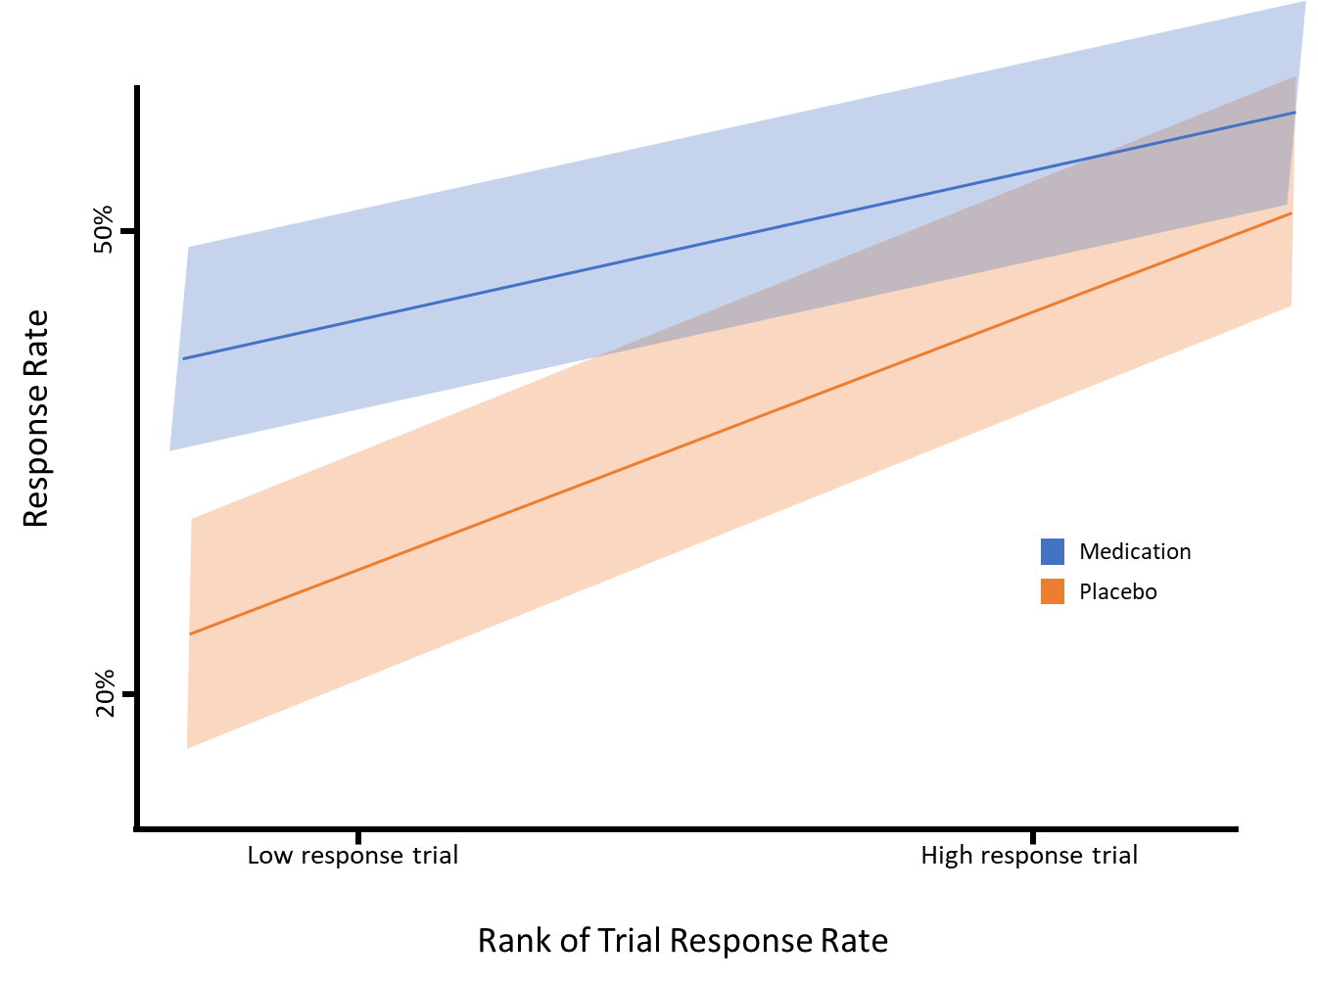
Figure 1: Cartoon demonstrating that placebo response rate and medication response rate are correlated, but the variability of medication response rate is lower. As a result, low response trials are more likely to demonstrate a separation between drug and placebo. However, high response trials show a similar medication response rate to low response trials, but the inference is that the medication is not efficacious.

