Clavicular and scapular, but not spinal kinematics vary with scapular dyskinesis type during arm elevation and lowering in persons with neck pain

Nipaporn Wannapromª, Gwendolen Jull^{b}, Julia Treleaven^{b}, Martin B Warner^{c}, Teerawat Kamnardsiri^{d}, Sureeporn Uthaikhup^{a,*}

ª Department of Physical Therapy, Faculty of Associated Medical Sciences, Chiang Mai University, Chiang Mai, Thailand

^{b} Physiotherapy, School of Health and Rehabilitation Sciences, The University of Queensland, St Lucia, Brisbane, Australia

^{c} School of Health Sciences, Faculty of Environmental and Life Sciences, University of Southampton, Southampton, United Kingdom

^{d} Department of Digital Game, College of Arts, Media and Technology, Chiang Mai University, Chiang Mai, Thailand

*Corresponding author
Assoc. Prof. Sureeporn Uthaikhup (PhD.)
Department of Physical Therapy,
Faculty of Associated Medical Sciences, Chiang Mai University,
Chiang Mai, Thailand, 50200
Phone: +66 (0) 53 949 249; Fax: +66 (0) 53 946 042
Email: sureeporn.uthaikhup@cmu.ac.th

Abstract
Background: Scapular dyskinesis is often observed in patients with neck pain. However, it is unknown whether clavicular, scapular and spinal kinematics vary with different types of scapular dyskinesis during arm movement.
Research question: Are there differences in clavicular, scapular and spinal kinematics during unilateral arm elevation and lowering among neck pain patients presenting with (i) scapular winging, (ii) with dysrhythmia, (iii) with no scapular abnormality and (iv) healthy controls?
Methods: Sixty participants with neck pain (20 in each group) and 20 asymptomatic controls were recruited. The 3D kinematic data were measured during unilateral arm elevation and lowering at 30°, 60°, 90°, and 120° in the scapular plane. A three-way mixed-effects ANOVA was used to determine the main effects (group, phase and angle) and the interactions between three independent variables on the kinematic data.
Results: The neck pain group with scapular winging had decreased clavicular retraction and increased scapular internal rotation and anterior tilt compared to the other neck pain and control groups at all angles during both phases of arm movement (p < 0.01). The neck pain group with scapular dysrhythmia had decreased scapular upward rotation compared to all other groups (p < 0.01). Some alterations in the kinematics existed during the lowering phase compared to the raising phase for all groups (p < 0.05). Spinal kinematics were similar across all groups (p > 0.05).
Significance: Specific patterns of clavicular and scapular kinematics were identified during arm movement relevant to the type of observed scapular dyskinesis in patients with neck pain. Such findings stand to inform more precise and relevant motor training in rehabilitation and improve understanding of the association between altered scapular kinematics and neck pain.

Keywords: Clavicle; Dyskinesis; Kinematics; Neck pain; Scapula

1. Introduction
Scapular dyskinesis has been associated with neck pain [1, 2] and attributed to the anatomical link between the cervical spine and scapulae via the axio-scapular muscles [3, 4]. Upper limb loading induces motion of cervical segments [5]. This loading may induce strain-related cervical joint pain and restrict upper limb activity. Clinically, patients often report that their neck pain is aggravated with upper limb activities such as lifting and carrying [6-8], which reflects this potential for adverse loading on cervical structures secondary to scapular dyskinesis [3, 9].
Consistent with these observations, changes in kinematics of the clavicle and scapula during arm elevation have been demonstrated in patients with neck pain compared to healthy controls [1, 10, 11]. These include reduced claviclular retraction and increased scapular downward rotation, external rotation and posterior tilt on the dominant side and increased scapular downward (or medial) rotation and internal rotation on the non-dominant side [1, 10, 11]. However, scapular dyskinesis is not present in all patients with neck pain [1, 12, 13]. These previous studies have treated their cohorts as a single group and not considered any influence of the presence or not of scapular dyskinesis. In addition, kinematics were measured on the participant’s dominant upper limb and not necessarily the side of neck pain [1, 10, 11]. Arm movements produce different ranges and patterns of spinal motion [14-16], but spinal kinematics during arm elevation has not been explored in patients with neck pain. A lack of consideration of these variables means that there is not a clear picture of scapular, clavicular or spinal kinematics in this patient group.
Furthermore, clinical observation of arm movement suggests that when scapular dyskinesis is present in association with neck pain, different types of scapular dyskinesis may present, in particular scapular winging and dysrhythmia [12, 13]. Scapular winging is usually related to impaired serratus anterior function whereas dysrhythmia suggests a general lack of axio-scapular muscle control [17, 18]. Thus, whether presence or type of scapular dyskinesis influences clavicular, scapular and spinal kinematic measurements of arm elevation and lowering in patients with neck pain remains unknown. Additionally, while attention has been given to the lowering or the eccentric phase of arm movement in patients with shoulder pain [19-21], to date this has not been examined in neck pain populations. Understanding kinematic patterns in association with neck pain and different types of dyskinesis might improve understanding of common functional complaints [6-8] and the potential for adverse cervical spine loading. Such understanding may ultimately direct specific rehabilitative exercises to strengthen muscles and improve motor control.
The purpose of this study was to investigate clavicular, scapular and spinal kinematics during both unilateral arm elevation and lowering in patients with neck pain with observed (i) scapular winging, (ii) scapular dysrhythmia, (iii) no scapular dyskinesis and compare them to asymptomatic controls with no scapular abnormality. In comparing the neck pain groups with scapular dyskinesis to the neck pain and control groups without scapular dyskinesis, it was hypothesized that there would be specific patterns of clavicular, scapular and spinal kinematics in neck pain patients with different types of scapular dyskinesis for all angles of arm elevation and lowering.

2. Methods
2.1. Participants
Sixty participants with neck pain and 20 adults without neck pain aged between 18 to 59 years old were recruited for this cross-sectional study. Participants with neck pain were recruited from local hospitals, physical therapy clinics, the university and community, based on the following inclusion criteria: neck pain on the dominant side for more than 3 months, an average neck pain intensity of ≥ 3 on a 0-10 cm Visual Analog Scale (VAS) in the past week, a current Neck Disability Index (NDI) score of at least 10/100. Participants with neck pain were recruited into one of the three groups on the basis of observational analysis of arm movement: 20 with definite scapular winging, 20 with definite scapular dysrhythmia and 20 with no obvious abnormal scapular movement. The requirement that scapular dyskinesis was both present on the painful side of the neck and the side of hand dominance was to negate the variable of hand dominance. In the observational analysis, scapular winging was defined when the medial border/inferior angle of the scapula was posteriorly displaced away from the thorax. Dysrhythmia was defined as premature or excessive elevation or protraction, non-smooth or a stuttering motion, during arm elevation or lowering, or rapid downward rotation during arm lowering [12, 13, 22]. Scapular dyskinesis was evaluated by an experienced physiotherapist. Inter-rater reliability for observation of scapular dyskinesis for this study was good (kappa = 0.73, percent agreement = 80%).
A convenience sample of 20 participants without neck pain were recruited from the university and community. Requirements were no history of neck pain in the past year and no observable abnormal scapular movement. The exclusion criteria for all participants were a history of head and neck injury or surgery, any known shoulder pathology or impairment, neurologic conditions and any musculoskeletal problems that could affect scapular movements. The study was approved by the Institution’s ethical review committee for research in humans (No. AMSEC-62EX-049) and was conducted in accordance with the declaration of Helsinki. All participants provided informed consent prior to commencement of the study.
Sample size estimation was based on a pilot study of clavicular and scapular kinematics in 24 patients with neck pain (8 with scapular winging, 8 with scapular dysrhythmia and 8 with no abnormal scapular movement) and 8 asymptomatic controls. Effect size ranged from 0.23 to 0.51 with a power of 80% and a significance level of 0.05. The smallest effect size was chosen for calculating sample size, so a minimum sample size required for the study was 80 participants (20 per group).

2.2. Instruments
3D clavicular, scapular and spinal kinematic data were recorded using a motion analysis system consisting of 10 cameras (Eagle cameras, Motion Analysis Corporation, Santa Rosa, CA, USA) at a sampling frequency of 120 Hz. Reflective markers were attached to bony landmarks with adhesive tapes on the sternal notch, spinous processes of C7 and T8 vertebrae, medial and lateral humeral epicondyles, 5 cm above lateral humeral epicondyle and olecranon process, ulnar and radial styloid processes (over and 5 cm above), lower ribs, anterior iliac anterior superior iliac spine (ASIS) and posterior superior iliac spine (PSIS) [23-25]. Reflective markers attached to a piece of Velcro were fastened to the participant’s head [26]. Acromion marker cluster (AMC), an ‘L’ shaped plate with three reflective markers was attached on the flat part of acromion where the acromion meets the spine of the scapula with one section of the AMC pointing anterior to the scapular plane, and the other following the spine of the scapula [24, 25]. A calibration wand was used to determine the location of the sternoclavicular joint with respect to the thorax markers, and to determine the acromioclavicular joint and scapular anatomical landmarks with respect to the AMC prior to data collection [24, 25]. The AMC method has been shown to be a reliable and valid measurement of scapular movement [24, 25, 27].

2.3. Experimental procedure
The 3D kinematic data were collected on the dominant side for all participants (which was also painful side in the neck pain groups) in accord with previous studies [24, 25]. Participants stood in a relaxed position with their feet hip-width apart. Male participants were asked to remove their shirts and female participants to wear a bra or vest to avoid marker occlusions from the cameras. Participants performed three consecutive repetitions of weighted unilateral arm elevation and lowering in the scapular plane in a neutral rotation, thumb-up position over a range of 120° during a 6-second count (3-second count for elevation and 3-second count for lowering) (Fig. 1). The weight use was 1-kg for women and 2-kg for men [12]. Two leader sticks were positioned along the lateral aspect of the participant’s arm to act as a guide to maintain movement in the scapular plane, defined as being 30° anterior to the frontal plane [28]. Participants performed one practice trial of arm elevation and lowering for the familiarization. The examiner was blinded to the participant’s group status.

2.4. Data managements and statistical analyses
The kinematic data were analysed using a custom written Matlab (Mathworks, USA) script. The software contained commands to determine the location of the clavicle and scapula anatomical landmarks in the global coordinate system based on their calibrated location with respect to the thorax and AMC markers. The glenohumeral joint centre was estimated using the pivot point of the helical axis between the scapular and humerus [29]. Subsequently, local coordinate systems, were created based on the location of the anatomical landmarks following ISB recommendations [23]. The movement of the clavicle and scapula with respect to the thorax was determined following Euler rotation sequences of clavicular elevation (+ve)/depression (-ve) (Y), clavicle protraction (+ve)/retraction (-ve) (Z), and scapular internal (+ve)/external rotation (-ve) (Y), scapular upward (+ve)/downward (-ve) rotation (X) and posterior tilt (+ve) / anterior tilt (-ve) (Z) [23-25]. All upward rotation angles were multiplied by -1 to obtain more easily interpretable data, with an increase in value corresponding to upward rotation of the scapula. Spinal kinematics were determined based on a Euler angle sequence of neck extension (+ve)/flexion (-ve) (Z), right (+ve)/left (-ve) neck lateral flexion (X), left (+ve)/right (-ve) neck rotation (Y), and thoracic extension (+ve)/flexion (-ve) (Z) and pelvic posterior (+ve)/anterior tilt (-ve) (Z).
The kinematic data were analyzed at 30°, 60°, 90°, 120° for both the arm elevation and lowering. Data were averaged across the three repetitions for analysis. The Shapiro-Wilk test was used to assess normality of data. One way analysis of variance (ANOVA) was used to determine any differences in participants’ demographic data and characteristics of neck pain. A three-way mixed-effects ANOVA was used to investigate differences in the clavicular, scapular and spinal kinematics, with group as the between-subjects factor and phase and angle as within-subject factors. When a three-way interaction was not significant, two-way interactions were investigated. If there were any interaction effects, the differences were estimated at each level. Main effects were considered only if no two-way interactions were found. All statistical analyses were conducted using SPSS software. The level of statistical significance was set at p < 0.05.

3. Results
3.1. Participants
There were no differences in demographic data between the groups (all p > 0.05, Table 1). Participants in the neck pain groups had similar characteristics with respect to pain duration, pain intensity and neck disability (all p > 0.05). All participants in the neck pain groups reported that their neck pain was aggravated by one or more upper limb activities such as carrying, lifting, holding and cleaning.

3.2. Kinematics
3.2.1. Clavicular kinematics
There was no significant group x angle x phase interaction for the clavicular protraction/retraction, but there was a significant interaction for elevation/depression (Table 2). There were no significant group x angle and group x phase interactions for either movement (Table 2). When comparing between the groups, the neck pain group with scapular winging had significantly decreased clavicular retraction than the other two neck pain groups (scapular dysrhythmia and no abnormality) and the control group at all angles during both arm raising and lowering phases (p < 0.01, Fig. 2). The neck pain group with scapular dysrhythmia had significantly decreased clavicular elevation compared to the neck pain group with winging at 60 degrees during the raising phase (p = 0.04, Fig. 2).
When comparing between the phases for each group, more clavicular retraction was identified in the lowering (eccentric) phase compared to the raising (concentric) phase (p < 0.01).

3.2.2. Scapular kinematics
There were no significant group x angle x phase interactions for all scapular movement directions (Table 2). There were also no significant group x angle and group x phase interactions in any direction (Table 2). When comparing between the groups, the neck pain group with scapular winging had significantly increased scapular internal rotation and anterior tilt than the other neck pain groups (scapular dysrhythmia and no abnormality) and the control group at all angles for both arm raising and lowering phases (p < 0.01, Fig. 3). The neck pain group with scapular dysrhythmia had significantly decreased scapular upward rotation compared to the other neck pain groups (scapular winging and no abnormality) and the control group at all angles during both arm raising and lowering phases (p < 0.01, Fig. 3).
When comparing between the phases for each group, more downward rotation was identified in the lowering (eccentric) phase compared to the raising (concentric) phase (p < 0.01).

3.2.3. Spinal (neck, thoracic and pelvic) kinematics
There were no significant group x angle x phase interactions for all direction of neck, thoracic and pelvic movements (Table 2). There were also no significant group x angle and group x phase interactions for all directions of spinal movements (Table 2). No between-group differences were found in any spinal movement at any angle during both arm raising and lowering phases (Table 2). When comparing between the phases for each group, more neck flexion, lateral flexion to the right, thoracic extension and anterior pelvic tilt were identified in the lowering (eccentric) phase compared to the raising (concentric) phase (p < 0.05, Fig. 4).

4. Discussion
Previous studies have documented altered clavicular and scapular kinematics during arm movement in patients with neck pain [1, 10, 11]. The present study provides new insights showing that specific alterations in clavicular and scapular but not spinal kinematics during arm elevation and lowering does depend on the type of scapular dyskinesis present, allowing us to accept part of our hypothesis. Neck pain patients with scapular winging (observable medial border and inferior angle prominence) had reduced clavicular retraction and increased scapular internal rotation and anterior tilt. Those with scapular dysrhythmia (observable non-smooth motion/rapid downward rotation) had reduced scapular upward rotation during both arm elevation and lowering but no notable changes in clavicular movement. Neck pain patients and controls without scapular dyskinesis had similar clavicular and scapular kinematics. The overall results suggest alterations in clavicular and/or scapular kinematics are specifically observed when scapular dyskinesis is present in patients with neck pain. However, a relationship between neck pain and the scapular dyskinesis and neck pain cannot be drawn from this study.
The results verify a biomechanical relationship identified between the humeral, scapular and spinal movements [14-16]. Small, but significant changes in spinal kinematics (neck flexion and lateral flexion to the right, thoracic extension and anterior pelvic tilt) were demonstrated from 30° to 120° during arm elevation and lowering. This may be influenced by gravity and muscle activity/force, which are different between arm elevation (concentric contraction) and lowering (eccentric contraction) [30]. However, the differences in spinal movement at the various ranges of movement were similar across all groups, suggesting that scapular dyskinesis does not alter spinal kinematics as such. Previous studies have measured the degree of spinal motion at full unilateral arm elevation in sagittal and scapular planes [14, 16]. Of interest, we have shown that the interrelationship between spinal and arm movement occurs throughout arm elevation, and it is not just an end of range phenomenon. Functional imaging methods (e.g., functional radiography) may further specify segmental spinal mobility during arm movement [31].
Scapular dyskinesis has been shown to be more prominent in the lowering (eccentric) phase of arm movements [19, 32, 33]. In the current study, the neck pain groups with scapular dyskinesis did not show greater phase effects (concentric vs. eccentric) than the groups with no scapular dyskinesis. In each of our groups, more scapular downward rotation and clavicular retraction occurred in the eccentric phase. This contrasts to the greater scapular tipping and internal rotation displayed in the eccentric phase by patients with shoulder pain [19-21]. We also observed slightly more spinal movement in the eccentric phase of arm lowering, which might reflect different demands in neuromuscular control strategies [34]. However, differences were small and would probably not impact on the clavicular, scapular and spinal kinematics during arm movement.
Activity of the axioscapular muscles was not measured in this study, but the altered movement patterns and control have previously been aligned with certain muscle function deficiencies, suggesting a change in motor control strategies [35, 36]. Scapular winging is primarily associated with muscle weakness or altered activation of serratus anterior and would account for both the increased anterior tilt and internal rotation of the scapula [18, 37], which may be accompanied by the reduced retraction of the clavicle due to the ligamentous and capsular attachments between the scapula and the clavicle [38, 39]. Scapular winging may also be related to tightness of the pectoralis minor and weakness of the middle trapezius and/or rhomboid muscles [18, 39, 40]. Scapular dysrhythmia, predominantly presenting with reduced upward rotation, could reflect uncoordinated and reduced activity in both the lower trapezius and serratus anterior muscles, in association with an overactive and tight levator scapulae and rhomboid muscles and lengthened upper trapezius [17, 37, 39]. This suggests that different rehabilitation strategies will be required depending on the type of dyskinesis observed with neck pain. A clinical trial of training of specific axio-scapular muscles in neck pain patients with each type of scapular dyskinesis is needed to test this assumption as well as furthering our understanding of the role of arm movement and load as an aggravator of neck pain. Of clinical relevance, the different scapular kinematics documented in this study also corresponded well to the clinical observation used to identify the different types of scapular dyskinesis for participant inclusion, which supports the use of visual observation for scapular dysfunction in clinical practice.
There are strengths and limitations in this study. A strength is that we recruited participants whose neck pain was on the side of the dominant hand as hand dominance can affect clavicular and scapular kinematics [1, 10, 11]. Therefore, we have some confidence that the differences in the kinematics between the groups were related to scapular dyskinesis associated with neck pain and not hand dominance. Reflective markers and acomion marker cluster may be distorted by skin motion, however humeral elevation angles in this study were calculated between 30° and 120° to reduce possible measurement errors [41].

5. Conclusion
In patients with neck pain, clavicular and scapular kinematics during arm elevation and lowering are dependent on the type of scapular dyskinesis (scapular winging and dysrhythmia). During arm elevation, scapular winging was associated with increased scapular internal rotation and anterior tilt while scapular dysrhythmia was associated with decreased scapular upward rotation. Specific movement patterns in each type of scapular dyskinesis provide directions for more efficacious rehabilitation programs to clearly understand the association between altered scapular kinematics and neck pain.

Conflict of interest statement: The authors declare that there is no conflict of interest regarding the publication of this article.

References
[1] H. Helgadottir, E. Kristjansson, S. Mottram, A.R. Karduna, H.J. Jonsson, Altered scapular orientation during arm elevation in patients with insidious onset neck pain and whiplash-associated disorder, J. Orthop. Sports Phys. Ther. 40 (2010) 784-791. https://doi.org/10.2519/jospt.2010.3405.
[2] B. Cagnie, F. Struyf, A. Cools, B. Castelein, L. Danneels, S. O'Leary, The relevance of scapular dysfunction in neck pain: a brief commentary, J. Orthop. Sports. Phys. Ther. 44 (2014) 435-439. https://doi.org/10.2519/jospt.2014.5038.
[3] J.F. Behrsin, K.E.N. Maguire, Levator scapulae action during shoulder movement: A possible mechanism for shoulder pain of cervical origin, Aust. J. Physiother. 32 (1986) 101-106. https://doi.org/10.1016/S0004-9514(14)60646-2.
[4] D. Johnson, H. Ellis, S. Standring, J. Healy, A. Williams, P. Collins, et al., Gray's anatomy: the anatomical basis of clinical practice, Elsevier, New York, 2008.
[5] H. Takasaki, T. Hall, S. Kaneko, T. Iizawa, Y. Ikemoto, Cervical segmental motion induced by shoulder abduction assessed by magnetic resonance imaging, Spine. 34 (2009) E122-126. https://doi.org/10.1097/BRS.0b013e31818a26d9.
[6] S.M. McLean, J.K. Moffett, D.M. Sharp, E. Gardiner, An investigation to determine the association between neck pain and upper limb disability for patients with non-specific neck pain: a secondary analysis, Man. Ther. 16 (2011) 434-439. https://doi.org/10.1016/j.math.2011.01.003.
[7] W. Osborn, G. Jull, Patients with non-specific neck disorders commonly report upper limb disability, Man. Ther. 18 (2013) 492-497. https://doi.org/10.1016/j.math.2013.05.004.
[8] K.S. See, J. Treleaven, Identifying upper limb disability in patients with persistent whiplash, Man. Ther. 20 (2015) 487-493. https://doi.org/10.1016/j.math.2014.12.001.
[9] L.R. Van Dillen, M.K. McDonnell, T.M. Susco, S.A. Sahrmann, The immediate effect of passive scapular elevation on symptoms with active neck rotation in patients with neck pain, Clin. J. Pain. 23 (2007) 641-647. https://doi.org/10.1097/AJP.0b013e318125c5b6.
[10] T.I. Yildiz, A. Cools, I. Duzgun, Alterations in the 3-dimensional scapular orientation in patients with non-specific neck pain, Clin. Biomech. 70 (2019) 97-106. https://doi.org/10.1016/j.clinbiomech.2019.08.007.
[11] M. Zabihhosseinian, M.W. Holmes, S. Howarth, B. Ferguson, B. Murphy, Neck muscle fatigue differentially alters scapular and humeral kinematics during humeral elevation in subclinical neck pain participants versus healthy controls, J. Electromyogr. Kinesiol. 33 (2017) 73-82. https://doi.org/10.1016/j.jelekin.2017.02.002.
[12] S. Konghakote, N. Wannaprom, S. Uthaikhup, Interrater reliability of assessment of scapular dyskinesis during non-weighted and weighted arm elevation in persons with chronic idiopathic neck pain, Thai. J. Phys. Ther. 44 (2022) 56-68.
[13] N. Wannaprom, S. Konghakote, R. Chaikla, S. Uthaikhup, Live and video observations of scapular dyskinesis in individuals with nonspecific neck pain: A reliability study, Physiother. Theory. Pract. (2022) 1-7. https://doi.org/10.1080/09593985.2022.2039335.
[14] S.G. Stewart, G.A. Jull, J.K.F. Ng, J.M. Willems, An Initial Analysis of Thoracic Spine Movement During Unilateral Arm Elevation, J. Man. Manip. Ther. 3 (1995) 15-20. https://doi.org/10.1179/jmt.1995.3.1.15.
[15] J. Crosbie, S.L. Kilbreath, L. Hollmann, S. York, Scapulohumeral rhythm and associated spinal motion, Clin. Biomech. 23 (2008) 184-192. https://doi.org/10.1016/j.clinbiomech.2007.09.012.
[16] D. Theodoridis, S. Ruston, The effect of shoulder movements on thoracic spine 3D motion, Clin. Biomech. 17 (2002) 418-421. https://doi.org/10.1016/s0268-0033(02)00026-8.
[17] W.B. Kibler, A. Sciascia, Current concepts: scapular dyskinesis, Br. J. Sports. Med. 44 (2010) 300-305. https://doi.org/10.1136/bjsm.2009.058834.
[18] R.M. Martin, D.E. Fish, Scapular winging: anatomical review, diagnosis, and treatments, Curr. Rev. Musculoskelet. Med. 1 (2008) 1-11. https://doi.org/10.1007/s12178-007-9000-5.
[19] T.S. Huang, H.L. Ou, C.Y. Huang, J.J. Lin, Specific kinematics and associated muscle activation in individuals with scapular dyskinesis, J. Shoulder. Elb. Surg. 24 (2015) 1227-1234. https://doi.org/10.1016/j.jse.2014.12.022.
[20] J.D. Borstad, P.M. Ludewig, Comparison of scapular kinematics between elevation and lowering of the arm in the scapular plane, Clin. Biomech. 17 (2002) 650-659. https://doi.org/10.1016/s0268-0033(02)00136-5.
[21] D.M. Rossi, R.A. Resende, S.T. da Fonseca, A.S. de Oliveira, Scapulothoracic kinematic pattern in the shoulder pain and scapular dyskinesis: A principal component analysis approach, J. Biomech. 77 (2018) 138-145. https://doi.org/10.1016/j.jbiomech.2018.07.010.
[22] P.W. McClure, A.R. Tate, S. Kareha, D. Irwin, E. Zlupko, A clinical method for identifying scapular dyskinesis, part 1: reliability, J. Athl. Train. 44 (2009) 160-164. https://doi.org/10.4085/1062-6050-44.2.160.
[23] G. Wu, F.C. van der Helm, H.E. Veeger, M. Makhsous, P. Van Roy, C. Anglin, et al., ISB recommendation on definitions of joint coordinate systems of various joints for the reporting of human joint motion--Part II: shoulder, elbow, wrist and hand, J. Biomech. 38 (2005) 981-992. https://doi.org/10.1016/j.jbiomech.2004.05.042.
[24] M.B. Warner, P.H. Chappell, M.J. Stokes, Measurement of dynamic scapular kinematics using an acromion marker cluster to minimize skin movement artifact, J. Vis. Exp. (2015) e51717-e51717. https://doi.org/10.3791/51717.
[25] M.B. Warner, P.H. Chappell, M.J. Stokes, Measuring scapular kinematics during arm lowering using the acromion marker cluster, Hum. Mov. Sci. 31 (2012) 386-396. https://doi.org/10.1016/j.humov.2011.07.004.
[26] S. Henmi, K. Yonenobu, T. Masatomi, K. Oda, A biomechanical study of activities of daily living using neck and upper limbs with an optical three-dimensional motion analysis system, Mod. Rheumatol. 16 (2006) 289-293. https://doi.org/10.1007/s10165-006-0499-x.
[27] Y. Bet-Or, W. van den Hoorn, V. Johnston, S. O'Leary, Reliability and Validity of an Acromion Marker Cluster for Recording Scapula Posture at End Range Clavicle Protraction, Retraction, Elevation, and Depression, J. Appl. Biomech. 33 (2017) 379-383. https://doi.org/10.1123/jab.2017-0058.
[28] B. Castelein, C. Barbara, T. Parlevliet, A. Cools, Superficial and Deep Scapulothoracic Muscle EMG Activity During Different Types of Elevation Exercises in the Scapular Plane, J. Orthop. Sports. Phys. Ther. 46 (2016) 184-193. https://doi.org/10.2519/jospt.2016.5927.
[29] H.E. Veeger, The position of the rotation center of the glenohumeral joint, J. Biomech. 33 (2000) 1711-1715. https://doi.org/10.1016/s0021-9290(00)00141-x.
[30] J. Gaveau, B. Berret, D.E. Angelaki, C. Papaxanthis, Direction-dependent arm kinematics reveal optimal integration of gravity cues, eLife. 5 (2016). https://doi.org/10.7554/eLife.16394.
[31] S.J. Edmondston, A. Ferguson, P. Ippersiel, L. Ronningen, S. Sodeland, L. Barclay, Clinical and radiological investigation of thoracic spine extension motion during bilateral arm elevation, J. Orthop. Sports. Phys. Ther. 42 (2012) 861-869. https://doi.org/10.2519/jospt.2012.4164.
[32] T.S. Huang, J.J. Lin, H.L. Ou, Y.T. Chen, Movement Pattern of Scapular Dyskinesis in Symptomatic Overhead Athletes, Sci. Rep. 7 (2017) 6621. https://doi.org/10.1038/s41598-017-06779-8.
[33] W.B. Kibler, T.L. Uhl, J.W. Maddux, P.V. Brooks, B. Zeller, J. McMullen, Qualitative clinical evaluation of scapular dysfunction: a reliability study, J. Shoulder. Elb. Surg. 11 (2002) 550-556. https://doi.org/10.1067/mse.2002.126766.
[34] D.D. Ebaugh, B.A. Spinelli, Scapulothoracic motion and muscle activity during the raising and lowering phases of an overhead reaching task, J. Electromyogr. Kinesiol. 20 (2010) 199-205. https://doi.org/10.1016/j.jelekin.2009.04.001.
[35] E.G. Willmore, M.J. Smith, Scapular dyskinesia: evolution towards a systems-based approach, Shoulder. Elbow. 8 (2016) 61-70. https://doi.org/10.1177/1758573215618857.
[36] K.J. McQuade, J. Borstad, A.S. de Oliveira, Critical and Theoretical Perspective on Scapular Stabilization: What Does It Really Mean, and Are We on the Right Track?, Phys. Ther. 96 (2016) 1162-1169. https://doi.org/10.2522/ptj.20140230.
[37] P.M. Ludewig, T.M. Cook, Alterations in shoulder kinematics and associated muscle activity in people with symptoms of shoulder impingement, Phys. Ther. 80 (2000) 276-291.
[38] R.M. Teece, J.B. Lunden, A.S. Lloyd, A.P. Kaiser, C.J. Cieminski, P.M. Ludewig, Three-dimensional acromioclavicular joint motions during elevation of the arm, J. Orthop. Sports. Phys. Ther. 38 (2008) 181-190. https://doi.org/10.2519/jospt.2008.2386.
[39] S.A. Sahrmann, Diagnosis and treatment of movement impairment syndromes, Mosby, St. Louis, 2002.
[40] J.D. Borstad, P.M. Ludewig, The effect of long versus short pectoralis minor resting length on scapular kinematics in healthy individuals, J. Orthop. Sports. Phys. Ther. 35 (2005) 227-238. https://doi.org/10.2519/jospt.2005.35.4.227.
[41] A.R. Karduna, P.W. McClure, L.A. Michener, B. Sennett, Dynamic measurements of three-dimensional scapular kinematics: a validation study, J. Biomech. Eng. 123 (2001) 184-190. https://doi.org/10.1115/1.1351892.

Table 1 Demographic and clinical characteristics of participants.
 | Neck pain (n = 60) |  |  | Asymptomatic controls  (n = 20)
 | Scapular winging  (n = 20) | Scapular Dysrhythmia  (n = 20) | No scapular abnormality  (n = 20)
Age (years) | 37.0 ± 9.8 | 40.0 ± 10.9 | 33.1 ± 8.2 | 34.5 ± 6.5
Gender (% female) | 65.0 | 60.0 | 75.0 | 70.0
Body mass index (kg/m²) | 22.4 ± 2.8 | 23.2 ± 3.2 | 21.7 ± 2.9 | 21.5 ± 2.7
Hand dominance (% right) | 85.0 | 95.0 | 85.0 | 95.0
Pain duration (months) | 31.5 ± 11.9 | 28.2 ± 13.9 | 26.3 ± 12.8 | -
Pain intensity (0 - 10 VAS) | 4.1 ± 0.5 | 4.0 ± 0.4 | 4.4 ± 0.8 | -
Neck disability (% NDI) | 28.0 ± 9.4 | 30.6 ± 10.4 | 25.3 ± 10.2 | -
Data are presented as mean ± SD unless otherwise indicated.
NDI = neck disability index, VAS = visual analogue scale

Table 2 Results of three-way repeated measures ANOVA for the clavicular, scapular and spinal (neck, thoracic and pelvic) kinematics.
Kinematics | Effect | F | p-value
Clavicle
Protraction/retraction | Group | 5.31 | <0.01
 | Phase | 37.79 | <0.01
 | Angle | 165.88 | <0.01
 | Group x phase | 0.58 | 0.63
 | Group x angle | 1.15 | 0.34
 | Phase x angle | 2.55 | 0.07
 | Group x phase x angle | 0.36 | 0.93
Elevation/depression | Group | 2.47 | 0.07
 | Phase | 0.41 | 0.52
 | Angle | 401.44 | <0.01
 | Group x phase | 0.62 | 0.60
 | Group x angle | 0.83 | 0.53
 | Phase x angle | 3.20 | 0.04
 | Group x phase x angle | 3.29 | <0.01
Scapula
Upward/downward rotation | Group | 9.17 | <0.01
 | Phase | 28.11 | <0.01
 | Angle | 483.29 | <0.01
 | Group x phase | 0.01 | 1.00
 | Group x angle | 1.34 | 0.26
 | Phase x angle | 35.61 | <0.01
 | Group x phase x angle | 1.59 | 0.15
Posterior/anterior tilt | Group | 13.34 | <0.01
 | Phase | 1.27 | 0.26
 | Angle | 88.85 | <0.01
 | Group x phase | 1.42 | 0.24
 | Group x angle | 1.52 | 0.21
 | Phase x angle | 28.82 | <0.01
 | Group x phase x angle | 1.15 | 0.34
Internal/external rotation | Group | 7.35 | <0.01
 | Phase | 0.40 | 0.53
 | Angle | 11.54 | <0.01
 | Group x phase | 0.85 | 0.47
 | Group x angle | 1.95 | 0.11
 | Phase x angle | 22.90 | <0.01
 | Group x phase x angle | 1.19 | 0.32
Neck
Extension/flexion | Group | 0.29 | 0.84
 | Phase | 27.74 | <0.01
 | Angle | 63.95 | <0.01
 | Group x phase | 0.69 | 0.56
 | Group x angle | 1.93 | 0.11
 | Phase x angle | 3.43 | 0.04
 | Group x phase x angle | 0.62 | 0.71
Lateral flexion right/left | Group | 0.35 | 0.79
 | Phase | 5.08 | 0.03
 | Angle | 0.82 | 0.49
 | Group x phase | 0.29 | 0.83
 | Group x angle | 0.64 | 0.63
 | Phase x angle | 0.25 | 0.68
 | Group x phase x angle | 1.21 | 0.31
Rotation left/right | Group | 0.41 | 0.75
 | Phase | 0.05 | 0.82
 | Angle | 1.62 | 0.19
 | Group x phase | 0.26 | 0.85
 | Group x angle | 1.63 | 0.17
 | Phase x angle | 0.73 | 0.49
 | Group x phase x angle | 0.49 | 0.82
Thoracic
Extension/flexion | Group | 2.05 | 0.11
 | Phase | 5.06 | 0.03
 | Angle | 79.41 | <0.01
 | Group x phase | 0.19 | 0.90
 | Group x angle | 1.09 | 0.37
 | Phase x angle | 7.32 | <0.01
 | Group x phase x angle | 1.56 | 0.17
Pelvic
Posterior/anterior tilt | Group | 1.36 | 0.26
 | Phase | 7.98 | 0.01
 | Angle | 99.16 | <0.01
 | Group x phase | 0.86 | 0.47
 | Group x angle | 0.83 | 0.54
 | Phase x angle | 4.51 | 0.01
 | Group x phase x angle | 0.20 | 0.98

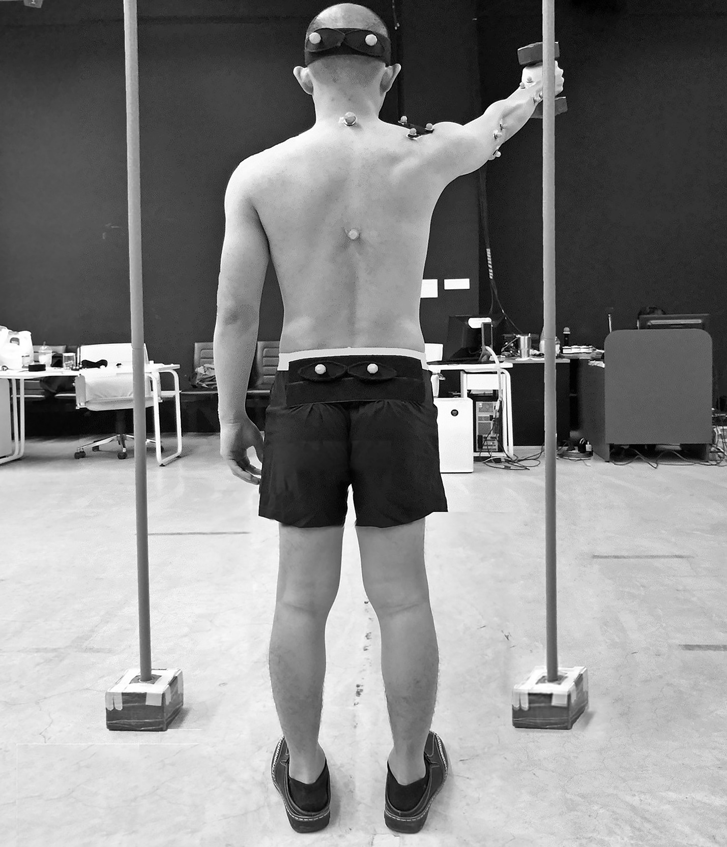
Fig. 1. Experimental setup

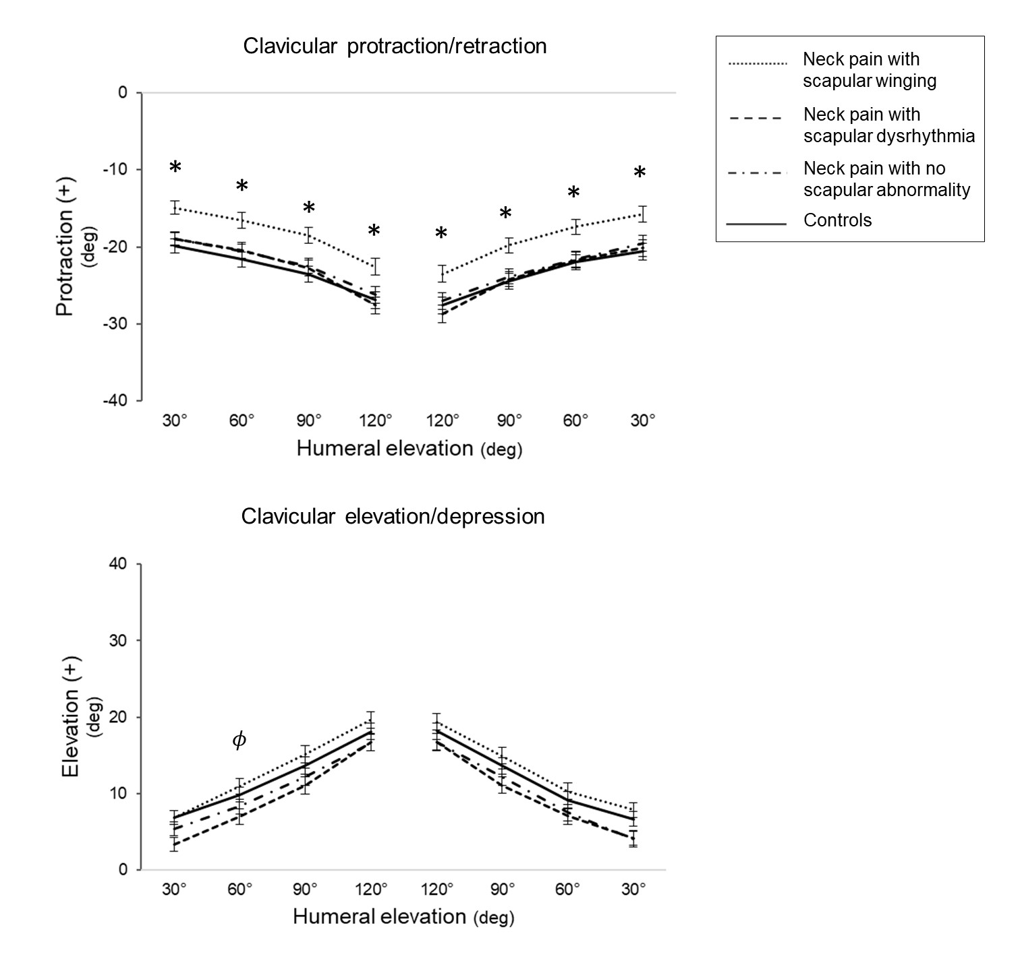
Fig. 2. Mean and standard error of clavicular kinematics during arm elevation and lowering between groups (neck pain with scapular winging, scapular dysrhythmia and no scapular abnormality, and asymptomatic controls). *Significant differences between scapular winging and the other groups (p < 0.01), ^{𝜙}Significant differences between scapular winging and dysrhythmia (p < 0.05)

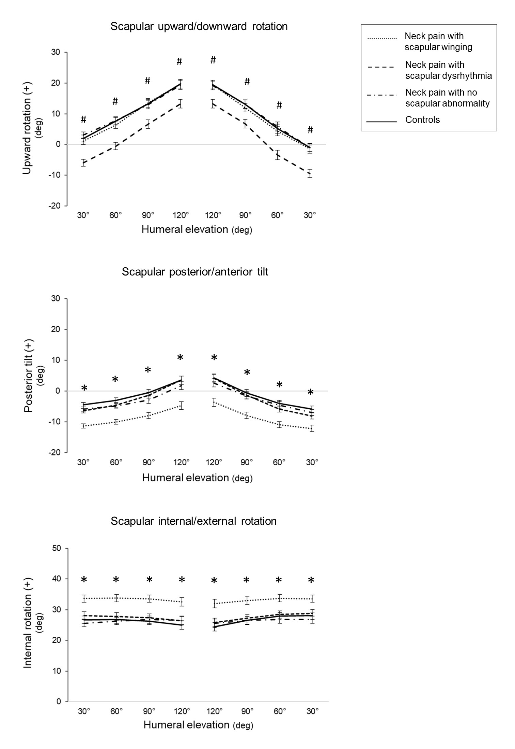
Fig. 3. Mean and standard error of scapular kinematics during arm elevation and lowering between groups (neck pain with scapular winging, scapular dysrhythmia and no scapular abnormality, and asymptomatic controls). *Significant differences between scapular winging and the other groups, #Significant differences between scapular dysrhythmia and the other groups (p < 0.01)

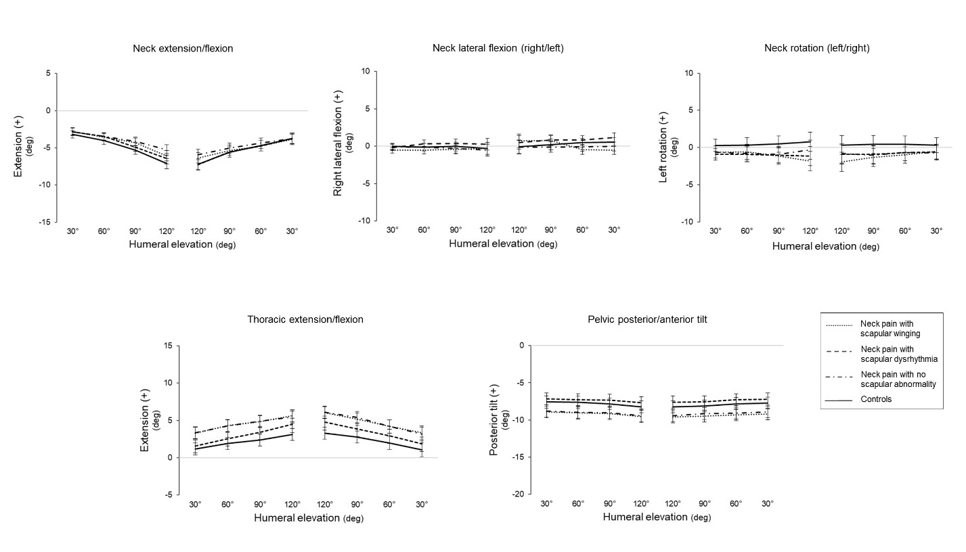
Fig. 4. Mean and standard error of spinal (neck, thoracic and pelvic) kinematics during arm elevation and lowering between groups (neck pain with scapular winging, scapular dysrhythmia and no scapular abnormality, and asymptomatic controls).

