Reducing antibiotic use in uncomplicated urinary tract infections in adult women: a systematic review and individual participant data meta-analysis

Yvonne Kaußner, PhD¹, Christian Röver PhD², Judith Heinz, PhD², Eva Hummers PhD³, Thomas P.A. Debray, PhD⁴, Alastair D Hay, FRCGP⁵, Stefan Heytens, PhD⁶, Ingvild Vik, PhD^{7,8}, Paul Little, FMedSci⁹, Michael Moore, FRCGP⁹, Beth Stuart, PhD⁹, Florian Wagenlehner, PhD¹⁰, Andreas Kronenberg, MD¹¹, Sven Ferry, PhD¹², Tor Monsen, PhD¹², Morten Lindbæk, PhD⁷, Tim Friede, PhD^{2*}, Ildikó Gágyor, PhD^{1,3,*}

* authors contributed equally

Author Affiliations:
¹ Department of General Practice, University Medical Center Wuerzburg, Germany
² Department of Medical Statistics, University Medical Center Goettingen, Germany
³ Department of General Practice, University Medical Center Goettingen, Germany
⁴ Julius Center for Health Sciences and Primary Care, University Medical Center Utrecht, Utrecht University, the Netherlands
⁵ Centre for Academic Primary Care, Bristol Medical School: Population Health Sciences, Bristol BS8 2PS
⁶ Department of Public Health and Primary Care, University of Ghent, Belgium
⁷ Antibiotic Centre of Primary Care, Department of General Practice, Institute of Health and Society, University of Oslo, Norway
⁸ Department of Emergency General Practice, Oslo Accident and Emergency Outpatient Clinic, Norway
⁹ Primary Care Research Centre, School of Primary Care Population Sciences and Medical Education Unit, Faculty of Medicine, University of Southampton, Aldermoor Health Centre, UK
¹⁰ Clinic for Urology, Pediatric Urology and Andrology, Justus Liebig University Giessen, Germany
¹¹ Institute for Infectious Diseases, University of Bern, Bern, Switzerland
¹² Department of Clinical Microbiology, Umeå University, Sweden

Correspondence to:
Yvonne Kaußner, PhD
Department of General Practice,
University Hospital Wuerzburg,
Josef-Schneider-Straße 2/ D7,
Phone: +4993120147811
97080 Wuerzburg, Germany,

E-mail address of all authors:
Yvonne Kaußner: kaussner_y@ukw.de (ORCID 0000-0002-4830-3647)
Christian Röver: christian.roever@med.uni-goettingen.de (ORCID 0000-0002-6911-698X)
Judith Heinz: judith.heinz@med.uni-goettingen.de (ORCID 0000-0001-8331-9137)
Eva Hummers: eva.hummers@med.uni-goettingen.de (ORCID 0000-0003-2707-6067)
Thomas Debray: t.debray@umcutrecht.nl (ORCID 0000-0002-1790-2719)
Alastair Hay: alastair.hay@bristol.ac.uk (ORCID 0000-0003-3012-375X)
Stefan Heytens: stefan.heytens@ugent.be (ORCID 0000-0003-1097-4987)
Ingvild Vik: ingvild.vik@medisin.uio.no (ORCID 0000-0002-8947-2914)
Paul Little: p.little@soton.ac.uk (ORCID 0000-0003-3664-1873)
Michael V. Moore: mvm198@soton.ac.uk (ORCID 0000-0002-5127-4509)
Beth Stuart: bls1@soton.ac.uk (ORCID 0000-0001-5432-7437)
Florian Wagenlehner: florian.wagenlehner@chiru.med.uni-giessen.de (ORCID 0000-0002-2909-0797)
Andreas Kronenberg: andreas.kronenberg@ifik.unibe.ch (ORCID 0000-0002-0006-7833)
Sven Ferry: sven.ferry@umu.se (ORCID 0000-0002-7333-5923)
Tor Monsen: tor.monsen@umu.se (ORCID 0000-0003-0516-7523)
Morten Lindbæk: morten.lindbak@medisin.uio.no
Tim Friede: tim.friede@med.uni-goettingen.de (ORCID 0000-0001-5347-7441)
Ildikó Gágyor: gagyor_i@ukw.de (ORCID: 0000-0002-7974-7603)

Manuscript word count: 3729

Abstract

Background
Randomised controlled trials (RCTs) investigated analgesics, herbal formulations, delayed prescription of antibiotics and placebo to prevent overprescription of antibiotics in women with uncomplicated urinary tract infections (uUTI).

Objectives
To estimate the effect of these strategies and to identify symptoms, signs or other factors that indicate a benefit from these strategies.

Data sources
MEDLINE, EMBASE, Web of Science, LILACS, Cochrane Database of Systematic Reviews and of Controlled Trials, and ClinicalTrials.

Study eligibility criteria, participants and interventions
RCTs investigating any strategies to reduce antibiotics versus immediate antibiotics in adult women with uUTI in primary care.

Data synthesis
We extracted individual participant data (IPD) if available, otherwise aggregate data (AD). Bayesian random-effects meta-analysis of the AD was used for pairwise comparisons. Candidate moderators and prognostic indicators of treatment effects were investigated using generalised linear mixed models based on IPD.

Results
We analysed IPD of 3524 patients from eight RCTs and AD of 78 patients.
Non-antibiotic strategies increased the rates of incomplete recovery (odds ratio [OR] 3.0; 95% credible interval [CI] 1.7-5.5; Bayesian p-value p_{B}=0.0017; τ=0.6), subsequent antibiotic treatment (OR 3.5 [95% CI 2.1, 5.8; p_{B}=0.0003) and pyelonephritis (OR 5.6; 95% CI 2.3, 13.9; p_{B}=0.0003). Conversely, they decreased overall antibiotic use by 63%.
In patients positive for urinary erythrocytes and urine culture were at increased risk for incomplete recovery (OR 4.7; 95% CI 2.1-10.8; p_{B} =0.0010), but no difference was apparent where both were negative (OR 0.8; 95% CI 0.3-2.0; p_{B} =0.667). In patients treated with using non-antibiotic strategies, urinary erythrocytes and positive urine culture were independent prognostic indicators for subsequent antibiotic treatment and pyelonephritis.

Conclusions and relevance
Compared to immediate antibiotics, non-antibiotic strategies reduce overall antibiotic use but result in poorer clinical outcomes. The presence of erythrocytes and tests to confirm bacteria in urine could be used to target antibiotic prescribing.

Keywords: cystitis, erythrocytes, antibiotics, general practice, analgesics, delayed prescription

Introduction
Uncomplicated urinary tract infections (uUTIs) are the most common bacterial infections in general practice¹ whereas up to 95% of women with symptoms suggestive of uUTIs are prescribed antibiotics.²⁻⁴ Given the rising levels of resistance⁵, strategies to reduce antibiotic use are of major interest. Several randomised controlled trials (RCTs) investigated analgesics, herbal formulations, delayed prescribing of antibiotics to reduce antibiotics and placebo in women with uUTIs.⁶⁻¹² Most of these trials suggest antibiotics to be more effective regarding clinical recovery, symptom burden, and the occurrence of pyelonephritis, but a reduction of antibiotic prescriptions by up to 84% was also demonstrated when using these strategies.⁷ A previous meta-analysis on placebo and two recent systematic reviews of RCTs evaluating different treatment strategies exist,¹³⁻¹⁵ but a comparison of these strategies has not yet been quantitatively summarised in a meta-analysis of individual participant data (IPD), the gold standard¹⁶ of evidence, especially in patients with differential treatment benefits.
Our objective was to conduct an IPD meta-analysis of RCTs comparing strategies to reduce antibiotics with immediate antibiotics (standard of care) in women with uUTIs in primary care. We aimed to assess (1) the effect of experimental strategies on symptoms, antibiotic use, and incidence of complications (specifically pyelonephritis and febrile UTI) and (2) to identify symptoms and signs or other factors that indicate a benefit from non-antibiotic strategies.

Methods
We performed a systematic review to identify eligible RCTs for meta-analysis and IPD meta-regression. We followed the Preferred Reporting Items for Systematic Reviews and Meta-Analyses (PRISMA statement).¹⁷ The protocol was published¹⁸ and registered with Prospero (CRD42019125804). The study was evaluated by the ethics review board of the University of Wuerzburg in August 2019 (ID 20129072301) No ethical objections were raised.

Search strategy
In April 2019, we performed a literature search in MEDLINE, EMBASE, Web of Science, LILACS, Cochrane Database of Systematic Reviews, Cochrane Central Register of Controlled Trials, Health Technology Assessment Database at the Centre for Reviews and Dissemination, and ClinicalTrials.gov databases for publications from 1990 to 2019. We updated the search in May 2021 and February 2022. Our search strategy addressed eligible RCTs using search terms including relevant medical subject headings and keywords such as urinary tract infection OR urinary tract infections OR UTI OR bacteriuria OR pyuria OR cystitis OR pyelonephritis) AND (antibiotic OR antibiotics OR anti-bacterial agents OR anti-microbial).¹⁸ The full search strategies are included in Supplement 4.

Study Selection
We included RCTs with adult women with symptoms suggestive of acute uUTI presenting to general practice. We considered patients eligible for the treatment group if a strategy to reduce antibiotic use was followed; patients immediately prescribed antibiotics formed the control group. Conference abstracts were excluded. There were no language restrictions.
Two investigators (CR, JH) independently screened the titles and abstracts of the retrieved publications. A third investigator (YK) rescreened all preselected studies. The three authors resolved disagreements by discussion.

Data collection and extraction
Two review authors (IG, TF) invited the authors of eligible studies to provide the IPD electronically via standardised anonymized data extraction sheets.¹⁸ Data transfers were performed via secured servers in compliance with relevant data protection regulations.¹⁹ If IPD were not available, we analysed the aggregated data (AD). Three authors (YK, CR, JH) screened the IPD and performed internal consistency checks against the published data. Discrepancies were resolved by querying the authors. We harmonised the data and different scales for UTI symptom scores (4, 5, 7-points) used in the studies to assess the severity of symptoms. We harmonised the data on UTI symptom severity, which was assessed with different symptom scores depending on the study (4, 5, and 7-point scales). We divided the absolute scores by their maximum score to express them in in a common percentage scale.²⁰ More than slight symptoms were defined as a score of more than 33% of the maximum score in the respective scale (Supplement Figure 1). The scores for dysuria, frequency, and urgency were averaged in order to derive an overall symptom score. For the definition of positive urine culture, which differs in most studies, we used the common denominator that would apply to all studies.²¹ This was the most important argument and in the case of E. coli, the most common pathogen, this limit also seemed justifiable.

Specification of outcome measures
The primary outcome incomplete recovery was a composite of more than slight symptoms (applied to at least one of the scores for dysuria, frequency, and urgency assessed last between days 3 and 7), or subsequent antibiotic treatment defined as antibiotics following experimental treatment during a follow-up of 14-49 days, or occurrence of complications (pyelonephritis, febrile UTI, or sepsis) during follow-upof.
Secondary outcomes were subsequent antibiotic treatment, symptom burden on days 2 and 3–7 (last assessment), clinical recovery (symptom score of 0 for dysuria, frequency, and urgency assessed last between days 3 and 7), and recurrent UTI.
Safety outcomes were serious adverse events (SAEs) or non-UTI-related adverse events (AEs).
After data screening, we added incomplete symptomatic recovery, defined as more than slight symptoms, as assessed last between days 3 and 7, and overall antibiotic use (number of courses including experimental antibiotics) as explorative outcomes. We combined relapses and recurrent UTIs (re-occurrence of UTI symptoms within 14 days vs. after 14 days)²² into a single dichotomous relapse/recurrent UTI outcome and analysed complications (pyelonephritis, febrile UTI and sepsis) as an additional safety outcome.

Quality assessment
Two authors (YK, JH) independently evaluated the quality of each study using the Cochrane risk-of-bias tool, disagreements were resolved by consensus with a third author (CR).²³ We generated funnel plots to detect publication bias.²⁴ To assess data availability bias, we compared studies with and without IPD.²⁵
We used the five GRADE (grading of recommendations assessment, development, and evaluation) considerations (study limitations, consistency of effect, imprecision, and publication bias) to assess the certainty of evidence for our analyses of the primary, main secondary and safety outcomes.²⁶

Data analysis
To estimate the effects of the non-antibiotic strategies versus immediate antibiotics we used pairwise meta-analysis for the primary, secondary and safety outcomes.
To identify patients who benefited from a particular treatment, we applied a meta-regression to the analysis of candidate treatment moderators. Accordingly, meta-regression was applied to identify prognostic indicators of the treatment effect in patients treated with non-antibiotic strategies. We stratified the analyses using random study effects. For two-stage methods involving AD, we assumed a normal likelihood in the meta-analysis models. We used generalised linear mixed models for the one-stage methods involving IPD. For meta-regression analyses, we included studies with patient-level data available on the relevant covariates.
Primary analyses focused on odds ratios (ORs) as effect measures for binary endpoints, risk ratios (RRs) were explored as alternatives. We calculated the incidence rate ratios (IRRs) for counts, and mean differences (MDs) for metric outcomes. Heterogeneity was quantified in terms of between-study standard deviation (τ). In a sensitivity analysis, we explored the results based on subgroups of trials evaluating similar treatments if a sufficient number of trials was available. Here, we further explored the values of τ for all studies, in comparison to the subgroups of trials evaluating similar treatments. We conducted analyses using Bayesian methods with uninformative priors for treatment effects and weakly informative priors for between-study variability (heterogeneity).²⁷
To identify symptoms and signs and other factors that could indicate benefit from non-antibiotic treatment we adopted multilevel models that adjusted treatment effect estimates for candidate treatment moderators, their combinations and (two-way) interactions on patient-level. Before including the moderators, we checked for consistency with AD analyses. To identify prognostic indicators, we proceeded similarly with patients assigned to any of the non-antibiotic treatment strategies.
Age, symptom burden, and duration of patient-reported symptoms at baseline, urine culture, leukocytes, erythrocytes, and nitrites were analysed as candidate moderators of treatment effects defined by the outcomes of incomplete recovery, incomplete symptomatic recovery, subsequent antibiotic treatment, symptom score, and occurrence of complications.
To identify prognostic indicators for clinical recovery, subsequent antibiotic treatment, and complications we investigated the non-antibiotic groups only. We used univariable and multivariable methods, including binary and continuous covariables, to develop prognostic models for the respective outcomes. For detailed analysis we considered different concentrations of prognostic indicators identified to be significant (e.g. erythrocytes) if available.
Effect estimates (ORs, IRRs, or MDs) are quoted along with 2-sided 95% credible intervals (CIs) and two-sided posterior tail probabilities (p_{B}). P_{B} values are analogous counterparts to (frequentist) P-values and are similarly connected to CIs.
Descriptive summaries were used to describe the study-level and patient-level characteristics including the occurrence of missing values. Metric variables were characterised by mean, median, and standard deviation (SfD; range), discrete variables by absolute or relative frequencies.
We used the R environment for statistical computing (version 3.6.3, add-on packages bayesmeta, brms, and forestplot) and RevMan for the quality assessment.²⁸

Results
Of 6090 publications 65 were checked by a full text screening and found 47 of them not eligible for inclusion (for details see Supplement 3). In nine of the remaining 18 RCTs, outcome data for the MA were not available (for details see Supplement 3) and enquiries to the authors were not answered. Finally, nine RCTs were eligible (Figure 1). ^{6-9,29-33} Four trials investigated analgesics, two herbal formulations and placebo respectively. One study addressed delayed antibiotic prescribing. We analysed the IPD of 3524 patients from eight trials and AD of 78 additional patients from one trial.⁸ We excluded one 17-year-old participant.⁹ For missing values, see Supplement Table 1.
The median age of the patients varied between 25 and 45 years. Symptom severity at baseline was similar across trials, as was the laboratory data, except for one where only 33% of participants were positive for urine erythrocytes (Table 1, Supplement Table 2).

Quality assessment
We assessed the bias as low risk in all domains for three studies²⁹⁻³¹ and as high risk in three trials^{8,9,33} in up to two domains. The risk was unclear in up to three domains, mainly due to lacking information^{6-9,29-33} (Supplement Figure 2).

Outcome Measures
Strategies to reduce antibiotics were associated with a higher rate of incomplete recovery than immediate antibiotics (OR 3.0; 95% CI 1.7-5.5; p_{B}=0.0017, Figure 2). ORs for the single studies and different non-antibiotic strategies varied between 1.3 (95% CI 0.9-1.8) and 8.0 (95% CI 4.6-13.9). The rate of subsequent antibiotic treatment was higher (OR 3.5; 95% CI 2.1-5.8; p_{B}=0.0003; Figure 2), the total number of antibiotic courses administered, however, was reduced by 63% (IRR 0.4; 95% CI 0.2-0.6; p_{B} = 0.00024, Figure 2) in the groups using non-antibiotic strategies. Pyelonephritis and febrile UTIs were less frequent with immediate antibiotics (OR=5.6; 95% CI 2.3-13.9; p_{B}=0.0003). Urosepsis was not reported. Non-antibiotic strategies were associated with increased rates of incomplete symptomatic recovery (OR 2.2; 95% CI 1.3-3.8; p_{B}=0.0073, Figure 2). Symptom burden on day 2 was higher with strategies to reduce antibiotics (MD 9.7; 95% CI 5.5-13.1; p_{B}=0.0013). Non-antibiotic strategies had no significant effect on the rates of relapses/recurrent UTIs (OR 1.7; 95% CI 0.9-3.2; p_{B}=0.1), AEs (OR 0.8, CI 0.6-1.1; p_{B}=0.13), and SAEs (OR 2.2 CI 0.7-6.2; p_{B}=0.16) (Supplement Figures 3,4).
Results for the subgroup of trials using analgesics (Figure 2, Supplement Figures 3,4) indicate similar results with larger ORs for the incomplete recovery (OR 4.5; 95% CI 2.4-8.0; p_{B}=0.0006), subsequent antibiotic treatment (OR 4.5; 95% CI 2.3-8.2; p_{B}=0.0008) as well as pyelonephritis and febrile UTI (OR 9.1; 95% CI 2.1-38.7; p_{B}=0.003).
The certainty of evidence was moderate for most outcomes, and low for symptom burden on days 3–7 and relapse/recurrent UTIs (Supplement Figure 8). Funnel plots were of limited value because of the small number of studies.²⁴
The between-trial heterogeneity was lowest for safety outcomes and highest for relapse/recurrent UTI, incomplete recovery, and incomplete symptomatic recovery (Figure 2). Due to the small number of studies, we restricted sensitivity analyses to the subgroup of studies using analgesics in the treatment group. Symptom related outcomes showed lower heterogeneity for analgesics than for all trials (Figure 2, Supplement Figures 3,4).
Comparisons of AD with IPD estimates showed consistent results, with slightly higher ORs in the IPD for complications (Supplement Table 3). Similarly, ORs and RRs showed agreement for most outcomes (Supplement Table 4).

Moderator analyses
Urine erythrocytes as well as urine culture results were independent significant moderators of the treatment effect for the whole population (Figure 3, Supplement Figures 5, 6). Non-antibiotic strategies were associated with higher rates of incomplete recovery when either moderator was positive. Incomplete recovery was most likely in patients receiving non-antibiotic strategies, when both were positive (OR 4.7; 95% CI 2.1-10.8) and there was no difference compared to immediate antibiotics when both were negative (OR 0.8; 95% CI 0.3-2.0) (Figure 3). In analgesic trials, urine erythrocytes were the only statistically significant moderator of incomplete recovery (Supplement Figure 6).

Prognostic indicators
Erythrocytes in urine and urine culture results were also prognostic indicators for subsequent antibiotic treatment and complications in the treatment groups (Figure 3). The best model fit for subsequent antibiotics was achieved when both factors were jointly included (presence of erythrocytes: OR 2.4; 95% CI 1.6-3.7; p_{B}=0.0014; positive urine culture results: OR 3.2; 95% CI 1.9-5.6; p_{B}=0.0008). The same was true for complications (presence of erythrocytes: OR 5.2; 95% CI 1.6-20.7; p_{B}=0.018; positive urine culture: OR 3.8; 95% CI 1.2-14.9; p_{B}=0.004) (Supplement Table 5). When both were positive, the OR for subsequent antibiotic treatment increased by approximately eightfold (2.4 × 3.2) and by about 20 times for complications (5.2 × 3.8) in comparison to none of them being positive.
For clinical recovery, only the maximum score remained in the model (OR 0.99; 95% CI 0.98-1.0; p_{B}=0.031), indicating that 25% higher ratings on the respective symptom scale corresponds to a decreasing OR of 0.99^²⁵=0.80 (Supplement Table 5). In analgesic trials, leukocytes were also associated with complications (Supplement Table 5, Figure 6).
In other combinations of factors (symptoms, dipstick test results, urine culture results)we could not identify any further interactions.
When urine culture was excluded from the models, the prognostic indicators remained the same for all outcomes (Supplement Table 6).
Exploratory analyses on the prognostic value of different erythrocyte concentrations (1+, 2+, 3+, 4+) showed that the odds for complications, incomplete recovery and subsequent antibiotic treatment increased by approximately 1.4 fold with each degree of erythrocyte concentration, while no impact was found for clinical recovery (Supplement Table 7, Figure 7).

Discussion
The investigated non-antibiotic strategies were associated with a threefold increase in the rate of incomplete recovery compared to immediate antibiotic treatment. Assuming a rate of 25% with immediate antibiotics, this would correspond to a number needed to harm (NNH) of five for non-antibiotic strategies. Similar effects were observed for the secondary and safety outcomes, specifically, occurrence of pyelonephritis and febrile UTI, incomplete symptomatic recovery, and clinical recovery. Subsequent treatment with antibiotics was less likely in the antibiotic groups: those who had already been treated with antibiotics had a lower risk of follow-up antibiotics than those who had not. On the other hand, strategies to reduce antibiotics lowered the overall use of antibiotics by 63%; a relevant finding from the perspective of antimicrobial stewardship.
A meta-analysis of placebo-controlled trials and a recent systematic review of trials on analgesics vs. antibiotics in women with uUTIs, further demonstrated the superiority of immediate antibiotics for symptom-related outcomes.^{13,14} The added value of our study is the larger sample size and the access to IPD allowing detailed analyses to identify patients who might benefit from a differential treatment effect.
As expected from its low annual incidence of approximately 0.02% in middle-aged women,³⁴ the proportion of patients with pyelonephritis or febrile UTIs was low. However, there was a significant difference between the groups (0.4% in the immediate antibiotics versus 3.6% in the non-antibiotic group). The low incidence of these complications may explain why an increased risk has not been consistently proven in earlier studies^{8,9} and why even in our meta-analysis, the incidence was too low to establish reliable risk estimates. Furthermore, effects such as masking of symptoms and inhibition of the immune response may account for the higher rates of pyelonephritis in the analgesic studies. ³⁵ Therefore, analysing large-scale registries, may be necessary to obtain robust evidence.^{36,37}
Despite various experimental treatment strategies considered, heterogeneity was moderate in the primary and secondary outcomes. Relapse/recurrent UTIs were an exception, with a rather high heterogeneity that might be explained, by combining the original two variables, relapse and recurrence, into a single variable. Interestingly, one might suppose a lower heterogeneity in analgesics trials only, but we could only confirm this for symptom-related outcomes. Further sources of heterogeneity were the differences in populations and design (e.g. blinded vs. non-blinded) and in the definitions and operationalisations of outcomes. In addition, non-antibiotic treatment strategies and control antibiotics differed between trials. This may explain why the authors of the systematic review on analgesics considered the heterogeneity to be too high to perform a meta-analysis.¹⁴
The history of recurrent UTIs could also be a source of heterogeneity and may have affected the results. These data were not included in our analyses because they were only available in a few studies. Some studies excluded patients with recurrent UTIs^{7,32} and other studies did not collect these data.^{6,8-11,29}
Our analyses suggest that erythrocytes in urine and positive urine cultures are significant moderators of the treatment effect. Incomplete recovery was more likely when both moderators were positive, but no difference between immediate antibiotics and non-antibiotic strategies studied was shown when both were negative. Analysis of prognostic indicators in the non-antibiotic groups revealed that the presence of erythrocytes and a positive urine culture with a bacterial count of ≥10³ cfu/ml were distinctly prognostic for subsequent antibiotic treatment and pyelonephritis and febrile UTI. The opposite was shown when both indicators were absent.
In our study, 10% of the participants had negative urine cultures and erythrocytes, while approximately 55% showed both positive erythrocytes and urine cultures and would most likely benefit from immediate antibiotics. Further, 21% had negative erythrocytes and positive urine cultures, and 14% had positive erythrocytes, but negative urine cultures (Table 1). For these patients, the prognostic model indicated a benefit from antibiotics compared to non-antibiotic strategies regarding subsequent antibiotic treatment. Assuming incomplete recovery rates of 25% with immediate antibiotics, this would correspond to a NNH of 10 with non-antibiotic strategies when erythrocytes are negative regardless of whether the urine culture is positive or negative. In case of negative erythrocytes but positive urine culture NNH would be six. For the diagnosis of UTI, haematuria in dipstick analysis has the highest sensitivity but lowest specificity among all variables.³³ In contrast to leucocyturia, haematuria can be seen by the patient itself and lead her to seek medical help. In addition, alpha-haemolysin was described as a toxin in E. coli not only causing early haematuria but implying higher risk for invasive infection including intravascular haemolysis and thrombopenia, too.³⁸ Therefore, as seen in our study, haematuria may be a risk factor for more severe courses of disease, with potential benefit for early antibiotic therapy.
Currently, antibiotics are prescribed for up to 95% of women with symptoms suggestive of uUTI, and only erythrocytes in the urine can be determined at the point of care.^{3,4}
Previous evidence focused more on the diagnosis of UTI than on treatment outcomes. Accordingly, the diagnostic value of erythrocytes in urine has been assessed in several studies.^{32,39,40} Leucocytes, nitrites, age, symptom severity and duration, and bladder incubation time were found to be prognostic for the diagnosis of UTI in prior studies, but we were unable to confirm these findings consistently for our outcomes.^{32,39-41} We identified leukocytes as prognostic indicators for complications in analgesic trials only, and symptom severity for clinical recovery only. The use of antibiotics targeted only to those patients who are more likely to suffer from adverse outcomes is desirable and, in light of our findings, has a potentially large scope for development, given that the proportion of symptomatic women with erythrocytes in urine and positive urine cultures varies.^{3,4,11} For the treatment choice, patients and clinicians should discuss potential benefits and harms of any treatment in the sense of a shared decision making. New techniques that enable the detection of bacteria in urine at the point of care are required.
The main strength of our trial was availability of the IPD from eight trials that allowed the computation of the harmonised primary outcome, incomplete recovery, across all trials, as well as the joint analysis of all strategies that enhanced the strength of evidence. Consequently, well-founded analyses of effect moderators and prognostic indicators were performed to identify patients who might benefit from non-antibiotic treatments.
We described sources of heterogeneity and discussed that publication bias could not be assessed via funnel plots due to the limited number of studies included. We looked at different strategies to reduce antibiotic use, assuming that uUTI is usually a self-limiting condition and expected the results of the studies to be determined more by the fact that antibiotic treatment could be avoided or postponed by all interventions than by the differences between the individual strategies. IPD could not be retrieved from one trial, therefore, data availability bias was difficult to assess.⁸ For two studies, we were unable to analyse incomplete recovery because of data on subsequent antibiotic use were missing. To be able to consider all studies, we analysed incomplete symptomatic recovery as an additional exploratory outcome. ^{9,10} For the outcomes incomplete recovery and incomplete symptomatic recovery, we set more than slight symptoms on at least one of the scores as a criterion. This was the closest to the patient reported outcome duration of moderately bad symptoms that has been used in clinical trials.^{10,11,42}
One trial did not show a difference between an herbal formulation and antibiotics for our primary and most secondary outcomes.⁷ It was, however, an outlier with 100% of the patients having pyuria since this was an inclusion criterion and it was also an outlier with only 33% of the patients having erythrocytes. It therefore remains unclear whether it was the low rate of erythrocytes or the actual effectiveness of the herbal formulation that was responsible for the favourable outcome. The latter was suggested by a recent retrospective database analysis,⁴³ Finally, we could not evaluate other herbal formulations such as cranberry because they have only been investigated as prevention of UTI, as add-on to antibiotics, or in feasibility studies. ⁴⁴

Conclusions
Compared to immediate antibiotics, non-antibiotic strategies reduce overall antibiotic use but result in poorer clinical outcomes in women with uUTI. The presence of erythrocytes and tests to confirm bacteria in urine could be used to target antibiotic prescribing.

.

Author Contributions
Conzeptualiziation: EH, ADH, SH, IV, PL, MM, BS, FW, AK, SF, TM, ML, TF, IG
Data curation: YK, CR, JH
Formal analysis: CR, TD, TF
Funding acquisition: TF, IG
Investigation: YK, CR, JH, TF, IG
Methodology: Cr, TD, TF
Project administration: YK
Resources: YK, IG
Software: CR
Supervision: TF, IG
Validation: YK, CR, JH
Visualisation: YK, CR
Writing original draft: YK, CR, JH, IG
Writing review & editing: EH, TD, ADH, SH, IV, PL, MM, BS, FW, AK, SF, TM, ML, TF

References
1 Foxman B. Urinary tract infection syndromes: occurrence, recurrence, bacteriology, risk factors, and disease burden. Infect Dis Clin 2014; 28(1): 1-13.
2 Mulder M, Baan E, Verbon A, Stricker B, Verhamme K. Trends of prescribing antimicrobial drugs for urinary tract infections in primary care in the Netherlands: a population-based cohort study. BMJ Open 2019; 9(5): e027221.
3 Butler CC, Francis N, Thomas-Jones E, et al. Variations in presentation, management, and patient outcomes of urinary tract infection: a prospective four-country primary care observational cohort study. Br J Gen Pract 2017; 67(665): e830-e41.
4 Gágyor I, Strube-Plaschke S, Rentzsch K, Himmel W. Management of urinary tract infections: what do doctors recommend and patients do? An observational study in German primary care. BMC Infect Dis 2020; 20(1): 813.
5 Breijyeh Z, Jubeh B, Karaman R. Resistance of Gram-Negative Bacteria to Current Antibacterial Agents and Approaches to Resolve It. Molecules 2020; 25(6): 1340.
6 Vik I, Bollestad M, Grude N, et al. Ibuprofen versus pivmecillinam for uncomplicated urinary tract infection in women—A double-blind, randomized non-inferiority trial. PLoS Med 2018; 15(5): e1002569.
7 Wagenlehner FM, Abramov-Sommariva D, Höller M, Steindl H, Naber KG. Non-Antibiotic Herbal Therapy (BNO 1045) versus Antibiotic Therapy (Fosfomycin Trometamol) for the Treatment of Acute Lower Uncomplicated Urinary Tract Infections in Women: A Double-Blind, Parallel-Group, Randomized, Multicentre, Non-Inferiority Phase III Trial. Urol Int 2018; 101(3): 327-36.
8 Christiaens TCM, De Meyere M, Verschraegen G, Peersman W, Heytens S, De Maeseneer JM. Randomised controlled trial of nitrofurantoin versus placebo in the treatment of uncomplicated urinary tract infection in adult women. Br J Gen Pract 2002; 52(482): 729-34.
9 Ferry SA, Holm SE, Stenlund H, Lundholm R, Monsen TJ. The natural course of uncomplicated lower urinary tract infection in women illustrated by a randomized placebo controlled study. Scand J Infect Dis 2004; 36(4): 296-301.
10 Little P, Moore MV, Turner S, et al. Effectiveness of five different approaches in management of urinary tract infection: randomised controlled trial. BMJ 2010; 340: c199.
11 Moore M, Trill J, Simpson C, et al. Uva-ursi extract and ibuprofen as alternative treatments for uncomplicated urinary tract infection in women (ATAFUTI): a factorial randomized trial. Clin Microbiol Infect 2019; 25(8): 973-80.
12 Ferry SA, Holm SE, Stenlund H, Lundholm R, Monsen TJ. Clinical and bacteriological outcome of different doses and duration of pivmecillinam compared with placebo therapy of uncomplicated lower urinary tract infection in women: The LUTIW project. Scand J Prim Health Care 2007; 25(1): 49-57.
13 Falagas ME, Kotsantis IK, Vouloumanou EK, Rafailidis PI. Antibiotics versus placebo in the treatment of women with uncomplicated cystitis: A meta-analysis of randomized controlled trials. J Infect 2009; 58(2): 91-102.
14 Carey MR, Vaughn VM, Mann J, Townsend W, Chopra V, Patel PK. Is Non-Steroidal Anti-Inflammatory Therapy Non-Inferior to Antibiotic Therapy in Uncomplicated Urinary Tract Infections: a Systematic Review. J Gen Intern Med 2020; 35(6): 1821-9.
15 Hoffmann T, Peiris R, Mar CD, Cleo G, Glasziou P. Natural history of uncomplicated urinary tract infection without antibiotics: a systematic review. Br J Gen Pract 2020; 70(699): e714-e22.
16 Thomas D, Radji S, Benedetti A. Systematic review of methods for individual patient data meta- analysis with binary outcomes. BMC Med Res Methodol 2014; 14(1): 79.
17 Stewart LA, Clarke M, Rovers M, et al. Preferred Reporting Items for Systematic Review and Meta-Analyses of individual participant data: the PRISMA-IPD Statement. Jama 2015; 313(16): 1657-65.
18 Heinz J, Röver C, Furaijat G, et al. Strategies to reduce antibiotic use in women with uncomplicated urinary tract infection in primary care: protocol of a systematic review and meta-analysis including individual patient data. BMJ Open 2020; 10(10): e035883.
19 General Data Protection Regulation. https://gdpr-info.eu.
20 de Jonge, T, Veenhoven, R, Arends L. Homogenizing Responses to Different Survey Questions on the Same Topic: Proposal of a Scale Homogenization Method Using a Reference Distribution. Soc Indic Res 2014; 117: 275–300.
21 Aspevall O, Hallander H, Gant V, et al. European guidelines for urinalysis: a collaborative document produced by European clinical microbiologists and clinical chemists under ECLM in collaboration with ESCMID. Clin Microbiol Infect 2001; 7(4): 173-178.
22 Interdisziplinäre S3 Leitlinie: Epidemiologie, Diagnostik, Therapie, Prävention und Management unkomplizierter, bakterieller, ambulant erworbener Harnwegsinfektionen bei erwachsenen Patienten. Langversion 1. AWMF Registernummer: 043/044. 2017. http://www.awmf.org/uploads/tx_szleitlinien/043-044l_S3_Harnwegsinfektionen.
23 Higgins J, Thomas J, Chandler J, et al. Cochrane Handbook for Systematic Reviews of Interventions version 6.2 (updated February 2021). 2021. http://www.training.cochrane.org/handbook (accessed 26.5.2022).
24 Sterne JAC, Sutton AJ, Ioannidis JPA, et al. Recommendations for examining and interpreting funnel plot asymmetry in meta-analyses of randomised controlled trials. BMJ 2011; 343: d4002.
25 Ahmed I, Sutton AJ, Riley RD. Assessment of publication bias, selection bias, and unavailable data in meta-analyses using individual participant data: a database survey. BMJ 2012; 344: d7762.
26 Atkins D, Best D, Briss PA, et al. Grading quality of evidence and strength of recommendations. Bmj 2004; 328(7454): 1490.
27 Röver C, Bender R, Dias S, et al. On weakly informative prior distributions for the heterogeneity parameter in Bayesian random-effects meta-analysis. Res Synth Methods 2021; 12(4): 448-74.
28 Team RC. R: A language and environment for statistical computing. 2020. https://www.R-project.org/ (accessed 26.5.2022).
29 Bleidorn J, Gágyor I, Kochen MM, Wegscheider K, Hummers-Pradier E. Symptomatic treatment (ibuprofen) or antibiotics (ciprofloxacin) for uncomplicated urinary tract infection? - Results of a randomized controlled pilot trial. BMC Medicine 2010; 8(1): 30.
30 Gágyor I, Bleidorn J, Kochen MM, Schmiemann G, Wegscheider K, Hummers-Pradier E. Ibuprofen versus fosfomycin for uncomplicated urinary tract infection in women: randomised controlled trial. BMJ 2015; 351: h6544.
31 Gágyor I, Hummers E, Schiemann G, et al. Herbal Treatment with Uva Ursi Extract Versus Fosfomycin in Women with Uncomplicated Urinary Tract Infection in Primary Care: A Randomized Controlled Trial. Clin Microbiol Infect 27: 1441-1447.
32 Kronenberg A, Bütikofer L, Odutayo A, et al. Symptomatic treatment of uncomplicated lower urinary tract infections in the ambulatory setting: randomised, double blind trial. BMJ 2017; 359: j4784.
33 Little P, Turner S, Rumsby K, et al. Dipsticks and diagnostic algorithms in urinary tract infection: development and validation, randomised trial, economic analysis, observational cohort and qualitative study. Health Technol Assess 2009; 13: 19.
34 Medina M, Castillo-Pino E. An introduction to the epidemiology and burden of urinary tract infections. Ther Adv Urol 2019; 11: 1756287219832172.
35 Bancos S, Bernard MP, Topham DJ, Phipps RP. Ibuprofen and other widely used non-steroidal anti-inflammatory drugs inhibit antibody production in human cells. Cell Immunol. 2009; 258(1):18-28.
36 Gulliford MC, Moore MV, Little P, et al. Safety of reduced antibiotic prescribing for self limiting respiratory tract infections in primary care: cohort study using electronic health records. BMJ 2016; 354: i3410.
37 Gulliford MC, Sun X, Charlton J, et al. Serious bacterial infections and antibiotic prescribing in primary care: cohort study using electronic health records in the UK. BMJ Open 2020; 10(2): e036975.
38 Johnsen N, Hamilton ADM, Greve AS, Christensen MG, Therkildsen JR, Wehmöller J, Skals M, Praetorius HA. α-Haemolysin production, as a single factor, causes fulminant sepsis in a model of Escherichia coli-induced bacteraemia. Cell Microbiol 2019 21(6): e13017.
39 Gágyor I, Haasenritter J, Bleidorn J, et al. Predicting antibiotic prescription after symptomatic treatment for urinary tract infection: development of a model using data from an RCT in general practice. Br J Gen Pract 2016; 66(645): e234-e40.
40 McIsaac WJ, Moineddin R, Ross S. Validation of a Decision Aid to Assist Physicians in Reducing Unnecessary Antibiotic Drug Use for Acute Cystitis. Arch Intern Med 2007; 167(20): 2201-6.
41 Ferry SA, Holm SE, Ferry BM, Monsen TJ. High Diagnostic Accuracy of Nitrite Test Paired with Urine Sediment can Reduce Unnecessary Antibiotic Therapy. Open Microbiol J 2015; 9: 150-9.
42 Little P, Francis NA, Stuart B, et al. Antibiotics for lower respiratory tract infection in children presenting in primary care in England (ARTIC PC): a double-blind, randomised, placebo-controlled trial. Lancet. 2021 Oct 16;398(10309):1417-1426.
43 Höller M, Steindl H, Abramov-Sommariva D, Wagenlehner F, Naber KG, Kostev K. Treatment of Urinary Tract Infections with Canephron® in Germany: A Retrospective Database Analysis. Antibiotics. 2021; 10(6):685.
44 Gbinigie O, Allen J, Williams N, et al. Does cranberry extract reduce antibiotic use for symptoms of acute uncomplicated urinary tract infections (CUTI)? A feasibility randomised trial. BMJ Open 2021; 11(2): e046791

Transparency Declaration

Conflict of interest disclosures
IG, GF, TF, EH, and MM were included in the studies with reference number³¹.
IV and ML were involved in the study with the reference number⁶.
SH was involved in the study with the reference number⁸.
PL and MM were involved in the study with the reference number¹⁰.
SF and TM were involved in the study with the reference number⁹.
IG, EH were involved in the studies with the reference numbers^{29,39}.
FW was involved in the study with the reference number⁷.
AK was involved in the study with the reference number³².
ADH was supported by the NIHR Senior Investigator Award (NIHR200151).

Funding
The study was funded by the Federal Ministry of Education and Research (No. 01KG1801) (www.bmbf.de). The funder was not involved in the study design, data collection, analysis, interpretation, writing the report, or in the decision to submit the paper for publication.

Acknowledgments
We are very grateful to Peter Jüni and Thierry Christiaens for their support in drafting the proposal for this project. We would also like to thank Christopher Schuchardt for his support in screening retrieved publications, Peter Konstantin Kurotschka for providing helpful feedback on the manuscript and all members of our patient and public involvement panel for their input and feedback.

Access to data
All de-identified IPDs, as provided by the primary authors, can be shared upon reasonable request to the corresponding author at kaussner_y@ukw.de (ORCID 0000-0002-4830-3647) after publication.

Table 1: Randomized controlled trials included in the meta-analysis and baseline characteristics of the study samples.
 | Country | Treatment/ control | Number of patients (treatment/ control) | Age  (years) | Symptom score* | Symptom duration (days) † | Urine culture positive‡ § ¶ | Urine Leukocytes positive ‡ | Urine  Erythrocytes positive‡ § | Urine Nitrites positive ‡
 |  |  | N(n/n) | Median (IQR) | Mean (SD) | Mean (SD) | % | % | % | %
Bleidorn 2010 | Germany | Ibuprofen/ ciprofloxacin | 77 (39/38) | 44 (33–60 | 56.6 (24.8) | 4.1 (6.1) | 81 | 88 | NA. | 30
Christiaens 2002†† | Belgium | Placebo/ nitrofurantoin | 78 (38/40) | 30 (NA) | NA | NA | 72 | NA | NA | NA
Ferry 2004 | Sweden | Placebo/ pivmecillinam | 1142(287/855) | 41 (26–58) | 64.6 (23.3) | 9.8 (19.5) | 77 | 71 | 80 | 40
Gágyor 2015 | Germany | Ibuprofen/ fosfomycin | 494 (248/246) | 35 (24–49) | 58.7 (23.5) | 2.3 (0.9) | 76 | 84 | 76 | 20
Gágyor 2021 | Germany | Uva ursi||/ fosfomycin | 398 (207/191) | 45 (29–57) | 62.4 (18.7) | 5.3 (10.2) | 88 | 83 | 78 | 21
Kronenberg 2017 | Switzerland | Diclofenac/ norfloxacin | 253 (133/120) | 32 (25–48) | 59.1 (13.8) | 2.5 (0.8) | 73 | 94 | 82 | 14
Little 2010 | UK | Delayed prescription/ trimethoprim | 120 (62/58) | 41 (NA) | 41.9 (31.0) | NA | NA | NA | NA | NA
Vik 2018 | Norway, Sweden, Denmark | Ibuprofen/ mecilinam | 383 (194/189) | 25 (21–32) | 69.0 (19.7) | 1.9 (1.1) | 65 | 93 | 80 | 18
Wagenlehner 2018 | Ukraine, Poland, Germany | BNO 1045**/ fosfomycin | 657 (325/332) | 45 (30–59) | 58.2 (9.1) | 1.7 (1.1) | 77 | 100 | 33 | 34
* Mean percentage of the maximum value of the appropriate rating scale (see Supplement Figure 1; † the first day was set to 0 for all studies by default . ‡ data were collected using a dipstick, apart from Ferry et al., who used microscopy. § Negative urine cultures and negative erythrocytes concerned 10% of participants, 55% of participants showed positive erythrocytes and urine cultures, 21% had negative erythrocytes and positive urine cultures, and 14% had positive erythrocytes but negative urine cultures. ¶ The cut-off value for positive urine culture could be harmonized to 10³ cfu/ml for all trials apart from Christiaens et al., where 10⁵ cfu/ml were used. || Bearberry (Arctostaphylos Uva Ursi), **BNO 1045 consists of Centaury herbs (Centaurium erythraea Rafn, herba), lovage roots (Levisticum officinale Koch, radix), and rosemary leaves (Rosmarinus officinalis L., folium); †† for this trial no individual participant data could be provided so that published aggregated data was analysed.
CFU, colony-forming units; uUTI, uncomplicated urinary tract infection; IQR, interquartile range; SD, standard deviation; NA, not available.

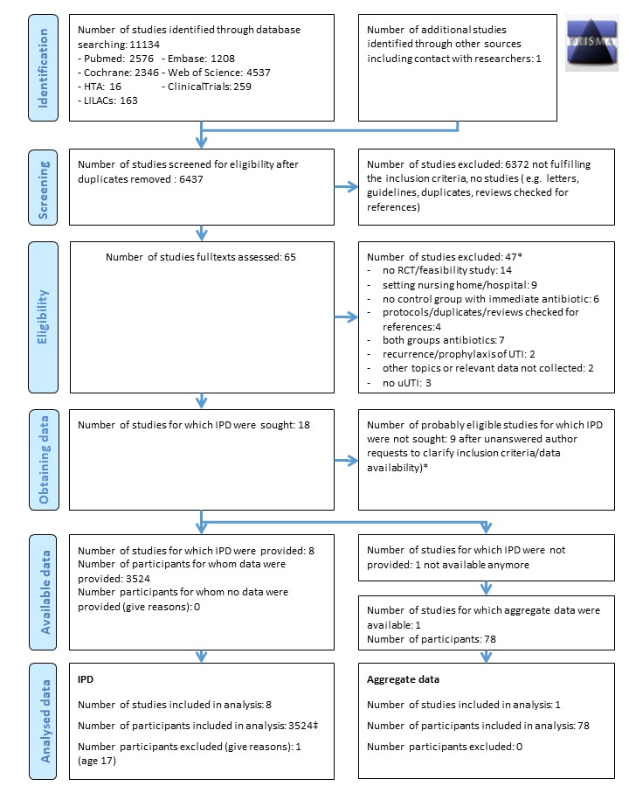
Figure 1: Study selection.
IPD, individual participant data; RCT, randomised controlled trial; uUTI, uncomplicated urinary tract infection.

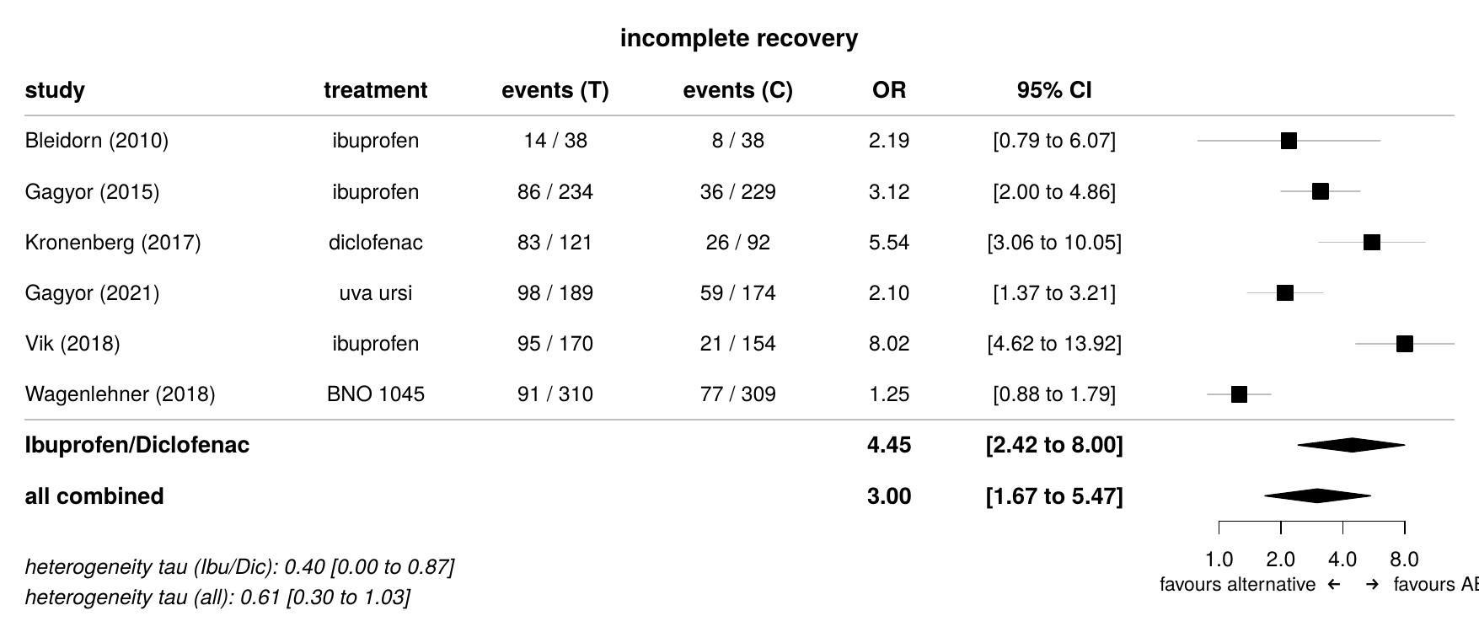
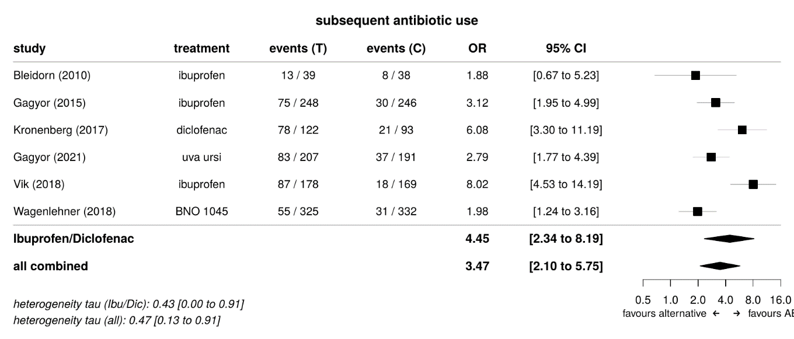
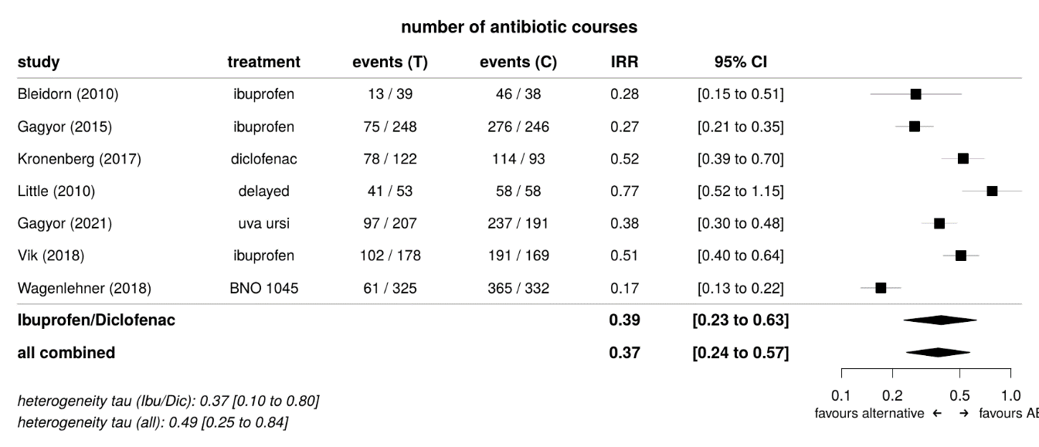
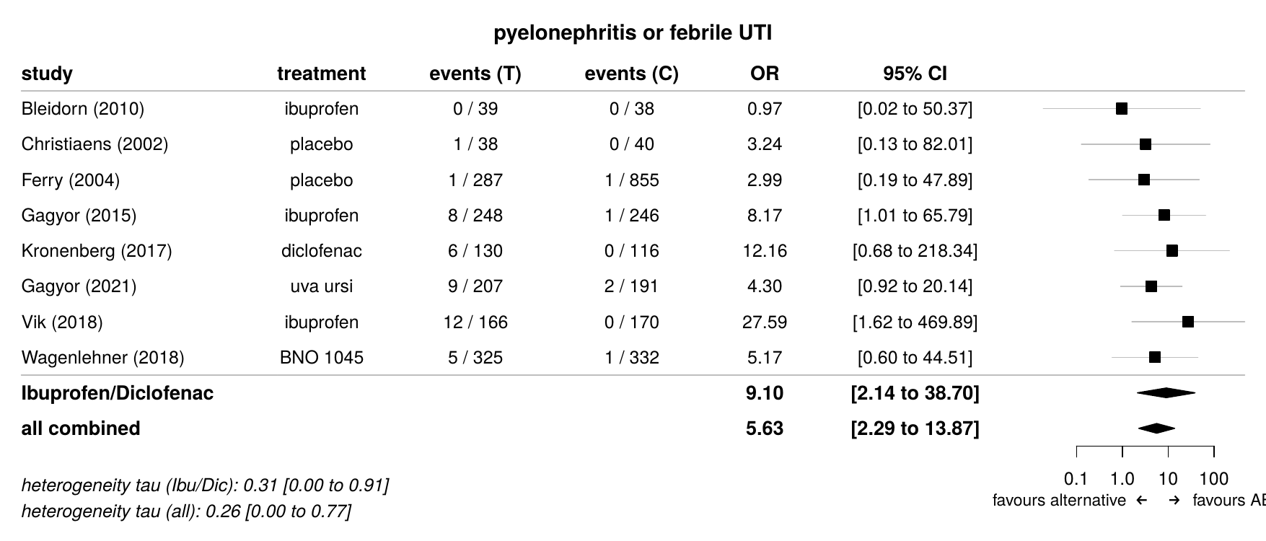
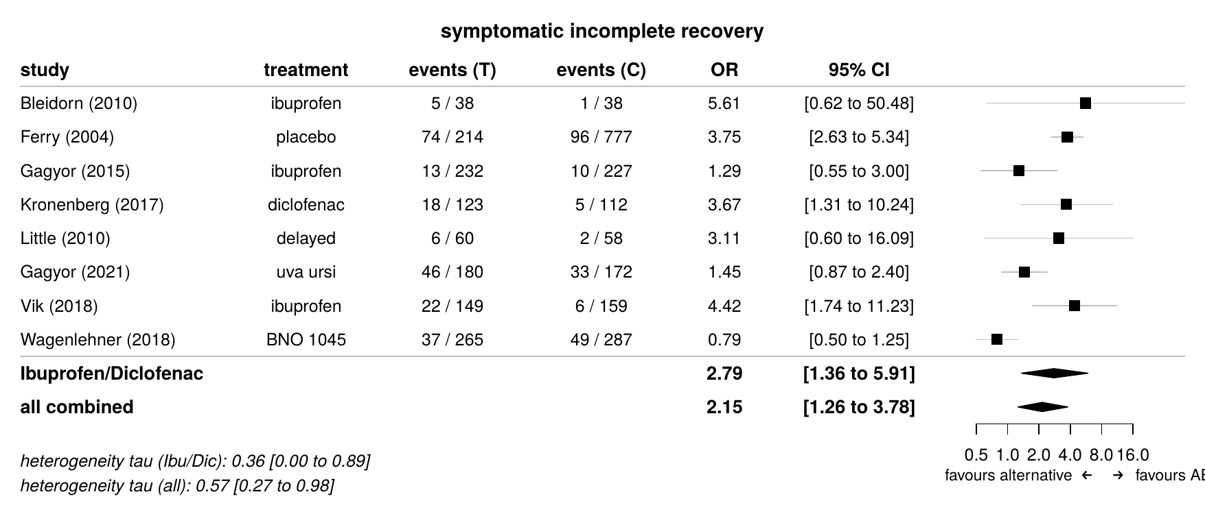
Figure 2: Forest plots for the primary, main secondary and safety outcomes (for the remaining secondary and safety outcomes see Supplement Figures 3,4).
Heterogeneity τ was provided with 95% credible intervals. Overall effect estimates and heterogeneity were given for all trials combined and for the subgroup of analgesic trials. In contrast to subsequent antibiotic use, experimental antibiotic treatment in the control groups is included in the number of antibiotic courses.
CI, credible intervals; OR, odds ratio; IRR, incidence rate ration, Ibu, ibuprofen; Dic, diclofenac; T, treatment group (non-antibiotic treatment); C, control group (immediate antibiotics); AB, antibiotic.

A) | 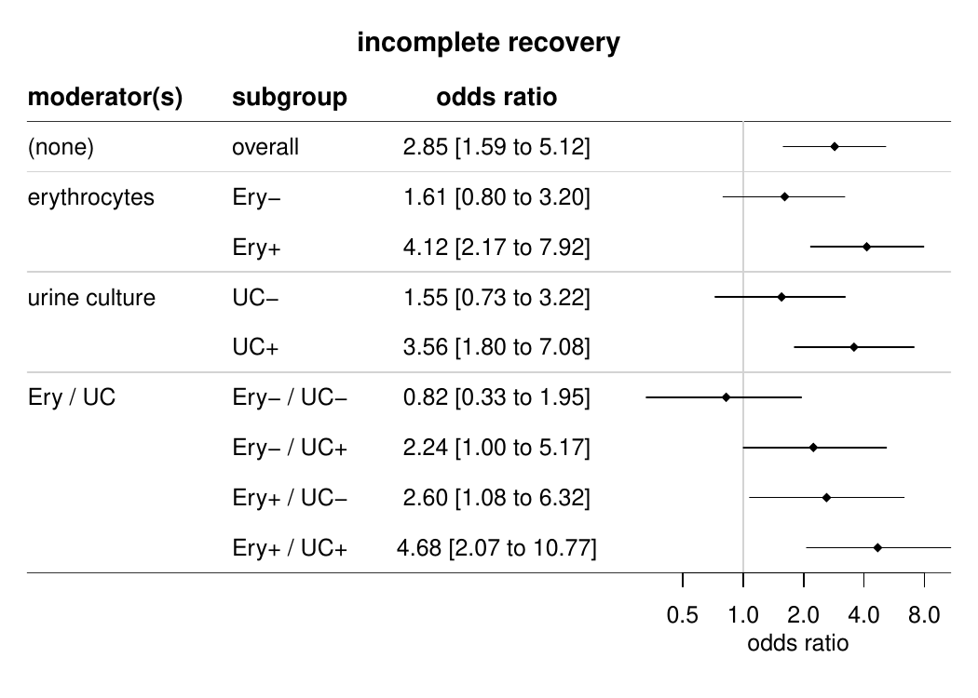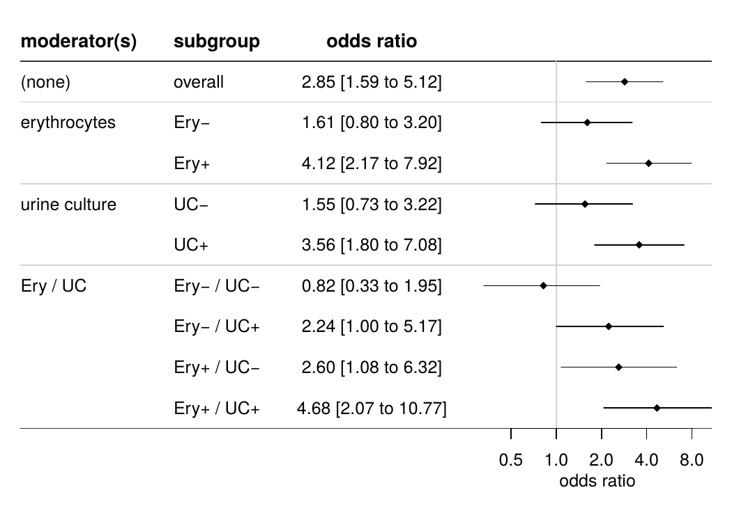
B) | 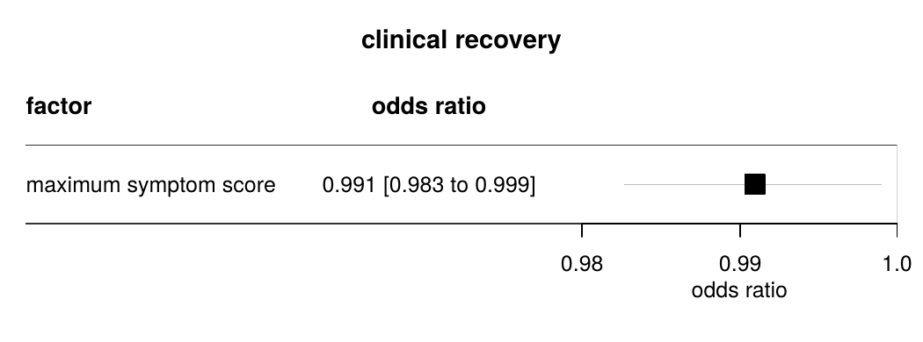  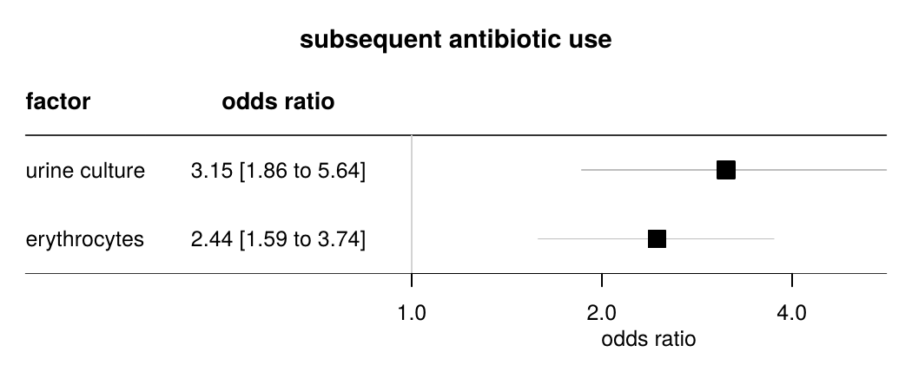  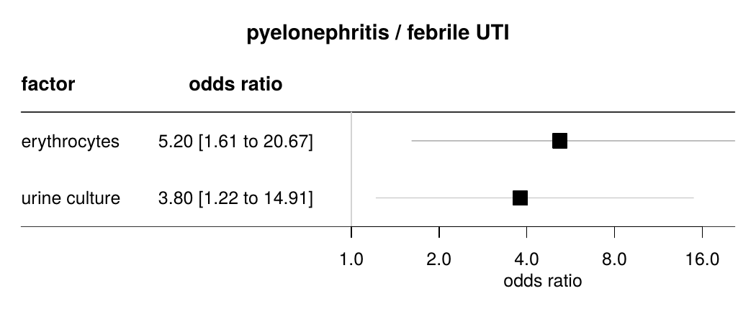
Figure 3: Effect moderators and prognostic indicators for several outcomes.
A) Moderators of the treatment effect. The first line shows the overall effect of strategies to reduce antibiotic use versus immediate antibiotics. The following lines indicate the effects when one or two moderators were considered. Analyses were calculated on the basis of the entire sample.
B) Prognostic indicators for the outcomes incomplete recovery, subsequent antibiotic treatment and pyelonephritis/febrile UTI. Multivariable regression analyses were calculated in patients treated with non-antibiotic treatments.
OR, odds ratio; Ery, erythrocytes; UC, urine culture; UTI, urinary tract infection.

