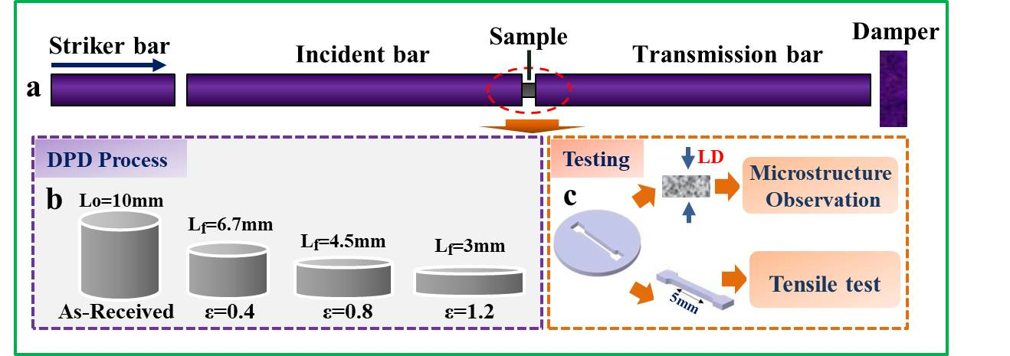
Fig.1. Schematic diagram of (a) DPD device, (b) samples before and after DPD processing and (c) position for microstructure observation and tensile testing

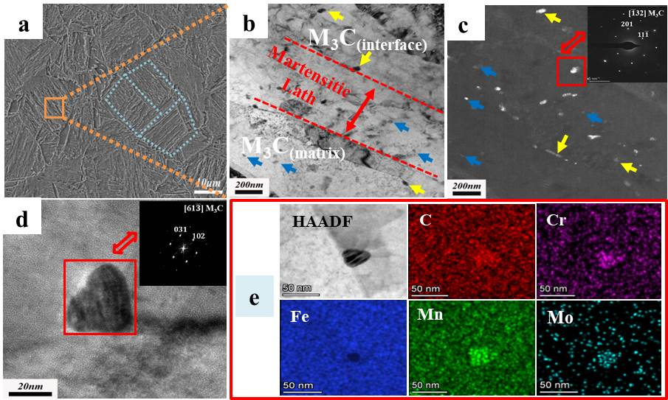
Fig.2. Microstructures of the as-received steel:(a) SEM image, (b)-(c) bright field and corresponding dark field TEM images with SAED pattern of M₃C along interface, (d) HRTEM image and FFT analysis of M₃C in matrix, (e) HAADF-STEM image with EDS results of M₃C particles

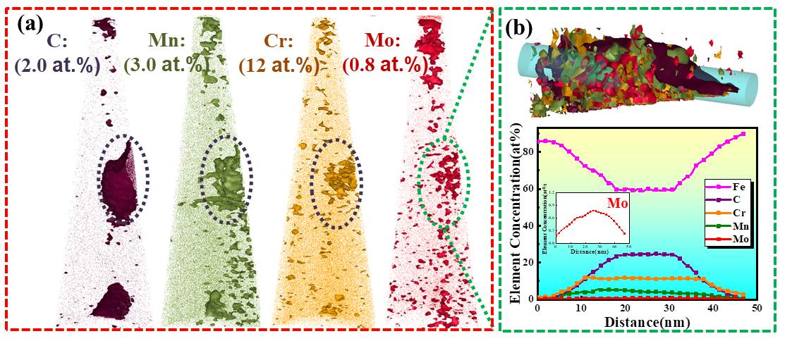
Fig.3. 3DAP analysis of the precipitates in the as-received steel, (a) isosurface of C, Mn, Cr and Mo elements, (b) APT composition measurement of a carbide particle

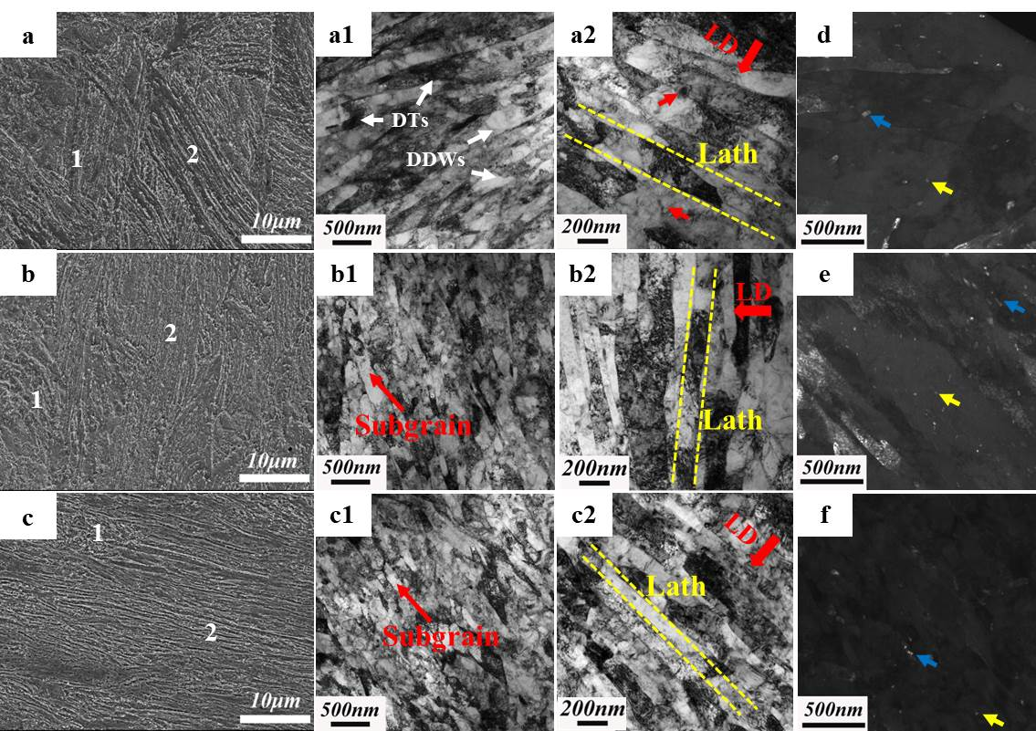
Fig.4. Microstructures of the steel after DPD processing at strain of (a, a1, a2, d) 0.4, (b, b1, b2, e) 0.8 and (c, c1, c2, f) 1.2. Herein (a, b, c) showing SEM images, (a1, b1, c1) and (a2, b2, c2) showing bright field TEM images corresponding to the zones marked 1 and 2 in (a, b, c), respectively, and (d, e, f) showing precipitates in dark field TEM images

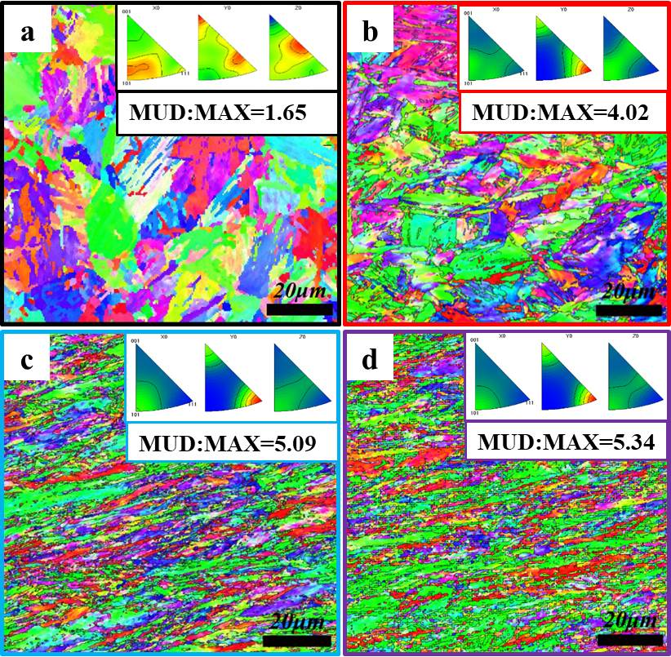
Fig.5. EBSD orientation color maps and corresponding IPF of the steel in (a) the as-received condition and after DPD processing at strain of (b) 0.4, (c) 0.8 and (d) 1.2

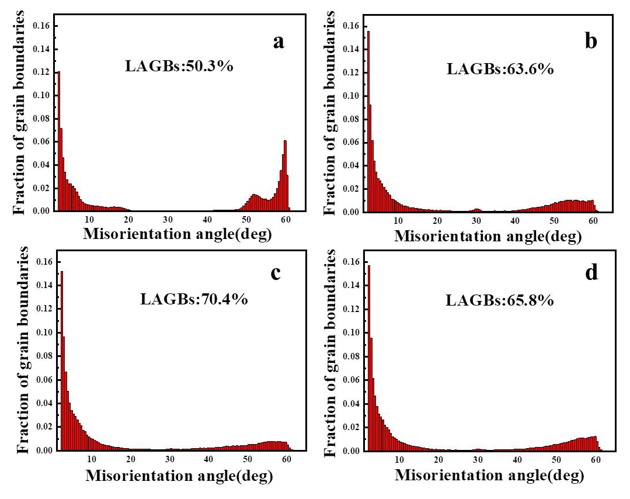
Fig.6. Histogram of the misorientation angle distributions for the steels in (a) the as-received condition and after DPD processing at strain of (b) 0.4, (c) 0.8 and (d) 1.2

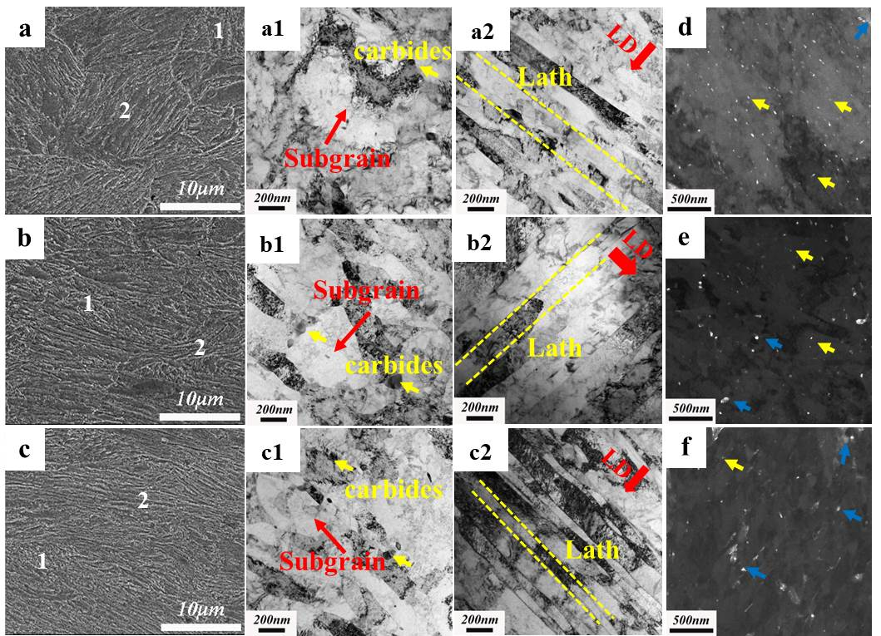
Fig.7. Microstructures of the steel after post-DPD annealing at strain of (a, a1, a2, d) 0.4, (b, b1, b2, e) 0.8 and (c, c1, c2, f) 1.2. Herein (a, b, c) showing SEM images, (a1, b1, c1) and (a2, b2, c2) showing bright field TEM images corresponding to the zones marked 1 and 2 in (a, b, c), respectively, and (d, e, f) showing precipitates in dark field TEM images
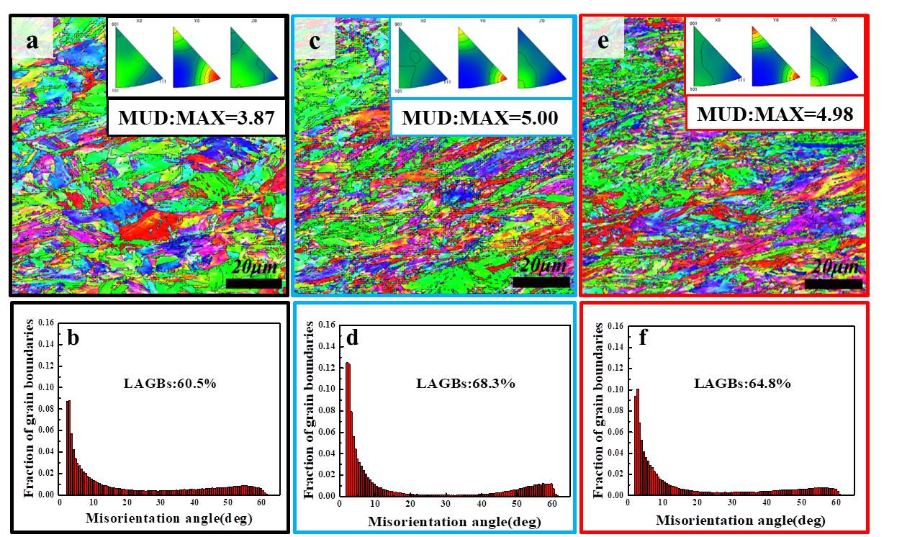
Fig.8. EBSD orientation color maps with corresponding IPF and histogram of the misorientation angle distributions for (a)-(b) DPD-0.4-450, (c)-(d) DPD-0.8-450 and (e)-(f) DPD-1.2-450 steels
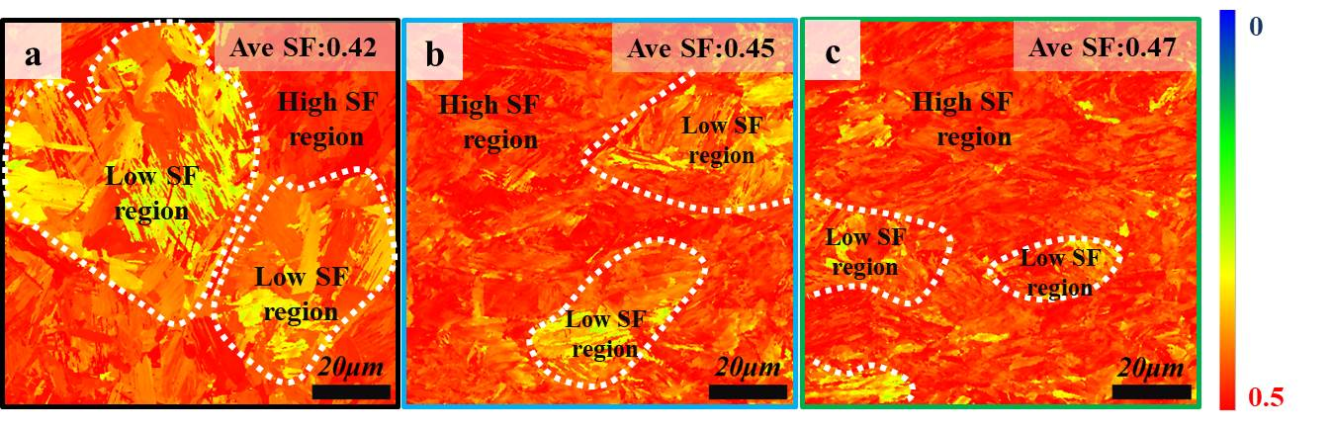
Fig.9. Schmidt factor distribution maps of (a) the as-received, (b) DPD-0.4, (c) DPD-0.4-450 samples

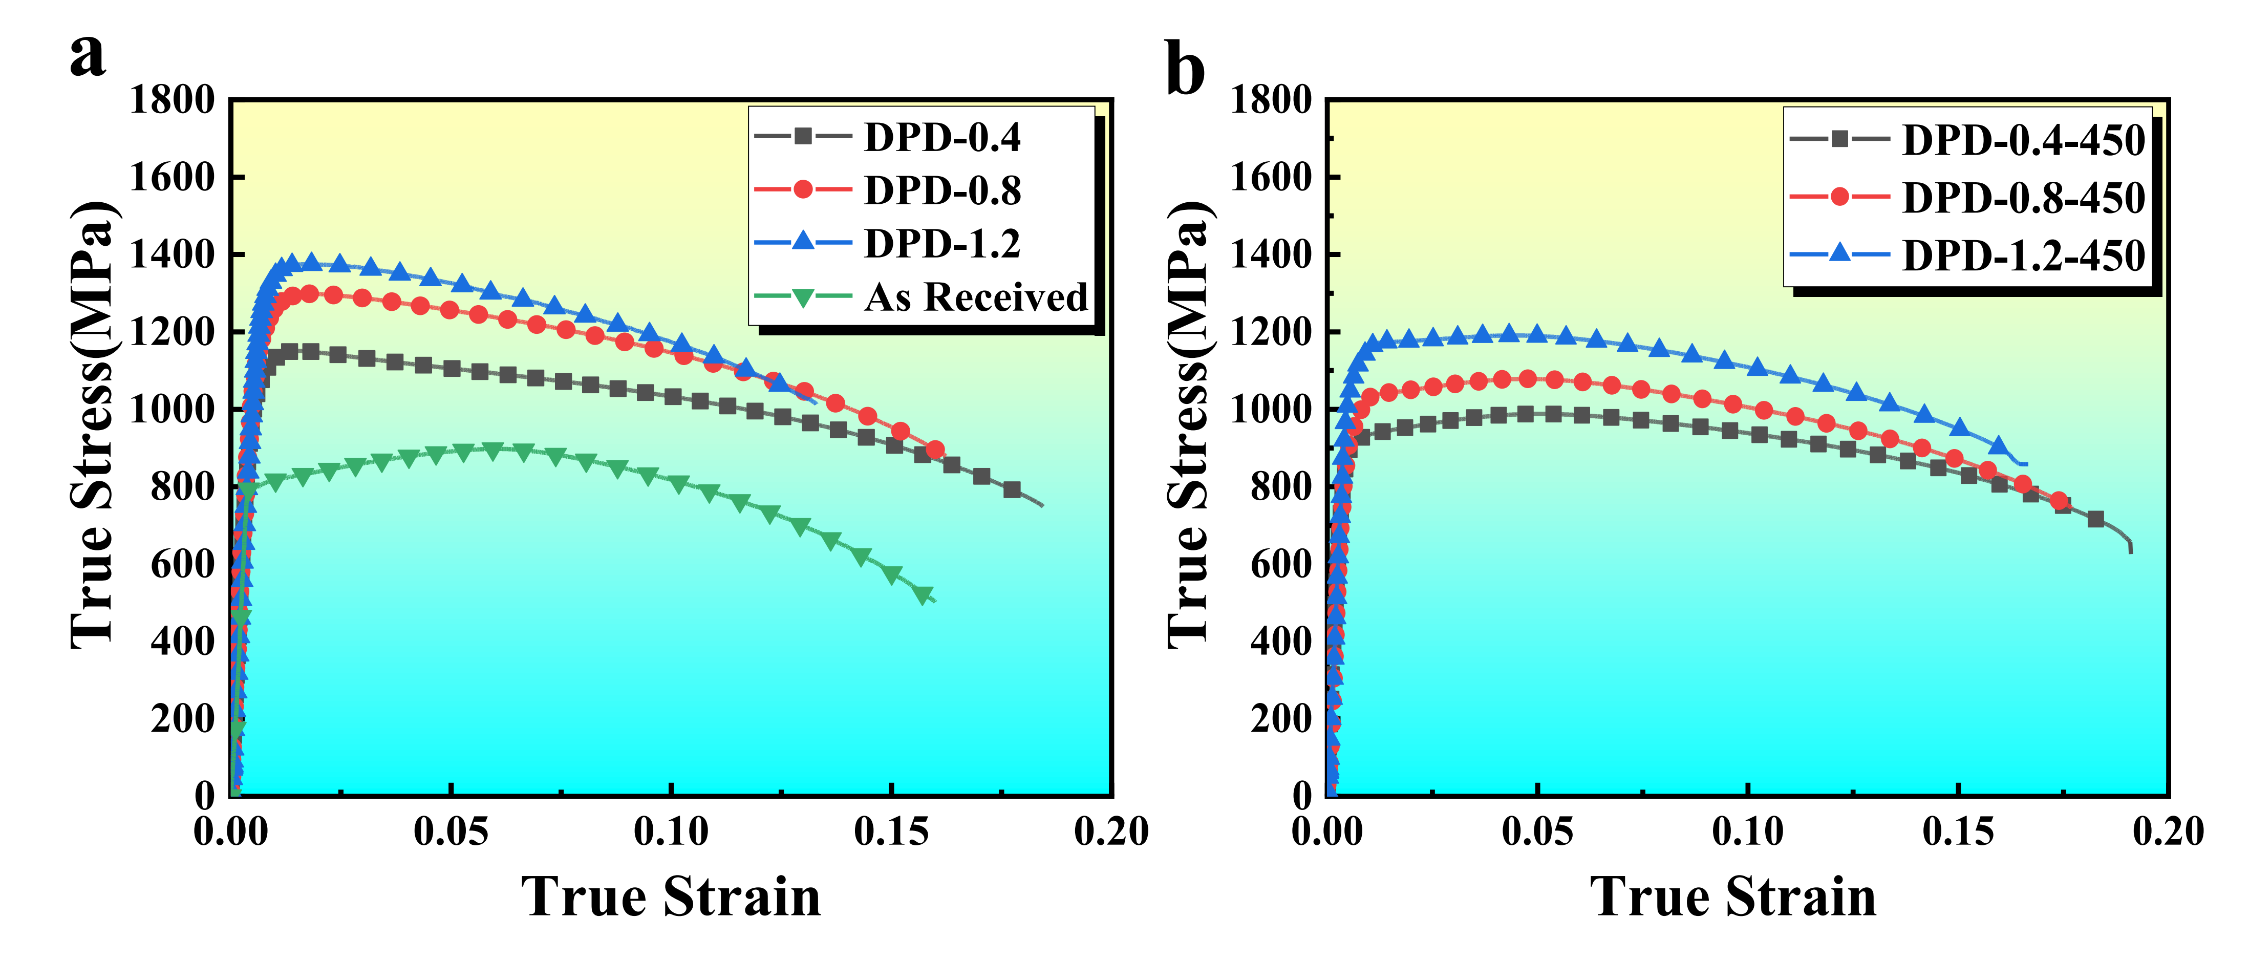
Fig.10. Mechanical properties of (a) as-received and DPD processed and (b) post-DPD annealed samples

Figure.11
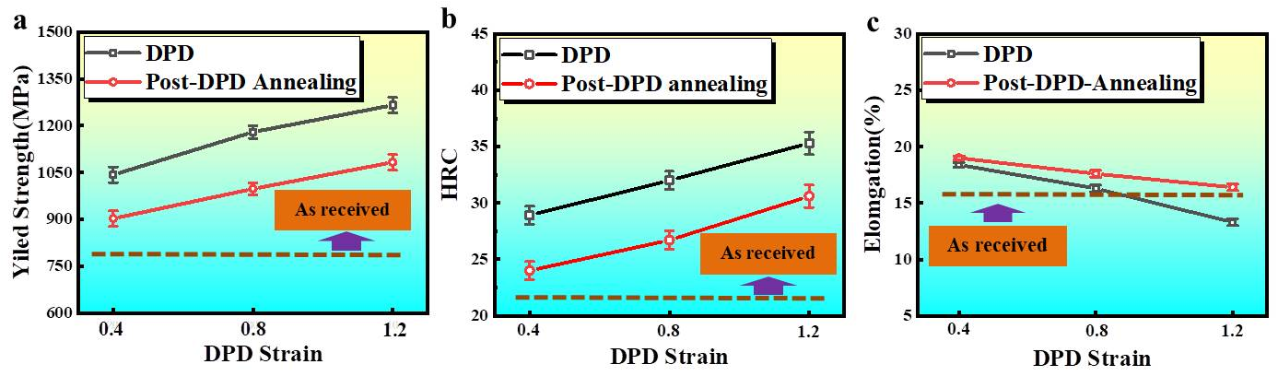
Fig.11. The influence of DPD strain on the (a) yield strengths, (b) HRC and (c) elongations of the DPD processed and post-DPD annealed steels

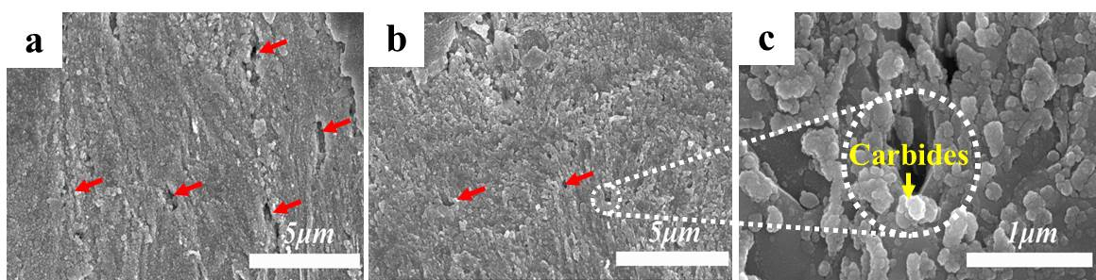
Fig.12. Longitudinal sections near the fracture surfaces of (a) the as-received and (b), (c) the post-annealed samples after tensile testing

Figure.13
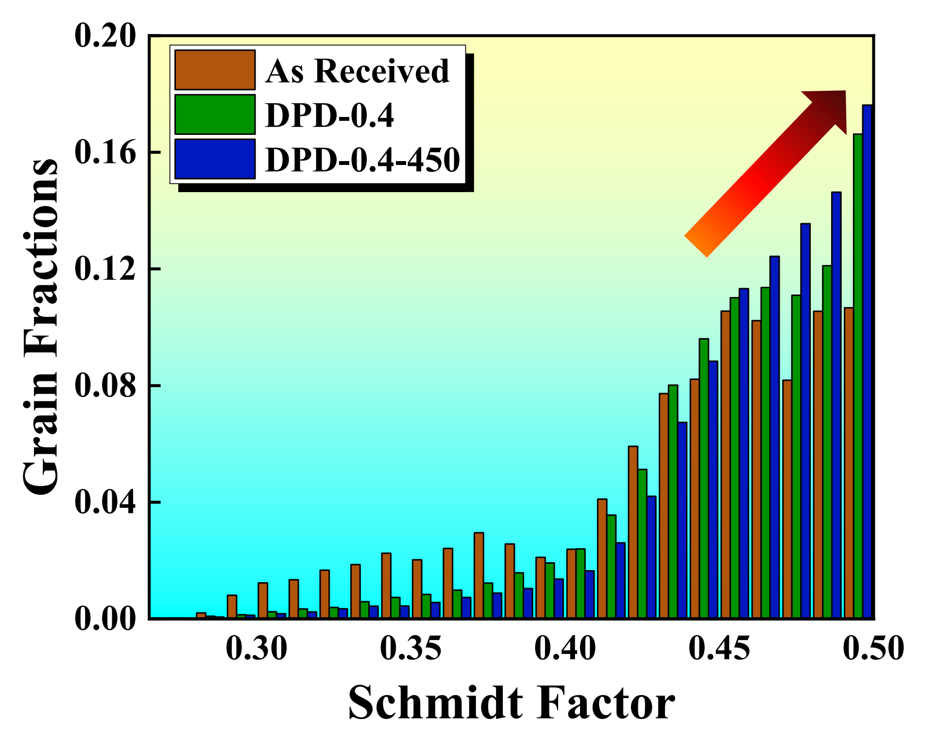
Fig.13. Frequency distribution histogram of Schmidt factors for the as-received, DPD-0.4 and DPD-0.4-450 steels

Table.1
Table.1 Sizes and densities of precipitates in DPD processed steels
 | M₃C_{(matrix)}  (No. density m⁻³) | M₃C_{(interface)}  (No. density m⁻³) | d_{M3C(matrix)}  (nm) | d_{M3C(interface)}  (nm)
As-received | 3.2±0.3×10²⁰ | 3.7±0.3×10¹⁹ | 45.9±3.3 | 127.3±4.7
DPD-0.4 | 2.8±0.3×10²⁰ | 2.4±0.2×10¹⁹ | 41.4±2.1 | 108.7±4.9
DPD-0.8 | 2.3±0.2×10²⁰ | 1.8±0.2×10¹⁹ | 32.6±1.8 | 90.8±3.2
DPD-1.2 | 1.9±0.2×10²⁰ | 1.1±0.1×10¹⁹ | 28.7±1.5 | 82.6±2.7

Table.2
Table.2. Sizes and densities of precipitates in post-DPD annealed steels
 | M₃C_{(matrix)}  (No. density m⁻³) | M₃C_{(interface)}  (No. density m⁻³) | d_{M3C(matrix)}  (nm) | d_{M3C(interface)}  (nm)
DPD-0.4-450 | 6.6±0.3×10²⁰ | 4.1±0.3×10¹⁹ | 36.2±2.3 | 94.3±5.5
DPD-0.8-450 | 5.8±0.3×10²⁰ | 5.3±0.2×10¹⁹ | 28.8±2.1 | 80.9±4.6
DPD-1.2-450 | 4.9±0.2×10²⁰ | 6.4±0.4×10¹⁹ | 21.6±2.5 | 72.5±4.4

