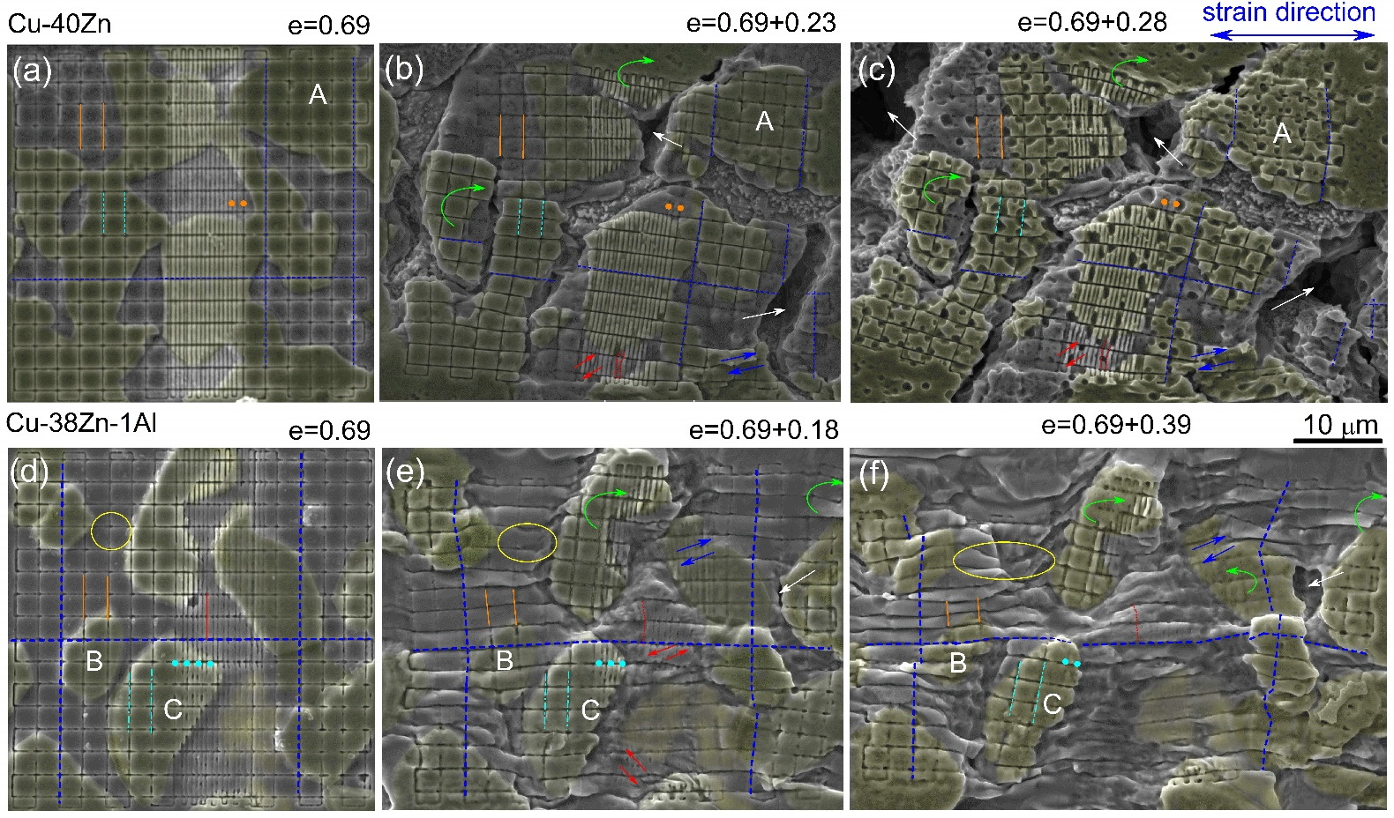
Fig.1 The surface microstructure for the (a-c) Cu-Zn and (d-f) Cu-Zn-Al brasses; (a,d) pre-strained to 0.69 and polished surface with FIB grids, (a-c and d-f) the same places after step-by step straining; stains are shown in Figures; α-phase is yellow-colored according with SEM-EDS data.
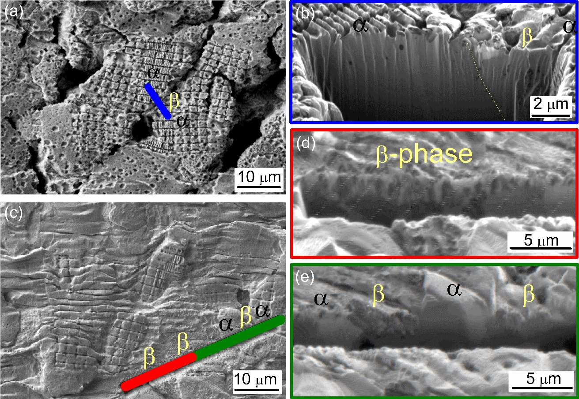
Fig. 2. FIB-images of the regions of the (a,c) strained surface and (b,d,e) FIB-milled trenches for the (a,b) Cu-Zn and (c-e) Cu-Zn-Al brasses; b – blue line area in (a), d – red-line area; e –grid line area in (c)
Fig. 3. Dislocation structure of the samples (a) Cu-Zn and (b) Cu-Zn-Al before the start of the superplastic deformation;
Fig 4. Dislocation structure of the sample (a-b) Cu-Zn and (c-d) Cu-Zn-Al alloys deformed with strain of 1.0 at temperature of 550°C with constant strain rate of 1.0 × 10⁻³ s⁻¹

