Improving the catalytic activity of Pt-Rh/C towards ethanol oxidation through the addition of Pb

Caio V. S. Almeida^{1,2}, Haoliang Huang^{3,4}, Andrea E. Russell³, Katlin I. B. Eguiluz^{1,2,*}, Giancarlo R. Salazar-Banda^{1,2,*}

¹ Laboratory of Electrochemistry and Nanotechnology, Institute of Technology and Research, 49.032-490, Aracaju, Sergipe, Brazil.
² Process Engineering Graduate Program, Tiradentes University, 49.032-490, Aracaju, Sergipe, Brazil.
³ School of Chemistry, University of Southampton, University Road, Southampton SO17 1BJ, United Kingdom.
⁴ Key Laboratory of Interfacial Physics and Technology, Shanghai Institute of Applied Physics, Chinese Academy of Sciences, Shanghai 201800, China.

* Corresponding Authors.
E-mail addresses: gianrsb@gmail.com (G.R. Salazar-Banda)
katlinbarrios@gmail.com (K. I. B. Eguiluz)

Abstract

This paper describes the effect of composition on the catalytic activity of carbon-supported Pt-Pb, Pt-Rh, and Pt-Rh-Pb catalysts towards ethanol oxidation in acid media. The catalysts were synthesised by a polyol reduction method and characterised using several experimental techniques, including X-ray diffraction (XRD), transmission electron microscopy (TEM), X-ray absorption near edge structure, and X-ray energy dispersive spectroscopy. The catalytic activity towards ethanol oxidation was evaluated by cyclic voltammetry, chronoamperometry, and in situ Fourier transform infrared spectroscopy (FTIR) experiments. XRD data indicate the presence of Pb in both alloyed and oxide forms. TEM images reveal nanoparticles well-dispersed on the carbon support, with spherical shapes and particle sizes around 2.0–6.5 nm. The Pt₃RhPb/C catalyst showed the highest catalytic activity for ethanol oxidation, reaching current densities 6.0 times higher than the commercial Pt/C catalyst. The trimetallic catalyst showed the highest CO₂ and acetic acid formation, explaining the higher current densities presented during cyclic voltammetry and chronoamperometry. Additionally, since the oxidation appears to follow a non-selective path, the role of Pb in the trimetallic catalyst is not related to driving the reaction towards the production of CO₂. The improvement in catalytic activity occurred due to the synergy between the metals.

Keywords: Bimetallic catalysts, Ethanol oxidation reaction, Fuel cells, FTIR, Trimetallic catalysts.

1. Introduction
Proton exchange membrane fuel cells (PEMFCs) fed with hydrogen have been identified as one of the most promising sources for generating clean and renewable energy due to their high energy densities and low operating temperature [1,2]. However, such technologies face hydrogen production, storage, and transportation challenges, hampering large-scale applications. Fuel cells operating on liquid fuels appear as an alternative to fuel cells powered by hydrogen due to the ease of transportation, handling, storage, and a higher volume-specific energy density [3].
As an alternative fuel, ethanol has attracted considerable attention in recent decades because it can be produced in large quantities from biomass. Compared to methanol, a fuel widely studied in fuel cell applications, ethanol has several advantages, including its non-toxicity, higher boiling point, and, more importantly, the fact that it is renewable [3,4]. Unfortunately, the relatively slow kinetics and incomplete ethanol oxidation reaction (EOR) that occurs at the anode are the main obstacles to the practical application and commercialisation of direct ethanol fuel cells (DEFCs) [4].
Pt is the most used metal as an anode in DEFCs due to its ability to absorb this alcohol. However, pure Pt can easily be poisoned by intermediates generated during the EOR [5]. Besides, breaking the C–C bond is not easily achieved, decreasing the efficiency of the cell. Thus, a tremendous effort has been devoted to developing efficient catalysts for breaking the C–C bond [6].
It is well-known that the formation of bimetallic and trimetallic catalysts based on Pt with elements such as Au, Ru, Rh, Sn, Ni, Cu and the use of metal oxides (CeO₂, SnO₂, and others) has been widely used to increase the catalytic activity and selectivity of these catalysts [7–15]. The improvement is attributed to electronic and/or bifunctional effects when these elements are involved in the catalytic process [7,9]. For example, in a previous report [9], we synthesised Pt₃Rh/C catalysts with different architectures (one alloy and one bimetallic mixture) to evaluate the effect of catalyst structure on its catalytic activity and the products formed during the EOR. In situ XAS data showed changes in the Pt 5d band vacancy due to Pt-Rh interactions, and the electronic effect was maximised when Pt formed an alloy with Rh. The Pt₃Rh/C catalyst showed the highest activity towards ethanol oxidation, presenting the highest current densities and the lowest onset potential. Moreover, in situ FTIR data reveal that the presence of Rh facilitates the C–C bond breaking, favouring the CO₂ formation at lower potentials.
The combination of Pt and Rh with an oxophilic metal has proved highly promising for the EOR [3,10,16,17]. Thus, Pb/Pb oxides could be a promising candidate as a co-catalyst in a trimetallic system of Pt-Rh-M towards ethanol oxidation, providing oxygenated species to oxidise the adsorbed CO and other substances intermediates, thus releasing new sites for oxidation. Several articles [12,18,19] observed an improvement in the catalytic activity of bimetallic Pt-Pb catalysts compared to the pure Pt catalyst. However, their joint action is still poorly studied, especially regarding the specific role played by Pb in the catalyst structure and the reaction mechanism.
On this basis, here we investigate the effect of the composition of carbon-supported Pt–Rh, Pt–Pb, and Pt–Pb–Rh catalysts on their catalytic activity towards ethanol oxidation. The catalysts were synthesised using a simple polyol method. Physical characterisations were carried out to determine the size and structure of nanocatalysts and to identify the metallic phases. Cyclic voltammetry and chronoamperometry were used to evaluate the electrochemical activity of the catalysts during EOR. Finally, in situ FTIR studies were used to identify and evaluate the effect of morphology on the oxidation reaction products.

2. Experimental section
2.1 Chemicals
All solutions were prepared using ultra-pure water from the Gehaka MS 2000 system (18.0 MΩ cm⁻¹ at room temperature). PbCl₂ (98%), hexachloroplatinic acid (99.95%), RhCl₃. xH₂O (39% of Rh), ethylene glycol (99.8%), 2-propanol (99.5%), Nafion® (5 wt.% solution), ethanol (99.8%) and sulphuric acid (99.5%) were all purchased from Sigma-Aldrich®. Vulcan XC-72R carbon black was obtained from Cabot, and Al₂O₃ (1.0 μm) was purchased from SKILL-TEC.

2.2 Catalyst preparation
According to the method described in the literature, all the catalysts synthesised in this work were obtained with 20% by weight of metals in relation to Vulcan XC72 carbon, using ethylene glycol as the reducing agent [16]. The Pt: Pb molar ratio was fixed at 3:1 based on the results presented by Silva et al. [18, 19]. Similarly, the choice of Pt: Rh molar ratio (3:1) was obtained through the studies of Gupta and Tayal [20], Almeida et al. [9], and Valério Neto et al. [10]. A commercial Pt/C (20 wt.% - Johnson Mathew) was used as a reference sample.

2.2.1 Synthesis of the catalysts
To synthesise Pt₃Pb/C, Pt₃Rh/C, and Pt₃RhPb/C nanoparticles, proper amounts of the metal precursors, PbCl₂, RhCl₃. xH₂O, and H₂PtCl₆·6H₂O (0.038 mol L^{–1}) solution (Table S1) were dissolved in 100 mL of ethylene glycol (EG). The solution pH was adjusted to 12 using 3.0 mol L^{–1} NaOH solution with continuous stirring for 30 min. 80 mg of Vulcan XC-72R carbon black was added to the mixture under stirring for 30 min. Then, the suspension was heated to 130 °C and kept constant for 3 h to ensure a complete reaction. After cooling to room temperature, concentrated sulphuric acid was added to adjust the pH value to 7. The resulting slurry was filtered, washed several times with ultra-pure water, and the precipitate was dried in a vacuum oven at 80 °C for 4 h.

2.3 Physical characterisation
The crystalline structures of the catalysts were studied by X-ray diffraction (XRD) analyses performed using a BRUKER diffractometer model D8 ADVANCE, operating with Cu Kα radiation (λ = 0.15406 nm). The diffraction patterns were registered from 15° to 90° at 2° min^{–1}. The crystallographic compositions of the catalysts were determined through the X’Pert HighScore Plus software by comparing the obtained data with reference standards of the Joint Committee on Powder Diffraction Data Standards (JCPDS) database.
The average size and dispersion of the nanoparticles were evaluated by transmission electron microscopy (TEM) images performed on an FEI TECNAI G² F20 HRTEM electron microscope operated at 200 kV. The average size of the nanoparticles was obtained using ImageJ software.
Energy-dispersive X-ray spectrometry (EDX) measurements were made in an EDX LINK ANALYTICAL (Isis System Series 300) with a SiLi Pentafet detector, ATW II ultra-thin window with 133 eV to 5.9 keV to resolution and 10 mm² of area, coupled to a ZEISS LEO 440 Electron Microscope (Cambridge, England).
X-ray absorption spectroscopy (XAS) measurements were conducted at the B18 beamline of Diamond Light Source (UK) using a Quick EXAFS mode with ring energy of 3.0 GeV and a ring current of 300 mA. The in situ measurements were performed using a customised spectroelectrochemical cell [21], with a flattened Au wire as a contact with a catalyst-painted carbon paper electrode, a Pt foil as the counter electrode, and a Hg/HgSO₄ electrode (measured as 0.65 V vs RHE in 0.5 M H₂SO₄) as the reference electrode. The Pt₃RhPb/C electrodes for in situ XAS were prepared by applying the catalyst ink (100 mg sample, 4 mL H₂O, 100 µL IPA and 400 µL 10 wt% Nafion®) on one side of a carbon paper (TGP-H-60, Toray) to achieve a Pb loading of 0.19 mg cm⁻², and the electrodes were dried under an IR lamp and hot pressed at 130 °C and 4 kg pressure for 3 min. The painted electrodes were flooded with water in a vacuum desiccator before being loaded into the cell. The in situ XAS spectra were measured at the Pb L₃ edge in fluorescence using a 36-element Ge detector. The XAS spectra of PbO₂ and Pb foil were measured in transmission using ionisation chambers. The XAS spectra were processed using ATHENA in the Demeter software package [22]. The energy shift of each spectrum was calibrated using Pt foil before measurements.

2.4 Electrochemical characterisation
Electrochemical measurements were carried out on an Autolab Model PGSTAT 302N potentiostat/galvanostat coupled to a glass cell with one compartment three-electrode set up at room temperature. A glassy carbon (GC) electrode (0.071 cm²) was used as the substrate for the catalysts. A reversible hydrogen electrode (RHE) and a carbon rod were used as the reference and counter electrodes.
Before each electrochemical measurement, the GC electrode was polished with Al₂O₃ (1.0 µm) for cleaning. After this, the electrode was sonicated in an ultrasonic bath with 2-propanol for 10 min to remove any Al₂O₃ traces. N₂ (White Martins, 99,998%) was bubbled in all solutions for 15 min before each electrochemical test to de-aerated the electrolytic solution. All experiments were carried out in a solution of 0.5 mol L^{–1} ethanol + 0.5 mol L^{–1} H₂SO₄.
To prepare the catalytic layer, a suspension of 3.0 mg of catalyst was mixed with 1.0 mL of 2-propanol and 30 μL Nafion®, followed by sonicated stirring for 10 min until a homogeneous black ink was formed. Then, 5 μL of this suspension was deposited on the GC electrode surface to give a loading of 14.6 µg of the catalyst per cm². Finally, the electrode was dried at room temperature.
Cyclic voltammetry experiments were performed between 0.05 and 0.80 V at a scan rate of 200 mV s^{–1} until stationary responses were obtained (after 25 cycles). Then two voltammetric cycles between 0.05 and 1.10 V were performed at a scan rate of 5 mV s^{–1} to evaluate the behaviour of each catalyst. The stability of the as-prepared catalysts was evaluated by chronoamperometric experiments performed at 0.5 V for 18000 s (5 h).
CO-stripping experiments were carried out in a 0.5 mol L^{–1} H₂SO₄ electrolyte. For this measurement, the same pre-treatment procedure described before was made. CO voltammograms were obtained after bubbling CO gas into the electrochemical cell for 5 min at 0.05 V. Then, the cell was purged with high purity N₂ for 20 min to remove the CO that remained in the solution. After, a CO-stripping voltammogram (1 cycle) between 0.05 V and 1.10 V at 5 mV s^{–1} was obtained. For the electrochemical active surface area (ECSA) calculation, the area below the CO oxidation peak was used, assuming that the oxidation of a monolayer of linearly adsorbed CO involves a charge of 420 μC cm^{–2} [23]. All electrochemical results presented in this paper were normalised using the ECSA. The synthesised catalysts were compared with a commercial Pt/C Johnson Matthey catalyst (20% at), namely, Pt/C JM. The accelerated durability test (ADT) of synthesised catalysts was evaluated by cyclic voltammetry applying 5000 consecutive cycles in the potential range from 0.05 to 1.10 V at 50 mV s^{–1} in the presence of ethanol 0.5 mol L^{–1}.
In situ Fourier Transform Infrared (FTIR) spectroscopy measurements were performed on a Bruker VERTEX 70v spectrometer with an MCD detector cooled with liquid nitrogen. The IR radiation passed in sequence through a CaF₂ window and reached a thin layer (5 μL) of the catalyst suspension deposited onto a gold electrode (0.785 cm²) previously polished with alumina powder (1.0 and 0.05 µm). Spectra were collected from an average of 64 interferograms, with a spectral resolution of 4 cm^{–1}. The reflectance spectra were collected at intervals of 0.05 V from E = 0.1 to 1.10 V during a linear sweep voltammogram (ν = 1 mV s^{–1}). The spectra were scanned between 3000 and 1000 cm^{–1} wavelength range.

3. Results and discussion
3.1. Physical characterisation
Figure 1a-b display the XRD patterns of the Pt/C, Pt₃Pb/C, Pt₃Rh, and Pt₃RhPb/C catalysts. All catalysts have a large peak at 2θ = 25° that corresponds to the plane (0 0 2) of the crystalline structure of the graphite of the carbon support (JCPDS number 00-001-0640), in addition to five peaks referring to the planes (1 1 1), (2 0 0), (2 2 0), (3 1 1) and (2 2 2) of the centred face cubic crystalline structure (fcc) of polycrystalline Pt (JCPDS number 01-087-0646).
However, for Pt₃Pb/C, Pt₃Rh/C, and Pt₃RhPb/C catalysts, these peaks are shifted to different values of 2θ compared with the Pt/C catalyst (Figure 1c). This displacement may correspond to changes in the lattice parameters due to the incorporation of Pb and Rh atoms in the crystalline structure of Pt [9,10,17–19].
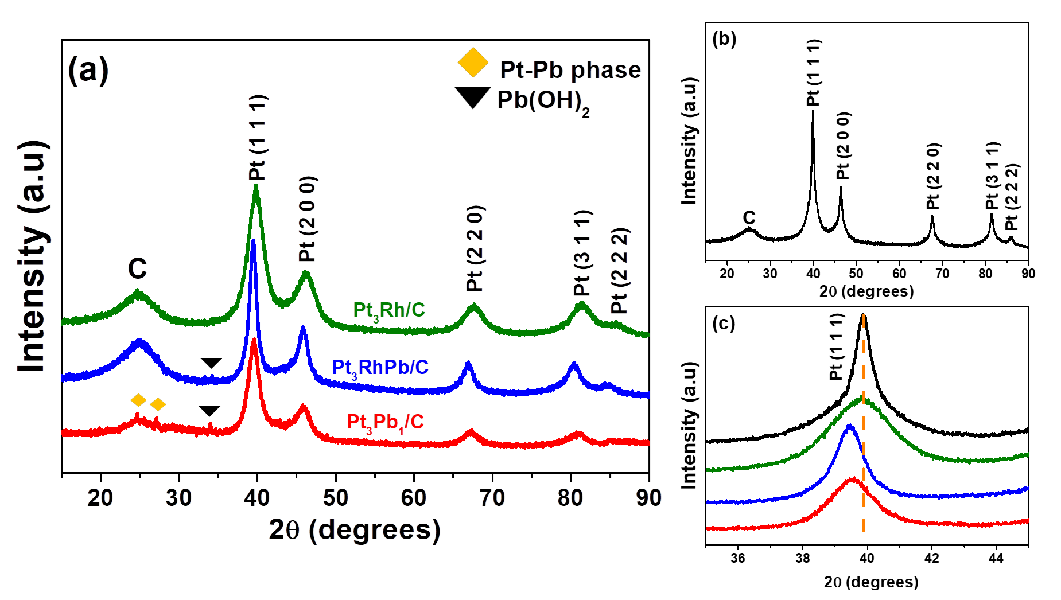
Figure 1. (a) X-ray diffractograms for Pt₃Pb/C, Pt₃Rh/C, and Pt₃RhPb/C, (b) XRD pattern of Pt/C JM and (c) Magnified view of the Pt (1 1 1) plane. The dashed line indicates the peak displacement of Pt₃Pb/C, Pt₃Rh/C, and Pt₃RhPb/C compared with the commercial Pt/C catalyst. Scan rate 0.02° s^{–1}.

The formation of Pt–Pb intermetallic phases is confirmed by the presence of peaks at 2θ = 24.7 and 27.1° in the Pt₃Pb/C catalyst, indexed, respectively, to the planes (1 0 0) and (1 0 1) of the hexagonal crystalline structure of Pt–Pb (JCPDS number 00-06-0374) [7–10]. The identification of the Pt–Pb intermetallic phase, only in the Pt₃Pb/C catalyst, may be related to the number of Pb atoms that can be accommodated in the Pt fcc structure. Once the crystalline structure of Pt can no longer accommodate Pb atoms, a more energetically favourable structure is formed, the hexagonal Pt–Pb phase [24]. These results agree with the observations made by Wang et al. [24]. They synthesized Pt–Pb intermetallic materials in different compositions (% Pb = 0–50%). It was observed that when the Pb concentration was increased to values above 25%, a new crystalline phase, the hexagonal Pt–Pb phase, was formed. It is worth noting that non-alloyed Pb or a decrease in the degree of alloying may also be responsible for the absence of this peak in the Pt₃RhPb/C catalyst. Additionally, Pb is identified in the Pb(OH)₂ phase for Pt₃Pb/C and Pt₃RhPb/C catalysts. It is owing to the (1 0 3) and (1 1 0) planes of the Pb(OH)₂ hexagonal structure appearing at 27.5° and 33.9° (JCPDS number 00-011-0270) [25].
In contrast, no peaks related to Rh are observed for Pt₃RhPb/C and Pt₃Rh/C catalysts. Previous studies [26–28] have shown that Pt and Rh form a homogenous binary solid solution over a wide composition range. Pt–Rh phase diagram (not shown here) also supported this hypothesis. Due to the incorporation of Rh into the fcc structure of Pt, compression of the lattice cell is expected since the atomic radius of Rh (0.134 nm) is smaller than that of Pt (0.139 nm). However, the lattice parameter of the Pt₃Rh/C is significantly the same as Pt/C JM (Table 1). The presence of non-alloyed Rh or its oxides is very likely and may explain the lattice parameter values.
It is worth mentioning that it is possible to expand the Pt lattice parameter due to the stress on its crystalline structure promoted by the Pb atoms, which have a larger atomic radius than Pt (r_{Pb} = 0.180 nm) [24,29]. In agreement with this, the lattice parameter of the Pt₃Pb/C catalyst is higher than that of Pt/C.
The lattice parameter of the Pt₃RhPb/C catalyst was larger than that of Pt₃Rh/C and smaller than that of Pt₃Pb/C. This intermediate value may result from the following reasons: (i) a lower amount of Pb alloyed with Pt or (ii) the presence of non-alloyed Pb. Due to the absence of the Pt–Pb phase on the Pt₃RhPb/C XRD pattern, it seems more plausible to assume the existence of non-alloyed Pb in the catalyst matrix.

Table 1: Structural proprieties of the as-prepared catalysts obtained by XRD and TEM measurements.
Catalyst | Lattice parameter (Å) | Crystallite size  (nm) | Mean particle size (nm)
Pt/C | 3.919 | 3.57 | ---
Pt₃Pb/C | 3.936 | 3.85 | 4.03±0.810
Pt₃Rh/C | 3.920 | 3.41 | 3.51±0.556
Pt₃RhPb/C | 3.926 | 3.69 | 3.67±0.674

The diffraction peak (2 2 0) of Pt was chosen to estimate the crystallite size of the materials, according to the Scherrer equation [30]. The calculated mean crystallite sizes of the catalysts are summarised in Table 1. Regarding the bimetallic catalysts, the crystallite size of Pt₃Rh/C is smaller than that of Pt₃Pb/C. Following the same trend observed in lattice parameter values, the average crystallite size of the Pt₃RhPb/C catalyst was smaller than that of Pt₃Pb/C and more prominent than that of Pt₃Rh/C.
The catalyst morphology and the particle size distribution were obtained using TEM micrographs. Figure 2 evidences a uniform dispersion of small nanoparticles across the carbon support with a spherical shape. Some agglomerates were observed on all materials and, largely, on Pt₃Pb/C.

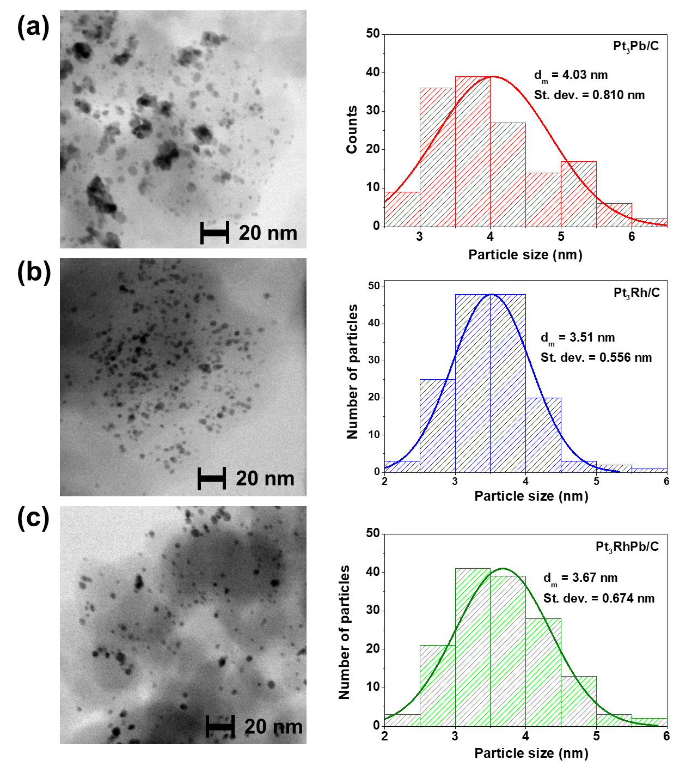
Figure 2. TEM images at 630,000× magnification and associated particle size distribution of the (a) Pt₃Pb/C, (b) Pt₃Rh/C and (c) Pt₃RhPb/C. The histogram of particle size was obtained by measuring 150 nanoparticles in different areas.

The shape of the histograms is broad for Pt₃Pb/C (Figure 2(a)) and narrow for Pt₃Rh/C (Figure 2(b)) and Pt₃RhPb/C (Figure 2(c)). From these results, it appears that Rh enhances the nucleation rate of nanoparticles, given that the greater the number of nuclei formed, the smaller the size of the nanoparticles. On the other hand, Pb atoms can slow down the nucleation rate, decrease the number of formed nuclei, and facilitate the agglomeration of nanoparticles. The values of the mean particle sizes and the corresponding standard deviations are included in Table 1. The Pt:Rh:Pb molar ratios taken from SEM-EDX measurements (Figure S1 and Table S2) are close to nominal, demonstrating the feasibility of the synthesis method adopted.
Figure S2 shows the cyclic voltammograms (1st cycle and 25th cycle) of the pre-treatment process of the catalysts in 0.5 mol L^{–1} H₂SO₄ solution saturated with nitrogen. In general, catalysts showed little change between the 1st and 25th cycles. All catalysts exhibited a slight decrease in their voltammetric area, followed by a drop in current values in the oxide-forming region. Such changes can be related to the oxidation of oxides/hydroxides initially present on the surface of the catalysts. [11].
Figure 3 shows the cyclic voltammograms of the Pt/C, Pt₃Pb/C, Pt₃Rh/C, and Pt₃RhPb/C catalysts in the absence (Figure 3a) and presence of 0.5 mol L^{–1} of ethanol (Figure 3(b)). The derivative voltammograms obtained from the current derivation during the anodic scan are shown in Figure 4(c), while Figure 4(d) shows the chronoamperometric curves with the fixed potential at 0.6 V.
The voltammetric profiles (Figure 3(a)) for all catalysts are characterised by three very distinct regions: the hydrogen adsorption/desorption region, the formation of the double electrical layer, and the formation of oxides. In the potential range between 0.05 and 0.35 V, hydrogen adsorption/desorption occurs. In the case of Pt₃RhPb/C and Pt₃Rh/C catalysts, the presence of Rh on the surface of these catalysts is identified by the intense peak at 0.15 V, commonly associated with hydrogen adsorption/desorption in an intermetallic Pt–Rh phase [9,10,18]. The Pt/C JM and Pt₃Pb/C catalysts showed a similar profile in this region.
The small peak at 0.70 V, indicated by the orange arrow, may be related to Rh or Pb oxide species due to their oxidation on the surface of these catalysts [31,32]. It is worth mentioning that the profile of Pt₃Rh/C also presents the peak of reduction of Rh oxides by 0.55 V (as indicated by the grey arrow). The presence of these two reduction peaks (0.78 and 0.55 V) indicates phase segregation between Pt and Rh [11], which agrees with the XRD data (Fig. 1) that suggested the presence of some non-alloyed Rh in the Pt₃Rh/C catalyst.
Figure 3. Cyclic voltammogram curves (second cycle) of Pt/C, Pt₃Pb/C, Pt₃RhPb/C, and Pt₃Rh/C in (a) absence and (b) presence of 0.5 mol L^{–1} ethanol solution. (c) Derivative voltammograms of the ethanol oxidation during the anodic sweep. Measurements were obtained in 0.5 mol L^{–1} H₂SO₄ at room temperature and a scan rate of 5 mV s^{–1}. (d) Chronoamperometric curves of Pt/C, Pt₃Pb/C, Pt₃Rh/C, and Pt₃RhPb/C at 0.6 V (vs RHE) in 0.5 mol L^{–1} H₂SO₄ + 0.5 mol L^{–1} ethanol solution.

Figure 3b shows the anodic scans for the synthesised catalysts during ethanol oxidation. It is possible to observe that the Pt₃Pb/C, Pt₃Rh/C, and Pt₃RhPb/C catalysts showed higher current density values than the Pt monometallic catalyst (Table 2). Specifically, the Pt₃RhPb/C catalyst obtained current density, measured at 0.6 V, approximately 6.0 times higher than the commercial Pt/C catalyst. The current density for bi- and trimetallic catalysts grows faster from lower potentials than that of the pure Pt catalyst, indicating that adding co-catalysts to Pt decreases the overpotential required for the start of ethanol oxidation.
Among all materials studied, the superior catalytic activity of the Pt3RhPb/C catalyst is related to the synergistic effect between the three elements. Pt participates in the adsorption of newly adsorbed ethanol, while Rh acts by facilitating the breaking of the C–C bond, allowing the total oxidation of ethanol to CO₂. When present on the catalyst surface, Pb oxide species help in the formation of hydroxyl species at low potentials, allowing the oxidation of intermediates strongly adsorbed on the surface of the catalysts [9,16,17]. Furthermore, the addition of co-catalysts can cause changes in the electronic structure of Pt, altering the binding strength between Pt and the adsorbed intermediates, facilitating the oxidation of these species [31,33,34].

Table 2. ECSA, ethanol onset potential, and specific activity obtained from CV tests and after 5 h of chronoamperometric curves.
Catalyst | ECSA  (cm²) | E_{CO}, onset (V) | E_{ethanol}, onset (V) | Specific activity  (mA cm^{–2})ª | Specific activity  (mA cm^{–2}) after 5 h
Pt/C JM | 1.42 | 0.70 | 0.40 | 0.110 | 0.0507
Pt₃Pb/C | 0.15 | 0.63 | 0.37 | 0.151 | 0.0530
Pt₃Rh/C | 2.58 | 0.59 | 0.35 | 0.329 | 0.0646
Pt₃RhPb/C | 1.60 | 0.58 | 0.30 | 0.660 | 0.119
ª Values were obtained at 0.6 V vs RHE.
^{b} Values were collected at the end of the experiment.

Another point worthy of note is that the ECSA (Table 2) of the Pt₃Pb/C is significantly small compared with the other catalysts. This may be related to particle size since bigger particles can have a lower fraction of surface atoms interacting with the carbon support than smaller particles, thus decreasing the charge transfer between carbon support and metallic centres [35,36]. This hypothesis is supported by the more significant amount of agglomerates and larger average diameter observed for the Pt₃Pb/C catalyst (Fig. 1a). Similarly, the higher ECSA value for the Pt₃Rh/C catalyst may be related to the better dispersion of nanoparticles on the carbon support and the smaller average diameter of its particles, as can be seen in the TEM images (Fig. 1b).
The onset potential (E_{onset}) was found, with precision, by the derivative voltammetry technique proposed by Murthy and Manthiran [37] for methanol oxidation and proved to be effective in the study of the electrochemical oxidation of ethanol [5,38] as well. The E_{onset} of each catalyst was estimated when the derivative current was higher than zero (Figure S3), which indicates an increase in the reaction rate. The values are listed in Table 2. The onset potential is displaced towards lower potentials for the Pt₃Pb/C, Pt₃Rh/C, and Pt₃RhPb/C catalysts compared to the Pt/C JM catalyst (0.40 V), demonstrating that ethanol can be more easily oxidation on the surface of these catalysts. We found the lowest onset potential for Pt₃RhPb/C (0.30 V), proving that the synergy between the metals anticipates the reaction by 100 mV.
According to Figure 3c, the catalysts have similar profiles, indicating similar reaction mechanisms. At low potentials (0.05–0.4 V), it is argued that dissociative adsorption of ethanol occurs. Other parallel reactions can happen in this potential range, including the formation of acetyl and acetate and the production of CO and CH_{x} groups [39]. In the potential range between 0.40 and 0.80 V, the derivative current grows fast, which can be attributed to the oxidation of CO and CH_{x} groups to CO₂.
Besides, acetic acid and acetaldehyde can be produced from less oxidised compounds such as acetyl and acetate [40,41]. In this potential range, water hydrolysis begins, and the presence of co-catalysts can facilitate the formation of active oxygen species at lower potentials than pure Pt [40]. This fact justifies the higher current values obtained for the Pt₃Pb/C, Pt₃Rh/C, and Pt₃RhPb/C catalysts than the Pt/C JM catalyst.
At potentials above 0.8 V, the oxidation of Pt begins, and the formation of surface oxides, which blocks the adsorption of ethanol and its subsequent oxidation, explaining the drop in derivative current values. The current increases again at potentials above 1.0 V due to the oxidation of species that previously adsorbed onto the catalyst's surface.
Figure 3d shows the corresponding current–time curves after applying a potential step from 0.05 V to 0.6 V. The current densities for the Pt₃Pb/C, Pt₃Rh/C, and Pt₃RhPb/C catalysts are higher than the Pt/C JM catalyst, in agreement with the trend shown in the voltammetric analysis (Figure 4b). The Pt₃RhPb/C catalyst obtained the highest current densities among the catalysts under study, reaching about 2.3 times higher than the Pt/C catalyst (Table 2), indicating that the trimetallic catalyst presents the best catalytic activity towards ethanol electrooxidation.
Although the direct comparison of results from different research groups is difficult because of the difference in experimental conditions, it was tried to compare the results presented in this work with other works focused on trimetallic Pt-based catalysts. Lu et al. [42] reported a maximum current of the forward potentiodynamic curve of 750 mA mg⁻¹_{Pt} for their most active Pt₆₆Ni₂₇Ru₇ ternary catalyst, which is much lower than the values in our work. Erini and co-workers [28] reported specific activity of 1.78 mA cm⁻² for PtRhSn catalyst, determined at 0.6 V vs. RHE. This value is higher than ours; however, considering the mass activity, the electrocatalytic activity of our catalyst is much higher than those reported by them. In summary, the ternary Pt₃RhPb/C catalyst showed higher catalytic activity for ethanol oxidation than those reported in the literature and listed in Table 3.

Table 3. Comparative studies of some Pt-based ternary catalysts for ethanol oxidation.
Catalyst | Specific activity  (mA cm⁻²) | Mass activity (mA mg⁻¹)_{Pt} | Supporting electrolyte | Ethanol concentration  (mol L⁻¹) | Scan rate  (mV s⁻¹) | Ref.
Pt₃RhPb/C | 0.66* (6.74)# | 2276.6*  (9634.6)# | H₂SO₄  0.5 M | 0.5 | 5 | This work
Pt₆₆Ni₂₇Ru₇ | 4.0# | ~750# | H₂SO₄  0.5 M | 0.5 | 20 | [42]
PtRhSn | 1.78 | 46.8 | H₂SO₄  0.5 M | 0.5 | 20 | [28]
PtAuSn/C | ~ 0.15 | --- | H₂SO₄  0.5 M | 1.0 | 20 | [43]
PtRhNi | --- | 50 | HClO₄  0.1 M | 0.5 | 20 | [26]
Pt₃Sn/γ-Fe₂O₃-C | ~ 0.1 | --- | H₂SO₄  0.5 M | 1.0 | 10 | [44]
Pt₂₁Rh₅Sn₃₉/C | --- | 250 | HClO₄  0.1 M | 0.5 | 10 | [45]
PtRhNi/SnO₂ | --- | 90 | HClO₄  0.1 M | 0.5 | 10 | [46]
PtRuSn | --- | 80 | H₂SO₄  0.5 M | 1.0 | 5 | [8]
* Values taken at 0.6 V vs. RHE
# Values taken at the anodic peak

Figure 4 shows the CO stripping results for the as-prepared catalysts. The adsorption of CO on the surface of the catalysts was confirmed through the suppression of the peaks related to the hydrogen desorption process due to the blocking of these active sites by pre-adsorbed CO molecules [41]. Evidently, there is a decrease in the onset potential for CO oxidation for the bimetallic and trimetallic catalysts concerning Pt/C JM, indicating that CO removal is facilitated on those surfaces. Significantly, the onset potential of the CO oxidation for Pt₃RhPb/C occurs at 0.58 V, about 0.12 V lower than that for the commercial Pt/C catalyst (Table 2). Moreover, the easier CO oxidation may be the reason for the shift to lower potentials of the ethanol oxidation onset potential for Pt₃Rh/C, Pt₃Pb/C, and Pt₃RhPb/C.
Figure 4. CO-monolayer stripping voltammetry (1st scan) on Pt/C JM, Pt₃Pb/C, Pt₃Rh/C, and Pt₃RhPb/C catalysts in 0.5 mol L^{–1} H₂SO₄ at 20 mV s^{–1}.

The presence of Pb contributes to the formation of OH– species at lower potentials, the so-called bifunctional effect, due to oxide formation and the CO adsorbed at the surface of Pt is more easily removed [25,27,47]. The electrochemical behaviour of Pb in Pt₃RhPb/C was then studied through in situ X-ray absorption spectroscopy (XAS) at the Pb L₃ edge to evaluate the existence of the bifunctional mechanism. Figure 5 shows the X-ray absorption near edge structure (XANES) spectra of Pt₃RhPb/C and two Pb reference samples collected in 0.5 mol L^{–1} H₂SO₄ under potential control, along with that under open circuit potential (OCP).

Figure 5. In situ Pb L₃ XAS data recorded for a Pt₃RhPb/C painted electrode under potential control in 0.5 mol L^{–1} H₂SO₄, along with Pb foil and PbO₂ reference samples. Arrows indicate the shifted edge and increased intensity with applied potentials.

In comparison with the Pb references, the rising edge of Pt₃RhPb/C is between those of Pb foil and PbO₂, and the XANES features of Pt₃RhPb/C regarding those of PbO₂ are found to show similarity to the reported Pb(OH)₂ and PbSO₄ [48], suggesting that the Pb of Pt₃RhPb/C is in the form of surface ad-atoms. This finding explains the absence of the Pt-Pb phase in X-ray diffractograms (Fig. 1). Under applied potentials from 0.05 V to 0.85 V, a clear potential dependence was found, with an edge-shift towards higher energy and increased intensity of a feature at ~13050 eV. Both of these behaviours suggest that a significant number of Pb atoms in Pt₃RhPb/C are electrochemically active and that the Pb oxidation state increases with applied potentials. As the extended X-ray absorption fine structure (EXAFS) part of the Pb L₃ edge overlaps with the Pt L₂ edge (13273 eV), we cannot further analyse how the local coordination environment of Pb changes with applied potentials. Nevertheless, the in situ XANES analyses suggest that Pb in the Pt₃RhPb/C is oxidised and electrochemical active, aligning with the bifunctional mechanism.
In addition, the presence of co-catalysts can decrease the adsorption force of the Pt–CO bond, promoting easier CO oxidation because Rh and Pb may alter the Pt 5d-band centre [5,49,50]. In our previous paper [5], in situ XAS data evidenced that Pt–Rh interactions produced changes in the Pt 5d-band vacancy. The 5d-band electrons of Pt may partly transfer to Rh, which has fewer d electrons and is more electronegative.
Figure 6 shows the in situ FTIR spectra of the Pt/C, Pt₃Pb/C, Pt₃Rh/C, and Pt₃RhPb/C catalysts for the oxidation of 0.5 mol L^{–1} ethanol in 0.5 mol L^{–1} H₂SO₄ solution. All catalysts have a positive band located at 1647 cm^{–1}, referring to the twisting mode of the H–O–H group of water [51], indicating the consumption of this specie as the potential increases. The positive bands located at 2989, 2903, and 1454 cm^{–1} correspond to ethanol consumption inside the thin layer [52]. Other bands unrelated to the oxidation of ethanol can be located at 1200 and 1100 cm^{–1}, referring to the modes of vibration of the ions SO₄^{2–} and HSO₄– of the supporting electrolyte [53], respectively.
The formation of acetic acid was accompanied by the bands at 2623, 1400, and 1280 cm^{–1}, attributed to the asymmetric stretching of the –CH₃ group, the deformation of the –OH group, and the elongation of the –C=O group, respectively [54,55]. In all catalysts, such bands appear only at potentials above 0.6 V. The band at 1720 cm^{–1} refers to the carbonyl group stretching (C=O) [55] present in acetic acid and acetaldehyde, confirming the formation of these species. In the case of the Pt₃Pb/C catalyst, this band starts at 0.5 V and from potential values greater than 0.6 V for the other catalysts.
Figure 6. In situ FTIR spectra obtained during ethanol electrochemical oxidation on (a) Pt/C JM, (b) Pt₃Pb/C, (c) Pt₃Rh/C and (d) Pt₃RhPb/C catalysts, for 128 scans at a resolution of 4 cm^{–1}, 0.5 mol L^{–1} H₂SO₄ + 0.5 mol L^{–1} ethanol. Reference spectra were recorded at 0.05 V during the chronoamperometry steps.

The formation of acetaldehyde could also be accompanied by the band at 1113 cm^{–1}, associated with the vibration of the C–H group [56]. However, such a band is superimposed with the band at 1100 cm^{–1}, corresponding to the HSO₄– ions. The formation of adsorbed acetate, produced from the adsorption of acetic acid, is evident by the appearance of the band at 1355 cm^{–1} [54], at potentials greater than 0.6 V. The appearance of this band indicates that acetate was an intermediate in the oxidation of ethanol.
The band at 2343 cm^{–1} was associated with the production of CO₂ [52]. For Pt/C JM and Pt₃Pb/C, this band starts at 0.60 V, and its intensity increases with the increase in potential, reaching stability above 1.0 V. For Pt₃Rh/C and Pt₃RhPb/C, CO₂ production is anticipated, starting at 0.60 V and 0.50 V, respectively, and its intensity increases up to 0.9 V, decreasing slightly at higher potentials.
The band between 2035 cm^{–1} and 2045 cm^{–1} corresponds to the CO linearly adsorbed (CO_{L}) on the surface of the catalysts [53]. For Pt₃Rh/C and Pt₃RhPb/C catalysts, this band started at 0.40 and 0.25 V. For the Pt/C JM and Pt₃Pb/C catalysts, this band is detected only after 0.50 V. It has a lower intensity (compared to the Pt₃Rh/C and Pt₃RhPb/C bands), confirming that Rh facilitates the C–C bond breaking. In all catalysts, the intensity of this band increases slightly until reaching a maximum, showing a decrease in its intensity soon after. The subsequent drop in the intensity of this band can be attributed to a drop in the formation of CO_{L} or an increase in the oxidation rate of these species. Considering that the appearance of the CO₂ bands accompanies the decrease in the intensity of the CO_{L} band, it seems plausible to assume that the increase in the oxidation of the CO_{L} is responsible for the fall in the CO_{L} bands.
Additionally, the areas of the CO₂ and CH₃COOH absorption bands were integrated to deepen the analysis of the infrared spectra. After integration, those areas were normalised by the ECSA of each catalyst, and their derivatives data were obtained as a function of the electrode potential. Figure 7 shows the anodic voltammogram from Figure 4b (1st column) together with band intensities, as a function of the potential, for CO₂ and acetic acid (2nd column) and differential signals for CO₂ (3rd column) and acetic acid (4th column). The procedure to obtain the data displayed in columns 3 and 4 was presented by Camara and coworkers [57–60].

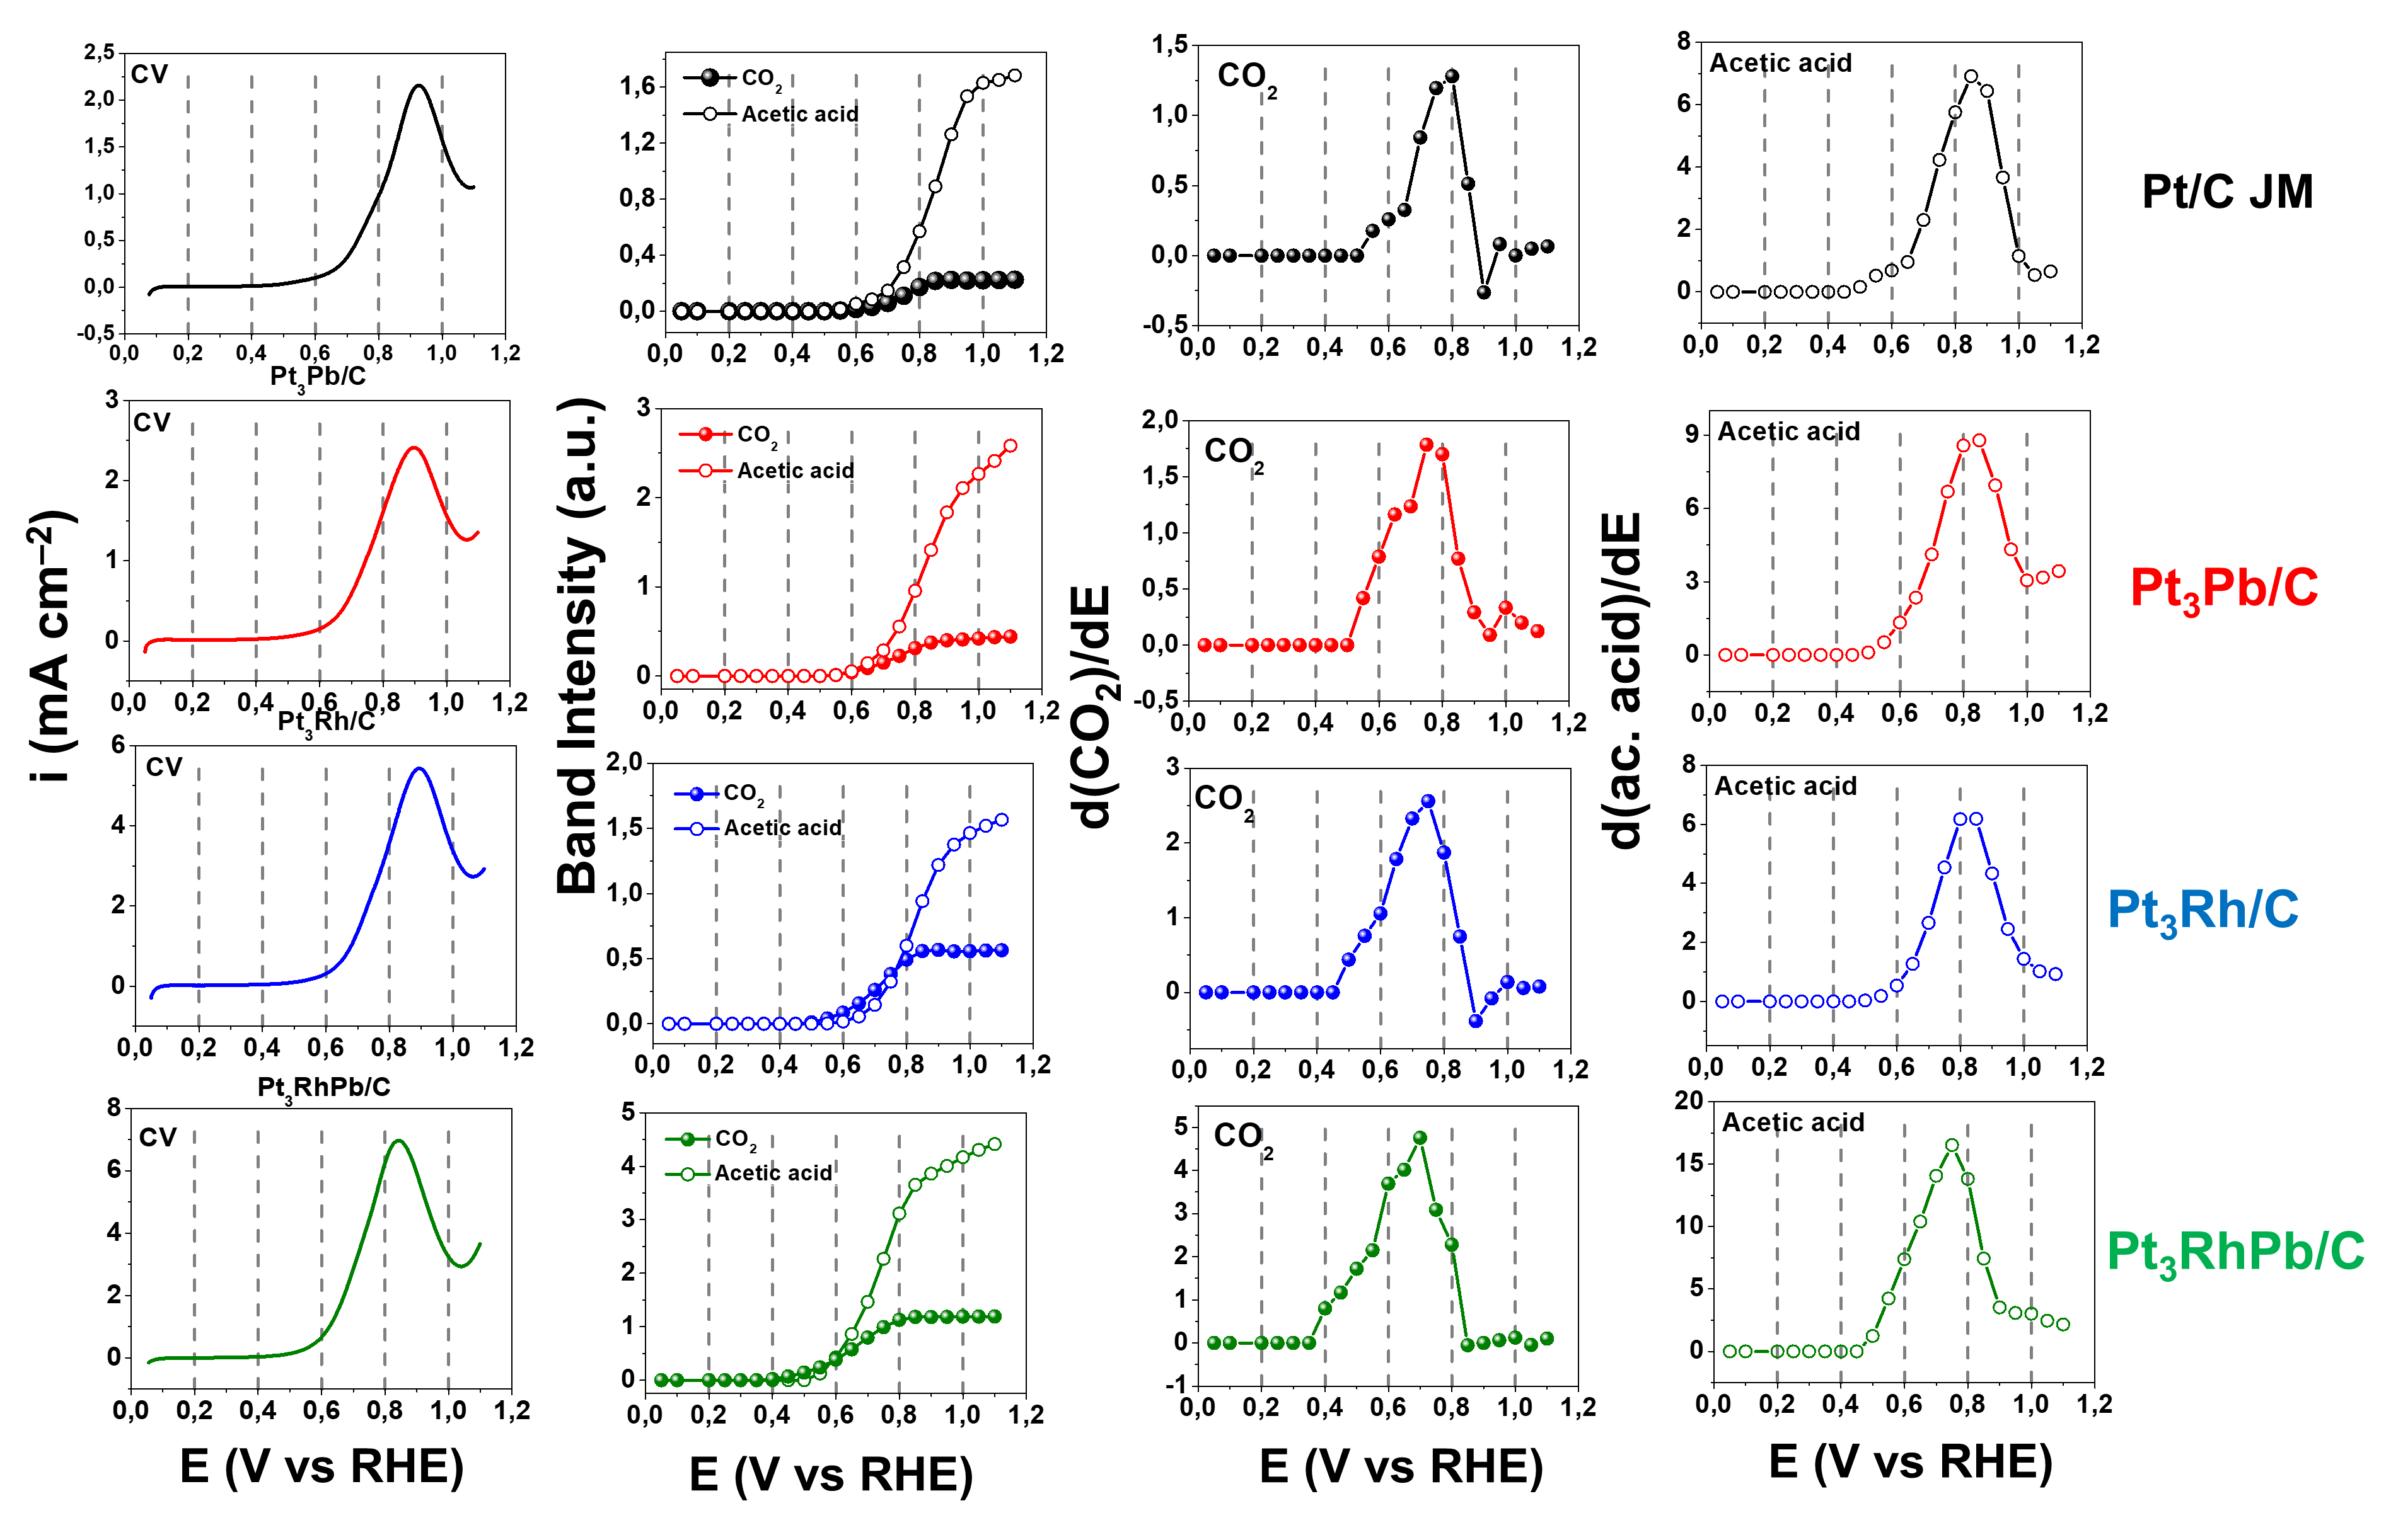
Figure 7. 1st column: anodic voltammetric scan from Figure 3b; 2nd column: CO₂ (filled circles) and acetic acid (unfilled circles) band intensities as a function of the potential. The data were extracted from FTIR spectra as a function of the potential; 3rd column: differential absorbances for CO₂; 4th column: differential absorbances for acetic acid.

Pt/C JM (1st row) shows the current peak at 0.92 V, which coincides with the maximum peak of differential absorbance for acetic acid (0.90 V). However, CO₂ is also produced, and its maximum is observed at lower potentials (0.8 V), although its production occurs concomitantly with acetic acid. For the other catalysts, Pt₃Pb/C (2nd row), Pt₃Rh/C (3rd row), and Pt₃RhPb/C (4th row), the situation is similar; there is an overlap between CO₂ and acetic acid bands. Nevertheless, by comparing the differential signals of these catalysts with the commercial Pt/C catalyst, the formation of both substances is shifted to lower potentials, which explains the lower onset potential of oxidation of these materials.
Analysing the intensity of the integrated bands of CO₂ and acetic acid (2nd column), it can be inferred that the presence of Pb in the trimetallic catalyst does not favour the production of CO₂, although the catalyst has shown the highest levels of production of this species. When estimating the ratio (R) between the maximum intensities of the integrated bands of CO₂ and acetic acid, it was observed that the Pt₃Rh/C catalyst presented the highest R-value (0.090), followed by Pt₃RhPb/C (0.067), Pt₃Pb/C (0.042), and Pt/C JM (0.036). Thus, these data show that the superior catalytic activity of the Pt₃RhPb/C catalyst can be explained by the synergy between the metals, in which each metal appears to perform a specific role during alcohol oxidation, as discussed by Adzic and coworkers [16,17]: Platinum provides active sites for the adsorption of ethanol molecules, Rh is effective in C–C bond breaking, while Pb oxide species are responsible for the formation of OH– species, which facilitates the oxidation step.
To complement the studies carried out by chronoamperometry (Fig. 3d), the catalysts were submitted to accelerate durability tests (ADT) during 5,000 cycles in the range from 0.05 to 1.1 V vs RHE in the presence of 0.5 mol L^{–1} ethanol to evaluate their stability. Fig. 8 shows the loss of current density at the anodic peak and the voltammetric profiles of the catalysts before and after the ADT procedure.

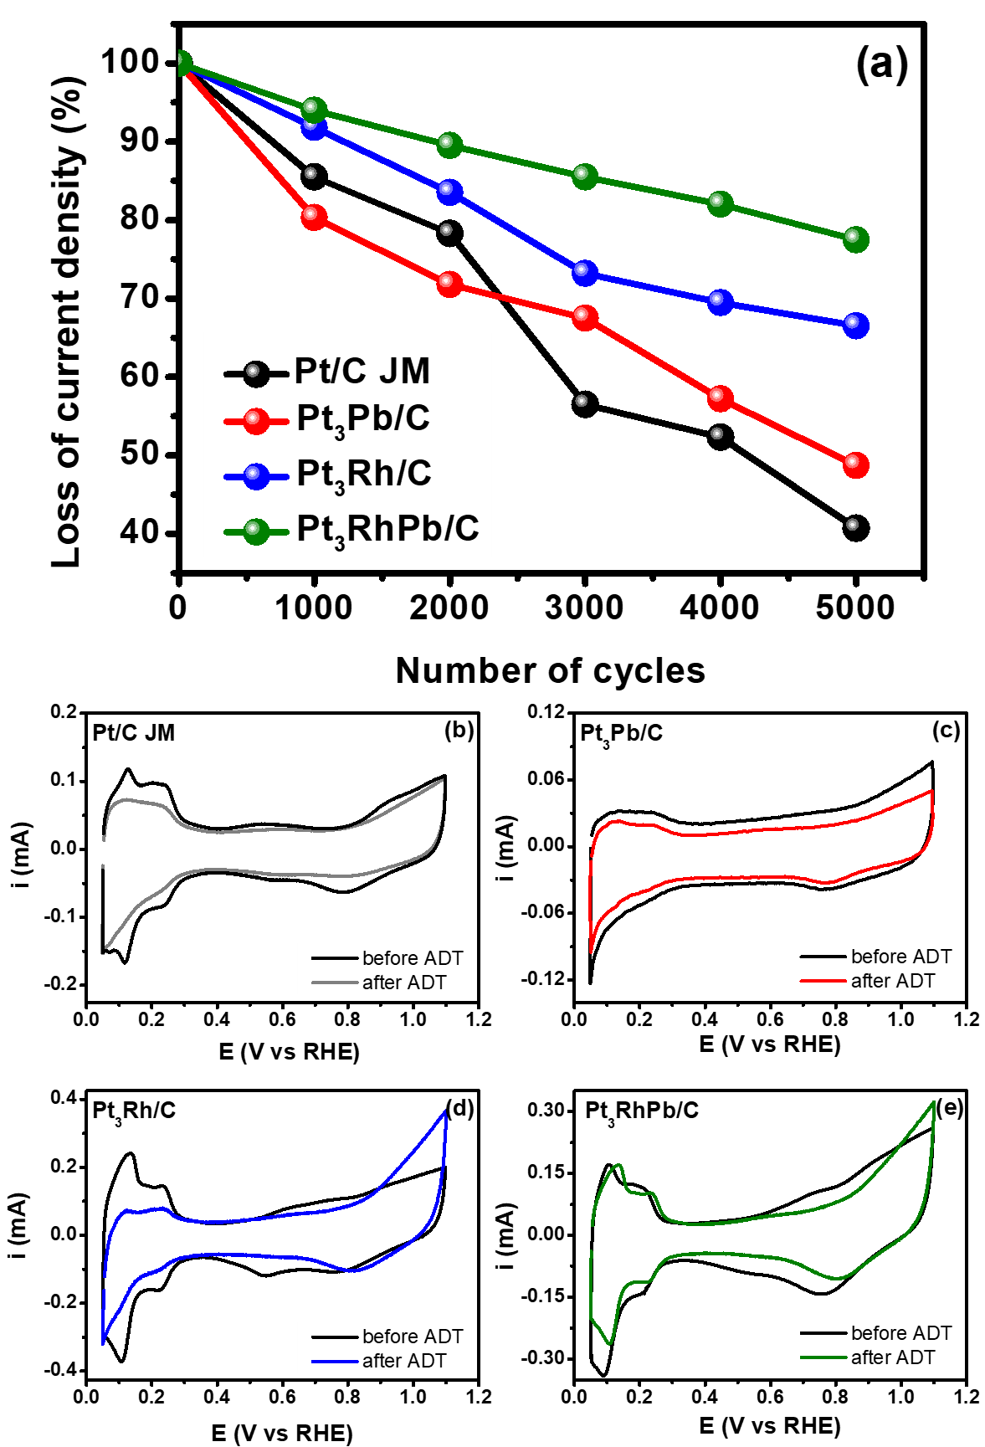
Figure 8: (a) The loss of current density at the anodic peak in the cyclic voltammetry curves versus the number of cycles for all the studied catalysts in 0.5 mol L^{–1} H₂SO₄ + 0.5 mol L^{–1} ethanol at 50 mV s^{–1}. Voltammetric cycles (second cycle) before and after the accelerate durability tests (ADT) for Pt/C JM (b), Pt₃Pb/C (c), Pt₃Rh/C (d), and Pt₃RhPb/C (e) in 0.5 mol L^{–1} H₂SO₄ at 50 mV s^{–1}.

For all materials, the current density decreases with the increasing number of cycles (Fig. 8a). The decrease in the catalytic activity of the materials could be attributed to the dissolution of Pt, Rh, and Pb, to the accumulation of poisonous species on the electrode surface during the experiment, or to the catalyst’s surface reconstruction [61–63].
Another point related to the decrease in the current densities during the ADT is the catalyst modification due to oxide formation. The potential window of the stability test includes the potential range for Pt oxide formation/reduction. Therefore, it seems plausible to suggest the formation and accumulation of Pt oxide that was not reduced during the cathodic scan over the surface of the catalysts. This behavior was proposed by Hornberger et al. [64] to explain the drop in Pt catalysts supported by titanium and ruthenium oxide catalytic activity during ORR and CO oxidation during ADT measurements consisting of 5000 cycles performed in a potential range of 0.6–0.95 V at 100 mV s^{–1}. The authors suggested that the Pt particles might be covered with a partially thin oxide layer due to strong metal-support interaction, which resulted in decreased ORR activity and CO oxidation.
Besides, the commercial Pt/C catalyst exhibited the highest loss of current density after the ADT measurement. Were observed reductions of 54.3%, 51.3%, 33.5%, and 22.5% in the initial current density after 5,000 cycles, respectively, for the Pt/C, Pt₃Pb/C, Pt₃Rh/C, and Pt₃RhPb/C catalysts. The Pt₃RhPb/C catalyst retained 77.5% of its initial current density, demonstrating its highest durability and stability. Pt₃Pb/C and Pt₃Rh/C also presented durability superior to the pure Pt catalyst, corroborating with the chronoamperometric curves (Fig. 3d). The lower durability for Pt₃Pb/C compared to Pt₃Rh/C may be related to the greater sensitivity of Pb to dissolution than Rh. Notably, Pt₃RhPb/C, besides being the most active catalyst, is also the most stable one. Thus, it represents a promising alternative for the commercial viability of fuel cell technologies because of their significantly higher electrochemical stability.
Subsequently, the electrodes were transferred to an electrochemical cell filled with the supporting electrolyte to evaluate probably changes on the catalyst’s surface after the stability tests. Fig. 8b-8e shows the cyclic voltammograms of the catalysts before and after the stability test.
All catalysts exhibited a reduction in the intensity of the peaks representing hydrogen adsorption/desorption reactions (0.05–0.35 V vs RHE). Moreover, for Pt₃Rh/C and to a minor extent to Pt₃RhPb/C, this region became more similar to pure Pt, indicating the reorganization of the catalyst surface related to the higher exposure of the Pt sites. Besides, the peak due to Pd oxidation for these catalysts showed an increase in current density for potentials above 0.9 V, suggesting the accumulation of several layers of Pt oxides on the catalyst surface [11]. More interesting, it was possible to observe the disappearance of two peaks. The first relates to the formation of Rh oxide species (0.7 V) on the surface of Pt₃Rh/C and Pt₃RhPb/C catalysts. And the second is the disappearance of the peak associated with the reduction of Rh oxide (0.55 V), during the cathodic scan. Both reinforce the idea of an increase in the exposure of Pt atoms.
The surface reorganization of materials, causing a most significant Pt atom exposure, can be explained based on the surface energy difference between the metals [11,65,66]. In multimetallic systems, the element with the lowest surface energy and the largest atomic radius tends to diffuse to the surface. Pb atoms tend to occupy the surface of the nanoparticles due to lower surface energy [67] and higher atomic radius (0.180 nm) compared with Pt and Rh (0.139 and 0.134 nm). Rh has higher surface energy than Pt and a smaller atomic radius, so some exchange between the Pt and Rh atoms during cycles can occur. Based on these pieces of information, it is believed that during the ADT Pt segregation to the surface occurred. It could be due to the faster diffusion of Pt than Rh and Pb, associated with the strong adsorption energy between Pt and ethanol during the stability test, as indicated by the voltammograms of Fig. 8b-8e.

4. Conclusions
In summary, we have successfully synthesised Pt₃Pb/C, Pt₃Rh/C, and Pt₃PbRh/C catalysis through a simple polyol method. Chemical composition data confirmed that these catalysts had a composition close to the nominal ones. XRD data confirmed the formation of intermetallic phases of Pt–Pb in the Pt₃Pb/C catalyst and the presence of oxidised Pb (Pb(OH)₂). TEM analysis revealed nanoparticles with a uniform dispersion onto the carbon support. At the same time, XANES data suggest the presence of electrochemical active Pb oxide species, which corroborates the existence of the bifunctional mechanism.
Electrochemical measurements indicated that the composition of the catalysts strongly influences the electrooxidation of ethanol on P_{t3}Pb/C, Pt₃Rh/C, and Pt₃RhPb/C. The Pt₃RhPb/C catalyst exhibited the highest catalytic activity for the EOR. This material showed a current density almost 6-fold higher than Pt/C catalyst (at 0.6 V) and presented the lowest onset potential for ethanol oxidation. In addition, the accelerated durability tests confirmed the higher stability of the trimetallic catalyst, where it retained 77.5% of its initial activity after 5,000 scanning cycles, almost two times higher than that for the commercial Pt catalyst.
In situ FTIR measurements confirmed the formation of CO₂, acetaldehyde, and acetic acid during ethanol oxidation. The Pt₃RhPb/C catalyst presented the highest CO₂ and CH₃COOH production levels at lower potentials. Not least, the Pb/Pb(OH)₂ in the trimetallic catalyst does not favour the formation of CO₂, although the production bands of this species were the largest for this catalyst.
Thus, the outstanding performance makes the Pt₃RhPb/C catalyst an excellent potential candidate for DEFCs application and to be applied in the oxidation of other organic molecules. Future research may optimise the composition of Pt:Rh:Pb or modify the morphology of the catalyst to analyse the relationship in the catalytic activity/structure of these novel materials.

Acknowledgements
The authors thank FAPITEC, FINEP, and the Brazilian National Council of Technological and Scientific Development-CNPq (grants: 305438/2018-2 and 311856/2019-5) for the financial support. This study was financed in part by the Coordenação de Aperfeiçoamento de Pessoal de Nível Superior - Brazil (CAPES) - Finance Code 001. Additionally, we thank Diamond Light Source for instrument access on B18 (SP20354-1) and the station scientist Veronica Celorrio for her assistance. HH acknowledges fellowship support from the China Scholarship Council (201608440295) and the University of Southampton, and the Young Potential Program of Shanghai Institute of Applied Physics, Chinese Academy of Sciences.

References
[1] O.Z. Sharaf, M.F. Orhan, An overview of fuel cell technology: Fundamentals and applications, Renew. Sustain. Energy Rev. 32 (2014) 810–853. https://doi.org/10.1016/j.rser.2014.01.012.
[2] V. Das, S. Padmanaban, K. Venkitusamy, R. Selvamuthukumaran, F. Blaabjerg, P. Siano, Recent advances and challenges of fuel cell based power system architectures and control – A review, Renew. Sustain. Energy Rev., 73 (2017) 10–18. https://doi.org/10.1016/j.rser.2017.01.148.
[3] E. Antolini, Catalysts for direct ethanol fuel cells, J. Power Sources 170 (2007) 1–12. https://doi.org/10.1016/j.jpowsour.2007.04.009.
[4] W. Zhou, Z. Zhou, S. Song, W. Li, G. Sun, P. Tsiakaras, Q. Xin, Pt based anode catalysts for direct ethanol fuel cells, Appl. Catal. B Environ. 46 (2003) 273–285. https://doi.org/10.1016/S0926-3373(03)00218-2.
[5] T. Iwasita, Fuel cells: spectroscopic studies in the electrocatalysis of alcohol oxidation, J. Braz. Chem. Soc. 13 (2002) 401–409.
[6] K. Fatih, V. Neburchilov, V. Alzate, R. Neagu, H. Wang, Synthesis and characterization of quaternary PtRuIrSn/C electrocatalysts for direct ethanol fuel cells, J. Power Sources 195 (2010) 7168–7175. https://doi.org/10.1016/j.jpowsour.2010.05.038.
[7] E.A. De Souza, M.J. Giz, G.A. Camara, E. Antolini, R.R. Passos, Ethanol electro-oxidation on partially alloyed Pt–Sn–Rh/C catalysts, Electrochim. Acta 147 (2014) 483–489. https://doi.org/10.1016/j.electacta.2014.09.141.
[8] J. Thepkaew, S. Therdthianwong, A. Therdthianwong, A. Kucernak, N. Wongyao, Promotional roles of Ru and Sn in mesoporous PtRu and PtRuSn catalysts toward ethanol electrooxidation, Int. J. Hydrogen Energy 38 (2013) 9454–9463. https://doi.org/10.1016/j.ijhydene.2012.12.038.
[9] C.V.S. Almeida, D.S. Ferreira, H. Huang, A.C. Gaiotti, G.A. Camara, A.E. Russell, K.I.B. Eguiluz, G.R. Salazar-Banda, Highly active Pt₃Rh/C nanoparticles towards ethanol electrooxidation. Influence of the catalyst structure, Appl. Catal. B: Environm. 254 (2019) 113–127. https://doi.org/10.1016/j.apcatb.2019.04.078.
[10] E.S. Valério Neto, M. A. Gomes, G.R. Salazar-Banda, K.I.B. Eguiluz, Pt and Pt–Rh nanowires supported on carbon and SnO₂:Sb nanoparticles for ethanol electrochemical oxidation in acidic media, Int. J. Hydrogen Energy 43 (2018) 178–188. https://doi.org/10.1016/j.ijhydene.2017.11.014.
[11] C.V.S. Almeida, N.A. Galiote, K.I.B. Eguiluz, G.R. Salazar-Banda, V. Del Colle, G. Tremiliosi-Filho, Evidence of surface restructuration on Pt–Rh/C and Pt–Rh–Ni/C nanoparticles applied to ethanol electrooxidation reaction, Electrochim. Acta 351 (2020) 136223. https://doi.org/10.1016/j.electacta.2020.136223.
[12] K. Zhang, H. Xu, B. Yan, J. Wang, Z. Gu, Y. Du, Rapid synthesis of dendritic Pt/Pb nanoparticles and their electrocatalytic performance toward ethanol oxidation, Appl. Surf. Sci. 425 (2017) 77–82. https://doi.org/10.1016/j.apsusc.2017.06.270.
[13] R.F.B. De Souza, A.E.A. Flausino, D.C. Rascio, R.T.S. Oliveira, E. Teixeira Neto, M.L. Calegaro, M.C. Santos, Ethanol oxidation reaction on PtCeO₂/C electrocatalysts prepared by the polymeric precursor method, Appl. Catal. B-Environ. 91 (2009) 516–523. https://doi.org/10.1016/j.apcatb.2009.06.022.
[14] W. Liang, Y. Wang, L. Zhao, W. Guo, D. Li, W. Qin, H. Wu,Y. Sun, L. Jiang, 3D Anisotropic Au@Pt–Pd Hemispherical Nanostructures as Efficient Electrocatalysts for Methanol, Ethanol, and Formic Acid Oxidation Reaction, Adv. Mater. 33 (2021) 2100713. https://doi.org/10.1002/adma.202100713.
[15] S.-H. Han, H.-M. Liu, P. Chen, J.-X. Jiang, Y. Chen, Porous Trimetallic PtRhCu Cubic Nanoboxes for Ethanol Electrooxidation, Adv. Energy Mater. 8 (2018) 1801326. https://doi.org/10.1002/aenm.201801326.
[16] M. Li, A. Kowal, K. Sasaki, N. Marinkovic, D. Su, E. Korach, P. Liu, R.R. Adzic, Ethanol oxidation on the ternary Pt–Rh–SnO₂/C electrocatalysts with varied Pt:Rh:Sn ratios, Electrochim. Acta 55 (2010) 4331–4338. https://doi.org/10.1016/j.electacta.2009.12.071
[17] A. Kowal, M. Li, M. Shao, K. Sasaki, M.B. Vukmirovic, J. Zhang, N.S. Marinkovic, P. Liu, A.I. Frenkel, R.R. Adzic, Ternary Pt/Rh/SnO₂ electrocatalysts for oxidizing ethanol to CO₂, Nat. Mater. 8 (2009) 325–330. https://doi.org/10.1038/nmat2359.
[18] L.S.R. Silva, F.E. López-Suárez, M. Perez-Cadenas, S.F. Santos, L.P. da Costa, K.I.B. Eguiluz, G.R. Salazar-Banda, Synthesis and characterization of highly active Pb_{x}@Pt_{y}/C core-shell nanoparticles toward glycerol electrooxidation, Appl. Catal. B: Environm. 198 (2016) 38–48. https://doi.org/10.1016/j.apcatb.2016.04.046.
[19] L.S.R Silva, I.G. Melo, C.V.S Almeida, C.T Meneses, K.I.B Eguiluz, G.R Salazar-Banda, The Effect of Pt Loading on Catalytic Activity of Pb_{0.25}@Pt_{x}/C Nanocomposites Toward Ethanol Oxidation, J. Nanosci. Nanotechnol. 20 (2020) 878–889. https://doi.org/10.1166/jnn.2020.16919.
[20] S.S. Gupta, J. Datta, A comparative study on ethanol oxidation behavior at Pt and PtRh electrodeposits, J. Electroanal. Chem. 594 (2006) 65–72. https://doi.org/10.1016/j.jelechem.2006.05.022.
[21] A.M. Wise, P.W. Richardson, S. W.T. Pricea, G. Chouchelamane, L. Calvillo, P.J. Hendra, M.F. Toney, A.E. Russell, Inhibitive effect of Pt on Pd-hydride formation of Pd@Pt core-shell electrocatalysts: An in situ EXAFS and XRD study, Electrochim. Acta 262 (2018) 27–38. https://doi.org/10.1016/j.electacta.2017.12.161.
[22] B. Ravel, M. Newville, ATHENA, ARTEMIS, HEPHAESTUS: data analysis for X-ray absorption spectroscopy using IFEFFIT, J. Synchrotron Radiat. 12 (2005) 537–541. https://doi.org/10.1107/S0909049505012719.
[23] J.C. Calderón, G. García, L. Calvillo, J.L. Rodríguez, M.J. Lázaro, E. Pastor, Electrochemical oxidation of CO and methanol on Pt–Ru catalysts supported on carbon nanofibers: the influence of synthesis method, Appl. Catal. B Environ. 165 (2015) 676–686. https://doi.org/10.1016/j.apcatb.2014.10.077.
[24] J. Wang, R.M. Asmussen, B. Adams, D.F. Thomas, A. Chen, Facile Synthesis and Electrochemical Properties of Intermetallic PtPb Nanodendrites, Chem. Mater. 21 (2009) 1716–1724. https://doi.org/10.1021/cm9000174.
[25] J. Cheng, X.-P. Zou, W.-L. Song, M.-S. Cao, Y. Su, G.-Q. Yang, X.-M. Lu, F.-X. Zhang, Shape-controlled synthesis and related growth mechanism of Pb(OH)₂ nanorods by solution-phase reaction, Chin. Phys. Lett. 27 (2010) 057302. https://doi.org/10.1088/0256-307X/27/5/057302.
[26] N. Erini, S. Rudi, V. Beermann, P. Krause, R. Yang, Y. Huang, P. Strasser, Exceptional Activity of a Pt–Rh–Ni Ternary Nanostructured Catalyst for the Electrochemical Oxidation of Ethanol, Chem Electro Chem 2 (2015) 903–908. https://doi.org/10.1002/celc.201402390.
[27] F. Colmati, E. Antolini, E.R. Gonzalez, Preparation, structural characterization and activity for ethanol oxidation of carbon supported ternary Pt–Sn–Rh catalysts, J. Alloys Compd. 456 (2008) 264–270. https://doi.org/10.1016/j.jallcom.2007.02.015.
[28] N. Erini, R. Loukrakpam, V. Petkov, E.A.Baranova, R. Yang, D.Teschner, Y. Huang, S.R. Brankovic, P. Strasser, Ethanol electro-oxidation on ternary platinum−rhodium−tin nanocatalysts: Insights in the atomic 3D structure of the active catalytic phase, ACS Catal. 4 (2014) 1859–1867. https://doi.org/10.1021/cs500147p.
[29] L. Bu, Q. Shao, Bin E, J. Guo, J. Yao, X. Huang, PtPb/PtNi Intermetallic core/atomic layer shell octahedra for efficient oxygen reduction electrocatalysis, J. Am. Chem. Soc. 139 (2017) 9576–9582. https://doi.org/10.1021/jacs.7b03510.
[30] S. Lee, H.J. Kim, S.M. Choi, M.H. Seo, W.B. Kim, The promotional effect of Ni on bimetallic PtNi/C catalysts for glycerol electrooxidation, Appl. Catal. A Gen. 429 (2012) 39–47. https://doi.org/10.1016/j.apcata.2012.04.00.
[31] C. Ranjan, R. Hoffmann, F.J. DiSalvo, H.D. Abruna, Electronic Effects in CO chemisorption on Pt-Pb intermetallic surfaces: A theoretical study, J. Phys. Chem. C 111 (2007) 17357–17369. https://doi.org/10.1021/jp0746603.
[32] R.T.S. Oliveira, M.C. Santos, L.O.S. Bulhões, E.C. Pereira, Rh electrodeposition on Pt in acidic medium: a study using cyclic voltammetry and an electrochemical quartz crystal microbalance, J. Electroanal. Chem. 569 (2004) 233–240. https://doi.org/10.1016/j.jelechem.2004.03.006
[33] Z. Yang, X. Wang, X Kang, S. Zhang, Y. Guo, The PtPdAg/C electrocatalyst with Pt-rich surfaces via electrochemical dealloying of Ag and Pd for ethanol oxidation, Electrochim. Acta 236 (2017) 72–81. https://doi.org/10.1016/j.electacta.2017.03.165.
[34] S.-M. Hwang, J.E. Bonevich, J.J. Kim, T.P. Moffat, Formic acid oxidation on Pt_{100−x}Pb_{x} Thin films electrodeposited on Au, J. Electrochem. Soc. 158 (2011) B1019. https://doi.org/10.1149/1.3599913.
[35] J. Perez, V.A. Paganin, E. Antolini, Particle size effect for ethanol electro-oxidation on Pt/C catalysts in half-cell and in a single direct ethanol fuel cell, J. Electroanal. Chem. 654 (2011) 108–115. https://doi.org/10.1016/j.jelechem.2011.01.013
[36] E. Antolini, Structural parameters of supported fuel cell catalysts: the effect of particle size, inter-particle distance and metal loading on catalytic activity and fuel cell performance, Appl. Catal. B: Environ. 181 (2016) 298–313. https://doi.org/10.1016/j.apcatb.2015.08.007.
[37] A. Murthy, A. Manthiram, Application of derivative voltammetry in the analysis of methanol oxidation reaction, J. Phys. Chem. C 116 (2012) 3827–3832. https://doi.org/10.1021/jp2092829.
[38] L.L.A. Souza, G.R.O. Almeida, L.S.R. Silva, F.O.F. Bergamaski, A.S. Lima, K.I.B. Eguiluz, G.R. Salazar-Banda, Outstanding electro-catalytic activity of Pt_{x}–(RuOy–CeO₂)_{1–x}/C composites towards ethanol oxidation in acid media, J. App. Eletrochem. 43 (2013) 953–965. https://doi.org/10.1007/s10800-013-0583-9.
[39] P.G. Corradini, E. Antolini, J. Perez, Activity, short-term stability (poisoning tolerance) and durability of carbon supported Pt–Pr catalysts for ethanol oxidation, J. Power Sources 251 (2014) 402–410. https://doi.org/10.1016/j.jpowsour.2013.11.078.
[40] O. Guillén-Villafuerte, G. García, M.C. Arévalo, J.L. Rodríguez, E. Pastor, New insights on the electrochemical oxidation of ethanol on carbon-supported Pt electrode by a novel electrochemical mass spectrometry configuration, Electrochem. commun. 63 (2016) 48–51. https://doi.org/10.1016/j.elecom.2015.12.007.
[41] I.J. McPherson, P.A. Ash, L. Jones, A. Varambhia, R.M.J. Jacobs, K.A. Vincent, Electrochemical CO oxidation at platinum on carbon studied through analysis of anomalous in situ IR spectra, J. Phys. Chem. C 121 (2017) 17176. https://doi.org/10.1021/acs.jpcc.7b02166.
[42] Y. Lu, W. Wang, X. Chen, Y. Zhang, Y. Han, Y. Cheng, X.-J. Chen, K. Liu, Y. Wang, Q. Zhang, S. Xie, Composition optimized trimetallic PtNiRu dendritic nanostructures as versatile and active electrocatalysts for alcohol oxidation, Nano Research 12 (2019) 651–657. https://doi.org/10.1007/s12274-019-2273-3.
[43] N.S. Nia, O. Guillen-Villafuerte, C. Griesser, G. Manning, J. Kunze-Liebhauser, C. Arevalo, E. Pastor, G. García, W₂C-supported PtAuSn - A catalyst with the earliest ethanol oxidation onset potential and the highest ethanol conversion efficiency to CO₂ known till date, ACS Catal. 10 (2020) 1113−1122. https://doi.org/10.1021/acscatal.9b04348.
[44] T.S. Almeida, C. Garbim, R.G. Silva, A.R. De Andrade, Addition of iron oxide to Pt-based catalyst to enhance the catalytic activity of ethanol electrooxidation, J. Electroanal. Chem. 796 (2017) 49–56. http://dx.doi.org/10.1016/j.jelechem.2017.04.039.
[45] M. Li, N.S. Marinkovic, K. Sasaki, In Situ Characterization of Ternary Pt–Rh–SnO₂/C Catalysts for Ethanol Electrooxidation, Electrocatalysis 3 (2012) 376–385. https://doi.org/10.1007/s12678-012-0090-5.
[46] G. Gruzeł, P. Piekarz, M. Pawlyta, M. Donten, M. Parlinska-Wojtan, Preparation of Pt-skin PtRhNi nanoframes decorated with small SnO₂ nanoparticles as an efficient catalyst for ethanol oxidation reaction, ACS Appl. Mater. Interfaces 11 (2019) 22352−22363. https://doi.org/10.1021/acsami.9b04690.
[47] L.G.S Pereira, V.A. Paganin, E.A. Ticianelli, Investigation of the CO tolerance mechanism at several Pt-based bimetallic anode electrocatalysts in a PEM fuel cell. Electrochim Acta 54 (2009) 1992–1998. https://doi.org/10.1016/j.electacta.2008.07.003.
[48] F. Meirer, B. Pemmer, G. Pepponi, N. Zoeger, P. Wobrauschek, S. Sprio, A. Tampieri, J. Goettlicher, R. Steininger, S. Mangold, P. Roschger, A. Berzlanovich, J.G. Hofstaetter, C. Streli, Assessment of chemical species of lead accumulated in tidemarks of human articular cartilage by X-ray absorption near-edge structure analysis, J. Synchrotron Rad. 18 (2011) 238–244. https://doi.org/10.1107/S0909049510052040.
[49] J. Tayal, B. Rawat, S. Basu, Bimetallic and trimetallic Pt–Sn/C, Pt–Ir/C, Pt–Ir–Sn/ C catalysts for electro-oxidation of ethanol in direct ethanol fuel cell, Int. Hydrogen Energy 36 (2011) 14884–14897. https://doi.org/10.1016/j.ijhydene.2011.03.035.
[50] M. Li, W.-P. Zhou, N.S. Marinkovic, K. Sasaki, R.R. Adzic, The role of rhodium and tin oxide in the platinum-based electrocatalysts for ethanol oxidation to CO₂, Electrochim. Acta 104 (2013) 454–461. https://doi.org/10.1016/j.electacta.2012.10.046.
[51] J.F. Gomes, G. Tremiliosi-Filho, Spectroscopic studies of the glycerol electro-oxidation on polycrystalline au and Pt surfaces in acidic and alkaline media, Electrocatalysis 2 (2011) 96–105. https://doi.org/10.1007/s12678-011-0039-0.
[52] A.B. Delpeuch, F. Maillard, M. Chatenet, P. Soudant, C. Cremers, Ethanol oxidation reaction (EOR) investigation on Pt/C, Rh/C, and Pt-based bi- and tri-metallic electrocatalysts: a DEMS and in situ FTIR study, Appl. Catal. B Environ. 181 (2016) 672–680, https://doi.org/10.1016/j.apcatb.2015.08.041.
[53] J.M. Perez, B. Beden, F. Hahn, A. Aldaz, C. Lamy, “In situ” infrared reflectance spectroscopic study of the early stages of ethanol adsorption at a platinum electrode in acid medium, J. Electroanal. Chem. 262 (1989) 251–261, https://doi.org/10.1016/0022-0728 (89)80026-9.
[54] F. Colmati, G. Tremiliosi-Filho, E.R. Gonzalez, A. Berna, E. Herrero, J.M. Feliu, Surface structure effects on the electrochemical oxidation of ethanol on platinum single crystal electrodes, Faraday Discuss. 140 (2008) 379–397, https://doi.org/10.1039/B802160K
[55] G. Sócrates, Infrared and Raman Characteristic Group Frequencies: Tables and Charts, 4 Ed. John Wiley & Sons, Chichester, 2004.
[56] G. Wu, Modern Fourier Transform Infrared Spectroscopy Techniques and their Applications, 1ed. Elsevier Science, London, United Kingdom, 1994.
[57] R.G.C.S. Reis, C.A. Martins, G.A. Camara, The electrooxidation of 2-propanol: an example of an alternative way to look at in situ FTIR data, Electrocatalysis 1 (2010) 116–121. https://doi.org/10.1007/s12678-010-0018-x
[58] L.C. Silva-Junior, G. Maia, R.R. Passos, E.A. de Souza, G.A. Camara, M.J. Giz, Analysis of the selectivity of PtRh/C and PtRhSn/C to the formation of CO₂ during ethanol electrooxidation, Electrochim. Acta 112 (2013) 612–619. http://dx.doi.org/10.1016/j.electacta.2013.09.030.
[59] C.A. Martins, M.J. Giz, G.A. Camara, Generation of carbon dioxide from glycerol: evidences of massive production on polycrystalline platinum, Electrochim. Acta 56 (2011) 4549–4553. https://doi.org/10.1016/j.electacta.2011.02.076.
[60] J.F. Gomes, C.A. Martins, M.J. Giz, G. Tremiliosi-Filho, G.A. Camara, Insights into the adsorption and electro-oxidation of glycerol: self-inhibition and concentration effects, J. Catal. 301 (2013) 154–161. https://doi.org/10.1016/j.jcat.2013.02.007.
[61] E. Antolini, Structural parameters of supported fuel cell catalysts: the effect of particle size, inter-particle distance and metal loading on catalytic activity and fuel cell performance, Appl. Catal. B: Environ. 181 (2016) 298–313. https://doi.org/10.1016/j.apcatb.2015.08.007.
[62] B. Zhang, D. Wang, Y. Hou, S. Yang, X.H. Yang, J.H. Zhong, J. Liu, H.F. Wang, P. Hu, H.J. Zhao, H.G. Yang, Facet-dependent catalytic activity of platinum nano- crystals for triiodide reduction in dye-sensitized solar cells, Sci. Rep. 3 (2013) 1836–1843. https://doi.org/10.1038/srep01836.
[63] R. Devivaraprasad, T. Kar, A. Chakraborty, R.K. Singh, M. Neergat, M. Neergat, T. Kinumoto, Y. Iriyama, Z. Ogumi, Y. Iwasawa, H. Zheng, Reconstruction and dissolution of shape-controlled Pt nanoparticles in acidic electrolytes, Phys. Chem. Chem. Phys. 18 (2016) 11220–11232. https://doi.org/10.1039/C5CP07832F.
[64] E. Hornberger, A. Bergmann, H. Schmies, S. Kuehl, G. Wang, J. Drnec, D. Sandbeck, V.K. Ramani, S. Cherevko, K.J.J. Mayrhofer, Peter Strasser, In situ stability studies of platinum nanoparticles supported on ruthenium-itanium mixed oxide (RTO) for fuel cell cathodes, ACS Catal. 8 (2018) 9675–9683. https://doi.org/10.1021/acscatal.8b02498.
[65] M.J. Prieto, G. Tremiliosi-Filho, Surface restructuring of Pt films on Au stepped surfaces: effects on catalytic behaviour, Phys. Chem. Chem. Phys. 15 (2013) 13184, https://doi.org/10.1039/C3CP51513C.
[66] F. Tao, S. Dag, L.W. Wang, Z. Liu, D.R. Butcher, H. Bluhm, M. Salmeron, G.A. Somorjai, Break-up of stepped platinum catalyst surfaces by high CO coverage, Science 327 (2010) 850, https://doi.org/10.1126/science.1182122.
[67] J.-M. Zhang, F. Ma, K.-W. Xu, Calculation of the surface energy of fcc metals with modified embedded-atom method, Appl. Surf. Sci. 229 (2004) 34–42. https://doi.org/10.1016/j.apsusc.2003.09.050.

