Relationship between strength and uniform elongation of metals based on a physics-based hardening law
Zhenjun Zhang^{a,b∗}, Zhan Qu^{a,b}, Ling Xu^{c}, Rui Liuª, Peng Zhang^{a,b}, Zhefeng Zhang^{a,b∗}, Terence G. Langdon ^{d}
^{a)} Shi-changxu Innovation Center for Advanced Materials, Institute of Metal Research, Chinese Academy of Sciences, Shenyang, 110016, People's R of China
^{b)} School of Materials Science and Engineering, University of Science and Technology of China, Shenyang, 110016, People's R of China
^{c)} Shenyang Institute of Engineering, Shenyang, 110136, People's R of China
^{d)} Department of Mechanical Engineering, University of Southampton, Southampton SO17 1BJ, UK
Abstract
An exponential strain-hardening (ESH) model for single phase metals was established and well verified by systematic experiments on Cu-Al alloys in an earlier study. In this report, several additional significant revelations will be documented for the tensile behavior of several typical metals. Firstly, a unified interpretation of the well-known five strain-hardening stages is developed by correlating the characteristics of each stage with the parameter n that relates to the dislocation annihilation behavior. Secondly, quantitative relationships among the yield strength (YS), ultimate tensile strength (UTS) and uniform elongation (UE) are established and verified using the tensile experimental results for Cu-Al alloys. Thirdly, the two general principles of the synchronous improvement of strength and uniform elongation (SISUE) effect, such as the composition adjustment and microstructure optimization, are quantitatively revealed by the composition parameter n and a microstructure type parameter η. Two typical trends of the true UTS-UE curves and two kinds of characteristic strengths are quantitatively revealed and confirmed by the relevant experimental data. Finally, a prediction model of tensile properties is proposed and a corresponding procedure is displayed, which is further verified by the tensile experimental results for Cu-Al alloys. These applications further support the validity and significance of the ESH model.
Keywords：
Composition; microstructure; strain hardening; strength; uniform elongation..
1. Introduction
In our previous study [1], a general exponential strain-hardening (ESH) model for several typical metals was developed and well verified through systematic experiments. In this report, several popular phenomena on the tensile behavior of metals will be quantitatively examined in detail including 1) the brief interpretation of the five strain-hardening stages; 2) the establishment of a relationship between tensile strength and uniform elongation; 3) a quantitative indication of the synchronous improvement of strength and uniform elongation (SISUE); 4) a indication of the several types of characteristic strength; and 5) a prediction of tensile properties for several typical metals. In the following paragraphs, problems associated with the above aspects will be briefly reviewed.
Firstly, the theory of strain hardening has had a turbulent history [2]. According to the Considère criterion, when the value of strain hardening rate equals that of the true stress, necking occurs and the UTS and UE are reached. This indicates that the strain hardening strongly affects the tensile properties [3]. There have been a large number of investigations on the strain hardening behavior of different metals based on a dislocation theoretical basis, and this was successful in explaining many strain-hardening behaviors [3-9]. However, even after more than half a century, the strain-hardening theory cannot be regarded as complete. Remarkable progress was made and the greatest achievement was the introduction of the concept of the “five strain-hardening stages” and the revelation of their corresponding mechanisms [3, 5, 10-19]. This makes it possible to deeply study the relationships between the mechanical behavior and the deformation mechanisms. Therefore, researchers later carried out systematic investigations on the microscopic processes of each stage and they built up some appropriate models for these stages [3, 4, 6, 8, 17-25]. Despite these advances, there remains a lack of any unified expression or consistent parameters to simply describe the five strain-hardening stages. Therefore, the first aim of the present study is to provide a brief and unified interpretation of these five regions.
Secondly, as the most basic mechanical properties of metals, the tensile properties are generally presented as strength and uniform elongation. A large number of studies show that there is an inverse relationship between strength (including the yield strength (YS) and the ultimate tensile strength (UTS)) and uniform elongation (such as the uniform elongation (UE)) and there is a positive correlation between YS and UTS as, for example, in face-centered cubic (FCC) Cu and its alloys [26-33], Al and its alloys [34-40] and Ni and its alloys [41-45], the body-centered cubic (BCC) alloys [7, 8, 46, 47], and also the hexagonal closely packed (HCP) alloys [48-52]. Nevertheless, these relationships have not been quantitatively revealed. Therefore, it is necessary to ask whether or not there is an intrinsic relationship among the YS, UTS and UE and the precise nature of their relationships. Therefore, our second task is to examine these problems.
Thirdly, synchronously improving strength and uniform elongation is an eternal objective for material researchers. Recently, significant progress was achieved for different metallic materials by introducing nano-twins [53-56], adjusting alloying elements [26-29, 41, 43, 57-59], introducing bi-model microstructures [45, 48, 60, 61] and adjusting the precipitate distributions [46]. These studies provide effective strategies for achieving the SISUE effect for different metals. However, they only focus on specific techniques and emphasize the improvement effect so that the general principles for SISUE remain ambiguous. Therefore, the third objective is to quantitatively reveal the general principles for the SISUE effect.
Previous studies have shown that for twinning-induced plasticity (TWIP) steel with different microstructures, when the tensile test data are plotted in true stress-strain coordinates, the true UTS presents a constant value with the change of elongation [59, 62-64]. For other metals, such as maraging steel and high-nitrogen steel, the true UTS decreases monotonously with the UE [65-67]. Therefore, it is important to examine the essential reasons behind these two different phenomena. In addition to the true UTS, there are in effect other two different types of strengths: the “critical strength” where the UE disappears during strengthening and the “limited strength” that appears after sufficiently high plastic deformation. This leads to questions concerning the nature of the two characteristic strengths and whether there are any general rules for alloys with different compositions. This means the the fourth target of this study is to quantitatively reveal the different types of strengths.
Undoubtedly, the ultimate goal of research on strain hardening should be a quantitative prediction to establish the relationship among various parameters such as the microstructure, composition and tensile properties. At present, the relevant predictions are basically mature for YS [18, 23] and the necking and fracture behaviors have also been systematically investigated and deeply revealed from a solids mechanics approach as, for instance, in the studies by Neale and Hutchinson [68-71], Marciniak [72, 73], Rice [74-77] and McClintock [78, 79], and also recently further developed and extended by Audoly, Pardoen, Bouaziz et. al. [55, 56, 80-83]. Relying on simple power hardening law, they have carefully analyzed the effect of strain hardening, imperfections, rates effects, etc [68, 70-92]. However, predictions of the UTS, UE and the tensile stress-strain curves for varying composition and YS based on an exponential model is lacking. Thus, in the last part of the application, taking Cu-Al alloys as an example, some predictive methods will be developed for accurately predicting the tensile properties for a given YS and composition.
For clarity, the structure of the this paper is illustrated in Fig. 1
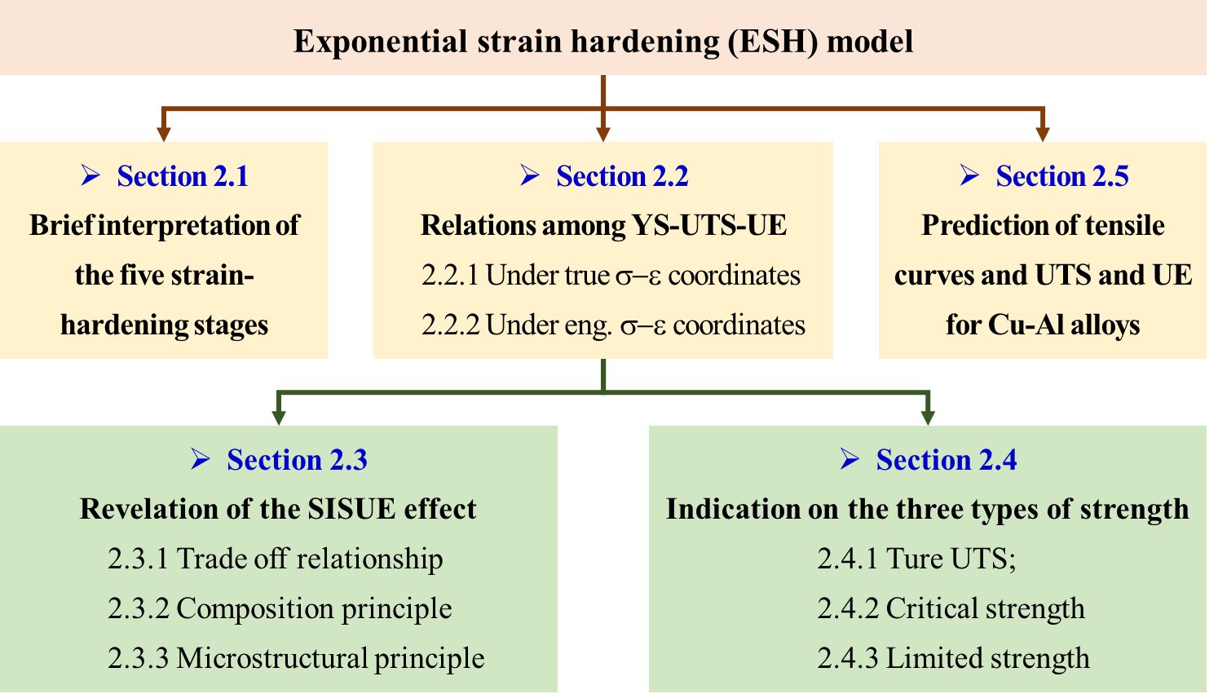
Fig. 1 Structure chart of this study
2. A quantitative revelation on popular tensile behavior
2.1 Brief interpretation of the five strain-hardening stages
The general trend of the five-stage strain hardening can be schematically illustrated in Fig. 2. The strain-hardening rate (Θ) is the lowest in Stage I, which increases sharply to the highest plateau in Stage II, and gradually decreases in Stage III, then comes to the second plateau in Stage IV, and finally decreases again to zero in Stage V [3, 5, 10-19]. Although having different macroscopic performances, the underlying mechanisms are the same, which is attributed to the competition between the dislocation multiplications and annihilations during plastic deformation [3-6, 8, 10, 13-25]. Therefore, in this section, by considering the corresponding features and behavior, the five-stage strain hardening is interpreted by the ESH model.
A concrete demonstration is provided in the Supplementary material, from which, a simple and unified interpretation for the five strain-hardening stages is elaborated using the ESH model. This indicates that the different trends and behaviors of the five stages can be readily described by the parameter n, as concluded in Fig. 2.
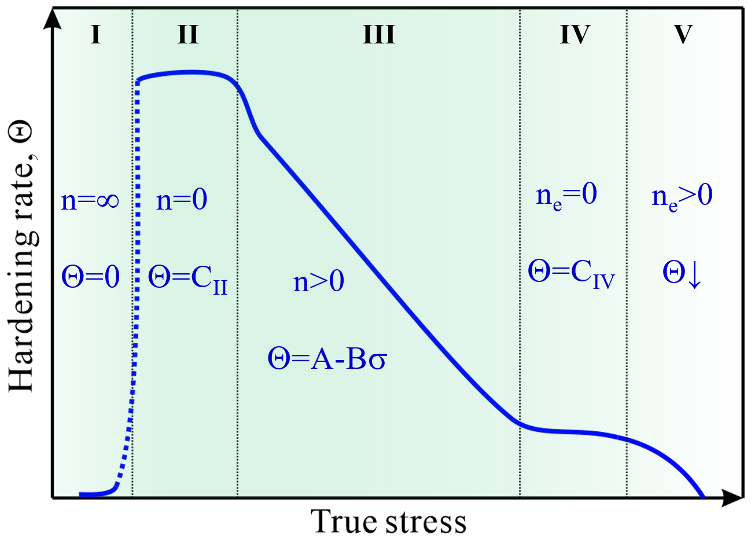
Fig. 2 General trend of the five-stage strain-hardening rate with flow stress for metals, and its unified interpretation by the parameter n.
2.2 Development of the relationships among the tensile properties
Normally, the tensile properties, such as YS, UTS and UE, can be obtained from the same tensile stress-strain curve, so there must be some quantitative relations among them. This will be revealed using the ESH model and the relevant experimental data of Cu-Al alloys.
2.2.1 Relationships under true stress-strain coordinates
According to the Considère criterion, when necking happens, the strain-hardening rate Θ and the flow stress σ should obey a simple relation of the form:
Θ = σ. (1)
Combining Eq. (S2) and Eq. (1), the expression of the UTS under the true stress-strain coordinates (σ_{n}) can be derived in a form of YS (σ_{y}):
. (2)
Similarly, combining Eqs. (S1), (1) and (2), the UE under the true stress-strain coordinates (ε_{n}) can be derived likewise in a form of YS:
. (3)
Furthermore, combining with the expressions of σ_{n} and ε_{n} in Eqs. (2) and (3) gives the relationship between the UTS and UE in a true stress-strain form:
. (4)
2.2.2 Relationships under engineering stress-strain coordinates
Since tensile properties are often given in the engineering (Eng.) stress-strain format still heavily used in industry, it is necessary to make a corresponding transformation. The conversion equations from the true stress-strain form to the engineering form are:
, (5)
. (6)
where s and e represent Eng. stress and Eng. strain respectively. Combining Eqs. (2)-(6), the relationship among the YS, UTS (s_{n}) and UE (e_{n}) under the engineering stress-strain coordinates can be obtained.
The relationship between Eng. UTS and YS (s_{n}-σ_{y}) is given by:
. (7)
The relationship between Eng. UE and YS (e_{n}-σ_{y}) is given by:
. (8)
The relationship between Eng. UTS and Eng. UE (s_{n}-e_{n}) is given by:
. (9)
Eqs. (7), (8) and (9) give a very good description of the relationship among the three important properties of YS, Eng. UTS (s_{n}) and Eng. UE (e_{n}). Since the above derivation process is based on the Considère criterion and ESH model, its application scope similar to that of the ESH model [1], so that the present analysis is mainly valid for simple loading conditions and single phase metals without kinematic hardening, grain boundary effect, size effect, etc. In addition, UE is very much affected by rate sensitivity [84-94] which is neglected here. Rate sensitivity is unimportant at room temperature in FCC with regular grain size but can become large at nanograin sizes [84, 87, 89, 91, 93, 94] and in HCP [87, 88, 93] or BCC [86, 90-92, 94] metals. Therefore, Eqs. (7), (8) and (9) may only apply to fixed temperature and strain rate, and metals with regular grain sizes. All the above mentioned conditions are fulfilled in the Cu-Al alloys of this study [1], which can be used to further verify the validity of the EHS model.
2.2.3 Display of the relationships among tensile properties for Cu-Al alloy
For the above relations among the tensile properties, three parameters are involved, the hardening exponent (n), the microstructure type parameter (η), and the initial hardening rate (Θ_{II}). Therefore, the values of the three parameters for the Cu-Al alloys are listed in Table 1 which are all taken from the experimental fitting results in our previous study [1].
Material | n | η | Θ_{II} (MPa)
Cu | 5.20 | 0.09 | 2000
Cu-2.5Al | 4.65 | 0.16 | 2000
Cu-5Al | 3.85 | 0.16 | 2000
Cu-8Al | 3.00 | 0.44 | 1710
Cu-11Al | 2.12 | 0.16 | 2000
Cu-15Al | 1.69 | 0.16 | 2000
Table 1 Experimental fitting values of n, η, and Θ_{II} for Cu-Al alloys.
Fig. 3 shows a comparison of results between the experimental data and the calculating lines using Eqs. (7)-(9) and the values of the relevant parameters are listed in Table 1. It can be seen that all the equations display a very good description of the relationship among the three important tensile properties, which is a natural result of the appropriate fitting of the ESH model on relevant data in Part I and also the validity of the Considere criterion.
For the relationship between Eng. UTS and YS, Eq. (7) only applies for the low YS part when Eng. UE>0, and for the high YS part where always Eng. UE=0, UTS equals to YS so that:
. (10)
The YS value at the joint point can be calculated by combining Eqs. (7) and (10):
. (11)
Therefore, in a large YS range, the Eng. UTS-YS relationship is a piecewise function of Eqs. (7) and (10) with a boundary of σ_{y} value calculated by Eq. (11).
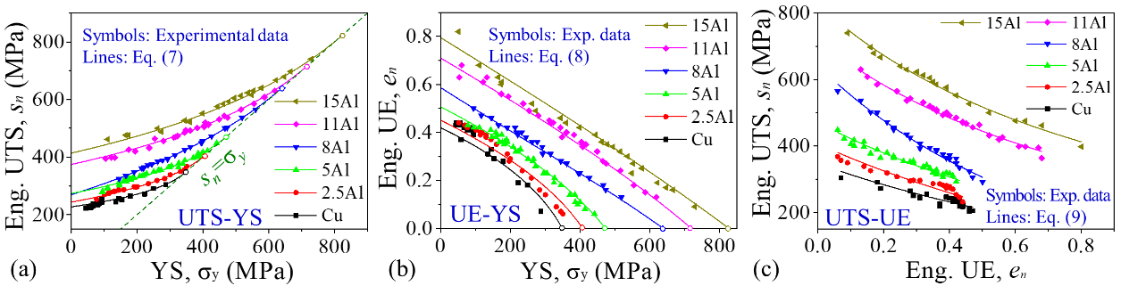
Fig. 3 Comparison between the experimental data (symbols) and the predicting lines (solid lines) for Cu-Al alloys: (a) Eng. UTS-YS, (b) Eng. UE-YS and (c) Eng. UTS- Eng. UE which shows very good consistency between the experimental results and the predicted lines.
2.3 Revelation of the SISUE effect
Reviewing recent research on the tensile properties of metals, two basic progresses can be concluded: 1) the trade-off relationship between strength and uniform elongation is extensively found and studied in different metals [7, 8, 26-52]; 2) the SISUE effects have been achieved in different metals, mainly through the two strategies of designing alloying compositions and adjusting microstructures [26-28, 41-44, 53, 54, 57, 58, 60, 61]. However, there are still requirements for a simple hardening law representation which can shed light on many aspects with a small number of parameters related to the physics of plastic deformation. It will be considered in this section by combining the ESH model.
2.3.1 Revelation of the trade-off relationship between strength and uniform elongation
For clarity, the relationship between Eng. UTS and Eng. UE in Eq. (9) can be simplified as follows:
, (12)
wherein, A and B are expressions of Θ_{II}, η and n, which are constant for the same composition and microstructure type. For actual value ranges of the three parameters, where. Θ_{II} > 0, 1 > η > 0 and n > 0, A and B are always positive so that the Eng. UTS (s_{n}) and Eng. UE (e_{n}) are always inverse with each other as displayed by Fig. 4.
Therefore, Eq. (9) or (12) can be considered as the quantitative explanation of the popular trade-off relationship between strength and uniform elongation. Behind these equations, the intrinsic reason can be further revealed through the following two aspects.
1) From a perspective of Θ, and under the regulation of the Considère criterion, the trade-off relation can be owing to the conflict that after strengthening Θ is required to increase to maintain homogenous deformation under tension, whereas Θ always decreases in real cases as reflected by the value of η where η < 1 for actual cases.
2) From a perspective of dislocation density, the trade-off relation intrinsically results from the unequal competition between dislocation multiplication (ρ⁺) and annihilation (ρ⁻), where the change rate of ρ⁺ is proportional to stress/strength while that of ρ⁻ is proportional to the square of stress/strength (see Eqs. (S3) and (S5) in [1]).
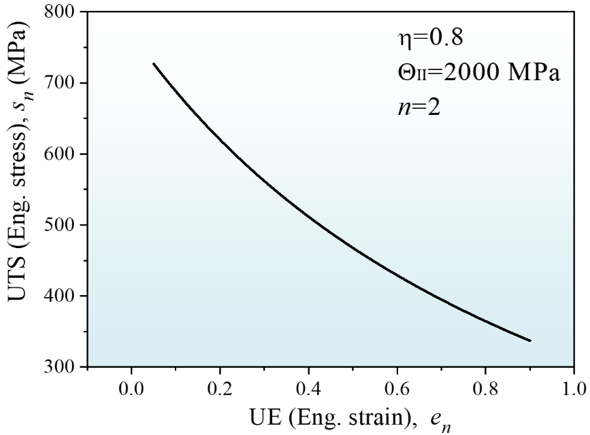
Fig. 4 Demonstration of the relationship of Eng. UTS- Eng. UE with typical Θ_{II}, η and n values, showing a typical trade-off relation.
2.3.2 Revelation of the common principles for the SISUE effect
The above discussions reveal the intrinsic mechanisms for the trade-off relation between strength and uniform elongation for certain materials and microstructure types. However, if changing the material composition or adjusting the microstructure type, this previous trade-off relation may thansfer to another higher inverted relationship curve, which seems to achieve the SISUE tendency. These two methods represent two basic strategies for the previous studies to achieve the SISUE effect in different metals [26-29, 41-46, 48, 53, 54, 57, 58, 60, 61]. In fact, these two factors are also exactly reflected by the ESH model. According to the function between UTS and UE in Eq. (9), three parameters affect the UTS-UE relationship, Θ_{II}, n and η. Among them, Θ_{II} is a material system constant so that it is hard to tailor Θ_{II} to achieve the SISUE effect for a certain material system. However, the other two parameters, n and η respectively corresponding to the composition and microstructure, can be adjusted to a large extent. Therefore, the common principles for the SISUE effect may be revealed from the following two aspects: 1) composition adjustment; and 2) microstructure tailoring.
1) SISUE induced by composition adjustment
According to the relationship of UTS-UE and UE-YS under the engineering stress-strain coordinates in Eqs. (8) and (9), when Θ_{II} and η are fixed, n will primarily influence the trade-off curve. As illustrated by Fig. 5, giving Θ_{II} and η typical values of 2000 MPa and 0.2, respectively, with decreasing n from 5 first to 3 and 2 obvious SISUE effects are achieved both for the Eng. UTS- Eng. UE and Eng. UE-YS relations. Therefore, reducing n through adjusting composition is a very effective method to realize the SISUE effect. The affecting mechanisms of composition on n are elaborated below.
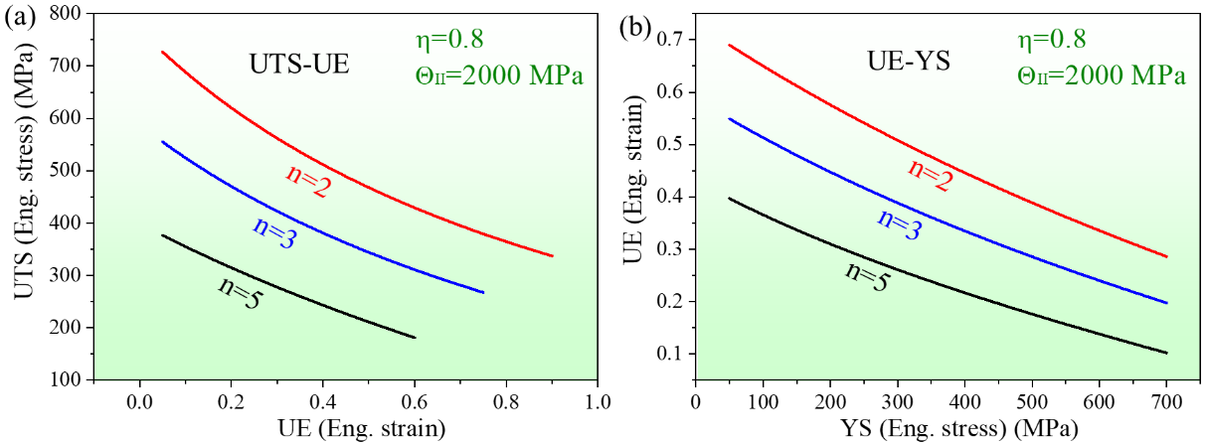
Fig. 5 Demonstration on the relationships of UTS-UE and UE-YS with Θ_{II} and η was given typical values and n changing, showing typical trade-off relations when fixing n and SISUE achievement when reducing n.
According to Eq. (S3), n is proportional to the equivalent dislocation annihilation distance y_{e}=my. For a typical tensile process of metals, only screw dislocations annihilate through cross-slip. It is well accepted that the stacking fault energy (SFE, γ) has a very important effect on the cross-slip of dislocations, with a higher SFE producing easier cross-slip [23]. Therefore, decreasing γ is beneficial to decrease the values of y_{e} and n. For example, Fig. 6(a) gives the values of n, y_{e} and γ for the Cu-Al alloys used in this study, in which the γ values are from previous studies [95-97]. It can be seen that n and y_{e} decrease monotonously with γ, which shows a simple power relation. On the other hand, it is verified that γ is only dependent on the composition at the same temperature [98]. For Cu-Al alloys used in this study, the effect of Al content (C) on γ is shown in Fig. 6(b) which also demonstrates a smooth monotonous relation between γ and C. Accordingly, the relationship between C and n can now be finally obtained, as shown in Fig. 6(c). This is the reason for the SISUE effect observed in Cu-Al alloys in Figs. 3(a)-3(c). Therefore, the effect of composition on n is mainly through affecting the SFE or for a more general case the dislocation slip mode which also includes the short-range order (SRO) [99-101].
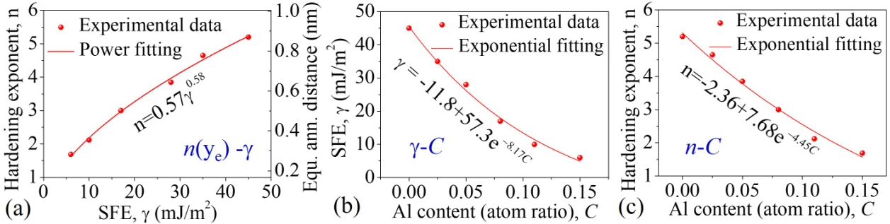
Fig. 6 Relationships of n(y_{e})-γ, γ-C and n-C for the Cu and five groups of Cu-Al alloys, which show monotonous changing trends for each couple.
In fact, among all the relevant studies on the SISUE effect mentioned above, a large number of research reports utilize the method of composition adjustment, including many previous studies by the present authors [26-29, 41, 43, 57, 58] which have essentially used this principle. As illustrated in Fig. 7, through changing the Al and Zn contents for Cu-Al and Cu-Zn alloys (Figs. 7(a)-7(c)) [26, 27, 29, 57, 58], the Co content for Ni-based superalloys and for Ni-Co-Al double-phase alloys (Figs. 7(d) and 7(e)) [41, 42], the Ni content for high-entropy alloys (Fig. 7(f)) [102], and also the Si content for Cu-Si and Ni-Si alloys [103, 104], their SFEs are adjusted so that the SISUE effect was successfully achieved in these alloys. Besides, through changing the Mn content for Cu-Mn alloys and the Cr content for Ni-Cr alloys to adjust the SRO [105, 106], the SISUE effect may be also achieved. Finally, a similar principle can even be extended to twinning dominated metals, through a composition adjustment to increase the twinning ability where dislocation annihilation is restricted and Θ is enhanced so that the SISUE effect can also be achieved. For example, though changing the N content for austenitic stainless steel (Fig. 7(g)) [65, 66] and the Mn, C and Al contents for TWIP steel (Figs. 7(h) and 7(i)) [62, 64], the SISUE effect is also realized in these alloys.
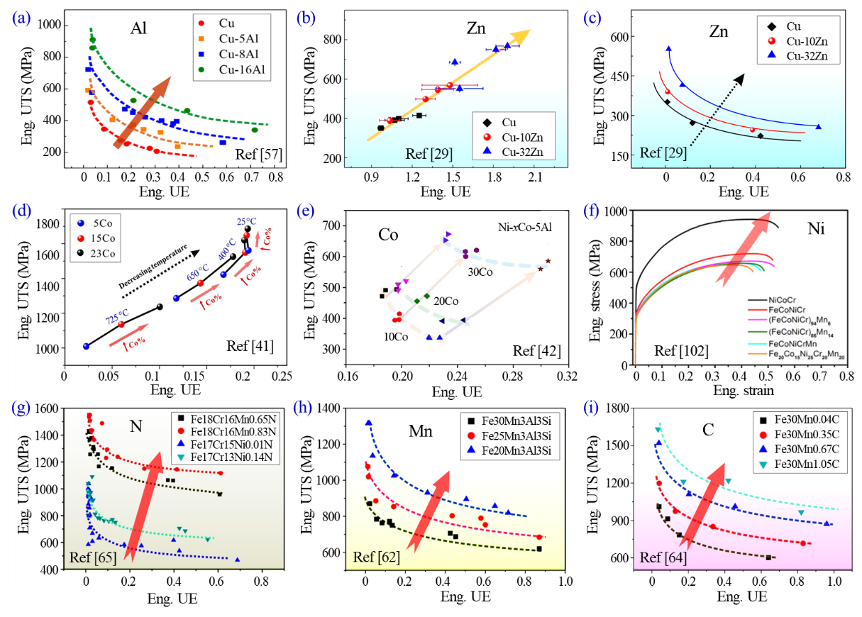
Fig. 7 Demonstration of the relevant previous studies on composition adjustment induced SISUE: (a)-(f) through changing SFE to increase slip planarity; (g-i) through changing SFE or dynamic strain aging (DSA) effect to increase slip planarity and twinnability.
2) SISUE induced by tailoring microstructure
Except for the composition, tailoring the microstructure can also realize the SISUE effect to a certain extent. Firstly, it should be noted that strengthening itself does not necessarily cause the SISUE effect. If using the same strengthening technique to obtain a similar microstructure type, the UTS-UE may obey the same trade-off relation. For example, the above six groups of Cu and Cu-Al alloys all behave in the trade-off relations because their microstructures were all prepared by the same strengthening technique. Therefore they have a similar microstructure type of recrystallized grains with low dislocation density. This means that in order to achieve the SISUE effect through microstructure adjustment it is necessary to optimize the technique and upgrade the microstructure type as reflected by the microstructure type parameter η.
According to the UTS-UE and UE-YS expressions in Eqs. (8) and (9), when Θ_{II} and n are fixed, η will influence the trade-off curve in a different way relative to n. As illustrated by Figs. 8(a) and 8(b), giving Θ_{II} and n typical values of 2000 MPa and 2, respectively, by increasing η from 0 to 1 an obvious SISUE effects can also be achieved both for the Eng. UTS- Eng. UE and Eng. UE-YS coordination. This is different from the composition adjustment because the microstructure induced SISUE effect shows an asymmetric enhancement whereby the SISUE effect decreases gradually with increasing UE or decreasing YS which finally disappears at the point of maximum UE and minimum YS (σ_{y} = 0). This is because when σ_{y} = 0 the stain-hardening process is only influenced by the dislocations and is not connected with the microstructure as in defect-free single crystals.
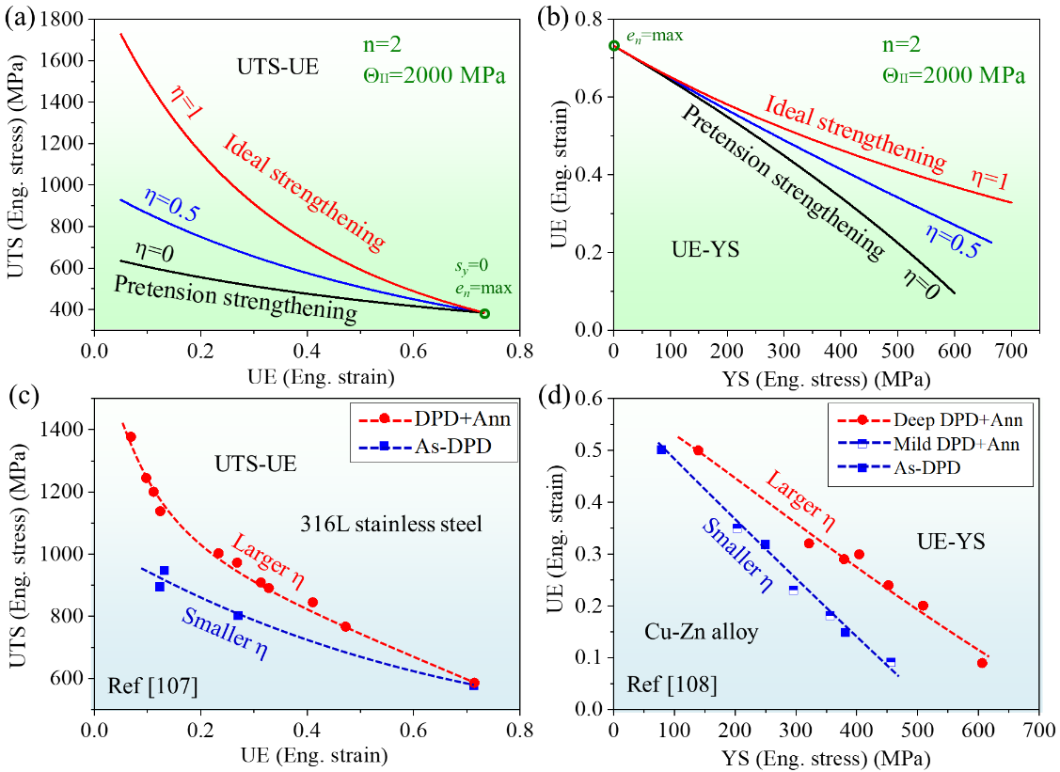
Fig. 8 Demonstration of the microstructure type adjustment induced SISUE: (a) Eng. UTS- Eng. UE and (b) Eng. UE-YS, and the relevant experimental evidence: (a) Eng. UTS- Eng. UE of 316L stainless steel and (b) Eng. UE-YS of a Cu-Zn alloy.
According to the definition of η in our previous study [1]:
, (13)
where σ_{ρy} represents the YS (σ_{y}) contributed by equivalent dislocations and η is the non-dislocation contributing proportion of YS. In other words, if σ_{y} is entirely contributed by the equivalent dislocations so that σ_{ρy}/σ_{y} = 1, the strengthening quality is the worst with η = 0 corresponding to the case of pretension strengthening as reflected by the black lines in Figs. 8(a) and 8(b). On the contrary, if there is no equivalent dislocation so that σ_{ρy}/σ_{y} = 0, the strengthening quality is the best and η = 1 corresponding to ideal strengthening as reflected by the red lines in Figs. 8(a) and 8(b).
As emphasized in our previous study [1], the parameter σ_{ρy}/σ_{y} does not represent the contribution of dislocations literally. Instead, it stands for an equivalent contribution of all defects that promote dislocation annihilation during tensile processes, such as grain boundaries (GB), phase boundaries and so on. The difference is that the contributions of different defects are different. In other words, each defect has its corresponding η value. In general, the more unstable defects contribute more promotion to the dislocation annihilation so that η is smaller. Therefore, a strengthening phase that does not prompt subsequent dislocation annihilation is the best. According to this principle, the order of the defect grades and their corresponding η values for single-phase materials may be roughly ranked as: 0 = pretension dislocations (PD) < rolling dislocation configurations (RDC) < non-equilibrium GBs (NEGB) < equilibrium GBs (EGB) < coherent twin boundaries (CTB) < 1. In real microstructures, η should be a mixture of several kinds of defects according to their fraction. For instance, for a single-phase polycrystal processed by cold rolling (CR) + incomplete annealing (Ann), if using a very simple and rough estimate, i.e. the mixture law, the value of η may be expressed as:
. (14)
where v_{xxx} represents the YS contribution proportion of each defect. It should be noted that Eq. (14) is simply an estimate whose verification might need more systematic and careful investigatons than the present study. Under the frame of Eq. (14), the larger is the proportion of high-ranking defects so the larger is the η value. Taking two kinds of microstructures as an example, one is obtained by mild RD and the other is obtained by heavy RD + Ann. When the YS is the same, the nonequilibrium defects of RD are obviously much more than that of RD + Ann, so η_{RD} should be less than η_{Ann+RD}. This is verified by the relevant experimental results in the previous studies [107-109] as demonstrated in the following paragraphs.
In Fig. 8(c) [107], two methods were used to strengthen the microstructure of 316L stainless steel, one through different amounts of dynamic plastic deformation (DPD) designated As-DPD and the other through DPD + different annealing conditions dewignated DPD+Ann. The main difference between the two microstructures is the proportion of different defects. The proportion of nonequilibrium defects in the As-DPD microstructure is obviously higher than in the DPD+Ann microstructure [107]. Consequently, the latter should have higher η and UTS-UE values and this is confirmed by the experimental results as indicated in Fig. 8(c). It can be seen that the experimental data show very similar trends with the model curves in Fig. 8(a).
In addition to the 316L stainless steel, another typical study on the UE-YS relation also shows a similar result in Cu-Zn alloys [108], as demonstrated in Fig. 8(d) in which the microstructure of mild DPD+Ann is more similar to that of As-DPD due to the small deformation amount and the annealing effect [108]. Comparing Fig. 8(c) with Fig. 8(a), a good consistency between the experimental and the model curves can also be found under the UE-YS coordinates. It should be noted that when UE is very small the elastic deformation and the elastic-plastic yielding occupy a large strain proportion of the UE, causing a deviated and extrinsic UE. Therefore, the data with UE close to 0 in the original figures of Figs. 8(c) and 8(d) were removed.
Besides the above two studies, a similar trend was reported in Cu where the microstructures prepared by DPD + Ann have better UE-YS matching than those by CR [79]. Furthermore, It should be noted that a nano-twin Cu [53, 54] was found to yield a high strength and uniform elongation combination relative to Cu with ordinary GBs, and this result is also well explained in a similar manner.
2.4 Discussion on the three types of strength
During strengthening of the microstructures of metallic materials generally, there are three kinds of strengths under the true stress-strain coordinates where these are the true UTS, the critical strength and the limited strength, as shown in Fig. 9. The critical strength (σ_{C}) represents the UTS where the UE has just disappeared when continuing to enhance the YS, and the limited strength (σ_{L}) represents the maximum strength achieved by a certain strengthening method. The three types of strengths will be examined in this section.
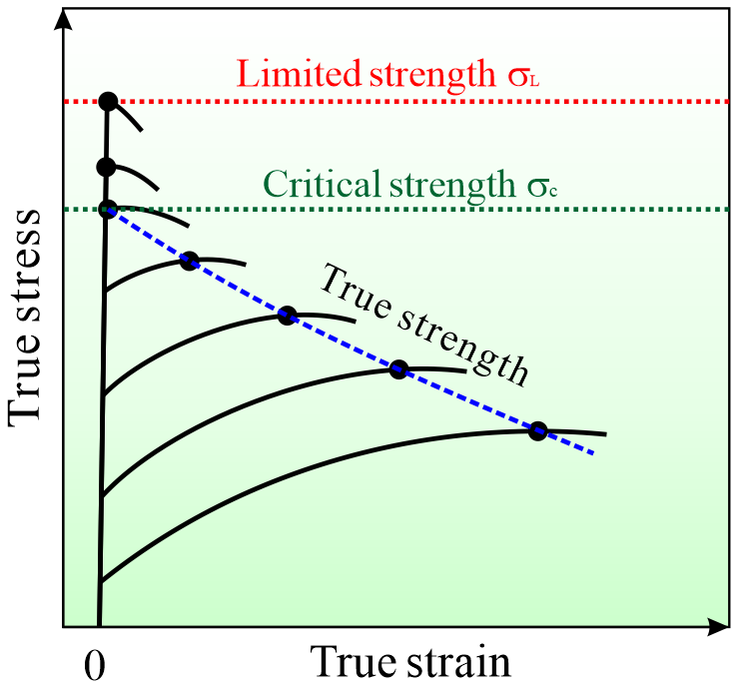
Fig. 9 Illustration of the three kinds of strengths under the true stress-strain coordinates: specifically the true UTS, the critical strength and the limited strength.
2.4.1 True UTS
Previous researchers [62-67] have found that for different metals, using severe plastic deformation (SPD) + Ann processing to prepare different states of microstructures, the trade-off curves of UTS-UE present a general L-shape under the true stress-strain coordinates, as shown in Fig. 10(a-d). Compared with the previous L-shape curves of different metals, two basic types can be categorized. One shows a right “L” with a constant true UTS in the horizontal section, such as for TWIP steels in Figs. 10(a) and 10(b) [62-64]. The other displays an obtuse “L” with various true UTS, represented by maraging and high-nitrogen steels in Figs. 10(c) and 10(d) [65-67] and also Cu-Al alloys in Fig. 10(e) [1]. The mechanisms behind the two trends of true UTS will now be examined using the ESH model.
According to the relationship between the true UTS and true UE as given by Eq. (4), the influence of η on the true UTS-UE curve with typical n and Θ_{II} is displayed in Fig. 10(f). This is different from the Eng. UTS- Eng. UE curves in Fig. 8(a), with η = 0 corresponding to the pretension case and the true UTS becoming a constant so that the UTS-UE curve is a horizontal line. When η > 0, the true UTS curve is an inclined curve but the whole trend is very close to a straight line, especially when η < 0.5. These trends provide an excellent explanation of the two different types of L-shaped curves in Fig. 10.
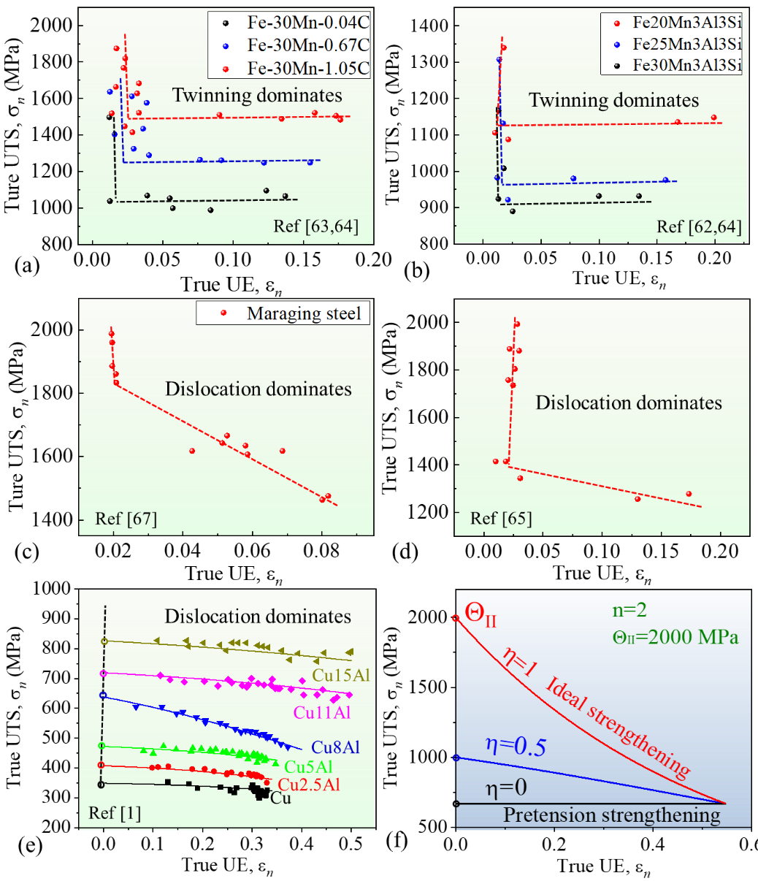
Fig. 10 Typical experimental data of true UTS-UE relations with the right “L” shape: (a) FeMnC and (b) FeMnAlSi TWIP steel, and with the obtuse “L” shape: (c) maraging steel, (d) high nitrogen steel and (e) Cu-Al alloys. (f) Influence of η on the true UTS-UE curve under typical n and Θ_{II} values.
By comparing the deformation mechanisms of the metals in Figs. 10(a)-10(d), it is easy to conclude that the metals in Figs. 10(a) and 10(b) are mainly dominated by twinning showing strong hardening ability [62-64] whereas those in Figs. 10(c-e) are all dominated by dislocation slip with a low hardening ability [65-67]. It can be seen that they also show an inclination trend. Therefore, we obtain a preliminary rule that TWIP steels with twinning tend to show a horizontal true UTS trend corresponding to the case of η = 0 while materials with dislocation slip are prone to show an inclined true UTS trend corresponding to the situation of η > 0. The intrinsic reasons for these effects are now briefly analyzed.
For TWIP steels, η = 0 means that the foregoing strengthening is equivalent to the subsequent pretension so that the strengthening does not contribute to the true UTS. This is because for TWIP steels the microstructure evolution is similar during the strengthening process and the tensile process is twin intersection, and the final microstructure is also similar with a high-density of TBs [62-64, 110]. This is due to their strong strain-hardening ability and low recovery velocity [58] so that the plastic deformation mechanism of these metallic materials have little dependence on the loading type. Therefore, the difference in the strengthening technique does not largely change the microstructure type in such metals. In this case, η = 0 for all the strengthening methods. On the contrary, for dislocation dominated metallic materials in Figs. 10(c-e), the strain-hardening ability is weak and the microstructural recovery is relatively easy [58]. Therefore, compared tothe dislocations formed during the tensile process, the GBs appear during the strengthening process. Thus, for the normal strengthening process of these metals, η > 0.
2.4.2 Critical strength (σ_{C}) and limited strength (σ_{L})
During strengthening, when UE is reduced to zero, the true UTS equals the Eng. UTS, which can be named the critical strength (σ_{C}). According to Eq. (4), when ε_{n}=0 the expression for the critical strength can be derived as:
. (15)
For the case of η=1 representing the ideal strengthening, σ_{C}=Θ_{II}, which is the maximum value of σ_{C} for certain material compositions, as marked in Fig. 10(f). According to Eq. (15) and setting Θ_{II} and η to typical values of 2000 MPa and 0.16 (Table 1), respectively, the critical strengths of the Cu-Al alloys are shown in Fig. 11. It can be seen that σ_{C} increases monotonously with decreasing SFE or increasing Al content. The relationships can be well fitted by power and exponential expressions, respectively.
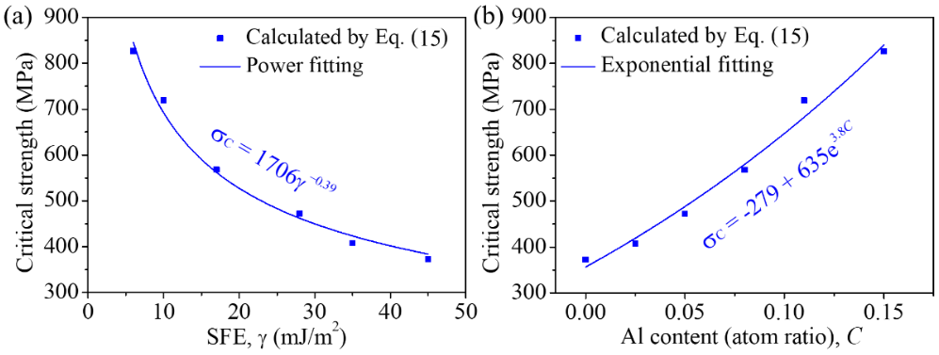
Fig. 11 Critical strengths σ_{C} of the Cu and five groups of Cu-Al alloys with respect to SFE (a) and Al content (b), showing that σ_{C} increases monotonously with decreasing SFE or increasing Al content.
With continuous strengthening of the metallic material, the microstructure will finally come into a saturation state corresponding to a certain technique. Accordingly, the UTS also reaches its saturation value, where this is designated the limited strength, σ_{L}. In principle, the strengthening processes are basically different from the tensile process, which includes grain refinements and GB evolution [19]. However, for metals deformed through twinning, as discussed above, the two processes have approximately similar strengthening behaviors so that η=0. Besides, for metals dominated by dislocations, the strain hardening behavior during tension can also give a large similarity to that of other strengthening techniques. Therefore, the limited strength calculated via pretension strengthening (η=0) will be used to give an index to the general strengthening capacity of a certain composition.
According to the Eqs. (11) and (19) in our previous study [1], the flow stress can be expressed as:
. (16)
As discussed above, letting η=0 and strain ε=∞, the saturation stress or the limited strength (σ_{L}) can be derived in a very simple form:
. (17)
According to Eq. (17) and setting Θ_{II} to a typical value of 2000 MPa as shown in Table 1 (values n are also from Table 1), the limited strengths of the six metals are shown in Figs. 12(a) and 12(b), with respect to the SFE and Al content, respectively. It can be seen that, similar to the changing trend of the critical strength σ_{C}, the limited strength σ_{L} also increases monotonously with decreasing SFE or increasing Al content.
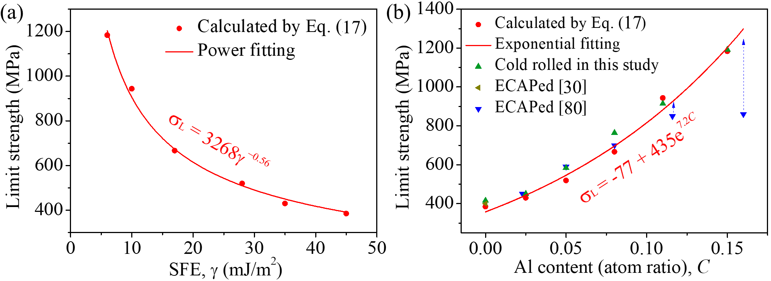
Fig. 12 Limit strengths σ_{L} of the Cu and five groups of Cu-Al alloys with respect to SFE (a) and Al content (b), in which the UTS of Cu-Al alloys prepared by ECAP and large strain amount of cold rolling is also shown for verification.
For comparison, the UTS of Cu-Al alloys prepared by equal-channel angular pressing (ECAP) and large strain cold rolling techniques [32, 111] are also plotted in Fig. 12(b). As indicated, in general the predicted values of σ_{L} are approximate to the experimental ones, among them the much lower values of Cu-11.6Al and Cu-16Al alloys by ECAP is due to the macro-scale defects introduced during ECAP because of the high work-hardening capacity [32, 111]. Therefore, the parameter σ_{L} can roughly reflect the maximum strength of a certain composition after different kinds of deformation strengthening techniques.
2.5 Prediction of tensile properties
According to the ESH model and relevant deductions, for a metal with a deformation mechanism dominated by dislocation slip, if the slip mode or annihilation distance of dislocations does not change much for different microstructure then the material system parameter Θ_{II} and the componential parameters n are both constants for a certain strengthening strategy or microstructure type and η is also a constant. In this case, the tensile properties can be systematically predicted by carrying out a minimum of only two tests. The procedure will be briefly introduced here.
As schematically shown in Fig. 13(a), firstly, carrying out two tensile tests of the samples prepared by two different technical parameters will yield two different YS and tensile stress-strain curves. Using the following exponential strain-hardening equation to fit the two curves:
, (18)
the n value and two sets of YS (σ_{y1} and σ_{y2}) and residual strengths (σ_{r1} and σ_{r2}) will be acquired. Then, making a linear fitting of the two sets of data under a σ_{y}-σ_{r} coordinate according to the relationship between σ_{y} and σ_{r}:
, (19)
the values of Θ_{ΙΙ} and η can be calculated, as shown in Fig. 13(b).
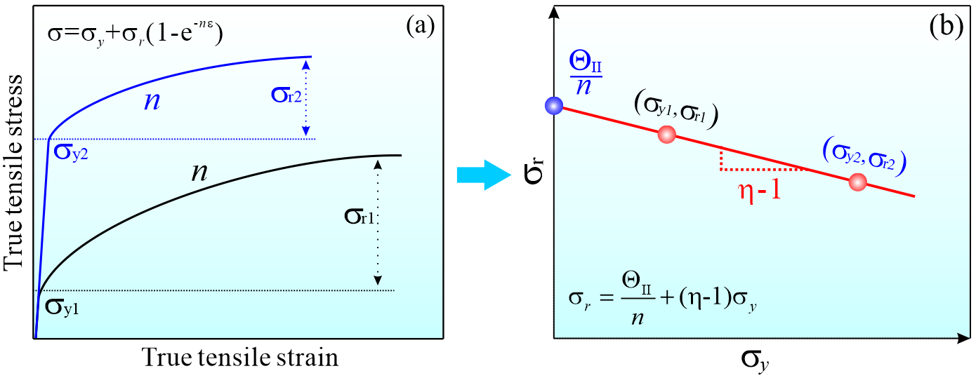
Fig. 13 Procedures for predicting tensile properties of metals with similar microstructure type: 1) carrying out a few tensile tests to get the value of n and σ_{y}-σ_{r} couples (a); 2) making linear fitting of the σ_{y}-σ_{r} data to acquire Θ_{II} and η (b); 3) using Eqs. (7)-(9), (16) and (20) to calculate UTS/UE and tensile curves for arbitrary YS.
Finally, using the relationship equations among the tensile properties (Eqs. (7)-(9)), the UTS and UE can be calculated for an arbitrary YS, and also using the stress-strain constitutive relation (Eq. (16)) and elastic equation given by.
(σ<σ_{y}), (20)
where E is Young’s modulus, so the tensile stress-strain curves can be drawn.
The above procedures supply a prediction method from very few tensile tests to tensile properties of an arbitrary YS for the same composition and similar microstructure type. In an ideal case, if using a further few tensile tests to obtain the quantitative relationship between the alloying content and n, and even between the strengthening technique/microstructure type and η, the tensile properties for any composition, strengthening technique/microstructure type and YS can be predicted.
Taking the present CR + Ann Cu-Al alloys as an example, since a quantitative relationship between composition and n has already been established, as shown in Fig. 6(c), the prediction of tensile properties for arbitrary Al content (< 16at. % for the solution limit of single-phase region) and YS can be readily achieved, as shown in Fig. 14. This demonstrates the quantitative relationships among Al%-YS-Eng. UE, Al%-YS- Eng. UTS and Al%- Eng. UTS- Eng. UE, respectively, from which, the UTS and UE values of random Al content and YS can be obtained. Besides, from Figs. 14(a) and 14(c), the overall trade-off relations between UTS/YS and UE and the obvious SISUE effect for varying Al content can be clearly observed.
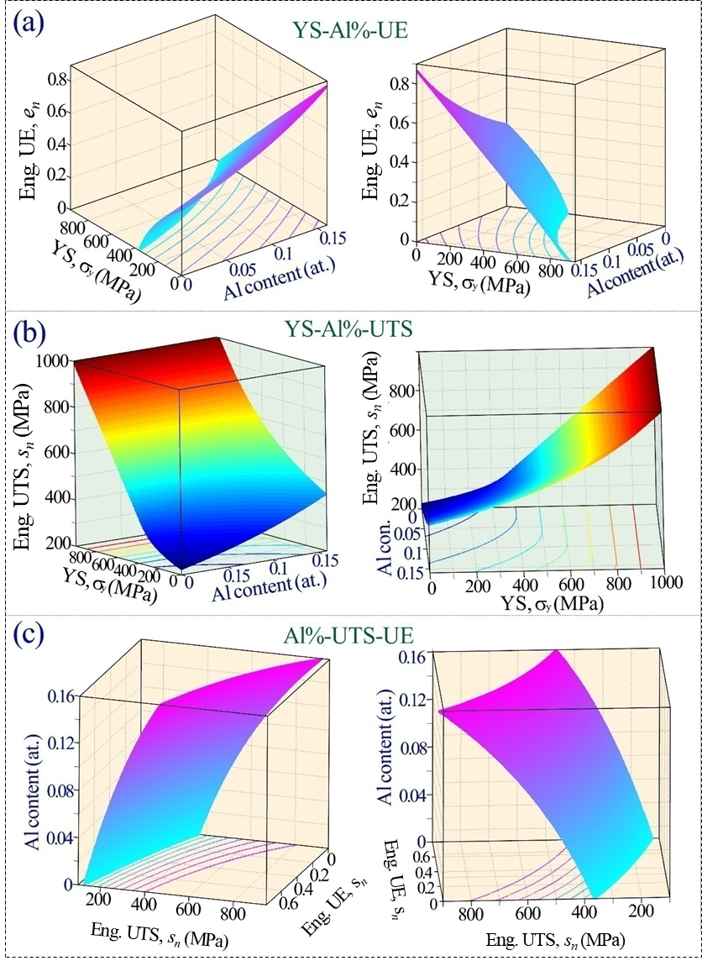
Fig. 14 Prediction results of the overall tensile properties for Cu-Al alloys prepared by cold rolled + annealing with arbitrary Al content and YS.
In practice, the tensile stress-strain curves of single-phase Cu-Al alloys with arbitrary Al content and YS can also be obtained. Fig. 15 shows the predicted tensile stress-strain curves of Cu-Al alloys with four typical contents, among them the former two (Cu-5Al and Cu-11Al) were set as the existing contents for verification and the latter two (Cu-6Al and Cu-12Al) were set as new contents. From comparisons between the predicting tensile stress-strain curves and the experimental ones in Figs. 15(a) and 15(b), it can be seen that, except for the deviation of the yield segment because of the elastic-plastic transformation, the predicted stress-strain curves show very good agreement with the uniform plastic segments of the experimental stress-strain curves. Therefore, it is expected that the predicted series of stress-strain curves of the two new compositions in Figs. 15(c) and 15(d) can also rightly reflect the experimental tensile stress-strain curves.
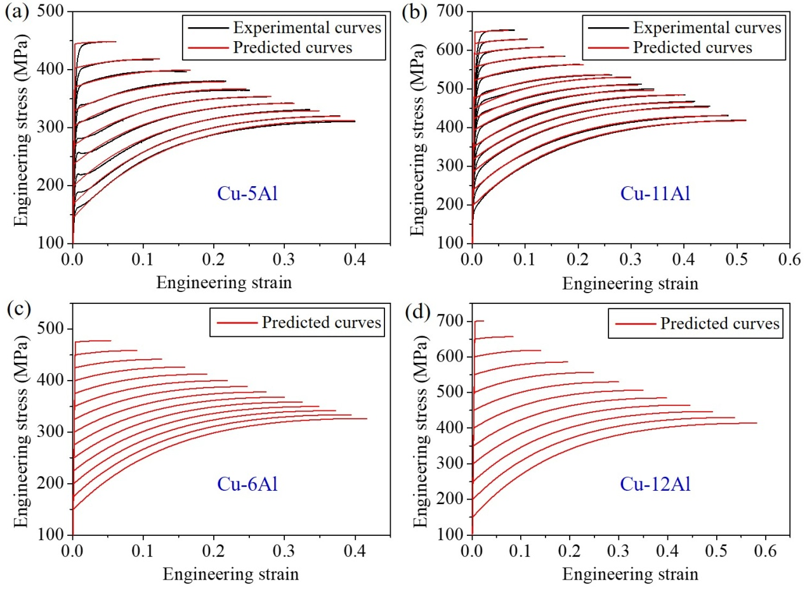
Fig. 15 Prediction of tensile stress-strain curves for Cu-Al alloys with two existing contents (for verifying the accuracy) (a) and (b), and two new contents (c) and (d).
3. Conclusions
In this study, several popular phenomena on the tensile behavior of several typical metals are quantitatively revealed using the ESH model and the conclusions are as follows:
1) By associating the dislocation activities of the different strain-hardening stages with the function of Θ derived from the ESH model, we provide a brief interpretation of the five strain-hardening stages where the different values and changing trends of Θ in different stages correspond to different n values.
2) By combining the present exponential stress-strain relationship with the necking criterion, we establish quantitative relationships of YS-UTS, YS-UE and UTS-UE, which are fully validated by systematic experimental results on Cu and five groups of Cu-Al alloys with more than 100 microstructural states.
3) By referring to the two important parameters, n and η, the two general principles for the SISUE effect (composition optimization and microstructure adjustment) are quantitatively interpreted, and this is fully verified by earlier studies.
4) The right and obtuse “L” trends of UTS under true UTS-UE coordinates for different metals are found to arise because of different strengthening mechanisms that yield different η values. The critical and limited strengths are quantitatively derived and verified by experimental data for Cu-Al alloys.
5) A prediction model for the tensile properties and stress-strain curves for arbitrary YS and even compositions and strengthening technologies is developed from this approach and the prediction results of Cu-Al alloys with both existing and new compositions are very well verified and displayed.
Acknowledgements
This work was financially supported by the Youth Innovation Promotion Association CAS (Grant No. 2021192), the National Natural Science Foundation of China (NSFC) under grant Nos. 51871223, 51790482, 52130002 and 52001153 and the KC Wong Education Foundation (GJTD-2020-09). The work of one of us was supported by the European Research Council under ERC Grant Agreement No. 267464-SPDMETALS (TGL).
References
[1] Z.J. Zhang, Z. Qu, L. Xu, R. Liu, P. Zhang, Z.F. Zhang, Exponential stress-strain constitutive relationship for ductile metals, Acta Mater. With editor (2021).
[2] A.H. Cottrell, Dislocations and plastic flow in crystals, Am. J. Phys. 22(4) (1954) 242-243.
[3] U.F. Kocks, Laws for work-hardening and low-temperature creep, J. Eng. Mater. Technol. 98(1) (1976) 76-85.
[4] U.F. Kocks, H. Mecking, Physics and phenomenology of strain hardening: the FCC case, Prog. Mater. Sci. 48(3) (2003) 171-273.
[5] A. Seeger, J. Diehl, S. Mader, H. Rebstock, Work-hardening and work-softening of face-centred cubic metal crystals, Philos. Mag. 2(15) (1957) 323-350.
[6] G. Taylor, Thermally-activated deformation of BCC metals and alloys, Prog. Mater. Sci. 36 (1992) 29-61.
[7] B. Peeters, B. Bacroix, C. Teodosiu, P. Van Houtte, E. Aernoudt, Work-hardening/softening behaviour of b.c.c. polycrystals during changing strain:: Part II. TEM observations of dislocation sheets in an IF steel during two-stage strain paths and their representation in terms of dislocation densities, Acta Mater. 49(9) (2001) 1621-1632.
[8] B. Peeters, M. Seefeldt, C. Teodosiu, S.R. Kalidindi, P. Van Houtte, E. Aernoudt, Work-hardening/softening behaviour of b.c.c. polycrystals during changing strain paths: I. An integrated model based on substructure and texture evolution, and its prediction of the stress–strain behaviour of an IF steel during two-stage strain paths, Acta Mater. 49(9) (2001) 1607-1619.
[9] D. Canadinc, H. Sehitoglu, H.J. Maier, Y.I. Chumlyakov, Strain hardening behavior of aluminum alloyed Hadfield steel single crystals, Acta Mater. 53(6) (2005) 1831-1842.
[10] N.F. Mott, LXXVIII. A theory of work-hardening of metals II: Flow without slip-lines, recovery and creep, Philos. Mag. 44(354) (1953) 742-765.
[11] E. Voce, The strain work hardening of metals, The engineer 195 (1953) 23.
[12] M.A. Adams, A.H. Cottrell, CXXXI. Effect of temperature on the flow stress of work-hardened copper crystals, Philos. Mag. 46(382) (1955) 1187-1193.
[13] U.F. Kocks, A statistical theory of flow stress and work-hardening, Philos. Mag. 13(123) (1966) 541-566.
[14] P.B. Hirsch, T.E. Mitchell, Stage II work hardening in crystals, Can. J. Phys. 45(2) (1967) 663-706.
[15] A.W. Thompson, M.I. Baskes, W.F. Flanagan, The dependence of polycrystal work hardening on grain size, Acta Metall. 21(7) (1973) 1017-1028.
[16] H.J. Kleemola, M.A. Nieminen, On the strain-hardening parameters of metals, Metall. Trans. 5(8) (1974) 1863-1866.
[17] J. Gil Sevillano, P. van Houtte, E. Aernoudt, Large strain work hardening and textures, Prog. Mater. Sci. 25(2) (1980) 69-134.
[18] J.P. Hirth, J. Lothe, Theory of dislocations, 2nd, Wiley, New York, 1982.
[19] M. Zehetbauer, V. Seumer, Cold work hardening in stages IV and V of F.C.C. metals—I. Experiments and interpretation, Acta Metall. Mater. 41(2) (1993) 577-588.
[20] H. Mecking, B. Nicklas, N. Zarubova, U.F. Kocks, A “universal” temperature scale for plastic flow, Acta Metall. 34(3) (1986) 527-535.
[21] W.J. Liu, A unified theoretical model for work-hardening of polycrystalline metals, Acta Mater. 44(6) (1996) 2337-2343.
[22] E. Nes, Modelling of work hardening and stress saturation in FCC metals, Prog. Mater. Sci. 41(3) (1997) 129-193.
[23] M.A. Meyers, K.K. Chawla, Mechanical behavior of materials, Cambridge University Press, Cambridge, 2009.
[24] D.A. Hughes, N. Hansen, The microstructural origin of work hardening stages, Acta Mater. 148 (2018) 374-383.
[25] S. Mishra, M. Yadava, K.N. Kulkarni, N.P. Gurao, A new phenomenological approach for modeling strain hardening behavior of face centered cubic materials, Acta Mater. 178 (2019) 99-113.
[26] Y.H. Zhao, Y.T. Zhu, X.Z. Liao, Z. Horita, T.G. Langdon, Tailoring stacking fault energy for high ductility and high strength in ultrafine grained Cu and its alloy, Appl. Phys. Lett. 89(12) (2006) 121906-3.
[27] Z.J. Zhang, Q.Q. Duan, X.H. An, S.D. Wu, G. Yang, Z.F. Zhang, Microstructure and mechanical properties of Cu and Cu-Zn alloys produced by equal channel angular pressing, Mater. Sci. Eng. A 528(12) (2011) 4259-4267.
[28] X.H. An, S.D. Wu, Z.F. Zhang, R.B. Figueiredo, N. Gao, T.G. Langdon, Enhanced strength–ductility synergy in nanostructured Cu and Cu–Al alloys processed by high-pressure torsion and subsequent annealing, Scr. Mater. 66(5) (2012) 227-230.
[29] P. Zhang, X.H. An, Z.J. Zhang, S.D. Wu, S.X. Li, Z.F. Zhang, R.B. Figueiredo, N. Gao, T.G. Langdon, Optimizing strength and ductility of Cu-Zn alloys through severe plastic deformation, Scr. Mater. 67(11) (2012) 871-874.
[30] Y.Z. Tian, L.J. Zhao, S. Chen, A. Shibata, Z.F. Zhang, N. Tsuji, Significant contribution of stacking faults to the strain hardening behavior of Cu-15%Al alloy with different grain sizes, Sci. Rep. 5(1) (2015) 16707.
[31] Y.Z. Tian, S. Gao, L.J. Zhao, S. Lu, R. Pippan, Z.F. Zhang, N. Tsuji, Remarkable transitions of yield behavior and Lüders deformation in pure Cu by changing grain sizes, Scr. Mater. 142 (2018) 88-91.
[32] F.D. Torre, R. Lapovok, J. Sandlin, P.F. Thomson, C.H.J. Davies, E.V. Pereloma, Microstructures and properties of copper processed by equal channel angular extrusion for 1-16 passes, Acta Mater. 52 (2004) 4819.
[33] F.H. Dalla Torre, E.V. Pereloma, C.H.J. Davies, Strain hardening behaviour and deformation kinetics of Cu deformed by equal channel angular extrusion from 1 to 16 passes, Acta Mater. 54(4) (2006) 1135-1146.
[34] J.K. Holmen, B.H. Frodal, O.S. Hopperstad, T. Børvik, Strength differential effect in age hardened aluminum alloys, Int. J. Plast. 99 (2017) 144-161.
[35] G. Fribourg, Y. Bréchet, A. Deschamps, A. Simar, Microstructure-based modelling of isotropic and kinematic strain hardening in a precipitation-hardened aluminium alloy, Acta Materialia 59(9) (2011) 3621-3635.
[36] J. da Costa Teixeira, L. Bourgeois, C.W. Sinclair, C.R. Hutchinson, The effect of shear-resistant, plate-shaped precipitates on the work hardening of Al alloys: Towards a prediction of the strength–elongation correlation, Acta Mater. 57(20) (2009) 6075-6089.
[37] P.K. Rout, M.M. Ghosh, K.S. Ghosh, Microstructural, mechanical and electrochemical behaviour of a 7017 Al–Zn–Mg alloy of different tempers, Mater. Charact. 104 (2015) 49-60.
[38] S.V. Kamat, J.P. Hirth, Effect of aging on mixed-mode I/III fracture toughness of 2034 aluminum alloys, Acta Mater. 44(3) (1996) 1047-1054.
[39] C.L. Yang, Q.L. Zhao, Z.J. Zhang, L.L. Li, W.S. Tian, R. Liu, P. Zhang, Y.J. Xu, Y.J. Li, Z.F. Zhang, Q.C. Jiang, R.O. Ritchie, Nanoparticle additions promote outstanding fracture toughness and fatigue strength in a cast Al-Cu alloy, Mater. Des. 186 (2020) 8.
[40] P.V. Liddicoat, X.-Z. Liao, Y. Zhao, Y. Zhu, M.Y. Murashkin, E.J. Lavernia, R.Z. Valiev, S.P. Ringer, Nanostructural hierarchy increases the strength of aluminium alloys, Nat. Commun. 1(6) (2010) 63.
[41] H. Xu, Z.J. Zhang, P. Zhang, C.Y. Cui, T. Jin, Z.F. Zhang, The synchronous improvement of strength and plasticity (SISP) in new Ni-Co based disc superalloys by controling stacking fault energy, Sci. Rep. 7(1) (2017) 8046.
[42] C.L. Yang, Z.J. Zhang, P. Zhang, C.Y. Cui, Z.F. Zhang, Synchronous improvement of the strength and plasticity of Ni-Co based superalloys, Mater. Sci. Eng. A 736 (2018) 100-104.
[43] C.L. Yang, Z.J. Zhang, P. Zhang, R. Liu, Z.F. Zhang, The synchronous improvement of the strength and plasticity of Ni alloys assisted by vacancies, Mater. Sci. Eng. A 680 (2017) 405-410.
[44] W.M. Yin, S.H. Whang, R.A. Mirshams, Effect of interstitials on tensile strength and creep in nanostructured Ni, Acta Mater. 53(2) (2005) 383-392.
[45] X.L. Wu, F.P. Yuan, M.X. Yang, P. Jiang, C.X. Zhang, L. Chen, Y.G. Wei, E. Ma, Nanodomained nickel unite nanocrystal strength with coarse-grain ductility, Sci. Rep. 5(1) (2015) 11728.
[46] G. Liu, G.J. Zhang, F. Jiang, X.D. Ding, Y.J. Sun, J. Sun, E. Ma, Nanostructured high-strength molybdenum alloys with unprecedented tensile ductility, Nat. Mater. 12(4) (2013) 344-350.
[47] B.Q. Han, F.A. Mohamed, E.J. Lavernia, Mechanical properties of iron processed by severe plastic deformation, Metall. Mater. Trans. A 34(1) (2003) 71-83.
[48] R. Valiev, Nanostructuring of metals by severe plastic deformation for advanced properties, Nat. Mater. 3(8) (2004) 511-516.
[49] T. Hu, W.L. Xiao, F. Wang, Y. Li, S.Y. Lyu, R.X. Zheng, C.L. Ma, Improving tensile properties of Mg-Sn-Zn magnesium alloy sheets using pre-tension and ageing treatment, J. Alloys Compd. 735 (2018) 1494-1504.
[50] B.J. Hayes, B.W. Martin, B. Welk, S.J. Kuhr, T.K. Ales, D.A. Brice, I. Ghamarian, A.H. Baker, C.V. Haden, D.G. Harlow, H.L. Fraser, P.C. Collins, Predicting tensile properties of Ti-6Al-4V produced via directed energy deposition, Acta Mater. 133 (2017) 120-133.
[51] C.L. Yang, Z.J. Zhang, S.J. Li, Y.J. Liu, T.B. Sercombe, W.T. Hou, P. Zhang, Y.K. Zhu, Y.L. Hao, Z.F. Zhang, R. Yang, Simultaneous improvement in strength and plasticity of Ti-24Nb-4Zr-8Sn manufactured by selective laser melting, Mater. Des. 157 (2018) 52-59.
[52] J.A. del Valle, F. Carreño, O.A. Ruano, Influence of texture and grain size on work hardening and ductility in magnesium-based alloys processed by ECAP and rolling, Acta Mater. 54(16) (2006) 4247-4259.
[53] L. Lu, X. Chen, X. Huang, K. Lu, Revealing the maximum strength in nanotwinned copper, Science 323(5914) (2009) 607-610.
[54] L. Lu, Y.F. Shen, X.H. Chen, L.H. Qian, K. Lu, Ultrahigh strength and high electrical conductivity in copper, Science 304(5669) (2004) 422-426.
[55] O. Bouaziz, S. Allain, C. Scott, P. Cugy, D. Barbier, High manganese austenitic twinning induced plasticity steels: A review of the microstructure properties relationships, Curr. Opin. Solid State Mater. Sci. 15(4) (2011) 141-168.
[56] O. Bouaziz, S. Allain, C. Scott, Effect of grain and twin boundaries on the hardening mechanisms of twinning-induced plasticity steels, Scr. Mater. 58(6) (2008) 484-487.
[57] R. Liu, Z.J. Zhang, L.L. Li, X.H. An, Z.F. Zhang, Microscopic mechanisms contributing to the synchronous improvement of strength and plasticity (SISP) for TWIP copper alloys, Sci. Rep. 5 (2015) 9550.
[58] S. Qu, X.H. An, H.J. Yang, C.X. Huang, G. Yang, Q.S. Zang, Z.G. Wang, S.D. Wu, Z.F. Zhang, Microstructural evolution and mechanical properties of Cu–Al alloys subjected to equal channel angular pressing, Acta Mater. 57(5) (2009) 1586-1601.
[59] X.H. An, S.D. Wu, Z.G. Wang, Z.F. Zhang, Significance of stacking fault energy in bulk nanostructured materials: Insights from Cu and its binary alloys as model systems, Prog. Mater. Sci. 101 (2019) 1-45.
[60] Y. Wang, M. Chen, F. Zhou, E. Ma, High tensile ductility in a nanostructured metal, Nature 419(6910) (2002) 912-915.
[61] X.J. Guan, F. Shi, H.M. Ji, X.W. Li, A possibility to synchronously improve the high-temperature strength and ductility in face-centered cubic metals through grain boundary engineering, Scr. Mater. 187 (2020) 216-220.
[62] F.Y. Dong, J.C. Pang, P. Zhang, Q.Q. Duan, Z.F. Zhang, Mechanical properties and tensile fracture mechanisms of Fe-Mn-(Al, Si) TRIP/TWIP steels with different ferrite volume fractions, Adv. Eng. Mater. 17(11) (2015) 1675-1682.
[63] H.K. Yang, Z.J. Zhang, F.Y. Dong, Q.Q. Duan, Z.F. Zhang, Strain rate effects on tensile deformation behaviors for Fe-22Mn-0.6C-(1.5Al) twinning-induced plasticity steel, Mater. Sci. Eng. A 607 (2014) 551-558.
[64] Z.F. Zhang, C.W. Shao, B. Wang, H.K. Yang, F.Y. Dong, R. Liu, Z.J. Zhang, P. Zhang, Tensile and fatigue properties and deformation mechanisms of twinning-induced plasticity steels, Acta Metall. Sin. 56(4) (2020) 476-486.
[65] F.Y. Dong, P. Zhang, J.C. Pang, Y.B. Ren, K. Yang, Z.F. Zhang, Strength, damage and fracture behaviors of high-nitrogen austenitic stainless steel processed by high-pressure torsion, Scr. Mater. 96 (2015) 5-8.
[66] F.Y. Dong, P. Zhang, J.C. Pang, Q.Q. Duan, Y.B. Ren, K. Yang, Z.F. Zhang, Microstructure and mechanical properties of high-nitrogen austenitic stainless steels subjected to equal-channel angular pressing, Acta Metall. Sin. (Engl. Lett.) 29(2) (2016) 140-149.
[67] B. Wang, P. Zhang, Q.Q. Duan, Z.J. Zhang, H.J. Yang, X.W. Li, Z.F. Zhang, Optimizing the fatigue strength of 18Ni maraging steel through ageing treatment, Mater. Sci. Eng. A 707 (2017) 674-688.
[68] J. Hutchinson, K. Neale, Influence of strain-rate sensitivity on necking under uniaxial tension, Acta Metall. 25(8) (1977) 839-846.
[69] Y. Zhou, K. Neale, L. Toth, A modified model for simulating latent hardening during the plastic deformation of rate-dependent FCC polycrystals, Int. J. Plast 9(8) (1993) 961-978.
[70] J. Hutchinson, K. Neale, Neck propagation, J. Mech. Phys. Solids 31(5) (1983) 405-426.
[71] J. Hutchinson, K. Neale, Sheet necking-II. Time-independent behavior, Mechanics of sheet metal forming, Springer1978, pp. 127-153.
[72] Z. Marciniak, K. Kuczyński, T. Pokora, Influence of the plastic properties of a material on the forming limit diagram for sheet metal in tension, Int. J. Mech. Sci. 15(10) (1973) 789-800.
[73] Z. Marciniak, A. Konieczny, Modelling the variation of the yield stress within the temperature range typical for cold and warm metal forming, Journal of mechanical working technology 15(1) (1987) 15-37.
[74] R.J. Asaro, J. Rice, Strain localization in ductile single crystals, J. Mech. Phys. Solids 25(5) (1977) 309-338.
[75] J.R. Rice, G. Rosengren, Plane strain deformation near a crack tip in a power-law hardening material, J. Mech. Phys. Solids 16(1) (1968) 1-12.
[76] J.R. Rice, D.M. Tracey, On the ductile enlargement of voids in triaxial stress fields∗, J. Mech. Phys. Solids 17(3) (1969) 201-217.
[77] J.R. Rice, On the structure of stress-strain relations for time-dependent plastic deformation in metals, Transactions of the ASME (1970) 728.
[78] F.A. McClintock, Plasticity aspects of fracture, Engineering fundamentals and environmental effects, Elsevier1971, pp. 47-225.
[79] F.A. McClintock, Local criteria for ductile fracture, Int. J. Fract.Mech. 4(2) (1968) 101-130.
[80] B. Audoly, J.W. Hutchinson, Analysis of necking based on a one-dimensional model, J. Mech. Phys. Solids 97 (2016) 68-91.
[81] B. Audoly, J.W. Hutchinson, One-dimensional modeling of necking in rate-dependent materials, J. Mech. Phys. Solids 123 (2019) 149-171.
[82] T. Pardoen, I. Doghri, F. Delannay, Experimental and numerical comparison of void growth models and void coalescence criteria for the prediction of ductile fracture in copper bars, Acta Mater. 46(2) (1998) 541-552.
[83] T. Pardoen, J. Hutchinson, An extended model for void growth and coalescence, Journal of the Mechanics Physics of Solids 48(12) (2000) 2467-2512.
[84] A. Bintu, G. Vincze, C.R. Picu, A.B. Lopes, J.J. Grácio, F.J.M.S. Barlat, Strain hardening rate sensitivity and strain rate sensitivity in TWIP steels, Mater. Sci. Eng. A 629 (2015) 54-59.
[85] N. Christodoulou, J. Jonas, Work hardening and rate sensitivity material coefficients for OFHC Cu and 99.99% A1, Acta Metall. 32(10) (1984) 1655-1668.
[86] P. El Ters, M.A. Shehadeh, Modeling the temperature and high strain rate sensitivity in BCC iron: Atomistically informed multiscale dislocation dynamics simulations, Int. J. Plast 112 (2019) 257-277.
[87] H. Huh, K. Ahn, J.H. Lim, H.W. Kim, L.J. Park, Evaluation of dynamic hardening models for BCC, FCC, and HCP metals at a wide range of strain rates, J. Mater. Process. Technol. 214(7) (2014) 1326-1340.
[88] M. Knezevic, M. Zecevic, I.J. Beyerlein, J.F. Bingert, R. McCabe, Strain rate and temperature effects on the selection of primary and secondary slip and twinning systems in HCP Zr, Acta Mater. 88 (2015) 55-73.
[89] P. Les, H. Stuewe, M. Zehetbauer, Hardening and strain rate sensitivity in stage IV of deformation in fcc and bcc metals, Mater. Sci. Eng. A 234 (1997) 453-455.
[90] V. Maier, C. Schunk, M. Göken, K. Durst, Microstructure-dependent deformation behaviour of bcc-metals–indentation size effect and strain rate sensitivity, Philos. Mag. 95(16-18) (2015) 1766-1779.
[91] G. Malygin, Analysis of the strain-rate sensitivity of flow stresses in nanocrystalline FCC and BCC metals, Phys. Solid State 49(12) (2007) 2266-2273.
[92] J. May, H.W. Höppel, M. Göken, Strain rate sensitivity of ultrafine grained fcc-and bcc-type metals, Materials Science Forum, Trans Tech Publ, 2006, pp. 781-786.
[93] P. Rodriguez, R. Armstrong, Strength and strain rate sensitivity for hcp and fcc nanopolycrystal metals, Bull. Mater. Sci. 29(7) (2006).
[94] Q. Wei, S. Cheng, K. Ramesh, E. Ma, Effect of nanocrystalline and ultrafine grain sizes on the strain rate sensitivity and activation volume: fcc versus bcc metals, Mater. Sci. Eng. A 381(1-2) (2004) 71-79.
[95] C.B. Carter, S.M. Holmes, The stacking-fault energy of nickel, Philos. Mag. 35(5) (1977) 1161-1172.
[96] P.C.J. Gallagher, The influence of alloying, temperature, and related effects on the stacking fault energy, Metall. Trans. 1(9) (1970) 2429-2461.
[97] K. Kamada, Effects of annealing and irradiation on the stacking fault energy of Cu-Al solid solutions, J. Appl. Phys. 39(3) (1968) 1824-1828.
[98] T. Cai, K.Q. Li, Z.J. Zhang, P. Zhang, R. Liu, J.B. Yang, Z.F. Zhang, Predicting the variation of stacking fault energy for binary Cu alloys by first-principles calculations, J. Mater. Sci. Technol. 53 (2020) 61-65.
[99] P. Schwander, B. Schönfeld, G. Kostorz, Configurational energy change caused by slip in short‐range ordered Ni–Mo, Phys. Status Solidi B 172(1) (1992) 73-85.
[100] T. Steffens, C. Schwink, A. Korner, H.P. Karnthaler, Transmission electron microscopy study of the stacking-fault energy and dislocation structure in CuMn alloys, Philos. Mag. A 56(2) (1987) 161-173.
[101] K. Wolf, H.-J. Gudladt, H. Calderon, G. Kostorz, Transition between planar and wavy slip in cyclically deformed short-range ordered alloys, Int. J. Fatigue 17(6) (1995) 451-451.
[102] S.F. Liu, Y. Wu, H.T. Wang, J.Y. He, J.B. Liu, C.X. Chen, X.J. Liu, H. Wang, Z.P. Lu, Stacking fault energy of face-centered-cubic high entropy alloys, Intermetallics 93 (2018) 269-273.
[103] C.L. Yang, Z.J. Zhang, T. Cai, P. Zhang, Z.F. Zhang, Recovery of strain-hardening rate in Ni-Si alloys, Sci. Rep. 5 (2015) 15532.
[104] X.K. Zhang, X.Y. Yang, W. Chen, J. Qin, J.P. Fouse, Effect of stacking fault energy on mechanical properties and annealing behavior of brasses, J. Alloys Compd. 679 (2016) 400-407.
[105] Y.J. Zhang, D. Han, X.W. Li, A unique two-stage strength-ductility match in low solid-solution hardening Ni-Cr alloys: Decisive role of short range ordering, Scr. Mater. 178 (2020) 269-273.
[106] D. Han, Z.Y. Wang, Y. Yan, F. Shi, X.W. Li, A good strength-ductility match in Cu-Mn alloys with high stacking fault energies: Determinant effect of short range ordering, Scr. Mater. 133 (2017) 59-64.
[107] F.K. Yan, G.Z. Liu, N.R. Tao, K. Lu, Strength and ductility of 316L austenitic stainless steel strengthened by nano-scale twin bundles, Acta Mater. 60(3) (2012) 1059-1071.
[108] G.H. Xiao, N.R. Tao, K. Lu, Strength–ductility combination of nanostructured Cu–Zn alloy with nanotwin bundles, Scr. Mater. 65(2) (2011) 119-122.
[109] Y.S. Li, Y. Zhang, N.R. Tao, K. Lu, Effect of thermal annealing on mechanical properties of a nanostructured copper prepared by means of dynamic plastic deformation, Scr. Mater. 59(4) (2008) 475-478.
[110] H.K. Yang, Z.J. Zhang, Z.F. Zhang, Comparison of work hardening and deformation twinning evolution in Fe-22Mn-0.6C (1.5Al) twinning-induced plasticity steels, Scr. Mater. 68(12) (2013) 992-995.
[111] X.H. An, Q.Y. Lin, S. Qu, G. Yang, S.D. Wu, Z.F. Zhang, Influence of stacking-fault energy on the accommodation of severe shear strain in Cu-Al alloys during equal-channel angular pressing, J. Mater. Res. 24(12) (2009) 3636-3646

∗ Corresponding author, Zhenjun Zhang, E-Mail: zjzhang@imr.ac.cn
∗ Corresponding author, Zhefeng Zhang, E-Mail: zhfzhang@imr.ac.cn

