A physics-based hardening law for single phase metals under uniaxial tension
Zhenjun Zhang^{a,b∗}, Zhan Qu^{a,b}, Ling Xu^{c}, Rui Liuª, Peng Zhang^{a,b}, Zhefeng Zhang^{a,b∗}, Terence G. Langdon ^{d}
^{a)} Shi-changxu Innovation Center for Advanced Materials, Institute of Metal Research, Chinese Academy of Sciences, Shenyang, 110016, People's R of China
^{b)} School of Materials Science and Engineering, University of Science and Technology of China, Shenyang, 110016, People's R of China
^{c)} Shenyang Institute of Engineering, Shenyang, 110136, People's R of China
^{d)} Materials Research Group, Department of Mechanical Engineering, University of Southampton, Southampton SO17 1BJ, UK
Abstract
Under the framework of the Kocks-Mecking-Estrin model, it is possible to develop a simple exponential strain hardening (ESH) model by introducing a microstructure-type parameter to quantitively reflect the effects of yield strength on the subsequent strain-hardening process. The relevant parameters indicating the respective effect of the composition (or dislocation annihilation distance) and the microstructure type (or strengthening technology) are comprehensively analyzed. The application scope of the model is then briefly discussed and several significant advantages are enumerated including the clear derivation processes, the explicit physical meaning of the various parameters and the high fitting accuracy. Finally, the ESH model is verified extensively by systematic tensile tests on six groups of Cu-Al alloys having many different microstructural states. In addition, significant quantitative revelations of strength and uniform elongation for ductile metals are elaborated in the following manuscript. The present ESH model is of significant theoretical value in providing a detailed understanding of the tensile performance of metallic materials.
Keywords: Dislocation annihilation; Uniform elongation; Strain hardening; Strength; Tensile testing.

1. Introduction
As basic mechanical properties for structural materials, the tensile properties highly affect other mechanical properties, such as hardness [1, 2], toughness [3] and the fatigue properties [4-6]. Therefore, quantitively revealing the tensile properties of metals is of significant importance both for engineering application and scientific understanding. According to the Considère criterion, the strain hardening is a bridge connecting the microscopic deformation mechanisms and the macroscopic mechanical properties [7]. Therefore, many investigations have been carried out on the strain-hardening behaviors of different metals [7-36].
Among this extensive research, two general types of metallic materials are involved in the form of either single crystals or polycrystals. The research on the strain hardening of single crystals is relatively sufficient and includes the lattice types [7-13], plastic deformation mechanisms [14-17] and also the effects of temperature and strain rate [7, 18, 19]. In practice, the most important progress will be a five-stage strain-hardening theory that correlates closely with the microscopic mechanisms [2, 7, 14, 37-41]. There are also many relevant studies on the strain hardening of polycrystals, involving different metals and deformation mechanisms [16, 17, 20-33]. However, the majority of these studies focus primarily on revealing the effect of different deformation mechanisms on the strain hardening qualitatively [16, 17, 30-33] and only a limited number of studies focus particularly on the general hardening law based on the microscopic deformation mechanisms [25, 34-36].
In view of the engineering requirements, some empirical hardening laws were proposed and popularly used by engineers, such as several different types of power law functions as proposed by Hollomon, Luduwik, Swift and Romberg-Osgood, the hyperbolic tangential function proposed by Prager, the exponential function proposed by Voce, etc. [2, 7, 42-44]. However, due to the lack of a correlation with the microscopic mechanisms, the physical meaning of the relevant parameters in these various functions is not well delineated [2, 7, 42-44]. Therefore, quantitative relationships between the microstructures and tensile properties can not easily be developed based on these empirical functions [42, 43].
After systematically studying the strain hardening of pure face-centred cubic (FCC) metals, Kocks et al. [7, 8] developed a strain-hardening model based on some salient fundamental features and with a dislocation theoretical basis, and this was successful in explaining the effects of temperature and strain rate on the strain-hardening behavior for several common FCC metals such as Cu, Al and stainless steel. By considering the interaction between twinning and dislocations, some researchers developed quantitative work-hardening models explaining the high strength and good uniform elongation of twinning-induced plasticity (TWIP) steels [16, 45, 46]. However, these models also provide no indication of the effect of the original microstructure on the strain hardening and tensile properties so that again the quantitative relationships among the tensile properties of metallic materials, such as the yield strength (YS), ultimate tensile strength (UTS) and uniform elongation, are absent [7, 8, 25, 34-36].
Based on the above brief review, the aim of the present study was 1) to derive a strain-hardening model that relates closely to the microstructural parameters based on the relevant dislocation theories and microscopic deformation mechanisms and 2) to develop quantitative relationships among composition, microstructure, and tensile properties by taking single-phase Cu-Al alloys as typical examples. Based on the model, some classical problems will be quantitively revealed in a following manuscript [47] such as the trade-off relationship between the strength and uniform elongation and the synchronous improvement of strength and plasticity (SISP). In the present report, the theoretical derivations and the relevant discussions and verification of the model will be presented.
2. Theoretical derivations
Previous studies have raised very mature models for dislocation multiplication and annihilation [37, 38, 48, 49]. In addition, the relationship between stress and strain in the exponential form under simple loading conditions was also proposed as early as 1953 by Voce [44] and later developed by Kocks et al. [7]. We will refer to these studies and rewrite the Kocks-Mecking-Estrin hardening model with some detailed amendments. In addition, the quantitative effect of the original microstructure or YS will be considered. As this model derives an exponential stress-strain relation, it is reasonably named the exponential strain hardening (ESH) model. The detailed derivation process goes in Section S1 of the Supplementary material and the results are displayed as follows.
i. Dislocation form:
The dislocation form of the ESH model is described by Eq.1, and the detailed derivation process is displayed in Section S1.1 of the Supplementary material. For a single phase material under uniaxial tension, the relationship between the normal flow stress contributed by dislocation storage only (σ_{ρ}) and the accumulated plastic strain (ε) can be expressed as:
, (1)
where the expressions for the parameters n, σ_{ρs} and σ_{ρr} are given as follows:
, (2)
, (3)
. (4)
where M is the Taylor factor, b is the Burgers vector, α is a constant and μ is the shear modulus; y_{e} = my represent the effective annihilation distance, therein m is the proportion of the forest dislocations having an opposite sign to the glide dislocations, y is the dislocation annihilation distance; p is designated as the “pinning ratio” representing the transformation ratio of glide dislocations to the forest dislocations.
In the above relationships, σ_{ρy} represents the YS contributed by the existing dislocations, and therefore can be called the “dislocation contributing YS”, σ_{ρs} is the “dislocation saturation strength” because it indicates a limiting flow stress when ε approaches infinite, σ_{ρr} can be called the “dislocation residual strength” that reflects the strain-hardening capacity quantitively and n is designated the “strain-hardening exponent”.
ii. General form (abbreviated):
Eq. (1) reflects an ideal case that only accumulating dislocations contribute to yield stress. However, in real situations, defects other than dislocations also contribute to the flow stress. Therefore, with σ_{i} representing the contribution of other defects, the YS (σ_{y}) includes two parts: σ_{ρy} and σ_{i}, so that
. (5)
Combining Eqs. (1) and (5), the general function of the ESH model may be obtained in an abbreviated form:
, (6)
. (7)
and the physical meanings of the parameters σ_{r} and n are the same as those in the dislocation function (Eq. (1)) so that σ_{r} can also be expressed as:
, (8)
and the relationship between σ_{s} and σ_{ρs} can be expressed as:
, (9)
The detailed derivation process and related discussion are shown in Section S1.2 of the Supplementary material. This abbreviated general function (Eq. (6)) also contains three basic parameters: 1) the saturation strength (σ_{s}) that reflects the limiting strength; 2) the residual strength (σ_{r}) that quantitively reflects the strain-hardening capacity; and 3) the strain-hardening exponent (n) that reflects the speed of the strain-hardening process.
iii. General form (expansion):
Let η represent the non-dislocation contributing proportion of YS, expressed as:
. (10)
then the third function form of the ESH model is obtained:
, (11)
from which the relationship between the saturated or residual strength and the YS can be expressed as:
, (12)
. (13)
and the detailed derivation process and related discussion are displayed in Section S1.2 of the Supplementary material.
Thus, the basic forms of the present ESH model have been derived, which contains three forms: the dislocation form (Eq. (1)), the abbreviated and expanded general form, Eq. (6) and (Eq. (11). Despite the different forms, the core is the same, and is based on the Kocks-Mecking hardening law. The dislocation form is proper for studying the strain-hardening process, the abbreviated general form is convenient for fitting the actual tensile stress-strain curves and the expanded general form is suitable for investigating the effect of microstructure.
3. Discussion of the ESH model
3.1 Overall comments
Eq. (11) contains four parameters, σ_{ρs}, n, η and σ_{y}, and among them, the former two are sensitive to the composition as indicated by their expressions (Eqs. (2) and (3)) and therefore they can be classified as composition parameters whereas the latter two are sensitive to the microstructure and can be ranked as microstructural parameters. For these two microstructural parameters, σ_{y} is more sensitive to the defect density in the microstructure, such as dislocation density and GB density/grain size; while η is more sensitive to the defect types. For example, pre-stretching will introduce a high density of dislocations while rolling/annealing will generate equilibrium GBs [50-53]. Therefore, η can be used to reflect the strengthening effect induced by different processing technologies which will be briefly discussed as follows.
3.2 Microstructure-type parameter η
For a given material composition with single phase and moderate grain size wherein strain hardening mainly comes from dislocation storage due to short range interactions and strong grain boundary effect, strain gradients or GNDs and second phase hardening do not exist, σ_{ρs} and n are assumed to be constant during microstructure strengthening, as will be verified in Section 4. In this case, the stress-strain hardening (CSS) curve in Fig. S2 should have the same shape for different microstructures. In addition, it is also interesting to find from the experimental results in Section 4 that, for a certain strengthening technology, η basically remains unchanged with the change of σ_{y} and even the composition. In this case, based on Eqs. (12) and (13), with a change of YS (Δσ_{y}), the change of saturation strength (Δσ_{s}) and residual strength (Δσ_{r}) can be respectively expressed as:
, (14)
. (15)
According to the exponential form of Eq. (6), the change in σ_{s} means moving the CSS curve vertically while the change in σ_{r} means moving the CSS horizontally. Accordingly, their ratio (Δσ_{s}/Δσ_{r}) determines the moving direction θ, defined as the angle between the moving direction and the strain axis, and the value of θ can be expressed by combining Eqs. (14) and (15):
, (16)
as illustrated by Fig. 1.
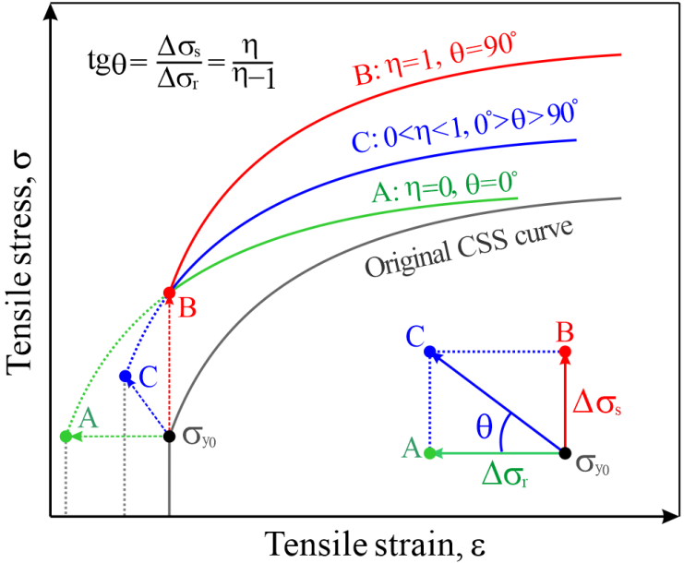
Fig.1 Illustration of the three typical strengthening effects, A: pretension strengthening; B: ideal strengthening; C: general strengthening.
Fig. 1 also illustrates the effect of three typical strengthening types on the tensile stress-strain curves (CSS curves) which also correspond respectively to the three cases in Fig. S3. For strengthening type A when η=0 and θ=0º, the strengthening effect is totally contributed by the equivalent dislocations according to Eq. (10), where Δσ_{y} = Δσ_{ρy} so that the saturation strength σ_{s} remains unchanged and the improving YS is totally at the cost of the strain-hardening capacity σ_{r}. For strengthening type B when η=1 and θ=90º, equivalent dislocations give no contribution to the strengthening effect so that Δσ_{ρy} = 0, and the saturation strength σ_{s} increases completely with the same degree of YS σ_{y}. Finally type C has an intermediate condition and effect so that 0 < η < 1 and 0º＜θ＜90º. Comparing the three strengthening types, η = 1 represents the ideal case which shows the best strengthening effect while η = 0 is the worst case which does not improve the true UTS and 0 < η < 1 is intermediate which represents the true situation. Therefore, the parameter η can be conveniently designated as the “strengthening quality index” that reflects the enhancing rate of the saturation strength σ_{s} or the loss rate of the hardening capacity σ_{r} during strengthening by certain technologies.
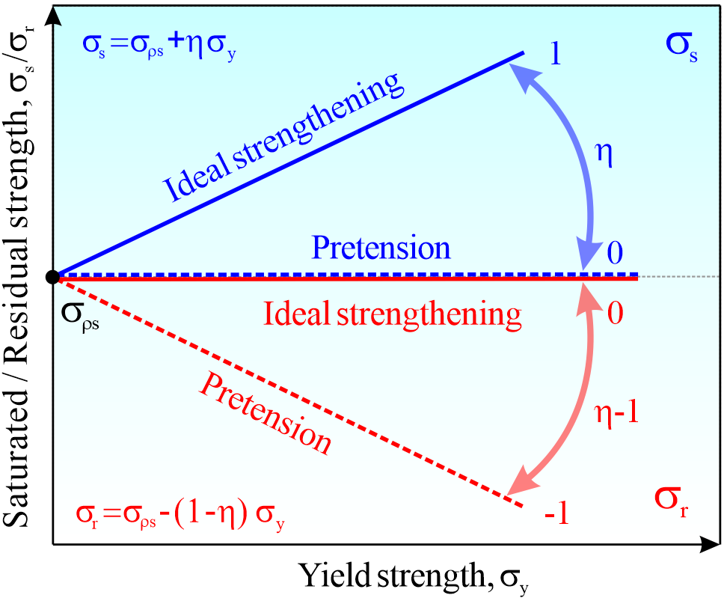
Fig. 2 Illustration of the linear relationship between σ_{y} and σ_{s}/σ_{r} for a certain strengthening technology with slopes of η and η-1, respectively.
Therefore, η has three different meanings but all are similar: the non-dislocation contributing proportion of YS, the microstructural type parameter and the strengthening quality index. Given this importance, we present a simple experimental method for acquiring the value of η. According to Eqs. (12) and (13), for certain microstructure types the relationship of σ_{y} - σ_{s} and σ_{y} - σ_{r} are both linear with slopes of η and η-1 and value ranges of 0~1 and -1~0, respectively, as illustrated in Fig. 2. Therefore, the value of η for materials made by a certain technology can be determined by linearly fitting the experimental results of σ_{y}-σ_{s} or σ_{y}-σ_{r}, which is used to obtain the η value of Cu-Al alloys in Section 4.
3.3 Parameters Θ_{y} and Θ_{II}
After taking differentiation of both sides of Eq. (11) by ε, the strain-hardening rate (Θ) can be conveniently expressed as:
. (17)
Letting ε = 0, the expression for the Θ value of the yield point (Θ_{y}) is given by:
. (18)
According to Eq. (18), letting σ_{y} approach to zero indicates a state where no pre-stored defects exist so that there is no dislocation annihilation and there is only dislocation multiplication so that Θ_{y} reaches its highest value. This corresponds to the linear hardening process (stage II) of a single crystal when Θ remains constant with a very high value [7, 8, 37] entitled as the “stage II hardening rate”, Θ_{II}. Therefore, the value of Θ_{II} can be acquired here based on Eqs. (3) and (18) by letting σ_{y} = 0:
. (19)
According to Eq. (19), Θ_{II} is only affected by the pinning ratio p and μ. Based on the definition of p, for certain material systems, it should change little with composition. Therefore, if μ also changes little with composition for certain material systems, Θ_{II} should be a constant which is consistent with the characteristic of the stage II hardening rate [8]. In fact, experimental results for Cu and five groups of Cu-Al alloys having similar shear modulus but with many different microstructures reveal in Section 4 that Θ_{II} is basically constant for the Cu-Al alloy system with different Al contents. Therefore, Θ_{II} should be described as a material system constant.
Furthermore, combining Eqs. (18) and (19) and giving ω the following expression:
, (20)
which leads to a simplified expression of Θ_{y},
, (21)
in which ω reflects a decreasing rate of strain-hardening rate because of strengthening and an increase of YS, entitled as the hardening losing rate as illustrated by Fig. 3. As η has values from 0 to 1, ω has values from 0 to n, and considering that n > 0, ω is always larger than zero which indicates that with increasing YS so Θ_{y} decreases monotonously. This should be the intrinsic reason for the trade-off relationship between strength and elongation of metallic materials.
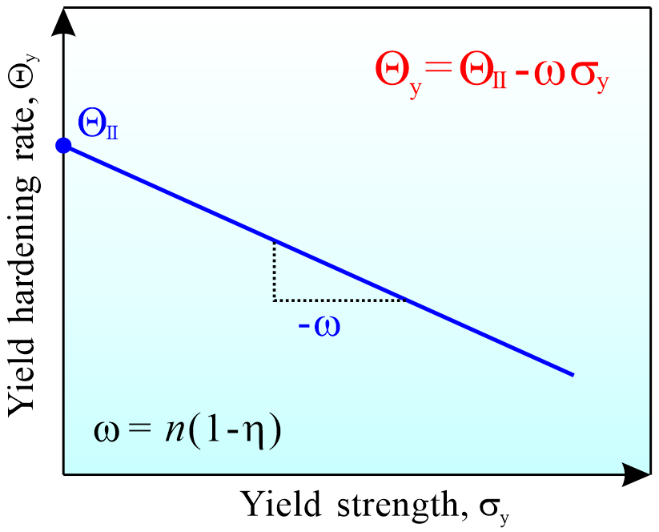
Fig. 3 Linear relationship between Θ_{y} and σ_{y} for certain composition and technology, with a slope of the hardening losing rate (ω).
Thus, the basic form of the present ESH model has been derived and the relevant parameters discussed. These relevant parameters can be classified into three different types. 1) Composition parameters: Θ_{II}, n and independent σ_{ρs} (σ_{ρs} = Θ_{II}/n). According to the expression of σ_{ρs}, n and Θ_{II}, these are mainly influenced by the composition for simple single phase material, such the system of Cu-Al alloy. 2) Technology or microstructure-type parameters: η and independent ω (ω = n(1-η)). During strengthening by a certain technology, if the proportion of different defects remains approximately the same, the microstructure type can be assumed to remain the same. In this case, η and ω are also basically constants. 3) Initial defect density parameters: σ_{y} and independent Θ_{y}. The value of σ_{y} relates strongly to the initial defect density and this differs from the microstructure type since different microstructure types may produce the same σ_{y}.
3.4 Application scope of the ESH model
Firstly, the model is only suitable for simple loading conditions, such as uniaxial tension and uniaxial compression with moderate accumulated strain, and it cannot be applied to complex loading modes, such as non-proportional loadings, loading reversals, change of loading path, etc.
Secondly, as the derivation process of the ESH model is based on the isotropic short-range interactions between dislocations, the model should be applied only to the deformation process dominated by the multiplication and annihilation process caused by dislocations only. For the strain hardening processes related strongly to the kinematic hardening [54-56], such as back stress [57-59], GND or strain gradients [56, 60-63], second phases [64, 65] inside the microstructure, etc, they are beyond the application scope of the ESH model. Many previous studies considered very deeply about these various complex effects [54-62, 65-71], while our model only considers one of the important aspects of the work hardening. Therefore, the single phase Cu-Al alloy with moderate grain size selected in Section 4 is suitable to demonstrate the very robust nature and reveal several regularities regarding the values of the parameters.
Thirdly, another important assumption when deriving the ESH model is that n and σ_{ρs} should not change significantly with microstructure and stress during deformation, which means the dislocation annihilation distance y and pinning ratio p are necessary to remain unchanged with microstructure and stress. These are good assumptions and can be applied for some simple cases where dislocation short-range interactions dominate the hardening process, such as some single phase metals with moderate grain size, as verified in Section 4 by the Cu-Al alloy system. However, the ESH model may not be applicable to the metals with strong grain boundary effect [72-75], i.e. ultrafine and nano grained metals, where those prerequisites are no longer vaklid.
Fourthly, the rate sensitivity that results from the thermally activated mechanisms acts as an extra source of the stabilization of the necking process [7, 56, 76], which is an important element that is also not taken into account in this ESH model. Thermally activated recovery mechanisms (depinning, annihilation, etc) are slow at room temperature for many metallic alloys, but they are sometimes significant especially in the small grain size and high stress regime [73, 75, 77, 78]. For these cases, the ESH model may have a major deficiency.
As for the effects of temperature (T) and strain rate ($\dot{ε}$), which should be considered for a complete strain-hardening model, these effects have not been sufficiently involved because this work focuses mainly on the effect of YS. However, it should be noted that the effects of T and $\dot{ε}$ on the strain hardening of FCC metals were fully studied by Kocks et al. [7, 8] so that, based on these earlier studies, the influences of T and $\dot{ε}$ on strain hardening are briefly discussed in Section S2 of the Supplementary material.
Except for the above unsuitable cases, the model should be applicable to the inhomogeneous microstructures and dislocation distributions although the derivation is based essentially on uniform structures; this application is elaborated in detail in Section S3 of the Supplementary material.
4. Verification of the ESH model
Although there are many experimental results on the tensile stress-strain curves of different metals and microstructures [27-29, 31-34, 79-103], they generally lack systematic and consistent experimental conditions so that it is difficult to verify the model using these extensive data. In order to better design the experiment, it should not only reveal the influence of the composition parameter n but also that of the microstructure parameter η. Therefore, we have selected single-phase FCC Cu-Al alloys to adjust the dislocation annihilation distances by changing the Al content [104-107] and adjusting the microstructure by changing the annealing temperature after severe cold rolling. Full details of the experimental procedures and microstructure characterization results are given in Section S4 of the Supplementary material.
4.1 Verification of the exponential hardening model
The tensile engineering stress-strain curves for six groups of metals with various microstructures are shown in Fig. 4. At first glance, the tensile engineering stress-strain curves show very similar curve shapes for each metal. Thus, the series of stress-strain curves seem to be a result of direct shifts of one curve with different upward/downward and leftward/rightward displacements. Accordingly, this readily implies the existence of the CSS curve as proposed in Section 3.2.
In addition, the details of the yield behavior are not the same for different metals or even for the same metal with different YS, for example Cu-5Al and Cu-8Al alloys show different yield behaviors among the respective series of tensile stress-strain curves. Fortunately, these different yield behaviors should be correlated with the original microstructure but this seems not to affect the subsequent hardening processes and the CSS curves, thereby indicating that strain hardening is an intrinsic process dominated by the interactions between dislocations. However, in the process of curve fitting to acquire the values of the relevant parameters, this difference should be considered. Several yield characteristics and their fitting methods are identified in Section S5 of the Supplementary material.
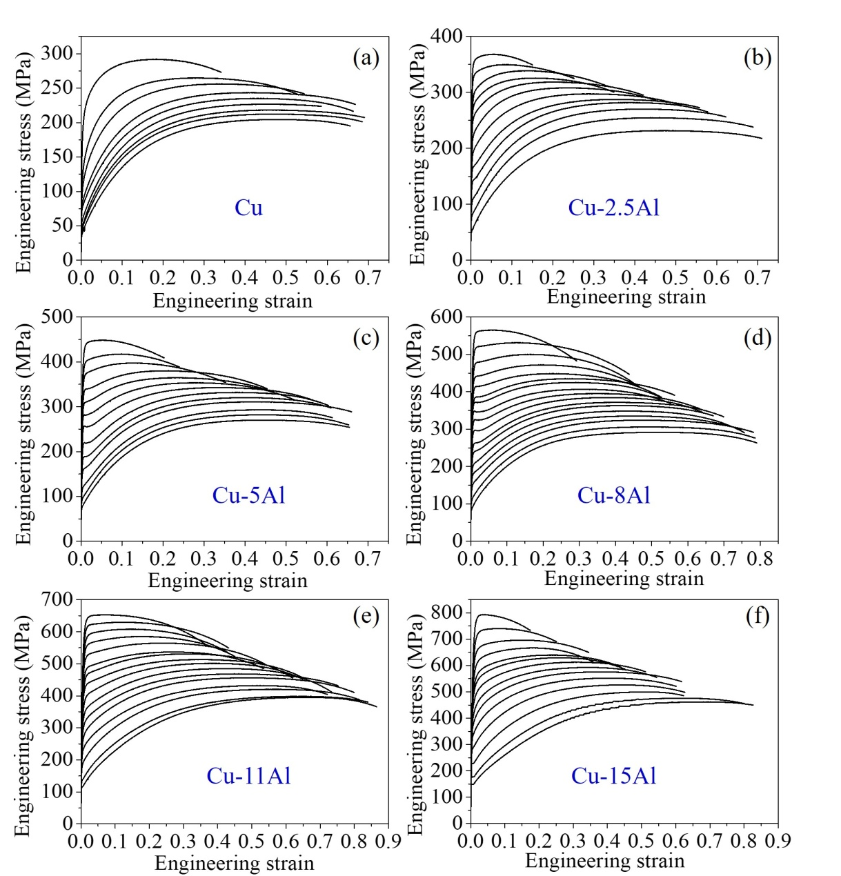
Fig. 4 Tensile engineering stress-strain curves for Cu and Cu-Al alloys with various microstructures.
For example, Fig. 5 demonstrates the fitting effect of the tensile true stress-strain curves of Cu-2.5Al and Cu-11Al alloys. Generally, the exponential function can well fit the uniform plastic section of the true stress-strain curves for Cu-Al alloys with different Al content and YS, thereby confirming the validity of the exponential function for Cu-Al alloys.
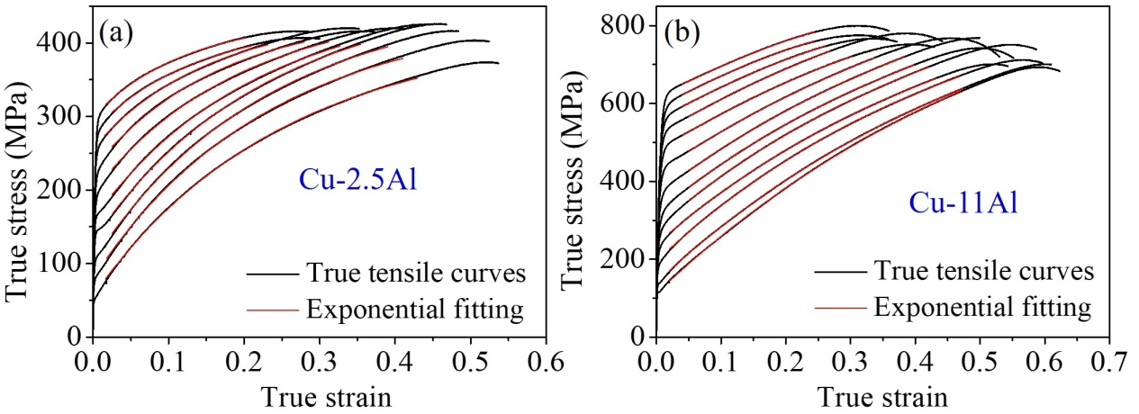
Fig. 5 Fitting effect demonstration of tensile true stress-strain curves for two typical Cu-Al alloys with various YS, showing a high fitting accuracy for the two alloys.
To further systematically verify the exponential relationship, we evaluated the fitting accuracy of the hundreds of stress-strain curves and all the results are shown in Fig. 6. The UTS data acquired by the fitting curves are almost the same as the experimental ones (Fig. 6(a)), and the differences in uniform elongation (UE) are also very small and within 4% error band (Fig. 6(b)). The reason that the difference of the UE is larger than the UTS is that the necking point has a strong effect on the strain but a weak effect on the stress. Nevertheless, the overall consistency of the UTS and UE verify that it is reasonable to use an exponential function to describe the uniform deformation part of Cu-Al alloys with different microstructures.
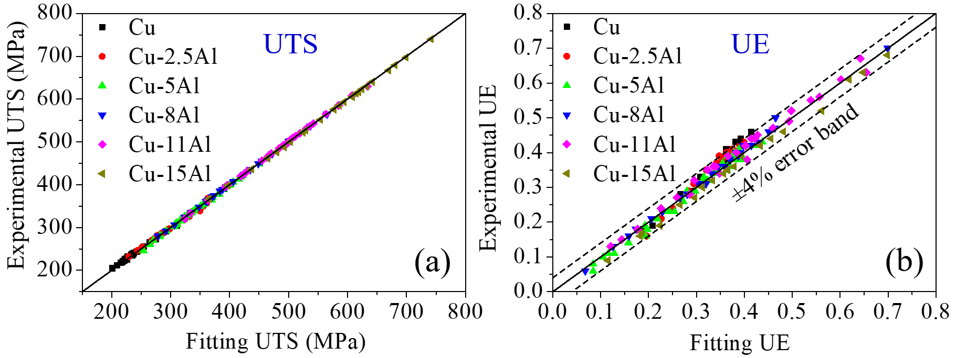
Fig. 6 Comparisons of the UTS (a) and UE (b) between the experimental values and calculated values from the fitting parameters for hundreds of Cu-Al microstructures, showing a high consistency for both UTS and UE.
4.2 Verification of the parameters
In addition to the above verification of the function form, evaluations of the parameter values are also very important for comprehensively verifying the ESH model. Thus, if the parameters have indicated the correct physical meanings, the changes in the parameter values should correspond to those in the compositions and microstructures. As concluded above, there are three kinds of parameters in the ESH model. 1) Composition parameters: n, Θ_{II} and independent σ_{ρs}, 2) Technical or microstructure type parameters: η and independent ω (ω = n(1-η)), and 3) Initial defect density parameters: σ_{y} and independent Θ_{y} (Θ_{y} = Θ_{II}-ωσ_{y}).
4.2.1 The strain hardening exponent, n
According to the expression for the strain-hardening exponent n (Eq. (2)), it is a function of the equivalent annihilation distance of dislocations (y_{e}), the Taylor factor (M) and the Burgers vector (b). Therefore, for certain material systems, n is solely controlled by y_{e}, which is mainly affected by the degree of difficulty for dislocation cross-slip. After fitting the tensile stress-strain curves, the values of n for the hundreds of microstructures of the six groups of metals were formulated with respect to the YS, as shown in Fig.7. This also shows the value of the equivalent annihilation distance (y_{e}) on the other vertical axis according to the relationship between n and y_{e}, with M = 3.06 and b = 0.2556 nm for Cu-Al alloys. From Fig. 7, an obvious feature can be quickly noticed. For each of the six groups of metals, the hardening exponent (n) nearly remains the same even though the YS changes to a large extent. For example, for Cu with σ_{y} = 54~288 MPa, n = 4.96~5.32; for Cu-5Al with σ_{y} = 80~440 MPa, n = 3.85~3.95; and for Cu-11Al with σ_{y} = 105~620 MPa, n = 1.96~2.14. This proves that for Cu-Al alloys with different microstructures n has a characteristic value for a specific composition. This means that the CSS curve exists for certain material compositions, as proposed in Section 3.2.
For Cu-15Al, the value of n shows an abnormal trend relative to the other five groups of metals, which may be owing to the great transformation of the deformation mechanism through the appearance of stacking faults (SFs) and micro-scale deformation twins (DTs). Although the SFs and DTs will cause a dynamic Hall-Petch effect [106, 108, 109] which should reduce the value of n, our previous studies found that for Cu-15Al, and when the grain size is very small, the DTs will be inhibited during plastic deformation [110] which in turn lowers the strain-hardening rate and increases the value of n. Therefore, for Cu-15Al, as for revealing the intrinsic effect of stacking fault energy (SFE) on n, the coarse-grained (CG) microstructure may be more representative. In view of this, we made an amendment on n for Cu-15Al based on the value of CG and for objectivity all of the other relevant parameters for Cu-15Al (such as the above-mentioned UE and UTS, and the following σ_{ρs}, η, Θ_{y}, etc.) were all calculated based on these amended values.
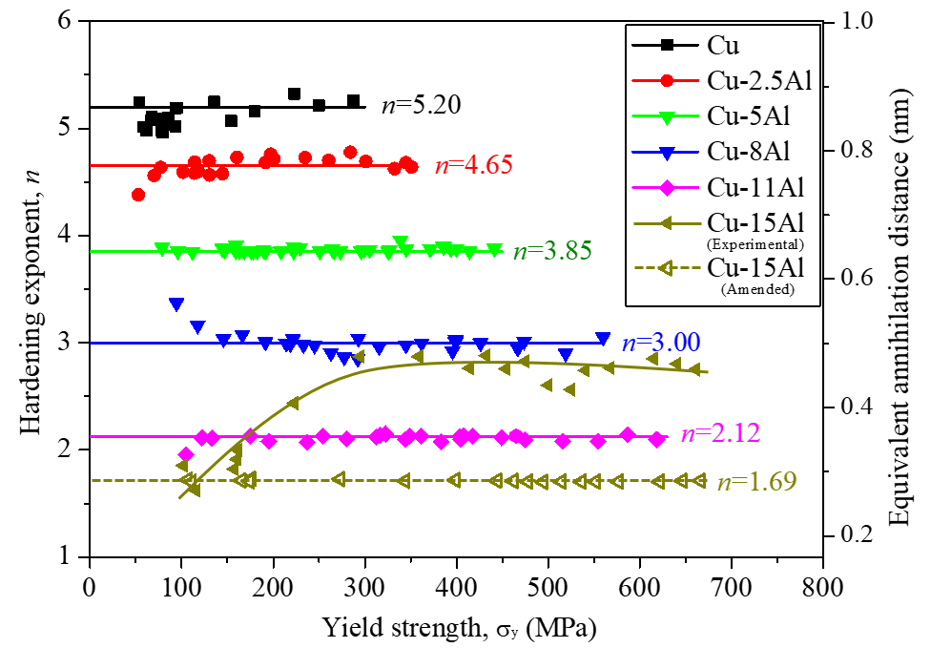
Fig. 7 Values of hardening exponent n and equivalent annihilation distance y_{e} with respect to YS for the Cu and five groups of Cu-Al alloys with hundreds of microstructures, thereby verifying that n nearly remains the same for each metal.
Except for the invariable n for each metal, another obvious feature can be observed from Fig. 7. That is for Cu-Al alloys the average value of n decreases monotonously with an increase in the Al content. This is consistent with the physical meaning of n: for Cu and single-phase Cu-Al alloys, so that with increasing Al content the SFE decreases monotonously as illustrated by Fig. S8 in the Supplementary material. Therefore, n is determined by the effective annihilation distance of dislocations, which is strongly affected by the SFE since a high SFE leads to easy cross-slip and therefore long annihilation distances [111]. This leads to a monotonous relationship between n and the Al content which reflects the compositional effect on the strain-hardening behavior.
4.2.2 Microstructure type parameter, η
According to the expressions for η (Eq. (10)), it represents the increasing velocity of σ_{s} or the decreasing velocity of σ_{r} when increasing the YS (σ_{y}) through microstructure strengthening. Therefore, the data of σ_{s} and σ_{r} acquired from curve fitting are plotted versus YS for the six groups of metals, as shown in Figs. 8(a) and 8(b), respectively. It is significant to find that both σ_{s} and σ_{r} remain a very good linear relationship with YS for the six groups of metals. Furthermore, the slopes of these lines, representing η, are basically the same with η~0.16 except for Cu and Cu-8Al. Combining with the similar microstructure characteristics of the Cu-Al alloys, the viewpoint that η is mainly correlated to the microstructure or defects type rather than to the microstructural state is well proven. As for the two exceptions, η = 0.09 for Cu and η = 0.44 for Cu-8Al, it can also be explained when further considering their characteristics in the microstructure. For Cu, the recrystallization of fine grains (FG) is not complete relative to others (as indicated by Figs. S13(a) and S14(b) in the Supplementary material) and for Cu-8Al the grain size distribution shows a unique bimodal feature (as illustrated by Figs. S13(c) and S14(d) in Supplementary material). Therefore, η can be designated a technical or microstructure type constant which is insensitive to YS (affected strongly by the overall defects density) and even the composition.
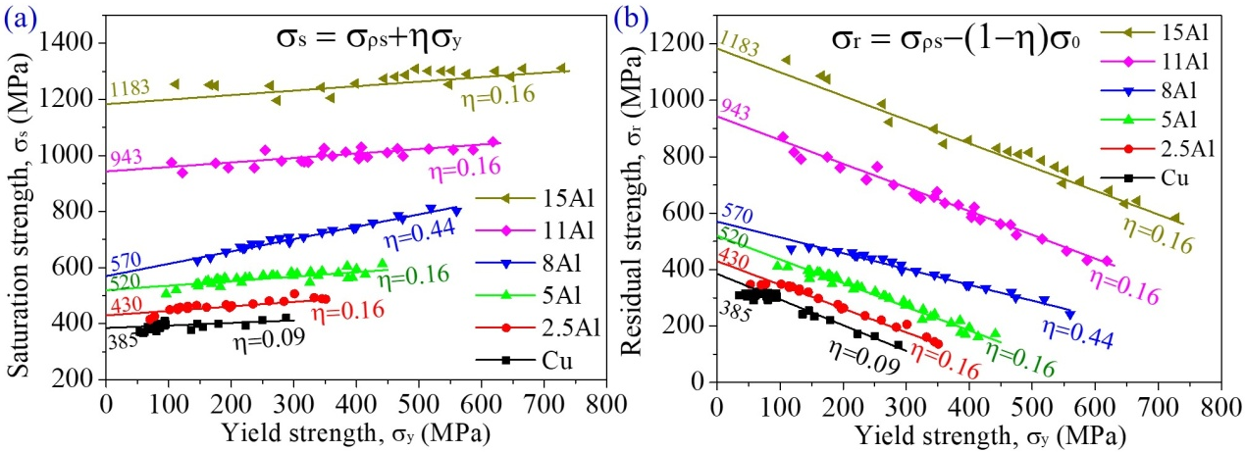
Fig. 8 Values of saturation strength σ_{s} and residual strength σ_{r} versus YS for the Cu and Cu-Al alloys, which shows that both σ_{s} and σ_{r} have very good linear relationships with YS and the slopes are basically the same for the Cu and five groups of metals.
Except for η, Fig. 8 also shows the values of the dislocation saturation strength (σ_{ρs}) of the six groups of metals, which are the intersections of the inclined lines with the vertical axis. According to Eq. (19)：, which indicates that σ_{ρs} is mainly affected by n and the pinning ratio (p) or initial hardening rate (Θ_{II}). As p or Θ_{II} is a constant for certain material systems, as further discussed in the following section, σ_{ρs} is mainly determined by n. Therefore, σ_{ρs} increases monotonously with the decrease of n or the increase of the Al content.
4.2.3 Initial hardening rate, Θ_{II}
According to the definition of Θ_{II}, it corresponds to the linear hardening process, also called the Stage II hardening process, of a single crystal when Θ remains a constant at its highest value. According to Eq. (21), Θ_{II} equals the value of the yield hardening rate (Θ_{y}) at σ_{y} = 0. Therefore, the Θ_{y} data of the six groups of metals derived from the curve fitting are plotted versus σ_{y} and the results are shown in Fig. 9.
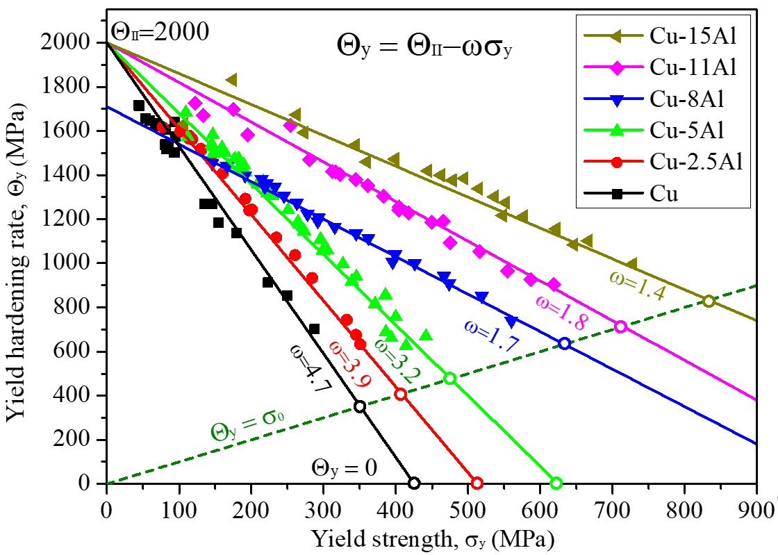
Fig. 9 Values of yield hardening rate Θ_{y} and pinning ratio p with respect to YS for the Cu and five groups of Cu-Al alloys, showing very good linear relationships between Θ_{y} and σ_{y}, and a very similar Θ_{II} value.
Firstly, there exist very good linear relationships between Θ_{y} and σ_{y} with slopes of ω which is a corresponding result for the constant η in Fig. 9 for each metal. There exists a simple relationship between η and ω, where ω = n(1-η) as defined in Eq. (20). In addition, when extrapolating the straight lines to σ_{y} = 0, the value of Θ_{II} can be acquired as marked in Fig. 9. It is interesting to find that except for Cu-8Al, the other five metals share a very similar Θ_{II}, ≈ 2000 MPa corresponding to a pinning ratio of p~3.6% with α = 0.25, μ = 47GPa and M = 3.06. This indicates that, as a reflection of the initial dislocation multiplication process, Θ_{II} is not affected by the composition or SFE that mainly affects the dislocation annihilation process.
According to an earlier investigation [8], for FCC single crystals the strain-hardening rate of stage II is only related to orientation and it is insensitive to temperature, strain rate or even the composition, and the value of dτ/dγ is about μ/300~μ/100 for different FCC metals having different orientations. In the present study, the Θ_{II} value of the free texture polycrystalline Cu-Al alloys can be regarded as average values of the single crystals. Therefore, Θ_{II} should be in the same range. According to the transformation between the hardening rate of the shear stress-strain and normal stress-strain:
, (22)
where dτ/dγ of μ/300~μ/100 is transformed to 1.4~4.4 GPa of Θ_{II} for Cu-Al alloys, which includes the present values of 2 GPa. Therefore, the same Θ_{II} for the different Cu-Al alloys may be due to similar multiplication mechanisms which are determined mainly by the lattice structure rather than by the composition or SFE. The unique phenomenon of Cu-8Al may be owing to its unique bimodal feature in grain size distribution as illustrated above.
The above discussions on the parameters verify that there generally exist certain regularities for the relevant parameters, as proposed during the derivation process of the model. Firstly, both the stable n for each metal with different YS and its variation tendency with the Al content certify that n can rightly reflect the essence of the dislocation annihilation process. Then, the existence of similar η for similar microstructure types but different compositions and YS confirms the validity and applicability of this newly proposed microstructure type parameter. Finally, the basically identical Θ_{II} for different Cu-Al alloys reveals the general uniformity of the dislocation multiplication mechanism for metals having similar lattice structures.
4.3 Advantages compared to other models
At present, the most popular models for the tensile stress-strain curves of polycrystalline materials contain two functional forms: one is the power-law function represented by the Hollomon and Ludwik equation [42, 43], and the other is the exponential function first proposed by Voce [44] and then developed by Kocks [7, 8]. Therefore, the following comparisons mainly focus on these two models.
Firstly, compared with the power-law functions, the exponential equation accords better with most of the tensile stress-strain curves. Specifically, the saturation of flow stress during tension or compression universally exists for different metals. To reveal the deformation saturation phenomenon of metals under uniaxial loading, we carried out compression tests on a typical coarse-grained Ni and two aging states 2024 Al alloys. Fig. 10 shows the joint compressive true stress-strain curves of the two metals, in which the joint points were marked out. After two times of compression, the curves all show an obvious saturation trend. If using the two kinds of functions to fit the curves, it is readily apparent that there is a very high coincidence between the exponential fitting curves and the actual curves whereas the power-law fitting curves show serious error for all three compressive stress-strain curves as shown by the dotted lines in Fig. 10. Nevertheless, the power law function has a deep foundation in the field of material mechanics and is easily translated for any hardening law, which sometimes is also used frequently to develop the hardening and fracture mechanics model [112-116].
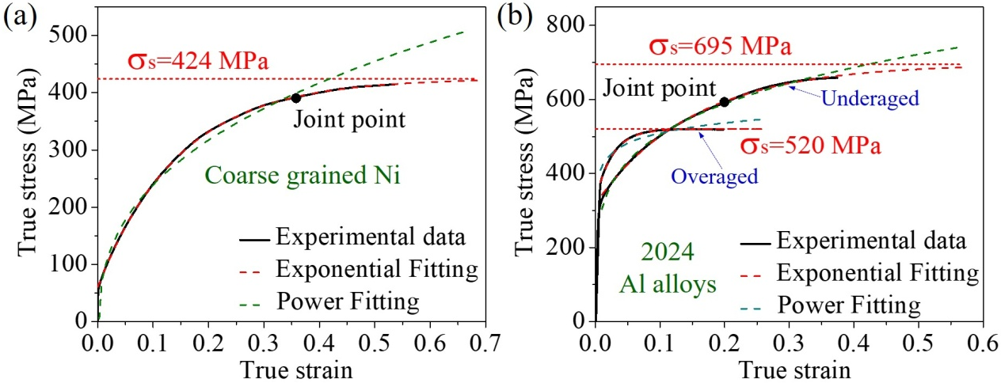
Fig.10 Comparison on the fitness of the power and exponential fitting with respect to the experimental curves acquired from twice compression tests for (a) coarse-grained Ni and (b) 2024 Al alloys, which reveal that the exponential function gives much better fitting accuracy than the power function for the whole strain range of both alloys.
Furthermore, relative to the power-law function, the exponential equation shows better self-consistency in describing the pretension experiment than the conventional power-law function. For the exponential equation, the functional form of the original tensile curve is described by Eq. (6) and the pretension curves can be described as:
, (23)
in which . Eq. (23) has the same form as Eq. (6). Besides, the parameters σ_{s} and n that are essentially not affected by the pretension and the change in the parameter σ_{r} has definite physical meaning as indicated in Fig. 11. However, for the empirical power-law equation, such as the Ludwik equation [42]:
, (24)
And the pretension curve will give a different equation of the form
, (25)
or different parameter values (σ₀₁, K₁ and n₁) that again have no physical meanings. Therefore, the exponential equation has fundamentally a more clear derivation process, a more definite physical meaning and a higher fitting accuracy compared to the power-law relation.
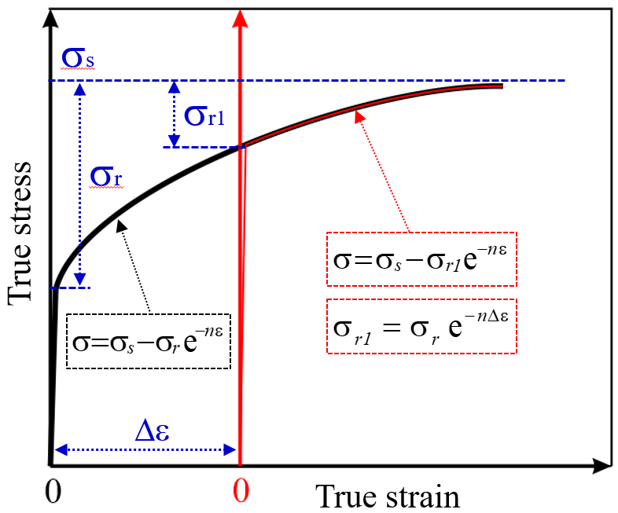
Fig. 11 Examination of self-consistency for the power and exponential equations, which indicates that only the exponential equation can satisfy the consistency of the form after pretension.
Relative to the exponential hardening form proposed by Voce [44] and later developed by Kocks [7, 8], by further emphasizing the influence of YS and microstructure, the effect of the microstructure type and strengthening technology were further revealed so that the quantitative relationship among the tensile properties (such as YS, UTS and UE) for different processing technologies are established and accordingly the tensile stress-strain curves can be finally predicted. The relevant achievements will be described in detail in a later report [47] which will make a significant quantitative revelation of strengths and uniform elongation using the present ESH model.
5. Conclusions
i) A dislocation annihilation model with clear physical meaning and a microstructural parameter, termed a strengthening quality index (η), is considered. Using this approach and based on the Kocks-Mecking-Estrin model, we developed an exponential hardening (ESH) model for single phase metallic materials under uniaxial tension. It is demonstrated that, compared with other models, this model has a clearer physical meaning and also can quantitatively reflect the influence of material composition and microstructure type.
ii) Systematic tensile experiments were carried out on six groups of Cu and Cu-Al alloys with more than one hundred different microstructures. It is shown that the fitting accuracy of the tensile stress-strain curves and the UTS and UE data, and also the changing trends of the relevant componential and microstructural parameters, all provide a clear verification of the validity of the ESH model. This model is scientifically reasonable in describing the intrinsic strain-hardening behaviors of simple metals with a deformation mechanism that is dominated by dislocation activities.
Acknowledgements
This work was financially supported by the Youth Innovation Promotion Association CAS (Grant No. 2021192), the National Natural Science Foundation of China (NSFC) under grant Nos. 51871223, 51790482, 52130002 and 52001153 and the KC Wong Education Foundation (GJTD-2020-09). The work of one of us was supported by the European Research Council under ERC Grant Agreement No. 267464-SPDMETALS (TGL).
References
[1] P. Zhang, S.X. Li, Z.F. Zhang, General relationship between strength and hardness, Mater. Sci. Eng. A 529 (2011) 62-73.
[2] M.A. Meyers, K.K. Chawla, Mechanical behavior of materials, Cambridge University Press, Cambridge, 2009.
[3] H.F. Li, Q.Q. Duan, P. Zhang, Z.F. Zhang, The relationship between strength and toughness in tempered steel: trade-off or invariable?, Adv. Eng. Mater. 21(4) (2019) 1801116.
[4] J.C. Pang, S.X. Li, Z.G. Wang, Z.F. Zhang, General relation between tensile strength and fatigue strength of metallic materials, Mater. Sci. Eng. A 564 (2013) 331-341.
[5] R. Liu, P. Zhang, Z. Zhang, B. Wang, Z. Zhang, A practical model for efficient anti-fatigue design and selection of metallic materials: II. Parameter analysis and fatigue strength improvement, J. Mater. Sci. Technol. (2020) in press.
[6] R. Liu, P. Zhang, Z. Zhang, B. Wang, Z. Zhang, A practical model for efficient anti-fatigue design and selection of metallic materials: I. Model building and fatigue strength prediction, J. Mater. Sci. Technol. (2020) in press.
[7] U.F. Kocks, Laws for work-hardening and low-temperature creep, J. Eng. Mater. Technol. 98(1) (1976) 76-85.
[8] U.F. Kocks, H. Mecking, Physics and phenomenology of strain hardening: the FCC case, Prog. Mater. Sci. 48(3) (2003) 171-273.
[9] A. Seeger, J. Diehl, S. Mader, H. Rebstock, Work-hardening and work-softening of face-centred cubic metal crystals, Philos. Mag. 2(15) (1957) 323-350.
[10] G. Taylor, Thermally-activated deformation of BCC metals and alloys, Prog. Mater. Sci. 36 (1992) 29-61.
[11] B. Peeters, B. Bacroix, C. Teodosiu, P. Van Houtte, E. Aernoudt, Work-hardening/softening behaviour of b.c.c. polycrystals during changing strain:: Part II. TEM observations of dislocation sheets in an IF steel during two-stage strain paths and their representation in terms of dislocation densities, Acta Mater. 49(9) (2001) 1621-1632.
[12] B. Peeters, M. Seefeldt, C. Teodosiu, S.R. Kalidindi, P. Van Houtte, E. Aernoudt, Work-hardening/softening behaviour of b.c.c. polycrystals during changing strain paths: I. An integrated model based on substructure and texture evolution, and its prediction of the stress–strain behaviour of an IF steel during two-stage strain paths, Acta Mater. 49(9) (2001) 1607-1619.
[13] D. Canadinc, H. Sehitoglu, H.J. Maier, Y.I. Chumlyakov, Strain hardening behavior of aluminum alloyed Hadfield steel single crystals, Acta Mater. 53(6) (2005) 1831-1842.
[14] J.P. Hirth, J. Lothe, Theory of dislocations, 2nd, Wiley, New York, 1982.
[15] J.W. Christian, S. Mahajan, Deformation twinning, Prog. Mater. Sci. 39(1-2) (1995) 1-157.
[16] O. Bouaziz, S. Allain, C. Scott, Effect of grain and twin boundaries on the hardening mechanisms of twinning-induced plasticity steels, Scr. Mater. 58(6) (2008) 484-487.
[17] H. Idrissi, K. Renard, D. Schryvers, P.J. Jacques, On the relationship between the twin internal structure and the work-hardening rate of TWIP steels, Scr. Mater. 63(10) (2010) 961-964.
[18] H. Mecking, B. Nicklas, N. Zarubova, U.F. Kocks, A “universal” temperature scale for plastic flow, Acta Metall. 34(3) (1986) 527-535.
[19] M. Yaghoobi, G.Z. Voyiadjis, The effects of temperature and strain rate in fcc and bcc metals during extreme deformation rates, Acta Mater. 151 (2018) 1-10.
[20] A.W. Thompson, M.I. Baskes, W.F. Flanagan, The dependence of polycrystal work hardening on grain size, Acta Metall. 21(7) (1973) 1017-1028.
[21] R.R. Jensen, J.K. Tien, Temperature and strain rate dependence of stress-strain behavior in a nickel-base superalloy, Metall. Trans. A 16(6) (1985) 1049-1068.
[22] D.R. Steinmetz, T. Jäpel, B. Wietbrock, P. Eisenlohr, I. Gutierrez-Urrutia, A. Saeed–Akbari, T. Hickel, F. Roters, D. Raabe, Revealing the strain-hardening behavior of twinning-induced plasticity steels: Theory, simulations, experiments, Acta Mater. 61(2) (2013) 494-510.
[23] J.Y. He, W.H. Liu, H. Wang, Y. Wu, X.J. Liu, T.G. Nieh, Z.P. Lu, Effects of Al addition on structural evolution and tensile properties of the FeCoNiCrMn high-entropy alloy system, Acta Mater. 62 (2014) 105-113.
[24] C.M. Cepeda-Jiménez, M. Castillo-Rodríguez, M.T. Pérez-Prado, Origin of the low precipitation hardening in magnesium alloys, Acta Mater. 165 (2019) 164-176.
[25] W.J. Liu, A unified theoretical model for work-hardening of polycrystalline metals, Acta Mater. 44(6) (1996) 2337-2343.
[26] S. Lee, S.J. Lee, B.C. De Cooman, Work hardening behavior of ultrafine-grained Mn transformation-induced plasticity steel, Acta Mater. 59(20) (2011) 7546-7553.
[27] D.K. Yang, P. Cizek, D. Fabijanic, J.T. Wang, P.D. Hodgson, Work hardening in ultrafine-grained titanium: Multilayering and grading, Acta Mater. 61(8) (2013) 2840-2852.
[28] J. Fan, W. Rao, J.W. Qiao, P.K. Liaw, D. Şopu, D. Kiener, J. Eckert, G.Z. Kang, Y.C. Wu, Achieving work hardening by forming boundaries on the nanoscale in a Ti-based metallic glass matrix composite, J. Mater. Sci. Technol. 50 (2020) 192-203.
[29] S.F. Lin, Z.W. Zhu, S.F. Ge, L. Zhang, D.M. Liu, Y.X. Zhuang, H.M. Fu, H. Li, A.M. Wang, H.F. Zhang, Designing new work-hardenable ductile Ti-based multilayered bulk metallic glass composites with ex-situ and in-situ hybrid strategy, J. Mater. Sci. Technol. 50 (2020) 128-138.
[30] C.L. Yang, Z.J. Zhang, T. Cai, P. Zhang, Z.F. Zhang, Recovery of strain-hardening rate in Ni-Si alloys, Sci. Rep. 5 (2015) 15532.
[31] C.L. Yang, Z.J. Zhang, P. Zhang, C.Y. Cui, Z.F. Zhang, Synchronous improvement of the strength and plasticity of Ni-Co based superalloys, Mater. Sci. Eng. A 736 (2018) 100-104.
[32] C.L. Yang, Z.J. Zhang, P. Zhang, R. Liu, Z.F. Zhang, The synchronous improvement of the strength and plasticity of Ni alloys assisted by vacancies, Mater. Sci. Eng. A 680 (2017) 405-410.
[33] C.L. Yang, Q.L. Zhao, Z.J. Zhang, L.L. Li, W.S. Tian, R. Liu, P. Zhang, Y.J. Xu, Y.J. Li, Z.F. Zhang, Q.C. Jiang, R.O. Ritchie, Nanoparticle additions promote outstanding fracture toughness and fatigue strength in a cast Al-Cu alloy, Mater. Des. 186 (2020) 8.
[34] H. Huh, K. Ahn, J.H. Lim, H.W. Kim, L.J. Park, Evaluation of dynamic hardening models for BCC, FCC, and HCP metals at a wide range of strain rates, J. Mater. Process. Technol. 214(7) (2014) 1326-1340.
[35] S. Mishra, M. Yadava, K.N. Kulkarni, N.P. Gurao, A new phenomenological approach for modeling strain hardening behavior of face centered cubic materials, Acta Mater. 178 (2019) 99-113.
[36] E.F. Rauch, J.J. Gracio, F. Barlat, Work-hardening model for polycrystalline metals under strain reversal at large strains, Acta Mater. 55(9) (2007) 2939-2948.
[37] P.B. Hirsch, T.E. Mitchell, Stage II work hardening in crystals, Can. J. Phys. 45(2) (1967) 663-706.
[38] M. Zehetbauer, V. Seumer, Cold work hardening in stages IV and V of F.C.C. metals—I. Experiments and interpretation, Acta Metall. Mater. 41(2) (1993) 577-588.
[39] N.F. Mott, LXXVIII. A theory of work-hardening of metals II: Flow without slip-lines, recovery and creep, Philos. Mag. 44(354) (1953) 742-765.
[40] J. Gil Sevillano, P. van Houtte, E. Aernoudt, Large strain work hardening and textures, Prog. Mater. Sci. 25(2) (1980) 69-134.
[41] E. Nes, Modelling of work hardening and stress saturation in FCC metals, Prog. Mater. Sci. 41(3) (1997) 129-193.
[42] K.G. Samuel, P. Rodriguez, On power-law type relationships and the Ludwigson explanation for the stress-strain behaviour of AISI 316 stainless steel, J. Mater. Sci. 40(21) (2005) 5727-5731.
[43] H.J. Kleemola, M.A. Nieminen, On the strain-hardening parameters of metals, Metall. Trans. 5(8) (1974) 1863-1866.
[44] E. Voce, The strain work hardening of metals, The engineer 195 (1953) 23.
[45] O. Bouaziz, N. Guelton, Modelling of TWIP effect on work-hardening, Mater. Sci. Eng. A 319-321 (2001) 246-249.
[46] O. Bouaziz, Strain-hardening of twinning-induced plasticity steels, Scr. Mater. 66(12) (2012) 982-985.
[47] Z.J. Zhang, Z. Qu, L. Xu, R. Liu, P. Zhang, Z.F. Zhang, Quantitative revelation on strength and plasticity for ductile metals, Acta Mater. With editor (2021).
[48] U.F. Kocks, A statistical theory of flow stress and work-hardening, Philos. Mag. 13(123) (1966) 541-566.
[49] Y. Estrin, Dislocation theory based constitutive modelling: foundations and applications, J. Mater. Process. Technol. 80 (1998) 33-39.
[50] T. Hu, W.L. Xiao, F. Wang, Y. Li, S.Y. Lyu, R.X. Zheng, C.L. Ma, Improving tensile properties of Mg-Sn-Zn magnesium alloy sheets using pre-tension and ageing treatment, J. Alloys Compd. 735 (2018) 1494-1504.
[51] J.P. Hou, Q.Y. Chen, Q. Wang, H.Y. Yu, Z.J. Zhang, R. Li, X.W. Li, Z.F. Zhang, Effects of annealing treatment on the microstructure evolution and the strength degradation behavior of the commercially pure Al conductor, Mater. Sci. Eng. A 707 (2017) 511-517.
[52] R. Liu, Y.Z. Tian, Z.J. Zhang, X.H. An, P. Zhang, Z.F. Zhang, Exceptional high fatigue strength in Cu-15at.% Al alloy with moderate grain size, Sci. Rep. 6 (2016) 27433.
[53] Y.Z. Tian, L.J. Zhao, N. Park, R. Liu, P. Zhang, Z.J. Zhang, A. Shibata, Z.F. Zhang, N. Tsuji, Revealing the deformation mechanisms of Cu-Al alloys with high strength and good ductility, Acta Mater. 110 (2016) 61-72.
[54] M. Tanaka, Y. Miyagawa, On generalized kinematic hardening theory of plasticity, Ingenieur-Archiv 44(4) (1975) 255-268.
[55] G. Weng, Kinematic hardening rule in single crystals, Int. J. Solids Struct. 15(11) (1979) 861-870.
[56] M. Ashby, The deformation of plastically non-homogeneous materials, Philos. Mag. 21(170) (1970) 399-424.
[57] L. Brown, Back-stresses, image stresses, and work-hardening, Acta Metall. 21(7) (1973) 879-885.
[58] J. Atkinson, L. Brown, W. Stobbs, The work-hardening of copper-silica: IV. The Bauschinger effect and plastic relaxation, Philos. Mag. 30(6) (1974) 1247-1280.
[59] L. Brown, W. Stobbs, The work-hardening of copper-silica, Philos. Mag. 23(185) (1971) 1201-1233.
[60] W.D. Nix, H. Gao, Indentation size effects in crystalline materials: a law for strain gradient plasticity, J. Mech. Phys. Solids 46(3) (1998) 411-425.
[61] N. Fleck, J. Hutchinson, A phenomenological theory for strain gradient effects in plasticity, J. Mech. Phys. Solids 41(12) (1993) 1825-1857.
[62] N. Fleck, G. Muller, M.F. Ashby, J.W. Hutchinson, Strain gradient plasticity: theory and experiment, Acta Metall. Mater. 42(2) (1994) 475-487.
[63] L. Evers, W. Brekelmans, M. Geers, Non-local crystal plasticity model with intrinsic SSD and GND effects, J. Mech. Phys. Solids 52(10) (2004) 2379-2401.
[64] F. Humphreys, J. Martin, The effect of dispersed phases upon dislocation distributions in plastically deformed copper crystals, Philos. Mag. 16(143) (1967) 927-957.
[65] H. Proudhon, W.J. Poole, X. Wang, Y. Brechet, The role of internal stresses on the plastic deformation of the Al–Mg–Si–Cu alloy AA6111, Philos. Mag. 88(5) (2008) 621-640.
[66] L. Cheng, W. Poole, J. Embury, D. Lloyd, The influence of precipitation on the work-hardening behavior of the aluminum alloys AA6111 and AA7030, Metall. Mater. Trans. A 34(11) (2003) 2473-2481.
[67] J. da Costa Teixeira, L. Bourgeois, C.W. Sinclair, C.R. Hutchinson, The effect of shear-resistant, plate-shaped precipitates on the work hardening of Al alloys: towards a prediction of the strength–elongation correlation, Acta Mater. 57(20) (2009) 6075-6089.
[68] G. Fribourg, Y. Bréchet, A. Deschamps, A. Simar, Microstructure-based modelling of isotropic and kinematic strain hardening in a precipitation-hardened aluminium alloy, Acta Mater. 59(9) (2011) 3621-3635.
[69] A. Simar, Y. Bréchet, B. De Meester, A. Denquin, C. Gallais, T. Pardoen, Integrated modeling of friction stir welding of 6xxx series Al alloys: Process, microstructure and properties, Prog. Mater Sci. 57(1) (2012) 95-183.
[70] L. Evers, D. Parks, W. Brekelmans, M. Geers, Enhanced modeling of hardening in crystal plasticity for FCC metals, J. Phys. IV 11(PR5) (2001) Pr5-179-Pr5-186.
[71] L. Evers, D. Parks, W. Brekelmans, M. Geers, Crystal plasticity model with enhanced hardening by geometrically necessary dislocation accumulation, J. Mech. Phys. Solids 50(11) (2002) 2403-2424.
[72] M. Calcagnotto, Y. Adachi, D. Ponge, D. Raabe, Deformation and fracture mechanisms in fine-and ultrafine-grained ferrite/martensite dual-phase steels and the effect of aging, Acta Mater. 59(2) (2011) 658-670.
[73] M. Calcagnotto, D. Ponge, D. Raabe, Effect of grain refinement to 1 μm on strength and toughness of dual-phase steels, Mater. Sci. Eng. A 527(29-30) (2010) 7832-7840.
[74] M. Delincé, Y. Bréchet, J.D. Embury, M. Geers, P. Jacques, T. Pardoen, Structure–property optimization of ultrafine-grained dual-phase steels using a microstructure-based strain hardening model, Acta Mater. 55(7) (2007) 2337-2350.
[75] L. Evers, W. Brekelmans, M. Geers, Scale dependent crystal plasticity framework with dislocation density and grain boundary effects, International Journal of solids structures 41(18-19) (2004) 5209-5230.
[76] E. Nes, K. Marthinsen, Y. Brechet, On the mechanisms of dynamic recovery, Scr. Mater. 47(9) (2002) 607-611.
[77] M.A. Meyers, A. Mishra, D.J. Benson, Mechanical properties of nanocrystalline materials, Prog. Mater Sci. 51(4) (2006) 427-556.
[78] D.G. Morris, I. Gutierrez-Urrutia, M. Munoz-Morris, Analysis of strengthening mechanisms in a severely-plastically-deformed Al–Mg–Si alloy with submicron grain size, J. Mat. Sci. 42(5) (2007) 1439-1443.
[79] B. Chen, S.K. Moon, X. Yao, G. Bi, J. Shen, J. Umeda, K. Kondoh, Strength and strain hardening of a selective laser melted AlSi10Mg alloy, Scr. Mater. 141 (2017) 45-49.
[80] S. Saimoto, D.J. Lloyd, A new analysis of yielding and work hardening in AA1100 and AA5754 at low temperatures, Acta Mater. 60(18) (2012) 6352-6361.
[81] S. Saimoto, P. Van Houtte, K. Inal, M.R. Langille, New biaxial yield function for aluminum alloys based on plastic work and work-hardening analyses, Acta Mater. 118 (2016) 109-119.
[82] S.J. Yoo, S.H. Han, W.J. Kim, Strength and strain hardening of aluminum matrix composites with randomly dispersed nanometer-length fragmented carbon nanotubes, Scr. Mater. 68(9) (2013) 711-714.
[83] D. Chu, J.W. Morris, The influence of microstructure on work hardening in aluminum, Acta Mater. 44(7) (1996) 2599-2610.
[84] Z.J. Zhang, Q.Q. Duan, X.H. An, S.D. Wu, G. Yang, Z.F. Zhang, Microstructure and mechanical properties of Cu and Cu-Zn alloys produced by equal channel angular pressing, Mater. Sci. Eng. A 528(12) (2011) 4259-4267.
[85] R. Liu, Z.J. Zhang, Z.F. Zhang, The criteria for microstructure evolution of Cu and Cu-Al alloys induced by cyclic loading, Mater. Sci. Eng. A 666 (2016) 123-138.
[86] P. Zhang, X.H. An, Z.J. Zhang, S.D. Wu, S.X. Li, Z.F. Zhang, R.B. Figueiredo, N. Gao, T.G. Langdon, Optimizing strength and ductility of Cu-Zn alloys through severe plastic deformation, Scr. Mater. 67(11) (2012) 871-874.
[87] S. Qu, X.H. An, H.J. Yang, C.X. Huang, G. Yang, Q.S. Zang, Z.G. Wang, S.D. Wu, Z.F. Zhang, Microstructural evolution and mechanical properties of Cu–Al alloys subjected to equal channel angular pressing, Acta Mater. 57(5) (2009) 1586-1601.
[88] L. Lu, X. Chen, X. Huang, K. Lu, Revealing the maximum strength in nanotwinned copper, Science 323(5914) (2009) 607-610.
[89] L. Lu, Y.F. Shen, X.H. Chen, L.H. Qian, K. Lu, Ultrahigh strength and high electrical conductivity in copper, Science 304(5669) (2004) 422-426.
[90] Y.H. Zhao, Y.Z. Guo, Q. Wei, A.M. Dangelewicz, C. Xu, Y.T. Zhu, T.G. Langdon, Y.Z. Zhou, E.J. Lavernia, Influence of specimen dimensions on the tensile behavior of ultrafine-grained Cu, Scr. Mater. 59(6) (2008) 627-630.
[91] T.S. Byun, N. Hashimoto, K. Farrell, Temperature dependence of strain hardening and plastic instability behaviors in austenitic stainless steels, Acta Mater. 52(13) (2004) 3889-3899.
[92] X. Hu, P. Van Houtte, M. Liebeherr, A. Walentek, M. Seefeldt, H. Vandekinderen, Modeling work hardening of pearlitic steels by phenomenological and Taylor-type micromechanical models, Acta Mater. 54(4) (2006) 1029-1040.
[93] C. Brozek, F. Sun, P. Vermaut, Y. Millet, A. Lenain, D. Embury, P.J. Jacques, F. Prima, A β-titanium alloy with extra high strain-hardening rate: Design and mechanical properties, Scr. Mater. 114 (2016) 60-64.
[94] J. Guo, M. Zhan, Y.Y. Wang, P.F. Gao, Unified modeling of work hardening and flow softening in two-phase titanium alloys considering microstructure evolution in thermomechanical processes, J. Alloys Compd. 767 (2018) 34-45.
[95] B.J. Hayes, B.W. Martin, B. Welk, S.J. Kuhr, T.K. Ales, D.A. Brice, I. Ghamarian, A.H. Baker, C.V. Haden, D.G. Harlow, H.L. Fraser, P.C. Collins, Predicting tensile properties of Ti-6Al-4V produced via directed energy deposition, Acta Mater. 133 (2017) 120-133.
[96] A.A. Salem, S.R. Kalidindi, R.D. Doherty, Strain hardening of titanium: role of deformation twinning, Acta Mater. 51(14) (2003) 4225-4237.
[97] C.L. Yang, Z.J. Zhang, S.J. Li, Y.J. Liu, T.B. Sercombe, W.T. Hou, P. Zhang, Y.K. Zhu, Y.L. Hao, Z.F. Zhang, R. Yang, Simultaneous improvement in strength and plasticity of Ti-24Nb-4Zr-8Sn manufactured by selective laser melting, Mater. Des. 157 (2018) 52-59.
[98] Y.H. Fan, W.Y. Wang, Z.P. Hao, C.Y. Zhan, Work hardening mechanism based on molecular dynamics simulation in cutting Ni–Fe–Cr series of Ni-based alloy, J. Alloys Compd. 819 (2020) 153331.
[99] W.M. Yin, S.H. Whang, R.A. Mirshams, Effect of interstitials on tensile strength and creep in nanostructured Ni, Acta Mater. 53(2) (2005) 383-392.
[100] H. Xu, Z.J. Zhang, P. Zhang, C.Y. Cui, T. Jin, Z.F. Zhang, The synchronous improvement of strength and plasticity (SISP) in new Ni-Co based disc superalloys by controling stacking fault energy, Sci. Rep. 7(1) (2017) 8046.
[101] R. Liu, Z.J. Zhang, L.L. Li, X.H. An, Z.F. Zhang, Microscopic mechanisms contributing to the synchronous improvement of strength and plasticity (SISP) for TWIP copper alloys, Sci. Rep. 5 (2015) 9550.
[102] L. Yang, L. Lu, The influence of sample thickness on the tensile properties of pure Cu with different grain sizes, Scr. Mater. 69(3) (2013) 242-245.
[103] X.H. An, S.D. Wu, Z.G. Wang, Z.F. Zhang, Significance of stacking fault energy in bulk nanostructured materials: Insights from Cu and its binary alloys as model systems, Prog. Mater. Sci. 101 (2019) 1-45.
[104] Z.J. Zhang, P. Zhang, L.L. Li, Z.F. Zhang, Fatigue cracking at twin boundaries: Effects of crystallographic orientation and stacking fault energy, Acta Mater. 60(6) (2012) 3113-3127.
[105] K. Kamada, Effects of annealing and irradiation on the stacking fault energy of Cu-Al solid solutions, J. Appl. Phys. 39(3) (1968) 1824-1828.
[106] A. Rohatgi, K.S. Vecchio, G.T. Gray, The influence of stacking fault energy on the mechanical behavior of Cu and Cu-Al alloys: Deformation twinning, work hardening, and dynamic recovery, Metall. Mater. Trans. A 32(1) (2001) 135-145.
[107] T. Cai, K.Q. Li, Z.J. Zhang, P. Zhang, R. Liu, J.B. Yang, Z.F. Zhang, Predicting the variation of stacking fault energy for binary Cu alloys by first-principles calculations, J. Mater. Sci. Technol. 53 (2020) 61-65.
[108] J. Gil Sevillano, An alternative model for the strain hardening of FCC alloys that twin, validated for twinning-induced plasticity steel, Scr. Mater. 60(5) (2009) 336-339.
[109] F. de las Cuevas, M. Reis, A. Ferraiuolo, G. Pratolongo, L.P. Karjalainen, J. Alkorta, J. Gil Sevillano, Hall-Petch relationship of a TWIP steel, Key Eng. Mater. 423 (2010) 147-152.
[110] Y.Z. Tian, L.J. Zhao, S. Chen, A. Shibata, Z.F. Zhang, N. Tsuji, Significant contribution of stacking faults to the strain hardening behavior of Cu-15%Al alloy with different grain sizes, Sci. Rep. 5(1) (2015) 16707.
[111] K.Q. Li, Z.J. Zhang, L.L. Li, P. Zhang, J.B. Yang, Z.F. Zhang, Effective stacking fault energy in face-centered cubic metals, Acta Metall. Sin. (Engl. Lett.) 31(8) (2018) 873-877.
[112] T. Pardoen, I. Doghri, F. Delannay, Experimental and numerical comparison of void growth models and void coalescence criteria for the prediction of ductile fracture in copper bars, Acta Mater. 46(2) (1998) 541-552.
[113] T. Pardoen, J. Hutchinson, An extended model for void growth and coalescence, Journal of the Mechanics Physics of Solids 48(12) (2000) 2467-2512.
[114] B. Audoly, J.W. Hutchinson, Analysis of necking based on a one-dimensional model, J. Mech. Phys. Solids 97 (2016) 68-91.
[115] B. Audoly, J.W. Hutchinson, One-dimensional modeling of necking in rate-dependent materials, J. Mech. Phys. Solids 123 (2019) 149-171.
[116] J.R. Rice, G. Rosengren, Plane strain deformation near a crack tip in a power-law hardening material, J. Mech. Phys. Solids 16(1) (1968) 1-12.

∗ Corresponding author, Zhenjun Zhang, E-Mail: zjzhang@imr.ac.cn
∗ Corresponding author, Zhefeng Zhang, E-Mail: zhfzhang@imr.ac.cn

