The Transactions of the royal institution of naval architects

Part A – International Journal of Maritime Engineering

AN EXPERIMENTAL APPROACH TO THE CHALLENGES OF MISSION PLANNING FOR COLLABORATIVE MARITIME AUTONOMOUS SYSTEMS

(DOI No: 10.3940/rina.ijme.2021.a2.???)

S.R. Turnock, T.S. Hoang, and J. Downes University of Southampton, UK
J. Lam, and B. Pritchard, Thales Maritime Autonomy Centre, Turnchapel Wharf, UK

SUMMARY

It is expected that a key part of a future with increasing use of maritime autonomous systems, will require collaborative and integrated approaches to working. How such approaches can be developed and tested was the focus of the Integrated Mission Management Systems 2019 project. The immediate objective was to experimentally demonstrate the ability of a single mission management system to control a fleet of heterogeneous, multi-domain autonomous vehicles whereby their collaborative mission could be planned, verified, and delivered. To challenge the various spatial-temporal-energetic-communication-environmental constraints when operating such a fleet, real-world demonstration trials were carried out in Plymouth Sound deployed from the Thales Maritime Autonomy Centre at Turnchapel Wharf. The trials were focussed on providing essential information into how such collaborations can be best executed, alongside invaluable lessons as to how existing vehicles need to enhance their interoperability and in particular, robustness of communications and mission plans.

NOMENCLATURE

AIS Automatic Identification System
ASV Autonomous Surface Vehicle
AUV Autonomous Underwater Vehicle
C2 Command and Control
CAA Civil Aviation Authority (UK)
C-Cat3 University of Southampton Uncrewed Surface Vehicle
EPSRC Engineering and Physical Sciences Research Council (UK)
Event-B A formal method for system-level modelling and analysis
IMMS Integrated Mission Management System
LSTS Underwater Systems and Technology Laboratory, University of Porto, Portugal.
MAS Maritime Autonomous System
MCA Maritime and Coastguard Agency (UK)
NOC National Oceanography Centre
RHIB Rigid-Hulled Inflatable Boat
ROS Robotic Operating System
UAV Uncrewed Aerial Vehicle
UKHO UK Hydrographic Office
UKRI United Kingdom Research and Innovation
UoS University of Southampton
USV Uncrewed Surface Vehicle
UUV Uncrewed Underwater Vehicle
UxV Generic unspecified Uncrewed Vehicle or Autonomous Vehicle i.e. Uncrewed <<insert>> Vehicle

1. INTRODUCTION

The development of autonomous ships has received significant interest in recent years and in particular, an appropriate focus on exactly how such systems can be safely operated in an assured regulatory framework. As with the on-going development of autonomous road vehicles, the degree of autonomy allowed to such a vehicle will require a progressive development process that’s ensures confidence in each successive phase. In this sense it is more appropriate to use the term Maritime Autonomous Systems (MAS) rather than ship as the public’s perception of an autonomous ship as a crewless, independent vessel self-navigating (with little or no human intervention) from port-to-port, remains for a distant future. However, as MAS develop, the collective behaviours of heterogeneous systems will become ever more prevalent, and it is important to understand and gather more detailed knowledge of the challenges of such interactions during actual maritime environments. It is this aspect that inspired a joint project between Thales UK and University of Southampton (UoS) in early 2019 - Integrated Mission Management Systems 2019 (IMMS2019).

The specific aim of the project was to investigate the challenges in the collaborative activity of maritime autonomous systems, covering surface, sub-surface, and aerial vehicles, in an experimental setting. This was achieved by conducting a series of field trials which examined how best to plan and execute missions at sea for three heterogeneous assets. The goal was to investigate how such a mission could be executed in such a way that the number of people involved can be significantly reduced whilst ensuring safety, validation and verification, security, and successful mission completion.

For the majority of MAS working today, it is still true that there is an inverted pyramid of effort required e.g. the number of people required is significantly larger than the number of MAS. This clearly highlights the difficulties of a future crewless autonomous ship. For example, if it takes a team of four or more to operate a small displacement ASV from a science vessel, then scaling up to a collaborative environment of many MAS implies a significant cost both in terms of operational as well as human resources.

In section 2, the paper discusses the state of the art of maritime autonomous systems and mission planning frameworks, then going on to describe in section 3, the IMMS as system as implemented in 2019 for initial trials. Sections 4 and 5 describe the implemented trials programme conducted in Plymouth Sound in October 2019 and the lessons learnt.

2. MARITIME AUTONOMOUS SYSTEMS AND MISSION PLANNING SYSTEMS

2.1 MARITIME AUTONOMOUS SYSTEMS

MAS, such as the example vehicles of University of Southampton as shown in Figure. 1, offer the potential to reduce costs and remove humans from harm's way. The seas and oceans present formidable challenges to the adoption of autonomous systems and in particular, the collaborative co-ordination of activity of multiple vehicles required to operate across significant spatial and temporal scales, and the associated communication difficulties. Energy restrictions force choices between speed of transit and mission duration. Similarly ensuring the resilience of complex multi-component systems is vital to allow successful completion of each individual task which inevitably will require systems that can adapt to individual component failure, changing conditions or mission alterations. These challenging conditions require vehicles of differing sizes and capabilities growing from smaller river capable to large ocean capable USV’s and UUV’s ranging in size and depth capabilities. There is no one size fit’s all solution.

Today’s ocean exploration and underwater operations, in the majority of cases, requires the presence of a large, dedicated vessel such as the Southampton-based RRS James Cook. Research cruises involve substantial crews of sailors, scientists and technicians. Although an increasing use is being made of AUVs such as the Autosub Long Range, it is still rare to attempt to coordinate the activities of multiples of such vehicles. Typically, these missions have a standard duration of ~8 to 24 hours, with the research ship needed to deploy, escort, monitor and recover these vehicles. The most detailed seabed survey to date using multiple assets was that by Thornton et al (2018) on behalf of the Schmidt Institute in the summer of 2018 when 11.8 hectares of seafloor were surveyed (Thornton, B., 2018). The oil and gas industry uses AUV for surveys of underwater assets such as pipelines. Often the vessel ‘follows’ the track of the AUV (speed 1 to 2 m/s) on the surface to provide a navigational position reference and to allow some communication when faults are found.

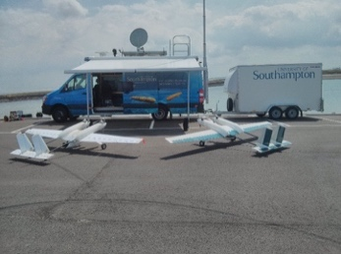 | 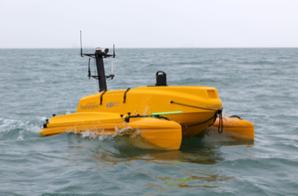
(a) UAV Spotter Vehicle | (b) L3-Harris USV C-CAT3 vehicle
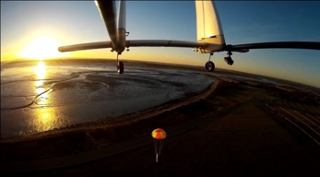 | 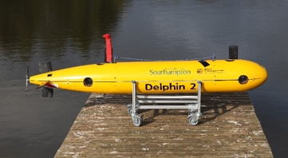
(c)Air drop testing of Eco-sub from SPOTTER aircraft at Thorney Island | (d) Delphin 2 in-house developed hover capable AUV
Figure 1: Examples of University of Southampton MAS vehicles

Long duration missions are possible with underwater glider AUVs (speed ~0.5 m/s) which have traversed the Pacific over several months and use a buoyancy engine to provide a saw tooth glide motion to sample the ocean environment. A next generation of glider (Lidtke et al., 2018) was developed in the Bridges H2020 project which was intended to go deep (~2000m +) and include a propeller so they can stay at depth and survey the seabed. There is limited ability to coordinate such activity due to communications generally being limited to when these gliders surface and energy/costs limits with the use of satellite communications. The gliders use dead reckoning and a depth sensor to develop positioning, updated with GPS data once on the surface. Sensors on gliders complement the vital international network of nearly 4000 Argo floats (Argo Programme - accessed 15-04-2021) which continually ascend/descend while they drift passively on the ocean currents.

The advances in MAS mirrors that across other domains such as driverless cars or drones. The development of robust and reliable vehicles has proved challenging. Organisations such as UK’s National Oceanography Centre (NOC) have been working on its Autosub suite of vehicles for over 30 years, but still has only a limited number to deploy as each new vehicle requires a multi-million-pound investment. Such valuable assets result in cautious approaches to AUV deployments and operations to minimise risk of losses (Amos, J., 2018).

Developments in USVs, whose performance is less limited by stored energy, navigational and communication constraints have been more rapid, with for example Thales having taken delivery in 2018 from an L3 Harris ASV of a 12m anti-mine system [L3 Harris ASV, 2019] capable of deploying aerial drones and underwater systems. PlanetOcean, in collaboration with NOC, L3 Harris ASV and UoS, funded by InnovateUK – an agency of UKRI, have developed the Ecosub [Ecosub Robotics., 2018]. This smaller, 0.5 m, version of Autosub that can be air launched from the Spotter autonomous aircraft Figure 1(a) or deployed from an USV to provide a short duration survey.

The current state-of-the-art (Thompson and Guihen., 2019) either relies on a large, inverted pyramid of effort to deploy a small number of autonomous vehicles or as with the Argo floats and gliders allows only very limited control as to their activity or location. These limitations are driven by the nature of the marine environment. Achieving a reasonable speed requires a ship or submarine to be large which in turns requires substantial stored energy. Localisation of position underwater is limited by either the ability to discern terrain features or the existence of a nearby baseline acoustic reference.

There are two obvious routes that will significantly reduce the cost of exploring the ocean. First, is to provide a simple means of getting multiple MAS of differing design and domain (heterogeneous) to collaborate without needing a stovepipe of many individuals to operate each vehicle as was required in Unmanned Warrior 2016 (Royal Navy, 2016). Second, is to use the collaborative ability of many such MAS so that they can be projected across a wide geographical range, for example using a fast ASV or an autonomous aircraft. The collective assembly of individual MAS can then provide a method for localisation, can relay messages, interact with human supervisors, and adapt their behaviour based on their local sensors. Scaling up from a small number of different MAS to one where there are many of varying type requires the use of algorithms that can provide assurance that the best choices are being made and that the team of human operators are not overwhelmed (Delle Fave et al., 2012). A key risk with autonomous systems is the trustworthiness of the decision-making and control mechanisms that substitute for or support human control: to be trustworthy, systems need to remain safe while being resilient to unpredictable changes, mechanism failures and cybersecurity threats (Schwarting et al., 2018).

2.2 MISSION PLANNING FRAMEWORKS

Thompson and Guihen (2019) reviewed mission planning for MAS with a view to developing an overview the current advances in automated planning for MAS fleets, limitations of currently available state‐of‐ the‐art tools and developing a road map of the goals and challenges for MAS. The authors use the term autonomous marine vehicles (AMV) rather than MAS.
The key areas addressed by the authors in this paper are shown in Figure 2 where the inner ring classifies the major challenges and considerations of MAS fleets, the middle ring decomposes these challenges into more specific areas, and the outer ring represents the key contributions of those challenges. The outer ring is further colour coded by the authors to show their view the readiness of these contributions – red = lab or proof of concept field trials; yellow = multiple field trials but not yet standard operating; green = implemented consistently in the field and maturing. This provides a useful overview of many of the concepts, considerations, and challenges in the MAS sector, for mission management.

They further suggest that MAS research has diversified into a range of specialised projects that address specific challenges. They highlight that the mission system design needs to be aware of the end user and operator needs to minimise the potential of mission failure. Existing mission planning systems for MAS tend to have been designed to maximise the utilisation and availability of vehicles primarily by parallelising the mission into a range of identical sub-mission. It is considered that the mission must solve a problem that is constrained by the priorities of the end user and the operator across a range of intersecting priorities.

State of the art planners from the wider robotics sector have begun to incorporate risk-based analysis of the vehicle and the mission to minimise the likelihood of failure occurring. Migrating these techniques into a fleet of MAS is non-trivial – each vehicle needs to be individually assessed for likelihood of failure as well as the interaction of vehicle-to-vehicle interactions as part of the overall system.

A number of toolchains and frameworks currently exist for the purposes of enabling the operators to interact and operate autonomous vehicles. Many of the frameworks are built upon there being a software (and corresponding hardware) component installed onto the individual vehicle.

Examples of this include the LSTS toolchain (Pinto et al., 2013; Ferreira et al., 2017) which was developed to control a fleet of heterogenous maritime vehicles from underwater to aerial for applications such as oceanographic survey. The system is built around four modules: Dune – the embedded software onboard the vehicle; IMC – specifically developed common control message format; Neptus – a distributed command and control desktop application for mission planning, execution, monitoring, and post-mission analysis; Ripples – a cloud-based data centralization and communications hub for data dissemination and situational awareness. A similar concept is the commercially available offering from SEEBYTE. Alternative systems include the MOOS-IvP system for providing autonomy onboard robotic vehicles and in particular, autonomous marine vehicles. MOOS stands for “Mission Oriented Operating Suite”.
IvP stands for “Interval programming” (Cesar et al., 2021); The Control Architecture for Robotic Agent Command and Sensing “CARACaS” (Huntsberger et al., 2008) is a system developed by NASA Jet Propulsion Laboratory (JPL) since 2005. CARACaS is based upon three coupled agents – these being a dynamic planning engine, a behaviour engine, and a perception engine.; The High level Distributed DecisioN (HiDDeN) layer for multi-robot mission monitoring was proposed by Gateau et al (2013) and the HiPOP hybrid framework (Bechon et al., 2020) which mixes partial order planning (POP) with an HTN based modelling of actions which computes plans with temporal flexibility allowing easier execution, and abstract actions which makes repair easier. The initial plan is computed offline and updated online whenever a disruptive event (s) occurs.

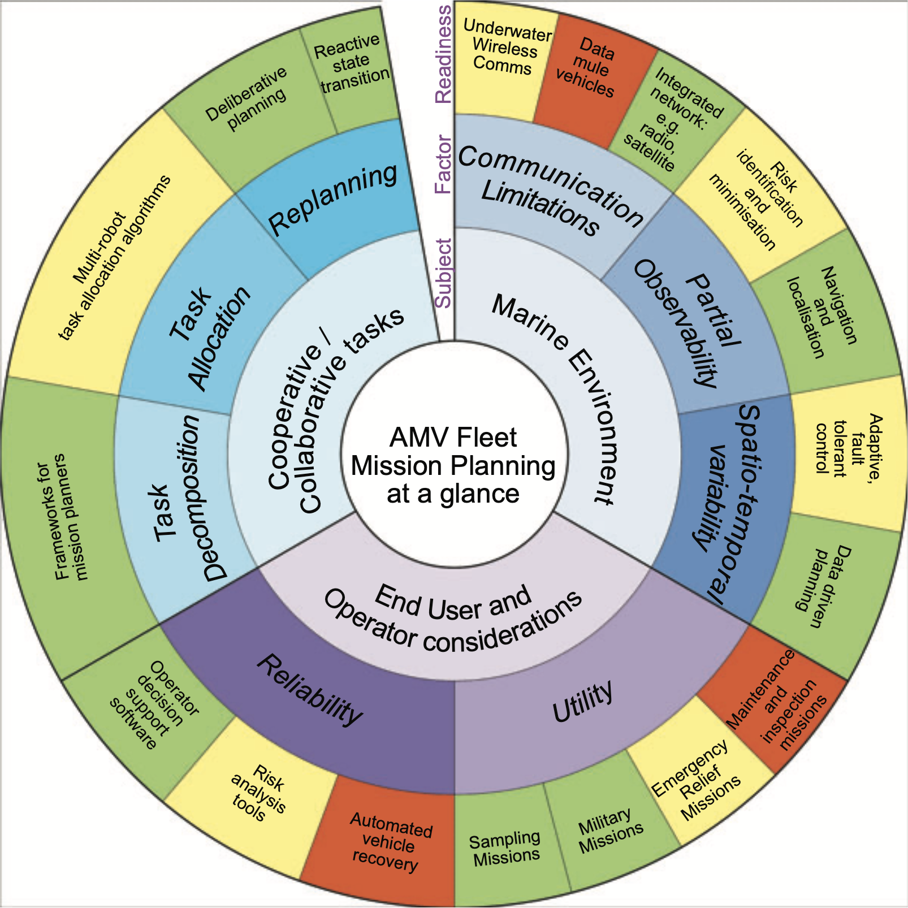
Figure 2 Summary of MAS Fleet Planning reviewed by Thomson and Guihen (2019)

Frameworks closer to the intentions of the work reported in this paper i.e., not requiring installation of software and hardware onboard the vehicles, include the Oceanids C2: An integrated Command, Control, and Data infrastructure for Over-the-Horizon Operation of Marine Autonomous Systems (Harris et al., 2020) which is a fully web-based microservice architecture aimed at the unified web-based system for the command, control and data management of MAS vehicles within the NERC National Marine Equipment Pool. It is designed around the use of data, metadata, and API standards, and prioritizing the flexibility and scalability the system the use long range of MAS systems for Ocean Science research. The MAPLE framework now in its 5th phase of development led by QinetiQ in partnership with BAE Systems, SeeByte, BMT, L3 Harris, DIEM analytics and Thales is a very large C2 system aimed at a wide range of maritime defence applications of MAS systems.

3. IMMS 2019 PROJECT

The Integrated Mission Management System 2019 (IMMS2019) project set out to create an integrated mission planning system for a heterogeneous multi domain fleet of MAS. The overarching goal of this project was to “establish a low-cost multi-vehicle experimentation capability” through the creation of a joint team between Thales and the UoS and to generate relevant research questions for future joint research.

The key objective was to experimentally demonstrate the ability of a single mission management system to control a fleet of heterogeneous, multi-domain autonomous vehicles whereby their collaborative mission could be planned, verified, and delivered. It was specifically designed as not to require installation of any hardware or software directly onto the vehicles themselves. Whilst limiting the modification of these vehicles, this is to avoid the issue of modifying or changing the safety assurance and validation of the vehicle as provided by the vehicle manufacturer. This aspect is becoming an ever more import aspect of autonomous operations.

To challenge the various spatial-temporal-energetic-communication-environmental constraints when operating such a fleet, real-world demonstration trials were carried out in Plymouth sound deployed from the Thales Maritime Autonomy Centre at Turnchapel Wharf.
The Integrated Mission Management System (IMMS) is an overarching architecture framework that allows the interoperability of diverse sets of autonomous systems operating across the sub-surface, surface, and aerial domains. At the heart of this framework, the IMMS software manages the interfaces between human operator(s) and the autonomous vehicles. The IMMS performs global planning and provides a mission definition across multiple vehicles, while also enabling an operator(s) to monitor the mission during its execution.

This system was designed to investigate improvements in the following performance metrics:
- Scalability – Reducing the people-to-vehicle ratio,
- Reusability – Expanding vehicle functionality and ease of Plug and Play,
- Flexibility – Speeding up and simplifying mission planning, re-planning, and execution.

A key aspect of the project was experimental trials focussed on providing essential information into how such collaborations can be best executed, alongside learning invaluable lessons as to how existing vehicles need to enhance their interoperability and in particular, robustness of communications and mission plans. The trials aimed to test the IMMS with real assets in a representative environment, generating a comprehensive data set covering all aspects of the system. In addition, the act of planning and executing a trials event facilitated the identification of research questions in the field of integrated mission management of MAS.

For the purposes of this project, a use case scenario was proposed by Thales UK’s Maritime Mission Systems business unit and further developed jointly within the project to test the development of an IMMS. This scenario is shown in Figure 3.

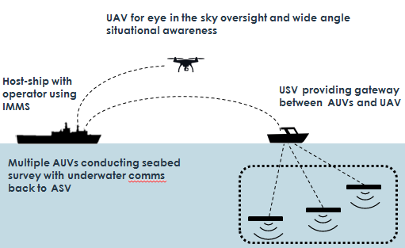
Figure 3: Proposed Use Case Scenario

The scenario context is to conduct a timely survey of the seabed in a defined area using available UxV assets. In addition to the base station or support ship, there is at least one available autonomous vessel for each of the aerial, surface, and underwater domains. Due to limitations in the vehicles available during the trials, the scenario was modified such that the AUV is connected directly to the IMMS on the host ship when surfacing rather than via the USV using acoustic methods.

4. IMMS SYSTEM DESIGN

The IMMS system developed for this trial was predominately software focussed but also had key aspects of physical interfaces to connect to the autonomous vessels. The key functions of the trial for the IMMS 2019 system have been grouped as follows, to have:
- A user interface for creating/planning a mission, previewing a mission, live monitoring (situational awareness of live assets) and recording.
- Path Planning and Optimisation including Validation and Verification of Mission Plans
- Conversion of “Approved” mission plans to the individual trial vehicles. The overview of the process is shown in Fig. 4.

Having identified the overall system goals, assumptions, and constraints, the mission management activities required of the IMMS and the operator(s) can be considered as:
- Planning of a mission after identifying the mission goals,
- Mission execution and,
- Reviewing the mission.

Figure 4 IMMS 2019 Conceptual Flow Diagram

The approach to eliciting the requirements of the IMMS system for the formal modelling for system validation and verification is described in Dghaym et al (2021). The need to have individually trustworthy autonomous vehicles working as separate entities is supplemented by the need to build a trustworthy management system that ensures the trustworthiness of the overall system.

Studies have shown that the cost of fixing errors during testing is ten times more than during the construction phase and can increase to more than 25 times post release (Leffingwell, 1997) and many problems discovered in software systems are related to shortcomings in requirements elicitation and specification (MacDonell et al., 2014).

Formal modelling using Event-B (Hoang, et al., 2016) was applied to develop a requirements analysis framework for identification of anticipated range of operational environments for autonomous missions, including human operator interactions, together with precise specification of safety and security envelopes for enactment of autonomous missions. This framework was used to validate and verify the mission plan for all the assets for a given mission

5. TRIALS PREPARATION

Trials were conducted from Thales UK’s maritime integration facility at Turnchapel Wharf, Plymouth. In terms of resources, UoS provided staff, an autonomous surface vessel, submarine and aerial vehicle and associated equipment for the trials. Thales provided the Turnchapel Wharf facilities, associated support vessel, and highly supportive staff. The joint team developed the IMMS.

5.1 FACILITIES

The facilities made available for the trials included enclosed hanger space shown in Figure 5 and the RHIB ‘Clyde of Dartmouth’ as shown in Figure 6, and access to the water via the Turnchapel Wharf slipway.

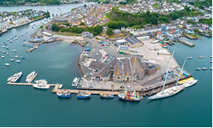 | 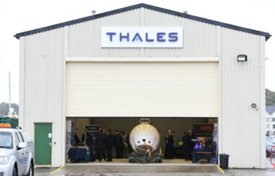
- Birds eye view | - Hanger
Figure 5 Facility at Turnchapel Wharf, Plymouth

The hangar was used to store equipment and assets, and as a space to set up a workspace and safely recharge batteries. The RHIB provided the primary on water support and housed the developed IMMS system. Adaptations were necessary to enable the RHIB to fully support the trials, as the systems placed on board for the trials required significant electrical power. The RHIB was equipped with two 230Ah of auxiliary batteries which were able to charge from the engines providing via a 600W inverter to two standard power sockets.

5.2 TRIALS AREA
A suitable trials area and UAV launch/landing site had been identified within the trials preparations previously on the other side of Plymouth Sound in Cawsand Bay (Figure 7). This area provided sufficient water depth for the AUV to use, was free from regular marine traffic, shielded (to an extent) from adverse weather which typically prevailed from the southwest, and contained an area considered suitable for aerial operations.

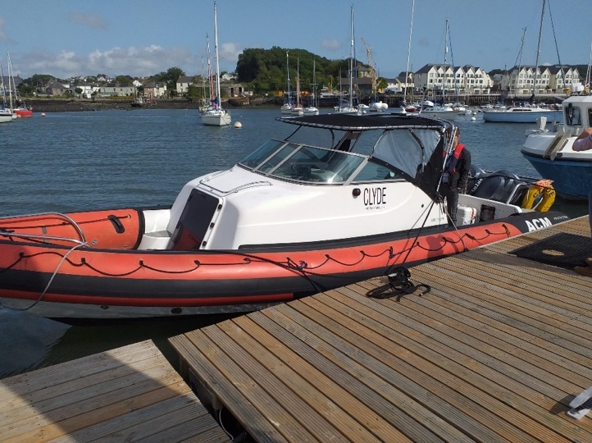
Figure 6 RHIB ‘Clyde of Dartmouth’ at Turnchapel Wharf

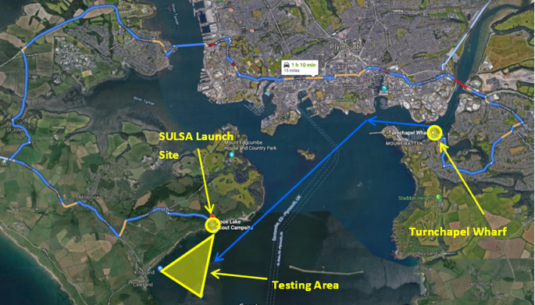
Figure 7 The trials area in Plymouth Sound was constrained within the coordinates [050.340, -004.181], [050.328, -004.185], [050.333, -004.197].

Aerial operations were conducted from the East Cornwall Scout Hooe Lake Campsite for which appropriate permissions for aerial operations were obtained. This is marked in Figure 7 as ‘SULSA Launch site’ and shown in Figure 8.

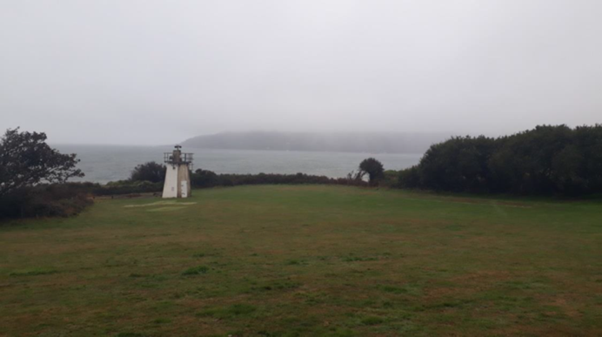
Figure 8 Aerial Vehicle Operating Site at Hooe Lake Campsite

5.3 MAS TRIALS ASSETS

Four assets were used during the Trials with overview specifications given in Tables 1 to 4.

5.4 PRE-TRIAL APPROVAL PROCESS

To ensure that the trials were delivered in a safe manner that minimises risk to life and the assets, whilst enabling suitable research endeavour to be undertaken, there were considerable pre-trial planning and approval processes conducted leading up to the trials week. This includes compliance with appropriate regulatory requirements e.g CAA & MCA, and industry best practise e.g the Maritime UK Industry Code of Practice,.

In compliance with the Queens Harbour Masters requirements for Plymouth and the Maritime UK Industry Code of Practice, the Turnchapel Wharf Trials Manager distributed a notice to mariners warning of the trials planned for this location. A CAA Standard Permission to Operate Uncrewed Aircraft Systems in UK Airspace was applied for and successfully obtained by University of Southampton SOTON UAV team for the trials.

The area selected for trials (Cawsand Bay) is a designated area for conducting trials in Plymouth sounds.

Table 1 AUV Ecosub Robotics EcoSub µ5
Principal Particulars: |  | 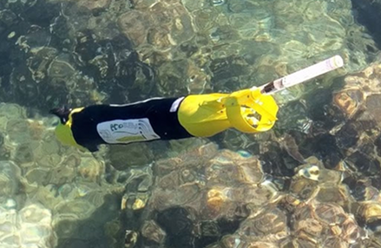
Length (including antenna) | 925mm
Diameter | 111mm
Weight in Air | 4Kg including Batteries
Depth Rating | 500m
Battery Technology | Manganese Alkaline
Speed | 1m/s
Range | 40Km
Endurance | Up to 12 hours
Communications (surface) | Iridium SBD, WiFi, GPS, Infrared and visible beacons
Communications (submerged) | Acoustic (optional)
Housekeeping | Internal temperature, pressure and humidity
CTD Sensor | NOC Micro-CT sensor (Conductivity and Temperature) (not commercially available)

Table 2 ASV L3 Harris C-CAT3
Principal Particulars: |  | 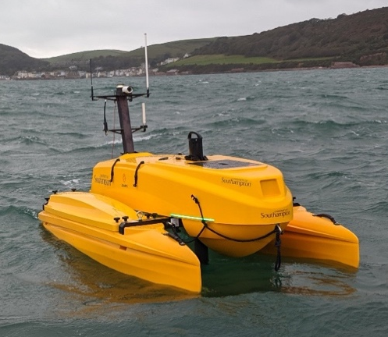
Length | 3.02m
Beam | 1.55m
Height | 1.4m
Draught | Min = 0.39m  Max (Payload depending) ~ 0.7m
Displacement | Lightship 270Kg  Full Load 350Kg
Primary Propulsion | 2 x DC electric motors driving 3 bladed propellers
Operational Speed Range | Up to 8 knots
Payload Power | 24V
Sensor Fit: | HD Forward Facing Camera  AIS Receiver  IMS (not part of ASView sensor suite)
Payload Fit: | Independent Payload Computer for ROS interface

Table 3 UAV University of Southampton SULSA
Principal Particulars: |  | 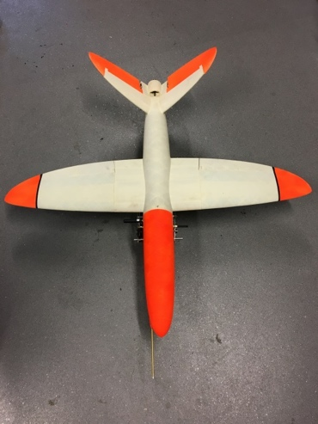
Wingspan | 1.2m
Cruise Speed | 60Knts
Max Take-off Weight | 4Kg
Power Plant | 1 brushless electric motor
Autopilot | ArduPilot
Payload | 2 HD wide angle video cameras – 1 fwd facing, 1 facing to the left hand side. DTC Sol7 video transmission system

Table 4 UAV Avios Bushmule
Principal Particulars: |  | 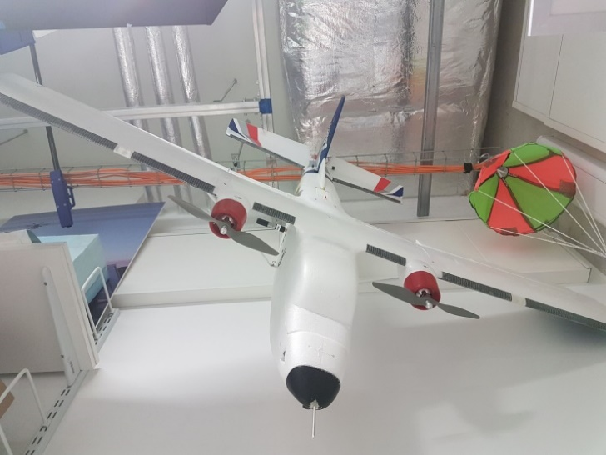
Wingspan | 1.5m
Length | 1.095m
Cruise Speed | ~30knts
Max Take-off Weight | 2.25Kg
Power Plant | Twin electric 850KV brushless outrunner motors
Payload | 2 HD wide angle video cameras – 1 fwd facing, 1 facing to the left hand side. DTC Sol7 video transmission system

The UAV launch/landing location was identified on Google Maps satellite view, surveyed by the Turnchapel team and was confirmed to meet the requirements specified by the UAV operations team of 50m of flat grass and accessibility for the mission control van.

A combined safety and risk assessment process was developed by the project team that satisfies the requirements of both Thales and the UoS. The overall process is illustrated in Fig. 9. As can be understood this required a significant investment of time and is worth bearing in mind as the prospect of such combined operations becomes more prevalent.

A detailed trials plan was developed which covered the aims and objectives of the trials; any pre-requisites; details on the location, equipment and resources; relevant regulations; limits of operating conditions; detailed daily schedule; Personal Protective Equipment (PPE); and the safety & risk assessment descriptions.

The trials plan was supplemented by a detailed trials playbook, produced prior to the trials. The described activities consisted of basic safety tests for the assets, tests to evaluate various functionalities from the original IMMS requirements, and demonstrations of the IMMS in realistic use case scenarios together with the assets. These activities were divided across the trials week which are ordered with increasing complexity throughout the week. It was intended that it would therefore be known which tasks the IMMS and assets would be capable of attempting, and the day’s activities could be defined accordingly in a briefing session each morning. The playbook described more activity items than were feasible in a single day’s trials. The purpose of this was to allow the playbook to be adaptable to suit changing environmental conditions and unknown levels of progress across the week.

A window of time for the trials was identified, based on personnel availability, trials facility availability, and project preparedness, with predicted weather forecast conditions used to determine the final choice. The final trials took place in early October and experienced a variety of weather conditions which did impact on the time available each day for testing. The decision to go ahead was based on a Met Office (UK national meteorological service) long range weather forecast:
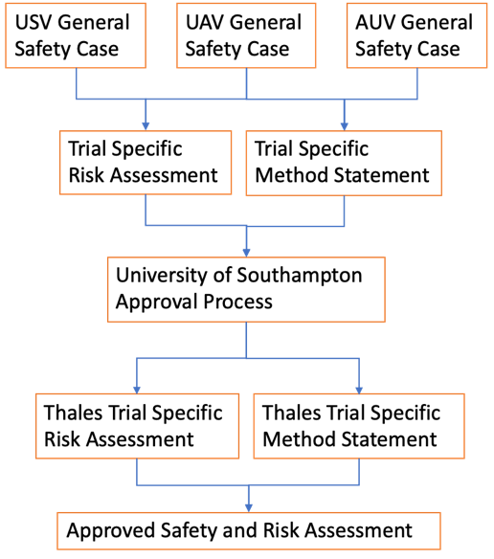
Figure 9 Safety and Risk Assessment Process

Thursday 3rd Oct 2019 - Saturday 12th Oct 2019
“It will be a chilly start on Thursday, with a rural air frost. Outbreaks of rain and strong winds will spread into western areas by the afternoon though, with gales possible. This unsettled weather will then move eastwards later in the day. By the weekend it is likely that unsettled, wet and possibly very windy weather will return, bringing with it a risk of gales, especially in the north and west During the following week, the unsettled weather may begin to become more generally confined to the north and west, with occasional spells of drier and brighter weather, particularly in the south and east. Temperatures are likely to vary around average, although some cold nights are possible under any clear skies.” UK Met Office Long Range Forecast.

The UK Hydrographic Office (UKHO) made available detailed Hydrographic data covering the test area in Cawsand bay as well as historic Automatic Identification System (AIS) data for the Plymouth region. These were displayed in the mission interface. This proved useful as a sanity check during one mission, as it was realised the end point of the C-Cat mission was outside the bathymetric data, and the sea bed was too shallow to safely run trials in that area, despite the conventional charts and maps showing it as sufficient.

6. TRIALS

Over the five days of the trials (Table 5) a progressive series of trials developed confidence that all the necessary components of the system could function and could be deployed. There were a number of issues with individual assets and in particular communication problems were identified with a number of the vehicles that required reference back to the supplier on a number of occasions. Key achievements were the ability for all assets and base stations including not just the RHIB but also the crew at Turnchapel and at the UAV control van to sharing the same mission information using a common system.

Table 5 Planned Trials schedule.

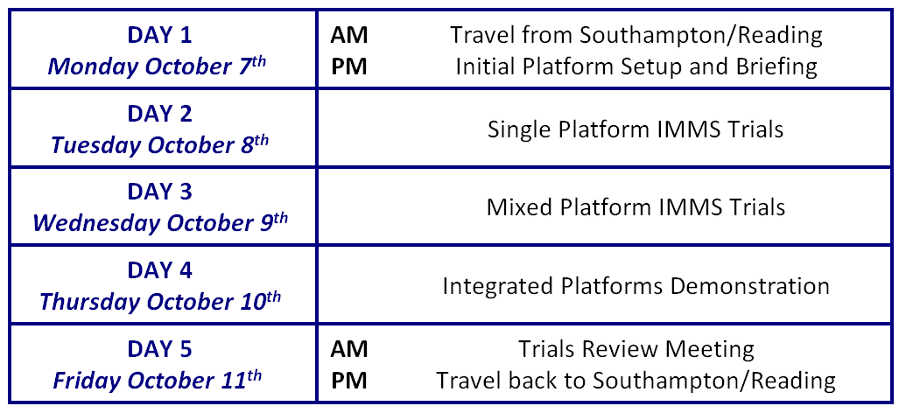

The following provided edited highlights from the test logs during the trials week which capture many of the challenges that are present in real world testing of MAS.

Day 1
“The objective of activity for Monday according to the trials plan was dedicated entirely to system setup, covering the communications network on the Clyde and checking all UxVs to be operating properly. Time was also put aside to brief the full team on plans and safety aspects for the week as well as give team introductions and the Turnchapel site. The plans for Monday afternoon were not significantly altered. All communications equipment was mounted to Clyde and shown to be in working order. The UAV SULSA was able to interpret an example mission generated using the IMMS. No attempt was made to fly as the UAV team undertook a reconnaissance of the UAV airfield site having not previously flown from that site.”

Day 2
“The goals on day 2 were to see the C-Cat 3 fully operational at Turnchapel and to perform initial test flights with the UAV SULSA. The weather was expected to be particularly poor on Tuesday morning making a trip to the test area less desirable. The seagoing vehicles did not leave the Turnchapel Wharf area. The EcoSubs were not able to be ballasted to reliably sit at the required 70°±5° to fully raise an antenna above the water. Therefore EcoSubs were not launched due to risk of loss. C-Cat 3 was successfully launched and brought alongside Clyde. It was driven remotely using the ASView-Helm manual controls and operated reliably within ~20m of Clyde. Beyond this range, communications issues were experienced..

In a late afternoon weather window, UAV SULSA flew from the Hooe Lake campsite under manual control and recorded approximately 15 minutes of HD video (Fig. 10). The aircraft performed well at all points until landing. The heavy landing was attributed to the required upgrades to the aircraft increasing its mass and requiring greater airspeeds. The wind direction also forced the landing to take place downhill which worsened the situation. A lighter replacement aircraft capable of running the same operating system was arranged for the rest of the week.”

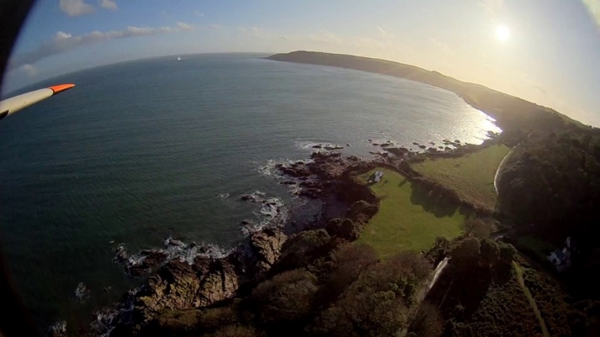
Figure 10 Still image from UAV SULSA

Day 3
“The C-Cat 3 was launched successfully and transited via RHIB Clyde of Dartmouth to the Cawsand Bay trials area and further single asset testing was undertaken. It was driven remotely using the ASView-Helm manual controls and operated reliably within ~200m of Clyde. Beyond this range, communications issues were experienced. Due to the issues with communications on the C-Cat 3 it was decided to halt the trials in Cawsand bay earlier than planned and return to Turnchapel Wharf for further investigation.

Via discussion with the support team at L3 Harris the underlying issues with communications were identified and rectified. It was a frustrating day with the assets due to the ongoing communications issues on the C-Cat 3 but with good success resolving these late in the afternoon. The replacement airframe flew successfully and proved to be adept at handling the challenges of the Hooe Lake campsite.”

Day 4
“Day 4’s objective was to undertake integrated mixed vehicle IMMS based trials. This was intended to create and validate missions within the IMMS system and use an integrated mix of differing assets to achieve the specified mission. Based on the condensed playbook developed on Day 3, five specific missions were defined for evaluation on Day 4 of the trials. It was decided by the team that that the most important outcome was to demonstrate the IMMS operating with multiple assets in one mission as this is where the core novelty lies within this project. These activities were further planned to include every element available to a mission in as few missions as possible.

It was successfully shown that an integrated mission for multiple assets could be developed, planned, and distributed using the established IMMS2019 system. The UAV successfully executed that mission (Fig. 11). Ongoing hardware issues prevented the ASV C-Cat3 and AUV Ecosubs from executing but the missions were delivered to the assets.”

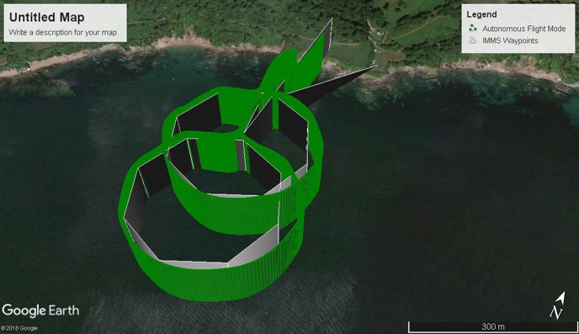
Figure 11 UAV 1st IMMS 2019 uploaded mission flight plan in grey and track of autonomous flight in green.

7. CONCLUSION

A multi vehicle experimentation capability was successfully developed and executed within a four-month period by a joint team of Thales and UoS engineers. The completion of a set of trials of increasing complexity allowed further exploration of the actual challenges when moving between a planned mission, via a virtual simulation to actual delivery.

The IMMS2019 System was successfully shown to be able to plan and execute multiple domain and multiple asset missions. The common network approach adopted enabled multiple sites and locations to participate in the trials. A joint team of 16 people in Turnchapel Wharf successfully delivered the 2019 trials

Significant challenges were experienced with the assets working in the field. These were primarily related to the use of proprietary systems, which stressed the importance of understanding interfaces and connectivity of closed systems vs. open systems. Real world communications provided significant challenges with inconsistencies during system set up that were challenging to detect, and fault find. There were problems with the selected site for UAV launch and recovery, dependent on weather conditions as well as issues of energy reserves to ensure suitable range could be achieved. This was partly due to the topography of Plymouth Sound regarding access to suitable landing strips but also reflects the energy resource issue of small assets.

While it was true that many of these issues were mainly associated with the need to mature the assets prior to, rather than during, the trial; their operations and likewise the developed software system requires the combined operation of many individual systems in advance of large-scale future integrated mission trials.

The IMMS2019 system was immature at this stage and needs further stress testing in advance of the field trials. Issues were found in the aspects of the code which had earlier lab trials of the complete system been undertaken, may have been identified. Ultimately, the IMMS demonstrates the importance of research, engineering design, testing of autonomous vehicles, albeit the assets are simple, to determine the real behaviours and embedded costs associated with conducting more complex MAS missions going into the future.

Since undertaking the trials, work has continued developing the IMMS system into a robust and coherent C2 framework which enable the easy insertion and removal of differing components. This underpins the original intention of developing and evaluating such a framework for the experimental capability of a single mission management system to control a fleet of heterogeneous, multi-domain autonomous vehicles whereby their collaborative mission could be planned, verified, and delivered, whilst challenging the various spatial-temporal-energetic-communication-environmental constraints.

8. ACKNOWLEDGEMENTS

The authors are grateful to the many others both at Turnchapel Marine Autonomy Centre and in Southampton who helped ensure the success of the IMMS trials. In particular, thanks are given to Dr D Dghaym, Prof M. Butler, Prof E. Rogers, and Prof J. Scanlan. The assistance of the UK Hydrography office in providing access to relevant environmental data proved invaluable. Likewise, the UKRI EPSRC capital funding that supported the original purchase of the assets deployed in the trials.

9. REFERENCES

- AMOS, J., 2018. ‘Boaty McBoatface’ sub survives ice mission.’ https://www.bbc.co.uk/news/science-environment-43378290 (accessed 15-04-2021)
- ARGO PROGRAMME. http://www.argo.ucsd.edu/ (accessed 15-04-2021)
- BECHON, P., LESIRE, C., & BARBIER, M. 2020. Hybrid planning and distributed iterative repair for multi-robot missions with communication losses. Autonomous Robots, 44(3), 505–531.
- CONLAN CESAR, BENJAMIN WHETTON, MICHAEL DEFILIPPO, MICHAEL BENJAMIN, MICHAEL SACARNY, SCOTT REED, ANDREA MUNAFO, Coordinating Multiple Autonomies to Improve Mission Performance, OCEANS 2021 MTS/IEEE, October, 2021
- CONTI, C. 2016. CARACaS - Autonomous Control for Unmanned Surface Vehicles. https://www.ndia.org/-/media/sites/ndia/meetings-and-events/divisions/robotics/december_2016_division_meeting/conti---autonomous-control-for-unmanned-surface-vehicles.ashx (accessed 06-07-2021).
- DELLE FAVE, F. M., ROGERS, A., XU, Z., SUKKARIEH, S. AND JENNINGS, N. R. 2012. Deploying the Max-Sum Algorithm for Coordination and Task Allocation of Unmanned Aerial Vehicles for Live Aerial Imagery Collection. In, Proceedings of ICRA, 14 - 18 May 2012, 469-476.
- DGHAYM, D., HOANG, T.S., TURNOCK, S.R., BUTLER, M., DOWNES, J. & PRITCHARD, B. 2021. An STPA-based formal composition framework for trustworthy autonomous maritime systems. Safety Science. 136105139.Ecosub Robotics https://www.ecosub.uk/news (accessed 15-04-2021)
- FERREIRA, A. S., PINTO, J., SOUSA DIAS, P., & DE SOUSA, J. B. 2017. The LSTS software toolchain for persistent maritime operations applied through vehicular ad-hoc networks. 2017 International Conference on Unmanned Aircraft Systems (ICUAS). June 2017. https://doi.org/10.1109/ICUAS.2017.7991471
- GATEAU, T., LESIRE, C., & BARBIER, M. 2013. HiDDeN: Cooperative plan execution and repair for heterogeneous robots in dynamic environments. 2013 IEEE/RSJ International Conference on Intelligent Robots and Systems, 4790–4795. https://doi.org/10.1109/IROS.2013.6697047
- HARRIS, C. A., LORENZO-LOPEZ, A., JONES, O., BUCK, J. J. H., KOKKINAKI, A., LOCH, S., GARDNER, T., & PHILLIPS, A. B. 2020. Oceanids C2: An Integrated Command, Control, and Data Infrastructure for the Over-the-Horizon Operation of Marine Autonomous Systems. Frontiers in Marine Science, 7, 397. https://www.frontiersin.org/article/10.3389/fmars.2020.00397 (accessed 24-08-2022)
- HOANG, THAI SON, SCHNEIDER, STEVE, TREHARNE, HELEN AND WILLIAMS, DAVID. 2016. Foundations for using linear temporal logic in Event-B refinement. Formal Aspects of Computing, 28 (6), 909-935. (doi:10.1007/s00165-016-0376-0).
- HUNTSBERGER, T., AGHAZARIAN, H., ESTLIN, T., & GAINES, D. 2008. Control Architecture for Robotic Agent Command and Sensing. Information Technology. https://www.techbriefs.com/component/content/article/tb/pub/techbriefs/information-sciences/3251 (accessed 24-08-2022)
- LEFFINGWELL, D., 1997. Calculating the Return Investment from more Effective Requirements Management. American Programmer, 10,13–16.
- LIDTKE, A., TURNOCK, S. AND DOWNES, J. 2018. Hydrodynamic Design of Underwater Gliders Using k-k(L)-omega Reynolds Averaged Navier-Stokes Transition Model. IEEE Journal of Oceanic Engineering, 43 (2), 356-368. (doi:10.1109/JOE.2017.2733778).
- L3 HARRIS ASV. 2019. https://www.asvglobal.com/brest-first-images-of-the-thales-mine-warfare-usv/ (accessed 24-08-2022)
- MACDONELL, S.G., MIN, K., CONNOR, A.M. 2014. Autonomous requirements specification processing using natural language processing. Computing Research Repository (CoRR) abs/1407.6. URL: http://arxiv.org/abs/1407.6099, arXiv:1407.6099.
- PINTO, J., DIAS, P. S., MARTINS, R., FORTUNA, J., MARQUES, E., & SOUSA, J. 2013. The LSTS toolchain for networked vehicle systems. 2013 MTS/IEEE OCEANS - Bergen, 1–9. https://doi.org/10.1109/OCEANS-Bergen.2013.6608148 (accessed 24-08-2022)
- ROYAL NAVY. 2016. Unmanned Warrior https://www.royalnavy.mod.uk/unmannedwarrior (accessed 15-04-2021)
- SCHWARTING, W., ALONSO-MORA, J., AND D. RUS. 2018. Planning and Decision-Making for Autonomous Vehicles, Annual Review Control, Robotics, and Autonomous Systems,1:1 2018.1.
- THORNTON, B. 2018. Rapid Data Analysis at Sea. https://www.southampton.ac.uk/smmi/news/2018/09/13-rapid-data-analysis-at-sea.page (accessed 15-04-2021)
- THORNTON, B., NISHIDA, Y., NAGANO, K., KOIKE, T., TAKAHASHI, T., BODENMANN, A., WALKER, J., LIM, J., MASSOT-CAMPOS, M., SHITASHIMA, K., AND AHN, J. 2018. Adaptive Robotics at Barkley Canyon and Hydrate Ridge. https://schmidtocean.org/cruise/adaptive-robotics-at-barkley-canyon-and-hydrate-ridge/ (accessed 15-04-2021)
- THOMPSON, F & GUIHEN, D. 2018. Review of mission planning for autonomous marine vehicles fleets, J. of Field Robotics, 2018, DOI:10.1002/rob.21819

