Supertoroidal Skyrmions and Space-Time Superoscillation of Light

Yijie Shen ª, Nikitas Papasimakis ª, and Nikolay I. Zheludev ^{a,b}
ª Optoelectronics Research Centre and Centre for Photonic Metamaterials, University of Southampton, Southampton SO17 1BJ, UK
ª Centre for Disruptive Photonic Technologies, School of Physical and Mathematical Sciences and The Photonics Institute, Nanyang Technological University, Singapore 637378, Singapore.

Abstract
Topological complex electromagnetic waves give access to nontrivial light-matter interactions and provide additional degrees of freedom for information transfer. An important example of such electromagnetic excitations are space-time non-separable single-cycle pulses of toroidal topology. Here we introduce an extended family of super-toroidal electromagnetic excitation, which exhibit skyrmionic structure of the electromagnetic fields, multiple singularities, and fractal-like energy backflow. By further introducing bandlimited effect into super-toroidal pulses, we show that space-time non-separable band-limited light fields can exhibit superoscillations simultaneously in the spatial and temporal domains, i.e. can oscillate faster that the highest harmonics of their spectra. The super-toroidal pulses with space-time superoscillation are of interest for transient light-matter interactions, ultrafast optics, spectroscopy, and toroidal electrodynamics.

Keywords: Topology, toroidal, skyrmion, superoscillation, structured light

INTRODUCTION
Structured light, with the ability to arbitrarily tailor light in its various degrees of freedom, has risen in prominence in recent years [1,2]. In particular there has been the emergence of vector beam, which is a space-polarization non-separable solution of electromagnetic field and acts as non-separable state with two degrees of freedom (DoFs), spin and orbital angular momentum (OAM), akin to the quantum entangled state, namely classically entangled light [3]. However, the potential for fully exploiting these beams is limited by the prevailing description of only two DoFs, corresponding to 2D bipartite entangled state (Bell state). Here we overcome this paradigm and propose a new structured light beam with highly symmetric 3D wavepacket invoking ray-wave duality structure, which creates multiple new DoFs of frequency degenerate ratio, coherent state phase, ray trajectory combination, etc. in vector vortex beam. Moreover, we demonstrate a simple laser configuration with no customized intracavity elements that is able to directly generate such ray-wave vectorially structured light in controllable high-dimensional multi-partite classically entangled states.
We recently demonstrated the generation of the Flying Doughnut, a few-cycle pulse of toroidal topology with space-time non-separable structure, discovered by Hellwarth and Nouchi in 1996. Here we show that a generalized family of toroidal pulses, termed Supertoroidal Pulses (STPs) [4], of which the Flying Doughnut is the fundamental member, allows for skyrmion-like electromagnetic field configurations in propagating pulses. We demonstrate different types of skyrmionic fields of different topological numbers within a single focused STP [5].
Superoscillation (SO) is a phenomenon in which a band-limited function contains local segments oscillating faster than its fastest Fourier component [6], as demonstrated in Fig.1(a-b). Superoscillatory behavior has been demonstrated in a variety of systems, including acoustics, quantum mechanics, electromagnetism, to name a few. In particular, in electrodynamics, superoscillations are typically considered either in the temporal or spatial domain, leading to applications in superresolution imaging and nanoscale metrology.

Skyrmionic Supertoroidal Light

Skyrmionic Supertoroidal Light Pulses
We report that the “Focused Doughnut” introduced by Hellwarth and Nouchi in 1996 is only a single member of an extended family of electromagnetic toroidal pulses with skyrmion topology propagating at the speed of light.
Toroidal light pulses (TLPs), often termed “Focused” or “Flying Doughnuts”, are single-cycle oscillations with space-time non-separable structure and complex topology in the form of line and ring singularities [7]. They form the propagating counterparts of the localized toroidal dipole excitations in matter with links to anapole, non-radiating excitations. Here we introduce a generalization of the toroidal light pulses, that we call supertoroidal light pulses (STLPs). We demonstrate that STLPs exhibit matryoshka-like electromagnetic field configurations and topological structure analogous to skyrmion quasiparticles in condensed matter that to date have not been observed in electromagnetic pulses.
Supertoroidal light pulses come from a more general class of pulses over three decades ago. In 1989, Ziolkowski proposed a family of localized finite-energy pulse solutions obtained as superpositions of “electromagnetic directed-energy pulse trains” (EDEPTs). Special cases of EDEPT solutions were studied by Hellwarth and Nouchi, who found the closed-form expressions that describe focused single-cycle spatiotemporal pulses with toroidal topology termed the TLP. TLPs can be characterized by two parameters q₁ and q₂, acting as effective wavelength and Rayleigh range, respectively. In addition, the TLP is characterized by a real dimensionless parameter α, where α≥1 ensures finite energy. While to date only the case of α=1 has been studied, here we consider its generalization for α≥1 to obtain the STLPs. Characteristic examples with α=1 (fundamental TLP), as well as higher values of α (STLPs, α=5, 10, 15) are shown in Figs. 1a-1d, represented by their instantaneous electric field structure. In contrast to the fundamental TLP, the STLPs exhibit more complex spatiotemporal evolution upon propagation and are reshaped multiple times due to Gouy phase shifts. The topological properties of the STLP are related to the parameter α and, in particular, the complexity of the topological structure increases with increasing α. For the case of azimuthally polarized (i.e. transverse electric (TE)) STLPs, an increasing number of electric singularity structures emerge with increasing α, see Figs. a-d, in the form of layered singular shells. We note that this process can be seen as an electromagnetic analog of the famous Matryoshka toy, see Fig. 1e.
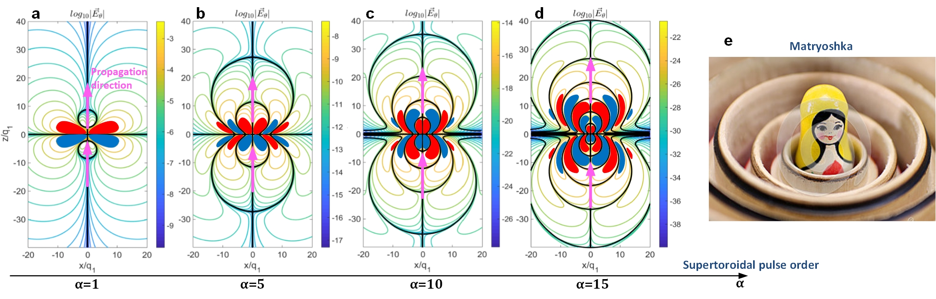
Fig. 1. Supertoroidal pulses propagating at the speed of light. The electric field structure of TE STLPs at focus (q₂=100q₁, α=1, 5, 10, and 15 for a-d, respectively). The purple arrows show the propagation direction. The red and blue regions represent isosurfaces of the electric field with amplitude of E = ±1% (normalized to the peak electric field value), respectively. The coloured lines correspond to contour plots of the logarithm of the electric field modulus. The solid black lines mark singularities, where the electric field vanishes. As the order of the STLP increases, the distribution of singularities resembles a matryoshka structure (see panel (e)).
The magnetic field of STLPs has both radial and longitudinal components, leading to a more complex topological behavior than the electric field. We firstly show the topological structure of the magnetic field of a fundamental TLP. Figure 2a shows its instantaneous magnetic vector fields (arrows) together with the logarithm of its amplitude (contours) in the x-z plane. The vector singularities in the magnetic field include vortex rings and saddle points. There are four saddle points along the z-axis and three vortex singular rings around the propagation axis. This topological structure results in two skyrmionic patterns of magnetic fields in planes normal to the propagation direction (z-axis) located in between the saddle points, marked as b1 and b2 in Fig. 2a. The corresponding skyrmion vector patterns are shown in Figs. 2b1 and 2b2, respectively. In contrast to the fundamental TLP, the STLP allows us to observe a wider range of skyrmion patterns in its magnetic vector field. Hereinafter, we illustrate the topological properties of STLPs by considering the TE (azimuthally polarized) mode with α=15. Figure 2c shows the instantaneous magnetic vector fields (arrows) together with the logarithm of its amplitude (contours) in the x-z plane. Sixteen saddle points are distributed along the z-axis, while the vortex singularities are distributed along two planes crossing the pulse center (x=z=0). This topological structure results in multiple skyrmion patterns of different textures as shown in Figs. 2b1-2b4, corresponding to the four transverse planes b1-b4 marked in Fig. 2a by black dashed lines. The texture of the skyrmion patterns can be characterized by the topological number, s, defined as s=1/(4π)∫∫n·(∂_{x}n×∂_{y}n)dxdy=p·m, where n=(cosαsinβ, sinαsinβ, cosβ), α=mθ+γ and β are the two angles that define mapping of a vector onto the unit sphere. Here the sign of s=±1 defines whether the magnetic field at the center of the skyrmion pattern is oriented parallel or antiparallel to the z-axes, while γ = 0 or π indicates that the magnetic field vector projection in the x-y plane points towards or away from the center. Only skyrmions with (s, γ) = (1, π) and (1, 0) are observable in the fundamental TLP, while the parameters of the four skyrmions in the STLP (Figs. 2b1-2b4) are (s, γ) = (1, π), (-1, π), (-1, 0) and (1, 0), respectively.
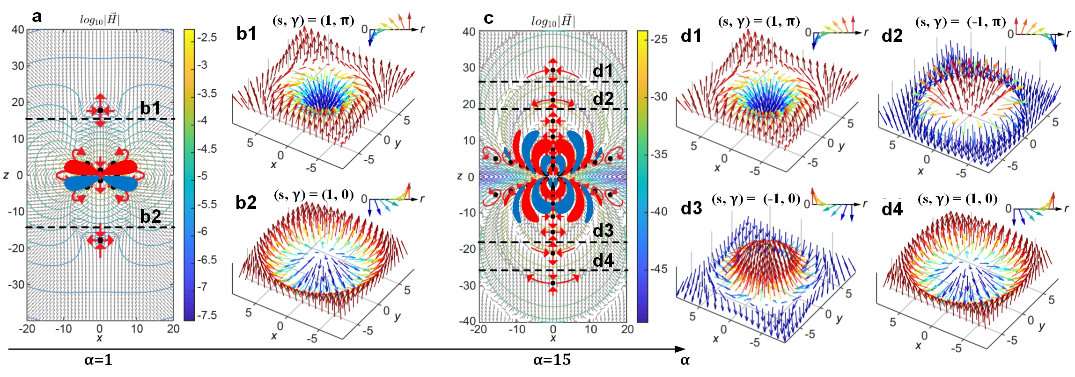
Fig. 2. Skyrmionic topology of the supertoroidal light pulses. a, Isoline and arrow plots of the amplitude and vector of magnetic field in the x-z plane for the fundamental TLP. Black dots indicate the zeros of the magnetic field with red arrows correspondingly marking the saddle or vortex type of the vector singularities. Panels b1 and b2 are corresponding to the two skyrmions, (s, γ) = (1, π) and (1, 0), marked by the black dashed lines in figure a. c, Isoline and arrow plots of the amplitude and vector of magnetic field in the x-z plane for the STLP with α=15. Panels d1-b4 are corresponding to the four skyrmions, (s, γ) = (1, π), (-1, π), (-1, 0) and (1, 0), marked by the black dashed lines in figure c. Unit for coordinates: q₁. The topological numbers (s, γ) for various skyrmions are marked at the corresponding panels.
Importantly, higher order STLPs exhibit a fractal-like pattern of singularities for the electric and magnetic fields (see Figs. 1a-1d). For the electric field, the matryoshka-like Ω-shaped singular shells result in a self-similar pattern that seems infinitely repeated. However, there is a finite number of shells defined by the value of α. On the other hand, in the case of the magnetic field, the vortex singularities (represented by the off-axis points in Figs. 2c) form a series of nested rings. This fractal-like configuration of electromagnetic fields results in a complex Poynting vector pattern consisting of areas of energy forward- and back-flow organized in singular shells similar to the electric field (not shown here).

Diffraction-Free Propagating Skyrmions
We report an extended family of diffraction-free super-toroidal light pulses, the exact solutions of Maxwell’s equations, allowing propagation-robust skyrmionic topologies that persist over arbitrary distances.
We recently demonstrated the generation of the Flying Doughnut, a few-cycle pulse of toroidal topology with space-time non-separable structure, discovered by Hellwarth and Nouchi in 1996. Here we show that a generalized family of toroidal pulses, termed Supertoroidal Pulses (STPs) [1], of which the Flying Doughnut is the fundamental member, allows for skyrmion-like electromagnetic field configurations in propagating pulses. We demonstrate different types of skyrmionic fields of different topological numbers within a single focused STP [2].
The propagation dynamics and topological structure of STPs are controlled by the effective wavelength q₁, Rayleigh range q₂, and a real dimensionless parameter α≥1. A typical example is shown in Fig. 3(a) for an STP with α=5 and q₂=100q₁ coming in and out of focus. At focus, the STP presents a complex topological structure with multiple magnetic field singularities including vortex rings and saddle points (see Fig. 3(b)). The combination of saddle points with vortex rings results in multiple skyrmionic patterns in the transverse plane (xy-plane in Fig. 3). Examples of such patterns are shown in Fig. 3(d), where two distinct types of skyrmionic configurations can be observed. We characterize the topology of such configurations by the topological charge s, vorticity m and helicity γ, which are typically used to describe skyrmions. The topological numbers of the skyrmionic fields of Fig. 3d are (s,m,γ) = (1,1,π) and (1,1,0) for left and right panels, respectively. At different positions of the pulse we can observe additional skyrmionic configurations with (s,m,γ) = (1,1,π), (-1,1,π), (-1,1,0) and (1,1,0), respectively. The evolution of the skyrmionic patterns and the role of space-time non-separability will be discussed at the conference.
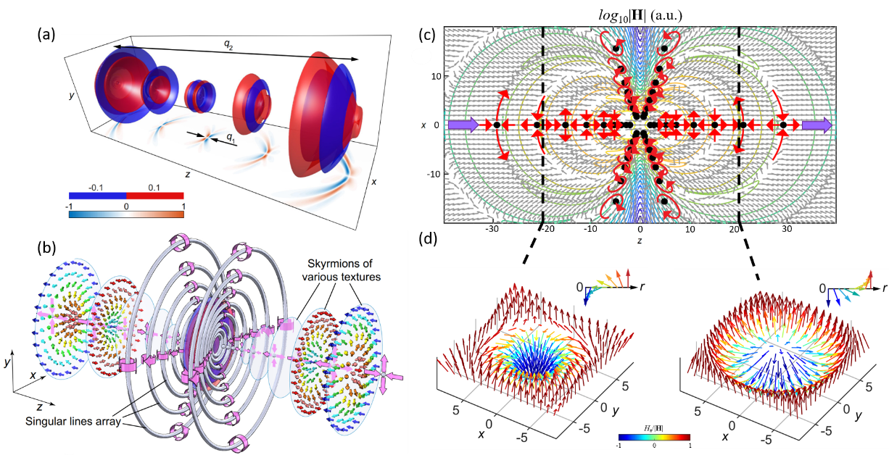
Fig. 3 (a) Isosurfaces for the electric field of a STLP with α=5 and q₂ = 100q₁, at t = 0, ±q₂/(4c), and ±q₂/(2c). Projections on the xz-plane shows cross-sections of field at y = 0. (b) Topological structure of the STLP at focus. Gray dots and rings represent singularities (saddle points and vortex rings) in magnetic field, while large magenta arrows indicate magnetic field direction. Colored arrow patterns show magnetic skyrmion patterns on the transverse plane. (c) Magnetic field amplitude (contour plot) and direction (arrow plot) in x-z plane at focus for a STLP with α=10. Black dots mark magnetic field singularities, while red arrows indicate singularity type (saddle or vortex). Purple arrows show the propagation direction. (d) Skyrmionic patterns in the transverse plane of the STLP presented in (c) at z=±20. Unit of length is q₁.
Then we show that the transverse divergence (q₃) of STPs can be tuned and introduce a subset of STPs comprising ultrafast structured pulses of non-diffracting nature. Such non-diffracting STPs (NDSTPs) exhibit propagation-robust topological properties. A characteristic example of such a pulse with q₃ = q₁ is plotted in Fig.4(a), where q₃ is schematically marked showing degree of transverse divergence: with decreasing value of q₃ the pulse envelope is gradually squeezed into a dumbbell shape and becomes nondiffracting. The evolution of the pulse from diffracting to nondiffracting is presented in Fig. 4(b). To verify the nondiffraction nature dependent on q₃, we simulate the z-dependent full width at half maximum (FWHM) radius of the transverse intensity pattern of the STPs with q₂ = 100q₁ and q₃ varying from infinity to q₁, in the range of propagation distances from focus to z = 10³q₁. With decreasing of q₃, the divergence becomes weaker and the pulse approaches a nondiffracting state at q₃ ≤ 5q₁. Figure 4(c) shows the magnetic field distribution of the NDSTP at t=0. The magnetic field includes both radial and longitudinal components, so as to form sets of vector singularities of vortex and saddle types. The saddle-type singularities are distributed along the propagation axis and the vortices trace an off-axis trajectory, see Fig. 4(d), which induces multiple electromagnetic skyrmions at transverse planes of the pulse, see Fig. 4(e). In contrast to the electromagnetic skyrmions in prior STPs that exist around pulse focus and collapse rapidly upon propagation, here in the NDSTP, the skyrmions always exist upon propagation and switch their topological textures,where for types of topological texture can be observed continually (combination of opposite two polarities and two helical angles).
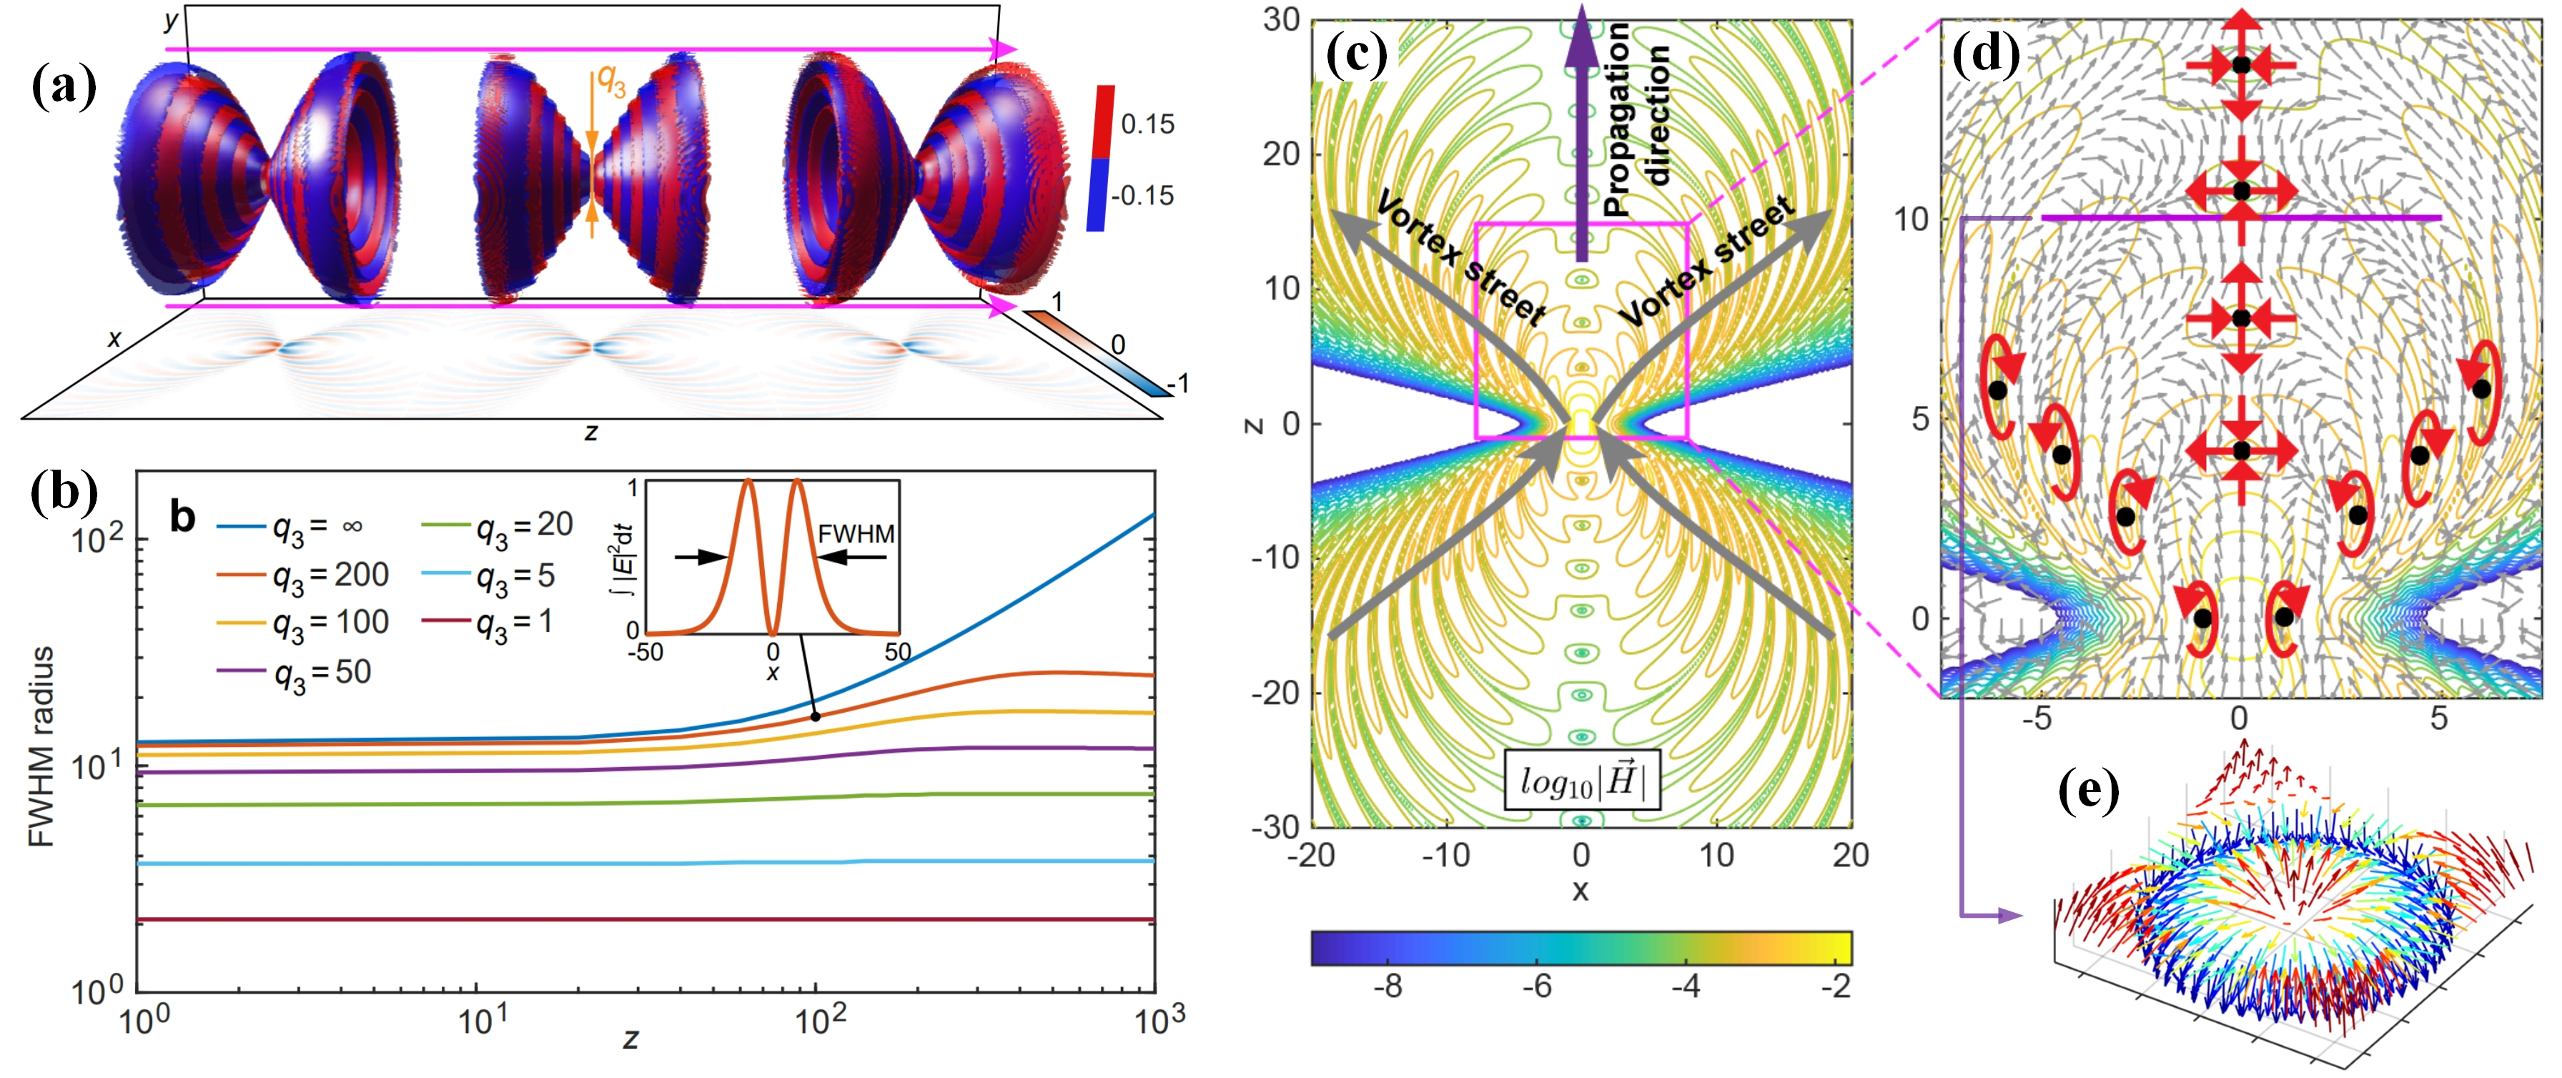
Fig. 4 (a) Isosurfaces for the electric field of a NDSTLP with α=5 and q₂ = 100q₁, at t = 0, ±q₂/(4c), and ±q₂/(2c). Projections on the xz-plane correspond to cross-sections of the electric field at y = 0. (b) The evolutions of FWHM radius (see inset) of intensity upon propagation for transversely divergent pulses with various q₃ values. (c) The structures of magnetic field of the NDSTP at t = 0, the contours show the logarithm of corresponding fields. (d) The zoom-in of the magnetic field with arrow plot showing the vector distribution, the black dots refer to the singularities, and surrounding red arrows mark the types of the vector singularities (vortex and saddle) serving as guide to the eye. (e) Arrow plot showing a skyrmionic structure of magnetic field in x-y plane at z = 10 (purple solid line in (d)).

Space-Time Superoscillation
We show that band-limited light fields can exhibit superoscillations simultaneously in space and time, which can oscillate faster that the highest harmonics of their space-time spectra, and verify such behavior in super-toroidal structured pulses.
Here, we extend the concept of superoscillations to the spatiotemporal domain introducing Space-Time Superoscillations (STSOs), whereby a band-limited spatiotemporal signal, at a certain time, locally oscillates faster than the fastest spatial frequency component of its entire spectrum, and, at a certain position, temporally oscillates faster than the fastest temporal frequency component of its entire spectrum. We show that such fine-scale features are present in space-time nonseparable light fields, i.e. fields whose spatial and temporal dependence cannot be factorized, such as the supertoroidal light pulse [2], leading to arbitrarily small spot sizes at focus.
A space-time superoscillatory field, F(x,t), should exhibit five main features: (1) Band-limited nature. Both the spatial and temporal frequency spectrum of F(x,t) should be band-limited. (2) Fast local oscillations. The field should contain local spatial segments oscillating faster than its fastest spatial Fourier components, and a local temporal segment oscillating faster than its fastest temporal Fourier component. (3) Rapid phase variations. Superoscillatory regions should be accompanied by rapid phase changes in space and in time, where the phase variation is faster than the phase variation of the highest harmonic in the spectrum. (4) Broad local spectrum. The spatial and temporal frequency spectrum of local segments of a space-time superoscillatory field can be much broader than that of the entire field. Figure 5 contrasts a common SO function to a band-limited STSO pulse, which is obtained from a supertoroidal pulse [2] with cutting-off frequency at bandlimit.
Then we verified the feature of rapid space-time phase variations in the band-limited supertoroidal pulses. we calculated the phase distribution of the supertoroidal pulses with various values of α and a fixed maximal frequency ω_{max}. Figures 6(a-c) show the simulated results for the pulses at focus of α=1, 20, and 50, including the distributions of the logarithms of amplitude log₁₀|F|, unwrapped phase ϕ, phase gradient (local wavevector) |∇ϕ|, and the spectra. The phase gradient curves at r=10 for diverse cases of α are plotted in Fig. 6d. In which we can clearly observe the evidence of SO, that the local wavevector can exceed the maximum of wavevector of entire spectrum, and the exceeding is more and more stronger with the increasing of supertoroidal order α.
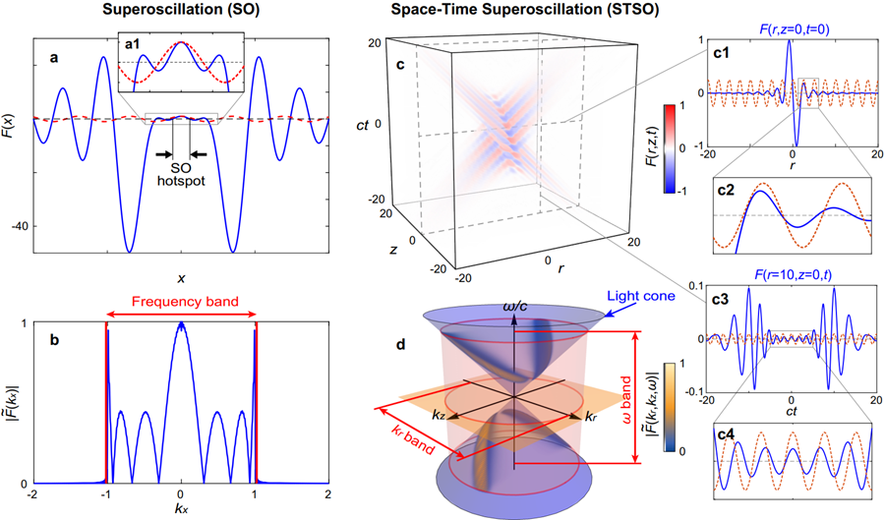
Fig. 5 Conventional SO vs STSO. a, b, An example of a band-limited function, F(x), exhibiting SOs in the spatial domain, and spatial frequency spectrum bounded by |k_{x}|<1. c, d, A supertoroidal light pulse [2], F(r,z,t), with truncated spatial and temporal frequency spectra exhibits space-time superoscillations: (c) pulse profile in space-time (r,z,t), insets (c1-c4) show the spatial and temporal traces of the pulse (blue) and its highest spatial frequency component (red); (d) pulse spectrum in the spatial and temporal frequency domain (k_{r},k_{z},ω) with pulse components being confined on the light cone. Red rings indicate the spatial and temporal frequency bandwidth.
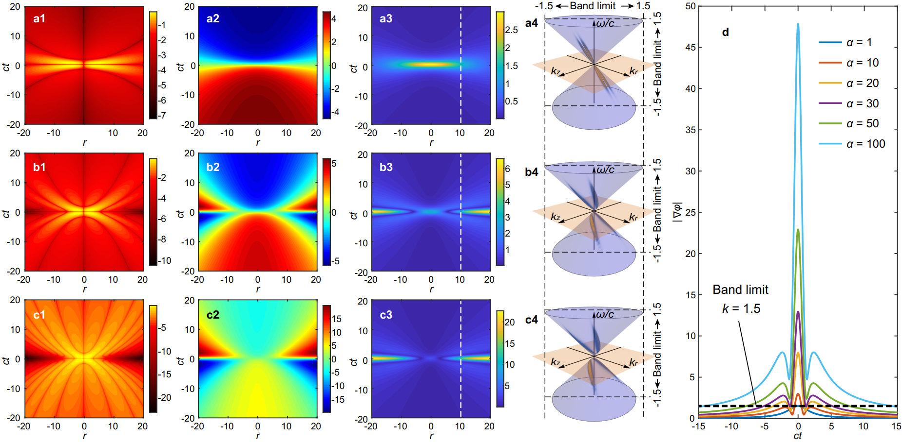
Fig. 6: a-c, The theoretical results for the supertoroidal pulses at focus of α=1, 20, and 50, respectively, including the distributions of the logarithms of amplitude log₁₀|F| (a1-c1), unwrapped phase ϕ (a2-c2), phase gradient (local wavevector) |∇ϕ| (a3-c3), and the spectra where the black dashed lines mark the band limit set in simulation (a4-c4). d, The phase gradient curves versus time of various supertoroidal signal at r=10 for diverse cases of α, where the black dashed line marks the value of band limit.

Summary
In conclusion, we present a generalized family of ultrafast toroidal pulses, the STLPs, which exhibit vector singularities of electromagnetic fields with intriguing topological properties, such as skyrmion-like magnetic field configurations and self-similar distribution of singularities. We note that the topological structure of the STLPs is not limited to the focal region and persists upon pulse propagation. Such topological features will be of interest for fundamental studies in topological optics, as well as for applications in encoding and transferring information by topologically structured fields.
We demonstrate non-diffracting toroidal pulses. Importantly, the sophisticated vector field configuration of NDSTPs induce robust topological structures including fractal-like singularities, skyrmions, vortex rings, and energy backflows, all of which can stably propagate at an infinitely long distance. The NDSTPs unveil intriguing analogies between fluid transport and flow of energy in structured light. In particular, the robust topological structure of NDSTPS that remains invariant upon propagation could be used for long-distance information transfer encoded in the topological features of the pulses. Finally, we anticipate that NDSTPs will inspire potential applications such as light-matter interactions, superresolution microscopy, and metrology.
In contrast to prior SO effect, the STSO effect proposed here extend new degree of freedom to manipulate counterintuitive oscillation effect in space-time coupled domain, where an extreme SO oscillation can emerge at a special location and time and may diffuse as time passing by. We proof the existence of STSO effect in space-time non-separable structured electromagnetic pulse as an example of the supertoroidal pulse, which promises the extension of applications such as superresolution ultrafast microscopy and metrology. Recently, creation of space-time optical pulse was attracting growing attention, thus it is highly possible to observe STSO effects in more kinds of space-time structured wave. Here we demonstrate STSO by electromagnetic wave, yet which is also open to general kinds of wave such as gravitational wave and acoustic wave, extending the frontier of modern physics.

References
- A. Forbes, M. Oliveira, and M. Dennis, “Structured light,” Nat. Photonics15, 253–262 (2021).
- Y. Shen, X. Wang, Z. Xie, C. Min, X. Fu, Q. Liu, M. Gong, and X. Yuan, “Optical vortices 30 years on: OAM manipulation from topological charge to multiple singularities,” Light Sci. Appl. 8, 90 (2019).
- Y. Shen, I. Nape, X. Yang, X. Fu, M. Gong, D. Naidoo, and A. Forbes, “Creation and control of high-dimensional multi-partite classically entangled light,” Light. Sci. & Appl.10, 50 (2021).
- Y. Shen, Y. Hou, N. Papasimakis, and N. I. Zheludev, Nat. Commun. 12, 5891 (2021).
- A. Zdagkas, Y. Shen, C. McDonnell, J. Deng, G. Li, T. Ellenbogen, N. Papasimakis, N. I. Zeludev, arXiv:2102.03636 [physics.optics] (2021).
- N. I. Zheludev and G. Yuan, Nat. Rev. Phys. 4, 16-32 (2021).
- Y. Shen, A. Zdagkas, N. Papasimakis, and N. I. Zheludev, “Measures of space-time nonseparability of electromagnetic pulses,” Phys. Rev. Res. 3, 013236 (2021).

