Microstructural influences on fatigue crack initiation and early propagation in Ni-based superalloy
D.Kim¹, R.Jiang^{1,2*}, I.Sinclair¹, P.A.S.Reed¹
¹Engineering Materials Research Group, School of Engineering, University of Southampton, Highfield, Southampton, SO17 1BJ, UK
²College of Energy and Power Engineering, Nanjing University of Aeronautics and Astronautics, Nanjing, China, 210016
*Corresponding author. Email: rjiang@nuaa.edu.cn

Abstract: Effects of unimodal secondary γʹ size and grain orientation on fatigue crack initiation and early crack propagation at room temperature have been investigated in RR1000 alloy. Fatigue tests show cracks mainly initiated at slip bands and/or pores followed by crystallographic facet formation whilst more diffuse strain localisation is observed around the pores by SEM-DIC analysis. Fatigue lifetime is linked to the number of crack initiations and consequent crack coalescence which accelerates crack propagation. Slip trace analysis with EBSD mapping shows cracks are likely to propagate along the primary active slip system with relatively high Schmid Factor. In the tests conducted here, the stochasticity of crack initiation events has more control on the overall lifetime than variations in secondary γʹ size.

Keywords: Ni-based superalloys; Fatigue crack initiation; Short fatigue crack growth; Microstructural effect; Strain localisation

1. Introduction
Powder metallurgy (P/M) Ni-based superalloys have been the material of choice in turbine disc applications due to their exceptional high temperature strength and damage tolerance, good fatigue and creep performance and resistance to oxidation and corrosion under service conditions [1,2]. Disc alloy performance and much of their service lifetime are controlled by fatigue crack initiation processes and the early stages fatigue crack growth (FCG), which is usually affected by the microstructure, environment, temperature and loading conditions and the synergistic effects between these [3–5]. The mechanisms of fatigue crack initiation and short FCG of polycrystalline Ni-based superalloys are closely associated with microstructural characteristics including size distribution of strengthening precipitate (γʹ), carbide distribution formed at the grain boundaries as well as grain boundary character.
It is known that fatigue cracks in Ni-based superalloys generally initiate at slip bands, precipitates, pores, grain boundaries, twin boundaries (TB) and other defects where stress concentration and strain localization arise [4,6–9]. Slip band cracking is generally observed as the predominant crack initiation mechanism at room temperature and it is closely associated with the microstructure of the alloys. The effect of varying γʹ size on FCG behaviour in Ni-based superalloys is often linked to variation in slip character as this affects the accumulation of damage which in turn affects crack initiation and crack growth processes [10–12]. Microstructures with coarse grains and fine γʹ precipitates are most likely to promote stage-I cracking along persistent slip bands promoted by heterogeneous and planar slip at room temperature, considerably contributing to slip band crack initiation [13,14]. It is also observed that primary cracks are initiated from pores which is a significant controlling factor of initiation in P/M superalloys together with slip bands impinging on, or emanating from, the pores due to the local stress concentration offered by them [15]. Highly faceted areas indicating planar slip behaviour and stage-I cracking along slip bands are observed near pores, indicating slip band cracking at the initiation point. In addition, cracks are likely to initiate at the interface between inclusions and the matrix as their different elastic properties can also promote an increase in stress concentration near the interface, leading to easier crack initiation [16].
The interaction of local microstructure features such as grain boundaries, grain orientation, TBs and precipitates with such slip band cracking is important in controlling the early stage FCG mechanisms [17–20]. The size distribution of γʹ precipitates and grains are tailorable microstructural parameters (related to optimization of the materials) and therefore influence deformation behaviour and consequent FCG behaviour. The γʹ precipitates provide some benefits in crack propagation resistance as slip bands are likely to terminate at grain boundaries or interfaces of γ matrix/primary γʹ in Ni-based superalloys [15,18]. In addition, a short crack can be arrested when it encounters γʹ precipitates, consequently hindering crack propagation. It has been observed that finer γʹ precipitates are more likely to exhibit precipitate cutting, whereas coarser γʹ precipitates shift to more bowing mechanisms in P/M Ni-based superalloys [21]. The γʹ precipitate cutting mechanism is associated with heterogeneous slip indicating enhanced slip reversibility or planar slip, which can result in lower crack growth rates [15,22,23]. On the other hand, comparatively less precipitate cutting takes place as precipitate size increases, indicating the dislocation process transferring to precipitate looping related to less planar slip.
In terms of grains and grain boundaries, it is believed that highly planar slip promotes more intense impingement of slip bands at grain boundaries, resulting from significant pile up of dislocations in the slip bands. This contributes to reduced crack growth resistance due to easier nucleation of dislocation sources near grain boundaries and weakens their effectiveness as a crack growth barrier. The effect of grain size on short crack growth is also linked to the free slip length for dislocation motion, which results in considerable pile up of dislocations expected at grain boundaries. This can cause the grain boundary to be weakened as a barrier for dislocation and also fewer such barriers are offered as grain size increases. However coarse grained materials also tend to exhibit more tortuous crack paths and highly planar slip character (heterogeneous slip) due to the intense slip bands extending across the grain [21]. This can then provide an increased resistance to crack growth due to increased crack tip deflection and hence intrinsic shielding with a more tortuous crack path. The crystallographic orientation between neighbouring grains (misorientation) can also affect short FCG behaviour and crack path. It is known that decelerated crack growth and larger crack deflections occur as misorientation of grain boundaries becomes higher whilst a lower angle of grain misorientation decelerates crack growth less. These competing effects of distribution of grain and grain boundary on crack propagation rates can be hard to untangle. It is also observed that a distribution of precipitates such as carbides formed at grain boundaries can contribute to enhanced fatigue crack initiation and short FCG [24,25]. Generally, metallic carbides (MC or M₂₃C₆) on grain boundaries inhibit the grain boundary sliding and consequent crack growth along the grain boundary. However carbides continuously formed at a grain boundary can reduce the binding force of the grain boundary, which promotes fatigue crack initiation and intergranular crack growth behaviour under applied stress [26].
Although extensive work has been conducted to investigate the effect of microstructural features on FCG behaviours of P/M turbine disc alloys, it has still been a matter of establishing the effect and relative balance of the γʹ size distribution and carbides on a grain boundary in relation to the fatigue crack initiation and short FCG behaviour. This is due to the bi or tri-modal γʹ size distributions typically found in commercial turbine disc superalloys, which makes it complex to dis-entangle the effects of varying γʹ population on slip character, related to overall fatigue lifetime. Therefore, it is important to understand the role of γʹ size and grain boundary feature to allow further optimization (e.g. heat treatment) of turbine disc alloys and eventually more advanced alloy performance. In this study, fatigue tests have been conducted on model RR1000 alloys with unimodal fine and coarse γʹ variants at room temperature in air, which is expected to further clarify the combined effects of γʹ size (linked to slip character and strain localisation) and grain boundary character on controlling overall fatigue life.

2. Materials and experimental procedures
2.1 Materials and characterisation
RR1000 alloy supplied by Rolls Royce was used in this study. The alloy consists of 15Cr, 18.5Co, 5.0Mo, 1.1Nb, 3.0Al, 3.6Ti, 2.0Ta, 0.5Hf, 0.027C, 0.015B, 0.06Zr, Ni Bal (in wt%). The alloy was produced by a P/M route, followed by various proprietary thermomechanical treatments and initially exhibited a bi-modal γʹ size distribution. A heat treatment blank was extracted from a disc, and samples for characterisation and fatigue tests were cut from the blank. Further non-commercial heat treatments as represented in Table 1 were employed to process the alloy to produce instead a unimodal size distribution of γʹ precipitates as seen in Figure 1 (a) and (b). The heat treatment includes a super-solvus solution treatment at 1180 °C for 2 hours to fully dissolve all primary γʹ and cooled by oil quench to minimise precipitation and growth. This is then followed by ageing treatments at 800 °C for 1 hour and 1050 °C for 1 hour with different, carefully controlled cooling to achieve unimodal fine and coarse secondary γʹ sizes, respectively. The mean precipitate size of the fine and coarse γʹ was found to be 73.2 nm ± 16.3 nm and 161.4 nm ± 43 nm, respectively. It is important to note that the RR1000 with coarse γʹ precipitates also shows a more continuous carbide formation along the grain boundary as seen in Figure 1 (d). Proof stress at room temperature is achieved at 1086 MPa and 1076 MPa in the fine and coarse γʹ variant, respectively.
Table 1 Heat treatment processes applied to the model RR1000 alloy.
Solution treatment | Fine/Coarse γʹ variants | 1180 °C for 2 h | $$→$$ | Oil quench cooled
Ageing treatment | Fine γʹ  variant | 800 °C for 1 h | $$→$$ | -0.1 °C /min cooled
 | Coarse γʹ  variant | 1050 °C for 1 h | $$→$$ | -1 °C /min cooled to 800 °C  -0.1 °C /min cooled for the rest
Note: γʹ -solvus is approximately 1160 °C
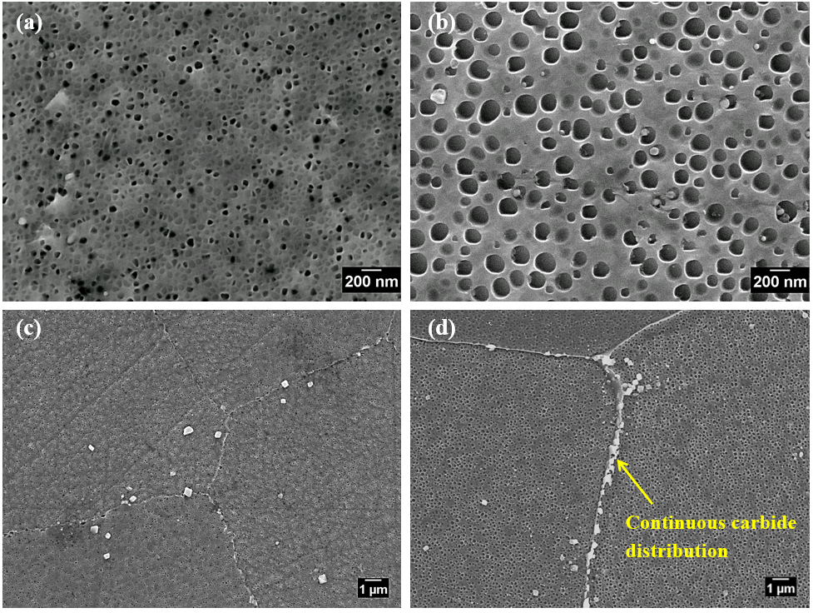
Figure 1 Morphology of secondary γʹ precipitate of (a) the fine γʹ variant (b) the coarse γʹ variant. Carbide distribution on grain boundary of (c) the fine γʹ variant (d) the coarse γʹ variant.
For the microstructural characterisation, the RR1000 alloy variants were etched by Kalling’s reagent (80 ml HCl + 40 ml CH₃OH + 40 g CuCl₂) for around 3 seconds to reveal grain boundaries and γʹ distribution. Microstructures of the alloy were examined by an Olympus BH2 optical microscope (OM), a JSM 6500F field emission gun (FEG) scanning electron microscope (SEM) under secondary electron imaging (SEI) and backscattered electron imaging (BEI) modes. The distribution of grain and grain size were investigated by Electron Backscatter Diffraction (EBSD) analysis using a JSM 6500F FEG-SEM. A final polishing stage of OPA followed by etching of the RR1000 samples was carried out for EBSD analysis. A step size of 1 µm and grain boundary tolerance angle of 2° were employed for EBSD mapping. It was observed that they showed similar quantitatively assessed grain size distributions, with 32.4 µm ± 24.0 µm and 32.9 µm ± 25.1 µm for the fine and coarse γʹ precipitate variants, respectively.
2.2 Methodology for fatigue testing and characterisation
Plain bend bar (PBB) specimens with a cross section of 9.3 mm × 3.8 mm were employed for the short fatigue crack tests on an Instron 8502 servo-hydraulic testing machine under three point bending with a loading span of 40 mm as seen in Figure 2 (a). Uninterrupted fatigue tests on RR1000 alloys were performed under nominal maximum applied stress of both 90% and 110% yield stress, load ratio of 0.1 and frequency of 20Hz at room temperature to investigate fatigue lifetime and subsequent fractography analysis. Fatigue tests on a group of RR1000 alloys were interrupted and replication method using a silicone compound (provided by Struers Ltd) was used on the top surface to monitor the evolution of short cracks at regular intervals until detectable nucleation of fatigue cracks was seen. The first interruption started at around a quarter of estimated lifetime and was repeated at intervals of 10,000 cycles until the first small crack was observed. Then the intervals between replica records were decreased as crack growth rate increased to allow a thorough evaluation of the evolution of surface crack length (a) versus number of cycles (N). Before testing, the samples were polished to 1 µm finish in a diamond suspension to ensure high resolution for clear observations of the crack growth captured by the replica method on the top surface of the specimens. To ensure the cracks were clear and visible when monitored, crack opening was induced by holding samples at the mean load level during the process of replication.
Optical microscopy (OM) was used to investigate the crack evolution process on the replica record and its interaction with various microscopic features. To examine the morphology of fractured features and identify the nature of fatigue failure including crack initiation sites and crack propagation behaviour in RR1000, a JEOL JSM 6500 FEG SEM was used with working distance of 10 mm and accelerating voltage of 15kV. The assessment of crack evolution by the replica record was conducted with OM images using Fiji software. The projected crack length in the replica images was measured using the same procedure as illustrated in [4]. Crack growth rates were obtained by the secant method and da/dN versus stress intensity factor range (ΔK) was plotted on log-log scales. The stress intensity factor range was evaluated from the empirical equation for surface breaking semi-elliptical cracks by Scott and Thorpe [27].
Post test analysis was carried out on the EBSD map which included the crack path. This was conducted using HKL Channel 5 software provided by Oxford Instruments. For the slip trace analysis, parameters including the {111} slip plane, the calculated inclination angle (α_{c}), measured inclination angle (α_{m}) and calculated Schmid Factor (SF) (µ_{c}) were examined. The α_{c} can be used as a reference to identify the active slip systems associated with the actual crack segment within each cracked grain. SF is indicative of the slip system and critically resolved shear stress, which is related to the active slip system. In order to calculate the SF of the grains of interest, Euler angles ($φ_{1}, ∅, φ_{2}$) were obtained from EBSD crystal orientation to allow coordinate transformation between sample and crystal frame. The rotation matrix g to transform from the sample to the crystal coordinates can be calculated with Euler angles as represented in the equation:
$g=\left[\begin{matrix}cosφ_{1}cosφ_{2}-sinφ_{1}sinφ_{2}cos∅ & sinφ_{1}cosφ_{2}+cosφ_{1}sinφ_{2}cos∅ & sinφ_{2}sin∅ \\ -cosφ_{1}sinφ_{2}-sinφ_{1}cosφ_{2}cos∅ & -sinφ_{1}sinφ_{2}+cosφ_{1}cosφ_{2}cos∅ & cosφ_{2}sin∅ \\ sinφ1sin∅ & -cosφ1sin∅ & cos∅\end{matrix}\right]$ (1)
By using the rotation matrix, the coordinate transformation of the loading direction (L) between the crystal and sample frame can be made using the following equation [28]:
L_{crystal} = gL_{sample} (2)
where L_{crystal} and L_{sample} are the vectors indicating the loading direction written in crystal and sample coordinates, respectively.
Then the SF for the primary slip systems of the grains of interest can be achieved by the equation:
Schmid Factor = |(L_{crystal} ·n^{ε})( L_{crystal} ·l^{ε})| (3)
where n^{ε} is the slip plane normal and l^{ε} is the slip direction for the slip system ε.
The calculated angle (α_{c}) between the slip trace and loading direction can be calculated using the equation [29]:
$cosα={(n}^{ε}×Z_{crystal})∙L_{crystal}$ (4)
where Z_{crystal} is the direction perpendicular to specimen surface written in crystal coordinates.
2.3 Characterisation of strain localisation under cyclic loading
Tension-tension fatigue tests were conducted on micro-tensile specimens on an Instron Electro-plus testing machine at room temperature with a 20 Hz sine waveform and a load ratio of 0.1 as shown in Figure 2 (b). A maximum nominal stress of 90% yield stress which was calculated based on the measured cross-section determined from optical measurements at the narrowest region in the gauge section was applied. The gauge section in the micro-tensile specimens was ground and polished up to 1 µm finish, followed by etching in Kalling’s reagent to reveal the γ' which provided the speckle pattern for ex-situ SEM-Digital Image Correlation (DIC) investigation of strain localisation under cyclic loading. Reference images were taken at two areas of interest (AOIs) within the gauge section using a JEOL JSM 6500 FEG SEM under SEI mode before the fatigue tests. The SEM images taken from the AOIs were stitched together using Fiji software, and the stitched images are shown in Figure 2 (c) and (d). Once the reference images were taken, fatigue tests were conducted and interrupted after further loading cycles to capture the SEM images in the ex-situ (unloaded) deformed gauge section. The observation history of this SEM-DIC specimen is taken sequentially at 10 cycles → 1,000 cycles → 10,000 cycles →95,000 cycles (at which point the test was stopped prior to expected failure as other cracks had also initiated elsewhere in the specimen). DIC analysis was carried out using MatchID commercial software, and the parameters used for DIC analysis is shown in Table 2 based on our previous study [20].
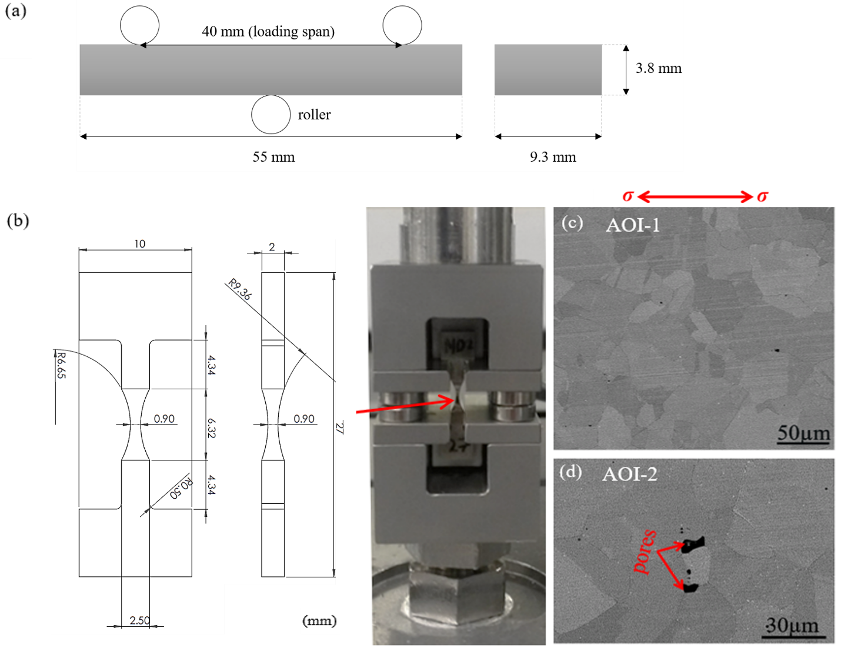
Figure 2 (a) Schematic diagram and dimension of the setup of fatigue testing with the sample under three point bending (b) schematic dimension of a micro-tensile sample and setup of tension-tension tests with the sample. (c) AOI-1 and (d) AOI-2 at the gauge section.
Table 2 Parameters used for DIC analysis.
Subset | Stepsize | Correlation algorithm | Interpolation | Shape functions | Pre-smoothing | Strain window
27 × 27 pixels | 7 pixels | ZNSSD | Bicubic spline | Quadratic | Gaussian 5 | 3

3. Results
3.1 Fatigue crack initiation and lifetime
Uninterrupted tests have been carried out on both fine and coarse γʹ variants to investigate the effect of distributions of γʹ and carbides on fatigue crack initiation and lifetime at room temperature in this study. Fatigue lives of both γʹ variants with different room temperature yield stresses are presented in Table 3 in terms of the proportion of yield stress applied. It is shown that the lifetime of the fine γʹ variant is clearly greater at 90% yield stress while it is only slightly higher at 110% yield stress. Fracture surfaces were examined after failure with SEM imaging and showed cracks have initiated from pores or/and slip bands at different loading conditions at room temperature. Figure 3 (a) and (b) shows surface pore crack initiation in the fine γʹ variant at 90% yield stress and Figure 3 (c) and (d) represent crystallographic faceted crack initiation and sub-surface pore crack initiation at 110% yield stress. In the coarse γʹ variant, cracks at both yield stress levels have initiated at slip bands showing crystallographic facets that is indicative of stage-I crack growth as seen in Figure 4. At room temperature, fatigue behaviour of both γʹ variants under two different stress levels is similar, showing slip band cracking is dominant (especially near pores).
Table 3 A test matrix for the uninterrupted tests carried out on RR1000.
Uninterrupted test | Sample | Loading conditions | Fatigue life (Cycle) | Crack initiation sites
Room temperature, frequency 20HZ, load ratio=0.1 | RR1000 with fine γʹ (PBB) | 90% yield stress | 757,135 | Pores/slip bands
 |  |  | 632,513
 |  | 110% yield stress | 176,566
 |  |  | 113,874
 | RR1000 with coarse γʹ (PBB) | 90% yield stress | 320,805
 |  |  | 483,731
 |  | 110% yield stress | 148,485

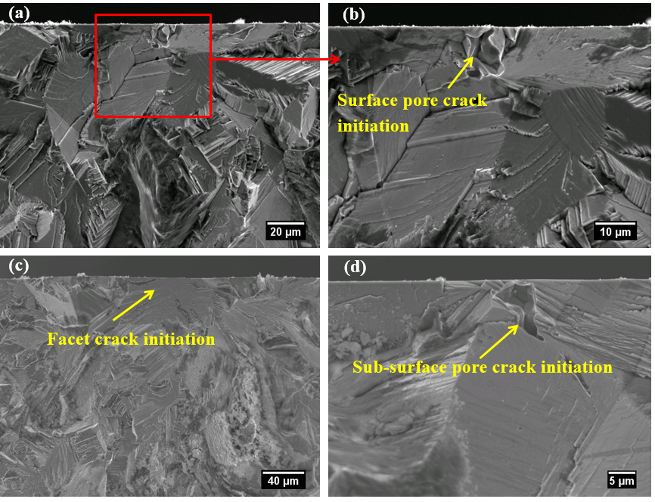
Figure 3 Fracture surfaces showing crack initiation area of RR1000 with fine γʹ (a) and (b) at 90%; (c) and (d) at 110% yield stress.

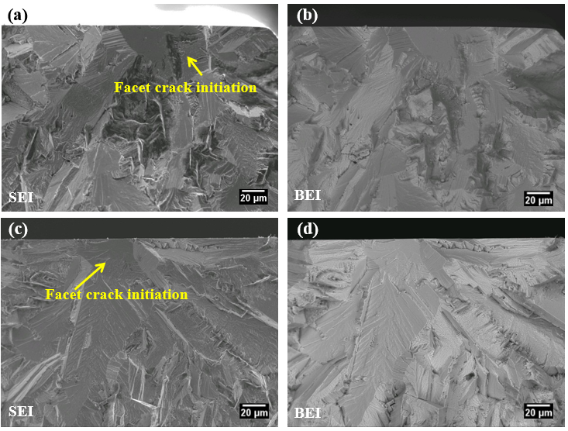
Figure 4 Fracture surfaces showing crack initiation area of RR1000 with coarse γʹ (a) SEI image and (b) BEI image at 90%; (c) SEI image and (d) BEI image at 110% yield stress.
3.2 Short fatigue crack growth behaviour
A test matrix for the group of interrupted tests where the replica silicone compound has been used to obtain a series of snapshots of the crack evolution and short FCG rates is presented in Table 4. Crack initiation is somewhat unpredictable in terms of the position and the number of cycles to initiate so that early stage crack propagation is often hard to capture. In the tests on both fine and coarse γʹ variants at 90% of yield stress, it was difficult to observe early stages of crack propagation for the high cycle fatigue regime via replica records. The fine γʹ variant appeared to offer less crack initiation resistance at 90% of yield stress as the first crack was observed earlier than in the coarse γʹ variant as described in Table 4. Only one crack was observed for each test of the fine γʹ variant at 270,000 and 2,000,000 cycles and no crack initiation up to 3,000,000 cycles for the coarse γʹ variant was observed, which indicates better crack initiation resistance in the coarse γʹ variant. On the other hand, at the higher yield stress level of 110% yield stress, 4 and 10 cracks for the fine γʹ variant and 10 cracks for the coarse γʹ variant were captured and measured through OM. Figure 5 presents the number of cracks observed during load cycling. Such scatter can be associated with slip character, defect distributions or grain orientation distributions. It can be inferred that the fewer crack initiation sites observed in fine γʹ_1 is associated with enhanced fatigue lifetime.
Table 4 A test matrix for interrupted short fatigue crack tests in RR1000.
Interrupted test | Sample | Loading conditions | Number of cracks
Room temperature, frequency 20HZ, load ratio=0.1 | RR1000 with fine γʹ (PBB) | 90% yield stress | 270,000 cycles, long crack seen, failed to capture early stage crack.
 |  |  | >2,000,000 cycles, long crack was observed.
 |  | 110% yield stress | Fine γʹ _1) 4 cracks were measured (stopped at 108,000 cycles).
 |  |  | Fine γʹ _2) 10 cracks were measured (failed at 85,603).
 | RR1000 with coarse γʹ (PBB) | 90% yield stress | No crack initiation after 3,000,000 cycles.
 |  | 110% yield stress | 10 cracks were measured (stopped at 115,000 cycles).

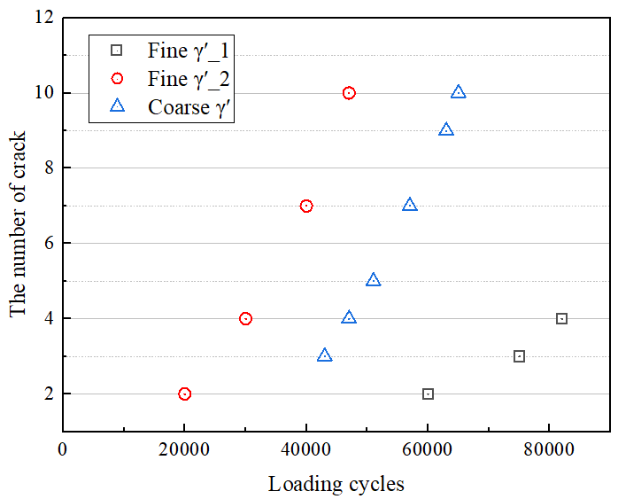
Figure 5 The number of cracks initiated over cycles applied until enough interruption for replica is obtained of both γʹ variants at 110% yield stress. Crack initiation behaviour of the fine γʹ variant shows a scatter in these two tests.
Evolution of the primary crack in the interrupted tests in RR1000 with fine and coarse γʹ can be seen in Figure 6 (a) and (b), respectively. The primary crack in the fine γʹ variant in Figure 6 (a) propagates from a pore on the surface. It is interesting to note that two cracks were initiated, showing initiation/early propagation to be along what appear to be locally angled directions of 45º to the loading applied, likely to be linked to slip band cracking but as the crack grows it turns to adopt an overall direction normal to the loading condition and crack coalescence is observed in both γʹ variants. It is found that there was crack coalescence at early stages of crack growth which is related to reduced lifetime in fine γʹ_2 while it occurred later in the coarse γʹ variant, linked to longer lifetime.
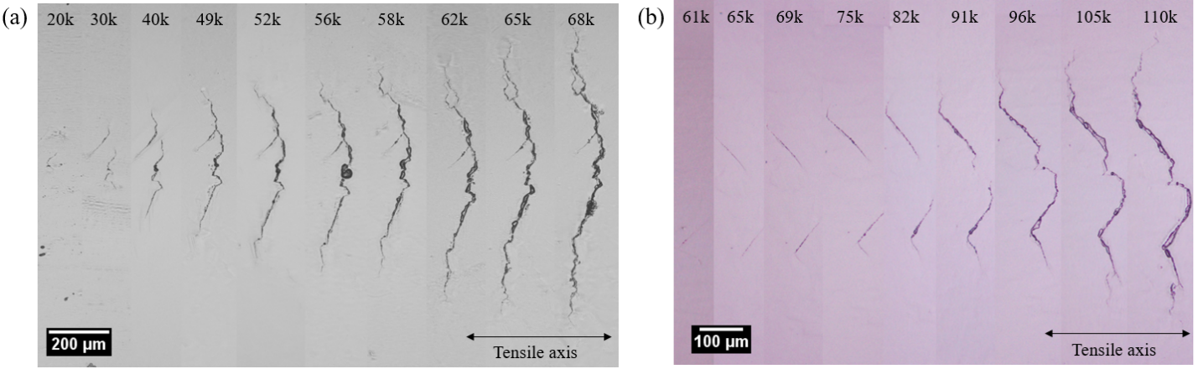
Figure 6 Primary crack evolution over loading cycles applied in the (a) fine γʹ_2 and (b) coarse γʹ interrupted tests at 110% yield stress.
Figure 7 represents the crack length over loading cycles of two tests for the fine γʹ variant and one test for the coarse γʹ variant, experiencing accelerated and decelerated FCG during loading cycles. It is shown that the primary crack which is most critical to final failure had propagated noticeably faster than other cracks. It should be noted that crack coalescence took place at an early stage in life and two other cracks (crack 8a and 8b in Figure 7 (b)) have propagated close to each other and coalesced later, leading to accelerated FCG rate and consequently reduced lifetime. The primary crack (crack number 5) in Figure 7 (c) emerged as a result of the coalescence of two cracks and thereby propagated fast. The FCG rate observed in both fine and coarse γʹ variants as a function of the ΔK is plotted in Figure 8. It can be seen that FCG rates of the fine γʹ variant occupy a slightly higher overall envelope of FCG rates than that of the coarse γʹ variant, both showing considerable overlapping scatter, particularly at lower ΔK levels, which is a characteristic of short crack growth.
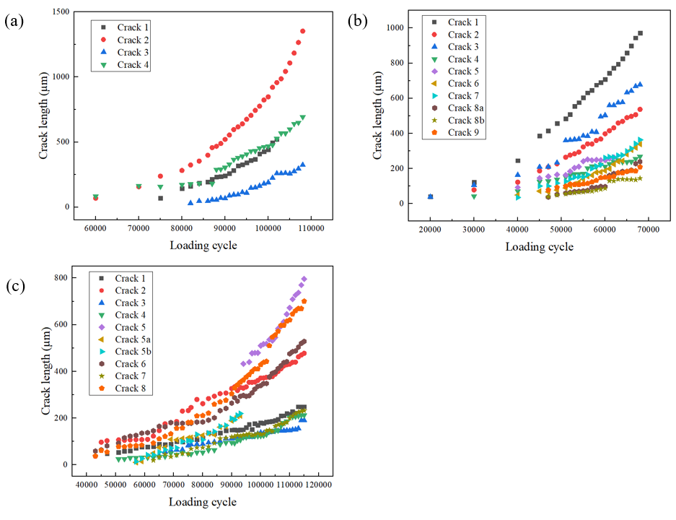
Figure 7 Crack length (a) versus loading cycles (N) tested at 110% yield stress for (a) fine γʹ_1 (b) fine γʹ_2 (c) coarse γʹ (note: fine γʹ_1 and 2 denote two different tests).
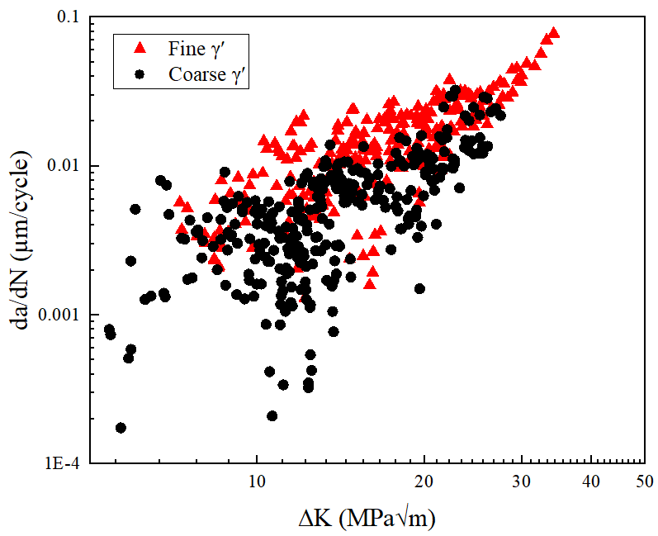
Figure 8 FCG rate da/dN vs ΔK compared for short FCG tests on fine and coarse γʹ variants.
EBSD analysis on the top surface of an interrupted test of the coarse γʹ variant was conducted to investigate in detail the effect of grain orientation on fatigue crack initiation and short FCG behaviour. Figure 9 (a) shows the crack path together with neighbouring grains examined by SEM and the crack path overlaid with EBSD mapping including grains and grain boundaries. It is shown that the crack has initiated along a TB in a relatively large grain as marked in the figure, which is commonly observed as a crack initiation site of P/M Ni based superalloys. Neighbouring grains overlapping with the crack initiation site and crack path are labelled to conduct a slip trace analysis. The calculated slip trace of the crack segment in each grain is presented in different colour legend bars. Table 5 summarises the slip trace analysis for the {111} slip plane on crack number 2 of the coarse γʹ variant including the calculated inclination angle (α_{c}), measured inclination angle (α_{m}) and calculated SF (µ_{c}). It is found that crack propagation in each grain usually follows one of the calculated slip traces although there is a slight deviation between the calculated slip trace and actual crack segment. It is interesting to note that the SF of the activated primary slip system is generally the highest but in some cases it is not the highest.
As seen in Figure 9 (a), the crack initiated along a TB area between grain 7 and 8 which is at an angle of around 45° to the applied loading. There was a noticeable deflection as one crack tip propagated “upwards” into grain 6 by following the TB, then splitting and one branch was deflected again when it turned into grain 5 and its grain boundary. The other crack tip direction propagated “downwards” into grain 9, the crack has propagated along the primary active slip system of grain 8 by accommodating grain 9 and then propagated into grain 10 with a similar inclination angle to that seen in the initiation area with the highest SF. When the crack propagated through grains from 10 to 12, a small zig-zag crack growth was observed. There was a significant deflection from grain 12, which propagated at a similar inclination angle in grain 13 which is a relatively large grain by following its primary active slip system. Figure 9 (b) and (c) represent a graph of crack length vs loading cycle applied and FCG rate vs ΔK, respectively. It is interesting to note there was crack temporary arrest and a decelerated FCG rate at the beginning of crack propagation although it propagated gradually back later. The zig-zag deflection from the ends of crack initiation and significant deflection can be related to the crack arrest and then corresponding slow crack propagation, showed in a scattered FCG rate.
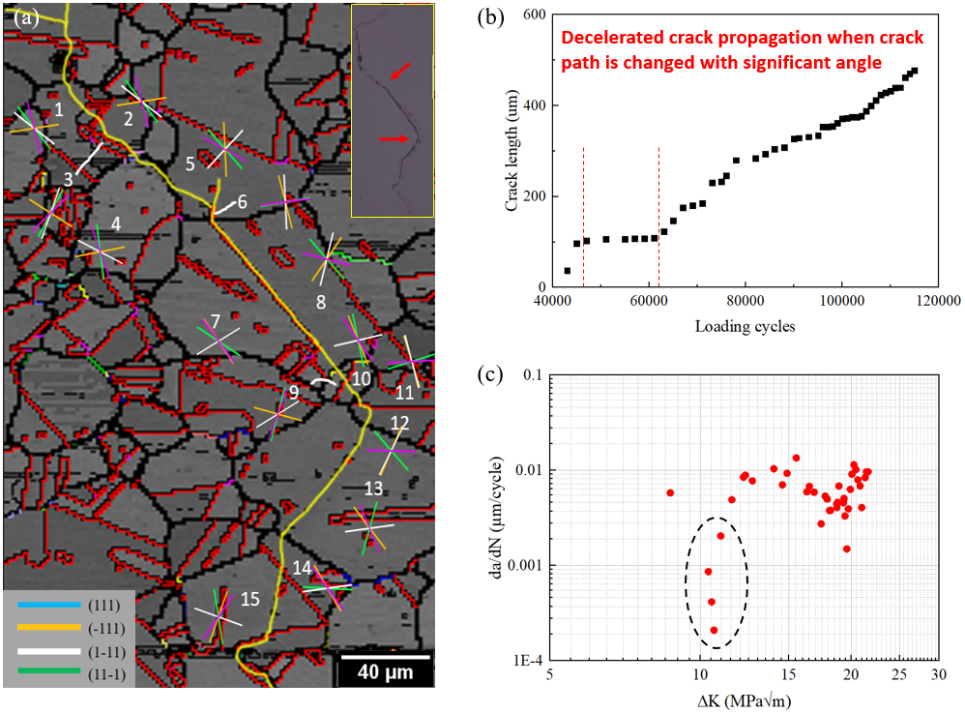
Figure 9 (a) band contrast map by EBSD overlaying the crack path including crack initiation site of crack 2 of the coarse γʹ variant. Black and red lines represent high angle grain boundaries and TBs. The calculated slip trace in the grains containing the crack path is labelled and the legend of {111} slip planes is described. (b) crack length over loading cycle of crack 2. (c) FCG rate vs ΔK of crack 2 of the coarse γʹ variant indicating decelerated crack propagation.
Table 5 Summary of µ_{c,} α_{c} and α_{m} in the grains neighbouring crack 2 of the coarse γʹ variant on {111} slip planes (note: * means it was ambiguous to define the match between α_{c} and α_{m}).
Grain | Slip system | µ_{c} | α_{c} | α_{m} | Grain | Slip system | µ_{c} | α_{c} | α_{m}
Grain 1 | (111)[01-1] | 0.294 | 49.280 | 43.2 | Grain 8 | (111)[1-10] | 0.147 | 46.359 | 47
 | (-111)[01-1] | 0.091 | 172.182 |  |  | (-111)[01-1] | 0.490 | 127.548
 | (1-11)[110] | 0.427 | 35.132 |  |  | (1-11)[011] | 0.460 | 105.091
 | (11-1)[1-10] | 0.263 | 74.131 |  |  | (11-1)[1-10] | 0.228 | 13.728
Grain 2 | (111)[01-1] | 0.294 | 49.280 | 36.8 | Grain 9 | (111)[01-1] | 0.498 | 106.663 | 47.2
 | (-111)[01-1] | 0.091 | 172.182 |  |  | (-111)[110] | 0.199 | 14.430
 | (1-11)[110] | 0.427 | 35.132 |  |  | (1-11)[110] | 0.339 | 151.584
 | (11-1)[1-10] | 0.263 | 74.131 |  |  | (11-1)[011] | 0.455 | 112.419
Grain 3 | (111)[01-1] | 0.335 | 120.179 |  | Grain 10 | (111)[10-1] | 0.129 | 77.238 | 45.2
 | (-111)[01-1] | 0.396 | 30.261 | 36.8 |  | (-111)[110] | 0.458 | 66.311
 | (1-11)[110] | 0.468 | 111.142 |  |  | (1-11)[-101] | 0.178 | 168.339
 | (11-1)[1-10] | 0.479 | 138.318 |  |  | (11-1)[1-10] | 0.478 | 52.412
Grain 4 | (111)[01-1] | 0.495 | 82.224 | 53.8 | Grain 11 | (111)[1-10] | 0.127 | 164.900 | 71.5
 | (-111)[110] | 0.132 | 170.529 |  |  | (-111)[101] | 0.453 | 71.037
 | (1-11)[110] | 0.299 | 25.349 |  |  | (1-11)[-101] | 0.380 | 74.426
 | (11-1)[011] | 0.436 | 69.772 |  |  | (11-1)[1-10] | 0.028 | 177.766
Grain 5 | (111)[1-10] | 0.234 | 46.188 | 23.2 | Grain 12 | (111)[1-10] | 0.157 | 46.440 | 111.5
 | (-111)[101] | 0.448 | 87.059 |  |  | (-111)[01-1] | 0.410 | 115.037
 | (1-11)[-101] | 0.489 | 136.648 |  |  | (1-11)[011] | 0.467 | 119.076
 | (11-1)[1-10] | 0.394 | 26.269 |  |  | (11-1)[1-10] | 0.027 | 1.617
Grain 6 | (111)[1-10] | 0.095 | 171.221 | 98.1 | Grain 13 | (111)[10-1] | 0.432 | 107.513 | 122.53*
 | (-111)[01-1] | 0.449 | 74.535 |  |  | (-111)[110] | 0.432 | 50.849
 | (1-11)[011] | 0.450 | 87.078 |  |  | (1-11)[-101] | 0.082 | 173.918
 | (11-1)[1-10] | 0.093 | 173.651 |  |  | (11-1)[1-10] | 0.331 | 65.096
Grain 7 | (111)[10-1] | 0.303 | 31.508 | 47 | Grain 14 | (111)[10-1] | 0.024 | 3.024 | 86.99
 | (-111)[110] | 0.492 | 53.002 |  |  | (-111)[110] | 0.418 | 57.787
 | (1-11)[-101] | 0.305 | 151.002 |  |  | (1-11)[011] | 0.039 | 173.015
 | (11-1)[1-10] | 0.493 | 51.254 |  |  | (11-1)[1-10] | 0.443 | 51.830
 |  |  |  |  | Grain 15 | (111)[10-1] | 0.427 | 80.863 | 122.5
 |  |  |  |  |  | (-111)[110] | 0.475 | 111.726
 |  |  |  |  |  | (1-11)[-101] | 0.271 | 18.639
 |  |  |  |  |  | (11-1)[1-10] | 0.443 | 127.798
Note: Active primary slip systems are highlighted in bold and blue font.
3.3 Strain localisation and evolution
Strain localisation which is closely related to fatigue cracking was characterised in RR1000 with coarse γ′ under cyclic loading by SEM-DIC. The DIC analysis was conducted on only the coarse γ′ variant as there was no evident difference in strain localisation in the fine and coarse γ′ variants as seen in [30]. Figure 10 presents strain (i.e. ε_{xx}) distribution at 10, 1,000, 10,000 and 95,000 cycles, and grain boundaries obtained by EBSD are overlaid on the strain map to better reveal the influence of microstructure on the strain localisation. As shown in DIC images in Figure 10, strain mainly occurs within the slip bands due to dislocation movement on the {111} slip plane. In certain grains, multiple sets of strain bands can be observed, indicating more than one slip system is activated. Observing the morphology of the slip band by SEM, sheared secondary γ′ precipitates can be discerned as shown in Figure 10 (c). As loading cycles increased from 10 to 1,000, the slip band density and the strain value in the slip band increases significantly, and it seems strain saturation may occur in 1,000 cycles as there is little strain increase observed in the following loading up to 10,000 and 95,000 cycles. Moreover, observation of the slip band with high strain value shows micro-cracking in the slip band as shown in Figure 10 (f).
Figure 11 shows strain localisation and fatigue cracking in another AOI containing pores. In general, similar strain localisation and evolution can be seen as shown in Figure 11, and the micro-cracking in the slip band is associated with relatively high strain value. However, the strain distribution seems to be more diffused around the pores rather than localised in the slip bands. Due to the stress concentration and strain localisation around the pores, micro-cracks form adjacent to the pores as shown in Figure 11 (c). In addition, a zig-zag crack path is observed when a micro-crack propagates through the grain boundaries (Figure 11 (d)), which is associated with intense strain accumulation in the slip bands.

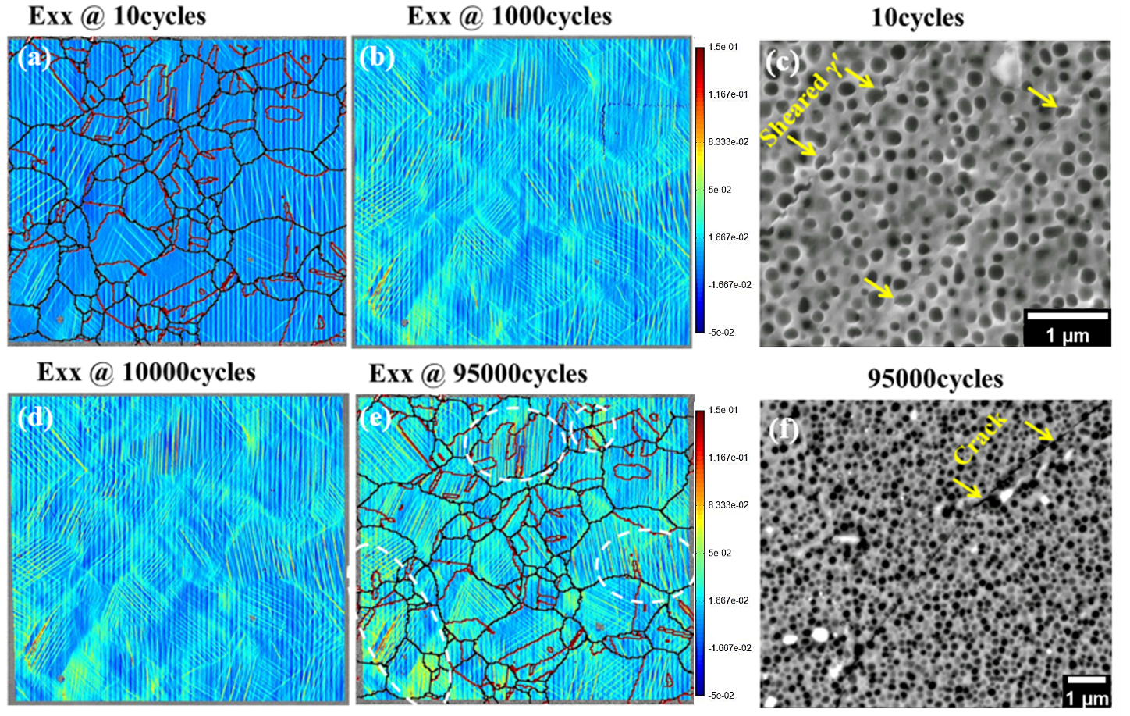
Figure 10 SEM-DIC analysis of AOI-1 of the coarse γ′ variant (a) strain localisation at 10 cycles and (b) at 1,000 cycles. (c) SEM image at 10 cycles showing sheared γ′. (d) strain localisation at 10,000 cycles and (e) at 95,000 cycles. (f) SEM image at 95,000 cycles showing fatigue cracking.
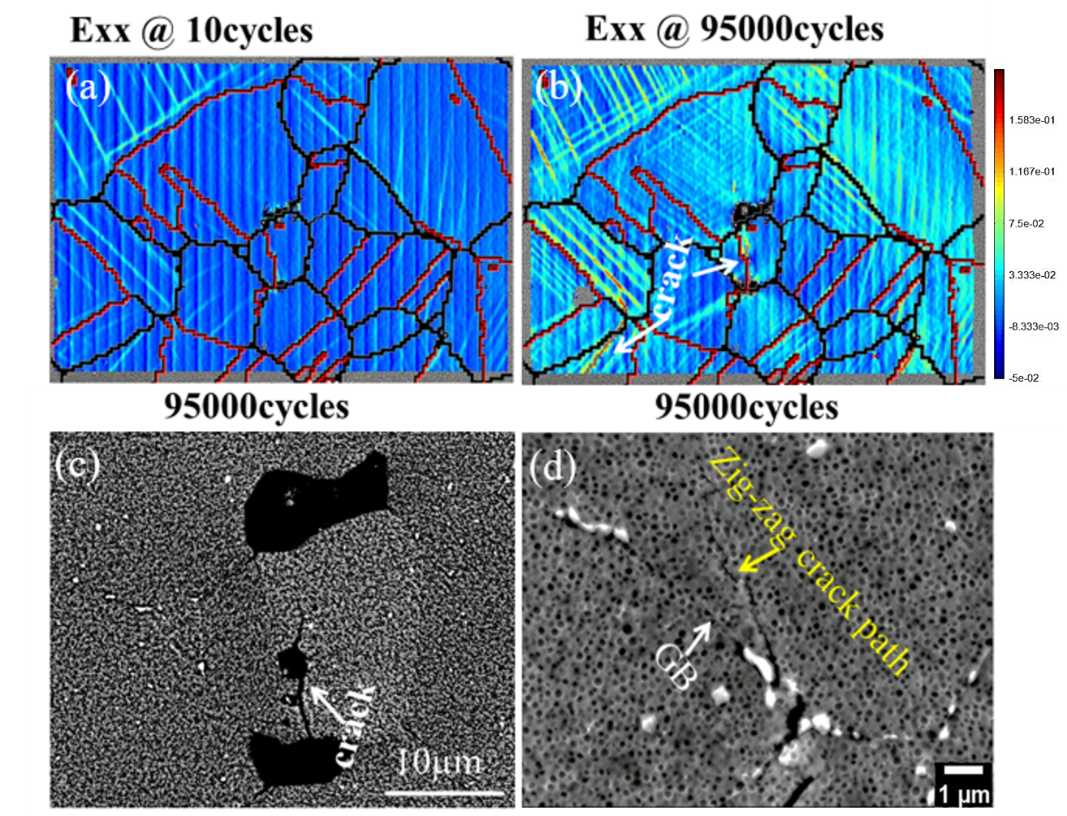
Figure 11 SEM-DIC analysis of AOI-2 of the coarse γ′ variant: (a) strain localisation at 10 cycles and (b) at 95,000 cycles. (c) SEM image at 95,000 cycles showing micro cracking. (d) SEM image at 95,000 cycles showing zig-zag crack path.

4. Discussion
4.1 Effect of microstructural features on lifetime and fatigue behaviour
It is observed that fatigue cracks in Ni-based superalloys generally initiate where stress concentration and strain localisation occur such as pores, slip bands, TBs, precipitates and grain boundaries. In this study, fatigue cracks have initiated mostly from slip bands, TBs and pores at the surface or sub-surface followed by crystallographic faceted growth indicative of stage-I propagation in both γ' variants. Crystallographic faceting then becomes less marked as the crack propagates, followed by the transition to stage-II crack growth. Porosity is expected to produce protrusions and locally stress concentrations and strain localisation, promoting crack initiation along crystallographic slip planes.
In the work on RR1000 alloys exhibiting a similar average grain size to that seen in this study [30], a fine γ' variant is likely to exhibit more highly planar slip with wider slip bands and subsequent heterogeneous slip character, which can be linked to less crack initiation resistance due to more intense slip band formation. Both the number of cracks observed and the number of cycles until the first crack is observed can indicate the level of fatigue crack initiation resistance. A scatter was seen in these measures as they are both dependent on the local microstructure and defect distribution. The interrupted tests at 90% yield stress indicated that the coarse γ' variant showed better crack initiation resistance as the first crack is seen later than in the fine γ' variant (in fact no crack initiation was seen even after 3,000,000 cycles). However, the lifetime of the coarse γ' variant at 90% yield stress is shorter in the uninterrupted test, which shows the high level of scatter in such tests associated with the variable influence of defects such as pore distribution and possibly large favourably oriented grains near the crack initiation sites. The lifetimes of both γ' variants at 110% yield stress are similar and seem to be more significantly linked to the number of cracks and the number of cycles until the first crack is observed. As seen in Figure 5, fewer crack initiations and later observation of the first crack in the fine γ'_1 test is associated with enhanced crack initiation resistance and consequently increased lifetime while more cracks were observed and earlier crack observation in the fine γ'_2 test is linked to inferior crack initiation resistance and a reduced lifetime. It should be noted that initiation life was very limited at this higher applied stress level and lifetime data and short fatigue crack behaviour typically do show a lot of scatter.
The fine γ' precipitate variant did exhibit more planar slip, which is sometimes associated with higher slip reversibility and less intrinsic damage accumulation while the coarse γ' showed somewhat less planar slip. This can indicate slightly higher crack growth resistance in the coarse γ' variant. FCG rate of the cracks generally shows an increasing trend while fluctuations of FCG rate were seen, with scattered FCG rate observed in both fine and coarse γ' variants at relatively low ∆K levels. This scattered data indicates typical features of short crack behaviour at low ∆K level where crack growth is considerably influenced by local microstructures (e.g. grain boundaries, grain orientation and precipitates) [31,32]. The slightly accelerated FCG rate of the fine γ' variant in this study is ascribed to the earlier crack coalescence due to cracks forming earlier than in the coarse γ'. Therefore, the decreased lifetime of the fine γ' variant at higher stress levels is ascribed to earlier crack emergence promoting coalescence and enhanced FCG rate while the increased lifetime of the same alloy at lower stress levels is associated with fewer crack initiations which emerged later in the lifetime and therefore delayed crack coalescence events. It can be inferred that the case of slightly improved lifetime of the fine γ' variant is then related to less crack coalescence due to fewer crack initiation sites than seen in the coarse γ' variant. Therefore, it is indicated that the number of crack initiation sites and subsequent crack coalescence events are important in controlling the fatigue lifetime at these stress levels.
4.2 Study of slip trace analysis and strain localisation in the coarse γʹ variant RR1000 alloy at room temperature
The effect of local microstructures (e.g. grain orientation and grain boundary) on crack initiation and short crack growth were investigated by EBSD analysis overlaid with SEM images containing the fatigue crack path, and the strain accumulation in the slip bands were measured by SEM-DIC. Strain developed under the fatigue loading is mainly localised in the slip bands. Slip band cracking in the coarse γʹ variant has initiated along a TB with the highest SF of activated slip systems as seen in grain 7. It is known that the highest SF is related to the highest resolved shear stress activating the slip systems and thereby enhanced crack initiation processes [33]. However, as reported in other polycrystalline Ni-based superalloys, crack initiation or propagation process does not always occur with the highest SF [4]. It is believed that TB can contribute to heterogeneous slip band formation at the matrix and twin, which can result in a high elastic incompatibility stress associated with the discontinuity of stress and displacement at the TB. Slip bands concentrated adjacent to the TB are closely related to a high strain localisation value and consequently an enhanced crack initiation process, which is commonly observed in other Ni-based superalloys [4,34].
Local microstructures predominantly influence primary slip system activation and early stage crack propagation processes. This is linked to the occurrence of a crystallographic zig-zag crack path during short crack propagation. Different orientations of grains accommodating the crack segments experience different SF related to the resolved shear stress acting on the slip system in terms of the applied tensile stress. Slip trace analysis (Table 5) conducted on the grains containing the crack segments indicates cracks are likely to propagate along the slip systems with the highest SF although some cases observed are not on the highest SF (possibly linked to the need for crack path contiguity), which is also seen in other polycrystalline Ni based superalloys [5]. It is interesting to note that a decelerated FCG rate after initiation is clearly induced by zig-zag crack path along a grain boundary and a large deflection when the crack propagated into a relatively large grain (Figure 9), which results in a clear shielding effect. The crack propagation along the grain boundary may also contribute to decelerated FCG rate due to the more continuous carbide formation on the coarse γʹ variant grain boundary providing a shielding effect.

5. Summary and Conclusions
The effects of microstructure on fatigue crack initiation, short FCG behaviour and fatigue lifetime at room temperature in RR1000 alloy were investigated in this study. Fatigue tests under three point bending and post analysis with a replication method, OM, SEM, EBSD and DIC were conducted. The following conclusions are drawn:
- Cracks have initiated mainly from slip bands, TB and pores at the surface or sub-surface followed by crystallographic faceted growth in both γʹ variants. Slip trace analysis by EBSD mapping indicates that a TB is a favourable factor in crack initiation together with a primary slip system with a relatively high SF (high resolved shear stress). SEM-DIC analysis showed micro-cracking occurred along the slip band with high strain levels and showed more diffuse strain localisation around the pores, which also promotes crack initiation.
- The short crack growth after initiation is likely to propagate along the slip system activated with the high SFs in the neighbouring grains. It appears that a zig-zag crack path in the coarse γʹ variant can contribute to partial crack arrest and corresponding decelerated FCG rate due to the intrinsic shielding effect of the crack path.
- Short FCG rates in both γʹ variants at the higher test stress level (110% yield stress) were scattered, showing typical short crack growth behaviour. Such scatter is closely associated with (1) the number of crack initiation sites (linked to subsequent crack coalescence events, as well as indicating the propensity for crack initiation) and (2) the number of cycles until the first crack is found (also indicating initiation resistance), both of which are important in controlling the fatigue lifetime. This gives rise to the difference in fatigue lifetimes observed in the two fine γʹ variant tests. A slightly inferior short FCG resistance of the fine γʹ variant is probably related to the frequent crack coalescence events as well as the observed more planar and heterogeneous slip character compared to the coarse γʹ variant.
- The effect of γʹ size appears to be less important in controlling fatigue lifetimes in these tests, via the classically expected effect of more or less planar slip character affecting either slip band initiation resistance or crack propagation modes. Instead, lifetime is more strongly affected (in these tests) by the number of crack initiation sites (partly linked to initiation resistance) which seems more linked to defect distributions or grain orientation distributions than γʹ size alone. The role of multi-site coalescence in determining lifetime at high stress levels seems to predominate the behaviour seen.

Acknowledgements
Thanks are due to the Engineering and Physical Sciences Research Council (Grant No. EP/M000710/1), UK for the funding support and to Rolls Royce Plc., UK for material supply. Dr R. Jiang would like to thank the National Natural Science Foundation of China [Grant No.11872204, 51805251] and the Natural Science Foundation of Jiangsu Province [Grant No.BK20180434] for financial support. The authors would like to thank Prof. Michael Preuss and Dr. Allan Harte at the University of Manchester for their help on the heat treatments and useful discussions. We would also like to thank Prof. Liguo Zhao from Loughborough University, Dr. Mark Hardy from Rolls Royce Plc. and Dr. Gordon McColvin from GE Power for useful discussions.

Declarations
Conflicts of Interest The authors declare that they have no conflict of interest.

References
[1] Reed. R. C., Superalloys: Fundamentals and applications, Cambridge University Press, 2006.
[2] J.Y. Guedou, J.C. Lautridou, Y. Honnorat, N18, Powder metallurgy superalloy for disks: Development and applications, J. Mater. Eng. Perform. 2 (1993) 551–556. doi:10.1007/BF02661740.
[3] S.D. Antolovich, Microstructural aspects of fatigue in Ni-base superalloys, Philos. Trans. R. Soc. A Math. Phys. Eng. Sci. 373 (2015) 1–36. doi:10.1098/rsta.2014.0128.
[4] R. Jiang, N. Karpasitis, N. Gao, P.A.S. Reed, Effects of microstructures on fatigue crack initiation and short crack propagation at room temperature in an advanced disc superalloy, Mater. Sci. Eng. A. 641 (2015) 148–159. doi:10.1016/j.msea.2015.05.065.
[5] R. Jiang, Y.D. Song, P.A. Reed, Fatigue crack growth mechanisms in powder metallurgy Ni-based superalloys—A review, Int. J. Fatigue. 141 (2020) 105887. doi:10.1016/j.ijfatigue.2020.105887.
[6] P.A.S. Reed, Fatigue crack growth mechanisms in superalloys: overview, Mater. Sci. Technol. 25 (2009) 258–270. doi:10.1179/174328408X361463.
[7] H.Y. Li, J.F. Sun, M.C. Hardy, H.E. Evans, S.J. Williams, T.J.A. Doel, P. Bowen, Effects of microstructure on high temperature dwell fatigue crack growth in a coarse grain PM nickel based superalloy, Acta Mater. 90 (2015) 355–369. doi:10.1016/j.actamat.2015.02.023.
[8] J. Gayda, T.P. Gabb, P.T. Kantzos, The effect of dual microstructure heat treatment on an advanced nickel-base disk alloy, Superalloys 2004. (2004) 323–329. doi:10.7449/2004/Superalloys_2004_323_329.
[9] T.P. Gabb, P.T. Kantzos, J. Telesman, J. Gayda, C.K. Sudbrack, B. Palsa, Fatigue resistance of the grain size transition zone in a dual microstructure superalloy disk, Int. J. Fatigue. 33 (2011) 414–426. doi:10.1016/j.ijfatigue.2010.09.022.
[10] V.S. Sarma, M. Sundararaman, K.A. Padmanabhan, Effect of γ′ size on room temperature low cycle fatigue behaviour of a nickel base superalloy, Mater. Sci. Technol. 14 (1998) 669–675. doi:10.1179/mst.1998.14.7.669.
[11] J. Telesman, T. Gabb, A. Carg, P. Bonacuse, J. Gayda, Effect of Microstructure on Time Dependent Fatigue Crack Growth Behavior In a P/M Turbine Disk Alloy, Superalloys 2008. (2008) 807–816. doi:10.7449/2008/Superalloys_2008_807_816.
[12] D.M. Knowles, D.W. Hunt, The influence of microstructure and environment on the crack growth behavior of powder metallurgy nickel superalloy RR1000, Metall. Mater. Trans. A Phys. Metall. Mater. Sci. 33 (2002) 3165–3172. doi:10.1007/s11661-002-0302-3.
[13] R.E. Stoltz, A.G. Pineau, Dislocation-Precipitate Interaction and Cyclic Stress-Strain Behavior of a γ′ Strengthened Superalloy, Mater. Sci. Eng. 34 (1978) 275–284.
[14] B.A. Lerch, N. Jayaraman, S.D. Antolovich, A Study of Fatigue Damage Mechanisms in Waspaloy from 25 to 800 °C, Mater. Sci. Eng. 66 (1984) 151–166.
[15] H.T. Pang, P.A.S. Reed, Fatigue crack initiation and short crack growth in nickel-base turbine disc alloys - The effects of microstructure and operating parameters, Int. J. Fatigue. 25 (2003) 1089–1099. doi:10.1016/S0142-1123(03)00146-4.
[16] C. Laird, J.M. Finney, D. Kuhlmann-Wilsdorf, Dislocation behavior in fatigue VI: Variation in the localization of strain in persistent slip bands, Mater. Sci. Eng. 50 (1981) 127–136. doi:10.1016/0025-5416(81)90093-8.
[17] J.C. Healy, L. Grabowski, C.J. Beevers, Short Fatigue Crack Growth in a Nickel Base Superalloy at Room and Elevated Temperature, Int J. Fatigue. 2 (1991) 1183–1196.
[18] M. Goto, D.M. Knowles, Initiation and propagation behaviour of microcracks in Ni-base superalloy Udimet 720 LI, Eng. Fract. Mech. 60 (1998) 1–18. doi:10.1016/S0013-7944(98)00003-4.
[19] J. Miao, T.M. Pollock, J. Wayne Jones, Microstructural extremes and the transition from fatigue crack initiation to small crack growth in a polycrystalline nickel-base superalloy, Acta Mater. 60 (2012) 2840–2854. doi:10.1016/j.actamat.2012.01.049.
[20] R. Jiang, F. Pierron, S. Octaviani, P.A.S. Reed, Characterisation of strain localisation processes during fatigue crack initiation and early crack propagation by SEM-DIC in an advanced disc alloy, Mater. Sci. Eng. A. 699 (2017) 128–144. doi:10.1016/j.msea.2017.05.091.
[21] H.T. Pang, P.A.S. Reed, Effects of microstructure on room temperature fatigue crack initiation and short crack propagation in Udimet 720Li Ni-base superalloy, Int. J. Fatigue. 30 (2008) 2009–2020. doi:10.1016/j.ijfatigue.2008.01.001.
[22] C.P. Blankenship Jr, E. Hornbogen, E.A. Starke Jr, Predicting slip behavior in alloys containing shearable and strong particles, Mater. Sci. Eng. A. 169 (1993) 33–41.
[23] B. Lawless, S.D. Antolovich, C. Bathias, B. Boursier, The effect of microstructure on the fatigue crack propagation and overload behavior of Waspaloy at room temperature, in: J.M. Wells, J.D. Landes (Eds.), Fract. Interact. Microstruct. Mech. Mech. Warrendale, PA TMSAIME, 1985: pp. 285–301.
[24] W. bin Ma, G. quan Liu, B. fu Hu, Y. wen Zhang, J. tao Liu, Effect of Hf on carbides of FGH4096 superalloy produced by hot isostatic pressing, Mater. Sci. Eng. A. 587 (2013) 313–319. doi:10.1016/j.msea.2013.05.015.
[25] J. Hou, J.X. Dong, Z.H. Yao, H. Jiang, M.C. Zhang, Influences of PPB, PPB affect zone, grain boundary and phase boundary on crack propagation path for a P/M superalloy FGH4096, Mater. Sci. Eng. A. 724 (2018) 17–28. doi:10.1016/j.msea.2018.03.066.
[26] D. Kim, R. Jiang, A. Evangelou, I. Sinclair, P.A.S. Reed, Effects of γʹ size and carbide distribution on fatigue crack growth mechanisms at 650 °C in an advanced Ni-based superalloy, Int. J. Fatigue. 145 (2021). doi:10.1016/j.ijfatigue.2020.106086.
[27] P.M. Scott, T.W. Thorpe, A critical review of crack tip stress intensity factors for semi elliptical cracks, Fatigue Eng. Marterials Struct. 4 (1981) 291–309.
[28] W.Z. Abuzaid, M.D. Sangid, J.D. Carroll, H. Sehitoglu, J. Lambros, Slip transfer and plastic strain accumulation across grain boundaries in Hastelloy X, J. Mech. Phys. Solids. 60 (2012) 1201–1220. doi:10.1016/j.jmps.2012.02.001.
[29] P. Villechaise, L. Sabatier, J.C. Girard, On slip band features and crack initiation in fatigued 316L austenitic stainless steel: Part 1: Analysis by electron back-scattered diffraction and atomic force microscopy, Mater. Sci. Eng. A. 323 (2002) 377–385. doi:10.1016/S0921-5093(01)01381-8.
[30] A. Harte, M. Atkinson, A. Smith, C. Drouven, S. Zaefferer, J. Quinta da Fonseca, M. Preuss, The effect of solid solution and gamma prime on the deformation modes in Ni-based superalloys, Acta Mater. 194 (2020) 257–275. doi:10.1016/j.actamat.2020.04.004.
[31] S. Suresh, Fatigue of Materials, 2nd ed., Cambridge University Press, 1998.
[32] Y. Gao, J.S. Stölken, M. Kumar, R.O. Ritchie, High-cycle fatigue of nickel-base superalloy René 104 (ME3): Interaction of microstructurally small cracks with grain boundaries of known character, Acta Mater. 55 (2007) 3155–3167. doi:10.1016/j.actamat.2007.01.033.
[33] J. Miao, T.M. Pollock, J. Wayne Jones, Crystallographic fatigue crack initiation in nickel-based superalloy René 88DT at elevated temperature, Acta Mater. 57 (2009) 5964–5974. doi:10.1016/j.actamat.2009.08.022.
[34] R.R. Stephens, L. Grabowski, D.W. Hoeppner, The effect of temperature on the behaviour of short fatigue cracks in Waspaloy using an in situ SEM fatigue apparatus, Int. J. Fatigue. 15 (1993) 273–282. doi:10.1016/0142-1123(93)90376-2.

