Rainbows and traffic lights: queer voters at the German ballot box

Stuart J Turnbull-Dugarte

The 2021 German Election brought change to Germany, the European Union’s most populated member state, by bringing about the end of sixteen years of Christian Democratic Unionist (CDU) led coalition governments. 2021 also brought change for political scientists interested in electoral behaviour. That year’s iteration of the long-standing German Longitudinal Election Study (GLES), a nationally representative electoral survey, adopted a direct measure of sexual orientation for the first time.

Comparative work demonstrates that, on average, lesbian, gay and bisexual voters – so-called lavender voters (Hertzog, 1996) – are politically distinct (Jones, 2021) and tend to prefer socially liberal “left” parties like the Social Democrats or the Greens (Turnbull-Dugarte, 2020) given that these parties are the political actors most inclined to drive the expansion of LGBT+ rights in the legislature.

The Merkel years (2005-2019) were a period where advances in LGBT+ rights were slow (Schotel, 2022). Whilst 2013 brought the landmark victory for LGBT+ rights campaigners with the legalisation of equal marriage, Merkel herself did not vote in favour of the motion and the issue was only brought to a vote in the Bundestag after the Socialists (SPD) – and other potential coalition partners – forced the CDU’s hand (Ahrens et al, 2022). Given these patterns in political party representation of LGBT+ concerns, do LGB voters electorally reward parties asymmetrically from their straight peers?

Divergence at the ballot box?
Using the new innovative data provided by GLES (N=3287), we can compare average levels of support for the catalogue of parties in Germany between heterosexual (92.4%) and LGB (7.6%) respondents. Reporting the electoral (list vote) preferences, we see that German queer and heterosexual voters are not that different. A plurality of both heterosexual and LGB respondents placed their political faith in Social Democracy. The SPD banked 29.5% of votes from heterosexuals whilst gaining slightly more from the LGB population at 33%. Overall, the distribution of party support between different sexuality blocks is largely symmetrical. Despite the CDU dragging its feet on expanding LGBT+ rights (Ahrens et al, 2022; Schotel, 2022), self-reported support for the conservatives is statistically identical between LGB (21.4%) and heterosexual voters (20.2%).

Figure 1: 2021 party (list) vote

Where we do observe substantive asymmetries is in support for some of Germany’s smaller parties. The Greens, which enjoyed significant success in 2021, were the second largest party for heterosexuals (22.3%) and the third largest party among LGB voters (19%). Comparing support for the liberals (FDP) and the Die Linke - both of which are openly supportive of contemporary LGBT+ rights issues (see Figure 3) including, for example, self-identification provisions for trans individuals (Ahrens et al., 2022) - the latter enjoys an LGB premium taking home 9% compared to 6% of the straight vote.

There is a sizeable asymmetry between sexuality groups in support for Germany’s radical right-wing party: Alternative für Deustchland (AfD). The far-right party, co-led by an out-lesbian (Alice Weidel) has made attempts to court the German LGB vote (Hunklinger and Ajanovíc, 2022) by signalling the alleged inimical threat that immigrants (read Muslims) present to the country’s LGBTQ+ community (see Figure 2). Consistent with comparative evidence that LGB voters are more favourable towards immigration (Turnbull-Dugarte, 2021), these campaign efforts appear to have failed to provide the radical right party with the desired electoral fruits. The AfD banked only 2.2% of the LGB vote - a proportion that is around only a third of that enjoyed by the party among heterosexuals (6.2%) – making it the least favoured electoral preference of LGB voters among Germany’s leading parties.

Figure 2: AfD homonationalist campaign poster

Figure 3: Pro-LGBT+ party campaign material

The traffic light outcome: Support for the traffic light outcome
The incoming SPD-led Traffic Light coalition agreement (including the Die Grünen and FDP) presents an ambitious portfolio of changes in LGBT+ rights. The top-line issues, amongst other pledges, are a new self-determination law for trans people (two proposed changes to trans rights were defeated in the previous Bundestag), a comprehensive ban on conversion therapy, and liberalisation of blood donation rules for LGBT+ people. When voters were asked how desirable they viewed the potential for a Traffic Light coalition, the GLES reports no divergence in the level of support (Figure 4). On an 11-point scale between -5 (coalition undesirable) and 5 (coalition desirable) straight and LGB voters evaluate the Traffic Light coalition equally at ≈1.8.

Figure 4: Support for the traffic light coalition

Even though voters expressed the desirability of the coalition before the terms of the agreement were announced, it is safe to assume that LGBT+ voters would have been able deduce that a Traffic Light coalition would be at the vanguard of progressive queer policies. Despite this, and whilst different coalition partners might source markedly distinct voter constitutions, there is, on average, no LGB premium in desirability enjoyed by the Traffic Light government in the GLES data. These findings are at odds with assumptions of the link between LGBT+ rights expansion and LGBT+ voter preferences.

The evolution of random probability samples to include instruments identifying LGB individuals opens new frontiers in political science. In the case of Germany, this new data shows that the “sexuality gap” between LGB voters and their straight counterparts is not so simple. Whilst the far-right suffers an LGB penalty and the Die Linke and the SPD enjoy an LGB premium, there is no significant (negative) divergence in support for the German centre-right that comparative evidence on LGB voting behaviour would bring us to expect.

Bibliography

Ahrens, P., Ayoub, P.M. & Lang, S. (2022) ‘Leading from Behind? Gender Equality in Germany During the Merkel Era’, German Politics, vol 31, no 1, pp 1-19.

Hertzog, M (1996). The Lavender Vote: Lesbians, Gay Men and Bisexuals in American Electoral Politics, New York: New York University Press.

Hunklinger, M. and Ajanovíc, E. (2022) ‘Voting Right? Analyzing Electoral Homonationalism of LGBTIQ* Voters in Austria and Germany’, Social Politics: International Studies in Gender, State & Society, vol29, no 1, pp 24-49.

Jones, P. (2021) ‘Political Distinctiveness and Diversity Among LGBT Americans’, Public Opinion Quarterly, vol, 85, no 2, pp 694-622.

Schotel, A.L. (2022) ‘A Rainbow Bundestag? An Intersectional Analysis of LGBTI Representation in Angela Merkel’s Germany’, German Politics, vol 31, no 1, pp 101-118.

Turnbull-Dugarte, S.J. (2020). ‘Who wins the British lavender vote? (Mostly) Labour’, Politics, Groups, and Identities, Online First.

Turnbull-Dugarte, S. J. (2021). ‘Multidimensional issue preferences of the European lavender vote’, European Journal of Public Policy, vol 28, no 11, pp 1827-1848.

Funding details:
This work was not supported by any concrete funding.

Conflict of interest statement:
The Author(s) declare(s) that there is no conflict of interest.
Acknowledgements:
I am grateful to Editorial team at the European Journal of Gender and Politics for their helpful comments on an earlier iteration of this report.
Bio note:
Dr. Stuart J. Turnbull-Dugarte holds a PhD in Politcal Science from King’s College London. At present, he is an Assistant Professor in Quantitative Political Science at the University of Southampton.
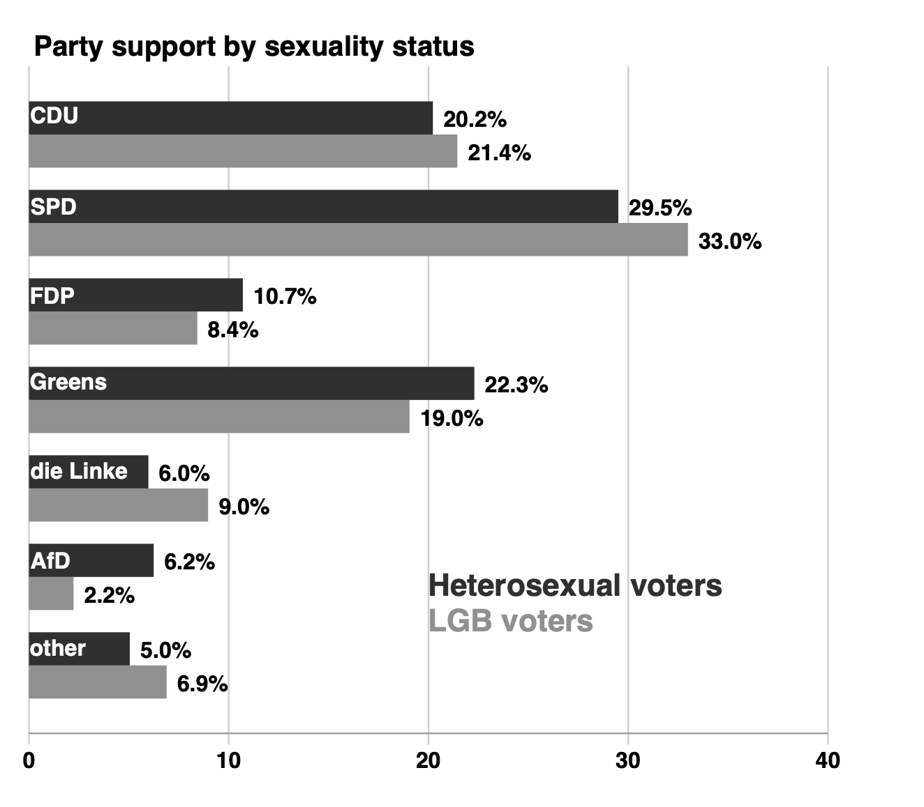
Figure 1
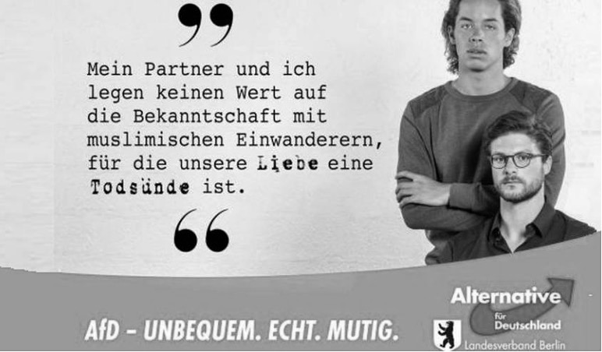
Figure 2

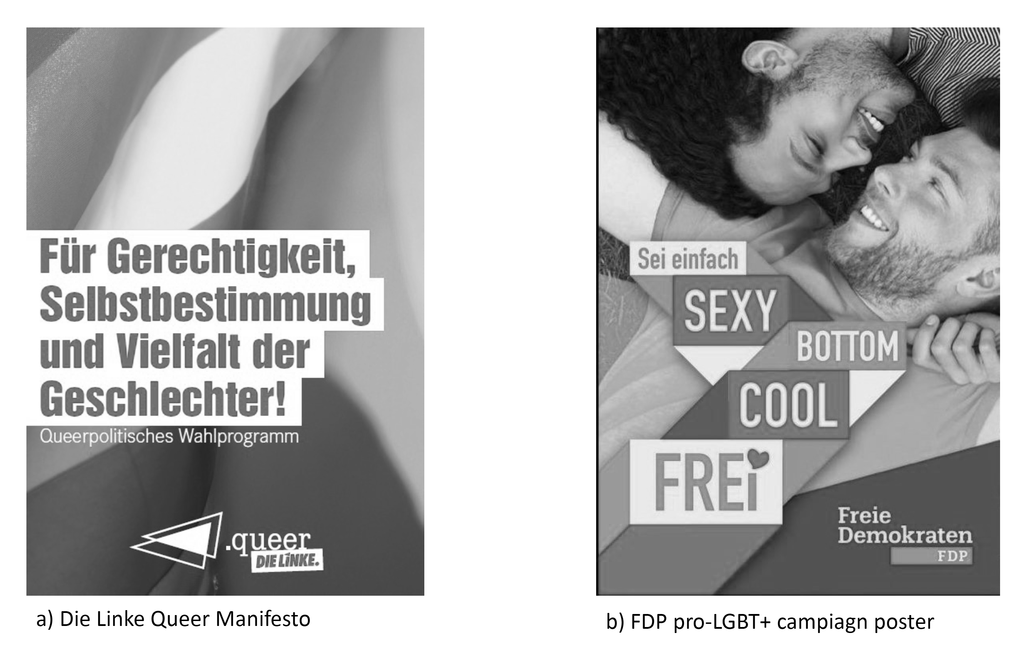
Figure 3

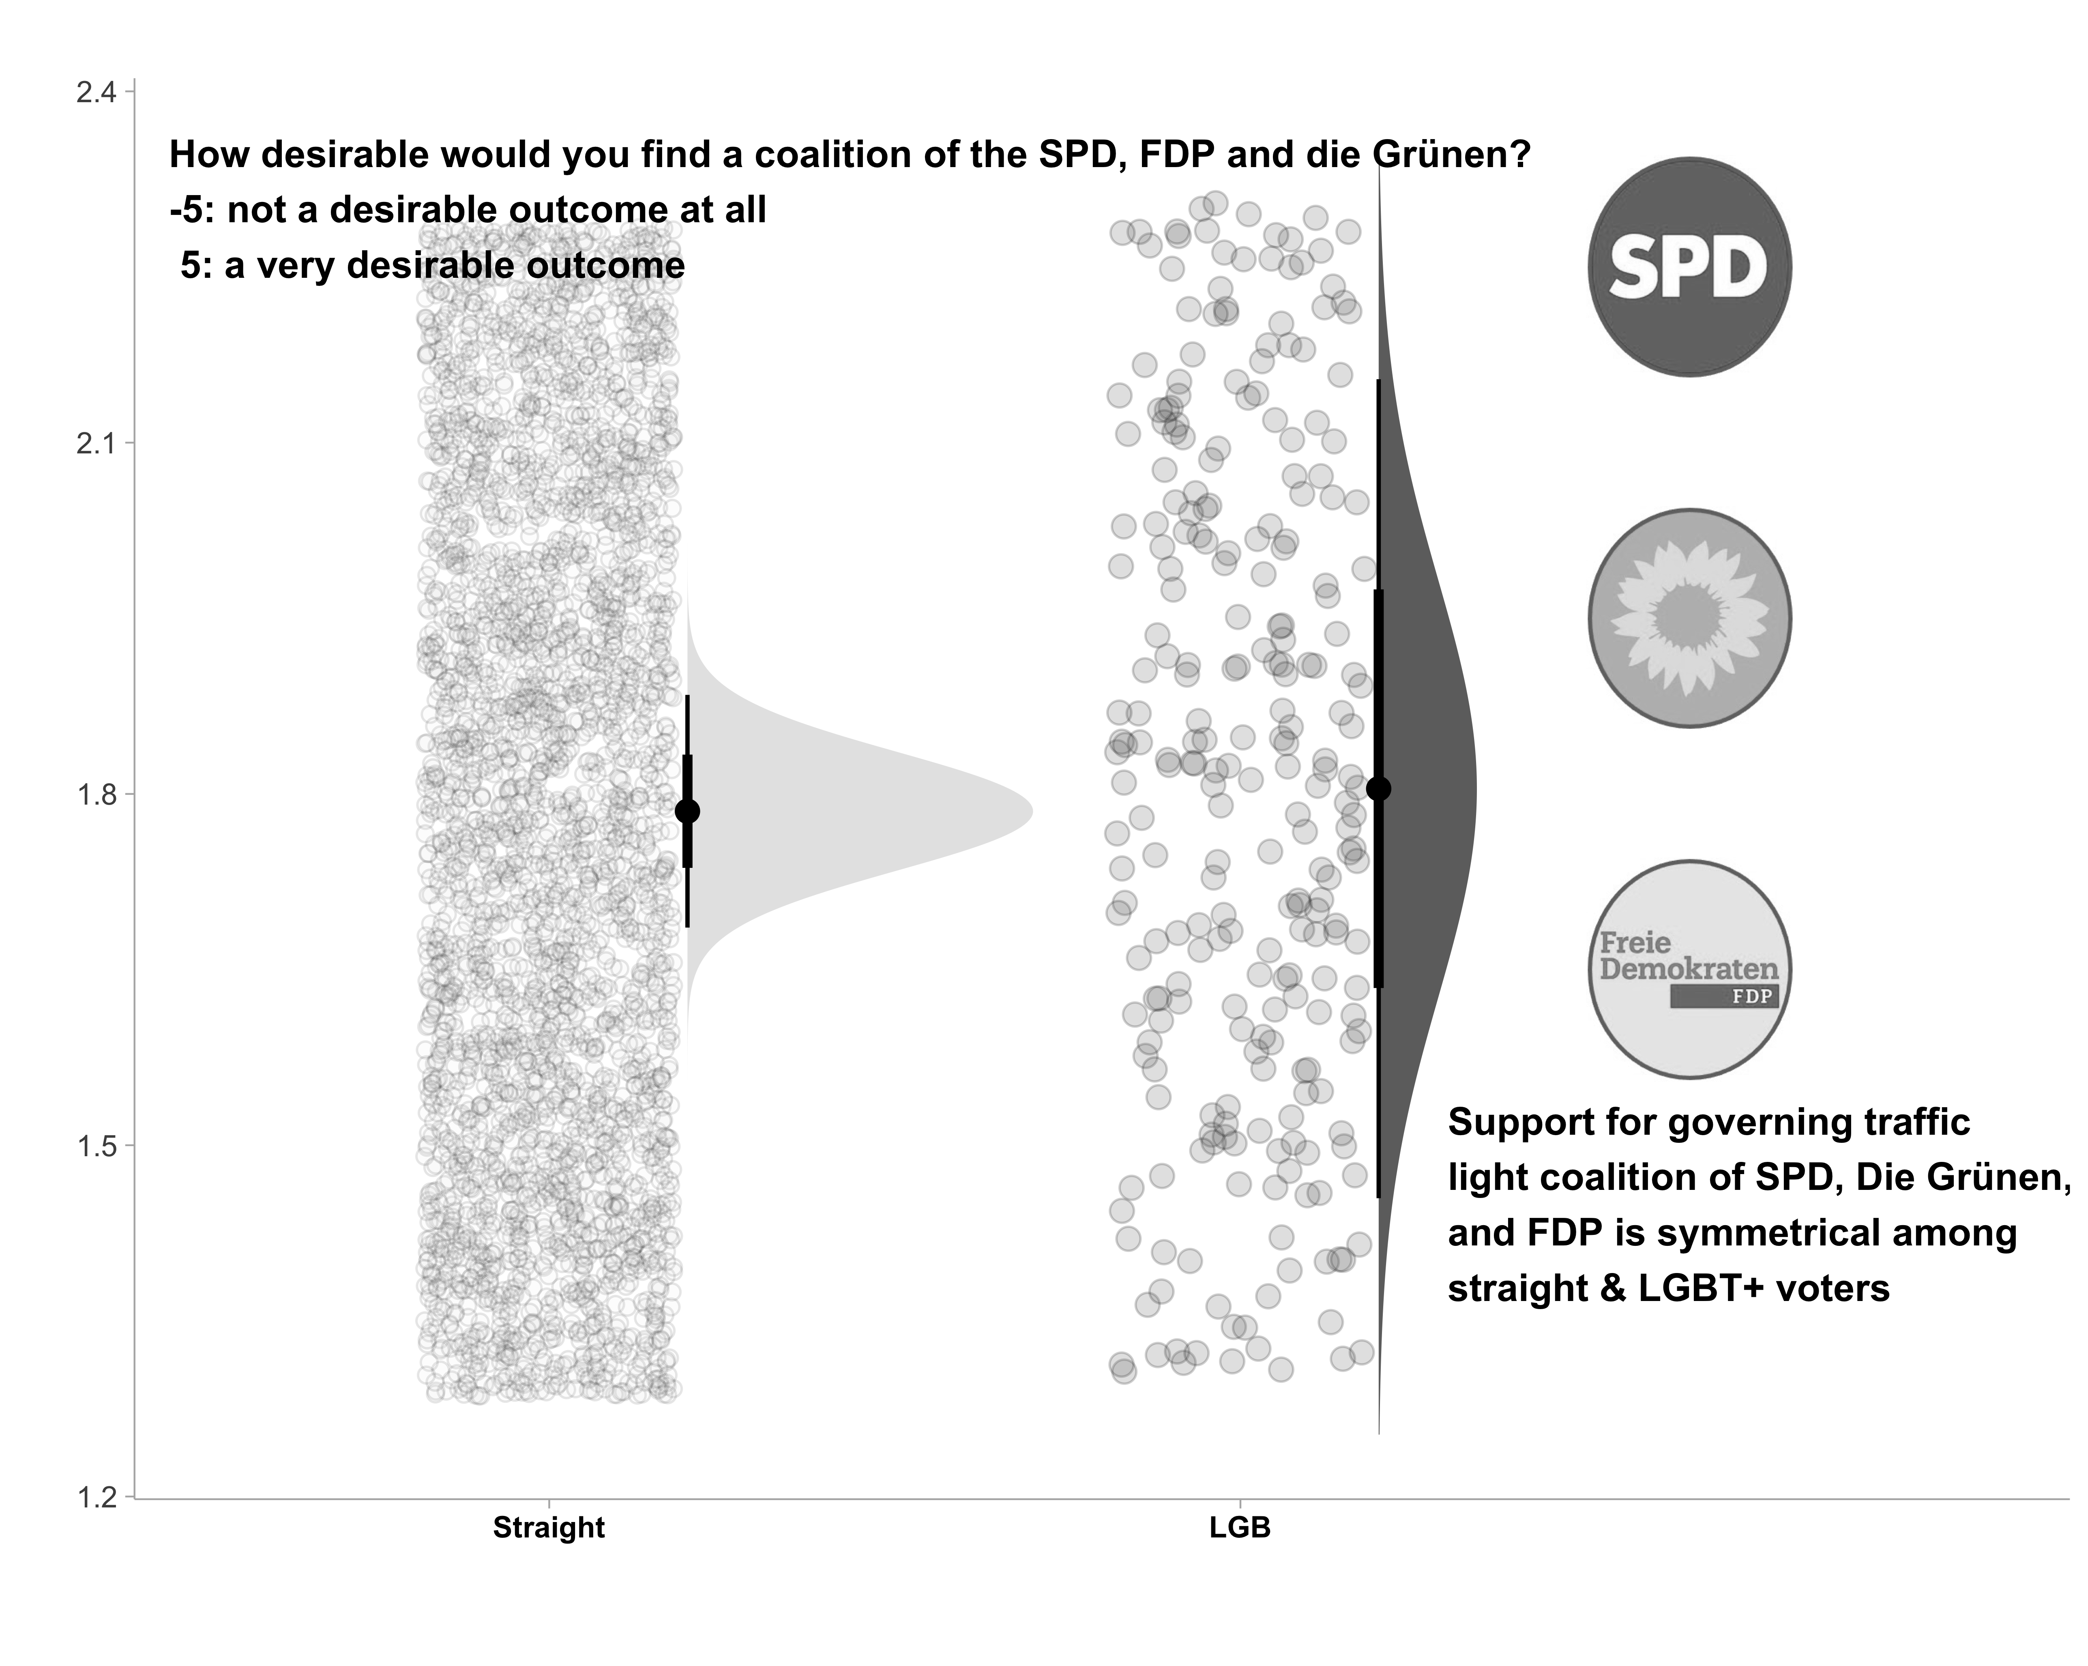Figure 4

Assistant Professor, University of Southampton. Email: s.turnbull-dugarte@soton.ac.uk

