Received 00th January 20xx,
- School of Chemistry and Biological Engineering, University of Science & Technology Beijing, Beijing 100083, P. R. China. E-mail: zhajw@ustb.edu.cn, zhengms@ustb.edu.cn
- School of Electrical Engineering, Guangxi University, Nanning 530004, P. R. China
- State Key Laboratory of Power System, Department of Electrical Engineering, Tsinghua University, Beijing 100084, P. R. China.
- Department of Electronics and Computer Science, University of Southampton, Southampton SO17 1BJ, United Kingdom.
- Shunde Graduate School of University of Science and Technology Beijing, Shunde 528399, P. R. China
† Electronic Supplementary Information (ESI) available:. See DOI:
Accepted 00th January 20xx
DOI: 10.1039/x0xx00000x

High energy density of polyimide films employing imidization reaction kinetics strategy at elevated temperature
Xue-Jie Liu, ª Ming-Sheng Zheng, *ª Gang Wang, ^{b} Yi-Yi Zhang, ^{b} Zhi-Min Dang, ^{c} George Chen ^{d} and Jun-Wei Zha *^{a,e}
Polymer dielectrics have been widely used in electrical energy storage devices. However, the relatively low operating temperature hinders their applications in harsh environments. Herein, the molecular structure of polyimide (PI) is optimized by adjusting the reaction kinetics of polyamic acid, which improves the energy storage performance of PI at elevated temperature. The PI film with optimal imidization degree achieves the simultaneous increase in dielectric permittivity and breakdown strength, resulting in a maximum discharged energy density (U_{e}) of 6.9 J cm⁻³ with a charge-discharge efficiency of 90.0 % at room temperature and high U_{e} of 3.9 J·cm⁻³ at 150 °C. The introduced -COOH/-CN-OH- polar groups increase the dielectric permittivity through the enhancement of dipole polarization. Moreover, a proper amount of -COOH/-CN-OH- groups as deep traps reduce the mobility of carriers, thereby increasing the breakdown strength. The finite element simulation reveals that the PI with proper imidization degree exhibits suppressed space charge accumulation and improved electric field distortion. This method reduces the PI processing temperature, which effectively reduces the production energy consumption. For verifying the universality of design strategy, the other two PIs prepared by different monomers are proved the same phenomenon. Finally, this production process of only reducing the preparation temperature without adjusting the original commercial PI production equipment is crucial for the practical application of capacitor films in the future.
1. Introduction
Compared with batteries and supercapacitors, dielectric capacitors have a much higher power density, making them widely used in various pulsed power systems.¹ Polymer dielectric capacitors have attracted massive attention due to their high breakdown strength (E_{b}), excellent self-healing properties, easy mass production and low manufacturing costs.²⁻⁴ For example, biaxially oriented poly-propylene (BOPP) has been widely used in film capacitors. However, due to its low operating temperature (< 105 ºC), an extra cooling system is necessary in high temperature and supernal electric field, which enlarges the volume of the power system and reduces the energy utilization efficiency.^{5, 6} Thus, high-temperature dielectric materials for capacitors are needed to meet the urgent requirements for miniaturization and multi-functionalization of equipment.⁷⁻⁹
Many potential high-temperature polymer capacitor materials have been developed. The most extensive method to improve the high-temperature energy storage performance is the design of polymer nanocomposites, and significant progress has been made.⁹⁻¹³ For example, Li et al.¹⁴ reported thermally crosslinked divinyltetramethyldisi-loxane-bis(benzocyclobutene) with 10 vol% boron nitride nanosheets that obtained a high discharged energy density (U_{e}) exceeding 2.2 J cm⁻³ with a charge-discharge efficiency (η) > 90 % under 400 MV m⁻¹ at 150 ºC. However, the possible interface problem caused by the agglomeration of fillers is always a potential risk. Pure polymers for high-temperature energy storage have also been developed.^{15, 16} Wang et al.¹⁷ prepared the crosslinked melt-processable fluoropolymers which achieved a U_{e} of 2.67 J cm⁻³ with η > 90% at 150 ℃. The significant improvement in high-temperature capacitive performance was attributed to the effective charge-trapping by a series of molecular trapping centers produced by the cross-linked structure. Ma et al.¹⁸ conducted initial screening through high-throughput density functional theory computations to identify potential polymer capacitor materials. Among 267 kinds of polymers with unique and reasonable structures, the polymer structures composed of aromatic groups and polar blocks (-NH-, -C(=O)- and -O-) with total a dielectric permittivity (electrons and ions) > 4 and band gap > 3 were selected. Among the several promising systems, polyimides (PIs) were chosen because of their potentially high dielectric permittivity and band gap. PIs also were found as the optimal choice due to their excellent thermal stability, high breakdown strength, synthesis flexibility and easy large-scale preparation.
The introduction of polar groups (e.g. cyano,¹⁹⁻²¹ bipyridine,²² crown ether,²³ etc.) on the molecular chain to increase the dipolar polarization for the energy storage performance improvement of PI is a commonly method. For instance, Zhu et al.²⁴ introduced two ortho-position aromatic nitrile groups into PI chain, which greatly improved its polarizability and dielectric permittivity (ε_{r}), and a U_{e} of 1.02 J cm⁻³ was obtained at room temperature. Peng et al.²² reported that the PI containing bipyridine units showed an excellent dielectric permittivity of 7.2, a breakdown strength of 295 kV mm⁻¹, and a discharged energy density of 2.77 J cm⁻³. The traditional strategy for improving the dielectric properties is preparing PIs with new chemical structures through organic synthesis reactions. However, this synthesis reaction not only makes the preparation process more complicated and time-consuming, but also does not involve the PI energy storage performance improvement at high temperatures. Therefore, a simple and effective method is urgently desired to improve the high temperature capacitive performances of PI films.
Compared with other polymers, the synthesis of PIs involves the selection of different monomers and the complex imidization reaction process, which offers countless possibilities for the performance improvement strategies. For example, the thermal imidization reaction is sensitive to temperature instead of treatment duration, and imidization degree (ID) can be controlled effectively by kinetic interruption. Many researchers have improved the performances of PIs by optimizing their thermal imidization process. Saeed et al.²⁵ adjusted the mechanical properties and viscoelastic behavior of PI films by optimizing the ID. Wei et al.²⁶ prepared high-performance PI nanofiltration membranes by optimizing the synergistic imidization reaction, showing excellent separation performance and stability. However, the method of optimizing the imidization process of polyamic acid (PAA) to regulate the energy storage performance at high temperature has not been reported so far.
In this work, the 4,4-'Oxydiphthalic Anhydride (ODPA)-1,3-phenylenediamine (MPD) films with different ID were sysnthesized by adjusting the PAA reaction kinetics, and their influence on high-temperature capacitance performance was explored. Dipole polarization was significantly enhanced by partial imidization of the remaining polar groups (-COOH/-CO-NH-), which improved the dielectric permittivity significantly. Furthermore, these small amounts of polar groups act as deep traps, inhibiting the transport of carriers in the polymer, thereby increasing the breakdown strength. The bipolar carrier transport model showed the influence of trap characteristics on the charge transport process. Meanwhile, low conductivity was also obtained. Therefore, the ODPA-MPD-3 film with the ID of 81% obtained a high breakdown strength to 618 MV m⁻¹ and a maximum discharged energy density of 6.9 J cm⁻³ with a η of 90% at room temperature. Notably, the ODPA-MPD-3 film obtained a U_{e} of 1.5 J cm⁻³ with a high η of 95% at 300 MV m⁻¹ and 150°C. The reduced processing temperature and the fabrication process matched to commercial manufacturing processes are beneficial for future practical applications of capacitor films.
2. Experimental Section
2.1. Materials
ODPA, MPD and 1,3-bis(4-aminophenoxy)benzene (BPB) were purchased from TCI Tokyo Chemical Industry Co., Ltd. Pyromellitic dianhydride (PMDA) and N-N-dimethylacetamide (DMAc) were provided by Shanghai Macklin Biochemical Co., Ltd. 4,4′-Diaminodiphenyl ether (ODA) and 4,4'-biphthalic Anhydride (BPDA) were purchased from Shanghai Aladdin Biochemical Technology Co., Ltd. All the chemicals were used as-received unless otherwise specified.
2.2. Synthesis of PI films
Three kinds of PI prepared by different dianhydrides and diamine monomers through a conventional two-step thermal imidization method as shown in Table S1. Fig. 1 showed that the ODPA-MPD-1~7 films synthesized from ODPA and MPD monomers were prepared by the following procedure in a typical experiment. ODPA and MPD monomers with a mole ratio of 1.02:1 were added to DMAc solvent under a nitrogen atmosphere, and reacted at room temperature for 8 hrs to obtain a PAA solution. Then the PAA solution was cast onto the glass substrate. The obtained PAA was subjected to thermal imidization reaction in a drying oven to prepare the ODPA-MPD-1~7 films with different ID at 150 ℃, 175 ℃, 200 ℃, 250 ℃, 300 ℃, 350 ℃, and 400 ℃, respectively. The other two PIs, namely PMDA-ODA and BPDA-BPB films, were prepared using the same thermal imidization reaction for comparison.
2.3. Characterization
Fourier transform infrared spectroscopy (FT-IR) was recorded on a BRUKER TENSOR 27 spectrometer with the range of 4000–400 cm⁻¹. X-ray diffraction (XRD) pattern was tested on a Bruker D8 Advance X-ray diffractometer using Cu Kα radiation (40kV, 40mA). Thermal gravimetric analyzer (TGA, SDT Q600) was applied to test thermostability at a heating rate of 10 °C/min from 30 °C to 900 °C in the nitrogen atmosphere. Dielectric properties of were tested using an impedance analyzer (Agilent 4294A) in the frequency ranging from 10² Hz to 10⁶ Hz. Differential scanning calorimetry (DSC) curves were obtained by a NETZSCH thermal analyzer (DSC 60) at a heating rate of 5 °C/min from 50 to 350 °C under flowing nitrogen. The breakdown strength and D-E loops were characterized by the Precision Multiferroic test system (Radiant Technologies) at 10 Hz. ESM303 electric tensile was applied to test the mechanical properties at a constant tensile rate of 13 mm/min. The Conductivity was obtained by the Keithley electrometer model 6517B with a standard three-electrode system under a constant applied electric field of 30 MV m⁻¹. Isothermal surface potential decay (ISPD) characteristics was obtained by isothermal surface potential attenuation system contained the electrostatic probe (TREK-6000B-5C) and the electrostatic potentiometer (TREK MODEL 347-3HCE). The charge–discharge tests were performed using a PKCPR1502 test system (PolyK Technologies) with the applied electric field of 200 MV m⁻¹ and the resistance of load resistor of 100 kΩ. UV-Vis-NIR diffuse reflection spectroscopy was recorded on a UH4150 spectrometer with the range of 200-2500 nm.
3. Results and discussion
3.1 FT-IR spectrum of the ODPA-MPD films
Fig. 2 showed the FT-IR spectra of ODPA-MPD films. The characteristic imide absorption peaks of asymmetrical C=O stretching, symmetrical C=O stretching, C–N stretching and C=O bending of imide ring were observed at 1781 cm⁻¹, 1720 cm⁻¹, 1365 cm⁻¹ and 748 cm⁻¹ in the ODPA-MPD-1~7 films, which confirmed that

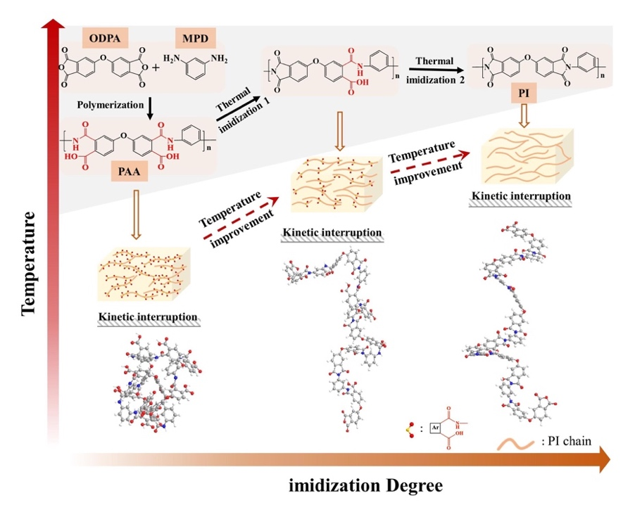
Fig. 1 Schematic of the synthesis process for the ODPA-MPD films with different imidization degree.
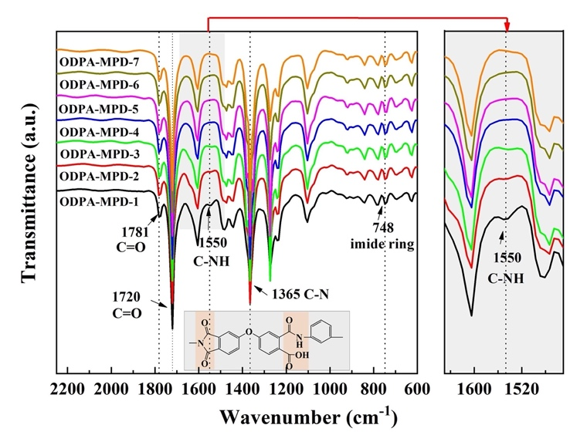

Fig. 2 FT-IR spectra of the ODPA-MPD films with different imidization degree.

the imidization reaction proceeded from ODPA-MPD-1 film to ODPA-MPD-7 film. The intensity corresponding to the characteristic PAA absorption peaks at 1550 cm⁻¹ for N-H deformation coupled with C-N stretching of the amide linkage gradually lessened with the incremental ID, indicating that the PI gradually reached " completely imidized" condition. Thus, the decreased imidization temperature resulted in suppressed ID.
3.2 Thermal imidization kinetics and thermal properties
As shown in Fig. 3a and 3b, the ID of ODPA-MPD-1~7 films can be accurately calculated according to the TGA results.²⁷⁻²⁹ Taking the ODPA-MPD-1 film as an example, the total weight loss of the ODPA-MPD-1 film includes three steps when the DMAc solvent is completely evaporated: dehydration of water adsorbed on the film surface (the first step), cyclization dehydration of PAA chains (the second step, two H₂O molecules per repeating unit) and thermal decomposition of PI (the third step). The ID can be obtained by the following Equation (1) using the weight loss generated in the second step.
Weight Loss%=$\frac{M(2H_{2}O)×(100\%-ID)}{M(PAA)-M(2H_{2}O)×ID}×100\%$ (1)
where M (PAA) is the molecular weight of the PAA repeating unit, M (H₂O) represents the molecular weight of H₂O. According to the TGA data (Fig. 3a) and Equation (1), the accurate IDs of ODPA-MPD-1~7 films were obtained, as shown in Table 1, which increased from 9.0% to 100%. TGA curves also showed that the weight of all ODPA-MPD films dropped rapidly after about 500 °C. The maximum weight loss rate occurred at ~ 610 °C, indicating the violent thermal decomposition. The heating process till ~ 300 °C during the TGA test resulted in the dehydration and cyclization of the -COOH and -CO-NH- groups, resulting in the weight loss of the ODPA-MPD-1~4 films at a lower temperature. Table 1 revealed that T_{d5%} and T_{d10%} from the ODPA-MPD-1 film to the ODPA-MPD-7 film gradually increased, mainly attributed to the increase in ID. The TGA curves and thermal decomposition temperatures of the two conventional PIs with different structures, the PMDA-ODA films and BPDA-BPB films, were also explored as shown in Figure S1, Table S2 and Table S3. Figure 3c showed that T_{g} was gradually promoted from 169 ℃ to 290 ℃ following the incremental ID, which was mainly due to the packing of PI molecular chains more closely as the rising imidization temperature.
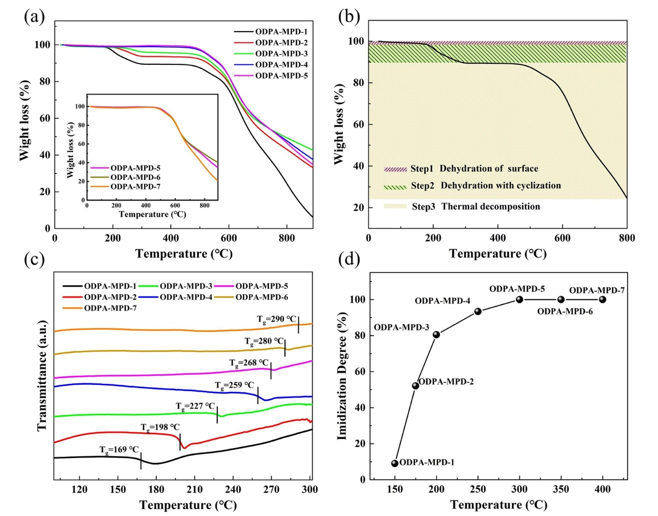
According to thermal imidization kinetics mechanism, the progress of the imidization reaction depends on temperature, which mainly caused by the decrease of the mobility of the molecular chains. Fig. 3d revealed the relationship between ID and temperature, and 150-200 °C was the rapid imidization stage. Moreover, the imidization reaction gradually became slower and was almost completed at about 300 °C. This was mainly attributed to the rising rigidity of the molecular chains, which led to a decrease in chain mobility,
Fig. 3 (a) TGA curves of the ODPA-MPD films with different ID. (b) Three steps of thermal weight loss process for the ODPA-MPD-1 film obtained by TGA curve. (c) DSC curves of the ODPA-MPD films with different ID. (d) ID of the ODPA-MPD films calculated from TGA data as a function of the temperature from 150 to 400 ℃.

hindering the imidization reaction, and the trends are consistent with previous work.^{30, 31} For comparison, the the IDs of PMDA-ODA and BPDA-BPB films were also explored as shown in Tables S2 and S3. The three PIs showed the similar tendency.
3.3 Dielectric properties
Fig. 4a and S4 showed the dielectric properties of the ODPA-MPD films at different temperatures. At room temperature, the ODPA-MPD-1 film had the highest number of polar groups, resulting in the highest dielectric permittivity of 4.59 at 1 kHz. It was inferred that -COOH/-CO-NH- polar groups played an important role in improving the dielectric permittivity. The XRD pattern showed that the ODPA-MPD-1~7 films remained amorphous during the imidization process as shown in Fig. S2. For amorphous polar macromolecules, dipole polarization (composed of dipole moment and dipole density) turns out to be the main contributor to the dielectric permittivity. The ODPA-MPD-1~4 films contain relatively more polar groups including -COOH and -CO-NH-, and the dielectric permittivity can be improved by the elevated dipole polarization. The temperature dependence of the dielectric properties of the ODPA-MPD films was evaluated as illustrated in Fig. 4b. From room temperature to 150 °C, the dielectric permittivity decreased slightly, and the decrease rate remains below 10% at 1 kHz. The dielectric loss (tanδ) of ODPA-MPD-2~7 films had high temperature stability in the whole temperature range, and slightly decreased with the increase of temperature at high frequency. The ODPA-MPD-1 film exhibited a sharp increase in dielectric loss above 50 °C due to the very low degree of imidization.

Table 1 Imidization degree and thermal property of the ODPA-MPD films.
ODPA-MPD | 1 | 2 | 3 | 4 | 5 | 6 | 7
ID (%) | 9 | 52 | 81 | 93 | ≈100 | ≈100 | ≈100
T_{d5%} (°C) | 213 | 268 | 473 | 522 | 520 | 517 | 516
T_{d10%} (°C) | 283 | 527 | 542 | 564 | 565 | 565 | 566
T_{g} (°C) | 169 | 198 | 227 | 259 | 268 | 280 | 290

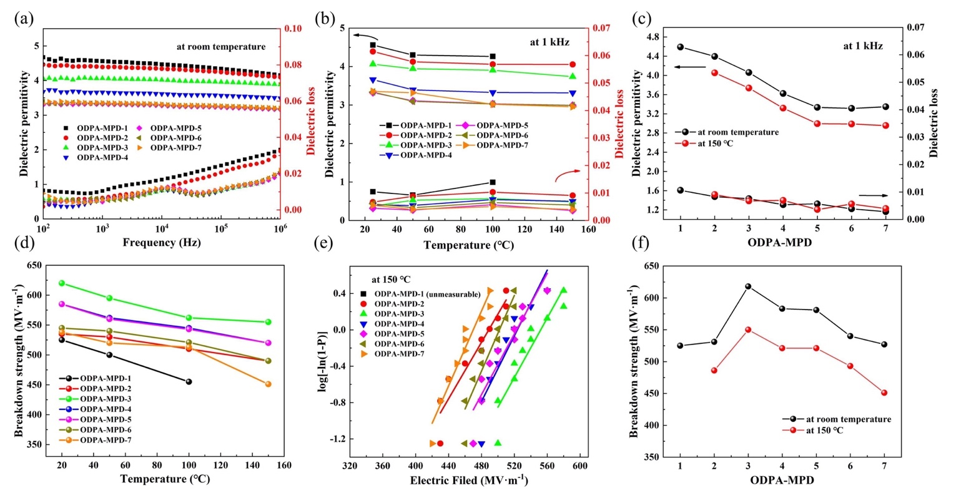
Fig. 4 Dielectric permittivity and loss of the ODPA-MPD films with different ID (a) at different frequency and (b) different temperature. (c) Dielectric properties at room temperature and 150 ℃ as a function of ID. Breakdown strength of the ODPA-MPD films (d) at different temperature and (e) at 150 ℃, and (f) the comparison of ODPA-MPD films at room temperature and 150 ℃.

Moreover, the low imidization temperature (150 °C) of the ODPA-MPD-1 film led to unmeasured dielectric properties at high temperatures. As shown in Fig. 4c, the dielectric permittivity of the ODPA-MPD films gradually decreased as the incremental ID, until they reach “complete” imidization at room temperature and 150 ℃. The dielectric loss of the ODPA-MPD films originated from dipolar polarization, which was enhanced by the decreasing ID. As shown in Fig. S4, similar tendency was found in the dielectric permittivity of the PMDA-ODA and BPDA-BPB films. It is proved that the dielectric permittivity of PI films can be effectively improved through the control of imidization reaction kinetics.
For linear dielectrics such as PI, U_{e} can be described as follows:
U_{e} = $\frac{1}{2}ε_{0}ε_{r}$E_{b}² (2)
where ε₀ (8.85×10⁻¹² F m⁻¹) is the vacuum permittivity. It can be seen from the Equation (2) that high-ε_{r} as well as high-E_{b} are the important factors for high U_{e}, which is essential for practical applications. As shown in Fig. 4d, the ODPA-MPD film with proper ID at different temperatures exhibited improved E_{b}. The maximum breakdown strength of the ODPA-MPD-3 film at room temperature was as high as 618 MV m⁻¹. Although the breakdown strength of ODPA-MPD films showed a typical decrease following the rising temperature, the breakdown strength of ODPA-MPD-3 film had been maintained the optimal value as shown in Fig. 4e and S5. For example, the breakdown strength of the ODPA-MPD-3 film was up to 550 MV m⁻¹ at 150 °C, which was significantly higher than the “completely imidized” PIs (i.e. the ODPA-MPD-5 film, 520 MV m⁻¹). As shown in Fig. 4f, the breakdown strength of ODPA-MPD films first increased and then decreased with the increase of ID at different temperatures, which was attributed to the improvement of the breakdown strength by an appropriate amount of -COOH and -CO-NH- polar groups. Fig. S6 showed that the PMDA-ODA-4 film with an ID of 89% achieved the highest breakdown strength of 430 MV m⁻¹ and the BPDA-BPB-4 film with an ID of 86% achieved the highest breakdown strength of 553 MV m⁻¹. It should be noted that the highest breakdown strength of three kinds of PIs discussed above was observed at the ID range of 80-90%. An appropriate number of -COOH/-CO-NH- groups induced deep traps was used to capture and disperse carriers. In addition, the charges trapped near the electrode by the deep traps suppressed further carrier injection. The carrier mobility and current density were reduced, resulting in the excellent breakdown strength of the ODPA-MPD-3 film. Fig. S7 and Table S4 showed that the band gap (E_{g}) decreased from 3.27 to 2.57 as the ID increased in the ODPA-MPD films. The residual polar groups affected the polymer chain structure to obtain different E_{g}. The E_{g} of ODPA-MPD-3 film was higher than that of “completely imidized” ODPA-MPD-5 film. It is speculated that the E_{g} had a positive effect on the breakdown strength.^{35, 36} Furthermore, the ODPA-MPD-3 film owned excellent mechanical properties, which ensured the high resistance for electromechanical breakdown as shown in Fig. S8.
3.4 Energy storage and cyclic charge-discharge performances
Fig. S9 showed the electric displacement decreased with the increasing ID. The ODPA-MPD films with higher ID showed linear dielectric behavior at room temperature and 150 °C. The discharged energy density and charge-discharge efficiency of the ODPA-MPD-1~7 films were obtained from the D-E loops at ambient and elevated temperatures as shown in Fig. 5. It could be seen from Fig. 5a that the discharged energy density of the ODPA-MPD-3 film reached 6.9 J cm⁻³ at room temperature, while the discharge efficiency was up to
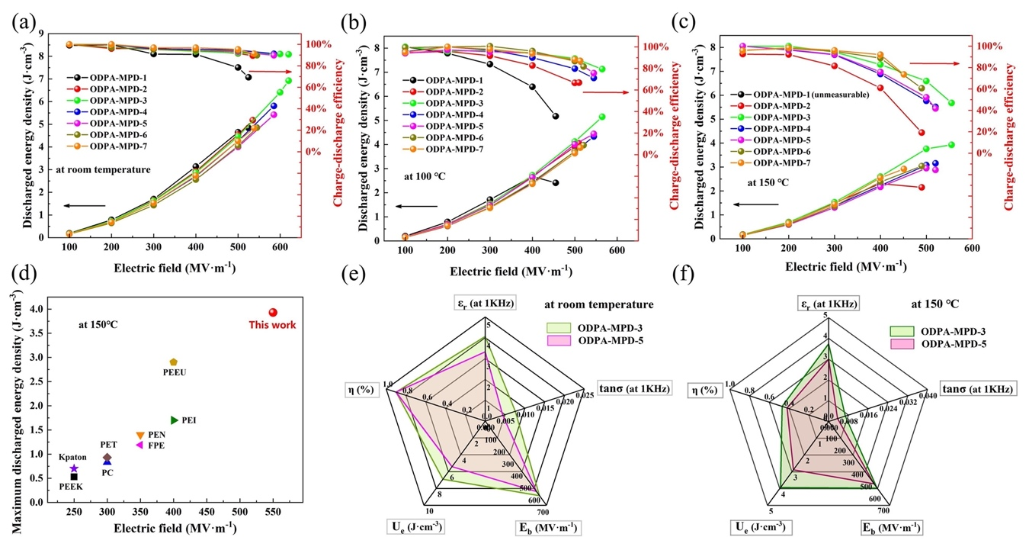
Fig. 5 Discharged energy density and charge-discharge efficiency of the ODPA-MPD films with different ID at (a) room temperature, (b) 100 °C and (c) 150 °C, respectively. (d) Comparison of the discharged energy density for high-temperature pure polymers at 150 °C. The radar plots of the ODPA-MPD-3 film and ODPA-MPD-5 film at (e) room temperature and (f) 150 °C.

90.0%. Compared with the completely imidized ODPA-MPD-5 film (U_{e}=5.4 J cm⁻³, η=89.7%), the U_{e} of the ODPA-MPD-3 film was increased by about 30%. At the same time, the working temperature of film preparation was reduced by 100 °C, which promoted the development of energy saving. As shown in Fig. S10 and 5b, the ODPA-MPD-3 film still maintained a high U_{e} at high temperatures. At 50 °C and 100 °C, the discharged energy density was 6.3 J cm⁻³ with a η > 90.0% and 5.2 J cm⁻³ with a η > 79.4%, respectively. Fig. 5c depicted that the highest U_{e} of ODPA-MPD-3 film was 3.9 J cm⁻³ with a η of 47% at 150℃ and 550 MV m⁻¹. Compared with the ODPA-MPD-5 film (U_{e} =2.88 J cm⁻³ with a η=41% at 520 MV m⁻¹), the U_{e} and η of the ODPA-MPD-3 film were significantly improved, which indicated that the strategy of regulating the ID of polyimide was effective to improve the high temperature capacitance performance. Notably, the ODPA-MPD-3 film obtained a U_{e} of 1.5 J cm⁻³ with a high η of 95% at 150°C and 300 MV m⁻¹, which was 67% higher than that of BOPP film (~0.9 J cm⁻³ at 25 °C and 300 MV m⁻¹).¹⁴ As shown in Fig. 5d, the U_{e} of the ODPA-MPD-3 film exceeded the most of high-temperature pure polymers (including Kapton, PEI, FPE, PEN, PEEU, etc.) implying that it is a promising polymer matrix material.^{10, 14, 37, 38} Compared with the “completely imidized” ODPA-MPD-5 film, the comprehensive energy storage performance of the ODPA-MPD-3 film showed a significant improvement (including ɛ_{r}, tanδ, E_{b}, U_{e} and η) as shown in Fig. 5e and 5f. The ODPA-MPD-3 film obtained a higher U_{e} and η at room temperature and 150 °C.
The cyclic charge-discharge performances of the ODPA-MPD films were also evaluated.^{39, 40} The films were charged at 200 MV m⁻¹, and then directly discharged to a 100 kΩ resistor load. The discharge time was defined as the time for the discharge energy density reached 90% of maximum U_{e} from the discharge profiles. As shown in Fig. 6a and 6b, the discharge times of BOPP, ODPA-MPD-3 and ODPA-MPD-5 film were 10.6, 9.9 and 10.4 μs, respectively. It should be noted that ODPA-MPD-3 film obtained the highest power density of 72.5 kWcm⁻³, which was 150% of BOPP. Fig. 6c illustrated that the fast charge-discharge process was cycled 5000 times without a significant decrease in discharged energy density. The polar groups did not adversely affect the cycle stability of the ODPA-MPD-3 film. It further proved the feasibility of ODPA-MPD-3 film in the capacitor films.
3.5 Electrical conduction and charge trapping
For dielectrics, conductivity is a considerable reason for the high temperature energy loss and a crucial factor for the thermal failure.⁴¹ Fig. 7a showed that the conductivity of ODPA-MPD films was detected under 30 MV m⁻¹ at different temperatures. At room temperature, the ODPA-MPD-3 film showed the lowest conductivity of 1.1·10⁻¹³ S m⁻¹. With the increase of temperature, more carriers were activated by heat, resulting in the enhanced conductivity of the ODPA-MPD films. However, the ODPA-MPD-3 film still maintained a low conductivity of 7.2·10⁻¹³ S m⁻¹ at 150 °C. The existence of an appropriate amount of -COOH/-CO-NH- groups hindered the accelerated movement of carriers in the electric field and reduced the carrier mobility, resulting in good insulation performance of the ODPA-MPD-3 film.
The ISPD method was used to study the distribution of trapped carriers. The important relationship between energy level (E_{T}) and charge density [N(E_{T})] could be derived and calculated:^{42, 43}
$E_{T}=kTln(vt)$ (3)
$N(E_{T})=\frac{ε_{0}ε_{r}t}{q_{e}kTδL}\frac{dφ(t)}{dt}$ (4)
where k is Boltzmann's constant, T represents the temperature in degrees Kelvin, υ is the attempt-to-escape frequency of the charges, t represents the decay time of the surface potential, q_{e} is Coulomb's
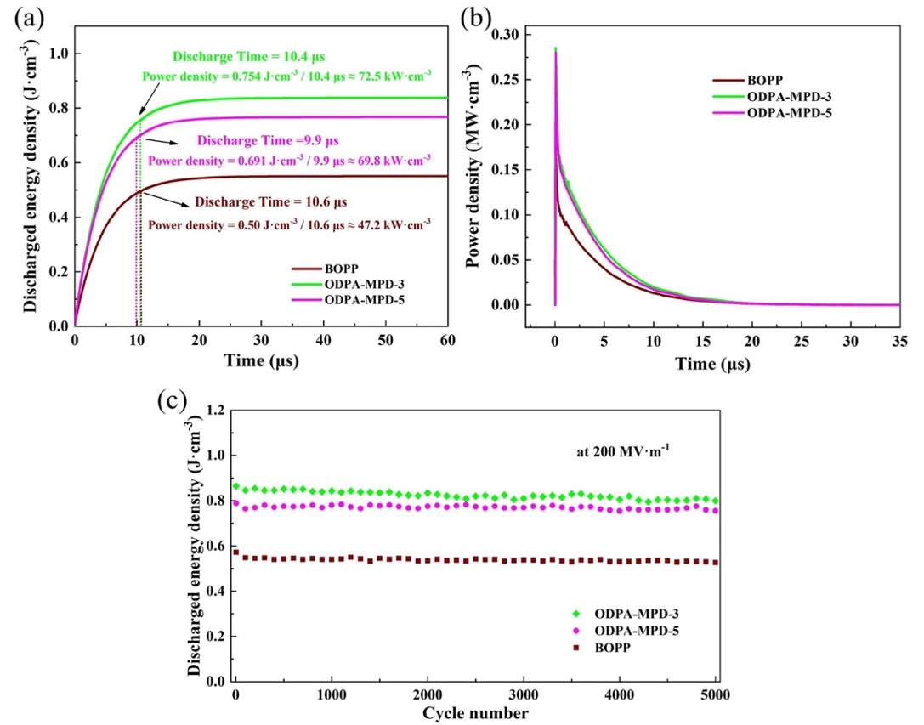
Fig. 6 (a) Discharged energy density, (b) power density as a function of time and (c) cyclic ability of the BOPP, ODPA-MPD-3 and ODPA-MPD-5 film at room temperature under 200 MV m⁻¹.
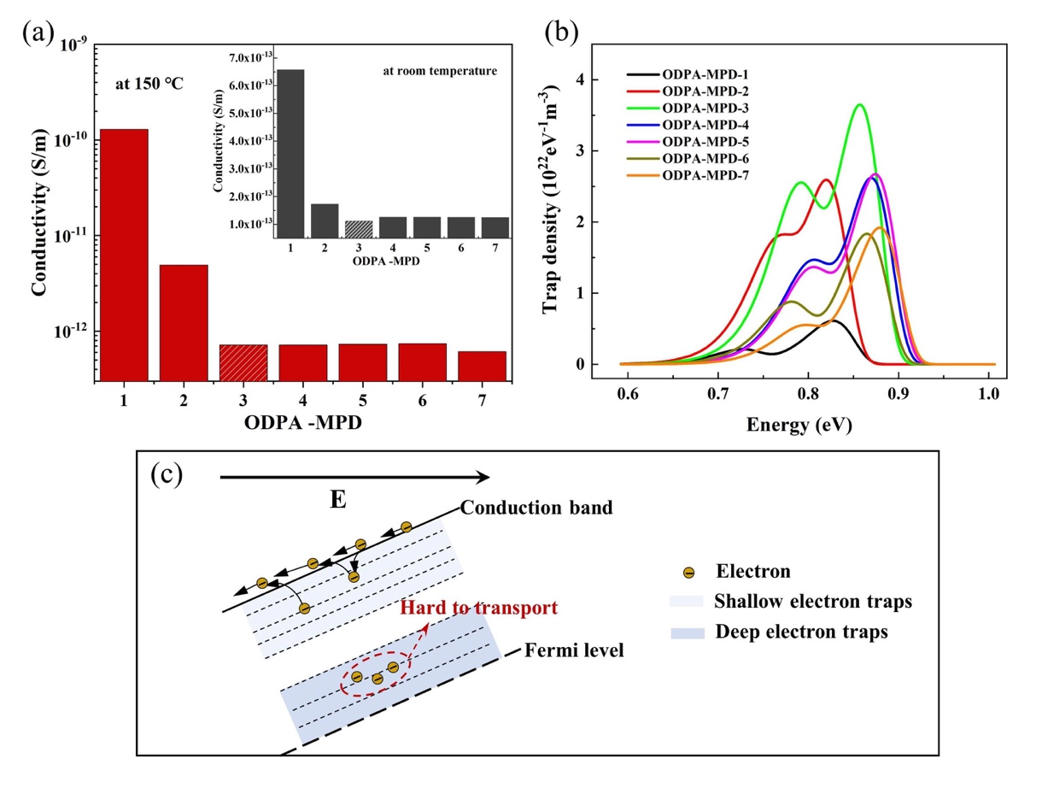

Fig. 7 (a) Conductivity and (b) trapped density distribution of the ODPA-MPD films with different ID. (c) Schematic of the transmission of electrons.

electron quantity, δ is the thickness of the top charge layer which usually set as 2 μm, L is the thickness of the thin films, φ(t) is the surface potential. According to the hypothesis of shallow traps and deep traps, the data was fitted to obtain the trap distribution.⁴⁴ As shown in Fig. 7b, two isothermal surface potential attenuation peaks were shown, representing the center of the shallow traps (peak on the left) and deep traps (peak on the right), respectively. The DC breakdown strength mainly depends on the charge transport characteristics. Polar groups can form localized states in the band gap, which have strong attraction to charges and act as traps to capture and disperse carriers during transport. ⁴⁵⁻⁴⁸ The density of deep traps for ODPA-MPD films increased first and then lowered down with the incremental ID, showing a trend similar to the breakdown strength. Fig. 7b showed that the ODPA-MPD-3 film with an appropriate amount of -COOH/-CO-NH- groups exhibited the highest density of deep traps, which improved the carrier trapping ability and reduced the carrier mobility, thus improving the insulation performance. On the one hand, the introduction of a large number of -COOH/-CO-NH- groups in films such as ODPA-MPD-1 and ODPA-MPD-2 led to overlapping of traps, which reduced the trap energy level. On the other hand, very few polar groups remained in the ODPA-MPD-5 film resulting in low deep trap density. The low trap level and density enhanced the carrier mobility, resulting in increased leakage current, which reduced the breakdown strength. Therefore, the high trap level and density induced by an appropriate amount of -COOH/-CO-NH- groups is the crucial to improve the insulation performance. Fig. 7c was a schematic diagram of deep traps reducing the carriers mobility. Moreover, the carriers captured by the deep traps near the electrodes led to
the formation of the homocharges, which enhanced the electric field required for charge injection. Space charge accumulation was reduced, thus improving the breakdown strength.
The bipolar carrier transport model was used to reveal the influence of trap characteristics on the process of charge transport.⁴⁹⁻⁵¹ Electrons and holes were injected into the ODPA-MPD films at 50 MV m⁻¹ by electrodes on the film surface. Under the action of the electric field, the charges migrated, diffused, and accumulated in the area near the electrodes. Fig. 8 showed the final equilibrium state of the charge and electric field distributions of the ODPA-MPD films. The X-axis and Y-axis represented the thickness and width of the films, which were 1 mm and 15 μm, respectively. This model was selected a part of the ODPA-MPD films (width and thickness of 15 μm) for demonstration. All ODPA-MPD films have the same width and thickness. The results illustrated that when there were many deep traps in the ODPA-MPD film, the free charges were captured by the traps during the migration and diffusion process to form trapped charges. The ODPA-MPD-2 film with low ID of 52%, ODPA-MPD-3 film with proper ID of 81% and ODPA-MPD-5 film with ID of about 100% were selected for simulation of space charge distributions and electric field distributions. As shown in Fig. 8a, the low deep trap density of the ODPA-MPD-2 film with lower ID made its poor carrier trapping effect, which was favorable for charge transport to form leakage current and increase the possibility of breakdown. The ODPA-MPD-3 film with proper ID showed the largest density of deep trap for trapping more charges (see Fig. 7b), which hindered the carrier transport process as shown in Fig. 8b. Compared with the ODPA-MPD-3 film, the ODPA-MPD-5 film with “complete imidization” had a lower deep trap density induced by -COOH/-CO-NH- groups, which facilitated the charge transport, as shown in Fig. 8c. On the other hand, the homocharges inhibited the charge injection at the
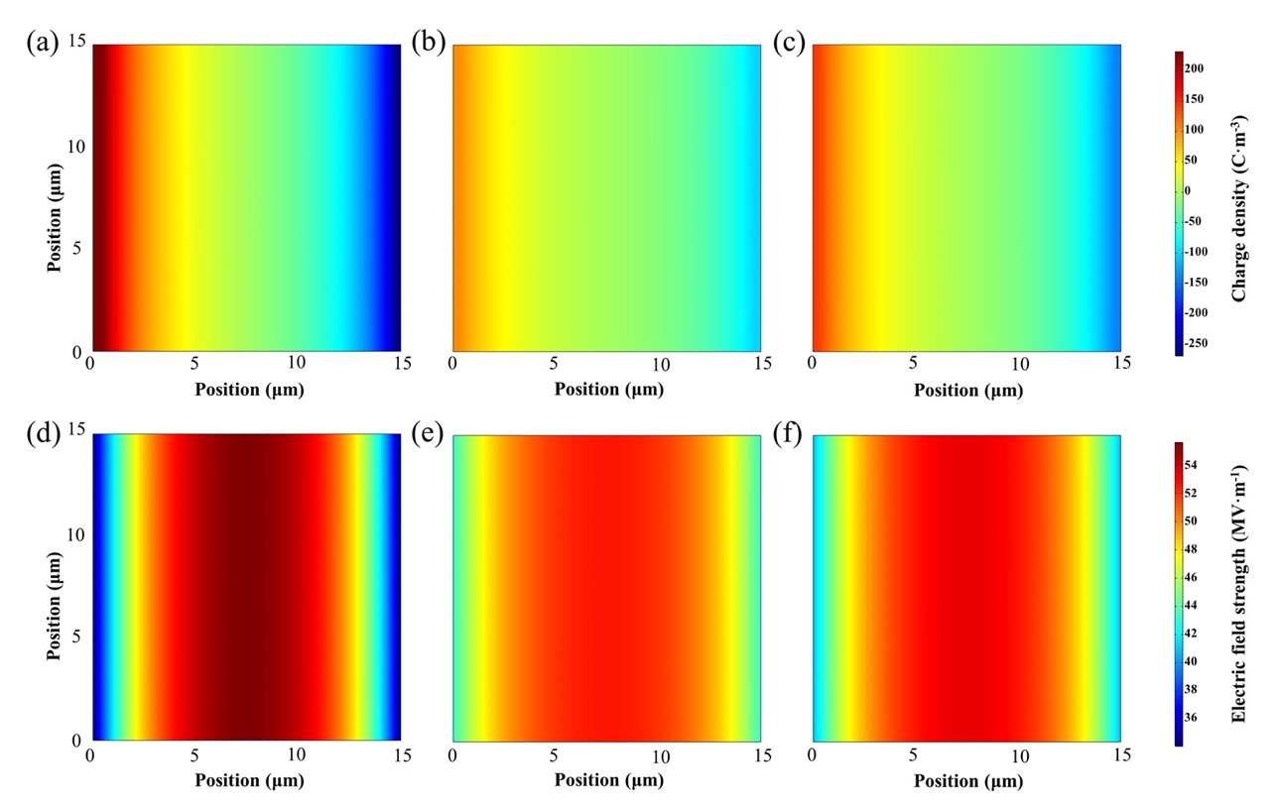
Fig. 8 Simulation of space charge distributions and electric field distributions of (a) and (d) the ODPA-MPD-2 film, (b) and (e) ODPA-MPD-3 film, (c) and (f) ODPA-MPD-5 film.

interface and reduced the space charge density near the electrode. For example, the vast majority of space charge accumulated near the electrode in the ODPA-MPD-2 film, while the ODPA-MPD-3 film with higher energy level and deeper trap density weakened the accumulation of space charge. The presence of accumulated space charges changed the original electric field distribution and distort the electric field of the ODPA-MPD films as shown in Fig. 8d-8f. The ODPA-MPD films with low ID (52%) or high ID (~ 100%) accumulate more space charges, which led to obvious the electric field distortion. While the ODPA-MPD-3 film had the lowest electric field distortion, due to the limited number of space charges. Thus, the ID of ODPA-MPD film was an important factor for the improvement of energy storage performance.
4. Conclusion
In summary, this work revealed a new molecular structure optimization mechanism based on the regulatory of the PI imidization process, and provided a brand-new strategy for improving the dielectric and energy storage performances of PIs. By adjusting the kinetics of imidization reaction, PI films with different imidization degrees were obtained. The ODPA-MPD-3 film (ID=81%) not only improved the dipole polarization but also promoted its breakdown strength due to the proper amount of -COOH/-CO-NH- groups. A maximum discharged energy density of 6.9 J cm⁻³ and excellent charge-discharge efficiency of 90.0% were obtained at room temperature. Meanwhile, the discharged energy density of 3.9 J cm⁻³ was also obtained at 150 °C. Notably, the U_{e} was increased by 130% while the processing temperature was reduced by 100℃ compared with “completely imidized” PI. Simulation of space charge and electric field distribution revealed the influence mechanism of traps on charge transport. Since a variety of diamine and dianhydride monomers can fabricate various functional PI, the strategy based on imidization reaction kinetics showed great potential applications in high-temperature energy storage field.
Conflicts of interest
There are no conflicts to declare.
Acknowledgements
This work was financially supported by National Natural Science Foundation of China (No. 51977114), Fundamental Research Funds for the Central Universities (No. FRF-NP-19-008 and FRF-TP-20-02B2), and Scientific and Technological Innovation Foundation of Foshan (BK21BE006). The authors appreciate the help offered by Prof. Meng Xiao from Tianjin University for the isothermal surface potential decay tests. Thanks to Hang-Dong Li from Guangxi University for his kind help.
References
- X. J. Liu, M. S. Zheng, G. Chen, Z. M. Dang and J.W. Zha, Energy Environ. Sci. 2021, DOI: 10.1039/d1ee03186d.
- Y. Qiao, X. Yin, T. Zhu, H. Li and C. Tang, Prog. Polym. Sci. 2018, 80, 153.
- J. S. Ho and S. G. Greenbaum, ACS Appl. Mater. Interfaces 2018, 10, 29189.
- B. Fan, M. Zhou, C. Zhang, D. He and J. Bai, Prog. Polym. Sci. 2019, 97, 101143.
- Q. Li, F. Z. Yao, Y. Liu, G. Zhang, H. Wang and Q. Wang, Ann. Rev. Mater. Res. 2018, 48, 219.
- J. W. Zha, M. S. Zheng, B. H. Fan and Z. M. Dang, Nano Energy 2021, 89, 106438.
- D. Tan, L. Zhang, Q. Chen and P. Irwin, J. Electron. Mater. 2014, 43, 4569.
- C. Wu, A. A. Deshmukh, Z. Li, L. Chen, A. Alamri, Y. Wang, R. Ramprasad, G. A. Sotzing and Y. Cao, Adv. Mater. 2020, 32, 2000499.
- W. Xu, J. Liu, T. Chen, X. Jiang, X. Qian, Y. Zhang, Z. Jiang and Y. Zhang, Small 2019, 15, 1901582.
- T. Zhang, X. Chen, Y. Thakur, B. Lu, Q. Zhang, J. Runt and Q. M. Zhang, Science Advances 2020, 6, eaax6622.
- L. L. Ren, H. Li, Z. L. Xie, D. Ai, Y. Zhou, Y. Liu, S. Y. Zhang, L. J. Yang, X. T. Zhao, Z. R. Peng, R. J. Liao and Q. Wang, Adv. Energy Mater. 2021, 11, 2101297.
- Q. Zhao, L. Yang, K. Chen, Y. Ma, H. Ji, M. Shen, H. Huang, H. He and J. Qiu, Nano Energy 2019, 65, 104007.
- H. Li, T. Yang, Y. Zhou, D. Ai, B. Yao, Y. Liu, L. Li, L. Q. Chen and Q. Wang, Adv. Funct. Mater. 2020, 31, 2006739.
- Q. Li, L. Chen, M. R. Gadinski, S. Zhang, G. Zhang, H. U. Li, E. Iagodkine, A. Haque, L. Q. Chen, T. N. Jackson and Q. Wang, Nature 2015, 523, 576.
- Z. Zhang, D. H. Wang, M. H. Litt, L. S. Tan and L. Zhu, Angew. Chem. Int. Ed. 2018, 57, 1528.
- Z. Zhang, J. Zheng, K. Premasiri, M.-H. Kwok, Q. Li, R. Li, S. Zhang, M. H. Litt, X. P. A. Gao and L. Zhu, Materials Horizons 2020, 7, 592.
- H. Li, M. R. Gadinski, Y. Huang, L. Ren, Y. Zhou, D. Ai, Z. Han, B. Yao and Q. Wang, Energy Environ. Sci. 2020, 13, 1279.
- R. Ma, A. F. Baldwin, C. Wang, I. Offenbach, M. Cakmak, R. Ramprasad and G. A. Sotzing, ACS Appl. Mater. Interfaces 2014, 6, 10445.
- D. H. Wang, J. K. Riley, S. P. Fillery, M. F. Durstock, R. A. Vaia and L. S. Tan, J. Polym. Sci., Part A: Polym. Chem. 2013, 51, 4998.
- D. H. Wang, B. A. Kurish, I. Treufeld, L. Yang, L. Zhu and L.S. Tan, MRS Proceedings 2013, 1541.
- I. Treufeld, D. H. Wang, B. A. Kurish, L. S. Tan and L. Zhu, J. Mater. Chem. A 2014, 2, 20683.
- X. Peng, W. Xu, L. Chen, Y. Ding, T. Xiong, S. Chen and H. Hou, React. Funct. Polym. 2016, 106, 93.
- T. Yang, W. Xu, X. Peng and H. Hou, RSC Advances 2017, 7, 23309.
- T. Zhu, Q. Yu, W. Zheng, R. Bei, W. Wang, M. Wu, S. Liu, Z. Chi, Y. Zhang and J. Xu, Polymer Chemistry 2021, 12, 2481.
- M. B. Saeed and M. S. Zhan, Eur. Polym. J. 2006, 42, 1844.
- C. Wei, Z. He, L. Lin, Q. Cheng, K. Huang, S. Ma and L. Chen, J. Membr. Sci. 2018, 563, 752.
- W. Chen, W. Chen, B. Zhang, S. Yang and C. Y. Liu, Polymer 2017, 109, 205.
- W. K. Yang, F. F. Liu, G. M. Li, E. S. Zhang, Y. H. Xue, Z. X. Dong, X. P. Qiu and X. L. Ji, Chin. J. Polym. Sci. 2016, 34, 209.
- E. Unsal and M. Cakmak, Macromolecules 2013, 46, 8616.
- M. Kotera, T. Nishino and K. Nakamae, Polymer 2000, 41, 3615.
- Y. K. Xu, M. S. Zhan and K. Wang, J Polym. Sci. Pol. Phys. 2004, 42, 2490.
- H. L. Liu, B. X. Du and M. Xiao, IEEE Trans. Dielectr. Electr. Insul. 2021, 28, 1539.
- J. W. Zha, Y. H. Wu, S. J. Wang, D. H. Wu, H. D. Yan and Z. M. Dang, IEEE Trans. Dielectr. Electr. Insul. 2016, 23, 2337.
- H. Yuan, Y. Zhou, Y. J. Zhu, S. X. Hu, C. Yuan, W. B. Song, Q. Shao, Q. Zhang, J. Hu, Q. Li and J. L. He, J. Phys. D. Appl. Phys. 2020, 53, 475301.
- D. Ai, H. Li, Y. Zhou, L. Ren, Z. Han, B. Yao, W. Zhou, L. Zhao, J. Xu and Q. Wang, Adv. Energy Mater. 2020, 10, 1903881.
- S. J. Ding, S. H. Yu, X. D. Zhu, S. H. Xie, R. Sun, W. H. Liao and C. P. Wong, Appl. Phys. Lett. 2017, 111, 153902.
- Y. Zhou, Q. Li, B. Dang, Y. Yang, T. Shao, H. Li, J. Hu, R. Zeng, J. He and Q. Wang, Adv. Mater. 2018, 30, 1805672.
- H. Li, Y. Zhou, Y. Liu, L. Li, Y. Liu and Q. Wang, Chem. Soc. Rev. 2021, 50, 6369.
- Y. Zhu, Y. Zhu, X. Huang, J. Chen, Q. Li, J. He and P. Jiang, Adv. Energy Mater. 2019, 9, 1901826.
- J. Y. Pei, S. L. Zhong, Y. Zhao, L. J. Yin, Q. K. Feng, L. Huang, D. F. Liu, Y. X. Zhang and Z. M. Dang, Energy Environ. Sci. 2021, 14, 5513.
- C. Yuan, Y. Zhou, Y. Zhu, J. Liang, S. Wang, S. Peng, Y. Li, S. Cheng, M. Yang, J. Hu, B. Zhang, R. Zeng, J. He and Q. Li, Nat. Commun. 2020, 11, 3919.
- J. Y. Li, F. S. Zhou, D. M. Min, S. T. Li and R. Xia, IEEE Trans. Dielectr. Electr. Insul. 2015, 22, 1723.
- B. Y. Zhang and G. X. Zhang, J. Appl. Phys. 2017, 121, 105105.
- J. G. Su, B. X. Du, T. Han, J. Li, Z. L. Li and M. Xiao, Compos. Part B-Eng. 2019, 178, 107434.
- J. Sworakowski, Braz. J. Phys. 1999, 29, 318.
- S. Li, D. Xie and Q. Lei, High Voltage 2020, 5, 643-649.
- C. Zhang, J. Chang, H. Zhang, C. Li and H. Zhao, Polymers, 2019, 11, 1624.
- C. Yuan, Y. Zhou, Y. Zhu, J. Liang, S. Wang, S. Peng, Y. Li, S. Cheng, M. Yang, J. Hu, B. Zhang, R. Zeng, J. He and Q. Li, Nat. Commun. 2020, 11, 3919.
- W. Wang, D. Min and S. Li, IEEE Trans. Dielectr. Electr. Insul. 2016, 23, 564.
- N. Amiour, Z. Ziari and S. Sahli, J Electrostat. 2021, 109, 103551.
- B. Zhang and G. Zhang, J. Appl. Phys. 2017, 121, 105105.

