Figure 1. Optimal medications after index procedures.
P=NS
P=0.02
P=NS
P=NS
P=NS
Title figure caption: rates and documented changes in OMT over the five years follow up of the SYNTAX trial
Abbreviations: N-A, North America, E-E, Eastern Europe; N-E, Northern Europe; S-E, Southern Europe; W-E, Western Europe; OMT: optimal medical therapy; NS, not significant. P values show the comparison of the rate of OMT at the discharge and 5 years in each region.

Figure 2. non-adjusted and adjusted survival curve of 5 regions in SYNTAXES trial.
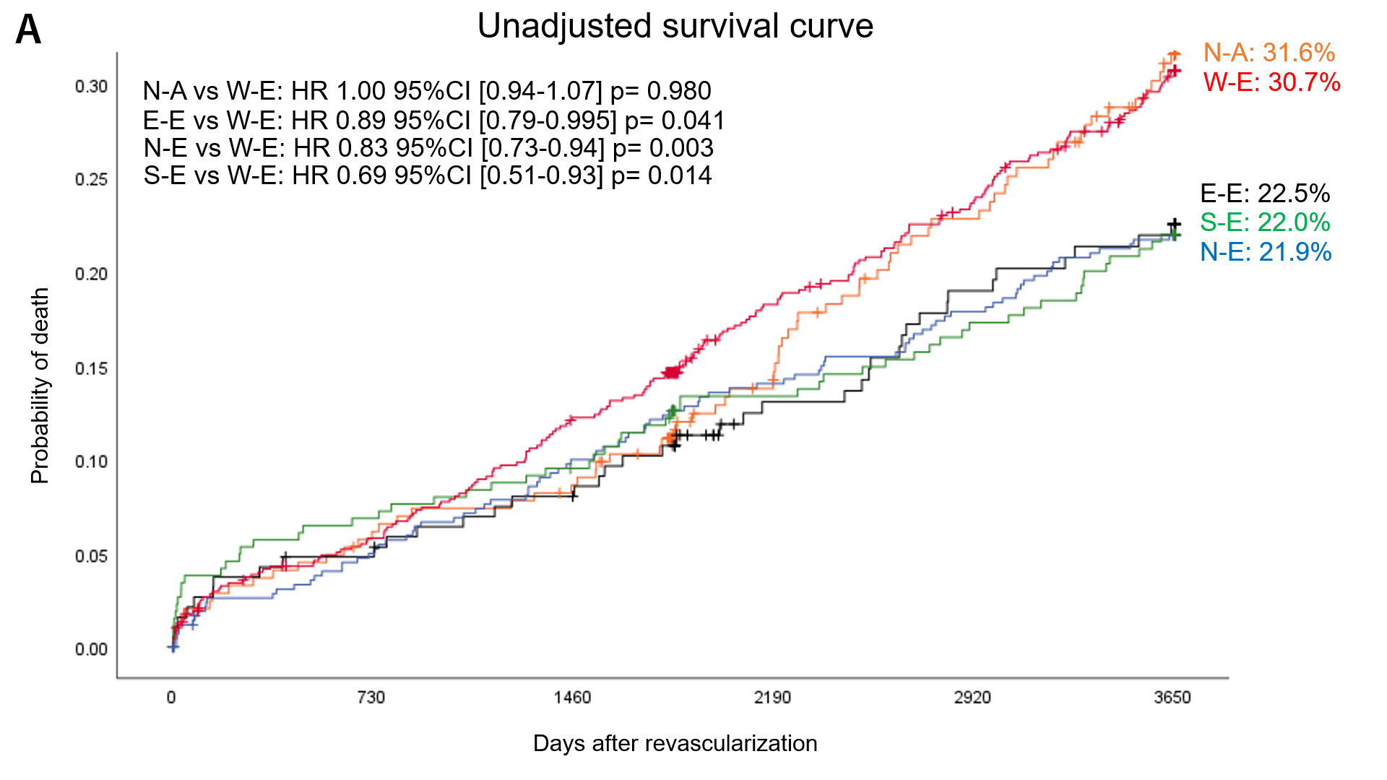
Number at risk
N-A | 245 | 228 | 221 | 191 | 170 | 144
E-E | 189 | 178 | 170 | 147 | 137 | 131
N-E | 425 | 400 | 379 | 359 | 343 | 325
S-E | 263 | 245 | 237 | 221 | 211 | 199
W-E | 678 | 631 | 587 | 518 | 479 | 428

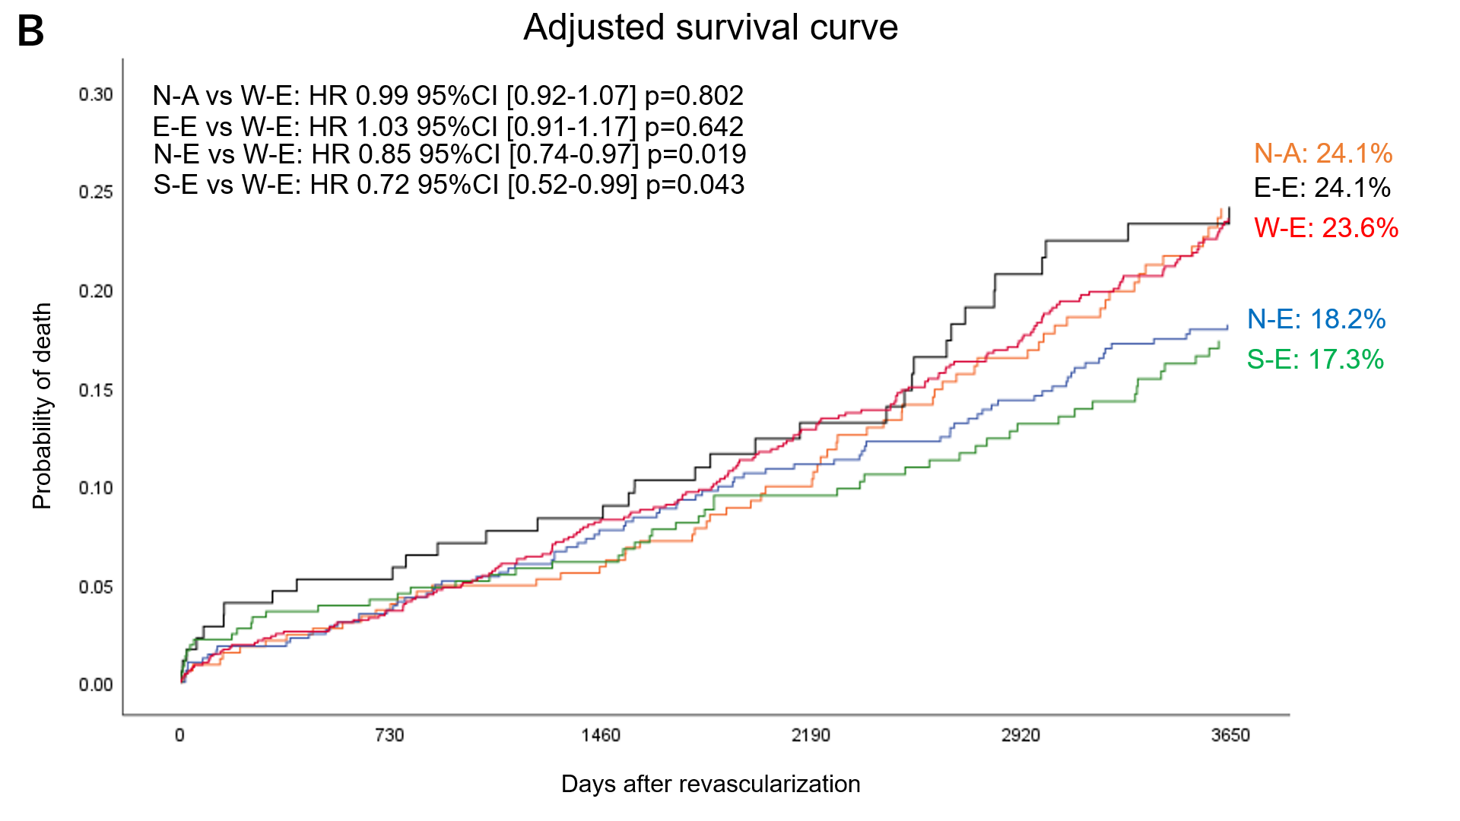

Figure 2A (upper) showed cumulative incidence of mortality (non-adjusted). Figure 2B (lower) showed adjusted survival curve of 5 regions. In each figure, hazard ratios, confidence interval, and p value of 10-year mortality of each region against W-E using Cox regression analysis were presented on left upper side.
Abbreviations: N-A, North America, E-E, Easterm Europe; N-E, Northern Europe; S-E, Southern Europe; W-E, Western Europe

Figure 3. non-adjusted and adjusted survival curve of 5 regions in each treatment arm.
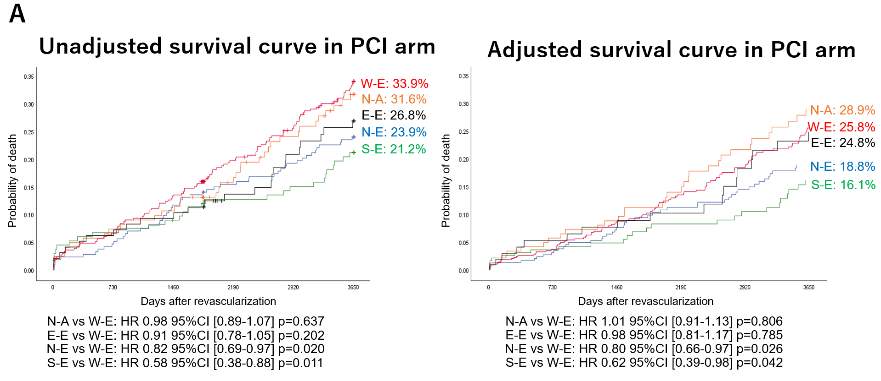
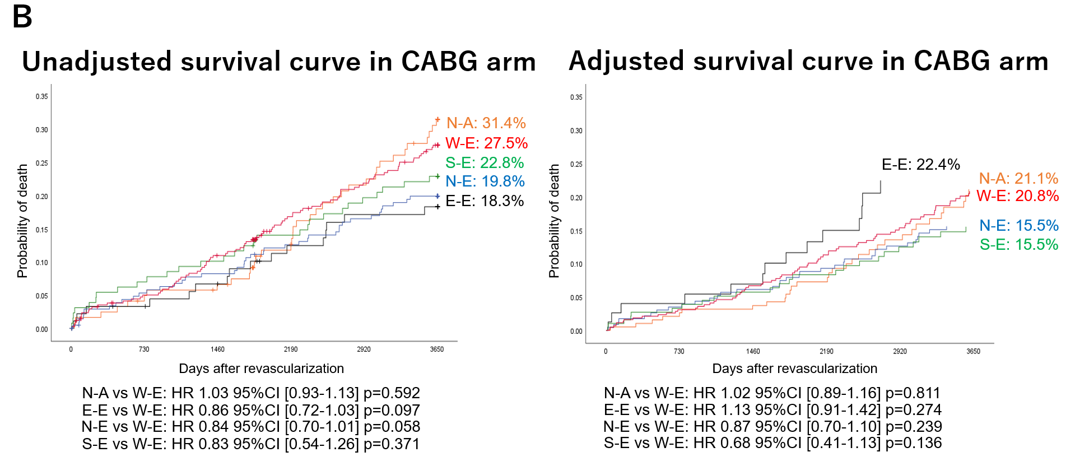

Figure 3A (upper) showed non-adjusted cumulative incidence of mortality (left) and adjusted cumulative incidence of mortality (right) of 5 regions in PCI arm. Figure 3B (lower) showed non-adjusted cumulative incidence of mortality (left) and adjusted cumulative incidence of mortality (right) of 5 regions in CABG arm. In each figure, hazard ratios, confidence interval, and p value of 10-year mortality of each region against W-E using Cox regression analysis were presented on middle lower.
Abbreviations: N-A, North America, E-E, Easterm Europe; N-E, Northern Europe; S-E, Southern Europe; W-E, Western Europe

Figure 4. Bubble chart and forest plot of the relation of observed 10-year mortality between revascularization strategy and regions.
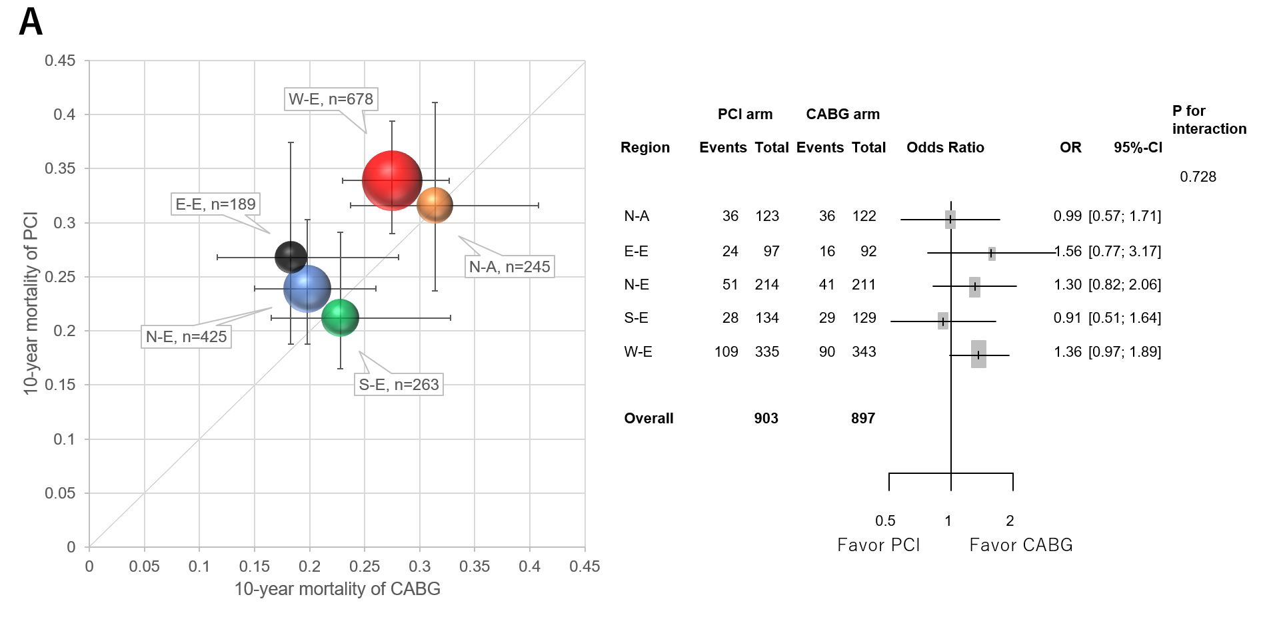
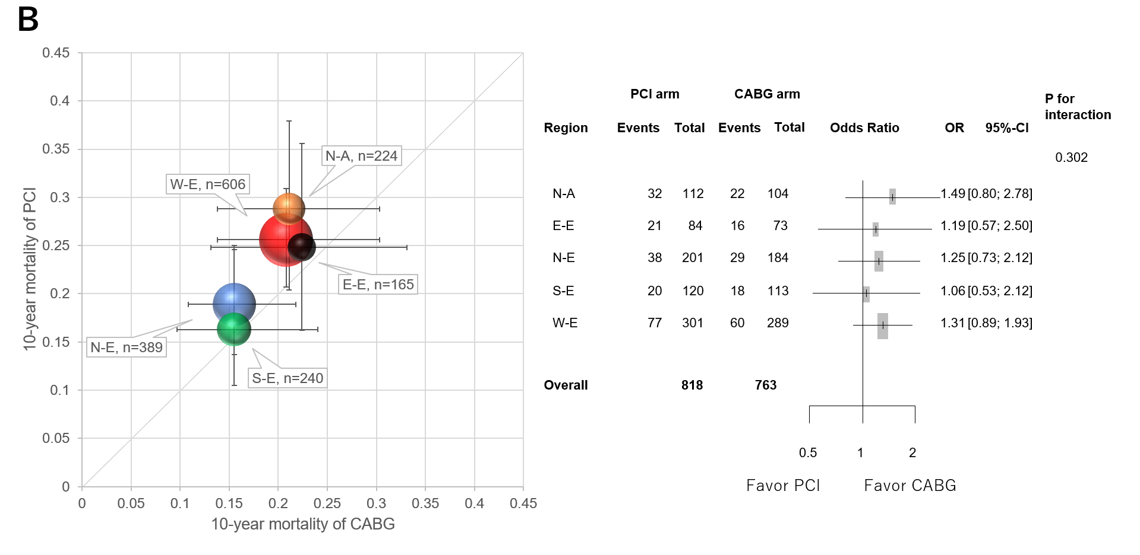

Figure 4A (left side) showed bubble chart of relations between unadjusted 10-year mortality per revascularization strategy and the region. The size of the bubble reflects the patient number of each region. Error bar reflects 95% CI of mortality of PCI or CABG in each group. (right side) showed forest plot presenting hazard ratio of PCI arm against CABG arm in the five 5 regions. P for interaction between revascularization and region was 0.728.
Figure 4B (left side) showed bubble chart of relations between adjusted 10-year mortality per revascularization strategy and the region. (right side) showed forest plot presenting hazard ratio of PCI arm against CABG arm in the five 5 regions. P for interaction between revascularization and region was 0.302.
Abbreviations: PCI, percutaneous coronary intervention; CABG, coronary artery bypass graft; E-E, Eastern Europe; N-E, Northern Europe; S-E, Southern Europe; W-E, Western Europe; N-A, North America; OR, odds ratio; CI, confidence interval.

