Space Charge Characteristics of Natural Ester oil-impregnated Paper with Different Moisture Contents
Hyungjin Yoon, and George Chen, The Tony Davies High Voltage Laboratory, University of Southampton
Abstract— Mineral oil is the most common dielectric liquid for the HVDC converter transformers. However, the natural ester oil receives much attention as an alternative dielectric liquid due to its environmental friendliness and low fire risk. Moisture is one of the most dangerous substances, which accelerates the degradation of oil-paper insulation systems. Thus, this paper investigates the impact of moisture on space charge characteristics of the natural ester oil-impregnated paper by comparing it with the mineral oil-impregnated paper. Space charge accumulation is a typical phenomenon under dc conditions, and its presence can lead to electric field distortion and accelerate insulation ageing. The space charge profiles in oil-impregnated papers with different moisture contents are obtained by the pulsed electroacoustic (PEA) method. It has been found that the hydrophilic characteristic of natural ester oil leads to a slow process of forming heterocharges in the natural ester oil-impregnated paper. On the other hand, the hydrophobic characteristic of mineral oil results in faster heterocharge formation in the mineral oil-impregnated paper.

Index Terms—cellulose, mineral oil, moisture, natural ester oil, pulsed electroacoustic method (PEA), space charge.

I. INTRODUCTION
T
HE surge in energy demand and renewable energy has highlighted the importance of high voltage direct-current (HVDC) technology. The HVDC is a promising technology to transfer bulk power over a long distance. The HVDC converter transformer plays an essential role in the power transmission system [1]. The efficiency of the HVDC power transmission system strongly relies on the HVDC converter transformer's performance [1]. Thus, a suitable insulation system is essential to maintain the reliable operation of the HVDC converter transformer [2]. Mineral oil and cellulose are the primary dielectric materials in an HVDC power transformer [3]. Mineral oils are still widely used as dielectric liquid and heat-transfer mediums in most power transformers. However, mineral oils still face several difficulties, such as high fire risk, low biodegradability, and scarcity [3].
Since natural ester oil is produced from natural resources such as soybean, rapeseed, and canola, it can achieve high biodegradability. Also, natural ester oil has a high fire point (~360°C), so it shows a lower fire risk than mineral oil, which has a low fire point (~160°C) [3]. As a result, natural ester oil has been considered as the alternative to replace mineral oil for HVDC power transformers.
The valve side of the HVDC converter transformer is inevitably exposed to AC, DC, and AC-DC combined electric fields [2]. The space charge accumulation is the phenomenon observed under DC field conditions. Especially, space charge accumulation may give rise to the enhancement of the electric field in specific regions, which may lead to the degradation or the premature breakdown of the insulation system [4]. Therefore, it is vital to investigate the space charge behaviours in the oil-paper insulation system for the stable and reliable operation of the HVDC converter transformers.
Moisture is one of the most undesirable substances in the oil-paper insulation system [5]. Cellulose is a hygroscopic material, so it must be maintained to be dry. However, moisture is produced by the oxidative process and the degradation of the molecular chain once oil-paper insulation systems get aged over many years [6].
During the ageing process, the furfural and acid contents in the dielectric liquid are affected by the moisture level [5]. Thus, the high moisture level can accelerate the degradation of the oil-paper insulation system, which drastically lowers the insulation system's breakdown strength and reduces the transformer's life [5]. Also, moisture aids the depth of charge penetration into the dielectric materials, which may cause higher electric field distortion in the oil-paper system.
Different chemical structures between natural ester oil and mineral oil may cause other impacts on dielectric properties. Therefore, further information is still needed about the natural ester oil whether it is applicable to HVDC apparatus. This paper mainly focused on how different moisture levels affect the space charge dynamics of natural ester oil-impregnated paper in comparison to mineral oil-impregnated paper.

II. Methodology

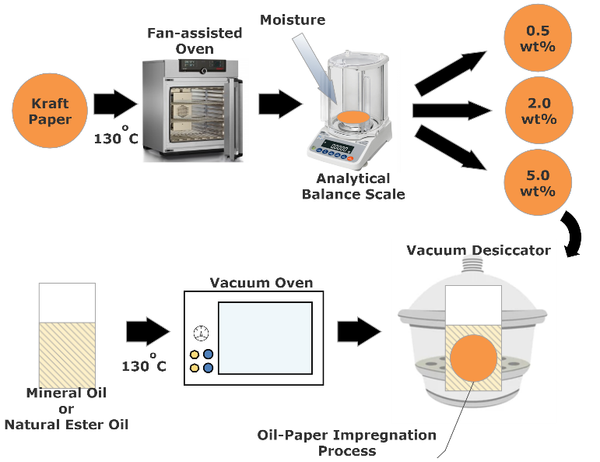
A. Materials and Sample Preparations
Fig. 1. Sample preparation.

Midel eN 1204 was used as the natural ester oil, and Shell Diala 3S ZX-IG was used as the mineral oil. The Kraft paper with 100 µm of thickness was applied to this research. Figure 1 illustrates the sample preparation to investigate how moisture affects the transformer oil-impregnated paper and study the difference between natural ester oil and mineral oil.
Kraft paper is hygroscopic, making it easy to absorb moisture. Thus, the moisture content can be controlled using Kraft paper. Each Kraft paper is 5cm in diameter and 100µm in thickness. To eliminate moisture, Kraft paper was heated in a fan-assisted oven at 130°C for 3 hours. After removing Kraft paper from a fan-assisted oven, it was weighed on an analytical balance. Table 1 illustrates the weight of Kraft paper with different moisture contents.
TABLE I
Weight of Kraft Paper with different Moisture Contents
Weight of Kraft Paper Before absorbing Moisture (g) | Weight of Kraft Paper After Absorbing Moisture (g) | Moisture Contents (wt%)
0.1176 | 0.1182 | 0.50
0.1218 | 0.1244 | 2.01
0.1180 | 0.1241 | 4.91

The moisture level in the HVDC power transformers should be dried as much as possible to avoid effects from the moisture. The moisture content of the cellulose in a new transformer is around 0.5wt%, and it is predicted to increase over the transformer’s lifetime steadily [7]. According to IEC 60422, less than 2.0wt% of the moisture content in transformers is a dry state; 2.0wt%-5.0wt% of the moisture content is considered moderately wet, and over 5.0wt% of the moisture content is an extremely wet state [7]. Thus, Kraft papers with 0.5wt%, 2.0wt%, and 5.0wt% of moisture were prepared, respectively in this study.
Natural ester oil and mineral oil were placed in the vacuum oven for 3 hours at 130°C to reduce moisture. Then, Kraft papers with different moisture contents were impregnated with degassed mineral oil and natural ester oil for 24 hours, respectively. The mass weight ratio between transformer oil and Kraft paper is 10:1 for the oil-paper impregnation process. Before the space charge measurement, the moisture contents of the transformer oils were tested with the Karl Fischer titrator. Also, the Omicron Spectano 100 was introduced to measure the dc conductivity of oil-impregnated papers.

B. Pulsed Electroacoustic (PEA) Method
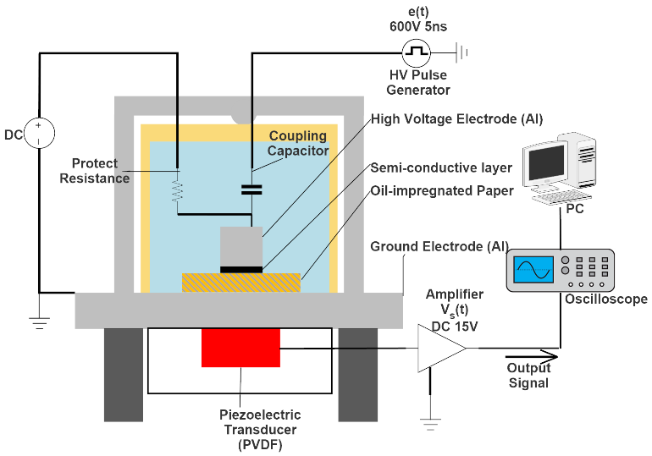
Fig. 2. Overview of the PEA system.

The pulsed electroacoustic (PEA) method is one of the most representative non-destructive techniques for measuring space charge profile. The PEA method does not cause any physical damages on dielectric materials. In addition, it provides both quantitative and qualitative analysis, unlike the destructive method.
As shown in Figure 2, the PEA method contains a HVDC supply, which can generate a high electric field across dielectric samples, and pulse generator, e(t), which produces an acoustic wave via interaction with charges [8]. The acoustic signal generated from charges is converted into a voltage signal by a piezoelectric transducer based on polyvinylidene fluoride (PVDF) [8]. In the final step, the voltage signal is amplified through the amplifier, and a PC receives the output voltage signal for data analysis.
In this paper, a single layer of the natural ester oil-impregnated-paper and mineral oil impregnated-paper with different moisture contents were placed between the ground electrode and the high voltage electrode, respectively. A semi-conductive layer was placed between oil-impregnated papers and the high voltage electrode to improve acoustic impedance matching. In addition, a drop of silicone oil was placed between the dielectric sample and the ground electrode to improve the propagation of the acoustic wave. 20 kV/mm of dc electric field was applied to oil-impregnated papers for 60 minutes to obtain space charge profiles. Then, the applied dc voltage was removed entirely for 60 minutes to investigate the space charge dissipation. Every test was carried out with the new sample to avoid the pre-stressed effect on charge formation in the oil-impregnated paper.

III. EXPERIMENTAL RESULTS

A. Moisture Contents
Figure 3 represents how different moisture contents in Kraft papers affected the natural ester oil and mineral oil, respectively. 1mL of natural ester oil and mineral oil was added to Karl Fischer titrator at room temperature (~20°C) to examine the moisture level. Kraft paper with different moisture levels (0.5wt%, 2.0wt%, and 5.0wt%) was impregnated with the degassed natural ester oil and mineral oil, respectively.
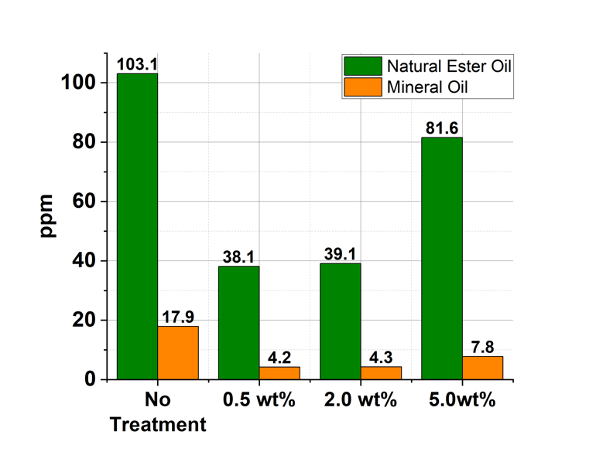
Fig. 3. Moisture Contents (ppm) in natural ester oil and mineral oil with different moisture wt% in Kraft paper.

The natural ester oil without any treatments had 103.1 ppm of moisture. When Kraft paper contained 0.5wt% of the moisture, considered a dry state, was impregnated with the natural ester oil, the moisture level in the oil was about 38.1 ppm. After Kraft paper with 2.0wt% of moisture contents was impregnated with the natural ester oil, it showed 39.1 ppm. 2.0 wt% of moisture in Kraft paper did not significantly influence the increase in moisture in the natural ester oil and mineral oil because 2.0wt% of moisture in Kraft paper was still considered as low as 0.5wt%. However, when Kraft paper with 5.0wt% of moisture was impregnated with degassed natural ester oil, the moisture content in the natural ester oil was much higher (81.58ppm) than samples with 0.5wt% and 2.0wt%. The mineral oil without treatment had 17.93 ppm of moisture contents. When the degassed mineral oil was impregnated with Kraft paper, which contained 0.5wt% of moisture, it showed 4.2 ppm. When Kraft paper had 2.0wt% of moisture contents, the mineral oil had 4.3 ppm. However, after the Kraft paper, which contained extremely high moisture content (5.0wt%), was impregnated with the mineral oil, 7.8 ppm of the moisture level was observed.
Kraft paper is a hygroscopic material that absorbs moisture readily. In the oil-paper insulation system, water is mainly absorbed by cellulose, so it is essential to keep cellulose dry [6]. However, although the Kraft paper had 5.0wt%, mineral oil rarely removed cellulose's moisture due to its hydrophobic characteristics [7]. On the other hand, like cellulose, natural ester oil is a hydrophilic liquid [7]. Hence, when the cellulose contained 5.0wt% of moisture, the natural ester oil absorbed more water (81.6 ppm) from the cellulose than mineral oil.
Triglycerides of natural oil react with water through hydrolysis, which results in long-chain fatty acids [9]. This process consumes dissolved water in the natural ester oil [9]. As a result, it moves extra water from the paper to the natural ester oil to keep the equilibrium [9]. This characteristic of the natural ester oil keeps the cellulose dry, and it can delay the degradation of the cellulose that may occur due to moisture.

B. DC Conductivity
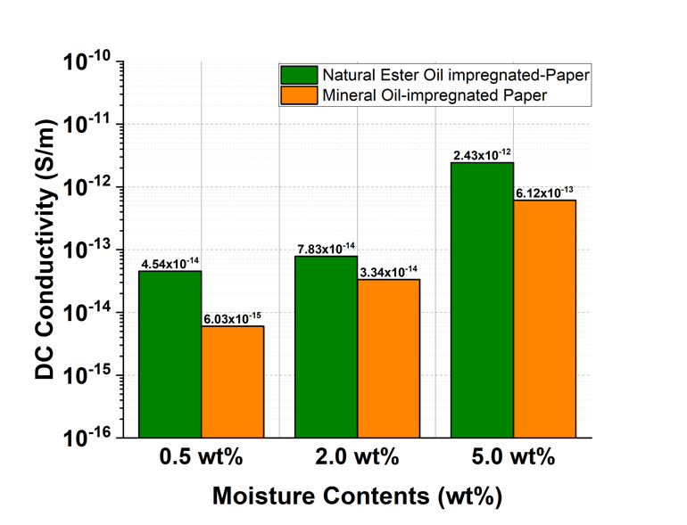
Fig. 4. DC conductivity with different moisture contents.

The polarisation depolarisation current (PDC) method was introduced to measure the quasi-dc conductivity of the oil-impregnated papers. The sweeping frequency from 1.0 mHz to 99 mHz was applied, based on 10 sampling points/decades. Then, 200$V_{dc}$ was applied for the quasi-dc conductivity measurement. The quasi-dc conductivity takes place in the low-frequency range.
Figure 4 represents that as the amount of moisture increased, dc conductivity of both natural ester oil-impregnated paper and mineral oil-impregnated paper also increased. The dc conductivity of the natural ester oil-impregnated paper was $4.54×{10}^{-14}S/m$ (at 0.5wt%), $7.84×{10}^{-14}S/m$ (at 2.0wt%), and $2.43×{10}^{-12}S/m$ (at 5.0wt%). Then, the dc conductivity of the mineral oil-impregnated paper showed $6.03×{10}^{-15}S/m$ (at 0.5wt%), $3.34×{10}^{-14}S/m$ (at 2.0wt%), and $6.12×{10}^{-13}S/m$ (at 5.0wt%).
The result illustrated that the dc conductivity of the natural ester oil-impregnated paper always had higher value than the mineral oil-impregnated paper for the same moisture contents due to a greater affinity of natural ester oil for water. From 0.5 wt% to 5.0wt% of moisture contents, the dc conductivity of the natural ester oil-impregnated paper increased by 53.53 times. However, the dc conductivity of mineral oil-impregnated paper increased by 101.5 times from 0.5wt% to 5.0wt% of moisture contents. Unlike the natural ester oil, the hydrophobic characteristic of mineral oil forced the moisture to stay in the cellulose. This phenomenon increased the dc conductivity of mineral oil-impregnated paper at a faster rate than that of the natural ester oil-impregnated paper with the increase of moisture.

C. Space Charge Characteristics
(a) 0.5wt%
(b) 2.0wt%
(c) 5.0wt%
Fig. 5. Space charge characteristics of the natural ester oil-impregnated paper with different moisture contents.

Under dc conditions, space charges can be injected into oil-impregnated papers. Accumulated charges can enhance the electric field in specific regions [10]. Also, it may accelerate the degradation process of the insulation system. Figure 5 and Figure 6 represent space charge characteristics of the natural ester oil-ipmpregnated paper and mineral oil-impregnated paper with different moisture contents.

(a) 0.5wt%
(b) 2.0wt%
(c) 5.0wt%
Fig. 6. Space charge characteristics of the mineral oil-impregnated paper with different moisture contents.

The electric stress can lower the potential barrier between electrodes and oil-impregnated paper. As a result, obvious homocharges are injected from both electrodes when dc electric field is applied. For dry natural ester oil-impregnated paper (0.5wt%), negative charge injections occurred when the dc field was applied. Then, these negative charges were accumulated initially, but the number of negative charges in the middle of the paper decreased over time due to possibly recombination process. For dry mineral oil-impregnated paper (0.5wt%), negative charges also travelled to the middle of the paper after the dc field was applied. After that, these negative charges were trapped and accumulated in the middle of the paper. However, a relatively lower amount of negative charges were injected in the mineral oil-impregnated paper than in the natural ester oil-impregnated paper.
When the natural ester oil-impregnated paper was moderately wet (2.0wt%), more negative charges were injected from the cathode than the dry state. Also, positive charges travelled from the anode to the middle of the paper because of the higher moisture contents. Then, these positive charges started to be accumulated in the middle of the paper at 60 minutes. When the moisture content was 2.0wt%, similar space charge characteristics were observed in the mineral oil-impregnated paper. However, the difference is that the increase in water caused the higher mobility of positive charges in the mineral oil-impregnated paper, resulting in forming heterocharges in the vicinity of the cathode at 60 minutes.
In the extremely wet condition (5.0wt%), the largest amount of heterocharges in the natural ester oil-impregnated paper were formed in the vicinity of the cathode at 60 minutes. These largest amounts of heterocharges induced negative charges on the cathode, resulting in the highest negative charge peak ($45 C/m^{3}$). On the other hand, natural ester oil-impregnated papers with 0.5wt% and 2.0wt% of moisture had $22 C/m^{3}$ and $30 C/m^{3}$ of negative charge peaks, respectively. When the mineral oil-impregnated paper was extremely wet (5.0wt%), it also showed the largest amount of heterocharges near the cathode, causing the highest negative peak ($38 C/m^{3}$). However, 0.5wt% and 2.0wt% of mineral oil-impregnated papers showed $25 C/m^{3}$ and $27 C/m^{3}$ of negative peaks, respectively.
The difference between the natural ester oil-impregnated paper and mineral oil-impregnated paper was that the mineral oil-impregnated paper caused faster heterocharge formation near the cathode than natural ester oil-impregnated paper in an extremely wet condition. This is probably because mineral oil's hydrophobic properties make water stay in the cellulose, creating more paths for charges, which travelled freely in the mineral oil-impregnated paper. The moisture content of Kraft paper has a major effect on space charge properties, while mineral oil and natural ester oil also have some effect on it. Mineral oil, in other words, repels moisture into the paper, but natural ester oil absorbs moisture from the paper. As a result, once the Kraft paper contains a high moisture content, it may give better mobility to charges, allowing them to travel more easily to the opposite electrode in the mineral oil-impregnated paper.
High moisture levels in oil-impregnated papers are undesirable because it forms heterocharges, which induce charges near the electrodes. Then, heterocharges likely causes enhanced electric field in a specific region.
However, when the moisture content in the Kraft paper is low, the properties of transformer oil are an important consideration in terms of space charge characteristics [11]. Even though the natural ester oil was degassed, the hydrophilic feature of the natural ester oil caused a more considerable amount of moisture than mineral oil, causing the higher dc conductivity in the natural ester oil-impregnated paper [12]. Then, it resulted in that when the natural ester oil had a lower moisture level, it showed a higher amount of negative charges injected from the cathode than the mineral oil.

D. Total Charge Amount
(a) Natural ester oil-impregnated paper
(b) Mineral oil-impregnated paper
Fig. 7. The total amount of charge with different moisture contents.

Figure 7 represents the total amount of charges in both oil-impregnated papers with different moisture contents for 60 minutes. The charge density at both electrodes was excluded in order to investigate the moisture impacts on space charge characteristics. As a result, the results only included charge density in the oil-impregnated paper. The total amount of charges can be calculated based on Equation (1) [13].
$Q_{total}=\int_{0}^{d}{\left|ρ\right|}∙Sdx$ (1)
where, $Q_{total}$ is the total amount of charge, $d$ is the thickness of the sample, $ρ$ is the charge density, $S$ is the area of the electrode. For natural ester oil-impregnated papers, as moisture increased, the total amount of charges increased together. For 0.5wt% and 2.0wt% of moisture contents in the natural ester oil paper, the largest total amount of charges occurred within 10 minutes. After that, it kept decreasing over time due to possibly recombination effect. For 5.0wt% of moisture content in the natural ester oil-impregnated paper, the largest total amount of charges also took place within 10 minutes. Then, it kept decreasing until 30 minutes due to possibly recombination effects. However, from 30 to 60 minutes, the total amount of charges increased again since the heterocharges were formed near the cathode. For 0.5wt%, 2.0wt%, and 5.0wt% of moisture contents, the largest total amount of charges in the natural ester oil-impregnated paper were $1.19×{10}^{-8}C/m^{3}$, $1.36×{10}^{-8}C/m^{3}$, and $1.37×{10}^{-8}C/m^{3}$, respectively. This indicates that the largest total amount of charges in the natural ester oil-impregnated paper increased about 1.15 times in the extremely wet state compared to the dry state.
When the cellulose contained 0.5wt% of moisture content, the total amount of charges in the mineral oil-impregnated paper increased during the first 20 minutes. Then, it kept decreasing due to the recombination effect until it reached out to $2.76×{10}^{-9}C/m^{3}$ of the total amount of charges for 60 minutes. For 2.0wt% of moisture content, the total amount charges in the mineral oil-impregnated paper sharply increased from $4.6×{10}^{-10}C/m^{3}$ to $8.36×{10}^{-9}C/m^{3}$ for the first 4 minutes. Then, it kept decreasing up to 40 minutes due to recombination effects. After that, it slightly increased again due to heterocharge formation near the cathode. For 5.0wt% of moisture contents, the total amount of charges kept increasing over time because of fast heterocharge formation near the cathode and positive charge accumulation in the middle of the paper. As a result, the largest total amount of charges ($1.61×{10}^{-8}C/m^{3}$) in the mineral oil-impregnated paper was formed at 60 minutes. Also, it indicates that the largest total amount of charges in the mineral oil-impregnated paper increased about 2.5 times in the extremely wet state compared to the dry state. The result from space charge profiles shows that the higher moisture in oil-impregnated papers contributed to forming heterocharges, which increased the negative charge peak at the cathode.

E. Electric Field Distortion Rate
Fig. 8. Electric field distortion rate with different moisture contents.

Under dc conditions, space charges can be accumulated in the oil-paper insulation system, causing electric field enhancement in the specific region, which can accelerate the degradation of the insulation system. Figure 8 shows maximum electric field distortion rates with different moisture contents in the natural ester oil-impregnated paper and the mineral oil-impregnated paper. The maximum electric field distortion was calculated based on Equation (2).
$∆E=\frac{E_{max}-E_{applied} }{E_{applied}}×100 (\%)$ (2)
Regarding 0.5wt% and 2.0wt% of moisture contents, the natural ester oil-impregnated paper had 20% and 30% of the maximum electric field distortion rates. On the other hand, the mineral oil-impregnated paper showed 5% and 15% of the maximum electric field distortion rate for 0.5wt% and 2.0wt% of moisture contents. This represents that when the moisture level is low in Kraft papers, the electric field distortion rate in the natural ester oil-impregnated paper was greater than that in the mineral oil-impregnated paper because of its higher moisture contents in the natural ester oil. However, when the moisture content was 5.0wt% in Kraft papers, the maximum electric field distortion rate was 35% for both oil-impregnated papers. In terms of electric field enhancement, mineral oil-impregnated paper is more sensitive to water than natural ester oil-impregnated paper.

F. Space Charge Decay
(a) Natural ester oil-impregnated paper
(b) Mineral oil-impregnated paper
Fig. 9. Total charge decay with different moisture contents.

The space charge decay for the natural ester oil-impregnated paper and the mineral oil impregnated paper was depicted in Figure 9. After removing the dc voltage, the space charge decay was observed for 60 minutes.
Most charges dissipated quickly within the first 10 minutes for the natural ester oil-impregnated paper. This is probably because the natural ester oil had a great affinity for moisture, so the charges had high mobility. Thus, the higher the moisture level, the higher dc conductivity, which led to that charges can easily escape from traps in the natural ester oil-impregnated paper [14]. As a result, fast charge dissipation occurred in the natural ester oil-impregnated paper.
The mineral oil-impregnated paper showed that when Kraft paper had 0.5 wt% and 2.0wt% of moisture contents, it took about 30 minutes to dissipate most charges. However, when the moisture level was high (5.0wt%), the mineral oil-impregnated paper showed that most charges were dissipated within the first 10 minutes. When the moisture contents were low (0.5wt% and 2.0wt%), the rate of charge dissipation was slower in the mineral oil-impregnated paper than that in the natural ester oil-impregnated paper.

IV. Discussion
Unlike a dielectric liquid, cellulose in the HVDC converter transformer is not easily accessible. Thus, it is crucial to investigate the difference between the natural ester oil-impregnated paper and the mineral oil-impregnated paper regarding the impact of the moisture. As shown above, the moisture significantly affects the space charge dynamics of the natural ester oil-impregnated paper and the mineral oil-impregnated paper. When the moisture increases, charges are more likely to have higher mobility [15]. In other words, the increase in moisture facilitates charges to penetrate deeper into the oil-impregnated paper [15].
When the moisture level was low, a smaller amount of charges were injected into the mineral oil- impregnated paper compared to the natural ester oil-impregnated paper. As a result, the mineral oil-impregnated paper showed only 5% of the maximum electric field distortion, while 20% of the maximum electric field distortion rate occurred in the natural ester oil-impregnated paper. In a dry state, although the influence of moisture was subtle, a relatively larger amount of moisture in natural ester oil aided that more charges were injected into cellulose compared to mineral oil. When the moisture level was moderately wet (2.0wt%), it showed a slight heterocharge accumulation in the mineral oil-impregnated paper due to increased mobility of charges, while natural ester oil-impregnated paper did not show the heterocharge accumulation for 60 minutes.

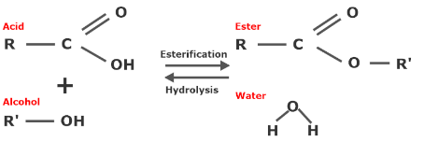
Fig. 10. Esterification process of the ester-based fluid.

When cellulose was extremely wet (5.0wt%), a significant difference was observed between the natural ester oil and mineral oil. The natural ester oil tends to absorb the water through the hydrolysis process, which produces fatty acids, as shown in Figure 10, so this characteristic leads natural ester oil to have a great affinity for moisture [16]. Therefore, when cellulose contains a high moisture level, the natural ester oil captivates the water from cellulose. On the other hand, mineral oil has a hydrophobic property, so when cellulose has a high moisture level, mineral oil forces water to stay in the cellulose. As a result, if the moisture level is high, the mineral oil-impregnated paper is more affected by water than the natural ester oil-impregnated paper. Thus, the mineral oil-impregnated paper forms faster heterocharge accumulations under high moisture level conditions than the natural ester oil-impregnated paper. In addition, the mineral oil-impregnated paper showed a lower maximum electric field distortion rate under low moisture level conditions (0.5wt% and 2.0wt%). However, when cellulose contained a high moisture level (5.0wt%), the same maximum electric field distortion rate was observed in both oil-impregnated papers. This indicates that the great affinity for moisture in the natural ester oil can be advantageous when the cellulose contains high moisture contents. On the other hand, space charge characteristics in the mineral oil-impregnated paper were more susceptible to moisture than that in the natural ester oil-impregnated paper.
After the applied voltage was removed, the space charge decay for both natural ester oil-impregnated paper and mineral oil-impregnated paper was observed. The decay process can be influenced by the charging time and the number of deep traps in the sample [17]. Furthermore, the sample's dc conductivity is the major factor influencing charge decay [18].
In dry conditions (0.5wt%), it seems that the oil properties, rather than moisture, mainly influenced both the natural ester oil-impregnated paper and the mineral oil-impregnated paper in terms of space charge decay. However, when the moisture content of the Kraft paper increases, the interaction of oil and moisture appears to be strongly involved in space charge decay.
In common, even though both oil impregnated-papers accumulated more charges with 5.0wt% of moisture compared to the moisture of 2.0 wt% during the volts-on process, most charges were dissipated more quickly. The higher conductivity caused by higher moisture levels is thought to improve charge mobility [18].
The difference is that if a large amount of moisture is present in the Kraft paper, some moisture can be absorbed by natural ester oil due to the hydrolysis interaction between natural ester oil and the moisture. This characteristic resulted in an only slight increase in the rate of charge dissipation of the natural ester oil-impregnated paper at 5.0wt% moisture compared to 2.0 wt% moisture. On the other hand, there is no hydrolysis process between mineral oil and moisture. Therefore, when the Kraft paper contained 5.0wt% of moisture, most of the moisture remained in the Kraft paper. As a result, the rate of charge dissipation in the mineral oil-impregnated paper increased significantly compared to the condition with 2.0 wt% moisture.

V. Conclusion
This paper investigates the impact of moisture on space charge characteristics of the natural ester oil-impregnated paper and the mineral oil-impregnated paper. By comparing the characteristics of natural ester oil and mineral oil, it is possible to estimate whether natural ester oil may be used as HVDC power transformer oil. Natural ester oil is a hydrophilic liquid, whereas mineral oil is a hydrophobic liquid. Thus, when the Kraft paper contained a high moisture level, natural ester oil absorbed a larger amount of moisture from the Kraft paper than mineral oil. Moisture helped that space charges penetrated deeper into both oil-impregnated papers. As moisture increased, heterocharges accumulated near the cathode, inducing the more negative charges. This caused a high electric field distortion in both oil-impregnated papers near the cathode. The faster heterocharge formation occurred in the mineral oil-impregnated papers compared to the natural ester oil-impregnated paper.
When the moisture content was low, mineral oil-impregnated paper still performed better than the natural ester oil-impregnated paper in terms of the electric field distortion rate. However, the electric field distortion rate in both oil-impregnated papers became similar when the Kraft paper contained 5.0wt % moisture content. This indicates that natural ester oil can provide some benefits in humid conditions. Thus, when the moisture level in Kraft paper is high, natural ester oil-impregnated paper can expect a similar dielectric performance to mineral oil-impregnated paper and the high water solubility of natural ester oil can keep Kraft paper drier [19].
After the applied dc voltage was removed, most space charges in the natural ester oil-impregnated paper decayed rapidly within the first 10 minutes for 0.5wt%, 2.0wt%, and 5.0 wt%. Under the dry state, it took 30 minutes to dissipate most charges in the mineral oil-impregnated paper, which might be disadvantageous for the polarity reversal. Mineral oil is still a decent dielectric liquid in a dry environment. However, in very humid environments, the hydrophobic characteristic of mineral oil can be serious drawbacks for the oil-paper insulation system in the HVDC converter transformer compared to natural ester oil.

Acknowledgment
The authors thank M&I Materials Ltd for providing research materials.

References
[1] Y. Shuai, X. Han, L. Zhang, C. Yang, X. Hu, and H. Wu, “Major insulation design consideration of converter transformer,” C. 2016 - Int. Conf. Cond. Monit. Diagnosis, pp. 1004–1007, 2016.
[2] M. Yea, K. J. Han, J. Park, S. Lee, and J. Choi, “Design optimisation for the insulation of HVDC converter transformers under composite electric stresses,” IEEE Trans. Dielectr. Electr. Insul., vol. 25, no. 1, pp. 253–262, 2018.
[3] S. Maneerot, K. Jariyanurat, P. Nimsanong, and C. Bunlaksananusor, “2018 Condition Monitoring and Diagnosis (CMD),” 2018 Cond. Monit. Diagnosis, pp. 1–4, 2018.
[4] J. Hao, G. Chen, R. Liao, L. Yang, and C. Tang, “Influence of moisture on space charge dynamics in multilayer oil-paper insulation,” IEEE Trans. Dielectr. Electr. Insul., vol. 19, no. 4, pp. 1456–1464, 2012.
[5] X. Wang, C. Tang, B. Huang, J. Hao, and G. Chen, “Review of research progress on the electrical properties and modification of mineral insulating oils used in power transformers,” Energies, vol. 11, no. 3, pp. 1–10, 2018.
[6] T. A. Prevost and T. V. Oommen, “Cellulose insulation in oil-filled power transformers: Part I - History and development,” IEEE Electr. Insul. Mag., vol. 22, no. 1, pp. 28–34, 2006.
[7] C. Perrier and T. Stirl, “Moisture-equilibrium Charts: Monitoring Natural-ester Green Transformers,” Transformers Magazine, vol. 4, no. 2, pp. 98–102, 2018.
[8] G. Ala et al., “Review of acoustic methods for space charge measurement,” in 2015 AEIT International Annual Conference (AEIT), Oct. 2015, pp. 1–6.
[9] K. J. Rapp, C. P. McShane, and J. Luksich, “Interaction mechanisms of natural ester dielectric fluid and Kraft paper,” in 2005 IEEE International Conference on Dielectric Liquids (ICDL), 2005, pp. 393–396.
[10] R. Liu, A. Jaksts, C. Tornkvist, and M. Bergkvist, “Moisture and space charge in oil-impregnated pressboard under HVDC,” in IEEE 6th International Conference on Conduction and Breakdown in Solid Dielectrics (ICSD), 1998, pp. 17–22.
[11] R. Villarroel, B. García de Burgos, and D. F. García, “Moisture dynamics in natural-ester filled transformers,” Int. J. Electr. Power Energy Syst., vol. 124, no. December 2019, pp. 2–3, 2021.
[12] J. Jacob, P. Preetha, and S. Thiruthi Krishnan, “Review on natural ester and nanofluids as an environmental friendly alternative to transformer mineral oil,” IET Nanodielectrics, vol. 3, no. 2, pp. 33–36, Jun. 2020.
[13] B. Huang, Z. Xu, M. Hao, and G. Chen, “Multilayers Oil and Oil-impregnated Pressboard Electric Field Simulation based on Space Charge,” IEEE Trans. Dielectr. Electr. Insul., vol. 26, no. 2, pp. 532–533, 2019.
[14] C. Tang, B. Huang, M. Hao, Z. Xu, J. Hao, and G. Chen, “Progress of space charge research on oil-paper insulation using pulsed electroacoustic techniques,” Energies, vol. 9, no. 1, pp. 1–35, 2016.
[15] L. Che, J. Wu, G. Zhou, Y. Yin, and Q. Wang, “Effect of moisture content on space charge behavior in oil-paper insulation under DC electric field,” IEEE Trans. Dielectr. Electr. Insul., vol. 27, no. 5, pp. 1570–1572, 2020.
[16] R. Liao, J. Hao, G. Chen, Z. Ma, and L. Yang, “A comparative study of physicochemical, dielectric and thermal properties of pressboard insulation impregnated with natural ester and mineral oil,” IEEE Trans. Dielectr. Electr. Insul., vol. 18, no. 5, pp. 1626–1637, 2011.
[17] Z. Xing, C. Zhang, H. Cui, Y. Hai, Q. Wu, and D. Min, “Space charge accumulation and decay in dielectric materials with dual discrete traps,” Appl. Sci., vol. 9, no. 20, p. 2, 2019.
[18] B. Huang, M. Hao, J. Hao, J. Fu, Q. Wang, and G. Chen, “Space charge characteristics in oil and oil- impregnated pressboard and electric field distortion after polarity reversal,” IEEE Trans. Dielectr. Electr. Insul., vol. 23, no. 2, p. 883, 2016.
[19] M. Lashbrook, H. Al-Amin, and R. Martin, “Natural ester and synthetic ester fluids, applications and maintenance,” in 2017 10th Jordan International Electrical and Electronics Engineering Conference, JIEEEC 2017, p. 2, 2017.
Hyungjin Yoon was born in South Korea in 1987. He received the B.Eng degree from the Ohio State University, Columbus, US in 2016, the MSc degree from University of Southampton, Southampton UK in 2018. He is pursuing his PhD degree from University of Southampton, Southampton, UK. His research interests includes space charge behaviours in the natural ester oil-impregnated papers for HVDC converter transformer.
George Chen received his B.Eng. (1983) and M.Sc. (1986) degrees in electrical engineering from Xi'an Jiaotong University, China. After he obtained his Ph.D. degree (1990) from the University of Strathclyde, United Kingdom, he joined the University of Southampton as a postdoctoral research fellow and subsequently became a senior research fellow. In 1997 he was appointed as a research lecturer and promoted to a reader in 2002. He is now the professor of high voltage engineering at the University of Southampton and a visiting professor at Xi'an Jiao tong University.

Research materials were supported in part by M&I Materials Ltd (Corresponding author: H. Yoon). Hyungjin Yoon is with the Tony Davies High Voltage Laboratory, University of Southampton, Southampton SO17 1BJ United Kingdom (e-mail: hy1y17@soton.ac.uk). George Chen is with the Tony Davies High Voltage Laboratory, University of Southampton, Southampton SO17 1BJ United Kingdom (e-mail: gc@ecs.soton.ac.uk).

