Feasibility of Space charge measurements on HVDC cable joints
Study Group – IEEE DEIS Technical Committee “HVDC cable and systems”

SG members | Initials
Antonios Tzimas (Advanced Energy, HV products group) (study group leader) | AT
Bassel Diban (Secretary, University of Bologna, Italy) | BD
Ludovic Boyer (SuperGrid Institute, France) | LB
George Chen (University of Southampton UK) | GC
Jérôme Castellon (University of Montpellier, France) | JC
Nathanail Chitiris (Hellenic cables, Greece) | NC
John Fothergill (City University London UK) | JF
Naohiro Hozumi (Toyohashi University of Technology, Toyohashi, Japan) | NH
Yoonhyoung Kim (LS cable systems, South Korea) | YK
June-Ho Lee (Hoseo University, South Korea) | JHL
Frank Mauseth (NTNU-Trondheim University, Norway) | FM
Giovanni Mazzanti (chairman of TC, University of Bologna, Italy) | GM
Peter Morshuis ("Solid dielectric solutions", the Netherlands) | PM
Ivan Troia (Scapa Italia SpA, Italy) | IT
Yasuhiro Tanaka (Tokyo City University, Japan) | YT
Kai Wu (Xi’an Jiaotong University, China) | KW

Summary: The first time that the feasibility of space charge measurements on full sized HVDC cable joints has been explicitly considered and whether the PEA and TSM techniques could be utilized.

Introduction
In order to ensure uninterrupted power delivery from remotely located wind farms to urban centers; a number of generation, transmission and distribution assets will have to operate seamlessly and reliably. The power transfer of renewable sources must frequently transition different environments: sea, land and occasionally both, relying on the design and built-in resilience of HVDC cable systems [1]. Despite the infancy of insulating material used in HVDC cable systems the voltage levels of these transmission lines are continuously increasing with the German corridor (North Sea to south Germany) planning for 525kV [2]. Logistical constraints on land dictates the length of cable that can be transported ranging from ~1 km to 2.2 km [3] implying a relatively large number of HVDC field joints. In DC designs, dielectric interfaces within the joint structure can act as centers of space charge accumulation; this complicates further the design, qualification and operational longevity of HVDC cable joints. There can be challenges related to trapped space charges within the insulation system that can cause a potential threat to the reliability of the cable system. Trapped space charge can give rise to locally high field stresses, especially at interfaces and with temperature gradients, that could initiate insulation breakdown.
The Technical Committee on HVDC Cable Systems has developed an IEEE Std. 1732-2017 “Recommended practice for space charge measurements in HVDC extruded cables for rated voltages up to 550 kV” and it is natural to evolve this standard to include space charge measurement on HVDC joints [4]. However, complex material interfaces as well as material layer thicknesses (~100mm) and non-uniform axially geometries at cable ends magnify the technical challenges of space charge measurement on cable joints.
In this article, the feasibility of space charge measurements on full sized HVDC cable joints is studied and the applicability of space charge measurements techniques such as the pulsed electro acoustic (PEA) and thermal step method (TSM) is considered. The ability to perform space charge measurements on full-sized cable joints presents benefit to the designers as localized field enhancement can be identified and mitigated. Space charge measurements on full sized cable joints could also provide an insight into charge profile modifications before, during and potentially after type tests or prequalification tests. The ability to measure the space charge profile in service may also provide an online monitoring tool for the health and longevity of the joints.
Unfortunately, very limited data is available on HVDC underground transmission lines where polymeric insulation is utilized at the maximum available rated voltages greater than 400kV. However, experience with HVAC cable systems [5] has shown that 19% of failures occur on lightning impulse voltage testing with failures also occurring during operation following SAT (site acceptance test). In [6] where HV joints had suffered from poor manufacturing and installation, a large number of joints failed during energization of the line. Typical breakdown paths in DC vs AC cable joints are shown in Figure 1: in AC these typically initiate from the conductor shielding material geometry whilst in DC, breakdown paths can occur closer to the cable semiconductor screen and pre-molded cable joint interfaces.
It should be highlighted that space charge accumulation is not the direct root cause of failure of both cases shown in Figure 1 which is a schematic and is not intended to be geometrically representative of a real joint. The failure in the DC case (350kV rated cable joint) is related with the quality of the insulation surface and therefore with the method used for the preparation of the cable end in order to remove the outer semiconductive screen. Possible causes of the failure are the local charge accumulation and field enhancement at asperities along the interface; degradation and subsequent electrical tree growth may occur possibly due to hot electrons and/or local electron avalanches [7].
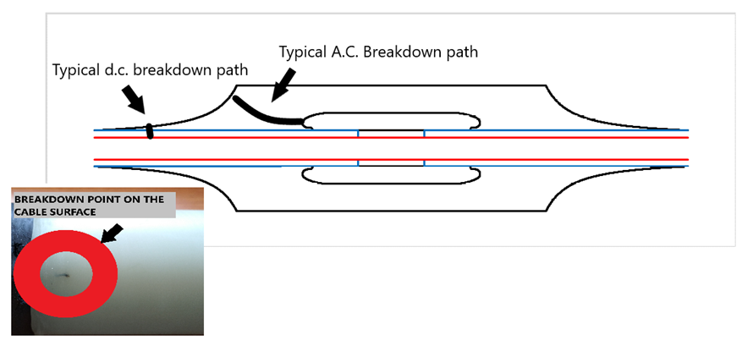
Figure 1. Typical breakdown paths in A.C. [Photo adapted 6]. vs D.C. (with permission from Hellenic Cables) cable joints.

HVDC joint technology and focus
Among the many issues and challenges that HVDC extruded cable systems are facing [1,8], one of the main is the development of long-lasting and reliable accessories, i.e., joints and terminations [4]. In particular, joints, whose number is huge in long underground HVDC interconnections, are crucial for cable system reliability [9]. The IEEE DEIS Technical Committee (TC) on “HVDC Cable Systems (Cables, Joints and Terminations)” has studied HVDC extruded cable system joints extensively, focusing on the two most used types of joints, namely [10]: factory joints (i.e., joints between extrusion lengths manufactured under controlled factory conditions, see Fig. 2.a) and prefabricated - or pre-molded - joints (i.e., joints where the main insulation is elastomeric and moulded prior to its application onto cable ends, see Fig. 2.b).
As illustrated in [11, 12], the TC singled out a lack of standardized tests on joints in general, thereby focusing on the development of new techniques to characterize joints. Two innovative electrical techniques were identified:
- space charge (SC) measurements, still quite challenging for full-sized joints (see below);
- partial discharge (PD) measurements, recommended in CIGRÉ TB 496 [13] and IEC Std. 62895 [14].
For these reasons, the TC started its standardization activity on joints by developing a detailed procedure for PD measurements under AC voltage with VHF/UHF sensors during routine tests on factory and pre-molded joints of HVDC extruded cable systems up to 800 kV; this procedure is recommended in IEEE Std. 2862-2020 [15].
However, SC accumulation under DC voltage application remains a major issue not only for HVDC extruded cables, but also for HVDC extruded cable joints. Due to the complexity of converting the raw acquired signal to charge density only a generic indication of the expected resolution can be given of microns to several millimeters for the PEA and TSM techniques respectively. This is mainly because SC tends to accumulate on the interfaces between the various insulating and semi conductive layers which compose HVDC cable joints, distorting the electric field distribution and fostering an increased aging and possibly premature failure of the joint [16, 17]. It is worth recalling [11] that multi-layering is used in the joint ensure [10]:
- an even distribution of voltage/field between the conductor and ground for all cable operating conditions;
- the elimination of voids at the interfaces between the cable and the joint body;
- the conduction of charging/fault currents to ground via a proper metallic screen/sheath;
- physical protection against the outer environment.
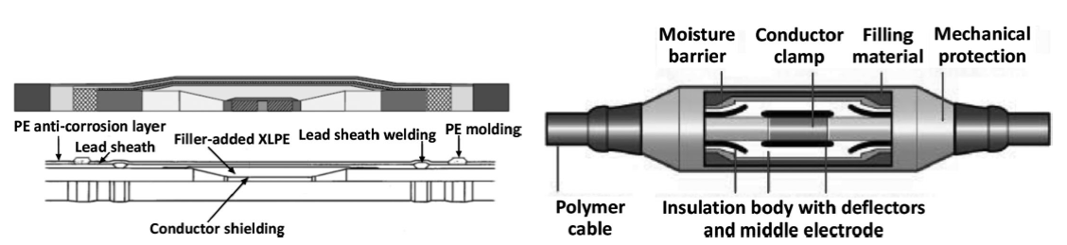
(a) (b)
Figure 2. (a) Factory joint for HVDC submarine cable and (b) pre-molded joint for HVDC land cable, after [4, 10].

To address the challenges of SC accumulation at joint interfaces in HVDC extruded cable system joints, the TC has decided to create a Study Group (SG) with the aim of assessing the feasibility of the development of a standard for the measurement of space charge on full sized HVDC extruded cable system joints. Such a standard would follow and integrate the parallel work done by the TC in developing IEEE Std. 1732-2017, which recommends a best practice for the measurement of space charges in full sizecables during qualification tests [18]. This position paper aims at illustrating the starting of the activities carried out by the SG from the viewpoint of the assessment of the state of the art in the measurement of SC in HVDC extruded cable system joints.

Brief review of SC measurements on full sized cables and HVDC joints
In the literature, several analyses using computer simulation (see, e.g. [19, 20, 21]) and experimental studies (see [22] for a review) have been used to predict and to measure, respectively, the distribution of space charge in the insulation of HVDC cables, particularly of the extruded type.
Focusing on SC measurements, the majority of studies are carried out on flat thin specimens due to the difficulties accompanied with measurements on thick cables. However, particularly in the last two decades, there have been many studies showing promising results on SC measurements in full-sized cable insulation using the Pulse-Electro-Acoustic (PEA) and the Thermal Step Method (TSM) techniques [22].
Even more difficulties are found when measuring SC on joints, mainly because of the thickness and the multi-layered structure of joint insulation. Below we will show the current status of SC measuring techniques on both cables and joints:
- Space charge measurement in Cables:
The PEA method for SC measurement can be applied to both flat specimens and full-sized coaxial cables by removing the thermoplastic sheath and the metallic screen. A detecting electrode is applied directly on the outer semi conductive layer, followed by a piezoelectric device. These are both covered by an acoustic absorber which prevents possible reflections of the waves into the piezoelectric transducer to avoid disturbing the PEA signal. The applied voltage pulse exerts a force on the stored SC thereby generating two pressure waves which travel towards the corresponding two electrodes. The piezoelectric transducer converts one of these pressure waves into a voltage proportional to the stored charge [11]. These arrangements are shown in Figure 3.
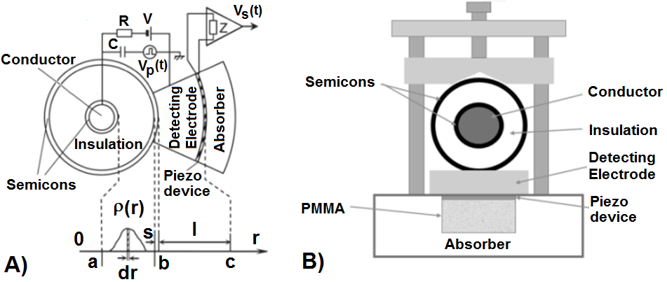
Figure 3. cross section of PEA cell with the measured cable. (A) coaxial cell (B) flat cell, after [11].
The TSM method has been developed at the University of Montpellier, France, as a non-destructive technique for SC measurements [11]. TSM can be applied on both flat specimens and full-sized cables. In TSM method, the cable is in an electrostatic equilibrium, either with an applied voltage or under short circuit. Then, the space charge within the insulation will induce charges at the inner and outer semiconductive layers. A thermal step (TS) is applied through the insulation disturbing the electrostatic equilibrium in the cable. This disturbance induces a rearrangement of the induced charges which is usually measured with a current amplifier. The disturbance happens mainly due to the thermal contraction and expansion which leads to a reversible movement of SC in the insulation, in addition to the weak variation in the permittivity with the temperature. This current, after processing, gives the space charge distribution inside the insulation. In cables, the TS can be generated by the so-called outer cooling technique (OCT) for local analysis of the cable (20 to 50 cm) or either by the inner heating technique (IHT) or outer heating technique (OHT) for measurements on the whole cable length using a high conductor or metallic screen current (several kA), respectively. SC measurements under DC requires the application of double capacitor configuration where a compensation cable, which is identical to the measured cable, is connected as shown in Fig. 4. The aim of the compensation cable is to compensate the polarization and conduction current during the measurement [23].
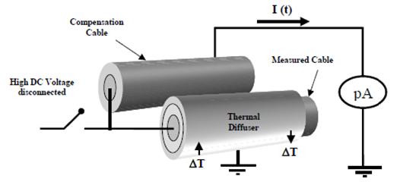
Figure 4. TSM space charge measurement in double capacitor configuration, after [24].
- Space charge measurement in Joints:
The difficulties related to SC measurements in joints are related with the joint structure (see above section on HVDC joint technology and focus) and can be summarized as follows [11]: 1) the attenuation of SC measuring signal due to the great dimensions of the joints compared to cables that induces a significant decrease in sample capacitance; 2) the complexity of the structure of joints compared to that of cables; and 3) the installation issues of PEA and TSM cells due to the difficulties of reaching the joint’s insulation. For these reasons, SC measurements have been mainly limited to flat specimens or small-sized cables that have the same multi-layered insulation structure as the joints.
There have been many studies of measurements on mini cables insulated by two layers to simulate joints. In [25], TSM was applied on a 2-layer insulation to study space charge accumulation within the insulation. In [26, 27, 28, 29, 30, 31, 32, 33] PEA was applied on a 2-layer insulation to study space charge accumulation within the different insulating materials. In [34, 35, 36, 37], the authors investigated the effect of semicon/insulation and insulation/insulation interfaces on the space charge accumulation and the electric field distribution in the insulation using PEA method.

PEA calibration and measurement techniques
There have been many developments of the PEA calibration and measurement techniques on single layer insulation [38]. The technique used in [39] allows the application of an HV pulse directly on the PEA cell without the need to remove the outer semi conductive layer; it also results in a strong measured signal with reduced distortion. Bodega et al. in [40, 41] investigated the difficulties of SC measurements in multi-dielectrics using PEA, where the measured acoustic signal does not accurately reflect the SC distribution due to the variation in the permittivity and/or acoustic properties. Both PEA and TSM have been successfully applied on full sized cables up to 320kV with an insulation thickness of 25 mm [42, 43]. The PEA measurement was successfully performed on a layered 88 mm thick polyethylene slab specimen in [44]. In [45] a lock-in calibration technique was proposed to achieve the calibration at the same time as the signal acquisition from the measured specimen. In [46], the measurement sensitivity was noticeably increased by replacing the metallic acoustic coupler by a polymeric acoustic coupler. Another development affects the length of the measured cable, TSM can provide measurements over 50 cm of cable length by using OCT/OHT or on a full cable length by using IHT [47], whereas PEA with a single sensor can be only applied on a thin layer of the cable in the range of cm depending on the acoustic sensor diameter [48]. In [49, 50], PEA was used for measuring SC in a thick joint using a 2D multichannel sensor array to scan the longitudinal SC distribution in a length comparable to that of TSM. In [51], the authors proposed a numerical model for calibration and interpretation of PEA measurement signals without applying a deconvolution algorithm. Other studies investigated the space charge distribution in sandwich-structured nanocomposites and the effect of insulations or nanocomposites interfaces on space charge injection, accumulation and traps. [52, 53, 54, 55].
Simulation and models were also used in the literature to study SC and electric field behavior in the presence of different types of interfaces in joints, the authors in [56, 57] investigated SC in 2-layer cable insulation using a bipolar charge transport model. Whereas, [27, 33] used quantum chemical calculation to explain SC accumulation in 2-layer insulations and a Q(t) (current integration) method to investigate the SC accumulation characteristics. The Maxwell-Wagner macroscopic model was used in [58, 59, 60] to study the electric field behavior in insulation/insulation interface as a function of the conductivity.

Space charge measurement challenges
The technical challenges with both PEA and TSM space charge measurement techniques lie with the application of HV pulse and thermal steps respectively. For the PEA technique, it is necessary to tune the amplitude, width and frequency of the HV pulse in order to induce a reproducible acoustic signal detected by an acoustic sensor. On the other hand, for the TSM technique the thermal shock temperature difference needs to be high enough to allow the propagation of the thermal wave through the width of the insulation and generate a reproducible current signal without significantly affecting the permittivity or the overall thermal equilibrium. For both space charge measurement techniques, the multiple dielectric material interfaces within a HVDC cable joint present a challenge because of the mismatching of different properties that will affect the shape of the unprocessed electrical profile and challenge the reconstruction of the space charge profile. As the dielectric material properties depend on the thermal as well as the electrical conditions imposed on the cable joint, any thermal gradient across the insulating materials will have a direct impact on the space charge profile. Thus, the thermal as well as the electrical conditions need to remain stable at the time of space charge measurements in order to ensure reproducibility [43, 48].

TSM challenges and opportunities
The TSM current magnitude is directly proportional to the sample capacitance crossed by the thermal step. On the other hand, the TSM current magnitude is also influenced by the global cable system capacitance.
An opportunity would be to locally apply thermal steps or to limit the measuring electrode surface to selectively characterize sections of the studied joint at the expense of the use of a measurement system with a high signal to noise ratio. Possible implementations are illustrated below in Figure 5. The stress cone illustrated in Figures 5 and 6 is a commercial shield break joint, it is not symmetrical in order to allow for the TSM measurement to be performed from the stress cone itself when the thermal shock is applied from the conductor.
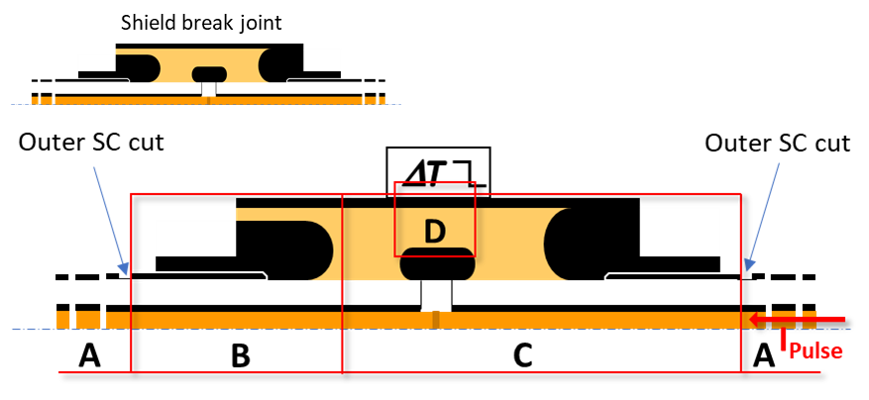
Figure 5: Illustration of possible opportunities to locally characterize space charge distribution in a joint using TSM.
Sections A are plain cable and would be characterized as already presented in the literature [43, 47]. Sections B and C would require the inner heating technique while the characterization of potion D requires the outer cooling technique. Limitation of the measuring electrode surface implies to cut a small section of the cable outer semiconductor which makes the measurement intrusive. As detailed in [61], a thermal step crossing a dielectric induces a rearrangement of influence charges measured by a current amplifier When the thermal step has crossed the dielectric thickness, no TSM current is measured as no rearrangement of influence charges occurs.
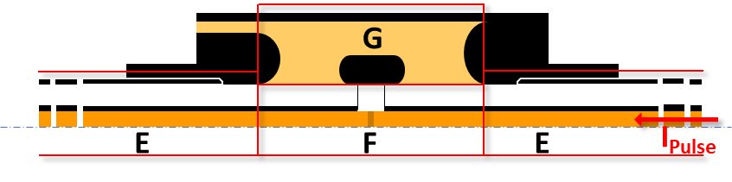
Figure 6: Cable and joint sections potentially characterized non-intrusively.
Using the inner heating technique, a current pulse could be applied to the cable conductor [24, 47]. The thermal wave crossing the cable insulation would induce a TSM current contributed only by the sections E and F from Figure 6. When entering the joint, the resulting TSM current would be contributed solely by sections F and G. In this case, sections F and G could be considered as a two layered composite material with different permittivities and conductivities. Such application of TSM would require a current measurement system with a high sensitivity and a setup allowing for a high signal to noise ratio as it is expected that the TSM current magnitude induced by section F and G will be much lower than the one from sections E. Specific techniques would also have to be developed to process such measurements. At least two consecutive TSM current measurements will have to be taken to ensure reproducibility before a third TSM current measurement is recorded for space charge profile reconstruction. Poor signal to noise ratio may also require more than two consecutive measurements for low TSM current magnitudes and signal conditioning. Moreover, signal filtering techniques could be applied. Separation between cable and accessory could also be performed if capacitance modification is required to improve the signal to noise ratio.
Thus, non-intrusive space charge characterization with a discrimination between cable and joint could be considered depending on the configuration of the system and the thermal step application technique.

PEA challenges and opportunities
Measurement of the space charge distribution in joints is complicated for a number of reasons. In the following, the complications will be detailed and potential solutions will be discussed.
The total traveling distance of the acoustic signal is large, reducing the signal to noise ratio;
PEA systems commonly use a thick aluminum block to delay the acoustic signal with respect to the pulse voltage. As a consequence, the interference of the pulse voltage noise with the PEA signal is minimized, and signal reflections are delayed so they will appear outside the signal of interest. The drawback of this method is that the acoustic matching between the joint and the metal coupling medium is poor, resulting in a reflection and a reduction in the acoustic energy transfer rate. Furthermore, a reflection occurs at the interface between the metallic coupler and the piezoelectric sensor. To avoid multiple reflections in the sensor and broaden the frequency range, often a polymeric backing material is applied behind the acoustic sensor, with an acoustic impedance close to that of the sensor. As a result, most of the signal received by the acoustic sensor propagates into the backing material.
Recent developments at Toyohashi University of Technology [49] have shown that a significant increase in the signal detected by the sensor can be obtained by using a polymeric acoustic coupler such as Poly(methyl methacrylate) (PMMA) or polystyrene. Thus, a good acoustic matching between the joint, the acoustic coupler and the polyvinylidene difluoride (PVDF) sensor is obtained. Additionally, a high-acoustic-impedance material is used as the backing material, resulting in a positive reflection at the back of the sensor. The pressure pulse detected by the sensor can be expressed as:
$p∝\frac{2Z_{1}}{Z_{1}+Z_{0}}∙\frac{2Z_{2}}{Z_{2}+Z_{1}}∙\left(1+\frac{Z_{3}-Z_{2}}{Z_{3}+Z_{2}}\right)$ equation (1)
with Z_{o} the acoustic impedance of the joint insulation, Z₁ the acoustic impedance of the acoustic coupler, Z₂ the acoustic impedance of the sensor and Z₃ the acoustic impedance of the backing material.
Table 1 - Acoustic impedance of materials in the acoustic signal path
Acoustic impedance | Classic (aluminum coupler and polymeric backing material)  [kg m⁻² s⁻¹] | New (polymeric coupler and metal backing material)  [kg m⁻² s⁻¹]
Z₀ (EPDM) | 1.2x10⁶ | 1.2x10⁶
Z₁ | 17x10⁶ | 3.2x10⁶
Z₂ | 4x10⁶ | 4x10⁶
Z₃ | 3.2x10⁶ | 38x10⁶
Taking approximate values for the acoustic impedances presented in Table 1, the ratio between the pulse detected by the new method and the classic method can be calculated:
$\frac{p_{new}}{p_{classic}}≈\frac{2.9}{0.63}≈4.6$ equation (2)
The new method has proven to be very sensitive in practice, by measurements on full-size HVDC cables and joints.
Due to the complex geometry of the joint, PEA measurements are required along the length of the joint.
This challenge can be addressed by placing an array of sensors along the length of the joint and reading the detected signals consecutively, as is shown in Figure 7 and Figure 8 [50].
The acoustic signal travels through a number of materials, each having different acoustic properties.
Processing of the detected PEA signal and correcting for the different acoustic parameters, such as acoustic velocity, impedance, attenuation and dispersion is a major challenge. For the conversion of the PEA signal to local charge density in the joint, the joint transfer function and the PEA measurement inverse transfer functions are needed. While the latter is quite easily obtained, the former is much more difficult to obtain. A new and alternative solution to address this problem is to determine the transfer function of the joint through matching a full acoustic model with the results of a reference PEA measurement. The thus obtained joint transfer function allows to calculate the PEA signal for any space charge distribution in the joint. By matching a PEA measurement result with a result obtained by using the joint transfer function, an estimation of the space charge distribution in the joint is obtained. Added advantage is that acoustic reflections are also taken into account in the transfer function, preventing a wrong analysis of measured PEA signals.

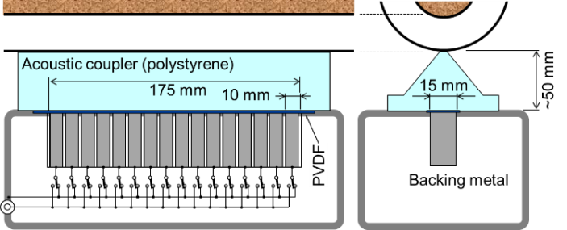
Figure 7 - PEA system with sensor array, allowing space charge measurement along the length of the joint [50].
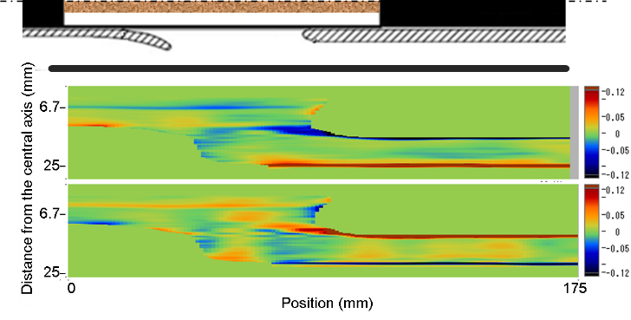
Figure 8 - Space charge profiles in a model joint obtained with the sensor array and polymeric acoustic coupler [50]. Please note that the color intensity is arbitrary.

Discussion
In the context of the need to vigorously develop clean and renewable energy, high voltage direct current (HVDC) technology has developed rapidly. Among the parameters related to cables, space charge is the key index to evaluate the health state of cable insulation. Therefore, the establishment of a corresponding space charge detection system suitable for power cables is of great significance to ensure its safe operation. Cable accessories, especially cable joints, have become the biggest weak link of the whole cable system, so it is particularly important to detect their health status through space charge detection techniques. At present, research [44, 45, 49] has improved the PEA detection system towards miniaturization of the pulse generation circuitry [44], which can greatly improve the practicability of the PEA detection system. The key parameters of cable insulation charge transport can be obtained through space charge detection system, and the change of internal charge transport state of insulation can be analyzed. It can provide effective design solutions and measurements for real-time monitoring of cable insulation status and potentially reducing power system faults [4], by promoting the safe and stable operation of cable systems. The power outages caused by cable insulation failure could be minimized by utilizing space charge measurements during the design of cable joints and during the subsequent type tests and prequalification programs [13, 14].
The most interesting information from the joint structure is indeed at the interfaces between the various dielectric materials and around the stress relief cone. The expected resolution of the two space charge measurement techniques will depend on the magnitude of the pulse, high voltage or thermal, depending on the space charge measurement techniques utilized and subsequently where the pulse is applied. At this stage, the study group has highlighted in this article the challenges and potential opportunities of the two space charge measurement techniques of pulse application. The potential measurable thickness will be limited by the measurement systems impulse voltage and sensitivity on the measurement side. For TSM, the thermal "pulse" travel time will increase by increased thickness. Thus, the resulting current will have to be measured for a long time greater than 5 mins. This is acceptable for “DC steady state” measurements, but for prolonged measurement duration, stability may prove challenging. However, as it is mentioned above, the TSM could be applied at the stress relief cone and that would potentially allow for a better sensitivity around the stress cone interface. Both space charge measurement techniques have inherent limitation with regards to the resolution, the TSM provides excellent resolution at the side where the thermal shock (ΔT) is applied but the change in temperature throughout the sample is slow and the resolution on the other side is low. On the other hand, the PEA technique could provide a better resolution than the TSM across the thickness of the joint and the internal conductor interface. Unfortunately, due to the complexity of converting the raw acquired signal to charge density only a generic indication of the expected resolution can be given of µm microns to several millimeters for the PEA and TSM techniques respectively. The resolution at the dielectric interfaces present with the joint structure will also depend highly on the quality of the interface to be free of discontinuities, physical and chemical, as well as how well the thermal and electrical properties are matched. Both techniques may be used complimentary to build a better space charge and eventually electric field distribution at the dielectric interfaces. However, at this stage due to the practical challenges presented a qualitative analysis is the natural next step forward.
Type test and prequalification programs [13] are already imposing a significant financial and time burden of HVDC cable system projects. Thus, a potential standard on space charge measurements on joints would need to be aligned with test programs recommended by existing standards [13, 14, 15, 18]. This imposes challenges on the timing of the space charge measurements and thermal profile of across the different material interfaces at various power loading conditions. Compared with the flat sample, the thickness of cable insulation layer and its joint insulation jacket is larger, and the signal obtained by PEA method weaker with reduced signal to noise ratio. As cable joints are generally made of soft materials such as silicone rubber when high-frequency sound waves are transmitted inside, there will be strong sound absorption, which further aggravates the distortion of the final waveform obtained. The waveform recovery becomes more difficult when a temperature gradient exists. For a cable or a film sample, an algorithm has been developed with a quadratic item introduced to describe the signal dispersion [62,63]. This algorithm still needs developing for a cable joint to take into account the acoustic reflection at the interface. Despite the challenges of space charge measurements on full size cable joints there are also substantial opportunities for the implementation of and development of the PEA and TSM techniques which this study group has introduced in this article.

Summary and future SG work
In this article the feasibility of space charge measurements on full sized HVDC cable joints has been reviewed by a dedicated Study Group from the IEEE Technical committee on HVDC cable and systems. The study group has reviewed the applicability of space charge measurements techniques such as the Pulsed Electro Acoustic (PEA) and Thermal Step Method (TSM) on full HVDC cable joints. The ability to perform space charge measurements on full-sized cable joints can be beneficial to the designers as localized field enhancement can be identified and mitigated and also as a potential online monitoring tool when a nondestructive application is possible. Space charge measurements on full sized cable joints could also provide an insight into the charge profile modifications before, during and potentially after Type Tests or Prequalification Tests. The ability to measure the space charge profile in service may also provide an online monitoring tool for the health and longevity of the joints. There are clear benefits for performing space charge measurements in cable joints, but there are also practical challenges to overcome related to the complex material interfaces, property mismatching and subsequently obtaining a stable and reproducible signal. Despite the challenges presented there are also opportunities in the literature reviewed in this article that could materialize space charge measurements on full sized cable joints and building a better understanding of the various dielectric interfaces present in a joint structure.
The TSM probe could be applied to different sections of the cable joints by utilizing a shield break joint and the current measuring electrode. The PEA cell cost and sized could be significantly reduced by taking advantage of the acoustic sensor line set up proposed in [44, 45, 49] where the HV pulse amplitude can be minimized together with the size of the PEA cell. In [49] is also shown that PEA sensors potentially could be installed in multiple locations. The study group in the future would be focusing on the practical aspects of the application of the HV pulse and the thermal shock for the PEA and TSM techniques respectively. The space charge resolution of the different measuring techniques will be investigated and quantified.
References:
[1] G. Mazzanti, “Issues and challenges for HVDC extruded cable systems”, Energies (MDPI), vol. 14, no. 15, pp. 1-34, 2021.
[2] 50Hertz Transmission GmbH; Amprion GmbH; Tennet TSO GmbH; TransentBw GmbH. Grid Development Plan. (GDP) 2030, 2nd Draft; Technical Report; German TSOs: Berlin, Germany, 2019.
[3] J. Santana et al, “ HVDC & HVAC Cable Systems delivered on long length drums”, Jicable, Paris, France, 2015
[4] G. Mazzanti, "Bulletin board: activities of the DEIS Technical Committee on “HVDC Cable Systems (Cables, Joints and Terminations)” for the development of IEEE Std. 2862TM-2020", IEEE Electrical Insulation Magazine, vol. 37, no. 5, pp. 48-50, Sep./Oct. 2021.
[5] “Update of service experience of HV underground and submarine cable systems” CIGRÉ Technical Brochure 815, 2020-09-01
[6] T. Liu, B. Hui, M. Fu, S. Hou, B. Luo and G. Wang, "Experimental and simulation analysis of electrical breakdown for 220kV silicone rubber pre-moulded cable joints," 2017 INSUCON - 13th International Electrical Insulation Conference (INSUCON), 2017, pp. 1-5, doi: 10.23919/INSUCON.2017.8097166
[7] Doedens, Espen, et al. "Local surface field-and charge distributions and their impact on breakdown voltage for HVDC cable insulation." JICABLE'19-10th International Conference on Power Insulated Cables,. 2019
[8] Fothergill, J.C. The coming of age of HVDC extruded power cables. In Proceedings of the 2014 IEEE Electrical Insulation Conference (EIC), Philadelphia, PA, USA, 8–11 June 2014; pp. 124–137.
[9] Mazzanti, G.; Marzinotto, M. Extruded Cables for High Voltage Direct Current Transmission: Advances in Research and Development; Power Engineering Series; Wiley-IEEE Press: Hoboken, NJ, USA, 2013.
[10] Accessories for HV Cables with Extruded Insulation, CIGRÉ Technical Brochure 177, 2001-02-01.
[11] G. Mazzanti, et al., "The insulation of HVDC extruded cable system joints. Part 1: Review of materials, design and testing procedures," IEEE Trans. Dielectr. Electr. Insul., vol. 26, no. 3, pp. 964-972, Jun. 2019.
[12] G. Mazzanti,et al., “The insulation of HVDC extruded cable system joints. Part 2: Proposal of a new AC voltage PD measurement protocol for quality control during routine tests”, IEEE Trans. Dielectr. Electr. Insul., vol. 26, n. 3, pp. 973-980, Jun. 2019.
[13] “Recommendations for Testing DC Extruded Cable Systems for Power Transmission at a Rated Voltage up to 500kV,” CIGRÉ Technical Brochure 496, 2012-04-01.
[14] High Voltage Direct Current (HVDC) Power Transmission—Cables with Extruded Insulation and Their Accessories for Rated Voltages up to 320 kV for Land Applications—Test Methods and Requirements; IEC 62895. 2017.
[15] Recommended Practice for Partial Discharge Measurements under AC Voltage with VHF/UHF Sensors during Routine Tests on Factory and Pre-Molded Joints of HVDC Extruded Cable Systems up to 800 kV, IEEE Standard 2862-2020, 2021-03-08.
[16] Dissado, L.A.; Fothergill, J.C. Electrical Degradation and Breakdown in Polymers; Peter Peregrinus: London, UK, 1992.
[17] Du, B. (Ed.) Polymer Insulation Applied for HVDC Transmission; Springer: Singapore, 2021; ISBN 9789811597305.
[18] Recommended Practice for Space Charge Measurements in HVDC Extruded Cables for Rated Voltages up to 550 kV, IEEE Standard 1732-2017, 2017-06-26.

[19] S. Le Roy, "Numerical methods in the simulation of charge transport in solid dielectrics," in IEEE IEEE Trans. Dielectr. Electr. Insul., vol. 13, no. 2, pp. 239-246, April 2006.
[20] S. L. Roy, G. Teyssèdre and C. Laurent, "Modelling space charge in a cable geometry," in IEEE Trans. Dielectr. Electr. Insul., vol. 23, no. 4, pp. 2361-2367, August 2016.
[21] Y. Zhan, G. Chen and M. Hao, "Space charge modelling in HVDC extruded cable insulation," in IEEE Trans. Dielectr. Electr. Insul., vol. 26, no. 1, pp. 43-50, Feb. 2019.
[22] G. Mazzanti, et al., “A protocol for space charge measurements in full-size HVDC extruded cables”, in IEEE Trans. Dielectr. Electr. Insul., Vol. 22, N. 1, pp. 21-34, Feb. 2015
[23] J. Castellon, S. Agnel and P. Notingher, "Review of space charge measurements in high voltage DC extruded cables by the thermal step method," in IEEE Electrical Insulation Magazine, vol. 33, no. 4, pp. 34-41, July-August 2017.
[24] J. Castellon et al., “Electric field and space charge measurements in thick power cable insulation,” IEEE Electr. Insul. Mag., vol. 25, no. 3, pp. 30-42, 2009
[25] L. Boyer et al., "Electric field measurements on XLPE/EPDM 2-layer insulation system under DC stress," International Conference on Insulated Power Cables, Jicable'11 - Paris - Versailles 19-23 June, 2011.
[26] K. Iguchi et al., "Measurement of Space Charge Distribution in Double-Layered Insulating Materials Composed of Polyethylene and Rubber Films," 2018 IEEE 2nd International Conference on Dielectrics (ICD), 2018, pp. 1-4.
[27] K. Iguchi et al., "Space charge accumulation characteristics in double-layered samples simulating DC cable joints," 2018 12th International Conference on the Properties and Applications of Dielectric Materials (ICPADM), 2018, pp. 119-123.
[28] K. Iguchi et al., "Space Charge Accumulation between Different Insulating Materials Simulated Cable Joint for HVDC, " 10th International Conference on Insulated Power Cables, Jicable'19 - Paris - Versailles 23-27 June, 2019
[29] N. Hozumi, T. Okamoto and T. Imajo, “Space Charge Accumulation and Decay at the Interface between Polyethylene and Ethylene-Vinylacetate Copolymer,” 8th International Symposium on High Voltage Engineering, Yokohama, Japan, August 23-27 1993.
[30] T. Tohmine, et al., "Evaluation of space charge accumulation characteristics in double-layered samples to simulate the behaviour of transmission cable joints under DC voltage," International Conference on Insulated Power Cables, Jicable'17, Dunkirk, France, 20-22 November, 2017.
[31] T. Tohmine, et al., "Measurement of space charge accumulated in multi-layered samples composed of different insulators used in the joints of DC transmission cables," 2017 International Symposium on Electrical Insulating Materials (ISEIM), 2017, pp. 299-302.
[32] T. Takada, T. Tohmine, Y. Tanaka and J. Li, "Space charge accumulation in double-layer dielectric systems—measurement methods and quantum chemical calculations," in IEEE Electrical Insulation Magazine, vol. 35, no. 5, pp. 36-46, Sept.-Oct. 2019.
[33] T. Tsuyoshi et al., "The Influence of Polarity Reversal on Two-layered EPR and LDPE Simulating DC Cable Joints, " IEEJ Transactions on Fundamentals and Materials, 139, 78-84, 2019.
[34] G. Chen, Y. Tanaka, T. Takada and L. Zhong, "Effect of polyethylene interface on space charge formation," in IEEE Trans. Dielectr. Electr. Insul., vol. 11, no. 1, pp. 113-121, Feb. 2004.
[35] D. Fabiani et al., "Polymeric HVDC Cable Design and Space Charge Accumulation. Part 1: Insulation/Semicon Interface," in IEEE Electrical Insulation Magazine, vol. 23, no. 6, pp. 11-19, Nov.-Dec. 2007.
[36] S. Delpino et al., "Feature article - Polymeric HVDC cable design and space charge accumulation. Part 2: insulation interfaces," in IEEE Electrical Insulation Magazine, vol. 24, no. 1, pp. 14-24, Jan.-Feb. 2008.
[37] D. Fabiani et al., "HVDC Cable Design and Space Charge Accumulation. Part 3: Effect of Temperature Gradient [Feature article]," in IEEE Electrical Insulation Magazine, vol. 24, no. 2, pp. 5-14, March-April 2008.
[38] M. Takashi, "Calibration of the pulsed electroacoustic method for measuring space charge density," IEEJ Transactions on Fundamentals and Materials 119.8-9 (1999): 1114-1119.
[39] T. Takeda et al., "Space charge behavior in full-size 250 kV DC XLPE cables," Power Deliv. IEEE Trans., vol. 13, no.1, pp. 28–39, 1998
[40] R. Bodega, P. H. F. Morshuis and J. J. Smit, "Space charge measurements on multi-dielectrics by means of the pulsed electroacoustic method," in IEEE Trans. Dielectr. Electr. Insul., vol. 13, no. 2, pp. 272-281, April 2006.
[41] R. Bodega, P. H. F. Morshuis, G. C. Montanari, D. Fabiani and J. J. Smit, "The Use of Cable System Models for the Assessment of Space Charge Behaviour in Full-size DC Cable Systems," 2006 IEEE Conference on Electrical Insulation and Dielectric Phenomena, 2006, pp. 732-735.
[42] H. Mori, H. Niinobe, Y. Yagi, "Space charge measurements and characteristics of HVDC XLPE cable," International Conference on Insulated Power Cables, Jicable'13, Perpignan, France, 18-20 November, 2013.
[43] L. Boyer, P. Mirebeau, K. Vershnin, A. Tzimas, J. Castellon, and P. Notingher, "Follow up of space charge distributions in HVDC cable during a Pre-Qualification test using the Pulse Electro Acoustic technique and the Thermal Step Method," International Conference on Insulated Power Cables, Jicable'19 - Paris - Versailles 23-27 June, 2019.
[44] S. Zahra et al., "Space Charge Measurement Equipment for Full-scale HVDC Cables Using Electrically Insulating Polymeric Acoustic Coupler," in IEEE Transactions on Dielectrics and Electrical Insulation, doi: 10.1109/TDEI.2022.3169106.2022.
[45] X. Li, S. Zahra, T. Kawashima, Y. Murakami and N. Hozumi, "Lock-in Calibration for Space Charge Measurement," 2020 IEEE 3rd International Conference on Dielectrics (ICD), 2020, pp. 391-394.
[46] S. Zahra, T. Kawashima, Y. Murakami and N. Hozumi, "Small-size Space Charge Measurement Device for Power Cables by Using Electrically Insulated Acoustic Coupler," 2020 IEEE 3rd International Conference on Dielectrics (ICD), 2020, pp. 359-362.
[47] M. Jebli et al., "Non-intrusive space charge measurement on DC cable using the thermal step method”, Jicable HVDC 2021
[48] A. Tzimas, L. Boyer, P. Mirebeau, S. Dodd, J. Castellon and P. Notingher, "Qualitative analysis of PEA and TSM techniques on a 200kV extruded cable during a VSC ageing program," 2016 IEEE International Conference on Dielectrics (ICD), 2016, pp. 49-52.
[49] S. Zahra et al "Two-dimensional Space Charge Measurement of Scaled Cable Joint" 2022 IEEE 3rd International Conference on Dielectrics (ICD), Italy, Palermo 2022

[50] Xiaoxin Li, Masaki Utagawa, Yeong-Guk AN, Tomohiro Kawashima, Yoshinobu Murakami, Naohiro., "Space Charge Measurement System of Thick Insulating Materials, " 2022 IEEE 3rd International Conference on Dielectrics (ICD), Italy, Palermo 2022.

[51] A. A. Mulla, S. J. Dodd, N. M. Chalashkanov and L. A. Dissado, "A new numerical approach to the calibration and interpretation of PEA measurements," in IEEE Trans. Dielectr. Electr. Insul., vol. 27, no. 2, pp. 666-674, April 2020.
[52] S. Akram et al., "Influence of nano layer interface on space charge behavior and trap levels using polyimide sandwich structure," in IEEE Trans. Dielectr. Electr. Insul., vol. 24, no. 6, pp. 3505-3514, Dec. 2017.
[53] S. Wang, J. Zha, W. Li, D. Zhang and Z. Dang, "Sandwiched structure effect on space charge characteristics of alumina/polyethylene nanocomposites," in IEEE Trans. Dielectr. Electr. Insul., vol. 24, no. 3, pp. 1365-1371, June 2017.
[54] F. Rogti, A. Mekhaldi and C. Laurent, "Space charge behavior at physical interfaces in cross-linked polyethylene under DC field," 2008 Annual Report Conference on Electrical Insulation and Dielectric Phenomena, 2008, pp. 129-132.
[55] F. Rogti and M. Ferhat, "Temperature effect on space charge dynamics in multi-layer insulation Fluorinated Ethylene Propylene (FEP) Low Density Polyethylene (LDPE)," 2013 Annual Report Conference on Electrical Insulation and Dielectric Phenomena, 2013, pp. 283-286.
[56] J. Chen, Y. Gao, M. Zhu, J. Li and Q. Yu, "Space charge dynamics in double-layered insulation cable under polarity reversal voltage," in IEEE Trans. Dielectr. Electr. Insul., vol. 27, no. 2, pp. 622-630, April 2020.
[57] S. Le Roy et al., "Computer simulation of space charge distribution in an XLPE-EPR sandwich," CEIDP '05. 2005 Annual Report Conference on Electrical Insulation and Dielectric Phenomena, 2005., 2005, pp. 661-664.
[58] P. H. F. Morshuis, R. Bodega, D. Fabiani, G. C. Montanari, L. A. Dissado and J. J. Smit, "Dielectric Interfaces in DC Constructions: Space Charge and Polarization Phenomena," 2007 IEEE International Conference on Solid Dielectrics, 2007, pp. 450-453.
[59] R. Bodega, P. H. F. Morshuis, E. Redjosentono and J. J. Smit, "Dielectric interface characterization by means of space charge measurements," 2003 Annual Report Conference on Electrical Insulation and Dielectric Phenomena, 2003, pp. 728-733.
[60] F. Rogti, M. Ferhat, "Maxwell–Wagner polarization and interfacial charge at the multi-layers of thermoplastic polymers," in Journal of Electrostatics, vol 72, pp. 91-97, 2014.
[61] P. Notingher et al., "Determination of Electric Field and Space Charge in the Insulation of Power Cables With the Thermal Step Method and a New Mathematical Processing”, IEEE Transactions on Industry Applications, Vol. 45, Issue 1. 2009, pp. 67-74.
[62] X. Wang, C. Chen, J. Q. Hao, K. Wu, X. Chen, W. P. Li and C. Zhang, “Recovery Algorithm for Space Charge Waveform in Coaxial Cable under Temperature Gradient”, SENSORS AND MATERIALS, Vol. 28, pp. 1147-1157, 2017
[63] H. S. Wang, K. Wu, Q. D. Zhu and X. Wang, “Recovery Algorithm for Space Charge Waveform under Temperature Gradient in PEA Method”, IEEE Trans. DEI, Vol. 22, pp. 1213-1219, 2015

