Maladaptation in Air Traffic Management: Development of a Human Factors methods framework

  - [Author details removed for blind review]

Abstract
Human Factors methods play a key role in challenging assumptions, analysing interactions and informing decision-making in complex sociotechnical systems and organisations that manage safety risks. Structured methodological approaches also have a role to play in better understanding properties of systems such as adaptation. Adaptation is increasingly recognised as being an important feature that supports the production of safety in complex sociotechnical systems. A safety management intervention, introduced to address a real risk in UK air traffic control but which resulted in unanticipated maladaptive and emergent effects, is analysed using the Hierarchical Task Analysis (HTA), Systems Theoretic Accident Model and Processes (STAMP), Functional Resonance Analysis Method (FRAM), Human Factors Analysis and Classification System (HFACS), Cognitive Work Analysis (CWA), Critical Decision Method (CDM) and Event Analysis of Systemic Teamwork (EAST) methods. The results from the application of each of the methods are presented and the different perspectives on adaptation that the methods provide are compared. A methodological framework is presented that has the potential to explore the factors of adaptation across the organisational hierarchy and assist safety practitioners in supporting decision makers in safety-related organisations.
Keywords: safety, adaptation, emergence, human factors methods, air traffic control

Introduction
Recent theories of safety such as high reliability organisations (Weick & Sutcliffe, 2015), resilience engineering (Hollnagel, Woods, & Leveson, 2006) and Safety II (Hollnagel, 2014) challenge the prevailing view that the management of safety is best achieved through an alignment of work with fixed roles and procedures and in preventing deviations from prescription through control and a pressure for compliance (Hale & Borys, 2013; Provan, Woods, Dekker, & Rae, 2020). A core element of this new understanding of how safety is created is the notion of adaptation: the continuous, real-time, demand compensations made by front-line workers to address the need for trade-offs by using informal practices and strategies (Foster, Plant, & Stanton, 2019).
Adaptation encapsulates the view that complex systems self-organise to address goals that conflict, priorities that change or to cope with new external demands (Holling, 1973; Reiman, Rollenhagen, Pietikäinen, & Heikkilä, 2015). For organisations, the management of safety is therefore reframed as a problem of how to uncover, facilitate and protect the features of the organisation that support the capacities to adapt whilst also anticipating future conditions and monitoring for emergent sources of risk and the erosion of safety margins (Dekker, 2003; Provan et al., 2020).
The Human Factors discipline has responded to this need through the ongoing development of structured methods and approaches that attempt to explore these features of complex sociotechnical systems and to consider the problems associated with increasing system complexity such as non-linearity, uncertainty and emergence. Despite this, there is little guidance to help safety practitioners to choose from amongst the many hundreds of possible methods (Holman et al., 2020) which combined with a lack of validation (Stanton, 2016) contributes to a research-practice gap in systemic accident analysis research (Underwood & Waterson, 2013).
In previous work, Foster, Plant & Stanton (2019) describe a systematic review of the safety literature using a grounded theory approach from a variety of industrial domains and theoretical stand-points. This review identified nine key factors (summaries of these factors are included in Appendix 1) within sociotechnical systems that describe how adaptation operates and is related to safety. These factors explore the relevance of context, complexity and unpredictability, the need to make trade-offs, the reliance on the skills, knowledge and experience of people and that whilst rules and procedures are necessary, they may be broken for a variety of reasons. The factors reinforce the view that human variability supports the adaptations necessary to mitigate the variability in the work – that people create safety.
The adaptation model was subjected to a test of ecological validity, using its nine factors as a systematic keyword trigger to support enquiry into a case study that explored UK oceanic air traffic controllers’ responses to the closure of US airspace following the terrorist attacks on the 11th September 2001 (Foster et al., 2019). This analysis confirmed the applicability of the factors but suggested that the problem of assessing adaptation (in common with other complex system behaviours) could benefit from more structured approaches (Underwood & Waterson, 2013). Furthermore, with safety and performance inextricably linked (Lofquist, 2010; Rochlin, 1999), suitable methods were likely to be related to systems thinking (Salmon, Walker, Gemma, Goode, & Stanton, 2017; Waterson et al., 2015). Additionally, in an organisational context where repeatability and guarantees of success are desired, practitioners often require more structured, formalised and recognised approaches to the assessment and understanding of systems and the introduction of changes (Holman et al., 2020; Stanton & Young, 1999). In subsequent work Foster, Plant & Stanton (2020a) conducted a 3-round ranking Delphi survey of Human Factors experts and safety practitioners to assess the applicability of Human Factors methods, techniques, models and approaches to the practical understanding of the factors of adaptation across the levels of the organisational hierarchy. This identified seven candidate approaches, since no one method was recommended for all factors and all levels of the organisational hierarchy, that had the potential to explore the factors of adaptation.
To consider how these techniques, models, approaches and methods (subsequently referred to as methods for simplicity and brevity but recognising that these approaches include techniques for the development of models of a system-under-review) identified in the Delphi survey might be used together, this paper describes the results of an application of these seven Human Factors methods to the circumstances surrounding a relatively normal risk management intervention in UK air traffic control. This was an intervention that did not appreciate the pre-existing adaptations in normal work and resulted in maladaptive and emergent effects that were not anticipated prior to the change. The paper explores the use of the methods to uncover the adaptive capacities present in normal work and the maladaptive effects that resulted from the intervention. The analysis therefore does not focus on, for example, the actions of one air traffic controller or even the pilot error itself, nor do we seek to solve the fundamental issue of level busts but instead we consider the broader implications of adaptation on decision-making under uncertainty in complex sociotechnical systems and provide a unique insight into industrial risk management. The paper provides a summary description of the methods, applies each of the methods to the case study and uses them to explore the adaptive features of the system. Recommendations for safety practitioners on the merits of these Human Factors methods for the analysis of adaptation are then discussed and a methodological framework is presented. Future avenues for research, including additional validation and cost-benefits analysis, are proposed.

The very Temporary Operating Instruction
Managers in organisations that operate with safety risks must draw on measures of performance, recommendations from investigations, their experience and personal values amongst other factors, to make decisions that address perceived risks to the operations with which they are entrusted (Le Coze, 2019; Maslen & Hopkins, 2014). When the UK experienced a sustained period of low air pressure in late 2013 and early 2014 this coincided with an increase in the number of a type of risk-bearing air traffic control incident known as a level bust due to altimeter setting error (ASE). This incident is generally caused when a pilot does not correctly change the reference barometric pressure setting (BPS) that the aircraft uses to determine its altitude. As a result, the aircraft can end up at an incorrect altitude that may already be occupied by another aircraft, resulting in a loss of separation (a precursor for the accident and used as an indicator of elevated risk in the system) (CAA & NATS, 2014; CAA, 2011, 2014). To address this perceived increase in risk, a minor procedural change known as a Temporary Operating Instruction (TOI) was made to UK air traffic control operations in early 2014 that required controllers to add the phrase ‘standard pressure setting’ to a control clearance issued to aircraft to climb through the transition altitude when the pressure was low. The transition altitude is where the switch from local (used for navigation close to airfields) to standard pressure setting (used globally) must occur and is described to pilots in airline Standard Operating Procedures (SOPs). Therefore, an instruction such as “BigJet 123, Climb Flight Level Eight-Zero” became “BigJet 123, Climb Flight Level Eight-Zero, Standard Pressure Setting”. The pilot was expected to readback the entire clearance instruction including the extra phrase since it included a pressure change instruction. It was believed that this additional phrase would serve as a reminder to pilots and so reduce the likelihood of a level bust occurring. There was no expectation of a change in either pilot or controller behaviours as a result of the change. The phrase was purely intended to serve as an additional reminder to pilots in circumstances where a clearance was being issued to a flight level from below the transition level (i.e., at an altitude). This can occur when an aircraft flies a Standard Instrument Departure (SID) that ends below the transition level (common in the UK) or where a controller has elected to take an aircraft off the SID early (e.g., to deconflict aircraft) and then issue a subsequent clearance through the transition level. For further background on the incident that motivated this safety intervention and details on the underlying air traffic control risk posed by level busts see Foster, Plant & Stanton (2020b).
This change was assessed for its risk as required by procedures contained within the organisation’s safety management system. The risk assessment process used to assure the change was based on a bow-tie methodology that uses operational subject matter experts and trained facilitators. The assessment process explores the possible hazards from the procedural change by looking for potential causes and hazardous effects. The experts are also required to identify preventative measures and mitigations that could be usefully deployed to reduce the risks of the effects to acceptable levels. This bow-tie process identified the hazard arising from the uncertainty associated with the introduction of the trial. Causes of this uncertainty were identified as an unawareness by either pilots or controllers of the need to use the new phraseology and whether the additional phraseology would be correctly interpreted as a pressure change instruction and be readback by pilots correctly as required (CAA, 2016). The hazardous effects that were identified as a result of the uncertainty related to workload issues due to the potential confusion. Mitigations and preventative measures identified were for supervising controllers to take action to reduce controller workload by ‘splitting sectors’ (effectively reducing the amount of airspace, and so the number of aircraft, controlled by a single controller) and that the operation would publish the procedure change as a TOI and pilots would be informed via the equivalent published instruction in a NOtices To AirMan (NOTAM). The TOI was issued to all relevant controllers in February 2014 on a trial basis with a planned end date 3 months later.
During the first few days of the trial a number of safety observations were raised by controllers who reported problems that included: the increase in time taken to issue a clearance with the new phrase, that it was not understood by pilots who were expecting globally standardised phraseology to be used, that it was not repeated back in full by the pilot as required, pilots questioning the clearance and so interrupting the flow of work as requests for clarification had to be addressed, confusion about the timing of the required pressure change due to differences between UK airline Standard Operating Procedures (SOPs) and airline SOPs based on ICAO standards, and, in one instance, the additional phraseology being misheard as a routing instruction for the aircraft to incorrectly turn towards the point ‘Detling’ in the London area.
This story of the TOI highlights the potential for maladaptive and unanticipated emergent effects in complex sociotechnical systems. The safety observations that were raised in the days after the introduction of the TOI and the reported unsustainable increase in controller workload required a rapid review of the TOI and it was subsequently withdrawn. What becomes apparent in an initial analysis of the circumstances surrounding the introduction of the TOI is the role that unobserved but ubiquitous adaptation plays in normal safe operations. Furthermore, whilst the flexibility that adaptation provides may be implicitly acknowledged, if adaptation is not explicitly considered when designing safety interventions, these changes can unintentionally impair or constrain normal resilient performance and have emergent and undesirable effects (Foster et al., 2020b).

Method

Motivation
The TOI was a relatively minor procedural change to address a perceived risk to the UK air traffic control operation and was subjected to a risk assessment prior to its introduction. Organisations use Human Factors methods to provide structure to these assessments although many continue to apply a single legacy method, for pragmatic reasons, despite growing evidence of unsuitability for more complex system problems such as adaptation (Holman et al., 2020; Salmon et al., 2017).
In order to assess what Human Factors methods might be suitable for the task of exploring adaptation, Foster, Plant & Stanton (2020a) conducted a 3-round ranking Delphi survey of Human Factors experts and safety practitioners to assess the applicability of Human Factors methods, techniques and approaches to the practical understanding of the factors of adaptation across the levels of the organisational hierarchy. The survey concluded with a general consensus for: Cognitive Work Analysis (CWA) supported by Hierarchical Task Analysis (HTA) and Critical Decision Method (CDM) at the level of the individual (micro level); the use of a multi-method approach based around CWA and CDM supplemented with Systems Theoretic Accident Model and Processes (STAMP), Functional Resonance Analysis Method (FRAM) and Event Analysis of Systemic Teamwork (EAST) at the level of the team (meso level); and, the use of STAMP and FRAM, with supporting methods such as HTA, EAST, Human Factors Analysis and Classification Scheme (HFACS) and ethnographic analysis, at the level of the organisation (macro level). These methods are summarised in the following paragraphs.

Hierarchical Task Analysis (HTA)
HTA is a widely used, flexible and generic task analysis technique and serves as a foundation step for many other approaches. It provides a structured approach to the description and decomposition of goals, sub-goals, plans and operations that exist in task performance and that can then be used in subsequent analysis (Annett, 2004; Rose & Bearman, 2012; Stanton, 2006; Stanton et al., 2013).

Systems Theoretic Accident Model and Processes (STAMP)
STAMP (Leveson, 2004) is an approach to incident investigation that treats accidents as more than a causal event chain and instead builds upon the principle that accidents involve complex interacting dynamic processes. STAMP explains accident analysis as a control problem rather than discrete failures. This is achieved using a hierarchical model of organisational actors and the control and feedback loops that exist. These controls can then be enforced to constrain the effects of disturbances, failures and dysfunctional interactions and so prevent accidents. The approach uses a classification scheme for flawed system controls to identify the dysfunctional interactions that occurred. (For a recent literature review related to STAMP see Zhang and colleagues (2021 in press).

Functional Resonance Analysis Method (FRAM)
FRAM (Hollnagel, 2012) is an approach that explores accidents by analysing the interactions of performance variations in the individuals and technology within complex sociotechnical systems. FRAM supports the analyst in exploring the complex interactions by identifying the unexpected combinations and unanticipated potential variabilities in functions and activities through the use of six parameters and a network connecting them. (See Patriarca and colleagues (2020) for a review of FRAM applications).

Human Factors Analysis and Classification Scheme (HFACS)
HFACS (Shappell & Wiegmann, 2000) was originally designed for the analysis of aviation accidents. It builds upon Reason’s Swiss Cheese model of accident causation (Reason, 1990) and uses a four-barrier structure of systems. The taxonomy that it presents describes how accidents result from the breakdowns that can occur in each layer. The taxonomy can be used to classify the latent failures and active errors that occurred in the accident scenario.

Cognitive Work Analysis (CWA)
CWA (Rasmussen, Pejtersen, & Goodstein, 1994; Vicente, 1999) is a set of structured approaches to inform the design and functionality of complex sociotechnical systems and to predict changes in behaviour when work conditions are altered. The method focuses on systematically identifying the purposes and constraints across abstraction layers of a system from overall goal to physical manifestations. CWA consists of five main phases: work domain analysis (WDA), control task analysis (ConTA), strategies analysis (StrA), social organisation and cooperation analysis (SOCA) and worker competencies analysis (WCA) (Stanton et al., 2013). For a discussion of the use of CWA in design see for example Read, Salmon, Lenné & Stanton (2015).

Critical Decision Method (CDM)
CDM (Klein et al., 1989) is a retrospective cognitive task analysis (CTA) technique that uses semi-structured interviews with individuals involved in an incident to obtain information about their decision-making steps and the use of expertise (Stanton et al., 2013; Wong, 2004). The main purpose of CDM, like other CTA methods, is to “yield information about the knowledge, thought processes and goal structures that underlie observable task performance” (Schraagen, Chipman, & Shalin, 2000, p. 3).

Event Analysis of Systemic Teamwork (EAST)
EAST is a framework that describes how a combination of methods and approaches can be integrated to explore complex sociotechnical systems. EAST is founded on the idea that an understanding of collaborative task performance can be achieved with a network-of-networks approach and that no one method can fully describe the multiple perspectives that exist in complex sociotechnical systems (Walker et al., 2010). The original version of EAST (Stanton et al., 2013) uses HTA, CDM, Coordination Demand Analysis (CDA) and observational studies to build up task descriptions. Comms Usage Diagram (CUD) and Social Network Analysis (SNA) are then used to describe the communications and relationships between the actors. This information is then integrated using Operation Sequence Diagram (OSD) and propositional networks are also generated. A shortened version of EAST has also been described that generates the task, social and information networks directly from the raw data (Stanton, 2014). For applications of EAST see, for example, Stanton, Salmon & Walker (2018).

Procedure
The methods, when taken together, should support a complete enquiry into adaptation across the organisational hierarchy. However, the methods take different perspectives, use different methodological approaches and present different representations of the systems under analysis. Therefore, it is unclear how the methods should be used together in a multi-method, multi-perspective way. To better understand this, an approach was adopted that follows the style and recommendations of Human Factors method reviews in the literature: selecting a single case study scenario for examination and exploring the use of the different methods (Holen, Utne, & Holmen, 2014; Kee, 2017; Pinto et al., 2019; Stanton, Salmon, Walker, & Stanton, 2019) to understand the practical implications for an enquiry into adaptation.
Therefore, we examine the broader circumstances of the decision-making surrounding the introduction, and subsequent withdrawal, of the TOI by applying each of the methods to understand the extent to which each method, in its own right, helps explore the adaptation factors at the different levels of the organisational hierarchy. Where it is recommended that one method should first be used as an input into a second method, then this naturally structures the analysis and permits the re-use and further development of the material from the first method with the second. A synthesis of the results of all seven methods is then presented and the wider implications for the deployment of the methods are explored.
The seven methods were applied by the first author using guidance typically available to practitioners such as method manuals (e.g. Stanton et al., 2013), texts on specific methods (Hollnagel, 2012; Leveson, 2011) or case study applications of the methods in the literature. The first author has over 20 years’ experience in ATC safety analysis in NATS, was also present during the original discussions on the effects of the TOI and is familiar with the decision-making processes and risk assessment methodologies applied in NATS. The application of these methods was assessed by the second and third authors who ensured methodological validity and provided their own perspectives based on their wide-ranging experience in HF methods and practices across different domains. They could also adopt a neutral, challenging standpoint since they were not involved in the circumstances surrounding the TOI and are not associated with NATS. This allowed a degree of control over any biases in the analysis.
Since this is a historic case study, the ability to observe the events of the TOI using ethnographic analysis was limited. However, this analysis benefits from historic data, workshop outputs and tabletop exercises conducted by the first author during the reassessment of the TOI in 2014. A further limitation results from the observation that the methods were not conducted independently of each other and results from one could be used in another. For example, data gathered from the CDM interviews could be used as a starting point for other methods – a clean, method-prompted data gathering step was not conducted for each method.

CDM procedure details
The CDM process is normally used for incidents or particularly challenging events since these abnormal incidents will be particularly memorable for the participants. For this scenario, the introduction of the TOI is a relatively normal situation for organisations that manage safety risks by responding to leading indicators of risk with interventions to reinforce the perceived controls for safety in certain contexts. However, the events surrounding the withdrawal of the TOI means that it is a memorable and challenging event where an intervention did not deliver the intended outcome.
Guidance on the application of CDM was sought from the literature (Crandall, Klein, & Hoffman, 2006; Okoli, Watt, Weller, & Wong, 2016; Plant & Stanton, 2013; Wong, 2004) and methods handbooks typically available to practitioners such as by Stanton and colleagues (2013). Once the incident is selected the CDM probes, areas of questioning that are designed to elicit information related to the decision-making process at key points in the incident, are selected. The CDM probes described by O’Hare and colleagues (1998) provide a useful starting point for the selection of pertinent areas of investigation. A mapping of the CDM probes to the adaptation factors was conducted and this determined there to be complete coverage of all factors using combinations of all the CDM probes. The probes were then used in a series of semi-structured interviews as topics and questions for discussion with the participants.
The next step is to select participants with knowledge of the incident to be interviewed regarding the decision-making in the development, introduction, and subsequent withdrawal of the TOI. This can be a challenge with the CDM approach if participants are unwilling or unable to discuss the events surrounding an incident. For the TOI event, two senior managers from NATS were invited and consented to be interviewed using the CDM approach around their recollections and involvement in the decisions surrounding the introduction of the TOI. Both were subject matter experts, former air traffic controllers and had been involved in procedure and safety improvement activities for many years. They also had first-hand knowledge of the decision-making processes in the event scenario. Even though 6 years had passed since the events in question, the participants could recall the events with relative ease and CDM has previously be found to be highly reliable even after the passage of many years after a critical event and usefully applied even with low numbers of participants (Plant & Stanton, 2013). The interviewees also made available additional materials including email exchanges, analysis, reports and meeting minutes to support the understanding of events. The interviews received University ethics panel approval (ERGO reference: 57951) and were conducted via video conference in July 2020.
These interviews were transcribed and a grounded theory approach was then used to explore the decision making processes surrounding the TOI intervention. This approach iteratively reviewed the transcribed interviews and additional materials for phrases, themes and ideas to make sense of this data. These highlights were cross compared, synthesised and refined to identify the timeline of the decision making. The CDM probes were then used to iteratively explore the timeline-coded transcripts and materials. The results were then written up in the form of CDM tables for each phase using the CDM probes.

Results
The following section describes the results from the application of each of the methods to the circumstances surrounding the introduction of the TOI with reference to the adaptation factors (which are called out in the descriptions) at different levels of the organisational hierarchy.

Hierarchical Task Analysis (HTA)

Application
The HTA of the TOI starts with a high-level review of the overall tasks of an air traffic controller to achieve the goals of safe and expeditious flow of air traffic (see Appendix 2 and Figure 13). The ‘receive handover’ and ‘give handover’ tasks that bookend a controller’s duty require no further elaboration for the focus of this analysis.
The core tactical control task is split into three sub-tasks: procedural activities, continuous tasks and reactive tasks. The procedural tasks (five sub-tasks) reflect the nature of the ‘as planned’ work of the controller: planning, assuming control and executing the plan (shown in focus in Figure 1). The continuous tasks (four sub-tasks) identify the features of the work related to the search for greater optimisations in the service and the detection of possible problems such as conflicts and non-conformances. These tasks relate to the concept of situational awareness of the controller or ‘the picture’ (Endsley & Smolensky, 1998; Walker et al., 2010). The reactive tasks (seven sub-tasks) highlight the requirement to respond to alerts, problems, suggestions from other controllers and requests from pilots.
The HTA supports a process-model view of air traffic control in contrast to a linear, barrier or defence-in-depth model. For example, the vigilance or continuous normal work processes of conflict detection are captured in the HTA as a repeating process whereby the controller has multiple opportunities to spot the possible problem before it occurs as opposed to an event tree analysis that recognises when the detection has failed and the barrier has been breached.
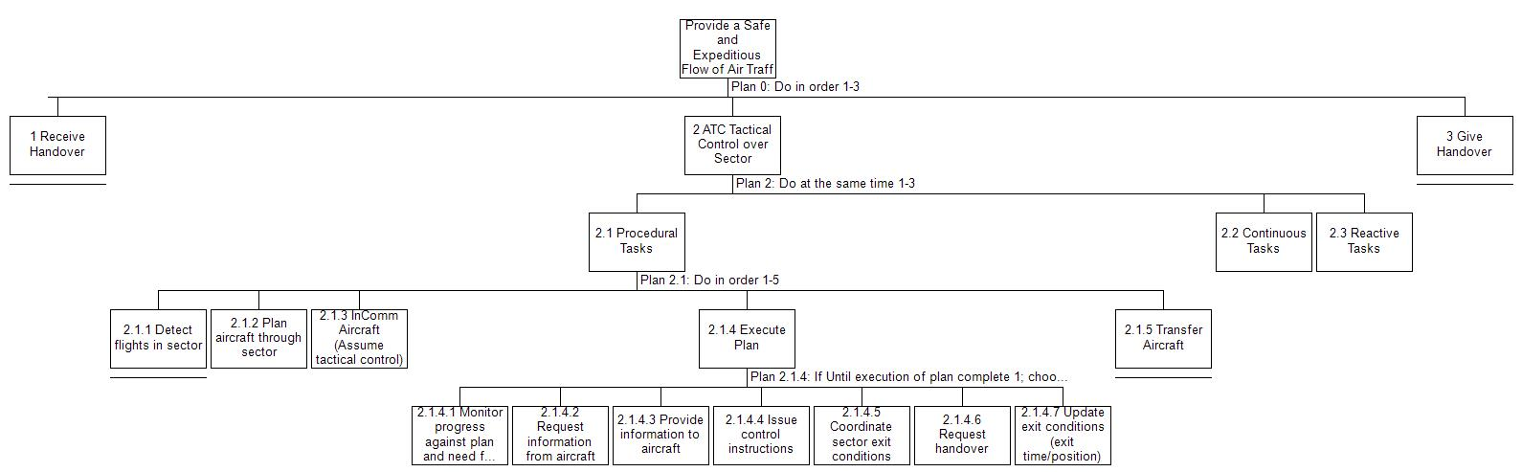
Figure 1: Simplified HTA of the ATC tactical tasks that were the aim of the TOI

Exploring Adaptation (HTA)
The HTA is particularly useful in describing the structure (Procedures & Rules) of the normal work of the controller. In many respects the HTA can be built from knowledge of the processes governing the work: the work-as-imagined (Dekker, 2003). This could then be supplemented by ethnographic studies of controllers to identify the reactive and continuous nature of many of the tasks and the learned strategies that achieve efficiencies and manage unpredictability.
However, when considering the phraseology change introduced by the TOI it is apparent that the intervention did not affect the fundamental task description or the planned sequence of tasks. Therefore, a far greater depth of analysis is necessary to reach the subtle and emergent consequences on performance from the TOI.
At the lowest levels of the HTA, the TOI affects the ‘Execute Plan’ task and its ‘Issue Control Instructions’ sub-task since it adds phraseology, and so lengthens, this instruction. However, the consequences of this are not readily captured. The interruption to the flow of work from the reported requests from aircraft for clarification affect the ‘Process/Respond to aircraft requests’ sub-tasks on the ‘reactive’ branch of the HTA resulting in a possible increase in the frequency of these tasks. However, it is not clear how the HTA would help identify the interactions between a minor change in one sub-task and the interactions with other tasks in other branches. The HTA task also does not adequately capture the depth and nuance of the interface between the pilot and controller. Whilst the ‘conformance monitoring sub-task’ includes the detection of an incorrect readback, the specific detail that was highlighted in the controller safety observations on the TOI of ‘aircraft failing to readback the required pressure instruction’ is not brought out at this level of detail and the HTA would need to be expanded to a far greater depth, and need the requisite imagination to identify these possibilities, to capture the potential for these issues.
This is the fundamental limitation of the HTA analysis. Whilst the analysis benefits from the structured notation-style for the work-as-imagined, the specific strategies and informal practices in use, the work-as-done, and the means of achieving the task are not necessarily brought to the fore. Similarly, the fluid nature of work, with its trade-offs and in-the-moment improvisation, is at odds with the purpose of the method which provides a descriptive structure for the work. The administrative burden to describe and then maintain such a detailed in-depth work-as-done structure also calls to mind the views of Dekker (2011) on formal descriptions of work always being incomplete or out-of-date as soon as they are written down. However, the notation that HTA provides is a useful structure to make sense of the work that can support other methods in keeping with its emerging practical use as a starting point for further analysis (Stanton, 2006).

Systems Theoretic Accident Model and Processes (STAMP)

Application
A STAMP control loop model was developed to illustrate the organisational expectations and the control mechanisms in place within air navigation service provision. A hierarchical control structure of the as-found control structure was modelled (see Figure 2 and Figure 3), to analyse the motivation behind the introduction of the TOI, and then analysed for possible flawed controls and disruption to the feedback loops.
The development branch of a STAMP model for ATC extends from supra-national organisations such as the International Civil Aviation Organisation (ICAO) and the European Aviation Safety Agency (EASA) to regional and State-level regulatory oversight of air navigation services such as the Civil Aviation Authority (CAA). It continues down through the multitude of organisational layers of the service delivery organisation and then across and within these layers to the supervisory air traffic control roles and to the front-line controller.
The STAMP analysis highlights the safety targets and key performance indicators that are cascaded down and how these high-level targets are translated into more detailed safety measures once they are within the service delivery organisation. These more detailed measures become more closely attuned to the work and the risk perceptions of the organisational actors lower down the model. As such the measures gradually move further away from the infrequent accident, a poor measure of control, and instead use more frequent process measures relating to accident precursors and surrogates such as level busts which were the focus of the TOI. The cultural pressures that the measures create are implied but not explicitly called out in the model.
The control structure then describes the mechanisms for action to address these measures based on the analysis of the causes of these precursors and the development and risk assessment of intervention actions. The TOI is therefore the actuation mechanism that forms the crossover to the operations branch of the STAMP model. Once the TOI was introduced into the operation, the STAMP model helps identify the positive feedback controls that supported the identification of the emergent issues with the TOI. The safety observations and controller reports described the maladaptive effects of the TOI and thus the flaws in the controls over its development in the risk assessment process for example, the assumptions made about airline SOPs and the effectiveness of mitigations such as the NOTAM, among other weaknesses, and the different and more frequent effects experienced. The STAMP model records how these issues were raised up through the hierarchical control model to the initiating and accountable organisational actors with authority to rapidly curtail the trial. Further development of this branch of the STAMP model is superfluous since the trial of the TOI was stopped.
The use of the flawed control classifications as part of the STAMP analysis provides a useful prompt to explore the weaknesses introduced by the TOI. For example, the classification system prompts an analysis of the creation process of the TOI and the issues with subject matter expert involvement in the specification and risk assessment of the intervention. The classifications also highlight the inconsistencies between the work-as-imagined (i.e., System Development) and work-as-done (i.e., System Operation) models of the work process. Within the work-as-done there were a number of process variations with controllers applying informal strategies to manage the risk that were not appreciated in the specification of the TOI, termed asynchronous evolution in the STAMP flawed classification scheme. Similarly, inadequate coordination amongst the actors was clear through the confusion caused by non-standardised language in the phraseology change and the differences in UK and ICAO airline SOPs for the expected timing of the pressure change. Flow interruptions (from the lack of readback) and the time lag created by the extra syllables in the instruction caused delays elsewhere in the process and these are also identified by application of the control classifications in the method.
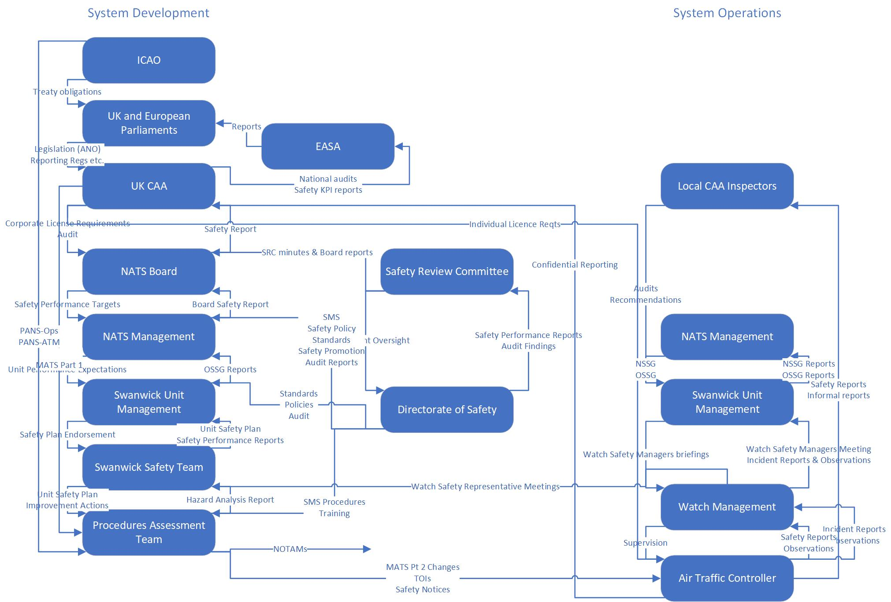
Figure 2: STAMP model for the organisational level representation of the TOI introduction
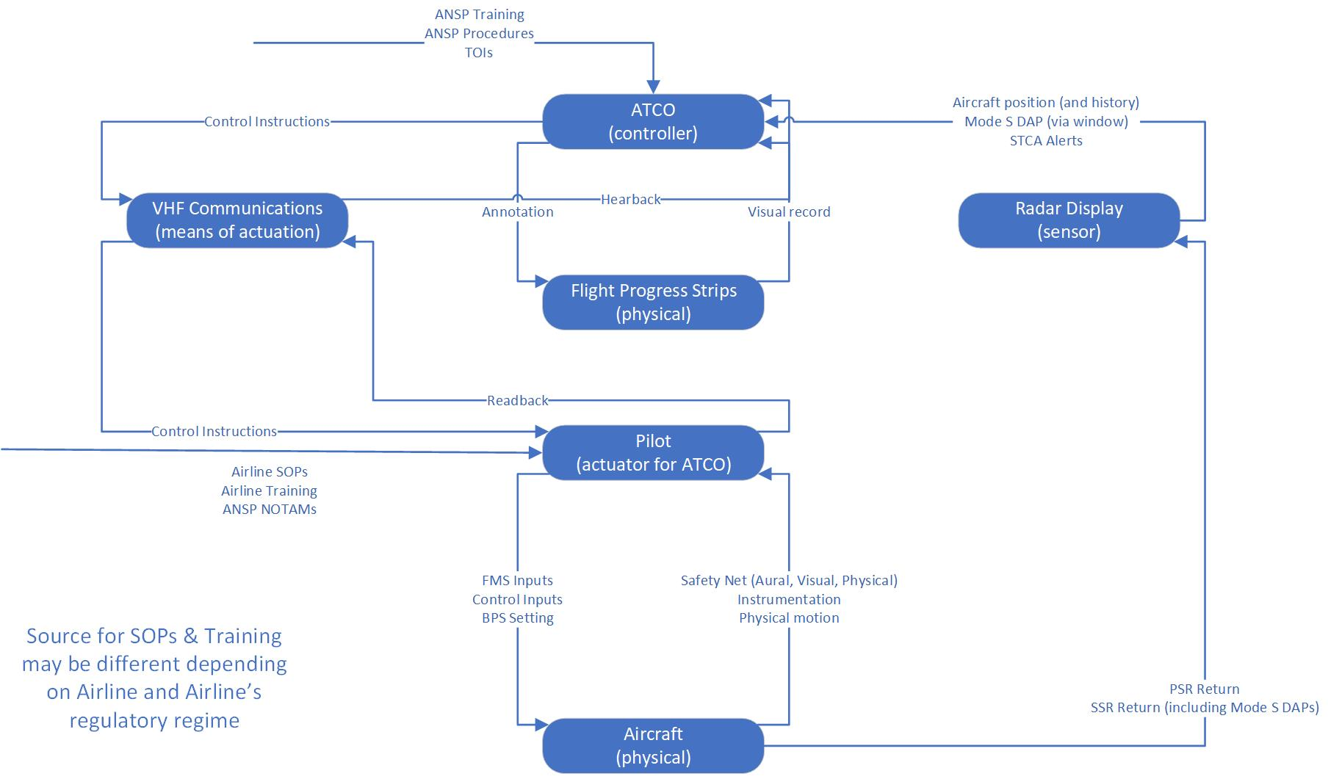
Figure 3: STAMP model for the individual level representation of the TOI introduction

Exploring Adaptation (STAMP)
The STAMP model is drawn towards the control structures enacted through the procedures (Procedures & Rules) described in the system and, by extension, the analysis can identify where these are flawed or violated (Violations). The ability of the STAMP model to describe the informal practices is possible, as alternative control structures and feedback loops, where these are identified although this would appear to require a degree of requisite imagination to break out of a perceived process control paradigm to consider that alternative models of the work may exist (Strategies & Informal Practice). This is possible with the benefit of hindsight and for a retrospective analysis (Unpredictability of Consequences). An evolution of STAMP exists to include an associated hazard analysis technique: Systems Theoretic Process Analysis (STPA) (Leveson, 2011) for more anticipative enquiry into the challenges of complex sociotechnical systems.

Functional Resonance Analysis Method (FRAM)

Application
The development of a FRAM model benefits from the use of software to support the capture of the functional links and to draw the network. Tools such as myFRAM (Patriarca, Di Gravio, & Costantino, 2018) and the FRAM Model Visualiser (FMV) help manage the potentially highly complex analysis of every identified function against every other function’s six aspects and provides the means to visualise and manipulate the functions in the model as it is iteratively developed. This process is considerably helped by the use of the earlier HTA analysis since the generalised ATC tasks could be naturally translated into functions for the FRAM model. This potentially addresses a criticism of FRAM (Cornelissen, Salmon, McClure, & Stanton, 2013) where it is unclear what functions should and should not be included.
However, unlike in the HTA (which is a recommended starting point for a FRAM analysis, see Hollnagel (2012)), the addition of the links between the functions illustrates the web of interconnectivity between the identified functions and the potential for complex emergent possibilities when a function is changed. These interconnections provide an alternative representation for many of the control and feedback loops within the system (see Figure 4).
Additionally, to cope with the complexity generated by the FRAM model and also generate different knowledge representations, it has been recommended that the functions of the system be explored at different resolutions and abstractions (Patriarca, Bergström, & Di Gravio, 2017). Therefore, to explore more detailed effects of the TOI, a single FRAM function of issuing a clearance to an aircraft that is climbing through the transition level can be considered as the focus and the changes to the six aspects of that function investigated (see Figure 5). At this resolution level or level of abstraction, the TOI can be seen to be an attempt to reduce the variability in the function by imposing an additional procedural constraint on the output: the ATC clearance with the additional phraseology. However, variability is also increased since the constraint on the use of standardised phraseology is weakened by the addition of non-standard language. The TOI change also adds further pre-conditions to the rules governing the function since the TOI only applied on days when pressure was below 1000HPa. The resources that the function consumes are negatively impacted since the added length of transmissions increases radio frequency (RF) usage and this, along with the potential for confusion due to the weakened constraints on standardised language, increased controller workload.
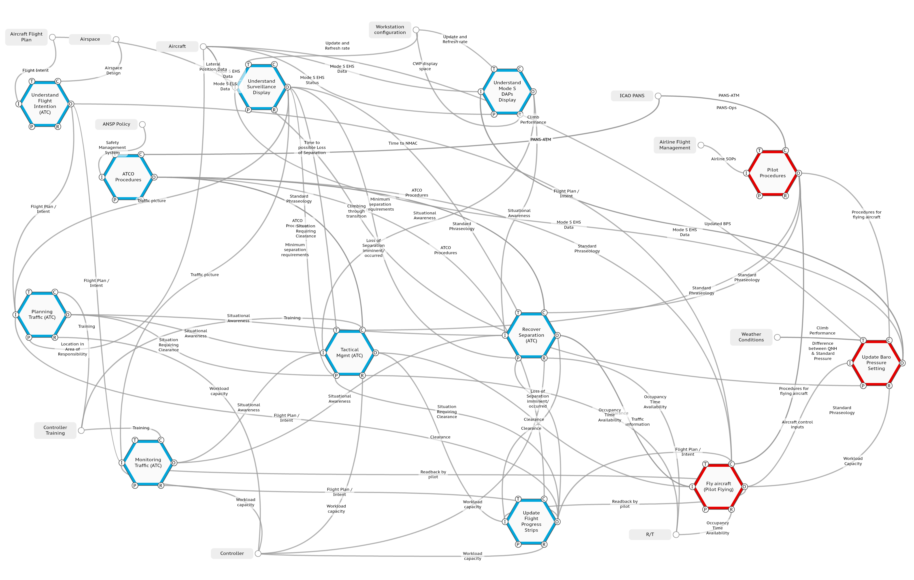
Figure 4: FRAM diagram for the wider system representation of the TOI introduction (blue: ATC, red: pilot, grey: external)

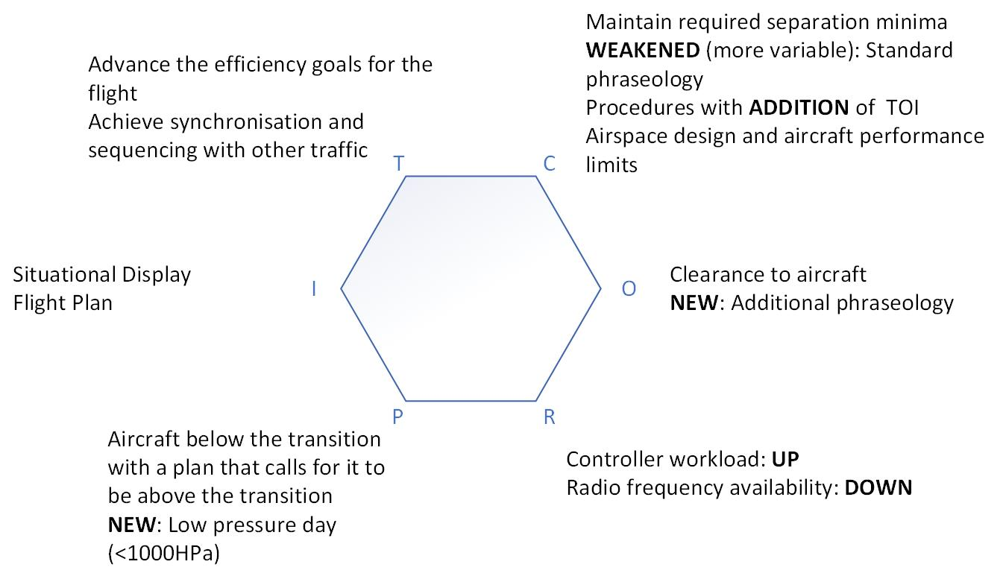
Figure 5: Simplified FRAM representation of the controller instruction function with TOI impacts highlighted

Exploring Adaptation (FRAM)
The FRAM model draws out the interwoven functions of the system through the connections between the aspects of the functions, although a degree of restraint and iteration is required to ensure the model draws out the important features of the system rather than obscures understanding under a plethora of connections. The completed representation illustrates the potential for unpredictable consequences by using the analysis of individual functions and then walking through the couplings in the wider system to explore potential sources of variability and conflict (Unpredictability of Consequences, Trade-Off for Performance). However, the findings from the system representation are challenging to contextualise. For example, whilst the detailed functional analysis identifies the changing and conflicting constraints on tactical management introduced by the TOI and the system view identifies the linkages to other functions, it is unclear how the model could be interpreted to anticipate what the exact manifestations of the maladaptation will be without the benefit of hindsight. However, the FRAM model provides a representation that can be used to analyse and illustrate the complexity and potential for unpredictable consequences in the system.

Human Factors Analysis and Classification Scheme (HFACS)

Application
HFACS was identified as a possible supplement to FRAM to provide better coverage of the adaptation factors. Given HFACS’ focus on accident scenarios it is more appropriate to start with the analysis of a level bust due to altimeter setting error. However, the focus of HFACS on error means that the focus of an analysis on level busts inevitably shifts to the pilot (who errs) rather than the controller. When considering the TOI as an intervention, this presents an interesting transfer of risk management activity in the wider system where one actor, the ATC organisation and the controller, takes on the responsibility for addressing the error and consequent risk from another, the pilot.
The issue with a level bust due to altimeter setting error is the incorrect change from one pressure standard to another after an air traffic control clearance to pass through the transition level. In HFACS terms (see Figure 6), this is an unsafe act that is an error of skill. In terms of pre-conditions for the unsafe act the major factors here are three-fold. The physical environment of the airspace design is such that a transition is required in the first place and the nature of the design means that in low pressure conditions the time to make the change is greatly reduced (and hence why low pressure is commonly associated with this incident type and provides a signal to experienced controllers for a possible increase in risk). The other pre-condition factors are closely related since in low pressure conditions, where the time to make the necessary change is reduced, pilot workload can already be high and the time available may be insufficient to complete this task in a timely way given the number of other concurrent tasks that are required in the cockpit during this complex stage of a flight. Additionally, low pressure is also associated with difficult flying conditions, such as high winds, and pilot workload can also be complicated by factors such as fatigue after a long night flight.
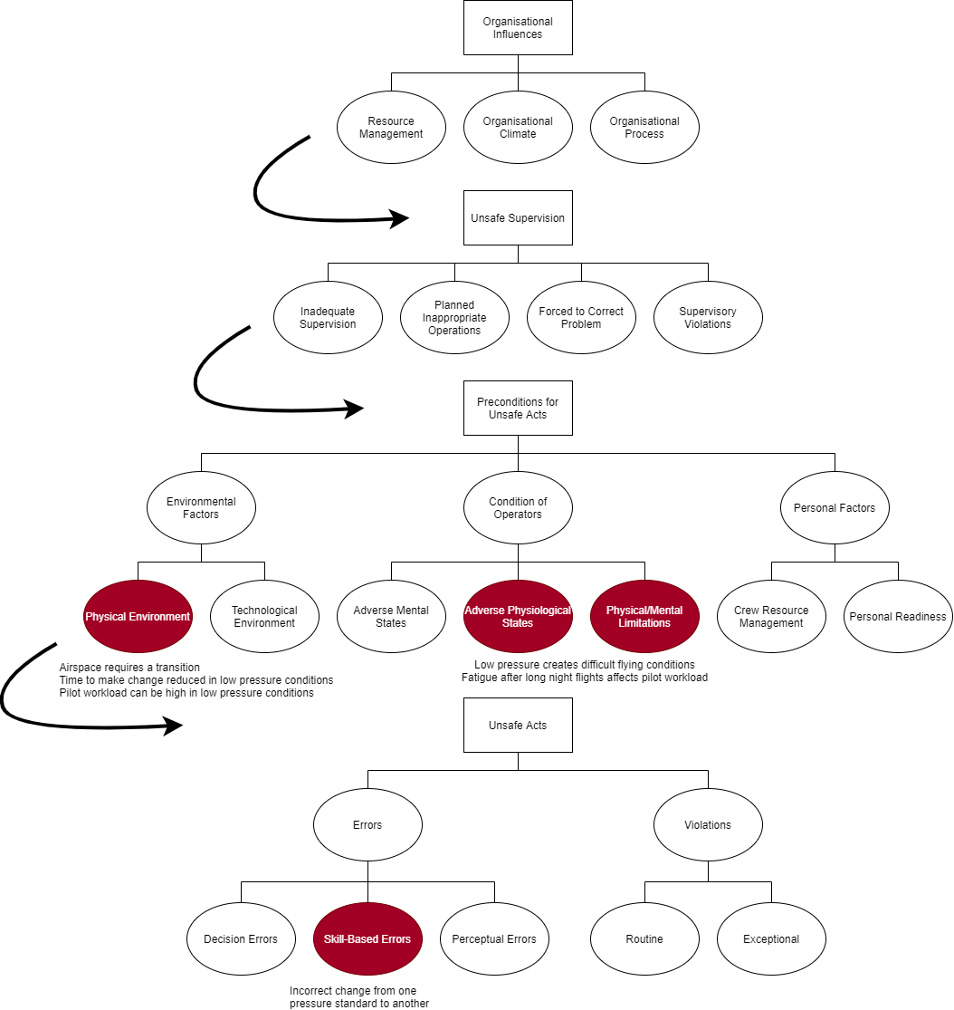
Figure 6: HFACS analysis – key latent and active errors in Level Bust incidents being addressed by the TOI

Exploring Adaptation (HFACS)
With its focus on error, HFACS is more naturally drawn to the adaptation factors related to violations and to the procedures and rules of work (Violations, Procedures & Rules). The survey of methods highlighted the possible complementary nature of HFACS and FRAM to provide a more complete coverage of the adaptation factors. There appears to be some potential in the use of FRAM to identify the interactions and functional connections in the system and for HFACS to provide some support to addressing the limitations found with FRAM in exploring the contextual interpretation of the FRAM outputs. Similar combinations of HFACS with other methods have also been discussed, such as to complement STAMP (Harris & Li, 2011).
HFACS has also been extended to include the Human Factors Intervention matriX (HFIX) (Shappell & Wiegmann, 2009) and the TOI can be examined, albeit retrospectively, as an intervention in this context. Applying the HFIX framework (see Table 1, blank cells show no identified HFIX features in the scope of the TOI decision-making process) suggests that the TOI was a Task/Mission intervention focusing on a procedural change to address a skill-based error. This intervention should be placed in the context of other interventions that had already been tried including working with airlines to understand their operating procedures and the addition of specific tools in the controller display equipment (a Human Machine Interface (HMI)) to present the BPS (after working with aircraft manufacturers and standardisation bodies to enable this information to be downlinked from the aircraft). Thus, it could be argued that the TOI was a complementary intervention to these prior initiatives.
Additionally, the HFIX approach calls out four other factors that govern the introduction of safety interventions: cost, effectiveness, feasibility and acceptability. Regarding cost and feasibility, the TOI is incredibly low cost compared to the technological initiatives and the amendment of phraseology is within the remit of the air traffic organisation. The effectiveness of the TOI was unknown; hence it was being trialled. However, the acceptability proved subsequently to be problematic given the safety observations and the reports of exchanges between pilots and controllers to query the change. However, the clearest indication from the use of HFACS (and HFIX) of the possible issues with the TOI is the mismatch between a pilot-domain error and the intervention being in the controller-domain.
Lastly, the Safety Notice issued after the TOI was withdrawn can be interpreted as an Organisational/Administrative intervention specifically related to disseminating practices and strategies across the organisation. This can also be considered to have been complementary to the technological and procedural interventions. Although HFACS merely prompts the practitioner to consider the breadth of possible interventions rather than commenting on the likely effectiveness of a safety intervention.
Table 1: Human Factors Intervention matrix (HFIX) for prior actions, the TOI intervention and the subsequent Safety Notice
 | Organisational/  Administrative | Human/Crew | Technology/  Engineering | Task/  Mission | Operational/  Physical Environment
Decision Errors
Skill-based Errors |  | Previous ATCO/Pilot interface interventions |  | TOI Intervention
Perceptual Errors | After TOI withdrawn, Safety Notice disseminated techniques to address risk |  | Previous support tools deployed to alert controllers to BPS setting errors
Violations

Cognitive Work Analysis (CWA)

Application
To conduct the initial WDA step, the Abstraction-Hierarchy (see Figure 7) was generated as recommended by Vicente (1999) and following the methodology for the completion of the Abstraction Decomposition Space (ADS) from Naikar et al. (2005). Once again, specific software tools such as the CWA Tool (Jenkins et al., 2007) can support the analyst in managing some of the complexity in the application of the method.
The ADS for air traffic control benefits from the HTA generated earlier and, at a high-level, the goals and design-independent functions identified are similar. The addition of the values and priorities between these layers of the abstraction extends the value of the HTA and immediately uncovers the potential requirement for trade-offs in the system to achieve conflicting goals or value measures.
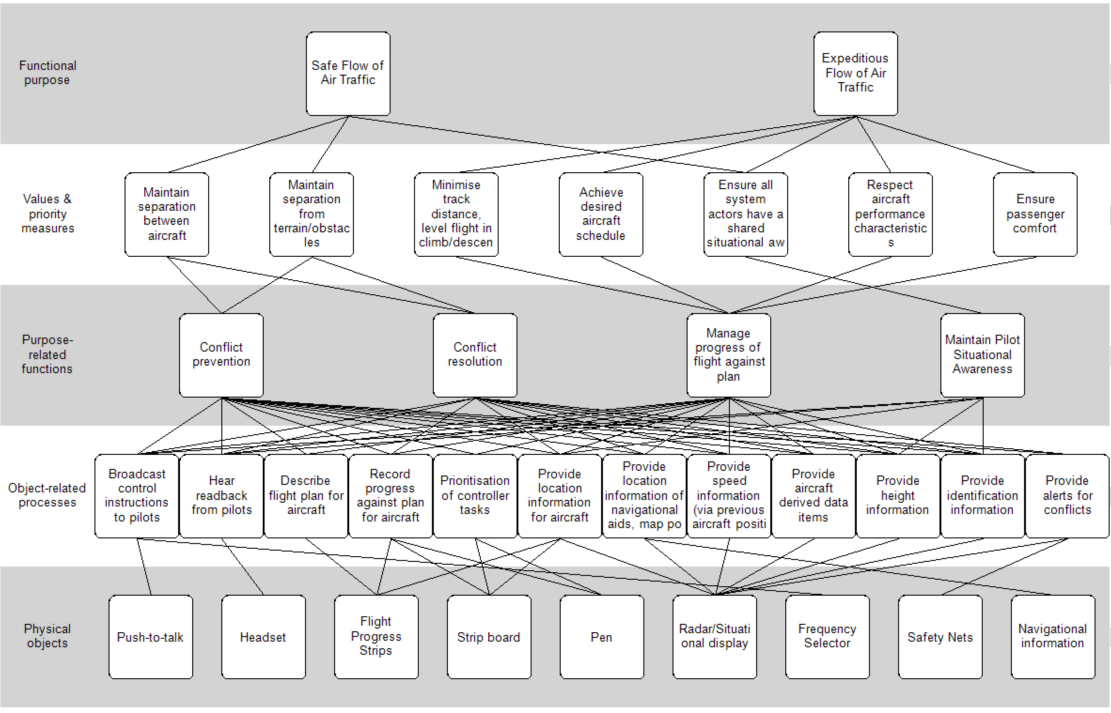
Figure 7: Abstraction Hierarchy for air traffic control
The Activity Analysis step uses the Contextual Activity Template as proposed by Naikar and colleagues (2006). This uses the functions identified in the ADS and decomposes the work into situations that may typically recur during normal activities. The output from the Activity Analysis illustrates the overlap in situations and the requirement, in normal work, for multiple functions to be conducted simultaneously, so further developing the understanding of possible trade-offs.
At this stage of the CWA process the description is still at a relatively high-level and the analysis has not yet uncovered features of the work with direct relevance to the TOI. This is rectified in the strategies analysis stage that first makes use of the Decision Ladder (Vicente, 1999) to explore the specifics of the change introduced by the TOI (see Figure 8). The alert or activation at the bottom of the ladder is the aircraft plan calling for a climb through the transition level. The form of the TOI, in requiring that all aircraft be treated the same by requiring the use of the additional phraseology in all necessary circumstances, is a natural procedural simplification that is attractive to managers seeking to intervene in a system (Dahl, 2013; Hale & Borys, 2013; Reason, Parker, & Lawton, 1998). However, the decision ladder prompts the identification of pre-existing shortcuts in the controllers’ activities: the use of experience and the flexible strategies that were employed in the operation to tailor phraseology to the perceived risk. The TOI, essentially, treats every controller as a novice, in decision ladder terms, and creates an expectation that controllers follow the planning and execution steps captured in the decision ladder in a linear fashion. The strategies, shortcuts in the flow of work, and the application of experience to tailor risk mitigation actions, a source of professional pride and the hallmark of expertise (Dekker, 2003), are therefore not appreciated in the TOI description.
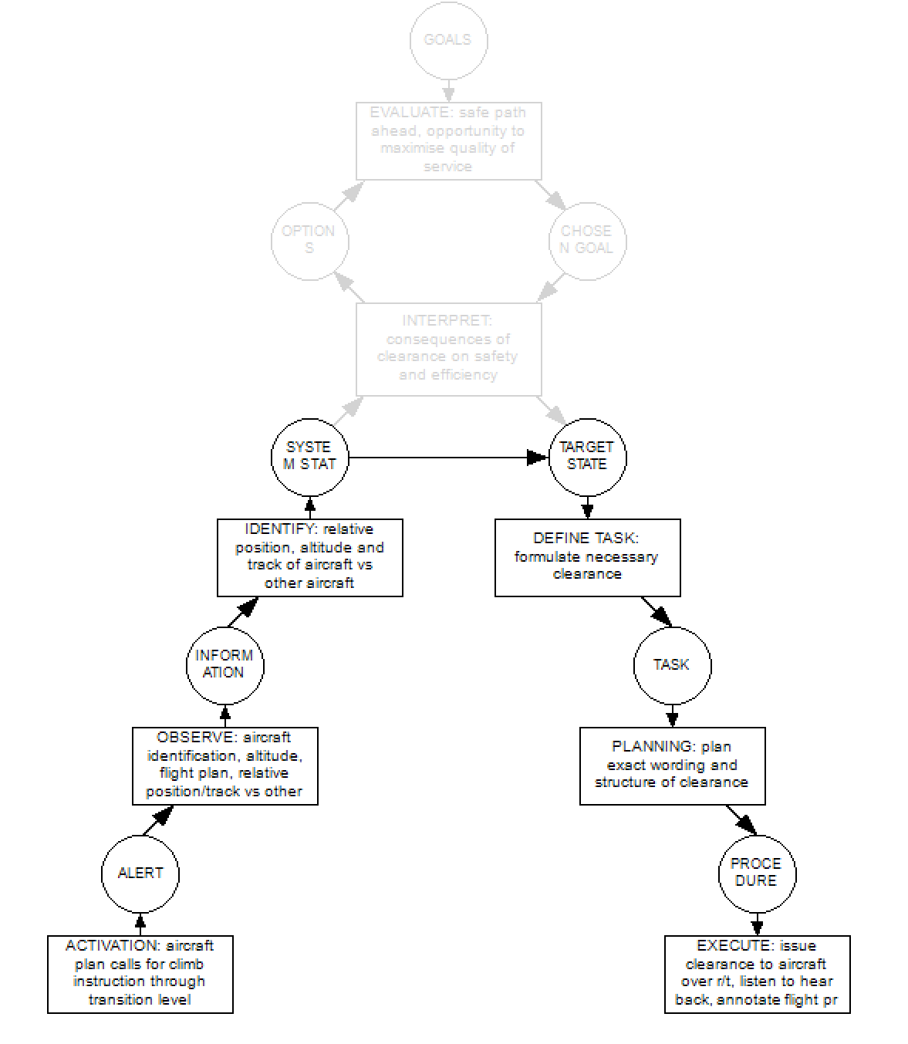
In normal work before the TOI a shortcut was employed (dashed arrow) that ‘shunts’ the Target State decision step
Addition of the <1000HPa check for applicability of the TOI
The TOI removed the ‘shunt’ (dashed arrow) by requiring additional phraseology in the clearance under certain conditions (Define Task) and reduced controller flexibility
Figure 8: Decision Tree for the TOI highlighting the reversion to more novice-style task conduct
This is further emphasised in the second stage of the strategies analysis. The implication from the TOI is that the TOI phraseology ‘strategy’ was selected in preference to a multitude of other strategies in use by controllers when issuing an instruction to climb through the transition level. The strategies analysis highlights commonalities in these approaches taken by controllers that involve a number of assessment steps related to the controller’s perception of a pilot’s English language proficiency, the risk of non-conformance due to an aircraft’s origin, their likely familiarity with UK airspace requirements and the controller’s prior experiences from similar situations. The safety observations raised in the early days of the TOI trial and the safety notice issued subsequent to the curtailment of the trial make this clear. In the Safety Notice, controllers are later recognised and encouraged to continue to apply the adaptive range of operating techniques, different phraseology options and changes in controlling style that had been in use but were unobserved. For example, controllers might reiterate the clearance using a phrase such as “… Maintain Flight Level Eight Zero (80) Standard Pressure is One Zero One Three (1013)” if they suspected that the aircraft might have a level bust. The Safety Notice therefore reverts the strategies available back to the high number of flexible options.
The Social Organisation and Cooperation Analysis (SOCA) highlights similar features to HFACS in that the intervention seeks to address a pilot error by acting on the controller’s ‘Execute task’ in the Decision Ladder, for example. This stage can be interpreted as highlighting the possible mismatch and potential for maladaptive effects through intervening in one domain (the controller) to affect a change in behaviours in another (the pilot) without appreciating the cooperation that already exists between pilot and controller.
The last step of the CWA is the WCA step (see Table 2) that examines the cognitive skills required for the performance of tasks and uses Rasmussen’s (1983) skills, rules and knowledge (SRK) framework. The TOI is an example of a change that alters the balance in cognitive work. The act of issuing an instruction to climb through the transition level is a rule-based behaviour, where the action taken by the controller is found implicitly and selected from previous successful control instructions in similar situations. For highly experienced individuals it may even approach a skill-based action where task performance is almost automatic. The TOI, by introducing additional process steps and applicability requirements, would be expected to move the task towards knowledge-based cognitive levels, at least while controllers were unfamiliar with the instruction. Similarly, the pilot domain can also be considered using the SRK framework. Pilots have an expectation of what control instructions they will hear and what actions they should take as a result. The change in phraseology interrupts this expected flow and moves their near skill-based activity of hearing and responding to controller radio instructions into knowledge-based behaviours and, given the unfamiliarity introduced, prompts additional radio calls for clarification of the instruction. However, a limitation identified in the application of the CWA approach is how these interactions are drawn out by the analysis. Whilst the shift to higher levels of cognitive load and interruptions to the flow of work are identified by the latter steps of the method, the potential for cascading workload effects resulting from other controller tasks, such as a shift to knowledge-based reasoning required to respond to pilot requests for clarification, or the possibility of the pilot mishearing the instruction and the controller having to correct an incorrect readback are not readily identified.
Table 2: Worker competencies identified for the pre-TOI case.
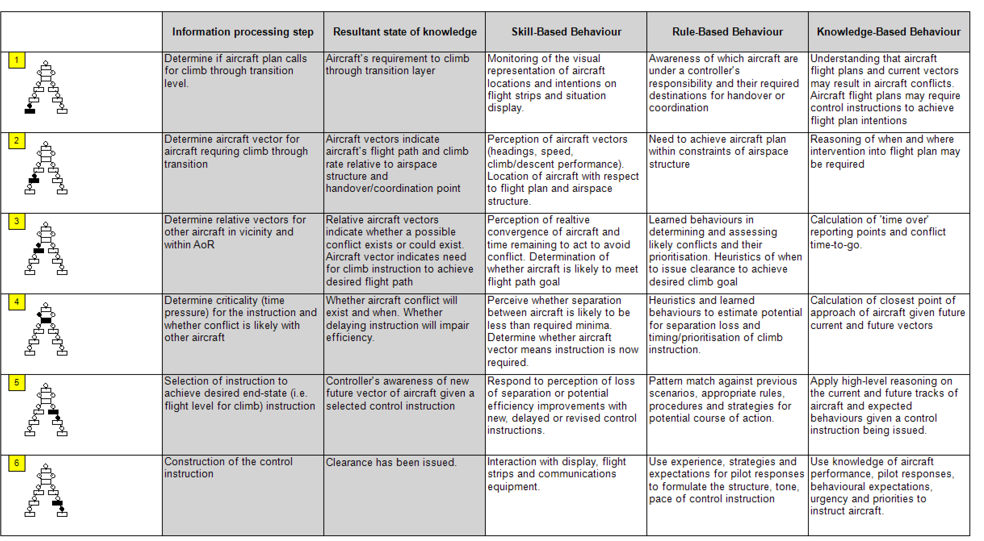

Exploring Adaptation (CWA)
The CWA draws out many of the adaptive features of the system related to the controller task performance. The abstraction hierarchy identifies the potential requirement for trade-offs in the work to achieve possibly conflicting goals (Trade-off for Performance). The use of experience and informal strategies within the work are probed and captured in the decision ladder and strategies analysis steps (Using Experience, Strategies & Informal Practice, Improvisation & Creativity). Similarly, the WCA explores the levels of cognitive work required for the change introduced by the TOI, how this was altered and probes for the hidden skills in adaptation that existed before the introduction of the trial change (Acquiring Knowledge, Skills Needed). The SOCA stage also highlights some of the micro-meso-macro interactions of acting in the controller domain to achieve an effect in the pilot-domain. The retrospective analysis of the TOI using the CWA approach suggests that many adaptive features in the existing task activity were being altered by the introduction of the trial and this points towards the possibility of complex emergent consequences (Unpredictability of Consequences).

Critical Decision Method (CDM)

Application
The CDM process calls for the construction of an incident timeline that explains the scenario phases following the approach described in Section 3.2.1. For the TOI, four phases were identified: ‘Need’: the realisation that ‘something had to be done’, ‘Evaluation’: whether ‘on the balance of risks’ the change should be introduced, ‘Reassessment’: the need to reflect on the TOI following feedback from controllers and ‘Withdrawal’: the decision of whether to reinstate or suspend the trial. For each of these four phases CDM tables were constructed using the material gained from the interviews and the resulting narrative that was extracted using CDM is summarised in Table 3 with the relevant CDM probes and key findings. This information was also supplemented with additional correspondence, presentations and briefings that were identified and made available as a result of the interviews.
Table 3: Identified CDM Phases and key points from CDM probes
Decision Phase | CDM Probe | Key Factors identified
Need | Goal Specification | During the ‘Need’ phase the subjective judgement of the management team was that the current actions in place to manage the risk of level bust incidents were largely correct.
 | Cue Identification | However, the predicted long period of low pressure (known to be associated with level busts) meant that there was an emerging recognition that ‘something had to be done’ in accordance with pre-existing cultural and professional drivers, including the accountability of managers, to demonstrate that they were acting responsibly on leading indicators of safety risk.
 | Expectancy | Whilst the problem of level busts was not new, regular reviews of safety data are routine occurrences, and an action plan was already in place, a significant loss of separation between two aircraft that occurred during Storm St. Jude proved to be a major trigger for consideration of additional measures. In this way, the organisation needs a degree of flexibility to respond to emerging trends with innovative actions. Whilst safety committees provide challenge and due diligence on risk management, this consultation can take time and so delay managing an evolving risk picture.
 | Conceptual Model | A procedural intervention was selected as the experience and perception of safety managers was that these types of incidents did not occur with more experienced controllers. It was also known that a range of techniques were in use and there was a desire to find ways of sharing these across the operation.
 | Influence of Uncertainty | However, a phraseology change was novel and there was uncertainty about the appropriateness of the selected option. There was, however, a degree of faith in the risk assessment process to uncover issues and prompt iterative changes to reduce uncertainty and any induced risk.
 | Situation Awareness | Many of the senior managers with responsibility for these decisions were current or former controllers. This experience provides a front-line appreciation of the risks and a credibility with the current operational community when seeking their acceptance and buy-in for an intervention.
 | Options | The selected phraseology change was made mandatory in the belief that a prescriptive measure would express the seriousness with which management wanted the risk addressed and also to achieve the greatest impact from the change. Other options to manage the risk were already planned and in progress.
Evaluation | Goal Specification | The decision-making in the ‘Evaluation’ phase was centred on the desire to understand, given the output from the risk assessment, whether the risks from the trial, such as the increase in radio calls and workload (low severity and possibly frequent), relative to the risks from level bust incidents (high severity but relatively rare) warranted the introduction of the change.
 | Cue Identification | With the completion of the risk assessment, following standard processes for the introduction of a procedural change, the decision revolved around whether ‘on the balance of risks’ the introduction of the phraseology trial should proceed and on what timescales (introduction and duration).
 | Expectancy | The evaluation and weighing up of risks is the essence of risk management decision-making in the presence of uncertainty in any complex system.
 | Influence of Uncertainty | The risk assessment made a number of generalised, uniform assumptions on airline operating procedures and had an expectation of the aircrew response which was by no means certain (for example, whether the NOTAM would be fully appreciated).
 | Information Integration | The prescriptive and mandatory nature of the TOI was understood to remove some flexibility from controllers; however, this was not a fundamental consideration of the risk assessment but rather was weighed in the decision-making.
 | Situation Awareness | However, the process for the introduction of the TOI was followed so that iterative reviews and judgements were presented up the management chain so that the people entrusted with the accountability for safety in the operation understood what was being proposed and the possible consequences. This judgement drew upon many different voices, inputs and opinions from across the operation on the merits of the TOI as a course of action – recognising that not all of these were supportive.
 | Situation Assessment | There was also some uncertainty about the estimation of the frequency of the increases in workload and radio calls and the likelihood and impact of these consequences could have been better understood in the risk assessment.
 | Options | At all times the option to not introduce the change existed. Even with momentum behind the change there is still the requirement to get someone higher up in the accountability chain to agree to the change and sign it off prior to introduction.
Reassessment | Cue Identification | As the safety observations and other feedback began to be reported by controllers the third scenario in the decision timeline is reached that culminated with the decision to revisit the risk assessment.
 | Goal Specification | The feedback from controllers in safety observations prompted decision makers to reflect upon the balance of risks and ask whether the TOI was generating more risk than existed prior to its introduction.
 | Expectancy | Feedback had been requested from the operation in recognition that there was not universal support for the change but, within a relatively short period of time, a high number of reports had been made suggesting a much greater consequence than had been anticipated.
 | Decision Blocking | Therefore, with the operation unhappy with the mandatory requirement, the low-pressure period continuing and the risk of level busts still believed to be high, there was a need to rapidly reappraise the approach.
 | Options | The option existed to continue with the trial whilst the risk assessment was reviewed but the decision was made to ‘tactically suspend’ the trial by instructing Operational Supervisors to not apply the procedure in the interim.
 | Information Integration | The feedback from the controllers highlighted that the frequency estimation for the consequence of the additional phraseology on workload and radio calls was not as had been predicted and represented a greater risk than had been assessed (e.g., as a result of pilots not fully appreciating the NOTAM describing the change the mitigation of the original risk was of reduced effectiveness).
 | Situation Assessment | To support the revision of the risk assessment further data on the impact on radio calls and workload was sought and additional expertise was made available for the revised risk assessment process which took advantage of the in-service data.
Withdrawal | Goal Specification | The revised risk assessment improved upon the description of the underlying hazards, the frequency of the consequences and the necessary mitigations to reduce the impact of the TOI on controller workload. This represented the fourth decision in the timeline that addressed whether the tactical suspension should be removed and the TOI reinstated or whether the TOI should be withdrawn.
 | Cue Identification | This decision represents the need to address the operational feedback and the results of the preliminary investigation into an incorrect readback and possible aircraft re-route (‘standard pressure setting’ was misheard and readback by a pilot as ‘route direct DET’, a point in the London Area) whilst balancing this against the judgement on the risks from level busts.
 | Expectancy | The decision on the curtailment of a trial is not an usual occurrence and the reappraisal of safety actions forms part of normal risk management activities.
 | Situation Assessment | The conclusion of the risk assessment highlighted that the assumptions in the TOI on aircrew actions (SOPs) were too general and whilst pilots could be consulted on the change, the normal sources of pilot information (large, UK and Ireland-based airlines) were not the fundamental problem (business aviation and long-haul non-European carriers).
 | Options | There was also an emerging recognition of the role of the controller in providing an adaptive capability in the safety of the operation. The feedback from the operational community was that the TOI constrained controllers by adding more phraseology at exactly the time when both controllers and pilots did not want to have more or longer radio calls. Controllers instead wanted the flexibility to protect themselves (known as defensive controlling techniques) that could be deployed at the appropriate time. Therefore, the options for addressing the risk moved back to finding a way of disseminating, in a non-prescriptive way, the informal strategies for managing the risk across the operation and, in particular, support controllers who were less experienced.
 | Decisions Blocking | The decision to withdraw the TOI and issue a safety notice that outlined some of these techniques was the culmination of the TOI timeline. The management of the level bust risk reverted to the original action plan. This decision to walk-back the TOI risked the management team ‘losing face’ with the operational front-line. However, in safety related decision-making it is inappropriate to proceed on the basis of ego. Part of the goal of the TOI, to raise awareness of the seriousness with which management considered the level bust risk, had been achieved and the safety notice reinforced their regard for the professionalism of controllers.
 | Basis of Choice | Whilst the safety assessment of change process is generally considered to have a good pedigree in identifying risks, preventative measures and possible mitigations, it did not adequately capture the likely frequency of the consequences of the TOI for when it was to be active (on low pressure days). The issue of controller flexibility and adaptive capability was also only considered as part of the wider discussion of the balance of risks.

Exploring Adaptation (CDM)
The CDM method was applied to capture and understand the decision-making process surrounding the introduction of a change that had the effect of reducing the flexibility of controllers in managing the safety of the air traffic operation. The focus of CDM on operator mental models, the use of expertise and the application of judgement in the face of competing demands shows a strong affinity with the model factors of ‘Using Experience, ‘Acquiring Knowledge’, ‘Trade-off for Performance’ ‘Skills Needed’ and ‘Strategies & Informal Practice’. Whilst the interviews naturally focus on the decisions of individuals, and therefore focus on the use of experience and the appreciation of skill, it is also worth noting that the discussions, perhaps inevitably in a regulated and process-based safety management organisation, also included the overarching framework at the organisational-level within which those decisions were taken (Procedures & Rules). This identified that whilst controller flexibility was only tangentially considered (Unpredictability of Consequences) in the decision-making process, at an organisational level the management of safety requires organisational adaptability to respond rapidly and with innovative interventions to a rapidly emerging risk picture (Improvisation & Creativity, Skills Needed). Thus, CDM can check for an appreciation of adaptation and some of the factors in the decision-making, but once it was found that it had only featured as part of the ‘balance of risks’ judgement on the introduction of the TOI, the specifics of the adaptation factors could not be explored further.

Event Analysis of Systemic Teamwork (EAST)

Application
The analysis of the TOI using the EAST method benefits from the perspectives already identified by the methods previously described. In common with the other methods, although specifically described as a first step, EAST starts with an HTA to frame the activities and scenarios under analysis. This is then extended to generate Task Networks, OSD, CUD and CDA. A key benefit of EAST is the extension of the HTA from a number of perspectives and, with particular relevance to the TOI example, the interfaces between the actors in the system as a social network (see Figure 9).
A Task Network can be constructed for the ATC tasks that are of relevance to the TOI example specifically around issuing a clearance to an aircraft and monitoring that climb (see Figure 10). The TOI can be seen to be strengthening one element (highlighted) in the Task Network structure by reinforcing the information provided to the aircraft, specifically the requirement to change pressure setting. The possibility for increased pilot queries or misunderstandings of the instruction can be represented in the Task Networks by linking the continuous and reactive tasks identified in the HTA to the normal procedural activities that support the controller in progressing the flight through the airspace. This highlights the potential increase in workload that is represented in the diagram. However, a degree of requisite imagination is required at this stage to identify the nature of the increase in these tasks as a result of the TOI.
The CUD however does start to add more detail to the assessment of the impact of the TOI. In this case a standard representation of an ATC instruction to a pilot via radio (the only possible means of communication) can be represented and the change in the nature of the communications assessed if the CUD is adapted to the effects on the comms medium used (in addition to the effect of the medium used). Here the potential for distortion on the radio broadcast is captured by specifically considering the means of communication and this could prompt the analyst to consider the possibility of a pilot mishearing the additional phraseology. Furthermore, the CUD identifies strengths in the radio broadcasts from the use of standardised phraseology which is then weakened by the introduction of the non-standard TOI phrases. Additionally, the change in the length of the broadcast, by the addition of the extra six syllables and the requirement for the pilot to read this back (since it is a pressure change instruction) is also captured as a potential increase in controller and pilot workload.
These aspects are explored in more detail by building the CDA to examine the interface between the pilot and controller which is at the heart of the issues with the TOI. One of the unwritten hallmarks of air traffic control is the degree of implied teamwork between the pilot and controller and the level of non-standard discourse and mutual support that the controller provides to pilots. Here the three lowest-level tasks in the HTA that are specifically impacted by the TOI can be examined in more detail to determine the impact on the coordination and teamwork across the pilot-controller interface. The TOI addresses the task of providing information to aircraft in the clearance and as such the positive aspects of the change are highlighted by considering the intended increase in situation awareness from the reminder to set standard pressure setting. However, the communications aspects of this teamwork are diminished by the use of non-standardised phrases and the lack of appreciation of the conflict between the instruction and some aircraft SOPs. It is also possible to use the CUD to examine the impact on the controller’s decision making, adaptability and assertiveness and so remark on the potential reduction in agency to apply tailored strategies based on experience and the perception of risk. Lastly, the aspects of leadership can also be affected since the dynamic of the shared responsibility between the pilot and controller to avoid a level bust is altered towards the controller. By being more overtly explicit in the need for the pilot to remember to change pressure setting, a requirement that most pilots are already aware of, this weakens the credibility of the controller and undermines the motivation of the pilot in achieving the shared goal.
The CDM step of EAST reuses the interviews conducted; although EAST recommends structuring these in the form of Propositional Networks (Stanton et al., 2013) (see Figure 11). This provides a useful notation for the CDM outputs and highlights the weakness in the development of the TOI regarding the assumptions on the aircrew procedures. It also highlights that whilst the actors in the decision-making surrounding the TOI all had controlling experience, this would not be shared and may not be of equivalent recency to the current operational community. Similarly, the measures of controller workload and radio use not being available to inform the risk assessment could be represented as a ‘broken link’ in the network (Stanton & Harvey, 2017). Only after feedback was received post-implementation were these measures considered in more detail. The CDM interviews discussed the as-found control and feedback structures in the organisation for the introduction of change. This can be outlined in a social-network analysis, as called for by EAST, although this was found to largely replicate the structure created during the STAMP analysis.
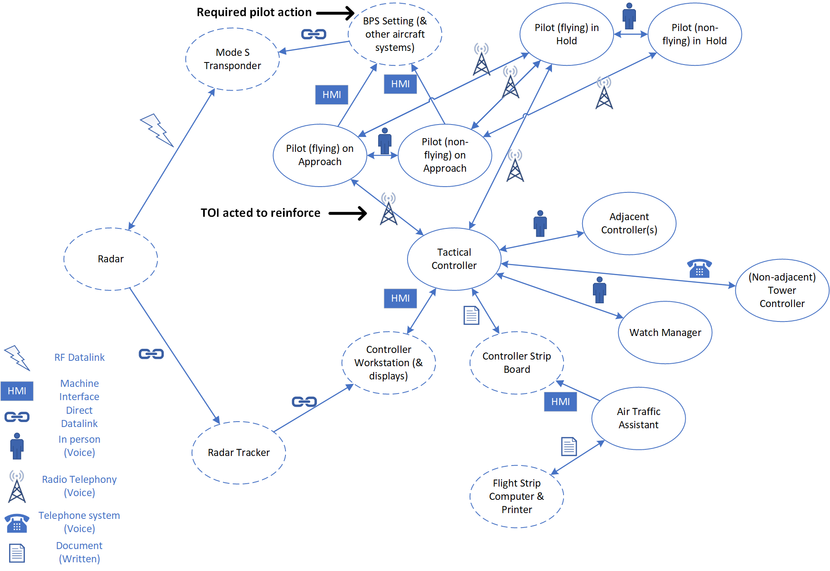
Figure 9: Social network overlain with communication means (non-human nodes shown as dashed lines, TOI action highlighted)
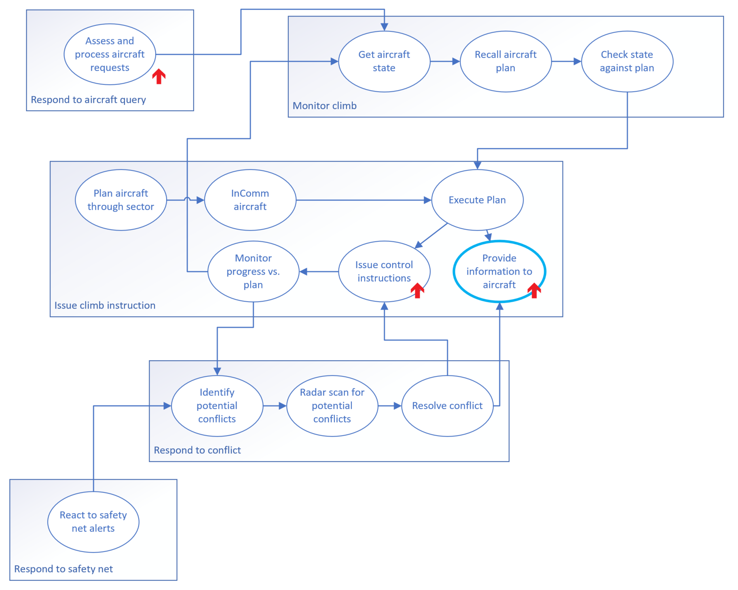
Figure 10: Simplified Task Network for functions addressed by the TOI (high-level tasks grouped, increased task workload indicated)
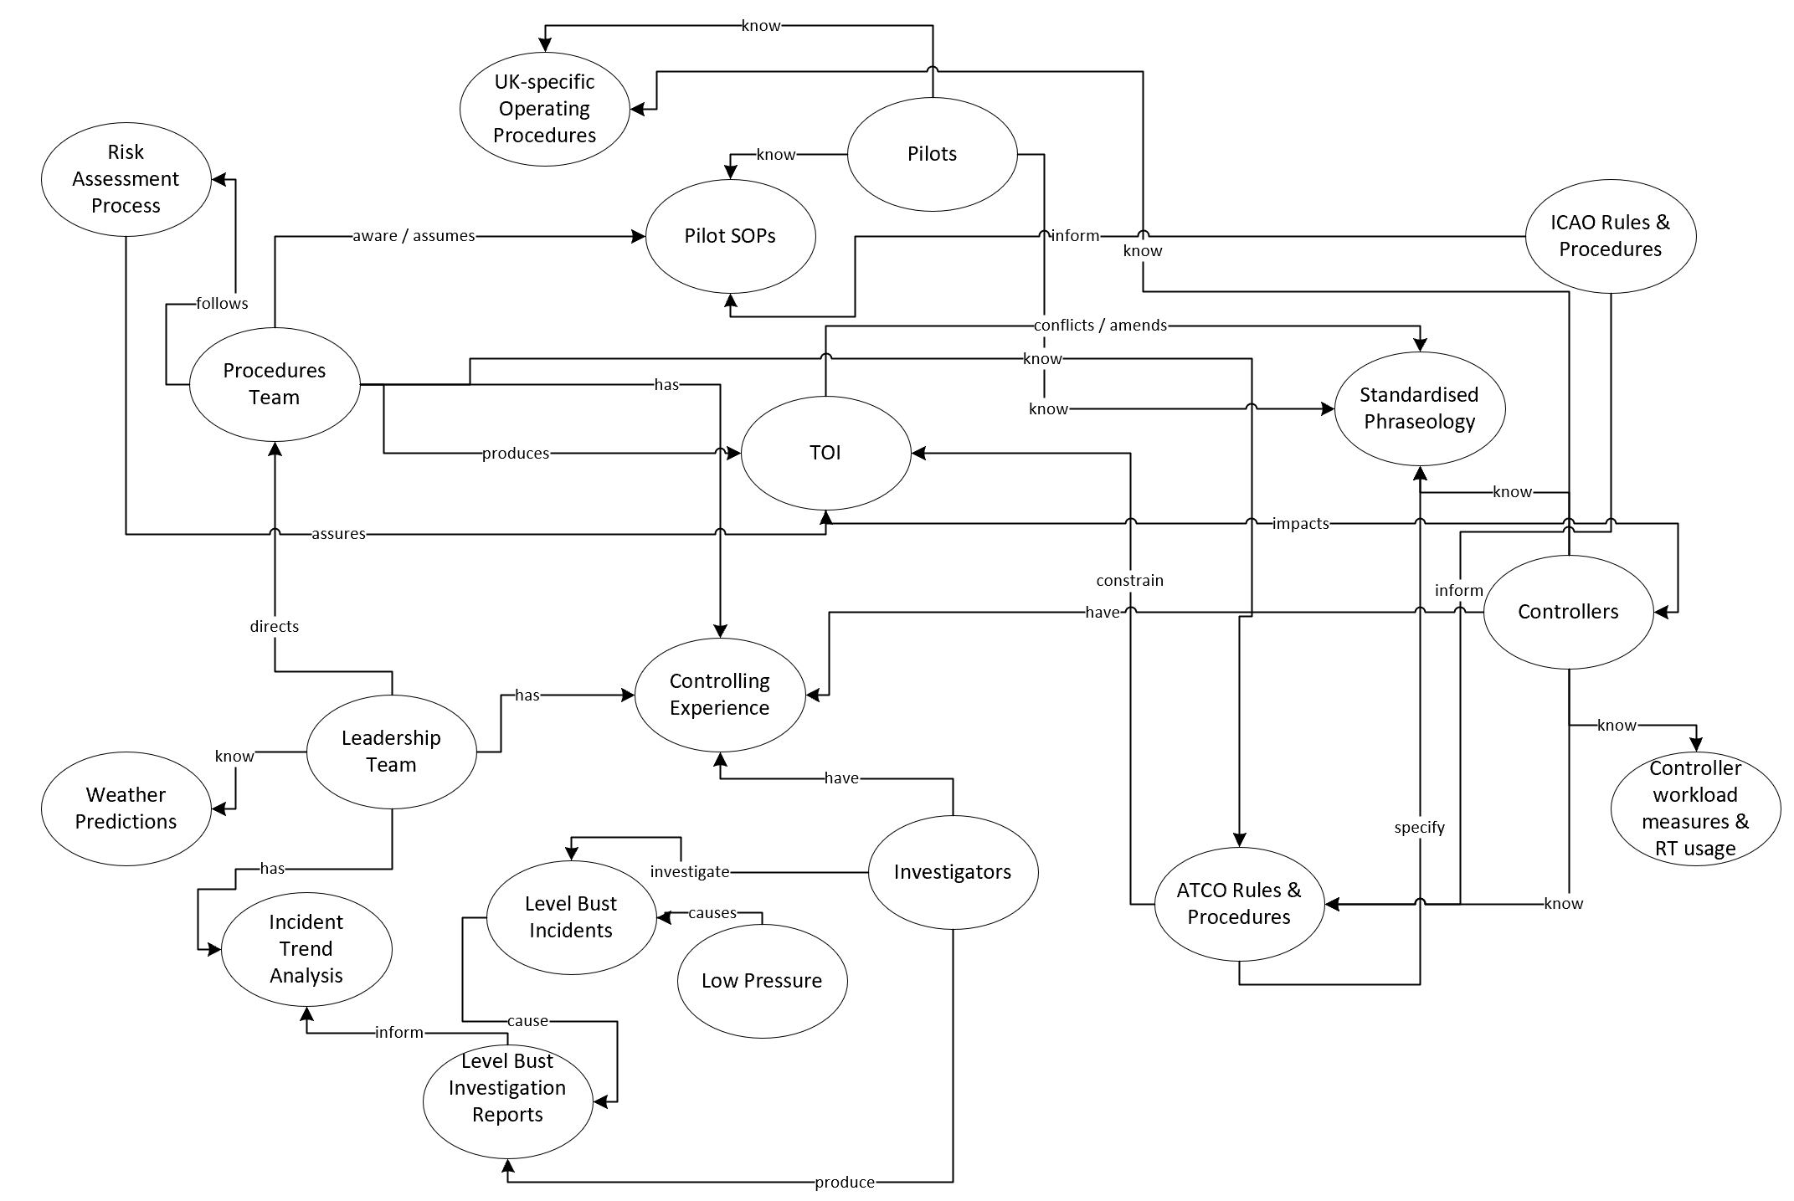
Figure 11: Propositional Network for TOI introduction

Exploring Adaptation (EAST)
The focus of EAST is on the interrelationships and communication means between the actors in the TOI case study and it uses methods that draw out these issues and helps identify weakness in the initial risk assessment related to assumptions around workload, airline SOPs and data across these interfaces. The propositional network provides more structure to the analysis of the features identified in the CDM interviews and places them in context. The graphical structure provided by these methods helps contextualise the observational and other data about the system that can support analysis of the informal practices and strategies that exist (Strategies & Informal Practice, Procedures & Rules).

Results Synthesis and Overview
The review of the circumstances surrounding the introduction of the TOI using the identified methods highlights the limitations of the original risk assessment to adequately explore the existing adaptive capabilities in the system. The seven methods each adopt a different perspective on the problem of the TOI and each method touches upon some of the factors of adaptation. The coverage of the adaptation factors by the Human Factors methods is illustrated in Table 4. Where the results from the use of the method appear to support the understanding of the adaptation factor this is shown against the expectation from the Delphi survey.
Table 4: Coverage of Adaptation Factors by Human Factors method for TOI Case Study (recommendations shown: black = highly applicable, grey = should be applicable, white = not positively recommended)
 | Methods
 | HTA | STAMP | FRAM | HFACS | CWA | CDM | EAST
Using Experience |  |  |  |  | Yes | Yes
Strategies & Informal Practice |  | Yes |  |  | Yes | Yes | Yes
Acquiring Knowledge |  |  |  |  | Yes | Yes
Unpredictability of Consequences |  | Yes | Yes |  | Yes | Yes
Trade-off for Performance |  |  | Yes |  | Yes | Yes
Skills Needed |  |  |  |  | Yes | Yes
Violations |  | Yes |  | Yes
Improvisation & Creativity |  |  |  |  | Yes | Yes
Procedures & Rules | Yes | Yes |  | Yes |  | Yes | Yes

The table shows a broad agreement between the Delphi survey expectation and the results of the case study for the HF methods that were highly recommended (black) for each of the factors. For the methods that were less recommended or where other methods were preferred (grey) there was less agreement, as might be expected. The case study identified a couple of factors that could be explored with methods that had not been recommended for that factor i.e., CDM for Unpredictability of Consequences and EAST for Procedures & Rules.
The different methods also take different perspectives on the nature of the work across the layers of the organisational hierarchy. A summary of these findings for each of the methods is shown in Table 5 compared to the Delphi survey results. As discussed, the applicability of CDM at the organisational level was identified in this case study although it may not generalise to other incidents.
Table 5: Applicability of Method to Organisational Hierarchy layer in TOI Case Study. Expectation from the Delphi survey shown as shading (black = highly applicable, grey = should be applicable, white = not positively recommended)
Methodology |  | Micro (Individual) | Meso  (Team) | Macro (Organisation)
Hierarchical Task Analysis | HTA | Describes the work-as-imagined. Useful as a starting point for other methods | Tasks that require interactions with other system actors described
Systems Theory Accident Modelling and Process | STAMP |  |  | Organisational controls & feedback mechanisms identified
Functional Resonance Analysis Method | FRAM |  |  | Alternative representation of the wider system functions, tasks and controls
Human Factors Analysis Classification System | HFACS | Focus on potential errors |  | Focus on potential systemic error influences
Cognitive Work Analysis | CWA | Analysis of the descriptions of work, strategies used and competencies needed
Critical Decision Method | CDM | Interviews focus on the decisions of individuals | Discussion of the relationships and interfaces that existed | Descriptions of the organisational processes as-prescribed and as-found disclosed
Event Analysis of the Systemic Teamwork Framework | EAST | Representations of the work | Representation of the data identified to describe the interfaces in the system. | Representation of the work structures

There was broad agreement of the applicability of the methods to the expected levels of the organisational hierarchy. There were also some additional levels where it was felt that the methods showed applicability such as in the discussion of organisational principles in CDM, errors and work representations at the individual level with HFACS and EAST respectively and highlighting of tasks where there are interactions with other actors in HTA.
As can be seen, and as expected, no single method addresses all the adaptation factors at all layers of the organisational hierarchy and this suggests that for a comprehensive analysis of adaptation in complex sociotechnical systems a methods framework is necessary. This would appear to support the toolkit approach based on multiple methods proposed by Kirwan (1998a, 1998b) and validated by Stanton et al. (2009).

Adaptation Methods Framework
During the conduct of the analysis in the case study the methods were used in a sequential manner where the outputs from one could be used as inputs to the next. Similarly, some methods provided a cross-check, alternative representation or validation of another. A proposed adaptation methods framework therefore emerges from this analysis and is outlined in Figure 12.
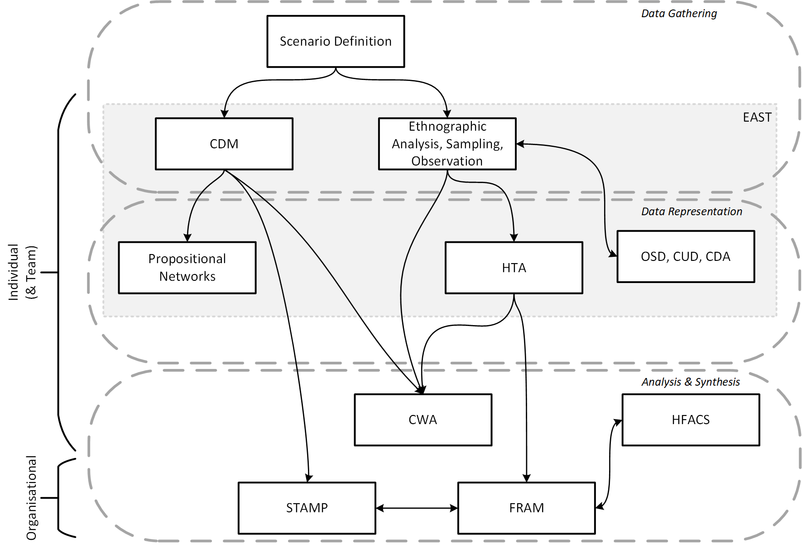
Figure 12: Adaptation Method Synthesis Framework
The adaptation method framework suggests three stages of analysis, a data gathering stage, a data representation stage and an analysis and synthesis stage. In the data gathering stage, the scenario is defined and observational studies and interviews are conducted, structured and analysed using CDM. All the data that is gathered is then structured and represented in different forms to allow different perspectives to be taken. HTA provides a useful and flexible notation for the structure of work and is often used as a starting point for many other methods. Similarly, the propositional networks of EAST provide a useful structure to describe the more informal networks of roles, functions and interactions that exist in the system. It may be useful to also include more measures of the data and the use of Operational Sequence Diagrams (OSD), Comms Usage Diagram (CUD), Coordination Demand Analysis (CDA), for example, may add further richness to the representation of the data gathering. The third stage is analysis & synthesis, and this uses CWA to further explore many of the features of adaptation at the level of the individual with STAMP and FRAM used to explore the features, such as control, feedback and unpredictability at the level of the organisation or wider system. The flow of results from one method to the next, identified in the application to the case study, is shown by arrows in the diagram. Where there are double-headed arrows this should be interpreted as a cross-check between methods for different representations of similar features.
The framework has been developed to illustrate how all the methods recommended by the Delphi survey could practically be deployed in a sequential fashion to provide complete coverage of all of the adaptation factors across all levels of the organisational hierarchy. The framework could also be interpreted as providing a series of possible pathways where methods are selected according to the available expertise, resources, data available and desired level of analysis. However, a core set of methods appears to be suggested from the factor and hierarchy coverage that includes HTA, CDM, CWA and STAMP with other methods providing complimentary or more in-depth analysis for a specific hierarchy level (e.g., EAST) or could be a seen as a supplement, cross-check or alternative for a specific sub-set of adaptation factors.

Discussion
Whilst safety management actions that are determined through linear simplifications of operational problems can result in specific, reductionist, local actions imposed upon the front-line, such as the phraseology change of the TOI (Provan et al., 2020), the use of a minor procedural change as a safety intervention to address a perceived emerging trend in a leading indicator of risk is not a particularly unusual practice for organisations managing safety-related risks. However, the story of the TOI is far richer than any initial superfluous dismissal of the genuine intention to control a real risk to the safety of UK air traffic operations might appreciate. Despite these intentions though, the TOI resulted in maladaptive emergent effects and impaired air traffic controller flexibility as the adaptive capacities that existed in the system and nature of the work were not fully appreciated in the risk and change assessment process. Whilst the TOI was a relatively minor addition of six syllables to controller transmissions under certain circumstances, it had a disproportionate effect on the air traffic control operation. This suggests a form of, or potential for, scale-invariance in the effects of changes in complex sociotechnical systems (Patriarca et al., 2017). The question this raises, and which has broader implications for Human Factors practitioners looking to better understand adaptation as a fundamental tenet of complex sociotechnical systems (Grant, Salmon, Stevens, Goode, & Read, 2018), is: how did this occur and could this have been anticipated?
Ultimately, the problem is not that safety practitioners do not understand or appreciate the role that adaptation plays in the safety of complex sociotechnical systems, the problem is that the methodological approaches that are currently in use may not support an appreciation and understanding of adaptation be that because they are linear, reductionist, focused on the individual or any other criticism of current practice (Holman et al., 2020; Salmon et al., 2017). In previous work, Foster et al. (2020a) used a Delphi survey of Human Factors experts and safety practitioners to identify a set of Human Factors methods that could be applied to the examination of nine factors of adaptation (Foster et al., 2019). This paper has applied these methods to the circumstances surrounding the decision to intervene, the TOI intervention itself, the pre-existing informal strategies and techniques, the subsequent emergent effects and the decision to withdraw the instruction. Each of these methods has been found to provide a slightly different perspective on the problem and the nature of adaptation. This is not an unexpected finding since in a multi-faceted problem in a complex sociotechnical system it should be expected that one method would be insufficient to adequately describe all perspectives (Holman et al., 2020; Kerr, Knott, Moss, Clegg, & Horton, 2008; Kirwan, 1998a, 1998b; Stanton et al., 2009; Walker et al., 2010). The analysis of the TOI case study also points towards the need to consider broader systemic interventions to address safety issues in complex sociotechnical systems (Shappell & Wiegmann, 2009).
Whilst the Human Factors methods were identified on the basis of their prospective explanatory power for the adaptation factors individually, this analysis has instead confirmed that it is the different perspectives that the application of the suite methods provides that helps uncover and explore adaptation. Therefore, a multi-perspective, multi-method, multi-faceted systemic analysis at different levels of abstraction is needed to identify and fully explore systemic features such as adaptation. A methodological framework has been proposed using all of these methods that has the potential to explore the features of adaptation and connect the different perspectives provided by the different methods at different levels of abstraction. Furthermore, as shown in the case of the TOI, it is possible for methods that are naturally more individual-focused to inform a discussion at the level of the organisation and so bridge the individual-to-organisational (micro-to-meso-to-macro) understanding of adaptation and safety (Grote, Weyer, & Stanton, 2014; Le Coze, 2019). For example, the CDM interviews of individuals identified both the need for operational responses to be flexible and the flexibility needed by the organisation to address emerging issues. These features can then be captured in the control and feedback structures used to describe the wider system and organisation with STAMP.
Given the comprehensive nature of the methods in the framework, the skill, experience, time and resource requirements may be considerable and a proportionate approach should be adopted commensurate with the scale of the change, the resources available, the likely value and, ultimately, the risk. Further research on the practical utility, efficacy and cost-benefit of such a multi-method, multi-perspective framework is warranted. However, by describing the methods as a framework it may be possible to tailor the selection of methods to the problem. For example, the data representation methods such as OSD, CDA, CUD may not be appropriate if the focus is on decision-making rather than communication and task analysis. Additionally, methods such as HFACS were originally suggested as a supplement to address some factors not fully covered by FRAM. Other combinations or linkages of the methods in the framework may also be appropriate to achieve full coverage of the adaptation factors for the system-under-analysis at the appropriate levels of the organisational hierarchy. In this case study, the representations of STAMP and FRAM were found to reflect the same prevailing paradigm and whilst useful as a cross-validation, it may be appropriate to select only one based on the domain, problem or experience of the analyst. Lastly, based on the results of this case study, the core methods of the framework would appear to be ethnographic observations (where possible), CDM, HTA, CWA and STAMP. It should also be noted that the methods in the framework are not specific to any particular domain and evidence of their use across the safety-related industries is replete in the literature. This suggests that the adaptation methods framework should be domain agnostic.

Conclusion
Seven Human Factors methods have been applied to examine the emergent and maladaptive effects of a routine risk management decision: the introduction of a temporary procedural change to manage a known risk in the UK air traffic operation. These methods were found to support an exploration of adaptation, recognised as an important feature of the safety of complex sociotechnical systems. However, no single method was shown to completely address all the factors of adaptation across all the levels of the organisational hierarchy. As such, a methodological framework is proposed that combines the different perspectives and approaches in these Human Factors methods and which would appear to have broad cross-domain applicability for safety practitioners seeking a structured way of exploring adaptation.
The methods and the emergent framework have been applied to a single retrospective case study. Both the methods and framework, including the pathways through the framework, will need to be further validated for their ability to anticipate potential maladaptive problems and provide assurance to decision-makers on the suitability of safety interventions using additional case studies and prospective applications. Similarly, the framework does not appear to support many of the other considerations that need to be taken into account in risk management decision-making in an organisational context such as cost, effectiveness, feasibility and acceptability. These safety management challenges featured prominently in the interviews as part of the CDM step in the discussion of the ‘balance of risks’ and in complex and uncertain situations the use of experience and judgement has a role in decision-making. The use of HFIX as an extension to HFACS may add further value to the framework for these issues.
In safety critical domains, it is incumbent on the safety practitioner to provide accountable decision-makers with the best possible data and analysis to support their risk management decisions. The recommended Human Factors methods have been shown to have a useful role in exploring adaptation. The proposed methods framework should also assist safety practitioners in structuring an exploration of adaptation across the organisational hierarchy. The methods approach does not appear to be limited to just the adaptations in normal work at the frontline and the case study has shown that it can also be applied to a problem related to organisational understanding and decision-making.

Acknowledgements
This work is funded by NATS and was originally motivated by a series workshops facilitated by Steven Shorrock from Eurocontrol. The authors are also grateful to the contribution of current and former NATS experts including Christine Deamer, Bill Leipnik, Lee Boulton, Simon Taylor, Roger Dillon and Anthony Smoker.

References
Annett, J. (2004). Hierarchical Task Analysis (HTA). In Handbook of Human Factors and Ergonomics Methods (pp. 33-1-33–37). CRC Press. https://doi.org/10.1201/9780203489925.ch33
CAA. (2011). CAA Paper 2011/03: CAA “Significant Seven” Task Force Reports. Retrieved from https://publicapps.caa.co.uk/docs/33/2011_03.pdf
CAA. (2014). Safety Notice SN–2014/004 Level Busts: Hazards and Defences. Retrieved January 6, 2020, from https://publicapps.caa.co.uk/docs/33/SafetyNotice2014004.pdf
CAA. (2016). CAP 413: Radiotelephony Manual. Retrieved from https://publicapps.caa.co.uk/docs/33/CAP413 MAY16.2.pdf
CAA & NATS. (2014). CAP 1186 Level Busts - Information for Pilots and Controllers. Retrieved January 6, 2020, from http://publicapps.caa.co.uk/docs/33/CAP 1186 Level Bust leaflet.pdf
Cornelissen, M., Salmon, P. M., McClure, R., & Stanton, N. A. (2013). Using cognitive work analysis and the strategies analysis diagram to understand variability in road user behaviour at intersections. Ergonomics, 56(5), 764–780. https://doi.org/10.1080/00140139.2013.768707
Crandall, B., Klein, G., & Hoffman, R. (2006). Working Minds. A Practioner’s Guide to Cognitive Task Analysis.
Dahl, T. (2013). Safety compliance in a highly regulated environment: A case study of workers’ knowledge of rules and procedures within the petroleum industry. Safety Science, 60, 185–195. https://doi.org/10.1016/j.ssci.2013.07.020
Dekker, S. W. A. (2003). Failure to adapt or adaptations that fail: Contrasting models on procedures and safety. Applied Ergonomics, 34(3), 233–238. https://doi.org/10.1016/S0003-6870(03)00031-0
Dekker, S. W. A. (2011). Drift into failure. Farnham: Ashgate. Retrieved from https://gowerpublishing.com/pdf/leaflets/Drift-into-Failure-2011.pdf
Endsley, M. R., & Smolensky, M. W. (1998). Situation awareness in air traffic control: The picture. Human Factors in Air Traffic Control., (September), 115–154. https://doi.org/1721.1/35929
Foster, C. J., Plant, K. L., & Stanton, N. A. (2019). Adaptation as a source of safety in complex socio-technical systems: A literature review and model development. Safety Science, 118(May), 617–631. https://doi.org/10.1016/j.ssci.2019.05.035
Foster, C. J., Plant, K. L., & Stanton, N. A. (2020a). A Delphi study of human factors methods for the evaluation of adaptation in safety-related organisations. Safety Science, 131(July), 104933. https://doi.org/10.1016/j.ssci.2020.104933
Foster, C. J., Plant, K. L., & Stanton, N. A. (2020b). A very temporary operating instruction: Uncovering emergence and adaptation in air traffic control. Reliability Engineering & System Safety, 208(November 2020), 107386. https://doi.org/10.1016/j.ress.2020.107386
Grant, E., Salmon, P. M., Stevens, N. J., Goode, N., & Read, G. J. (2018). Back to the future: What do accident causation models tell us about accident prediction? Safety Science. https://doi.org/10.1016/j.ssci.2017.12.018
Grote, G., Weyer, J., & Stanton, N. A. (2014). Beyond human-centred automation - concepts for human-machine interaction in multi-layered networks. Ergonomics. Taylor & Francis. https://doi.org/10.1080/00140139.2014.890748
Hale, A., & Borys, D. (2013). Working to rule or working safely? Part 2: The management of safety rules and procedures. Safety Science, 55, 222–231. https://doi.org/10.1016/j.ssci.2012.05.013
Harris, D., & Li, W. C. (2011). An extension of the Human Factors Analysis and Classification System for use in open systems. Theoretical Issues in Ergonomics Science, 12(2), 108–128. https://doi.org/10.1080/14639220903536559
Holen, S. M., Utne, I. B., & Holmen, I. M. (2014). A preliminary accident investigation on a Norwegian fish farm applying two different accident models. In PSAM 2014 - Probabilistic Safety Assessment and Management.
Holling, C. S. (1973). Resilience and Stability of Ecological Systems. Annual Review of Ecology and Systematics, 4(1), 1–23. https://doi.org/10.1146/annurev.es.04.110173.000245
Hollnagel, E. (2012). FRAM: The Functional Resonance Analysis Method. FRAM: The Functional Resonance Analysis Method. Ashgate Publishing Ltd. https://doi.org/10.1201/9781315255071
Hollnagel, E. (2014). Safety-I and safety-II: The past and future of safety management. Ashgate Publishing Ltd.
Hollnagel, E., Woods, D. D., & Leveson, N. G. (2006). Resilience Engineering - Concepts and Precepts. Resilience Engineering: Concepts and Precepts.
Holman, M., Walker, G., Lansdown, T., Salmon, P., Read, G., & Stanton, N. (2020). The Binary-Based Model (BBM) for Improved Human Factors Method Selection. Human Factors. https://doi.org/10.1177/0018720820926875
Jenkins, D. P., Stanton, N. A., Salmon, P. M., & Walker, G. H. (2008). Cognitive work analysis: Coping with complexity. Cognitive Work Analysis: Coping with Complexity. https://doi.org/10.1080/00140130903458293
Jenkins, D. P., Stanton, N. A., Salmon, P. M., Walker, G. H., Young, M. S., Whitworth, I., … Hone, G. (2007). The development of a cognitive work analysis tool. Lecture Notes in Computer Science (Including Subseries Lecture Notes in Artificial Intelligence and Lecture Notes in Bioinformatics), 4562 LNAI(2003), 504–511. https://doi.org/10.1007/978-3-540-73331-7_55
Kee, D. (2017). Comparison of Systemic Accident Investigation Techniques Based on the Sewol Ferry Capsizing. Journal of the Ergonomics Society of Korea. https://doi.org/10.5143/JESK.2017.36.5.485
Kerr, M. P., Knott, D. S., Moss, M. A., Clegg, C. W., & Horton, R. P. (2008). Assessing the value of human factors initiatives. Applied Ergonomics, 39(3). https://doi.org/10.1016/j.apergo.2007.10.003
Kirwan, B. (1998a). Human error identification techniques for risk assessment of high risk systems - Part 1: Review and evaluation of techniques. Applied Ergonomics, 29(3), 157–177. https://doi.org/10.1016/S0003-6870(98)00010-6
Kirwan, B. (1998b). Human error identification techniques for risk assessment of high risk systems - Part 2: Towards a framework approach. Applied Ergonomics, 29(3), 157–177. https://doi.org/10.1016/S0003-6870(98)00011-8
Klein, G. A. G. A., Calderwood, R., & MacGregor, D. (1989). Critical decision method for eliciting knowledge. Ieee Transactions On Systems Man And Cybernetics, 19(3), 462–472. https://doi.org/10.1109/21.31053
Le Coze, J. C. (2019). Safety as strategy: Mistakes, failures and fiascos in high-risk systems. Safety Science, 116(December 2017), 259–274. https://doi.org/10.1016/j.ssci.2019.02.023
Leveson, N. G. (2004). A new accident model for engineering safer systems. Safety Science, 42(4), 237–270. https://doi.org/10.1016/S0925-7535(03)00047-X
Leveson, N. G. (2011). Engineering a Safer World. Engineering a Safer World. MIT Press. https://doi.org/10.7551/mitpress/8179.001.0001
Lofquist, E. A. (2010). The art of measuring nothing: The paradox of measuring safety in a changing civil aviation industry using traditional safety metrics. Safety Science, 48(10), 1520–1529. https://doi.org/10.1016/j.ssci.2010.05.006
Maslen, S., & Hopkins, A. (2014). Do incentives work? A qualitative study of managers’ motivations in hazardous industries. Safety Science, 70, 419–428. https://doi.org/10.1016/j.ssci.2014.07.008
Naikar, N., Hopcroft, R., & Moylan, A. (2005). Work domain analysis: Theoretical concepts and methodology. Defence Science and Technology Report, 104. Retrieved from http://dspace.dsto.defence.gov.au/dspace/bitstream/1947/3909/1/DSTO-TR-1665 PR.pdf
Naikar, N., Moylan, A., & Pearce, B. (2006). Analysing activity in complex systems with cognitive work analysis: Concepts, guidelines and case study for control task analysis. Theoretical Issues in Ergonomics Science. https://doi.org/10.1080/14639220500098821
O’Hare, D., Wiggins, M., Williams, A., & Wong, W. (1998). Cognitive task analyses for decision centred design and training. Ergonomics, 41(11), 1698–1718. https://doi.org/10.1080/001401398186144
Okoli, J., Watt, J., Weller, G., & Wong, W. B. L. (2016). The role of expertise in dynamic risk assessment: A reflection of the problem-solving strategies used by experienced fireground commanders. Risk Management, 18(1), 4–25. https://doi.org/10.1057/rm.2015.20
Patriarca, R., Bergström, J., & Di Gravio, G. (2017). Defining the functional resonance analysis space: Combining Abstraction Hierarchy and FRAM. Reliability Engineering and System Safety, 165(July 2016), 34–46. https://doi.org/10.1016/j.ress.2017.03.032
Patriarca, R., Di Gravio, G., & Costantino, F. (2018). MyFRAM: An open tool support for the functional resonance analysis method. 2017 2nd International Conference on System Reliability and Safety, ICSRS 2017, 2018-Janua, 439–443. https://doi.org/10.1109/ICSRS.2017.8272861
Patriarca, R., Di Gravio, G., Woltjer, R., Costantino, F., Praetorius, G., Ferreira, P., & Hollnagel, E. (2020). Framing the FRAM: A literature review on the functional resonance analysis method. Safety Science, 129(April), 104827. https://doi.org/10.1016/j.ssci.2020.104827
Pinto, A., Filho, G., Thomas, G., Waterson, P., Goncalves Filho, A. P., Jun, G. T., & Waterson, P. (2019). Four studies , two methods , one accident – An examination of the reliability and validity of Accimap and STAMP for accident analysis. Safety Science, 113(December 2018), 310–317. https://doi.org/10.1016/j.ssci.2018.12.002
Plant, K. L., & Stanton, N. A. (2013). What is on your mind? Using the perceptual cycle model and critical decision method to understand the decision-making process in the cockpit. Ergonomics, 56(8), 1232–1250. https://doi.org/10.1080/00140139.2013.809480
Provan, D. J., Woods, D. D., Dekker, S. W. A., & Rae, A. J. (2020). Safety II professionals: How resilience engineering can transform safety practice. Reliability Engineering & System Safety, 195(August 2018), 106740. https://doi.org/10.1016/j.ress.2019.106740
Rasmussen, J. (1983). Skills, Rules, and Knowledge; Signals, Signs, and Symbols, and Other Distinctions in Human Performance Models. IEEE Transactions on Systems, Man and Cybernetics, SMC-13(3), 257–266. https://doi.org/10.1109/TSMC.1983.6313160
Rasmussen, J., Pejtersen, A. M., & Goodstein, L. (1994). Cognitive Systems Engineering. New York: Wiley & Sons.
Read, G. J. M., Salmon, P. M., Lenné, M. G., & Stanton, N. A. (2015). Designing sociotechnical systems with cognitive work analysis: putting theory back into practice. Ergonomics. https://doi.org/10.1080/00140139.2014.980335
Reason, J. (1990). Human Error. Cambridge University Press.
Reason, J., Parker, D., & Lawton, R. (1998). Organizational controls and safety: The varieties of rule-related behaviour. Journal of Occupational and Organizational Psychology, 71(4), 289–304. https://doi.org/10.1111/j.2044-8325.1998.tb00678.x
Reiman, T., Rollenhagen, C., Pietikäinen, E., & Heikkilä, J. (2015). Principles of adaptive management in complex safety-critical organizations. Safety Science, 71(PB), 80–92. https://doi.org/10.1016/j.ssci.2014.07.021
Rochlin, G. I. (1999). Safe operation as a social construct. Ergonomics, 42(11), 1549–1560. https://doi.org/10.1080/001401399184884
Rose, J. A., & Bearman, C. (2012). Making effective use of task analysis to identify human factors issues in new rail technology. Applied Ergonomics, 43(3). https://doi.org/10.1016/j.apergo.2011.09.005
Salmon, P. M., Walker, G. H., Gemma, G. J., Goode, N., & Stanton, N. A. (2017). Fitting methods to paradigms: are ergonomics methods fit for systems thinking? Ergonomics, 60(2), 194–205. https://doi.org/10.1080/00140139.2015.1103385
Schraagen, J. M., Chipman, S. F., & Shalin, V. L. (Eds.). (2000). Cognitive Task Analysis. Psychology Press.
Shappell, S. a, & Wiegmann, D. a. (2000). The Human Factors Analysis and Classification System – HFACS. USDOT/FAA/AM-00/7 Office of Aviation Medicine. https://doi.org/10.1177/1062860613491623
Shappell, S., & Wiegmann, D. (2009). A methodology for assessing safety programs targeting human error in aviation. International Journal of Aviation Psychology, 19(3), 252–269. https://doi.org/10.1080/10508410902983904
Stanton, N. A. (2006). Hierarchical task analysis: Developments, applications, and extensions. Applied Ergonomics, 37(1 SPEC. ISS.), 55–79. https://doi.org/10.1016/j.apergo.2005.06.003
Stanton, N. A. (2014). Representing distributed cognition in complex systems: How a submarine returns to periscope depth. Ergonomics. https://doi.org/10.1080/00140139.2013.772244
Stanton, N. A. (2016). On the reliability and validity of, and training in, ergonomics methods: a challenge revisited. Theoretical Issues in Ergonomics Science, 17(4), 345–353. https://doi.org/10.1080/1463922X.2015.1117688
Stanton, N. A., Baber, C., & Harris, D. (2008). Modelling command and control: Event analysis of systemic teamwork. Modelling Command and Control: Event Analysis of Systemic Teamwork. https://doi.org/10.1080/00140130902924196
Stanton, N. A., & Harvey, C. (2017). Beyond human error taxonomies in assessment of risk in sociotechnical systems: a new paradigm with the EAST ‘broken-links’ approach. Ergonomics, 60(2), 221–233. https://doi.org/10.1080/00140139.2016.1232841
Stanton, N. A., Salmon, P., Harris, D., Marshall, A., Demagalski, J., Young, M. S., … Dekker, S. (2009). Predicting pilot error: Testing a new methodology and a multi-methods and analysts approach. Applied Ergonomics, 40(3), 464–471. https://doi.org/10.1016/j.apergo.2008.10.005
Stanton, N. A., Salmon, P. M., Rafferty, L. A., Walker, G. H., Baber, C., & Jenkins, D. P. (2013). Human factors methods: A practical guide for engineering and design, 2nd edition. Human Factors Methods: A Practical Guide for Engineering and Design, 2nd Edition. Ashgate Publishing Ltd. https://doi.org/10.1080/00140139.2014.948659
Stanton, N. A., Salmon, P. M., & Walker, G. H. (2018). Systems thinking in practice: Applications of the Event Analysis of Systemic Teamwork Method. CRC Press Taylor & Francis Group.
Stanton, N. A., Salmon, P. M., Walker, G. H., & Stanton, M. (2019). Models and methods for collision analysis: A comparison study based on the Uber collision with a pedestrian. Safety Science, 120(February), 117–128. https://doi.org/10.1016/j.ssci.2019.06.008
Stanton, N. A., & Young, M. S. (1999). What price ergonomics. Nature, 399(6733), 197–198. https://doi.org/10.1038/20298
Underwood, P., & Waterson, P. (2013). Systemic accident analysis: Examining the gap between research and practice. Accident Analysis and Prevention, 55, 154–164. https://doi.org/10.1016/j.aap.2013.02.041
Vicente, K. J. (1999). Cognitive Work Analysis: Towards Safe, Productive and Healthy Computer-Based Work. Cognitive Work Analysis. Boca Raton: CRC Press. https://doi.org/10.1201/b12457
Walker, G. H., Stanton, N. A., Baber, C., Wells, L., Gibson, H., Salmon, P., & Jenkins, D. (2010). From ethnography to the east method: A tractable approach for representing distributed cognition in air traffic control. Ergonomics, 53(2), 184–197. https://doi.org/10.1080/00140130903171672
Waterson, P., Robertson, M. M., Cooke, N. J., Militello, L., Roth, E., & Stanton, N. A. (2015). Defining the methodological challenges and opportunities for an effective science of sociotechnical systems and safety. Ergonomics, 58(4), 565–599. https://doi.org/10.1080/00140139.2015.1015622
Weick, K. E., & Sutcliffe, K. M. (2015). Managing the unexpected : sustained performance in a complex world (3rd ed.). John Wiley & Sons.
Wiegmann, D. A., & Shappell, S. A. (2012). A human error approach to aviation accident analysis: The human factors analysis and classification system. A Human Error Approach to Aviation Accident Analysis: The Human Factors Analysis and Classification System.
Wong, B. L. W. (2004). Data Analysis for the Critical Decision Method. In D. Diaper & N. Stanton (Eds.), The Handbook of Task Analysis for Human-Computer Interaction (pp. 327–345). London: Lawrence Erlbaum.
Zhang, Y., Dong, C., Guo, W., Dai, J., & Zhao, Z. (2021). Systems theoretic accident model and process (STAMP): A literature review. Safety Science, (November), 105596. https://doi.org/10.1016/j.ssci.2021.105596

Appendix 1: Adaptation Model Factors
Table 6: Adaptation Model Factor Summaries
Adaptation Factor | Summary
Using Experience | The capability of individuals to adapt in the complex work environment implies a certain level of experience in the system. Whilst novices may use what they have been taught, practised operators draw on their experiences to spot the cues, appreciate what is critical, draw on analogies and patterns to apply the acquired lore of the system. However, experience may also breed over confidence, pride in risk taking so feeding a hero complex. Operators may also become stuck in their ways and be unwilling or unable to adapt.
Strategies & Informal Practice | The literature identifies adaptation as relating to breaking rules to achieve a goal, however, we draw a distinction between violations and the inconsequential and normal adaptations in work that are not rule breaches. These strategies and informal practices emerge through the everyday conduct of work and address the rigidity of complex and highly optimised systems. These adaptations can be seen as the patterns of behaviour and the routines of normal work.
Acquiring Knowledge | The skills needed to develop strategies for adaptation and the experience to apply them are largely built up on-the-job: recognising the patterns, similarity matching, appreciation of the constraints and demands and the boundaries of work. Operators use feedback from the system to build competence through practice. Additionally, they may share in the knowledge of others and their experiences.
Unpredictability of Consequences | Work needs to be done but it is grounded in a specific context. In complex sociotechnical systems this context is one of uncertainty, non-linearity and emergence. Whilst the work environment has structure, the multitude of connections between interrelated functions all having mutual interdependence upon each other generates emergent complexity. Humans in such systems are inevitably forced to make choices based on an incomplete understanding of the possible effects of their decision.
Trade-off for Performance | Adaptation is a decision, conscious or not, to make a trade-off. Goal conflicts create pressure from the need to address other demands with safety becoming another goal to be managed. Adaptation is required when resources are scarce. Adaptive decisions may satisfice - the search for the least bad option. Similarly, the design of the system itself may be a compromise that can expose human frailties. Trade-offs may normally work but can be reported as contributing to incidents.
Skills Needed | The changing needs of the work environment require individuals to acquire experience or certain skills to support their ability to adapt. This can include the ability to assimilate many diverse indicators and sources of information. Individuals in the system are able to appreciate the patterns in the system and use their knowledge to interpret them and the rules to make a judgement, in the presence of uncertainty, on the course of action. When procedures or rules do not appear to work, safety in complex systems relies on the skills of creativity, problem solving and innovation. If these are found wanting then individuals can work as a group to communicate, cooperate and build consensus to resolve issues through teamwork.
Violations | Violations are deliberate deviations from a rule that has previously been declared to be safe for the approved task and they arise through deviations between governance and practice. Violations can be positive, despite the negative connotations of the language. Exceptional violations are covered in the next factor (Improvisation & Creativity). Routine violations are believed to improve the system, for example a work around or the omission of a step in a procedure to address, for example, procedural limitations that create extra work. In highly optimised systems rules become less effective when they get in the way of normal work. For many professionals, routine work does not need procedures and violations can occur when the consequences are believed to be negligible. Indeed, violations may be needed to get the work done.
Improvisation & Creativity | Exceptional violations are observed in complex systems when individuals are placed under unusual demands. Procedures cannot necessarily be relied upon in an emergency and additional skills are often called upon. Adaptation is reactive innovation in context, in the moment and relies upon the skill, prior knowledge and resources available. The autonomy granted to the front-line in many complex systems provides the capability to have immediate feedback and adjust to ensure changing goals continue to be met, to recover and to support the emergence of innovative responses to cope with the unforeseen.
Procedures & Rules | The nature of decision making in a complex system is influenced by the presence of rules and procedures. The general belief is that safety comes from minimising uncertainty through the control of work. The aim of rules and procedures is to motivate, guide, educate, influence or constrain the behaviour of front-line operators. Procedures try to identify the good practices, address variation and so minimise risks. But a compliance-based attitude can breed more procedures that add further complexity. Yet procedures can support adaptation by being the first thing that is tried and, where they are goal-based they can strike a balance between compliance and flexibility to support safety.

Appendix 2: HTA Diagram
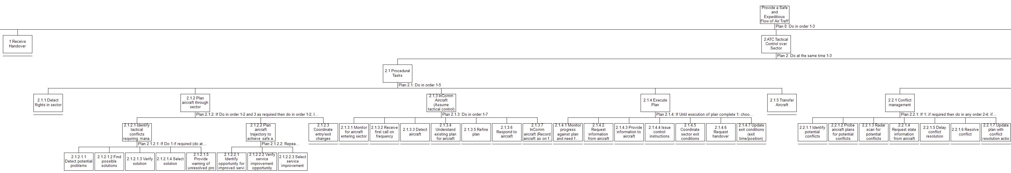 | 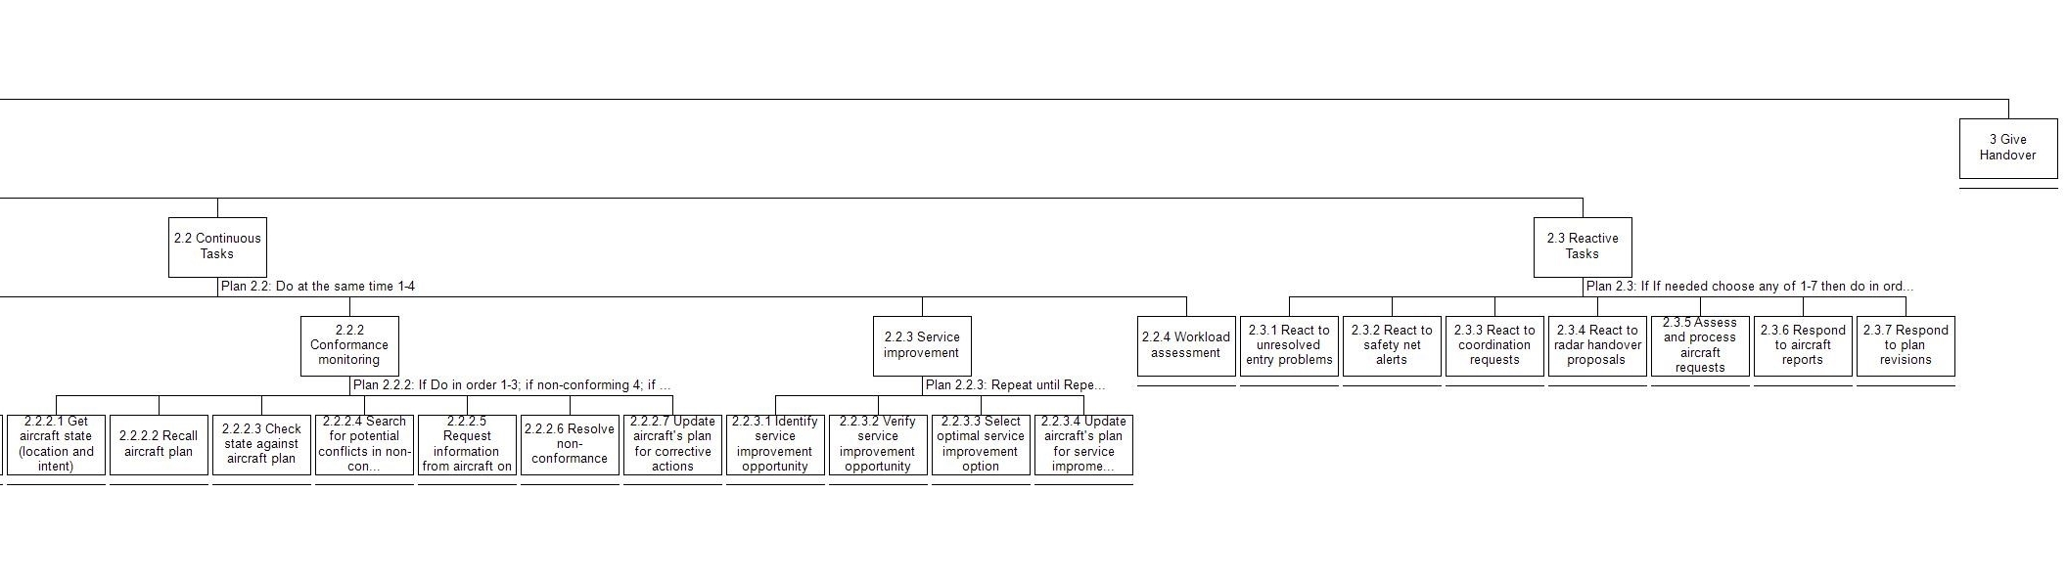
Figure 13: Complete HTA diagram for the tactical controlling task

